22.08.2023

BILL CHECKING

Mounika Annamneedi

Mounika.annamneedi@techneai.com

**Functional Requirement Document**

**CONTENTS**

1. INTRODUCTION 2

2. BUSINESS REQUIREMENT 2

3. SCOPE 2

4. BUSINESS & SYSTEM RULES 2

5. PROPOSED SYSTEM 2

6. TEST DATA 5

1. **INTRODUCTION**

The bill checking module is the billing process which is helpful in creating bills, payment details, approval process and bill payments.

1. **BUSINESS REQUIREMENT**

Enter details of the ticket requirement.

|  |  |  |  |
| --- | --- | --- | --- |
| **Requirement ID** | **Requirement Name** | **Short Description** | **Priority** |
| BR001 | Bill payments - Filter | The bill payments filter is defined | High |
| BR002 | Bill payments - record view | The bill payments view action for the filtered data | Medium |
| BR003 | Bill payments - export | The bill payments export data of the filtered data | Medium |
| BR004 | Download text files | The download of the text files for the payment procedure | High |
| BR005 | Auto update payment | For uploading the data of the paid entries to update the payment | High |

1. **SCOPE**

The scope of the point is up to the bill payments module where the payments to be made is viewed, based on it, the downloading and uploading of the data in the module.

1. **BUSINESS & SYSTEM RULES**

* User should be registered in the system.
* User should be logged in.
* System should display error message for incorrect details if entered.
* System should pop up a message, if any issues in the system is detected.
* All forms should have on field validations. System should display on field errors in case of incorrect inputs.

1. **PROPOSED SYSTEM**

**BR001 - Bill payments Filter**

The bill payments filters the data where the payment to be made. Only the bills, where the status is released is filtered. The following are the filters.

* Bill type
* Till date
* Filter

|  |  |  |  |
| --- | --- | --- | --- |
| **FIELDS** | **INPUT TYPE** | **MANDATORY/ OPTIONAL** | **DESCRIPTION** |
| Bill type | Drop down | Optional | The bill type required for the payment is selected from the drop down. The drop down options are fetched from the bill type master.  Validation: User can select all, multiple and single bill types. If the user did not select the bill type, then all the bill types to be considered. |
| Till date | Date picker | Mandatory | The till date is entered, the bill payment date before and equal to the date are fetched where the status is release. |
| Filter | Button | - | The filter button to filter the data. |

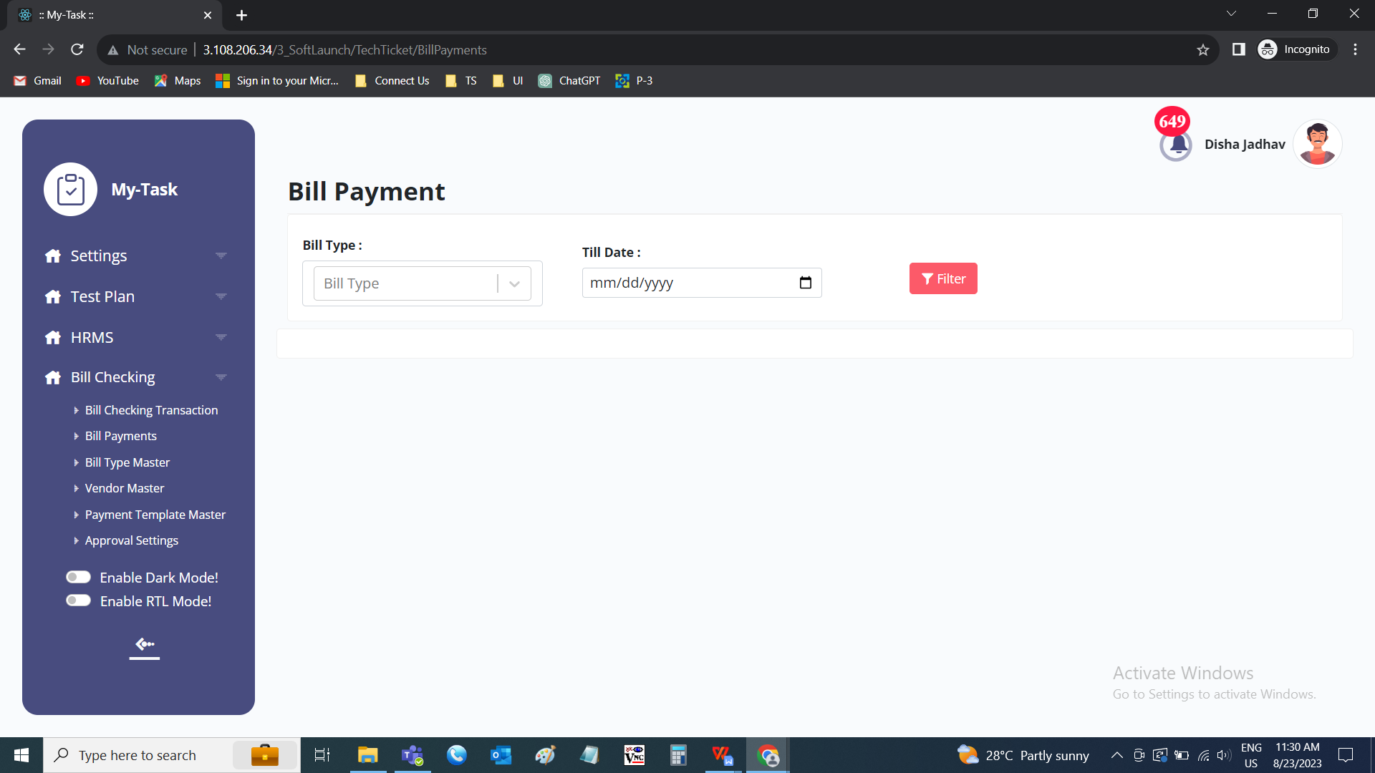

The filtered record consists of the following data.

* Action
* Sr No
* Vendor name
* Bill type
* Payment date
* Payment amount
* Vendor bill No.
* Bill ID
* SBI amount
* Remark
* Beneficiary name
* Bank name
* Branch name
* Account No
* IFSC code

|  |  |
| --- | --- |
| **FIELDS** | **DESCRIPTION** |
| Action | The action field consists of the view button to view the record in detail. |
| Sr No | The serial number for the record is displayed |
| Vendor name | The vendor name of the bill is displayed |
| Bill type | The bill type of the bill is displayed. If there are multiple against it, the comma separated values are displayed. |
| Payment date | The payment date of the vendor is displayed. If there are multiple against it, the comma separated values are displayed. |
| Payment amount | The payment amount of the vendor is displayed. If there are multiple against it, the comma separated values are displayed. |
| Vendor bill No. | The vendor bill number is displayed. If there are multiple against it, the comma separated values are displayed. |
| Bill ID | The bill ID is displayed. If there are multiple against it, the comma separated values are displayed. |
| SBI amount | The vendor if having the SBI account, the amount is displayed. |
| Remark | The remark against the payment entry is displayed. If there are multiple against it, the comma separated values are displayed. |
| Beneficiary name | The beneficiary name of the vendor is displayed |
| Bank name | The bank name of the vendor is displayed |
| Branch name | The bank branch name of the vendor is displayed |
| Account No | The account number of the vendor is displayed |
| IFSC code | The IFSC code of the vendor is displayed |

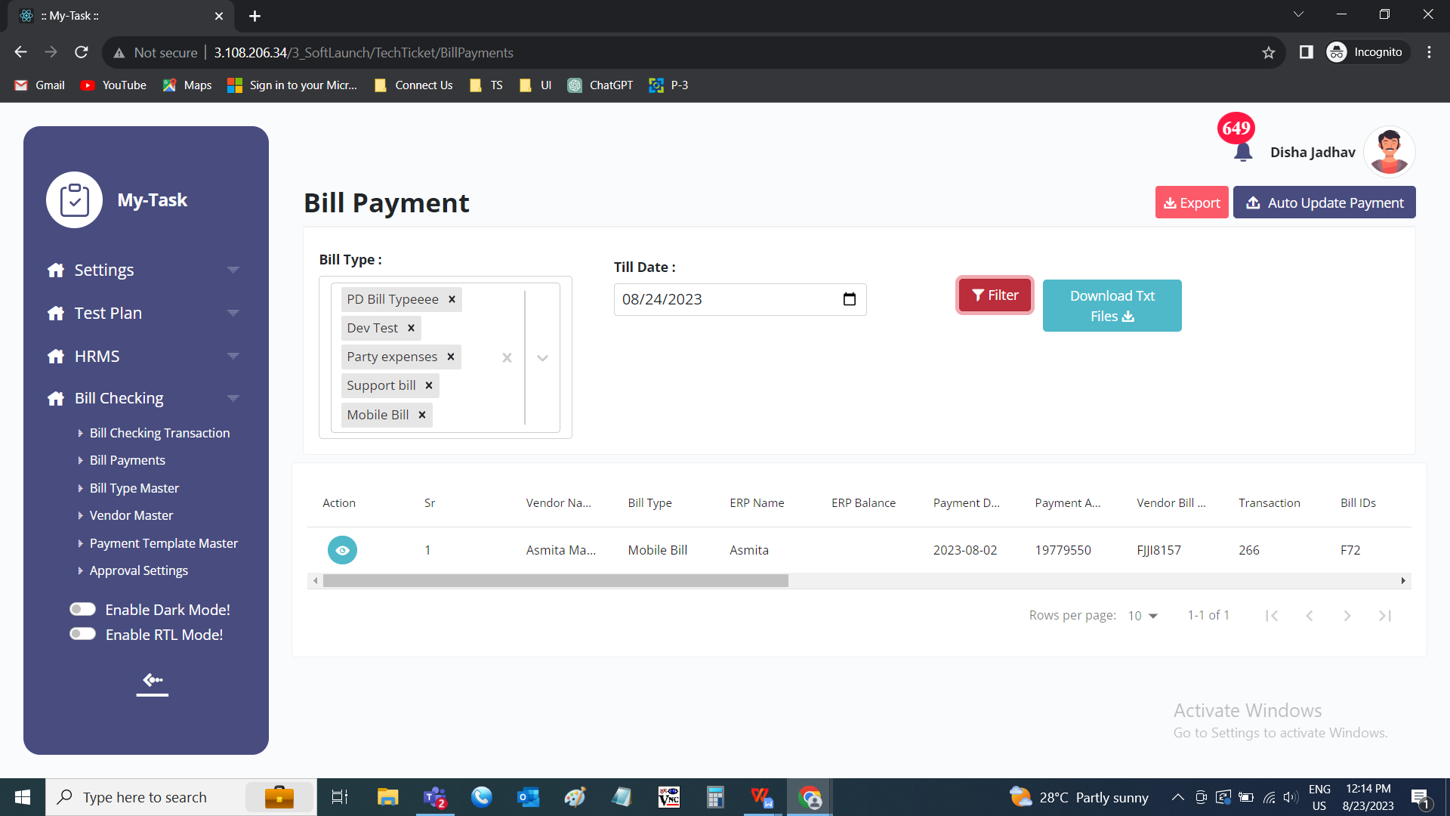

**BR002 - Bill payments - Record view**

The bill payments record view consists of the following fields.

* Bill ID
* Vendor name
* Amount
* TDS
* IGST
* GST
* Net payment
* Amount to be paid
* Payment date
* Payment status

|  |  |
| --- | --- |
| **FIELDS** | **DESCRIPTION** |
| Bill ID | The bill ID is displayed. If there are multiple bills, shown in records. |
| Vendor name | The vendor name is displayed |
| Amount | The total amount of the bill is displayed |
| TDS | The TDS amount of the total bill is displayed |
| IGST | The IGST amount of the total bill is displayed |
| GST | The GST amount of the total bill is displayed |
| Net payment | The total net payment of the total bill is displayed |
| Amount to be paid | The amount to be paid is displayed |
| Payment date | The payment date of the bill is displayed |
| Payment status | The payment status of the record is displayed |

**BR003 - Bill payments - Export**

When the user clicks on the export. The following are the fields exported in the excel sheet.

* Sr No
* Vendor name
* Bill type
* Payment date
* Payment amount
* Vendor bill No.
* Bill ID
* SBI amount
* Remark
* Beneficiary name
* Bank name
* Branch name
* Account No
* IFSC code

|  |  |
| --- | --- |
| **FIELDS** | **DESCRIPTION** |
| Action | The action field consists of the view button to view the record in detail. |
| Sr No | The serial number for the record is displayed |
| Vendor name | The vendor name of the bill is displayed |
| Bill type | The bill type of the bill is displayed. If there are multiple against it, the comma separated values are displayed. |
| Payment date | The payment date of the vendor is displayed. If there are multiple against it, the comma separated values are displayed. |
| Payment amount | The payment amount of the vendor is displayed. If there are multiple against it, the comma separated values are displayed. |
| Vendor bill No. | The vendor bill number is displayed. If there are multiple against it, the comma separated values are displayed. |
| Bill ID | The bill ID is displayed. If there are multiple against it, the comma separated values are displayed. |
| SBI amount | The vendor if having the SBI account, the amount is displayed. |
| Remark | The remark against the payment entry is displayed. If there are multiple against it, the comma separated values are displayed. |
| Beneficiary name | The beneficiary name of the vendor is displayed |
| Bank name | The bank name of the vendor is displayed |
| Branch name | The bank branch name of the vendor is displayed |
| Account No | The account number of the vendor is displayed |
| IFSC code | The IFSC code of the vendor is displayed |

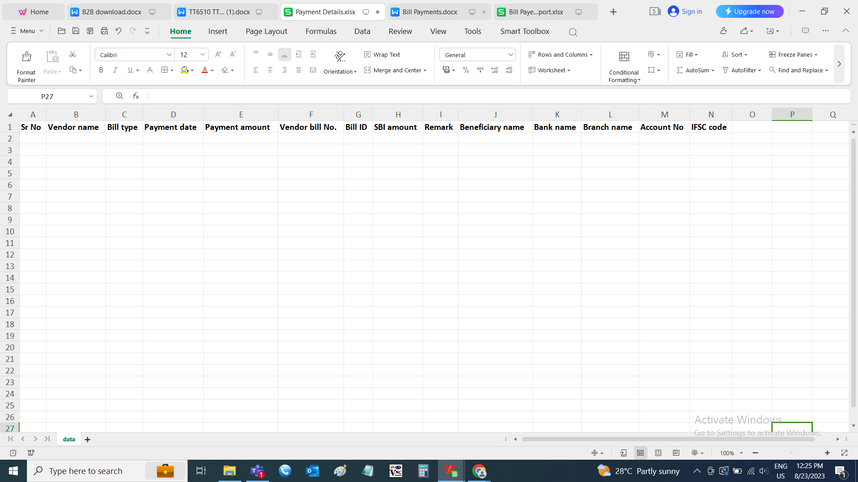

**BR004 - Download text files**

The text files are downloaded based on the selection of the vendors. The following are the text files to be downloaded.

* SBI_PAYEE.txt
* RTGS_PAYEE.txt
* NEFT_PAYEE.txt
* PAYEE.txt

|  |  |
| --- | --- |
| **FIELDS** | **DESCRIPTION** |
| SBI_PAYEE.txt | The SBI file is downloaded where the vendor is having the SBI bank account. The following is the format for the SBI_PAYEE.txt.  (our account number)#(our IFSC code - last 5 digit)#(payment date)#(total payment)##(unique key)#(SBI unique key)#  Newline  (vendor account no)#(vendor IFSC code - last 5 digit)#(payment date)##(amount to be paid to the vendor)#(unique key)#(SBI unique key)  If multiple vendors, multiple line are added. |
| RTGS_PAYEE.txt | The RTGS file is downloaded where the vendor is non SBI holder and the amount exceeding Rs.2 lakhs. The following is the format for the RTGS_PAYEE.txt.  (our account number)#(our IFSC code - last 5 digit)#(payment date)#(total payment)##(unique key)#(SBI unique key)#RTGS newline (vendor account no)#(vendor IFSC code)#(payment date)##(amount to be paid to the vendor)#(unique key)#(Non SBI RTGS unique key)#RTGS  If multiple vendors, multiple line are added. |
| NEFT_PAYEE.txt | The RTGS file is downloaded where the vendor is non SBI holder and the amount below Rs.2 lakhs. The following is the format for the NEFT_PAYEE.txt.  (our account number)#(our IFSC code - last 5 digit)#(payment date)#(total payment)##(unique key)#(SBI unique key)#NEFT newline (vendor account no)#(vendor IFSC code)#(payment date)##(amount to be paid to the vendor)#(unique key)#(Non SBI NEFT unique key)#NEFT  If multiple vendors, multiple line are added. |
| PAYEE.txt | The payee file is downloaded where the vendors details to be updated. The following is the format for the PAYEE.txt.  (O - in case of non SBI)#A#(vendor name)#(vendor account number)#(vendor IFSC code)#(vendor bank name)#(vendor bank branch)# new line  (S - in case of SBI)#A#(vendor name)#(vendor account number)#(vendor IFSC code)#(vendor bank name)#(vendor bank branch)# If multiple vendors, multiple line are added. |

Sample files are added in the test data.

**BR005 - Auto update payment**

The auto update payment is update the payment date and payment status in the module. When the user clicks on auto update payment, pop up is opened. The pop up consists of the following fields.

* Choose file
* Submit
* Cancel

|  |  |  |  |
| --- | --- | --- | --- |
| **FIELDS** | **INPUT TYPE** | **MANDATORY/ OPTIONAL** | **DESCRIPTION** |
| Choose file | File upload | Optional | The file to upload is attached |
| Upload | Button | Optional | The upload button to upload the file |
| Back | Button | Optional | The back button to close the pop-up |

When the empty file uploaded, then error message is displayed “Something went wrong - Empty file uploaded”.

When the wrong file uploaded, then error message is displayed “Something went wrong - Invalid file type”.

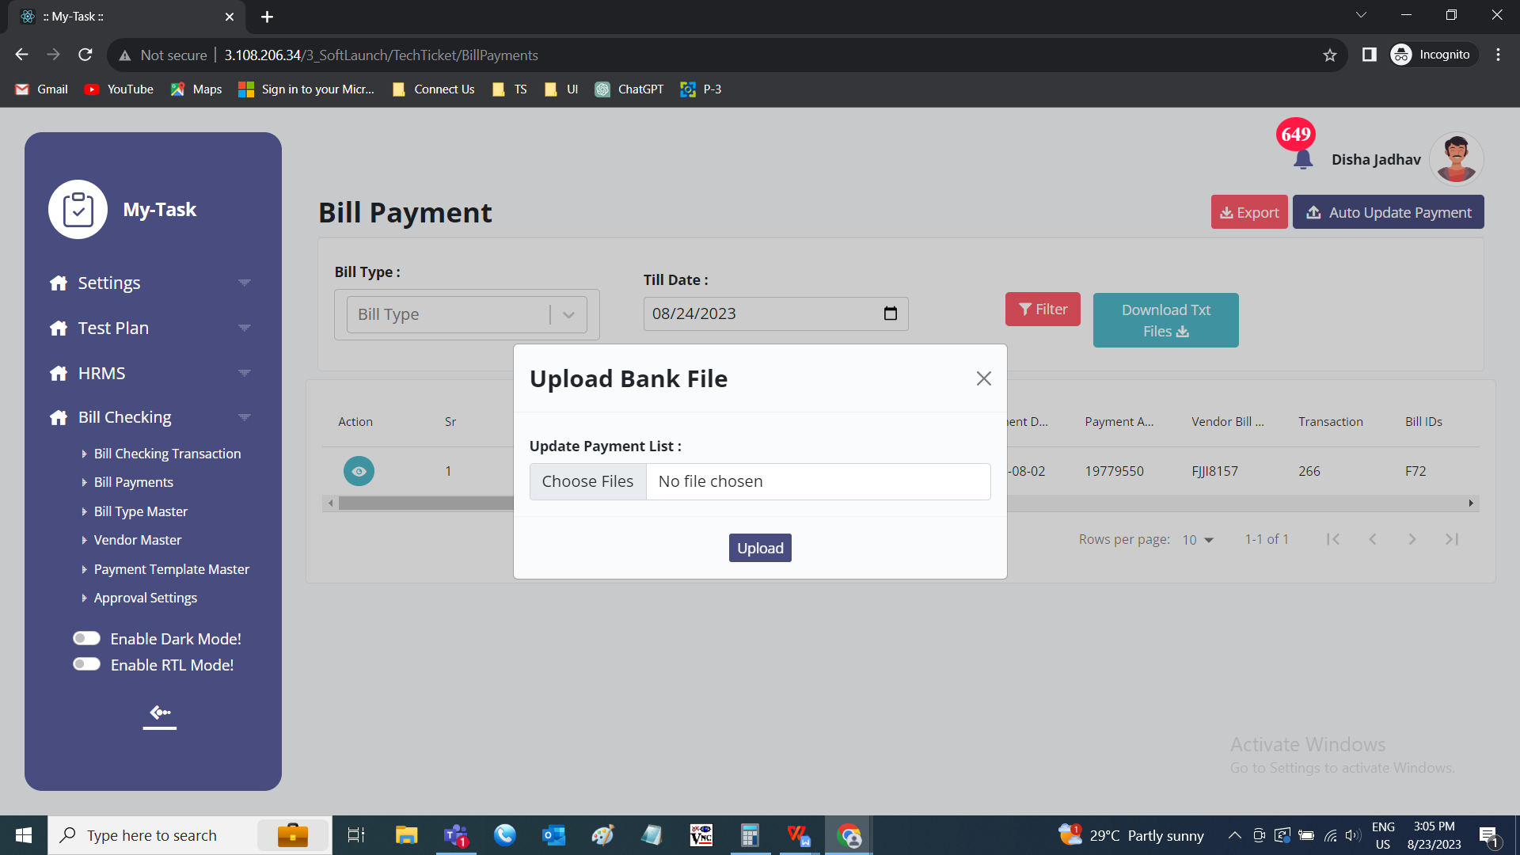

The file is downloaded from the bank website where we uplaoded the data. The format of the file is as follows.

* Record type
* Corporate ID
* E-pay order no.
* Account number
* Branch code
* MMID
* Mobile number
* Debit amount
* Credit amount
* Corporate reference number
* Description
* Payment type
* Transaction status
* Transaction date
* Transaction time
* Status description
* UTR number
* UTR posted date
* UTR status
* Maker
* Authorizer 1
* Authorizer 1 date
* Authorizer 2
* Authorizer 2 date

|  |  |
| --- | --- |
| **FIELDS** | **DESCRIPTION** |
| Record type | The record type is displayed whether the entry is debited or credited. Initial entry will be debit and the others are credit. |
| Corporate ID | The corporate Id is given by the bank is displayed |
| E-pay order no. | The e-pay order no generated by the bank is displayed |
| Account number | The account number where the debit or credit done is displayed |
| Branch code | The branch code of the bank is displayed |
| MMID | The MMID code issued by the bank to the customer is displayed |
| Mobile number | The mobile number of the vendor is displayed |
| Debit amount | The debit amount to be debited is displayed |
| Credit amount | The credit amount to be credited is displayed |
| Corporate reference number | The corporate reference number I.e., the unique code given in the downloaded sheet is displayed |
| Description | The description I.e., the SBI unique code in case of SBI. The non SBI RTGS unique code, in case of RTGS. The non SBI NEFT unique code in case of NEFT. |
| Payment type | The payment type is displayed |
| Transaction status | The transaction status of that transaction is displayed |
| Transaction date | The transaction date of that transaction is displayed |
| Transaction time | The transaction time of that transaction is displayed |
| Status description | The status description of the transaction is displayed |
| UTR number | The UTR number is shown usually for the non SBI payees |
| UTR posted date | The UTR posted date is displayed |
| UTR status | The UTR status is displayed |
| Maker | The maker of the payment is displayed generally chandukaka |
| Authorizer 1 | The transaction date of that transaction is displayed |
| Authorizer 1 date | The transaction date of that transaction is displayed |
| Authorizer 2 | The transaction date of that transaction is displayed |
| Authorizer 2 date | The transaction date of that transaction is displayed |

Sample file is attached in the test data.

The status of the payment and payment date will get updated in the payment details and the payment history.

The payment status will be changed to paid. The payment date is changed to when the payment is made.

1. **TEST DATA**



