09.09.2024

Sanika Dewoolkar

dewoolkar.sanika@techneai.com

**Functional Requirement Document**

**CONTENTS**

1. TICKET DETAILS 2

2. VERSION CONTROL 2

3. APPROVALS 2

4. ESTIMATION 2

5. INTRODUCTION 3

6. BUSINESS REQUIREMENT 3

7. SCOPE 3

8. BUSINESS & SYSTEM RULES 3

9. ABBREVIATIONS & TERMS 3

10. EXISTING SYSTEM 3

11. GRAPHICAL REPRESENTATION 3

12. PROPOSED SYSTEM 3

13. TEST DATA 4

14. ODUS 4

15. REFERENCES OF THE USERS 5

1. **TICKET DETAILS**

|  |  |
| --- | --- |
| **Ticket ID** | TT23495 |
| **Ticket description** | Content Management System for CS Website |
| **Created by** | Sanika Dewoolkar |
| **Created on** | 15/07/2024 |
| **Priority** | High |

1. **VERSION CONTROL**

|  |  |  |  |  |
| --- | --- | --- | --- | --- |
| **Sr. No** | **Version no** | **Version Date** | **User name** | **User department** |
| **1.** | **1.1** | **8/9/2024** | **Sanika Dewoolkar** | **IT Implementation** |

1. **APPROVALS**

|  |  |  |
| --- | --- | --- |
| **Field** | **Name of the User** | **Approved date by the user** |
| **Actual User Name Actual User Department Organization Name** | Sidharth Shah  Gaurav Shah  Aditya Shah |  |
| **Assigned BA** | Sanika Dewoolkar |  |
| **Assigned Developer** | Somya S  Asmita M  Yogita J |  |
| **Assigned Tester** | Swapnil R  Amreen Shaikh |  |

1. **INTRODUCTION**

This document outlines the functional requirements for the Content Management System (CMS) that will be implemented for CS Website. The CMS is designed to provide a user-friendly interface for managing website content, ensuring that non-technical users can create, edit, publish, and manage content efficiently.

1. **BUSINESS REQUIREMENT**

|  |  |  |  |
| --- | --- | --- | --- |
| **Requirement ID** | **Requirement Name** | **Short Description** | **Priority** |
| BR001 | Metal type master | Metal type master should allow users to add, edit, view, metal type in the system | High |
| BR002 | Item Group master | Item group master should allow users to add, edit, view, Item group in the system | High |
| BR003 | Item master | Item master master should allow users to add, edit, view, Item in the system | High |
| BR004 | Category master | Category master should allow users to add, edit, view, Category in the system | High |
| BR005 | Collection master | Collection master should allow users to add, edit, view, Collection in the system | High |
| BR006 | Payment type master | Payment type master should allow users to add, edit, view, Payment type in the system | Medium |
| BR007 | Testimonial master | Testimonial master should allow users to add, edit, view, testimonial in the system which should be reflected on website | High |
| BR008 | Store master | Store master should allow users to add, edit, view, stores in the system which should be reflected on website | High |
| BR009 | FAQs master | FAQs master should allow users to add, edit, view, FAQs in the system which should be reflected on website | High |
| BR010 | Subscriptions master | Subscriptions master should allow users to add, edit, view, subscriptions in the system which should be reflected on website | High |
| BR011 | Banner Master | Banner Master should allow users to add, edit, view, Banners in the system which should be reflected on website | High |
| BR012 | Menu Master | The Menu Master module will allow administrators to manage the menus of the website. | High |
| BR013 | Section Type master | The Section Type Master module will allow administrators to manage the types of sections that can be used on the website | High |
| BR014 | Dynamic Content | Through this type of managing content on website, user can add data which will be dynamically displayed on the website. | High |
| BR015 | Redirect URL | Through this type of managing content, user can add URL which will be redirected to a specific section on the website | High |
| BR016 | HTML Content | Through this type of managing content, user can directly input the HTML code will be displayed on the website. | High |
| BR017 | Page Section Master | Through this menu, user should be able to manage the sections on website | High |
| BR018 | Page section Content Maser | Through this menu, user should be able to manage the content in section on website | High |
| BR019 | Settings Master | User should be able to change settings. | Medium |
| BR020 | Non Functional Requirements | To focus on dynamic content generation, personalized user experiences, and scalability | Medium |

1. **SCOPE**

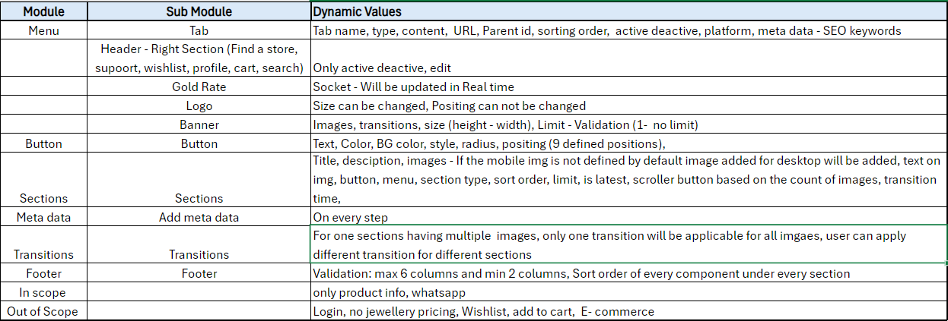

1. **BUSINESS & SYSTEM RULES**

* User should be registered in the system.
* User should be logged in.
* System should display error message for incorrect details if entered.
* System should pop up a message, if any issues in the system is detected.
* All forms should have on field validations. System should display on field errors in case of incorrect inputs.

1. **ABBREVIATIONS & TERMS**

CMS - Content Management System

JSON- JavaScript Object Notation

1. **PROPOSED SYSTEM**

MASTERS:

1. **MENU MASTER :**

Through this menu, users can add, edit the menus on website.

Below fields will be included in this section:

* Tenant Name
* Parent Menu Name
* Menu name
* Platform
* Type : Dynamic, HTML, React
* Content
* URL
* Sort Order
* Meta Title
* Meta Description
* Meta Keywords
* Remark

FIELD DESCRIPTION:

**Input table**

|  |  |  |  |
| --- | --- | --- | --- |
| **FIELDS** | **INPUT TYPE** | **MANDATORY/ OPTIONAL** | **DESCRIPTION** |
| Tenant Name | Dropdown | Mandatory | Dropdown of tenant name should be displayed. The dropdown will be fetched from the tenant master.  For the tenant logged in, tenant name should be auto- filled and disabled. |
| Parent Name | Dropdown | Optional | The menu names added should be displayed in the dropdown. |
| Menu Name | Text | Mandatory | User should be able to enter the menu name.  Validation:  It should accept alphabets only. |
| Platform | Radio button | Mandatory | Below radio buttons should be displayed:   * Website * Mobile * Both   By default, both should be selected. |
| Page Type | Dropdown | Mandatory | User should be able to define the type of menu.  The dropdown should consist below fields:   * HTML * React * Dynamic |
| Page name | Dropdown | Mandatory | Pre-Condition:  If the user selects the Type as HTML, Dynamic this field will be populated.  User needs to select the page for which HTML Code has to be written. |
| Content | Text | Mandatory | Pre- Condition:  If the user selects the type as HTML, this field should be displayed.  User should be able to define the content that will be displayed under the menu. |
| URL | Dropdown | Mandatory | Pre- Condition:  If the user selects the type as React, this field should be displayed.  Here user can select the pre-defined pages which will be displayed upon clicking on the menu.  Eg, The menu to be redirected to product - catalogue page, user can select product catalogue as type. |
| Is Redirection | Radio Button | Mandatory | Pre - Condition:  If the type is selected as React,this field will be displayed.  It should display radio buttons with Yes, No  If the menu has to be directed to another dynamic page then user should select the Is Redirection as ‘Yes’ |
| Redirect To | Radio Buttons | Mandatory | Pre- Condition: If the Is Redirection is selected as ‘Yes’, this field sould be displayed.  Here, user can define the page details which is going to be displayed after clicking on the menu.  It should display three radio buttons as below:   * Product filter * Collection * Product   Upon selecting on Product filter below fields should be displayed:   * Metal * Item group * Item * Category   Upon selecting on Collection below fields should be displayed:   * Collection * Product   Upon selecting on Product, product name field should be displayed.  Metal, Item group, Item, Category, Collection, Product these fields will be dropdown fields fetched from Metal master, Item group master, Item master, Category master, Product master respectively. |
| Sort Order | Text | Mandatory | To define the sort order of the menu |
| Meta Title | Text | Mandatory | User should be able to define the meta title.  Meta Title is the title of a webpage that appears in search engine results and the browser tab. It summarizes the content and helps with SEO by incorporating relevant keywords.  Validation: It typically should be around 50-60 characters long. |
| Meta Description | Text | Mandatory | User should be able to define meta description which provides a short summary of the webpage’s content, usually around 150-160 characters. It appears under the title in search results and should be compelling to encourage users to click through. |
| Meta Keywords | Text | Mandatory | User should be able to define the meta keywords where it will help in SEO. |
| Remark | Text | Optional | To add remark if any. |
| Is Active | Radio button | Mandatory | IT should display Active, Deactive radio buttons.  By default, the menu should be active. |

1. **PAGE MASTER**

Through this menu, user should be able to define the pages on the website

Below fields should be displayed in this menu:

* Page name
* Content
* Preview JSON- Auto fill
* Publish JSON- Auto fill
* Status
* Remark

FIELD DESCRIPTION:

|  |  |  |  |
| --- | --- | --- | --- |
| **FIELDS** | **INPUT TYPE** | **MANDATORY/ OPTIONAL** | **DESCRIPTION** |
| Page name | Text | Mandatory | User should be able to add the page name. |
| Content | Text | Optional | User should be able to add the text details to be displayed in the page. |
| Preview JSON | - | - | This field will be autofilled |
| Publish JSON | - | - | This field will be auto filled. |

1. **SECTION TYPE MASTER**

Through this menu, user should be able to add Section type master.

Below fields will be included in this master:

* Section name
* Has Image
* Is Multiple Image Required
* Min Limit

FIELD DESCRIPTION:

**Input table**

|  |  |  |  |
| --- | --- | --- | --- |
| **FIELDS** | **INPUT TYPE** | **MANDATORY/ OPTIONAL** | **DESCRIPTION** |
| Section type name | Text | Mandatory | User should be able section type in the master. |
| Has Image | Dropdown | Mandatory | User should be able to define if the section type has image or not.  It should display two radio buttons as Yes and No |
| Is Multiple Image Required | Dropdown | Mandatory | Pre - Requisite:  If the Has image field is selected as Yes, this field will be populated.  It will display radio buttons with Yes, No |
| Min limit | Text | Mandatory | Min limit of images can be defined in this field. |

1. **PAGE SECTION MASTER**

User should be able to define the section details like Title, description, Sort order etc through this menu.

Below fields will be displayed in this menu:

* Page name
* Section type
* Title
* Description
* Sort Order
* Background Image
* Text Alignment

|  |  |  |  |
| --- | --- | --- | --- |
| **FIELDS** | **INPUT TYPE** | **MANDATORY/ OPTIONAL** | **DESCRIPTION** |
| Page name | Dropdown | Mandatory | The dropdown will be fetched from the page master.  User should be able to define the page name in which the section is to be added. |
| Section type | Dropdown | Mandatory | The dropdown will be fetched from the Section type master. |
| Section name | Text | Mandatory | To define the section name. |
| Title | text | Mandatory | To define the title of section |
| Description | Text | Optional | To add description in the section |
| Sort Order | Text | Mandatory | To define the sorting order of the sections to be added on website |
| Background Image | Img | Optional | User should be able to upload the background image for the section through image path. |
| Text Alignment | Click | Mandatory | To define the text allignment.  User should be able to align text to left, centre, Right, justify. |

1. **PAGE SECTION CONTENT MASTER**

User should be able to define the content to be displayed in the section through this menu.

Below fields will be displayed in this menu:

* Section name
* Title
* Description
* Sort Order
* Image Hyperlink
* Font style
* Button hyperlink
* Image path

|  |  |  |  |
| --- | --- | --- | --- |
| **FIELDS** | **INPUT TYPE** | **MANDATORY/ OPTIONAL** | **DESCRIPTION** |
| Section name | Dropdown | Mandatory | Dropdown should be fetched from the page section master |
| Title | Text | Mandatory | To define the title of section content |
| Description | Text | Optional | To define the description of section content |
| Sort Order | Text | Text | To define the sorting order of Section content. |
| Image path | Image | Optional | To add the image in the section content if any. |
| Image Hyperlink | Link | Optional | To add the hyperlink to image if any |
| Font style | Dropdown | Optional | To define the font style of content. |
| Button hyperlink | Link | Optional | To define the button hyperlink. |

**DEFAULT SETTINGS:**

Initially, a few menus / features will be displayed to tenants as per default settings. Further as per applied settings, menus / features will be displayed to the tenants.

Super admin will add default settings, it will display following fields:

* Module name
* Sub module name
* Setting name
* Setting data type
* Default value
* Possible values
* Sort order
* User can change
* Use encryption
* Remark
* Is active
* Save & add more button
* Save button

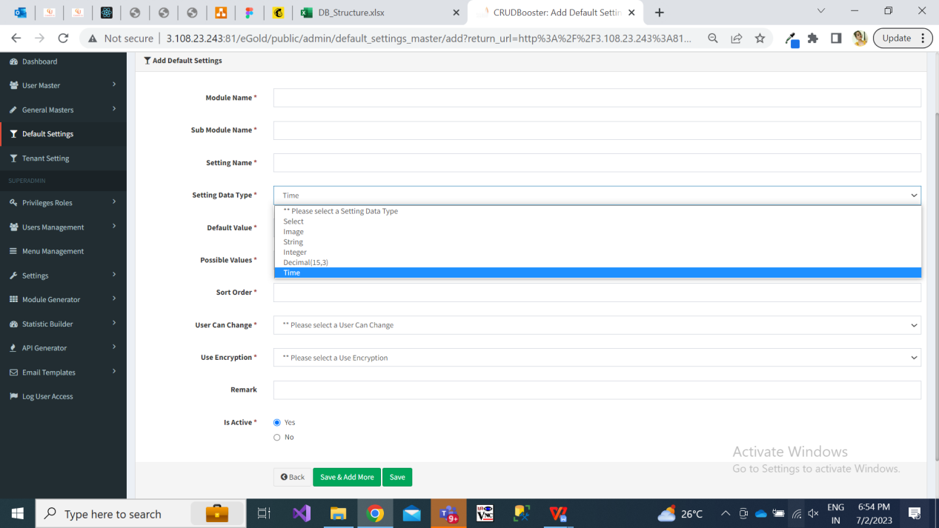

Fig: Add default settings

|  |  |  |  |
| --- | --- | --- | --- |
| **FIELDS** | **INPUT TYPE** | **MANDATORY / OPTIONAL** | **DESCRIPTION** |
| Module name | text | Mandatory | Super admin will enter the module name referring to which the setting is about. |
| Sub module name | text | Mandatory | Super admin will enter the sub-module name referring to which the setting is about. |
| Setting name | text | Mandatory | Super admin will enter the setting name referring to which the setting is about. |
| Setting data type | Drop-down | mandatory | It will be the data type of setting we are reffing to.  Image  Select  String  Int  Decimal  Time  Example: If setting is about image like displaying logo, then super admin will select data type as image.  If setting is about text field, then super admin will select string.  If setting is about timing, then super admin will select time. Example: If tenant wants to set start time and end time during which customers can make transactions, then tenant will select data type as time for such setting. |
| Default value | text | Mandatory | Super admin will enter the default value as per data type.  Means, by default which image / text should be displayed in the selected setting. |
| Possible values | text |  | This field will be displayed only if super admin selects data type as ‘select’. |
| Sort order | text |  |  |
| User can change | Drop down | Mandatory | It will display yes / no. Means, whether tenant can change it or not through tenant settings -> edit action. |
| Use encryption | Drop down | Mandatory | It will display yes / no to display encrypted data for selected field on customer’s page. |
| remark | text | Optional | Super admin will mention additional comments in this text field. |
| Is active | Radio button | mandatory | By default it will display as active.  Once the particular default setting is deactivated then this field won’t be editable to tenant. |
| Save button | click |  | Once super admin clicks on save button, then as per settings & development in database, the default setting will get added and the same will get reflected against each active tenant in tenant settings.   Also, default settings will be displayed to customers until their tenant hasn’t changed the particular setting from tenant settings. |

**TENANT SETTINGS:**

Initially, tenant will get all default settings further which tenant can edit them. If any changes are not made in settings by tenant, then tenant will get view on website as per default settings.

As and when tenant is added by super admin in tenant master, then all active settings will get added in tenant settings against that newly added tenant.

Once tenant log into web application by their credentials, tenants will have access to tenant settings menu. It will have following fields in grid for each available setting:

* Tenant id
* Setting name
* Setting value
* Remark
* Is active
* Created at & by
* Updated at & by
* Edit action
* View action

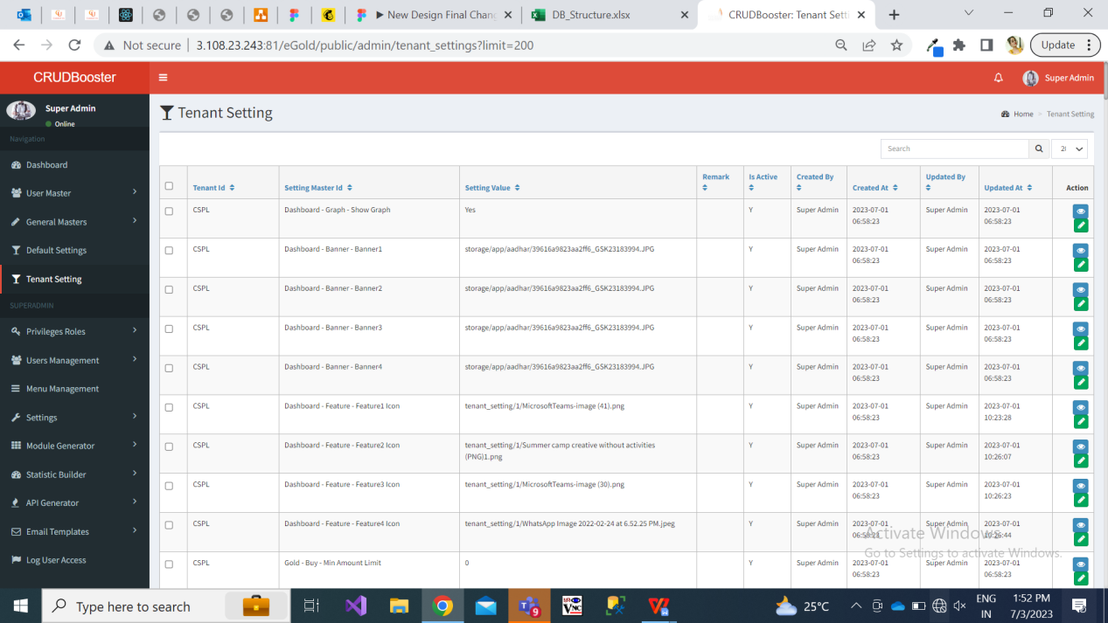

Fig: Tenant setting

Once user clicks on edit action of tenant setting, it will display following pre-filled fields:

* Setting name
* Setting value
* Remark
* Is active

Here, the setting name will be read only field. In setting value, initially it will display the value as in default settings whereas tenant can change it. As per data type of that setting name, it will display the setting value field.

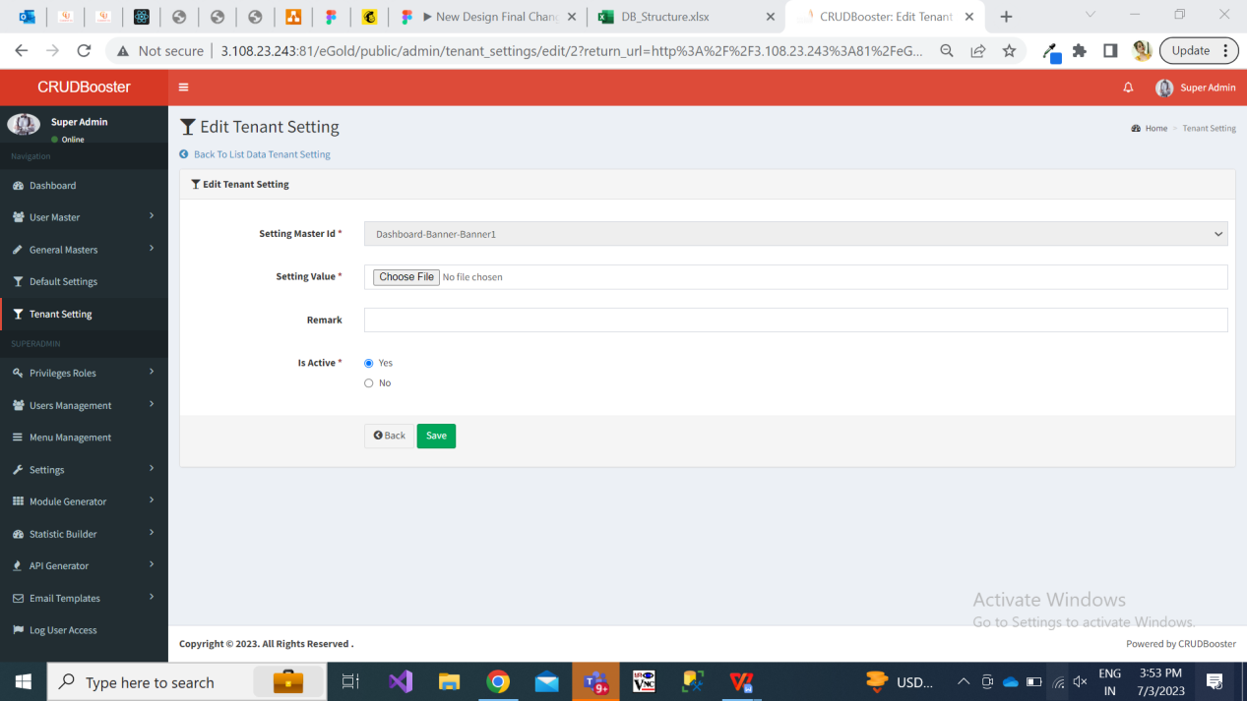

Fig: tenant settings edit action.

Further, if any default setting is deactivated by super admin, then that setting will be disabled in tenant setting as well.

As of now, below settings will be applied:

* Logo
* Favicon
* Find a store
* Support
* Live rate - Gold, Silver
* Global Search
* Adress
* Whatsapp - Provider, Number, Key
* SMS - Sender ID, Provider, Username, Password,
* Rate refresh time
* Payment gateway - Provider, Username, Salt key, Payment URL, Payment Client ID
* Tenant Configuration -
  + Company name
  + GST number
  + Security key, Base URL
  + Licence Expiry
  + CDN
  + Google Analytics Integration
  + Web Menu
  + Mobile menu
  + Mobile number
  + Email
  + Terms and Conditions - Policy
  + Delivery partner
* Social media Links - Facebook, Instagram, Twitter, Youtube, Whatsapp
* Footer - Logo, Tenant Info, Newsletter, Copyright

**NON - FUNCTIONAL REQUIREMENTS:**

Performance Requirements:

* **Response Time:** The website should load dynamic content within 3 seconds, regardless of user location.
* **Scalability:** The website should dynamically scale to handle at least 15,000 concurrent users during peak periods, such as festival seasons.
* **Dynamic Content Loading:** AJAX or similar technologies should be used to load dynamic content without requiring a full page reload, keeping content load times under 2 seconds.
* **Latency:** The system should ensure end-to-end latency of under 300ms for users accessing the site globally

Security Requirements:

* **Secure APIs:** All dynamic data exchanges between the website and backend systems (e.g., product databases) must be secured using OAuth 2.0 and HTTPS.
* **Protection Against Dynamic Attacks:** Protection against dynamic threats such as Cross-Site Scripting (XSS), SQL Injection, and Content Security Policy (CSP) should be in place to secure dynamic elements of the website.

Usability Requirements:

* **Responsive Design:** The dynamic features of the website must adapt seamlessly to different screen sizes and orientations, providing a smooth experience on mobile, tablet, and desktop devices.
* **Real-Time Feedback:** User actions, such as searching store on website, should trigger immediate dynamic feedback (e.g., popups or UI changes) with no noticeable delay.
* **Cross-Browser and Platform Compatibility:** The dynamic elements should function consistently across major browsers (Chrome, Firefox, Safari, Edge) and platforms (Windows, macOS, Android, iOS).

1. **REFERENCES OF THE USERS**

|  |  |  |  |
| --- | --- | --- | --- |
| **User** | **Name** | **Mail** | **Contact number** |
| **Actual user** |  |  |  |
| **Ticket created by (if any)** |  |  |  |
| **Assigned business analyst** |  |  |  |
| **Assigned developer** |  |  |  |
| **Assigned tester** |  |  |  |