Queries Date - 22/8/2024

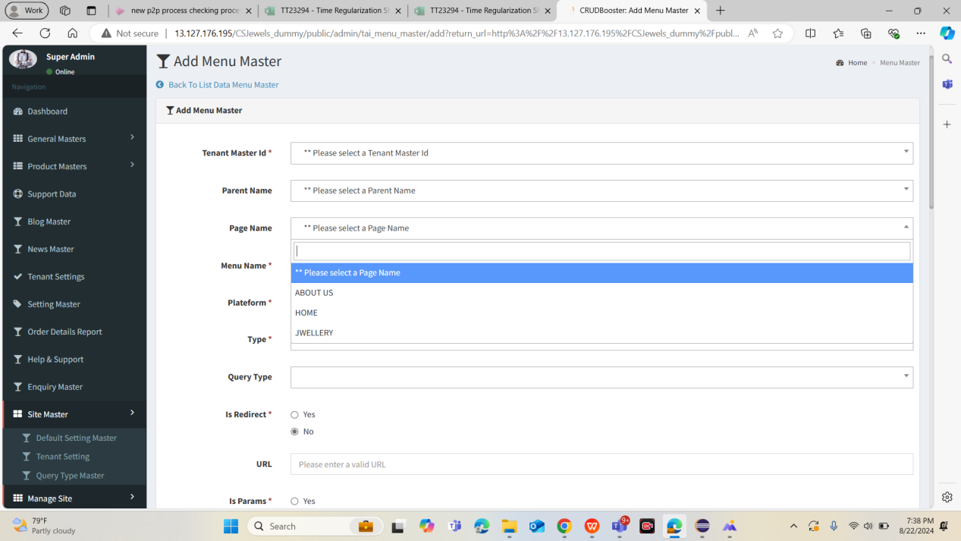

Page name field , derived from which master?

-

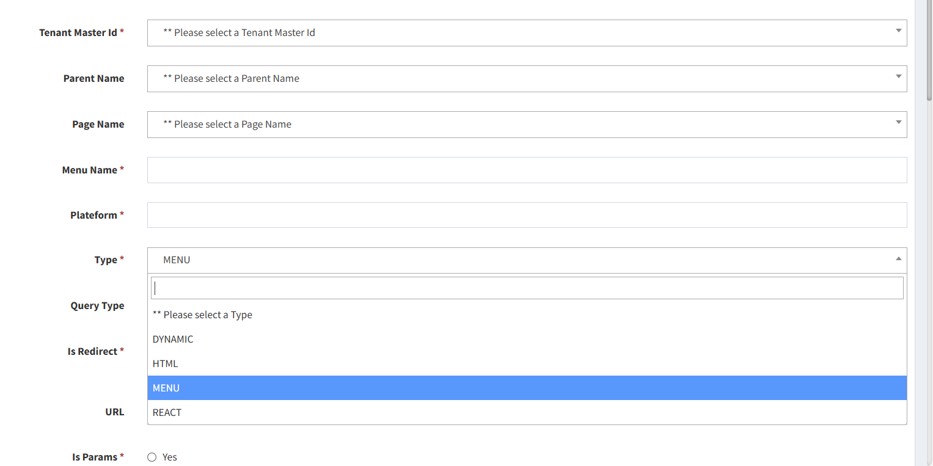

What does it mean , how system behave if we select menu option ? need more clarity?

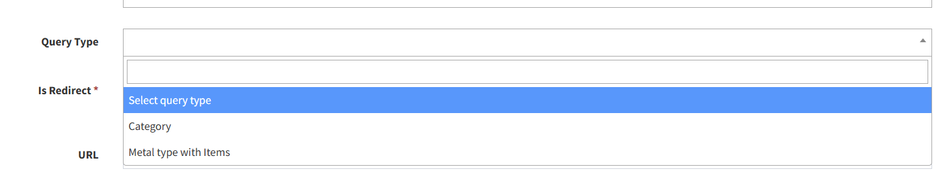

What does Query Type do ? what is the significance of category & Metal type with items ?

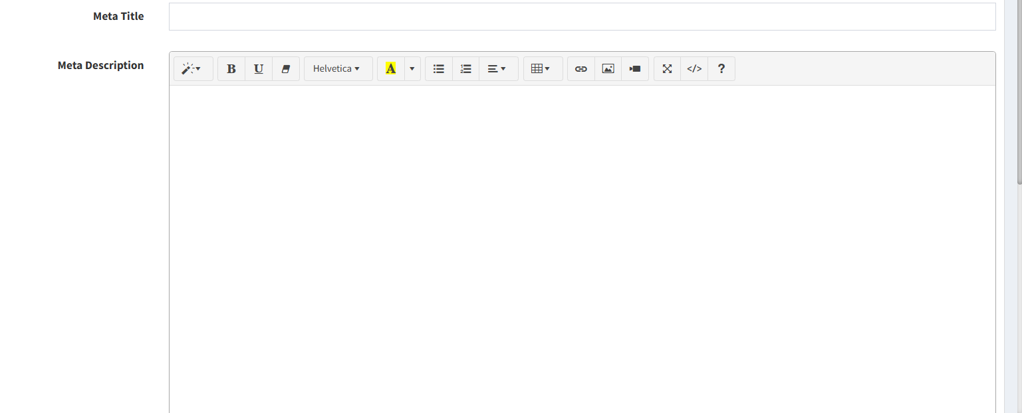

What is Meta title and meta description ? Need more clarity.

Queries :

URL? Menu - Is redirected ?

What if Is redirected to selected