make cust
30.10.2023
TICKETING SYSTEM

Handover Document

CONTENTS

1. VERSION CONTROL 3
2. INTRODUCTION 3
3. SCOPE 3
4. BUSINESS & SYSTEM RULES 3
5. ABBREVIATIONS & TERMS 4
6. GRAPHICAL REPRESENTATION 4
7. DEVELOPED SYSTEM 4
LOGIN 4
MASTERS 14
USER MASTER 14
CUSTOMER MASTER 29
COUNTRY MASTER 36
STATE MASTER 41
CITY MASTER 46
DESIGNATION MASTER 51
DEPARTMENT MASTER 56
ROLE MASTER 61
ADD ACCESS 66
STATUS MASTER 68
CUSTOMER TYPE MASTER 73
DYNAMIC FORM 78
QUERY TYPE MASTER 89
QUERY GROUP MASTER 95
TEMPLATE MASTER 100
DYNAMIC FORM DROP DOWN 121
QUERY GROUP MASTER 127
TESTING TYPE MASTER 132
PROJECT MASTER 137
MODULE MASTER 144
SUB-MODULE MASTER 148
TENANT MASTER 154
DASHBOARD 160
TASK TABS 163
MY TASKS 165
PENDING TASKS 166
UPCOMING TASKS 167
WORK ANALYSIS 168
NOTIFICATION 169
PROFILE 171
MY TICKETS 178
FILTER 181
TABS 185
TICKET EDIT 192
TICKET VIEW 199
TICKET HISTORY 201
BASKET 204
TASKS 206
BASKETS 208
EDIT BASKET 208
TASKS 210
PLANNER 216
TASK HISTORY 218
SUBTASK 221
EXPORT ALL DATA 222
TEST CASES 223
CREATION OF TEST CASES 223
REVIEWER 235
ALL TEST CASES 245
CREATE BASKET 254
TEST PLAN 256
TEST SUITE 266
CREATE TEST SUITE 267
UPDATE TO EXISTING TEST SUITE 268
ASSIGN TO 269
REPORTS 271
USER TASK REPORT 272
RESOURCE PLANNING REPORT 275
VARIANCE REPORT 279
8. TEST DATA AND BUSINESS SCENARIOS 283

- VERSION CONTROL
Sr. No | Ticket ID | Version No | Version Date | User name | User department | Updated By
1 | - | 1 | 30.10.2023 | Gaurav Shaha | IT Manager | Mounika Annamneedi
2 | TT17802 | 2 | 24.11.2023 | Mounika Annamneedi | IT Implementation | Mounika Annamneedi

- INTRODUCTION
A ticketing system collects and manages all customer support interactions from different platforms, including social media. This management system enables IT support agents to route various types of tickets to the correct person, resource, or department to obtain the fastest resolution.

- SCOPE
The scope of the ticketing system is to raise the tickets, internal communication, assigning of the tickets based on the query type, allocation of resources and estimations and working of the resources and the reports such as user task report, resource planning report and the variance report.

- BUSINESS & SYSTEM RULES
- User should be registered in the system.
- User should be logged in.
- System should display error message for incorrect details if entered.
- System should pop up a message, if any issues in the system is detected.
- All forms should have on field validations. System should display on field errors in case of incorrect inputs.

- ABBREVIATIONS & TERMS
NA

- GRAPHICAL REPRESENTATION
Use Case Diagram
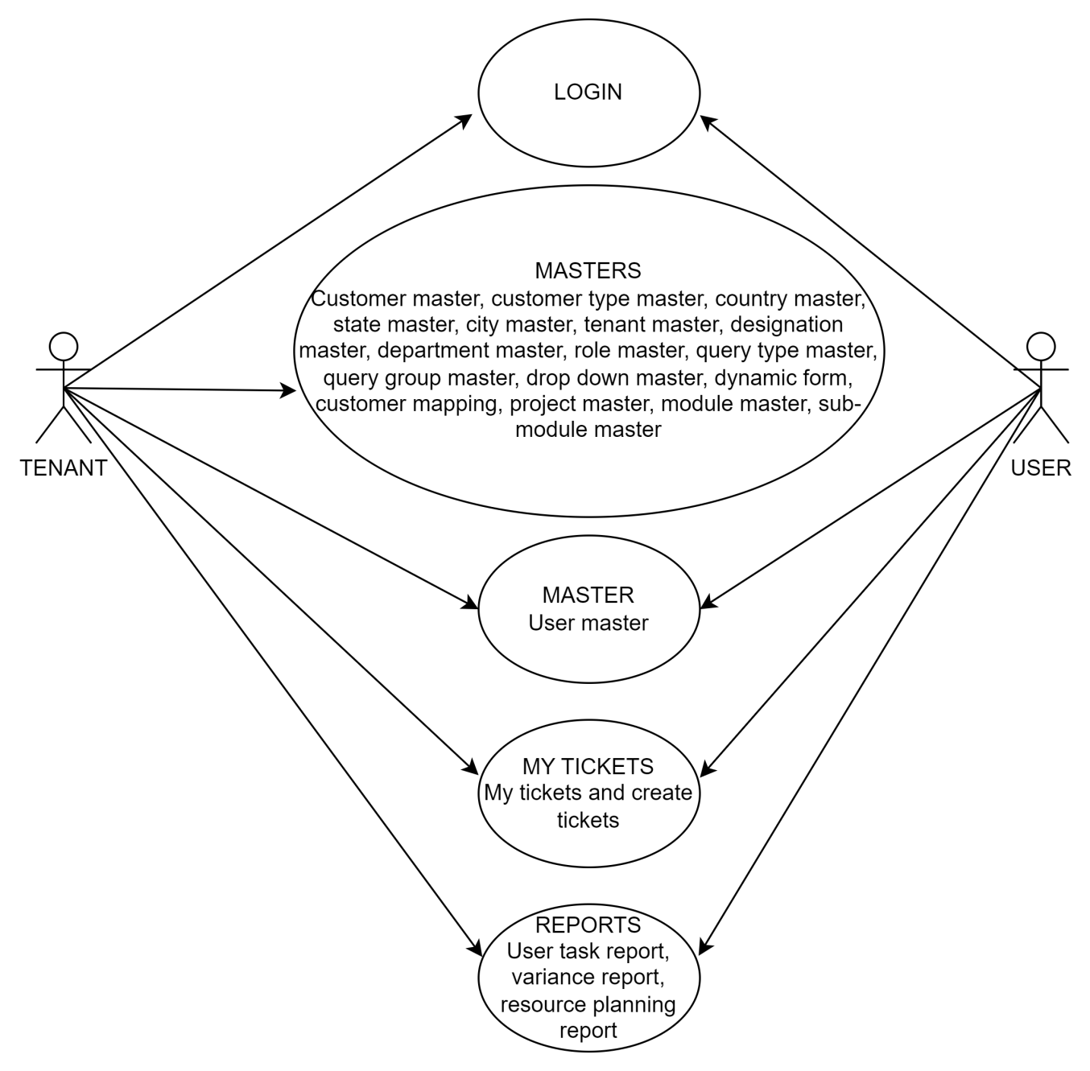

Flow Diagram of User creation
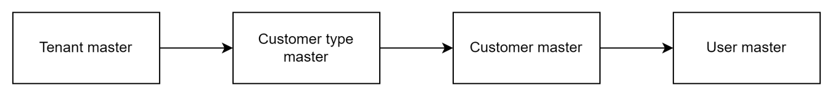

Flow Diagram of Customer mapping

Flow Diagram of Ticket creation
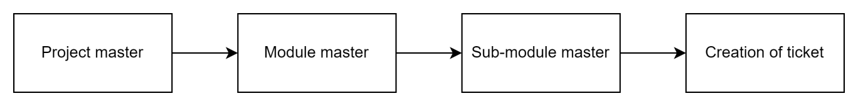

Use case diagram of ticket actions
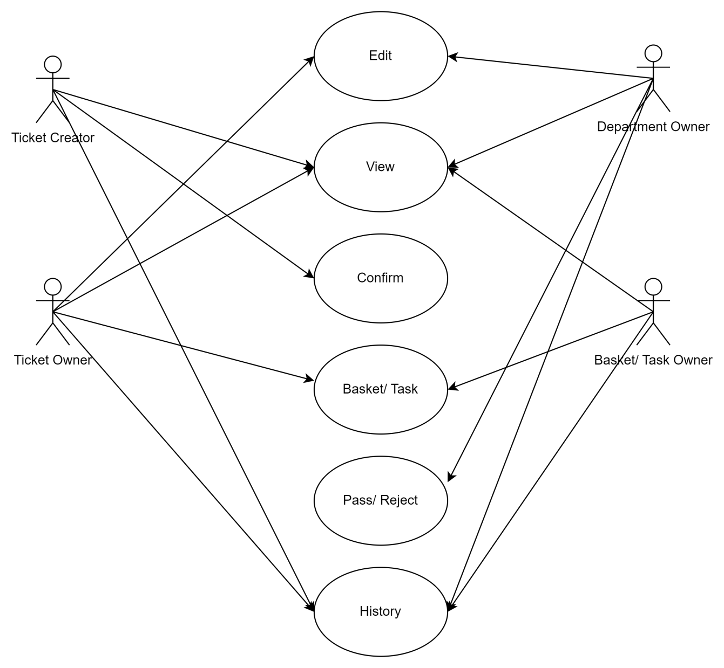

Flow diagram of Task
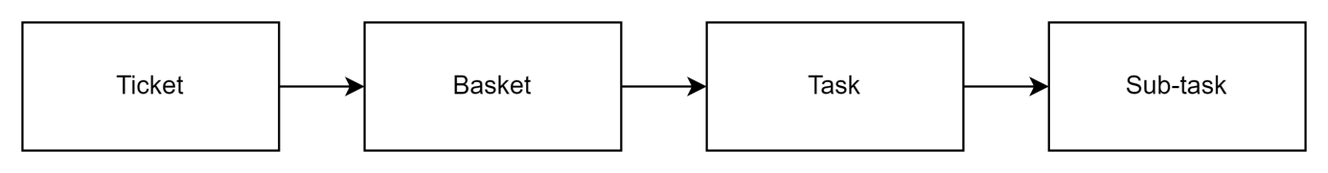

- DEVELOPED SYSTEM

LOGIN
Initially, the login into the system is necessary. To login, the user should be added in the user master in the system. The credentials given in the user master are used at the time of login. Later, the user can change the credentials from the profile after the login.
The login page consists of the following fields.
- Username
- Password
- Forgot password
- Sign in

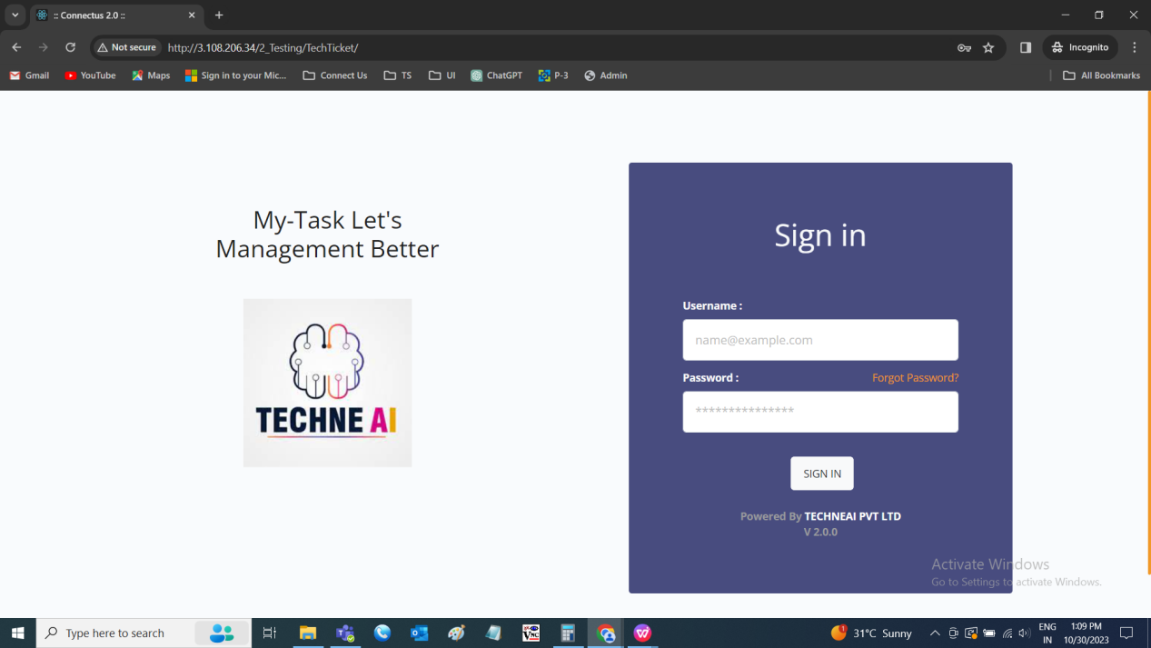

Input table
Fields | Input type | Mandatory/ Optional | Editable/ No | Description
Username | Text | Mandatory | - | The username of the user is mentioned. The user can even login into the system either by using the email or mobile number added in the user master or else edited/ updated in the profile.  Validation:  Username:  - The username entered is case insensitive.  - Can accept alpha-numeric data and special characters.  Email:  - Can accept characters, integers and special characters such as “ ._-“ and finally @domain name, .com or .in.  Mobile number:  - Accepts only integers with 10 digits.
Password | Text | Mandatory | - | The password set in the user master or else updated in the profile whichever is later is allowed.  Validation:  Accepts alpha-numeric data and special characters minimum of 8 characters.
Forgot password | Button | - | - | If the user forgets the credentials, he/ she can login using the email ID where a confirmation OTP is sent to the email and user can set the password and login into the system.
Sign in | Button | - | - | The sign in button to sign in into the system. The sign in is done only when the credentials are correct. If the credentials are incorrect, pop up error is shown with invalid credentials.

Empty username
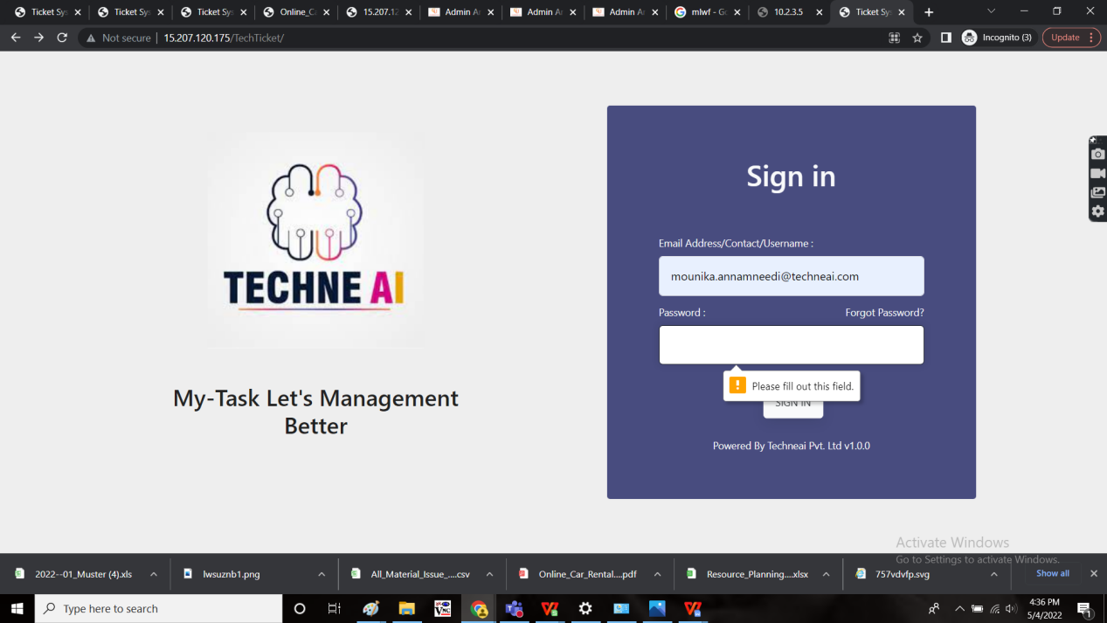
Empty password
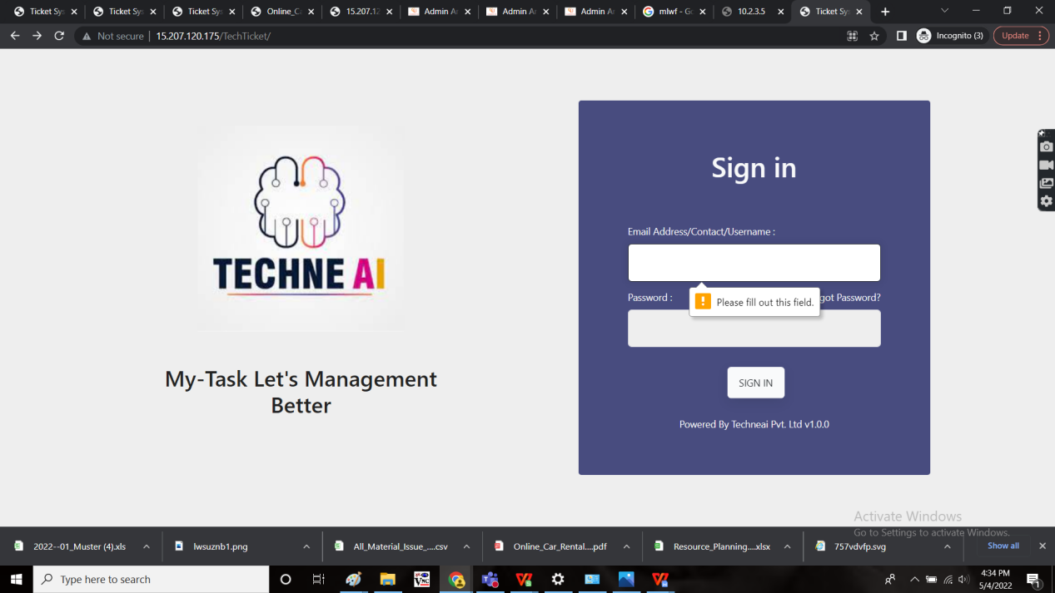
Invalid username
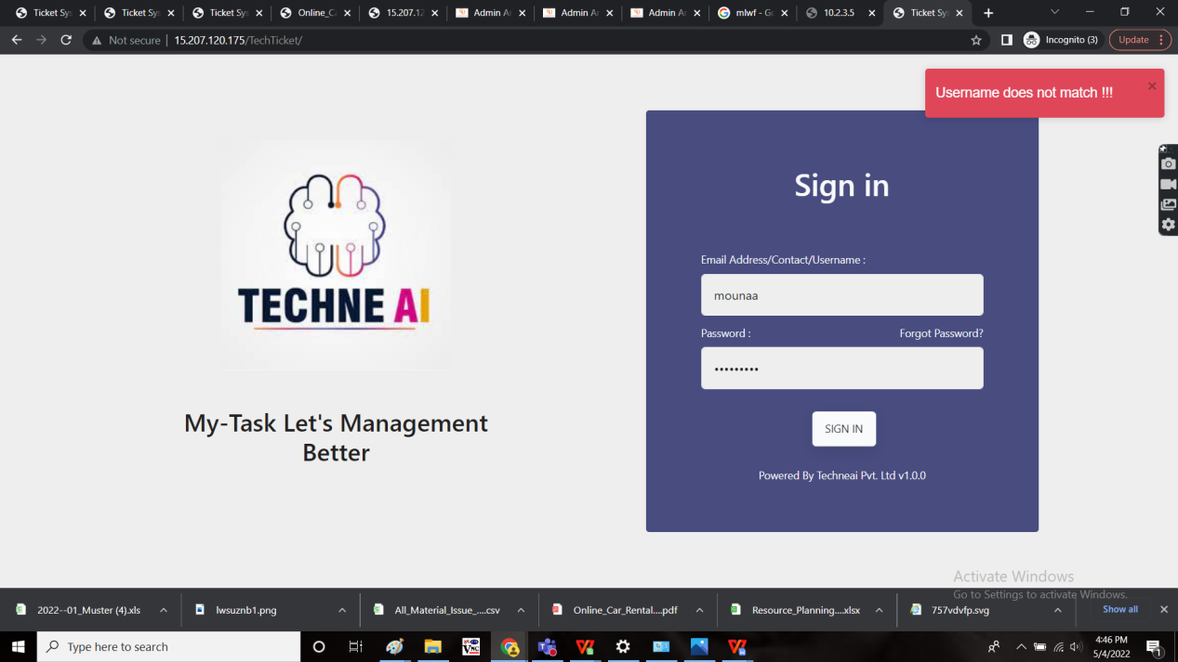
Invalid email ID
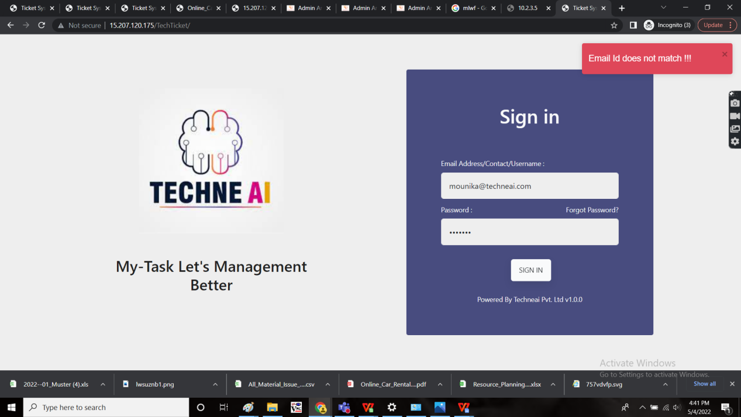
Invalid contact number
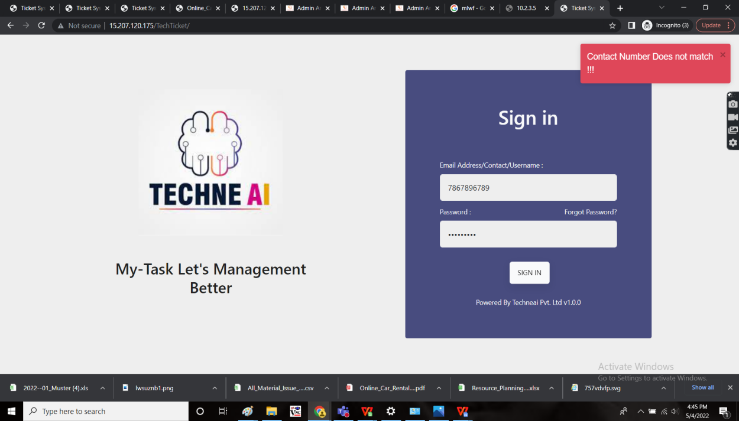
Invalid password
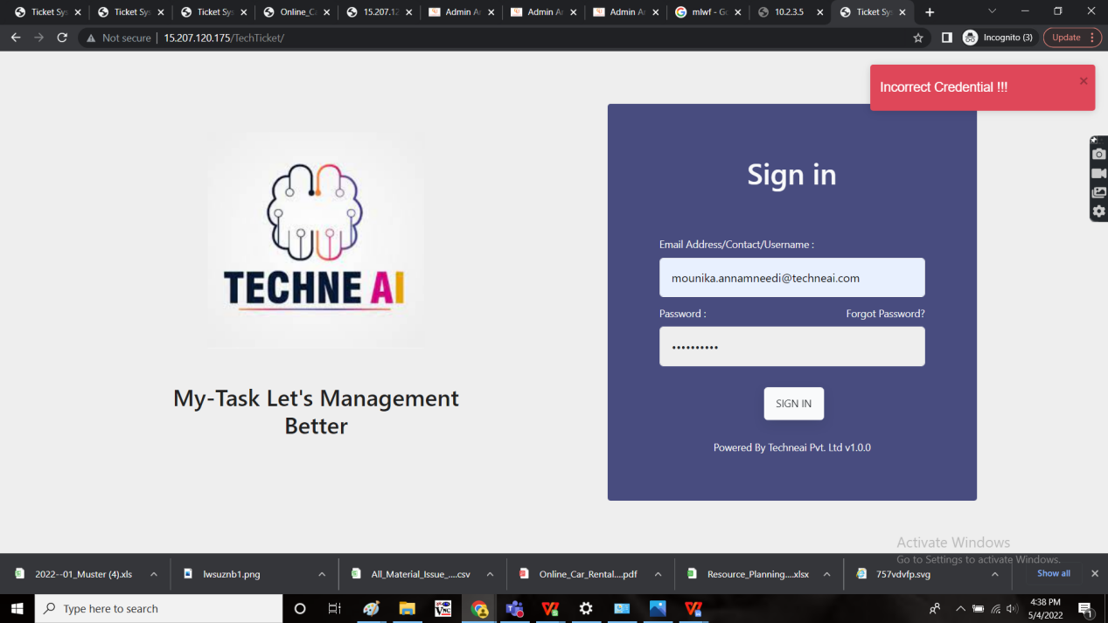

FORGOT PASSWORD
The forgot password option to the users who forgets their password. The forgot password consist of the following flow.
When the user clicks on the forgot password, the page consists of the following fields.
- Email address or mobile number
- Submit
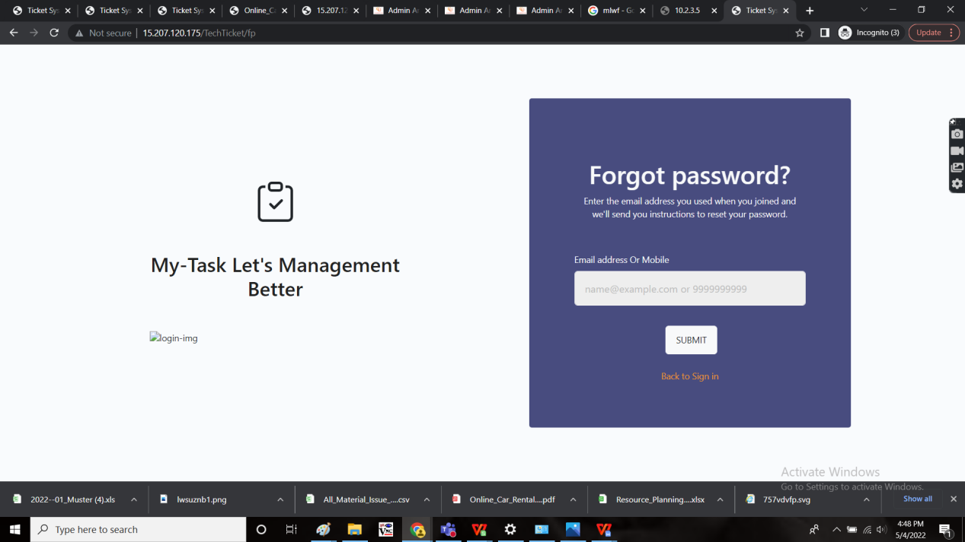
Input table
Fields | Input type | Mandatory/ Optional | Editable/ No | Description
Email address or mobile number | Text | Mandatory | - | The user can enter their email address or mobile number for the following flow. The user can enter the email or mobile number added in the user master or else edited/ updated in the profile.  Validation:  Email:  - Can accept characters, integers and special characters such as “ ._-“ and finally @domain name, .com or .in.  Mobile number:  Accepts only integers with 10 digits.
Submit | Button | - | - | The submit button to submit the input given. As soon as the user clicks on submit, if it is valid an OTP is sent to the input given (either email address or mobile number). If it is invalid input, error is displayed.
Invalid input
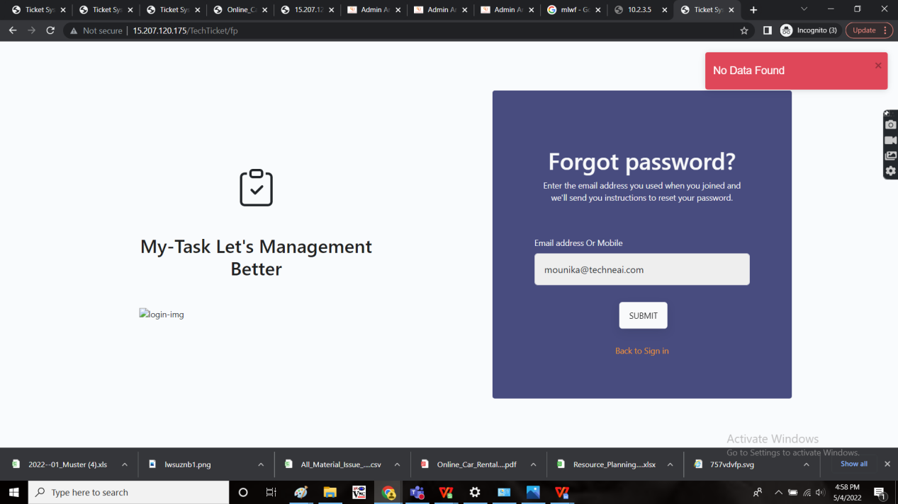
After the click on submit, the OTP is sent to email address or mobile number whatever the input was given.
OTP Mail
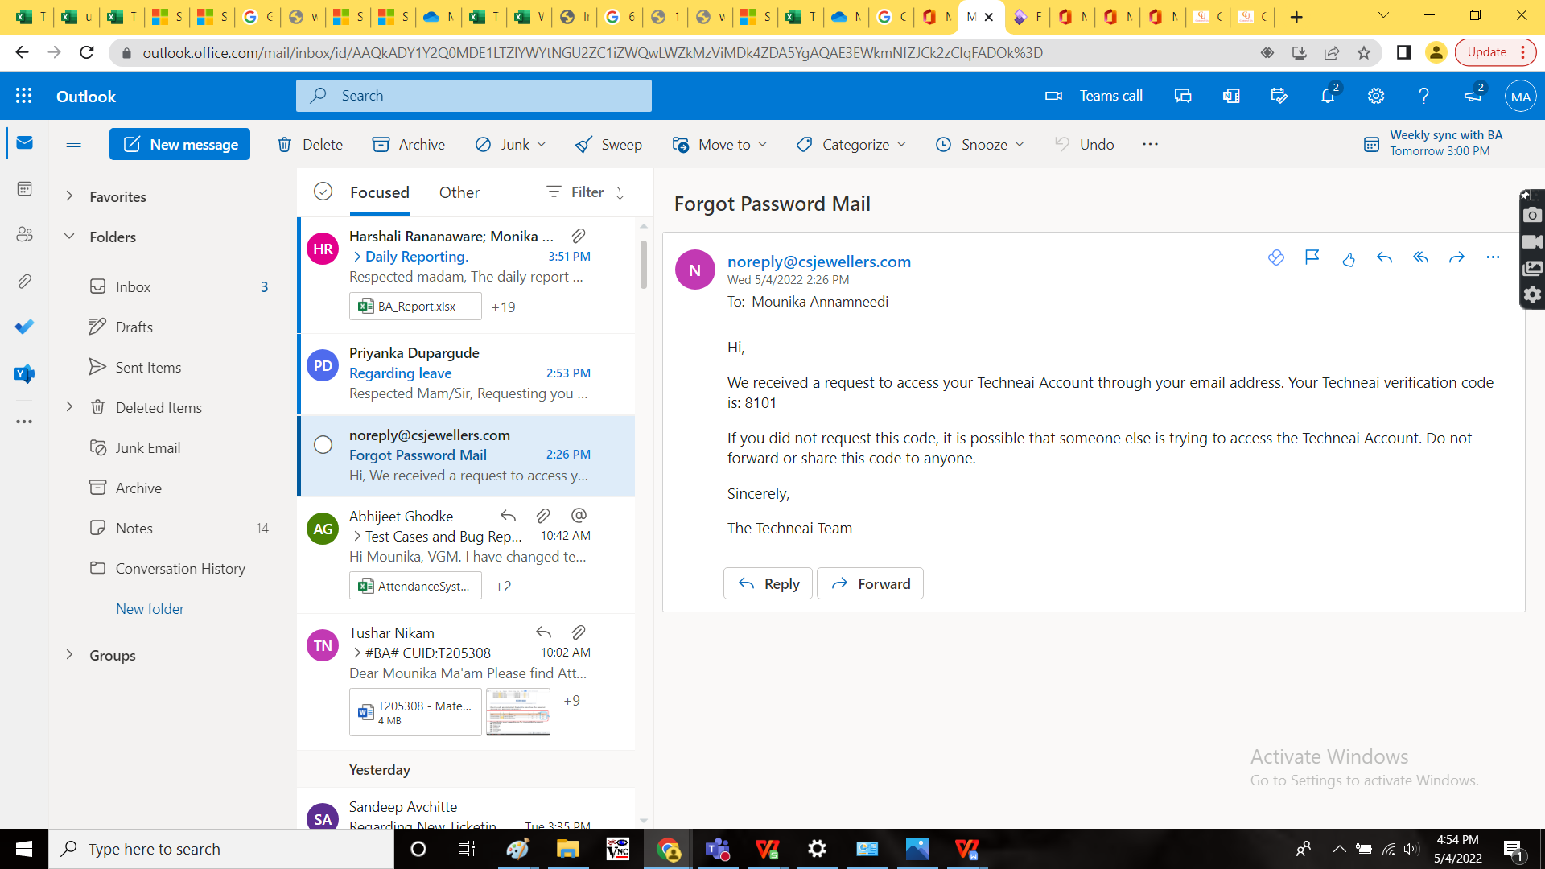
The forget password page redirects to the OTP page. The OTP page consist of the following fields.
- OTP
- Submit
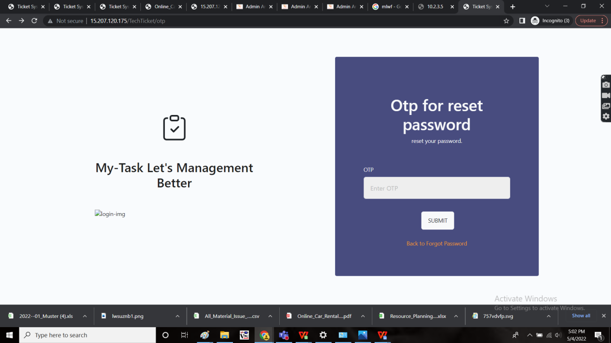
Input table
Fields | Input type | Mandatory/ Optional | Editable/ No | Description
OTP | Int | Mandatory | - | The OTP sent to the email address or the mobile number is entered.  Validation:  The OTP accepts only integers with 6 digits.
Submit | Button | - | - | The submit button to submit the input given. As soon as the user clicks on submit, if it is valid OTP, the following page to reset the password is displayed. If it is invalid input, error is displayed.

Invalid OTP
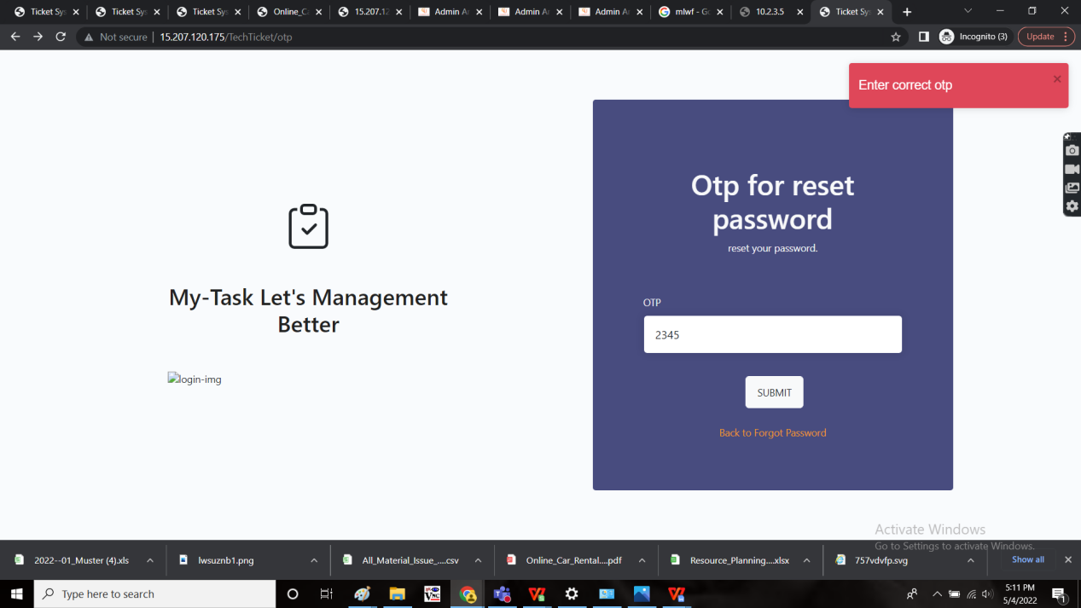
After the valid OTP entered and after the submission, the following page with the reset of the password is open. The following fields are displayed.
- New password
- Confirm password
- Submit
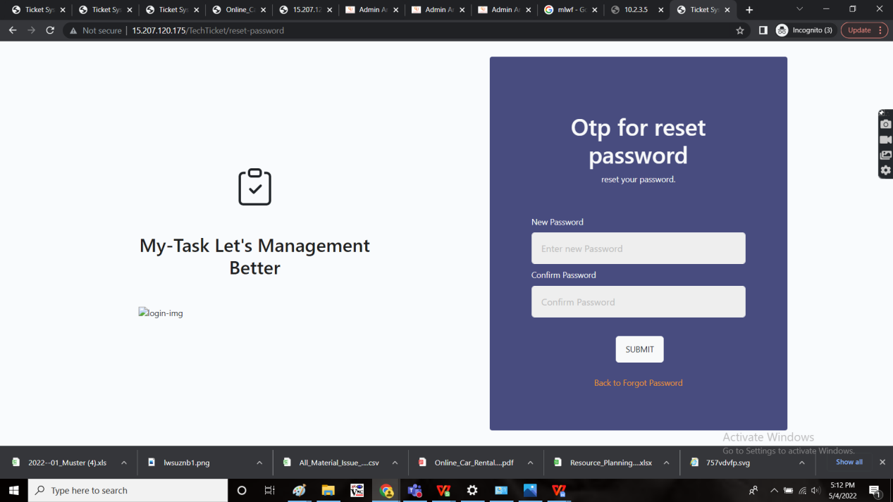
Input table
Fields | Input type | Mandatory/ Optional | Editable/ No | Description
New password | Text | Mandatory | - | The new password to be reset is entered.  Validation:  Accepts alpha-numeric data with special characters minimum of 8 characters.
Confirm password | Text | Mandatory | - | The password entered in the new password to be entered again to confirm the new password.  Validation:  Same password to be entered which is entered in the new password.
Submit | Button | - | - | The submit button to submit the password. If the new password and the confirm password is not same, error is displayed. If they are same, the system allows it as the new password and updated in the user master and the profile of the user.  The login page is opened where the user have to give the credentials (I.e., new password) to login into the system.

When new password not equal to confirm password
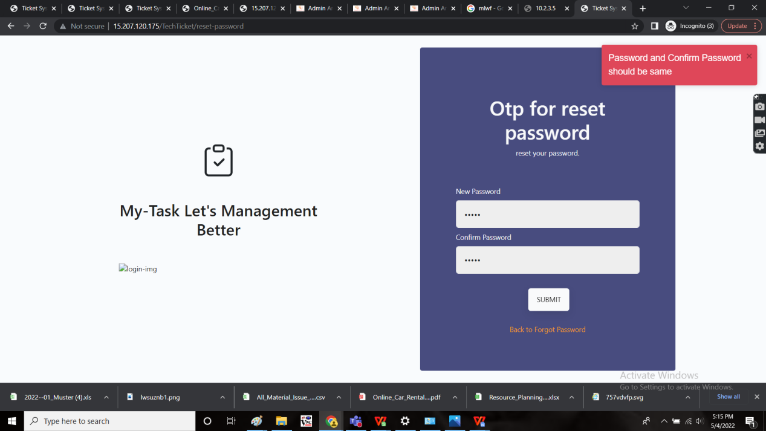

MASTERS
The ticketing system for the flow of the system, requires few masters where they play the important role at the functionality of the tickets. The following are the masters in the ticketing system.
- User master
- Customer master
- Country master
- State master
- City master
- Designation master
- Department master
- Role master
- Status master
- Customer type master
- Dynamic form drop-down master
- Query group master
- Testing type master
- Tenant master
- Project master
- Module master
- Sub-module master

USER MASTER
The user master consist of the user details. The user master is used from the login into the system to the assigning of the functionalities to the user. The user master refers to the users using the ticketing system for say, employees and also the customers of the organization. The following are the fields in the user master.
- Search
- Reset
- Export
- Add user
- Edit user
- User details
- User setting
- Sr
- Account for
- Customer
- Name
- Email
- Contact no
- Whatsapp no
- Same as contact no
- Username
- Password
- Confirm password
- Role
- Designation
- Address
- Pincode
- Country
- State
- City
- User Details - Next
- User Details - Cancel
- User setting - Sr No
- Department
- Ticket type show
- Ticket passing authority
- Make default
- User setting - Action
- User setting - Submit
- User setting - Cancel
- User setting - Back
- Status
- Created at
- Created by
- Updated at
- Updated by
- Grid - Action

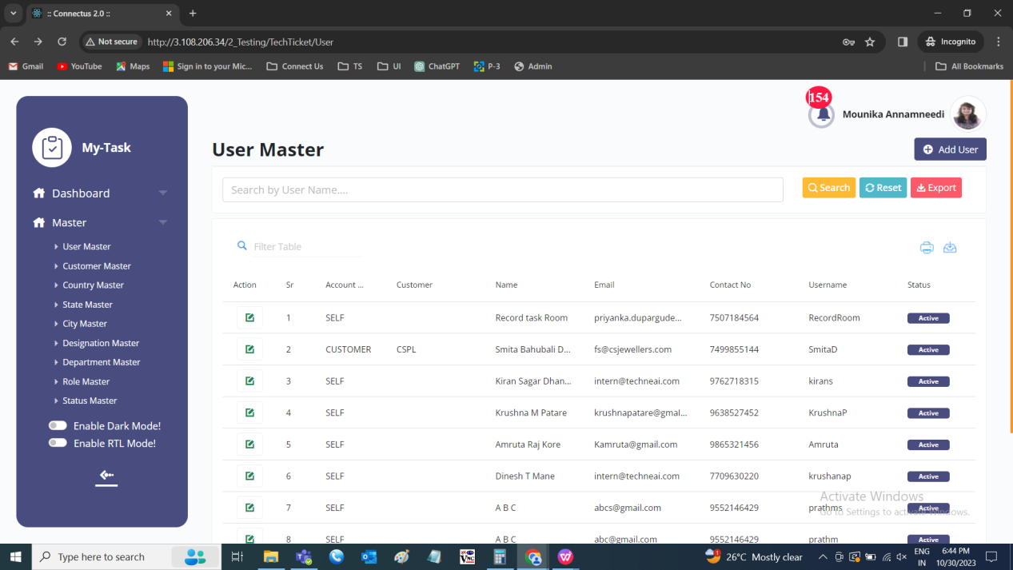

The master consists of the following actions.
Fields | Grid view | Add | Edit | Export | User Details | User Setting
Search | ✓ | x | x | x | x | x
Reset | ✓ | x | x | x | x | x
Export | ✓ | x | x | x | x | x
Add user | ✓ | x | x | x | x | x
Edit user | ✓ | x | x | x | x | x
User details | x | ✓ | ✓ | x | x | x
User setting | x | ✓ | ✓ | x | x | x
Sr | ✓ | x | x | ✓ | x | x
Account for | ✓ | ✓ | ✓ | ✓ | ✓ | x
Customer | ✓ | ✓ | ✓ | ✓ | ✓ | x
Name | ✓ | ✓ | ✓ | ✓ | ✓ | x
Email | ✓ | ✓ | ✓ | ✓ | ✓ | x
Contact no | ✓ | ✓ | ✓ | ✓ | ✓ | x
Whatsapp no | x | ✓ | ✓ | ✓ | ✓ | x
Same as contact no | x | ✓ | ✓ | x | ✓ | x
Username | ✓ | ✓ | ✓ | ✓ | ✓ | x
Password | x | ✓ | ✓ | x | ✓ | x
Confirm password | x | ✓ | ✓ | x | ✓ | x
Role | x | ✓ | ✓ | ✓ | ✓ | x
Designation | x | ✓ | ✓ | ✓ | ✓ | x
Address | x | ✓ | ✓ | ✓ | ✓ | x
Pincode | x | ✓ | ✓ | ✓ | ✓ | x
Country | x | ✓ | ✓ | ✓ | ✓ | x
State | x | ✓ | ✓ | ✓ | ✓ | x
City | x | ✓ | ✓ | ✓ | ✓ | x
User Details - Next | x | ✓ | ✓ | x | ✓ | x
User Details - Cancel | x | ✓ | ✓ | x | ✓ | x
User Setting - Sr No | x | ✓ | ✓ | x | x | ✓
Department | x | ✓ | ✓ | ✓ | x | ✓
Ticket type show | x | ✓ | ✓ | ✓ | x | ✓
Ticket passing authority | x | ✓ | ✓ | ✓ | x | ✓
Make default | x | ✓ | ✓ | ✓ | x | ✓
User Setting - Action | x | ✓ | ✓ | x | x | ✓
User setting - Submit | x | ✓ | ✓ | x | x | ✓
User setting - Cancel | x | ✓ | ✓ | x | x | ✓
User setting - Back | x | ✓ | ✓ | x | x | ✓
Status | x | x | ✓ | ✓ | ✓ | x
Created at | ✓ | x | x | ✓ | x | x
Created by | ✓ | x | x | ✓ | x | x
Updated at | ✓ | x | x | ✓ | x | x
Updated by | ✓ | x | x | ✓ | x | x
Grid - Action | ✓ | x | x | x | x | x

Input table
Fields | Input type | Mandatory/ Optional | Editable/ No | Description
Search | Button | - | - | The search tab where the user fills the data to be searched and after clicking the search button, the entered input is searched and displayed.  Validation:  The search can accept alpha-numeric with special characters as well.
Reset | Button | - | - | The reset button to reset the search tab.
Export | Button | - | - | The export button to export the data of the user in the user master.
Add user | Button | - | - | The add user button to add the data of the user in the master.
Edit user | Button | - | - | The edit button to edit the data of the user in the master.
User details | Tab | - | - | The user details tab to add or edit the user details in the master.
User setting | Tab | - | - | The user settings tab to add or edit the user settings in the master.
Sr | Auto | - | - | The serial number consists of the count of the users added in the user master in the grid and export.
Account for | Drop down | Mandatory | Yes | The account for consists of defining the user is created for the self or for any customer. The account for consist of the following fields in the drop down.  - Self  - Customer  Validation:  - Single selection  - By default, self is selected.
Customer | Drop down | Mandatory | Yes | The customer field gets enabled when the user selected the customer option in the account for field. The drop-down options are fetched from the customer master.  Validation:  - The active customers are fetched from the customer master.  - Single selection
Name | Text | Mandatory | Yes | The name of the user is entered or displayed in the format - first name, middle name and last name.  Validation:  Accepts only alphabetic characters up-to 50 each.
Email | Text | Mandatory | Yes | The email ID of the user is entered.  Validation:  Can accept characters, integers and special characters such as “ ._-“ and finally @domain name, .com or .in.
Contact no | Int | Mandatory | Yes | The contact number of the user is entered or displayed.  Validation:  Accepts only integers with 10 digits.
Whatsapp no | Int | Optional | Yes | The whatsapp number of the user is entered or displayed.  Validation:  Accepts only integers with 10 digits.
Same as contact no | Check box | Optional | Yes | The same as contact number is the check box. The check box is selected when the contact number and the whatsapp number are the same.  Validation:  - By default, the check box is not selected.  - When the check box is selected, the whatsapp number field gets disabled.
Username | Text | Mandatory | Yes | The username of the user is entered or displayed.  Validation:  - Accepts alpha-numeric data and the special characters up-to 50 characters.  - The username should be the unique value.
Password | Text | Mandatory | Yes | The password for the login is entered if required. If already saved data is presented, then it should not show at the time of edit.  Validation:  Can accept alpha-numeric data with the special characters minimum of 8 characters.
Confirm password | Text | Mandatory | Yes | The confirm password is the confirmation to match the password given. If already saved data is presented, then it should not show at the time of edit.  Validation:  The password should match the password given above.
Role | Drop down | Mandatory | Yes | The role of the user is selected from the drop-down. The drop-down options are fetched from the role master.  Validation:  - Only active roles are fetched from the role master  - Single selection
Designation | Drop down | Mandatory | Yes | The designation of the user is selected from the drop-down. The drop-down options are fetched from the designation master.  Validation:  - Only active designations are fetched from the designation master  - Single selection
Address | Text | Optional | Yes | The address of the user is entered or displayed.  Validation:  Accepts alpha-numeric data with special characters up-to 1000 characters.
Pincode | Int | Optional | Yes | The pin-code of the user is entered or displayed.  Validation:  Accepts only integers with 6 digits.
Country | Drop down | Optional | Yes | The country of the user is selected from the drop-down. The drop-down options are fetched from the country master.  Validation:  - Only active countries are fetched from the country master  - Single selection
State | Drop down | Optional | Yes | The state of the user is selected from the drop-down. The state drop-down is dependent on the country selected by the user in the country field. The drop-down options are fetched from the state master.  Validation:  - Only active states are fetched from the state master  - Single selection
City | Drop down | Optional | Yes | The city of the user is selected from the drop-down. The city drop-down is dependent on the state selected by the user in the state field. The drop-down options are fetched from the city master.  Validation:  - Only active cities are fetched from the city master  - Single selection
User Details - Next | Button | - | - | The user details page consist of the next button to save the details of the user details and redirect to the user settings page.  Validation:  All the mandatory and validations to be checked, if not, error message to be displayed.
User Details - Cancel | Button | - | - | The user details page consist of the cancel button to cancel the data entered and navigate to main page of the user master.
User setting - Sr No | Auto | - | - | The user settings page consists of the serial number where the rows are displayed with the serial numbers.
Department | Drop down | Optional | Yes | The department of the user is selected from the drop-down. The drop-down options are fetched from the department master.  Validation:  - Only active departments are fetched from the department master  - Single selection
Ticket type show | Drop down | Optional | Yes | The ticket type show consist of the option to show all the tickets in that department or only the tickets belong to that user in the my tickets module. The ticket type show consist of the following options.  - My tickets  - Department tickets  My tickets to show only tickets related to self.  Department tickets to show all the tickets in that department including self.  Validation:  Single selection
Ticket passing authority | Check box | Optional | Yes | The ticket passing authority to be given or not is defined. If the user have the authority, the tickets created by users in that department and who are not having the passing authority, the tickets are sent to unpassed tickets tab (in Ticketing System >> Ticket >> My ticket >> Unpassed tickets) and can be viewed. So that the authority person can pass or reject the ticket. If any authority person created the ticket, the ticket is directly passed.  Validation:  By default, the check box is not selected.
Make default | Check box | Optional | Yes | The make default option is used for making the department as a default option. So that, at the time of defining the department, the department which is made default is selected initially.  Validation:  - Only one default to be selected.  - If there is single row, automatically the make default is selected.  - Minimum 1 to be selected.
User setting - Action | Button | - | - | The action consist of the add button to add the row in the user setting. The added rows get the delete button to delete the row.  Validation:  Minimum 1 row is required.
User setting - Submit | Button | - | - | The submit button to submit the details and add the user in the user master.
User setting - Cancel | Button | - | - | The user details page consist of the cancel button to cancel the data entered and navigate to main page of the user master.
User setting - Back | Button | - | - | The back button to navigate to the user details page.
Status | Radio button | Mandatory | Yes | The status consists of the active and the de-active options. The user is active or not is selected.  Validation:  When user is added, automatically, their status is active.
Created at | Auto | Optional | Yes | The username who created the user is displayed.
Created by | Auto | Optional | Yes | The date and time when the user is created is displayed.  Validation:  Format - YYYY-MM-DD HH:MM:SS
Updated at | Auto | Optional | Yes | The username who last updated the user is displayed.
Updated by | Auto | Optional | Yes | The date and time when the user is updated last is displayed.  Validation:  Format - YYYY-MM-DD HH:MM:SS
Grid - Action | Button | - | - | The action field consist of the edit button to edit the data of the user.

Add data - user details
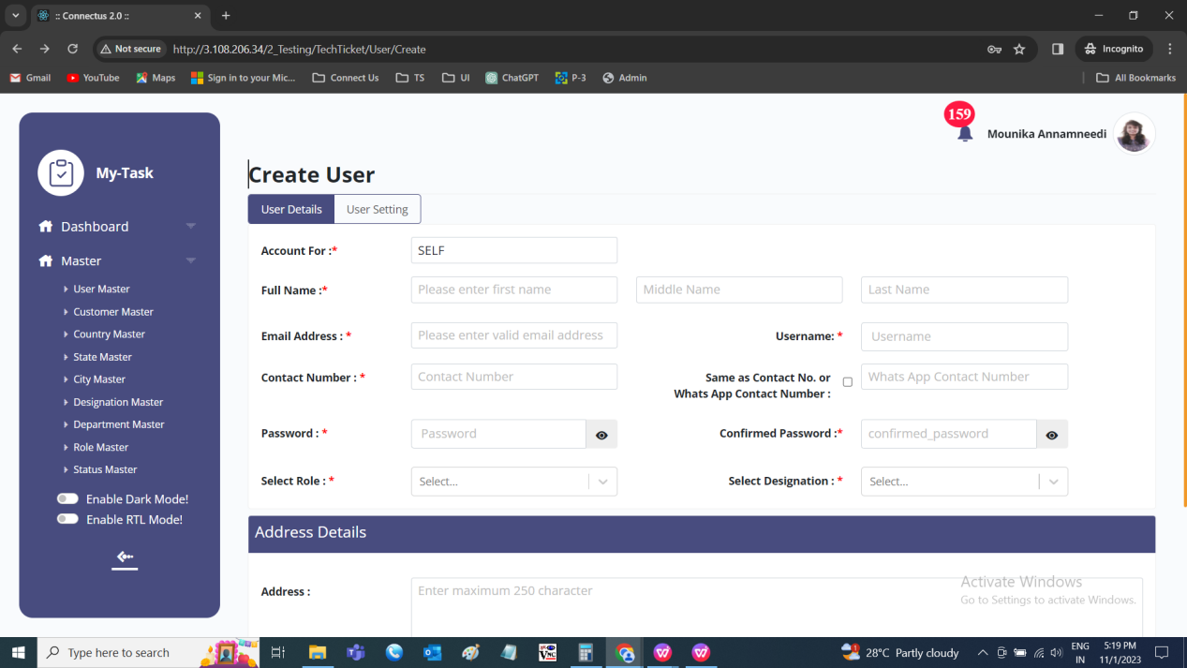

Add data - user settings
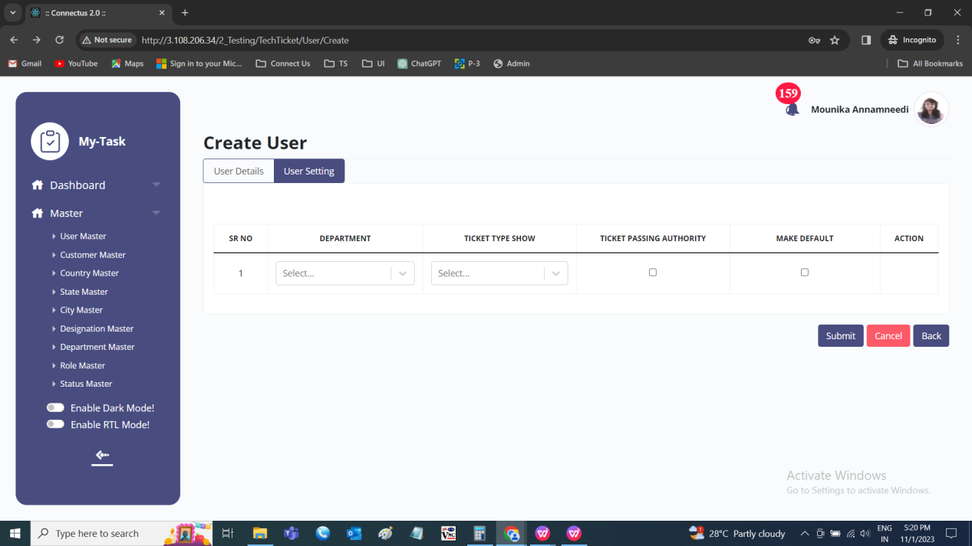

Edit data - user details
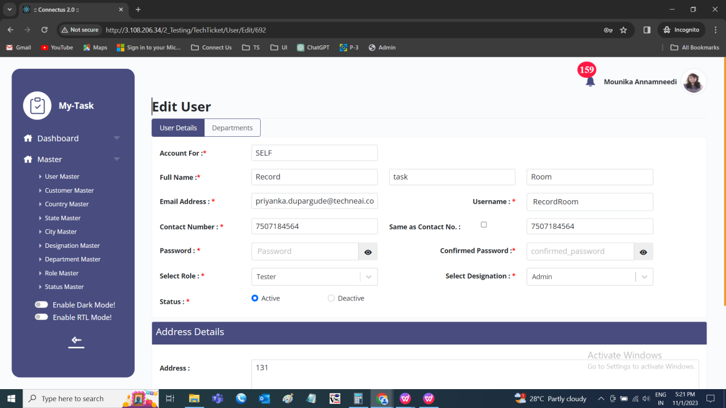

Edit data - departments
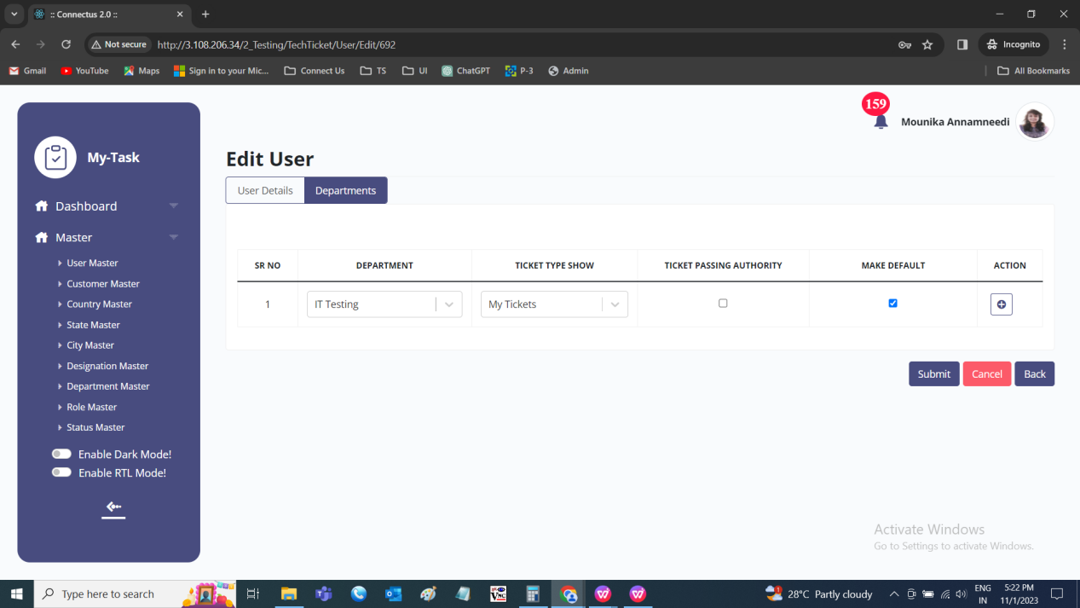

Export
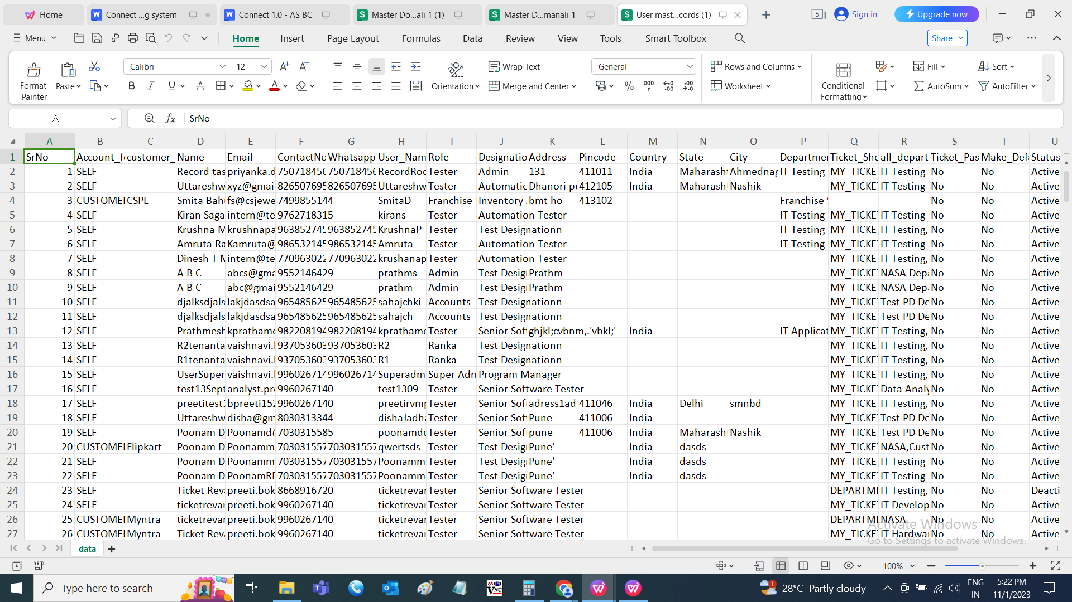

CUSTOMER MASTER
The customer master belongs to the customers of the tenant. The tenants can create their customers based on the customer type. The following are the fields in the customer master.
- Search bar
- Reset
- Export
- Add customer
- Sr
- Name
- Type
- Email address
- Contact number
- Address
- Pin-code
- Country
- State
- City
- Status
- Created at
- Created by
- Updated at
- Updated by
- Action

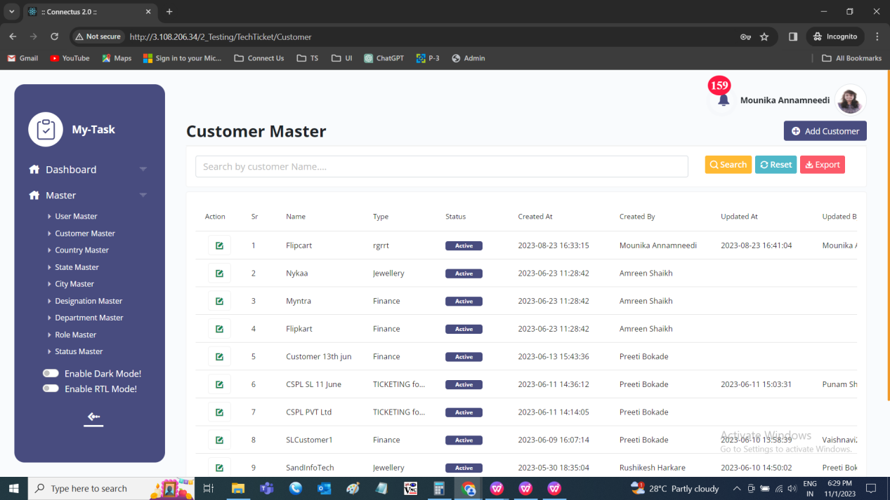

The master consists of the following actions.
Fields | Grid view | Add | Edit | Export
Search | ✓ | x | x | x
Reset | ✓ | x | x | x
Export | ✓ | x | x | x
Add customer | ✓ | x | x | x
Sr | ✓ | x | x | ✓
Customer Name | ✓ | ✓ | ✓ | ✓
Customer Type | ✓ | ✓ | ✓ | ✓
Email | x | ✓ | ✓ | ✓
Contact no | x | ✓ | ✓ | ✓
Address | x | ✓ | ✓ | ✓
Pincode | x | ✓ | ✓ | ✓
Country | x | ✓ | ✓ | ✓
State | x | ✓ | ✓ | ✓
City | x | ✓ | ✓ | ✓
Status | ✓ | x | ✓ | ✓
Created at | ✓ | x | x | ✓
Created by | ✓ | x | x | ✓
Updated at | ✓ | x | x | ✓
Updated by | ✓ | x | x | ✓
Grid - Action | ✓ | x | x | x

Input table
Fields | Input type | Mandatory/ Optional | Editable/ No | Description
Search | Button | - | - | The search tab where the user fills the data to be searched and after clicking the search button, the entered input is searched and displayed.  Validation:  The search can accept alpha-numeric with special characters as well.
Reset | Button | - | - | The reset button to reset the search tab.
Export | Button | - | - | The export button to export the data of the customers in the customer master.
Add customer | Button | - | - | The add customer button to add the data of the customer in the master.
Sr | Auto | - | - | The serial number consists of the count of the customers added in the customer master in the grid and export.
Customer Name | Text | Mandatory | Yes | The customer’s name of the tenant is entered or displayed.  Validation:  Accepts alpha-numeric data and special characters up-to 100 characters.
Customer Type | Drop down | Mandatory | Yes | The type of the customer is selected from the drop-down. The drop-down options are fetched from the customer type master.  Validation:  - The active customer types are fetched from the customer type master.  - Single selection
Email | Text | Mandatory | Yes | The email ID of the customer is entered.  Validation:  Can accept characters, integers and special characters such as “ ._-“ and finally @domain name, .com or .in.
Contact no | Int | Mandatory | Yes | The contact number of the customer is entered or displayed.  Validation:  Accepts only integers with 10 digits.
Address | Text | Optional | Yes | The address of the customer is entered or displayed.  Validation:  Accepts alpha-numeric data with special characters up-to 1000 characters.
Pincode | Int | Optional | Yes | The pin-code of the customer is entered or displayed.  Validation:  Accepts only integers with 6 digits.
Country | Drop down | Optional | Yes | The country of the customer is selected from the drop-down. The drop-down options are fetched from the country master.  Validation:  - Only active countries are fetched from the country master  - Single selection
State | Drop down | Optional | Yes | The state of the customer is selected from the drop-down. The state drop-down is dependent on the country selected by the user in the country field. The drop-down options are fetched from the state master.  Validation:  - Only active states are fetched from the state master  - Single selection
City | Drop down | Optional | Yes | The city of the customer is selected from the drop-down. The city drop-down is dependent on the state selected by the user in the state field. The drop-down options are fetched from the city master.  Validation:  - Only active cities are fetched from the city master  - Single selection
Status | Radio button | Mandatory | Yes | The status consists of the active and the de-active options. The customer is active or not is selected.  Validation:  When user is added, automatically, their status is active.
Created at | Auto | Optional | Yes | The username who created the customer is displayed.
Created by | Auto | Optional | Yes | The date and time when the customer is created is displayed.  Validation:  Format - YYYY-MM-DD HH:MM:SS
Updated at | Auto | Optional | Yes | The username who last updated the customer is displayed.
Updated by | Auto | Optional | Yes | The date and time when the customer is updated last is displayed.  Validation:  Format - YYYY-MM-DD HH:MM:SS
Grid - Action | Button | - | - | The action field consist of the edit button to edit the data of the customer .

Add data
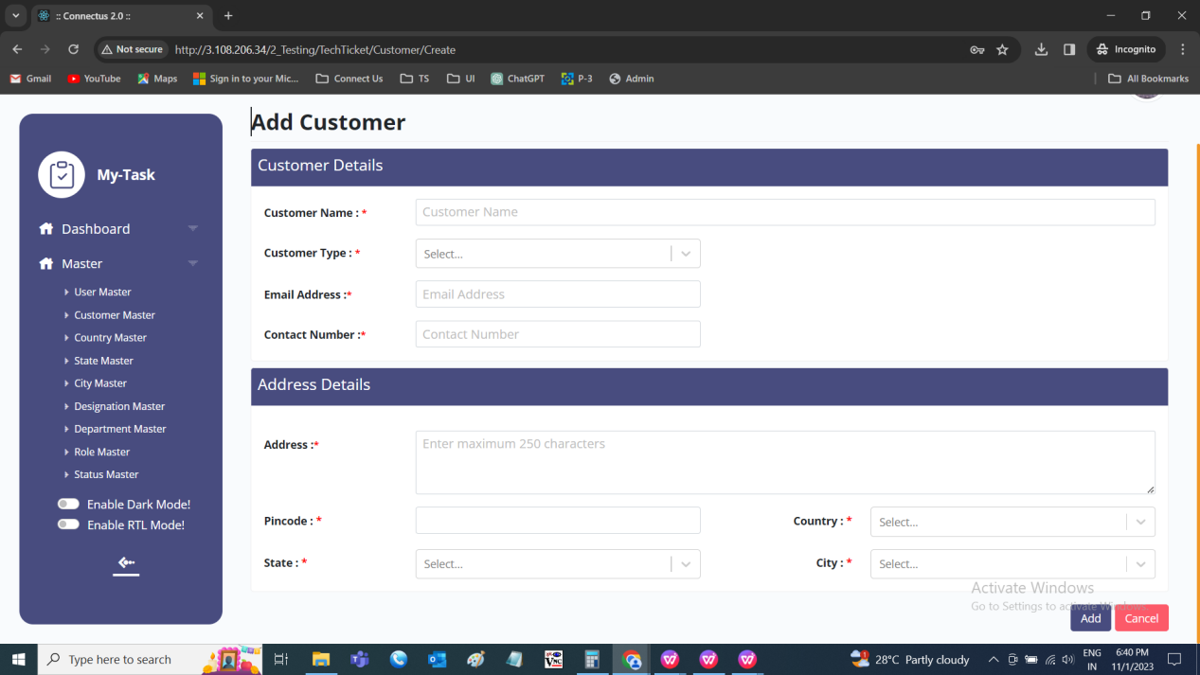

Edit data
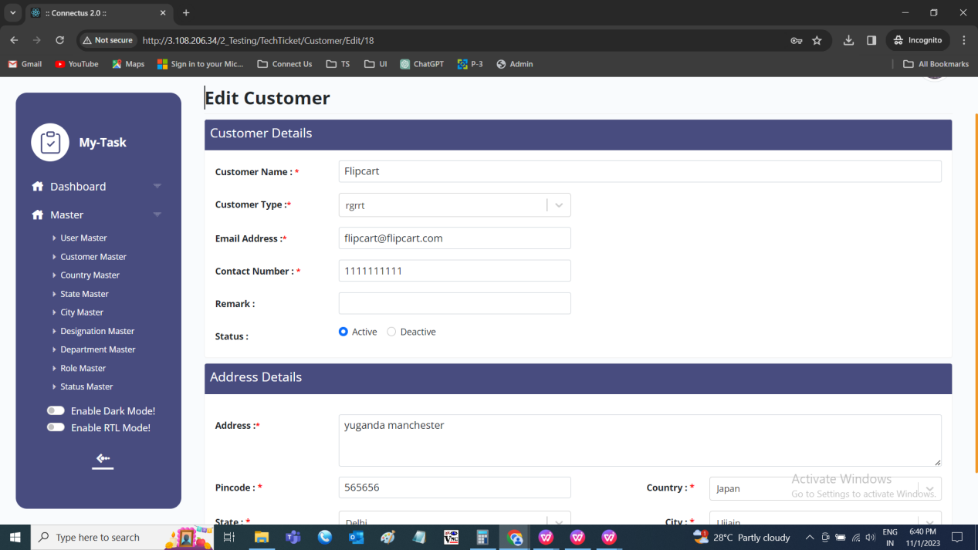

Export data
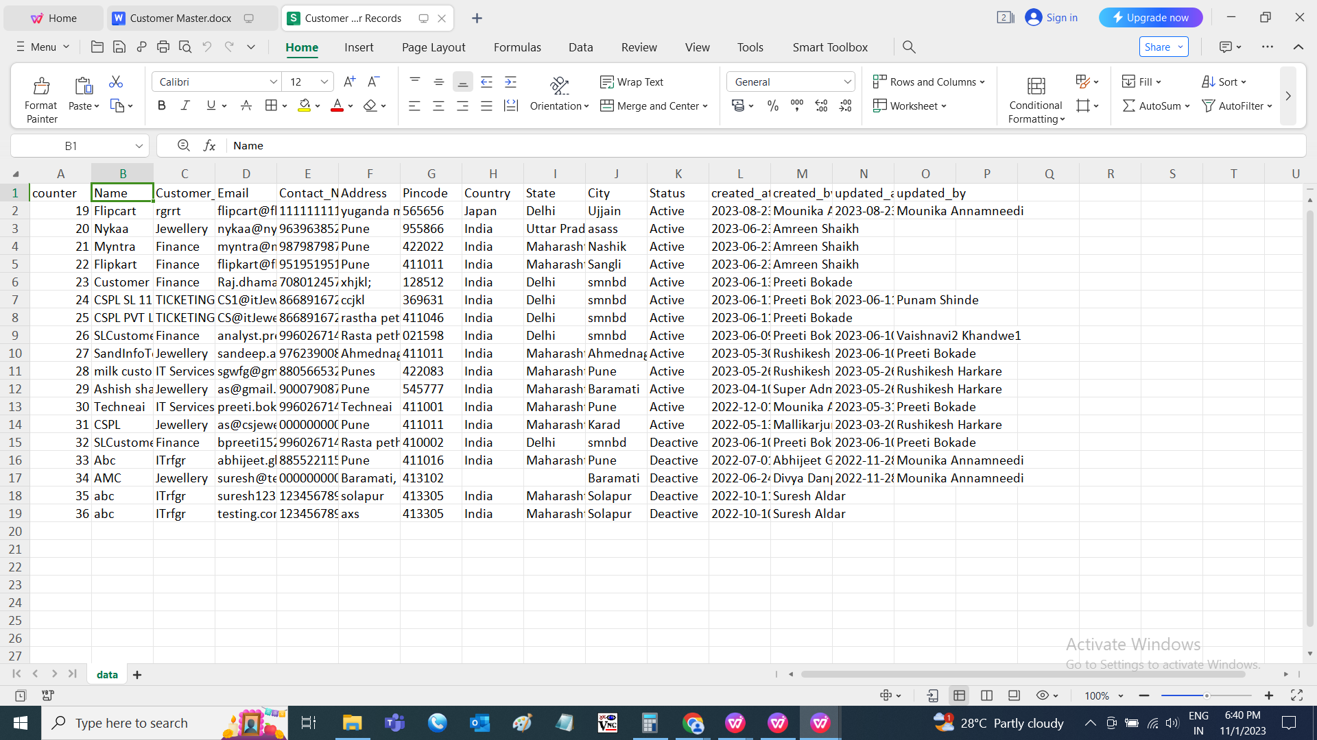

COUNTRY MASTER
The country master consists of all the countries details which helps in fetching the data easily. The following are the fields in country master.
- Search
- Reset
- Export
- Add country
- Sr
- Country
- Remark
- Status
- Created at
- Created by
- Updated at
- Updated by
- Action

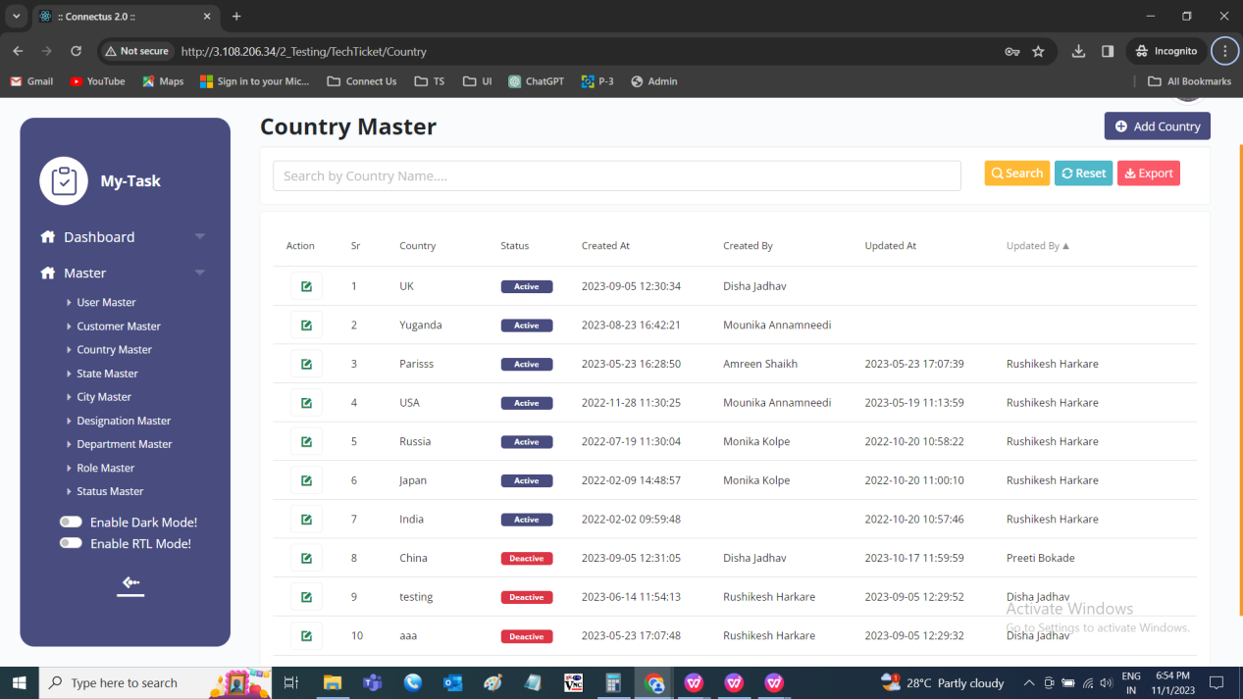

The master consists of the following actions.
Fields | Grid view | Add | Edit | Export
Search | ✓ | x | x | x
Reset | ✓ | x | x | x
Export | ✓ | x | x | x
Add country | ✓ | x | x | x
Sr | ✓ | x | x | ✓
Country | ✓ | ✓ | ✓ | ✓
Remark | x | ✓ | ✓ | ✓
Status | ✓ | x | ✓ | ✓
Created at | ✓ | x | x | ✓
Created by | ✓ | x | x | ✓
Updated at | ✓ | x | x | ✓
Updated by | ✓ | x | x | ✓
Grid - Action | ✓ | x | x | x

Input table
Fields | Input type | Mandatory/ Optional | Editable/ No | Description
Search | Button | - | - | The search tab where the user fills the data to be searched and after clicking the search button, the entered input is searched and displayed.  Validation:  The search can accept alpha-numeric with special characters as well.
Reset | Button | - | - | The reset button to reset the search tab.
Export | Button | - | - | The export button to export the data of the countries in the country master.
Add country | Button | - | - | The add country button to add the data of the country in the master.
Sr | Auto | - | - | The serial number consists of the count of the countries added in the country master in the grid and export.
Country Name | Text | Mandatory | Yes | The country name is entered or displayed.  Validation:  Accepts alpha-numeric data and special characters up-to 100 characters.
Remark | Text | Optional | Yes | The remark if any is entered or displayed.  Validation:  Accepts alpha-numeric data with special characters up-to 1000 characters.
Status | Radio button | Mandatory | Yes | The status consists of the active and the de-active options. The country is active or not is selected.  Validation:  When country is added, automatically, their status is active.
Created at | Auto | Optional | Yes | The username who created the country is displayed.
Created by | Auto | Optional | Yes | The date and time when the country is created is displayed.  Validation:  Format - YYYY-MM-DD HH:MM:SS
Updated at | Auto | Optional | Yes | The username who last updated the country is displayed.
Updated by | Auto | Optional | Yes | The date and time when the country is updated last is displayed.  Validation:  Format - YYYY-MM-DD HH:MM:SS
Grid - Action | Button | - | - | The action field consist of the edit button to edit the data of the country.

Add data
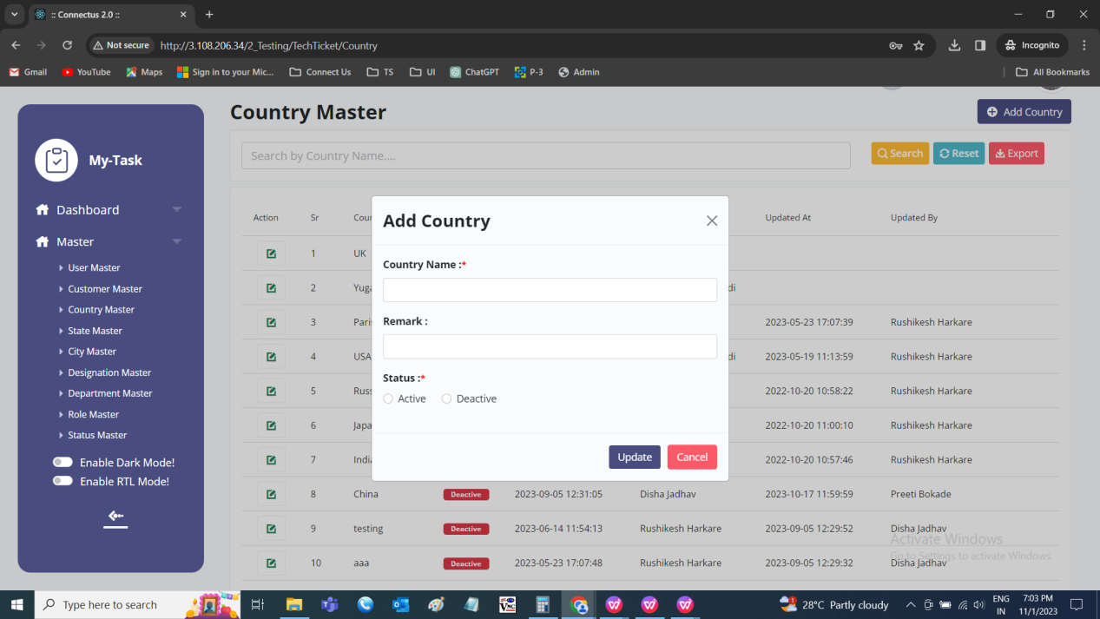

Edit data
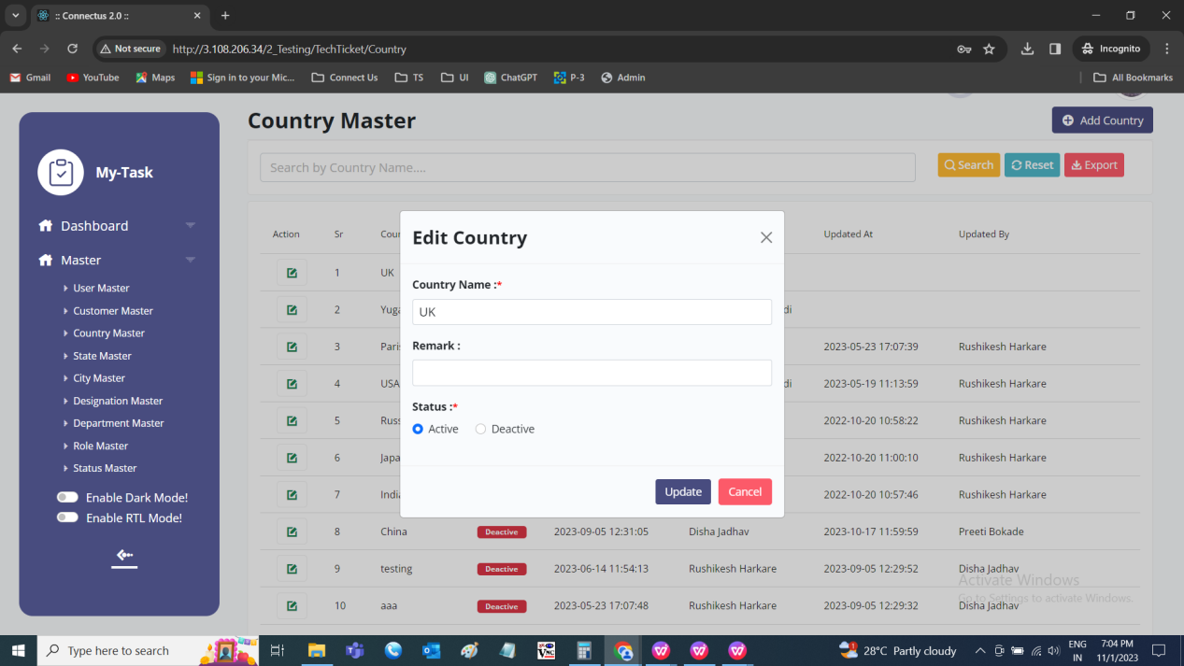

Export
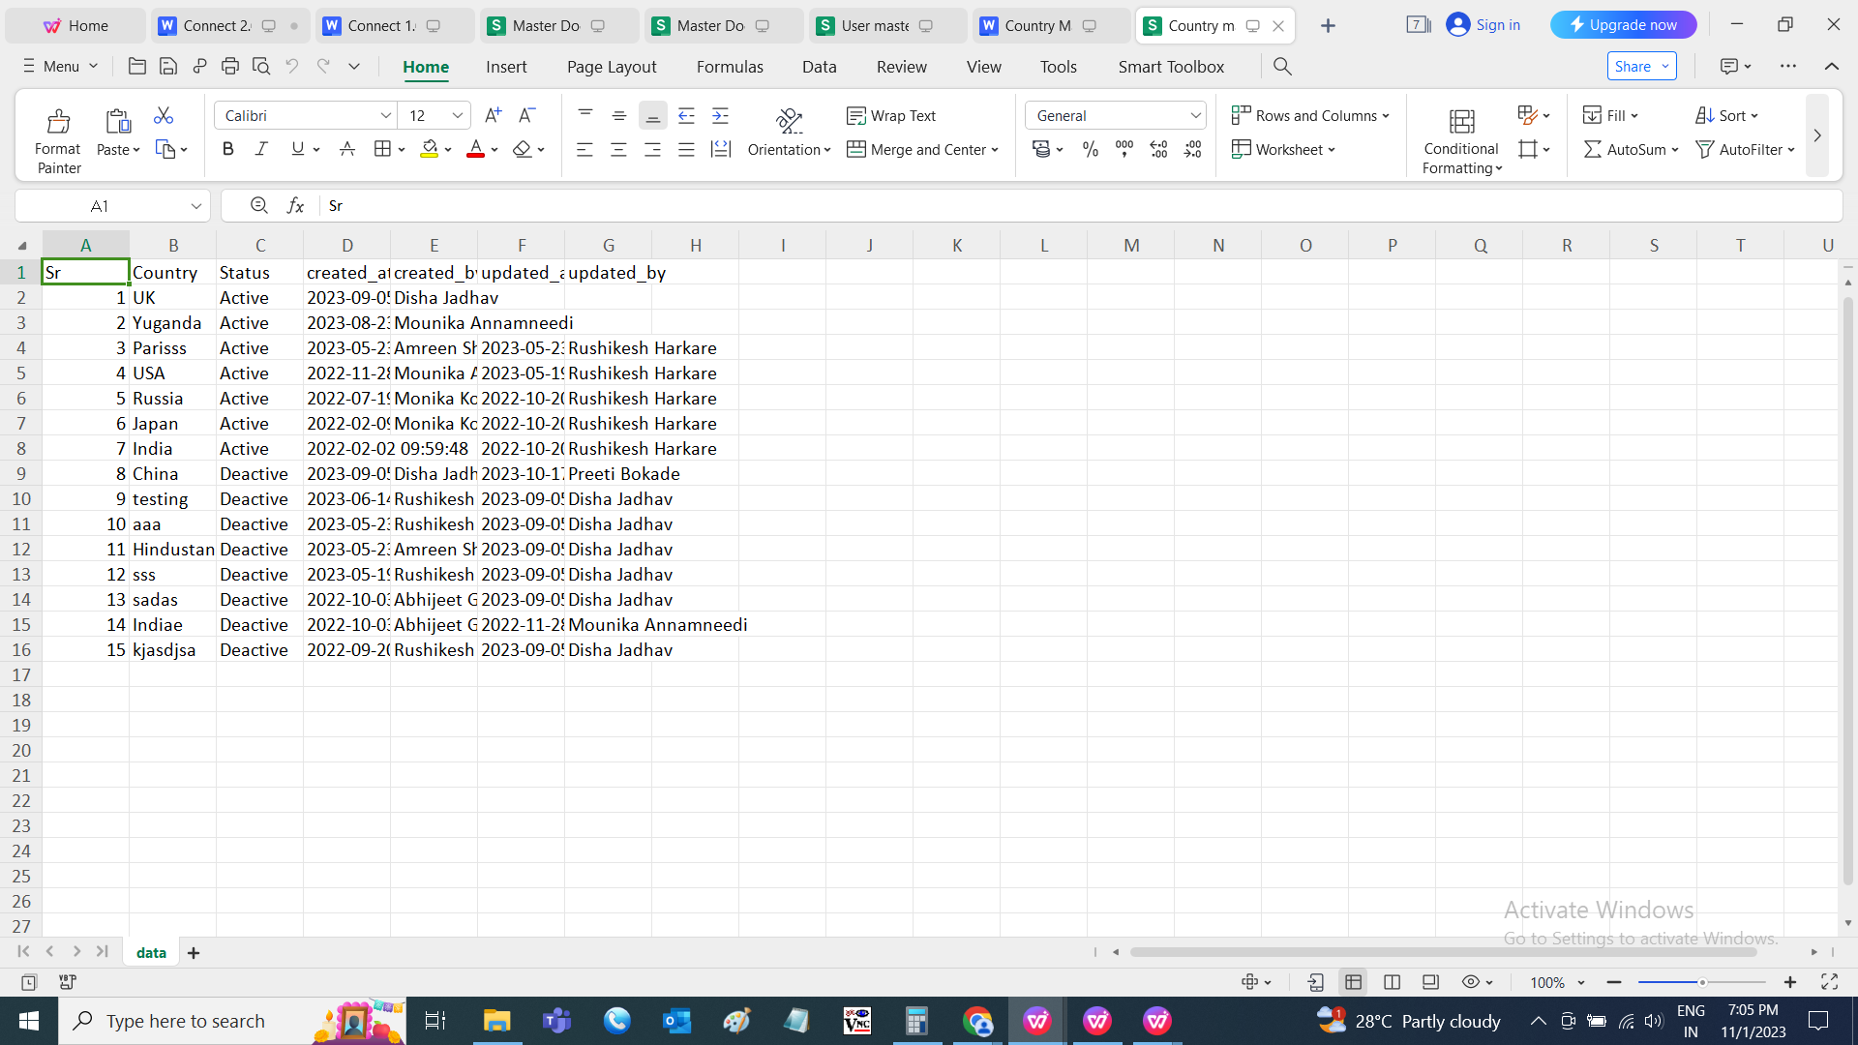

STATE MASTER
The state master is dependent on the country selected. The state master consists of all the state details which helps in the easy access of the data. The following are the fields in state master.
- Search
- Reset
- Export
- Add state
- Sr
- State
- Country
- Remark
- Status
- Created at
- Created by
- Updated at
- Updated by
- Action

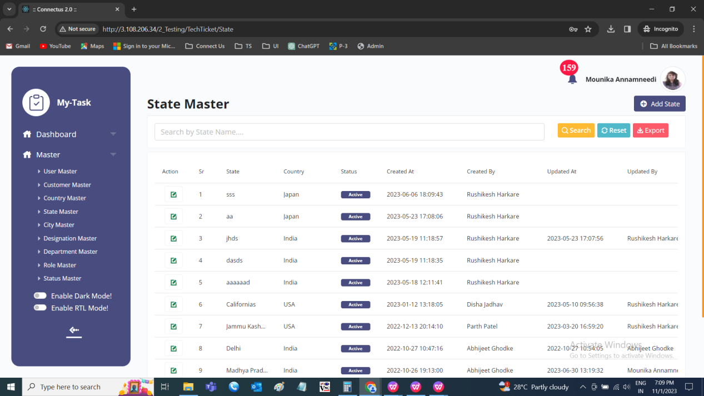

The master consists of the following actions.
Fields | Grid view | Add | Edit | Export
Search | ✓ | x | x | x
Reset | ✓ | x | x | x
Export | ✓ | x | x | x
Add state | ✓ | x | x | x
Sr | ✓ | x | x | ✓
State | ✓ | ✓ | ✓ | ✓
Country | ✓ | ✓ | ✓ | ✓
Remark | x | ✓ | ✓ | ✓
Status | ✓ | x | ✓ | ✓
Created at | ✓ | x | x | ✓
Created by | ✓ | x | x | ✓
Updated at | ✓ | x | x | ✓
Updated by | ✓ | x | x | ✓
Grid - Action | ✓ | x | x | x

Input table
Fields | Input type | Mandatory/ Optional | Editable/ No | Description
Search | Button | - | - | The search tab where the user fills the data to be searched and after clicking the search button, the entered input is searched and displayed.  Validation:  The search can accept alpha-numeric with special characters as well.
Reset | Button | - | - | The reset button to reset the search tab.
Export | Button | - | - | The export button to export the data of the states in the state master.
Add state | Button | - | - | The add state button to add the data of the state in the master.
Sr | Auto | - | - | The serial number consists of the count of the states added in the state master in the grid and export.
State Name | Text | Mandatory | Yes | The state name is entered or displayed.  Validation:  Accepts alpha-numeric data and special characters up-to 100 characters.
Country | Drop down | Mandatory | Yes | The country to which the state is belonged is selected from the drop-down. The drop-down options are fetched from the country master.  Validation:  - Only active countries are fetched from the country master  - Single selection
Remark | Text | Optional | Yes | The remark if any is entered or displayed.  Validation:  Accepts alpha-numeric data with special characters up-to 1000 characters.
Status | Radio button | Mandatory | Yes | The status consists of the active and the de-active options. The state is active or not is selected.  Validation:  When state is added, automatically, their status is active.
Created at | Auto | Optional | Yes | The username who created the state is displayed.
Created by | Auto | Optional | Yes | The date and time when the state is created is displayed.  Validation:  Format - YYYY-MM-DD HH:MM:SS
Updated at | Auto | Optional | Yes | The username who last updated the state is displayed.
Updated by | Auto | Optional | Yes | The date and time when the state is updated last is displayed.  Validation:  Format - YYYY-MM-DD HH:MM:SS
Grid - Action | Button | - | - | The action field consist of the edit button to edit the data of the state.

Add data
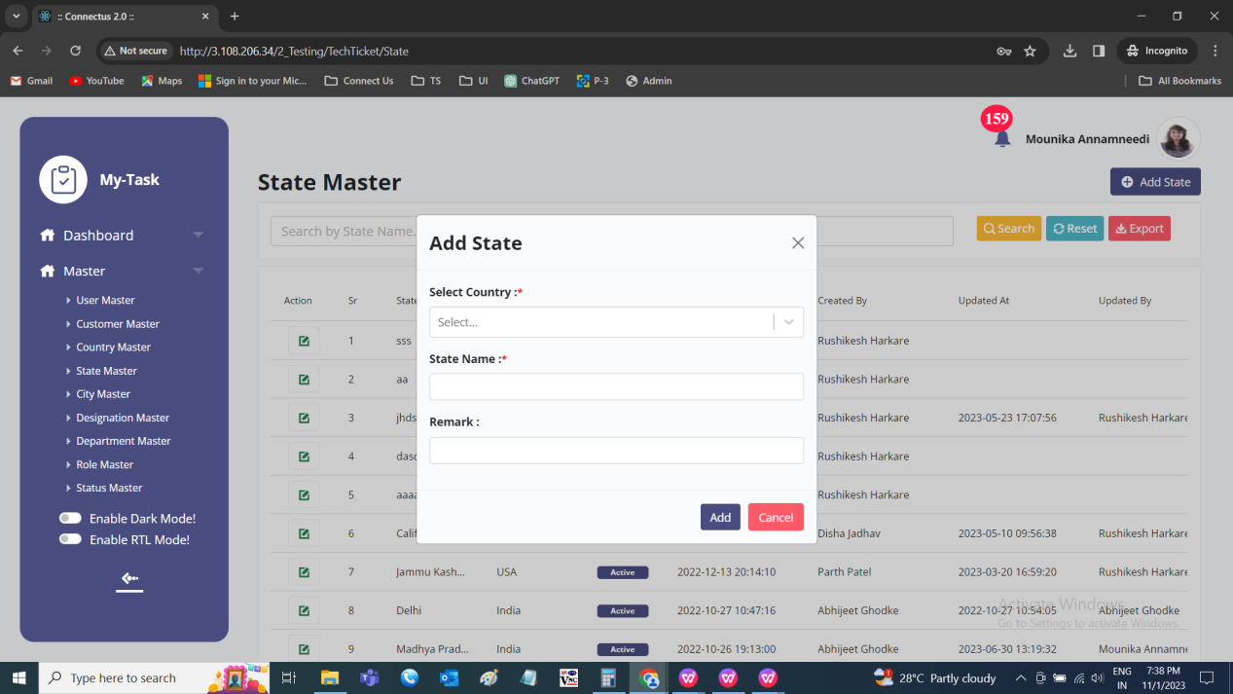

Edit data
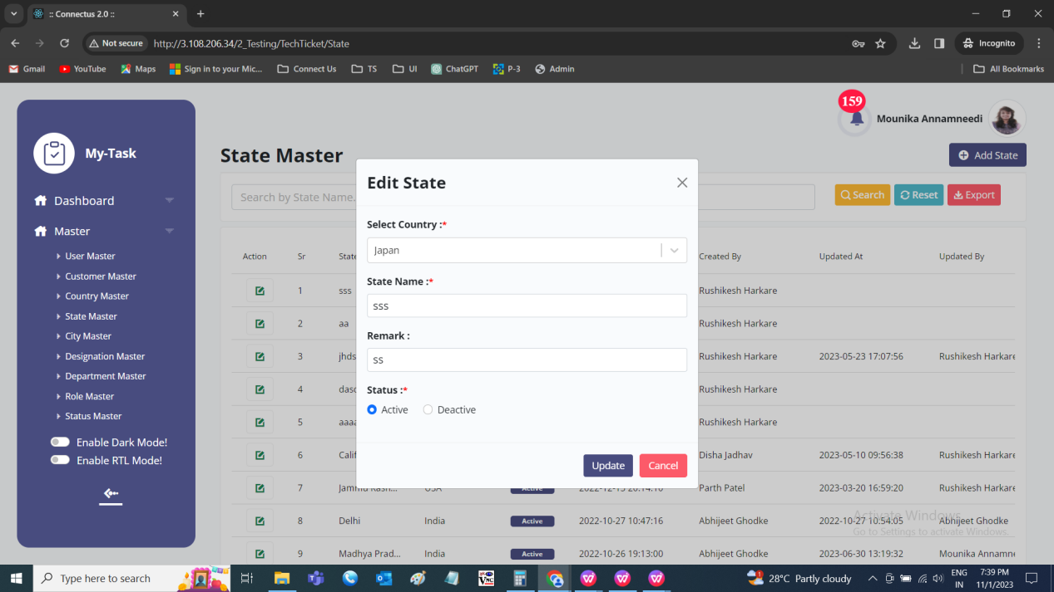

Export
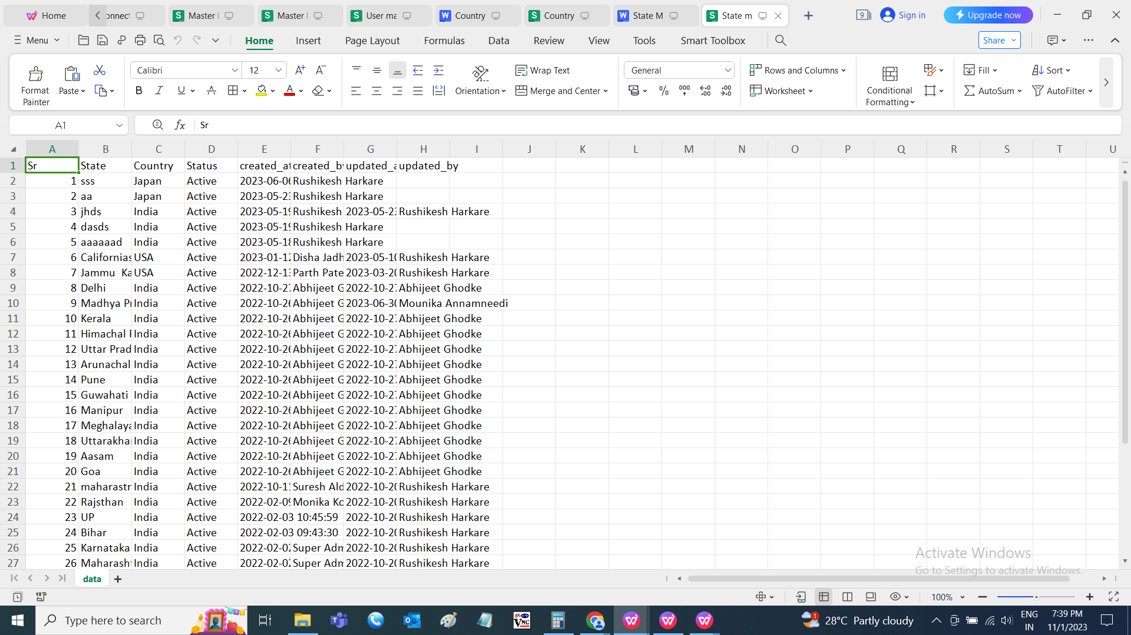

CITY MASTER
The city master is dependent on the state selected. The city master consists of all the city details which helps in the easy access of the data. The following are the fields in city master.
- Search
- Reset
- Export
- Add city
- Sr
- Country
- State
- City
- Remark
- Status
- Created at
- Created by
- Updated at
- Updated by
- Action

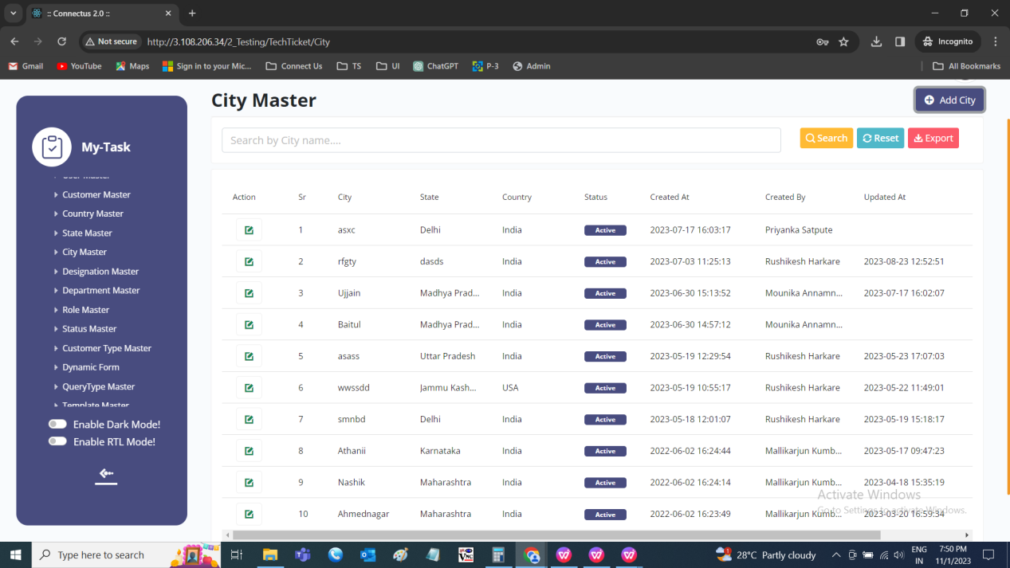

The master consists of the following actions.
Fields | Grid view | Add | Edit | Export
Search | ✓ | x | x | x
Reset | ✓ | x | x | x
Export | ✓ | x | x | x
Add city | ✓ | x | x | x
Sr | ✓ | x | x | ✓
Country | ✓ | ✓ | ✓ | ✓
State | ✓ | ✓ | ✓ | ✓
City | ✓ | ✓ | ✓ | ✓
Remark | x | ✓ | ✓ | ✓
Status | ✓ | x | ✓ | ✓
Created at | ✓ | x | x | ✓
Created by | ✓ | x | x | ✓
Updated at | ✓ | x | x | ✓
Updated by | ✓ | x | x | ✓
Grid - Action | ✓ | x | x | x

Input table
Fields | Input type | Mandatory/ Optional | Editable/ No | Description
Search | Button | - | - | The search tab where the user fills the data to be searched and after clicking the search button, the entered input is searched and displayed.  Validation:  The search can accept alpha-numeric with special characters as well.
Reset | Button | - | - | The reset button to reset the search tab.
Export | Button | - | - | The export button to export the data of the cities in the city master.
Add city | Button | - | - | The add city button to add the data of the city in the master.
Sr | Auto | - | - | The serial number consists of the count of the cities added in the city master in the grid and export.
Country | Drop down | Mandatory | Yes | The country to which the state is belonged is selected from the drop-down. The drop-down options are fetched from the country master.  Validation:  - Only active countries are fetched from the country master  - Single selection
State | Drop down | Mandatory | Yes | The state to which the city is belonged is selected from the drop-down. The state drop down values are based on the country selected. The drop-down options are fetched from the state master.  Validation:  - Only active states are fetched from the state master  - Single selection
City | Text | Mandatory | Yes | The city name is entered or displayed.  Validation:  Accepts alpha-numeric data and special characters up-to 100 characters.
Remark | Text | Optional | Yes | The remark if any is entered or displayed.  Validation:  Accepts alpha-numeric data with special characters up-to 1000 characters.
Status | Radio button | Mandatory | Yes | The status consists of the active and the de-active options. The city is active or not is selected.  Validation:  When city is added, automatically, their city is active.
Created at | Auto | Optional | Yes | The username who created the city is displayed.
Created by | Auto | Optional | Yes | The date and time when the city is created is displayed.  Validation:  Format - YYYY-MM-DD HH:MM:SS
Updated at | Auto | Optional | Yes | The username who last updated the city is displayed.
Updated by | Auto | Optional | Yes | The date and time when the city is updated last is displayed.  Validation:  Format - YYYY-MM-DD HH:MM:SS
Grid - Action | Button | - | - | The action field consist of the edit button to edit the data of the city.

Add data
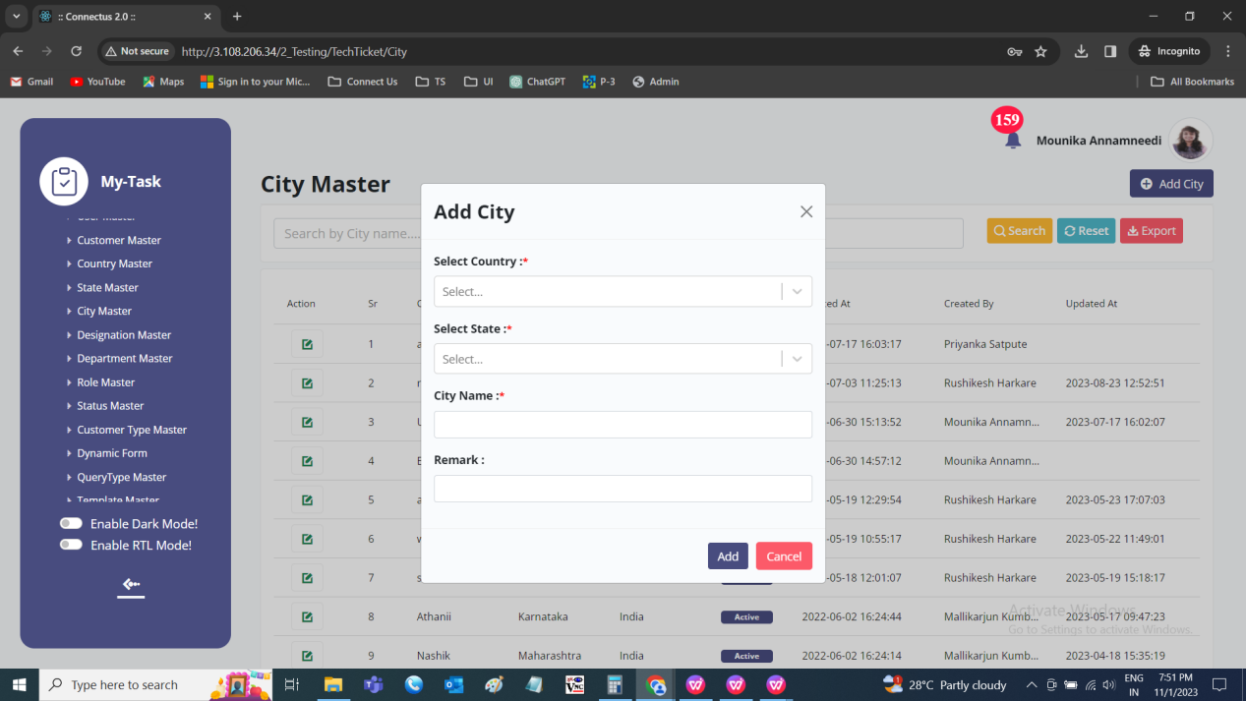

Edit data
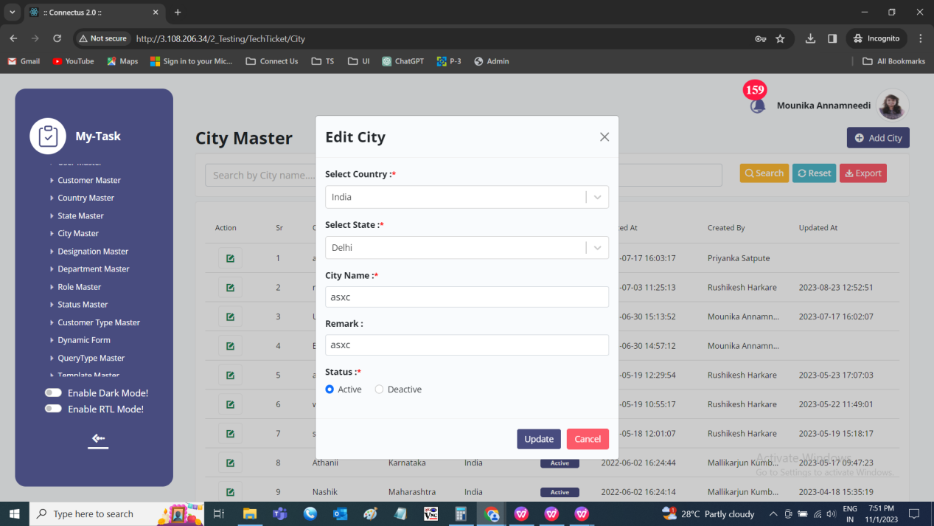

Export data
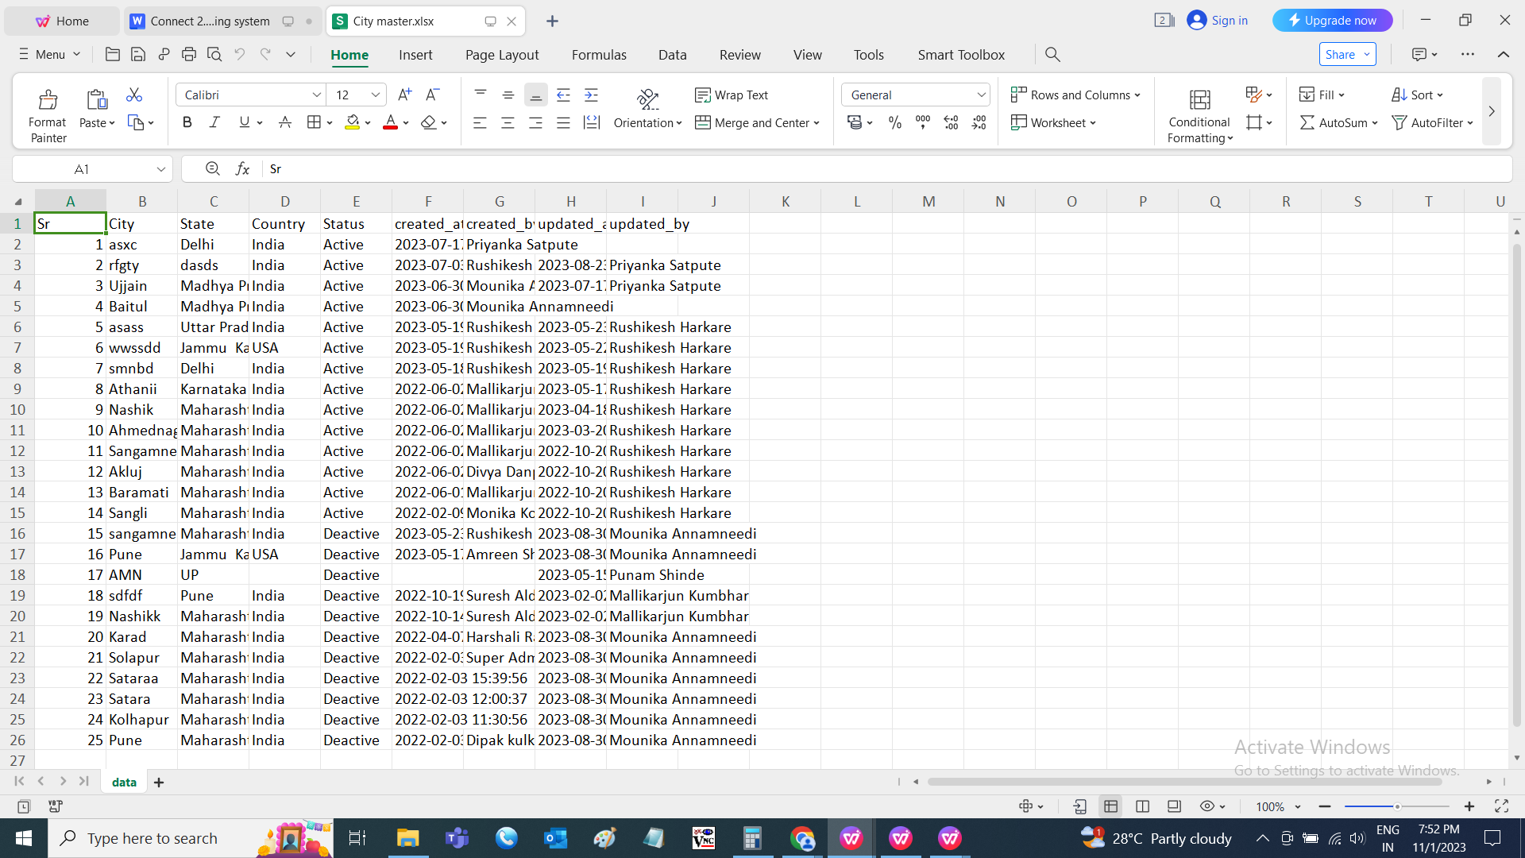

DESIGNATION MASTER
The designation master consists of all the designation details which helps in fetching the data easily. The following are the fields in designation master.
- Search
- Reset
- Export
- Add designation
- Sr
- Designation
- Remark
- Status
- Created at
- Created by
- Updated at
- Updated by
- Action

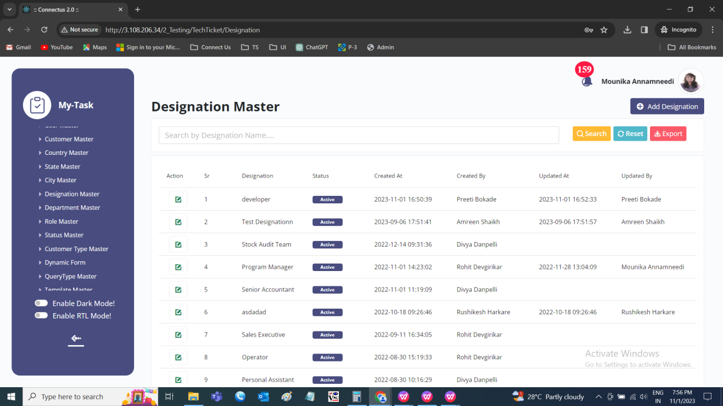

The master consists of the following actions.
Fields | Grid view | Add | Edit | Export
Search | ✓ | x | x | x
Reset | ✓ | x | x | x
Export | ✓ | x | x | x
Add designation | ✓ | x | x | x
Sr | ✓ | x | x | ✓
Designation | ✓ | ✓ | ✓ | ✓
Remark | x | ✓ | ✓ | ✓
Status | ✓ | x | ✓ | ✓
Created at | ✓ | x | x | ✓
Created by | ✓ | x | x | ✓
Updated at | ✓ | x | x | ✓
Updated by | ✓ | x | x | ✓
Grid - Action | ✓ | x | x | x

Input table
Fields | Input type | Mandatory/ Optional | Editable/ No | Description
Search | Button | - | - | The search tab where the user fills the data to be searched and after clicking the search button, the entered input is searched and displayed.  Validation:  The search can accept alpha-numeric with special characters as well.
Reset | Button | - | - | The reset button to reset the search tab.
Export | Button | - | - | The export button to export the data of the designations in the designation master.
Add designation | Button | - | - | The add designation button to add the data of the designation in the master.
Sr | Auto | - | - | The serial number consists of the count of the countries added in the country master in the grid and export.
Designation Name | Text | Mandatory | Yes | The designation name is entered or displayed.  Validation:  Accepts alpha-numeric data and special characters up-to 100 characters.
Remark | Text | Optional | Yes | The remark if any is entered or displayed.  Validation:  Accepts alpha-numeric data with special characters up-to 1000 characters.
Status | Radio button | Mandatory | Yes | The status consists of the active and the de-active options. The designation is active or not is selected.  Validation:  When designation is added, automatically, their status is active.
Created at | Auto | Optional | Yes | The username who created the designation is displayed.
Created by | Auto | Optional | Yes | The date and time when the designation is created is displayed.  Validation:  Format - YYYY-MM-DD HH:MM:SS
Updated at | Auto | Optional | Yes | The username who last updated the designation is displayed.
Updated by | Auto | Optional | Yes | The date and time when the designation is updated last is displayed.  Validation:  Format - YYYY-MM-DD HH:MM:SS
Grid - Action | Button | - | - | The action field consist of the edit button to edit the data of the designation .

Add data
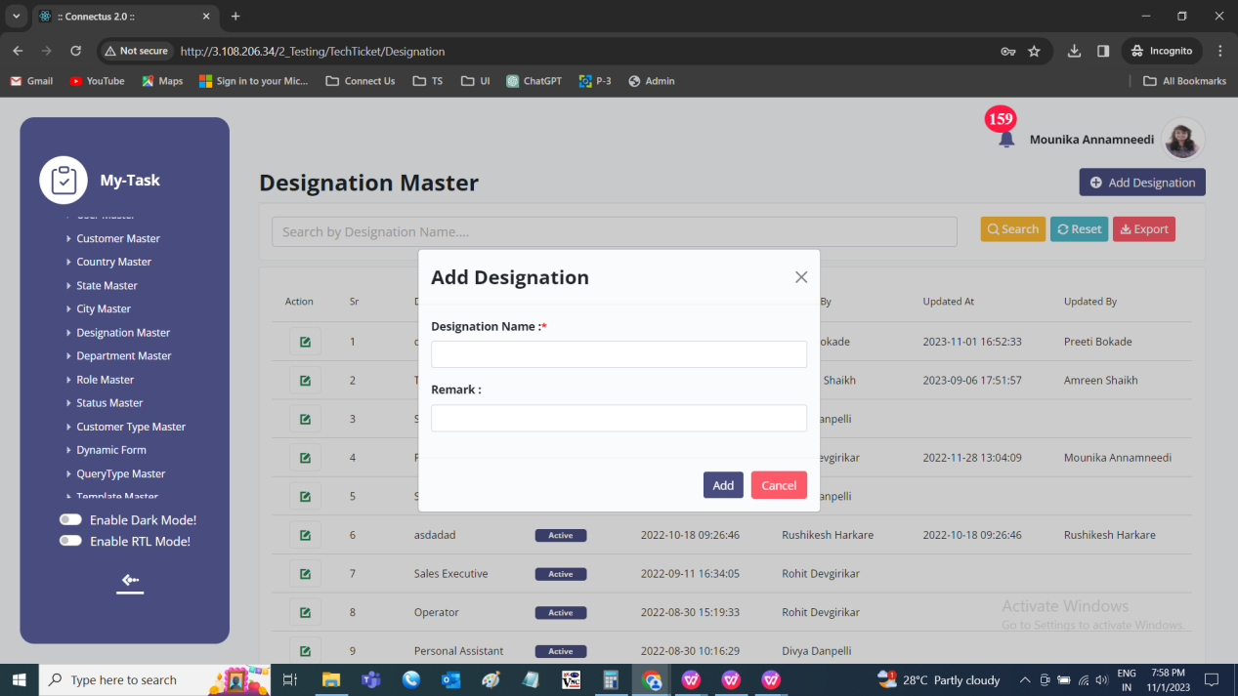

Edit data
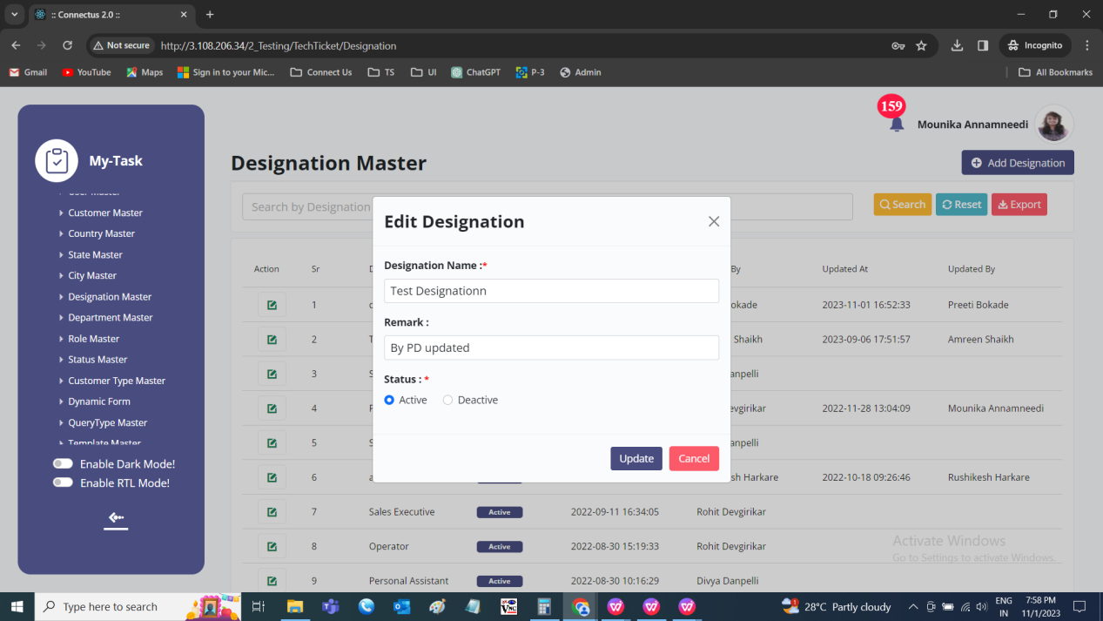

Export data
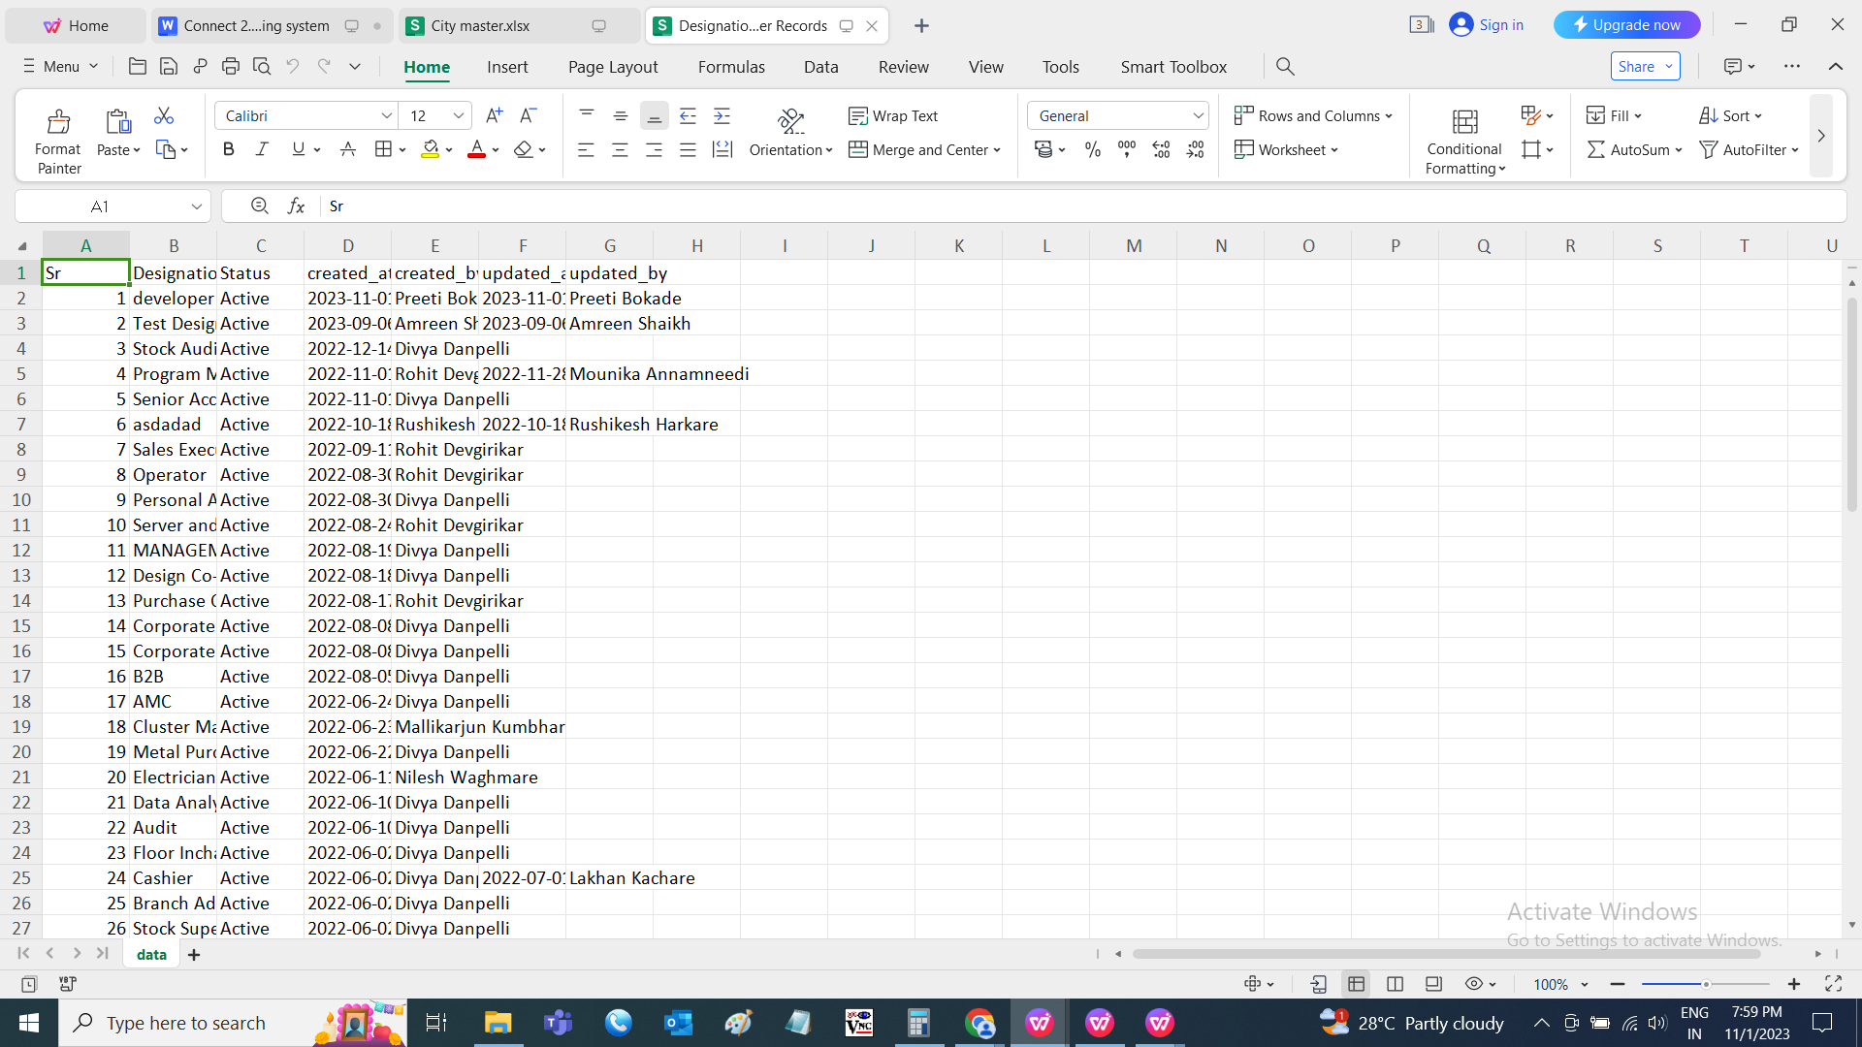

DEPARTMENT MASTER
The department master consists of all the departments details which helps in fetching the data easily. The following are the fields in department master.
- Search
- Reset
- Export
- Add country
- Sr
- Country
- Remark
- Status
- Created at
- Created by
- Updated at
- Updated by
- Action

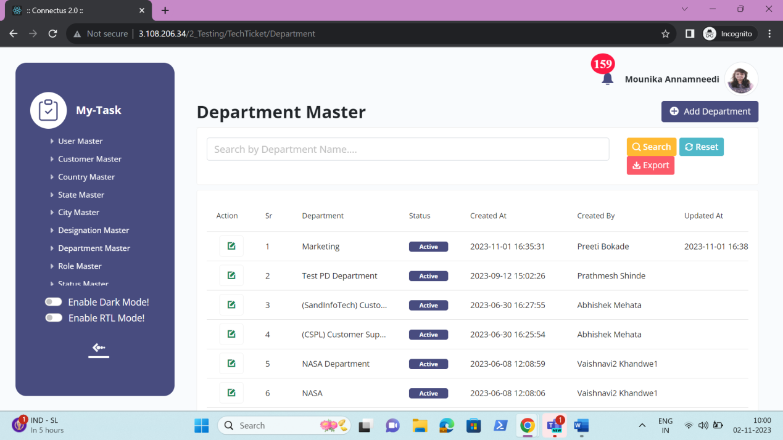
The master consists of the following actions.
Fields | Grid view | Add | Edit | Export
Search | ✓ | x | x | x
Reset | ✓ | x | x | x
Export | ✓ | x | x | x
Add department | ✓ | x | x | x
Sr | ✓ | x | x | ✓
Department | ✓ | ✓ | ✓ | ✓
Remark | x | ✓ | ✓ | ✓
Status | ✓ | x | ✓ | ✓
Created at | ✓ | x | x | ✓
Created by | ✓ | x | x | ✓
Updated at | ✓ | x | x | ✓
Updated by | ✓ | x | x | ✓
Grid - Action | ✓ | x | x | x

Input table
Fields | Input type | Mandatory/ Optional | Editable/ No | Description
Search | Button | - | - | The search tab where the user fills the data to be searched and after clicking the search button, the entered input is searched and displayed.  Validation:  The search can accept alpha-numeric with special characters as well.
Reset | Button | - | - | The reset button to reset the search tab.
Export | Button | - | - | The export button to export the data of the departments in the department master.
Add department | Button | - | - | The add department button to add the data of the department in the master.
Sr | Auto | - | - | The serial number consists of the count of the departments added in the department master in the grid and export.
Department Name | Text | Mandatory | Yes | The department name is entered or displayed.  Validation:  Accepts alpha-numeric data and special characters up-to 100 characters.
Remark | Text | Optional | Yes | The remark if any is entered or displayed.  Validation:  Accepts alpha-numeric data with special characters up-to 1000 characters.
Status | Radio button | Mandatory | Yes | The status consists of the active and the de-active options. The department is active or not is selected.  Validation:  When department is added, automatically, their status is active.
Created at | Auto | Optional | Yes | The username who created the department is displayed.
Created by | Auto | Optional | Yes | The date and time when the department is created is displayed.  Validation:  Format - YYYY-MM-DD HH:MM:SS
Updated at | Auto | Optional | Yes | The username who last updated the department is displayed.
Updated by | Auto | Optional | Yes | The date and time when the department is updated last is displayed.  Validation:  Format - YYYY-MM-DD HH:MM:SS
Grid - Action | Button | - | - | The action field consist of the edit button to edit the data of the department.

Add data
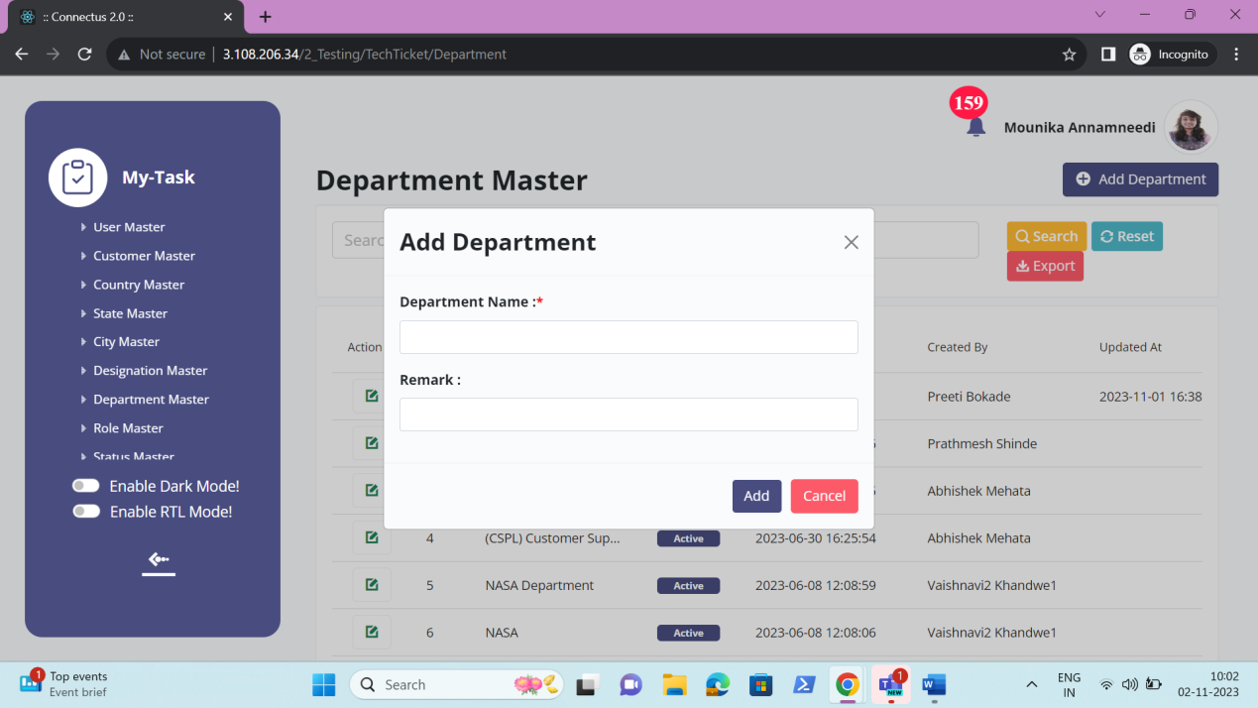

Edit data
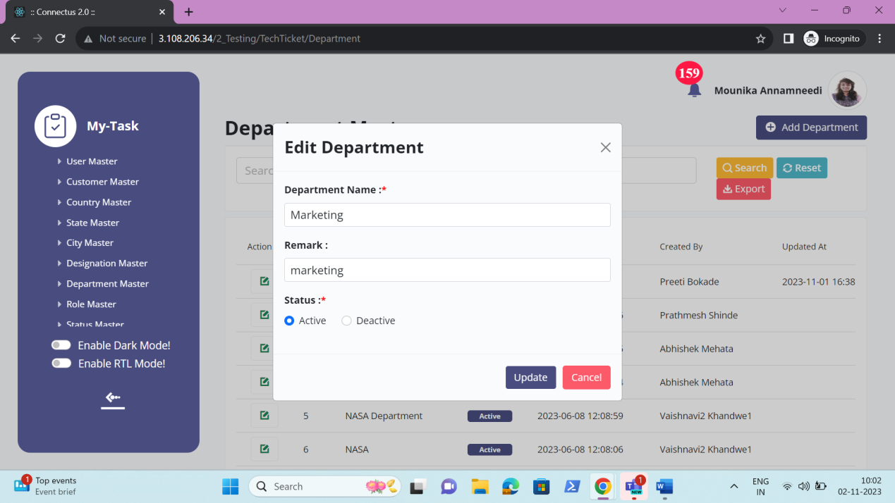

Export data
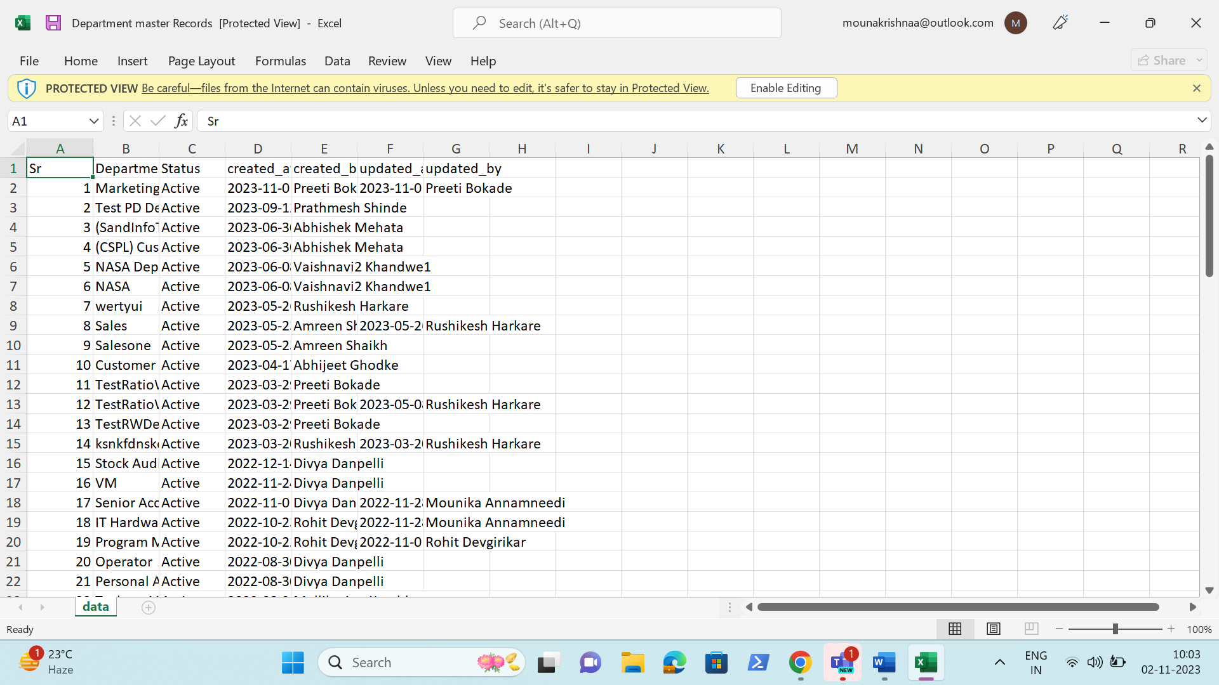

ROLE MASTER
The role master consists of all the roles details which helps in fetching the data easily. The following are the fields in role master.
- Search
- Reset
- Export
- Add role
- Sr
- Role
- Remark
- Status
- Created at
- Created by
- Updated at
- Updated by
- Action
- Add access
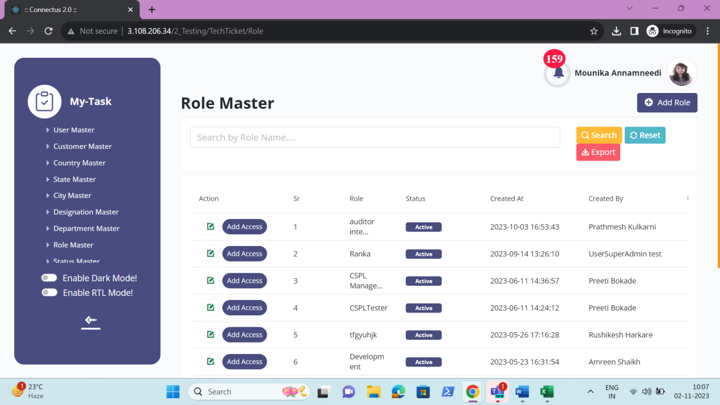

The master consists of the following actions.
Fields | Grid view | Add | Edit | Export
Search | ✓ | x | x | x
Reset | ✓ | x | x | x
Export | ✓ | x | x | x
Add department | ✓ | x | x | x
Sr | ✓ | x | x | ✓
Department | ✓ | ✓ | ✓ | ✓
Remark | x | ✓ | ✓ | ✓
Status | ✓ | x | ✓ | ✓
Created at | ✓ | x | x | ✓
Created by | ✓ | x | x | ✓
Updated at | ✓ | x | x | ✓
Updated by | ✓ | x | x | ✓
Grid - Action | ✓ | x | x | x
Add access | ✓ | x | x | x

Input table
Fields | Input type | Mandatory/ Optional | Editable/ No | Description
Search | Button | - | - | The search tab where the user fills the data to be searched and after clicking the search button, the entered input is searched and displayed.  Validation:  The search can accept alpha-numeric with special characters as well.
Reset | Button | - | - | The reset button to reset the search tab.
Export | Button | - | - | The export button to export the data of the roles in the role master.
Add role | Button | - | - | The add role button to add the data of the role in the master.
Sr | Auto | - | - | The serial number consists of the count of the roles added in the role master in the grid and export.
Role Name | Text | Mandatory | Yes | The role name is entered or displayed.  Validation:  Accepts alpha-numeric data and special characters up-to 100 characters.
Remark | Text | Optional | Yes | The remark if any is entered or displayed.  Validation:  Accepts alpha-numeric data with special characters up-to 1000 characters.
Status | Radio button | Mandatory | Yes | The status consists of the active and the de-active options. The role is active or not is selected.  Validation:  When role is added, automatically, their status is active.
Created at | Auto | Optional | Yes | The username who created the role is displayed.
Created by | Auto | Optional | Yes | The date and time when the role is created is displayed.  Validation:  Format - YYYY-MM-DD HH:MM:SS
Updated at | Auto | Optional | Yes | The username who last updated the role is displayed.
Updated by | Auto | Optional | Yes | The date and time when the role is updated last is displayed.  Validation:  Format - YYYY-MM-DD HH:MM:SS
Grid - Action | Button | - | - | The action field consist of the edit button to edit the data of the role.
Add access | Button | - | - | The add access to give access of menus to the user based on their role.

Add data
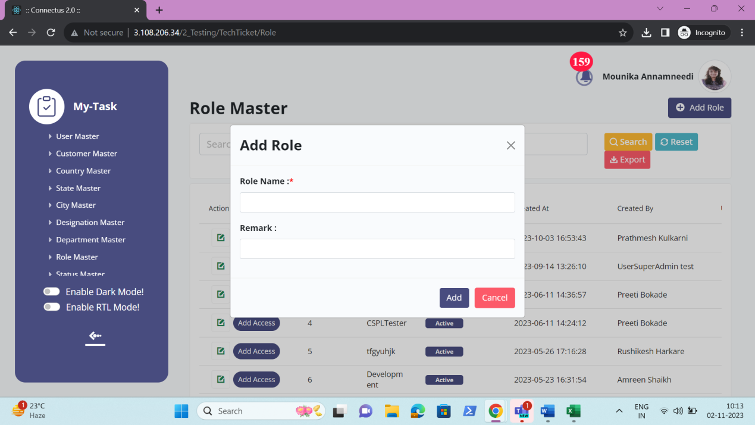

Edit data
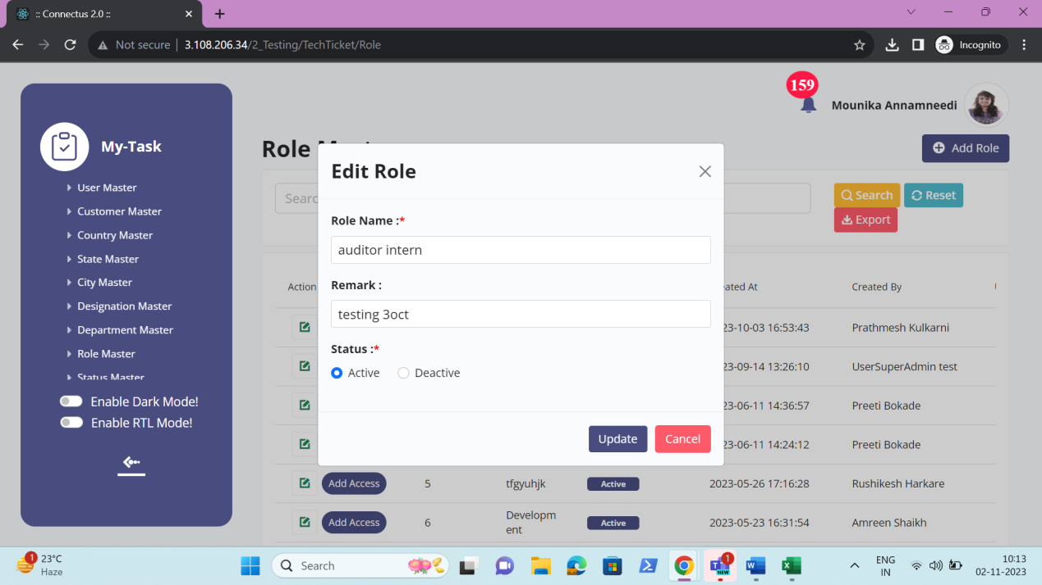

Export data
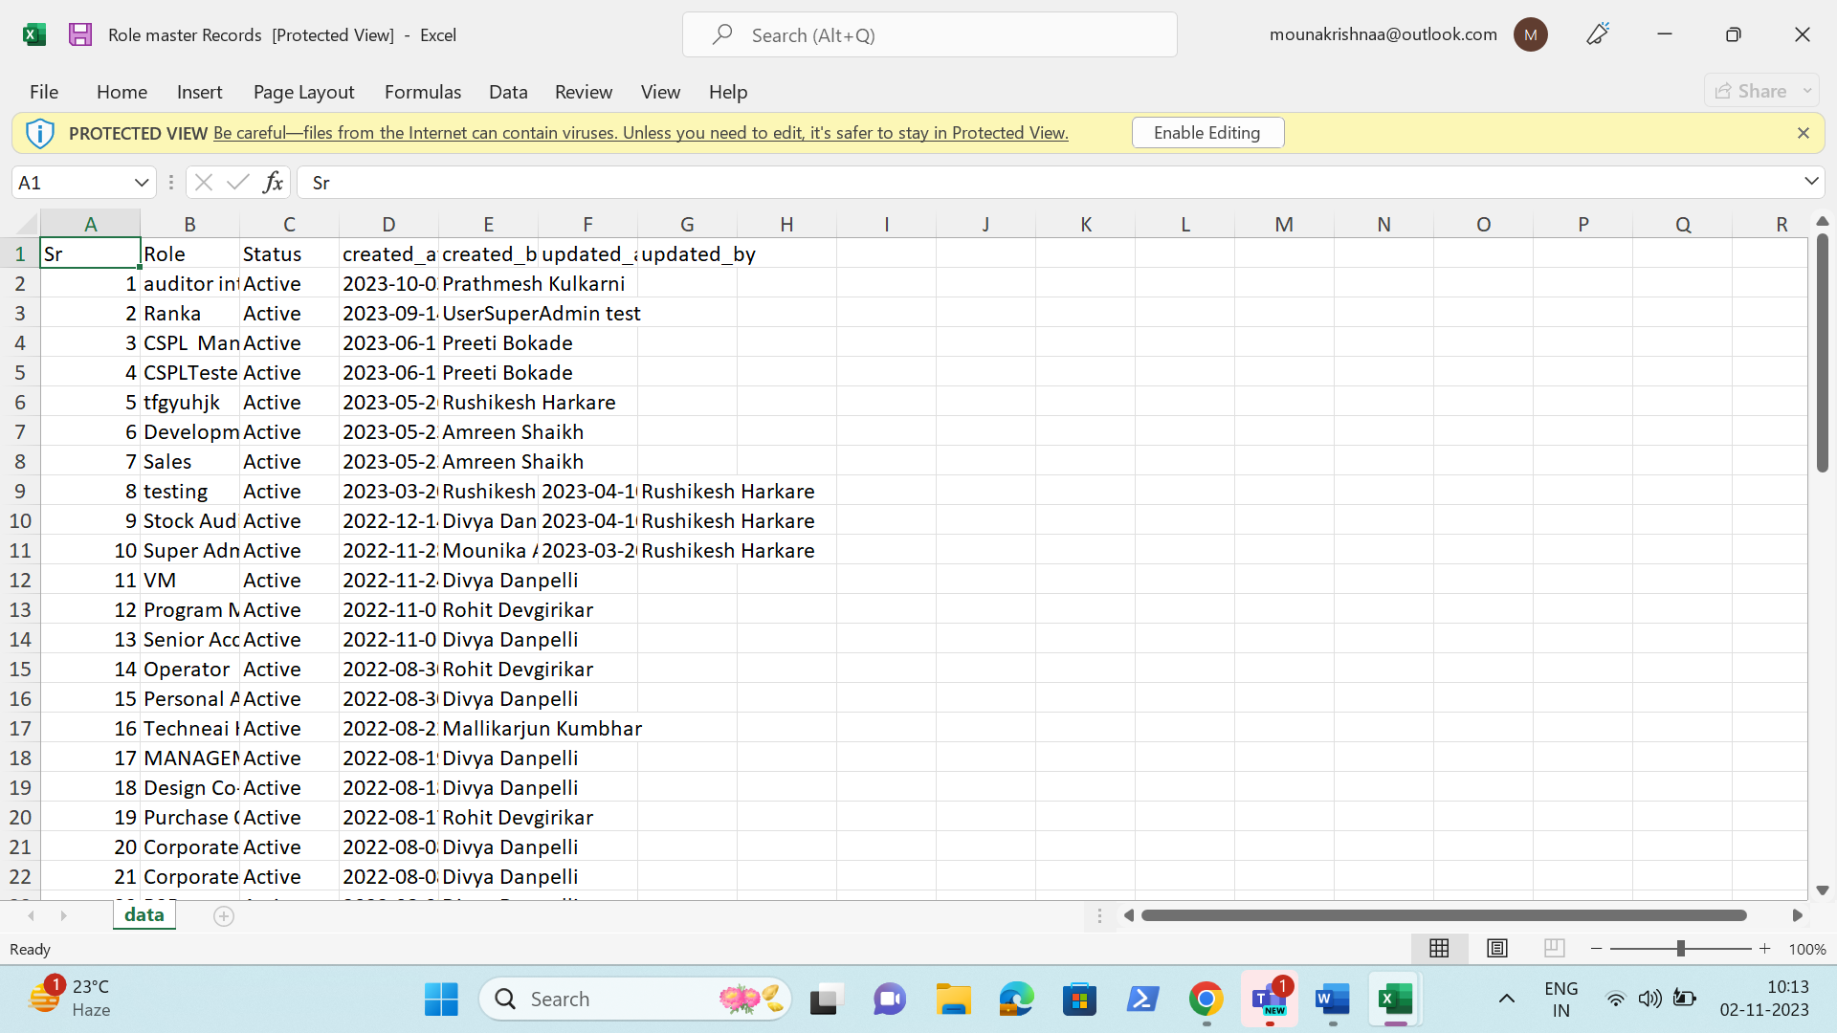

ADD ACCESS
The add access module to allow the access of the menus or modules to the users based on the role. The add access consists of the following fields.
- Menu names
- Select all
- Read
- Create
- Update

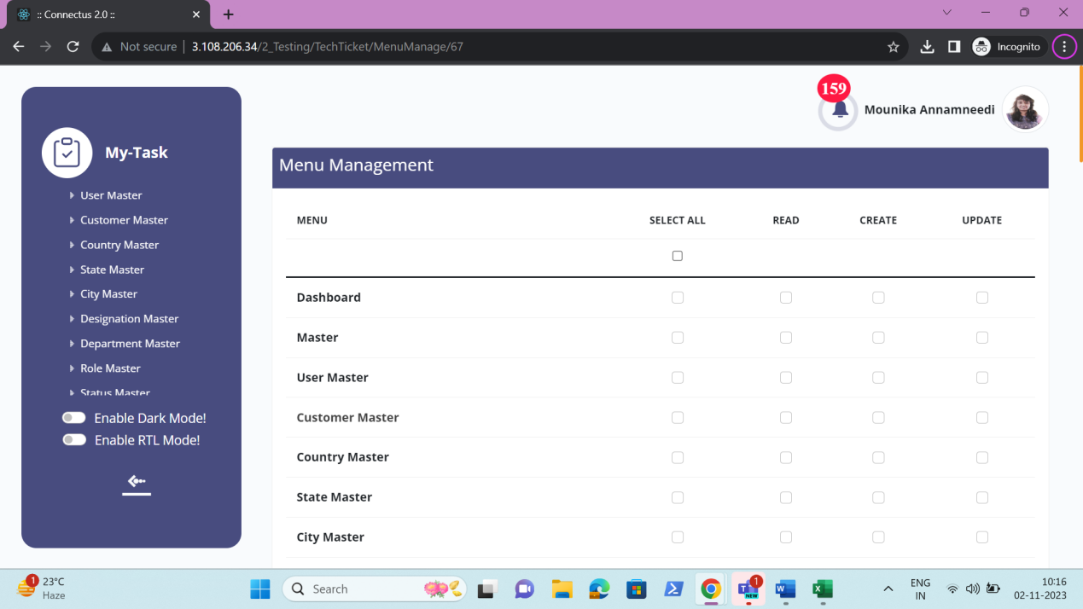

Input table
Fields | Input type | Mandatory/ Optional | Editable/ No | Description
Menu names | Auto | - | - | The menus or modules added in the system are displayed in an alphabetic order. Based on the menu selected, the user having the role can view that menu and get the access for the authorities selected – read (view), create (add) and update (edit).
Select all | Check box | - | - | The select all check box to select all the functionalities - read, create and update.  Validation:  - By default, the check box is not selected.  - When select all is selected, by default, all the three – read, create and update to be selected. If after selection, anyone of the functionality is un selected, then the select all should get un selected.
Read | Check box | - | - | The read functionality is to view the record in the menu selected.  Validation:  By default, the check box is not selected.
Create | Check box | - | - | The create functionality is to add the record in the menu selected.  Validation:  By default, the check box is not selected.
Update | Check box | - | - | The update functionality is to edit the record existing in the menu selected.  Validation:  By default, the check box is not selected.

STATUS MASTER
The status master consists of all the status details which helps in fetching the data easily. The following are the fields in status master.
• Search
• Reset
• Export
• Add status
• Sr
• Status name
• Remark
• Status
• Created at
• Created by
• Updated at
• Updated by
• Action

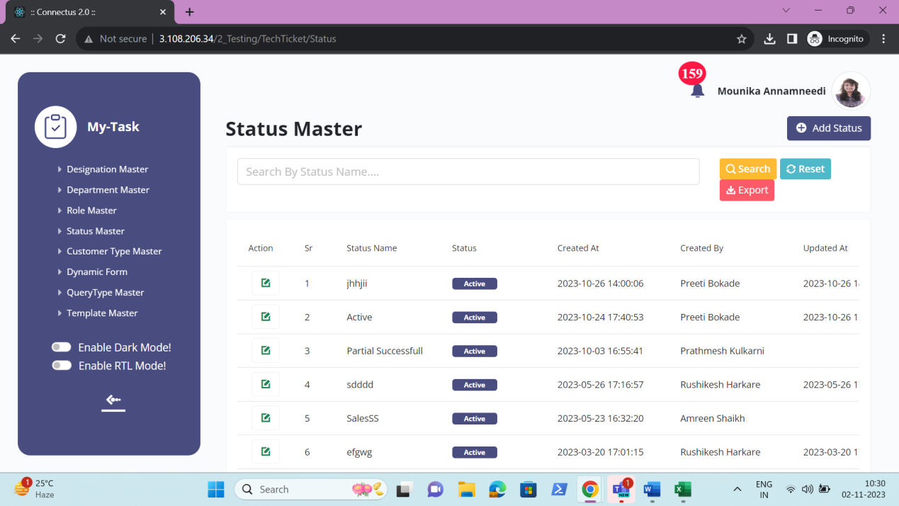
The master consists of the following actions.
Fields | Grid view | Add | Edit | Export
Search | ✓ | x | x | x
Reset | ✓ | x | x | x
Export | ✓ | x | x | x
Add status | ✓ | x | x | x
Sr | ✓ | x | x | ✓
Status name | ✓ | ✓ | ✓ | ✓
Remark | x | ✓ | ✓ | ✓
Status | ✓ | x | ✓ | ✓
Created at | ✓ | x | x | ✓
Created by | ✓ | x | x | ✓
Updated at | ✓ | x | x | ✓
Updated by | ✓ | x | x | ✓
Grid - Action | ✓ | x | x | x

Input table
Fields | Input type | Mandatory/ Optional | Editable/ No | Description
Search | Button | - | - | The search tab where the user fills the data to be searched and after clicking the search button, the entered input is searched and displayed.  Validation:  The search can accept alpha-numeric with special characters as well.
Reset | Button | - | - | The reset button to reset the search tab.
Export | Button | - | - | The export button to export the data of the departments in the department master.
Add status | Button | - | - | The add status button to add the data of the status in the master.
Sr | Auto | - | - | The serial number consists of the count of the status added in the status master in the grid and export.
Status Name | Text | Mandatory | Yes | The status name is entered or displayed.  Validation:  Accepts alpha-numeric data and special characters up-to 100 characters.
Remark | Text | Optional | Yes | The remark if any is entered or displayed.  Validation:  Accepts alpha-numeric data with special characters up-to 1000 characters.
Status | Radio button | Mandatory | Yes | The status consists of the active and the de-active options. The status added is active or not is selected.  Validation:  When status is added, automatically, their status is active.
Created at | Auto | Optional | Yes | The username who created the status is displayed.
Created by | Auto | Optional | Yes | The date and time when the status is created is displayed.  Validation:  Format - YYYY-MM-DD HH:MM:SS
Updated at | Auto | Optional | Yes | The username who last updated the status is displayed.
Updated by | Auto | Optional | Yes | The date and time when the status is updated last is displayed.  Validation:  Format - YYYY-MM-DD HH:MM:SS
Grid - Action | Button | - | - | The action field consist of the edit button to edit the data of the status.

Add data
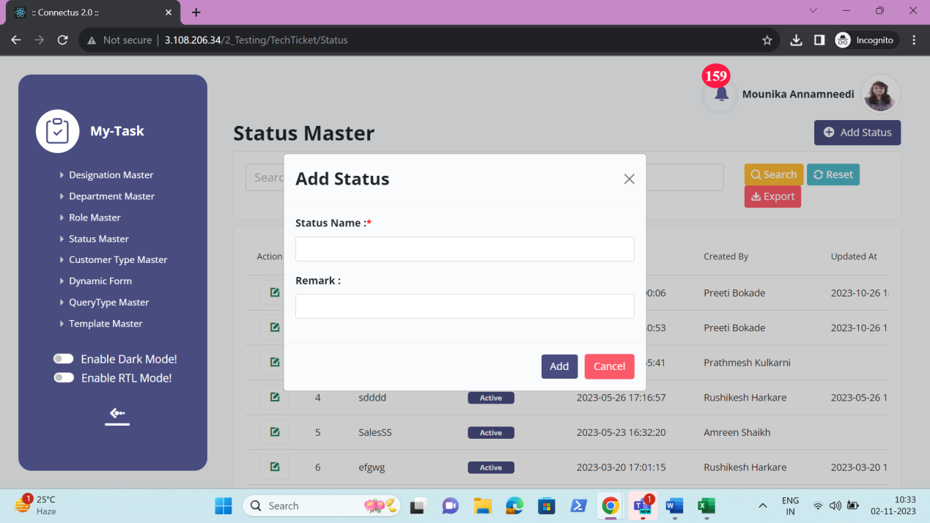

Edit data
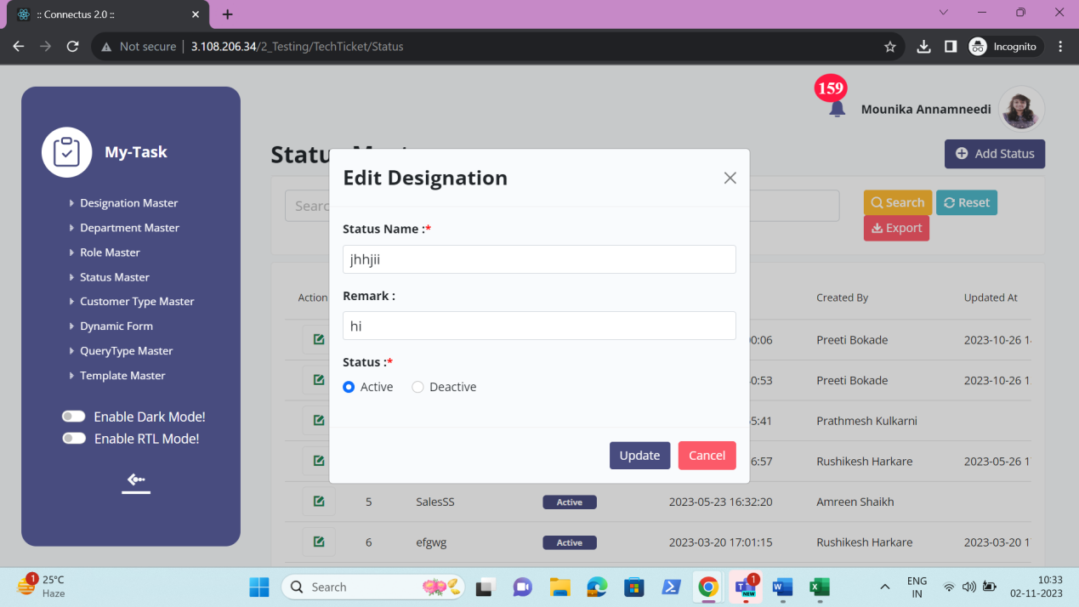

Export data
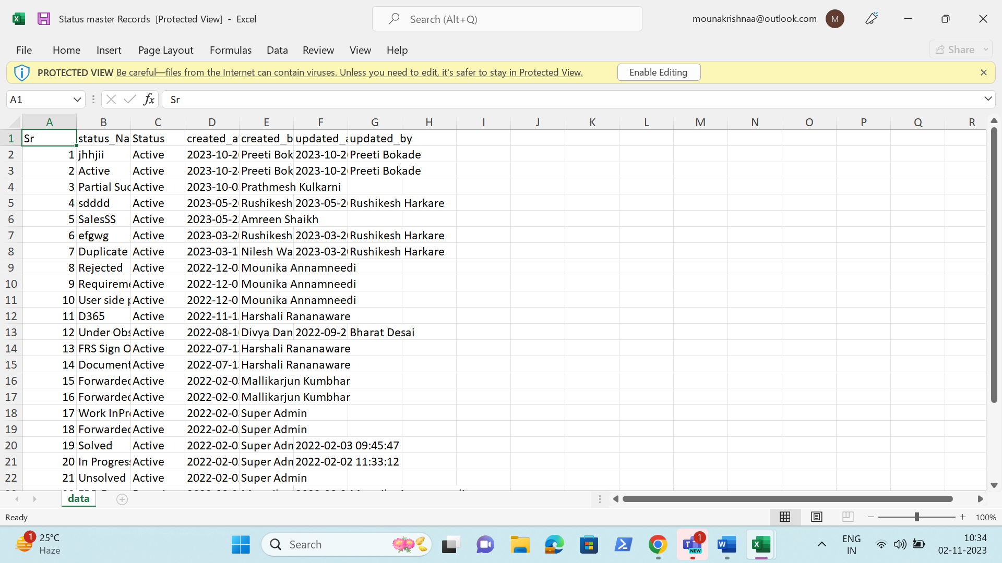

CUSTOMER TYPE MASTER
The customer type master consists of all the customer types details which helps in fetching the data easily. The following are the fields in customer type master.
• Search
• Reset
• Export
• Add customer type
• Sr
• Customer type
• Remark
• Status
• Created at
• Created by
• Updated at
• Updated by
• Action

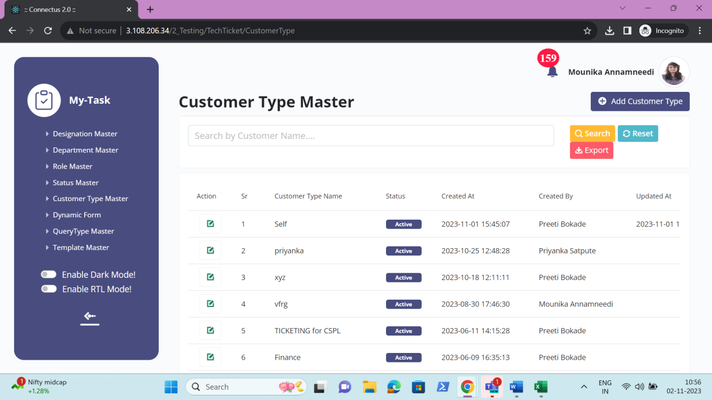

The master consists of the following actions.
Fields | Grid view | Add | Edit | Export
Search | ✓ | x | x | x
Reset | ✓ | x | x | x
Export | ✓ | x | x | x
Add customer type | ✓ | x | x | x
Sr | ✓ | x | x | ✓
Customer type | ✓ | ✓ | ✓ | ✓
Remark | x | ✓ | ✓ | ✓
Status | ✓ | x | ✓ | ✓
Created at | ✓ | x | x | ✓
Created by | ✓ | x | x | ✓
Updated at | ✓ | x | x | ✓
Updated by | ✓ | x | x | ✓
Grid - Action | ✓ | x | x | x

Input table
Fields | Input type | Mandatory/ Optional | Editable/ No | Description
Search | Button | - | - | The search tab where the user fills the data to be searched and after clicking the search button, the entered input is searched and displayed.  Validation:  The search can accept alpha-numeric with special characters as well.
Reset | Button | - | - | The reset button to reset the search tab.
Export | Button | - | - | The export button to export the data of the customer types in the customer type master.
Add customer type | Button | - | - | The add customer type button to add the data of the customer type in the master.
Sr | Auto | - | - | The serial number consists of the count of the customer type added in the customer type master in the grid and export.
Customer type Name | Text | Mandatory | Yes | The customer type name is entered or displayed.  Validation:  Accepts alpha-numeric data and special characters up-to 100 characters.
Remark | Text | Optional | Yes | The remark if any is entered or displayed.  Validation:  Accepts alpha-numeric data with special characters up-to 1000 characters.
Status | Radio button | Mandatory | Yes | The status consists of the active and the de-active options. The customer type is active or not is selected.  Validation:  When customer type is added, automatically, their status is active.
Created at | Auto | Optional | Yes | The username who created the customer type is displayed.
Created by | Auto | Optional | Yes | The date and time when the customer type is created is displayed.  Validation:  Format - YYYY-MM-DD HH:MM:SS
Updated at | Auto | Optional | Yes | The username who last updated the customer type is displayed.
Updated by | Auto | Optional | Yes | The date and time when the customer type is updated last is displayed.  Validation:  Format - YYYY-MM-DD HH:MM:SS
Grid - Action | Button | - | - | The action field consist of the edit button to edit the data of the customer type.

Add data
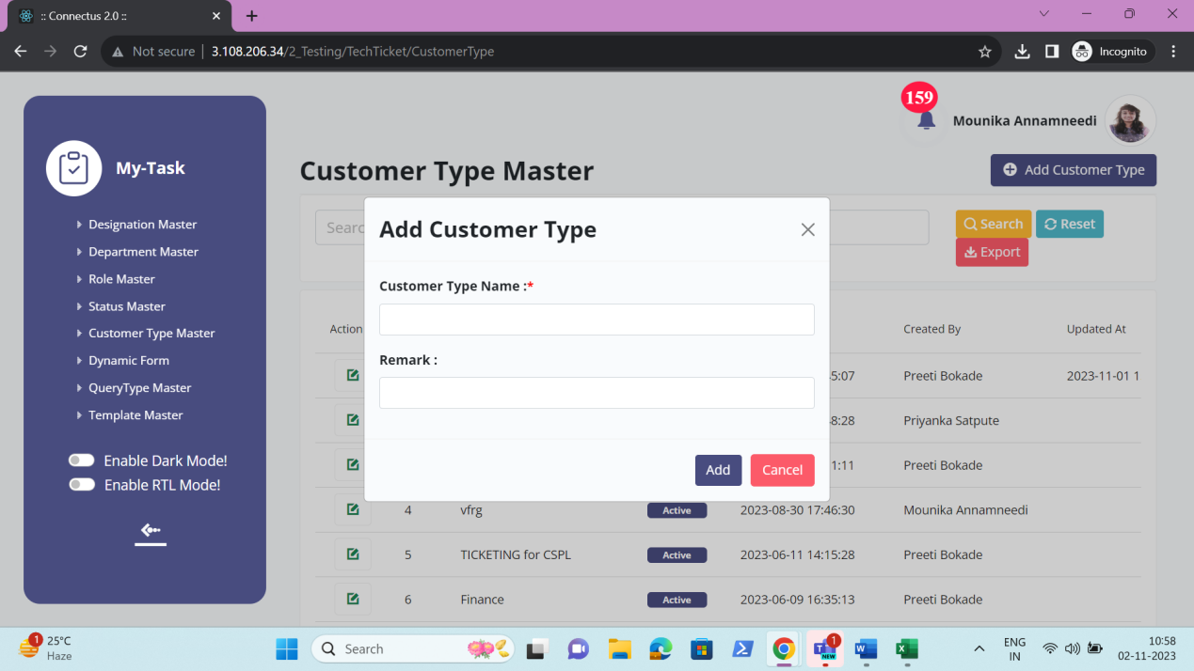

Edit data
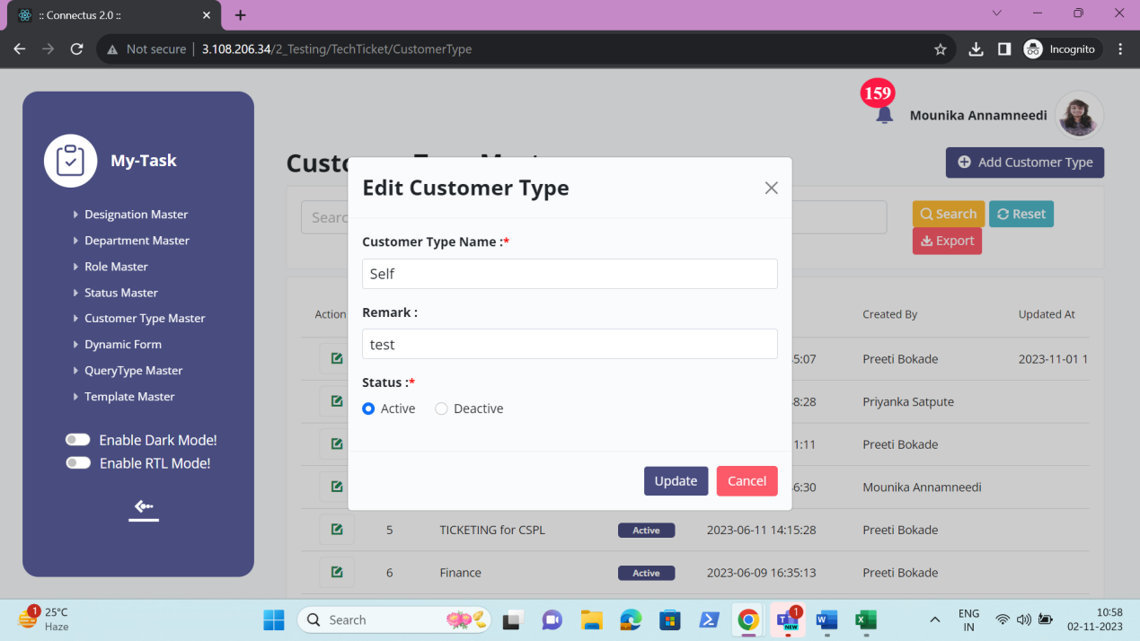

Export data
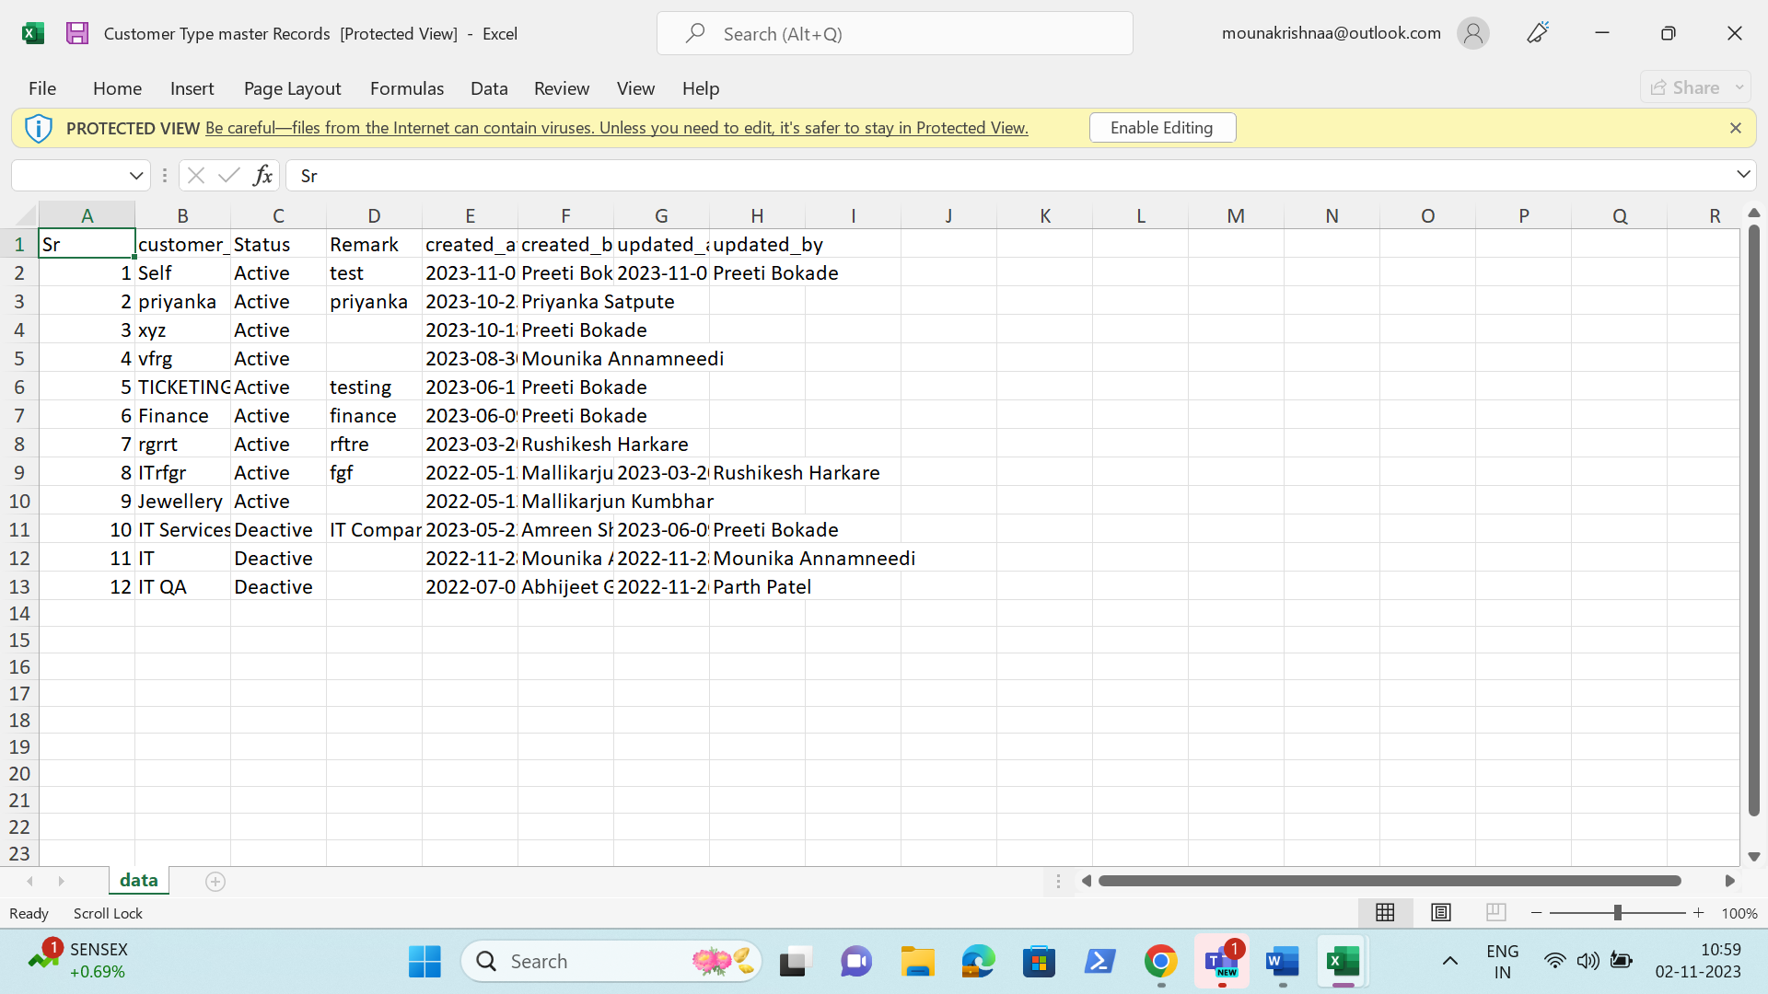

DYNAMIC FORM
The dynamic form is the module which helps in creation of the query form based on the query type selected. This dynamic form is used in the creation of the ticket. Based on the ticket selected, the form selected or mapped to the query type in customer mapping is displayed. The dynamic form consists of the following fields.
- Search
- Reset
- Export
- Add dynamic form
- Sr
- Form name
- Form - Sr.no
- Type
- Width
- Label
- Deferred value
- Mandatory
- Multiple
- Format
- Add ons
- Form - Action
- View/ hide form
- Remark
- Status
- Created at
- Created by
- Updated at
- Updated by
- Action

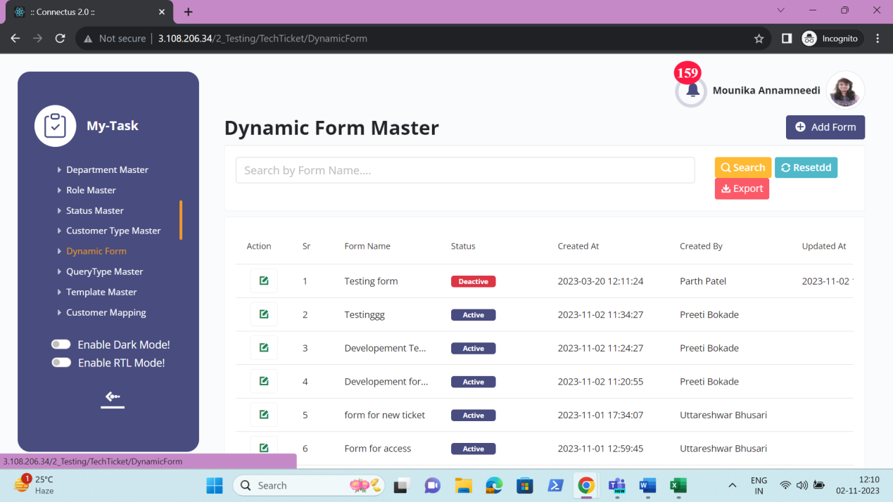

The master consists of the following actions.
Fields | Grid view | Add | Edit | Export
Search | ✓ | x | x | x
Reset | ✓ | x | x | x
Export | ✓ | x | x | x
Add dynamic form | ✓ | x | x | x
Sr | ✓ | x | x | ✓
Form name | ✓ | ✓ | ✓ | ✓
Form - Sr.no | x | ✓ | ✓ | ✓
Type | x | ✓ | ✓ | ✓
Width | x | ✓ | ✓ | ✓
Label | x | ✓ | ✓ | ✓
Deferred value | x | ✓ | ✓ | ✓
Mandatory | x | ✓ | ✓ | ✓
Multiple | x | ✓ | ✓ | ✓
Format | x | ✓ | ✓ | ✓
Add ons | x | ✓ | ✓ | ✓
Form - Action | x | ✓ | ✓ | ✓
View/ hide form | x | ✓ | ✓ | ✓
Remark | x | x | ✓ | ✓
Status | ✓ | x | ✓ | ✓
Created at | ✓ | x | x | ✓
Created by | ✓ | x | x | ✓
Updated at | ✓ | x | x | ✓
Updated by | ✓ | x | x | ✓
Action | ✓ | x | x | x

Input table
Fields | Input type | Mandatory/ Optional | Editable/ No | Description
Search | Button | - | - | The search tab where the user fills the data to be searched and after clicking the search button, the entered input is searched and displayed.  Validation:  The search can accept alpha-numeric with special characters as well.
Reset | Button | - | - | The reset button to reset the search tab.
Export | Button | - | - | The export button to export the data of the dynamic forms in the dynamic form master.
Add dynamic form | Button | - | - | The add dynamic form button to add the data of the dynamic form in the master.
Sr | Auto | - | - | The serial number consists of the count of the dynamic forms added in the dynamic form master in the grid and export.
Form name | Text | Mandatory | Yes | The form name is entered or displayed.  Validation:  Accepts alpha-numeric data with special characters up-to 100.
Form - Sr.no | Auto | - | - | The fields added are shown in the serial wise.
Type | Drop down | Mandatory |  | The type of field is selected from drop down. The following are the fields in the drop down.  - Text  - Text area  - Number  - Date  - Date time  - Time  - Select  - Select master  - Radio  - Check box  - Decimal  The text is used for small text boxes.  The text area is used for the paragraphs data.  The number is used for the integers.  The date is used for date picker.  The date time is used for the date and time picker.  The time is used for the time picker.  The select is used for the drop down.  The select master is used for the drop down from the existing masters.  The radio is used as the radio options.  The check box is used for the multiple selection.  The decimal is used for the entering the decimal values.  Validation:  Single selection
Width | Drop down | Mandatory | - | The width of the field required is selected from the drop down. The drop-down options consist of the following.  - Very small  - Small  - Medium  - Large  - X-Large  - XX-Large  Validation:  Single selection
Label | Text | Mandatory | Yes | The label name of the field is entered or displayed.  Validation:  Accepts alpha-numeric data with special characters up-to 100 characters.
Deferred value | Text | Mandatory | Yes | The deferred value to be shown in the field is entered or displayed.  Validation:  Accepts alpha-numeric data with special characters up-to 50 characters.
Mandatory | Check box | Mandatory | Yes | The field is mandatory or not is displayed. If the field is mandatory, it is reflected at the time of creation of ticket, the compulsory field.  Validation:  By default, the check box is not selected.
Multiple | Check box | Mandatory | Yes | The multiple option is enabled, when the type is either select or select master or check box. The multiple is selected, when multiple values can be selected in the drop down at the time of creation of the ticket.  Validation:  By default, the check box is not selected.
Format | Drop down | Mandatory | Yes | The format of the field to be represented is selected from the drop down. The field gets enables when date, time and date and time is selected.  When the date is selected, the following are the options.  - DD/MM/YYYY  - MM/DD/YYYY  - YYYY/MM/DD  When the time is selected, the following are the options.  - HH:MM  - HH:MM:SS  - MM:SS  When the date time is selected, the following are the options.  - DD/MM/YYYY HH:MM  - DD/MM/YYYY HH:MM:SS  - DD/MM/YYYY MM:SS  - MM/DD/YYYY HH:MM  - MM/DD/YYYY HH:MM:SS  - MM/DD/YYYY MM:SS  - YYYY/MM/DD HH:MM  - YYYY/MM/DD HH:MM:SS  - YYYY/MM/DD MM:SS  Validation:  Single selection
Add ons | Text, date & time picker, date picker, time picker, int | Optional | Yes | The add ons are the extra functionalities added to the fields. The add ons are as follows.  When number is selected, the minimum and maximum values to be entered is mentioned and displayed.  When the date is selected, the minimum and maximum input of the date is selected by the date picker.  When the date time is selected, the minimum and maximum input of the date time is selected by the date and time picker.  When the time is selected, the minimum and maximum input of the time is selected by the time picker.  When the select is selected, the drop-down values to be fetched from the drop-down master. The drop-down options consist of the drop-down master.  When the select master is selected, the masters added are shown in the drop-down.  When radio selected, the drop-down values to be fetched from the drop-down master. The drop-down options consist of the drop-down master.  When check box is selected, the drop-down values to be fetched from the drop-down master. The drop-down options consist of the drop-down master.  When decimal is selected, the minimum and maximum values to be entered is mentioned and displayed.
Form - Action | Button | - | - | The add button to add the row. The added rows consist of the delete button to delete the added rows.
View/ hide form | Button | - | - | The form can be previewed and hide the form.
Remark | Text | Optional | Yes | The remark if any is entered or displayed.  Validation:  - Accepts alpha-numeric data with special characters up-to 1000 characters.
Status | Radio button | Mandatory | Yes | The status consists of the active and the de-active options. The dynamic form is active or not is selected.  Validation:  When dynamic form is added, automatically, their status is active.
Created at | Auto | Optional | Yes | The username who created the dynamic form is displayed.
Created by | Auto | Optional | Yes | The date and time when the dynamic form is created is displayed.  Validation:  Format - YYYY-MM-DD HH:MM:SS
Updated at | Auto | Optional | Yes | The username who last updated the dynamic form is displayed.
Updated by | Auto | Optional | Yes | The date and time when the dynamic form is updated last is displayed.  Validation:  Format - YYYY-MM-DD HH:MM:SS
Grid - Action | Button | - | - | The action field consist of the edit button to edit the data of the dynamic form.

Add data
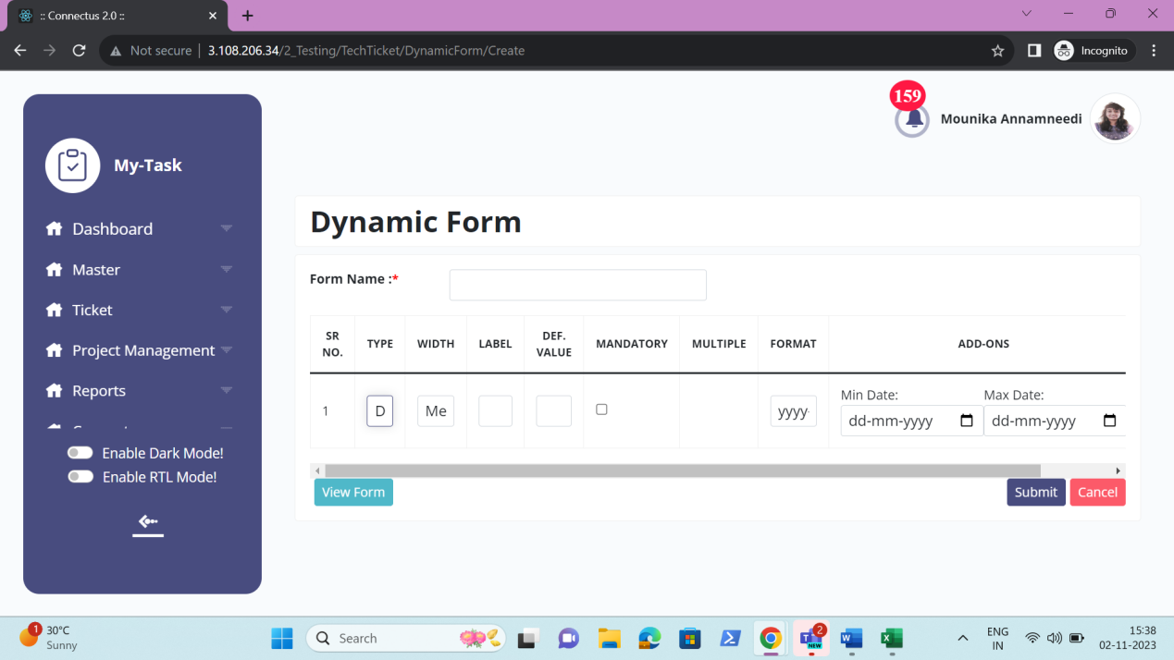

Edit data
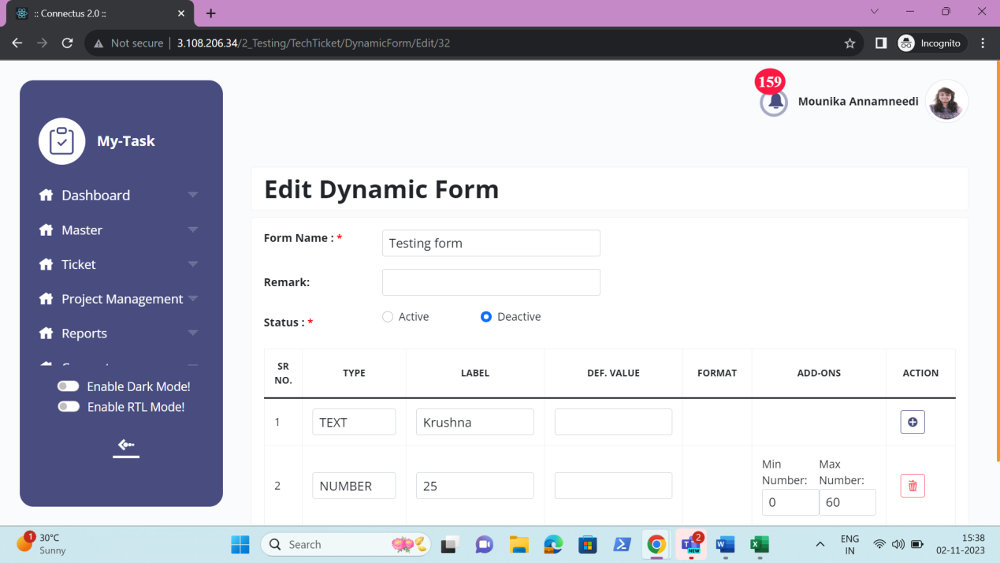

Export data
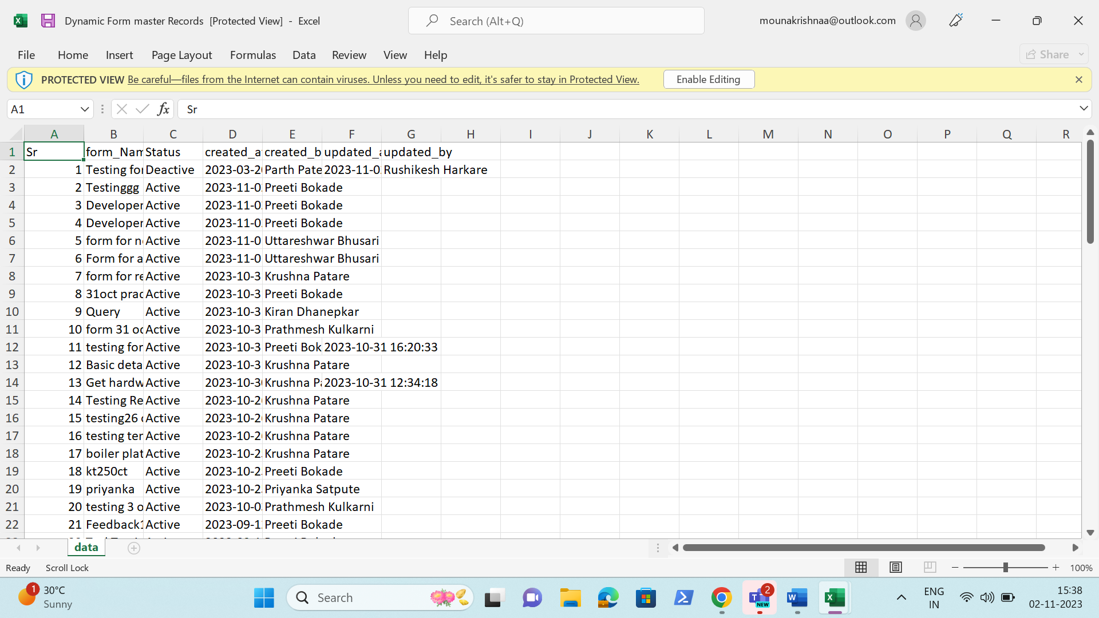

QUERY TYPE MASTER
The query type master is used for the mapping of the ticket with the query type in the customer mapping module. The query type master consists of the following fields.
- Search
- Reset
- Export
- Add query type
- Sr
- Query type
- Form name
- Select customer
- Query group
- Hamburger
- Remark
- Status
- Created at
- Created by
- Updated at
- Updated by
- Action

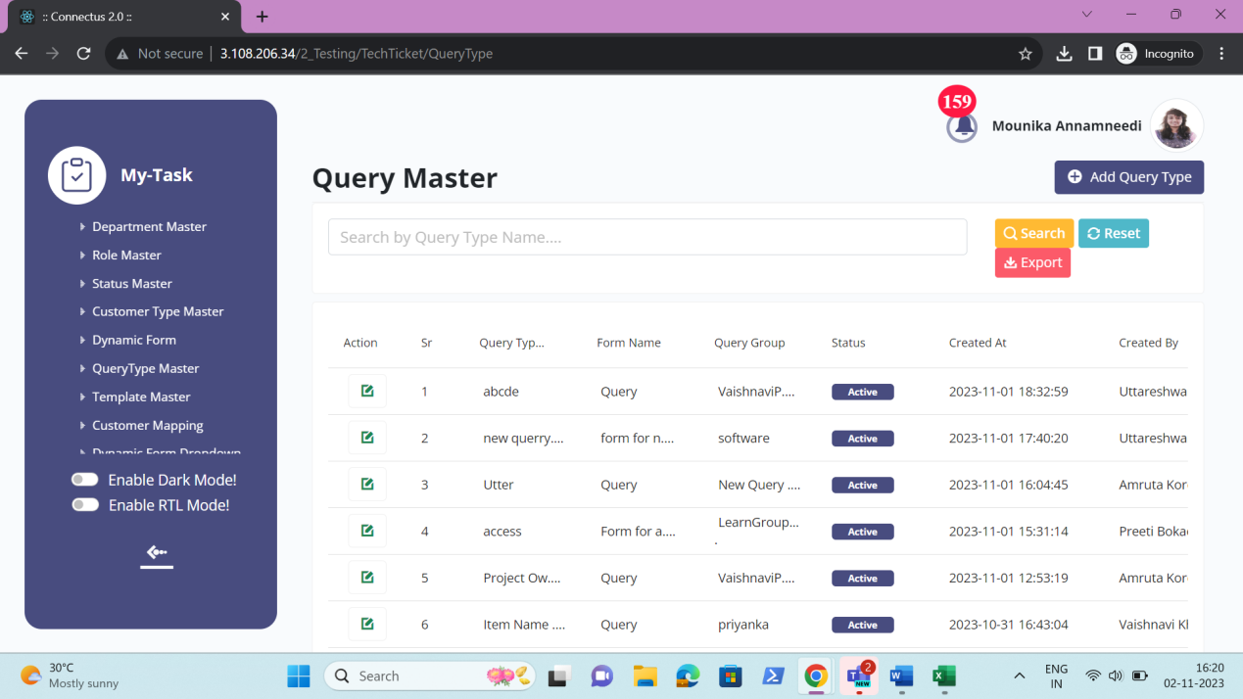

The master consists of the following actions.
Fields | Grid view | Add | Edit | Export
Search | ✓ | x | x | x
Reset | ✓ | x | x | x
Export | ✓ | x | x | x
Add query type | ✓ | x | x | x
Sr | ✓ | x | x | ✓
Query type | ✓ | ✓ | ✓ | ✓
Form name | ✓ | ✓ | ✓ | ✓
Select customer | x | ✓ | ✓ | ✓
Query group | ✓ | ✓ | ✓ | ✓
Hamburger | x | ✓ | ✓ | ✓
Remark | x | ✓ | ✓ | ✓
Status | ✓ | x | ✓ | ✓
Created at | ✓ | x | x | ✓
Created by | ✓ | x | x | ✓
Updated at | ✓ | x | x | ✓
Updated by | ✓ | x | x | ✓
Grid - Action | ✓ | x | x | x

Input table
Fields | Input type | Mandatory/ Optional | Editable/ No | Description
Search | Button | - | - | The search tab where the user fills the data to be searched and after clicking the search button, the entered input is searched and displayed.  Validation:  The search can accept alpha-numeric with special characters as well.
Reset | Button | - | - | The reset button to reset the search tab.
Export | Button | - | - | The export button to export the data of the query types in the query type master.
Add query type | Button | - | - | The add query type button to add the data of the query type in the master.
Sr | Auto | - | - | The serial number consists of the count of the query types added in the query type master in the grid and export.
Query type Name | Text | Mandatory | Yes | The query type name is entered or displayed.  Validation:  Accepts alpha-numeric data and special characters up-to 100 characters.
Form name | Drop down | Mandatory | Yes | The form to be inserted in the query type is selected. The drop-down options are fetched from the dynamic form master.  Validation:  - All the active forms from the dynamic form are fetched.  - Single selection
Select customer | Drop down | Mandatory | Yes | The customer for whom the query type is made is selected from the drop-down. The drop-down options are fetched from the customer master.  Validation:  - All the active customers from the customer master are fetched.  - Single selection
Query group | Drop down | Mandatory | Yes | The query group to which the query type is made is selected from the drop-down. The drop-down options are fetched from the query group master.  Validation:  - All the active query groups from the query group master are fetched.  - Multiple selection
Hamburger | Button | - | - | The hamburger consist of the edit & view and add button to add and make changes in the query group master.
Remark | Text | Optional | Yes | The remark if any is entered or displayed.  Validation:  Accepts alpha-numeric data with special characters up-to 1000 characters.
Status | Radio button | Mandatory | Yes | The status consists of the active and the de-active options. The query type is active or not is selected.  Validation:  When query type is added, automatically, their status is active.
Created at | Auto | Optional | Yes | The username who created the query type is displayed.
Created by | Auto | Optional | Yes | The date and time when the query type is created is displayed.  Validation:  Format - YYYY-MM-DD HH:MM:SS
Updated at | Auto | Optional | Yes | The username who last updated the query type is displayed.
Updated by | Auto | Optional | Yes | The date and time when the query type is updated last is displayed.  Validation:  Format - YYYY-MM-DD HH:MM:SS
Grid - Action | Button | - | - | The action field consist of the edit button to edit the data of the query type.

Add data
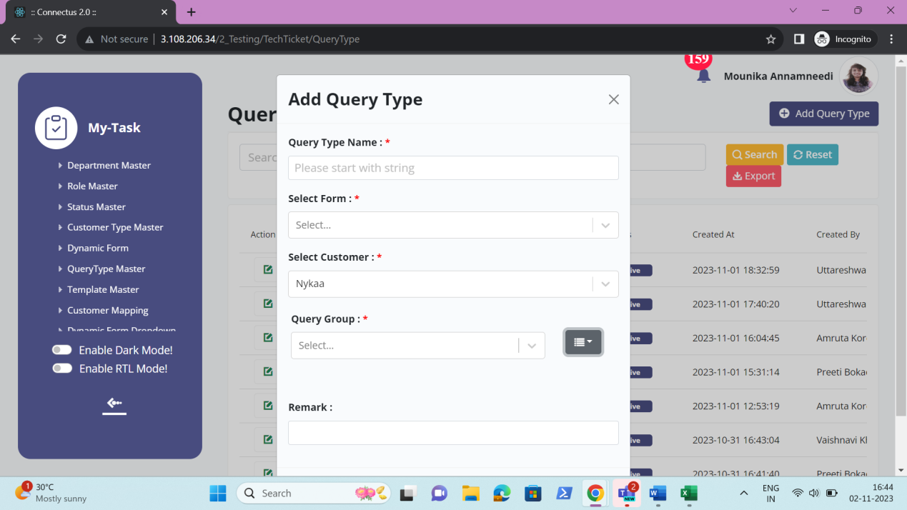

Edit data
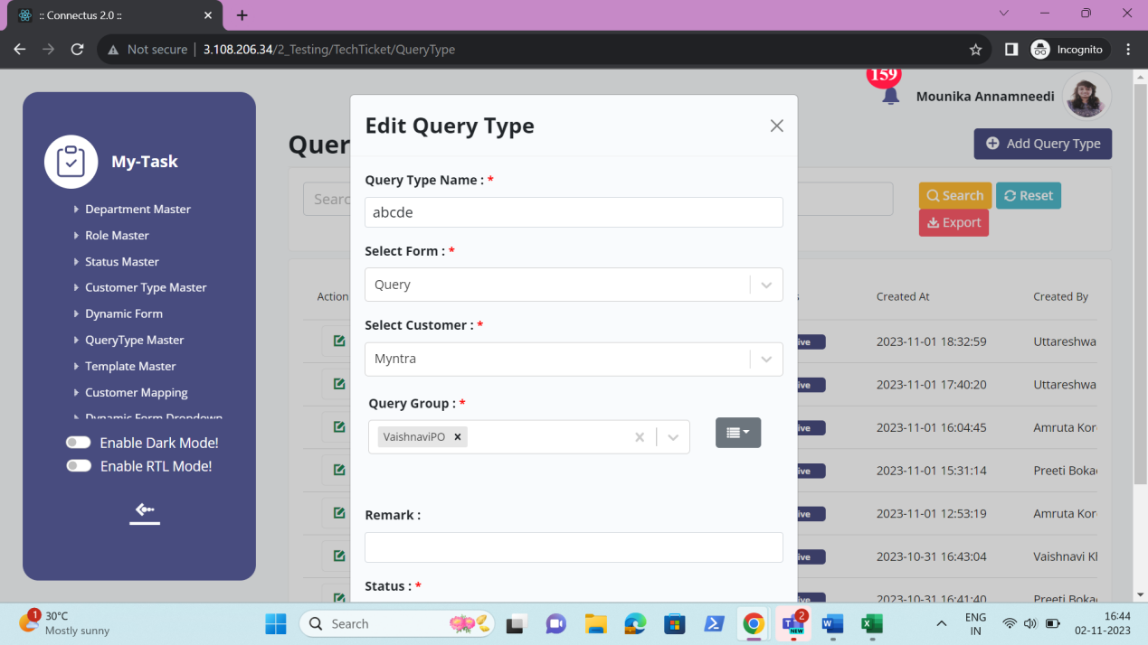

Export data
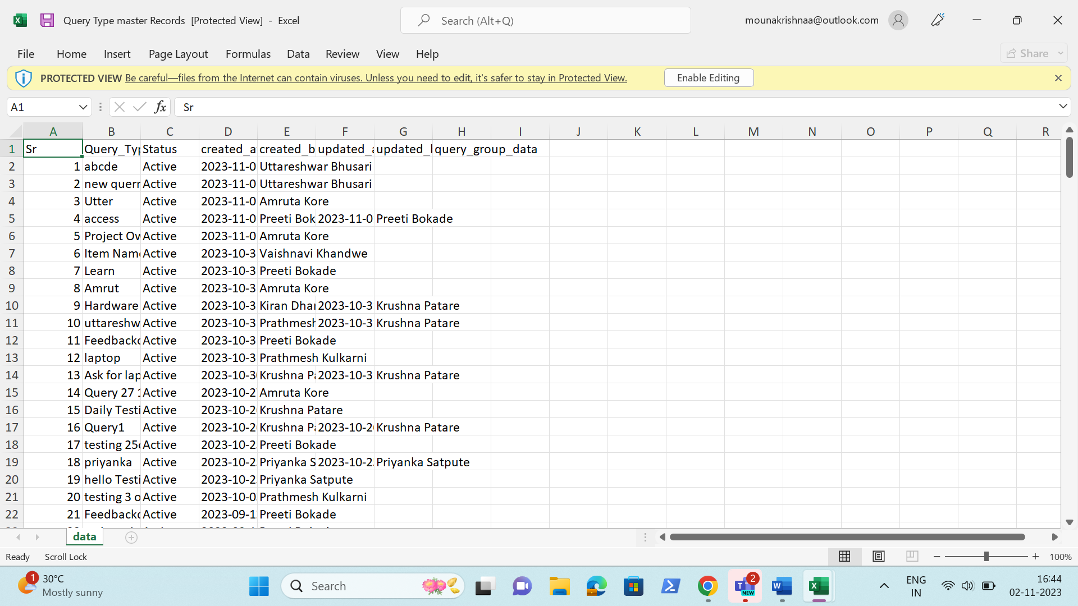

QUERY GROUP MASTER
The query group master is the parent of the query types. The query group consists of the following.
- Search
- Reset
- Export
- Add query group
- Sr
- Query group
- Remark
- Status
- Created at
- Created by
- Updated at
- Updated by
- Action

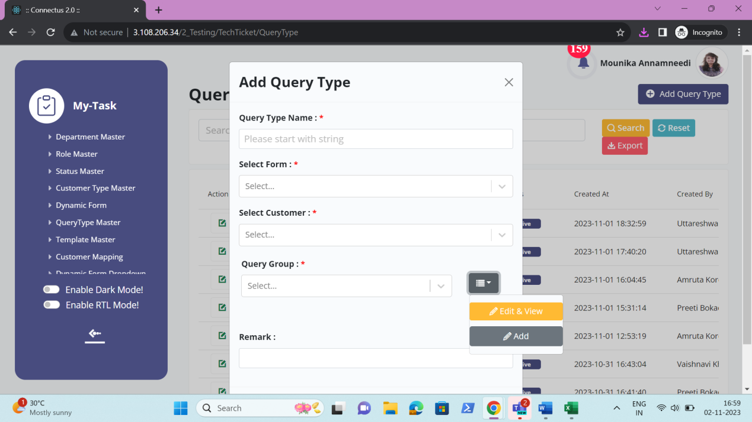

The master consists of the following actions.
Fields | Edit & View | Add | Export
Search | ✓ | x | x
Reset | ✓ | x | x
Export | ✓ | x | x
Add query group | ✓ | x | x
Sr | ✓ | x | ✓
Query group | ✓ | ✓ | ✓
Status | ✓ | x | ✓
Created at | ✓ | x | ✓
Created by | ✓ | x | ✓
Updated at | ✓ | x | ✓
Updated by | ✓ | x | ✓
Grid - Action | ✓ | x | x

Input table
Fields | Input type | Mandatory/ Optional | Editable/ No | Description
Search | Button | - | - | The search tab where the user fills the data to be searched and after clicking the search button, the entered input is searched and displayed.  Validation:  The search can accept alpha-numeric with special characters as well.
Reset | Button | - | - | The reset button to reset the search tab.
Export | Button | - | - | The export button to export the data of the query groups in the query group master.
Add query group | Button | - | - | The add query group button to add the data of the query group in the master.
Sr | Auto | - | - | The serial number consists of the count of the query groups added in the query group master in the grid and export.
Query group Name | Text | Mandatory | Yes | The query group name is entered or displayed.  Validation:  Accepts alpha-numeric data and special characters up-to 100 characters.
Remark | Text | Optional | Yes | The remark if any is entered or displayed.  Validation:  Accepts alpha-numeric data with special characters up-to 1000 characters.
Status | Radio button | Mandatory | Yes | The status consists of the active and the de-active options. The query group is active or not is selected.  Validation:  When query group is added, automatically, their status is active.
Created at | Auto | Optional | Yes | The username who created the query group is displayed.
Created by | Auto | Optional | Yes | The date and time when the query group is created is displayed.  Validation:  Format - YYYY-MM-DD HH:MM:SS
Updated at | Auto | Optional | Yes | The username who last updated the query group is displayed.
Updated by | Auto | Optional | Yes | The date and time when the query group is updated last is displayed.  Validation:  Format - YYYY-MM-DD HH:MM:SS
Grid - Action | Button | - | - | The action field consist of the edit button to edit the data of the query group.

Add data
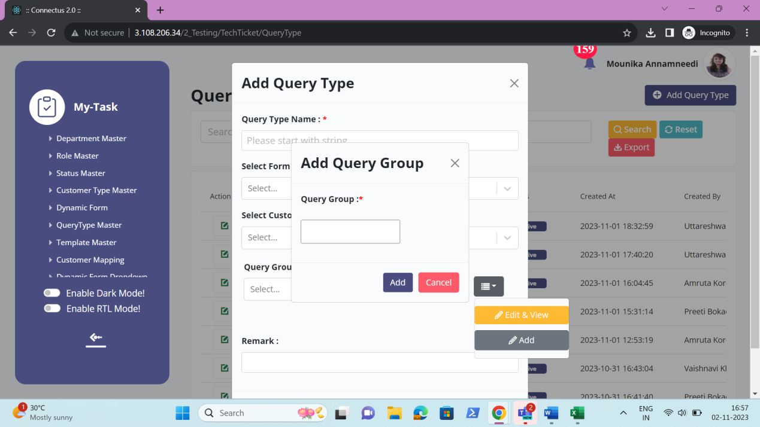

Edit & view data
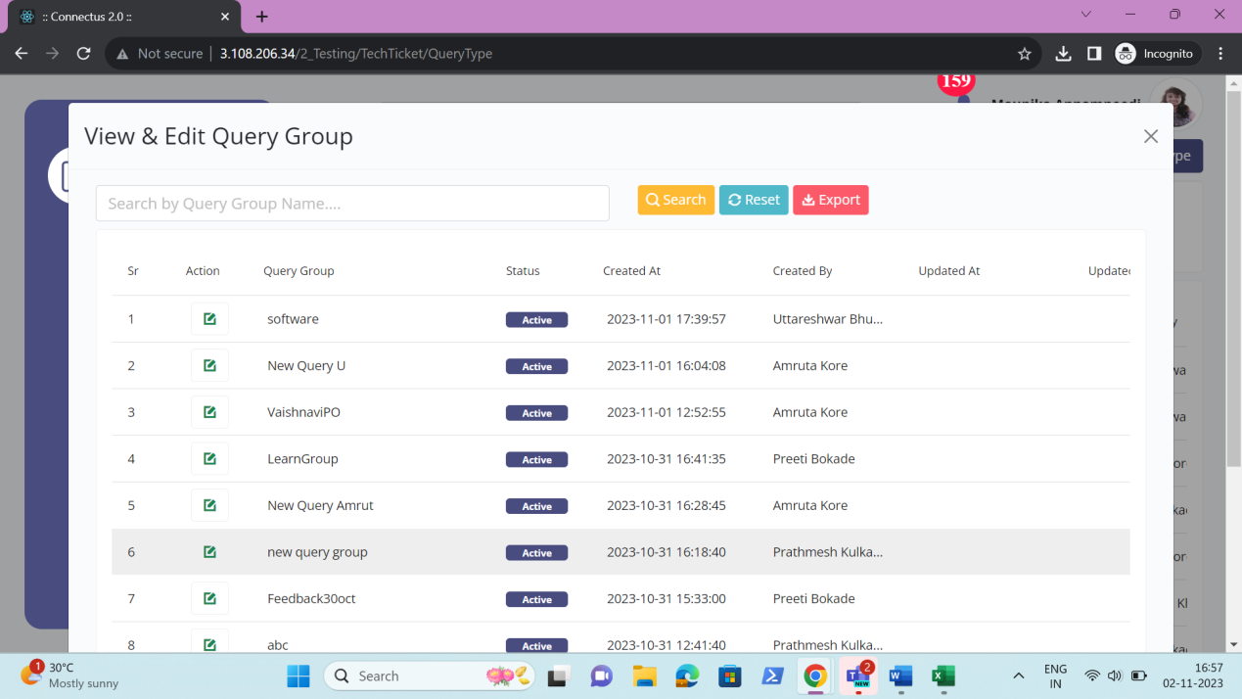

Export data
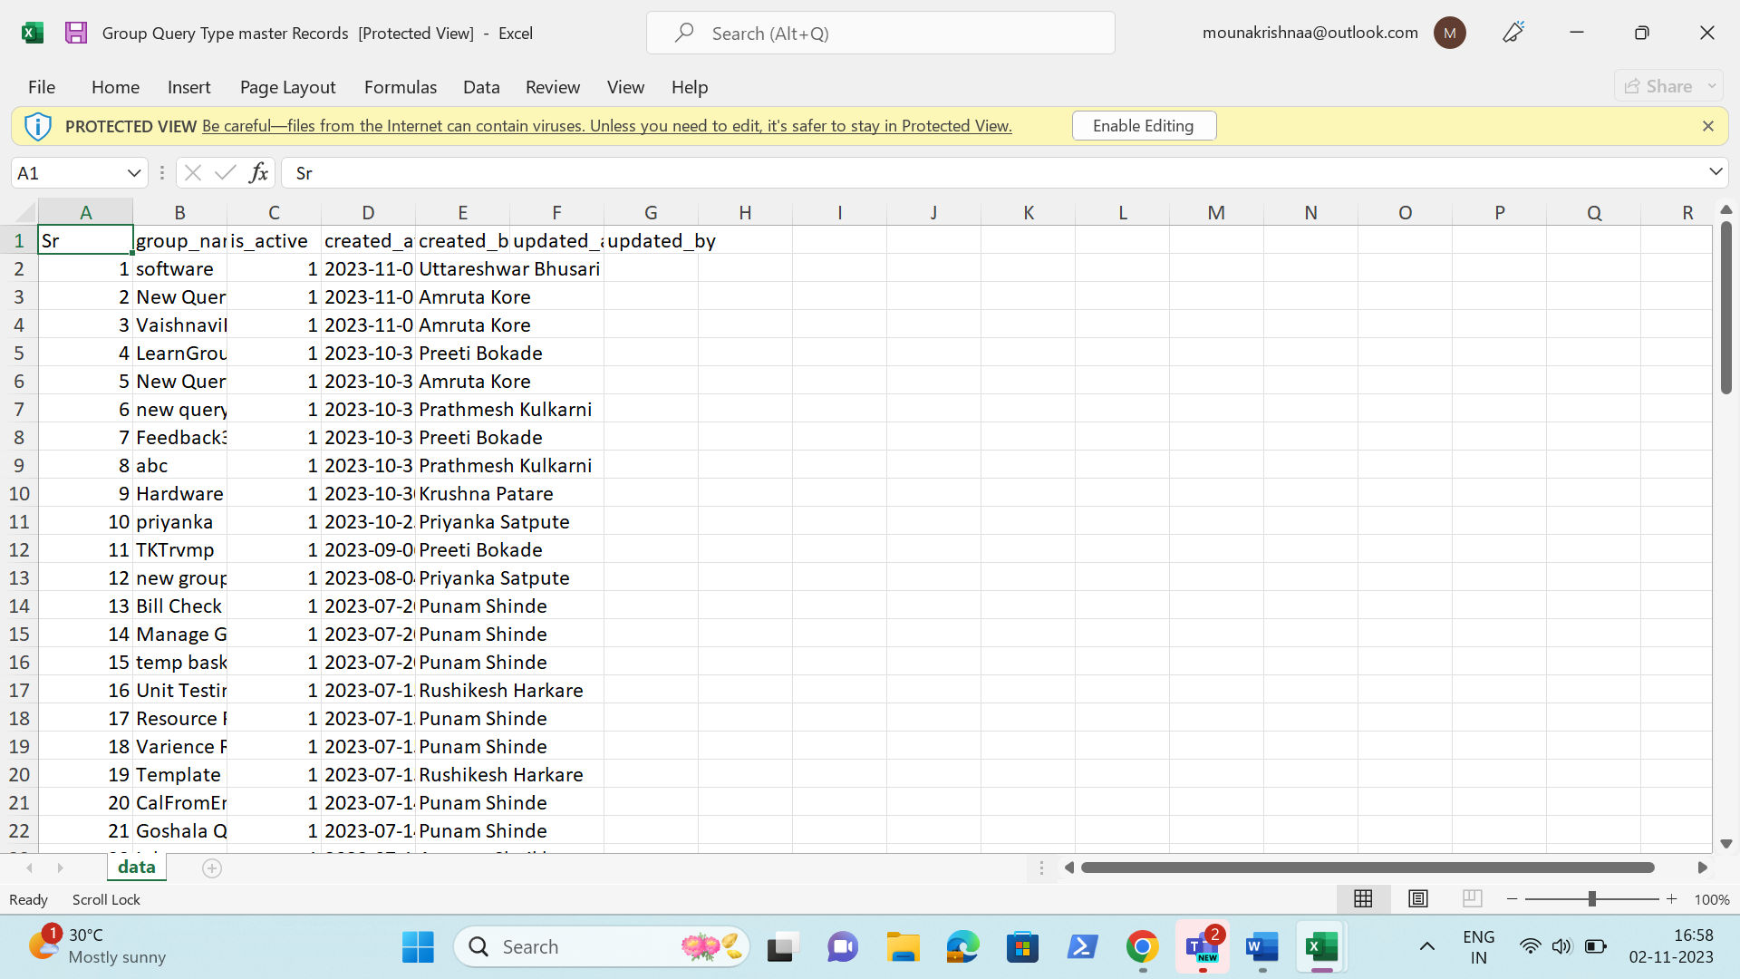

TEMPLATE MASTER
The template master consists of all the templates details which helps in fetching the data easily. The following are the fields in template master.
- Search
- Reset
- Export
- Add template
- Sr
- Template
- Calculate days from
- Basket - Sr
- Basket name
- Assign to
- Basket - Action
- Edit basket
- Create task
- Edit task
- Basket - Submit
- Basket - Cancel
- Title
- Days required
- Hours required
- Start task after days/ End task before days
- Add task
- Delete task
- Remark
- Status
- Created at
- Created by
- Updated at
- Updated by
- Action

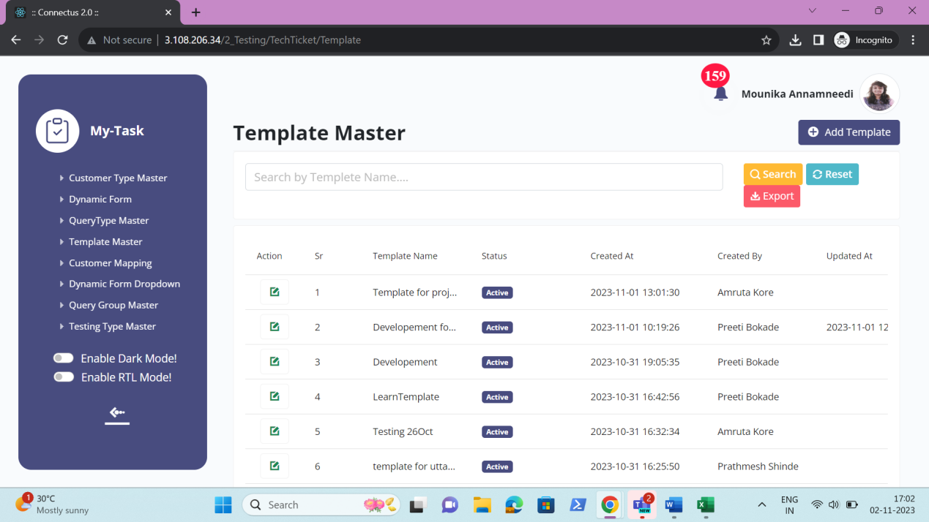

The master consists of the following actions.
Fields | Grid view | Add | Edit | Export
Search | ✓ | x | x | x
Reset | ✓ | x | x | x
Export | ✓ | x | x | x
Add template | ✓ | x | x | x
Sr | ✓ | x | x | ✓
Template | ✓ | ✓ | ✓ | ✓
Calculate days from | x | ✓ | ✓ | ✓
Basket - Sr | x | ✓ | ✓ | ✓
Basket name | x | ✓ | ✓ | ✓
Assign to | x | ✓ | ✓ | ✓
Basket - Action | x | ✓ | ✓ | x
Edit basket | x | ✓ | ✓ | x
Create task | x | ✓ | ✓ | x
Edit task | x | ✓ | ✓ | x
Basket - Submit | x | ✓ | ✓ | x
Basket - Cancel | x | ✓ | ✓ | x
Title | x | ✓ | ✓ | ✓
Days required | x | ✓ | ✓ | ✓
Hours required | x | ✓ | ✓ | ✓
Start task after days/ End task before days | x | ✓ | ✓ | ✓
Add task | x | ✓ | ✓ | x
Delete task | x | ✓ | ✓ | x
Remark | x | ✓ | ✓ | ✓
Status | ✓ | x | ✓ | ✓
Created at | ✓ | x | x | ✓
Created by | ✓ | x | x | ✓
Updated at | ✓ | x | x | ✓
Updated by | ✓ | x | x | ✓
Grid - Action | ✓ | x | x | x

Input table
Fields | Input type | Mandatory/ Optional | Editable/ No | Description
Search | Button | - | - | The search tab where the user fills the data to be searched and after clicking the search button, the entered input is searched and displayed.  Validation:  The search can accept alpha-numeric with special characters as well.
Reset | Button | - | - | The reset button to reset the search tab.
Export | Button | - | - | The export button to export the data of the templates in the template master.
Add template | Button | - | - | The add template button to add the data of the template in the master.
Sr | Auto | - | - | The serial number consists of the count of the templates added in the template master in the grid and export.
Template Name | Text | Mandatory | Yes | The template name is entered or displayed.  Validation:  Accepts alpha-numeric data and special characters up-to 100 characters.
Calculate days from | Drop down | Mandatory | Yes | The calculation of the task based on the start date of the ticket or end date of the ticket is selected from the drop-down. The drop-down options consist of the following.  - Start date  - End date  The start date is selected when the task to be started based on the ticket creation date.  The end date is selected when the task to be started based on the ticket end date.  Validation:  Single selection
Basket - Sr | Auto | - | - | The serial count of the baskets is displayed in order.
Basket name | Text | Mandatory | Yes | The basket name of the basket to be created under the ticket is entered or displayed.  Validation:  Accepts alpha-numeric data with special characters up-to 50 characters.
Assign to | Drop down | Mandatory | Yes | The assign to name of the user where the basket to be assigned is selected from the drop down. The drop-down options are fetched from the user master.  Validation:  - The active users are fetched from the user master.  - Single selection
Basket - Action | Button | - | - | The action field consists of add button to add the other basket into the template. The delete button against the added basket to delete the basket.
Edit basket | Button | - | - | The edit basket button to edit the basket created.
Create task | Button | - | - | Create task button to create the task under the basket created.
Edit task | Button | - | - | The edit task button to edit the task created.
Basket - Submit | Button | - | - | The submit button to add or update the details of the basket and the tasks added or updated.
Basket - Cancel | Button | - | - | The cancel button to cancel the details given in the basket or the task.
Title | Text | Mandatory | Yes | The task name to be entered or displayed.  Validation:  Accepts alpha-numeric data with special characters up-to 100 characters.
Days required | Int | Mandatory | Yes | The days required to finish the task is entered or displayed.  Validation:  Accepts only integers up-to 2 digits.
Hours required | Int | Mandatory | Yes | The hours required to finish the task is entered or displayed.  Validation:  Accepts only integers up-to 3 digits.
Start task after days/ End task before days | Int | Mandatory | Yes | If start date is selected in the calculate days from field, then start days after days is displayed. If end date is selected in the calculate days from field, then end task before days is displayed.  Start task after days is calculated based on the days calculated from ticket creation date selected.  End task before days is calculated based on the days calculated from tick end date selected.  The days to be entered.  Validation:  Accepts only integers up-to 2 digits.
Add task | Button | - | - | The add task button to add the task under the basket.
Delete task | Button | - | - | The delete task button to delete the task under the basket.
Remark | Text | Optional | Yes | The remark if any is entered or displayed.  Validation:  Accepts alpha-numeric data with special characters up-to 1000 characters.
Status | Radio button | Mandatory | Yes | The status consists of the active and the de-active options. The template is active or not is selected.  Validation:  When template is added, automatically, their status is active.
Created at | Auto | Optional | Yes | The username who created the template is displayed.
Created by | Auto | Optional | Yes | The date and time when the template is created is displayed.  Validation:  Format - YYYY-MM-DD HH:MM:SS
Updated at | Auto | Optional | Yes | The username who last updated the template is displayed.
Updated by | Auto | Optional | Yes | The date and time when the template is updated last is displayed.  Validation:  Format - YYYY-MM-DD HH:MM:SS
Grid - Action | Button | - | - | The action field consist of the edit button to edit the data of the template.

Add data
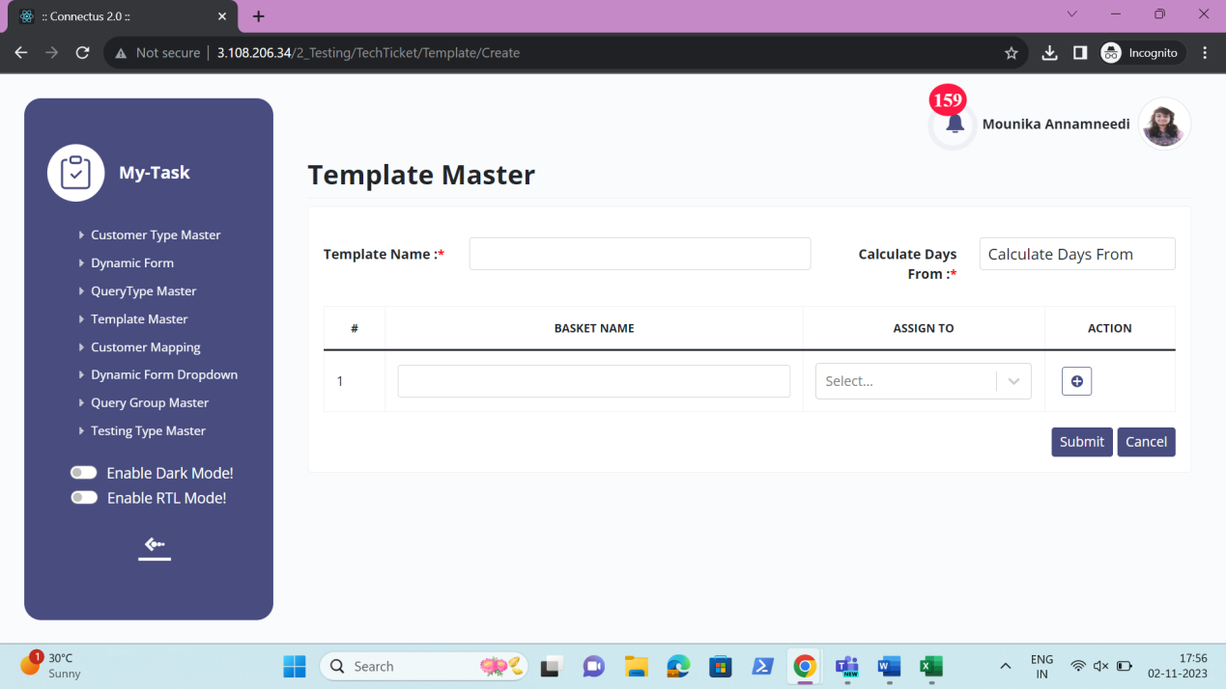

Edit data
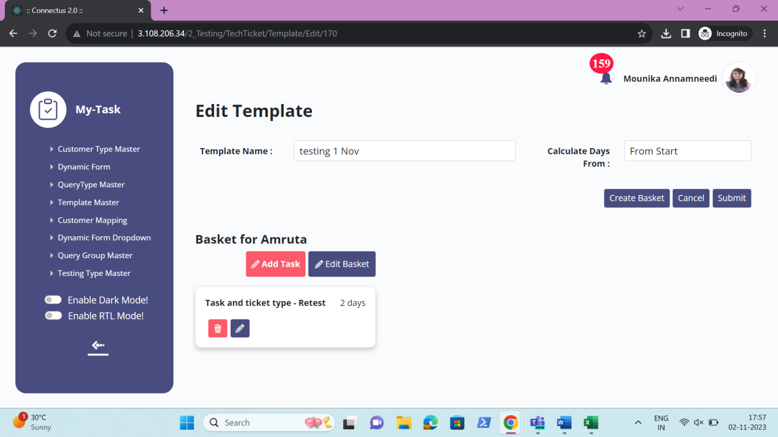

Export data
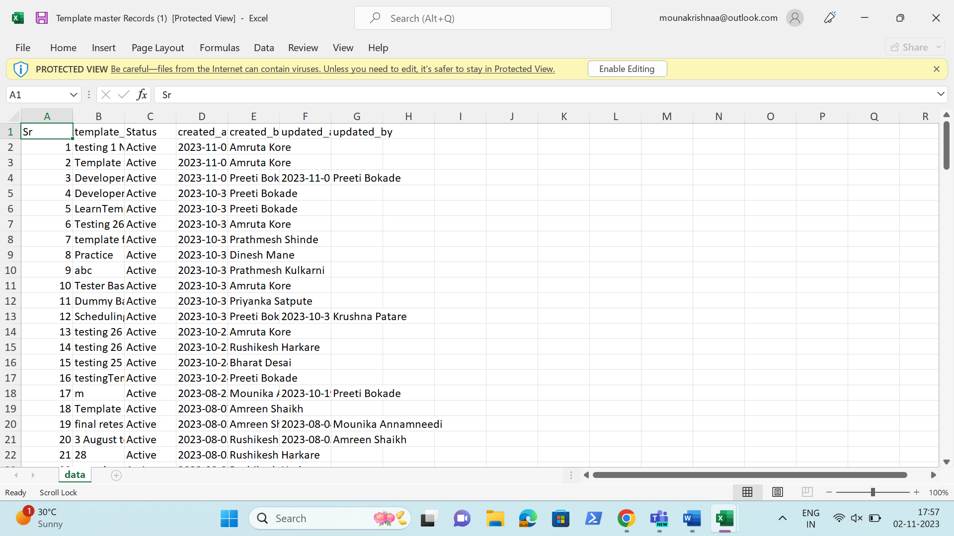

CUSTOMER MAPPING
The customer mapping concept refers to the mapping of customers based on the query type. So, the tickets are directly assigned to the users based on the query type selected at the time of creation of the ticket. The following are the mapping based on the following.
- Customer type
- Query type
- Priority
- Approach
- Department
The customer mapping consists of the following fields.
- Search
- Reset
- Export
- Add customer mapping
- Sr
- Select customer type
- Select query type
- Select form
- Select template
- Select priority
- Select approach
- Select department
- Select user
- Users
- Ratios
- Confirmation required
- Remark
- Status
- Created at
- Created by
- Updated at
- Updated by
- Action

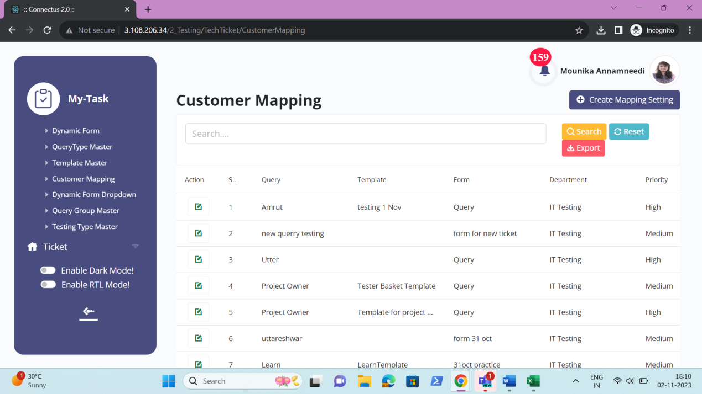

The master consists of the following actions.
Fields | Grid view | Add | Edit | Export
Search | ✓ | x | x | x
Reset | ✓ | x | x | x
Export | ✓ | x | x | x
Add customer mapping | ✓ | x | x | x
Sr | ✓ | x | x | ✓
Select customer type | ✓ | ✓ | ✓ | ✓
Select query type | ✓ | ✓ | ✓ | ✓
Select form | ✓ | ✓ | ✓ | ✓
Select template | ✓ | ✓ | ✓ | ✓
Select priority | ✓ | ✓ | ✓ | ✓
Select approach | ✓ | ✓ | ✓ | ✓
Select department | ✓ | ✓ | ✓ | ✓
Select user | x | ✓ | ✓ | ✓
Users | x | ✓ | ✓ | ✓
Ratios | x | ✓ | ✓ | ✓
Confirmation required | x | ✓ | ✓ | ✓
Remark | x | ✓ | ✓ | ✓
Status | ✓ | x | ✓ | ✓
Created at | ✓ | x | x | ✓
Created by | ✓ | x | x | ✓
Updated at | ✓ | x | x | ✓
Updated by | ✓ | x | x | ✓
Grid - Action | ✓ | x | x | x

Input table
Fields | Input type | Mandatory/ Optional | Editable/ No | Description
Search | Button | - | - | The search tab where the user fills the data to be searched and after clicking the search button, the entered input is searched and displayed.  Validation:  The search can accept alpha-numeric with special characters as well.
Reset | Button | - | - | The reset button to reset the search tab.
Export | Button | - | - | The export button to export the data of the customer mapping in the customer mapping master.
Add customer mapping | Button | - | - | The add customer mapping button to add the data of the customer mapping in the master.
Sr | Auto | - | - | The serial number consists of the count of the customer mapping added in the customer mapping master in the grid and export.
Select customer type | Drop down | Mandatory | Yes | The customer type is selected from the drop down. The drop-down options are fetched from the customer type master.  Validations:  - The active customer types are fetched from the customer type master.  - Single selection
Select query type | Drop down | Mandatory | Yes | The query type is selected from the drop down. The drop-down options are fetched from the query type master.  Validations:  - The active query types are fetched from the query type master.  - Single selection
Select form | Drop down | Mandatory | Yes | The dynamic form is selected from the drop down based on the query type selected. The drop-down options are fetched from the dynamic form master.  Validations:  - The active dynamic forms are fetched from the dynamic form master.  - Single selection
Select template | Drop down | Optional | Yes | The template is selected from the drop down. The drop-down options are fetched from the template master.  Validations:  - The active templates are fetched from the template master.  - Single selection
Select priority | Drop down | Mandatory | Yes | The priority is selected from the drop down. The drop-down options are fetched from the priority master.  Validations:  - The active priorities are fetched from the priority master.  - Multiple selection
Select approach | Drop down | Mandatory | Yes | The approach in which the ticket is assigned is based on the approach selected. The approach consists of the following options.  - Department wise round robin  - User having less ticket  - Single person  - Ratio wise  The Department wise round robin refers to where the tickets are distributed among the departments in the round wise equally. It goes on disturbing the tickets in circular motion irrespective of the tickets, the user have. When the user selects the department wise round robin, then automatically, extra field will be displayed in which the user to be selected.  User having less tickets refers to where, in a department, where there are less tickets, the tickets are assigned to those persons accordingly. When the user selects the user having less tickets approach, then automatically, extra field will be displayed in which the user to be selected.  Single person refers to where the few tickets based on the above factors, selected to specific person. When the user selects the single person, then automatically, extra field will be displayed in which the user to be selected.  Ratio wise refers to where the tickets are distributed in ratio wise in the departments. When the user selects the ratio wise, automatically, there will be the extra fields of the users against the department and the empty fields for entering the ratios among the users. So that the users are assigned the tickets based on those ratios.  Validation:  Single selection
Select department | Drop down | Mandatory | Yes | The department to whom the ticket is selected from the drop down. The department drop down options are fetched from the department master.  Validation:  - The active departments are fetched from the department master.  - Single selection
Select user | Drop down | - | Yes | The select user field will get enabled when the following approaches are selected.  - Department wise round robin  - User having less ticket  - Single person  The users to whom the tickets to be assigned is selected from the user master from the drop down. The drop-down options are fetched from the user master.  Validation:  - The active users are fetched from the user master  - Multiple selection
Users | Auto | - | Yes | The user field will get enabled when ratio-wise is selected. The users in that department are displayed in order.  Validation:  Only active users are fetched from the user master.
Ratios | Int | - | Yes | The ratios field get enabled when ratio-wise is selected. The ratios to be assigned against the user is mentioned or displayed.  Validation:  Accepts only integers and the total should not be more or less than 100.
Confirmation required | Radio button | Mandatory | Yes | The confirmation required at the time of solving the ticket is required or not is selected.  Validation:  - Single selection  - By default, the confirmation required is not selected.
Remark | Text | Optional | Yes | The remark if any is entered or displayed.  Validation:  Accepts alpha-numeric data with special characters up-to 1000 characters.
Status | Radio button | Mandatory | Yes | The status consists of the active and the de-active options. The customer mapping is active or not is selected.  Validation:  When country is added, automatically, their status is active.
Created at | Auto | Optional | Yes | The username who created the customer mapping is displayed.
Created by | Auto | Optional | Yes | The date and time when the customer mapping is created is displayed.  Validation:  Format - YYYY-MM-DD HH:MM:SS
Updated at | Auto | Optional | Yes | The username who last updated the customer mapping is displayed.
Updated by | Auto | Optional | Yes | The date and time when the customer mapping is updated last is displayed.  Validation:  Format - YYYY-MM-DD HH:MM:SS
Grid - Action | Button | - | - | The action field consist of the edit button to edit the data of the customer mapping.

Add data
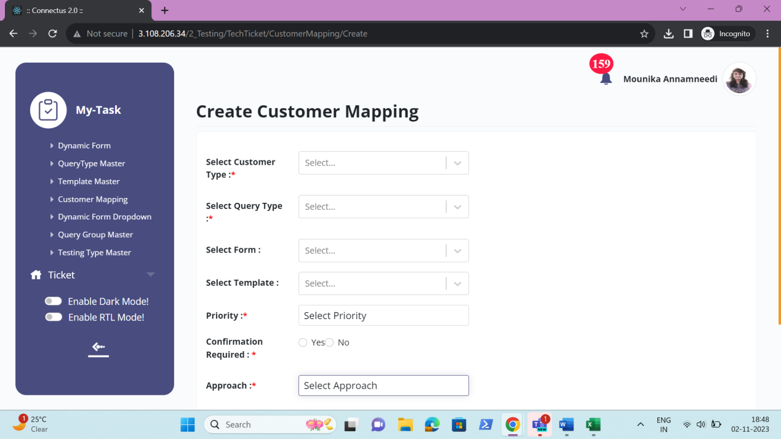

Edit data
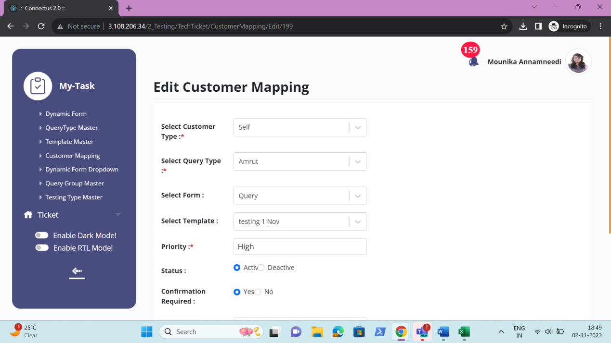

Department wise round robin
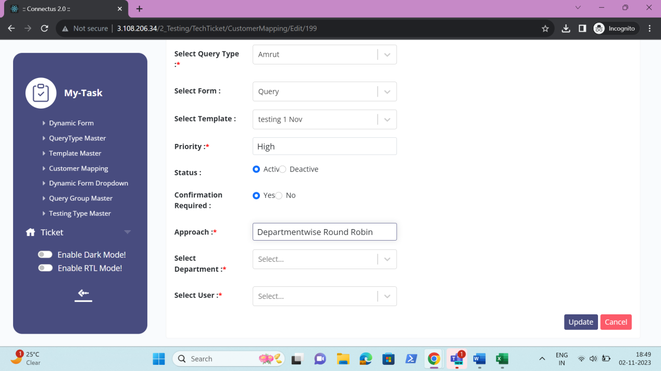

User having less tickets
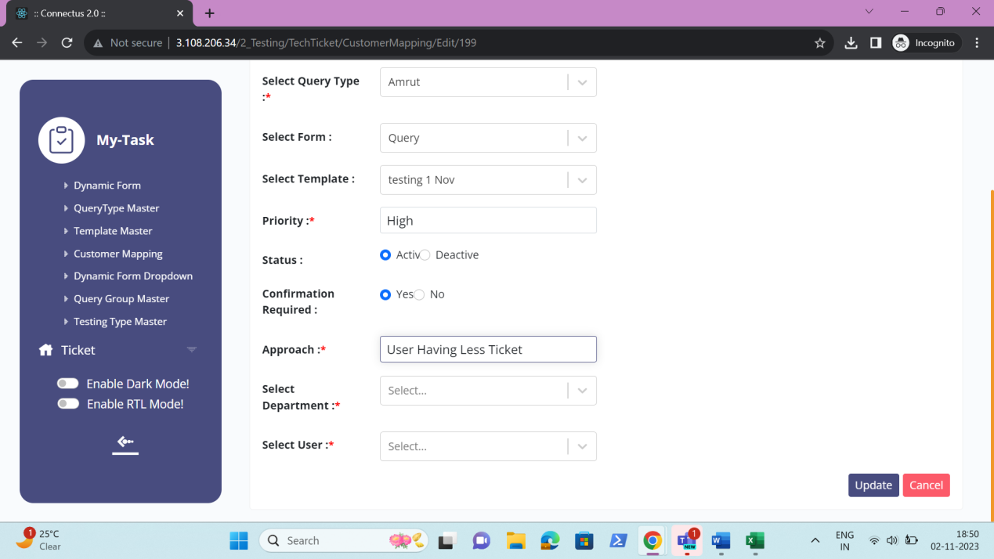

Single selection
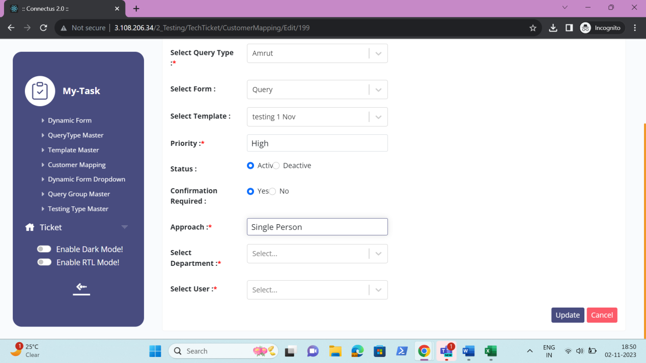

Ratio wise
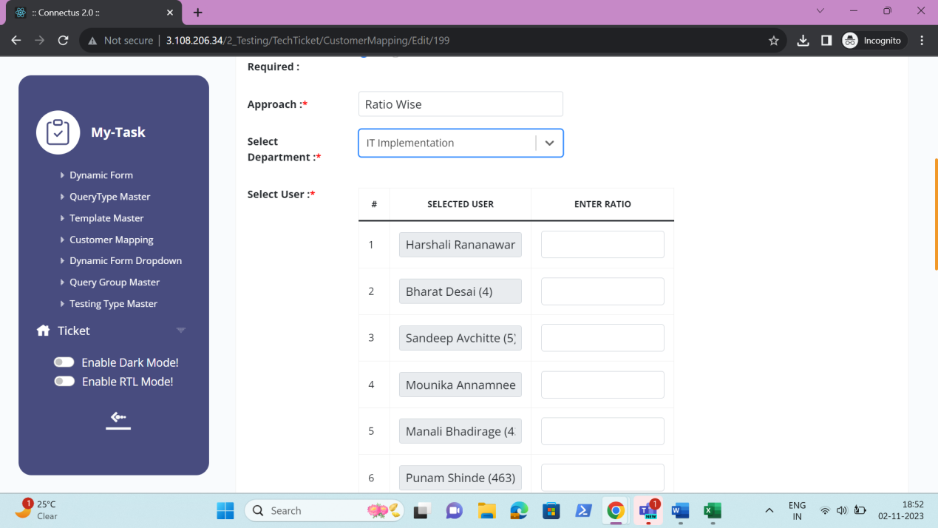

Export data
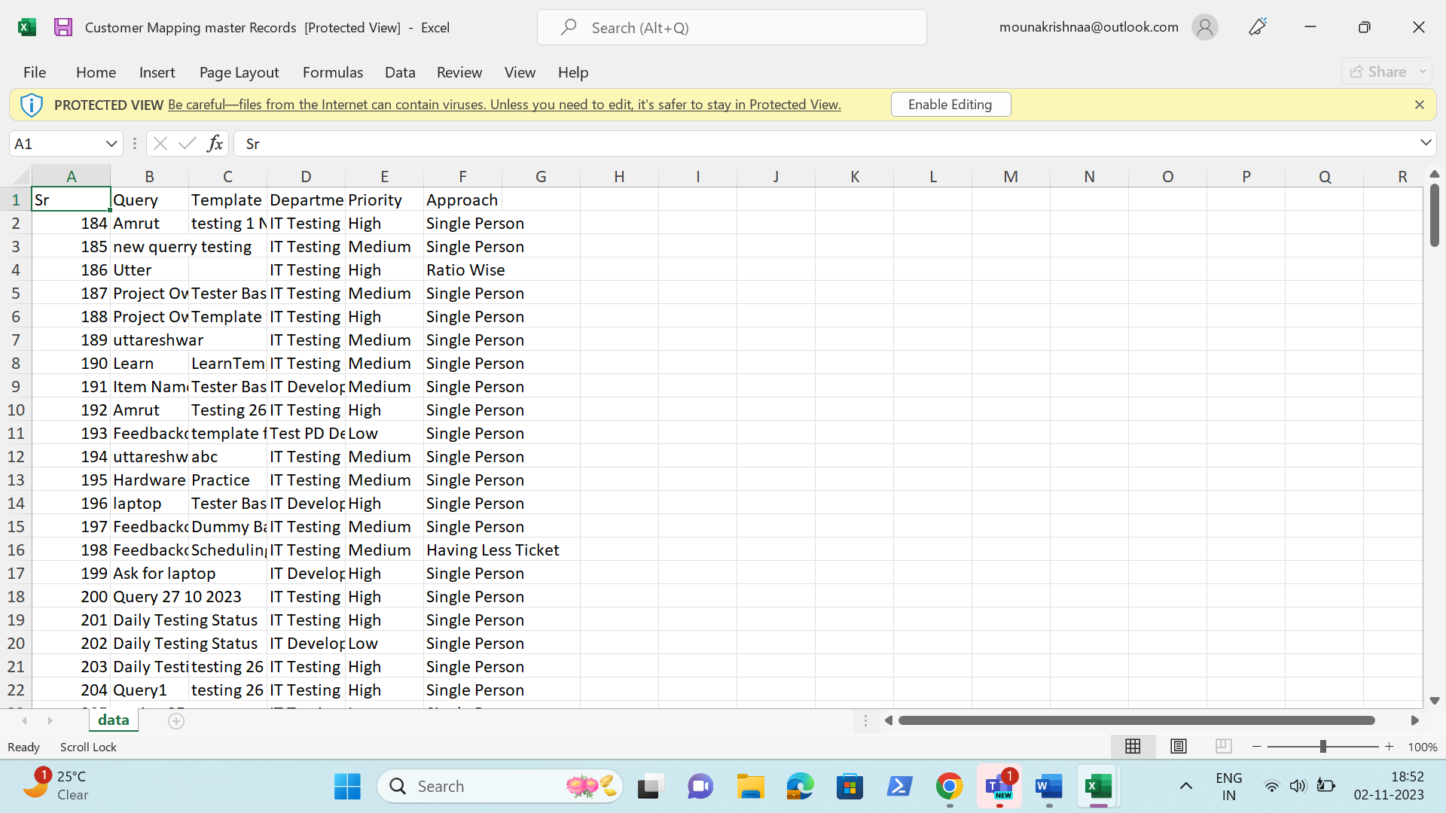

DYNAMIC FORM DROP DOWN
The dynamic form drop-down at the time of selection of select type, check box and radio button in dynamic form (in ticketing system >> masters >> dynamic form). The drop-down masters consist of the drop-down options consists of values of drop-down values. The drop-down masters consist of the following.
- Search
- Reset
- Export
- Add drop down
- Sr
- Drop down
- Drop down - Sr No
- Value
- Label
- Action
- Remark
- Status
- Created at
- Created by
- Updated at
- Updated by
- Action

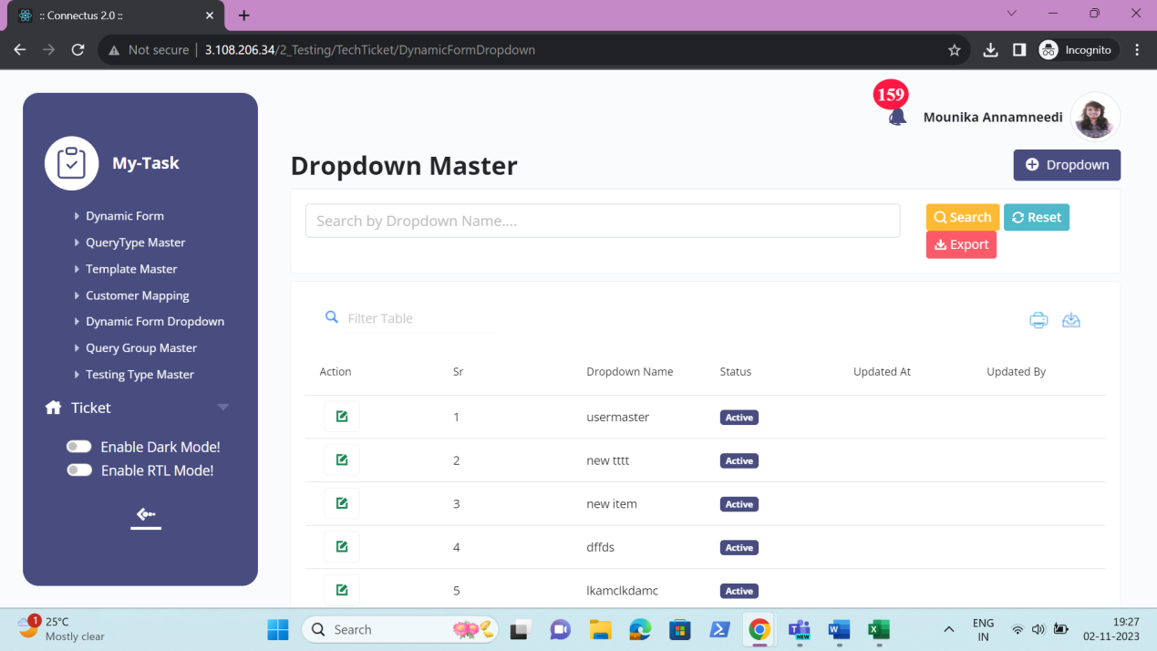

The master consists of the following actions.
Fields | Grid view | Add | Edit | Export
Search | ✓ | x | x | x
Reset | ✓ | x | x | x
Export | ✓ | x | x | x
Add drop down | ✓ | x | x | x
Sr | ✓ | x | x | ✓
Drop down | ✓ | ✓ | ✓ | ✓
Drop down - Sr No | x | ✓ | ✓ | ✓
Value | x | ✓ | ✓ | ✓
Label | x | ✓ | ✓ | ✓
Action | x | ✓ | ✓ | x
Remark | x | ✓ | ✓ | ✓
Status | ✓ | x | ✓ | ✓
Created at | ✓ | x | x | ✓
Created by | ✓ | x | x | ✓
Updated at | ✓ | x | x | ✓
Updated by | ✓ | x | x | ✓
Grid - Action | ✓ | x | x | x

Input table
Fields | Input type | Mandatory/ Optional | Editable/ No | Description
Search | Button | - | - | The search tab where the user fills the data to be searched and after clicking the search button, the entered input is searched and displayed.  Validation:  The search can accept alpha-numeric with special characters as well.
Reset | Button | - | - | The reset button to reset the search tab.
Export | Button | - | - | The export button to export the data of the countries in the country master.
Add drop down | Button | - | - | The add drop down button to add the data of the drop down in the master.
Sr | Auto | - | - | The serial number consists of the count of the drop down added in the drop-down master in the grid and export.
Drop down | Text | Mandatory | Yes | The drop-down name is entered or displayed.  Validation:  Accepts alpha-numeric data and special characters up-to 100 characters.
Drop down - Sr No | Auto | - | - | The serial order of the rows added is displayed
Value | Text | Mandatory | Yes | The value of the field is entered or displayed.  Validation:  Accepts alpha-numeric data with special characters up-to 100 characters.
Label | Text | Mandatory | Yes | The label of the field is entered or displayed.  Validation:  Accepts alpha-numeric data with special characters up-to 100 characters.
Action | Button | - | - | The add button to add the row. The added row contains the delete button against the row to delete the added row.
Remark | Text | Optional | Yes | The remark if any is entered or displayed.  Validation:  Accepts alpha-numeric data with special characters up-to 1000 characters.
Status | Radio button | Mandatory | Yes | The status consists of the active and the de-active options. The drop-down is active or not is selected.  Validation:  When country is added, automatically, their status is active.
Created at | Auto | Optional | Yes | The username who created the drop-down is displayed.
Created by | Auto | Optional | Yes | The date and time when the drop-down is created is displayed.  Validation:  Format - YYYY-MM-DD HH:MM:SS
Updated at | Auto | Optional | Yes | The username who last updated the drop-down is displayed.
Updated by | Auto | Optional | Yes | The date and time when the drop-down is updated last is displayed.  Validation:  Format - YYYY-MM-DD HH:MM:SS
Grid - Action | Button | - | - | The action field consist of the edit button to edit the data of the drop-down.

Add data
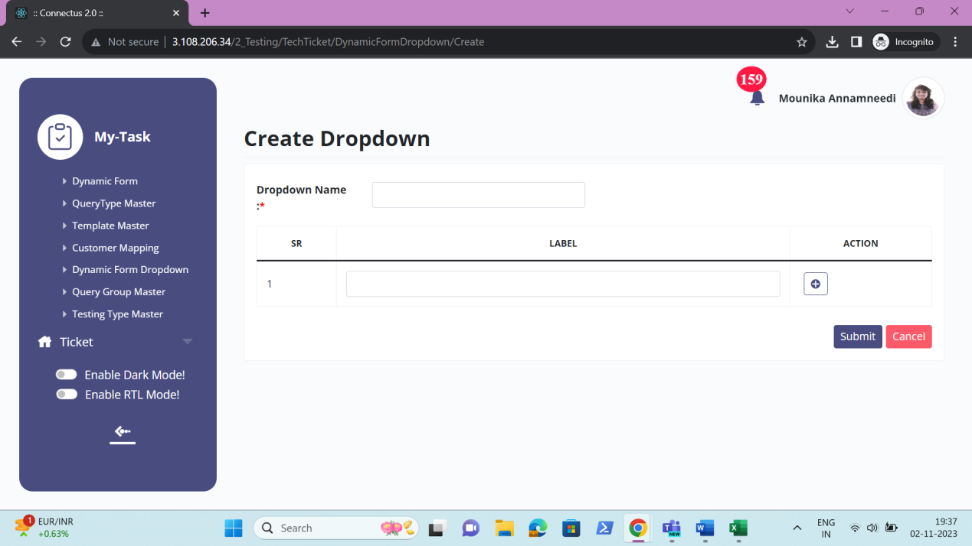

Edit data
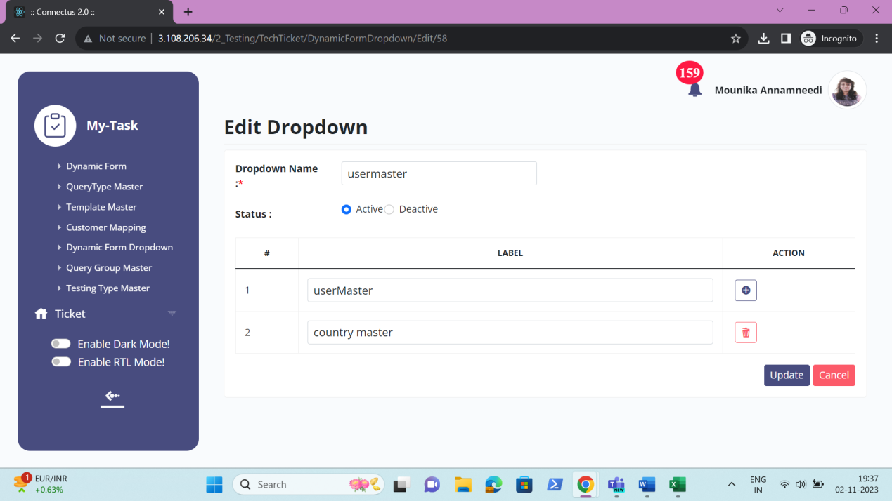

Export data
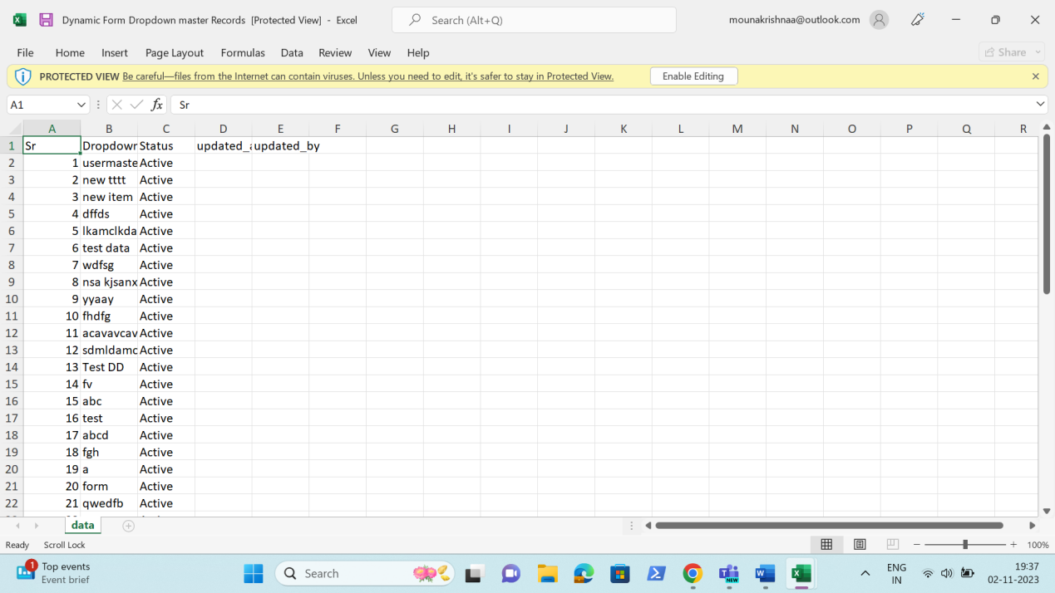

QUERY GROUP MASTER
The query group master is mapped on the query type selected. The query group master consists of all the query group details which helps in the easy access of the data. The following are the fields in query group master.
- Search
- Reset
- Export
- Add query group
- Sr
- Query group
- Query type
- Remark
- Status
- Created at
- Created by
- Updated at
- Updated by
- Action

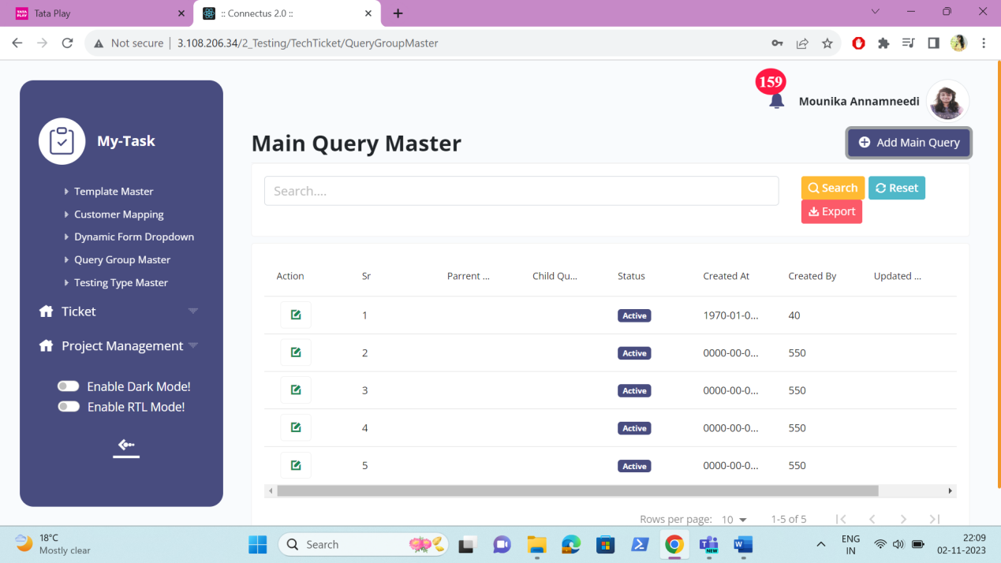

The master consists of the following actions.
Fields | Grid view | Add | Edit | Export
Search | ✓ | x | x | x
Reset | ✓ | x | x | x
Export | ✓ | x | x | x
Add query group | ✓ | x | x | x
Sr | ✓ | x | x | ✓
Query group | ✓ | ✓ | ✓ | ✓
Query type | ✓ | ✓ | ✓ | ✓
Remark | x | ✓ | ✓ | ✓
Status | ✓ | x | ✓ | ✓
Created at | ✓ | x | x | ✓
Created by | ✓ | x | x | ✓
Updated at | ✓ | x | x | ✓
Updated by | ✓ | x | x | ✓
Grid - Action | ✓ | x | x | x

Input table
Fields | Input type | Mandatory/ Optional | Editable/ No | Description
Search | Button | - | - | The search tab where the user fills the data to be searched and after clicking the search button, the entered input is searched and displayed.  Validation:  The search can accept alpha-numeric with special characters as well.
Reset | Button | - | - | The reset button to reset the search tab.
Export | Button | - | - | The export button to export the data of the query group in the query group master.
Add query group | Button | - | - | The add query group button to add the data of the query group in the master.
Sr | Auto | - | - | The serial number consists of the count of the query group added in the query group master in the grid and export.
Query group Name | Text | Mandatory | Yes | The query group name is entered or displayed.  Validation:  Accepts alpha-numeric data and special characters up-to 100 characters.
Query Type | Drop down | Mandatory | Yes | The query group is selected from the drop-down. The drop-down options are fetched from the query group master.  Validation:  - Only active query group are fetched from the query group master  - Single selection
Remark | Text | Optional | Yes | The remark if any is entered or displayed.  Validation:  Accepts alpha-numeric data with special characters up-to 1000 characters.
Status | Radio button | Mandatory | Yes | The status consists of the active and the de-active options. The query group is active or not is selected.  Validation:  When query group is added, automatically, their status is active.
Created at | Auto | Optional | Yes | The username who created the query group is displayed.
Created by | Auto | Optional | Yes | The date and time when the query group is created is displayed.  Validation:  Format - YYYY-MM-DD HH:MM:SS
Updated at | Auto | Optional | Yes | The username who last updated the query group is displayed.
Updated by | Auto | Optional | Yes | The date and time when the query group is updated last is displayed.  Validation:  Format - YYYY-MM-DD HH:MM:SS
Grid - Action | Button | - | - | The action field consist of the edit button to edit the data of the query group.

Add data
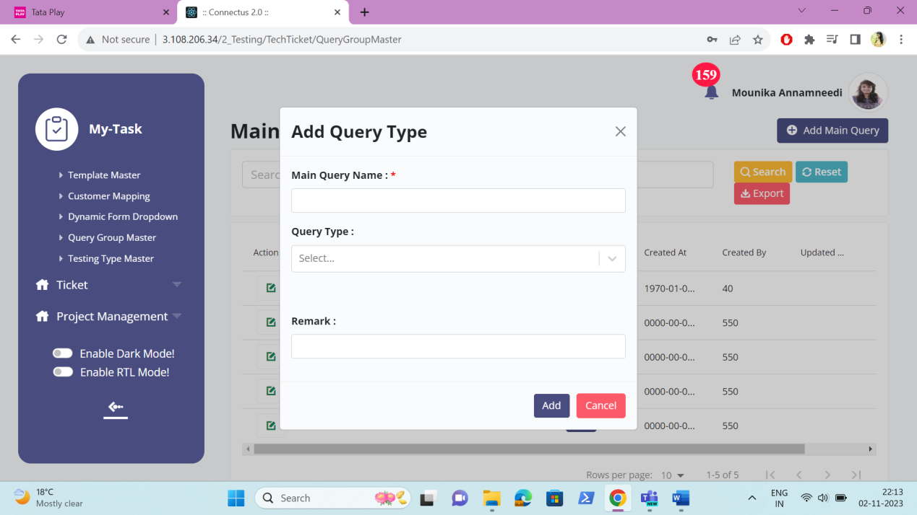

Edit data
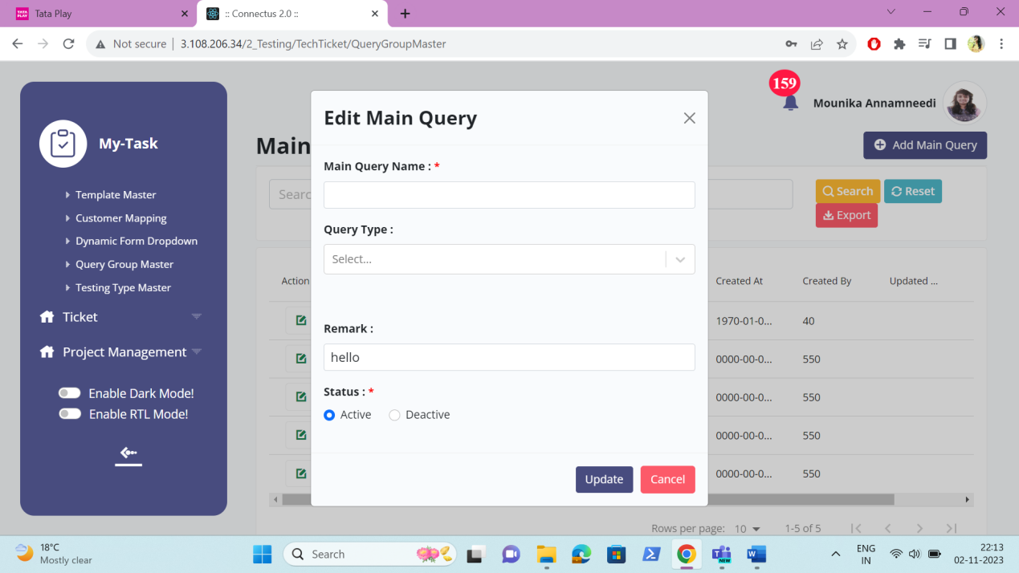

Export data

TESTING TYPE MASTER
The testing type master consists of all the testing type details which helps in fetching the data easily. The following are the fields in testing type master.
• Search
• Reset
• Export
• Add testing type
• Sr
• Testing type
• Remark
• Status
• Created at
• Created by
• Updated at
• Updated by
• Action

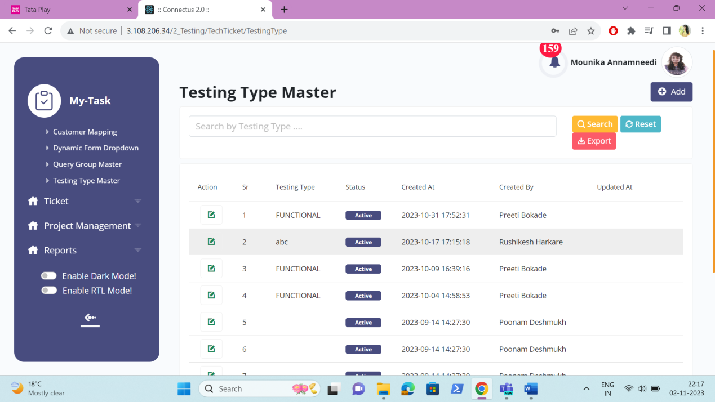

The master consists of the following actions.
Fields | Grid view | Add | Edit | Export
Search | ✓ | x | x | x
Reset | ✓ | x | x | x
Export | ✓ | x | x | x
Add testing type | ✓ | x | x | x
Sr | ✓ | x | x | ✓
Testing type | ✓ | ✓ | ✓ | ✓
Remark | x | ✓ | ✓ | ✓
Status | ✓ | x | ✓ | ✓
Created at | ✓ | x | x | ✓
Created by | ✓ | x | x | ✓
Updated at | ✓ | x | x | ✓
Updated by | ✓ | x | x | ✓
Grid - Action | ✓ | x | x | x

Input table
Fields | Input type | Mandatory/ Optional | Editable/ No | Description
Search | Button | - | - | The search tab where the user fills the data to be searched and after clicking the search button, the entered input is searched and displayed.  Validation:  The search can accept alpha-numeric with special characters as well.
Reset | Button | - | - | The reset button to reset the search tab.
Export | Button | - | - | The export button to export the data of the testing type in the testing type master.
Add testing type | Button | - | - | The add testing type button to add the data of the testing type in the master.
Sr | Auto | - | - | The serial number consists of the count of the testing type added in the testing type master in the grid and export.
Testing type Name | Text | Mandatory | Yes | The testing type name is entered or displayed.  Validation:  Accepts alpha-numeric data and special characters up-to 100 characters.
Remark | Text | Optional | Yes | The remark if any is entered or displayed.  Validation:  Accepts alpha-numeric data with special characters up-to 1000 characters.
Status | Radio button | Mandatory | Yes | The status consists of the active and the de-active options. The testing type is active or not is selected.  Validation:  When testing type is added, automatically, their status is active.
Created at | Auto | Optional | Yes | The username who created the testing type is displayed.
Created by | Auto | Optional | Yes | The date and time when the testing type is created is displayed.  Validation:  Format - YYYY-MM-DD HH:MM:SS
Updated at | Auto | Optional | Yes | The username who last updated the testing type is displayed.
Updated by | Auto | Optional | Yes | The date and time when the testing type is updated last is displayed.  Validation:  Format - YYYY-MM-DD HH:MM:SS
Grid - Action | Button | - | - | The action field consist of the edit button to edit the data of the testing type.

Add data
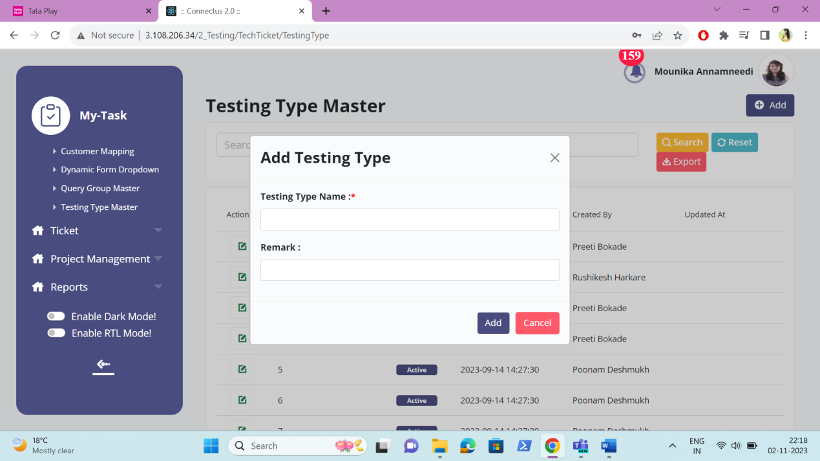

Edit data
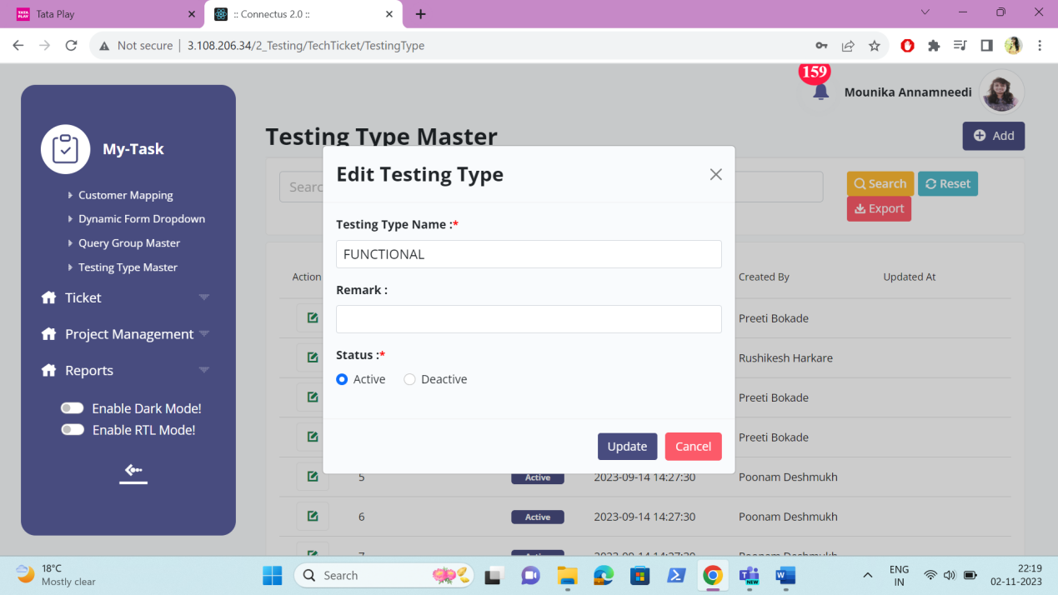

Export data
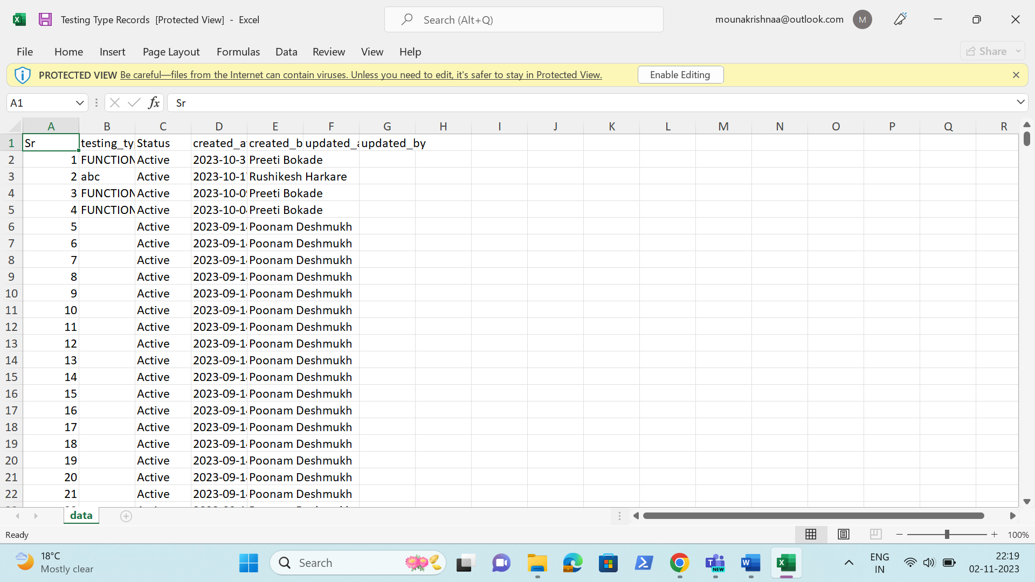

PROJECT MASTER
The project master consists of all the projects details which helps in fetching the data easily. The following are the fields in project master.
- Search
- Reset
- Export
- Add project
- Sr
- Select customer
- Project name
- Select owner
- Project logo
- Project reviewer
- Description
- GIT project URL
- API Document link
- Remark
- Status
- Created at
- Created by
- Updated at
- Updated by
- Action

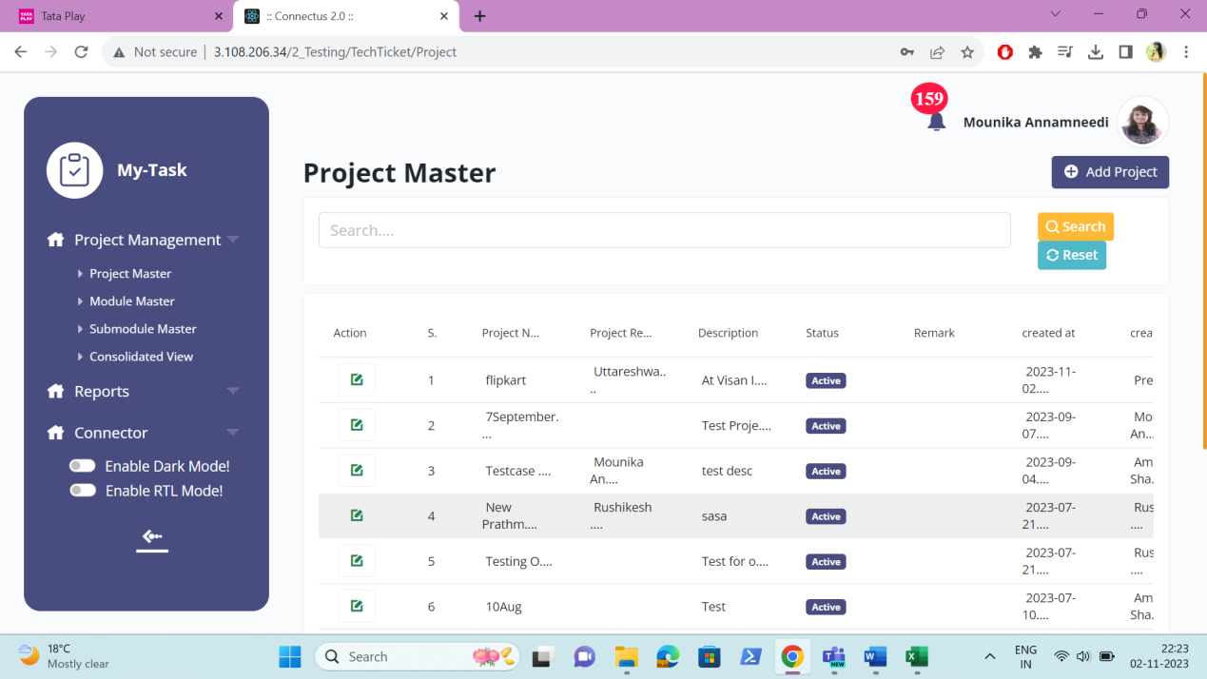

The master consists of the following actions.
Fields | Grid view | Add | Edit | Export
Search | ✓ | x | x | x
Reset | ✓ | x | x | x
Export | ✓ | x | x | x
Add project | ✓ | x | x | x
Sr | ✓ | x | x | ✓
Select customer | x | ✓ | ✓ | ✓
Project name | ✓ | ✓ | ✓ | ✓
Select owner | ✓ | ✓ | ✓ | ✓
Project logo | x | ✓ | ✓ | ✓
Project reviewer | x | ✓ | ✓ | ✓
Description | ✓ | ✓ | ✓ | ✓
GIT project URL | x | ✓ | ✓ | ✓
API Document link | x | ✓ | ✓ | ✓
Remark | x | ✓ | ✓ | ✓
Status | ✓ | x | ✓ | ✓
Created at | ✓ | x | x | ✓
Created by | ✓ | x | x | ✓
Updated at | ✓ | x | x | ✓
Updated by | ✓ | x | x | ✓
Grid - Action | ✓ | x | x | x

Input table
Fields | Input type | Mandatory/ Optional | Editable/ No | Description
Search | Button | - | - | The search tab where the user fills the data to be searched and after clicking the search button, the entered input is searched and displayed.  Validation:  The search can accept alpha-numeric with special characters as well.
Reset | Button | - | - | The reset button to reset the search tab.
Export | Button | - | - | The export button to export the data of the projects in the project master.
Add country | Button | - | - | The add project button to add the data of the project in the master.
Sr | Auto | - | - | The serial number consists of the count of the projects added in the project master in the grid and export.
Select customer | Drop down | Mandatory | Yes | The customer of the project to be selected from the drop down. The drop-down options are fetched from the customer master.  Validation:  - The active customers from the customer master is fetched.  - Multiple selection
Project name | Text | Mandatory | Yes | The project name is entered or displayed.  Validation:  Accepts alpha-numeric data and special characters up-to 100 characters.
Select owner | Drop down | Mandatory | Yes | The owner of the project to be selected from the drop down. The drop-down options are fetched from the user master.  Validation:  - The active users from the user master is fetched.  - Multiple selection
Project logo | File upload | Optional | Yes | The logo of the project is uploaded.  Validation:  The file up-to 2MB can be uploaded maximum of 1 image.
Project reviewer | Drop down | Optional | Yes | The project reviewer I.e., who reviews the test cases made by the tester and can assign the test cases to test plan for that project is selected from the drop down. The drop down options are fetched from the user master.  Validation:  - The active users are fetched from the user master  - Multiple selection
Description | Text | Mandatory | Yes | The description of the project is entered or displayed.  Validation:  Accepts alpha-numeric data with special characters up-to 1000 characters.
GIT project URL | Text | Optional | Yes | The GIT project URL is entered or displayed.  Validation:  Accepts alpha-numeric data with special characters up-to 500 characters.
API Document link | Text | Optional | Yes | The API document link is entered or displayed.  Validation:  Accepts alpha-numeric data with special characters up-to 500 characters.
Remark | Text | Optional | Yes | The remark if any is entered or displayed.  Validation:  Accepts alpha-numeric data with special characters up-to 1000 characters.
Status | Radio button | Mandatory | Yes | The status consists of the active and the de-active options. The project is active or not is selected.  Validation:  When country is added, automatically, their status is active.
Created at | Auto | Optional | Yes | The username who created the project is displayed.
Created by | Auto | Optional | Yes | The date and time when the project is created is displayed.  Validation:  Format - YYYY-MM-DD HH:MM:SS
Updated at | Auto | Optional | Yes | The username who last updated the project is displayed.
Updated by | Auto | Optional | Yes | The date and time when the project is updated last is displayed.  Validation:  Format - YYYY-MM-DD HH:MM:SS
Grid - Action | Button | - | - | The action field consist of the edit button to edit the data of the project .

Add data
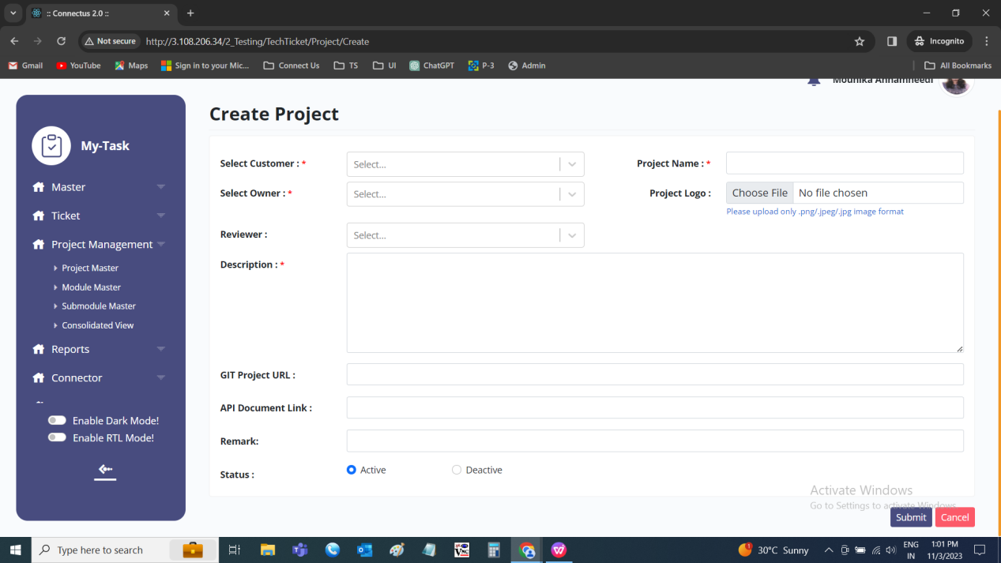

Edit data
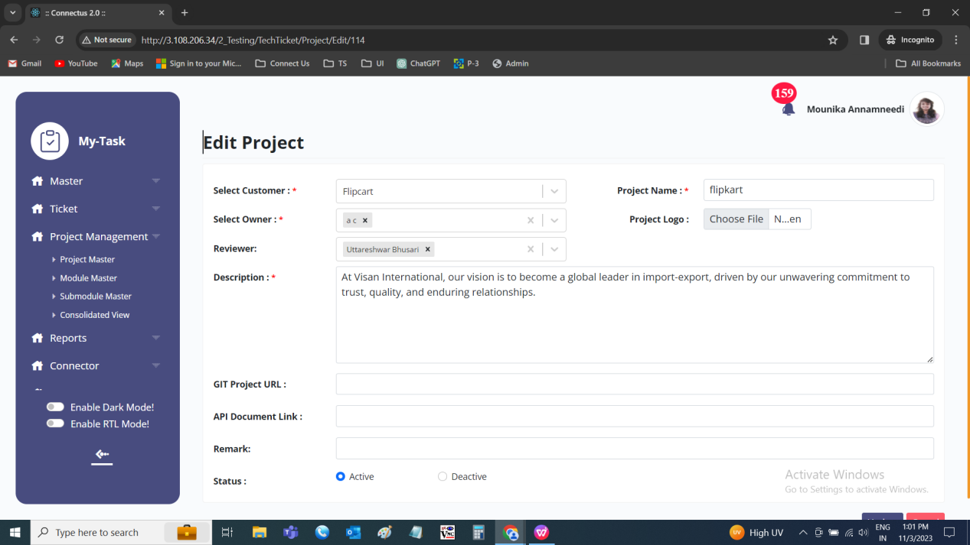

MODULE MASTER
The module master is dependent on the project selected. The module master consists of all the module details which helps in the easy access of the data. The following are the fields in module master.
- Search
- Reset
- Export
- Add module
- Sr
- Module
- Project
- Description
- Remark
- Status
- Created at
- Created by
- Updated at
- Updated by
- Action

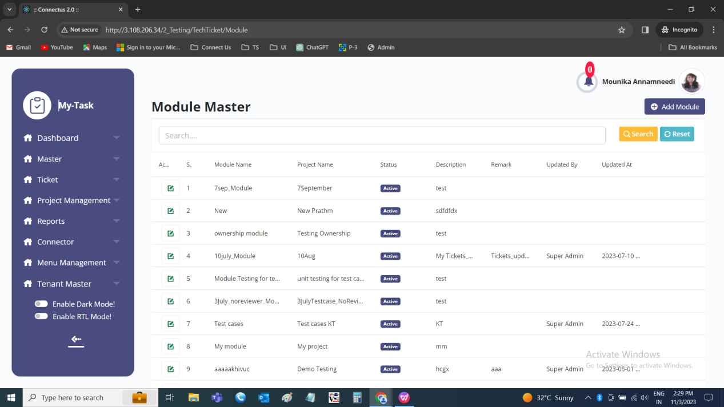

The master consists of the following actions.
Fields | Grid view | Add | Edit | Export
Search | ✓ | x | x | x
Reset | ✓ | x | x | x
Export | ✓ | x | x | x
Add module | ✓ | x | x | x
Sr | ✓ | x | x | ✓
Module | ✓ | ✓ | ✓ | ✓
Project | ✓ | ✓ | ✓ | ✓
Description | ✓ | ✓ | ✓ | ✓
Remark | x | ✓ | ✓ | ✓
Status | ✓ | x | ✓ | ✓
Created at | ✓ | x | x | ✓
Created by | ✓ | x | x | ✓
Updated at | ✓ | x | x | ✓
Updated by | ✓ | x | x | ✓
Grid - Action | ✓ | x | x | x

Input table
Fields | Input type | Mandatory/ Optional | Editable/ No | Description
Search | Button | - | - | The search tab where the user fills the data to be searched and after clicking the search button, the entered input is searched and displayed.  Validation:  The search can accept alpha-numeric with special characters as well.
Reset | Button | - | - | The reset button to reset the search tab.
Export | Button | - | - | The export button to export the data of the modules in the module master.
Add module | Button | - | - | The add module button to add the data of the module in the master.
Sr | Auto | - | - | The serial number consists of the count of the module added in the module master in the grid and export.
Module Name | Text | Mandatory | Yes | The module name is entered or displayed.  Validation:  Accepts alpha-numeric data and special characters up-to 100 characters.
Project | Drop down | Mandatory | Yes | The project to which the module is belonged is selected from the drop-down. The drop-down options are fetched from the project master.  Validation:  - Only active projects are fetched from the project master  - Single selection
Remark | Text | Optional | Yes | The remark if any is entered or displayed.  Validation:  Accepts alpha-numeric data with special characters up-to 1000 characters.
Status | Radio button | Mandatory | Yes | The status consists of the active and the de-active options. The module is active or not is selected.  Validation:  When module is added, automatically, their status is active.
Created at | Auto | Optional | Yes | The username who created the module is displayed.
Created by | Auto | Optional | Yes | The date and time when the module is created is displayed.  Validation:  Format - YYYY-MM-DD HH:MM:SS
Updated at | Auto | Optional | Yes | The username who last updated the module is displayed.
Updated by | Auto | Optional | Yes | The date and time when the module is updated last is displayed.  Validation:  Format - YYYY-MM-DD HH:MM:SS
Grid - Action | Button | - | - | The action field consist of the edit button to edit the data of the module.

Add data
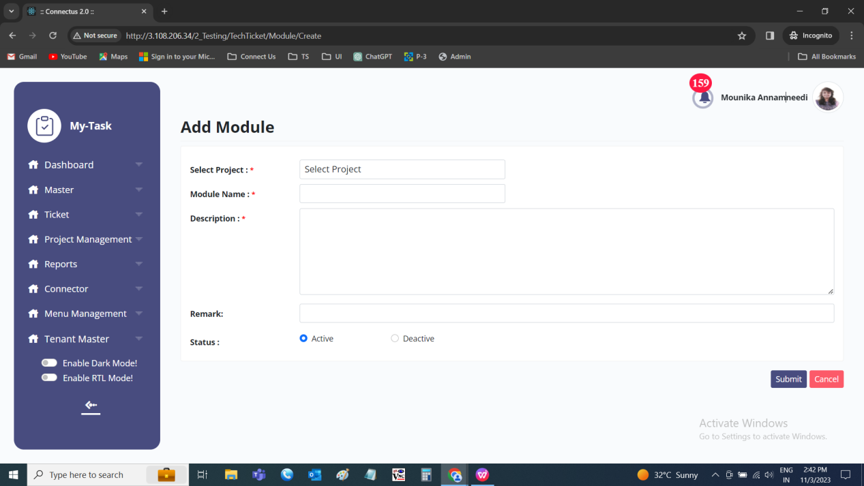

Edit data
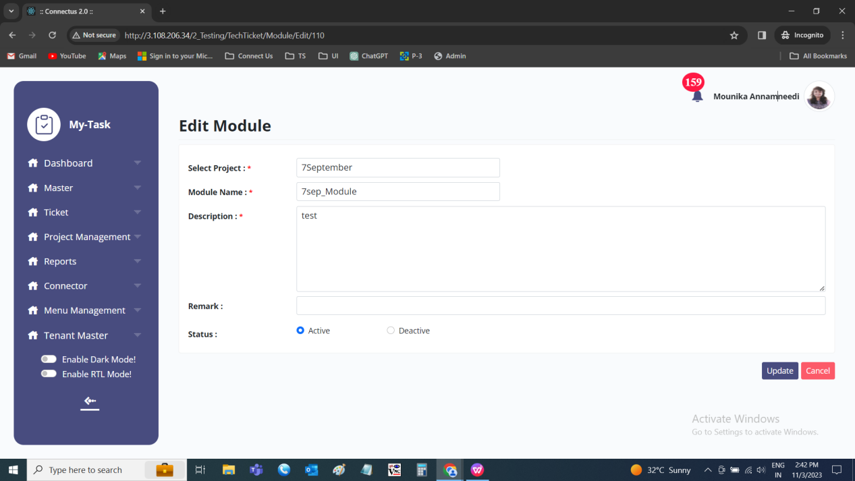

SUB-MODULE MASTER
The sub-module master is dependent on the module selected. The sub-module master consists of all the sub-module details which helps in the easy access of the data. The following are the fields in sub-module master.
- Search
- Reset
- Export
- Add sub-module
- Sr
- Project
- Module
- Sub-module
- Description
- Remark
- Status
- Created at
- Created by
- Updated at
- Updated by
- Action

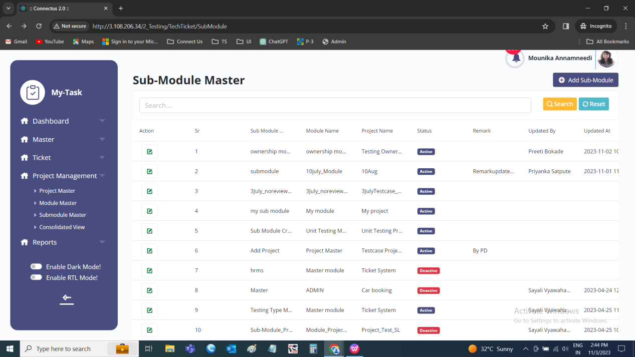

The master consists of the following actions.
Fields | Grid view | Add | Edit | Export
Search | ✓ | x | x | x
Reset | ✓ | x | x | x
Export | ✓ | x | x | x
Add sub-module | ✓ | x | x | x
Sr | ✓ | x | x | ✓
Project | ✓ | ✓ | ✓ | ✓
Module | ✓ | ✓ | ✓ | ✓
Sub-module | ✓ | ✓ | ✓ | ✓
Description | x | ✓ | ✓ | ✓
Remark | x | ✓ | ✓ | ✓
Status | ✓ | x | ✓ | ✓
Created at | ✓ | x | x | ✓
Created by | ✓ | x | x | ✓
Updated at | ✓ | x | x | ✓
Updated by | ✓ | x | x | ✓
Grid - Action | ✓ | x | x | x

Input table
Fields | Input type | Mandatory/ Optional | Editable/ No | Description
Search | Button | - | - | The search tab where the user fills the data to be searched and after clicking the search button, the entered input is searched and displayed.  Validation:  The search can accept alpha-numeric with special characters as well.
Reset | Button | - | - | The reset button to reset the search tab.
Export | Button | - | - | The export button to export the data of the sub-modules in the sub-module master.
Add sub-module | Button | - | - | The add sub-module button to add the data of the sub-module in the master.
Sr | Auto | - | - | The serial number consists of the count of the sub-modules added in the sub-module master in the grid and export.
Project | Drop down | Mandatory | Yes | The project to which the module is belonged is selected from the drop-down. The drop-down options are fetched from the project master.  Validation:  - Only active projects are fetched from the project master  - Single selection
Module | Drop down | Mandatory | Yes | The module to which the sub-module is belonged is selected from the drop-down. The module drop down values are based on the project selected. The drop-down options are fetched from the module master.  Validation:  - Only active module are fetched from the module master  - Single selection
Sub-module | Text | Mandatory | Yes | The sub-module name is entered or displayed.  Validation:  Accepts alpha-numeric data and special characters up-to 100 characters.
Description | Text | Mandatory | Yes | The description is entered or displayed.  Validation:  Accepts alpha-numeric data with special characters up-to 1000 characters.
Remark | Text | Optional | Yes | The remark if any is entered or displayed.  Validation:  Accepts alpha-numeric data with special characters up-to 1000 characters.
Status | Radio button | Mandatory | Yes | The status consists of the active and the de-active options. The sub-module is active or not is selected.  Validation:  When sub-module is added, automatically, their sub-module is active.
Created at | Auto | Optional | Yes | The username who created the sub-module is displayed.
Created by | Auto | Optional | Yes | The date and time when the sub-module is created is displayed.  Validation:  Format - YYYY-MM-DD HH:MM:SS
Updated at | Auto | Optional | Yes | The username who last updated the sub-module is displayed.
Updated by | Auto | Optional | Yes | The date and time when the sub-module is updated last is displayed.  Validation:  Format - YYYY-MM-DD HH:MM:SS
Grid - Action | Button | - | - | The action field consist of the edit button to edit the data of the sub-module.

Add data
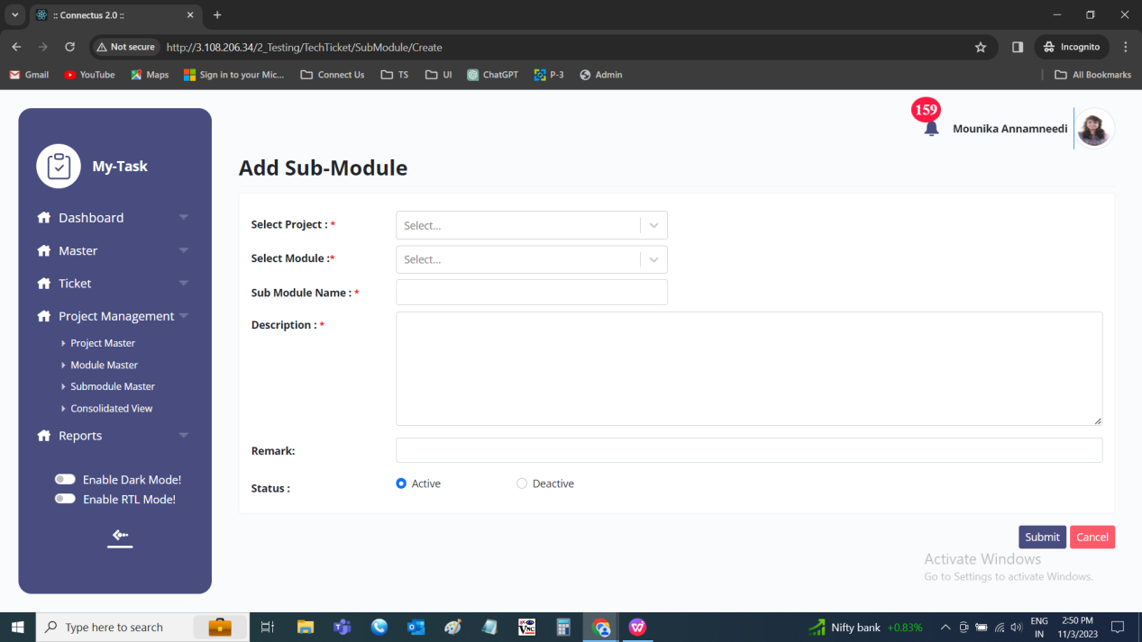

Edit data
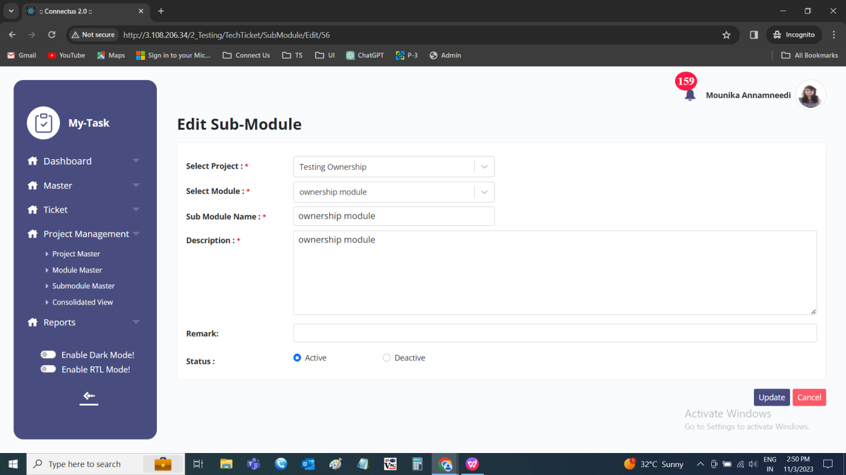

TENANT MASTER
The tenant master belongs to the customers of the ticketing system. The tenants can create their customers based on the customer type. The following are the fields in the tenant master.
- Search bar
- Reset
- Export
- Add tenant
- Sr
- Tenant name
- Company Type
- Email address
- Contact number
- Address
- Pin-code
- Country
- State
- City
- Status
- Created at
- Created by
- Updated at
- Updated by
- Action

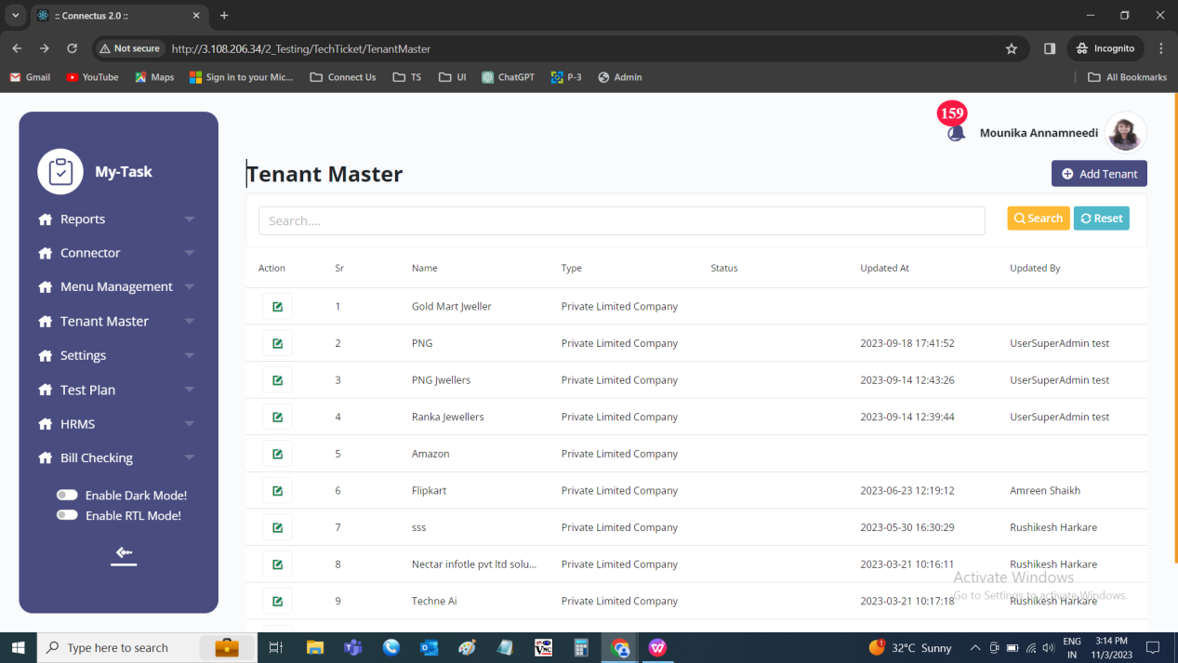

The master consists of the following actions.
Fields | Grid view | Add | Edit | Export
Search | ✓ | x | x | x
Reset | ✓ | x | x | x
Export | ✓ | x | x | x
Add tenant | ✓ | x | x | x
Sr | ✓ | x | x | ✓
Tenant Name | ✓ | ✓ | ✓ | ✓
Company Type | ✓ | ✓ | ✓ | ✓
Email | x | ✓ | ✓ | ✓
Contact no | x | ✓ | ✓ | ✓
Address | x | ✓ | ✓ | ✓
Pincode | x | ✓ | ✓ | ✓
Country | x | ✓ | ✓ | ✓
State | x | ✓ | ✓ | ✓
City | x | ✓ | ✓ | ✓
Status | ✓ | x | ✓ | ✓
Created at | ✓ | x | x | ✓
Created by | ✓ | x | x | ✓
Updated at | ✓ | x | x | ✓
Updated by | ✓ | x | x | ✓
Grid - Action | ✓ | x | x | x

Input table
Fields | Input type | Mandatory/ Optional | Editable/ No | Description
Search | Button | - | - | The search tab where the user fills the data to be searched and after clicking the search button, the entered input is searched and displayed.  Validation:  The search can accept alpha-numeric with special characters as well.
Reset | Button | - | - | The reset button to reset the search tab.
Export | Button | - | - | The export button to export the data of the tenants in the tenant master.
Add tenant | Button | - | - | The add tenant button to add the data of the tenant in the master.
Sr | Auto | - | - | The serial number consists of the count of the tenants added in the tenant master in the grid and export.
Tenant Name | Text | Mandatory | Yes | The tenant’s name of the tenant is entered or displayed.  Validation:  Accepts alpha-numeric data and special characters up-to 100 characters.
Company Type | Drop down | Mandatory | Yes | The type of the company is selected from the drop-down. The drop-down options are as follows.  - Private limited company  - Public limited company  - Limited liability partnership  - Property management company  - Community interest company  Validation:  Single selection
Email | Text | Mandatory | Yes | The email ID of the tenant is entered.  Validation:  Can accept characters, integers and special characters such as “ ._-“ and finally @domain name, .com or .in.
Contact no | Int | Mandatory | Yes | The contact number of the tenant is entered or displayed.  Validation:  Accepts only integers with 10 digits.
Address | Text | Optional | Yes | The address of the tenant is entered or displayed.  Validation:  Accepts alpha-numeric data with special characters up-to 1000 characters.
Pincode | Int | Optional | Yes | The pin-code of the tenant is entered or displayed.  Validation:  Accepts only integers with 6 digits.
Country | Drop down | Optional | Yes | The country of the tenant is selected from the drop-down. The drop-down options are fetched from the tenant master.  Validation:  - Only active tenants are fetched from the tenant master  - Single selection
State | Drop down | Optional | Yes | The state of the tenant is selected from the drop-down. The state drop-down is dependent on the country selected by the user in the country field. The drop-down options are fetched from the state master.  Validation:  - Only active states are fetched from the state master  - Single selection
City | Drop down | Optional | Yes | The city of the tenant is selected from the drop-down. The city drop-down is dependent on the state selected by the user in the state field. The drop-down options are fetched from the city master.  Validation:  - Only active cities are fetched from the city master  - Single selection
Status | Radio button | Mandatory | Yes | The status consists of the active and the de-active options. The tenant is active or not is selected.  Validation:  When tenant is added, automatically, their status is active.
Created at | Auto | Optional | Yes | The username who created the tenant is displayed.
Created by | Auto | Optional | Yes | The date and time when the tenant is created is displayed.  Validation:  Format - YYYY-MM-DD HH:MM:SS
Updated at | Auto | Optional | Yes | The username who last updated the tenant is displayed.
Updated by | Auto | Optional | Yes | The date and time when the tenant is updated last is displayed.  Validation:  Format - YYYY-MM-DD HH:MM:SS
Grid - Action | Button | - | - | The action field consist of the edit button to edit the data of the tenant.

Add data
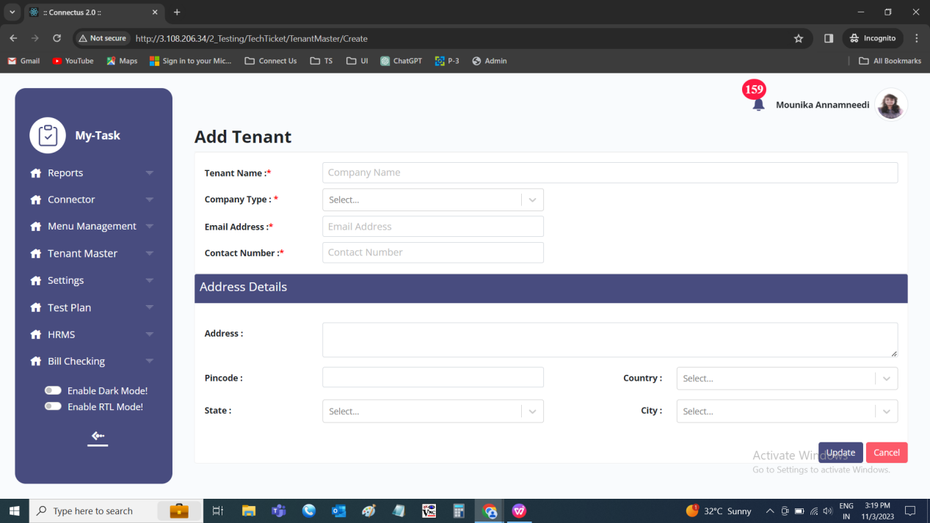

Edit data
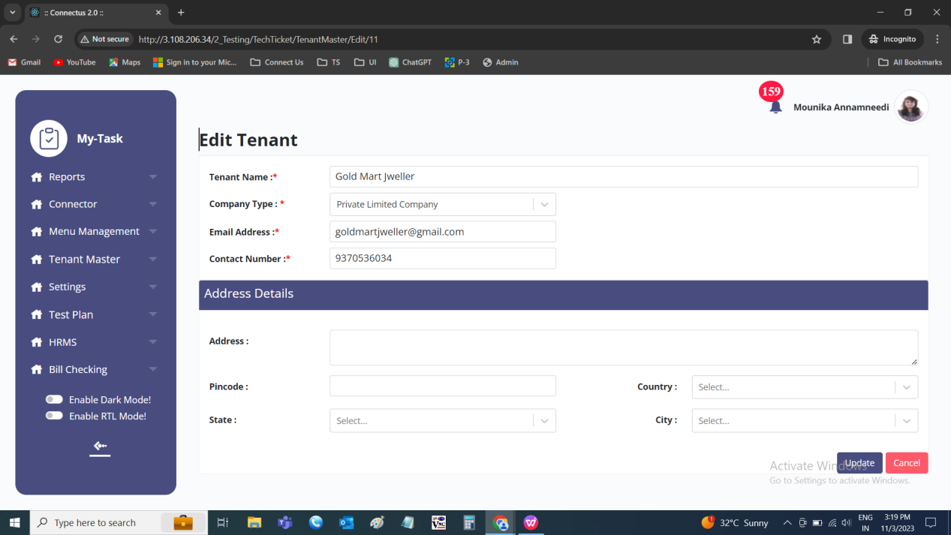

DASHBOARD
The dashboard consist of the pictorial representation of the project handled. Th e dashboard consist of the following.
- Notification
- Profile
- Navigation bar
- Task tabs
- My tasks
- Pending tasks
- Upcoming tasks
- Work analysis

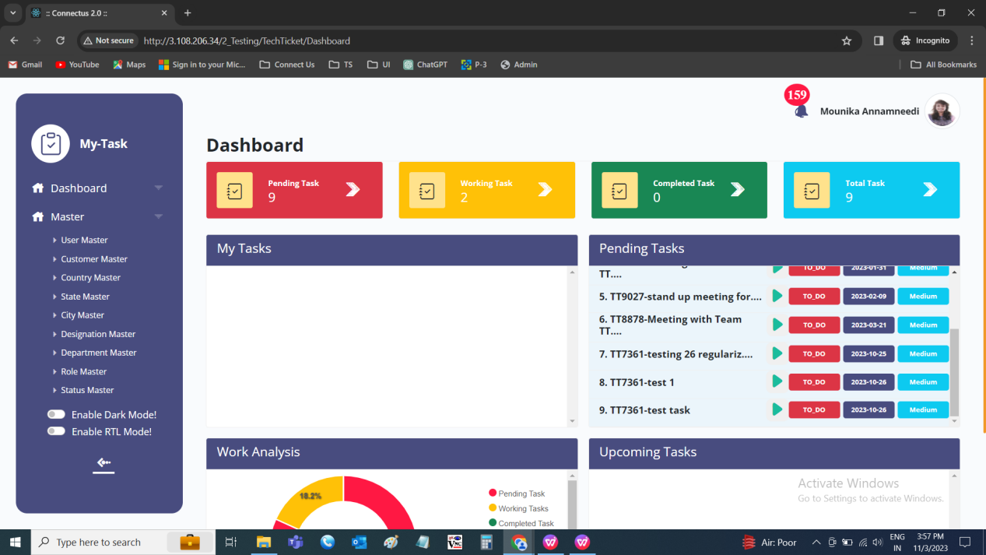

Input table
Fields | Input type | Mandatory/ Optional | Editable/ No | Description
Notification | Int | - | - | The notifications received to the user are shown with the bell icon with the count of the notifications.
Profile | - | - | - | The profile details of the user can be viewed in detail
Navigation bar | - | - | - | The navigation bar where it consist of the menu’s and modules.
Task tabs | - | - | - | The task tabs consists of the count of pending tasks, working tasks, completed tasks and total tasks.  - Pending tasks consists of the total count of pending tasks.  - Working tasks consists of the total count of the tasks where the status is in progress in that particular week (Monday to Sunday).  - Completed tasks consists of the total count of the tasks where the status completed in that particular week (Monday to Sunday).  - Total tasks are the count of pending + working + completed.
My tasks | - | - | - | The my tasks are displayed of the present day. The task which is playing currently is displayed on the top. The user can play or pause the task at any point of time from the dashboard. When clicked on that specific task, it navigates to that task page. Tasks consists of the following.  - Sr. No  - Ticket ID  - Task name  - Play/pause  - Status  - Priority
Pending tasks | - | - | - | The pending tasks consists of the total pending tasks (status - pending, in progress till that day). When clicked on that specific task, it navigates to that task page. The user can play or pause the task at any point of time from the dashboard. Tasks consists of the following.  - Sr.No  - Ticket ID  - Task name  - Play/pause  - Status  - Delivery date  - Priority
Upcoming tasks | - | - | - | The future tasks consists of the future tasks. When clicked on that specific task, it navigates to that task page. The user can play or pause the task at any point of time from the dashboard. Tasks consists of the following.  - Sr.No  - Ticket ID  - Task name  - Play/pause  - Status  - Delivery date  - Priority
Work analysis | Pie chart | - | - | The work analysis is the pie chart where work is displayed in the form of the following in the week.  - Pending tasks  - In progress tasks  - Completed tasks

TASK TABS
The task tabs consists of the count of pending tasks, working tasks, completed tasks and total tasks.
- Pending tasks
- Working tasks
- Completed tasks
- Total tasks

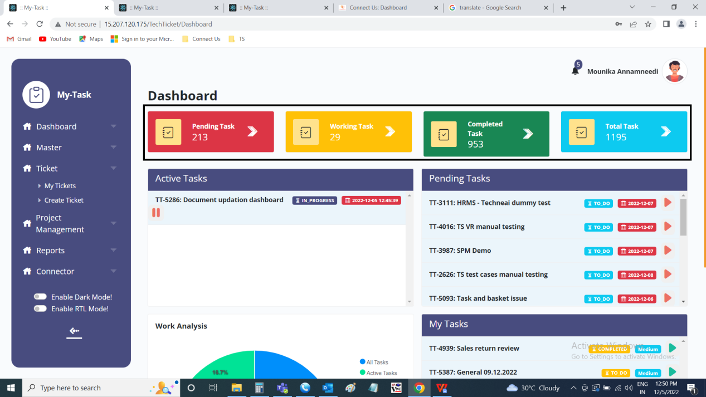

Input table
Fields | Input type | Mandatory/ Optional | Editable/ No | Description
Pending tasks | Auto | - | - | The total count of pending tasks is displayed where the end date of the task is greater than the current tasks.
Working tasks | Auto | - | - | The total count of the tasks where the status is in progress in that particular week (Monday to Sunday).
Completed tasks | Auto | - | - | The total count of the tasks where the status completed in that particular week (Monday to Sunday).
Total tasks | Auto | - | - | The count of pending tasks + working tasks + completed tasks

MY TASKS
The my tasks are displayed of the present day. The task which is playing currently is displayed on the top. The user can play or pause the task at any point of time from the dashboard. When clicked on that specific task, it navigates to that task page. Tasks consists of the following.
- Sr. No
- Ticket ID
- Task name
- Play/pause
- Status
- Priority

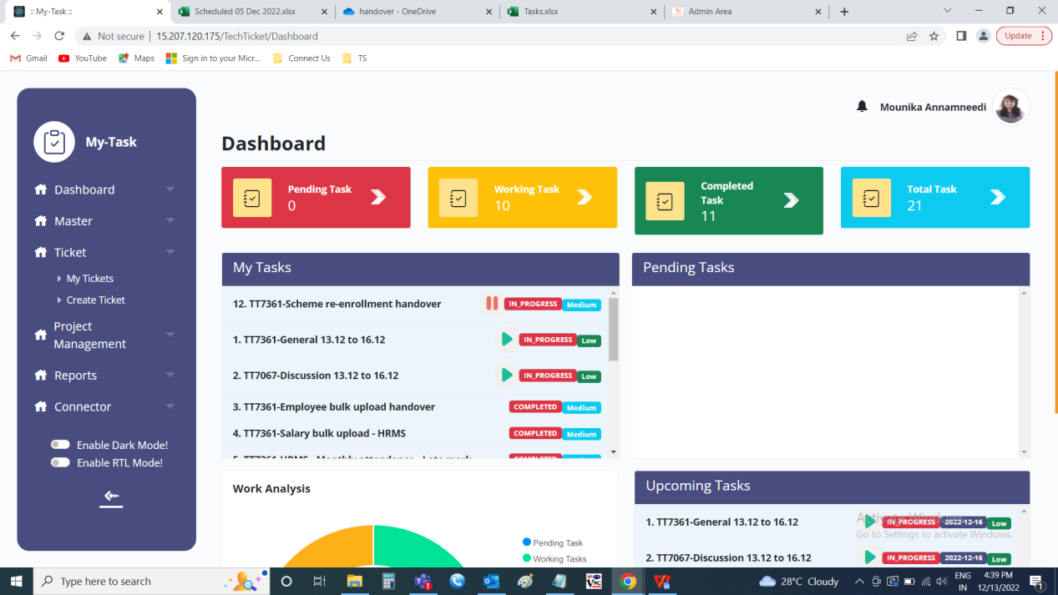

Input table
Fields | Input type | Mandatory/ Optional | Editable/ No | Description
Sr. No | Auto | - | - | The serial count of the tasks is displayed in order.
Ticket ID | Auto | - | - | The ticket ID of the task is displayed
Task name | Auto | - | - | The task name of the task is displayed
Play/pause | Auto | - | - | The play/ pause button to play/ pause the task. Only single task to be played and the task playing will be displayed on the top.
Status | Auto | - | - | The status of the task is displayed
Priority | Auto | - | - | The priority of the task is displayed

PENDING TASKS
The pending tasks consists of the total pending tasks (status - pending, in progress till that day). When clicked on that specific task, it navigates to that task page. The user can play or pause the task at any point of time from the dashboard. Tasks consists of the following.
- Sr.No
- Ticket ID
- Task name
- Play/pause
- Status
- Delivery date
- Priority

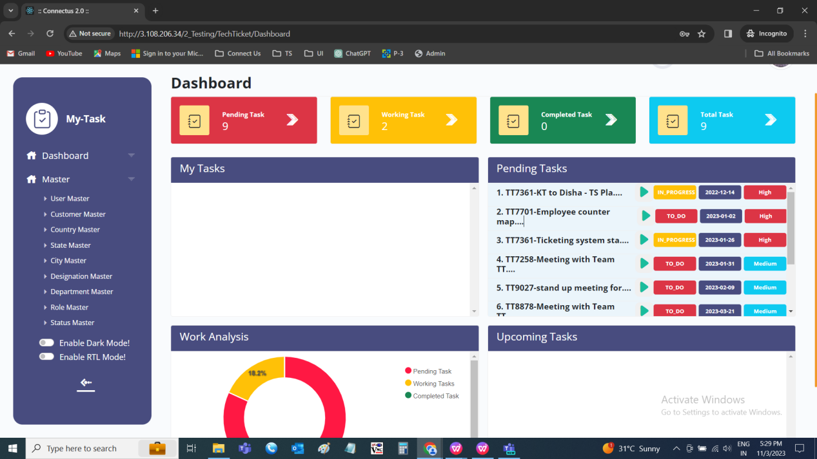

Input table
Fields | Input type | Mandatory/ Optional | Editable/ No | Description
Sr.No | Auto | - | - | The serial count of the tasks is displayed in order.
Ticket ID | Auto | - | - | The ticket ID of the task is displayed
Task name | Auto | - | - | The task name of the task is displayed
Play/pause | Auto | - | - | The play/ pause button to play/ pause the task. Only single task to be played and the task playing will be displayed on the top.
Status | Auto | - | - | The status of the task is displayed
Delivery date | Auto | - | - | The delivery date I.e., end date of the task is displayed
Priority | Auto | - | - | The priority of the task is displayed

UPCOMING TASKS
The future tasks consists of the future tasks. When clicked on that specific task, it navigates to that task page. The user can play or pause the task at any point of time from the dashboard. Tasks consists of the following.
- Sr.No
- Ticket ID
- Task name
- Play/pause
- Status
- Delivery date
- Priority

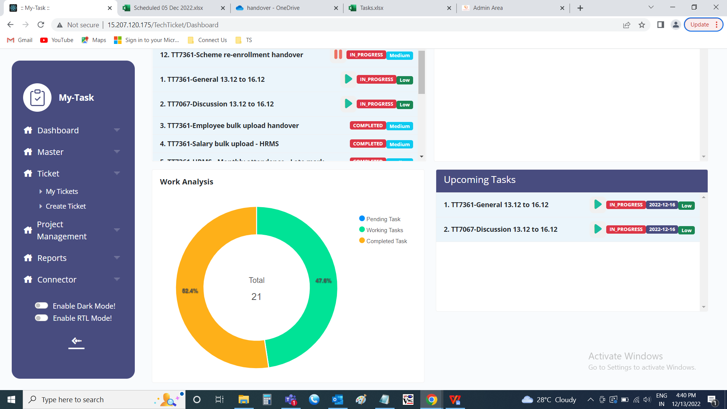

Input table
Fields | Input type | Mandatory/ Optional | Editable/ No | Description
Sr.No | Auto | - | - | The serial count of the tasks is displayed in order.
Ticket ID | Auto | - | - | The ticket ID of the task is displayed
Task name | Auto | - | - | The task name of the task is displayed
Play/pause | Auto | - | - | The play/ pause button to play/ pause the task. Only single task to be played and the task playing will be displayed on the top.
Status | Auto | - | - | The status of the task is displayed
Delivery date | Auto | - | - | The delivery date I.e., end date of the task is displayed
Priority | Auto | - | - | The priority of the task is displayed

WORK ANALYSIS
The work analysis is the pie chart where work is displayed in the form of the following in the week.
- Pending tasks
- In progress tasks
- Completed tasks

NOTIFICATION
The notifications received to the user are shown with the bell icon with the count of the notifications. The notifications consist of the following.
- Notification content
- View all notifications tab
- Approved only by me tab
- Mark all read

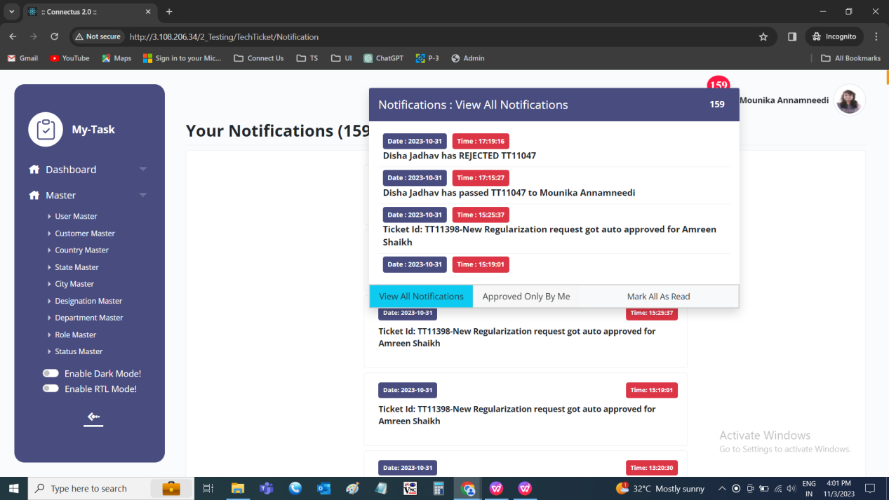

Input table
Fields | Input type | Mandatory/ Optional | Editable/ No | Description
Notification content | - | - | - | The notification content consist of the notification data with the date and the time. The user click on notification, then notification related page is opened.
View all notifications tab | Button | - | - | The view all notifications tab to view all the notifications in detail. The user click on notification, then notification related page is opened.
Approved only by me tab | Button | - | - | The approved only by me tab to view all the notifications related to the approvals. The user click on notification, then notification related page is opened.
Mark all read | Button | - | - | The mark all read button to mark the notifications as read.

View all notifications
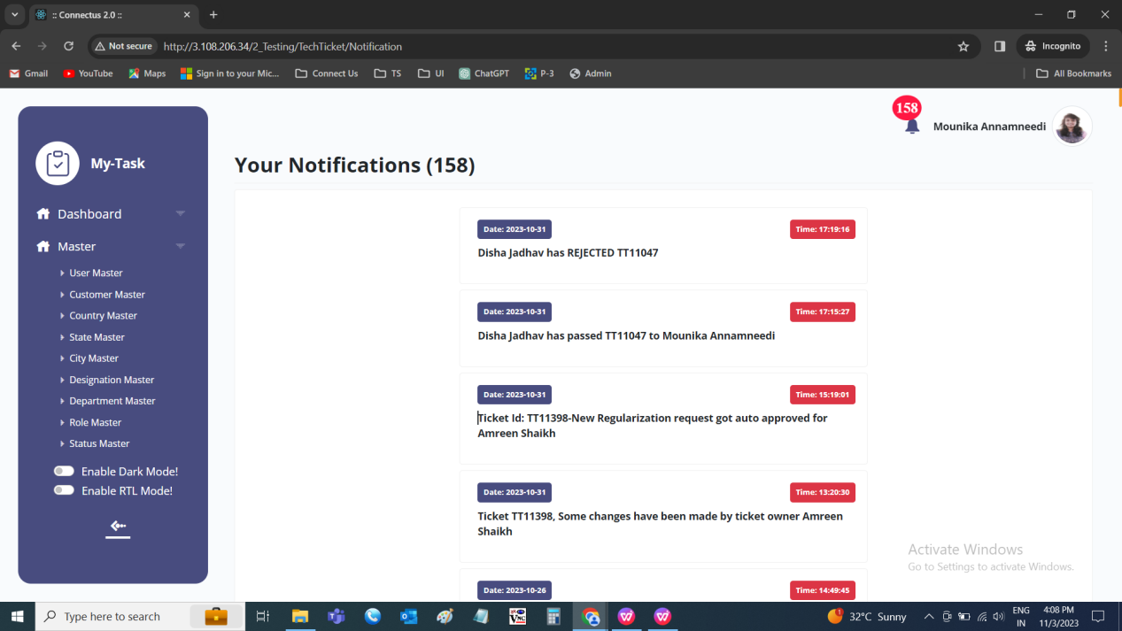

Approved only by me
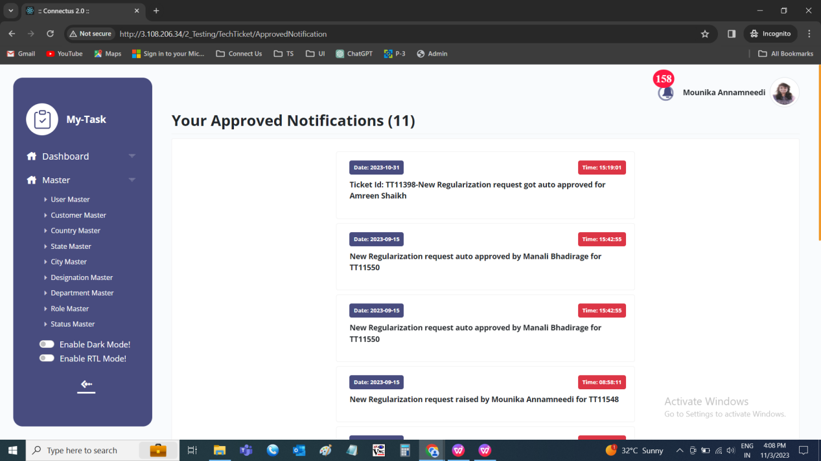

PROFILE
The profile of the user is displayed. The profile on all pages is as follows.
- User name
- Profile picture

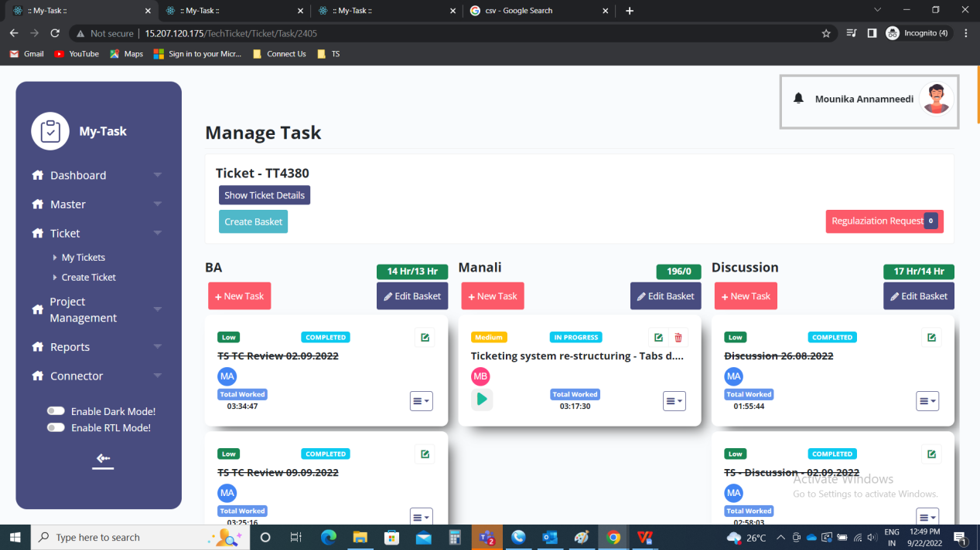

When the user click on it, a tab is opened. The tab consist of the following.
- Username
- User mail ID
- Profile picture
- Your profile
- Sign out

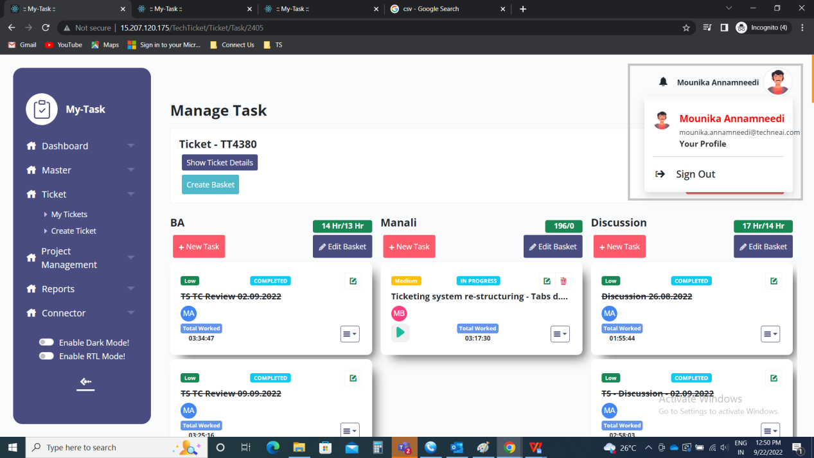

Input table
Fields | Input type | Mandatory/ Optional | Editable/ No | Description
Username | - | - | - | The username of the user is displayed
User mail ID | - | - | - | The mail ID of the user is displayed
Profile picture | - | - | - | The profile picture of the user is displayed
Your profile | Button | - | - | The your profile button to view the profile
Sign out | Button | - | - | The sign out button to sign out from the existing login. The existing user login sign outs and automatically login page is displayed.

Your profile
When the user, clicks on the “Your Profile”, user profile is viewed. The user profile is divided into 4 sections. The following are the sections of the user profile.
- Profile picture
- Your departments
- Account details

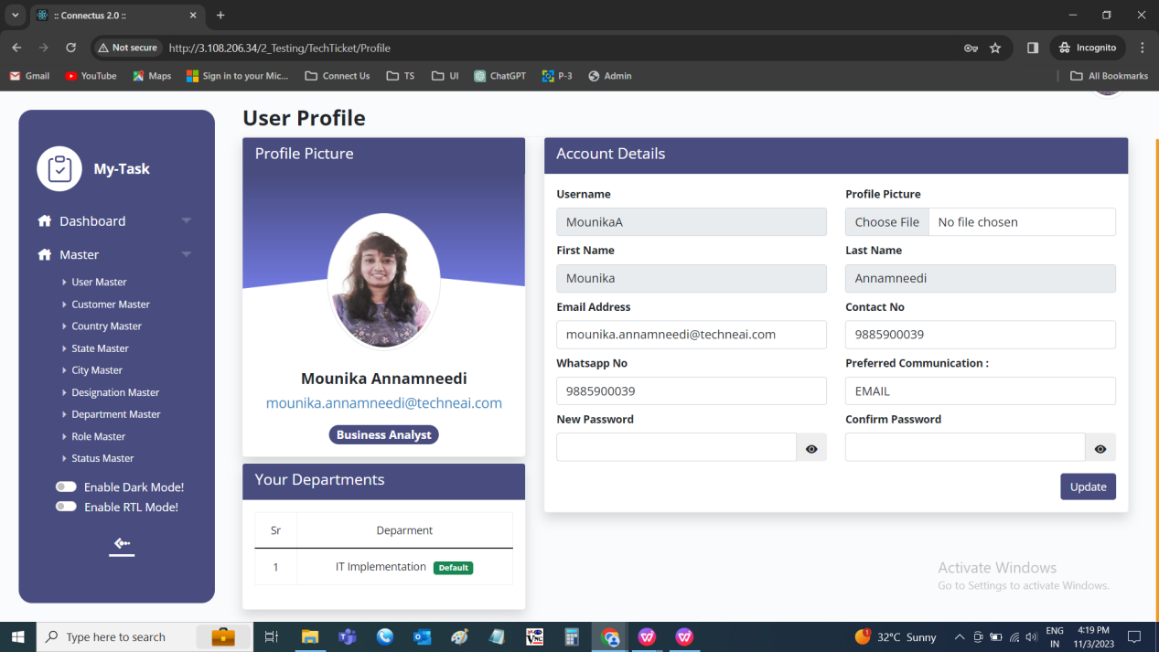

Profile picture
The profile picture consists of the following.
- User picture
- User Name
- User mail ID
- User Designation

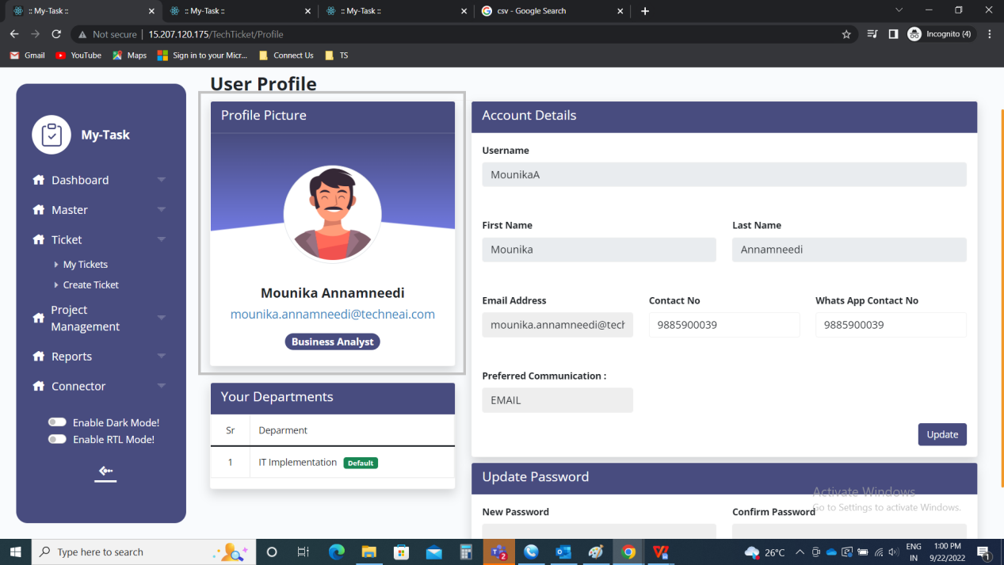

Input table
Fields | Input type | Mandatory/ Optional | Editable/ No | Description
User picture | - | - | - | The profile picture of the user is displayed
User Name | - | - | - | The user’s username updated in the user master or in the profile whichever is later is displayed
User mail ID | - | - | - | The mail ID of the user displays as per the user master or the updated one in the user profile whichever is later
User Designation | - | - | - | The user designation updated as per the user master or the updated one in the user profile whichever is later

Your Departments
All the departments set against the user in the user master is displayed with the default one.

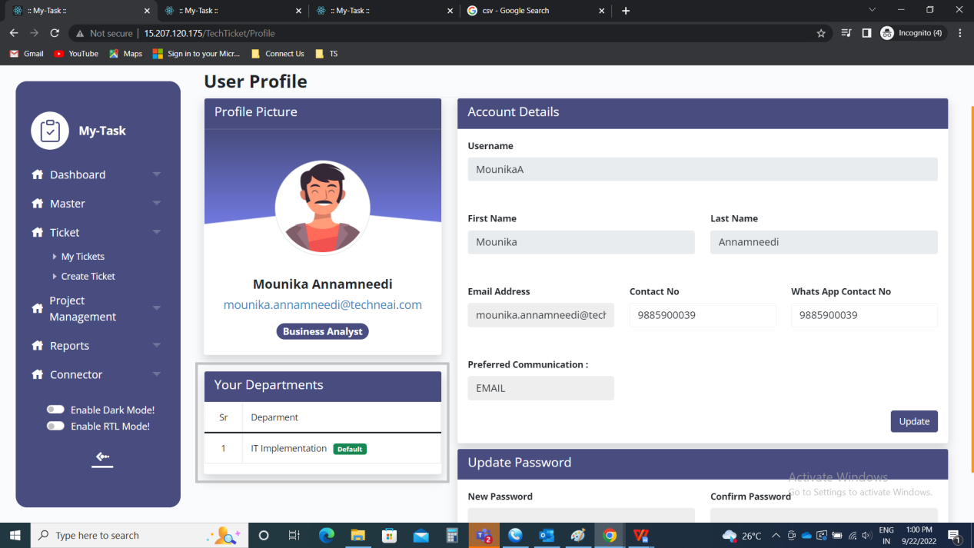

Account Details
The account details are displayed. The following are the fields in the account details.
- Username
- Profile picture
- First name
- Last name
- Email address
- Contact No
- Whats App Contact No
- Preferred communication
- New password
- Confirm password
- Update

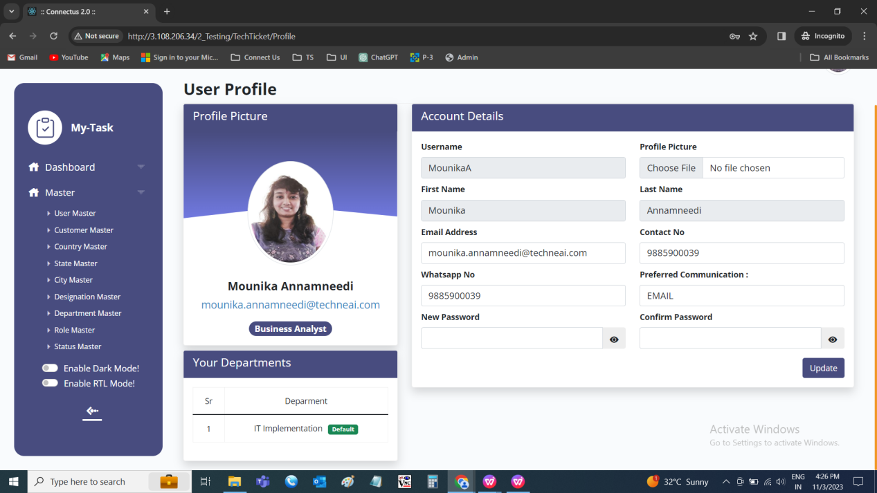

Input table
Fields | Input type | Mandatory/ Optional | Editable/ No | Description
Username | Text | Mandatory | Yes | The username of the user is displayed.  Validation:  - Accepts alpha-numeric data and the special characters up-to 50 characters.  - The username should be the unique value.
Profile picture | File upload | Optional | Yes | The profile picture of the user is uploaded or displayed.  Validation:  Accepts file up-to 2MB maximum of 1 image.
First name | Text | Mandatory | Yes | The first name of the user is entered or displayed.  Validation:  Accepts alphabetic data up-to 50 characters.
Last name | Text | Mandatory | Yes | The last name of the user is entered or displayed.  Validation:  Accepts alphabetic data up-to 50 characters.
Email address | Text | Mandatory | Yes | The email ID of the user is entered or displayed.  Validation:  Can accept characters, integers and special characters such as “ ._-“ and finally @domain name, .com or .in.
Contact No | Int | Mandatory | Yes | The contact number of the user is entered or displayed.  Validation:  Accepts only integers with 10 digits.
Whats App Contact No | Int | Optional | Yes | The whatsapp number of the user is entered or displayed.  Validation:  Accepts only integers with 10 digits.
Preferred communication | Drop down | Mandatory | Yes | The preferred communication where the OTP to be sent at the time of confirmation is selected from the drop down. The drop down consist of the following fields.  - Email  - Whatspp  - SMS  Validation:  - By default, the email is selected  - Single selection
New password | Text | Mandatory | - | The new password to be reset is entered.  Validation:  Accepts alpha-numeric data with special characters minimum of 8 characters.
Confirm password | Text | Mandatory | - | The password entered in the new password to be entered again to confirm the new password.  Validation:  Same password to be entered which is entered in the new password.
Update | Button | - | - | The update button to update the details. The details are updated in the user master as well.

CREATE TICKET
The create ticket page to create the ticket in the ticketing system. The user can create single ticket or multiple tickets using bulk upload. The following are the fields in the create ticket.
- Manual/ bulk upload
- Your department
- Query group
- Query type
- Ticket type
- Confirmation required
- Reference ID
- Priority
- Expected solved date
- Description
- Dynamic fields
- Upload attachment

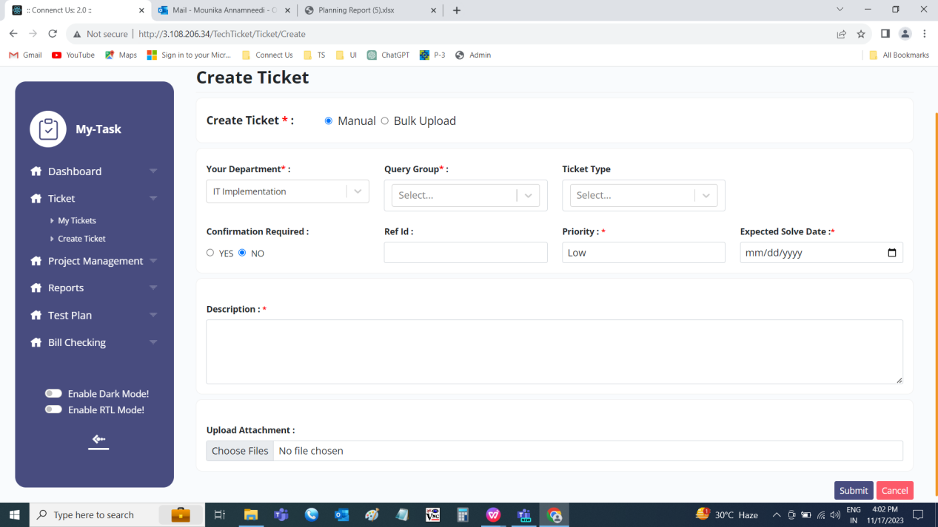

The actions are as follows
Fields | Create | Bulk upload
Manual/ bulk upload | ✓ | x
Your department | ✓ | x
Query group | ✓ | ✓
Query type | ✓ | ✓
Ticket type | ✓ | ✓
Confirmation required | ✓ | ✓
Reference ID | ✓ | ✓
Priority | ✓ | ✓
Expected solved date | ✓ | ✓
Description | ✓ | ✓
Dynamic fields | ✓ | ✓
Upload attachment | ✓ | x

Input table
Fields | Input type | Mandatory/ Optional | Editable/ No | Description
Manual/ bulk upload | Radio button | Mandatory | - | The ticket to be added manually or bulk upload is selected.  Validation:  Single selection
Your department | Drop down | Mandatory | - | The user department is selected by default, which is mentioned as by default in user master. If the user is mapped with multiple departments, the departments mapped are displayed in the drop down.  Validation:  Single selection
Query group | Drop down | Mandatory | - | The query group is selected from the drop down. The drop down options are fetched from query group master.  Validation:  - The active query groups to be fetched from the query group master.  - Single selection
Query type | Drop down | Mandatory |  | The query type is selected from the drop down. The query type is selected based on the query group selected. The drop down options are fetched from the query type master.  Validation:  - The active query types are fetched from the query type master.  - Single selection
Ticket type | Drop down | Optional | - | The ticket type is selected from the drop down. The drop down options are fetched from ticket type master.  Validation:  - The active ticket types to be fetched from the ticket type master.  - Single selection
Confirmation required | Radio button | Mandatory | - | The confirmation required or not is fetched from the customer mapping based on the query type selected. The confirmation required consists of the yes and no options. The user can edit them if required. If confirmation is required, the user will get the OTP at the time of solving the ticket.  Validation:  Single selection
Reference ID | Text | Optional | - | The reference ID if any to be entered.  Validation:  Accepts alpha-numeric data with special characters up-to 100 characters.
Priority | Drop down | Mandatory | - | The priority of the ticket selected at the customer mapping based on the query type is displayed. The user can change the priority if required. The priority to be selected from the drop down. The drop-down options are as follows.  - Low  - Medium  - High  - Very high  Validation:  Single selection
Expected solved date | Date picker | Mandatory | - | The expected solved date of the ticket to be solved is selected.  Validation:  - The expected date should be equal or greater than the ticket date.  - The expected solved date can be changed only by project manager I.e., the owner of the project selected in the project field.
Description | Text | Mandatory | - | The ticket description is entered.  Validation:  Accepts alpha-numeric data with special characters up-to 1000 characters.
Dynamic fields | - | Mandatory | - | The dynamic fields at the time of creation of ticket based on the query type is displayed and entered accordingly.
Upload attachment | File upload | Optional | - | The attachments if any are uploaded.  Validation:  Size of 2MB up-to maximum 5 are accepted. Any file format is accepted.

Bulk upload
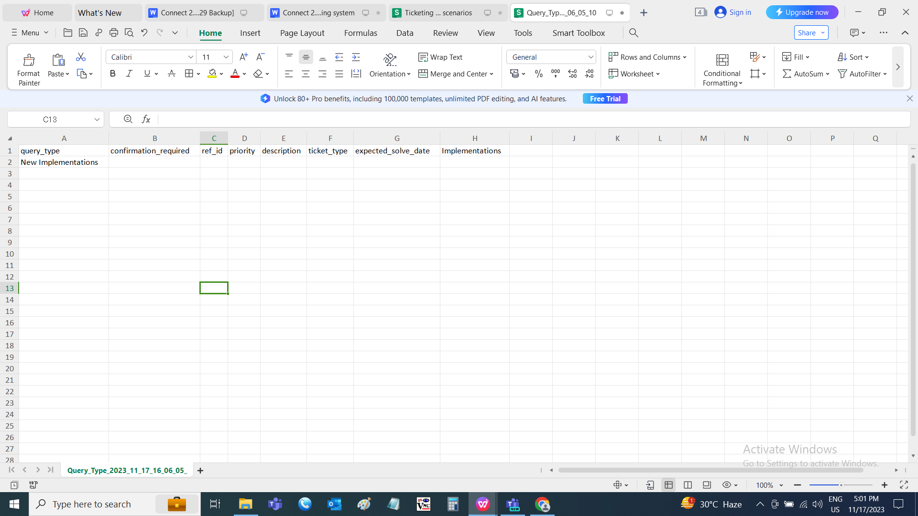

MY TICKETS
My tickets consist of the list of the tickets assigned to the user, department, created by the user and the passing tickets. My tickets page also consist of the working of the ticket I.e., basket and task data as well in the ticket.
The ticket consist of the following
- Filters
- Search filter
- Assigned to
- Created by me
- Department wise ticket
- Your task
- Unpassed ticket

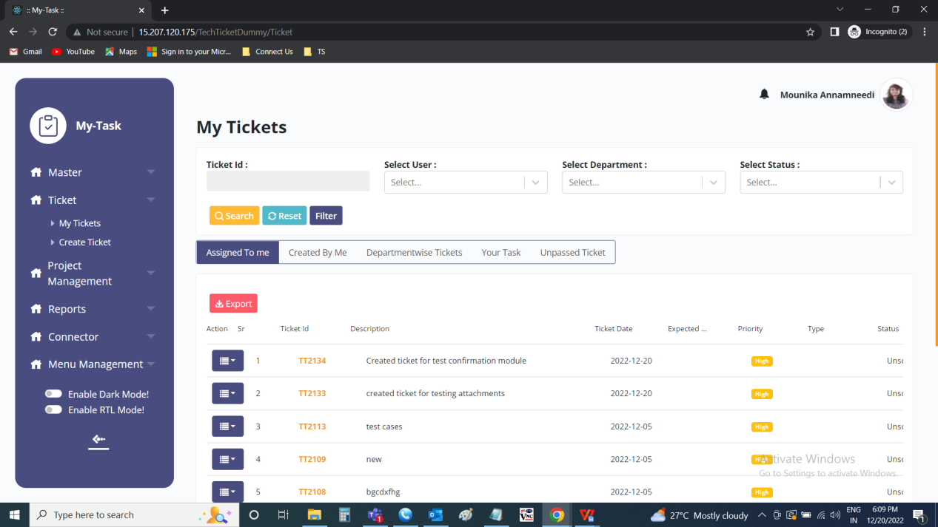

The filters on the page consist of the following.
- Ticket ID
- User
- Department
- Status

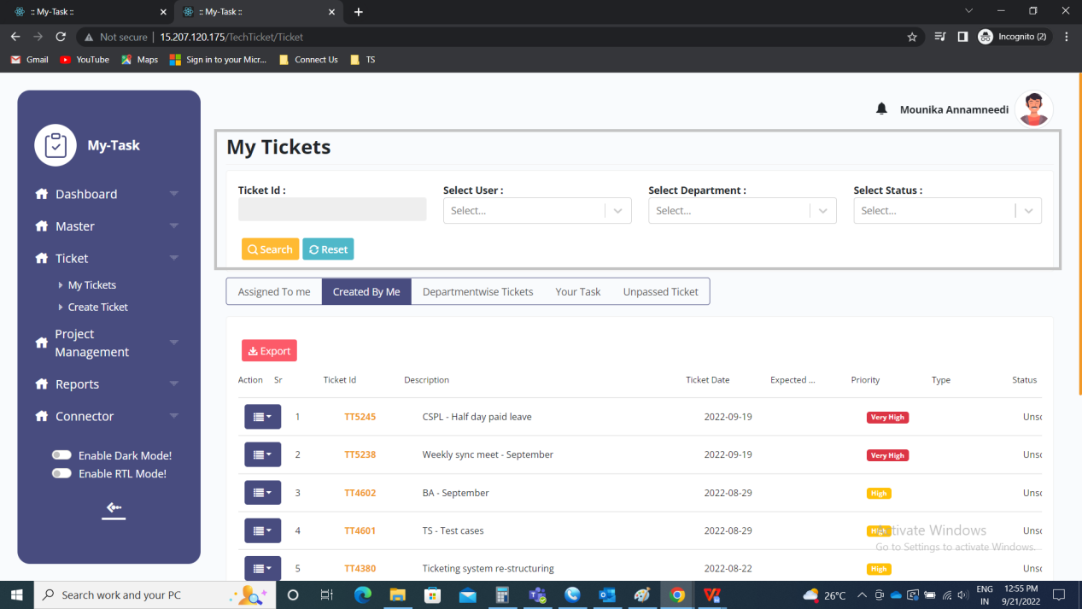

Input table
Fields | Input type | Mandatory/ Optional | Editable/ No | Description
Ticket ID | Text | Optional | - | The ticket ID to be searched is entered. If multiple ticket Id’s, then comma separated values to be entered.  Validation:  The tickets created to be entered.
User | Drop down | Optional | - | The user related to that either ticket creation user or ticket assigned user is selected from the drop down. The drop down options are fetched from the user master.  Validation:  - The users who are active as well as deactivated are fetched from the user master.  - Multiple selection
Department | Drop down | Optional | - | The department of the user related to that either ticket creation user or ticket assigned user is selected from the drop down. The drop down options are fetched from the department master.  Validation:  - The department of the users who are active as well as deactivated are fetched from the department master.  - Multiple selection
Status | Drop down | Optional | - | The status of the ticket is selected from the drop down. The drop down options are fetched from the status master.  Validation:  - The active and deactivated statuses are fetched from the status master  - Multiple selection

When the data is searched, the search result tab is displayed.

FILTER
The filter button consist of the following fields.
- From date
- To date
- Assigned department
- Assigned user
- Entry department
- Entry user
- Status
- Ticket ID

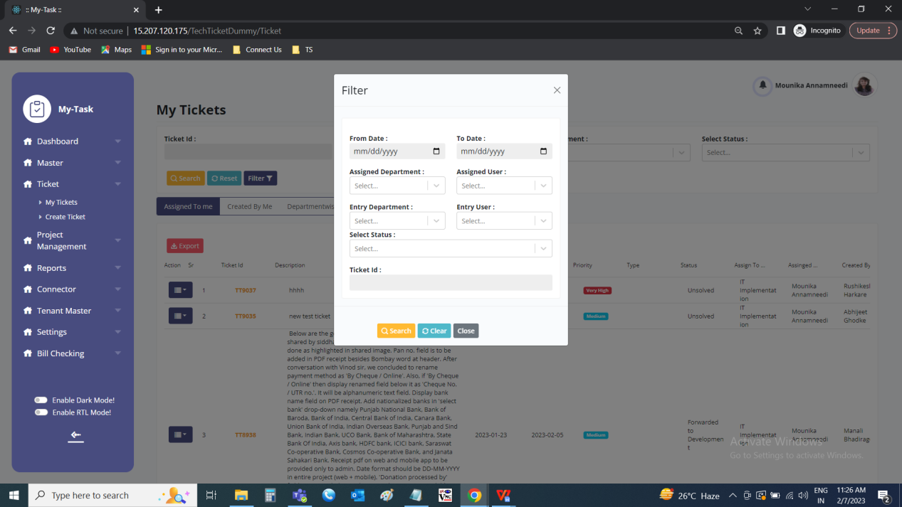

Input table
Fields | Input type | Mandatory/ Optional | Editable/ No | Description
From date | Date picker | Optional | - | The from date filter is based on the ticket creation date. The date can be entered using the date picker.  Validation:  - If from date is mentioned, to date is even mandatory for applying the filter.  - Future date cannot be accepted.
To date | Date picker | Optional | - | The to date filter is based on the ticket creation date. The date can be entered using the date picker.  Validation:  - If to date is mentioned, from date is even mandatory for applying the filter.  - The to date should be greater than the from date.
Assigned department | Drop down | Optional | - | The assigned department filter consists of the departments to which department, the ticket is assigned to. The assigned department field is fetched from the department master (the records which are in active and deactivated status) (in ticketing system >> masters >> department master).  Validation:  Multiple selection.
Assigned user | Drop down | Optional | - | The assigned user filter consists of the users to whom the ticket is assigned. The assigned user field is fetched from the user master (the records which are in active and deactivated status) (in ticketing system >> masters >> user master). if assigned department filter is selected, then the users mapped against those departments to be displayed.  Validation:  Multiple selection
Entry department | Drop down | Optional | - | The entry department filter consists of the departments from which the ticket is created. The entry department field is fetched from the department master (the records which are in active and deactivated status) (in ticketing system >> masters >> department master).  Validation:  Multiple selection
Entry user | Drop down | Optional | - | The entry user filter consists of the users by whom the ticket is created. The entry user field is fetched from the user master (the records which are in active status) (in ticketing system >> masters >> user master). if entry department filter is selected, then the users mapped against those departments to be displayed.  Validation:  Multiple selection
Status | Drop down | Optional | - | The status filter consists of the ticket status. The status field is fetched from the status master (the records which are in active status) (in ticketing system >> masters >> status master).  Validation:  Multiple selection
Ticket ID | Text | Optional | - | The ticket ID to be searched is entered. Multiple records can be searched by separation (,).  Validation:  The tickets created to be entered.

TABS
The my tickets page consists of the following tabs.
- Search filter
- Assigned to
- Created by me
- Department wise ticket
- Your task
- Unpassed ticket

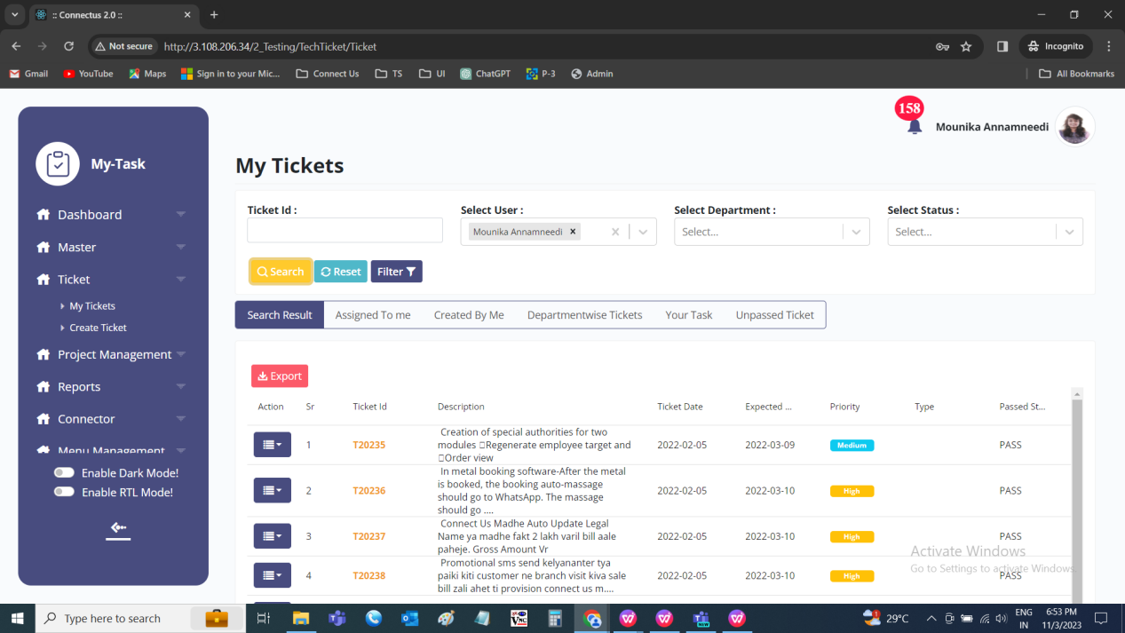

Actions view:
Fields | Edit | View | History | Basket/ Task | Confirm | Pass | Reject
Search filter | x | ✓ | ✓ | x | x | x | x
Assigned to | ✓ | ✓ | ✓ | ✓ | x | x | x
Created by me | x | ✓ | ✓ | x | ✓ | x | x
Department wise ticket | ✓ | ✓ | ✓ | ✓ | x | x | x
Your task | x | ✓ | x | ✓ | x | x | x
Unpassed ticket | x | ✓ | x | x | x | ✓ | ✓

Input table
Fields | Input type | Mandatory/ Optional | Editable/ No | Description
Search filter | - | - | - | The search filter tab enables when any data searched in the filters.
Assigned to | - | - | - | “Assigned to me” tab displays all the tickets in the grid assigned to the user.
Created by me | - | - | - | The person who has created the ticket will be referred as Ticket creator. All the tickets created by the user will be displayed under “Created by me” tab.
Department wise ticket | - | - | - | All the tickets of the department, that user belongs to, will be displayed under “Department-wise Tickets”. If there multiple departments assigned against the user master, then multiple departments will be displayed.
Your task | - | - | - | Tickets which may/ may not be assigned to you but includes basket or its task assigned to the user, those tickets will be displayed under “Your Task” tab.
Unpassed ticket | - | - | - | Ticket once created by user will be submitted to Department head (authority given against the user master) for the passing of the ticket. The department head has the authority to pass / unpass the ticket. The department head checks created ticket is required or not and then passes or unpasses it accordingly.

The tabs consist of the following fields.
- Action
- Sr No
- Ticket ID
- Description
- Ticket date
- Expected date
- Priority
- Type
- Passed status
- Status
- Assign to department
- Assign to user
- Created by

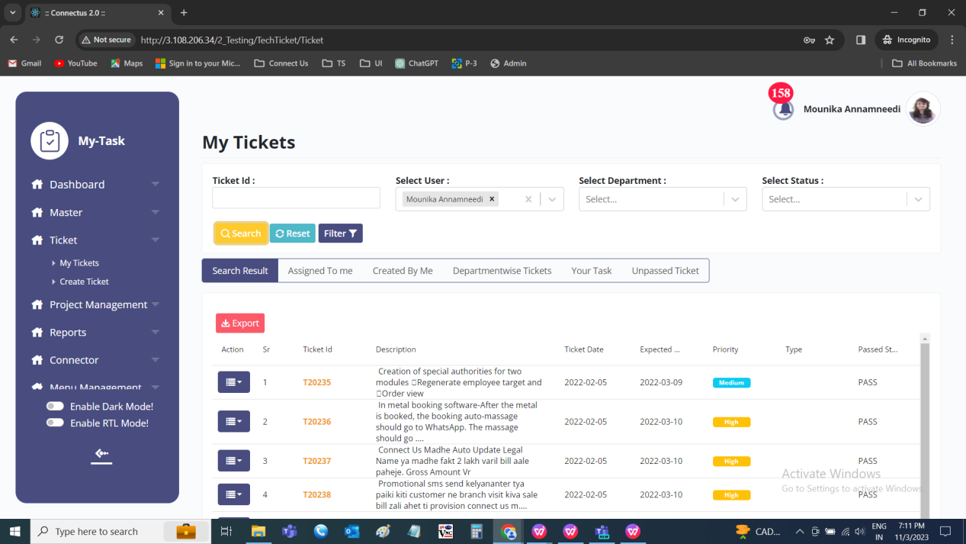

Input table
Fields | Input type | Mandatory/ Optional | Editable/ No | Description
Action | - | - | - | The actions fields consists of the following.  - Edit  - View  - History  - Basket/ task  - Confirm  - Pass  - Reject  Edit button to edit the ticket  View button to view the ticket  History button to view the changes/ updates made in the ticket.  Basket/ task button to create the basket (when no basket is created) or task and functioning of the ticket.  Confirm button to solve the ticket directly the user who created the ticket.  The pass button to pass the ticket  The reject button to reject the ticket.
Sr No | - | - | - | The serial number of the tickets is displayed in order
Ticket ID | - | - | - | The ticket ID of the ticket is displayed in the descending order (the latest tickets are shown first)
Description | - | - | - | The description of the ticket is displayed
Ticket date | - | - | - | The ticket creation date is displayed
Expected date | - | - | - | The expected date of the ticket to be solved or solved date of the ticket (if in case, it is solved) is displayed
Priority | - | - | - | The priority of the ticket is displayed
Type | - | - | - | The query type of the ticket is displayed
Passed status | - | - | - | The passed status of the ticket, I.e., passed, unpassed or rejected is displayed
Status | - | - | - | The status of the ticket is displayed
Assign to department | - | - | - | The assign to user department is displayed
Assign to user | - | - | - | The assigned username is displayed
Created by | - | - | - | The user who created the ticket is displayed

Search result
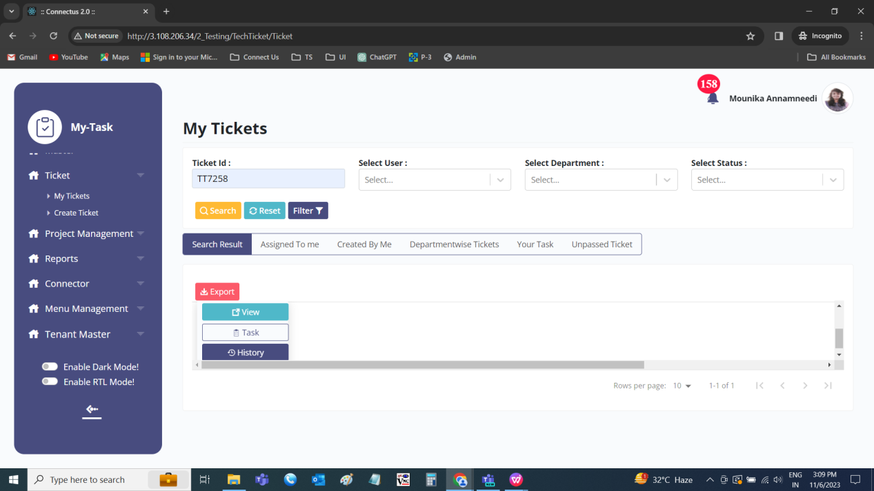

Assigned to me
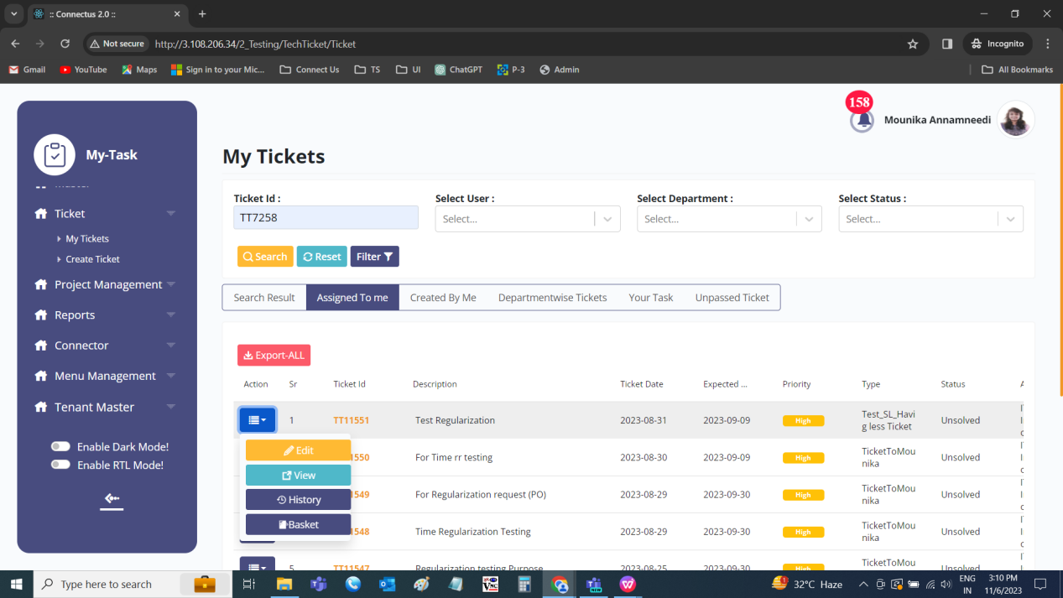

Created by me
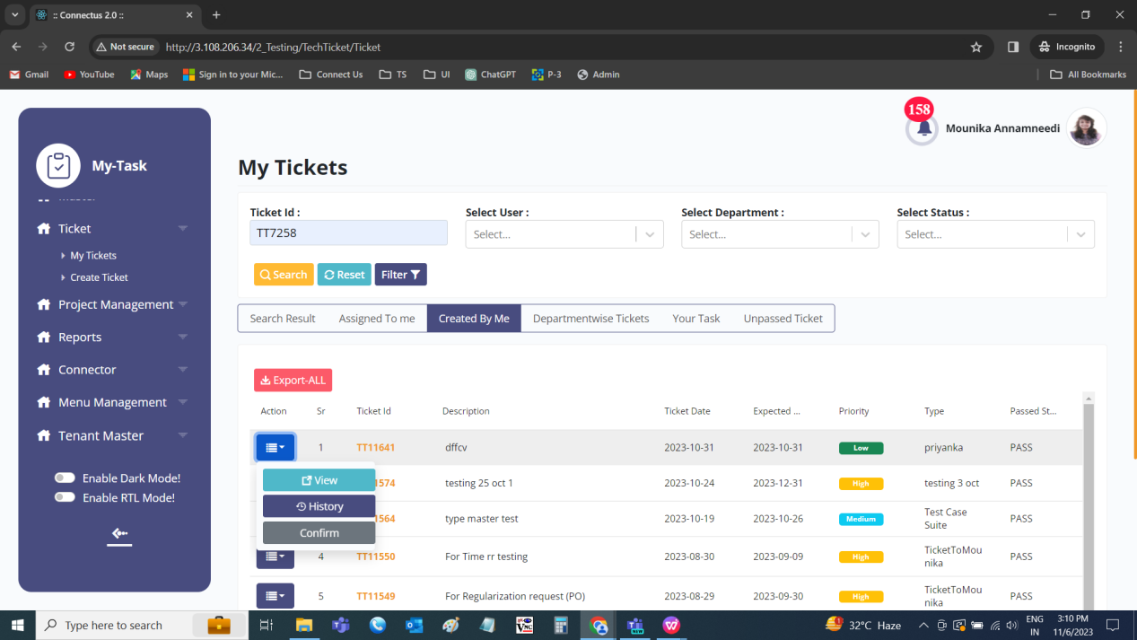

Department-wise tickets
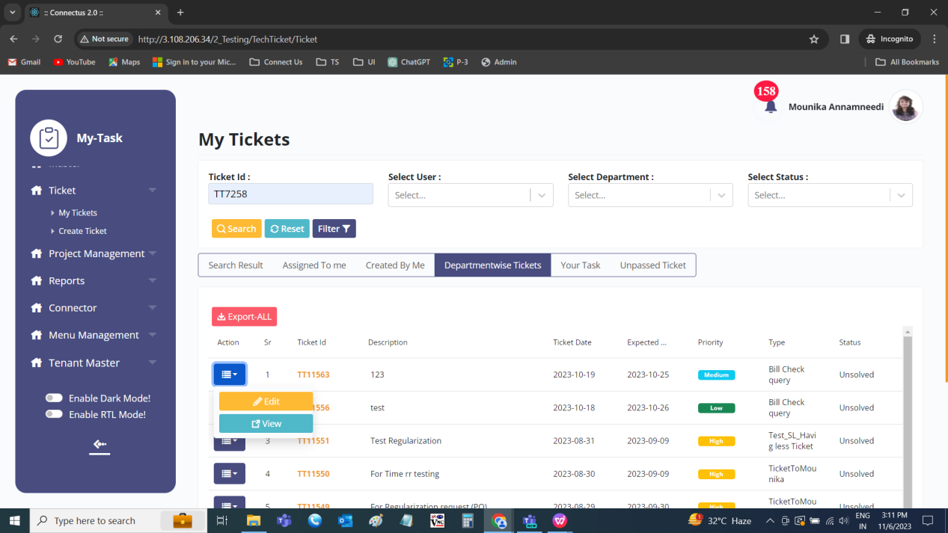

Your tasks
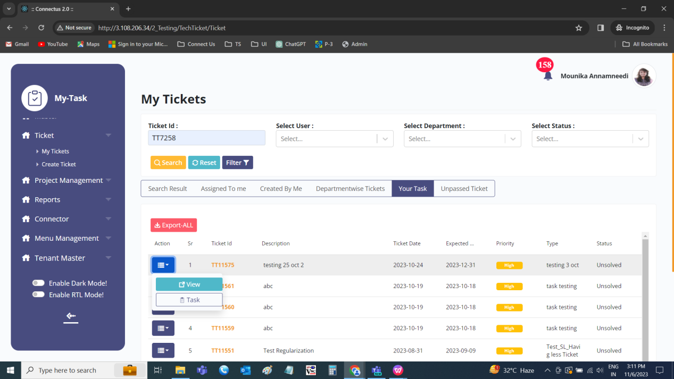

Unpassed tickets
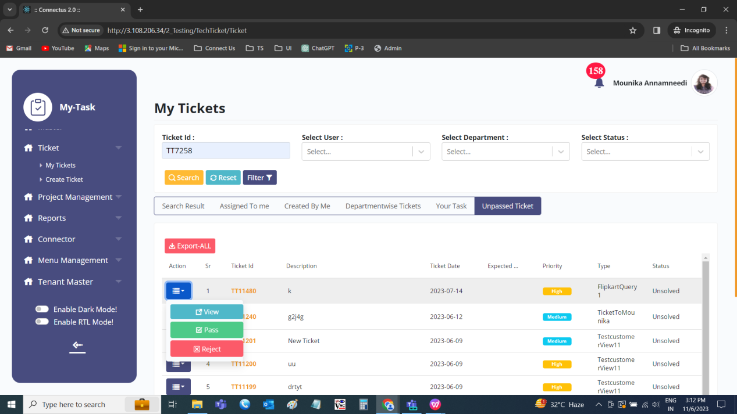

TICKET EDIT
The edit button to edit the ticket. The following are the fields in the edit ticket.
- Query type
- Confirmation required
- Passing status
- Passing remark
- Ticket date
- Expected solved date
- Reference ID
- Entry department
- Entry user
- Project
- Module
- Sub-module
- Reviewer
- Assign to department
- Assign to user
- Priority
- Status
- Dynamic fields
- Description
- Upload attachment
- Submit
- View
- Cancel
- Ticket chat
- Send

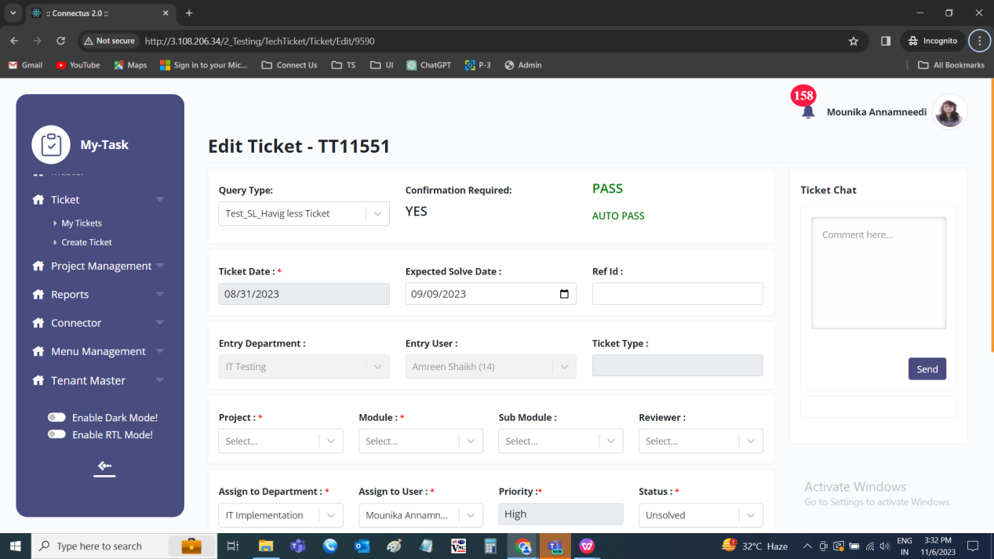

Input table
Fields | Input type | Mandatory/ Optional | Editable/ No | Description
Query type | - | Mandatory | No | The query type of the ticket selected at the time of creation of the ticket is displayed.
Confirmation required | - | Mandatory | No | The confirmation required or for solving the ticket selected at the time of creation of ticket is displayed.
Passing status | - | Mandatory | No | The passing status of the ticket whether passed, unpassed or rejected is displayed.
Passing / rejected remark | - | Mandatory | No | The passing/ rejection remark at the time of passing of ticket or rejection of the ticket is displayed.
Ticket date | - | Mandatory | No | The ticket date I.e., ticket creation date is displayed.
Expected solved date | Date picker | Mandatory | Yes | The expected solved date of the ticket to be solved is displayed.  Validation:  - The expected date should be equal or greater than the ticket date.  - The expected solved date can be changed only by project manager I.e., the owner of the project selected in the project field.
Reference ID | Text | Optional | Yes | The reference ID if any to be entered or displayed.  Validation:  Accepts alpha-numeric data with special characters up-to 100 characters.
Entry department | - | Mandatory | No | The department of the user who created the ticket is displayed
Entry user | - | Mandatory | No | The username of the user who created the ticket is displayed
Project | Drop down | Mandatory | Yes | The project of the ticket to be selected from the drop down. The drop down options are fetched from the project master.  Validation:  - The active projects to be fetched from the project master  - Single selection
Module | Drop down | Mandatory | Yes | The module is dependent on the project selected. The module is selected from the drop down. The drop-down options are fetched from the module master. Based on the project selected, the modules are fetched.  Validation:  - The active modules are fetched from the module master  - Single selection
Sub-module | Drop down | Optional | Yes | The sub-module is dependent on the module selected. The sub-module is selected from the drop down. The drop-down options are fetched from the sub-module master. Based on the module selected, the sub-modules are fetched.  Validation:  - The active sub-modules are fetched from the sub-module master  - Single selection
Reviewer | Drop down | Optional | Yes | The reviewer who reviews the test cases and add the test cases to the test plan is selected from the drop down. The drop-down options are fetched from the reviewer options mentioned in the project against the project selected.  Validation:  Single selection
Assign to department | Drop down | Mandatory | Yes | The assign to department, the department of the user to whom the ticket is assigned or to be assigned is selected from the drop down. The drop-down options are fetched from the department master.  Validation:  - The active departments to be fetched from the department master  - Single selection
Assign to user | Drop down | Mandatory | Yes | The assign to user is dependent on the assign to department selected. Based on the assign to department selected, the users who belong to that department are fetched from the drop down. The assign to user is the user to whom the ticket is assigned or to be assigned. The drop-down options are fetched from the user master.  Validation:  - The active users to be fetched from the user master.  - Single selection
Priority | Drop down | Mandatory | Yes | The priority of the ticket selected at the entry of the ticket is displayed. The user can change the priority if required. The priority to be selected from the drop down. The drop-down options are as follows.  - Low  - Medium  - High  - Very high  Validation:  Single selection
Status | Drop down | Mandatory | Yes | The status of the ticket is displayed. Initially, when the ticket is created, the status is unsolved.  When the ticket is rejected at the time of passing of ticket, then it is rejected.  When the ticket is solved, the status is changed solved. The solved status cannot be edited any more.  The status to be selected from the drop down. The drop-down options are fetched from the status master.  Validation:  - The active statuses from the status master are fetched.  - Single selection
Dynamic fields | Auto | - | Yes | The dynamic fields at the time of creation of ticket based on the query type is displayed and edited if required.
Description | - | Mandatory | No | The description given at the time of creation of the ticket is displayed.
Upload attachment | File upload | Optional | Yes | The attachments if any are uploaded.  Validation:  Size of 2MB up-to maximum 5 are accepted. Any file format is accepted.
Submit | Button | - | - | The submit button to update the data updated.
View | Button | - | - | The view button to navigate to view page of the ticket.
Cancel | Button | - | - | The cancel button to cancel the data mentioned and navigate to my tickets page.
Ticket chat | Text | Optional | - | The ticket chat can be used as the chat purpose by the users. The user can tag any person with @ and mention anything.  Validation:  - Accepts alpha-numeric data with special characters up-to 1000 characters.  - The latest chat is displayed earlier.  - The username with the date and time beside the message is displayed.
Send | Button | - | - | The send button to send the message.

TICKET VIEW
The view button to view the ticket in detail. The following are the fields in the ticket view.
- Status
- Created by
- Created at
- Priority
- Passing status
- Type
- Dynamic fields
- Description
- Attachments
- Ticket Chat
- Send

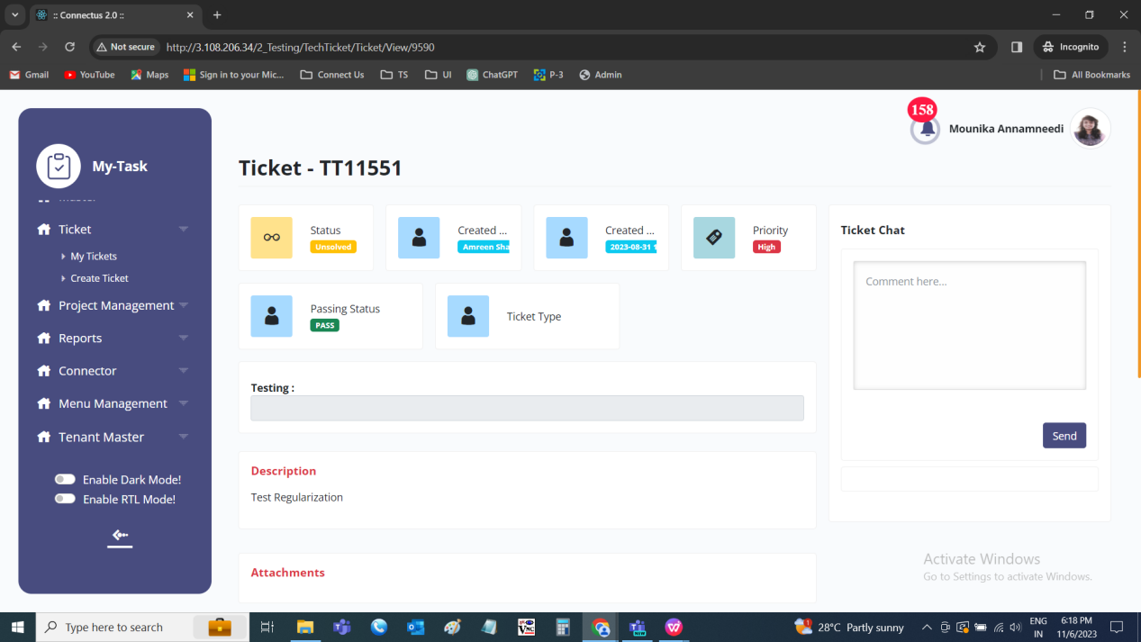

Input table
Fields | Input type | Mandatory/ Optional | Editable/ No | Description
Status | - | - | - | The status of the ticket is displayed.
Created by | - | - | - | The username of the user who created the ticket is displayed
Created at | - | - | - | The ticket date I.e., ticket creation date is displayed.
Passing status | - | - | - | The passing status of the ticket whether passed, unpassed or rejected is displayed.
Query type | - | - | - | The query type of the ticket selected at the time of creation of the ticket is displayed.
Dynamic fields | Auto | - | - | The dynamic fields at the time of creation of ticket based on the query type is displayed and edited if required.
Description | - | - | - | The description given at the time of creation of the ticket is displayed.
Attachment | - | - | - | The attachments if any are displayed and downloaded if required.
Ticket chat | Text | Optional | - | The ticket chat can be used as the chat purpose by the users. The user can tag any person with @ and mention anything.  Validation:  - Accepts alpha-numeric data with special characters up-to 1000 characters.  - The latest chat is displayed earlier.  - The username with the date and time beside the message is displayed.
Send | Button | - | - | The send button to send the message.

TICKET HISTORY
The history to view the history of the ticket. The ticket history can be viewed by the ticket owner and the project owner in the actions fields in my tickets. The following are the fields in the ticket history. The history of the ticket from the ticket creation to ticket solved can be known in the ticket history. Every edit or change made by any user is known in every row with the respective person, date and time.
- Sr
- Ticket ID
- Ticket created by user
- Ticket created by department
- Expected date
- Passing date
- Passing status
- Passed by
- Query type
- Project name
- Module name
- Sub-module name
- Reference ID
- Priority
- Assigned to user
- Assigned to department
- Status
- Confirmation
- Created at
- Updated at
- Updated by
- Operation

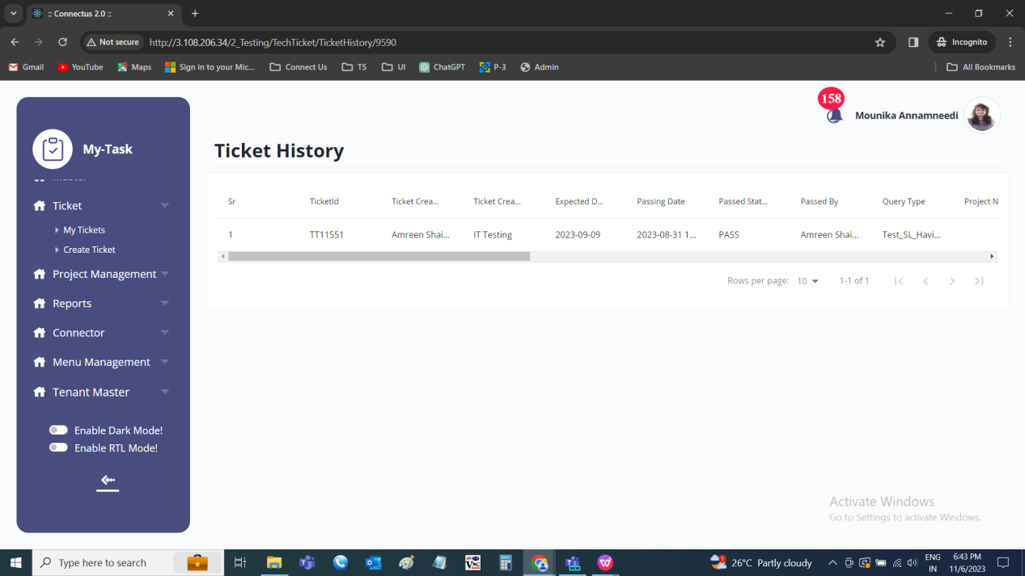

Input table
Fields | Input type | Mandatory/ Optional | Editable/ No | Description
Sr No | - | - | - | The serial number of the tickets is displayed in order
Ticket ID | - | - | - | The ticket ID of the ticket is displayed in the descending order (the latest tickets are shown first)
Ticket Created by user | - | - | - | The user who created the ticket is displayed
Ticket created by department | - | - | - | The department of the user who created the ticket is displayed
Expected date | - | - | - | The expected date of the ticket to be solved or solved date of the ticket (if in case, it is solved) is displayed
Passing date | - | - | - | The ticket passing date is displayed. If the ticket is auto passed, the creation date is displayed.
Passing status | - | - | - | The ticket passing status is displayed. If the ticket is auto passed, the auto passed is displayed.
Passed by | - | - | - | The user who passed the ticket is displayed. If the ticket is auto passed, auto passed is displayed.
Query Type | - | - | - | The query type of the ticket is displayed
Project | - | - | - | The project of the ticket is displayed
Module | - | - | - | The module is dependent on the project selected. The module name selected is displayed.
Sub-module | - | - | - | - The sub-module is dependent on the module selected. The sub-module selected is displayed.
Reference ID | - | - | - | The reference ID is displayed
Priority | - | - | - | The priority of the ticket is displayed
Assign to department | - | - | - | The assign to user department is displayed
Assign to user | - | - | - | The assigned username is displayed
Status | - | - | - | The status of the ticket is displayed
Confirmation | - | - | - | The confirmation required or not is displayed.
Created at | - | - | - | The username who created the ticket is displayed.
Created by | - | - | - | The date and time when the ticket is created is displayed.
Updated at | - | - | - | The username who last updated the data is displayed.
Updated by | - | - | - | The date and time when the data is updated last is displayed.
Operation | - | - | - | The operation held whether add or update is displayed.

BASKET
When there are no baskets created, the basket button is displayed. When the basket is created, then the task button is displayed.
The basket is the terminology used for the departments or for particular bulk work. The following are the fields in basket creation.
- Sr no
- Basket name
- Owner
- Start date
- End date
- Action
- Submit
- Cancel

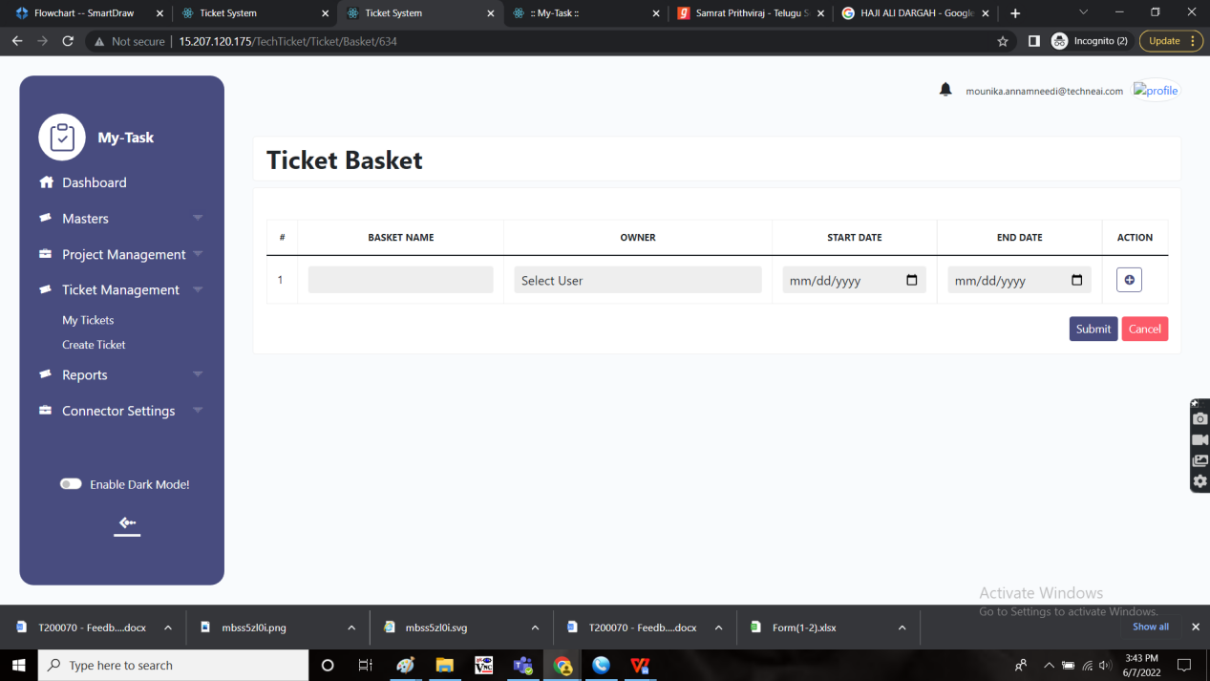

Input table
Fields | Input type | Mandatory/ Optional | Editable/ No | Description
Sr no | Auto | - | - | The serial record of the basket list is displayed.
Basket name | Text | Mandatory | - | The basket name of the basket is entered.  Validation:  Accepts alpha-numeric data with special characters up-to 50.
Owner | Drop down | Mandatory | - | The owner of the basket is selected from the drop down. The drop-down options are fetched from the user master.  Validation:  - The active users from the user master are fetched.  - Single selection
Start date | Date picker | Mandatory | - | The start date for the creation of the basket is selected from the date picker.  Validation:  The start date should be greater or equal to the ticket creation date.
End date | Date picker | Mandatory | - | The end date to end the basket is selected from the date picker.  Validation:  - The end date should be greater or equal to the start date.  - The end date should be equal or less than the expected solved date.
Action | Button | - | - | The add button to add other row to add another basket. There will be a delete button beside the created baskets to delete the existing basket entered.
Submit | Button | - | - | The submit button to create the basket
Cancel | Button | - | - | The cancel button to cancel and navigate to the my tickets page.

TASKS
The task button to add the tasks, edit the tasks and perform the tasks. The task page consist of the following.
- Ticket ID
- Ticket description
- Ticket attachments
- Baskets
- Tasks
- Hamburger

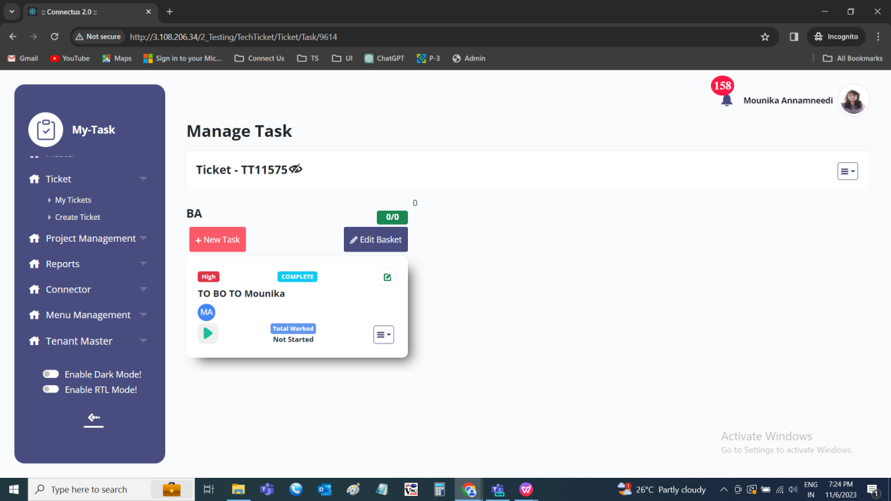

Input table
Fields | Input type | Mandatory/ Optional | Editable/ No | Description
Ticket ID | Auto | - | - | The ticket ID of the ticket is displayed
Ticket description | Auto | - | - | The ticket description is displayed
Ticket attachments | Auto | - | - | The attachments added are displayed
Baskets | - | - | - | The detail list of the baskets where the user can add or edit the existing basket
Tasks | - | - | - | The tasks list under the basket. The user can add tasks and edit the tasks.
Hamburger | Button | - | - | The hamburger for the features such as follows.  - Export all task data  - Create basket  - All test cases  - Time regularization

Ticket view
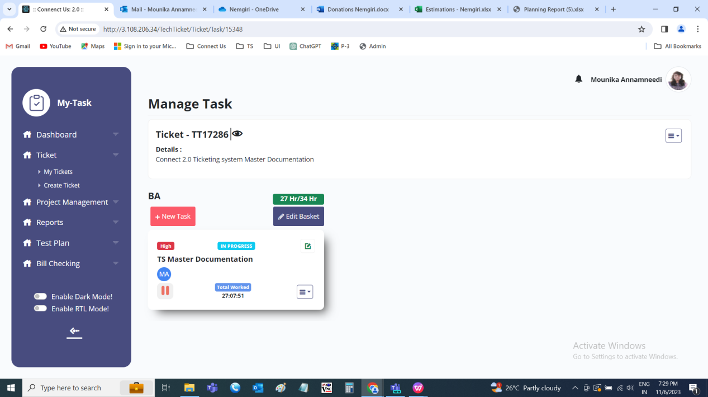

BASKETS

In task page, the user can add the baskets and also edit the existing basket. The project owner and the ticket owner can view and edit all the baskets. The basket owner can view and edit his/ her baskets. The task users can view the basket where the task is existed.
Fields | View | Edit
Project owner | ✓ | ✓
Ticket owner | ✓ | ✓
Basket owner | ✓ | ✓
Task owner | ✓ | X

EDIT BASKET
The edit basket button to edit the basket. The baskets can be edited either by the ticket owner or the project owner. The following are the fields in edit basket.
- Basket name
- Select user
- Start date
- End date
- Submit
- Cancel

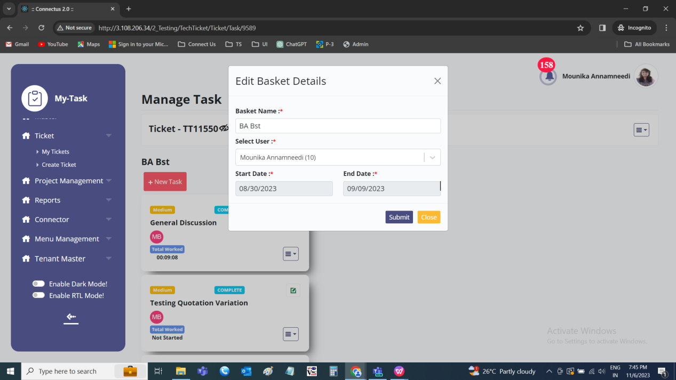

Input table
Fields | Input type | Mandatory/ Optional | Editable/ No | Description
Basket name | Text | Mandatory | - | The basket name of the basket is entered or displayed.  Validation:  Accepts alpha-numeric data with special characters up-to 50.
Owner | Drop down | Mandatory | - | The owner of the basket is selected from the drop down. The drop-down options are fetched from the user master.  Validation:  - The active users from the user master are fetched.  - Single selection
Start date | Date picker | Mandatory | - | The start date for the creation of the basket is selected from the date picker.  Validation:  The start date should be greater or equal to the ticket creation date.
End date | Date picker | Mandatory | - | The end date to end the basket is selected from the date picker.  Validation:  - The end date should be greater or equal to the start date.  - The end date should be equal or less than the expected solved date.
Submit | Button | - | - | The submit button to update the basket
Cancel | Button | - | - | The cancel button to cancel and navigate to the my tasks page.

TASKS

In tasks page, the user can add the tasks or edit the tasks. The tasks are the part of the baskets. Under the basket, the task details are displayed. The following are the fields in the task page view.
- New task
- Task name
- Task priority
- Task status
- Edit button
- Assigned users
- Task played time
- Hamburger

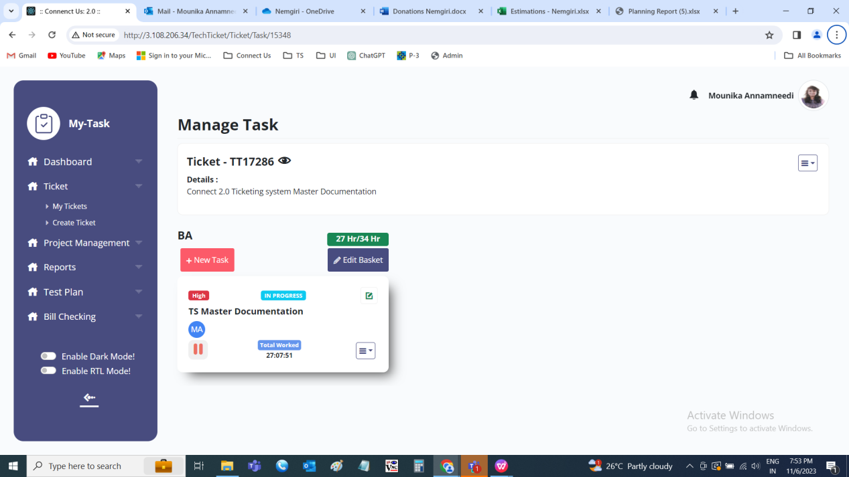

Input table
Fields | Input type | Mandatory/ Optional | Editable/ No | Description
New task | Button | - | - | The new task button to add the task under the basket added.
Task name | Auto | - | - | The task name of the task is displayed
Task priority | Auto | - | - | The task priority is displayed
Task status | Auto | - | - | The task status is displayed
Edit button | Button | - | - | The edit button to edit the task
Assigned users | Auto | - | - | The assigned users of the task is displayed
Task played time | Auto | - | - | The total task played till now is displayed
Hamburger | Button | - | - | The hamburger menu consist of the following.  - Planner  - Task history  - Sub task  - Request regularization  - Test cases

Hamburger
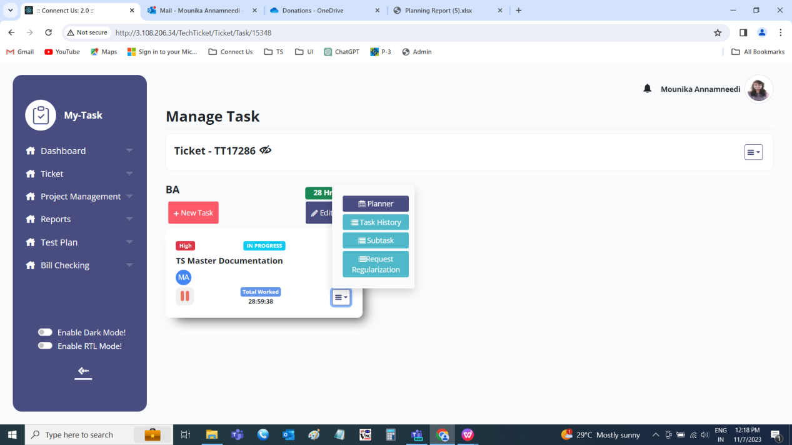

The add and edit task consists of the following fields.
- Select task type
- Task name
- Start date
- End date
- Task hours
- Task priority
- Select status
- Description
- Assign to user
- Dependent task
- Attachment

Input table
Fields | Input type | Mandatory/ Optional | Editable/ No | Description
Select task type | Radio button | Mandatory | Yes | The select type button to select whether the task is for the individuals or for the group.  Validation:  Single selection
Task name | Text | Mandatory | Yes | The task name of the task s entered or displayed.  Validation:  Accepts alpha-numeric data with special characters up-to 100.
Start date | Date picker | Mandatory | Yes | The start date of the task is selected from the date picker.  Validation:  - The start date should be greater than or equal to the basket start date.  - The start date should be less than or equal to the basket end date.
End date | Date picker | Mandatory | Yes | The end date of the task is selected from the date picker.  - The end date should be greater than or equal to the the start date.  - The end should be equal to or less than the basket end date.
Task hours | Time picker | Mandatory | Yes | The task hours required for that task to complete is mentioned.  Validation:  HH:MM format
Task priority | Drop down | Mandatory | Yes | The task priority is selected from the drop down. The drop-down consists of the following.  - High  - Medium  - Low  Validation:  Single selection
Select status | Radio button | Mandatory | Yes | The status of the task is selected from the options given. The options are as follows.  - To do  - In progress  - Completed  Validation:  - When a task is created, the status by default, it is to do.  - Single selection
Description | Text | Optional | Yes | The description of the task is mentioned or displayed.  Validation:  Accepts alpha-numeric data with the special characters up-to 1000 characters.
Assign to user | Drop down | Mandatory | Yes | The users to whom the task to be assigned is selected from the drop down. The drop-down options are fetched from the user master.  Validation:  - The active users are fetched from the user master.  - Multiple selection  - When group task is selected, multiple users are mandatory
Dependent task | Drop down | Optional | Yes | The task on which the the existing task is dependent is selected from the drop down. The drop-down options consists of the all the tasks added in that ticket.  Validation:  Single selection
Attachment | File upload | Optional | Yes | The files to be attached for the task as supporting is attached.  Validation:  Size of 2MB up-to maximum 5 are accepted. Any file format is accepted.

Add task
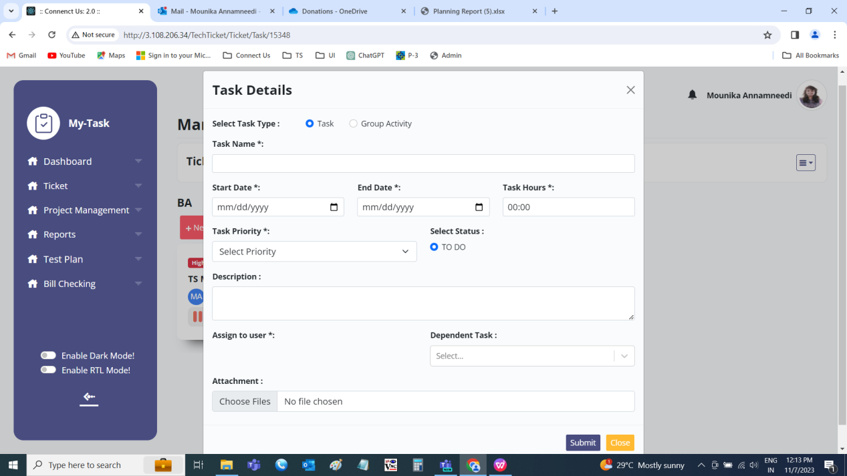

Edit task
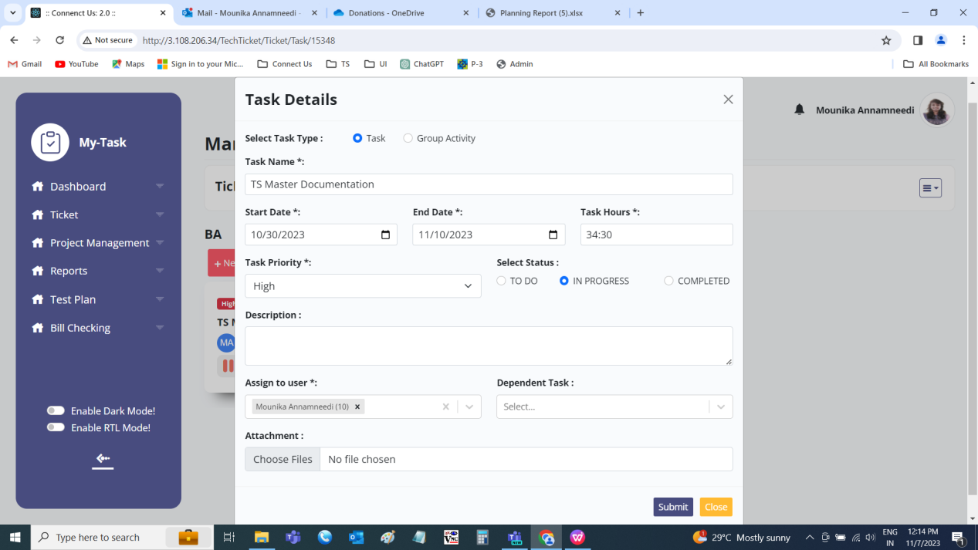

PLANNER
The planner relates the planning of the tasks in the regular life. It is based on how many hours a user is working on the particular day.
The planner is divided with the number of the days and equal number of hours in the particular day. If there were multiple users, the hours is divided equally among all the users based on the days equally.
The following are the fields in the planner.
- Sr no
- Username
- Date
- Hours
- Total hours
- Update
- Close

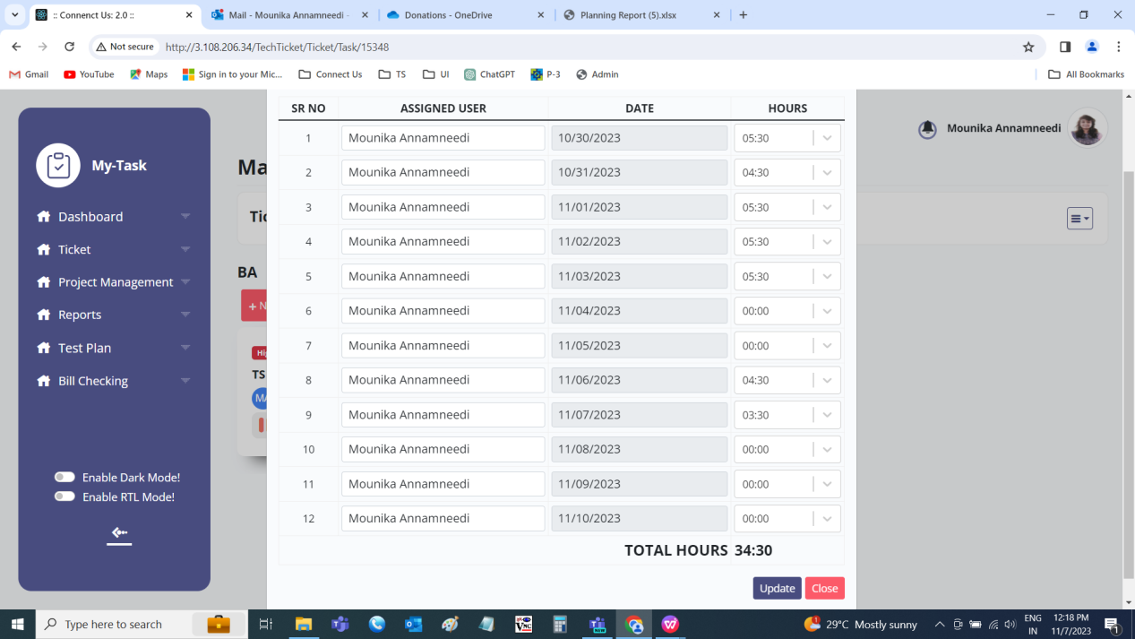

Input table
Fields | Input type | Mandatory/ Optional | Editable/ No | Description
Sr no | Auto | Mandatory | - | The serial count of the rows is displayed in the order.
Username | Auto | Mandatory | - | The username of the task is displayed. If multiple users, the multiple rows for each date is displayed.
Date | Auto | Mandatory | - | The date on which the task is belonged to is displayed. If multiple users, the multiple rows for each date is displayed.
Hours | Time picker | Mandatory | Yes | The hours divided for the day for that task is displayed. The user can change the time if required.  Validation:  - HH:MM format  - The hours should not be greater than the total hours scheduled.
Total hours | Auto | Mandatory | - | The total hours required to complete the task is displayed.  When the task scheduled, the total hours will be the task hours.  Later, when the user changes the hours, the total to be auto calculated and displayed.  Validation:  The total hours should be equal to or less than the tasks hours scheduled in the task.
Update | Button | - | - | The update button to update the task.
Close | Button | - | - | The close button to close the pop up.

TASK HISTORY
The task history of the task from the task creation to task completed solved can be known in the task history. Every edit or change made by any user is known in every row with the respective person, date and time. The following are the fields in the task history.
- Sr no
- Task ID
- Task name
- Basket name
- Start date
- End date
- Priority
- Status
- Description
- Task hours
- Created at
- Created by
- Updated at
- Updated by

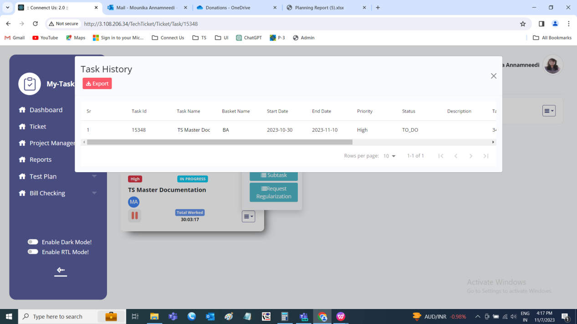

Input table
Fields | Input type | Mandatory/ Optional | Editable/ No | Description
Sr no | - | - | - | The serial number of the record is displayed in order.
Task ID | - | - | - | The task ID is displayed
Task name | - | - | - | The task name of the task is or displayed.
Basket name | - | - | - | The basket name under which the task is presented is displayed.
Start date | - | - | - | The start date of the task is selected from the date picker.
End date | - | - | - | The end date of the task is selected from the date picker.
Priority | - | - | - | The task priority is selected from the drop down is displayed. The drop-down consists of the following.  - High  - Medium  - Low
Status | - | - | - | The status of the task is selected from the options given is displayed. The options are as follows.  - To do  - In progress  - Completed
Description | - | - | - | The description of the task is displayed.
Task hours | - | - | - | The task hours required for that task to complete is displayed.
Created at | - | - | - | The username who created the task is displayed.
Created by | - | - | - | The date and time when the task is created is displayed.  Validation:  Format - YYYY-MM-DD HH:MM:SS
Updated at | - | - | - | The username who last updated the task is displayed.
Updated by | - | - | - | The date and time when the task is updated last is displayed.  Validation:  Format - YYYY-MM-DD HH:MM:SS

SUBTASK
The sub task are the part of the tasks. The sub-tasks are mentioned as check lists which helps in easing the process. The following are the fields of sub-task.
- Sr No
- Sub-task
- Action
- Text field
- “+” button

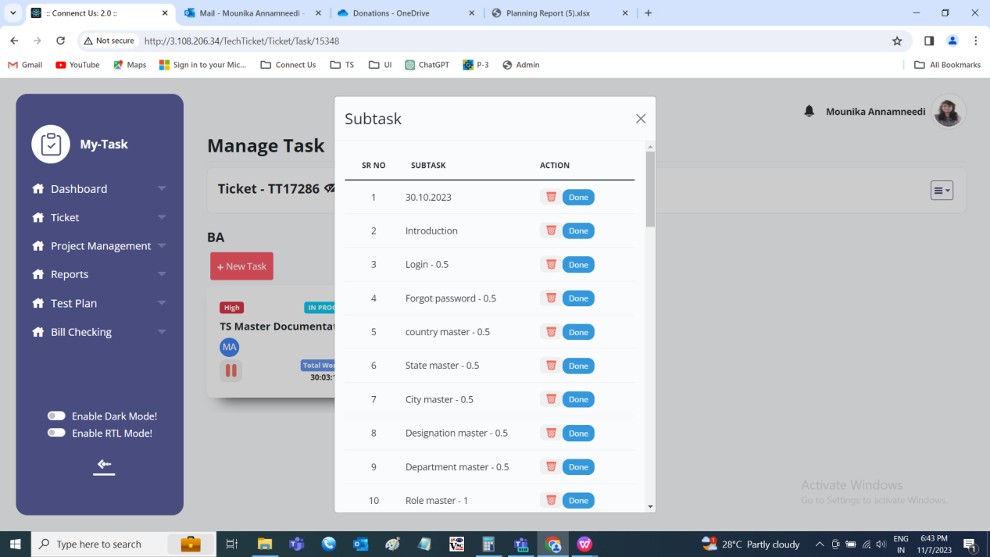

Input table
Fields | Input type | Mandatory/ Optional | Editable/ No | Description
Sr no | Auto | Mandatory | - | The serial count of the rows is displayed in the order.
Sub-task | Auto | Mandatory | - | The sub task name is displayed
Action | Buttons | - | - | The action field consist of the delete and done buttons.  Delete button to delete the data.  Done button to complete the sub-task. The sub-task name will be strike-through.  Validation:  The completed tasks cannot be deleted.
Text field | Text | Mandatory | - | The text field to enter the new sub-task under the task.  Validation:  - Duplicate data not allowed.  - Accepts alpha-numeric data with special characters up-to 100 characters.
“+” button | Button | - | - | The add button to add the sub-task mentioned in the text field.

EXPORT ALL DATA

The export all data to export the baskets and tasks details in that ticket. The functionality can be accessed by the ticket owner and the project owner. The data is fetched from the ticket details, basket details and the task details. The following are the fields in the export all data.
- Sr no
- Ticket ID name
- Task name
- Task hours
- Start date
- End date
- Status
- Priority
- Total worked
- Basket name
- Task owner names

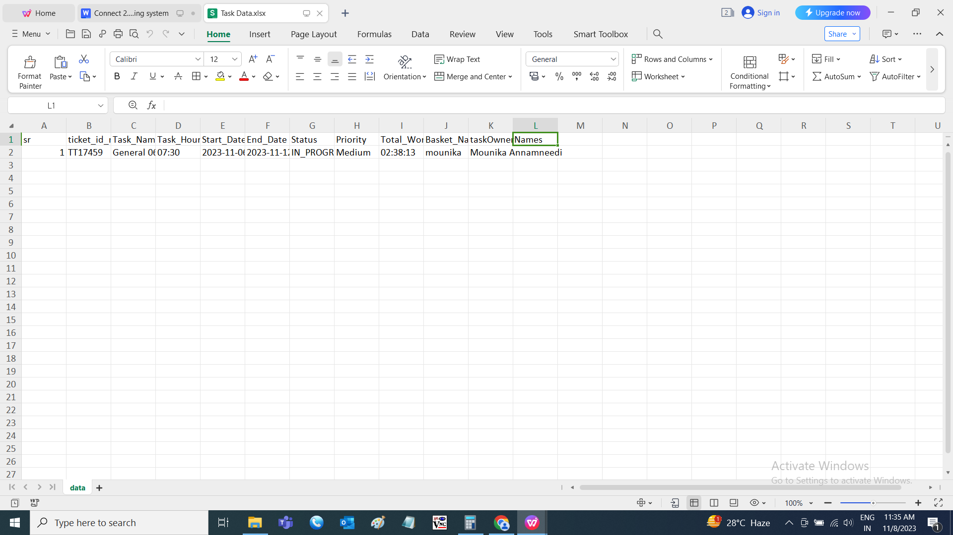

TEST CASES

The test cases are created by the tester for the developments done by the developers. These test cases are reviewed by the business analysts or the reviewer. The developers and business analysts can view whether the test case is passed or failed (detection of the bugs) and can give the remark of necessary. When the test cases are passed, then it is treated that the development is properly done.

CREATION OF TEST CASES
The tester can write the test cases in the test cases field. The test cases consist of the following fields.
- Script path
- Platform
- APK version
- OS version
- Module name
- Sub-module name
- Sr no
- Ticket ID
- Test case ID
- Testing type
- Function
- Field
- Test description
- Expected result
- Actual result
- Tester status
- Tester comment
- Reviewer comment
- Severity
- Priority
- Operation
- Task ID
- BA status
- BA comment
- Developer status
- Developer comment
- Approved status changed by
- Approved status
- Approved at
- Attachment
- Created at
- Created by
- Updated at
- Updated by
- Review
- Add to test plan
- Export
- Download format file
- Import
- Enable/ disable
- Add data
- Edit data
- History

Fields | Grid view | Add | Edit | History | Download format file | Export | Filter
Script path | ✓ | ✓ | ✓ | ✓ | x | ✓ | x
Platform | ✓ | ✓ | ✓ | ✓ | ✓ | ✓ | x
APK version | ✓ | ✓ | ✓ | ✓ | ✓ | ✓ | x
OS version | ✓ | ✓ | ✓ | ✓ | ✓ | ✓ | x
Module name | x | x | x | ✓ | x | ✓ | x
Sub-module name | x | x | x | ✓ | x | ✓ | x
Sr no | x | x | x | ✓ | x | x | x
Ticket ID | x | x | x | ✓ | x | x | x
Test case ID | ✓ | ✓ | ✓ | ✓ | x | ✓ | x
Testing type | ✓ | ✓ | ✓ | ✓ | ✓ | ✓ | ✓
Function | ✓ | ✓ | ✓ | ✓ | ✓ | ✓ | ✓
Field | ✓ | ✓ | ✓ | ✓ | ✓ | ✓ | x
Test description | ✓ | ✓ | ✓ | ✓ | ✓ | ✓ | x
Expected result | ✓ | ✓ | ✓ | ✓ | ✓ | ✓ | x
Actual result | x | x | x | ✓ | x | ✓ | x
Tester status | x | x | x | ✓ | x | ✓ | x
Tester comment | ✓ | ✓ | ✓ | ✓ | ✓ | ✓ | x
Reviewer comment | x | x | x | x | x | ✓ | x
Severity | ✓ | ✓ | ✓ | ✓ | ✓ | ✓ | ✓
Priority | x | x | x | ✓ | x | x | x
Operation | x | x | x | ✓ | x | x | x
Task ID | x | x | x | ✓ | x | x | x
BA status | x | x | x | ✓ | x | x | x
BA comment | x | x | x | ✓ | x | x | x
Developer status | x | x | x | ✓ | x | x | x
Developer comment | x | x | x | ✓ | x | x | x
Approved status changed by | x | x | x | ✓ | x | x | x
Approved status | x | x | x | ✓ | x | x | x
Approved at | x | x | x | ✓ | x | x | x
Attachment | x | x | x | ✓ | x | x | x
Created at | x | x | x | ✓ | x | x | x
Created by | x | x | x | ✓ | x | x | x
Updated at | x | x | x | ✓ | x | x | x
Updated by | x | x | x | ✓ | x | x | x
Review | ✓ | ✓ | ✓ | x | x | x | x
Add to test plan | ✓ | ✓ | ✓ | x | x | x | x
Export | ✓ | ✓ | ✓ | x | x | x | x
Download format file | ✓ | ✓ | ✓ | x | x | x | x
Import | ✓ | ✓ | ✓ | x | x | x | x
Enable/ disable | ✓ | ✓ | ✓ | x | x | x | x
Add data | ✓ | ✓ | ✓ | x | x | x | x
Edit data | ✓ | ✓ | ✓ | x | x | x | x
History | ✓ | ✓ | ✓ | x | x | x | x

Input table
Fields | Input type | Mandatory/ Optional | Editable/ No | Description
Script path | Text | Optional | - | The script path of the test cases is entered or displayed.  Validation:  Accepts alpha-numeric data with special characters up-to 500 characters.
Platform | Drop down | Mandatory | - | The platform is selected from the drop down. The drop down options consists of following.  - APK  - OS  When the APK is selected in case of android, APK version field is enabled.  When the OS is selected in case of apple, OS version field is enabled.  Validation:  Single selection
APK version | Text | Optional | - | The APK version of the application is entered or displayed.  Validation:  Accepts integers and dot (.) upto 20 characters.
OS version | Text | Optional | - | The OS version of the application is entered or displayed.  Validation:  Accepts integers and dot (.) upto 20 characters.
Module name | Auto | - | - | The module name of the ticket is fetched and displayed.
Sub-module name | Auto | - | - | The sub-module name of the ticket is fetched and displayed
Sr no | Auto | - | - | The serial count of the records is displayed in order.
Ticket ID | Auto | - | - | The ticket ID where the test cases belong is displayed
Test case ID | Auto | - | - | The test case ID is auto generated for each test case.
Testing type | Drop down | Mandatory | Yes | The testing type is selected from the drop down. The drop down options are fetched from the testing type master.  Validation:  - The active testing types are fetched from the testing type master.  - Single selection
Function | Drop down | Mandatory | Yes | The function of the test cases is selected from the drop down. The drop-down options consist of the following.  - Add  - Edit  - View  - Delete  - Grid view  - Export  - Reset  - Search  - Custom export  - History  - Custom/ other button  - Filter  - Pre-requisite  Validation:  Single selection
Field | Text | Optional | Yes | The field name is entered or displayed.  Validation:  Accepts alpha-numeric data with special characters up-to 50 characters.
Test description | Text | Mandatory | Yes | The test description I.e., the description of the test case is entered or displayed.  Validation:  Accepts alpha-numeric data with special characters up-to 1000 characters.
Expected result | Text | Mandatory | Yes | The expected result for that test case to be entered or displayed.  Validation:  Accepts alpha-numeric data with special characters up-to 1000 characters.
Actual result | Auto | - | - | The actual result for the test cases is displayed
Tester status | Auto | - | - | The tester status for the test case is displayed.
Tester comment | Text | Optional | Yes | The tester comment if any for that test case is entered or displayed.  Validation:  Accepts alpha-numeric data with special characters up-to 1000 characters.
Reviewer comment | Auto | - | - | The reviewer comment for that test case id displayed.
Severity | Drop down | Mandatory | Yes | The severity of the test case is selected from the drop down. The drop down consist of the following.  - Low  - Medium  - High  Validation:  Single selection
Priority | Auto | - | - | The priority of the test case is displayed
Operation | Auto | - | - | The operation I.e., the action taken place whether add or edit is displayed.
Task ID | Auto | - | - | The task ID of the task is displayed
BA status | Auto | - | - | The BA status of the test case is displayed.
BA comment | Auto | - | - | The BA comment of the test case is displayed.
Developer status | Auto | - | - | The developer status of the test case is displayed
Developer comment | Auto | - | - | The developer comment of the test case is displayed
Approved status changed by | Auto | - | - | The reviewer who updated the test case is displayed
Approved status | Auto | - | - | The reviewer status whether the test case is approved or rejected is displayed.
Approved at | Auto | - | - | The test case whether approved or rejected, the last updated date and time is displayed in DD/MM/YYYY HH:MM:SS format.
Attachment | Auto | - | - | The attachment attached as support is displayed
Created at | Auto | - | - | The date and time when the test case is created in DD/MM/YYYY HH:MM:SS format is displayed.
Created by | Auto | - | - | The username of the user who created the test case is displayed.
Updated at | Auto | - | - | The date and time when the test case is last updated in DD/MM/YYYY HH:MM:SS format is displayed.
Updated by | Auto | - | - | The username of the user who last updated the test case is displayed.
Review | Button | - | - | In case, reviewer is available, then review button is displayed. The test cases will be sent to reviewer for the review by auto creating the basket and task for the reviewer.
Add to test plan | Button | - | - | The add to test plan button if in case, there is no reviewer is displayed. The add to test plan will add the test cases to test plan.
Export | Button | - | - | The export button to export the test cases.
Download format file | Button | - | - | The download format button to download the format to upload the test cases.
Import | Button | - | - | The import button to import the test cases into the system.
Enable/ disable | Button | - | - | The enable/ disable button to enable or disable the test cases. The disabled test cases will be blocked until approval. The disabled test cases cannot be sent further neither to the test plan or to the reviewer for the review.
Add data | Button | - | - | The add data button to add the test case after that test case.
Edit data | Button | - | - | The edit button to edit the test case.
History | Button | - | - | The history button to view the history of the test case.

Creation of test cases
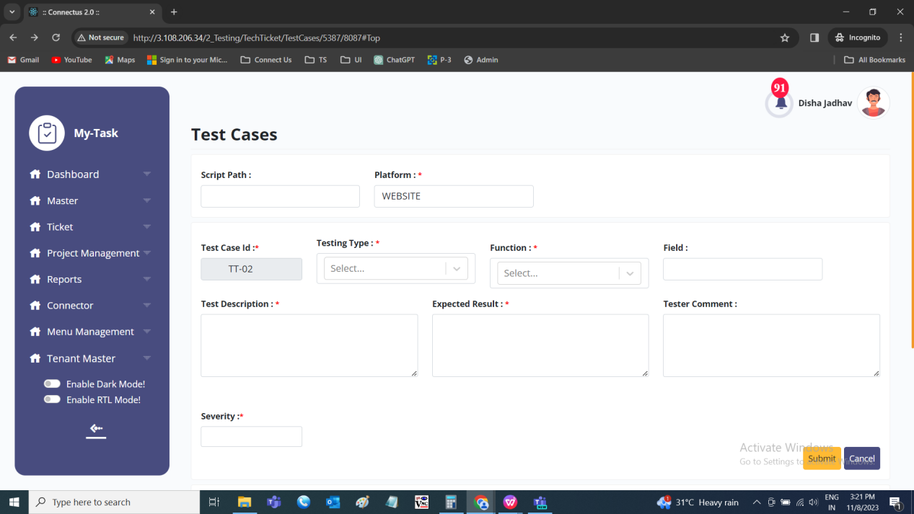

Filter
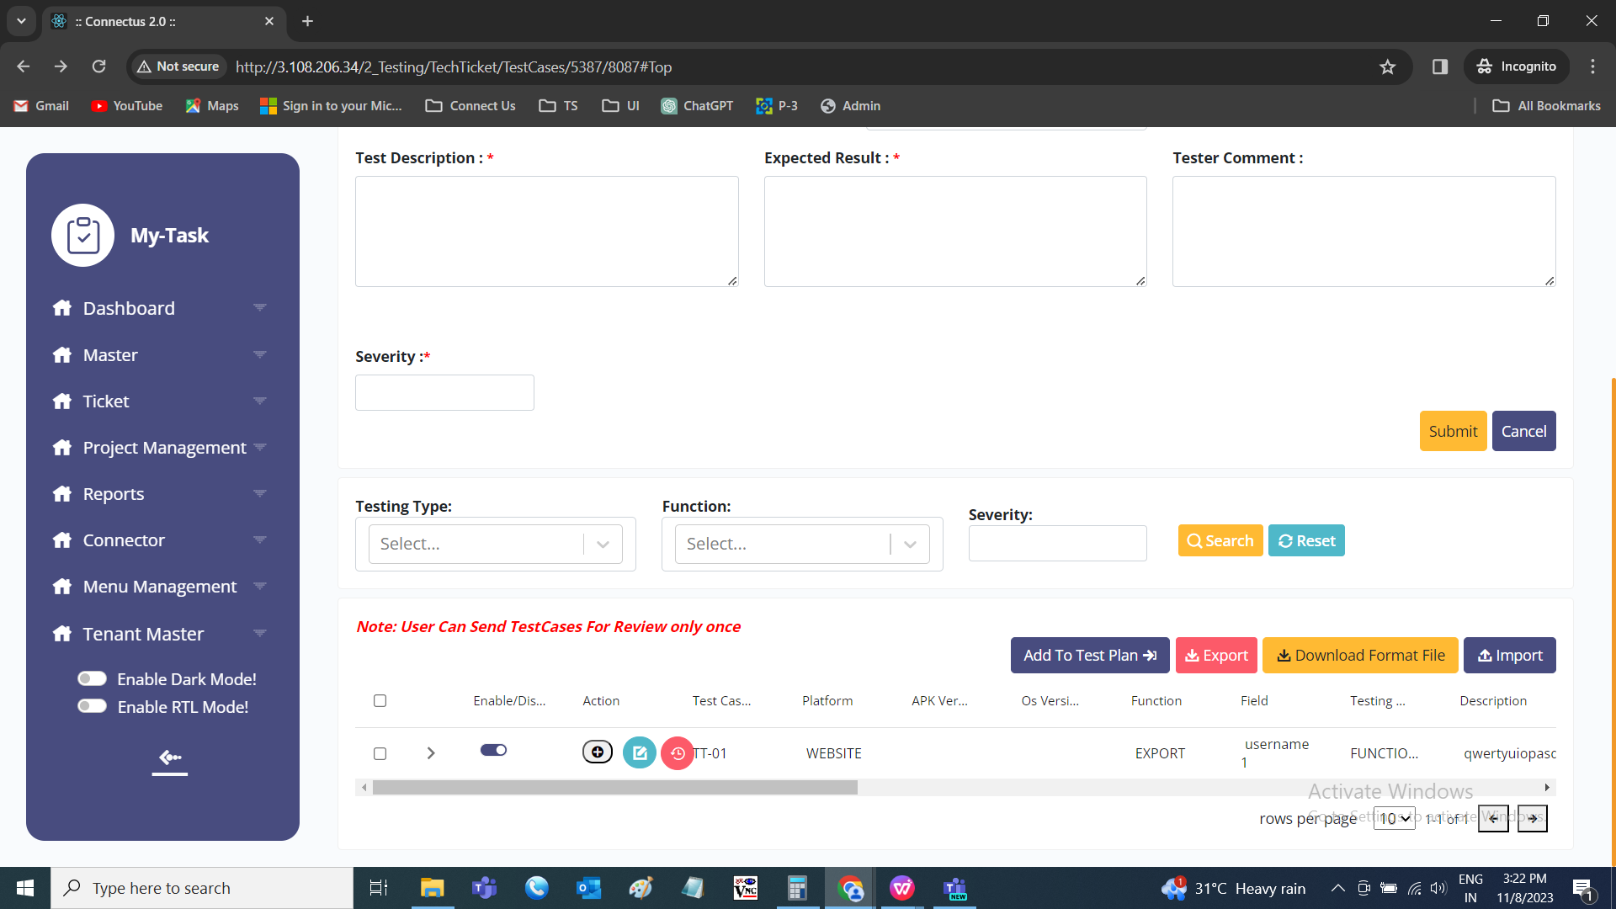

Grid view

Export
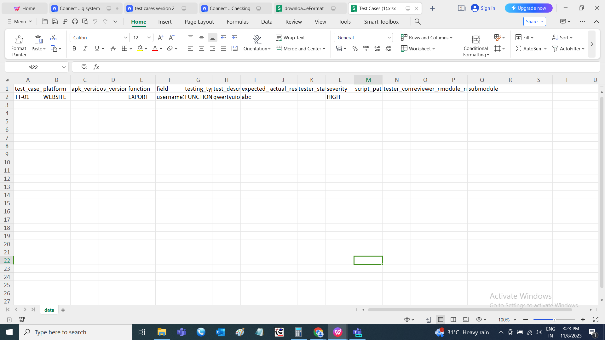

Download format file
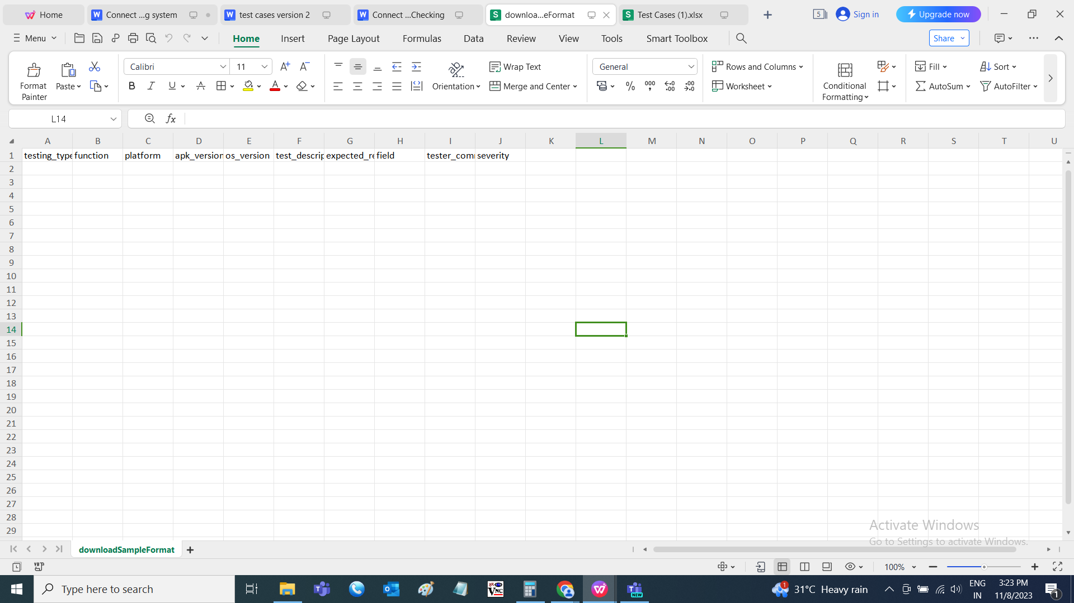

REVIEWER
The tester clicks on the review button, automatically reviewer basket is created and task for the reviewer is created and the notification is sent to the reviewer. The reviewer task is created automatically with the following details.

Input table
Fields | Input type | Mandatory/ Optional | Editable/ No | Description
Task name | - | - | - | The task name will be “Review of <task name of the tester>
Start date | - | - | - | The start date will be next day (excluding Saturday and Sunday) when the tester sent for the review.
End date | - | - | - | The end date and the start date will be same
Task hours | - | - | - | The task hours will be based on the number of the test records. Each record will be considered 30seconds. If there are 30 test cases, then the task hours will be 00:15 (15 minutes).
Priority | - | - | - | The priority will be same as the tester task priority
Assigned users | - | - | - | The assigned user will be the reviewer of that ticket
Dependent task | - | - | - | The dependent task is selected based on the tester task sent for the review

The reviewer can review the test cases in the record view. The test cases consists of the following fields. The reviewer can edit in line.
- Platform
- APK version
- OS version
- Module name
- Sub-module name
- Sr no
- Ticket ID
- Test case ID
- Testing type
- Function
- Field
- Test description
- Expected result
- Actual result
- Tester status
- Tester comment
- Reviewer comment
- Severity
- Priority
- Operation
- Task ID
- BA status
- BA comment
- Developer status
- Developer comment
- Approved status changed by
- Approved status
- Approved at
- Attachment
- Created at
- Created by
- Updated at
- Updated by
- Send to
- Export
- History
- Approve/ reject

Fields | Grid view | Edit | History | Filter | Export
Platform | ✓ | x | ✓ | x | ✓
APK version | ✓ | x | ✓ | x | ✓
OS version | ✓ | x | ✓ | x | ✓
Module name | x | x | ✓ | x | ✓
Sub-module name | x | x | ✓ | x | ✓
Sr no | x | x | ✓ | x | ✓
Ticket ID | x | x | ✓ | x | ✓
Test case ID | ✓ | x | ✓ | x | ✓
Testing type | ✓ | ✓ | ✓ | ✓ | ✓
Function | ✓ | ✓ | ✓ | ✓ | ✓
Field | ✓ | ✓ | ✓ | x | ✓
Test description | ✓ | ✓ | ✓ | x | ✓
Expected result | ✓ | ✓ | ✓ | x | ✓
Actual result | x | ✓ | ✓ | x | ✓
Tester status | x | x | ✓ | x | ✓
Tester comment | ✓ | x | ✓ | x | ✓
Reviewer comment | ✓ | ✓ | ✓ | x | ✓
Severity | ✓ | ✓ | ✓ | ✓ | ✓
Priority | x | x | ✓ | x | ✓
Operation | x | x | ✓ | x | ✓
Task ID | x | x | ✓ | x | ✓
BA status | x | x | ✓ | x | ✓
BA comment | x | x | ✓ | x | ✓
Developer status | x | x | ✓ | x | ✓
Developer comment | x | x | ✓ | x | ✓
Approved status changed by | x | x | ✓ | x | ✓
Approved status | x | x | ✓ | x | ✓
Approved at | x | x | ✓ | x | ✓
Attachment | x | x | ✓ | x | ✓
Created at | x | x | ✓ | x | ✓
Created by | x | x | ✓ | x | ✓
Updated at | x | x | ✓ | x | ✓
Updated by | x | x | ✓ | x | ✓
Send to | ✓ | x | x | x | x
Export | ✓ | x | x | x | x
History | ✓ | x | x | x | x
Approve/ reject | ✓ | x | x | x | x

Input table
Fields | Input type | Mandatory/ Optional | Editable/ No | Description
Platform | Auto | - | - | The platform of the test cases is displayed.
APK version | Auto | - | - | The APK version of the application is displayed.
OS version | Auto | - | - | The OS version of the application is displayed.
Module name | Auto | - | - | The module name of the ticket is fetched and displayed.
Sub-module name | Auto | - | - | The sub-module name of the ticket is fetched and displayed
Sr no | Auto | - | - | The serial count of the records is displayed in order.
Ticket ID | Auto | - | - | The ticket ID where the test cases belong is displayed
Test case ID | Auto | - | - | The test case ID is auto generated for each test case.
Testing type | Drop down | Mandatory | Yes | The testing type is selected from the drop down. The drop down options are fetched from the testing type master.  Validation:  - The active testing types are fetched from the testing type master.  - Single selection
Function | Drop down | Mandatory | Yes | The function of the test cases is selected from the drop down. The drop-down options consist of the following.  - Add  - Edit  - View  - Delete  - Grid view  - Export  - Reset  - Search  - Custom export  - History  - Custom/ other button  - Filter  - Pre-requisite  Validation:  Single selection
Field | Text | Optional | Yes | The field name is entered or displayed.  Validation:  Accepts alpha-numeric data with special characters up-to 50 characters.
Test description | Text | Mandatory | Yes | The test description I.e., the description of the test case is entered or displayed.  Validation:  Accepts alpha-numeric data with special characters up-to 1000 characters.
Expected result | Text | Mandatory | Yes | The expected result for that test case to be entered or displayed.  Validation:  Accepts alpha-numeric data with special characters up-to 1000 characters.
Actual result | Auto | - | - | The actual result for the test cases is displayed
Tester status | Auto | - | - | The tester status for the test case is displayed.
Tester comment | Text | Optional | Yes | The tester comment if any for that test case is entered or displayed.  Validation:  Accepts alpha-numeric data with special characters up-to 1000 characters.
Reviewer comment | Text | - | - | The reviewer comment if any for that test case is entered or displayed.  Validation:  Accepts alpha-numeric data with special characters up-to 1000 characters.
Severity | Drop down | Mandatory | Yes | The severity of the test case is selected from the drop down. The drop down consist of the following.  - Low  - Medium  - High  Validation:  Single selection
Priority | Auto | - | - | The priority of the test case is displayed
Operation | Auto | - | - | The operation I.e., the action taken place whether add or edit is displayed.
Task ID | Auto | - | - | The task ID of the task is displayed
BA status | Auto | - | - | The BA status of the test case is displayed.
BA comment | Auto | - | - | The BA comment of the test case is displayed.
Developer status | Auto | - | - | The developer status of the test case is displayed
Developer comment | Auto | - | - | The developer comment of the test case is displayed
Approved status changed by | Auto | - | - | The reviewer who updated the test case is displayed
Approved status | Auto | - | - | The reviewer status whether the test case is approved or rejected is displayed.
Approved at | Auto | - | - | The test case whether approved or rejected, the last updated date and time is displayed in DD/MM/YYYY HH:MM:SS format.
Attachment | Auto | - | - | The attachment attached as support is displayed
Created at | Auto | - | - | The date and time when the test case is created in DD/MM/YYYY HH:MM:SS format is displayed.
Created by | Auto | - | - | The username of the user who created the test case is displayed.
Updated at | Auto | - | - | The date and time when the test case is last updated in DD/MM/YYYY HH:MM:SS format is displayed.
Updated by | Auto | - | - | The username of the user who last updated the test case is displayed.
Send to | Button | - | - | The send to button to send the test cases to the test plan.
Export | Button | - | - | The export button to export the test cases.
History | Button | - | - | The history button to view the history of the test cases.
Approve/ reject | Button | - | - | The approve/ reject button to approve or reject the test cases.  Only the approved test cases are sent to the test plan. The rejected test cases are send to the tester again by auto creating the task under the tester basket.

Reviewer test cases
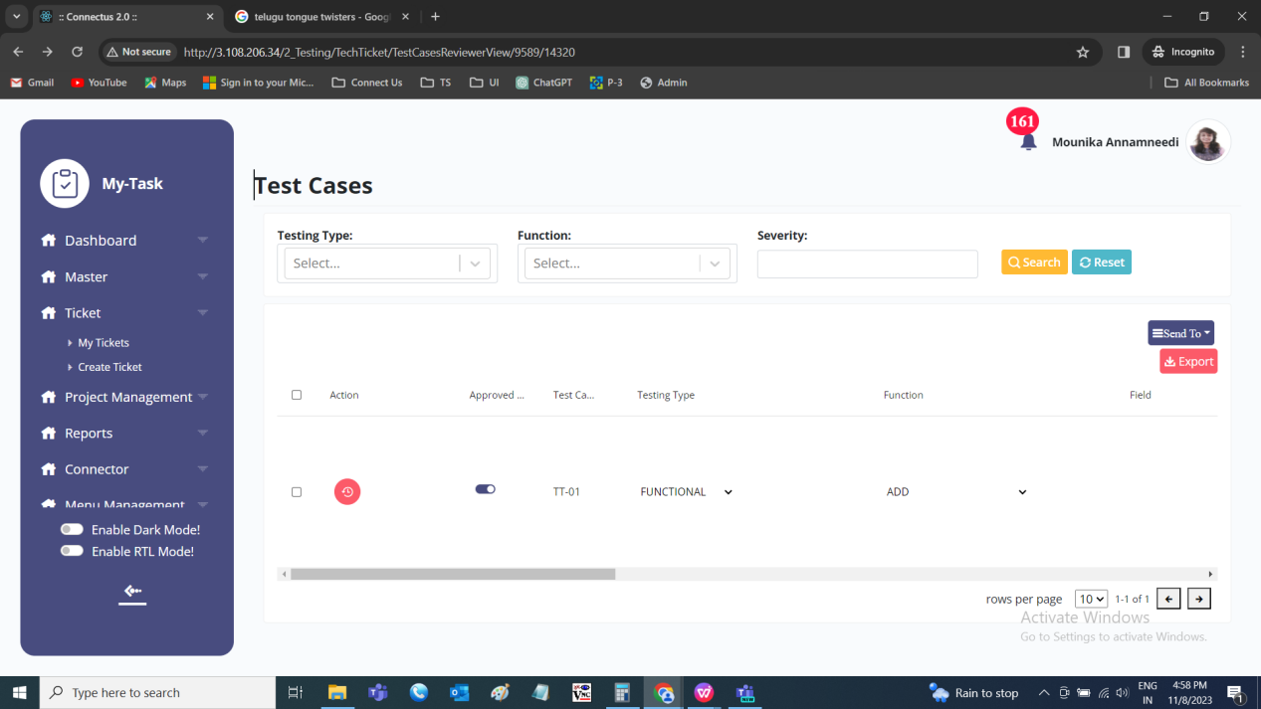

History
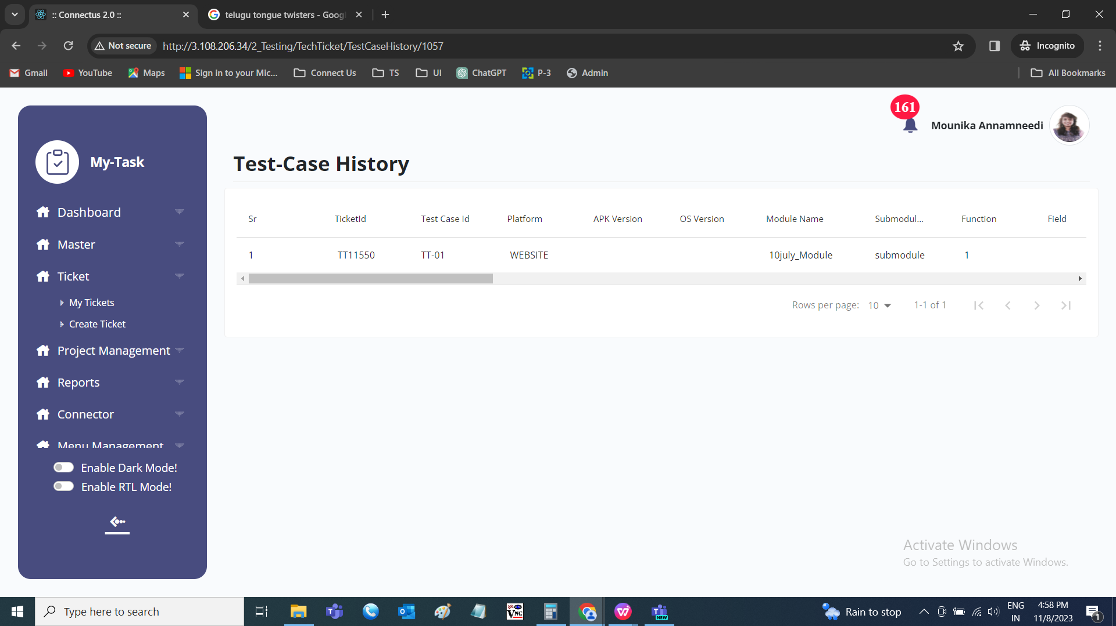

Export

ALL TEST CASES
The test cases consist of the following and can be viewed by the project owner, ticket owner, all basket owners and all task owners.
- Platform
- APK version
- OS version
- Module name
- Sub-module name
- Sr no
- Ticket ID
- Test case ID
- Test case name
- Testing type
- Function
- Field
- Test description
- Expected result
- Actual result
- Tester status
- Tester comment
- Reviewer comment
- Severity
- Priority
- Operation
- Task ID
- BA status
- BA comment
- Developer status
- Developer comment
- Approved status changed by
- Approved status
- Approved at
- Attachment
- Created at
- Created by
- Updated at
- Updated by
- Send to
- Export
- Edit data
- History

Fields | Grid view | Edit by Tester | Edit by Reviewer | Edit by BA | Edit by Developer | History | Export | Filter
Platform | ✓ | x | x | x | x | ✓ | ✓ | x
APK version | ✓ | x | x | x | x | ✓ | ✓ | x
OS version | ✓ | x | x | x | x | ✓ | ✓ | x
Module name | ✓ | x | x | x | x | ✓ | ✓ | x
Sub-module name | ✓ | x | x | x | x | ✓ | ✓ | x
Sr no | x | x | x | x | x | ✓ | ✓ | x
Ticket ID | x | x | x | x | x | ✓ | ✓ | x
Test case ID | ✓ | x | x | x | x | ✓ | ✓ | x
Test case name | x | x | x | x | x | x | x | ✓
Testing type | ✓ | x | x | x | x | ✓ | ✓ | ✓
Function | ✓ | x | x | x | x | ✓ | ✓ | ✓
Field | ✓ | x | x | x | x | ✓ | ✓ | x
Test description | ✓ | x | x | x | x | ✓ | ✓ | x
Expected result | ✓ | x | x | x | x | ✓ | ✓ | x
Actual result | ✓ | ✓ | ✓ | x | x | ✓ | ✓ | x
Tester status | ✓ | ✓ | ✓ | x | x | ✓ | ✓ | ✓
Tester comment | ✓ | ✓ | ✓ | x | x | ✓ | ✓ | x
Reviewer comment | ✓ | x | ✓ | x | x | ✓ | ✓ | x
Severity | ✓ | ✓ | x | x | x | ✓ | ✓ | ✓
Priority | ✓ | x | x | ✓ | x | ✓ | ✓ | ✓
Operation | x | x | x | x | x | ✓ | x | x
Task ID | x | x | x |  | x | ✓ | x | x
BA status | ✓ | x | x | ✓ | x | ✓ | ✓ | ✓
BA comment | ✓ | x | x | ✓ | x | ✓ | ✓ | x
Developer status | ✓ | x | x | x | ✓ | ✓ | ✓ | ✓
Developer comment | ✓ | x | x | x | ✓ | ✓ | ✓ | x
Approved status changed by | x | x | x | x | x | ✓ | ✓ | x
Approved status | x | x | x | x | x | ✓ | ✓ | x
Approved at | x | x | x | x | x | ✓ | ✓ | x
Attachment | x | x | x | x | x | ✓ | ✓ | x
Created at | x | x | x | x | x | ✓ | ✓ | x
Created by | x | x | x | x | x | ✓ | ✓ | x
Updated at | x | x | x | x | x | ✓ | ✓ | x
Updated by | x | x | x | x | x | ✓ | ✓ | x
Send to | ✓ | x | x | x | x | x | x | x
Export | ✓ | x | x | x | x | x | x | x
Edit data | ✓ | x | x | x | x | x | x | x
History | ✓ | x | x | x | x | x | x | x

Input table
Fields | Input type | Mandatory/ Optional | Editable/ No | Description
Platform | Drop down | Mandatory | - | The platform of the test cases is displayed.
APK version | Text | Optional | - | The APK version of the application is displayed.
OS version | Text | Optional | - | The OS version of the application is displayed.
Module name | Auto | - | - | The module name of the ticket is fetched and displayed.
Sub-module name | Auto | - | - | The sub-module name of the ticket is fetched and displayed
Sr no | Auto | - | - | The serial count of the records is displayed in order.
Ticket ID | Auto | - | - | The ticket ID where the test cases belong is displayed
Test case ID | Auto | - | - | The test case ID is auto generated for each test case.
Testing type | Auto | - | - | The testing type of the test case is displayed.
Function | Auto | - | - | The function of the test cases of the test case is displayed.
Field | Auto | - | - | The field name of the test case is displayed.
Test description | Auto | - | - | The test description I.e., the description of the test case is displayed.
Expected result | Auto | - | - | The expected result for that test case to be displayed.
Actual result | Text | Mandatory | Yes | The actual result for the test cases is entered or displayed.  Validation:  Accepts alpha-numeric data with special characters with 1000 characters.
Tester status | Drop down | Mandatory | Yes | The tester status for the test case is selected from the drop down. The drop-down options are as follows.  - Pass  - Fail  - Suggestion  - Under development  Validation:  Single selection
Tester comment | Text | Optional | Yes | The tester comment if any for that test case is entered or displayed.  Validation:  Accepts alpha-numeric data with special characters up-to 1000 characters.
Reviewer comment | Text | Optional | Yes | The reviewer comment if any for that test case is entered or displayed.  Validation:  Accepts alpha-numeric data with special characters up-to 1000 characters.
Severity | Drop down | Mandatory | Yes | The severity of the test case is selected from the drop down. The drop down consists of the following.  - Low  - Medium  - High  Validation:  Single selection
Priority | Drop down | Mandatory | Yes | The priority of the test case is selected from the drop down. The drop down consists of the following.  - Low  - Medium  - High  Validation:  Single selection
Operation | Auto | - | - | The operation I.e., the action taken place whether add or edit is displayed.
Task ID | Auto | - | - | The task ID of the task is displayed
BA status | Drop down | Mandatory | Yes | The BA status for the test case is selected from the drop down. The drop-down options are as follows.  - Not a bug  - CR  - Bug  - Not in the phase  - Solved  - To be discussed  Validation:  Single selection
BA comment | Text | Optional | Yes | The BA comment if any for that test case is entered or displayed.  Validation:  Accepts alpha-numeric data with special characters up-to 1000 characters.
Developer status | Drop down | Mandatory | Yes | The developer status for the test case is selected from the drop down. The drop-down options are as follows.  - Solved  - Resolved  - Deferred  - Not a bug  - Pending  - CR  Validation:  Single selection
Developer comment | Text | Optional | Yes | The developer comment if any for that test case is entered or displayed.  Validation:  Accepts alpha-numeric data with special characters up-to 1000 characters.
Approved status changed by | Auto | - | - | The reviewer who updated the test case is displayed
Approved status | Auto | - | - | The reviewer status whether the test case is approved or rejected is displayed.
Approved at | Auto | - | - | The test case whether approved or rejected, the last updated date and time is displayed in DD/MM/YYYY HH:MM:SS format.
Attachment | Auto | - | - | The attachment attached as support is displayed
Created at | Auto | - | - | The date and time when the test case is created in DD/MM/YYYY HH:MM:SS format is displayed.
Created by | Auto | - | - | The username of the user who created the test case is displayed.
Updated at | Auto | - | - | The date and time when the test case is last updated in DD/MM/YYYY HH:MM:SS format is displayed.
Updated by | Auto | - | - | The username of the user who last updated the test case is displayed.
Send to | Button | - | - | The send to button to send the test cases to the test plan.
Export | Button | - | - | The export button to export the test cases.
Edit data | Button | - | - | The edit button to edit the test case.
History | Button | - | - | The history button to view the history of the test case.

All test cases page
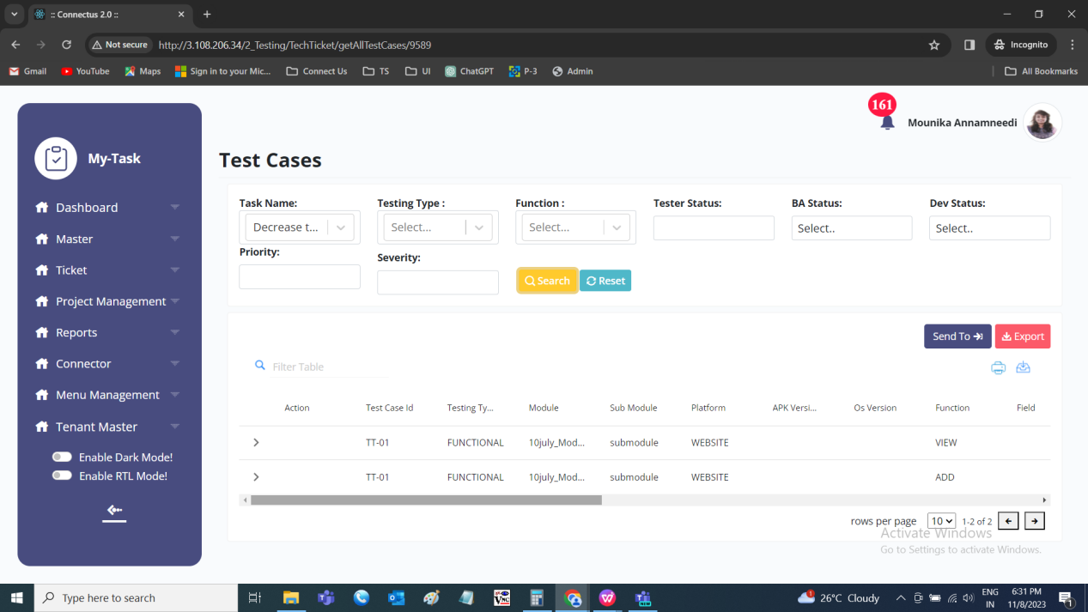

History

Export

CREATE BASKET

The edit basket button to edit the basket. The baskets can be edited either by the ticket owner or the project owner. The following are the fields in edit basket.
- Basket name
- Select user
- Start date
- End date
- Submit
- Cancel

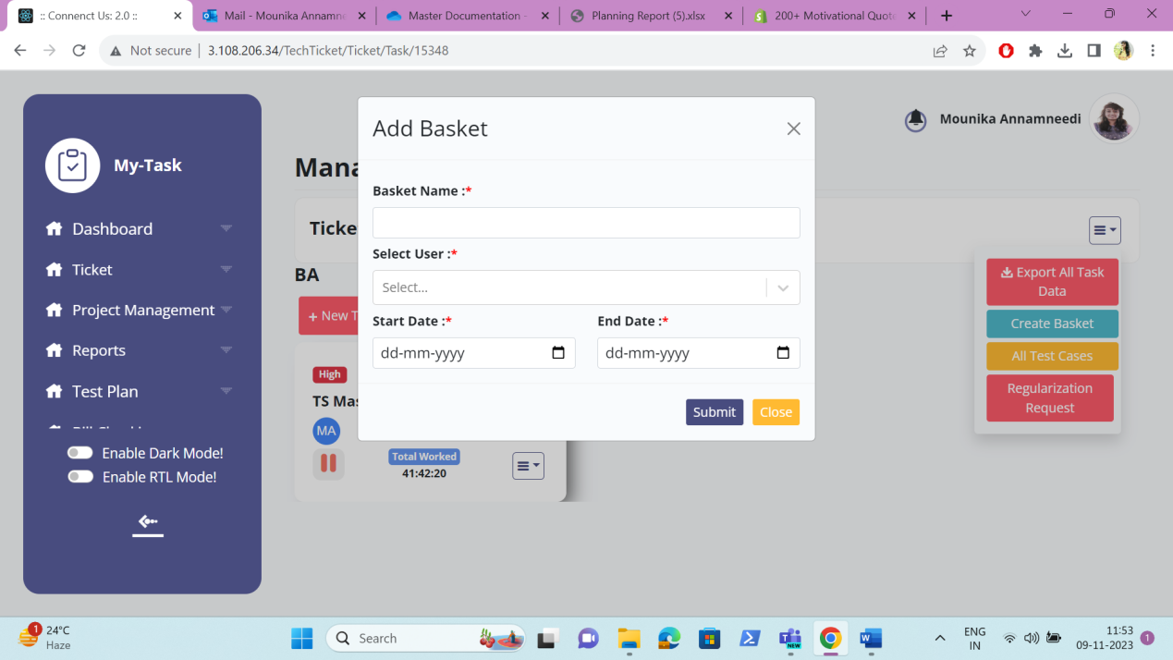

Input table
Fields | Input type | Mandatory/ Optional | Editable/ No | Description
Basket name | Text | Mandatory | - | The basket name of the basket is entered.  Validation:  Accepts alpha-numeric data with special characters up-to 50.
Owner | Drop down | Mandatory | - | The owner of the basket is selected from the drop down. The drop-down options are fetched from the user master.  Validation:  - The active users from the user master are fetched.  - Single selection
Start date | Date picker | Mandatory | - | The start date for the creation of the basket is selected from the date picker.  Validation:  The start date should be greater or equal to the ticket creation date.
End date | Date picker | Mandatory | - | The end date to end the basket is selected from the date picker.  Validation:  - The end date should be greater or equal to the start date.  - The end date should be equal or less than the expected solved date.
Submit | Button | - | - | The submit button to add the basket
Cancel | Button | - | - | The cancel button to cancel and navigate to my tasks page.

TEST PLAN
The test plan is the planner where the test cases are stored, test suites are made from it, shared with the testers for the execution and can be referred and used at any time. The test plan consists of the following filters. All the filters are optional and can select multiple.
- Project
- Module
- Sub-module
- Ticket ID
- Test suite
- Testing type
- Severity
- Priority
- Tester status
- Developer status
- BA status

Input table
Fields | Input type | Mandatory/ Optional | Editable/ No | Description
Project | Drop down | - | - | The project is selected from the drop down. The drop-down options are fetched from the project master.  Validations:  - The active and inactive projects are fetched from the project master.  - Multiple selection
Module | Drop down | - | - | The module is based on the project selected. The module is dependent on the project. The module is selected from the drop down. The drop-down options are fetched from the module master.  Validations:  - The active and inactive modules are fetched from the module master.  - Multiple selection
Sub-module | Drop down | - | - | The sub-module is based on the module selected. The sub-module is dependent on the module. The sub-module is selected from the drop down. The drop-down options are fetched from the sub-module master.  Validations:  - The active and inactive sub-modules are fetched from the sub-module master.  - Multiple selection
Ticket ID | Text | - | - | The ticket ID to be searched is entered.  Validation:  - Valid ticket ID’s to be entered.  - Accepts alpha-numeric data with special character (,).  - For multiple tickets, comma separated value is entered.
Test suite | Drop down | - | - | The test suite to be searched is selected from the drop down. The drop-down options are fetched from the test suite where they are created in the back-end.  Validation:  - All the test suites created are fetched.  - Multiple selection
Testing type | Drop down | - | - | The testing type to be searched is fetched from the drop down. The drop-down options are fetched from the testing type master.  Validation:  - The active and inactive testing types are fetched.  - Multiple selection
Severity | Drop down | - | - | The severity to be searched is selected from the drop down. The drop-down options are as follows.  - Low  - Medium  - High  Validation:  Multiple selection
Priority | Drop down | - | - | The priority to be searched is selected from the drop down. The drop-down options are as follows.  - Low  - Medium  - High  Validation:  Multiple selection
Tester status | Drop down | - | - | The tester status to be searched is selected from the drop down. The drop-down options are as follows.  - Pass  - Fail  - Suggestion  - Under development  Validation:  Multiple selection
Developer status | Drop down | - | - | The developer status to be searched is selected from the drop down. The drop-down options are as follows.  - Solved  - Resolved  - Deferred  - Not a bug  - Pending  - CR  Validation:  Multiple selection
BA status | Drop down | - | - | The BA status to be searched is selected from the drop down. The drop-down options are as follows.  - Not a bug  - CR  - Bug  - Not in the phase  - Solved  - To be discussed  Validation:  Multiple selection

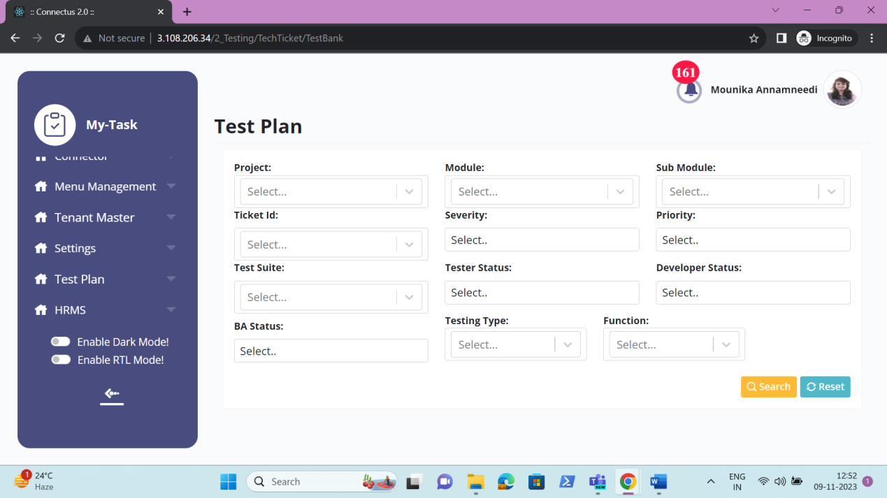

Grid view
The grid view consists of the following fields.
- Check box
- Sr no
- Ticket ID
- Test case ID
- Project
- Module
- Sub-module
- Testing Type
- Function
- Field
- Platform
- APK version
- OS version
- Description
- Expected result
- Actual result
- Severity
- Priority
- Tester comment
- Reviewer comment
- Developer comment
- BA comment
- Tester status
- Developer status
- BA status
- Screenshot
- Test suite
- Assign to
- Export

Fields | Grid view | Export
Check box | ✓ | X
Platform | ✓ | ✓
APK version | ✓ | ✓
OS version | ✓ | ✓
Module name | ✓ | ✓
Sub-module name | ✓ | ✓
Sr no | ✓ | ✓
Ticket ID | ✓ | ✓
Test case ID | ✓ | ✓
Testing type | ✓ | ✓
Function | ✓ | ✓
Field | ✓ | ✓
Test description | ✓ | ✓
Expected result | ✓ | ✓
Actual result | x | ✓
Tester status | x | ✓
Tester comment | ✓ | ✓
Reviewer comment | x | ✓
Severity | ✓ | ✓
Priority | ✓ | ✓
BA status | ✓ | ✓
BA comment | ✓ | ✓
Developer status | ✓ | ✓
Developer comment | ✓ | ✓
Attachment | ✓ | ✓
Test suite | ✓ | x
Assign to | ✓ | x
Export | ✓ | x

Input table
Fields | Input type | Mandatory/ Optional | Editable/ No | Description
Check box | Check box | Optional | - | The check box to select the test cases.
Platform | Drop down | Mandatory | - | The platform of the test case is displayed.
APK version | Text | Optional | - | The APK version of the application is displayed.
OS version | Text | Optional | - | The OS version of the application is displayed.
Module name | Auto | - | - | The module name of the ticket is fetched and displayed.
Sub-module name | Auto | - | - | The sub-module name of the ticket is fetched and displayed
Sr no | Auto | - | - | The serial count of the records is displayed in order.
Ticket ID | Auto | - | - | The ticket ID where the test cases belong is displayed
Test case ID | Auto | - | - | The test case ID is auto generated for each test case.
Testing type | Drop down | Mandatory | Yes | The testing type of the test case is displayed.
Function | Drop down | Mandatory | Yes | The function of the test cases is displayed.
Field | Text | Optional | Yes | The field name is displayed.
Test description | Text | Mandatory | Yes | The test description I.e., the description of the test case is displayed.
Expected result | Text | Mandatory | Yes | The expected result for that test case to be displayed.
Actual result | Auto | - | - | The actual result for the test cases is displayed
Tester status | Auto | - | - | The tester status for the test case is displayed.
Tester comment | Text | Optional | Yes | The tester comment if any for that test case is displayed.
Reviewer comment | Auto | - | - | The reviewer comment for that test case id displayed.
Severity | Drop down | Mandatory | Yes | The severity of the test case is displayed.
Priority | Auto | - | - | The priority of the test case is displayed
Operation | Auto | - | - | The operation I.e., the action taken place whether add or edit is displayed.
Task ID | Auto | - | - | The task ID of the task is displayed
BA status | Auto | - | - | The BA status of the test case is displayed.
BA comment | Auto | - | - | The BA comment of the test case is displayed.
Developer status | Auto | - | - | The developer status of the test case is displayed
Developer comment | Auto | - | - | The developer comment of the test case is displayed
Attachment | Auto | - | - | The attachment attached as support is displayed
Test suite | Button | - | - | The send to button sends the test cases to the test suite.
Assign to | Button | - | - | The assign to button to assign the test cases to the tester for the execution.
Export | Button | - | - | The export button to export the test cases.

Grid view
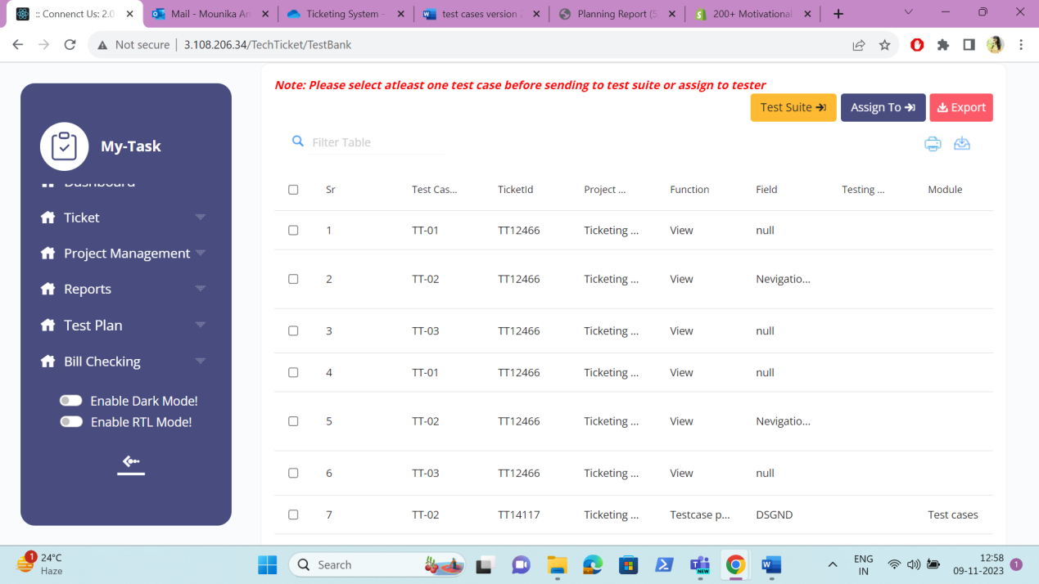

Export
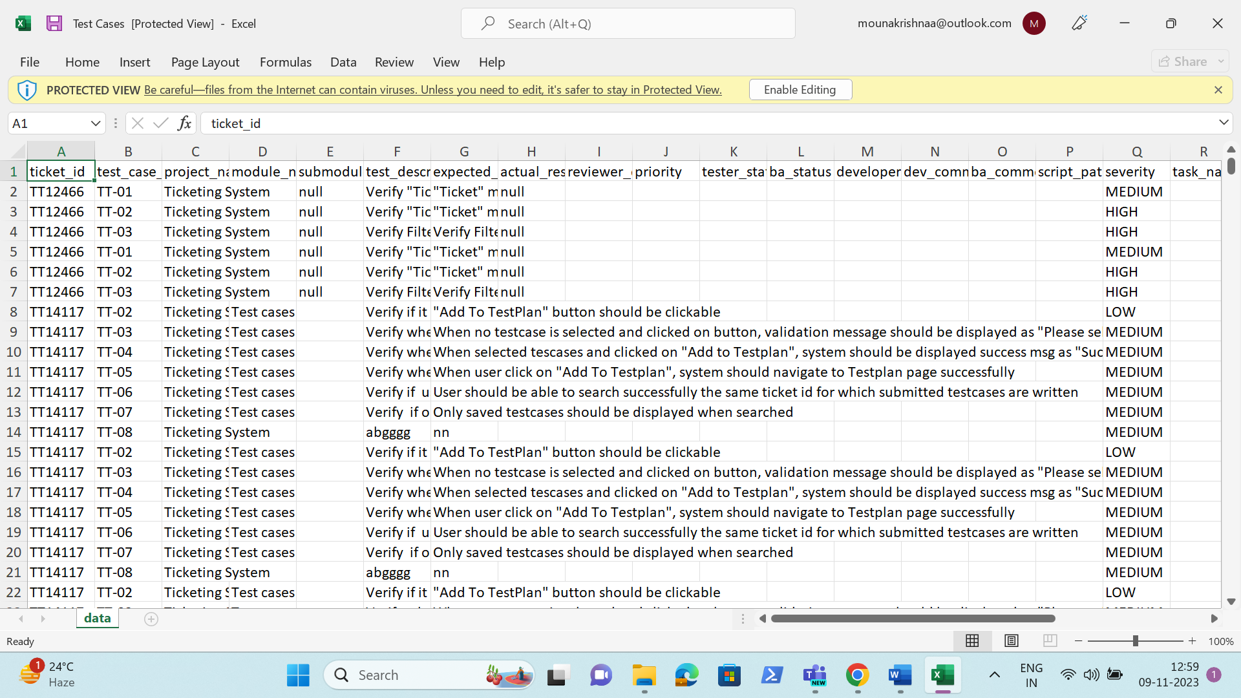

TEST SUITE

The test suite is the collection of the test cases. Where the test cases are added into the test suites which can be used easier and whenever required. When the user clicks on the test suite, the following fields are displayed.
- Create test suite
- Update to existing test suite

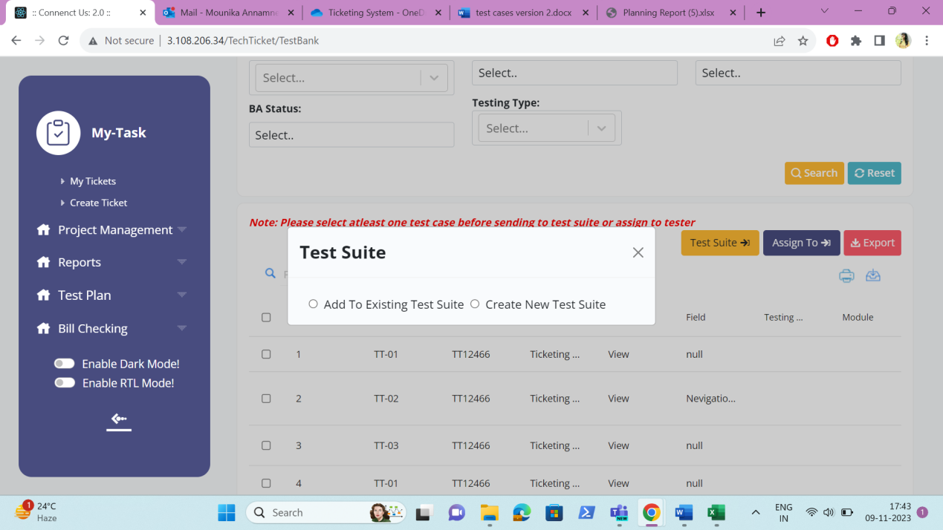

CREATE TEST SUITE

In create test suite, the new test suite is created with the selected test cases. The following are the fields displayed.
- Test suite
- Submit
- Cancel

Fields | Input type | Mandatory/ Optional | Editable/ No | Description
Test suite | Text | Mandatory | - | The test suite name is entered.  Validation:  Accepts alpha-numeric data with special characters up-to 100 characters.
Submit | Button | - | - | The submit button to update the test cases under the test suite created.
Cancel | Button | - | - | The cancel button to close the tab

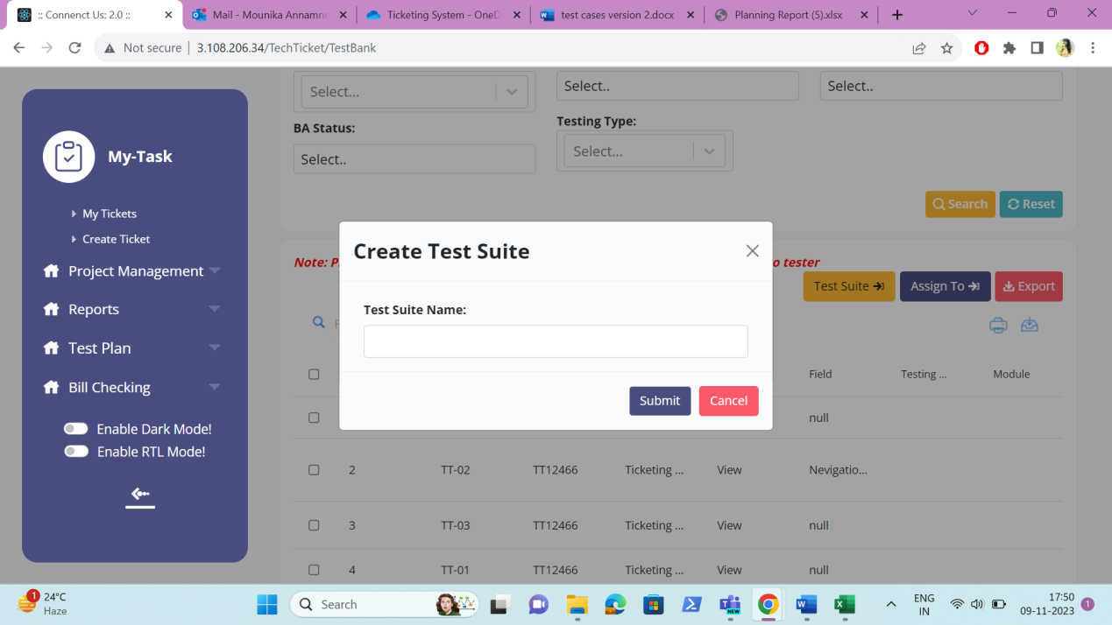

UPDATE TO EXISTING TEST SUITE

The update to existing test suite is to add the test cases to the existing test suite. The following are the fields displayed.
- Select test suite
- Submit
- Cancel

Fields | Input type | Mandatory/ Optional | Editable/ No | Description
Select test suite | Drop down | Mandatory | - | The test suite is selected from the drop down. The drop-down options are fetched from the test suite.  Validation:  Single selection
Submit | Button | - | - | The submit button to update the test cases under that test suite
Cancel | Button | - | - | The cancel button to close the tab

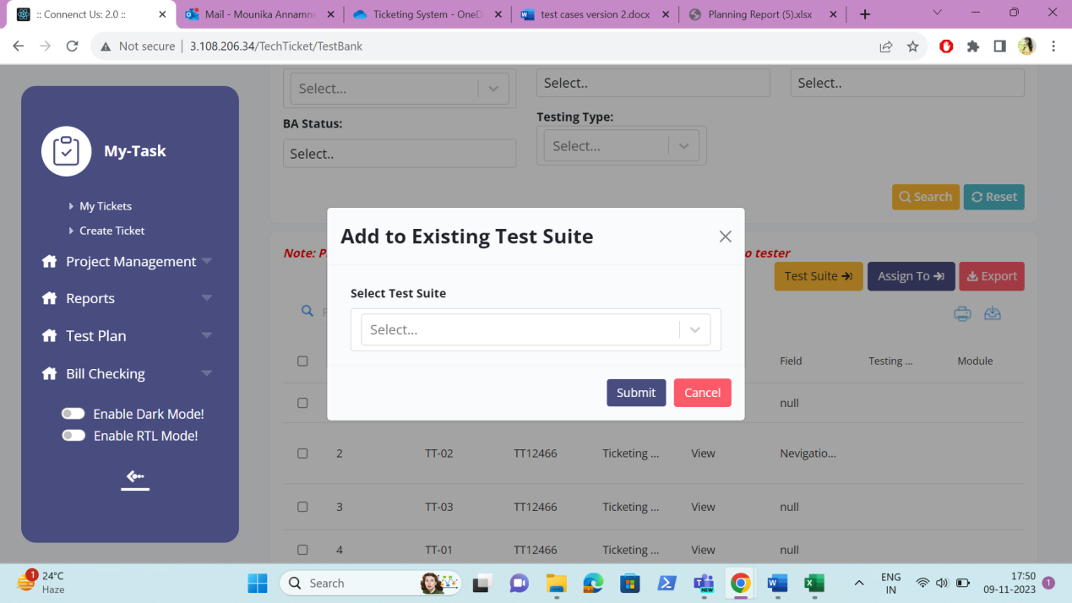

ASSIGN TO

The assign to button is used to assign the test suite to the tester for the execution of the test cases. The assign to test suite consists of the following fields.
- Select tester
- Select ticket
- Select basket
- Task name
- Start date
- To date
- Task hours

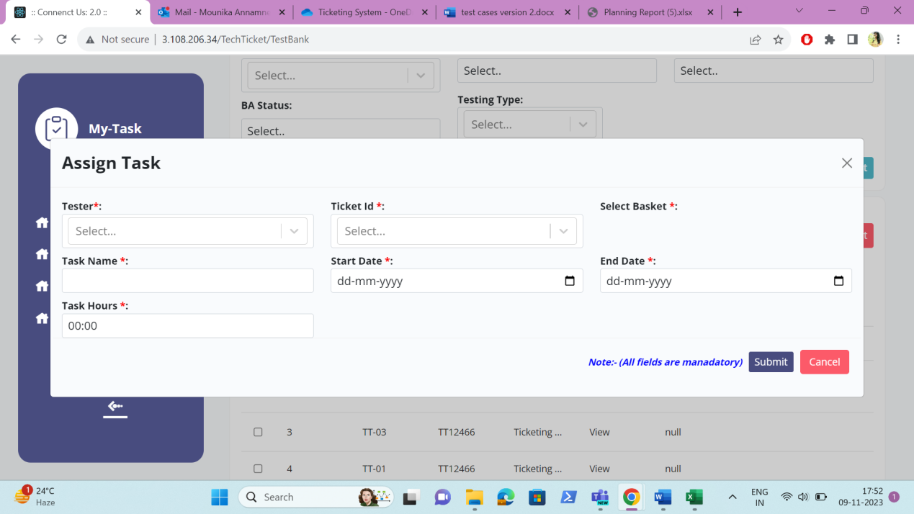

Fields | Input type | Mandatory/ Optional | Editable/ No | Description
Select tester | Drop down | Mandatory | - | The tester is selected from the drop down. The drop-down options are fetched from the user master who’s designation is tester.  Validation:  - The active users are fetched from the user master.  - Single selection
Select ticket | Drop down | Mandatory | - | The ticket to be selected where the basket and task to be created from the drop down. The drop-down consists of all the tickets except, where the ticket status is solved and rejected.  Validation:  Single selection
Select basket | Drop down | Mandatory | - | The basket to be selected where the task to be created from drop down. The drop-down consists of all the baskets in the ticket.  Validation:  - All the baskets fetched from that ticket  - Single selection
Task name | Text | Mandatory | - | The task name is entered.  Validation:  Accepts alpha-numeric data with special characters up-to 100 characters.
Start date | Date picker | Mandatory | - | The start date for the creation of the basket is selected from the date picker.  Validation:  The start date should be greater or equal to the ticket creation date.
To date | Date picker | Mandatory | - | The end date to end the basket is selected from the date picker.  Validation:  - The end date should be greater or equal to the start date.  - The end date should be equal or less than the expected solved date.
Task hours | Time picker | Mandatory | - | The task hours required for that task to complete is mentioned.  Validation:  HH:MM format

REPORTS
The reports consists of the following reports.
- User task report
- Resource planning report
- Variance report

USER TASK REPORT
The user task report refers to the total worked time of the user based on the tasks and the users. The following are the fields in the user task report.
- Select user
- Search task
- From date
- To date
- Search
- Reset
- Export
- Sr no
- Ticket id
- Task name
- User name
- Total worked
- Total time in minutes
- Task status
- Updated at

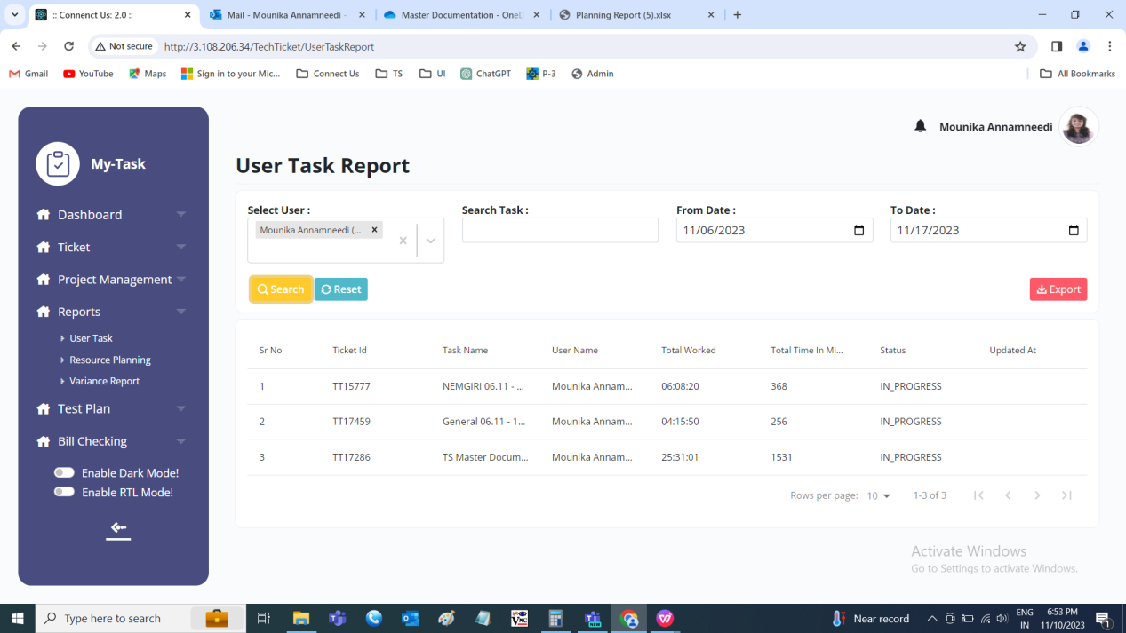

Fields | Filter | Grid view | Export
Select user | ✓ | ✓ | X
Search task | ✓ | ✓ | X
From date | ✓ | ✓ | X
To date | ✓ | ✓ | X
Search | ✓ | ✓ | X
Reset | ✓ | ✓ | X
Export | X | ✓ | X
Sr no | X | ✓ | ✓
Ticket id | X | ✓ | ✓
Task name | X | ✓ | ✓
User name | X | ✓ | ✓
Total worked | X | ✓ | ✓
Total time in minutes | X | ✓ | ✓
Task status | X | ✓ | ✓
Updated at | X | ✓ | ✓

Input table
Fields | Input type | Mandatory/ Optional | Editable/ No | Description
Select user | Drop down | Optional | - | The user who’s data to be searched is selected from the drop down. The drop-down options are fetched from the user master.  Validation:  - The active and inactive users are fetched from the user master.  - Multiple selection
Search task | Text | Optional | - | The task to be searched is entered.  Validation:  Accepts alpha-numeric data with special characters up-to 100 characters.
From date | Date picker | Optional | - | The from date from when the task to be searched is selected from the date picker. The date on which the task played.  Validation:  Future date is not accepted.
To date | Date picker | Optional | - | The to date to when the task to be searched is selected from the date picker. The date on which the task played.  Validation:  - Future date is not accepted.  - The to date should be greater than or equal to the from date.
Search | Button | - | - | The search button to search the data entered in the filters.
Reset | Button | - | - | The reset button to clear the data in the fields.
Export | Button | - | - | The export button to export the data.
Sr no | Auto | - | - | The serial count of the record is displayed.
Ticket id | Auto | - | - | The ticket ID of the task is displayed.
Task name | Auto | - | - | The task name is displayed.
User name | Auto | - | - | The username of the task is displayed
Total worked | Auto | - | - | The total hours played by that user for the task on the date selected is displayed
Total time in minutes | Auto | - | - | The total time in minutes is displayed
Task status | Auto | - | - | The task status is displayed
Updated at | Auto | - | - | The last updated date and time is displayed in DD/MM/YYYY HH:MM:SS format.

Export
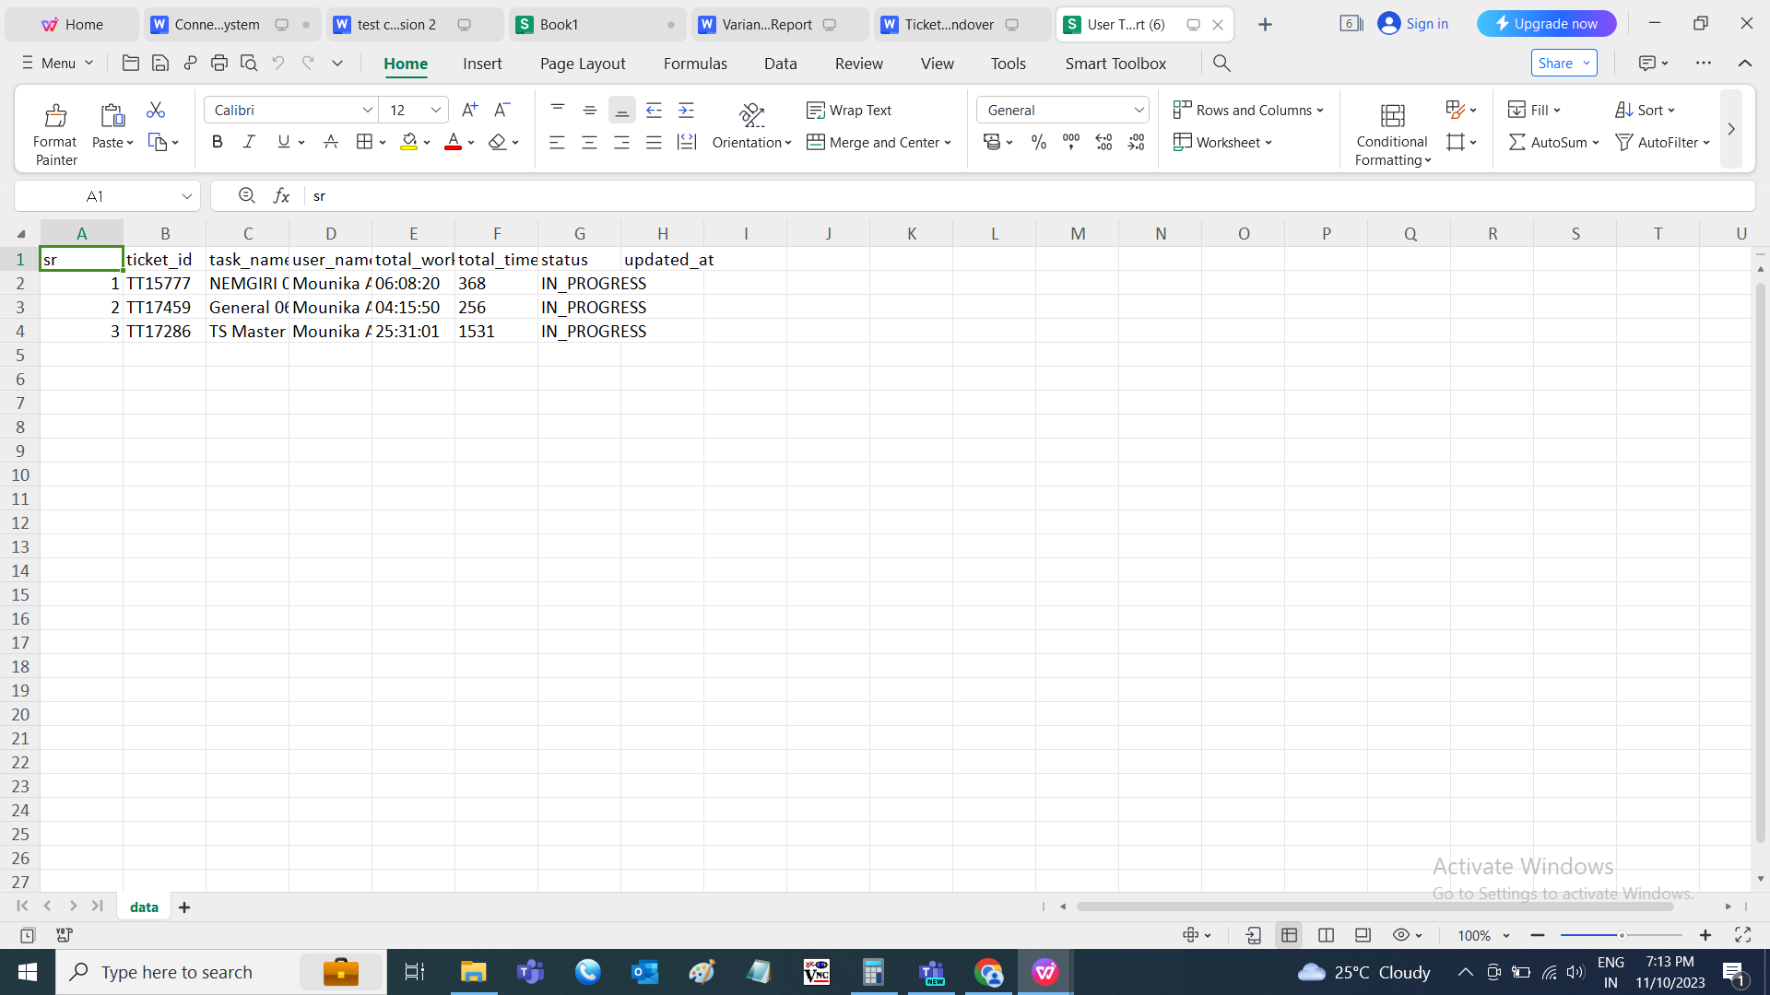

RESOURCE PLANNING REPORT
The resource planning report is used to know the total time estimated from the tasks of the tickets on the particular days. The following are the fields in the resource planning report.
- Username
- From date
- To date
- Search
- Reset
- Export
- Downward arrow
- Sr no
- Date
- User name
- Hours
- Sr No in detail
- Ticket ID
- Task name
- Hours in detail

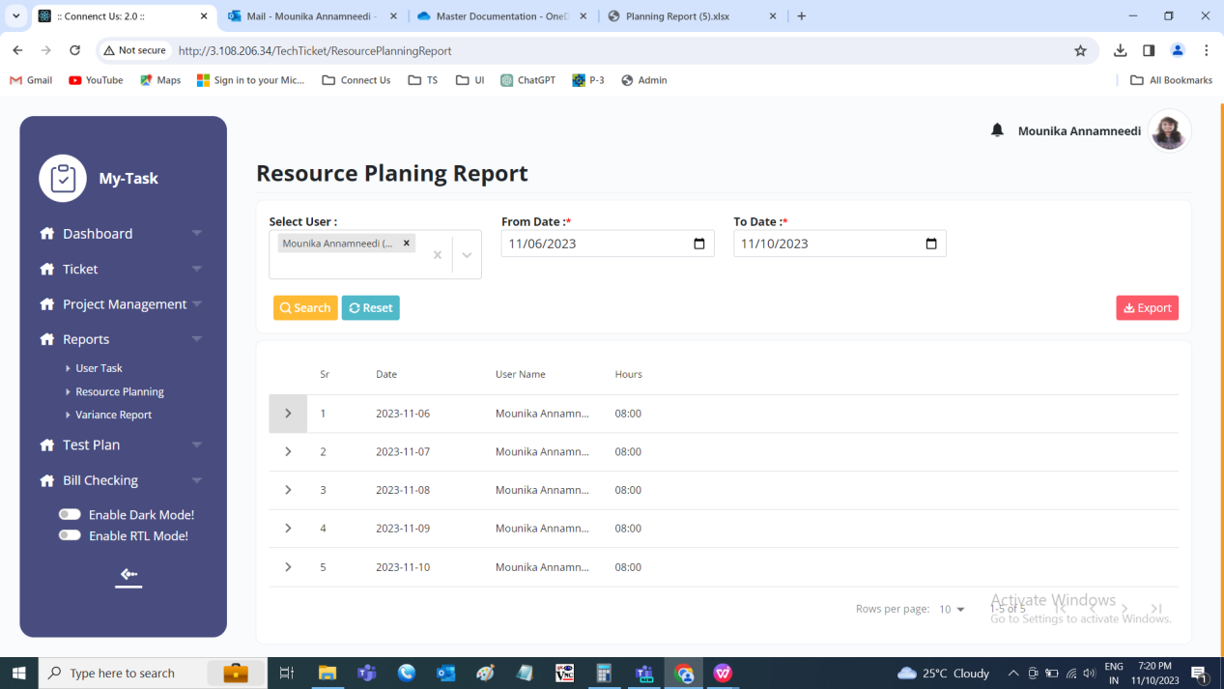

Fields | Filter | Grid view | In detail | Export
Username | ✓ | ✓ | X | X
From date | ✓ | ✓ | X | X
To date | ✓ | ✓ | X | X
Search | ✓ | ✓ | X | X
Reset | ✓ | ✓ | X | X
Export | X | ✓ | X | X
Downward arrow | X | ✓ | X | X
Sr no | X | ✓ | X | X
Date | X | ✓ | X | ✓
User name | X | ✓ | X | ✓
Hours | X | ✓ | X | X
Sr No in detail | X | ✓ | ✓ | ✓
Ticket ID | X | ✓ | ✓ | ✓
Task name | X | ✓ | ✓ | ✓
Hours in detail | X | ✓ | ✓ | ✓

Input table
Fields | Input type | Mandatory/ Optional | Editable/ No | Description
Username | Drop down | Optional | - | The user who’s data to be searched is selected from the drop down. The drop-down options are fetched from the user master.  Validation:  - The active and inactive users are fetched from the user master.  - Multiple selection
From date | Date picker | Optional | - | The from date from when the task to be searched is selected from the date picker. The date on which the task scheduled in planner.
To date | Date picker | Optional | - | The to date to when the task to be searched is selected from the date picker. The date on which the task scheduled in planner.  Validation:  The to date should be greater than or equal to the from date.
Search | Date picker | Optional | - | The search button to search the data entered in the filters.
Reset | Button | - | - | The reset button to clear the data in the fields.
Export | Button | - | - | The export button to export the data.
Downward arrow | Button | - | - | The downward arrow will show the data in detail of a specific date.
Sr no | Auto | - | - | The serial count of the record is displayed.
Date | Auto | - | - | The date on which task scheduled is displayed.
User name | Auto | - | - | The username of the task is displayed.
Hours | Auto | - | - | The task hours of the user on on the specific date is displayed.
Sr No in detail | Auto | - | - | The serial count of the record is displayed.
Ticket ID | Auto | - | - | The ticket ID of the task is displayed.
Task name | Auto | - | - | The task name is displayed
Hours in detail | Auto | - | - | The hours in detail for the specific task on the particular date is displayed

Resource planning in detail
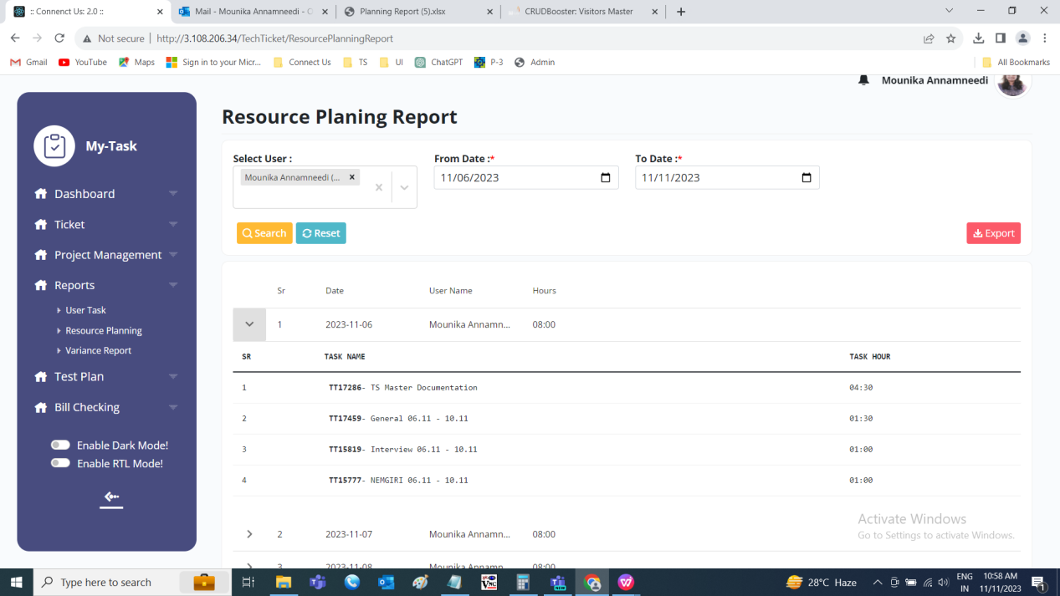

Export
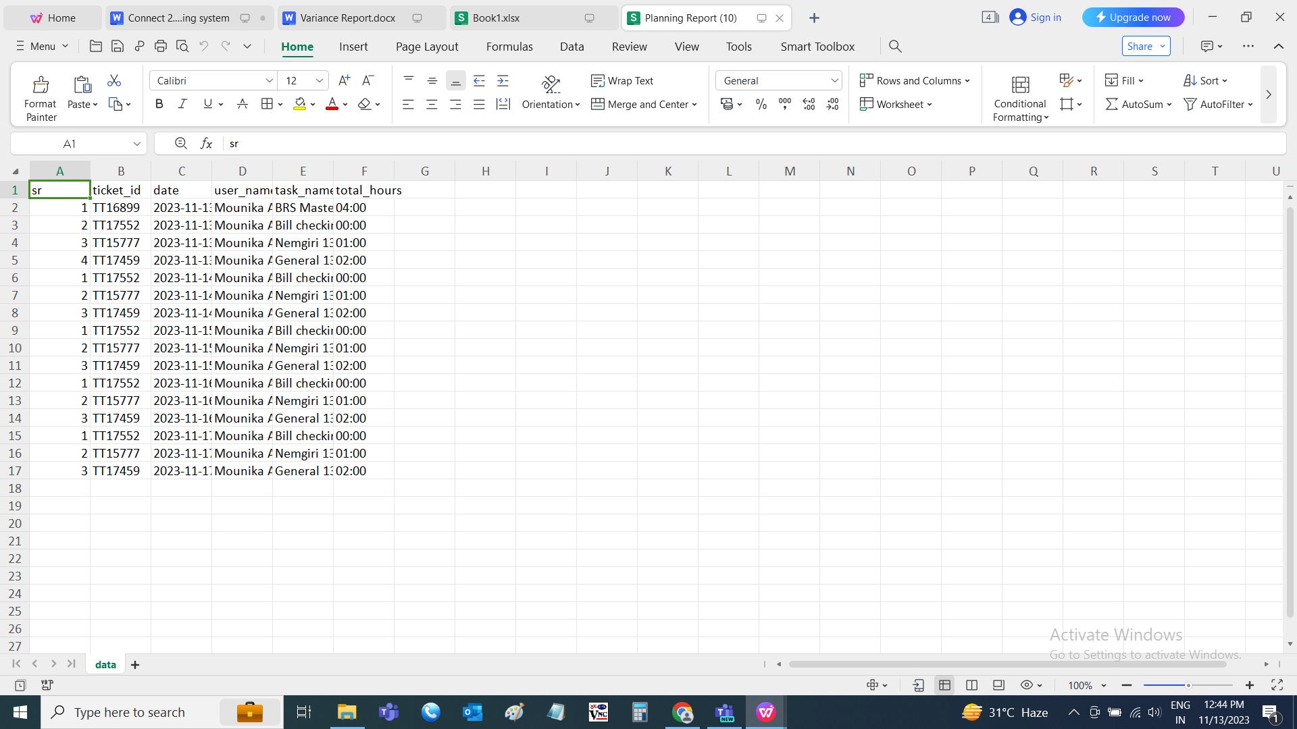

VARIANCE REPORT
The variance report is the report which is made to know the status of the user task based on the scheduled dates and time. The variance report helps in fetching the data of the employees to take the better decisions for the growth of the employees and the organization. It tracks the employees based on the tasks. The following are the filters in the variance report.
- Username
- From date
- To date
- Search
- Reset
- Export
- Sr no
- Ticket ID
- Task owner
- Task name
- Start date
- Hours scheduled
- Actual worked
- Delivery scheduled
- Status
- Actual status
- Completed at

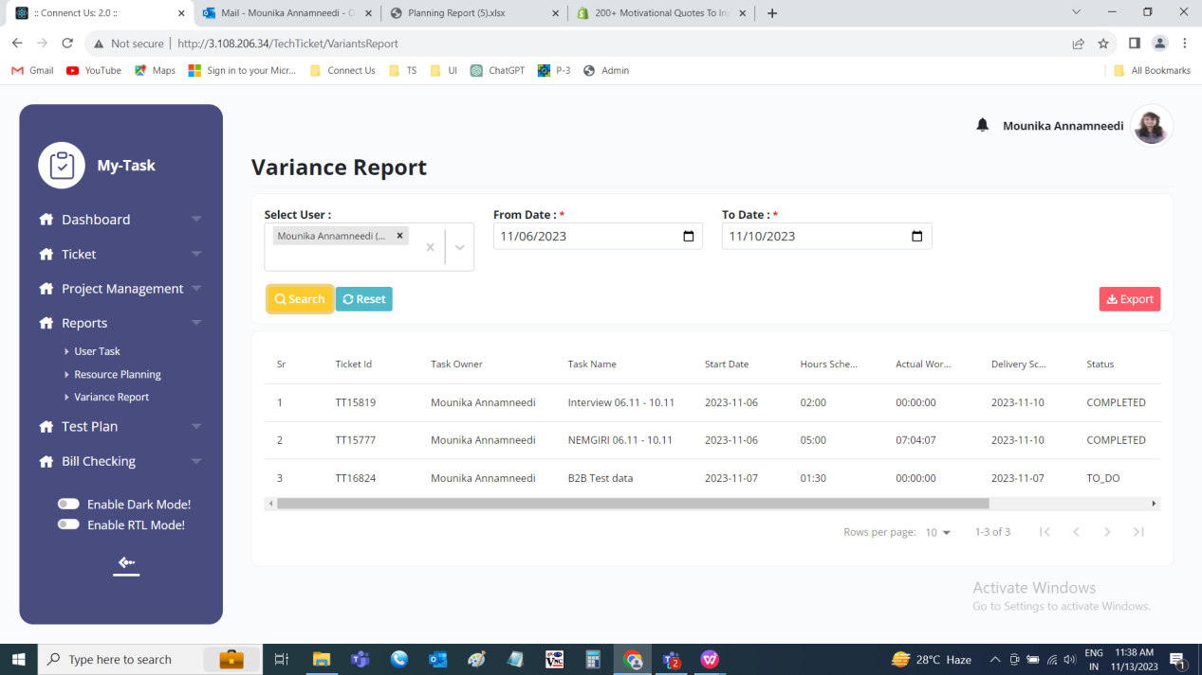

Fields | Filter | Grid view | Export
Username | ✓ | ✓ | X
From date | ✓ | ✓ | X
To date | ✓ | ✓ | X
Search | ✓ | ✓ | X
Reset | ✓ | ✓ | X
Export | ✓ | ✓ | X
Sr no | X | ✓ | ✓
Ticket ID | X | ✓ | ✓
Task owner | X | ✓ | ✓
Task name | X | ✓ | ✓
Start date | X | ✓ | ✓
Hours scheduled | X | ✓ | ✓
Actual worked | X | ✓ | ✓
Delivery scheduled | X | ✓ | ✓
Status | X | ✓ | ✓
Actual status | X | ✓ | ✓
Completed at | X | ✓ | ✓

Input table
Fields | Input type | Mandatory/ Optional | Editable/ No | Description
Username | Drop down | Optional | - | The user who’s data to be searched is selected from the drop down. The drop-down options are fetched from the user master.  Validation:  - The active and inactive users are fetched from the user master.  - Multiple selection
From date | Date picker | Optional | - | The from date from when the task to be searched is selected from the date picker. The date on which the task planned.
To date | Date picker | Optional | - | The to date to when the task to be searched is selected from the date picker. The date on which the task planned.  Validation:  The to date should be greater than or equal to the from date.
Search | Button | - | - | The search button to search the data entered in the filters.
Reset | Button | - | - | The reset button to clear the data in the fields.
Export | Button | - | - | The export button to export the data.
Sr no | Auto | - | - | The serial count of the record is displayed.
Ticket ID | Auto | - | - | The ticket ID of the task is displayed.
Task owner | Auto | - | - | The task owner of the task is displayed.
Task name | Auto | - | - | The task name is displayed.
Start date | Auto | - | - | The start date of the task is displayed
Hours scheduled | Auto | - | - | The total hours scheduled for that task in that particular period is displayed in HH:MM format.
Actual worked | Auto | - | - | The total hours played by that user for the task on the date selected is displayed
Delivery scheduled | Auto | - | - | The end date of the task is displayed.
Status | Auto | - | - | The status of the task is displayed
Actual status | Auto | - | - | The actual status of the task is displayed. The actual status of the task is same as the status except in following scenarios.  - If the total scheduled hours is greater than the total played hours, the status will be displayed as delayed.  - If the current date is greater than the task end date and if the task is not completed yet, then the status will be displayed as delayed.
Completed at | Auto | - | - | The last updated date and time is displayed in DD/MM/YYYY HH:MM:SS format.

Export
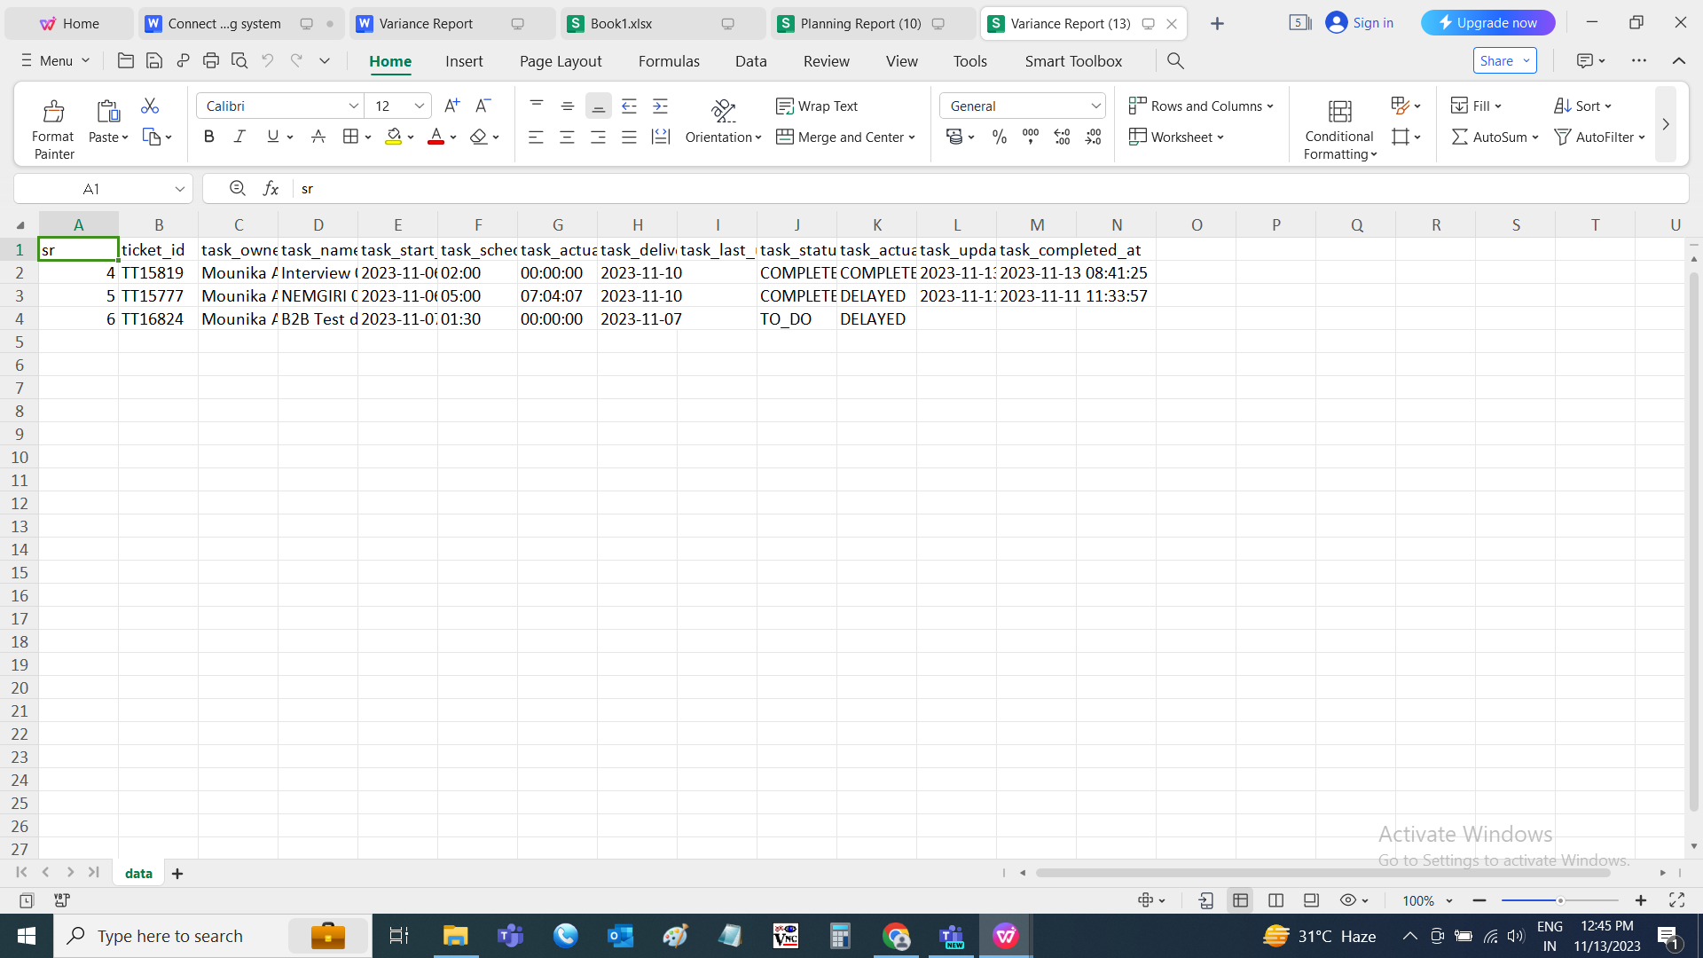

- TEST DATA AND BUSINESS SCENARIOS

