11.12.2023

GOSHALA

Mounika Annamneedi

Mounika.annamneedi@techneai.com

**Functional Requirement Document**

**CONTENTS**

1. TICKET DETAILS 3

2. VERSION CONTROL 3

3. APPROVALS 3

4. ESTIMATION 3

5. INTRODUCTION 3

6. BUSINESS REQUIREMENT 4

7. SCOPE 4

8. BUSINESS & SYSTEM RULES 5

9. ABBREVIATIONS & TERMS 5

10. EXISTING SYSTEM 5

11. GRAPHICAL REPRESENTATION 5

12. PROPOSED SYSTEM 6

BR001 - LOGIN 6

BR002 - ADD DONATIONS 9

BR003 - ADD COW 16

BR004 - ADD DONOR 21

BR005 - REPORT - VIEW DONATIONS 23

BR006 - REPORT - VIEW GOMATA 24

BR007 - EXPORT DONATIONS 26

BR008 - PROFILE 28

13. TEST DATA / USE CASE SCENARIOS 31

14. REFERENCES OF THE USERS 31

1. **TICKET DETAILS**

|  |  |
| --- | --- |
| **Ticket ID** | TT18091 |
| **Ticket description** | Goshala version 13 working with Pan and Aadhaar update. |
| **Created by** | Mounika Annamneedi |
| **Created on** | 28/11/2023 |
| **Priority** | High |

1. **VERSION CONTROL**

|  |  |  |  |  |
| --- | --- | --- | --- | --- |
| **Sr. No** | **Version no** | **Version Date** | **User name** | **User department** |
| **1** | **1** | **11/12/2023** | **Mounika Annamneedi** | **IT Implementation** |

1. **APPROVALS**

|  |  |  |
| --- | --- | --- |
| **Field** | **Name of the User** | **Approved date by the user** |
| **Actual User Name Actual User Department Organization Name** | Siddarth Shah Management  Goshala |  |
| **Assigned BA** | Mounika Annamneedi |  |
| **Assigned Developer** |  |  |
| **Assigned Tester** |  |  |

1. **ESTIMATION**

|  |  |  |  |  |
| --- | --- | --- | --- | --- |
| **Department name** | **Estimated Time (In hr)** | **Scheduled Date (Starting date)** | **Estimated date** | **Actual delivery date** |
| **BA** | 13.5 | 09/12/2023 | 14/12/2023 |  |
| **Development** |  |  |  |  |
| **Testing** |  |  |  |  |

1. **INTRODUCTION**

Dayoday Goshala is a service organization to rescue and safeguard the cows. The application consists of the donations list and the cows list. Goshala, a Sanskrit word ("Go" means cow and "Shala" means a shelter place: Go + Shala = shelter for cows), means the abode or sanctuary for cows, calves and oxen.

1. **BUSINESS REQUIREMENT**

|  |  |  |  |
| --- | --- | --- | --- |
| **Requirement ID** | **Requirement Name** | **Short Description** | **Priority** |
| BR001 | Login | The login page where the user gets login into the system | High |
| BR002 | Add donations | The users adds the donations through the donation module | High |
| BR003 | Add cow | The users add the details of the cows adopted by Goshala in the system. | High |
| BR004 | Add donor | The donors are added through the add donors module. | High |
| BR005 | Report - view donations | The donations report can be viewed through the donations report. | High |
| BR006 | Report - view Gomata pravesh | The Gomata pravesh report can be viewed through the Gomata Pravesh report. | High |
| BR007 | Export - Donations | The export functionality to filter the report and export the data filtered. | High |
| BR008 | Profile | The profile to view the user details and change the password. | High |

1. **SCOPE**

The scope of the ticket is to view the functionalities working for the version 12 to be worked in the version 13.

1. **BUSINESS & SYSTEM RULES**

* User should be registered in the system.
* User should be logged in.
* System should display error message for incorrect details if entered.
* System should pop up a message, if any issues in the system is detected.
* All forms should have on field validations. System should display on field errors in case of incorrect inputs.

1. **ABBREVIATIONS & TERMS**

NA

1. **EXISTING SYSTEM**

In the existing system, the application is working for the android devices where the version up-to 12.

1. **GRAPHICAL REPRESENTATION**

USE CASE DIAGRAM  
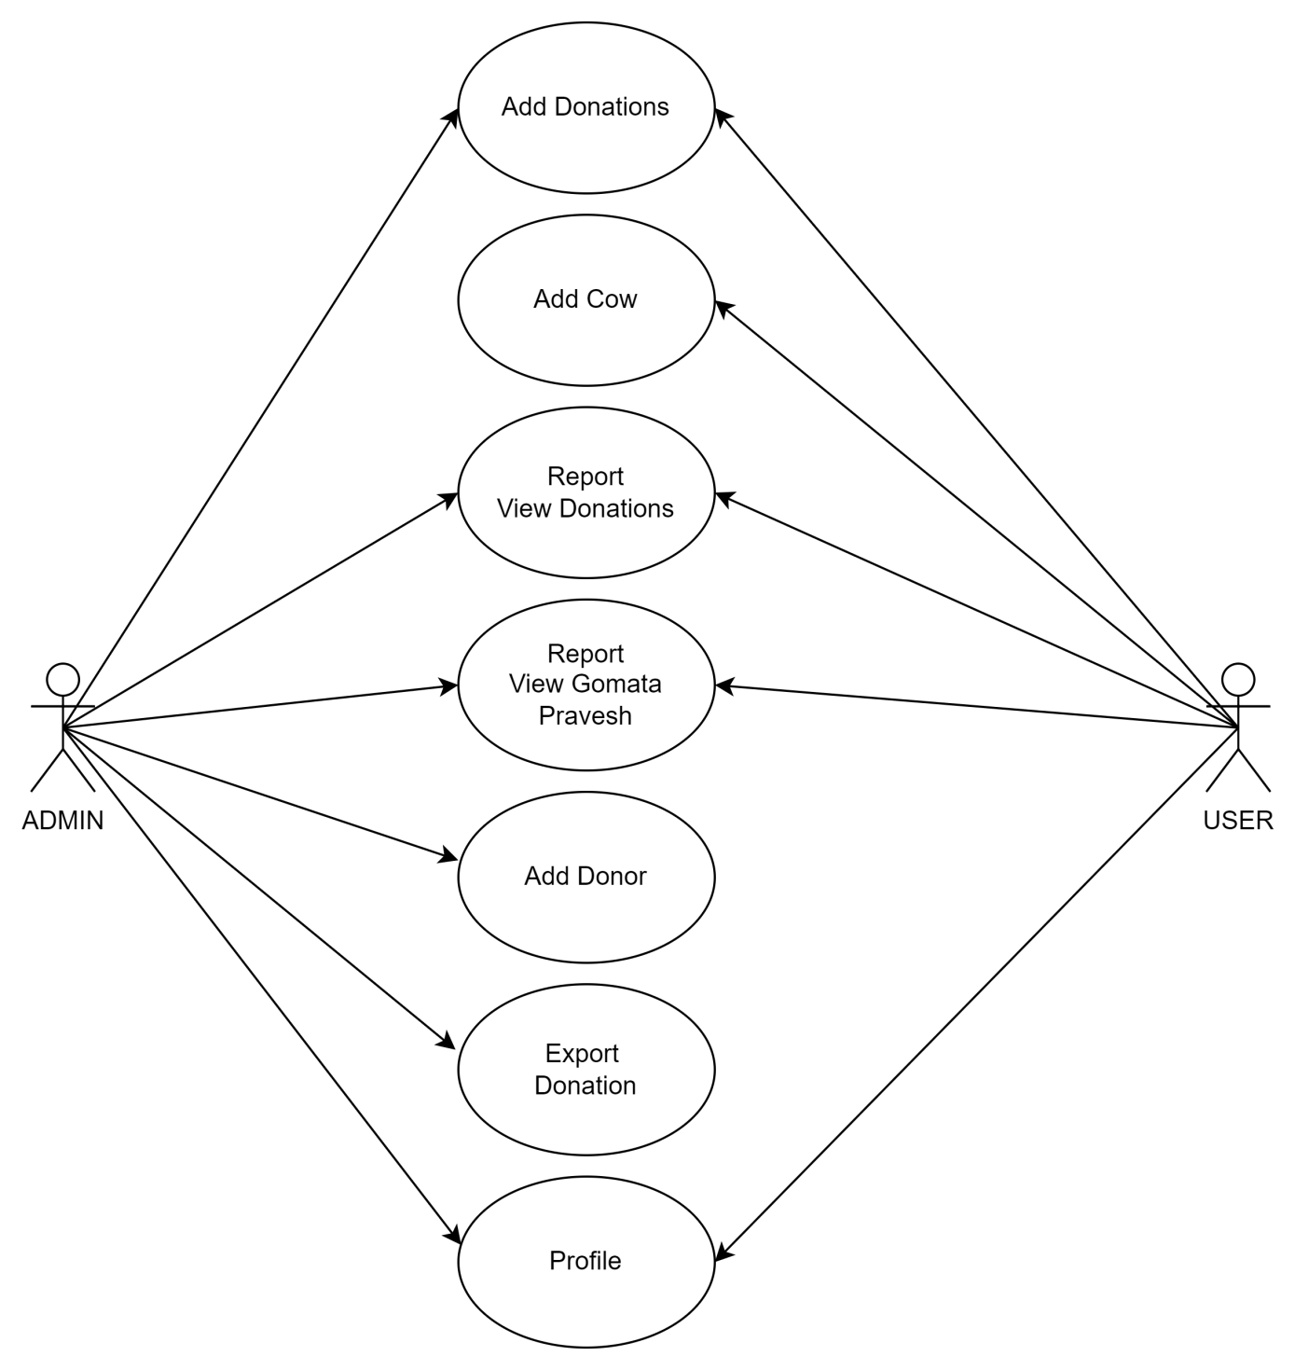

1. **PROPOSED SYSTEM**

## BR001 - LOGIN

The Goshala application can be downloaded in play-store using both Android devices.

The application will be shown as

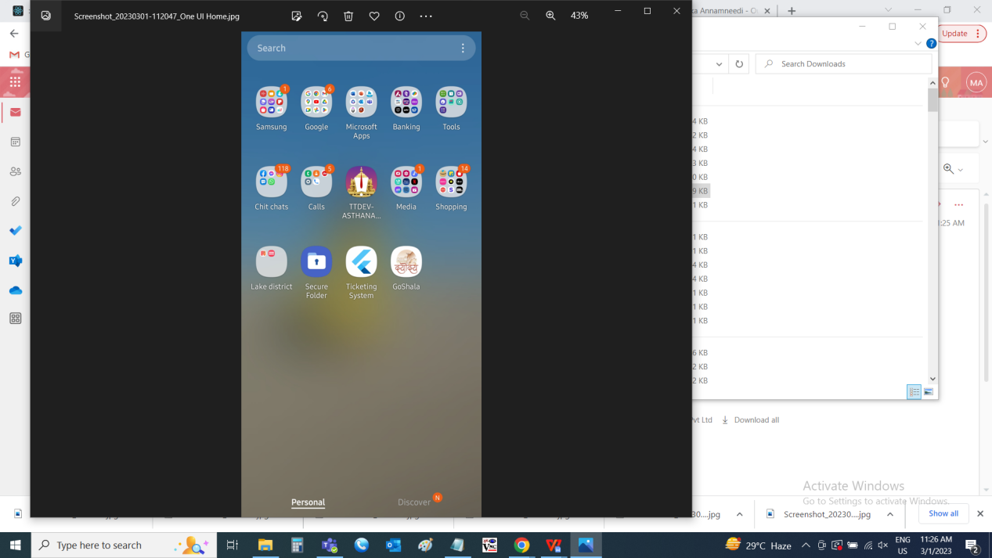

The login page is used to login into the account. The login page consists of the following.

* Username
* Password
* Login

|  |  |  |  |  |
| --- | --- | --- | --- | --- |
| **FIELDS** | **INPUT TYPE** | **MANDATORY/ OPTIONAL** | **EDITABLE/ NO** | **DESCRIPTION** |
| Username | Text | Mandatory | - | The username of the account is to be entered. The login is created in the web application.  Validation:  Accepts alpha-numeric data with special characters up-to 50 characters. |
| Password | Text | Mandatory | - | The password of the account is to be entered. The login password is created and set against the web application.  Validation:  Accepts alpha-numeric data with special characters up-to 50 characters. |
| Login | Button | Mandatory | - | The login button to login into the application |

Note: The valid credentials to be entered to login in the application.

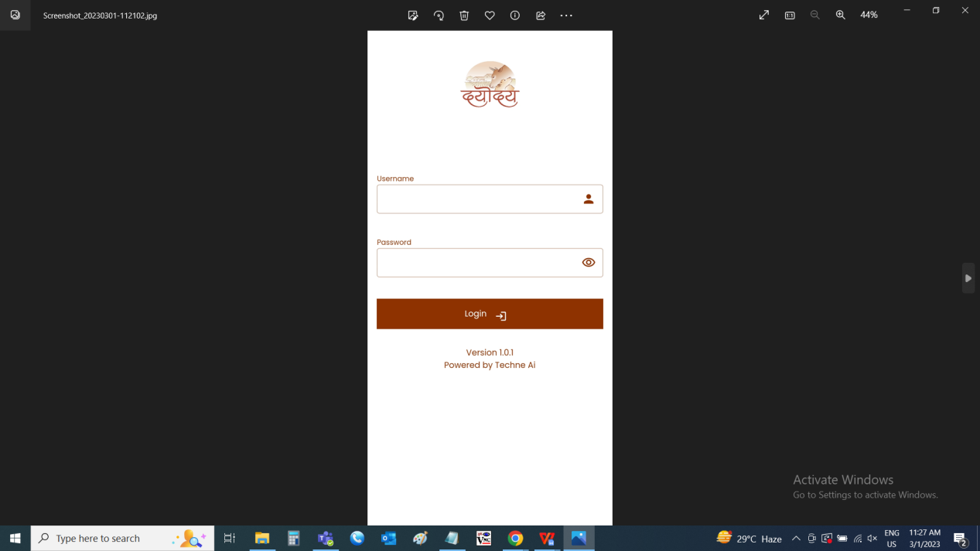

MATRIX

The matrix for showing the privileges

|  |  |  |
| --- | --- | --- |
| **MODULES** | **ADMIN** | **USER** |
| Add donations | Yes | Yes |
| Add cow | No | Yes |
| Report - View donations | Yes | Yes |
| Report - View gomata pravesh | Yes | Yes |
| Add donor | Yes | No |
| Export - Report (donation) | Yes | No |
| Profile | Yes | Yes |
|  |  |  |

Note: The privileges can be given to user if required through web application.

## BR002 - ADD DONATIONS

The donations can be added through this menu. The donors when the make any donation to the Goshala. Their data is added through this menu. The add donations consists of the following fields.

* Date
* Contact no
* Donor name
* Name on receipt
* Date of birth
* 80G
* Pan No
* Aadhar No
* Attachment
* Amount in Rs.
* Amount in words
* Payment method
* Bank name
* Cheque/ UTR No
* Payment date
* Payment reference number
* Address
* Pin-code
* Manual/ System generated
* Invoice upload
* Save
* Cancel

|  |  |  |  |
| --- | --- | --- | --- |
| **FIELDS** | **INPUT TYPE** | **MANDATORY/ OPTIONAL** | **DESCRIPTION** |
| Date | Auto | - | The current date is automatically generated on the date of donation or adding the details.  Validation:  The date is displayed in DD/MM/YYYY format. |
| Contact no | Int | Mandatory | The contact number of the donor is to be entered in the mobile number format.  Validation:  Accepts only positive integers up-to 10 digits. |
| Donor name | Text | Mandatory | The donor name is displayed automatically if the donor is previously added. If not, the donor name to be entered. The donor will be added in the donor in the donor master for the future reference.  Validation:  Accepts only alphabetic characters up-to 100 characters. |
| Name on receipt | Text | Optional | The name on receipt is automatically fetches the donor name. The name on receipt if to be changed, is to be entered.  Validation:  Accepts only alphabetic characters up-to 100 characters. |
| Date of birth | Date picker | Mandatory | The date of birth of the donor is to be selected from the date picker. The donor date of birth is displayed automatically if the donor is previously added. If not, the donor date of birth to be entered. The donor date of birth will be added in the donor list in the donor master for the future reference.  Validation:   * Future date cannot be selected. * Date is displayed in DD/MM/YYYY format. |
| 80G | Radio button | Optional | The tax benefit of 80G is required or not to be selected. If 80G is selected, the following fields are displayed.   * PAN No * Aadhaar No * PAN or Aadhaar attachment   Validation:  Single selection |
| Pan No | Text | Optional | The tax benefit of 80G is selected, then pan number is required. The user can select either PAN number or Aadhaar number. The pan number to be entered in the pan number format.  Validation:   * It should be ten characters long. * The first five characters should be any upper-case alphabet. * The next four-characters should be any number from 0 to 9. * The last (tenth) character should be any upper-case alphabet. * It should not contain any white spaces. |
| Aadhaar Number | Int | Optional | The tax benefit of 80G is selected, then aadhaar number is required. The user can select either PAN number or Aadhaar number. The aadhaar number to be entered in the aadhaar number format.  Validation:   * Accepts only numbers. * 12-digit number has to be entered. |
| PAN or aadhaar attachment | File upload | Mandatory | The Aadhaar attachment or PAN attachment available is attached.   Validation:  Can accept pdf, jpeg, .png up-to 2 maximum of 2MB. |
| Amount in Rs. | Int | Mandatory | The donation amount to be entered in rupees.  Validation: Accepts positive integers up-to 2 decimals maximum of 1crore rupees. |
| Amount in words | Auto | - | The donation amount entered is displayed in words automatically. |
| Payment method | Drop down | Mandatory | The payment method to be selected from the drop down list. By default cash is selected. The drop down list consists of the following.   * By cash * By cheque * UPI/ online   If cheque/ online is selected, the bank name, cheque/ UTR No. And the payment date fields are displayed and are mandatory.  If UPI is selected, the payment date and payment reference number are displayed and are mandatory. Once the payment gateway is enabled, the user can directly add the details and payment will be made automatically.  Validation:   * Single selection * By default, cash is selected. |
| Bank name | Drop down | Optional | For by cheque/ online and UPI payment methods, the bank name is mandatory. The bank name is to be selected from the drop down list. The drop down list consists of the following banks.   * Bank of India * Bank of Maharashtra * HDFC Bank * Punjab National Bank * Bank of Baroda * Central Bank of India * Canara Bank * Union Bank of India * Indian Overseas Bank * Punjab and Sind Bank * Indian Bank * UCO Bank * Axis Bank * ICICI Bank * Saraswat Co-operative Bank * Cosmos Co-operative Bank * Janata Sahakari Bank * Others * NA   Validation:  Single selection |
| Cheque/ UTR No | Text | Optional | For by cheque/ online, cheque/ UTR No is mandatory. The cheque/ UTR No is to be entered.  Validation: Cheque validation:   * Accepts only numeric value up-to 15 digits   UTR No validation:   * Accepts only numeric value up-to 16 digits |
| Payment date | Date picker | Optional | For by cheque/ online and UPI payment methods, the payment date is mandatory. The payment date is selected from the date picker.  Validation:  Can accept current date or future date only. |
| Payment reference number | Int | Optional | For UPI payment methods, the payment reference number is mandatory. The payment reference number is to be entered.  Validation:  Accepts only numeric value up-to 12 digits. |
| Address | Text | Optional | The address of the donor to be entered. If exists, the data is fetched from the donor master.  Validation:  Accepts alpha-numeric data with special characters up-to 1000 characters. |
| Pin-code | Int | Optional | The pin-code of the donor to be entered. If exists, the data is fetched from the donor master.  Validation:  Accepts numeric data of 6 digits. |
| Manual/ System generated | Radio button | Optional | The manual/ system generated to be selected from the options.  If manual, the attachment is mandatory. If system generated, attachment is optional.  Validation   * By default, manual is to be selected. * Single selection |
| Invoice upload | File upload | Optional | The attachment is mandatory when the receipt type - manual is selected. The attachment of the manual receipt is attached. The user can capture the image as well using the camera.  Validation:  Accepts images, pdf, jpeg, .png up-to 2 maximum of 2MB. |
| Save | Button | Optional | The save button to save the data. As soon as the data saved, whatsapp message is sent to the donor along with the receipt by thanking the donor for the donation. |
| Cancel | Button | Optional | The cancel button to refresh the page |

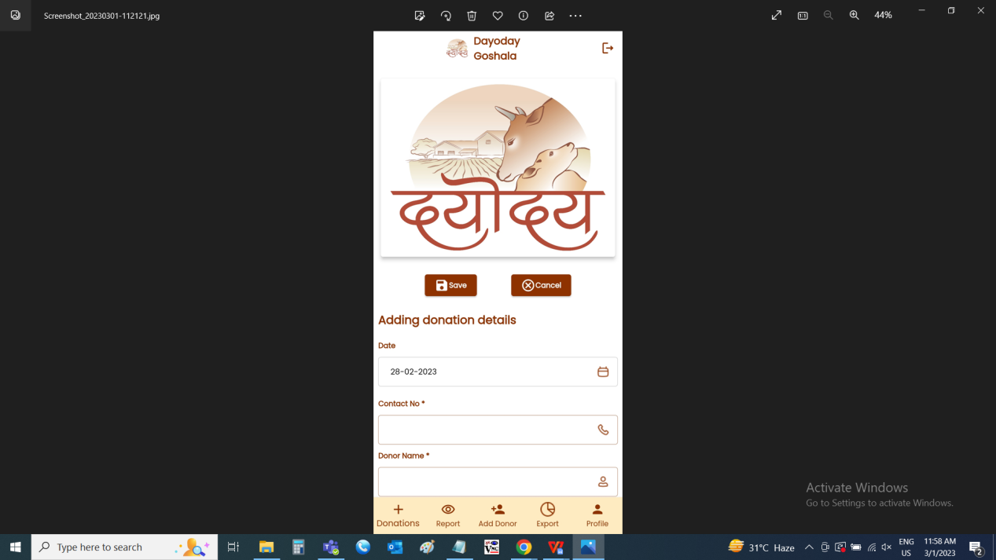

## BR003 - ADD COW

The add cow menu is used to add the data of the cow to be donated. The cow details can be added only by the user. The add cow consists of the following fields.

* Owner mobile
* Owner name
* Owner address
* Donation reason
* Owner photos
* Cow name
* Cow DOB
* Cow age
* Cow birthmark
* Cow color
* Cow type
* Cow delivered calves
* Cow disease detail
* Cow current health
* Is cow conceiving
* Cow daily milk (in ltrs)
* Cow market value
* Cows photo
* I agree
* Save
* Cancel

|  |  |  |  |
| --- | --- | --- | --- |
| **FIELDS** | **INPUT TYPE** | **MANDATORY/ OPTIONAL** | **DESCRIPTION** |
| Owner mobile | Int | Mandatory | The contact number of the owner of the cow is entered. The mobile number to be entered in proper format.  Validation:  Accepts only positive integers of 10 digits. |
| Owner name | Text | Mandatory | The name of the cow’s owner is entered.  Validation: Accepts alphabetic characters up-to 200 characters. |
| Owner address | Text | Mandatory | The address of the cow’s owner is entered.  Validation: Accepts alpha-numeric data with special characters up-to 1000 characters. |
| Donation reason | Text | Mandatory | The reason for donating the cow is entered.  Validation: Accepts alpha-numeric data with special characters up-to 1000 characters. |
| Owner photos | File upload | Mandatory | The owners photos along with his/ her cow is attached.  Validation:  Accepts images, pdf, jpeg, .png up-to 2 maximum of 2MB. |
| Cow name | Text | Mandatory | The cow name to be entered.  Validation: Accepts alpha-numeric data with special characters up-to 100 characters. |
| Cow DOB | Date picker | Mandatory | The date of birth of the cow is selected from the date picker.  Validations: Future date cannot be selected. |
| Cow age | Auto | Mandatory | The age of the cow is automatically calculated (Today’s date - cow’s DOB) based on the cow date of birth entered. |
| Cow birthmark | Text | Mandatory | The cow’s birth mark is entered.  Validation: Accepts alpha-numeric data with special characters up-to 1000 characters. |
| Cow color | Drop down | Mandatory | The color of the cow is selected from the drop down. The drop down options consists of the following.   * Black * White * Red (maroon) * Copper * Golden * Silver * Brown * Black spotted * Red spotted * Grey spotted * Brown spotted   Validation: Single selection |
| Cow type | Drop down | Mandatory | The type of the cow is selected from the drop down. The drop down options consists of the following.   * Red neck * Desi khilar * Sahiwal * Geer * Tharparkar * Jersey * Sindhi * Red sindhi * Gavalau * Devani   Validation:  Single selection |
| Cow delivered calves | Text | Mandatory | The number of calves, the cow delivered is entered.  Validation: Accepts numeric data maximum of 10. |
| Cow disease detail | Text | Mandatory | The diseases of the cows is entered. If there is no disease, NA is entered.  Validation: Accepts alpha-numeric data with special characters up-to 1000 characters. |
| Cow current health | Text | Mandatory | The current health of the cow is entered.  Validation: Accepts alpha-numeric data with special characters up-to 1000 characters. |
| Is cow conceiving | Drop down | Mandatory | The cow is conceiving or not is selected from the drop down. The drop down consists of the following.   * Yes * No   Validation: Single selection |
| Cow daily milk (in ltrs) | Int | Mandatory | The number of liters of milk, the cow gives daily, is entered.  Validation: Accepts positive integers up-to 2 decimals. |
| Cow market value | Int | Mandatory | The market value of the cow is entered  Validation: Accepts positive integers up-to 2 decimals. |
| Cows photo | File upload | Mandatory | The photos of the cow to be uploaded.  Validation:  Accepts images, pdf, jpeg, .png up-to 2 maximum of 2MB. |
| I agree | Check box | Mandatory | The I agree check box to agree the terms and conditions before the donation. |
| Save | Button | Optional | The save button to save the data |
| Cancel | Button | Optional | The cancel button to refresh the page |

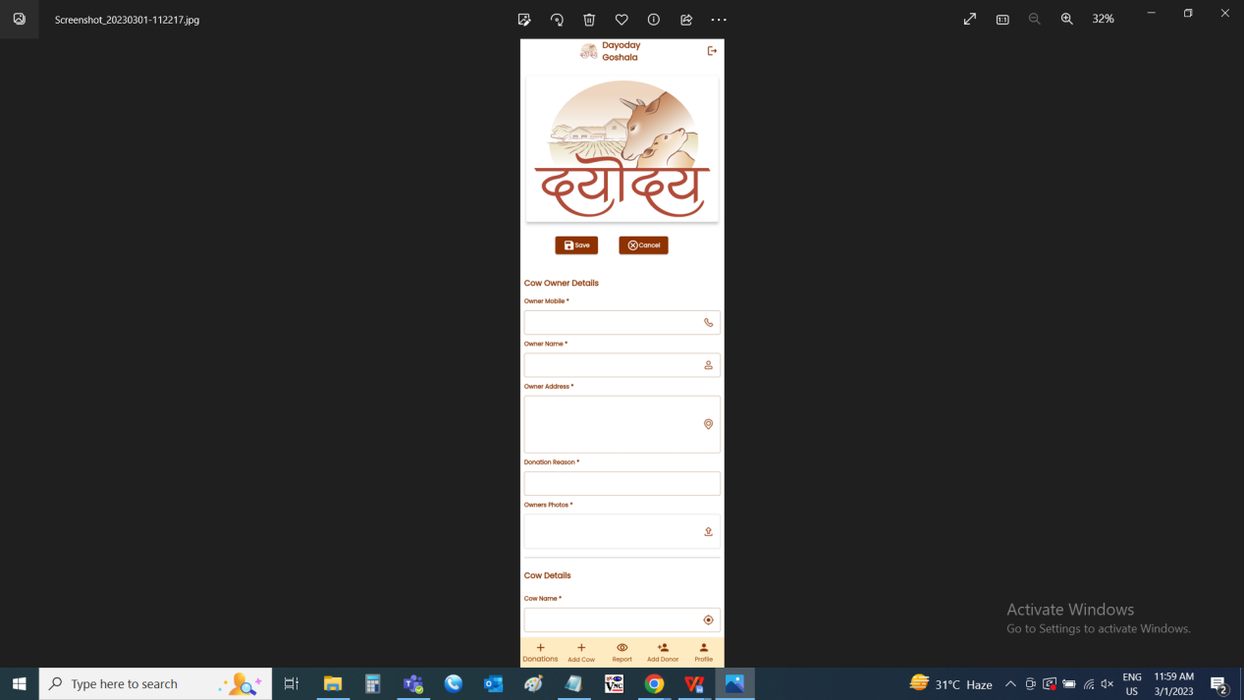

## BR004 - ADD DONOR

The donor details are added in the add donor menu. The data is updated in the donor master. The add donor consists of the following fields.

* Donor name
* Contact No
* Date of birth
* Pan No
* Address
* Pin-code
* Save
* Cancel

|  |  |  |  |
| --- | --- | --- | --- |
| **FIELDS** | **INPUT TYPE** | **MANDATORY/ OPTIONAL** | **DESCRIPTION** |
| Donor name | Text | Mandatory | The donor name is entered.  Validation: Accepts only alphabetic characters up-to 100. |
| Contact No | Int | Mandatory | The contact number of the donor is entered.  Validation:  Accepts only positive integers of 10 digits. |
| Date of birth | Date picker | Mandatory | The date of birth of the donor is selected from the date picker.  Validation: Future date cannot be selected. |
| Pan No | Text | Optional | The pan number of the donor is entered.  Validation:   * It should be ten characters long. * The first five characters should be any upper-case alphabet. * The next four-characters should be any number from 0 to 9. * The last (tenth) character should be any upper-case alphabet. * It should not contain any white spaces. |
| Address | Text | Optional | The address of the donor is entered.  Validation: Accepts alpha-numeric data with special characters up-to 1000 characters. |
| Pin-code | Int | Optional | The pin-code of the donor is entered.  Validation: Accepts positive integers of 6 decimals. |
| Save | Button | Optional | The save button to save the data |
| Cancel | Button | Optional | The cancel button to refresh the page |

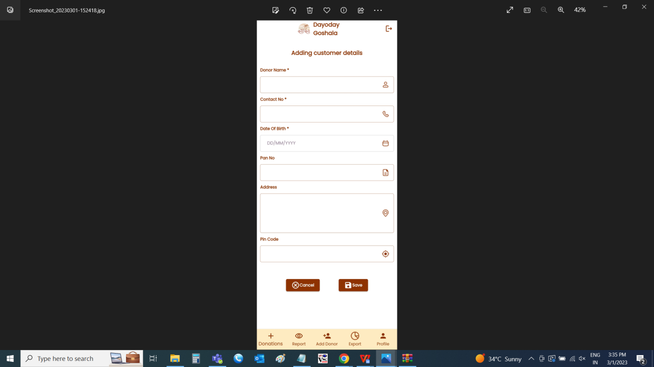

## BR005 - REPORT - VIEW DONATIONS

The donation list consists of the donations made. For the admin, all the donations will be displayed. For the users, the donations made by that particular user is displayed. The donation list consists of the following fields.

* Search
* Receipt no
* Donor details
* Pan number
* Amount
* Receipt

|  |  |
| --- | --- |
| **FIELDS** | **DESCRIPTION** |
| Search | The search bar to search any particular donation |
| Receipt no | The receipt number of the donation is displayed |
| Donor details | The donor details I.e., address of the donor is displayed |
| Pan number | The pan number of the donor is displayed |
| Amount | The amount donated by the donor is displayed |
| Receipt | The receipt click to view the receipt of the donation is displayed |

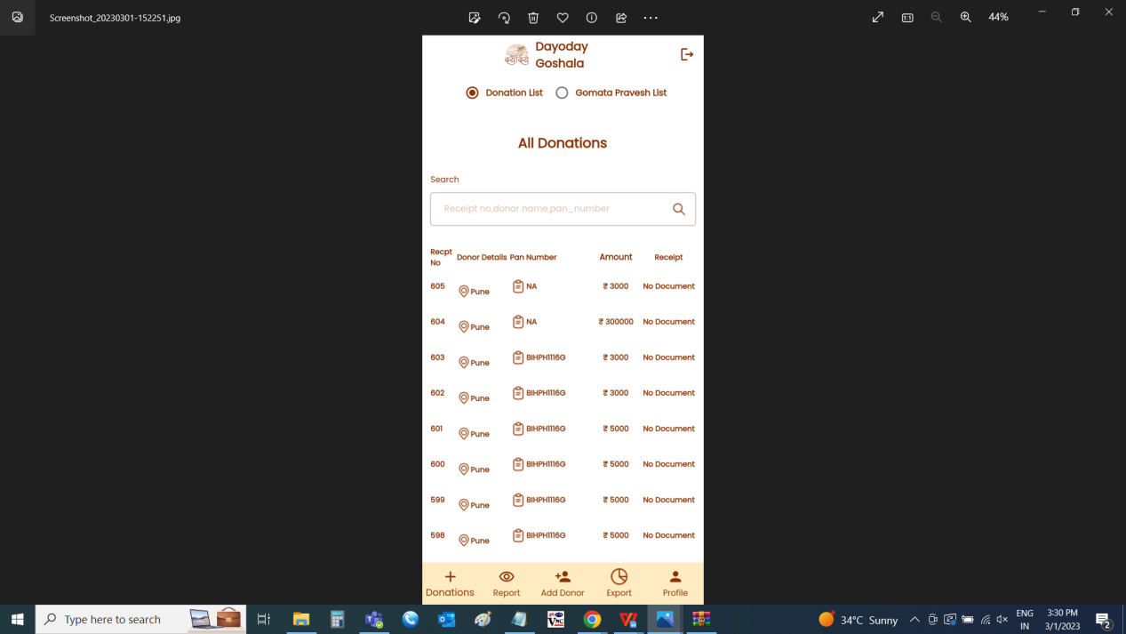

## BR006 - REPORT - VIEW GOMATA

The Gomata pravesh list consists of the cow donations made. For the admin, all the cow donations will be displayed. For the users, the cow donations made by that particular user is displayed. The gomata pravesh list consists of the following fields.

* Search
* Form ID
* Owner number
* Owner name
* Cow type
* View

|  |  |
| --- | --- |
| **FIELDS** | **DESCRIPTION** |
| Search | The search bar to search any particular cow donation made |
| Form ID | The form ID is displayed |
| Owner number | The cow’s owner number is displayed |
| Owner name | The name of the cow’s owner is displayed |
| Cow type | The type of the cow is displayed |
| View | The view click to view all the details of the cow donation |

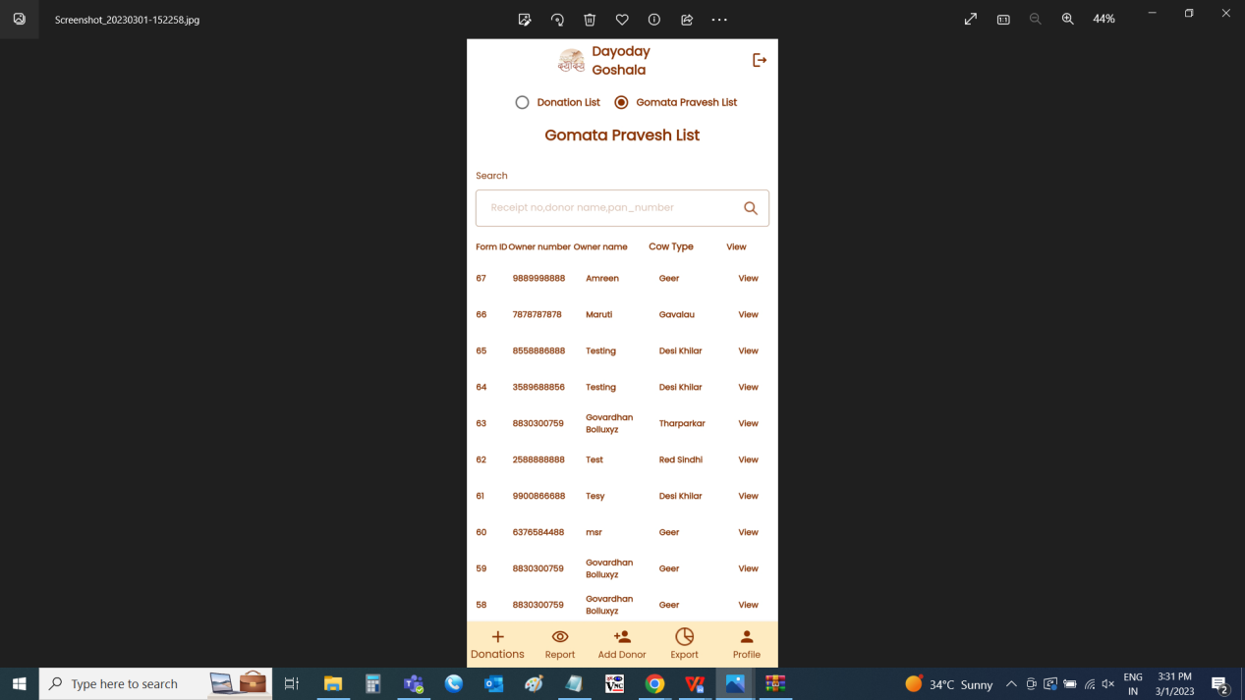

View page of cow details

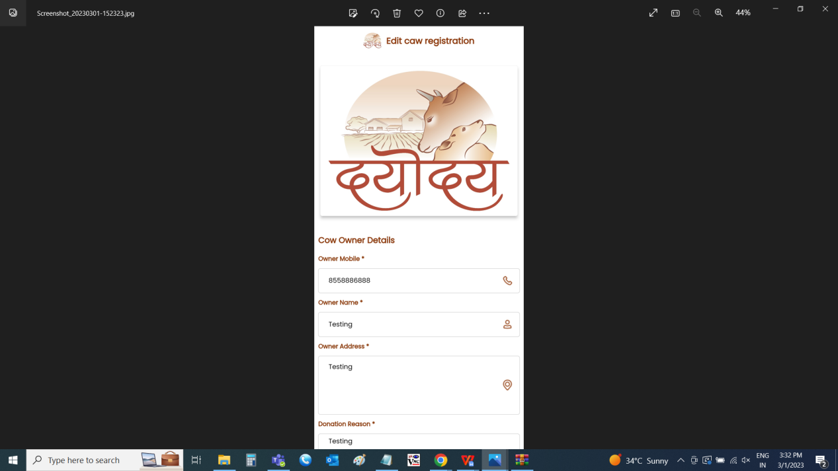

## BR007 - EXPORT DONATIONS

The reports consists of the data of the donations of the donor from specific time to specific time. The following are the fields in the reports.

* From date
* To date
* Report

|  |  |  |  |
| --- | --- | --- | --- |
| Field | Input type | Mandatory/ Optional | Description |
| From date | Date picker | Mandatory | The from date to be selected from when the report to be generated.  Validation:   * Future date cannot be selected. * Format - DD/MM/YYYY |
| To date | Date picker | Mandatory | The to date to be selected to when the report to be generated.  Validation:   * The to date should be greater or equal to the from date. * Format - DD/MM/YYYY |
| Report | Button | - | The report button to generate the report based on the from and to date filter. |

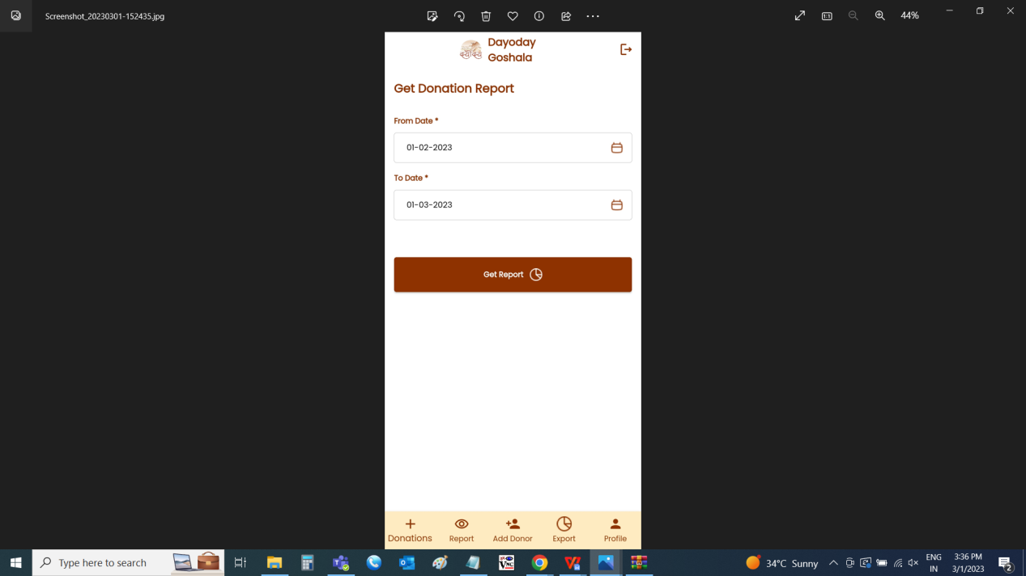

Report consists of the following fields

* Sr no
* Date
* Receipt no
* Donor name
* Name on receipt
* Date of birth
* Pan number
* Address
* Pincode
* Amount
* Amount in words
* Payment date
* Payment method
* Bank name
* Payment reference number
* Cheque/ UTR No

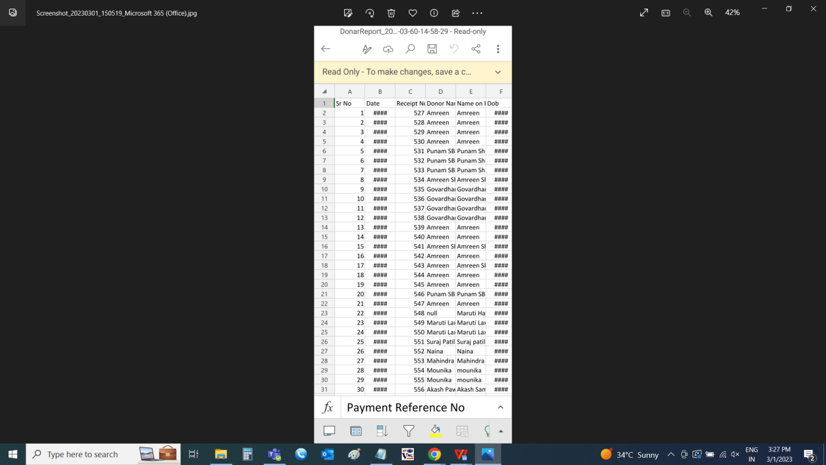

## BR008 - PROFILE

The profile is used to view the user details and to edit the password of the existing account. The following are the fields in the profile tab.

* Profile picture
* Name
* Email
* Client name
* New password
* Old password
* Eye button
* Apply changes

|  |  |  |  |
| --- | --- | --- | --- |
| **FIELDS** | **INPUT TYPE** | **EDITABLE/ NO** | **DESCRIPTION** |
| Profile picture | File upload | Yes | The profile picture of the user is shown. If required, the profile picture can be changed by uploading a new picture either by using camera or from the gallery.  Validation:  Accepts images, pdf, jpeg, .png up-to 1 maximum of 2MB. |
| Name | - | No | The name of the user is displayed |
| Email | - | No | The email ID of the user is displayed |
| Client name | - | No | The client name is displayed |
| New password | Text | Yes | The new password the user want to set as the password to be entered.  Validation: Can accept alpha-numeric data with special characters minimum of 4 characters and maximum of 100 characters. |
| Old password | Text | Yes | The old password of the user is entered.  Validation: Can accept alpha-numeric data with special characters minimum of 4 characters and maximum of 100 characters. |
| Eye button | Button | - | The eye button to view the password in text format is displayed |
| Apply changes | Button | - | The button to apply the changes. |

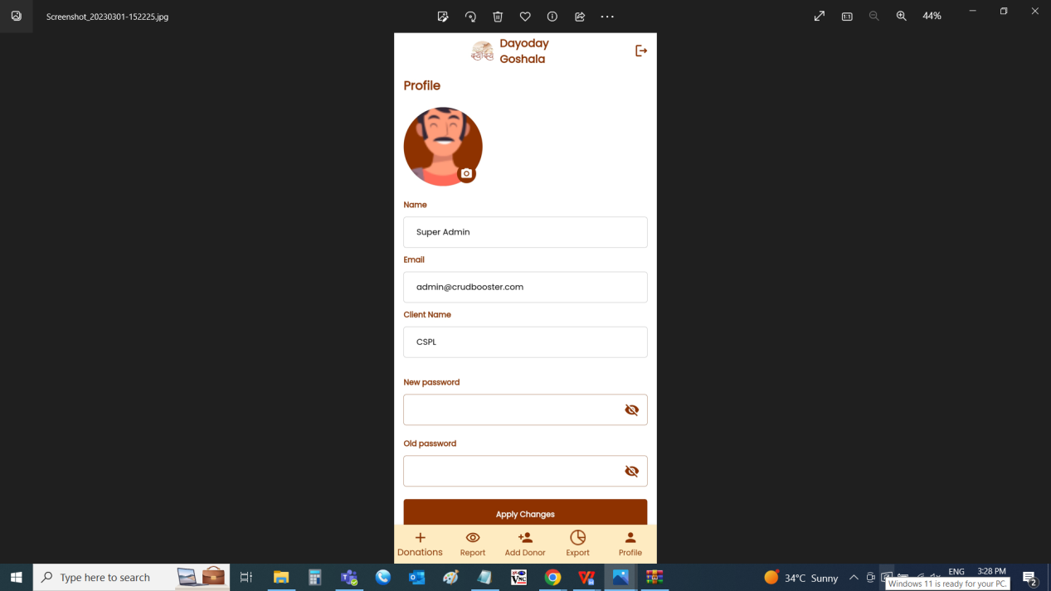

LOGOUT

The upper right symbol indicates to log out from the existing account. The following tab is displayed when the user clicks on it. “Do you want to logout?” with options “No” and “Yes”.

|  |  |  |  |
| --- | --- | --- | --- |
| **FIELDS** | **INPUT TYPE** | **MANDATORY/ OPTIONAL** | **DESCRIPTION** |
| No | Button | Optional | The remain in the same login |
| Yes | Button | Optional | To log out from the existing account |

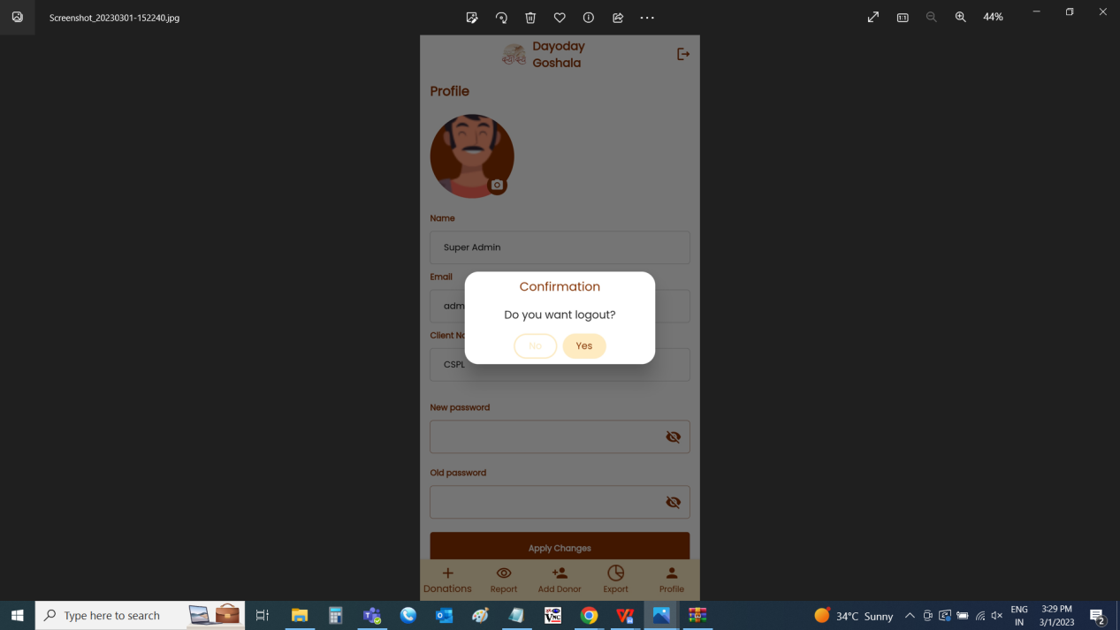

1. **TEST DATA / USE CASE SCENARIOS**



1. **REFERENCES OF THE USERS**

|  |  |  |  |
| --- | --- | --- | --- |
| **User** | **Name** | **Mail** | **Contact number** |
| **Actual user** | Aditya Shah |  |  |
| **Assigned business analyst** | Mounika Annamneedi |  |  |
| **Assigned developer** | Goverdhan Bollu |  |  |
| **Assigned tester** | Kiran |  |  |