22.08.2023

BILL CHECKING

Mounika Annamneedi

Mounika.annamneedi@techneai.com

**Functional Requirement Document**

**CONTENTS**

1. INTRODUCTION 2

2. BUSINESS REQUIREMENT 2

3. SCOPE 2

4. BUSINESS & SYSTEM RULES 2

5. PROPOSED SYSTEM 2

6. TEST DATA 5

1. **INTRODUCTION**

The bill checking module is the billing process which is helpful in creating bills, payment details, approval process and bill payments.

1. **BUSINESS REQUIREMENT**

Enter details of the ticket requirement.

|  |  |  |  |
| --- | --- | --- | --- |
| **Requirement ID** | **Requirement Name** | **Short Description** | **Priority** |
| BR001 | Payment Details | The payment details consists of the amount, payment date for the same and the status. | High |
| BR002 | Payment Details - edit | The payment details edit can be edited in detailed | Medium |
| BR003 | Payment Details - export | The payment details can be exported in detail | Medium |

1. **SCOPE**

The scope of the point is up to the payment details and and the change of the status based on the authorities.

1. **BUSINESS & SYSTEM RULES**

* User should be registered in the system.
* User should be logged in.
* System should display error message for incorrect details if entered.
* System should pop up a message, if any issues in the system is detected.
* All forms should have on field validations. System should display on field errors in case of incorrect inputs.

1. **PROPOSED SYSTEM**

**BR001 - Payment Details**

The payment details consists of the payment details in detail. The following are the fields in the payment details.

* Export
* Action
* Sr no
* Amount to be paid
* Status
* Payment date
* Remark
* Actual payment date
* Payment reference number

|  |  |
| --- | --- |
| **FIELDS** | **DESCRIPTION** |
| Export | The export button to export the data of the payment details |
| Action | The action field to edit the payment details |
| Sr no | The serial number of the record is shown |
| Amount to be paid | The amount to be paid in detail is displayed. The amount of the net payment is more than Rs.99,00,000 then it classifies the amount and displays amount up to 99,00,00 in one row and the remaining amount in second row.  Example: Net payment is 1,00,00,000. Then in payment details. It will display 99,00,000 in one row and remaining 1,00,000 in another row. |
| Status | The status of the payment detail is displayed. The status consists of the following.   * Hold * Hold till audit * Paid * Release |
| Payment date | The payment date of the record is auto calculated based on the payment template and the vendor selected and it is displayed. |
| Remark | The remark of the payment is displayed if any mentioned |
| Actual payment date | The actual payment date is displayed when the actual payment is made. |
| Payment reference number | The payment reference number is displayed when the actual payment is made. |

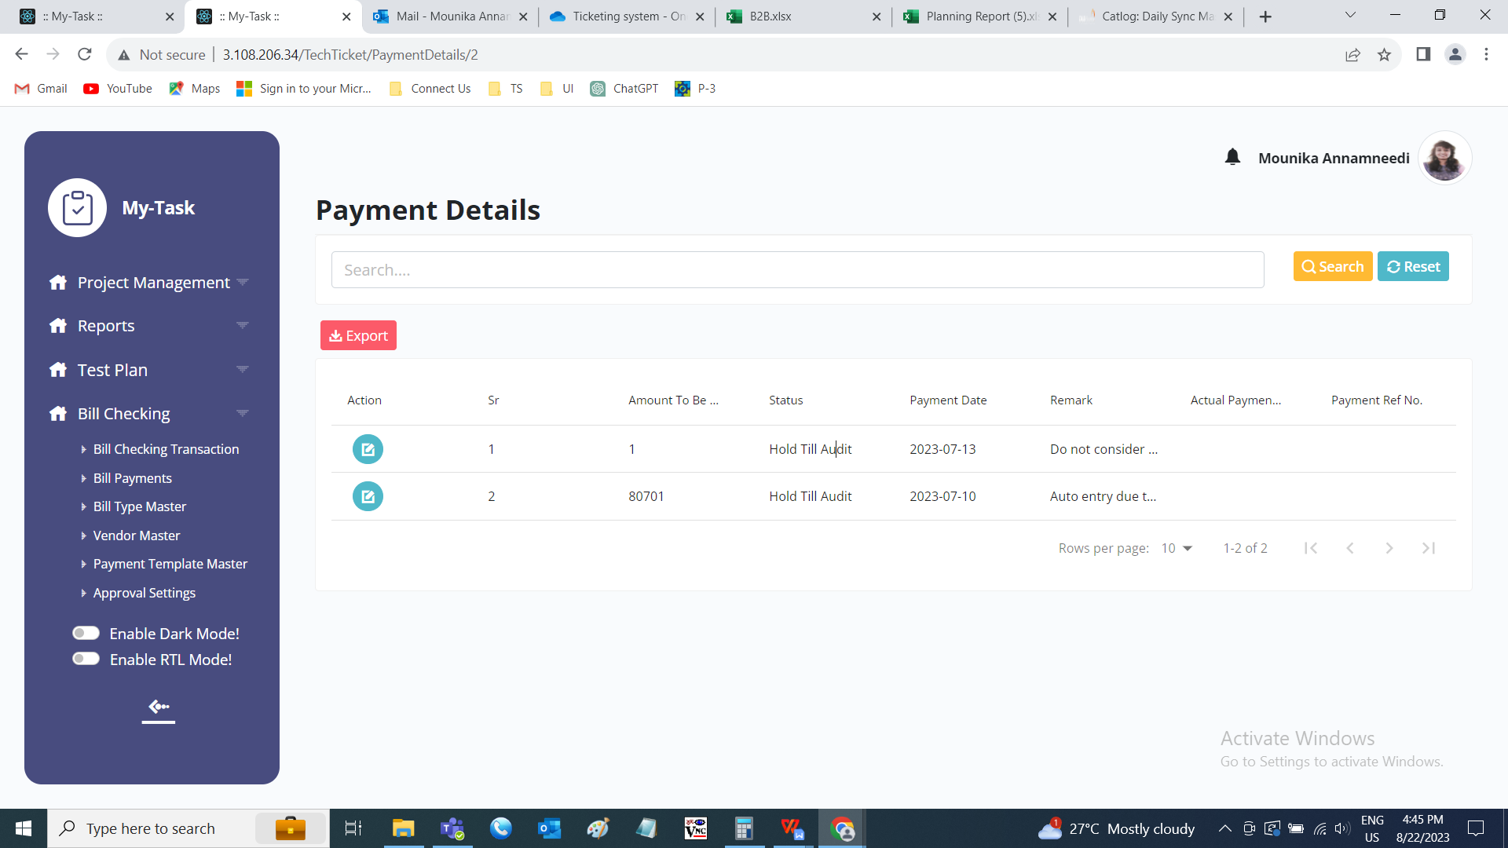

**BR002 - Payment Details - Edit**

The payment detail edit is based on the authority based settings given in the approval settings. The following fields are editable.

* Amount to be paid
* Status
* Payment date
* Remark

|  |  |  |  |
| --- | --- | --- | --- |
| **FIELDS** | **INPUT TYPE** | **MANDATORY/ OPTIONAL** | **DESCRIPTION** |
| Amount to be paid | Text | Mandatory | The amount to be paid is entered. If the amount is bifurcated, the amount entered will be saved and for the remaining amount, new record is created.  Validation: The updated amount should be not greater than the existed amount. |
| Status | Drop down | Mandatory | The status for the payment record is selected from the drop down. The drop down consists of the following options.   * Hold * Hold till audit * Paid * Release |
| Payment date | Date picker | Mandatory | The payment date is auto calculated and displayed based on the payment template and the vendor selected and it is displayed. Validation: Cannot be the past date |
| Remark | Text | Mandatory | The remark is entered at the time of update. Validation: Can accept characters, integers and special characters up to 500 characters. |

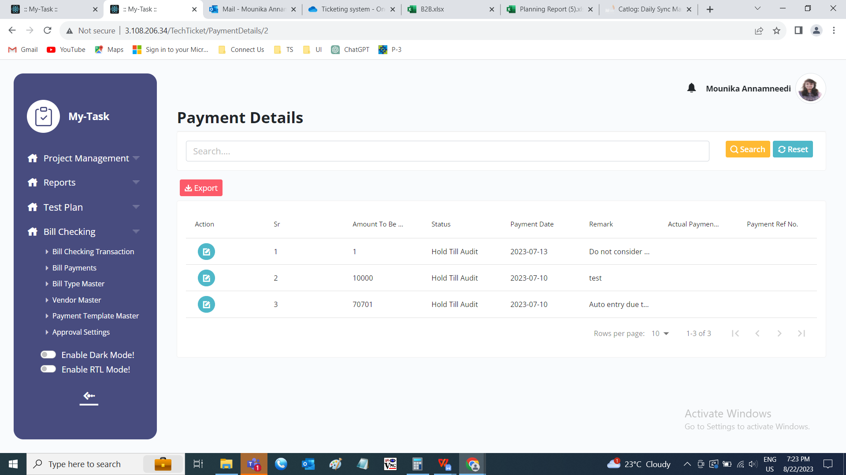

**BR003 - Payment Details - export**

The export consists of the following fields.

* Sr No
* Bill ID
* Amount to be paid
* Status
* Payment date
* Remark
* Actual payment date
* Payment reference number

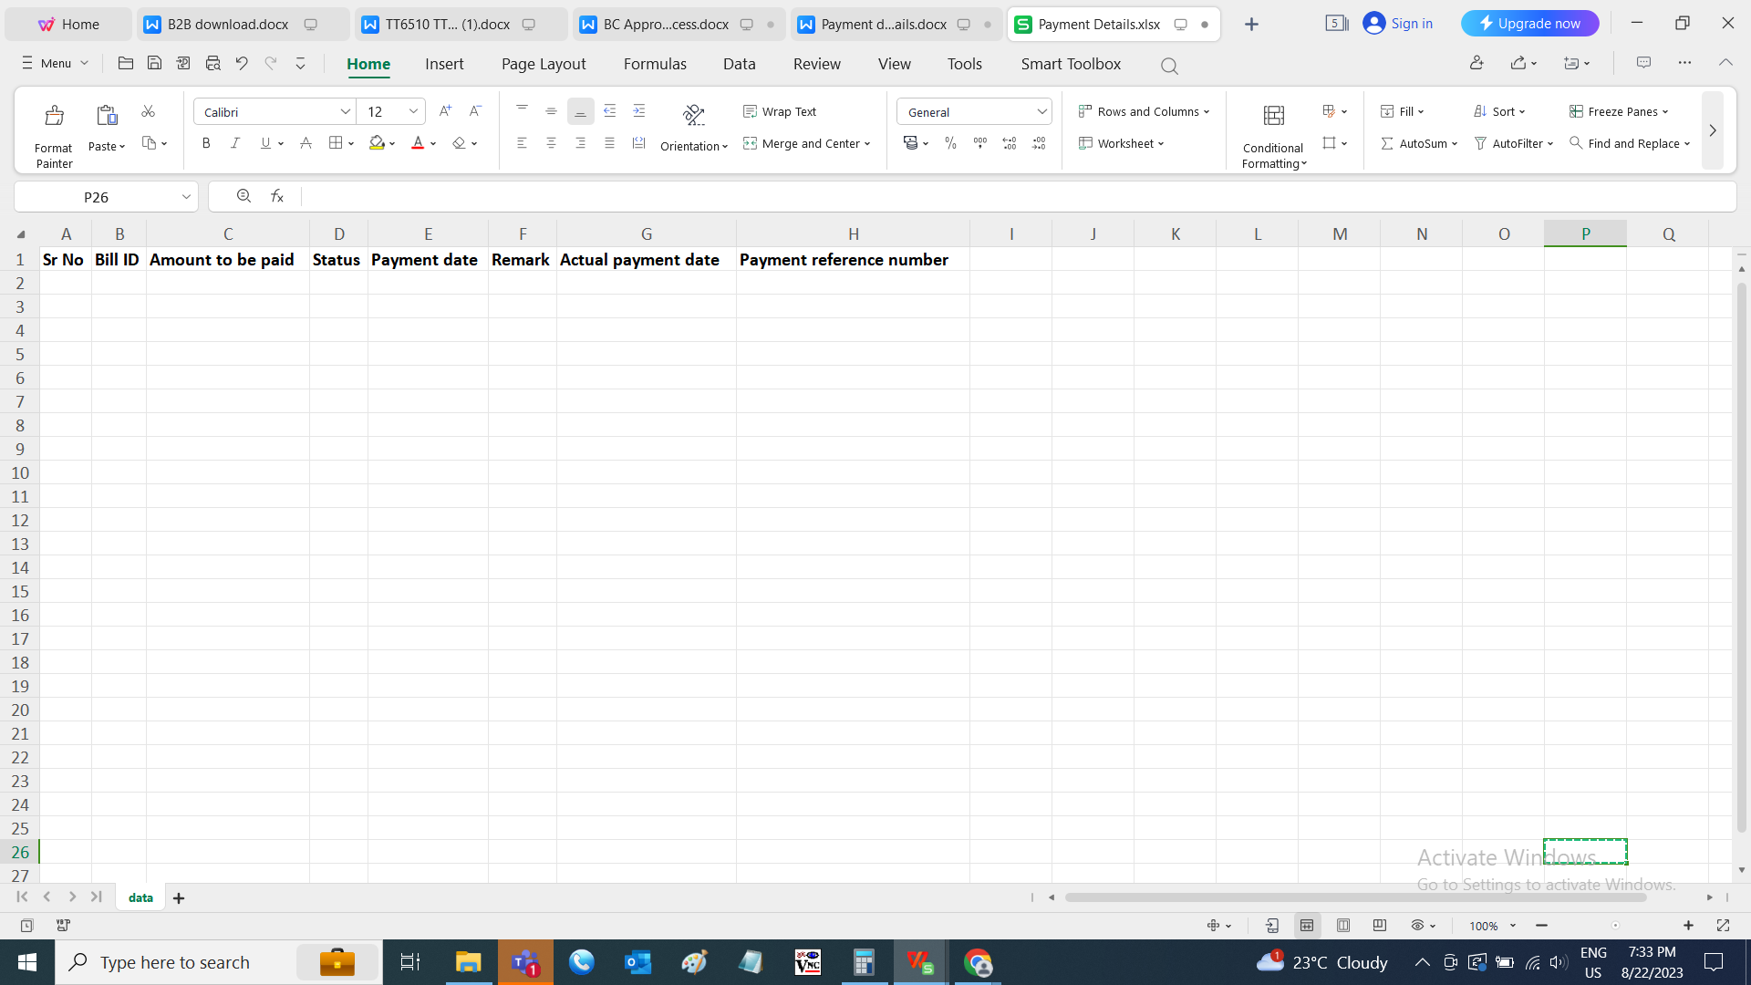

1. **TEST DATA**

|  |  |  |  |  |  |  |
| --- | --- | --- | --- | --- | --- | --- |
| **Sr No** | **Amount to be paid** | **Status** | **Payment date** | **Remark** | **Actual payment date** | **Payment reference number** |
| 1 | 10000 | Hold | 23/08/2023 | Testing |  |  |