|  |  |
| --- | --- |
| **Ticket ID** | *TT11135* |
| **Ticket description** | *Unfix process development in inventory* |
| **Created by** | *Manali Bhadirage* |
| **Created on** | *10/04/2023* |
| **Priority** | *Very high* |
| **Version** | *1.0* |

**Version**

|  |  |  |  |  |
| --- | --- | --- | --- | --- |
| **Sr. No** | **Version no** | **Version Date** | **User name** | **User department** |
| **1** | **1.0** | **10/04/2023** | **Pritam Mehta** |  |
| **2** | **2.0** | **11/04/2023** | **Pritam Mehta** |  |
| **3** | **2.1** | **13/04/2023** | **Pritam mehta** |  |
| **4** | **3.1** | **14/04/2023** | **Pritam Mehta** |  |
| **5** | **4.0** | **21/04/2023** | **Pritam Mehta** |  |
| **6** | **4.1** | **27/12/2023** | **Pritam Metha** |  |

**Approvals**

|  |  |  |
| --- | --- | --- |
| **Field** | **Name of the User** | **Approved date by the user** |
| **Actual User Name** | Sanjay Dhanole / Rakesh Annappa Thikane |  |
| **Actual User Department** | Inventory |  |
| **Organization Name** | CSJ |  |
| **Assigned BA** | Manali Bhadirage |  |
| **Assigned Developer** | Parth Patel / Punam Shinde |  |
| **Assigned Tester** | Priyanka dupargude |  |

**Estimation**

|  |  |  |  |  |
| --- | --- | --- | --- | --- |
| **Department name** | **Estimated Time (In hr)** | **Scheduled Date (Starting date )** | **Estimated date** | **Actual delivery date** |
| **BA** |  |  |  |  |
| **Development** |  |  |  |  |
| **Testing** |  |  |  |  |
|  |  |  |  |  |

**Introduction**

*During procurement, PO is sent to supplier and unfix rate is mentioned by authorized person against the vendor. Once we receive the material and bill from the vendor, material details are entered in Connect Us -> material issue menu and doc. No. Is generated for the same. Further, the generated document is sent for checking step by step : Design check -> QC check -> PO check -> HM check. Once HM check process is completed, the Purchase return and RD purchase document is created in Padm system as per* unfix rate*. Then, the rate is fixed for the items. Once the rate is fixed, then as credit or debit note is generated and issued to the vendor and the payment is done. If the unfix rate > fix rate, then credit note is issued to vendor. If unfix rate < fix rate, then debit note is issued to vendor.*

**Existing system**

*There is no such existing system.*

**Proposed system**

*Step 1. In Connect us -> material issue main menu -> material issue, once user clicks on add data, it will display following fields:*

*Issued Date*

*Challan No.*

*Location*

*Issued Type*

*Vendor*

*Sub supplier*

*Narration*

*Remark*

***Type of Rate - Fix / Unfix***

***Rate***

***Is RD purchase?***

***Attachment***

*The additional fields should be displayed in add, edit and view action of each document.*

**Input table**

|  |  |  |
| --- | --- | --- |
| **FIELDS** | **INPUT TYPE** | **DESCRIPTION** |
| Type of Rate | checkbox | It will be checkbox displaying either Fix or Unfix.  While adding the data in material issue, the user can specify whether the rate for the particular vendor is fixed or not. |
| Rate | Text | Rate which is decided by the vendor for the day during purchase, it will be mentioned here.  It will be auto-filled from imported PO. It will also be editable field. It should accept only numbers. |
| Is RD purchase? | Checkbox | It will display check box as Yes / No. |
| Attachment(s) | Attach | User will enter the bill of the total items received from vendor.  It will be multi-select.  It should only accept jpeg / jpg / png / pdf extensions of file. |

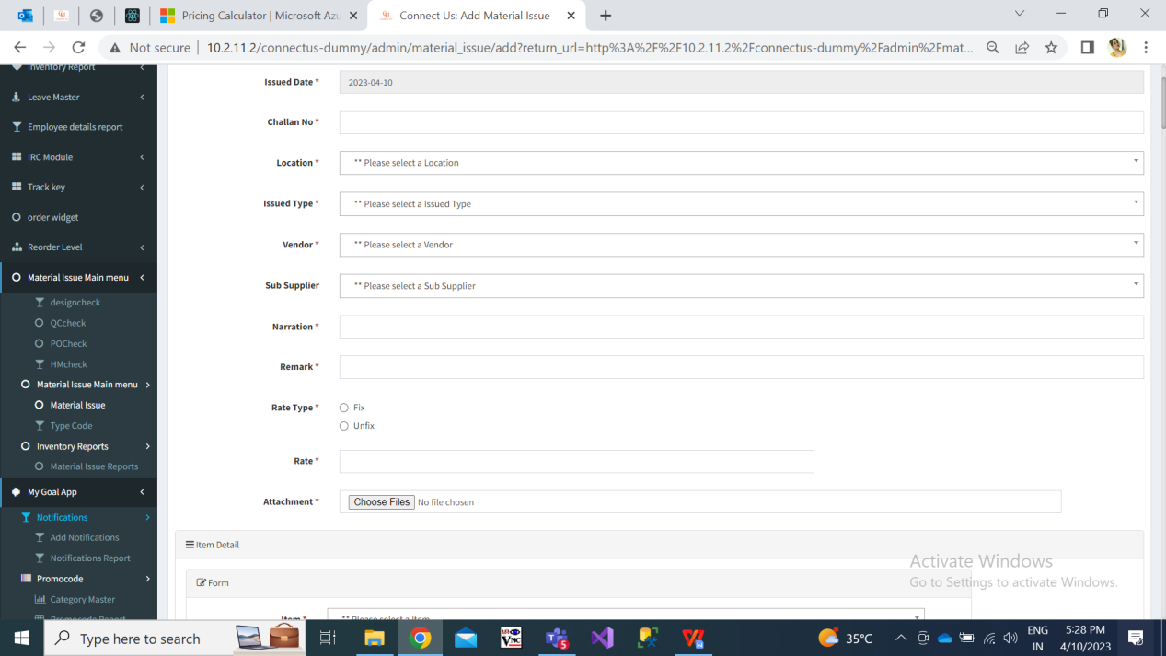

Fig: material issue -> add

Once user enters items details, adds to table and clicks on submit, the doc. no. will be generated to it. It will be displayed in material issue grid.

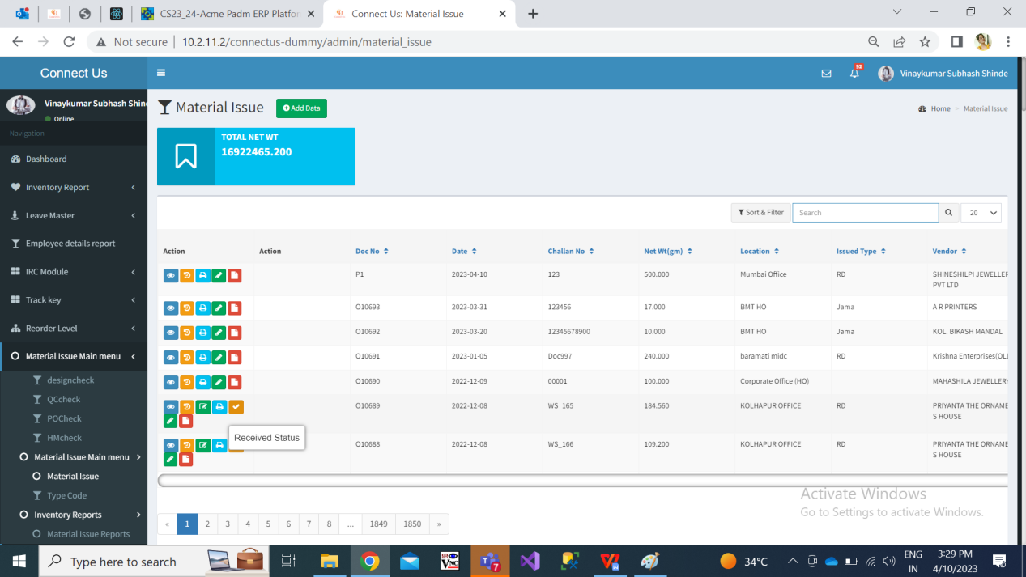

Fig: material issue -> grid

We need to display newly added fields namely rate, type of rate, is RD purchase and attachment in edit and view action as well of material issue.

Step 2. Once the data is marked as received by authority from material issue, it will be displayed in design check module.

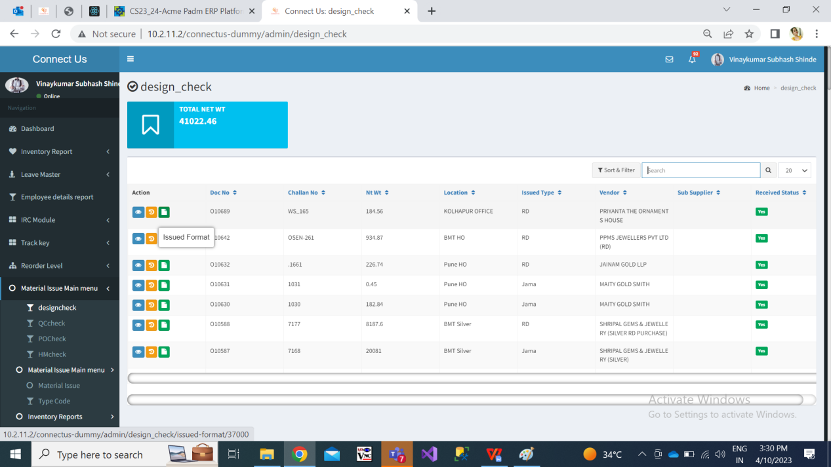

Fig: design check -> grid

Once user checks the items and enters details of rejected gross wt, rejected net wt and rejected pcs , then the remaining accepted gross wt, accepted net wt, accepted pcs will be auto calculated and displayed. Only the accepted details of the items will be forwarded to quality check process.

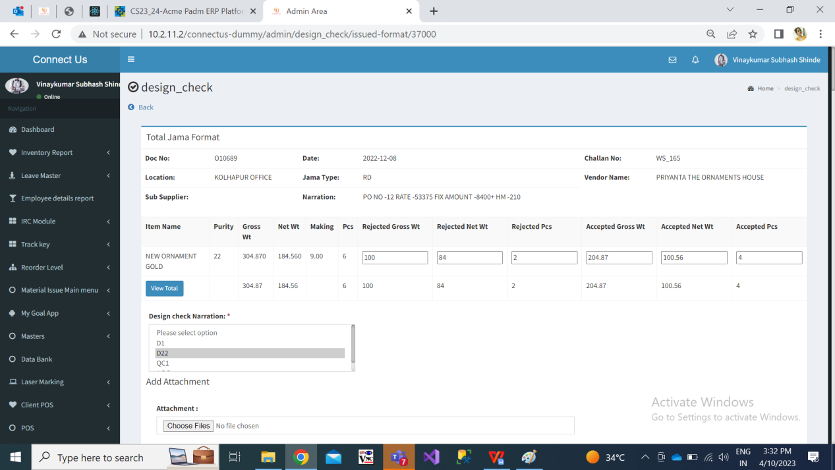

Step 3. Only the accepted gross wt, accepted net wt and accepted pcs from design check will be forwarded to quality check.

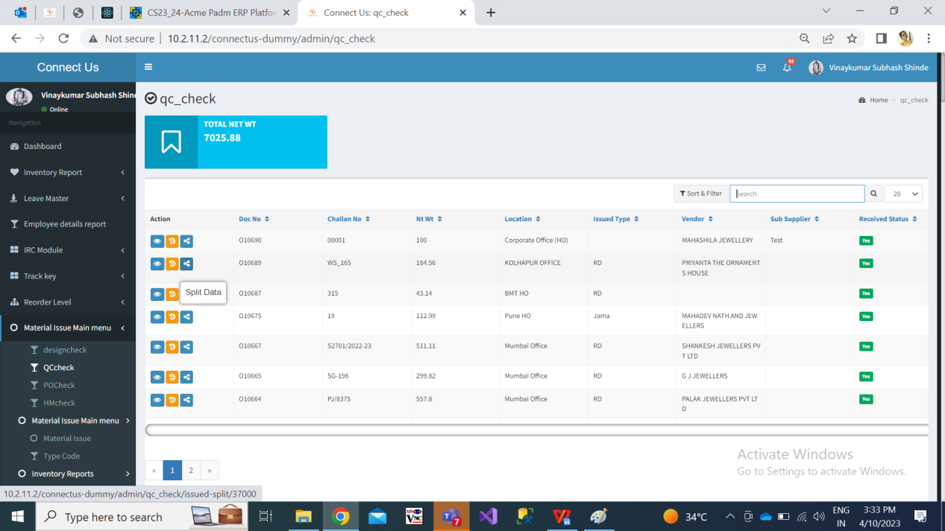

Fig: quality check -> grid

Qc incharge will split the accepted pcs into employees. The split data / pcs will be displayed to the employees and will be able to perform quality checking of the items.

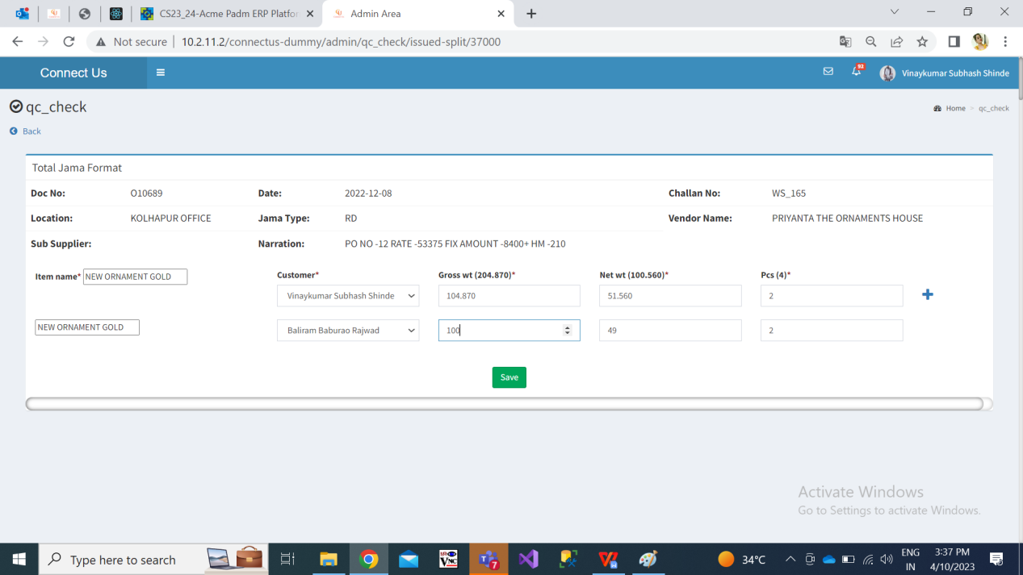

Fig: QC check -> split

Once QC employees checks the items and enters details of rejected gross wt, rejected net wt and rejected pcs , then the remaining accepted gross wt, accepted net wt, accepted pcs will be auto calculated and displayed.

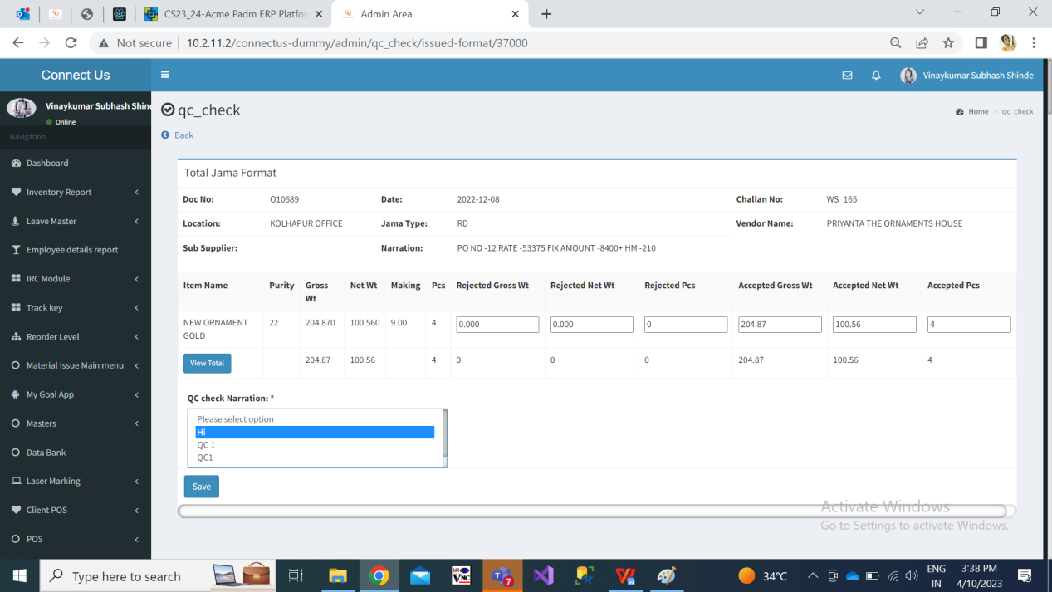

Step 4. Only the accepted details of the items from qc check document will be computed together and will be forwarded to POcheck process.

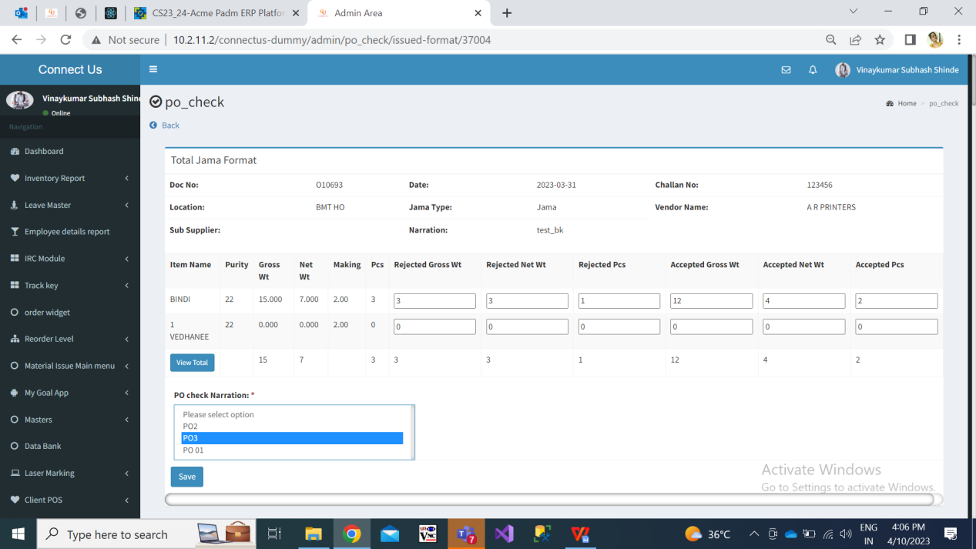

Step 5. Only the accepted details of the items in from PO check document will be computed together and will be forwarded to HMcheck process.

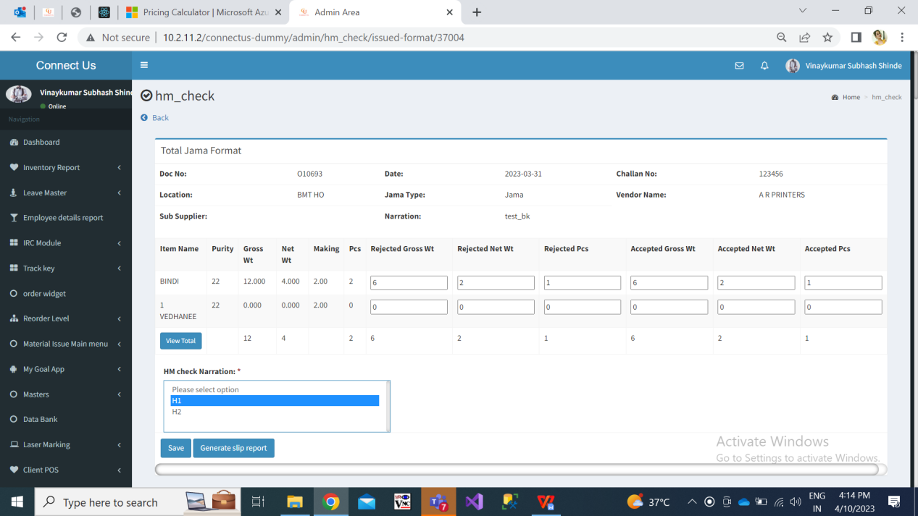

Once user enters of rejected gross wt, net wt and pcs, it will displayed accepted gross wt, net wt and pcs. Once user clicks on view total button, it will display all the collated details of accepted & rejected gross wt, net wt and pcs in each process.

Step 6. **All the collated details of accepted & rejected gross wt, net wt and pcs in each process should be sent to vendor via SMS / Whats-App / Email.**

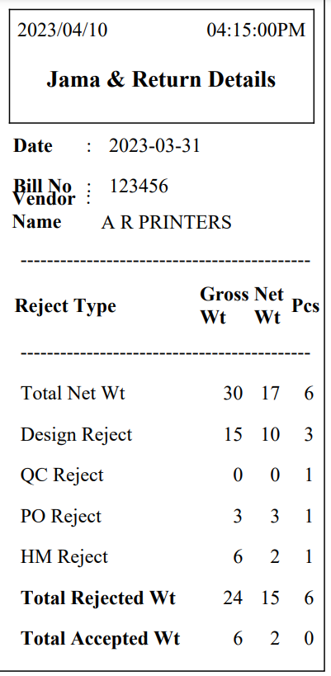

Step 7. We need to create a menu ‘Fix Rate’ which will display all the documents in grid which were marked as ‘yes’ for “Is RD purchase” field and rate type is “unfix” in material issue menu and have cleared HMcheck process.

It will display following fields in grid:

* Action - view, edit, fix rate
* Doc no.
* Challan no.
* Vendor name
* Rate type - Fix / Unfix
* Rate
* Fix data generated - Yes / No
* Fix data generated at

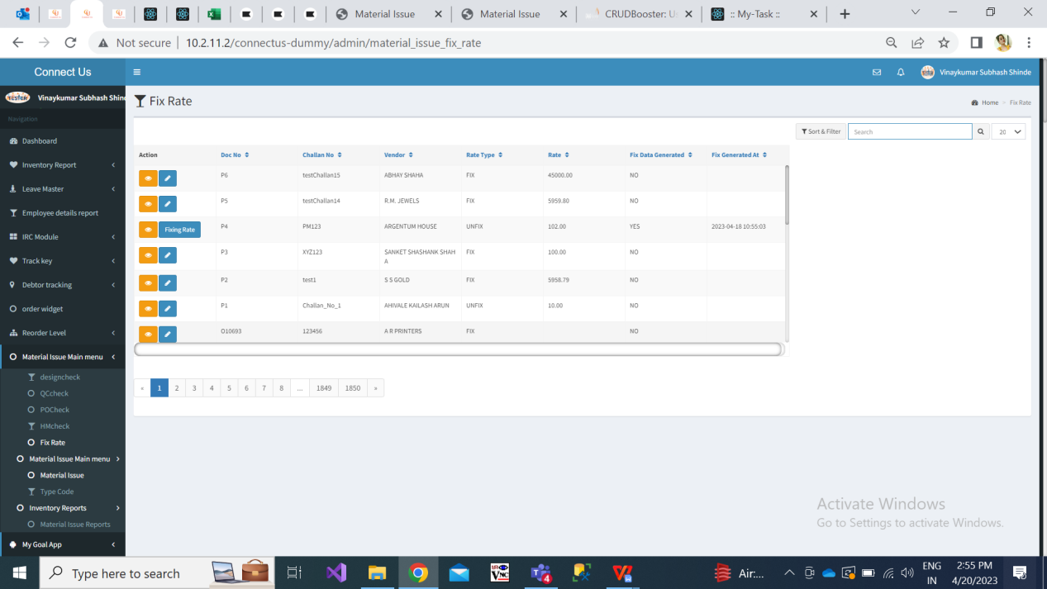

Fig: Fix Rate menu

|  |  |
| --- | --- |
| **FIELDS** | **DESCRIPTION** |
| Action | View - It will be displayed to all users having access to fix rate module. As and when details are updated through edit action and fixing action, it will be displayed in view action page as well. It will be displaying following read only details:   * Doc no. * Challan No. * Vendor Name: * Rate type: * Rate * Fix rate generated by & at * RD purchase documents: (it will display list of doc as entered during edit action) * Total gross wt * Total net wt * Total pcs * Total Stone amount * Total HM charges * Total Other charges * Total TDS * Total GST * Total Gross amount * Total Net amount * Total Fine wt * Purchase return documents: (it will display list of doc separated by comma as entered during edit action) * Total gross wt * Total net wt * Total pcs * Total Stone amount * Total HM charges * Total Other charges * Total TDS * Total GST * Total Gross amount * Total Net amount * Total Fine wt * Fix rate table  1. Balance fine wt 2. Rate 3. Quantity (I.e wt) 4. Created at & by  * Note type:- credit / debit   Edit - Through edit action user can enter the purchase return doc no. and RD purchase doc no. It will be matched with the doc. no. From material issue -> accepted and rejected. This button will be displayed based on authority. (Authority from masters -> general master -> login special authority)  Fixing rate - Through this action user can break and fix rate as per available accepted weight. This button will be displayed based on authority. (Authority from masters -> general master -> login special authority) |
| Doc No. | In grid, it will display the doc. no. as generated in material issue. |
| Challan no. | In grid, it will display the challan no. as generated in material issue. |
| Vendor name | In grid, it will display vendor name as per doc. no. From material issue. |
| Rate type | It will display either fix or unfix as selected while adding doc. In material issue. |
| Rate | It will display rate as mentioned in material issue while adding doc. |
| Fix data generated | It will display ‘yes’ when user has edited the entry and entered details of RD purchase doc. and purchase return doc. |
| Fix data generated at | It will display date and time when the user edited and entered details of RD purchase doc. and purchase return doc. |

Step 8. Once user clicks on edit action it will display following fields in form:

* Doc no.
* Challan no.
* Vendor name
* Total accepted - gross wt, net wt, pcs
* Total rejected - gross wt, net wt, pcs
* RD purchase doc no. - search and check button
* Doc no.
* Doc date
* Gross wt
* Net wt
* Pcs
* Stone amount
* HM charges
* Other charges
* TDS
* GST
* Gross amount
* Net amount
* Fine wt
* Purchase return doc no. - search and check button
* Doc no.
* Doc date
* Gross wt
* Net wt
* Pcs
* Stone amount
* HM charges
* Other charges
* TDS
* GST
* Gross amount
* Net amount
* Fine wt
* Save (button)
* Cancel (button)

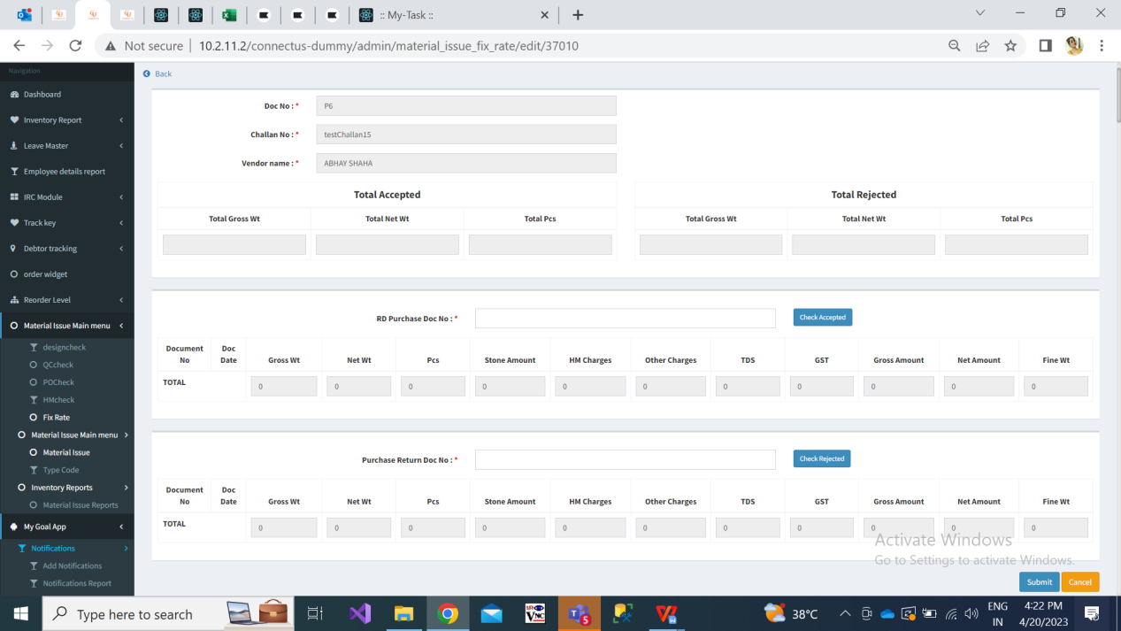

Fig: Fix rate -> edit action

|  |  |
| --- | --- |
| **FIELDS** | **DESCRIPTION** |
| Doc No. | It will display the doc no. generated while adding data in material issue. |
| Challan no. | It will display the challan no. Entered while adding data in material issue. |
| Vendor name | It will display the vendor name entered while adding data in material issue. |
| Total accepted - gross wt, net wt, pcs | It will display total accepted gross wt, net wt and pcs in the selected document as per details entered HM check process. |
| Total rejected - gross wt, net wt, pcs | It will display total rejected gross wt, net wt and pcs in the selected document as per details mentioned in HM check process. |
| RD Purchase No. | Details of accepted pcs are entered in RD purchase documents.  User will enter RD purchase doc number from Padm here and will click on check button.  As per entered doc. no. from Padm, following details of the document will be displayed:  Doc no.  Doc date  Gross wt  Net wt  Pcs  Stone amount  Hm charges  Other charges  TDS  GST  gross amount  Net amount  Fine wt  **Total**  User can enter multiple RD purchase documents in this field.  If multiple documents are entered then at bottom of document entries, it will display the total of gross wt, net wt, pcs, stone amount, hm charges, other charges,TDS, GST, gross amount, net amount, and fine wt.  For each entry, it should have cross button so that user can cancel the entry of entered document and then the total should be recalculated and displayed accordingly.  It should not accept purchase return document numbers. It should display error message as “please enter valid document no.”.  In case user has entered incorrect document number, then it should display error message as “document doesn’t exist”. |
| Purchase return no. | Details of rejected pcs are entered in RD purchase documents.  User will enter purchase return doc number from Padm here and will click on check button.  As per entered doc. no. from Padm, following details of the document will be displayed:  Doc no.  Doc date  Gross wt  Net wt  Pcs  Stone amount  Hm charges  Other charges  TDS  GST  gross amount  Net amount  Fine wt  **Total**  User can enter multiple purchase return documents in this field.  If multiple documents are entered then at bottom of document entries, it will display the total of gross wt, net wt, pcs, stone amount, hm charges, other charges,TDS, GST, gross amount, net amount, and fine wt.  Example: JHPRA-78  For each entry, it should have cross button so that user can cancel the entry of entered document and then the total should be recalculated and displayed accordingly.  It should not accept RD purchase document numbers. It should display error message as “please enter valid document no.”.  In case user has entered incorrect document number, then it should display error message as “document doesn’t exist”. |
| Save (button) | Once user clicks on save button, it should display dialogue box as “Do you really want to save the changes? Yes / No”. Once user clicks on yes, then it should display message as “data saved successfully” and should direct user to grid page. If user clicks on no, then it should keep user on the edit action page.  However, if the total of purchase return doc and RD purchase doc doesn’t match with the details as per pdf / report of HMcheck (accepted & rejected), then it should display message as “Data doesn’t match. Do you still want to save the changes? Yes / No”. Once user clicks on yes, then it should display message as “data saved successfully” and should direct user to grid page. If user clicks on no, then it should keep user on the edit action page. |

Step 9. Once data is edited and saved, then edit action should be removed for that doc. No. and “Fixing rate” action will be provided. All the details, as entered in edit action, should be reflected in view action.

Once user clicks on "Fixing rate” action, it will display following fields:

* Total fine wt
* Doc no.
* Vendor name
* Balance fine wt
* Rate
* Quantity
* Action

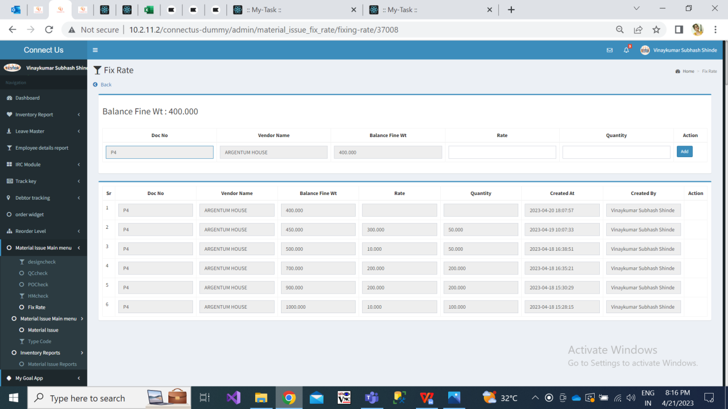

Fig: Fixing rate

Here, rate and quantity will be editable text fields. It will accept only numeric value. Each time authorized user will enter the rate and the quantity (means rate per kg or grams).

Once user breaks & enters the rate it will be displayed in the row below and also the email of the same will be sent to the vendor. (Email address of vendor is mentioned in bill checking-> vendor master.)

The row at bottom will have following fields:

* Sr no.
* Doc no.
* Balance fine wt
* Unfix rate
* Fix Rate
* Net
* Quantity
* Voucher amount
* Remark
* Note no.
* Created by & at

Each time when rate is break, the remaining fine wt will be displayed in 'balance fine wt' field

Authorised user will be able to break & enter the rate till balance fine wt is 0.00. Then all editable fields will be disabled.

Further, the total of the rate column will be displayed at bottom. When balance wt is 0.00 that means the rate of entire fine wt is decided / entered in system.

In unfix rate column of the table, we will display the rate which was entered in the material issue main menu -> fix rate field. It will be for per gram.

Fix rate column will display the rate which was entered by the user above while breaking. It will be for per gram.

Net will display the difference between unfix rate and fix rate of each entry in the table. Net = Unfix rate - Fix rate

Voucher amount = Net * Qty

Remark : As per greate rate amount it will display whether credit note or debit will be generated. If **fix rate > unfix rate**, then **debit note** should be generated.

If **fix rate < unfix rate**, then **credit note** should be generated.

If **fix rate = unfix rate**, then none of the note will be required.

Note no. : User will mention the debit / credit note number here. It shoukd acceot alohnumeric value. Min length = 3 characters and max length = 25 characters.

The details of break rate and note will be displayed in view action as in fix rate page.

Step 10: Once note is generated, user can pass entry to Padm. Once user clicks on pass entry action, it will display following fields:

* RD purchase no.
* Vendor Name
* Unfix rate
* Our accounting Date
* Net wt
* Gross wt
* Total fine wt
* Fix rate
* Generated note - credit / debit
* Party debit / credit note no.
* Date
* Attachment

|  |  |  |
| --- | --- | --- |
| **FIELDS** | **INPUT TYPE** | **DESCRIPTION** |
| Party debit / credit note no. | Text | It will be mandatory field.  Party note can be received after some time or on same day.  User will manually enter serial no. which will be on the note received from the vendor. |
| Date | Calendar | It will be mandatory field.  User will select the date on which the user received the party note.  Disable future dates. |
| Attachment | Attach | It will be mandatory field. User will attach the file / note received from the vendor.  It will be single select. |
| Save | Click | Once user clicks on save button, it should display pop-up message as “Do you want to pass entry in Padm? Yes / no “.  Once user clicks on Yes, Auto Entry of Debit / Credit note needs to be pass in Padma and its bill checking ID should be generated. |

**References of the users**

|  |  |  |  |
| --- | --- | --- | --- |
| **User** | **Name** | **Mail** | **Contact number** |
| **Actual user** | Sanjay dhanole |  |  |
| **Ticket created by (if any)** | Manali bhadirage | Manali.bhadirage@techneai.com |  |
| **Assigned business analyst** | Manali bhadirage | Manali.bhadirage@techneai.com |  |
| **Assigned developer** | Parth patel  Prathmesh shinde  Punam Shinde | [Parth.patel@techneai.com](mailto:Parth.patel@techneai.com)  [Prathmesh.shinde@techneai.com](mailto:Prathmesh.shinde@techneai.com)  Punam.shinde@techneai.com |  |
| **Assigned tester** | Priyanka dupargude  Preeti Bokade  Amruta Kore | Priyanka [dupargude@techneai.com](mailto:dupargude@techneai.com)  [Preeti.bokade@techneai.com](mailto:Preeti.bokade@techneai.com)  Intern@techneai.com |  |