[Project wise documentation storage ]

6.12.2023

Priyanka Suhas Gole

Priyanka.gole@techneai.com

**Functional Requirement Document**

**CONTENTS**

1. TICKET DETAILS 2

2. VERSION CONTROL 2

3. APPROVALS 2

4. ESTIMATION 2

5. INTRODUCTION 3

6. BUSINESS REQUIREMENT 3

7. SCOPE 3

8. BUSINESS & SYSTEM RULES 3

9. ABBREVIATIONS & TERMS 3

10. EXISTING SYSTEM 3

11. GRAPHICAL REPRESENTATION 3

12. PROPOSED SYSTEM 3

13. TEST DATA 4

14. ODUS 4

15. REFERENCES OF THE USERS 5

1. **TICKET DETAILS**

|  |  |
| --- | --- |
| **Ticket ID** | TT13906 |
| **Ticket description** | Make a provision to upload project wise attachments |
| **Created by** | Mallikarjun Kumbhar |
| **Created on** |  |
| **Priority** | Medium |

1. **VERSION CONTROL**

|  |  |  |  |  |
| --- | --- | --- | --- | --- |
| **Sr. No** | **Version no** | **Version Date** | **User name** | **User department** |
| **1** | **1** | **6-12-2023** | **Mallikarjun Kumbhar** | **Application Support** |
|  |  |  |  |  |
|  |  |  |  |  |

1. **APPROVALS**

|  |  |  |
| --- | --- | --- |
| **Field** | **Name of the User** | **Approved date by the user** |
| **Actual User Name Actual User Department Organization Name** | Mallikarjun Kumbhar |  |
| **Assigned BA** | Priyanka Gole |  |
| **Assigned Developer** |  |  |
| **Assigned Tester** |  |  |

1. **ESTIMATION**

|  |  |  |  |  |
| --- | --- | --- | --- | --- |
| **Department name** | **Estimated Time (In hr)** | **Scheduled Date (Starting date)** | **Estimated date** | **Actual delivery date** |
| **BA** |  |  |  |  |
| **Development** |  |  |  |  |
| **Testing** |  |  |  |  |

1. **INTRODUCTION**

Usually many documentations, attachments are created by BA team or any other teams against a ticket. These documents are used for multiple purpose. Like, query solution or doubt clearance.

Example, project has been developed with proper requirement document, FRD documentation, test case documentation or any other type of attachments. And kept all documents on mail

We have to make a provision to store all types of documents against project at single location. So it would be easy for searching, if any type of document requires at any time.

1. **BUSINESS REQUIREMENT**

|  |  |  |  |
| --- | --- | --- | --- |
| **Requirement ID** | **Requirement Name** | **Short Description** | **Priority** |
| BR001 | Create a menu to upload/view/ download | Create a menu to upload / view / download project wise module wise documents | High |
| BR002 | Upload document against project. | Make a provision to upload project wise module wise documents. | High |
| BR003 | Setting to allow all logged in users to view / download document | Make a setting to allow all logged in users to view/download the document.  This setting will be available for each document.  By default it will be ‘YES’. | Medium |
| BR004 | View Document against project | Make a provision to view the document if above setting is ‘YES’. | High |
| BR005 | Download document against project | Make a provision to download the document if above setting is ‘YES’. | High |
| BR006 | Authority based delete permission | The user having delete permission, can delete the attachment.  Before ticket marked as solved ‘assigned to user can delete the attachments’ | High |

1. **SCOPE**

The scope of this project is to upload any type of document against a project and view or download it whenever require.

Ticket owner will have authority to upload and delete the attachment against a project. Any authorized user will have authority to view or download the attachment.

1. **BUSINESS & SYSTEM RULES**

* User should be registered in the system.
* User should be logged in with proper credentials.
* Unauthorized user will not be able to download or view the document.
* System should display error message for incorrect details if entered.
* System should pop up a message, if any issues in the system is detected.
* All forms should have on field validations. System should display on field errors in case of incorrect inputs.

1. **ABBREVIATIONS & TERMS**

Upload: attach a document or any attachment from computer system against a project.

Download: Get a document or any attachment from project to a computer system.

1. **EXISTING SYSTEM**

Users keep documentations like FRD document, test case document, Handover document or any types of document on the mail. Some times user keep it on own workspace/ laptop. Its quite difficult to search a mail or storage location for requirement document at the moment. To overcome this, we are developing a new system.

1. **GRAPHICAL REPRESENTATION**

Select module

Select project

Select Menu

upload/ download/ view/delete functionality.

Select sub module

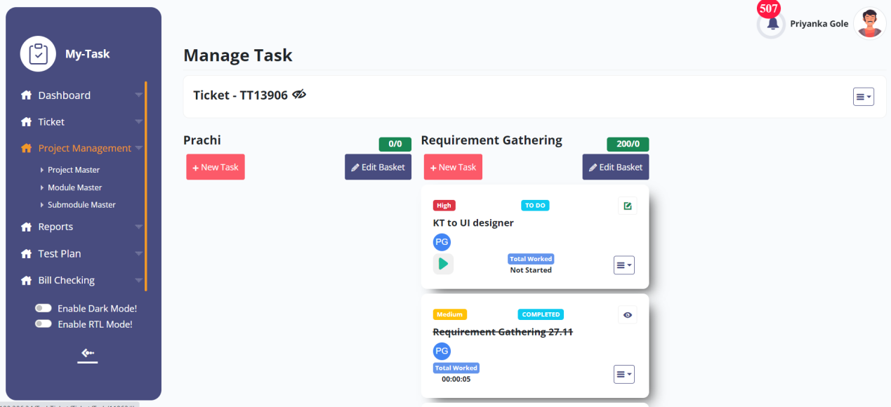

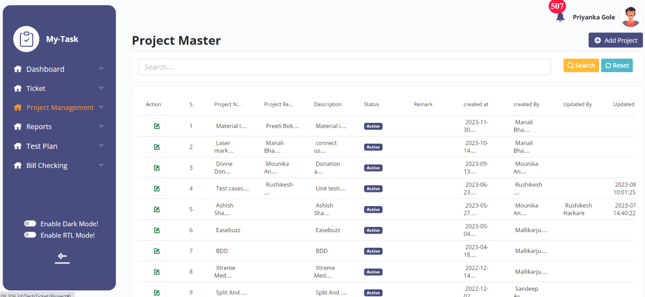

1. **PROPOSED SYSTEM**

BR001: Create a menu to upload/view/ download

We have to create a new module for uploading documents against project under project management.

Main menu -- Project wise documentation

On click of the menu new screen will get open showing project master, module master.

BR002& BR003: Upload document against project.

In case duplicate document uploaded then previous document will get replace.

**Input table**

|  |  |  |  |
| --- | --- | --- | --- |
| **FIELDS** | **INPUT TYPE** | **MANDATORY/ OPTIONAL** | **DESCRIPTION** |
| Project Name | drop-down | Mandatory | To upload the document against a module, we have to select project first  Validation: Fetch data from project master. |
| Module Name | Dependent Drop Down | Mandatory | On basis of project, display modules to upload the projects  Validation: Fetch data from module master. |
| Upload attachment | Browse | Optional | Upload any type of document like  .doc, .docx, .pdf, .pptx, .png, .jpeg, .mp4  Validation: max size of uploading will be 100MB for each document. |
| Is show to all | Check box | Optional | Some of the documents may be confidential so, every attachment should not be visible to all users. Show a check box as ‘Is show to all’.  It is non editable field.  If the field value is ‘NO’ then it will be visible to only project owner and project reviewer.  If the field value is ‘YES’ then it will visible to all users who are logged in and who has menu.  Validation: Default value is ‘YES’. |
| Submit | Button | - | On click of the submit button attachments w  ill get upload on server against a project and module. |

BR004: View documentations

This functionality introduces, View functionality of the document attached against project/module.

**Input table**

|  |  |  |  |
| --- | --- | --- | --- |
| **FIELDS** | **INPUT TYPE** | **MANDATORY/ OPTIONAL** | **DESCRIPTION** |
| view | Button | Optional | To view the document,click on the view button  And view documents on same screen. |

BR005: download documentations

This functionality introduces, download functionality of the document attached against project/module.

**Input table**

|  |  |  |  |
| --- | --- | --- | --- |
| **FIELDS** | **INPUT TYPE** | **MANDATORY/ OPTIONAL** | **DESCRIPTION** |
| Download | Button | Optional | To download the document of a module, click on the download  And get documents on computer system.  If the ‘is show to all’ is yes,then this functionality will be available to all.  otherwise project owner and project reviewer only can download the document. |
| Download all | Button | - | Give a provision to download all document at a time in extraction format. |

BR006: Authority Based delete permission.

**Input table**

|  |  |  |  |
| --- | --- | --- | --- |
| **FIELDS** | **INPUT TYPE** | **MANDATORY/ OPTIONAL** | **DESCRIPTION** |
| Delete | Button | Optional | To delete the document of a module, click on the delete  And delete documents.  Users having delete permission, can delete the attachment. It will be the special auth in special auth master. |
| Bulk delete | Button | Optional | Using multiple delete selection, user can delete multiple attachment at one shot. |

1. **TEST DATA**

Multiple examples can be mentioned in sheet. Provide multiple scenarios for each field in the module. Input value and expected output value should be specified. Live examples in existing or alternative system should be provided if possible.



1. **ODUS ( Open Discussed Unhanded scenarios )**

ODUS sheet will contain questions raised by team which needs to be confirmed from user, points to be discussed with user, confirmation of points which isn’t given from user yet.

|  |  |  |  |  |
| --- | --- | --- | --- | --- |
| **Sr. No.** | **Topic** | **Priority**  **(High / medium / low)** | **Remark** | **Status**  **(Open/**  **Closed)** |
| 1 | Date : Query and its description |  | Write solution which is decided by user or head or us. | Open for queries which are recently asked and which are pending. |
| 2 |  |  |  |  |
| 3 |  |  |  |  |
|  |  |  |  |  |
|  |  |  |  |  |

1. **REFERENCES OF THE USERS**

|  |  |  |  |
| --- | --- | --- | --- |
| **User** | **Name** | **Mail** | **Contact number** |
| **Actual user** |  |  |  |
| **Ticket created by (if any)** |  |  |  |
| **Assigned business analyst** |  |  |  |
| **Assigned developer** |  |  |  |
| **Assigned tester** |  |  |  |