Priyanka Gole

Priyanka.gole@techneai.com

[Documentation Module ]

19.08.2024

**Functional Requirement Document**

**CONTENTS**

1. TICKET DETAILS 2

2. VERSION CONTROL 2

3. APPROVALS 2

4. ESTIMATION 2

5. INTRODUCTION 3

6. BUSINESS REQUIREMENT 3

7. SCOPE 3

8. BUSINESS & SYSTEM RULES 3

9. ABBREVIATIONS & TERMS 3

10. EXISTING SYSTEM 3

11. GRAPHICAL REPRESENTATION 3

12. PROPOSED SYSTEM 3

13. TEST DATA 4

14. ODUS 4

15. REFERENCES OF THE USERS 5

1. **TICKET DETAILS**

|  |  |
| --- | --- |
| **Ticket ID** | TT24427 |
| **Ticket description** | Make a provision to upload project wise Documents |
| **Created by** | Priyanka Gole |
| **Created on** | 19/08/2024 |
| **Priority** | Medium |

1. **VERSION CONTROL**

|  |  |  |  |  |
| --- | --- | --- | --- | --- |
| **Sr. No** | **Version no** | **Version Date** | **User name** | **User department** |
| **1** | **1** | **19-08-2024** | **Priyanka Gole** | **Business Analyst** |
|  |  |  |  |  |
|  |  |  |  |  |

1. **APPROVALS**

|  |  |  |
| --- | --- | --- |
| **Field** | **Name of the User** | **Approved date by the user** |
| **Actual User Name Actual User Department Organization Name** | Priyanka Gole |  |
| **Assigned BA** | Priyanka Gole |  |
| **Assigned Developer** |  |  |
| **Assigned Tester** |  |  |

1. **ESTIMATION**

|  |  |  |  |  |
| --- | --- | --- | --- | --- |
| **Department name** | **Estimated Time (In hr)** | **Scheduled Date (Starting date)** | **Estimated date** | **Actual delivery date** |
| **BA** |  |  |  |  |
| **Development** |  |  |  |  |
| **Testing** |  |  |  |  |

1. **INTRODUCTION**

Usually many documentations, attachments are created by BA team or any other teams against a ticket. These documents are used for multiple purpose. Like, query solution or doubt clearance.

Example, project has been developed with proper requirement document, FRD documentation, test case documentation or any other type of attachments. And kept all documents on mail

We have to make a provision to store all types of documents against project at single location. So it would be easy for searching, if any type of document requires at any time.

1. **BUSINESS REQUIREMENT**

|  |  |  |  |
| --- | --- | --- | --- |
| **Requirement ID** | **Requirement Name** | **Short Description** | **Priority** |
| BR001 | Require Icon on the consolidated view to upload project wise Attachment. | Create a Icon on consolidated view to upload / view / download project wise module wise documents. | High |
| BR002 | Upload document against project. | On select of the icon, make a provision to upload project wise documents. If no module, sub module selected then attachment will be for project. | High |
| BR003 | Provision to upload Sub module wise document | Make a provision to upload sub module wise documents. | Medium |
| BR004 | Active records History button should show document name, uploaded by, uploaded at date time. | Active records History button should show document name, uploaded by, uploaded at date time. | Medium |
| BR005 | Deactive records History button should show document name, uploaded by, uploaded at date time, deleted by, deleted at date time | Deactive records History button should show document name, uploaded by, uploaded at date time, deleted by, deleted at date time. | High |
| BR006 | Remove filter note (3) as system showing all documents/attachments | On the upload document page, 3 messages are appeared. Remove third one. It is related to filter. | High |

1. **SCOPE**

The scope of this project is to upload any type of document against a project and view or download it whenever require. And to maintain the history for delete and upload the document

1. **BUSINESS & SYSTEM RULES**

* User should be registered in the system.
* User should be logged in with proper credentials.
* Unauthorized user will not be able to download or view the document.
* System should display error message for incorrect details if entered.
* System should pop up a message, if any issues in the system is detected.
* All forms should have on field validations. System should display on field errors in case of incorrect inputs.

1. **ABBREVIATIONS & TERMS**

Upload: attach a document or any attachment from computer system against a project.

Download: Get a document or any attachment from project to a computer system.

1. **EXISTING SYSTEM**

Users keep documentations like FRD document, test case document, Handover document or any types of document on the mail. Some times user keep it on own workspace/ laptop. Its quite difficult to search a mail or storage location for requirement document at the moment. To overcome this, we are developing a new system.

1. **GRAPHICAL REPRESENTATION**

Click on icon to open documentation module

Select project

Select consolidated View menu

Upload module, sub module wise document.

Upload project wise document

View History

Delete Document

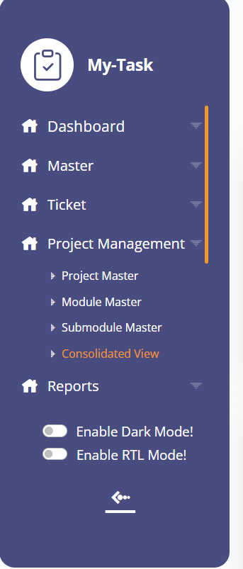

Following is the view of projects and modules under consolidated view menu.

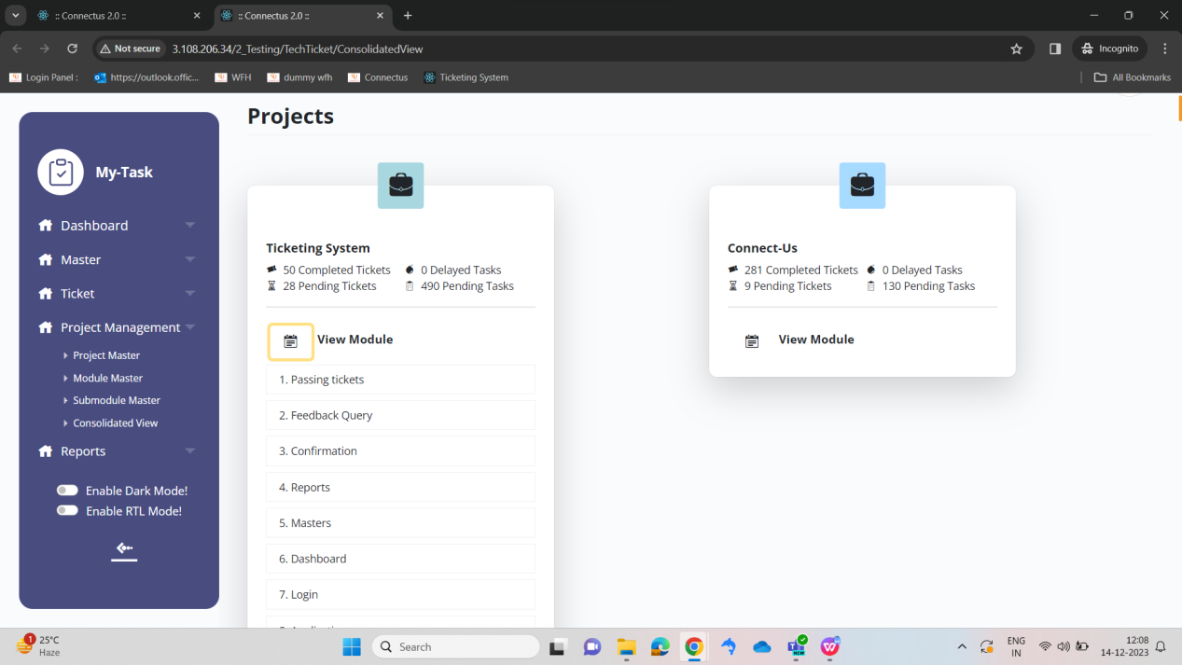

1. **PROPOSED SYSTEM**

BR001: Require Icon on the consolidated view to upload project wise.

On the consolidated view, near to project name add a icon to upload project wise document. Currently we can upload document module wise only on selection of project.

On click of the icon, existing screen will get open to upload.

BR002: Provision to upload document against project.

On select of the icon, make a provision to upload project wise documents. Make module and sub disable as project wise documents uploaded. If no module, sub module selected then attachment will be for project.

**Input table**

|  |  |  |  |
| --- | --- | --- | --- |
| **FIELDS** | **INPUT TYPE** | **MANDATORY/ OPTIONAL** | **DESCRIPTION** |
| Add file | Button | - | On click of the upload document icon Upload any type of document against project.  Types of documents like  .doc, .docx, .pdf, .pptx, .png, .jpeg, .mp4  Any user can upload documents/ attachments.  Validation: max size of uploading will be 200MB for each document. |
| Is show to all | Check box | Optional | Some of the documents may be confidential so, every attachment should not be visible to all users. Show a check box as ‘Is show to all’. This setting will  It is non editable field.  If the field value is ‘NO’ then it will be visible to only project owner and project reviewer and specific user also.  If the field value is ‘YES’ then it will visible to all users who are logged in and who has menu.  Validation: Default value is ‘YES’. |
| Submit | Button | - | On click of the submit button attachments will get upload on server against a project. |

BR003: Provision to upload Sub module wise document View documentations

This functionality introduces, upload sub module wise documents against a project.

Is show to all check box is selected by default while uploading the document. If checked then it will be visible to all users. If not then document will be visible only for project owner. Deleted document will be visible under deactivate filter.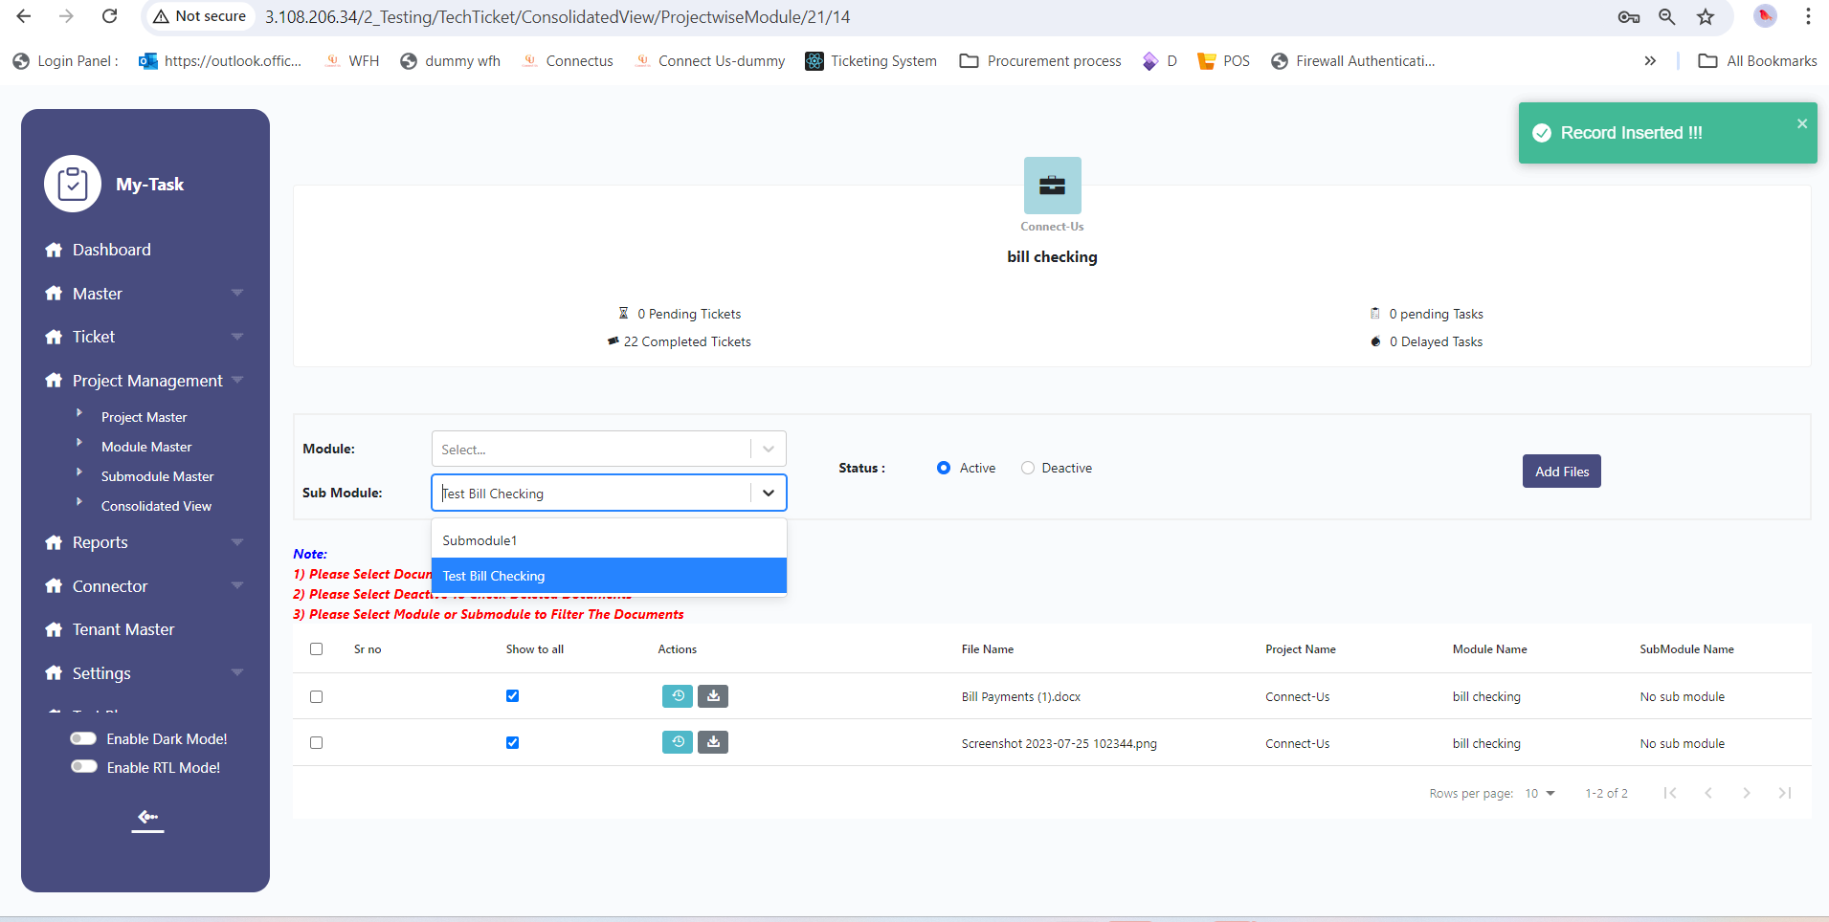

BR004: Active records History button should show document name, uploaded by, uploaded at date time

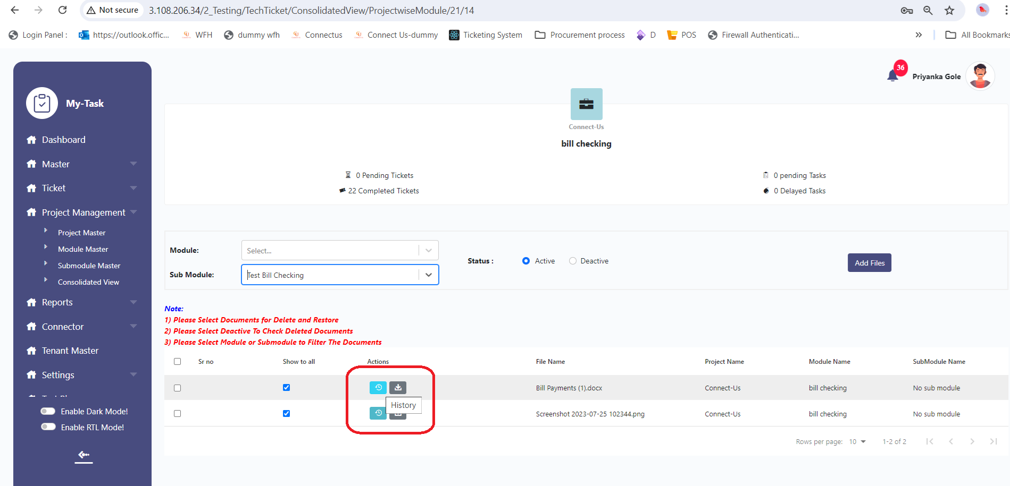

|  |  |  |  |
| --- | --- | --- | --- |
| **FIELDS** | **INPUT TYPE** | **MANDATORY/ OPTIONAL** | **DESCRIPTION** |
| Document name | Label | Mandatory | It will show name of the document/image |
| Uploaded by | Label | Mandatory | It will show user name of document uploader. |
| Uploaded at | Label | Mandatory | It will show date and time of document upload/attached |
| Hostname | Label | Mandatory | It will show host name from document is uploaded. |
| Status | Label | Mandatory | It will show status of the document if it is active or deactive. If document is deleted it is deactive. |

BR005: Deactive records History button should show document name, uploaded by, uploaded at date time, deleted by , deleted at date time

|  |  |  |  |
| --- | --- | --- | --- |
| **FIELDS** | **INPUT TYPE** | **MANDATORY/ OPTIONAL** | **DESCRIPTION** |
| Document name | Label | Mandatory | It will show name of the document/image |
| Uploaded by | Label | Mandatory | It will show user name of document uploader. |
| Uploaded at | Label | Mandatory | It will show date and time of document upload/attached |
| Hostname | Label | Mandatory | It will show host name from document is uploaded. |
| Deleted by |  |  | It will show name of user who has deleted document/attachment. |
| Deleted at |  |  | It will show date and time of deleted document/attachment. |
| Status | Label | Mandatory | It will show status of the document if it is active or deactive. If document is deleted it is deactive. |

BR005: download documentations - Existing

This functionality introduces, download functionality of the document attached against project/module.

**Input table**

|  |  |  |  |
| --- | --- | --- | --- |
| **FIELDS** | **INPUT TYPE** | **MANDATORY/ OPTIONAL** | **DESCRIPTION** |
| Download | Button | Optional | To download the document of a module, click on the download  And get documents on computer system.  If the ‘is show to all’ is yes,then this functionality will be available to all.  otherwise project owner and project reviewer and specific user only can download the document. |
| Download all | Button | - | Give a provision to download all document at a time in compressed format. Above settings are applicable to this field also. |

BR006: Authority Based delete permission. - Existing

Under general setting, delete document is the setting to user wise delete functionality.

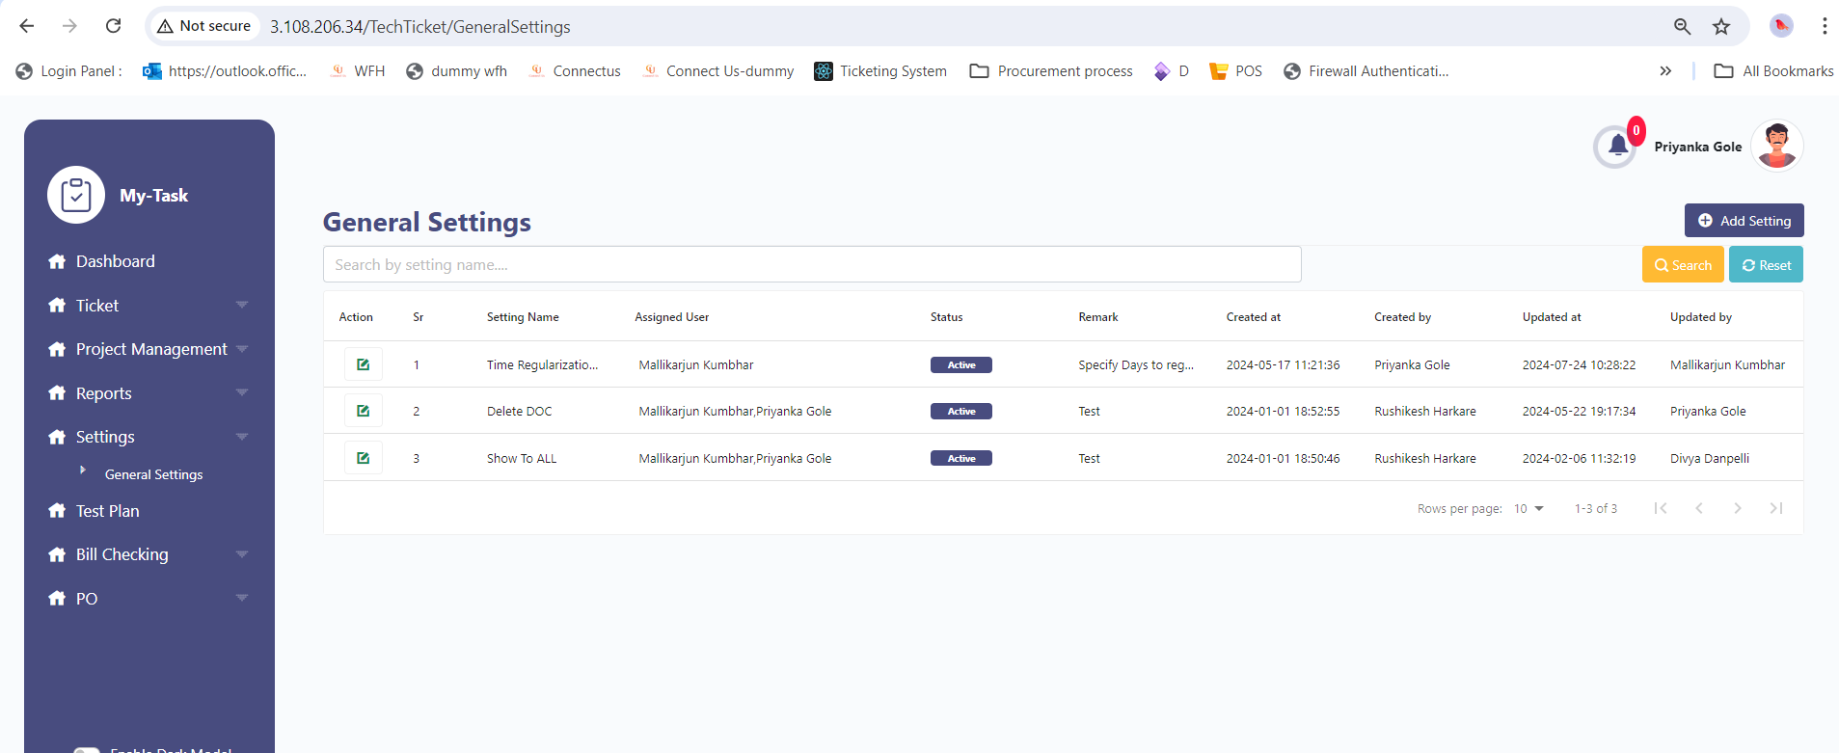

**Input table**

|  |  |  |  |
| --- | --- | --- | --- |
| **FIELDS** | **INPUT TYPE** | **MANDATORY/ OPTIONAL** | **DESCRIPTION** |
| Delete | Button | Optional | To delete the document of a module, click on the delete  And delete documents.  Users having delete permission, can delete the attachment. It will be the special auth in special auth master. |
| Bulk delete | Button | Optional | Using multiple delete selection, user can delete multiple attachment at one shot. |

1. **TEST DATA**

Multiple examples can be mentioned in sheet. Provide multiple scenarios for each field in the module. Input value and expected output value should be specified. Live examples in existing or alternative system should be provided if possible.



1. **ODUS ( Open Discussed Unhanded scenarios )**

ODUS sheet will contain questions raised by team which needs to be confirmed from user, points to be discussed with user, confirmation of points which isn’t given from user yet.

|  |  |  |  |  |
| --- | --- | --- | --- | --- |
| **Sr. No.** | **Topic** | **Priority**  **(High / medium / low)** | **Remark** | **Status**  **(Open/**  **Closed)** |
| 1 | Date : Query and its description |  | Write solution which is decided by user or head or us. | Open for queries which are recently asked and which are pending. |
| 2 |  |  |  |  |
| 3 |  |  |  |  |
|  |  |  |  |  |
|  |  |  |  |  |

1. **REFERENCES OF THE USERS**

|  |  |  |  |
| --- | --- | --- | --- |
| **User** | **Name** | **Mail** | **Contact number** |
| **Actual user** |  |  |  |
| **Ticket created by (if any)** |  |  |  |
| **Assigned business analyst** |  |  |  |
| **Assigned developer** |  |  |  |
| **Assigned tester** |  |  |  |