26.04.2023

HRMS - Attendance and Leave System

Sanika Dewoolkar  
sanika.dewoolkar@techneai.com

**Functional Requirement Document**

**CONTENTS**

1. TICKET DETAILS 2

2. VERSION CONTROL 2

3. APPROVALS 2

4. ESTIMATION 2

5. INTRODUCTION 3

6. BUSINESS REQUIREMENT 3

7. SCOPE 3

8. BUSINESS & SYSTEM RULES 3

9. ABBREVIATIONS & TERMS 3

10. EXISTING SYSTEM 3

11. GRAPHICAL REPRESENTATION 3

12. PROPOSED SYSTEM 3

13. TEST DATA 4

14. ODUS 4

15. REFERENCES OF THE USERS 5

1. **TICKET DETAILS**

|  |  |
| --- | --- |
| **Ticket ID** | TT15986 |
| **Ticket description** | HRMS on 2.0 |
| **Created by** | Sanika Dewoolkar |
| **Created on** | 1/12/2023 |
| **Priority** | High |

1. **VERSION CONTROL**

|  |  |  |  |  |
| --- | --- | --- | --- | --- |
| **Sr. No** | **Version no** | **Version Date** | **User name** | **User department** |
| **1** | **1.0** | **1/12/2023** | **Pritam Shah** | **IT** |
|  |  |  |  |  |
|  |  |  |  |  |

1. **APPROVALS**

|  |  |  |
| --- | --- | --- |
| **Field** | **Name of the User** | **Approved date by the user** |
| **Actual User Name Actual User Department Organization Name** |  |  |
| **Assigned BA** |  |  |
| **Assigned Developer** |  |  |
| **Assigned Tester** |  |  |

1. **ESTIMATION**

|  |  |  |  |  |
| --- | --- | --- | --- | --- |
| **Department name** | **Estimated Time (In hr)** | **Scheduled Date (Starting date)** | **Estimated date** | **Actual delivery date** |
| **BA** |  |  |  |  |
| **Development** |  |  |  |  |
| **Testing** |  |  |  |  |
|  |  |  |  |  |

1. **INTRODUCTION**

An HRMS, or human resources management system, is a suite of software applications used to manage human resources and related processes throughout the employee life cycle. An HRMS enables a company to fully understand its workforce while staying compliant with changing tax laws and labor regulations.

Attendance and Leave management system is designed to assist human resources to track employees' working hours in an organization. It also enables HR managers to manage daily workforce tasks and record attendance for working and non-working employees.

The primary purpose of an employee attendance management system is to handle leave requests impartially and ensure that an employee's absence from work does not affect the day-to-day functioning of a company. The system automates the recording process to ease the complexities of employee attendance tracking. Using it can decrease payroll errors, ensure legal compliance and prevent accidental resource crunches.

It is possible to pre-schedule leaves, such as vacations and paid holidays, for at least a month so they do not impact an organisation's functioning. A robust leave management system can simplify the entire process and ensure its smooth operation.

1. **BUSINESS REQUIREMENT**

Enter details of the ticket requirement.

|  |  |  |  |
| --- | --- | --- | --- |
| **Requirement ID** | **Requirement Name** | **Short Description** | **Priority** |
| BR001 |  |  | High |
| BR002 |  |  | High |

1. **SCOPE**
2. **BUSINESS & SYSTEM RULES**

* User should be registered in the system.
* User should be logged in.
* If a task is played and then its paused it should reflect in the pending task and if the same task is played it should not be visible in the pending task and should be sent to working task .
* If a task is completed it should reflect in the Completed task .
* If a task is played but

1. **ABBREVIATIONS & TERMS**

HRMS - Human Resource Management System

1. **EXISTING SYSTEM**

There is no such existing project in the connect us 2.0

1. **GRAPHICAL REPRESENTATION**
2. **PROPOSED SYSTEM**

Attendance and Leave management system will include below menus:

* Dashboard
* Punch In/Out
* Regularization
* Leave system
* Shift Roaster
* Leave auto approval
* Substitute Leave request
  1. **Dashboard :**

Once user logs into the attendance and leave module, it should enable user to apply leave, punch in/ out, apply for regularization, check and add events in the calender, reject/approve leave and regularization requests on the dashboard.

* **FILTERS FOR AUTHORIZED USERS TO VIEW DATA:**

Authorized users should be able to view employee data by below filters:

* Select Option
* Designation
* Employee name

|  |  |  |  |
| --- | --- | --- | --- |
| **FIELDS** | **INPUT TYPE** | **MANDATORY/ OPTIONAL** | **DESCRIPTION** |
| Select Option | Drop down | - | Once the admin/authorized user logins, user should be able to select which data is to be displayed. The drop down will contain all departments and ‘self’ field.  Post Condition:   1. Once the admin selects departments, details of that department should be displayed. 2. On selecting ‘self’ field, self details of admin should be displayed.   This field should be only visible to admin. |
| Designation | Dropdown |  | Pre Condition:   1. If the admin selects the option as Self, this field should not be visible.   This field is to view attendance and leave data designation wise.  The fields in this drop down will be fetched from designation master.  This field should be only visible to admin. |
| Select employee | Drop down |  | Pre Condition:   1. If the admin selects the option as Self, this field should not be visible.   This field is to view attendance and leave data employee wise.  The fields in this drop down will be fetched from employee master.  This field should be only visible to admin. |

Fig:

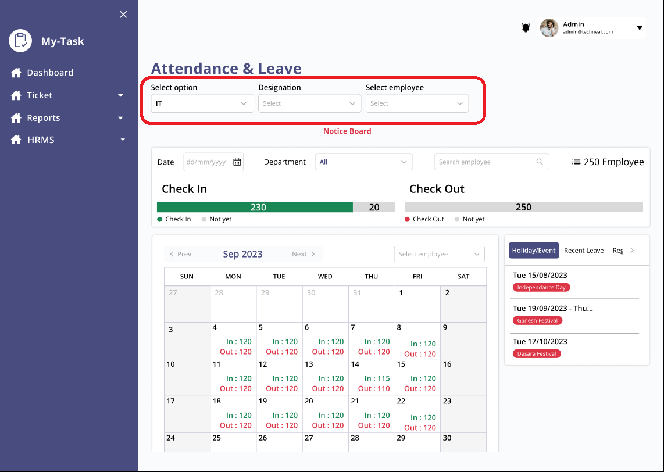

* **CHECK IN - CHECK OUT DETAILS :**

Admin should be able to view check In and check out data of employees.

The below fields will be included in the interface:

Note: The below fields should only be visible to admin.

* Date
* Department
* Search Employee
* Total employee count
* Graphical representation of checked in and checked out employees

|  |  |  |  |
| --- | --- | --- | --- |
| **FIELDS** | **INPUT TYPE** | **MANDATORY/ OPTIONAL** | **DESCRIPTION** |
| Date | Calender |  | Admin should be able to filter the checked in and checked out number of employees by date  Once the admin selects date, graphical representation of checked in and checked out employees should be displayed. |
| Department | Drop down |  | Admin should be able to filter the checked in and checked out number of employees by department.  .  Once the admin selects department, graphical representation of checked in and checked out employees should be displayed. |
| Search Employee | Text |  | Admin should be able to search employee to fetch the calender view and events date wise. |
| Total employee count | Click |  | By clicking on this field, admin can view checked in time and check out time of employees. The data can be filtered/searched by employee name, department as well.  The pop up screen will have below fields:   * Search * Department dropdown * Department drop down * Checked in employee list * Check out employee list.   User should be able to filter data by click department drop down and search. |
| Notice Board | Text |  | To display notice events, announcement, deadlines etc. |

Fig :

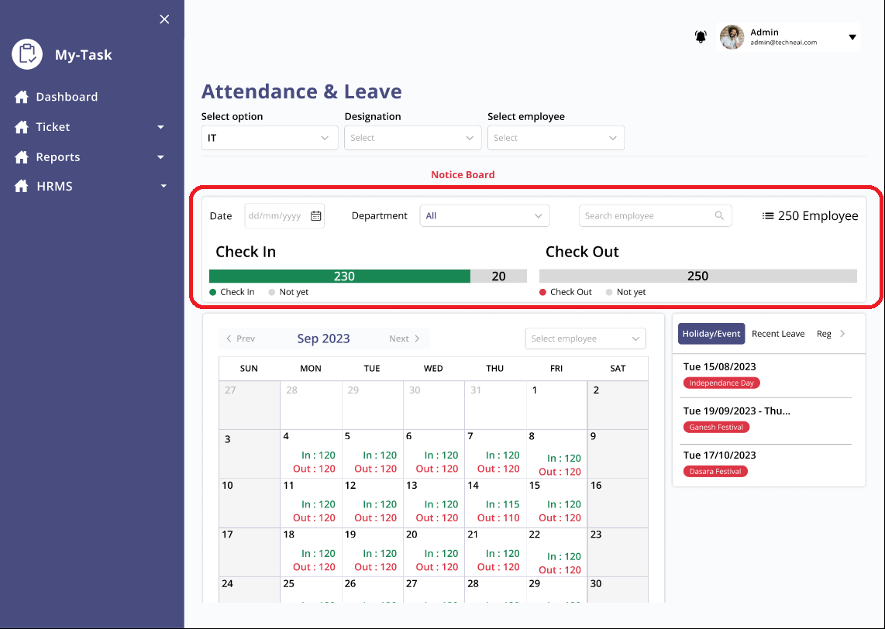

* **ATTENDANCE SYSTEM:**
* Search Employee -

Admin should be able to search employee to view the attendance and leave details of that employee.

Once the admin searches employee, below employee details should be displayed:

* Present days
* Absent days
* Paid half day
* Paid leave
* Extra working day
* Half day
* Late mark
* Total

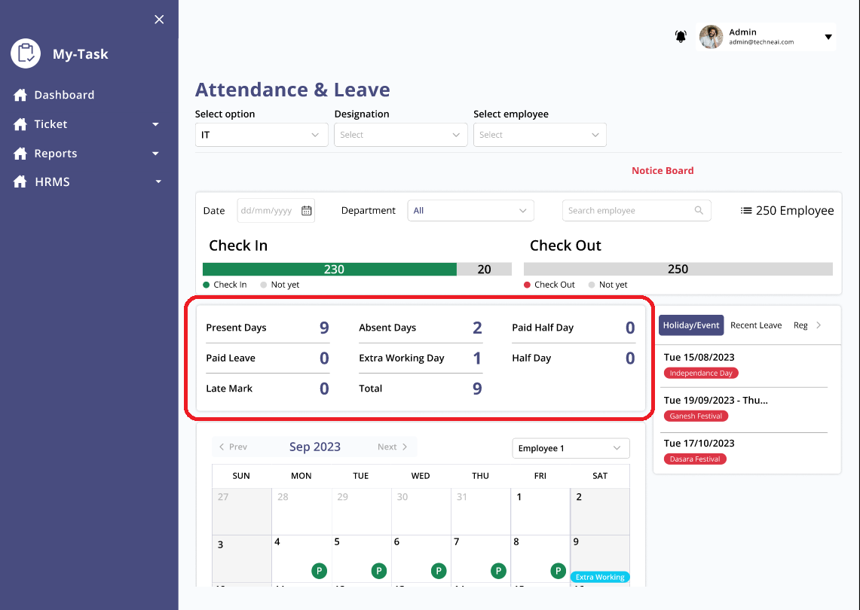

**REGULARIZATION:**

To record, manage/correct the attendance record of entry user.

Once the user clicks on Regularization, a pop with below fields will be displayed.

|  |  |  |  |
| --- | --- | --- | --- |
| FIELDS | INPUT TYPE | MANDATORY/OPTIONAL | DESCRIPTION |
| From date | Calender | Mandatory | To select from date which user wants to regularize. |
| To date | Calender | Mandatory | To select to date which user wants to regularize |
| From time | Text | Mandatory | To select time which user wants to regularize |
| To time | Text | Mandatory | To select time which user wants to regularize |
| Remark | Text | Optional | To add remarks if any. |
| Submit | Button | - | To submit the regularization request. |
| Add | Button | - | To add more records.  Post Condition:  Once the user clicks on the Add button, user should be able to add more records, by staying on the same pop up screen. |

Fig :

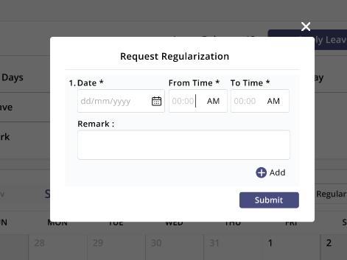

User can check the regularization updates and history in regularization tab.

Once the user regularizes the attendance, the authorized user will receive the request in the regularization tab beside the recent leaves.

It will display below fields in card format, authorized user can view these details by clicking on the card as well:

1. Employee name
2. Remark
3. Date
4. From time
5. To time
6. Approve button
7. Reject button
8. Regularization status :

It will display if the request is pending, approved or rejected.

**TODAY’S SCHEDULE:**

* Users should be able to view their present day’s schedule.
* Users should be able to search further schedules as well
* User should be able to view schedule in below format
  + Title - Title of event should be displayed
  + Time - Time of event should be displayed

**UPDATES:**

* Users can check updates regarding, holidays/events, recent leaves, regularization here.
* Authorized user should be able to approve/reject regularization request from regularization tab.

|  |  |
| --- | --- |
| FIELDS | DESCRIPTION |
| Holiday/Event | Upcoming holiday/event should be displayed.  The below fields should be displayed:   1. Event/holiday name 2. Date 3. Day |
| Recent leave | To check the recent leaves of employees.  Initially, it will display drop down of select employees.  Once the admin selects employee,  Recent leaves of employee for **last 30 days** should be displayed with below details in a card view:   1. Date 2. Day 3. Reason of leave   Once the admin clicks on the card, new pop up with below fields should be displayed:   1. Leave type 2. No of days 3. From date 4. To date 5. Substitute 6. Approver 7. Reason 8. Ok button - Once the user clicks on this button, pop should be closed. |
| Approve | Admin>>Regularization  To approve the regularization request.  Post Condition:   1. Once the admin clicks on approve, new pop up with confirmation message is displayed. If the admin clicks on ‘Yes’ , a success message will be displayed.      1. Employee should be able to view the status of leaves in the recent leaves tab. 2. Status of request should be changed from pending to approved |
| Reject | Admin>>Regularization  To reject the regularization request.  Post Condition:   1. Once the admin clicks on reject, new pop with confirmation message is displayed. If the admin clicks on ‘Yes’ , a success message will be displayed. 2. Employee will receive notification regarding the rejection of regularization request 3. Status of request should be changed from pending to rejected. |
| Approve all | Admin>> Regularization  This field is to approve all the requests at a single click.  Post Condition:  Once the admin clicks on the approve all button, new pop with below fields should be displayed with below fields:   1. Employee name 2. From date 3. To date 4. From time 5. To time 6. YES 7. No     Once the admin clicks on yes, success message should be displayed and all the requests should be approved. |
| Reject all | Admin>> Regularization  This field is to reject all the requests at a single click.  Post Condition:  Once the admin clicks on the reject all button, new pop with below fields should be displayed with below fields:   1. Employee name 2. From date 3. To date 4. From time 5. To time 6. YES 7. No   Once the admin clicks on yes, success message should be displayed and all the requests should be rejected. |

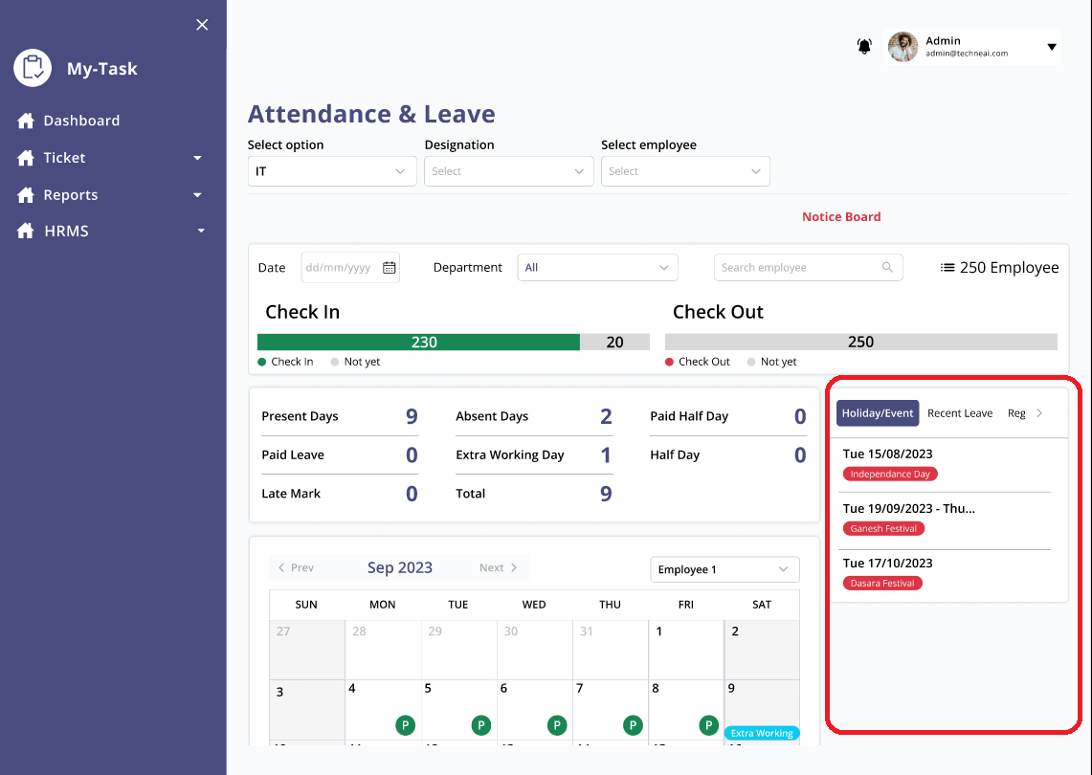

**LEAVE SYSTEM:**

Users should be able to apply leaves.

This interface should include below fields:

* Present days
* Absent days
* Paid half day
* Paid leaves
* Extra working day
* Half day
* Late mark
* Total
* Apply leave button - The field in apply leave form are described in the below table

|  |  |  |  |
| --- | --- | --- | --- |
| **FIELDS** | **INPUT TYPE** | **MANDATORY/ OPTIONAL** | **DESCRIPTION** |
| Apply Leave | Button |  | User should be able to apply leave.  The apply leave interface should include below fields:   1. Leave type 2. Days 3. From date 4. To date 5. Substitutes 6. Approves |
| Leave type | Drop down | Mandatory | To select the leave type. It will be fetched from leave type master. |
| Days | Text |  | User should be able to select number of days  Validation: It should only accept numbers. |
| From date | Calender |  | To select date from which leave is to be applied |
| To date | calender |  | To select date from which leave is to be ended |
| Substitutes | Drop down |  | To add substitute resource on leave days.  Employee list from that department should be displayed. |
| Approves | Drop down |  | List of leave approves’  should be displayed.  Note :   * If the leave request of employee gets rejected, employee should be able to reapply for leave by selecting the approve 2 and so on. |
| Reason | Text |  | User should be able to input reason of leave. |
| Attach file | File |  | To support the documents for leave request. |
| Submit | Button |  | To submit the leave request.  Post Condition:   * Once the user submits the leave request, it should be sent to the approve’s recent leaves tab * Once the user submits the form, user should be redirected to the home page. |
| Leaves from your department | - |  | Leave of other employees from the user’s department should be displayed. |

**Fig : Apply Leave**

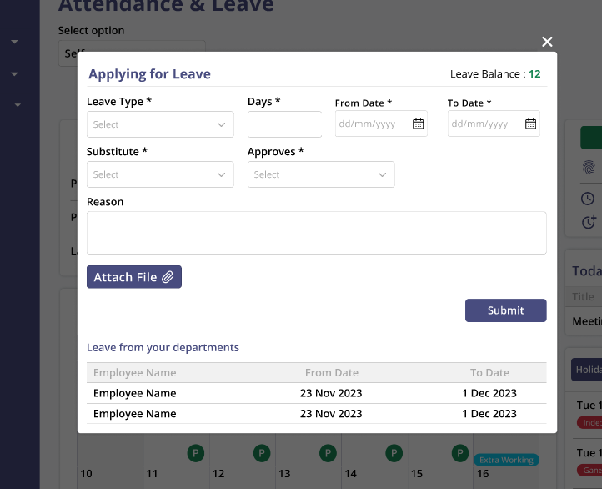

**PUNCH IN/OUT :**

User should be able to view below details on dashboard:

* Punch IN/Out button
* Punch in/out time
* Break time
* Overtime

|  |  |  |  |
| --- | --- | --- | --- |
| FIELDS | INPUT TYPE | MANDATORY/OPTIONAL | DESCRIPTION |
| Punch In/Out button | Button | - | Once the user clicks on the button, a new screen with detailed punch in/out details should be displayed. |
| Punch in/out | - | - | Punch in/out time should be displayed. |
| Break | - | - | Break time should be displayed. |
| Overtime | - | - | Overtime time by user should be displayed |

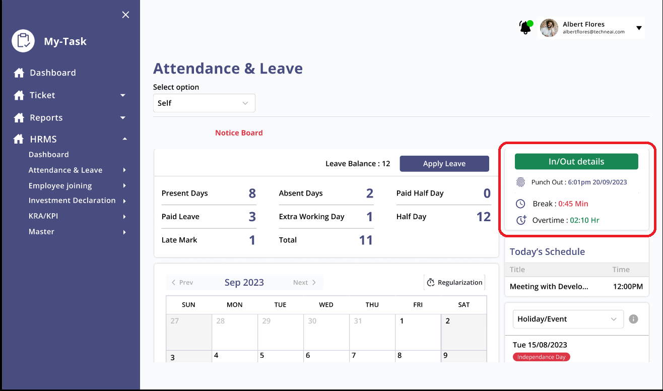

Image : Dashboard view of Punch in/out details

**MONTH WISE CALENDER:**

Month wise calender is displayed on the home page.

Below details should be displayed on the dates :

1. Late marks
2. Late in
3. Early out
4. Pending leave
5. Approved leave
6. Rejected leave
7. Extra working
8. Event/Holiday

User can add event to particular date by clicking on the date in calender .

Once the user clicks on date, a new pop will be displayed to add event to that date, below fields should be included in the pop up interface:

* Select event
* From date
* To date
* Description
* Display on notice board
  + Yes
  + No
* Display as
* Selected date
  + Edit button
* Add required attendees
* Add optional attendees
* Meeting link
* Location
* From time
* To time
* Save
* Cancel

|  |  |  |  |
| --- | --- | --- | --- |
| **FIELDS** | **INPUT TYPE** | **MANDATORY/ OPTIONAL** | **DESCRIPTION** |
| Select Event | Drop down | Mandatory | To add event on that day. |
| From date | calender | Mandatory | To add event start date. |
| To date | calender | Mandatory | To add event end date |
| Description | text | Optional | To add description if any. |
| Display on notice board   * Yes * No | Checkbox |  | User should be able to select if the event has to be displayed on the notice board or not.   * If the user selects as yes, the event should be displayed on the notice board from date - to date. |
| Display as | Text |  | User should be able to add text to be displayed on notice board for that event.  Precondition: This field will be displayed only if the user chooses to display the event on notice board. |
| Selected date | Button |  | Selected date should be displayed with an edit option. User should be able to edit the date. |
| Add required attendees | Drop down | Mandatory | Precondition: This field should be displayed only if the user selects event as meeting.  Field in the drop down should be fetched from the employee master. |
| Add optional attendees | Dropdown | Optional | Precondition: This field should be displayed only if the user selects event as meeting.  Fields should be fetched from the employee master.  Employee name selected in the required attendees should be disabled. |
| Meeting link | Link | Mandatory | Precondition: This field should be displayed only if the user selects event as meeting.  User should be able to insert the meeting link. |
| Location |  |  | Precondition: This field should be displayed only if the user selects event as meeting. |
| From time | Calender |  | Precondition: This field should be displayed only if the user selects event as meeting  To select the meeting start time. |
| To time | Calender |  | Precondition: This field should be displayed only if the user selects event as meeting  To select the meeting end time. |
| Save | Button |  | To save the record. Once the user clicks on the button, user should be redirected to the homepage. |
| Cancel | Button |  | To cancel the record. Once the user clicks on the button, user should be redirected to the homepage. |

Fig :

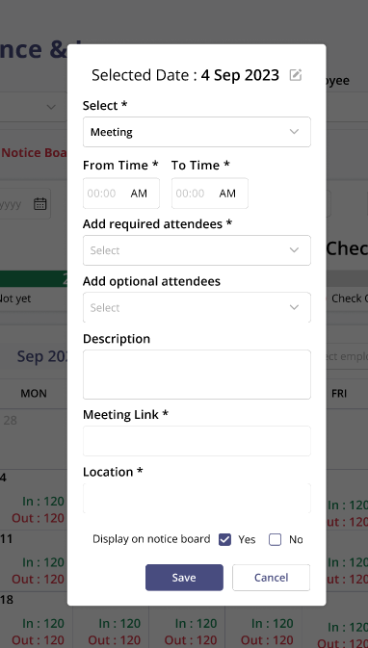

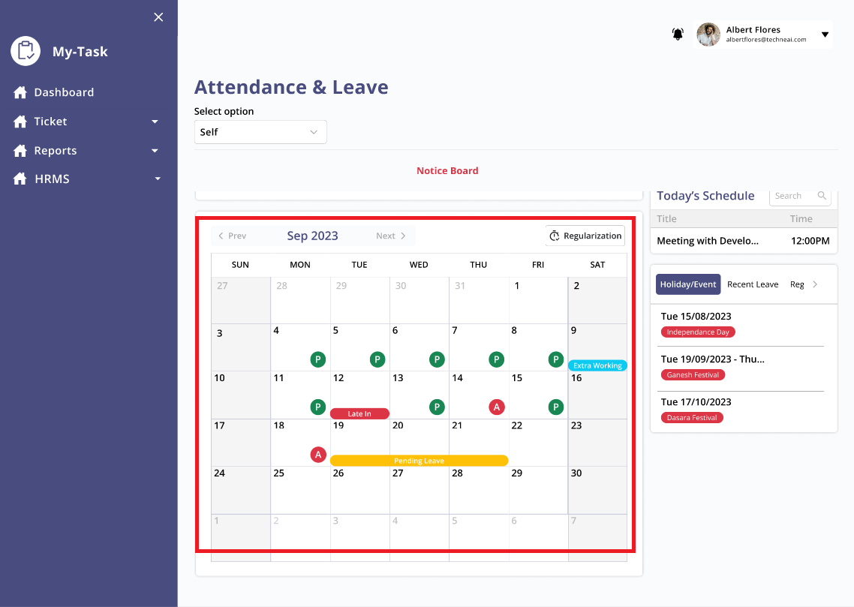

* 1. **Punch In/Out**

Detailed view of Punch in/out details:

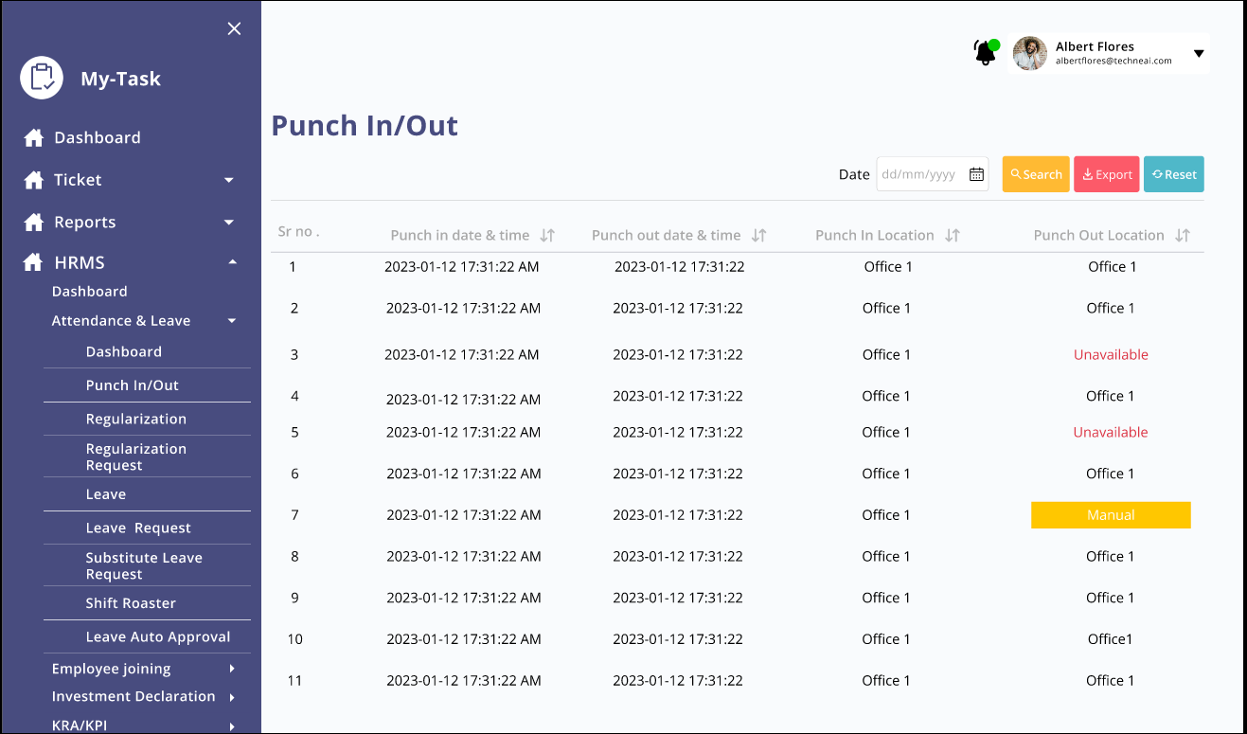

* 1. **REGULARIZATION:**
* User should be able to apply for regularization through this menu.
* User should be able to view the status of regularization request
* User should be able to edit the regularization request.

Below fields will be in the interface of regularization:

* Regularization
* From date
* To date
* From time
* To time
* Add
* Submit
* Remark
* Action
* Approver
* Created at
* Created by

|  |  |  |  |
| --- | --- | --- | --- |
| FIELDS | INPUT TYPE | MANDATORY/OPTIONAL | DESCRIPTION |
| Regularization | Button | - | User should be able to add regularization request through this button, once the user clicks on this button, a new pop up should be opened. |
| From date | Date |  |  |
| To date | date |  |  |
| From time | Time |  |  |
| To time | time |  |  |
| Add | Button |  |  |
| Submit | Button |  |  |
| Remark | Text |  |  |
| Action | Button |  |  |
| Approver | - |  |  |
| Created at | - |  |  |
| Created by | - |  |  |

* 1. **REGULARIZATION REQUEST**
  2. **LEAVE SYSTEM**
  3. **LEAVE REQUEST**
  4. **SUBSITUTE LEAVE REQUEST**
  5. **LEAVE AUTO APPROVAL**

**MASTERS:**

Attendance and leave system will have dependency of below master:

* Leave master
* Event master
* Event template
* Shift Master
* **LEAVE MASTER:**

The leave master is designed to add leave type in the system.

The masters will have below fields:

* Sr No
* Add leave type
* Search
* Remark
* Save
* Cancel
* Update
* Export
* Reset
* Created by
* Created at
* Updated at
* Updated by
* Leave type
* Action

|  |  |  |  |
| --- | --- | --- | --- |
| FIELDS | INPUT TYPE | MANDATORY/OPTIONAL | DESCRIPTION |
| Add leave type | Button | - | To add leave type in the system.  Post Condition:  Once the user clicks on the button, a new pop should be opened. |
| Leave Type | Text | Mandatory | To add leave type in the system.  Validation -   1. Max 25 characters should be accepted. |
| Remark | Text | Optional | User should be able to enter remark against the leave type.  Validation - It should accept 250 character limit. |
| Save | Button | - | To save the filled in details and add leave type in the system.  Pre Condition -   1. All the mandatory fields should be filled in, else the system should throe error.   Post Condition -   1. Once the user clicks on the save button, user should be redirected to the home page and and the record should be saved. 2. If the user tries to add new record, previous data should be cleared. |
| Cancel | Button | - | To cancel the selection.  Post Condition -   1. Once the user clicks on the cancel button, user should be redirected to the home page and and the record should not be saved. 2. If the user tries to add new record, previous data should be cleared. |
| Search | Text |  | User should be able to search data. |
| Export | Button | - | To download the data in the leave master.  Once the user clicks on the button, a .csv file should be downloaded in system with all the columns in the grid view. |
| Reset | Button | - | To reset the search.  Post Condition -  Once the user clicks on the button, the homepage should display all the data available in the leave type master. |
| Action - Edit | Button | - | User should be able to edit the record.  Pre Condition -  Once the user adds the record in the system, edit action should be active.  Post Condition -  Once the user clicks on the edit button, a new pop should be displayed to edit the record. |
| Action - View | Button | - | To view the record. |
| Update | Button | - | To update the filled in details and add leave type in the system.  Pre Condition -   1. All the mandatory fields should be filled in, else the system should throw error.   Post Condition -   1. Once the user clicks on the update button, user should be redirected to the home page and and the record should be updated. |
| Created at | - | - | The time when the record was created should be displayed. |
| Created by | - | - | The entry user name who created the record should be displayed |
| Updated at | - | - | The time when the record was edited should be displayed. |
| Updated by | - | - | The entry user name who updated the record should be displayed. |

The view in the masters will have below fields:

|  |  |  |  |  |
| --- | --- | --- | --- | --- |
| **FIELDS** | **GRID VIEW** | **ADD** | **EDIT** | **VIEW** |
| Add leave type | ✔ | x | x | x |
| Leave Type | ✔ | ✔ | ✔ | ✔ |
| Remark | ✔ | ✔ | ✔ | ✔ |
| Save | x | ✔ | x | x |
| Cancel | x | ✔ | ✔ | x |
| Search | ✔ | x | x | x |
| Export | ✔ | x | x | x |
| Reset | ✔ | x | x | x |
| Action - Edit | ✔ | x | x | x |
| Action - View | ✔ | x | x | x |
| Update | x | x | ✔ | x |
| Created at | ✔ | x | x | x |
| Created by | ✔ | x | x | x |
| Updated at | ✔ | x | x | x |
| Updated by | ✔ | x | x | x |

* **EVENT MASTER:**

Event master is designed to add the events in the system.

The masters will have below fields :

* Add event
* From date
* To date
* Event title
* Department
* Description
* Save
* Cancel
* Update
* Created at
* Created by
* Updated at
* Updated by
* Action

|  |  |  |  |
| --- | --- | --- | --- |
| FIELDS | INPUT TYPE | MANDATORY/OPTIONAL | DESCRIPTION |
| Add leave type | Button | - | To add leave type in the system.  Post Condition:  Once the user clicks on the button, a new pop should be opened. |
| Leave Type | Text | Mandatory | To add leave type in the system.  Validation -   1. Max 25 characters should be accepted. |
| Remark | Text | Optional | User should be able to enter remark against the leave type.  Validation - It should accept 250 character limit. |
| Save | Button | - | To save the filled in details and add leave type in the system.  Pre Condition -   1. All the mandatory fields should be filled in, else the system should throe error.   Post Condition -   1. Once the user clicks on the save button, user should be redirected to the home page and and the record should be saved. 2. If the user tries to add new record, previous data should be cleared. |
| Cancel | Button | - | To cancel the selection.  Post Condition -   1. Once the user clicks on the cancel button, user should be redirected to the home page and and the record should not be saved. 2. If the user tries to add new record, previous data should be cleared. |
| Search | Text |  | User should be able to search data. |
| Export | Button | - | To download the data in the leave master.  Once the user clicks on the button, a .csv file should be downloaded in system with all the columns in the grid view. |
| Reset | Button | - | To reset the search.  Post Condition -  Once the user clicks on the button, the homepage should display all the data available in the leave type master. |
| Action - Edit | Button | - | User should be able to edit the record.  Pre Condition -  Once the user adds the record in the system, edit action should be active.  Post Condition -  Once the user clicks on the edit button, a new pop should be displayed to edit the record. |
| Action - View | Button | - | To view the record. |
| Update | Button | - | To update the filled in details and add leave type in the system.  Pre Condition -   1. All the mandatory fields should be filled in, else the system should throw error.   Post Condition -   1. Once the user clicks on the update button, user should be redirected to the home page and and the record should be updated. |
| Created at | - | - | The time when the record was created should be displayed. |
| Created by | - | - | The entry user name who created the record should be displayed |
| Updated at | - | - | The time when the record was edited should be displayed. |
| Updated by | - | - | The entry user name who updated the record should be displayed. |

The view in the masters will have below fields:

|  |  |  |  |  |
| --- | --- | --- | --- | --- |
| **FIELDS** | **GRID VIEW** | **ADD** | **EDIT** | **VIEW** |
| Add leave type | ✔ | x | x | x |
| Leave Type | ✔ | ✔ | ✔ | ✔ |
| Remark | ✔ | ✔ | ✔ | ✔ |
| Save | x | ✔ | x | x |
| Cancel | x | ✔ | ✔ | x |
| Search | ✔ | x | x | x |
| Export | ✔ | x | x | x |
| Reset | ✔ | x | x | x |
| Action - Edit | ✔ | x | x | x |
| Action - View | ✔ | x | x | x |
| Update | x | x | ✔ | x |
| Created at | ✔ | x | x | x |
| Created by | ✔ | x | x | x |
| Updated at | ✔ | x | x | x |
| Updated by | ✔ | x | x | x |

1. **TEST DATA**

Multiple examples can be mentioned in sheet. Provide multiple scenarios for each field in the module. Input value and expected output value should be specified. Live examples in existing or alternative system should be provided if possible.



1. **ODUS ( Open Discussed Unhanded scenarios )**

ODUS sheet will contain questions raised by team which needs to be confirmed from user, points to be discussed with user, confirmation of points which isn’t given from user yet.

|  |  |  |  |  |
| --- | --- | --- | --- | --- |
| **Sr. No.** | **Topic** | **Priority**  **(High / medium / low)** | **Remark** | **Status**  **(Open/**  **Closed)** |
| 1 | Are all filter selection selection mandatory to filter the data |  | Write solution which is decided by user or head or us. | Open for queries which are recently asked and which are pending. |
| 2 | Scheduling meeting is necessary in this module? |  |  |  |
| 3 | Count not mentioned |  |  |  |
|  | Where will the leaves applied by employees received to admin?? |  |  |  |
|  |  |  |  |  |

1. **REFERENCES OF THE USERS**

|  |  |  |  |
| --- | --- | --- | --- |
| **User** | **Name** | **Mail** | **Contact number** |
| **Actual user** |  |  |  |
| **Ticket created by (if any)** |  |  |  |
| **Assigned business analyst** |  |  |  |
| **Assigned developer** |  |  |  |
| **Assigned tester** |  |  |  |