04.07.2023
DAILY STOCK
MOUNIKA ANNAMNEEDI
Mounika.annamneedi@techneai.com
Functional Requirement Document

CONTENTS

1. TICKET DETAILS 2
2. VERSION CONTROL 2
3. APPROVALS 2
4. ESTIMATION 2
5. INTRODUCTION 3
6. BUSINESS REQUIREMENT 3
7. SCOPE 3
8. BUSINESS & SYSTEM RULES 3
9. EXISTING SYSTEM 3
10. PROPOSED SYSTEM 3
11. REFERENCES OF THE USERS 4

- TICKET DETAILS
Ticket ID | TT4751
Ticket description | In stock verification system , system should automatically assign item to sales person so and sales person will take the stock of the counter accordingly. ( Current 3 days lock should not be impacted)
Created by | Pritam Mehta
Created on | 02/09/2022
Priority | High

- VERSION CONTROL
Sr. No | Version no | Version Date | User name | User department
1 | 1 | 04/07/2023 | Pritam Mehta | Internal Audit
2 | 2 | 07.07.2023 | Pritam Mehta | Internal Audit
3 | 3 | 18.07.2023 | Pritam Mehta | Internal Audit
4 | 4 | 22.12.2023 | Pritam Mehta | Internal Audit

- APPROVALS
Field | Name of the User | Approved date by the user
Actual User Name  Actual User Department  Organization Name | Pritam Mehta  Internal Audit  CS Jewellers
Assigned BA | Mounika Annamneedi
Assigned Developer | Nikhil Bhosale
Assigned Tester | -

- ESTIMATION
Department name | Estimated Time (In hr) | Scheduled Date (Starting date) | Estimated date | Actual delivery date
BA | 3 | 04.07.2023 | 04.07.2023 | 04.07.2023

- INTRODUCTION
Daily stock project is used for re-calculation of inventory in the organization.

- BUSINESS REQUIREMENT
Requirement ID | Requirement Name | Short Description | Priority
BR001 | Auto assigning | The employees are auto assigned to the system based on the attendance | High
BR002 | Calender master | The calender master for the setting the ratio of the items assigned as for the shift. | High
BR002.1 | Calender master | Addition of shift | High

- SCOPE
The scope of the project is up to auto assigning of employees based on the attendance in FIFO method.

- BUSINESS & SYSTEM RULES
- User should be registered in the system.
- User should be logged in.
- System should display error message for incorrect details if entered.
- System should pop up a message, if any issues in the system is detected.
- All forms should have on field validations. System should display on field errors in case of incorrect inputs.

- EXISTING SYSTEM
In the existing system, the employees are assigned manually.

- PROPOSED SYSTEM
BR001 – Auto Assigning
The employees are auto assigned into the system based on FIFO basis.

In connect us >> Daily stock
The employees are auto assigned based on the attendance. When the users punch in into the system, the data is collected and users are assigned in FIFO (first in first out) logic. In detail, whoever punches first will be assigned first. In the sequential order, the employees are assigned.

Condition: The same employee cannot be assigned to the item for 3 consecutive days.
Solution: For example, the employee is assigned with 1 item, the same item, he/ she cannot be assigned for 3 consecutive days. In this condition, the employee is skipped for the item he/ she assigned previously and assigned to the new item.

Item Name | Assigned Employee Day 1 | Assigned Employee Day 2 | Assigned Employee Day 3 | Assigned Employee Day 4 | Assigned Employee Day 5 | Assigned Employee Day 6
Item 1 | A | B | C | D | A | B
Item 2 | A | B | C | D | A | B
Item 3 | A | B | C | D | A | B
Item 4 | B | C | D | A | B | C
Item 5 | B | C | D | A | B | C
Item 6 | B | C | D | A | B | C
Item 7 | C | D | A | B | C | D
Item 8 | C | D | A | B | C | D
Item 9 | C | D | A | B | C | D
Item 10 | D | A | B | C | D | A
Item 11 | D | A | B | C | D | A
Item 12 | D | A | B | C | D | A
Item 13 |  |  |  |  | A | B
Item 14 |  |  |  |  |  | C
Item 15 |  |  |  |  |  | D

Note: For Assignment of item it is preferable to assign same counter items.

BR002 - Calender master

In calender master, the percentage of the items to be assigned to the shift is defined.
Filters such as from date and to date is mentioned, based on the date filter, the shift ratio is assigned.
Filters
The filters consists of the from date and the to date.

FIELDS | INPUT TYPE | MANDATORY/ OPTIONAL | DESCRIPTION
From date | Date picker | Mandatory | The from date is selected from when the ratio is applied
To date | Date picker | Mandatory | The to date is selected to when the ratio is applied
Submit | Button | - | To apply the filter
Reset | Button | - | To reset the filter

Data
The shift 1 and 2 with percentage is displayed. The total should be equal to 100

The master consist of the following fields.
- Add data
- View data
- Edit data
- Delete
- Action
- From date
- To date
- First shift opening time
- First shift opening percentage
- Second shift opening time
- Second shift opening percentage
- Third shift opening time
- Third shift opening percentage
- First shift closing time
- First shift closing percentage
- Second shift closing time
- Second shift closing percentage
- Third shift closing time
- Third shift closing percentage
- Is active

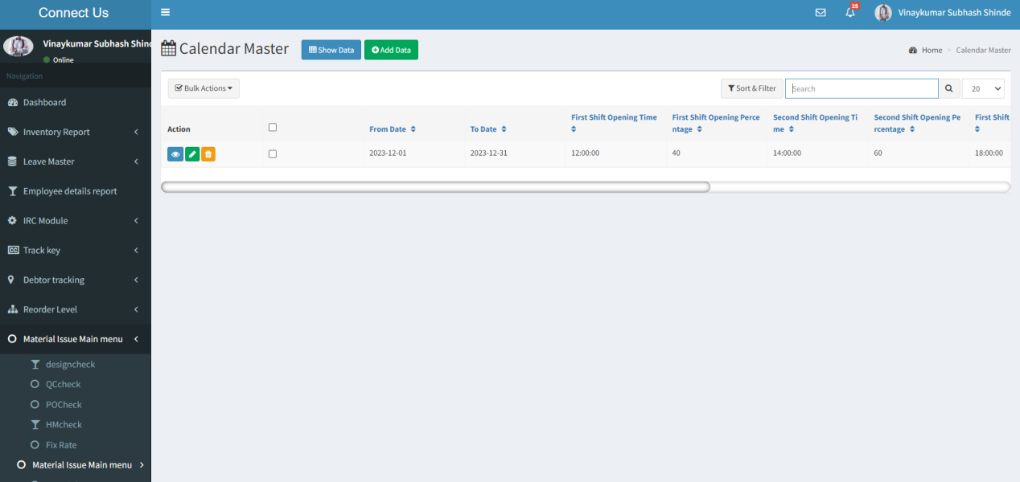

The master consist of the following actions.
Fields | Grid view | Add | View | Edit
Add data | ✓ | x | x | x
View data | ✓ | x | x | x
Edit data | ✓ | x | x | x
Delete | ✓ | x | x | x
Action | ✓ | x | x | x
From date | ✓ | ✓ | ✓ | ✓
To date | ✓ | ✓ | ✓ | ✓
First shift opening time | ✓ | ✓ | ✓ | ✓
First shift opening percentage | ✓ | ✓ | ✓ | ✓
Second shift opening time | ✓ | ✓ | ✓ | ✓
Second shift opening percentage | ✓ | ✓ | ✓ | ✓
Third shift opening time | ✓ | ✓ | ✓ | ✓
Third shift opening percentage | ✓ | ✓ | ✓ | ✓
First shift closing time | ✓ | ✓ | ✓ | ✓
First shift closing percentage | ✓ | ✓ | ✓ | ✓
Second shift closing time | ✓ | ✓ | ✓ | ✓
Second shift closing percentage | ✓ | ✓ | ✓ | ✓
Third shift closing time | ✓ | ✓ | ✓ | ✓
Third shift closing percentage | ✓ | ✓ | ✓ | ✓
Is active | ✓ | ✓ | ✓ | ✓

Input table
Fields | Input type | Mandatory/ Optional | Editable/ No | Description
Add data | Button | - | - | The add data button to add the data in the master.
View data | Button | - | - | The view data button to view the data in the record.
Edit data | Button | - | - | The edit data button to edit the data of the record.
Delete | Button | - | - | The delete button to delete the data of the record.
Action | - | - | - | The action field consist of the view, edit and delete buttons.
From date | Date picker | Mandatory | Yes | The from date from when the shift to be applied is selected from the date picker in dd/mm/yyyy format.  Validation:  The current or future date can be selected.
To date | Date picker | Mandatory | Yes | The to date to when the shift to be applied is selected from the date picker in dd/mm/yyyy format.  Validation:  The to date should be greater or eual to the from date.
First shift opening time | Time picker | Mandatory | Yes | The first shift opening time is selected from the time picker in hh/mm format.  Validation:  The opening time should be current or future time.
First shift opening percentage | Int | Mandatory | Yes | The first shift opening percentage of how many employees punch in to be assigned is entered.  Validation:  - Values of 1-100 is entered.  - No decimal values are accepted.
Second shift opening time | Time picker | Mandatory | Yes | The second shift opening time is selected from the time picker in hh/mm format.  Validation:  - The opening time should be future time.  - The second shift opening time should be greater than the first shift opening time.
Second shift opening percentage | Int | Mandatory | Yes | The second shift opening percentage of how many employees punch in to be assigned is entered.  Validation:  - Values of 1-100 is entered.  - No decimal values are accepted.
Third shift opening time | Time picker | Mandatory | Yes | The third shift opening time is selected from the time picker in hh/mm format.  Validation:  - The opening time should be future time.  - The third shift opening time should be greater than the second shift opening time.
Third shift opening percentage | Int | Mandatory | Yes | The third shift opening percentage of how many employees punch in to be assigned is entered.  Validation:  - Values of 1-100 is entered.  - No decimal values are accepted.
First shift closing time | Time picker | Mandatory | Yes | The first shift closing time is selected from the time picker in hh/mm format.  Validation:  - The closing time should be future time.  - The first shift closing time should be greater than the first shift opening time.
First shift closing percentage | Int | Mandatory | Yes | The first shift closing percentage of how many employees punched out to be assigned is entered.  Validation:  - Values of 1-100 is entered.  - No decimal values are accepted.
Second shift closing time | Time picker | Mandatory | Yes | The second shift closing time is selected from the time picker in hh/mm format.  Validation:  - The closinng time should be future time.  - The second shift closing time should be greater than the first shift closing time.
Second shift closing percentage | Int | Mandatory | Yes | The second shift closing percentage of how many employees punched out to be assigned is entered.  Validation:  - Values of 1-100 is entered.  - No decimal values are accepted.
Third shift closing time | Time picker | Mandatory | Yes | The third shift cosing time is selected from the time picker in hh/mm format.  Validation:  - The closing time should be future time.  - The third shift closing time should be greater than the second shift closing time.
Third shift closing percentage | Int | Mandatory | Yes | The third shift closing percentage of how many employees punched out to be assigned is entered.  Validation:  - Values of 1-100 is entered.  - No decimal values are accepted.
Is active | Radio button | Mandatory | Yes | The status of the record whether active or not is selected. If the record is active, “yes” is selected, if not, “no” is selected  Validation:  - Single selection  - By default, active is selected

- REFERENCES OF THE USERS
User | Name | Mail | Contact number
Actual user | Pritam Mehta | ia@csjewellers.com
Assigned business analyst | Mounika Annamneedi | Mounika.annamneedi@techneai.com

