a

26.04.2023

[HRMS- Employee Joining]

Sanika Dewoolkar

sanika.dewoolkar@techneai.com

**Functional Requirement Document**

**CONTENTS**

1. TICKET DETAILS 2

2. VERSION CONTROL 2

3. APPROVALS 2

4. ESTIMATION 2

5. INTRODUCTION 3

6. BUSINESS REQUIREMENT 3

7. SCOPE 3

8. BUSINESS & SYSTEM RULES 3

9. ABBREVIATIONS & TERMS 3

10. EXISTING SYSTEM 3

11. GRAPHICAL REPRESENTATION 3

12. PROPOSED SYSTEM 3

13. TEST DATA 4

14. ODUS 4

15. REFERENCES OF THE USERS 5

1. **TICKET DETAILS**

|  |  |
| --- | --- |
| **Ticket ID** | TT8878 |
| **Ticket description** | Hi Team, We need to develop a recruitment portal with a back end recruitment menu. Please refer attached Doc for reference. |
| **Created by** | Sanika Dewoolkar |
| **Created on** | 2023-01-20 |
| **Priority** | Very high |

1. **VERSION CONTROL**

|  |  |  |  |  |
| --- | --- | --- | --- | --- |
| **Sr. No** | **Version no** | **Version Date** | **User name** | **User department** |
| **1.** | **1.0** | **10/04/2023** | **Sanika Dewoolkar** | **IT Implementation** |
| **2.** | **1.1** | **3/25/2024** | **Sanika Dewoolkar** | **IT Implementation** |
| **3.** | **1.2** | **4/5/2024** | **Sanika Dewwolkar** | **IT Implementation** |

1. **APPROVALS**

|  |  |  |
| --- | --- | --- |
| **Field** | **Name of the User** | **Approved date by the user** |
| **Actual User Name**  **Actual User Department**  **Organization Name** | Sagar Dahane |  |
| **Assigned BA** | Sanika Dewoolkar |  |
| **Assigned Developer** | Amit Solanki, Somyaranjan Sethi - Frontend  Prathmesh Shinde, Reshma Gawade - Backend |  |
| **Assigned Tester** | Priyanka Dupargude, Kiran Dhanpekaar, Uttareshwar Bhusari |  |

1. **BUSINESS REQUIREMENT**

Enter details of the ticket requirement.

|  |  |  |  |
| --- | --- | --- | --- |
| **Requirement ID** | **Requirement Name** | **Short Description** | **Priority** |
| BR001 | Branch master | To add location in the system | High |
| BR002 | Source master | To add source of job application in the system | High |
| BR003 | Remark master | To add remark in the system | High |
| BR004 | Interview Master | To add steps, opening and interviewer details | High |
| BR005 | Salary Master | To add salary for every location and designation | High |
| BR006 | Application Form | Application form to be filled by candidate | High |
| BR007 | Candidate list | To view the application form details filled by candidate | High |
| BR008 | Candidate details | To edit and view history of candidate details | Medium |
| BR009 | Interview Process | To schedule, reschedule, send link/location details, proceed/reject and remark of the interview process | High |
| BR010 | Negotiation Cycle | Send negotiation salary to senior HR and maintain history of negotiation cycle. | High |
| BR011 | Send Joining form | To send joining form to candidate on email and whatsapp through the system | High |
| BR012 | Interview Schedule History | To maintain the interview schedule date and time | Medium |
| BR013 | Remark History | To view remark added for every interview step | Medium |
| BR014 | Follow up | To add follow up of candidate and next follow up date | Medium |
| B4015 | Process/ Rejection | To proceed, reject candidate from the interview process | High |

1. **SCOPE**

The scope of this project is to develop the Employee Joining process for CSPL. This process will include steps like Candidate filling the job application form, Application form shortlisting, Interview panel selection from interview master, interview scheduling- rescheduling, follow up of candidate, Interview process, sending invites for interview-to-interview panel and candidates, Interview process, shortlisting of candidate, Salary negotiation and generating and sending offer to candidate.

1. **BUSINESS & SYSTEM RULES**

* User should be registered in the system.
* User should be logged in.
* System should display error message for incorrect details if entered.
* System should pop up a message, if any issues in the system is detected.
* All forms should have on field validations. System should display on field errors in case of incorrect inputs.

1. **ABBREVIATIONS & TERMS**

HRMS- Human Resource Management System

1. **EXISTING SYSTEM**

There is no existing system.

1. **GRAPHICAL REPRESENTATION**

Kindly refer below figma link:

<https://www.figma.com/proto/kFHBwe7FrZxEqGKT2Rfhhq/Employee-Joining?type=design&node-id=1361-24543&t=IKR7QaSVf1g28QkN-1&scaling=contain&page-id=1361%3A12309&starting-point-node-id=1361%3A24543&show-proto-sidebar=1&mode=design>

1. **PROPOSED SYSTEM** 
   1. **MASTERS:**

* Branch Master
* Source Master
* Remark Master
* Interview Master
* **BRANCH MASTER:**

Feature Overview:

Branch master helps entry user to add branch name I.e. Location in the system.

Below are the fields in the master:

* Sr no
* Search
* Reset
* Export
* Add
* Action
* Branch name
* Remark
* Active
* Deactive
* Save
* Cancel
* Update
* Created at
* Updated at
* Created by
* Updated by

Field Description:

|  |  |  |  |
| --- | --- | --- | --- |
| **FIELD** | **INPUT TYPE** | **MANDATORY/OPTIONAL** | **DESCRIPTION** |
| Sr No | - | - | To display the serial number |
| Search | Text | - | User should be able to search the record by data present at grid view  Validation: The search can accept alpha-numeric with special characters as well. |
| Reset | Button | - | To reset the search tab |
| Export | Button | - | To export the data in branch master  Once the user clicks on the export button, excel file with the data in grid view should be downloaded in the system. |
| Add Branch | Button | - | To add branch in the branch master  Once the user clicks on ‘Add’ button, pop up should be displayed to add data. |
| Branch name | Text | Mandatory | User should be able to enter branch name.  Validation: Should accept alpha numeric and special characters up to 100. |
| Status - Active, Deactive | Radio Button | - | By default the status of branch should be active, if the user updates the status as deactive, the record should not be displayed in the location dropdown. |
| Remark | Text | Optional | To enter the necessary remark.  Validation: Remark field should accept 1000 alpha numeric, special characters. |
| Action | Button | - | To edit the record, Once the user clicks on action button, pop up to edit the data should be displayed. |
| Save | Button | - | To save the record.  Precondition:   * User must have filled all the mandatory details before clicking on the save button. Else, error should be thrown “Please fill all the mandatory details!”   Post Condition:   * Once the user clicks on the save button, pop up should be displayed with confirmation message as “Do you want to save this record?” along with Yes, No button. * If the user clicks on “Yes” data should be saved and reflected in the grid view. At the same time, user should be redirected to the grid view. * In case, user clicks on “No” the user should be redirected to the Previous pop up. |
| Update | Button | - | To update the edited record.  Precondition:  Users must have filled in all the mandatory details before clicking on the update button. Else, error should be thrown “Please fill all the mandatory details!”  Post Condition:   * Once the user clicks on the Update button, pop up should be displayed with confirmation message as “Do you want to update this record?” along with Yes, No button. * If the user clicks on “Yes” data should be updated and reflected in the grid view. At the same time, user should be redirected to the grid view. * In case, user clicks on “No” the user should be redirected to the Previous pop up. |
| Cancel | Button | - | To cancel the input records.  Post Condition:   * User should be redirected to the grid page * The data should not be saved. |
| Created at | - | - | The date and time when the branch is created should be displayed.  Validation: Format - YYYY-MM-DD HH:MM:S |
| Created by | - | - | The username who created the branch should be displayed. |
| Updated at | - | - | The date and time when the branch is updated last should be displayed.  Validation: Format - YYYY-MM-DD HH:MM:SS |
| Updated by | - | - | The username who last updated the branch name should be displayed. |

The masters consist of following actions:

|  |  |  |  |  |
| --- | --- | --- | --- | --- |
| **FIELD** | **GRID** | **ADD** | **EDIT** | **EXPORT** |
| Sr No | ✓ | x | x | ✓ |
| Search | ✓ | x | x | x |
| Reset | ✓ | x | x | x |
| Export | ✓ | x | x | x |
| Add Branch | ✓ | x | x | x |
| Branch name | ✓ | ✓ | ✓ | ✓ |
| Status - Active, Deactive | ✓ | x | ✓ | ✓ |
| Remark | ✓ | ✓ | ✓ | ✓ |
| Action | ✓ | x | x | x |
| Save | x | ✓ | x | x |
| Update | x | x | ✓ | x |
| Cancel | x | ✓ | ✓ | x |
| Created at | ✓ | x | x | ✓ |
| Created by | ✓ | x | x | ✓ |
| Updated at | ✓ | x | x | ✓ |
| Updated by | ✓ | x | x | ✓ |

* **SOURCE MASTER**

Feature Overview:

Source master helps entry user to add Source of the application in the system. Source refers to the platform through which candidate has got to know about job opening/ the platform through which the candidate has scanned the QR code.

Below are the fields in the master:

* Sr no
* Search
* Reset
* Export
* Add
* Action
* Source name
* Remark
* Active
* Deactive
* Save
* Cancel
* Update
* Created at
* Updated at
* Created by
* Updated by

Field Description:

|  |  |  |  |
| --- | --- | --- | --- |
| **FIELD** | **INPUT TYPE** | **MANDATORY/OPTIONAL** | **DESCRIPTION** |
| Sr No | - | - | To display the serial number |
| Search | Text | - | User should be able to search the record by data present at grid view  Validation: The search can accept alpha-numeric with special characters as well. |
| Reset | Button | - | To reset the search tab |
| Export | Button | - | To export the data in source master  Once the user clicks on the export button, excel file with the data in grid view should be downloaded in the system. |
| Add Source | Button | - | To add source in the source master  Once the user clicks on ‘Add’ button, pop up should be displayed to add data. |
| Source name | Text | Mandatory | Users should be able to enter the source name.  Eg, Naukri, Linkedin, Walk in, Reference  Validation:   1. Should accept alpha numeric and special characters up to 100. |
| Status - Active, Deactive | Radio Button | - | By default, the status of source name should be active, if the user updates the status as deactive, the record should not be displayed in the Source dropdown. |
| Remark | Text | Optional | To enter the necessary remark.  Validation: Remark field should accept 1000 alpha numeric, special characters. |
| Action | Button | - | To edit the record, Once the user clicks on action button, pop up to edit the data should be displayed. |
| Save | Button | - | To save the record.  Precondition:   * User must have filled all the mandatory details before clicking on the save button. Else, error should be thrown “Please fill all the mandatory details!”   Post Condition:   * Once the user clicks on the save button, pop up should be displayed with confirmation message as “Do you want to save this record?” along with Yes, No button. * If the user clicks on “Yes” data should be saved and reflected in the grid view. At the same time, user should be redirected to the grid view. * In case, user clicks on “No” the user should be redirected to the Previous pop up. |
| Update | Button | - | To update the edited record.  Precondition:  User must have filled all the mandatory details before clicking on the update button. Else, error should be thrown “Please fill all the mandatory details!”  Post Condition:   * Once the user clicks on the Update button, pop up should be displayed with confirmation message as “Do you want to update this record?” along with Yes, No button. * If the user clicks on “Yes” data should be updated and reflected in the grid view. At the same time, user should be redirected to the grid view. * In case, user clicks on “No” the user should be redirected to the Previous pop up. |
| Cancel | Button | - | To cancel the input records.  Post Condition:   * User should be redirected to the grid page * The data should not be saved. |
| Created at | - | - | The date and time when the source is created should be displayed.  Validation: Format - YYYY-MM-DD HH:MM:S |
| Created by | - | - | The username who created the source should be displayed. |
| Updated at | - | - | The date and time when the source is updated last should be displayed.  Validation: Format - YYYY-MM-DD HH:MM:SS |
| Updated by | - | - | The username who last updated the source name should be displayed. |

The masters consist of following actions:

|  |  |  |  |  |
| --- | --- | --- | --- | --- |
| **FIELD** | **GRID** | **ADD** | **EDIT** | **EXPORT** |
| Sr No | ✓ | x | x | ✓ |
| Search | ✓ | x | x | x |
| Reset | ✓ | x | x | x |
| Export | ✓ | x | x | x |
| Add Source | ✓ | x | x | x |
| Source name | ✓ | ✓ | ✓ | ✓ |
| Status - Active, Deactive | ✓ | x | ✓ | ✓ |
| Remark | ✓ | ✓ | ✓ | ✓ |
| Action | ✓ | x | x | x |
| Save | x | ✓ | x | x |
| Update | x | x | ✓ | x |
| Cancel | x | ✓ | ✓ | x |
| Created at | ✓ | x | x | ✓ |
| Created by | ✓ | x | x | ✓ |
| Updated at | ✓ | x | x | ✓ |
| Updated by | ✓ | x | x | ✓ |

* **REMARK MASTER:**

Feature Overview:

Remark master helps entry user to add Remark in the remark dropdown while proceeding or rejecting the candidate.

Eg, If the employer wants to Reject the candidate, employer should be able to select the reason for rejection through remark field dropdown.

This dropdown values will be fetched from the remark master.

Below are the fields in the master:

* Sr no
* Search
* Reset
* Export
* Add
* Action
* Type
* Remark Description
* Supporting Remark
* Active
* Deactive
* Save
* Cancel
* Update
* Created at
* Updated at
* Created by
* Updated by

Field Description:

|  |  |  |  |
| --- | --- | --- | --- |
| **FIELD** | **INPUT TYPE** | **MANDATORY/OPTIONAL** | **DESCRIPTION** |
| Sr No | - | - | To display the serial number |
| Search | Text | - | User should be able to search the record by data present at grid view  Validation: The search can accept alpha-numeric with special characters as well. |
| Reset | Button | - | To reset the search tab |
| Export | Button | - | To export the data in remark master  Once the user clicks on the export button, excel file with the data in grid view should be downloaded in the system. |
| Add Remark | Button | - | To add remark in the Remark master  Once the user clicks on ‘Add’ button, pop up should be displayed to add data. |
| Remark Description | Text | Mandatory | User should be able to enter Remark description in this field.  Validation: Should accept alpha numeric and special characters up to 1000. |
| Status - Active, Deactive | Radio Button | - | By default the status of remark added should be active, if the user updates the status as deactive, the record should not be displayed in the Remark dropdown. |
| Supporting Remark | Text | Optional | To enter the necessary supporting details(Remark)  Validation: Remark field should accept 1000 alpha numeric, special characters. |
| Action | Button | - | To edit the record, Once the user clicks on action button, pop up to edit the data should be displayed. |
| Save | Button | - | To save the record.  Precondition:   * 1.User must have filled all the mandatory details before clicking on the save button. Else, error should be thrown “Please fill all the mandatory details!”   Post Condition:   * Once the user clicks on the save button, pop up should be displayed with confirmation message as “Do you want to save this record?” along with Yes, No button. * If the user clicks on “Yes” data should be saved and reflected in the grid view. At the same time, user should be redirected to the grid view. * In case, user clicks on “No” the user should be redirected to the Previous pop up. |
| Update | Button | - | To update the edited record.  Precondition:  User must have filled all the mandatory details before clicking on the update button. Else, error should be thrown “Please fill all the mandatory details!”  Post Condition:   * Once the user clicks on the Update button, pop up should be displayed with confirmation message as “Do you want to update this record?” along with Yes, No button. * If the user clicks on “Yes” data should be updated and reflected in the grid view. At the same time, user should be redirected to the grid view. * In case, user clicks on “No” the user should be redirected to the Previous pop up. |
| Cancel | Button | - | To cancel the input records.  Post Condition:   * User should be redirected to the grid page * The data should not be saved. |
| Created at | - | - | The date and time when the record is created should be displayed.  Validation: Format - YYYY-MM-DD HH:MM:S |
| Created by | - | - | The username who created the record should be displayed. |
| Updated at | - | - | The date and time when the record is updated last should be displayed.  Validation: Format - YYYY-MM-DD HH:MM:SS |
| Updated by | - | - | The username who last updated the record should be displayed. |

The masters consist of following actions:

|  |  |  |  |  |
| --- | --- | --- | --- | --- |
| **FIELD** | **GRID** | **ADD** | **EDIT** | **EXPORT** |
| Sr No | ✓ | x | x | ✓ |
| Search | ✓ | x | x | x |
| Reset | ✓ | x | x | x |
| Export | ✓ | x | x | x |
| Add Remark | ✓ | x | x | x |
| Remark Description | ✓ | ✓ | ✓ | ✓ |
| Status - Active, Deactive | ✓ | x | ✓ | ✓ |
| Supporting Remark | ✓ | ✓ | ✓ | ✓ |
| Action | ✓ | x | x | x |
| Save | x | ✓ | x | x |
| Update | x | x | ✓ | x |
| Cancel | x | ✓ | ✓ | x |
| Created at | ✓ | x | x | ✓ |
| Created by | ✓ | x | x | ✓ |
| Updated at | ✓ | x | x | ✓ |
| Updated by | ✓ | x | x | ✓ |

* **INTERVIEW MASTER:**

Feature Overview:

The Interview Master assists users in adding details for each step or round of an interview. Typically, interviews are conducted in various stages such as Technical Interview, HR Interview, etc. This tool helps in determining the specifics of each interview round, such as the number of rounds/steps based on the specific job title, department, and level of experience. Additionally, users can select the interviewers for each round/step by providing details like their designation, name, and email address.

**The first step of application shortlisting and last step of Offer generation and onboarding will be fixed in this process. Users should not be able to add/edit these steps.**

Eg, If the user selects the department, designation, and experience level, steps such as IT Implementation, BA, with 2 years of experience, 3 steps respectively, the BA position will entail 3 rounds of interviews. For each step of the interview, the user can set a title, for example, "Technical Interview Round". Furthermore, by inputting the designation, name, and email of the interviewer in the Interviewer details section, the user can designate who will conduct each round/step of the interview.

Below are the fields in the master:

* Sr no
* Search
* Reset
* Export
* Add Steps
* Action
* Department
* Designation
* Experience level
* Steps Count
* Step Title
* Designation
* Name
* Email
* Remark
* Active
* Deactive
* Save
* Cancel
* Update
* Created at
* Updated at
* Created by
* Updated by

Field Description:

|  |  |  |  |
| --- | --- | --- | --- |
| **FIELD** | **INPUT TYPE** | **MANDATORY/OPTIONAL** | **DESCRIPTION** |
| Sr No | - | - | To display the serial number |
| Search | Text | - | User should be able to search the record by data present at grid view  Validation: The search can accept alpha-numeric with special characters as well. |
| Reset | Button | - | To reset the search tab |
| Export | Button | - | To export the data in Interview master  Once the user clicks on the export button, excel file should be downloaded in the system. |
| Add Steps | Button | - | To add step details in the interview master  Once the user clicks on ‘Add’ button, pop up should be displayed to add data. |
| Department | Dropdown | Mandatory | Add Interview Steps>>Opening Details>>  User should be able to select the department for which the job opening is available.  The values in this dropdown will be fetched from the department master.  Validation:   1. Single selection. 2. Only Active values should be fetched. |
| Designation | Dropdown | Mandatory | Add Interview Steps>>Opening Details>>  User should be able to select the designation for which the job opening is available.  The values in this dropdown will be fetched from the designation master.  Validation:   1. Single selection. 2. Only Active values should be fetched. |
| Experience level | Dropdown | Mandatory | Add Interview Steps>>Opening Details>>  User should be able to select the experience level for which the job opening is available.  The dropdown will have below values:   * Fresher * 0-1 years of experience * 1-3 years of experience * 3-5 years of experience * 5+ years of experience   Validation: Single selection. |
| Steps Count | Dropdown | Mandatory | User should be able to select the count of interview steps/round.  Post Condition:   * Once the user selects the step count, number of rows = Step count should be added in the pop up, to assign interviewer to each step. * Eg, if user adds step count as 3, 3 rows of interviewer details should be added as shown below:     Validation:  Min step should be 1  Max should be 7 |
| Step Title | Text | Mandatory | To give title to each step/round of interview. Eg, Technical Interview, HR interview.  Validation:  This field should accept alpha numeric special characters up to 50 |
| Designation | Dropdown | Mandatory | Interviewer Details>>  User should be able to select the designation of interviewer. The values of this dropdown will be fetched from the designation master.  Validation:   1. Only Active values should be fetched. 2. Single selection |
| Name | Dropdown | Mandatory | Users should be able to select the interviewer's name from the dropdown. These values will be fetched from User master.  Pre-Condition:  User must have selected the designation before clicking on this field. If user clicks on the Name field without inputting designation, error message with red colour below name should be displayed as “Please select designation first.” |
| Email | - | Mandatory | This field should be auto fetched after the user selects the Name of interviewer. The email assigned to that interviewer/ user in user master should be displayed.  This field should be read-only.  Precondition:  The user must have selected the Name field before clicking on this field. If user clicks on the email without selecting Name, error message with red colour below email should be displayed as “Please select Name first.” |
| Status - Active, Deactive | Radio Button | - | By default, the status of record should be active, if the user deactivates the template of interview steps then for that specific opening the added details should not be fetched. |
| Remark | Text | Optional | To enter the necessary remark.  Validation: Remark field should accept 1000 alpha numeric, special characters. |
| Action – View, History | Button | - | Edit button- To edit the record, Once the user clicks on action button, pop up to edit the data should be displayed.  View Button – To view the record, Once the user clicks on view button, pop up with added records should be displayed. |
| Save | Button | - | To save the record.  Precondition:   * The user must have filled in all the mandatory details before clicking on the save button. Else, error should be thrown “Please fill all the mandatory details!”   Post Condition:   * Once the user clicks on the save button, pop up should be displayed with confirmation message as “Do you want to save this record?” along with Yes, No button. * If the user clicks on “Yes” data should be saved and reflected in the grid view. At the same time, user should be redirected to the grid view. * In case, user clicks on “No” the user should be redirected to the Previous pop up. |
| Update | Button | - | To update the edited record.  Precondition:  Users must have filled in all the mandatory details before clicking on the update button. Else, error should be thrown “Please fill all the mandatory details!”  Post Condition:   * Once the user clicks on the Update button, pop up should be displayed with confirmation message as “Do you want to update this record?” along with Yes, No button. * If the user clicks on “Yes” data should be updated and reflected in the grid view. At the same time, user should be redirected to the grid view. * In case, user clicks on “No” the user should be redirected to the Previous pop up. |
| Cancel | Button | - | To cancel the input records.  Post Condition:   * User should be redirected to the grid page * The data should not be saved. |
| Created at | - | - | The date and time when the record is created should be displayed.  Validation: Format - YYYY-MM-DD HH:MM:S |
| Created by | - | - | The username who created the record should be displayed. |
| Updated at | - | - | The date and time when the record is updated last should be displayed.  Validation: Format - YYYY-MM-DD HH:MM:SS |
| Updated by | - | - | The username who last updated the record should be displayed. |

The masters consist of following actions:

|  |  |  |  |  |
| --- | --- | --- | --- | --- |
| **FIELD** | **GRID** | **ADD** | **EDIT** | **EXPORT** |
| Sr No | ✓ | x | x | ✓ |
| Search | ✓ | x | x | x |
| Reset | ✓ | x | x | x |
| Export | ✓ | x | x | x |
| Add Steps | ✓ | x | x | x |
| Department | x | ✓ | ✓ | ✓ |
| Designation | x | ✓ | ✓ | ✓ |
| Experience level | x | ✓ | ✓ | ✓ |
| Steps Count | ✓ | ✓ | ✓ | ✓ |
| Step Title | x | ✓ | ✓ | ✓ |
| Designation | x | ✓ | ✓ | ✓ |
| Name | x | ✓ | ✓ | ✓ |
| Email | x | ✓ | ✓ | ✓ |
| Status - Active, Deactive | ✓ | x | ✓ | ✓ |
| Remark | x | ✓ | ✓ | ✓ |
| Action | ✓ | x | x | x |
| Save | x | ✓ | x | x |
| Update | x | x | ✓ | x |
| Cancel | x | ✓ | ✓ | x |
| Created at | ✓ | x | x | ✓ |
| Created by | ✓ | x | x | ✓ |
| Updated at | ✓ | x | x | ✓ |

* **SALARY MASTER**

Feature Overview:

Salary master allows user to add salary for different designation, experience level and locations.

Below are the fields in the master:

* Sr no
* Search
* Reset
* Export
* Add Salary
* Action
* Department
* Designation
* Location
* Experience level
* Salary (Net)
* Remark
* Active
* Deactive
* Save
* Cancel
* Update
* Created at
* Updated at
* Created by
* Updated by

Field Description:

|  |  |  |  |
| --- | --- | --- | --- |
| **FIELD** | **INPUT TYPE** | **MANDATORY/OPTIONAL** | **DESCRIPTION** |
| Sr No | - | - | To display the serial number |
| Search | Text | - | Users should be able to search the record.  Validation: The search can accept alpha-numeric with special characters as well. |
| Reset | Button | - | To reset the search tab |
| Export | Button | - | To export the data in branch master  Once the user clicks on the export button, excel file with the data in grid view should be downloaded in the system. |
| Add Salary | Button | - | To add branch in the branch master  Once the user clicks on ‘Add’ button, pop up should be displayed to add data. |
| Department | Dropdown | Mandatory | User should be able to select the department from the dropdown.  The values in this dropdown will be fetched from the department master.  Validation:  Single selection.  Only Active values should be fetched. |
| Designation | Dropdown | Mandatory | User should be able to select the designation from the dropdown.  The values in this drop-down will be fetched from the designation master.  Validation:  Single selection.  Only Active values should be fetched. |
| Experience Level | Dropdown | Mandatory | Add Interview Steps>>Opening Details>>  User should be able to select the experience level for which the job opening is available.  The dropdown will have below values:   * Fresher * 0-1 years of experience * 1-3 years of experience * 3-5 years of experience * 5+ years of experience   Validation: Single selection. |
| Location | Dropdown | Mandatory | This dropdown values will be fetched from the Branch master.  Validation:  Multi- selection  Only active values should be fetched. |
| Salary(Net) | Text | Mandatory | User should be able to set the salary against the selected department>>designation>>experience level and location.  Validation:  It should accept numbers only. |
| Status - Active, Deactive | Radio Button | - | By default the status of record should be active, if the user updates the status as deactive, the salary updated against the department>>designation>>experience level and location should be deactivated. |
| Remark | Text | Optional | To enter the necessary remark.  Validation: Remark field should accept 1000 alpha numeric, special characters. |
| Action | Button | - | To edit the record, Once the user clicks on action button, pop up to edit the data should be displayed. |
| Save | Button | - | To save the record.  Precondition:   * User must have filled all the mandatory details before clicking on the save button. Else, error should be thrown “Please fill all the mandatory details!”   Post Condition:   * Once the user clicks on the save button, pop up should be displayed with confirmation message as “Do you want to save this record?” along with Yes, No button. * If the user clicks on “Yes” data should be saved and reflected in the grid view. At the same time, user should be redirected to the grid view. * In case, user clicks on “No” the user should be redirected to the Previous pop up. |
| Update | Button | - | To update the edited record.  Precondition:  User must have filled all the mandatory details before clicking on the update button. Else, error should be thrown “Please fill all the mandatory details!”  Post Condition:   * Once the user clicks on the Update button, pop up should be displayed with confirmation message as “Do you want to update this record?” along with Yes, No button. * If the user clicks on “Yes” data should be updated and reflected in the grid view. At the same time, user should be redirected to the grid view. * In case, user clicks on “No” the user should be redirected to the Previous pop up. |
| Cancel | Button | - | To cancel the input records.  Post Condition:   1. User should be redirected to the grid page 2. The data should not be saved. |
| Created at | - | - | The date and time when the record is created should be displayed.  Validation: Format - YYYY-MM-DD HH:MM:S |
| Created by | - | - | The username who created the record should be displayed. |
| Updated at | - | - | The date and time when the record is updated last should be displayed.  Validation: Format - YYYY-MM-DD HH:MM:SS |
| Updated by | - | - | The username who last updated the record should be displayed. |

The masters consist of following actions:

|  |  |  |  |  |
| --- | --- | --- | --- | --- |
| **FIELD** | **GRID** | **ADD** | **EDIT** | **EXPORT** |
| Sr No | ✓ | x | x | ✓ |
| Search | ✓ | x | x | x |
| Reset | ✓ | x | x | x |
| Export | ✓ | x | x | x |
| Add Salary | ✓ | x | x | x |
| Department | ✓ | ✓ | ✓ | ✓ |
| Designation | ✓ | ✓ | ✓ | ✓ |
| Experience Level | ✓ | ✓ | ✓ | ✓ |
| Location | ✓ | ✓ | ✓ | ✓ |
| Salary(Net) | ✓ | ✓ | ✓ | ✓ |
| Status - Active, Deactive | ✓ | x | ✓ | ✓ |
| Remark | x | ✓ | ✓ | ✓ |
| Action | ✓ | x | x | x |
| Save | x | ✓ | x | x |
| Update | x | x | ✓ | x |
| Cancel | x | ✓ | ✓ | x |
| Created at | ✓ | x | x | ✓ |
| Created by | ✓ | x | x | ✓ |
| Updated at | ✓ | x | x | ✓ |
| Updated by | ✓ | x | x | ✓ |

* 1. **JOB APPLICATION FORM:**

This is the first step of Employee joining process, where the candidate submits the required details in the job application form. The details submitted by candidate should be fetched in the system.

Step 1: Scan QR Code

Candidate should be able to fill the job application form by scanning QR code available at different sources or by directly visiting the CSPL Website.

Once the candidate scans the QR Code, it should be redirected to the CSPL Website Career Page and the application form should be displayed.

The Job Application form will have below fields:

* Source
* Full Name
* Date of Birth
* Preferred Role
* Preferred Location
* Phone Number
* Email
* Current years of work experience
* Current monthly salary(Net)
* Expected salary(Net)
* Notice period
* Upload Resume
* Apply Now
* Verify OTP
* Resend

Fields Description:

|  |  |  |  |
| --- | --- | --- | --- |
| **FIELDS** | **INPUT TYPE** | **MANDATORY/OPTIONAL** | **DESCRIPTION** |
| Source | Dropdown | Mandatory | The source dropdown should be fetched from the source master.  If the candidate scans the QR code and redirects to the application form, the source should be auto filled and read-only.  In case, the candidate visits the website career page directly, candidate should be able to enter the source manually.  Validation:  Single selection only. |
| Referee Name | Text | Mandatory | Pre Condition:  If the source is selected as Reference, this field should be populated.  Validation:   1. It should accept characters and space only. 2. Maximum length of input field should be 50 characters.   This field shouldn’t be case sensitive. |
| Full Name | Text | Mandatory | Candidate should be able to enter the First name and last name.  Validation:   * It should accept characters and space only. * Maximum length of input field should be 50 characters. * This field shouldn’t be case sensitive. |
| Date of Birth | Calendar picker | Mandatory | Candidate should be able to select his/her date of birth from the calendar.    Future dates should be disabled. |
| Preferred Role | Dropdown | Mandatory | Candidate should be able to select the preferred role from dropdown. The dropdown values will be fetched from the Role master.  Validation:  Multiple Selection should be allowed. |
| Preferred Location | Dropdown | Mandatory | Candidate should be able to select the preferred location from dropdown. The dropdown values will be fetched from the branch master.  Validation:  Multiple Selection should be allowed. |
| Phone Number | Text | Mandatory | * Only numbers should be accepted. * Maximum 10 digits should be accepted. * It should be unique. * Consecutive ten zeros or consecutive ten ones shouldn’t be accepted as a number. |
| Email | Text | Optional | * This field should accept “ @ - . “ only as special characters. * In case of invalid format, it should display on field error message as “Invalid email address”. * It shouldn’t accept space anywhere. * It should be unique. * Maximum length of input field should be 50 characters. |
| Current years of work experience | Dropdown | Mandatory | The dropdown will be hard coded.  It should have below values:   * Fresher * 0-1 years of experience * 1-3 years of experience * 3-5 years of experience * 5+ years of experience |
| Current monthly salary(Net) | Text | Optional | Candidate should be able to add currently monthly salary  Validation:  It should accept numbers only. |
| Expected Monthly salary (Net) | Text | Optional | Candidate should be able to add expected monthly salary  Validation:  It should accept numbers only. |
| Notice period (In days) | Text | Optional | Candidate should be able to enter the notice period.  Validation:  It should accept numbers only. |
| Upload Resume | Upload | Mandatory | It should accept only one attachment of maximum 2MB size with jpeg, jpg, png, pdf, docx extensions only. |
| Apply Now | Button | - | Candidate should be able to submit the application by clicking on this field.  Pre- Condition:  Before clicking on this field, all the mandatory fields should be filled in.  Post Condition:   1. Once the candidate clicks on this field, it should be redirected to mobile number authentication page. 2. On clicking the Apply now button, candidate should receive 4 digit OTP on the registered mobile. |
| Verify OTP | Button | - | Pre Condition:   1. Candidate should have input the received code. If the code is not entered, the verify otp button should be disabled.   Post Condition:   1. Upon clicking on the verify otp button, if the code is correct, success message should be displayed as -   “Profile has been submitted successfully!  Our team will review your application and contact you shortly.  Your Application ID is: ------”     1. If the code is incorrect, ‘’Please enter correct otp” should be displayed with the input otp highlighted as red 2. If the authentication is done, Application ID should be generated and sent on contact number and email ID(If the email id is entered) |
| Application ID | - | - | Upon verifying the registered contact number, the Application ID should be generated.  Validation:   * This application ID should be numeric. * It should be unique |
| Resend | Button | - | OTP should be sent on the registered mobile number. |

* **MANUAL ENTRY OF JOB APPLICATION FORM:**

Other than Candidate, HR should be able to add candidate details in the system by manually filling in the Job application form.

Below fields will be present in the form:

* Add data
* Source
* Full Name
* Date of Birth
* Preferred Role
* Preferred Location
* Phone Number
* Email
* Current years of work experience
* Current monthly salary(Net)
* Expected salary(Net)
* Notice period
* Upload Resume
* Apply Now
* Verify OTP
* Resend

Fields Description:

|  |  |  |  |
| --- | --- | --- | --- |
| **FIELDS** | **INPUT TYPE** | **MANDATORY/OPTIONAL** | **DESCRIPTION** |
| Add Data | Button | - | To add candidate details.  Once the users click on this field, pop up should be opened. |
| Source | Dropdown | Mandatory | Entry user should be able to add source manually, the dropdown values will be fetched from the source master.  Validation:  Single selection only. |
| Referee Name | Text | Mandatory | Pre-Condition:  If the source is selected as Reference, this field should be populated.  Validation:   * It should accept characters and space only. * Maximum length of input field should be 50 characters. * This field shouldn’t be case sensitive. |
| Full Name | Text | Mandatory | Users should be able to enter the First name and last name.  Validation:   * It should accept characters and space only. * The maximum length of input field should be 50 characters. * This field shouldn’t be case sensitive. |
| Date of Birth | Calendar picker | Mandatory | Candidate’s date of birth should be selected from the calendar.    Future dates should be disabled. |
| Preferred Role | Dropdown | Mandatory | Entry users should be able to select the preferred role of candidate from dropdown. The dropdown values will be fetched from the Role master.  Validation:  Multiple Selection should be allowed. |
| Preferred Location | Dropdown | Mandatory | Entry users should be able to select the preferred location of candidate from dropdown. The dropdown values will be fetched from the branch master.  Validation:  Multiple Selection should be allowed. |
| Phone Number | Text | Mandatory | * Only numbers should be accepted. * Maximum 10 digits should be accepted. * It should be unique. * Consecutive ten zeros or consecutive ten ones shouldn’t be accepted as a number. |
| Email | Text | Optional | * This field should accept “ @ - . “ only as special characters. * In case of invalid format, it should display on field error message as “Invalid email address”. * It shouldn’t accept space anywhere. * It should be unique. * Maximum length of input field should be 50 characters. |
| Current years of work experience | Dropdown | Mandatory | The dropdown will be hard coded.  It should have below values:   * Fresher * 0-1 years of experience * 1-3 years of experience * 3-5 years of experience * 5+ years of experience |
| Current monthly salary(Net) | Text | Optional | Entry users should be able to add the current monthly salary of the candidate.  Validation:  It should accept numbers only. |
| Expected Monthly salary (Net) | Text | Optional | Entry users should be able to add the expected monthly salary of the candidate  Validation:  It should accept numbers only. |
| Notice period (In days) | Text | Optional | Entry users should be able to enter the notice period of candidates.  Validation:  It should accept numbers only. |
| Upload Resume | Upload | Mandatory | It should accept only one attachment of maximum 2MB size with jpeg, jpg, png, pdf, docx extensions only. |
| Apply Now | Button | - | Users should be able to submit the application by clicking on this field.  Pre- Condition:  Before clicking on this field, all the mandatory fields should be filled in.  Post Condition:   * Once the users click on this field, it should be redirected to mobile number authentication page. * On clicking the Apply now button, candidate should receive 4 digit OTP on the registered mobile. |
| Verify OTP | Button | - | Pre-Condition:   * Users should be able to input the received code. If the code is not entered, the verify otp button should be disabled.   Post Condition:   * Upon clicking on the verify otp button, if the code is correct, success message should be displayed as - * “Profile has been submitted successfully! Application ID is : ------” * If the code is incorrect, ‘’Please enter correct otp” should be displayed with the input otp highlighted as red * If the authentication is done, Application ID should be generated and sent on contact number and email ID(If the email id is entered) |
| Application ID | - | - | Upon verifying the registered contact number, the Application ID should be generated.  This application ID should be numeric. |
| Resend | Button | - | OTP should be sent on the registered mobile number. |

Once the candidate submits the job application, the details of the candidate should be fetched in the employee joining system.

The employer should be able to view the candidate details and perform further hiring procedures through this system.

* 1. **DASHBOARD**

Once user logs into the employee joining system, it should display insights, employer schedule for that day, status of hiring procedure with candidate details on the dashboard.

* **Insights:**

It should display the insights of current day interview scheduled, current day joining of candidate, upcoming interview, pending position, and total of all.

This count should be displayed and updated as and when the candidate submits the application and hiring procedure goes ahead.

Once the user clicks on the fields in the Insights, candidate’s list should be filtered.

Eg, If the user clicks on the Today’s interview, candidate list whose interview is scheduled should be displayed.

Eg, If the user clicks on the pending position, then the pop up with pending position should be displayed.

* **Current day’s schedule :**

It should display the current day’s schedule of the user.

User should be able to view below fields in the schedule:

* Title of task/activity
* Position
* Time
* **CANDIDATE LIST:**

Once the Job application form is submitted, the entry of candidate details should be displayed in the grid view.

**If the candidate has applied for multiple positions rows = position applied should be added. Eg, if the candidate has applied for 2 positions, 2 entries should be added in the grid view, with different positions applied.**

Below details should be displayed in grid:

* Sr no
* Search
* Reset
* Export
* Add Data
* Action
* Candidate name
* Applied Position
* Date of application
* Status of application
* Source

|  |  |  |  |
| --- | --- | --- | --- |
| **FIELDS** | **INPUT TYPE** | **MANDATORY/ OPTIONAL** | **DESCRIPTION** |
| Sr No | - | **-** | To display the serial number. |
| Search | Text | **-** | Users should be able to search for the record.  Validation: The search can accept alpha-numeric with special characters as well. |
| Reset | Button | **-** | To reset the search tab |
| Export | Button | **-** | To export the data of candidate's application.  Once the user clicks on the export button, an excel file should be downloaded in the system. |
| Action | Button | **-** | To view the employee joining procedure.  Once the user clicks on the view button, it should be redirected to the employee joining procedure screen. |
| Application ID | Text | **-** | Users should be able to view the application ID of candidate which is generated after submission of application form by candidate and the HR in the system. |
| Candidate name | **-** | **-** | It should be fetched from the job application form submitted by the users. |
| Applied position | **-** | **-** | It should be fetched from the job application form submitted by the users.  If the candidate has applied for multiple positions, new rows with each position should be added. |
| Date of application | **-** | **-** | Date of job application form submission should be displayed. |
| Status | **-** | **-** | Status of employee joining should be displayed.   * **Applied –** If the users have submitted the application form and no action has been taken on the record then the status of application will be ‘Applied’. * **In Process -** If the candidate is a part of hiring process and not yet on board then the status should be ‘In process’. * **Offer sent -** If the interviewer submits the application of candidate for approval and the candidate is on boarded, then the status should be displayed as ‘selected’ * **Reject -** If the employee is rejected at any point of step of hiring procedure, then the status should be displayed as ‘Rejected’. |
| Source | **-** | **-** | It will be fetched from the source entered in the job application form. |

* 1. **ASSESSMENT:**
* It is the first step of employee joining process.
* Once the candidate submits the job application form, the details filled by candidate should be displayed in the system. Furthermore, employer should be able to send assignment to the candidate by clicking on Send Assignment Button.
* Further, when the candidate sends the assignment back to employer, employer should be able to upload the test results and download it in the system as well without leaving the screen.

After reviewing the test results, employer should be able to take action like Proceed or reject the candidate profile.

* **EMPLOYEE JOINING SYSTEM:**

By clicking on the action button at Candidate List page, user should be redirected to the Interview Process tab.

This screen consists of 5 Tabs as below:

* Candidate List
* Interview process
* Follow up
* Remak history
* Interview Schedule History

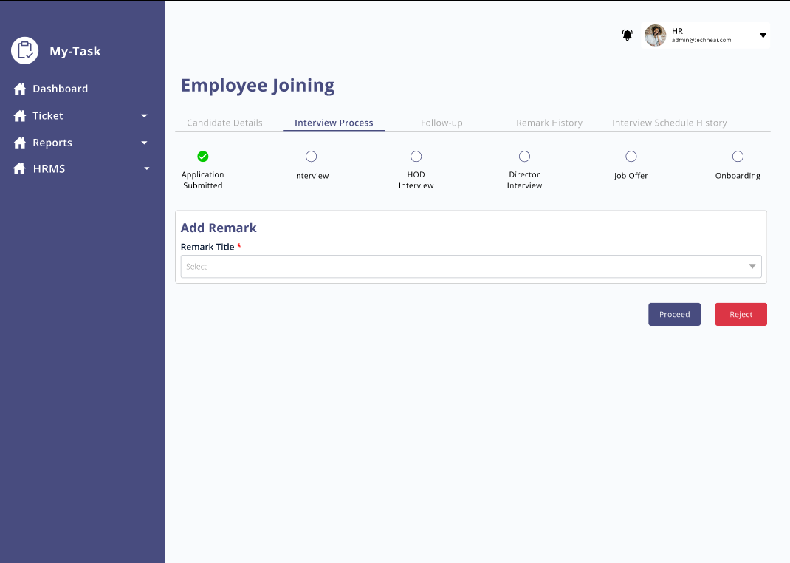

* **CANDIDATE DETAILS:**

The details submitted in the job application form filled in by Candidate and by HR through system should be reflected in this section along with application ID. The application ID field should be readable only.

HR should be **able to edit the fields below** by clicking on the edit button. Upon clicking on the edit button, the update and cancel button should be displayed.

The edited details history should be maintained on the same page.

|  |  |  |
| --- | --- | --- |
| **FIELDS** | **EDITABLE (Readable only)** | **INCLUDE IN HISTORY COLUMN** |
| Source | No | No |
| Referee Name | No | No |
| Full Name | No | Yes |
| Date of Birth | No | No |
| Preferred Role | No | Yes |
| Preferred Location | No | Yes |
| Phone Number | No | No |
| Email | No | No |
| Current years of work experience | Yes | Yes |
| Current monthly salary (Net) | Yes | Yes |
| Expected Monthly salary (Net) | Yes | Yes |
| Notice period (In days) | Yes | Yes |
| Upload Resume | Yes | No |

* **INTERVIEW PROCESS:**

In this tab, the journey from application submission to onboarding is captured.

Step 1: Application Submission

By default, when the user clicks on the action button and visits this tab, the application submission step should be completed.

HR will now decide whether to go ahead with this application or not.

To proceed or reject the candidate after reviewing the application, HR must submit the remark from the dropdown which will be fetched from the remark master and then click on the proceed/reject button.

If the required remark is not present in the dropdown, ‘other’ should be selected, once the user selects ‘Other’ ‘specify other’ text box should be displayed.

The remark input should be saved in the Remark history tab.

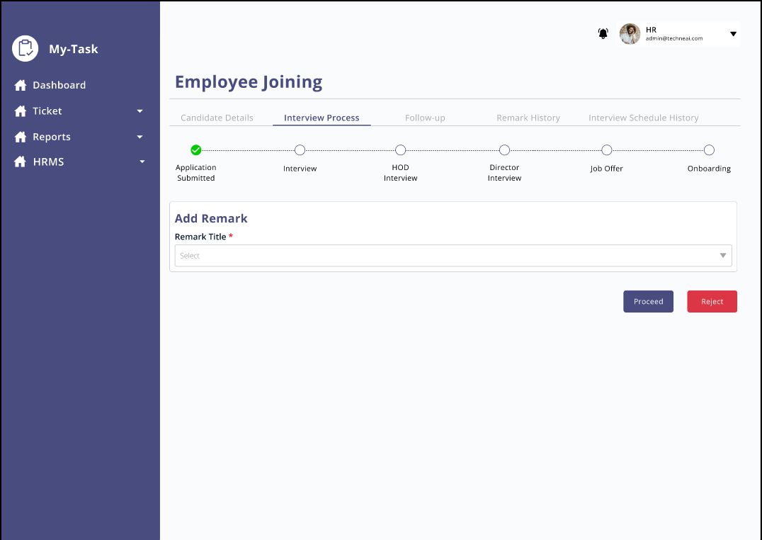

Img: Screen after clicking on action button at candidate details page

**Proceed:**

If the user decides to proceed ahead with the candidate and clicks on proceed button, user should be able to view ‘Schedule Interview’ button.

* **Schedule Interview:**

Users should be able to schedule an interview by clicking on date and time. Successful message pop up should be displayed on screen after the user has scheduled the interview.

Post Condition:

1. Once the interview is scheduled, the record should be visible in the interview schedule history tab
2. Once the user schedules the interview, Candidate and the interviewer should receive email and WhatsApp with the details of interview.
3. User should be able to view ‘Reschedule’ and ‘Send interview link/location’ buttons on the screen

* **Reschedule Interview:**

Users should be able to reschedule the interview by clicking on date and time. Once the user reschedules the interview, the reschedule history should be maintained in the interview schedule history tab.

* **Send interview link/location:**

Once the interview is scheduled and the date and time is confirmed by the candidate, users should be able to send link/location for interview from the system by clicking on the button. Users will input the link/location and upon clicking on send button, candidate and the interviewer will receive it over the WhatsApp and email.

* Proceed:

Once the user clicks on proceed button after the schedule button appears on the screen, it specifies that the candidate has cleared the interview, and the system will move ahead with the next round of interview/joining process.

**Reject:**

If the user clicks on the reject button, the application journey should be aborted at that point.

Pre-Condition: User must specify the reason of rejection by inputting the remark which will be fetched from the remark master.

Validation: Employer should not be able to go to next menu.

* The cycle after the processing of candidate will be repeated for the steps count mentioned in the interview master.

Eg, If the user has specified 4 steps in the interview master for a specific designation. The process of Schedule Interview>> Reschedule (In case of rescheduling interview)>> Send interview link/location)>> updating remark will go on for 4 times with condition applied the candidate has successfully passed the interview round. If the candidate gets rejected in any step the process will be halted at that point.

* **GENERATE OFFER:**

Feature Overview:

* Once the candidate passes all the interview rounds, the user should be able to send an offer to the candidate.
* Once the entry user enters the role, location, relevant experience, experience level, max salary, preferred salary the system will display the max salary which can be offered by company as per settings in the salary master.
* If the preferred salary conveyed by the candidate and the salary set by company matches or the candidate agrees to the negotiation done by user, user will proceed to the employee joining form. In case the candidate does not agree to the negotiation, the user will update the salary and submit it for approval to the higher authority.
* The higher authority will receive the details input and can either directly send a joining form to the candidate or enter the salary which can be delivered and submit it.
* Upon receiving the negotiated updated salary from higher authority HR can revise the offer and the cycle will be repeated or reject, send joining form to the candidate
* HR and Senior HR can send joining form to the candidate at any time or reject the candidate.
* Salary negotiation history will be maintained on the same screen as by HR and higher authority.
* On sending the joining form to the candidate, HR professionals still have the option to reject the candidate and abort the process.

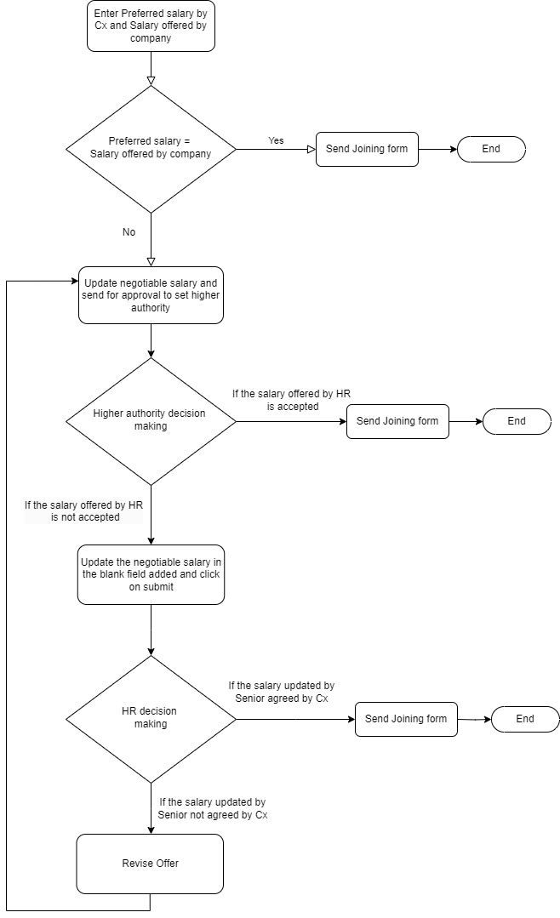FIELD DESCRIPTION:

|  |  |  |  |
| --- | --- | --- | --- |
| FIELD | INPUT TYPE | MANDATORY/OPTIONAL | DESCRIPTION |
| Role | Dropdown | Mandatory | Will be fetched from role master.  Validation:  Single selection |
| Location | Dropdown | Mandatory | Will be fetched from the branch master  Validation: Single selection |
| Relevant Experience | Dropdown | Mandatory | Validation: |
| Experience level | Dropdown |  |  |
| Current Salary | Text | Mandatory | Pre-Condition:  If the experience is selected as Fresher then this field should not be populated.  Validation:  Should accept numbers only |
| Preferred salary | Text | Mandatory | Validation:  Should accept numbers only. |
| Negotiable salary | Text | Mandatory | The salary set in the system should be auto populated once the role and location is selected.  Validation:  Field shoule be editable  Should accept numbers only. |
| Submit for approval | Button | - | Once the user clicks on submit for approval, the request to review add updated negotiable salary should be sent to set higher authority. |
| Send Joining form | Button | - | Once the user clicks on this button, candidate should receive then joining form on email and WhatsApp. |
| Revise Offer | Button | - | If the users want to revise the offer and wants to repeat the negotiation cycle, then the user can click on the revise offer button.  Post Condition:   1. A back button should be displayed in case the user doesn't want to go ahead with the revise offer option. 2. Negotiated salary input field should be displayed to input the updated salary. |

* **SALARY NEGOTIATION ACTIVITY:**

The salary negotiation history will be maintained in this section:

Below fields will be displayed in this section:

* Sr No
* Salary
* Negotiated salary
* Created at
* Created by
* Updated at
* Updated by

Eg, If the first salary input by HR is 25k on 2nd November, and is sent for approval to senior HR and it gets updated to 24k on 3rd November then:

|  |  |  |  |  |  |  |
| --- | --- | --- | --- | --- | --- | --- |
| Sr No | Salary | Negotiated Salary | Created at | Created by | Updated at | Updated by |
| 1 | 25000 | - | 2/11/2023 | HR |  |  |
| 2 | - | 24000 |  | Senior HR | 2/11/2023 | Senior HR |

* **JOINING FORM:**

Once the salary negotiation is done, the user should be able to send a Joining letter to the candidate from the system. Once the user proceeds to send the joining form, the candidate should receive the on boarding message and email on the registered mobile number.

* 1. **ONBOARDING**

Once the candidate receives the job offer and the candidate accepts the offer, on boarding process will end.

In case, after sending the joining form candidate does not want to join, user can still reject the candidate and close the process.

**ADDITIONAL FEATURE:**

* Upon clicking on Proceed, reject the step should be marked with green ticket, red ticket respectively.

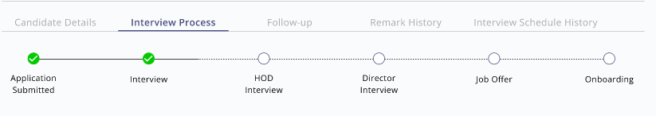

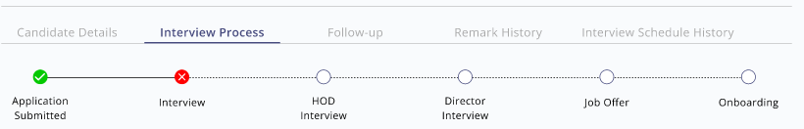

* **FOLLOW UP:**

Feature Overview:

In this tab, users can add follow up details discussed with the candidate in this section.

Users can add text, next follow up date and time, attachment. These details added will get saved and users can view the history of follow up details on the same page.

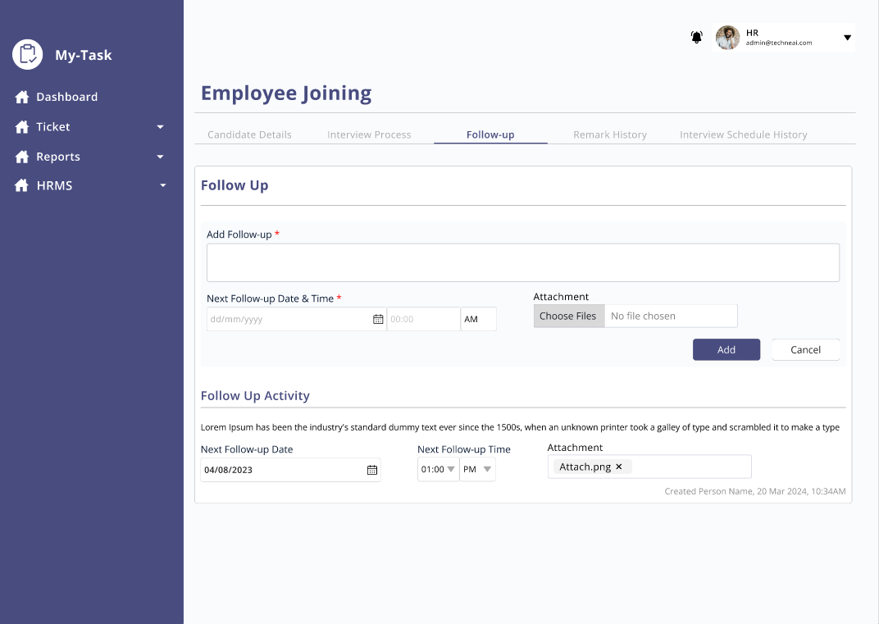

This tab contains below fields:

* Add Follow up
* Next Follow up date and time
* Attachment
* Add
* Cancel
* Follow up activity

Field Description:

|  |  |  |  |
| --- | --- | --- | --- |
| FIELD | INPUT TYPE | MANDATORY/OPTIONAL | DESCRIPTION |
| Add follow up | Text | Mandatory | To add follow-up details.  Validation: Should accept alpha numeric, special characters up to 1000 |
| Next Follow up date and time | Date and time | Mandatory | User should be able to add date and time of next follow up to be taken of candidate up to be ta |
| Attachment | All formats | Optional | Users should be able to add attachment if any.  Validation:  Single file selection.  File format: Jpg, jpeg, pdf, docx, csv |
| Add | Button | - | To add follow up details.  Once the user clicks on the button, follow up details should be saved, and the history should be reflected on the same page.  The data should be cleared from the text box, next follow up date and time, attachment. |
| Cancel | Button | - | Once the user clicks on the cancel button, data should be cleared, and the details should not be saved. |
| Follow up activity | - | - | The history of follow up added should be visible in this section.  Along with all the details added, below details should be visible:   * Created by- Username of the person who has added the record. * Date and time- date and time the follow up was added |

* **REMARK HISTORY TAB**

Once the user adds the remark on every step of interview, the history should be saved in this section automatically.

Along with remark, the username of the person who has posted the remark, date and time the remark was added should be displayed.

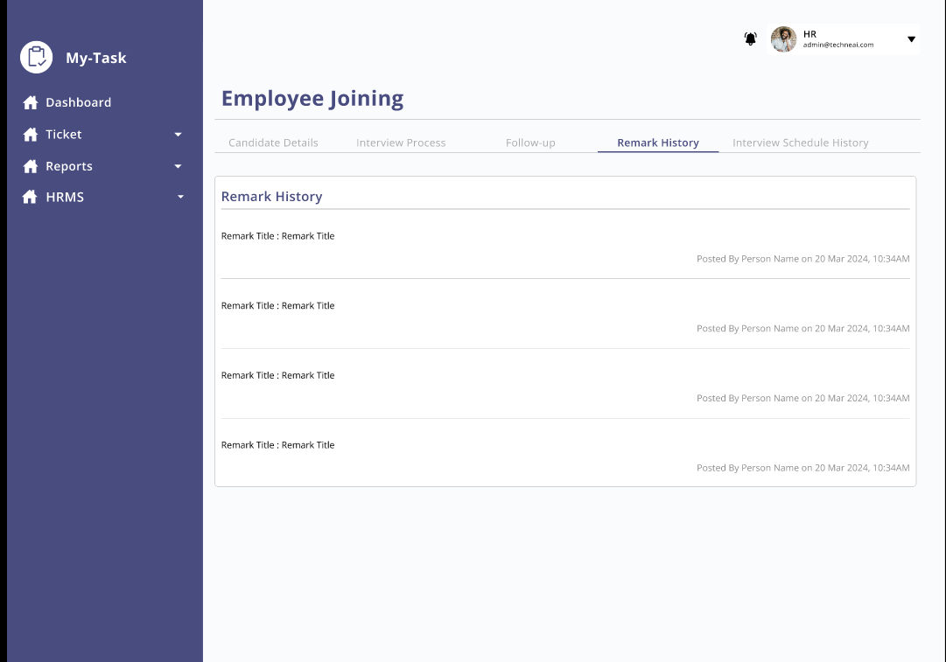

* **INTERVIEW SCHEDULE HISTORY TAB**

The history of the interview schedule should be displayed in this tab.

Below fields will be present in this tab:

* Sr No
* Status
* Schedule time and date
* Created at
* Created by
* Updated at
* Updated by

|  |  |  |  |
| --- | --- | --- | --- |
| **FIELD** | **INPUT TYPE** | **MANDATORY** | **DESCRIPTION** |
| Sr No | - | - | To display the serial number |
| Status | - | - | If the interview scheduled for the first time then the status should be Schedule and if the interview is rescheduled the status should be rescheduled. |
| Created at | - | - | The date and time of the interview scheduled should be displayed. |
| Created by | - | - | The username of the interview scheduler should be displayed |
| Updated at | - | - | The rescheduled interview date and time should be displayed |
| Updated by | - | - | The username of the interview re scheduler should be displayed. |

* 1. **ASSESSMENT MASTER**

Assessment master is designed to set the assessment against department, designation and experience level. It will help recruiting manager to send the assessment in no time and without any hurdle as per the candidate profile.

The assessment master will have below fields :

* Add Assessment
* Search
* Export
* Reset
* Sr No
* Action
* Department
* Experience level
* Upload file
* Designation
* Created at
* Created by
* Updated at
* Updated by

|  |  |  |  |
| --- | --- | --- | --- |
| **FIELD** | **INPUT TYPE** | **MANDATORY/OPTIONAL** | **DESCRIPTION** |
| Add Assessment | Button | - | To add assessment in the master.  Once the user clicks on the button, a pop up should be displayed. |
| Search | Text | - | User should be able to search by designation, department name. |
| Export | Button | - |  |
| Reset | Button | - | To reset the search data. |
| Action - Edit, Download | - | - | How can we edit the assignment, option to un select should be given. |
| Department | Dropdown | Mandatory | User should be able to select the department. This department will be fetched from the department master. |
| Experience level | Dropdown | Mandatory | User should be able to select the experience level. |
| Designation | Dropdown | Mandatory | User should be able to select the department. This department will be fetched from the designation master. |
| Upload File | File | Mandatory | User should be able to upload the assessment file which will be set against the selected department, designation and experience level.  The system should support below file formats - pdf, word file |
| Add | Button | - | Add assessment>>  Pre Condition:   * User must fill all the mandatory details before clicking on this field. * If the user tries to add the data without filling mandatory details, system should throw error. |
| Update | Button | - | Edit>>  Pre Condition:   * User must fill all the mandatory details before clicking on this field. * If the user tries to update the data without filling mandatory details, system should throw error. |
| Cancel | Button | - | User should be able to cancel the selection.  Post Condition-   * If the user cancels the selection, it should be redirected to the grid page of assesment master. * The data should be cleared. |

Below fields will be visible in the grid view, add, edit

|  |  |  |  |
| --- | --- | --- | --- |
| **FIELDS** | **GRID** | **ADD** | **EDIT** |
| Add Assessment | ✔ | x | x |
| Search | ✔ | x | x |
| Export | ✔ | x | x |
| Reset | ✔ | x | x |
| Sr No | ✔ | x | x |
| Action | ✔ | x | x |
| Department | ✔ | ✔ | ✔ |
| Experience level | ✔ | ✔ | ✔ |
| Upload file | ✔ | ✔ | ✔ |
| Designation | ✔ | ✔ | ✔ |
| Created at | ✔ | x | x |
| Created by | ✔ | x | x |
| Updated at | ✔ | x | x |
| Updated by | ✔ | x | x |
| Add | x | ✔ | x |
| Update | x | x | ✔ |
| Cancel | x | ✔ | ✔ |

1. **TEST DATA**



1. **REFERENCES OF THE USERS**

|  |  |  |  |
| --- | --- | --- | --- |
| **User** | **Name** | **Mail** | **Contact number** |
| **Actual user** |  |  |  |
| **Ticket created by (if any)** |  |  |  |
| **Assigned business analyst** |  |  |  |
| **Assigned developer** |  |  |  |
| **Assigned tester** |  |  |  |