26.04.2023

**Handover Document**

**CONTENTS**

1. VERSION CONTROL 2

2. INTRODUCTION 2

3. SCOPE 2

4. BUSINESS & SYSTEM RULES 2

5. ABBREVIATIONS & TERMS 2

6. GRAPHICAL REPRESENTATION 2

7. DEVELOPED SYSTEM 2

1. **VERSION CONTROL**

|  |  |  |  |  |  |  |
| --- | --- | --- | --- | --- | --- | --- |
| **Sr. No** | **Version no** | **Version Date** | **User name** | **User department** | **Updated By** | **Ticket ID** |
| 1. | 1.1 | 21/05/2024 | Sanika Dewoolkar | IT Implementation | Sanika Dewoolkar | TT19686 |

1. **INTRODUCTION**

Once the ticket is raised by user, unique ticket ID is generated. Through this development, we have made provision, wherein, tenant can define the ticket ID series for themselves.

1. **SCOPE**

This ticket outlines the addition of below fields:

* ‘Ticket ID series’ field in the tenant master
* Add filters for customer’s user login

1. **BUSINESS & SYSTEM RULES**

* User should be registered in the system.
* User should be logged in.
* System should display error message for incorrect details if entered.
* System should pop up a message, if any issues in the system is detected.
* All forms should have on field validations. System should display on field errors in case of incorrect inputs

1. **DEVELOPED SYSTEM**

**BR0001: Add Ticket ID Series field**

In tenant master, ‘Ticket ID Series’ field will be added.

A ticket ID series typically refers to a sequential numbering system used to uniquely identify tickets or requests within a system.

Each time a new ticket is created, it is assigned a unique ticket ID from the series, often incrementing by one for each new ticket.

|  |  |  |  |
| --- | --- | --- | --- |
| **FIELD NAME** | **INPUT TYPE** | **MANDATORY/OPTIONAL** | **DESCRIPTION** |
| Ticket ID Series | Text | Mandatory | Ticket ID series field will be in below format:  __ __ 0001  User will be able to input alphabets in both the blank spaces.    Validation:   * Only capital letter alphabet should be accepted * If the user tries to input symbols, numeric data, or small case letters then the system should throw errors. * Ticket ID Series can be duplicate.   Once the user sets the series, the ticket generated should be reflected with the changes. |

Tenant Master:

Ticket ID Series should be displayed in below views for Customer master and Tenant master:

|  |  |  |  |
| --- | --- | --- | --- |
| **FIELD** | **GRID VIEW** | **ADD** | **EDIT** |
| Ticket ID Series | ✓ | ✓ | ✓ |

**BR0002: TO ADD FILTERS FOR CUSTOMER USERS:**

**The search result of filters should include tickets related to Customer’s users only. Customer users should not be able to view tickets of users/department of tenant.**

The filters on the page should consist of the following.

* User
* Department

Input table

|  |  |  |  |  |
| --- | --- | --- | --- | --- |
| **Fields** | **Input type** | **Mandatory/ Optional** | **Editable/ No** | **Description** |
| User | Drop down | Optional | - | The user related to that ticket creation user should be selected from the drop down. The drop-down options are fetched from the user master.    Validation:   * The active and deactivated users are fetched from the user master. * Multiple selection |
| Department | Drop down | Optional | - | The department of the user related to that either ticket creation user or ticket assigned user is selected from the drop down. The drop-down options are fetched from the department master.  Validation:   * The department of active and deactivated users is fetched from the department master. * Multiple selection |

**FILTER**

The filter button should consist of the following fields.

* Assigned department
* Assigned user
* Entry department
* Entry user

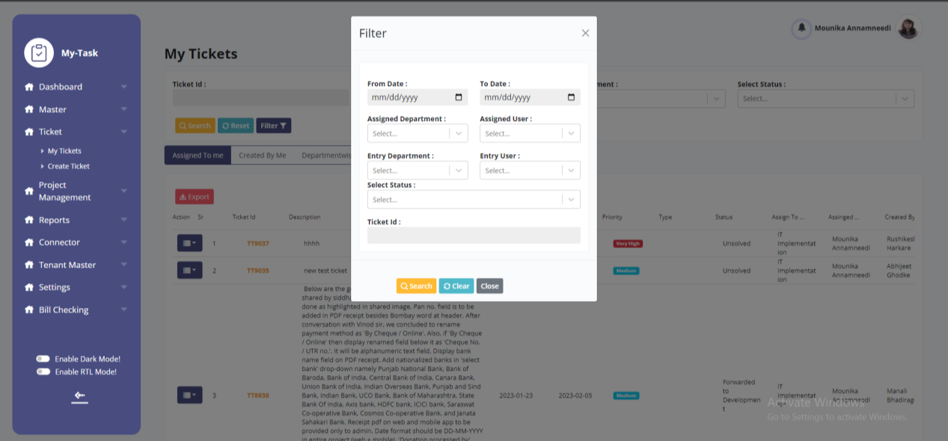

Input table

|  |  |  |  |  |
| --- | --- | --- | --- | --- |
| **Fields** | **Input type** | **Mandatory/ Optional** | **Editable/ No** | **Description** |
| Assigned department | Drop down | Optional | - | The assigned department filter consists of the departments to which department the ticket is assigned to. The assigned department field is fetched from the department master (the records which are in active and deactivated status) (in ticketing system >> masters >> department master).    Validation:  Multiple selection. |
| Assigned user | Drop down | Optional | - | The assigned user filter consists of the users to whom the ticket is assigned. The assigned user field is fetched from the user master (the records which are in active and deactivated status) (in ticketing system >> masters >> user master). if assigned department filter is selected, then the users mapped against those departments to be displayed.    Validation:  Multiple selection |
| Entry department | Drop down | Optional | - | The entry department filter consists of the departments from which the ticket is created. The entry department field is fetched from the department master (the records which are in active and deactivated status) (in ticketing system >> masters >> department master).    Validation:  Multiple selection |
| Entry user | Drop down | Optional | - | The entry user filter consists of the users by whom the ticket is created. The entry user field is fetched from the user master (the records which are in active status) (in ticketing system >> masters >> user master). if entry department filter is selected, then the users mapped against those departments to be displayed.    Validation:  Multiple selection |