[Connect-us

Sales Incentive

New Structure]

14.09.2023

Priyanka Suhas Gole

Priyanka.gole@techneai.com

**Functional Requirement Document**

**CONTENTS**

1. TICKET DETAILS 2

2. VERSION CONTROL 2

3. APPROVALS 2

4. ESTIMATION 2

5. INTRODUCTION 3

6. BUSINESS REQUIREMENT 3

7. SCOPE **Error! Bookmark not defined.**

8. BUSINESS & SYSTEM RULES 4

9. ABBREVIATIONS & TERMS **Error! Bookmark not defined.**

10. EXISTING SYSTEM 4

11. GRAPHICAL REPRESENTATION **Error! Bookmark not defined.**

12. PROPOSED SYSTEM 4

13. TEST DATA **Error! Bookmark not defined.**

14. ODUS **Error! Bookmark not defined.**

15. REFERENCES OF THE USERS 12

1. **TICKET DETAILS**

|  |  |
| --- | --- |
| **Ticket ID** | TT16520 |
| **Ticket description** | Sales Incentive New Structure |
| **Created by** | Priyanka Gole |
| **Created on** | 14-09-2023 |
| **Priority** | Very High |

1. **VERSION CONTROL**

|  |  |  |  |  |
| --- | --- | --- | --- | --- |
| **Sr. No** | **Version no** | **Version Date** | **User name** | **User department** |
| **1** | **1** | **14-09-2023** | **Dinesh Sonawane** | **Audit Department** |
| **2** | **2** | **10-11-2023** | **Dinesh Sonawane** | **Audit Department** |
| **3** | **3** | **28-12-2023** | **Dinesh Sonawane** | **Audit Department** |
| **4** | **4** | **03-01-2024** | **Dinesh Sonawane** | **Audit Department** |

1. **APPROVALS**

|  |  |  |
| --- | --- | --- |
| **Field** | **Name of the User** | **Approved date by the user** |
| **Actual User Name Actual User Department Organization Name** | Dinesh Sonawane  Audit Department  CSPL | 25-09-2023 |
| **Assigned BA** | Priyanka Gole |  |
| **Assigned Developer** | Prathmesh Shinde, Punam Shinde |  |
| **Assigned Tester** | Preeti Bokade, Prathmesh kulkarni |  |

1. **ESTIMATION**

|  |  |  |  |  |
| --- | --- | --- | --- | --- |
| **Department name** | **Estimated Time (In hr)** | **Scheduled Date (Starting date)** | **Estimated date** | **Actual delivery date** |
| **BA** | 10 | 14-09-2023 |  |  |
| **Development** |  |  |  |  |
| **Testing** |  |  |  |  |
|  |  |  |  |  |

1. **INTRODUCTION**

We are developing a new structure for sales incentive. Sales Incentive is the reward offered to individuals or teams in a organization as a motivational tool to encourage them to achieve specific sales goals, targets, or performance objectives. These incentives can come in monetary bonuses and they are designed to boost sales performance, increase motivation, and drive revenue growth within a company. Sales incentives help align the interests of salespeople with the organization's goals, fostering a competitive and driven sales culture.

In this module, we will explore the new structure of sales incentive calculations that we are implementing. This exciting change is aimed at enhancing the motivation and performance of our sales team while aligning with our strategic goals.

Sales incentives are a crucial component of our sales strategy, motivating our sales force to achieve their targets and drive revenue growth. In this section of the BRD, we will outline the key changes and improvements in how we calculate and administer sales incentives.

This section will serve as a comprehensive guide to the updated methodology, criteria, and processes involved in determining sales incentives. This document will provide you with a clear understanding of the new incentive structure and its implications.

Let's explore the exciting changes and enhancements in our sales incentive calculation methodology together, ensuring that our sales force is motivated and well-rewarded for their outstanding efforts in driving our business forward.

1. **BUSINESS REQUIREMENT**

|  |  |  |
| --- | --- | --- |
| **Requirement ID** | **Requirement Name** | **Priority** |
| BR001 | Product wise, grade wise incentive generation for Sales Emp | High |
| BR002 | Bhishi Linked Diamond | High |
| BR003 | Bhishi 2 X conversion | High |
| BR004 | Business Mix for Sales Emp | High |
| BR005 | Business Mix for CM, BM, OM, FM | High |
| BR006 | Regular Bhishi Incentive | High |
| BR007 | Negative impact on Incentive | Medium |
| BR007.1 | Negative Impact on Incentive -Non purchase Customer | Medium |
| BR007.2 | Negative Impact on Incentive - Ticket Size | Medium |
| BR008 | Employee wise detail Incentive Report | Medium |

1. **SCOPE**

Scope of this project is to generate sale incentive for sales Employee.Through multiple ways sales employee will get incentive. Upon generation of total incentive, there are some conditions which will affect on incentive payout. Prepare new reports to show employee sales incentive, bhishi Incentive and Bhishi Linked Diamond Incentive, Bhishi 2X conversion. In this new system we will generate monthly incentive.

1. **BUSINESS & SYSTEM RULES**

* **Prerequisite**
  + Set Branch wise Monthly Target
  + Set Counter wise Target group mapping
  + Set Branch wise counter wise targets
  + Set counter Employee mapping
  + Set Grade to sales Employee
  + Grade wise employee Target generation
  + Daily Synch Sales, Sales return data
* **Business Rules**
  + Branch should achieve min 50% revised target for incentive payout.
  + Sales Employee should achieve min 50% revised target for incentive payout.
  + In addition to sales Incentive Employee will get other incentive also like bhishi linked diamond, Bhishi 2X conversion, Bhishi Incentive if he/she is achieving respected targets.
  + After final generation of incentive, there are 2 negative impacts like non purchase customers and ticket size. If any of these not achieved then 5% incentive will be deducted from overall incentive except bhishi incentive.
  + If both negative impacts not achieved then 10 % will be deducted from total incentive amount expect regular bhishi incentive

# ABBREVIATIONS & TERMS

GO - Gold Ornament

SO - Silver Ornament

CT - Diamond Carat

Gm - gram

SS - Sterling Silver

# EXISTING SYSTEM

In the existing system, Incentive was calculated and paid Quarterly but in the new incentive structure, incentive calculated and paid monthly.

Employee wise incentive calculation was based on grades and target achievement slabs, but now it is based on sold netwt or amount of the product group.

There was no any negative impact except min branch branch target. But now we have introduced 2 negative impacts as Non purchase customers and ticket size.

1. **PROPOSED SYSTEM**

**BR001: Product Group wise Sales Incentive for Sales Employee**

Check the item is star product

Use the star product rates and calculate incentive

**YES**

**NO**

Use the star product rates and calculate incentive

Check the item is small product

**YES**

**NO**

Check the item is sterling silver product

**YES**

Use the sterling silver product group wise incentive rates and calculate

**NO**

Use the star product rates and calculate incentive

Check target group of the item

**YES**

Make the employee wise addition of all types of incentives

* **Create Master for Product Group wise Sales Incentive Rate**

|  |  |  |  |  |  |  |  |
| --- | --- | --- | --- | --- | --- | --- | --- |
| **Grade** | **GO** | **Diamond** | **SO** | **SS** | **Bhishi Additional** | **Gold small/ star product** | **Silver small/star Product** |
| **Rates On** | **Gm** | **CT** | **Gm** | **Gm** | **CT** | **Gm** | **Gm** |
| **A** | 4 | 500 | 1 | 5 | 50 | 10 | 1.5 |
| **B** | 3 | 400 | 0.70 | 3 | 50 | 8 | 1 |
| **C** | 2 | 300 | 0.50 | 2 | 50 | 6 | 0.6 |

* For the Sale Employee, Incentive generated based on grade. In case of Gold Ornament, Silver Ornament and sterling silver total of net wt sold is considered to calculate incentive.
* We will get product wise data from below path

Sales Incentive --> Sales Transaction ---> Select period, Branch and filter --> select target group wise counter and employee from the action buttons. -->You will get data for product/Target group wise employee wise targets and achievements.

OR

Sales Incentive --> Sales Transaction ---> Employee wise target setting --> Check Actual sale in Qty I.e Actual sale in Qty = Total sale in Qty - Sales Return Qty

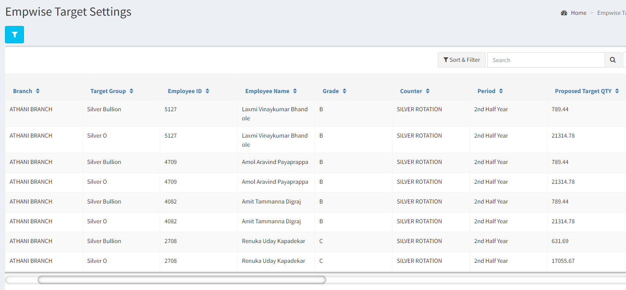

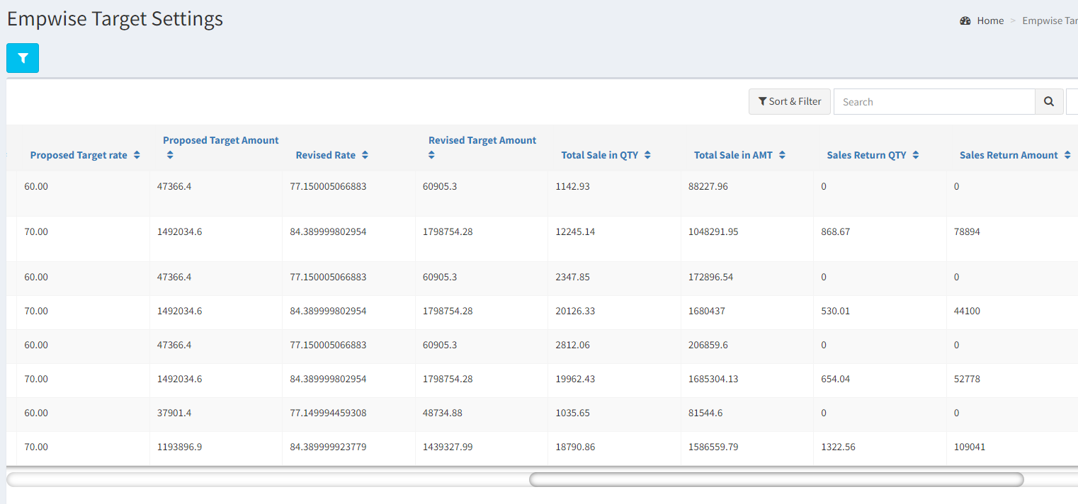

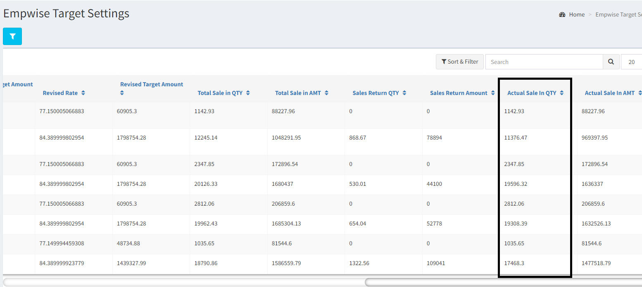

Explanation :

* In case of Gold O target group, incentive is depend on the gm.

If a sales employee sold 1342.31 gm in Nov- 2023 period and grade is A, then he should get gold incentive **1342.31*4 = 5,369.24 rs.**

* Same calculation for Silver O
* In case of Diamond incentive 500 rs per CT means he sold 3.62 CT, in NOV -2023 and grade is ‘A’ then **3.62 *500 = 1810** is the diamond incentive.
* In case of sterling silver product group, Sterling silver si para type is defined against item in the item master.

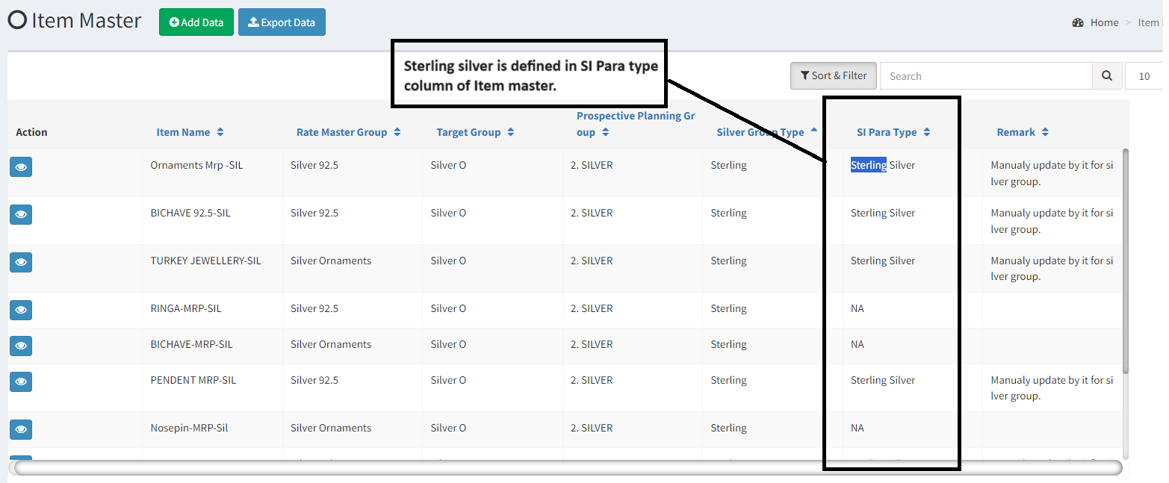

* Bhishi Additional Incentive is the bhishi linked diamond incentive, explained below BR002.
* In case of silver/gold small product, define product group wise small product in item master. Rates are defined in above chart.
* In case of start product, 180 days above from the labeling date is considered as star product. Rates are defined in the above chart.
* Club together all types of incentive as the final incentive.

Explanation: If the 1 Cr is revised target of sales Employee for a month and 10% to 12 % diamond business mix target (10 to 12 lakh)is achieved then

50 Rs per CT will be additional incentive. If the Sales Employee having “A” grade then 500+50 = 550 will be additional incentive. Considering 1lakh per CT.

Condition

* Min 50% branch wise target 50% should be achieved.
* Min Sales employee wise revised target excluding gold and silver Bullion 50% should be achieved.
* Star Product = Above 180 days from labeling date

At the time of Incentive calculation, check the product labeling date is above 180 days. If it is star product then consider star product incentive rate (last column)

List of the small products

**[SI\Small Ornament & Star Product Definition.xlsx](SI/Small Ornament & Star Product Definition.xlsx)**

**BR002 : Bhishi Linked Diamond Incentive**

Check bhishi target achieved target achieved

**NO**

Set branch wise designation wise bhishi target

Do not generate Incentive

**YES**

Check branch achieved revised target > 50%

**NO**

Do not generate Incentive

**YES**

Additional incentive calculated on diamond CT *50 (as per setting in below table)

* Bhishi linked Diamond means to give additional incentive on diamond incentive per CT provided 100 % bhishi target is achieved.
* Bhishi achievement is depend on the bhishi enrollment amount in a month. If the bhishi closed before 150 days from starting date then it is prematurely closed. Prematurely closed bhishi amount will not be considered in bhishi target achievement. Prematurely closed bhishi amount will be deducted from the total enrollment amount, and it will be considered as bhishi target achievement.
* **Set Bhishi linked diamond Target in Bhishi Target Setting**

|  |  |  |  |
| --- | --- | --- | --- |
| **Branch** | **Designation** | **Bhishi Linked Diamond Target** | **Bhishi 2X Conversion Incentive Rate** |
| Pune Branch | Sales Executive | 50,000 | 700 |
| Chinchwad  Branch | Sales Executive | 40,000 | 800 |

* You will get bhishi Details from below path

Sales Report --> Employee Reference Report --> Select From Date ---> Select To date

Select Cluster ---> Select Schemes (All Scheme)

Premature closed bhishi amount will be removed from here, it is not working now.

Depends on premature closed bhishi, target achieved will get find out.

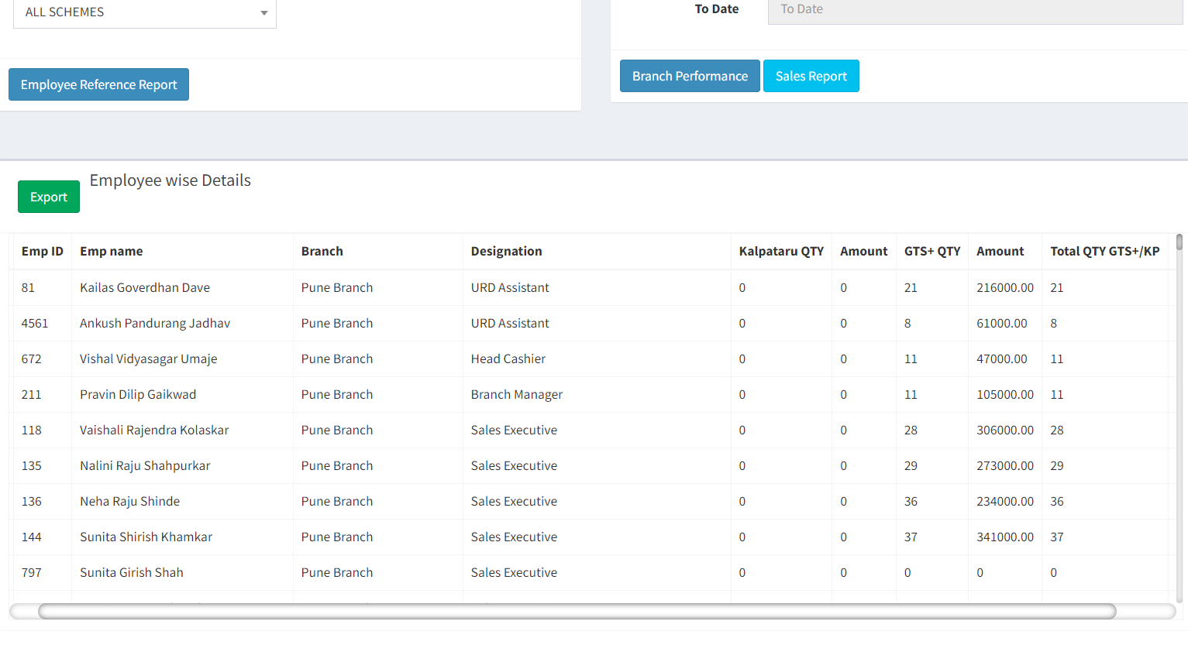

Another option is to get details directly from the POS system - padm.

Process :-

1. Download Close Report of " GTS ACCOUNT CLOSE REPORT - DA TEAM" from UDR
2. Download "Saving Scheme Redemption Voucher" from UDR.
3. Compare with last 6 Months Enrollment Data.
4. Find out data of below 150 days.
5. Remove redemption amount of premature closed bhishi in the same month of incentive. Finalize report.

Check the attachments, here test data is prepared

[SI\Premature Bhishi closed.xls](SI/Premature Bhishi closed.xls)

* You will get Diamond target achievement from below path

Sales Incentive --> Sales Transaction --> Select Period --> Select Branch --->Filter

* ---> Select Target group as Diamond ---> Go to counter wise Target ---> Employee wise target action button ---> Here you will get Employee wise Diamond CT.

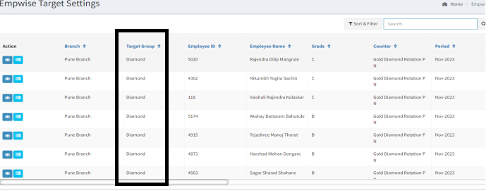

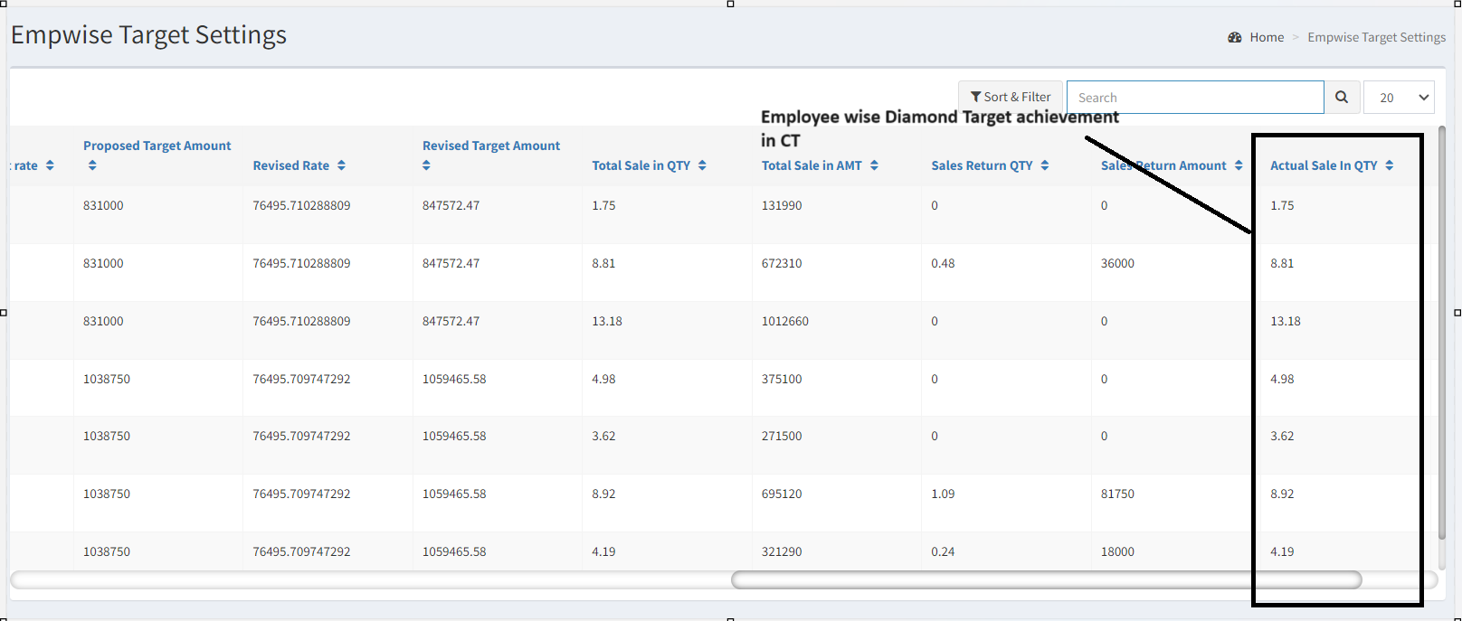

* Example1 : If Bhishi target is 50K and Diamond target is 10CT
* If bhishi target is fully achieved then only, sales executive will get bhishi linked diamond incentive based on diamond CT sold. I.e 10
* condition
  + Branch should achieve min 50% revised target for incentive payout.
* Sales Employee should achieve min 50% revised target excluding gold and silver Bullion for incentive payout.
* **Bhishi Linked Diamond Incentive Report**

This report will show details of employees for bhishi linked diamond Incentive with target and incentive amount.

* Filters
* Period : Period Master
* Branch : Branch Master where incentive applicable is ‘YES’
* Cluster : Branch Master cluster

|  |  |  |
| --- | --- | --- |
| **Field Name** | **Fetched From** | **Description** |
| Branch | Selected in Filter | Display branch, which is selected in the filter. |
| Period | Selected in Filter | Display Period, which is selected in the filter. |
| Cluster | Selected in Filter | Display Cluster, which is selected in the filter. |
| Employee ID | Fetched from Employee Master | It is the list of employee Ids of selected branch having designation as ‘sales Executive ’. |
| Employee Name | Fetched from Employee Master | It is the list of employee Ids of selected branch having designation as ‘sales Executive ’. |
| Designation | Fetched from Employee Master | Show designation of employee |
| Diamond CT | Fetched from Period wise target setting | Show diamond CT achieved by the employee in selected period. |
| Bhishi Target | Fetched from Bhishi Target setting Master | It is defined in the Bhishi Target setting master |
| Bhishi Linked Diamond Incentive | Calculated | Depends on the Diamond CT and Bhishi Target |

**BR003 : Bhishi 2 X conversion**

Bhishi 2X conversion Target is depend on bhishi redemption amount.

Check the redemption amount of bhishi (except bullion)

Check employee wise bhishi closed in a month (except prematurely closed bhishi)

Check the sale asscociated with bhishi in padm

Set the bhishi 2X conversion target on bhishi redemption amount

Check for branch revised target >50% and sales person target >50%

Check Target Vs Sale 100 % achieved

Pay incentive as “bhishi 2X conversion” 700Rs

* **Master To set Bhishi 2X conversion Incentive Rate.**

|  |  |  |
| --- | --- | --- |
| **Branch** | **Designation** | **Bhishi 2X Conversion Incentive Rate** |
| Pune Branch | Sales Executive | 700 |
| Chinchwad Branch | Sales Executive | 800 |

**If the 2X conversion target achieved then sales person will be eligible for 2X conversion incentive with above incentive rate.**

**Explanation is given below.**

Bhishi Redemption amount is the total installments amount paid of closed bhishi in a month

Do not consider Gold Bullion/Silver Bullion redemption sale in target and achievement.

* We will get Employee wise redemption amount to check Bhishi Target achievement from below path

Check the attachment --------

1. Download padm UDR report - UDR - SALES REGISTER RCD-Mobile No. 1 updated_08_12_2023 11_17_42
2. Perform 2X target calculation based on Item amount of GTS Order sales bill and Kalpataru Order Sales Bill
3. You will get data of Sales person wise 2 x conversion achievement for a month.
4. If the achievement is 200% or more then he will be eligible for bhishi 2X conversion incentive I.e 700 rs.
5. Redemption bhishi [Bhishi Redemption data.xlsx](C:\\Users\\User\\Downloads\\Bhishi Redemption data.xlsx)Test data given in below file

* Explained in below example

**Example1**:

Suppose 3 customers closed bhishi of 1lakh each then

Gold O = redemption 1 lakh (sale 3 lakh)

Gold Bullion =redemption 1 Lakh (sale 2 lakh)

Diamond = redemption 1 Lakh then (Sales 2lakh)

2 lakh redemption except bullion so 2x conversion is 4 lakh will be target amount and 5 lakh will be achieved target amount. I.e 100 % achievement so

Additional incentive will be 700 (fixed amount) if target achieved.

If less than 100% achievement is there then, incentive will not get to sales employee.

**Example 2**

Suppose a employee, redeemed bhishi of 10 lakh amount and 2 lakh bullion

Then 8 lakh *2(2X conversion) = 16 lakh will be target amount

If 16 lakh target amount is achieved(100% target achieved then only ) in 700 will be additional incentive amount.

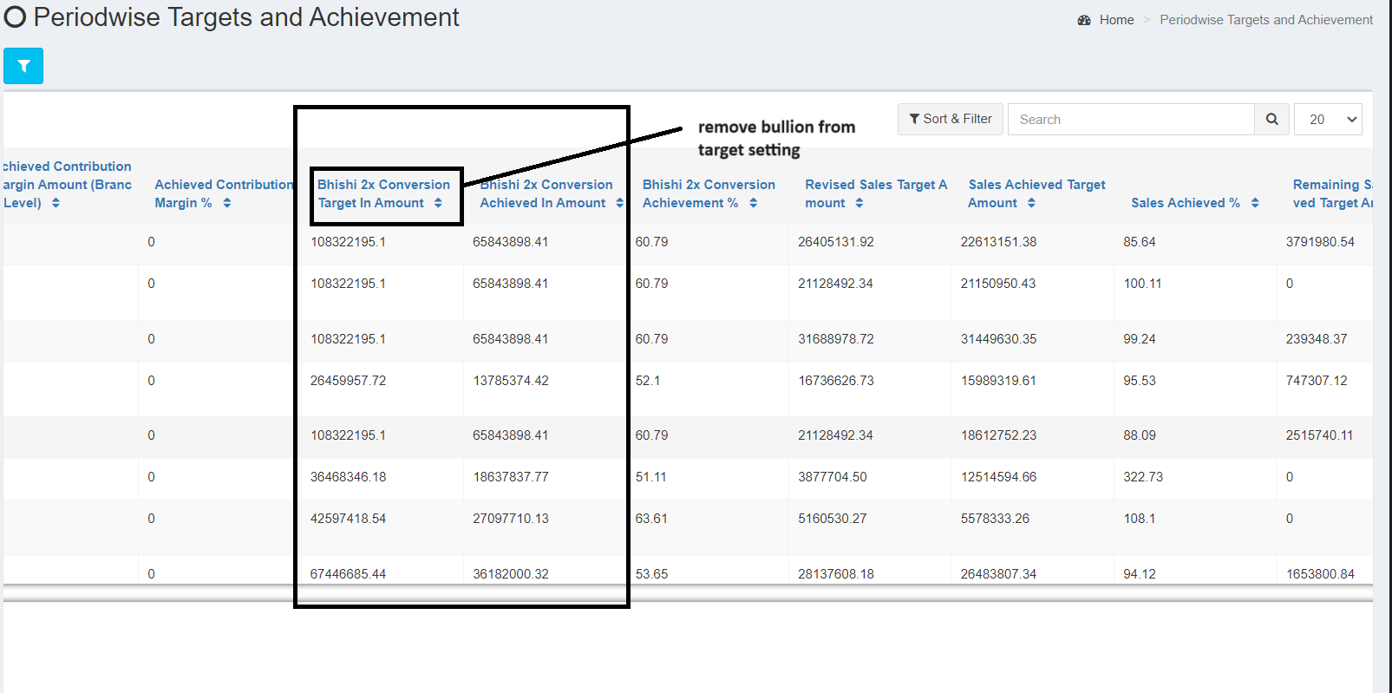

**In the existing System:**

Slab wise and grade wise incentive setting was done in **Designation wise grade wise Incentive setting menu** but now we are doing incentive on 100 % achievement of bhishi target.

Currently system showing branch wise Bhishi 2X conversion Target Amount and Bhishi 2X conversion Achieved Amount. Instead of that show sales employee wise targets and achievement

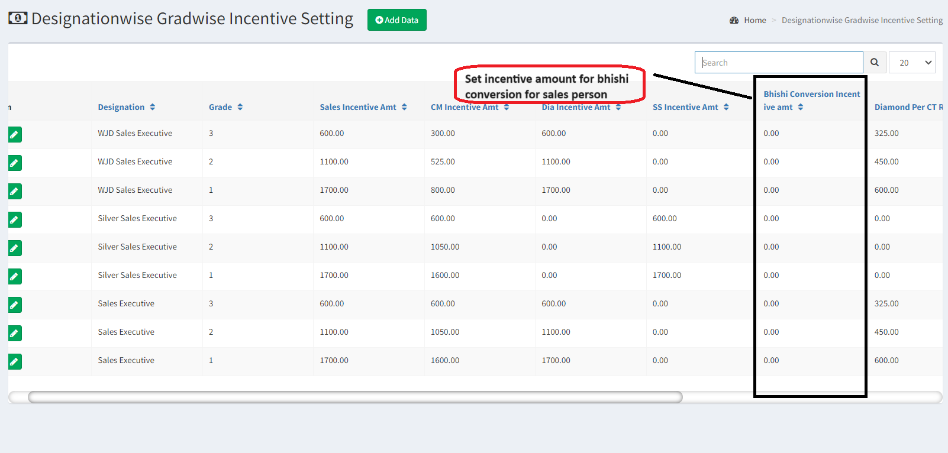

* **Create a View/Report to check employee wise Designation wise Bhishi redemption Target and applicable 2X conversion incentive**
* Filters
* Period : Period Master
* Branch : Branch Master where incentive applicable is ‘YES’
* Cluster : Branch Master cluster

|  |  |  |
| --- | --- | --- |
| **Field Name** | **Fetched From** | **Description** |
| **Branch** | Selected in Filter | Display branch, which is selected in the filter. |
| **Period** | Selected in Filter | Display Period, which is selected in the filter. |
| **Cluster** | Selected in Filter | Display Cluster, which is selected in the filter. |
| **Employee ID** | Fetched from Employee Master | It is the list of employee Ids of selected branch having designation as ‘sales Executive ’. |
| **Employee Name** | Fetched from Employee Master | It is the Name of employee of selected branch having designation as ‘sales Executive ’. |
| **Designation+** | Fetched from Employee Master | Show designation of employee. |
| **Bhishi Redemption Target** | It is calculated, based on bhishi redemption amount | Calculation shown above in explanation |
| **Bhishi 2X conversion incentive** | Fetched from bhishi Target Setting | It is the target set for branch wise designation wise |
| **Bhishi 2X conversion incentive amt** | Calculated | If the target achieved then employee will get full incentive amount else not. |

**BR004 : Business Mix**

Calculate incentive on diamond sold CT according to slab (2nd column)

Check slab wise Branch wise Diamond sale (I.e. Diamond Business Mix)

Check Branch wise Overall actual sale (sale-sales return) out of revised target

Check slab wise Branch wise Sterling Silver sale

(I.e. Sterling Silver Business Mix)

Calculate incentive on Sterling silver sold Gm according to slab(2nd column)

Check conditions given below if satisfied then pay incentive

Business mix is the term used to check how much diamond OR sterling silver actual sale (sales - sales Return) done out of overall branch wise revised target amount. Slab wise diamond business mix or sterling silver mix additional incentive rates are defined in below table.

**Create master to Set Diamond Mix and sterling silver Mix rates**

**Master: Diamond Business Mix Incentive rate Setting**

|  |  |  |
| --- | --- | --- |
| **Diamond** | **Diamond Incentive Additional Rates** | **Designation** |
| **0.00 to 9.99%** | 0 | Sales Executive |
| **10.00 to 11.99%** | 50 | Sales Executive |
| **12.00 to 14.99%** | 100 | Sales Executive |
| **15.00 to 16.99%** | 200 | Sales Executive |
| **17.00 to 19.99%** | 300 | Sales Executive |
| **20.00 to 24.99%** | 400 | Sales Executive |
| **Above 25 %** | 500 | Sales Executive |

**Sterling Silver Business Mix Incentive Rate Setting**

|  |  |  |
| --- | --- | --- |
| **Sterling Mix** | **Sterling Silver Incentive Additional Rates** | **Designation** |
| **0.00 to 7.99%** | 0 | Sales Executive |
| **8.00 to 11.99%** | 0.50 | Sales Executive |
| **12.00 to 14.99%** | 1 | Sales Executive |
| **15.00 to 16.99%** | 2 | Sales Executive |
| **17.00 to 19.99%** | 3 | Sales Executive |
| **20.00 to 24.99%** | 4 | Sales Executive |
| **Above 25 %** | 5 | Sales Executive |

* For the calculation of diamond Business Mix consider overall branch Plan target vs Diamond and Diamond Jewellery actual sale.
* Convert DJ net wt into CT.
* For the calculation of sterling silver business mix consider only silver Ornament, Silver Bullion and sterling silver. Vs sterling silver sale
* Example: For a particular Branch Revised Target amount is 1 Cr. Out of that 80 lakh is Gold sale considering gold jewellery and Gold Bullion. 10 lakh is the Diamond sale considering diamond jewellery and diamond. And 10 lakh is other,

then 10 lakh is the diamond business mix. In terms of percentage 10% is diamond business mix.

Suppose 5 lakh sterling is included in it then 5% is the sterling Silver business mix

In the above example 10% is the Diamond business mix and 5% is the sterling Business Mix. According to below slab setting 50Rs per CT will be additional incentive.

Sterling silver business mix will be calculated based on slab wise rs per gm of sterling silver.

Note: SS Mix = Sterling Silver Mix

* **Conditions:**
* Branch wise revised target achievement should be above 50%.
* Individual wise revised target achievement excluding gold and silver Bullion should be above 50 %.
* Branch wise Diamond Mix achievement out of revised target of branch should be above 10% for diamond mix additional incentive.
* Individual wise Diamond Mix achievement out of revised target of individual target should be above 10% for diamond mix additional incentive.
* Branch wise Sterling Silver Mix target should be above 10% for Sterling Silver mix additional incentive.
* Individual wise Sterling Silver Mix target should be above 10% for Sterling Silver mix additional incentive.

**Below are the scenario to generate Diamond Business Mix Incentive**

**1.**

|  |  |  |  |  |  |
| --- | --- | --- | --- | --- | --- |
| **Branch Target Above 10 % Business Mix** | | | | |  |
|  | **A** | **Revised Target** | **Achievement** | **%** |  |
| Total Target | 1000 |  |  |  |  |
| Diamond | 200 | 20 | 15 | 15% |  |
| Gold | 800 | 80 | 80 | 80% |  |
|  |  | **100** | **95** | **95%** |  |

**Employee achieved above 10% slab & branch also achieved 10% slab So, Emp will get Incentive**

**2.**

|  |  |  |  |  |
| --- | --- | --- | --- | --- |
| **Branch Above 10 % Business Mix** | | | | |
|  | **B** | **Revised Target** | **Achievement** | **%** |
| Total Target | 1000 |  |  |  |
| Diamond | 90 | 9 | 9 | 9.0% |
| Gold | 910 | 91 | 91 | 91.0% |
|  |  | **100** | **100** | **100%** |

**Employee not achieved 10% slab & branch achieved 10% slab So, Emp will not get Incentive**

**3.**

|  |  |  |  |  |
| --- | --- | --- | --- | --- |
| **Branch Above 10 % Business Mix** | | | | |
|  | **C** | **Revised Target** | **Achievement** | **%** |
| Total Target | 1000 |  |  |  |
| Diamond | 90 | 9 | 15 | 15.0% |
| Gold | 910 | 91 | 85 | 85.0% |
|  |  | **100** | **100** | **100%** |

**Employee achieved above 10% slab & branch achieved 10% slab So, Emp will get Incentive**

**4.**

|  |  |  |  |  |
| --- | --- | --- | --- | --- |
| **Branch below 10 % Business Mix** | | | | |
|  | **C1** | **Revised Target** | **Achievement** | **%** |
| Total Target | 1000 |  |  |  |
| Diamond | 90 | 9 | 15 | 15.0% |
| Gold | 910 | 91 | 95 | 95.0% |
|  |  | **100** | **110** | **110%** |

**Employee achieved above 10% slab & branch not achieved 10% slab So, Emp will not get Incentive**

**BR005: Incentive Rate for CM, BM, OM, FM Employee On Diamond Mix**

Create a master to set Diamond Business Mix Incentive rates for operational emp

We can merge both masters for sales executive and other operational staff.

In this case Branch revised target will be applicable for above roles.

|  |  |  |  |  |
| --- | --- | --- | --- | --- |
| **Diamond/ Sterling Mix** | **Diamond Incentive Additional Rates** | | |  |
| **Diamond Mix** | **CM** | **BM** | **OM** | **FM** |
| **0.00 to 9.99%** | 0 | 0 | 0 | 0 |
| **10.01 to 11.99%** | 10 | 20 | 15 | 10 |
| **12.00 to 14.99%** | 15 | 30 | 20 | 15 |
| **15.00 to 16.99%** | 30 | 60 | 40 | 30 |
| **17.00 to 19.99%** | 45 | 90 | 65 | 45 |
| **20.00 to 24.99%** | 60 | 120 | 85 | 60 |
| **Above 25 %** | 75 | 150 | 105 | 75 |

For sterling Silver Business Mix not applicable for **CM, BM, OM, FM**

**Conditions:**

1. Branch wise revised target achievement should be above 50%.
2. Individual wise revised target achievement excluding gold and silver Bullion should be above 50 %.
3. Branch wise Diamond Mix achievement out of revised target of branch should be above 10% for diamond mix additional incentive.

**BR006 Slab wise Regular bhishi Incentive**

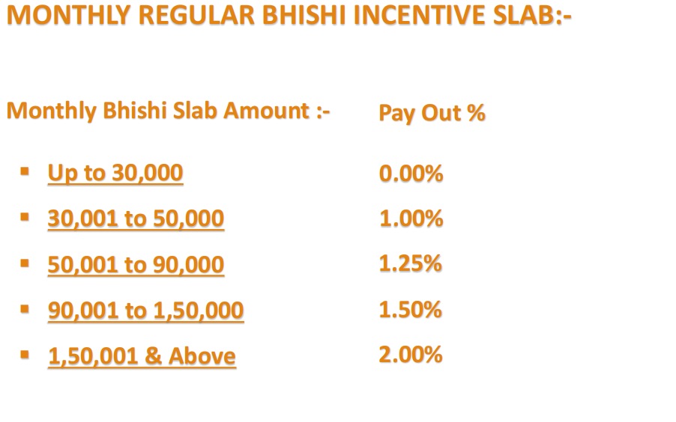

In the existing system, we have provision to set bhishi incentive slab, just need to change the slab according to requirement.

Also correct a bug that it includes premature incentive data also, do not consider premature bhishi amount

**BR007 Negative Impact On Sales Incentive**

Upon fully generation of incentive payout, there are few negative impacts on it if any of the following not achieved then it will deduct 5 % from overall incentive except bhishi incentive

* Non purchase Customers
* Ticket Size

**7.1 Non purchase Customer:**

In the PRO system, Sales employee tracks visitors data. Min 88% customers should be converted to purchase. Other wise 5% employee wise incentive will be deducted.

**Example**: 1000 is the branch wise visitors count, visitors count mapped with customer in PRO system, Suppose each employee mapped with 100 visitors then each employee should convert 88 % i.e 88 visitors into customer. Then only sales employee will get full incentive other wise 5% overall sales person wise incentive will be deducted.

Note: Do not consider bhishi installment, URD,-------------------------- customer for non purchase customers %

**7.2 Ticket Size:**

Ticket size is the negative impact on incentive amount of Sales Person and branch

Gold ticket size in gm = Total net wt of gold O/ no of product group wise unique customers per day

Silver ticket size in gm = Total net wt of Silver O/ no of product group wise unique customers

Diamond Ticket Size in Amount = Total amount of diamond and Diamond Jewellery/ No of Unique Customers per day.

For the calculation of branch wise ticket size consider, overall branch wise product group wise net wt/ amount and unique customer count of branch.

For the calculation of Employee wise ticket size consider, sales man wise product group wise net wt/ amount and unique customer count od sales emp.

510 net wt /85 = 6 gm is the ticket size for gold ornament , silver ornament,

500000 amount /50 = 50000 is the ticket size for diamond +diamond Jewellery.

Do not consider small ornament in the ticket size

Create a master to set branch wise target of ticket size

|  |  |  |  |
| --- | --- | --- | --- |
| **Branch Name** | **Product Group** | **Month Ticket Size** | **Ticket Size Target** |
| **Satara Road** | **D + Diamond Jewellery** | **Oct** | Manual entry |
| **Satara Road** | **Gold O** | **Oct** | Manual entry |
| **Satara Road** | **Silver O** | **Oct** | Manual entry |

Branch wise Ticket Size Report

|  |  |  |  |  |  |  |  |
| --- | --- | --- | --- | --- | --- | --- | --- |
| **Branch Name** | **Product Group** | **Month** | **Day Wise Unique Customer** | **Achievement (A)** | **Target (B)** | **Ticket Size (A/B)** | **%** |
| **Satara Road** | **D + Diamond Jewellery** | **Oct** | 11992 | 455803958 | Fetch from above master | 38,009 |  |
| **Satara Road** | **Gold O** | **Oct** | 150 | 1000 | Fetch from above master | 6.67 |  |
| **Satara Road** | **Silver O** | **Oct** | 6310 | 224199 | Fetch from above master | 35.53 |  |

Employee wise Ticket size Report

|  |  |  |  |  |  |  |  |  |
| --- | --- | --- | --- | --- | --- | --- | --- | --- |
| **Employee Name** | **Branch Name** | **Product Group** | **Month** | **Day Wise Unique Customer** | **Achivement (A)** | **Target (B)** | **Ticket Size (A/B)** | **%** |
| **E1** | **Satara Road** | **D + Diamond Jewellery** | **Oct** | 11992 | 455803958 | Fetch from above master | 38,009 |  |
| **E2** | **Satara Road** | **Gold O** | **Oct** | 150 | 1000 | Fetch from above master | 6.67 |  |
| **E3** | **Satara Road** | **Silver O** | **Oct** | 6310 | 224199 | Fetch from above master | 35.53 |  |

List of small ornament item is given below

**If any of the above not achieved then 5 % incentive will be deducted**

**Note : Including Bhishi target.**

**If both not achieved then 10 % will be negative impact on incentive generation.**

**BR008: Employee wise SIP Detail Report**

**Filter - Cluster, Branch, Period, Employee ID**

|  |  |  |
| --- | --- | --- |
| **Sr No** | **CLUSTER** | **Name of the Cluster** |
| **1** | **BRANCH NAME** | **Name of the Branch** |
| **2** | **EMP NAME** | **Name of the Employee of selected branch** |
| **3** | **EMP ID** | **Employee ID of the employee** |
| **4** | **GRADE** | **Grade of the Employee** |
| **5** | **DESIGNATION** | **Designation of the employee** |
| **6** | **OVERALL INCENTIVE AMOUNT** | **It is the addition of all incentives like Product group wise incentive, bhishi linked Diamond Incentive, Diamond Business Mix, sterling silver Business Mix, Bhishi Incentive** |
| **7** | **BRANCH ACHIVEMENT%** | **Branch Achievement %** |
| **8** | **BRANCH DIAMOND BUSINESS MIX%** | **Branch Diamond Mix %** |
| **9** | **BRANCH SS BUSINESS MIX%** | **Branch SS Business Mix %** |
| **10** | **EMP OVERALL TARGET** | **Addition of Revised Target amount for all product group excluding gold and silver Bullion.** |
| **11** | **EMP OVERALL ACHIVEMENT** | **Addition of Actual Sale amount for all product group excluding gold and silver Bullion.** |
| **12** | **EMP OVERALL ACH %** | **(11/10% )Revised target Amt Vs Actual Sale in Amt %** |
| **13** | **GOLD O TARGET** | **Proposed Target Qty of Gold O excluding small product, star product** |
| **14** | **GOLD O ACHIVEMENT** | **Gold O Actual Sale in Qty excluding small product, star product** |
| **15** | **GOLD O ACHIEVEMENT %** | **(14/13%) I.e Gold O Actual Sale in Qty excluding small product, star product /GOLD O TARGET %** |
| **16** | **GOLD O INCENTIVE AMT** | **Calculate Gold O incentive amount on grade wise rate** |
| **17** | **DIAMOND CARAT TARGET** | **Employee wise Diamond CT target from employee wise target setting.** |
| **18** | **DIAMOND CARAT ACHIEVEMENT** | **Employee wise Diamond CT achievement from employee wise target setting.** |
| **19** | **DIAMOND INCENTIVE AMT** | **Product group wise incentive for Diamond group will be added here.** |
| **20** | **SILVER O TGT** | **Proposed Target Qty of Silver O excluding small product, star product** |
| **22** | **SILVER O ACH** | **Silver O Actual Sale in Qty excluding small product, star product** |
| **23** | **SILVER O ACH%** | **(14/13%) I.e Silver O Actual Sale in Qty excluding small product, star product /GOLD O TARGET %** |
| **24** | **SILVER O INCENTIVE AMT** | **Product group wise incentive for Silver group will be added here.** |
| **26** | **STERLING SILVER ACH** | **Identify sterling silver item and add achievement** |
| **28** | **STERLING SILVER INCENTIVE AMT** | **Calculate incentive amount for SS based on rate and grade** |
| **29** | **GOLD SMALL ORNAMENTS SALE** | **Net wt for gold small ornaments** |
| **30** | **GOLD SMALL ORNAMENTS INCENTIVE** | **Incentive amount for Gold small ornament** |
| **31** | **STAR PRODUCT GOLD O SALE** | **Net Wt of Gold Star product group** |
| **32** | **STAR PRODUCT GOLD O INCENTIVE** | **Incentive amount for Gold star ornament** |
| **33** | **STAR PRODUCT SILVER O SALE** | **Net Wt of silver Star product group** |
| **34** | **STAR PRODUCT SILVER O INCENTIVE** | **Incentive amount for Silver star ornament** |
| **35** | **BHISHI LINK DIAMOND INCENTIVE** | **Bhishi Linked Diamond Incentive amount** |
| **36** | **bhishi target** | **It is the target of bhishi, set against branch** |
| **37** | **bhishi achievement** | **It is bhishi achievement amount expect premature data** |
| **38** | **bhishi regular incentive as per slab** | **Include bhishi slab** |
| **39** | **bhishi 2x target** | **Calculated based on redemption sale bill excluding bullion** |
| **40** | **bhishi 2x ach** | **Sale bill exclude bullion** |
| **41** | **bhishi 2x ach%** | **41/40% I.e bhishi 2X ach / bhishi 2X target %** |
| **42** | **Bhishi 2x incentive amount** | **2X conversion amount** |

# REFERENCES OF THE USERS

|  |  |  |  |
| --- | --- | --- | --- |
| **User** | **Name** | **Mail** | **Contact number** |
| **Actual user** | Dinesh Sonawane | [hoaccountcc@csjewellers.com](mailto:hoaccountcc@csjewellers.com) |  |
| **Assigned business analyst** | Priyanka Gole | [Priyanka.gole@techneai.com](mailto:Priyanka.gole@techeai.com) |  |
| **Assigned developer** | Prathmesh S, Nikhil Bhosale | [Prathmesh.shinde@techneai.com](mailto:Prathmesh.shinde@techneai.com)  [Nikhil.bhosale@techneai.com](mailto:Nikhil.bhosale@techneai.com) |  |
| **Assigned tester** | Prathmesh Kulkarni | [Preeti.bokade@techneai.com](mailto:Preeti.bokade@techneai.com)  [intern@techneai.com](mailto:intern@techneai.com) |  |