|  |  |
| --- | --- |
| **Ticket ID** | *T195353* |
| **Ticket description** | *IN-OUT DEPT BMT-HO*  *१ )६ नंबर बॉक्समध्ये जे document no टाकणार आहे ते स्कॅन करून ते document auto पडले पाहिजे .*  *२ ) ८ नंबर बॉक्समध्ये auto box count झाले पाहिजे ( पडले पाहिजे ).*  *३ ) जे document स्कॅन झाले आहे किंवा पडले आहे ते खाली गेले पाहिजे ( ९ नं बॉक्स वर पडला पाहिजे व ७ नं बॉक्स खाली गेला पाहिजे ).*  *४ ) ज्यावेळी Select Type यामध्ये manually select करतो त्यावेळी ADD option असला पाहिजे .* |
| **Created by** | *Jayant dilip magdum* |
| **Created on** | *07-02-2022* |
| **Priority** | *Very high* |
| **Version** | *0* |

**Version**

|  |  |  |  |  |
| --- | --- | --- | --- | --- |
| **Sr. No** | **Version no** | **Version Date** | **User name** | **User department** |
| 1 | 0 | 07-02-2022 | Jayant dilip magdum | Inventory Silver HO |

**Approvals**

|  |  |  |
| --- | --- | --- |
| **Field** | **Name of the User** | **Approved date by the user** |
| **Actual User Name** | Jayant dilip magdum |  |
| **Actual User Department** | Inventory Silver HO |  |
| **Organization Name** | CSPL |  |
| **Assigned BA** | Akash Rewade |  |
| **Assigned Developer** | Nikhil bhosale |  |
| **Assigned Tester** | Maruti Hakke |  |

**Estimation**

|  |  |  |  |  |
| --- | --- | --- | --- | --- |
| **Department name** | **Estimated Time (In hr)** | **Scheduled Date (Starting date )** | **Estimated date** | **Actual delivery date** |
| **BA** |  |  |  |  |
| **Development** |  |  |  |  |
| **Testing** |  |  |  |  |
|  |  |  |  |  |

**Introduction**

*New Requirement*

**Business requirement**

In connect us-> Stock transfer system user require change in system are

* In stock transfer system when user search with document no in ( From series no ) in Proposed system user want scan document without Add on click button .
* No box count automatic.
* Series document no in serial wise.
* When click on “print document “user want No Box count .

**Abbreviations & terms**

Connect us > CU

Acme > PADM

**Existing system**

* In CU > stock transfer system when user click on select type “AUTO” In present system User must click on “Add” Refer ( Image 1 ) so that Document entry is Generated In stock transfer detail As shown (Refer Image 2 ).

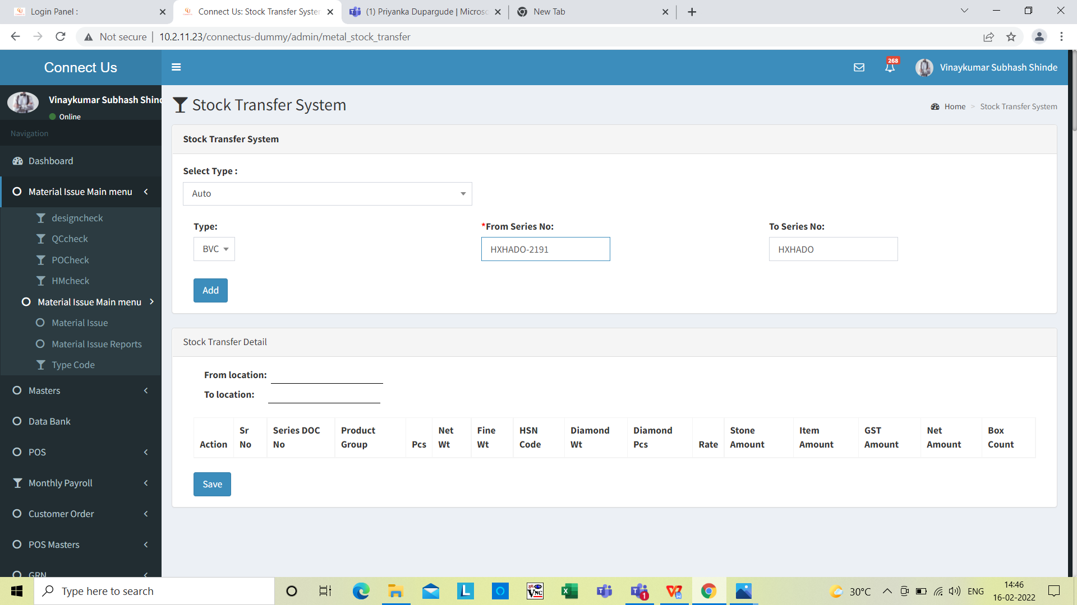

Click on Add

**Image 1**

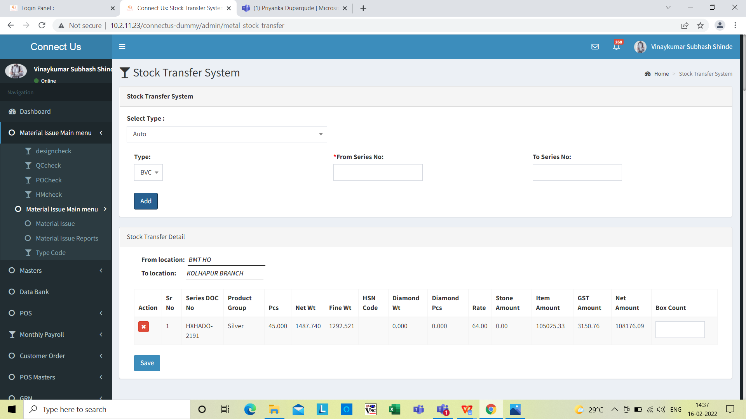

When user click on “ADD” Button eg - barcode- HXHADO -2191 stock transfer Detail entry is generated .

**Image 2**

* In CU > Stock transfer system when user click on select type “AUTO” In present system stock transfer detail “Box count” User do it manually Refer (Image 3)



Box count user fill manual

**Image 3**

* In CU > Stock transfer system when user click on select type “AUTO” In present system stock transfer detail “series doc no” is not Sr no wise (Image 4)

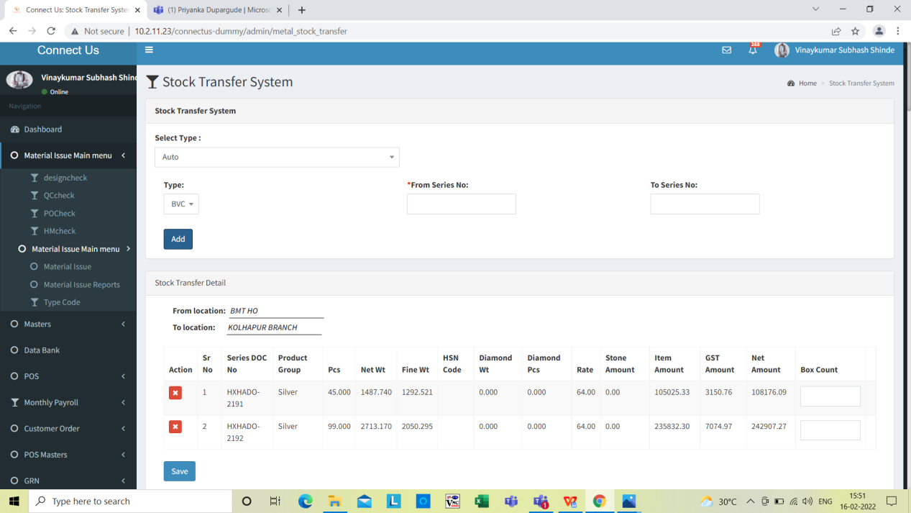

Series Doc no is not serial is not as per serial wise

**Image 4**

Proposed system

1. In CU > stock transfer system when user click on select type “AUTO” In Proposed system User Don’t want “Add button” Refer ( Image 5 & Image 6) so that User Want Document entry is Generated In stock transfer detail automatic.

Eg - When user search “From series no” HXHADO-2191 User want automatic entry record click on “Enter button” same like PADM.



when click on “ENTER button” user Want document automatically

**Image 5**



User want Without “ADD” Button eg - barcode- HXHADO -2191 stock transfer Detail entry is generated

**Image 6**

2 ) In CU > Stock transfer system when user click on select type “AUTO” In Proposed system stock transfer detail “Box count” User want Automatically Refer (Image 7)

Eg - No box count which is automatically fetch data from PADM document

In PADM > Document > Document master selection ( All stock transfer document )

> Ho to branch transfer gold > click on find document > Click on Enter User fill manually refer ( Image 8 )



BOX count user want automatic in Proposed system

Image 7

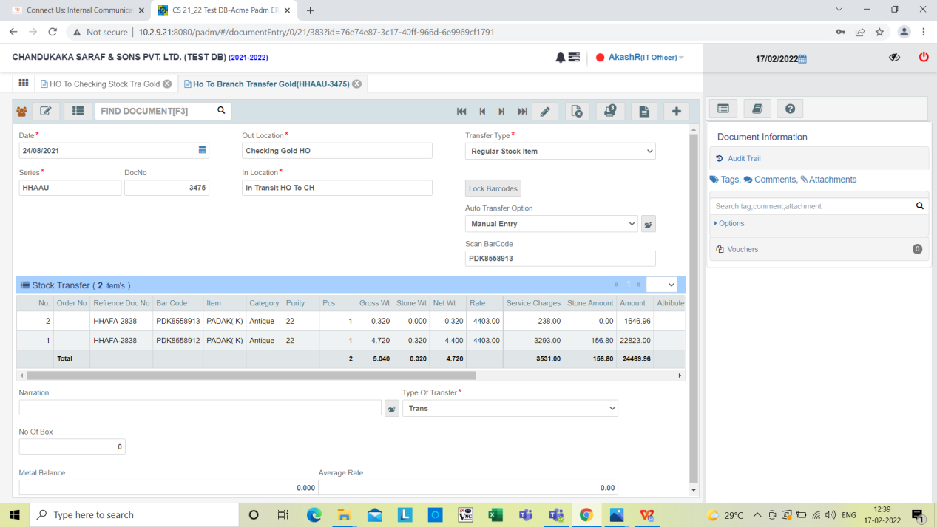

User manually enter NO of box count so that Automatic shown in stock transfer detail

Refer image 8

Image 8

3) In CU > Stock transfer system when user click on select type “AUTO” In Proposed system stock transfer detail “series doc no” is not Sr no wise (Image 9)

Eg - Series Doc no is not as per serial no user want HXHADO 2192 2191 2190 like that newly entry which is shown in below Image refer ( Image 9)



Series Doc no is not as per serial no

Image 9

**References of the users**

|  |  |  |  |
| --- | --- | --- | --- |
| **User** | **Name** | **Mail** | **Contact number** |
| **Actual user** | Jayant dilip magdum |  |  |
| **Ticket created by (if any)** |  |  |  |
| **Assigned business analyst** | Akash Rewade | Akash.rewade@techneai.com |  |
| **Assigned developer** | Nikhil bhosale | Nikhil.bhosale@techneai.com |  |
| **Assigned tester** | Maruti Hakke | Maruti.hakke@techneai.com |  |