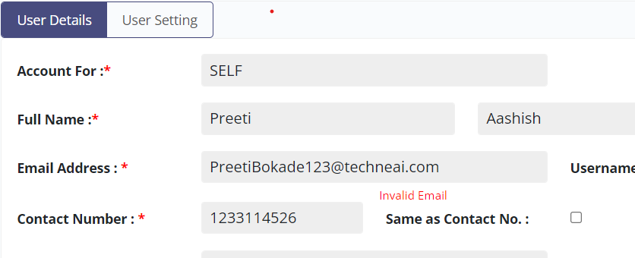

Email Address field throwing error for valid input.

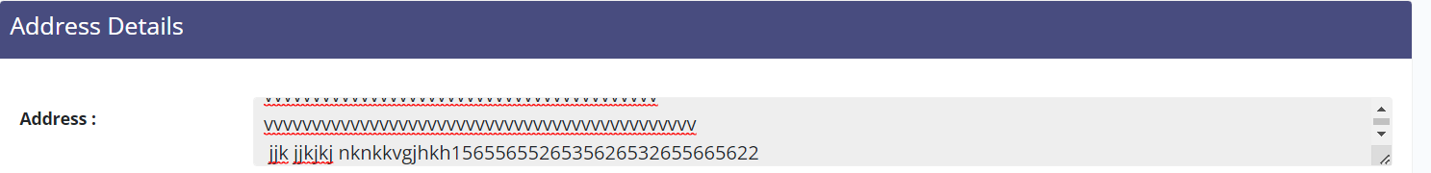

Address field has no limit . Accepting

User master

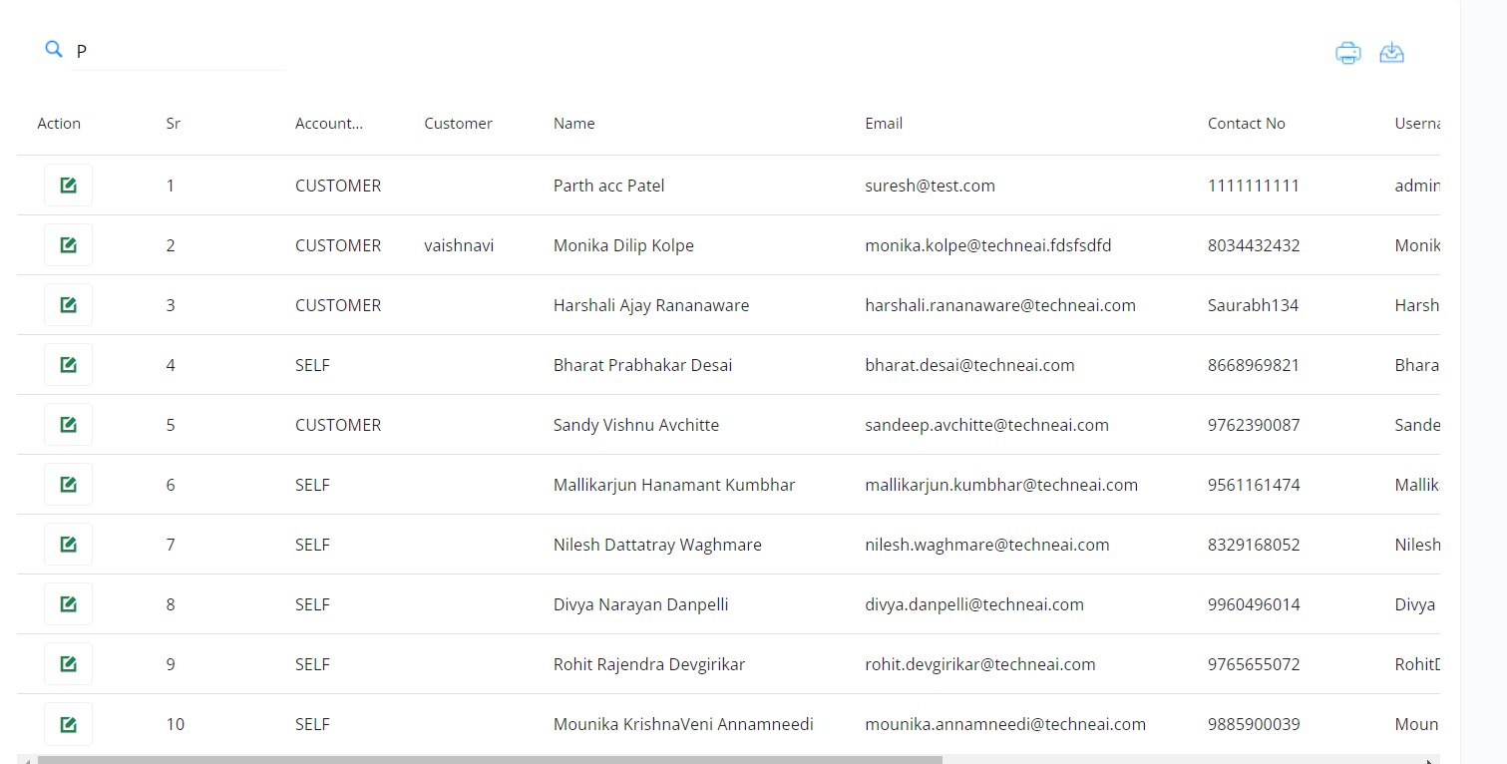

No Tool tip nothing for search guidance , How would user know that search will work with name field or ….

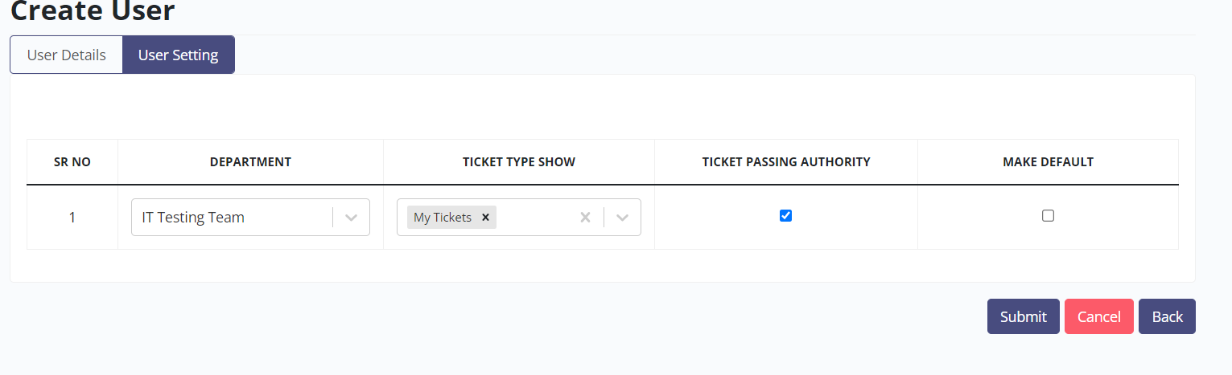

After click on Submit button , user won’t acknowledged.

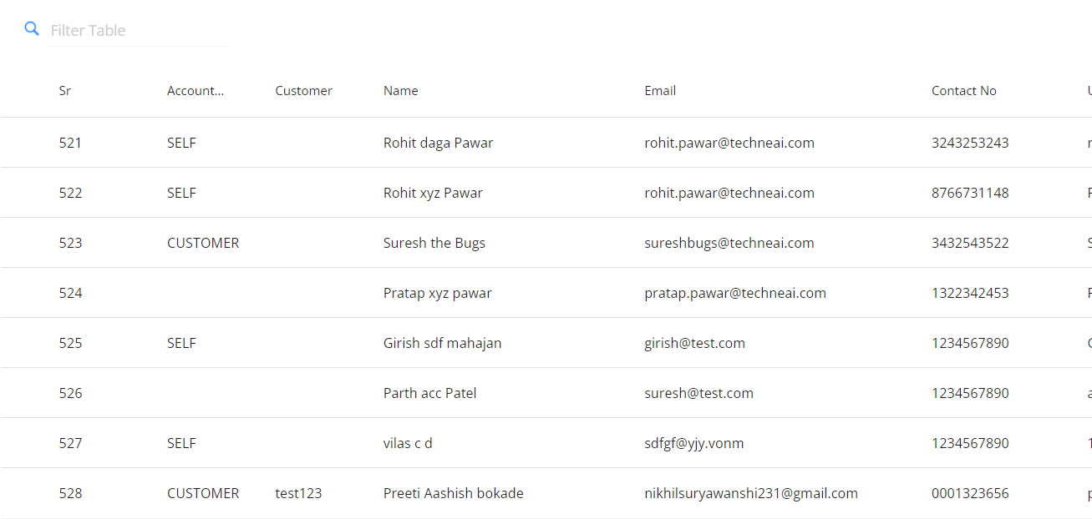

The latest created user displayed at end of the page expected to display at first.

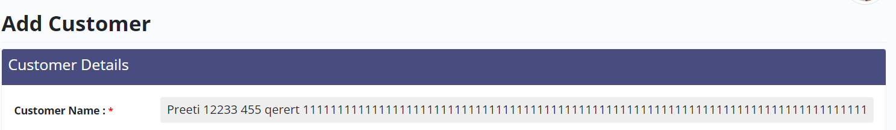

Customer Name accepting unlimited character…no limit set here

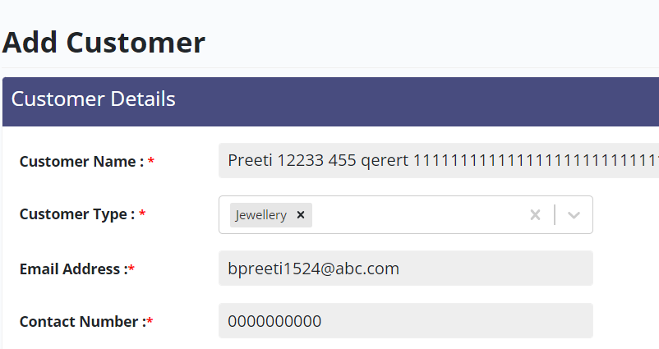

Contact number accepting all ten digit as 0.

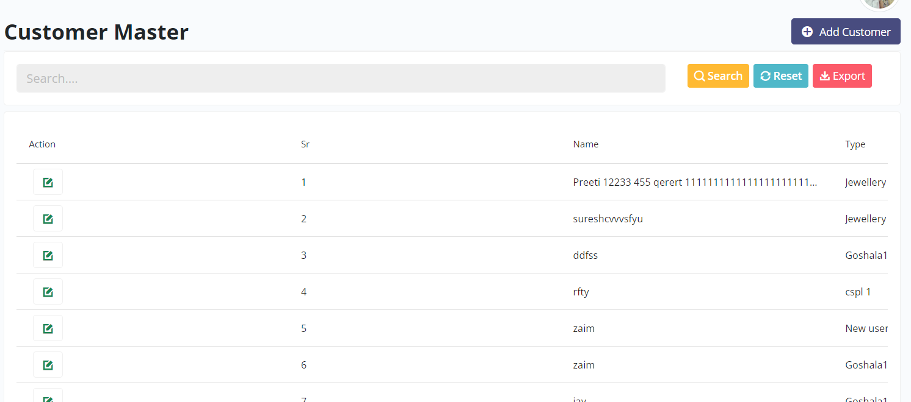

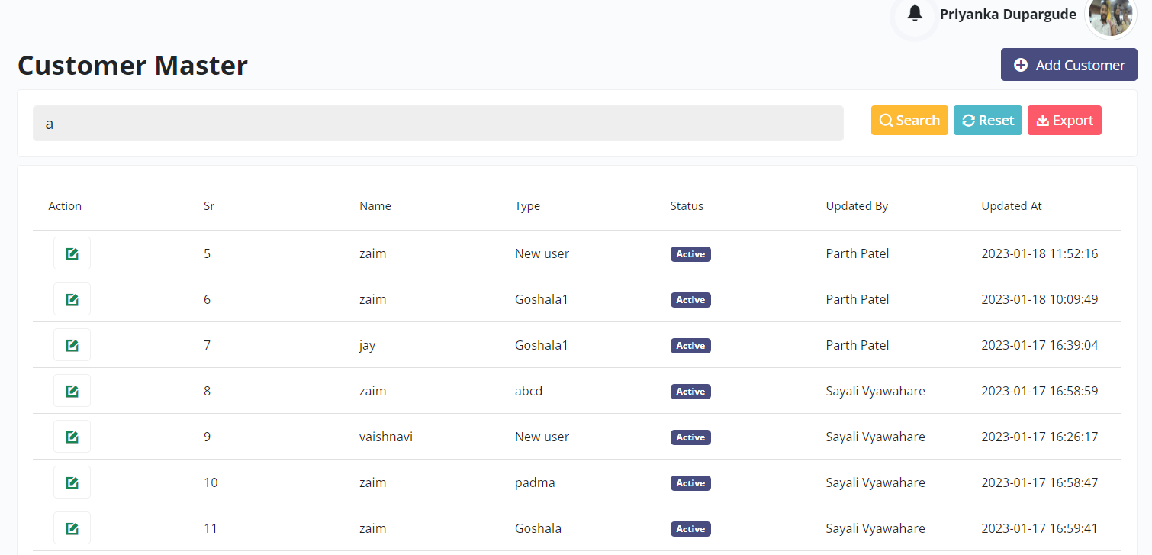

No consistency while display the search result. Some times it is displayed 4 fields someties it displayed 10 fields.

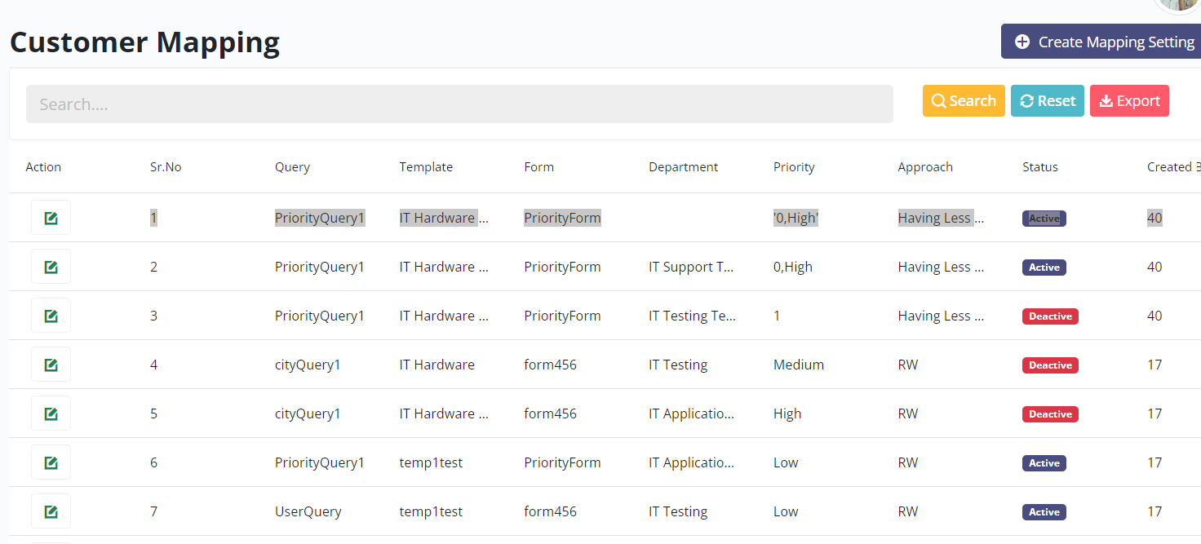

Suggestion - Status Field – Active & Deactive badges values either markup then size would be same if size would be same then don’t markup.

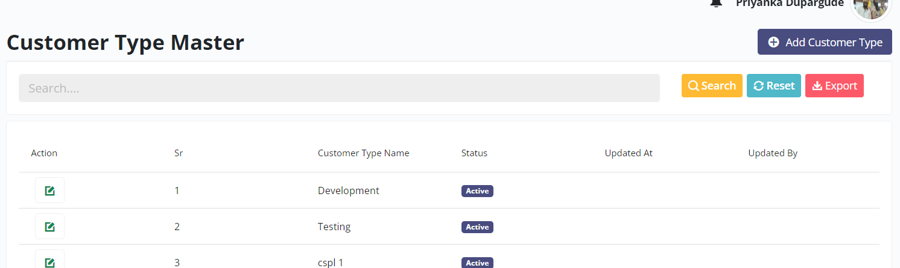

The newly added customer displayed with serial number 1 . There is no consistency while display the records throughout the app (For example : while adding new user it displayed as last record however for customer type displayed 1st record for newly added customer type.

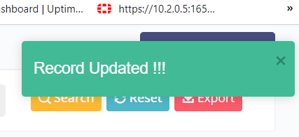

Small suggestion -User getting acknowledgement at right corner, it would be better if it populate at center of the screen.

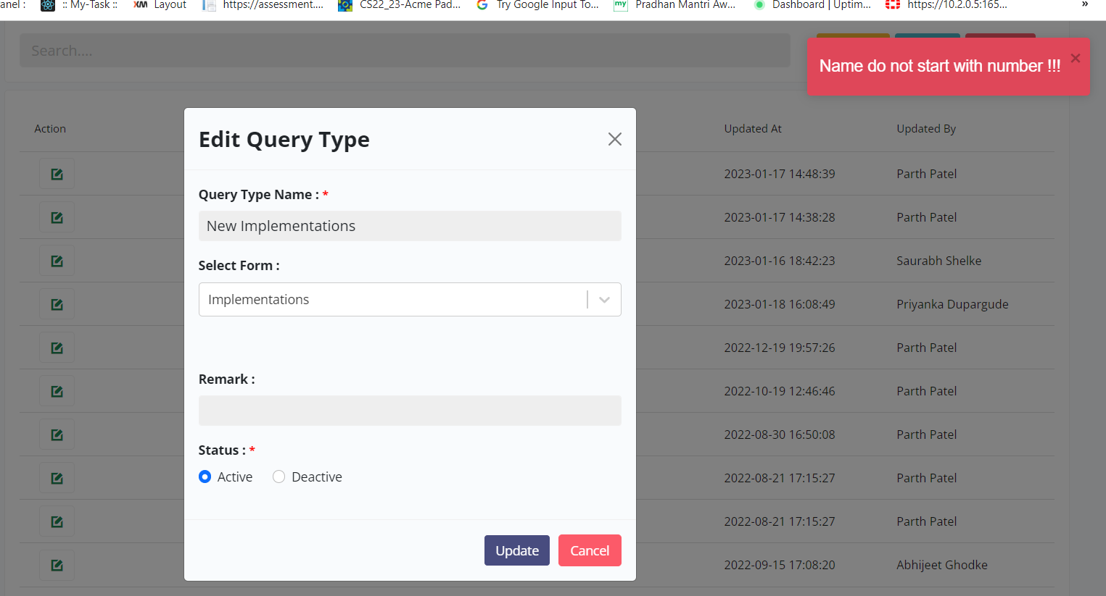

Whild trying to edit the query , tried to update the deactive status to active .. getting irrelevant message .

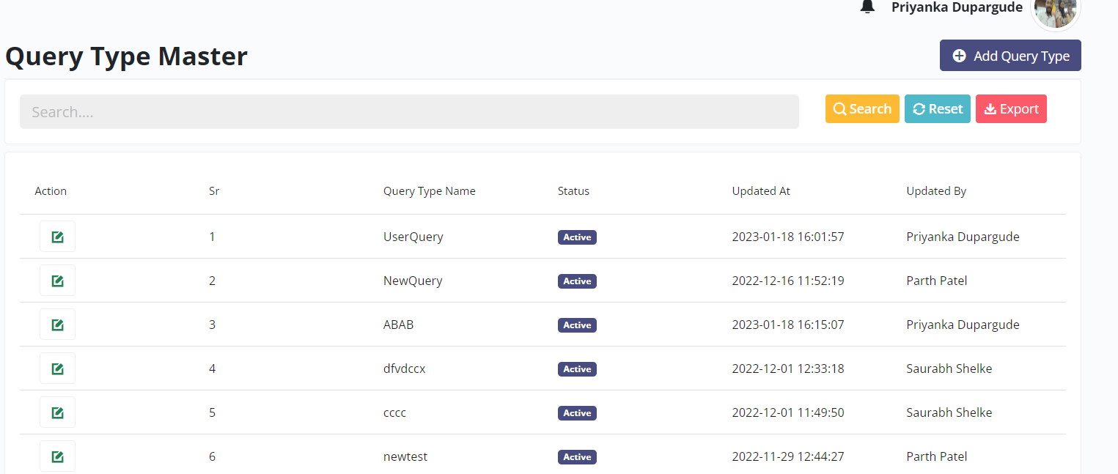

In Sorted manner records are not displayed ( for example neither records sorted by query name , nor by update at nor by Updated By field.

🡺http://15.207.120.175/TechTicketDummy/Ticket/View/4181

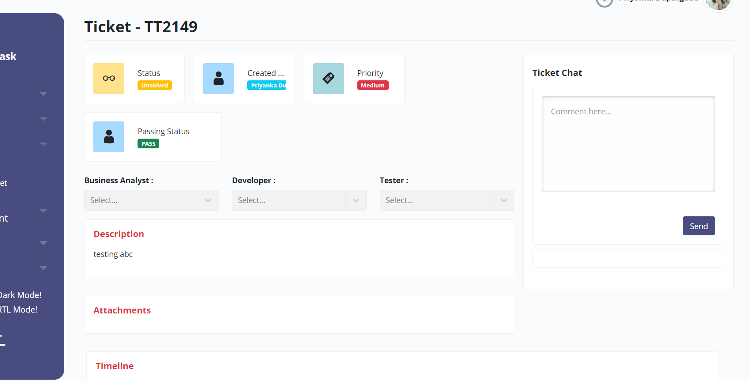

Ticket was created by me however while view the ticket , Department details not fetched or seen to this screen.

The Description , Attachment and Timeline labels are in red colour .Red colour in general used for alert and warn case however here this is not the scenario.

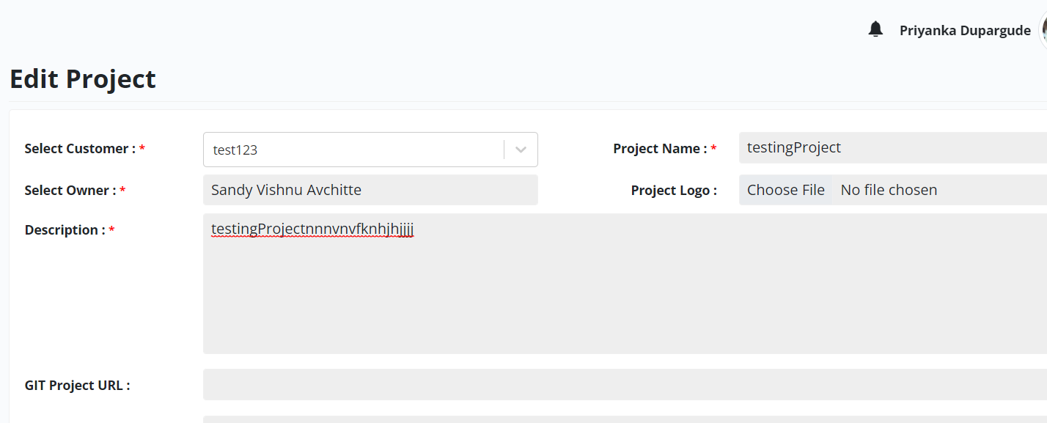

While edit project, Description field not accepting the numerical.