**COUNTRY MASTER**

The country master consists of all the countries details which helps in fetching the data easily. The following are the fields in country master.

* Search
* Reset
* Add country
* Sr
* Country
* Status
* Updated by
* Updated at
* Action

|  |  |
| --- | --- |
| Field | Description |
| Search bar | To search the fields |
| Reset button | To refresh the search bar |
| Add button | To add a new country in the master |
| Sr | The serial count is displayed |
| Country | The countries list is displayed |
| Status | Whether the country is active or not is displayed |
| Updated by | Last updated by is mentioned |
| Updated at | The time on which it is updated last is displayed |
| Action | The action field consists of the edit button to edit the existing country |

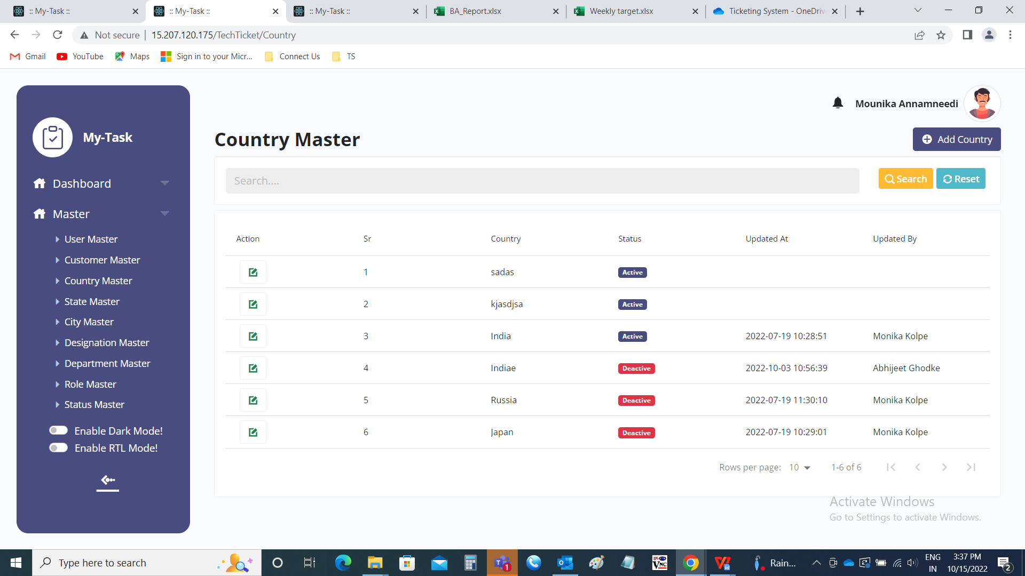

Add data:

The add page consists of the following fields.

* Country
* Remark
* Status
* Add
* Cancel

|  |  |  |  |
| --- | --- | --- | --- |
| **FIELDS** | **INPUT TYPE** | **MANDATORY/ OPTIONAL** | **DESCRIPTION** |
| Country | Text | Mandatory | The country name is entered. |
| Remark | Text | optional | The remark if any is mentioned |
| Select status | Radio button | Mandatory | The radio button consists of active and de-active. By default, active is selected. Active is selected if the country is active or else deactive is selected. |
| Add | Button | Optional | To create the country |
| cancel | Button | Optional | To navigate to the country master main page |

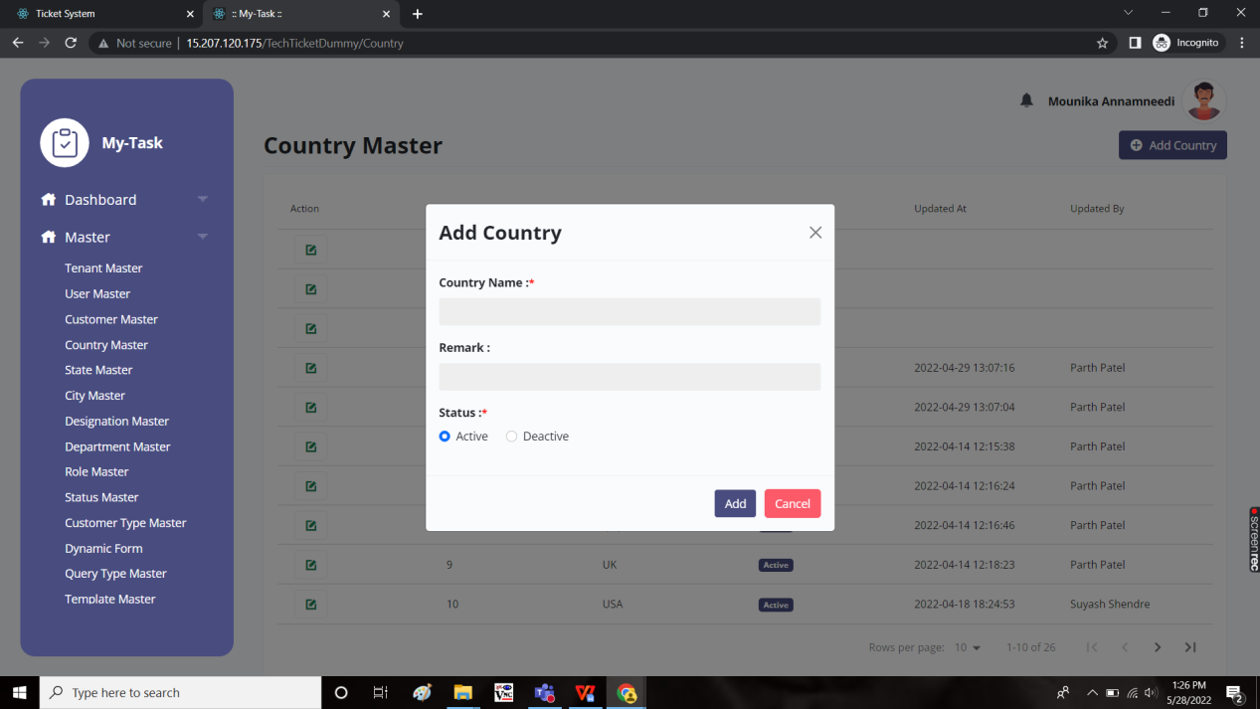

Edit page:

The edit page consists of the following and all fields can be edited if required.

* Country
* Remark
* Status
* Update
* Cancel

