**CREATE TICKET**

In ticketing system >> Tickets >> Create Ticket

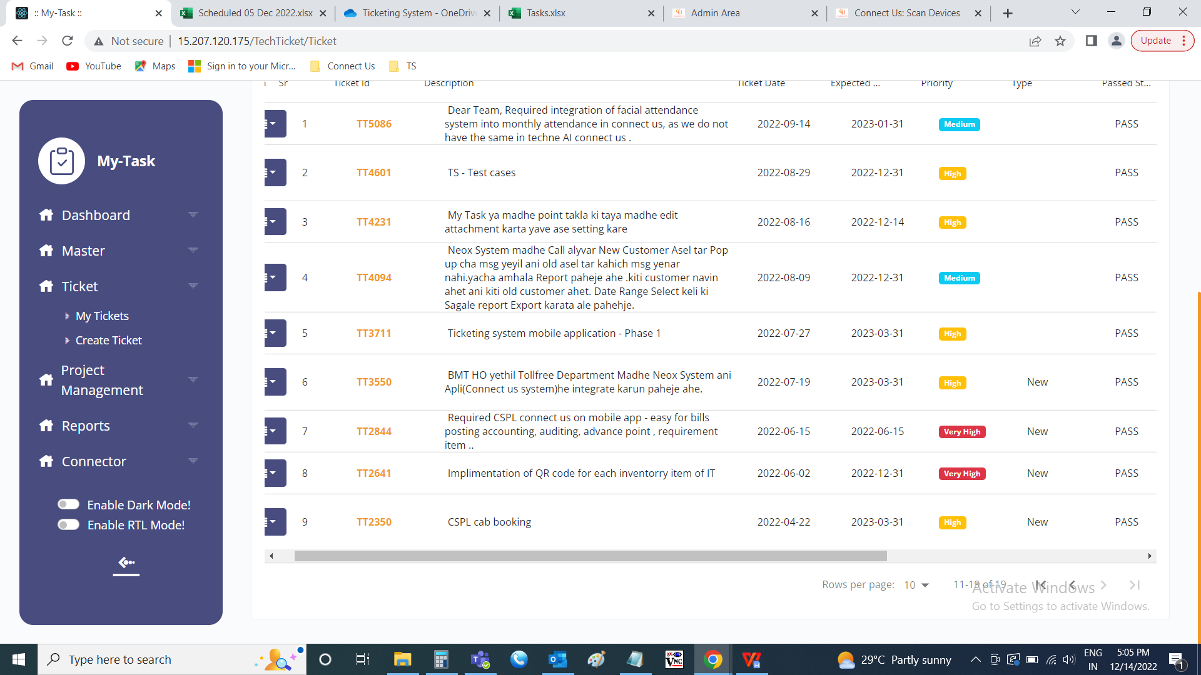

The create ticket menu is used to create the tickets on the ticketing system. The following are the fields in create ticket.

* Your Department
* Query type

|  |  |  |  |
| --- | --- | --- | --- |
| **FIELDS** | **INPUT TYPE** | **MANDATORY/ OPTIONAL** | **DESCRIPTION** |
| Your Department | Drop-down | Mandatory | The department the user belongs to will be shown in the drop down. The departments of the users are set against the user in the user master. |
| Query type | Drop-down | Mandatory | The query type is selected. The drop down options are fetched from query type master. The query type is linked with the dynamic form, where the form fields will display below as the fields and those fields are optional. These forms are made using the dynamic form master. The query type is set in the query type master and the form is selected to that respective query. |

As soon as the query is selected, basic fields with the dynamic form related fields set against the query type are displayed.

The following are the basic fields

* Confirmation required
* Reference ID
* Priority
* Description
* Upload attachment
* Submit
* Cancel

|  |  |  |  |
| --- | --- | --- | --- |
| **FIELDS** | **INPUT TYPE** | **MANDATORY/ OPTIONAL** | **DESCRIPTION** |
| Confirmation Required | Radio button | Mandatory | The radio button consists of the yes and no options. The confirmation required field is for the confirmation request of the ticket by the ticket owner from the ticket creator. When the ticket is solved, the ticket owner changes the status to solved. The ticket creator will get an OTP to the preferred communication set (where the preferred is set in user profile of the user). The ticket owner have to enter the OTP for solving the ticket if the confirmation required is “yes”. By default, the preferred communication is “no”. |
| Reference ID | Text | Optional | The reference ID if any is entered |
| Priority | Drop-down | Mandatory | The priority of the ticket is selected. The drop down options are hard-coded. The following are the drop down options.   * Low * Medium * High * Very high |
| Description | Text | Mandatory | The description for the ticket is displayed. |
| Upload attachment | Attachment | Optional | The documents or images if any are uploaded. |
| Submit | Button | Optional | To create the ticket |
| Cancel | Button | Optional | To navigate to my tickets page. |

