**CUSTOMER MAPPING**

The customer mapping concept refers to the mapping of customers based on the query type. So, the tickets are directly assigned to the users based on the query type selected at the time of creation of the ticket. The following are the mapping based on.

* Customer type
* Query type
* Priority
* Approach
* Department

The customer mapping consists of the following fields.

* Add customer mapping
* Sr
* Query
* Template
* Form
* Department
* Priority
* Approach
* Status
* Updated by
* Updated at
* Action

|  |  |
| --- | --- |
| Field | Description |
| Search bar | To search the fields |
| Reset button | To refresh the search bar |
| Add customer mapping button | To add a new customer mapping in the master |
| Sr | The serial count is displayed |
| Query | The query type is mentioned |
| Template | The template name is mentioned |
| Form | The form selected is displayed |
| Department | The department name is mentioned |
| Priority | The priority of the ticket is mentioned |
| Approach | The approach type is mentioned |
| Status | The status of the mapping is mentioned whether it is active or inactive. |
| Updated by | Last updated by is mentioned |
| Updated at | The time on which it is updated last is displayed |
| Action | The action field consists of the edit button to edit the existing customer mapping |

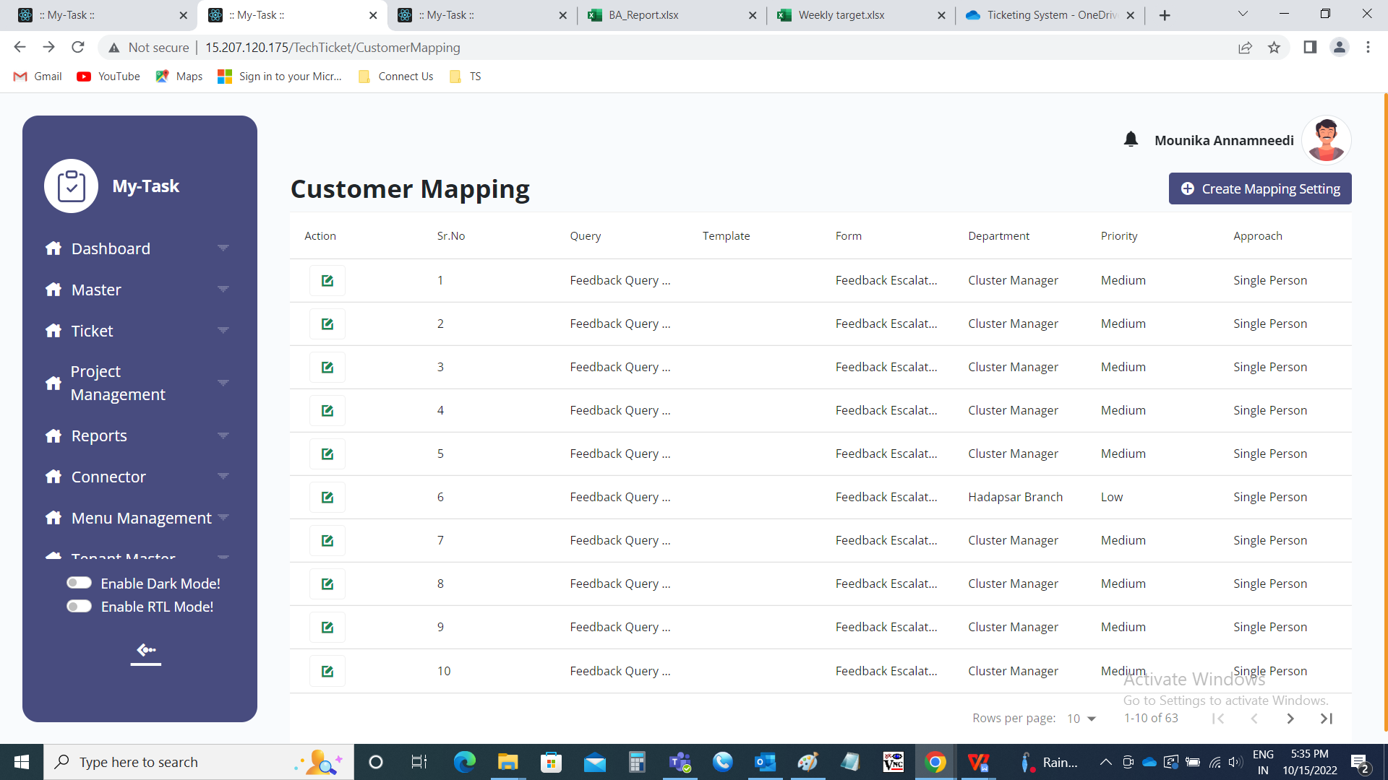

Add customer mapping

The add customer mapping button is used to add the new data in the customer mapping. The following are the fields in the customer mapping.

* Select customer type
* Select query type
* Select form
* Select template
* Select priority
* Select approach
* Select department
* Confirmation required
* Submit
* Cancel

|  |  |  |  |
| --- | --- | --- | --- |
| **FIELDS** | **INPUT TYPE** | **MANDATORY/ OPTIONAL** | **DESCRIPTION** |
| Select customer type | Drop down | Mandatory | The customer type is selected from the drop down list. The drop down options are fetched from customer type master (in Ticketing system >> Masters >> Customer Type Master). |
| Select query type | Drop down | Mandatory | The query type is selected from the drop down list. The drop down options are fetched from query type master (in Ticketing system >> Masters >> Query type master). |
| Select Form | Drop down | Optional | The form which is against the query type is displayed. The user can edit the form if required. The form name is selected from the drop down. The drop down options are fetched from dynamic form (in Ticketing system >> Masters >> Dynamic Form). |
| Select template | Drop down | Optional | The template is selected from the drop down list. The drop down options are fetched from template master (in Ticketing system >> Masters >> Template Master). |
| Select priority | Drop down | Mandatory | The priority is selected from the drop down list. The drop down option consists of the following.   * Low * Medium * High * Very high |
| Select approach | Drop down | Mandatory | The approach is selected from the drop down list. The drop down option consists of the following.   * Department wise round robin * User having less tickets * Single person * Ratio wise   Department wise round robin refers to where the tickets are distributed among the departments in the round wise equally.  User having less tickets refers to where, in a department, where there are less tickets, the tickets are assigned to those persons accordingly.  Single person refers to where the few tickets based on the above factors, selected to specific person.  Ratio wise refers to where the tickets are distributed in ratio wise in the departments. |
| Select department | Drop down | Mandatory | The department is selected from the drop down list. The drop down options are fetched from department master (in Ticketing system >> Masters >> Department master). |
| Confirmation required | Radio button | Mandatory | The confirmation required at the time of solving the ticket is selected. By default, yes is selected. If confirmation required, yes is selected, if not, no is selected. |
| Submit | Button | Optional | To submit the data |
| Cancel | Button | Optional | To cancel the data |

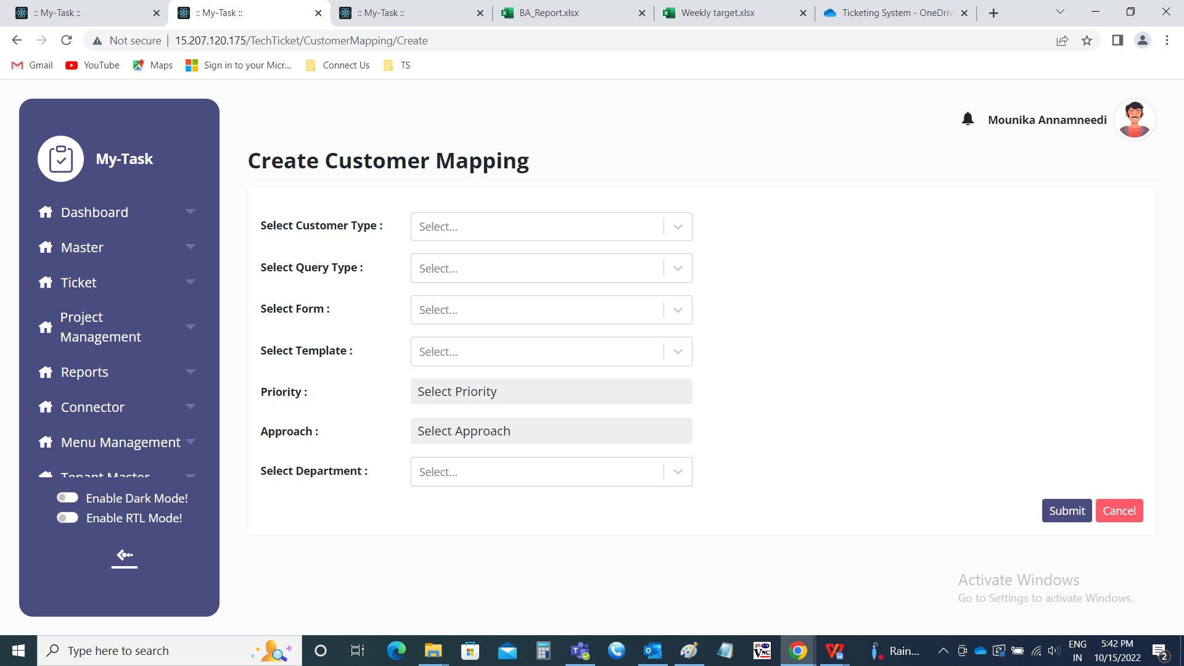

Department Wise Round Robbin

The Department wise round robin refers to where the tickets are distributed among the departments in the round wise equally. It goes on disturbing the tickets in circular motion irrespective of the tickets, the user have. When the user selects the department wise round robbin, then automatically, extra field will be displayed in which the user to be selected.

* Select user

|  |  |  |  |
| --- | --- | --- | --- |
| **FIELDS** | **INPUT TYPE** | **MANDATORY/ OPTIONAL** | **DESCRIPTION** |
| Select user | Drop down | Mandatory | The user to be selected from the drop down list. The drop down options are fetched from the user master (in ticketing system >> masters >> user master). The users are fetched against the department. Single or multiple users can be selected |

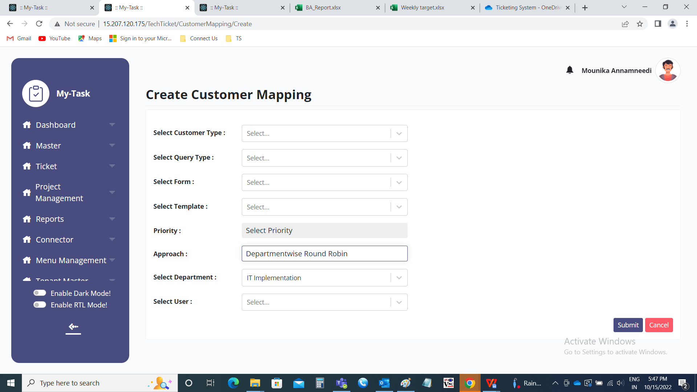

User having less tickets

User having less tickets refers to where, in a department, where there are less tickets, the tickets are assigned to those persons accordingly. When the user selects the user having less tickets approach, then automatically, extra field will be displayed in which the user to be selected.

* Select user

|  |  |  |  |
| --- | --- | --- | --- |
| **FIELDS** | **INPUT TYPE** | **MANDATORY/ OPTIONAL** | **DESCRIPTION** |
| Select user | Drop down | Mandatory | The user to be selected from the drop down list. The drop down options are fetched from the user master (in ticketing system >> masters >> user master). The users are fetched against the department. Single or multiple users can be selected |

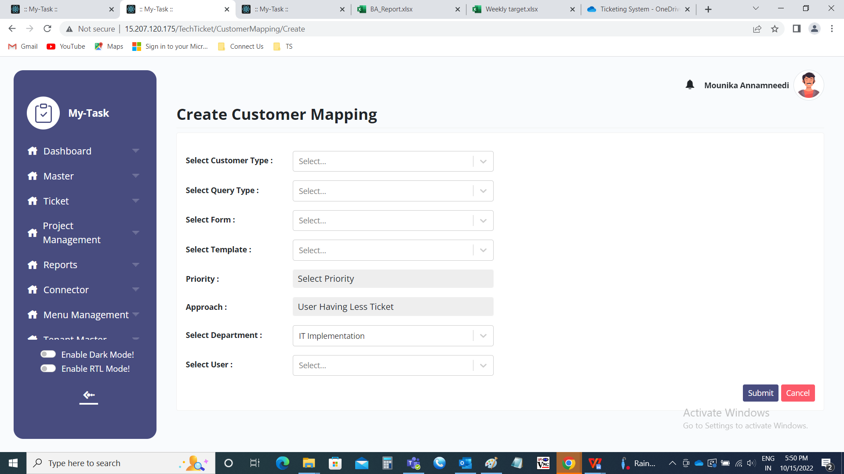

Single person:

Single person refers to where the few tickets based on the above factors, selected to specific person. When the user selects the single person, then automatically, extra field will be displayed in which the user to be selected.

* Select user

|  |  |  |  |
| --- | --- | --- | --- |
| **FIELDS** | **INPUT TYPE** | **MANDATORY/ OPTIONAL** | **DESCRIPTION** |
| Select user | Drop down | Mandatory | The user to be selected from the drop down list. The drop down options are fetched from the user master (in ticketing system >> masters >> user master). The users are fetched against the department. |

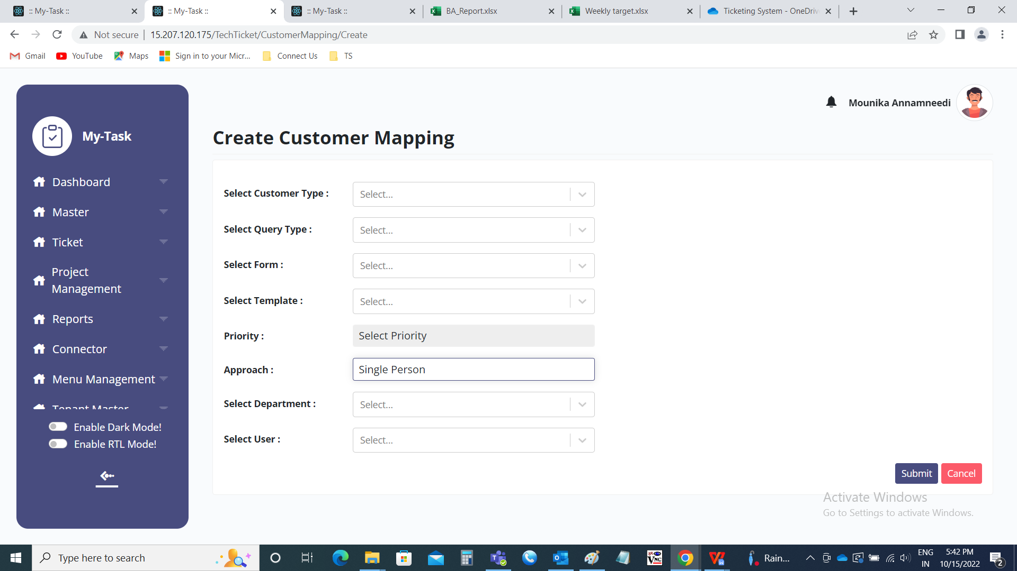

Ratio wise:

Ratio wise refers to where the tickets are distributed in ratio wise in the departments. When the user selects the ratio wise, automatically, there will be the extra fields of the users against the department and the empty fields for entering the ratios among the users. So that the users are assigned the tickets based on those ratios.

* User and ratio

|  |  |  |  |
| --- | --- | --- | --- |
| **FIELDS** | **INPUT TYPE** | **MANDATORY/ OPTIONAL** | **DESCRIPTION** |
| Users | - | Mandatory | The users are automatically displayed against the department selected |
| Ratios | Text | Mandatory | The ratios are entered manually by the users. |

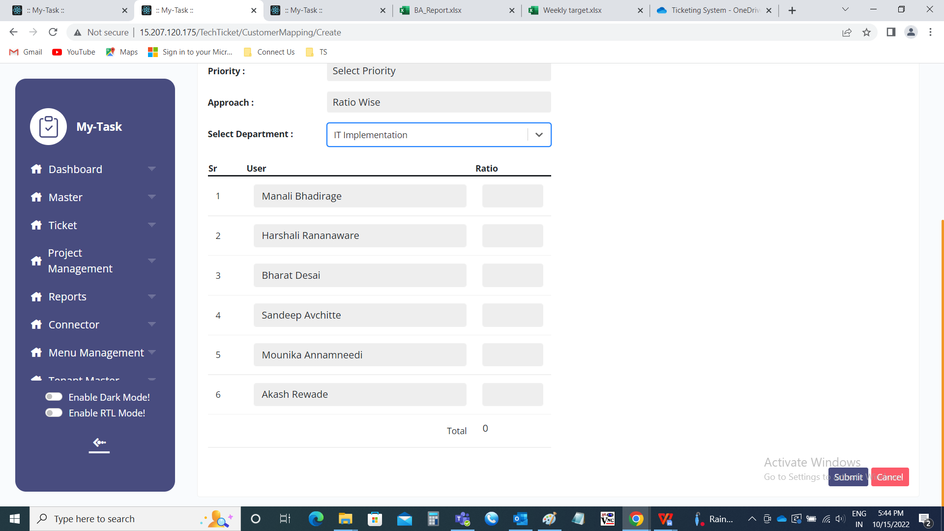

Edit data:

The edit button is used to edit the data. The following fields are the fields in edit page and all the fields can be edited.

* Select customer type
* Select query type
* Select form
* Select template
* Select priority
* Select approach
* Select department
* Confirmation required
* Status
* Update
* Cancel

