**CUSTOMER MASTER**

The customer master belongs to the customers of the tenants. The tenants can create their customers based on the customer type.

The following are the fields in the customer master.

* Search bar
* Reset
* Add customer button
* Sr
* Name
* Type
* Status
* Updated by
* Updated at
* Action

|  |  |
| --- | --- |
| Field | Description |
| Search bar | To search the fields |
| Reset button | To refresh the search bar |
| Add customer button | To add a new customer in the master |
| Sr | The serial count is displayed |
| Name | The name of the tenant displays |
| Type | The type of the tenant displays |
| Status | The status of the customer is displayed |
| Updated by | Last updated by is mentioned |
| Updated at | The time on which it is updated last is displayed |
| Action | The action field consists of the edit button to edit the existing customer |

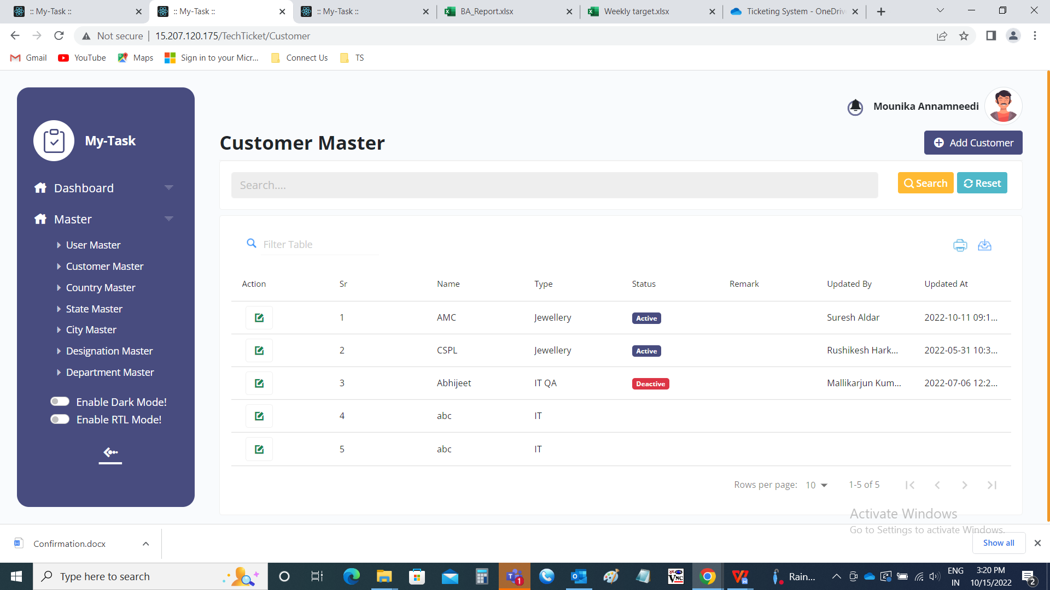

Add page:

The add page consists of the following

* Customer details
* Customer name
* Customer type
* Email address
* Contact number
* Address details
* Address
* Pincode
* Country
* State
* City
* Add
* Cancel

|  |  |  |  |
| --- | --- | --- | --- |
| **FIELDS** | **INPUT TYPE** | **MANDATORY/ OPTIONAL** | **DESCRIPTION** |
| Customer name | Text | Mandatory | The name of the customer is entered |
| Customer type | Drop-down | Mandatory | The type of the customer is selected from the drop down options. The drop down options consists of list of customer type fetched from customer type master(in Ticketing System >> Masters >> Customer Type Master). |
| Email address | Text | Mandatory | The mail address of the customeris entered |
| Contact number | Int | Mandatory | The contact number of the customer is entered |
| Address | Text | Mandatory | The address of the customer is entered |
| Pin-code | Int | Mandatory | The pin-code of the customer is entered |
| Country | Drop down | Mandatory | The country is selected from the drop box menu which is fetched from country master (in ticketing system >> masters >> country master) |
| State | Drop down | Mandatory | The state is selected from the drop box menu which is fetched fro state master (in ticketing system >> masters >> state master) |
| City | Drop down | Mandatory | The city is selected from the drop box menu which is fetched from city master (in ticketing system >> masters >> city master) |
| Add | Button | Optional | To create the customer |
| cancel | Button | Optional | To navigate to the customer master main page |

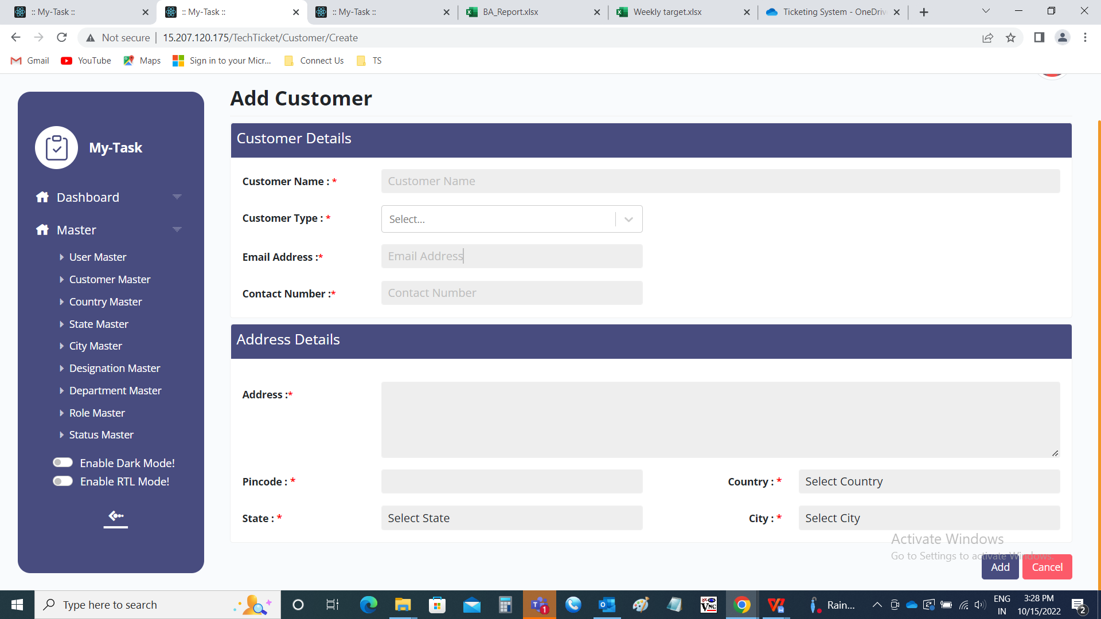

Edit page:

The edit page consists of the following and all fields can be edited if required.

* Customer details
* Customer name
* Customer type
* Email address
* Contact number
* Address details
* Address
* Pincode
* Country
* State
* City
* Select status
* Update
* Cancel

