3 Feb 2023

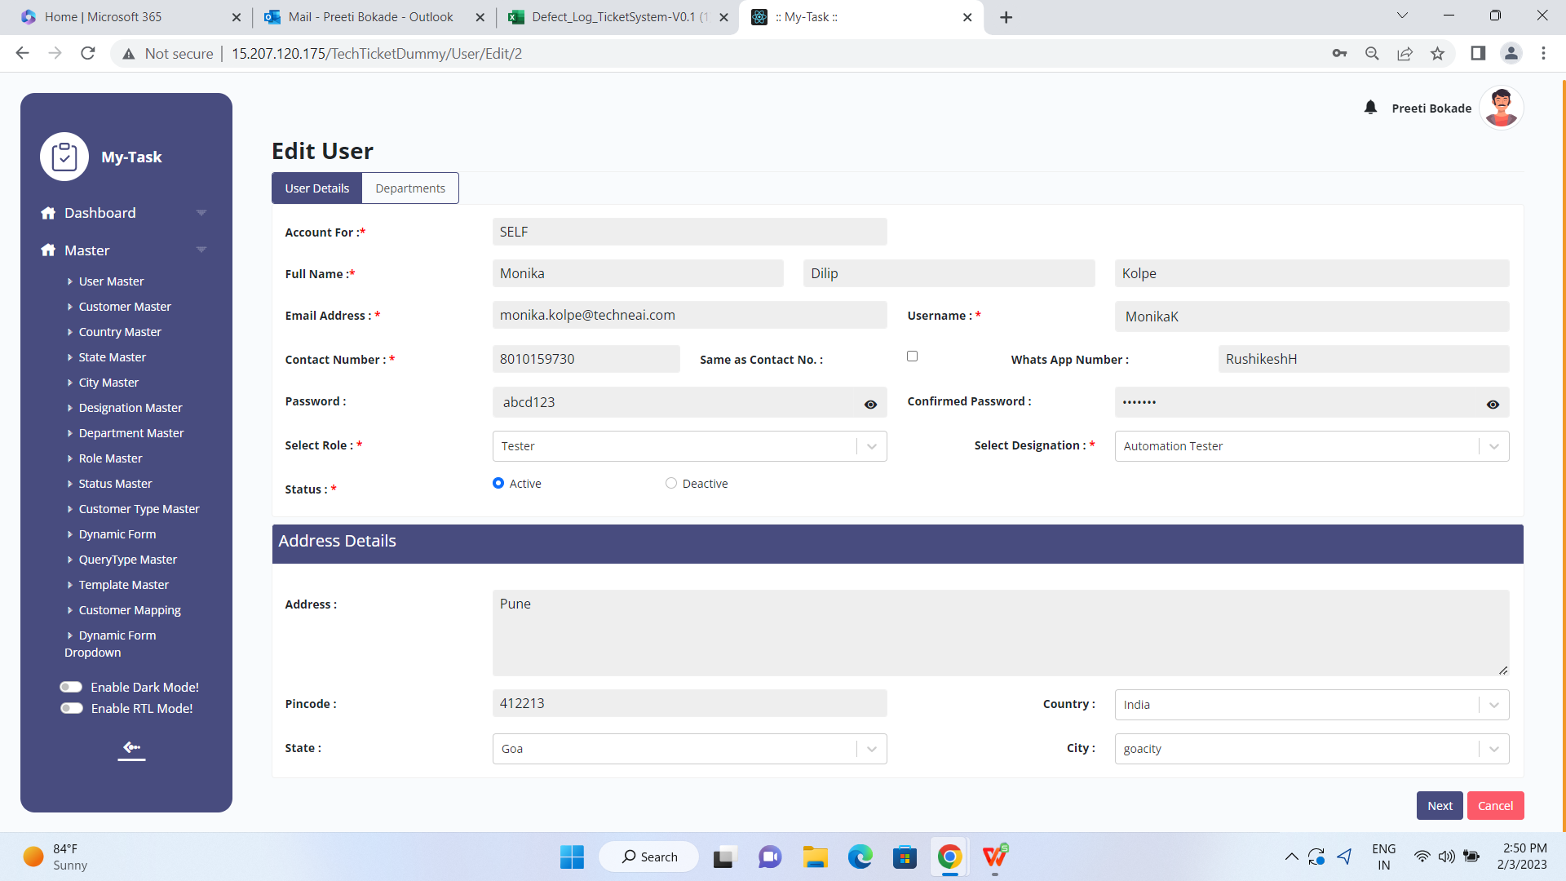

One can change the password of Deactive user.
Edit user - Confirm Password field -password is not visible though click on eye button.

Deactive user is able to login into Ticketing system .

Deactive user is able to create the ticket.

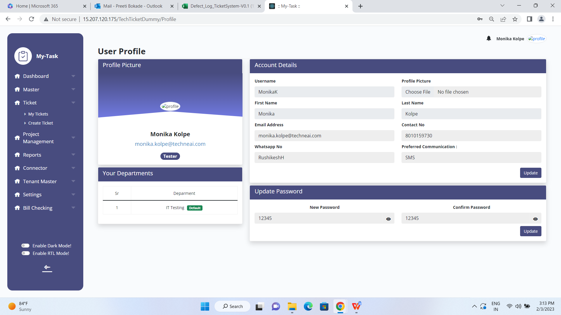

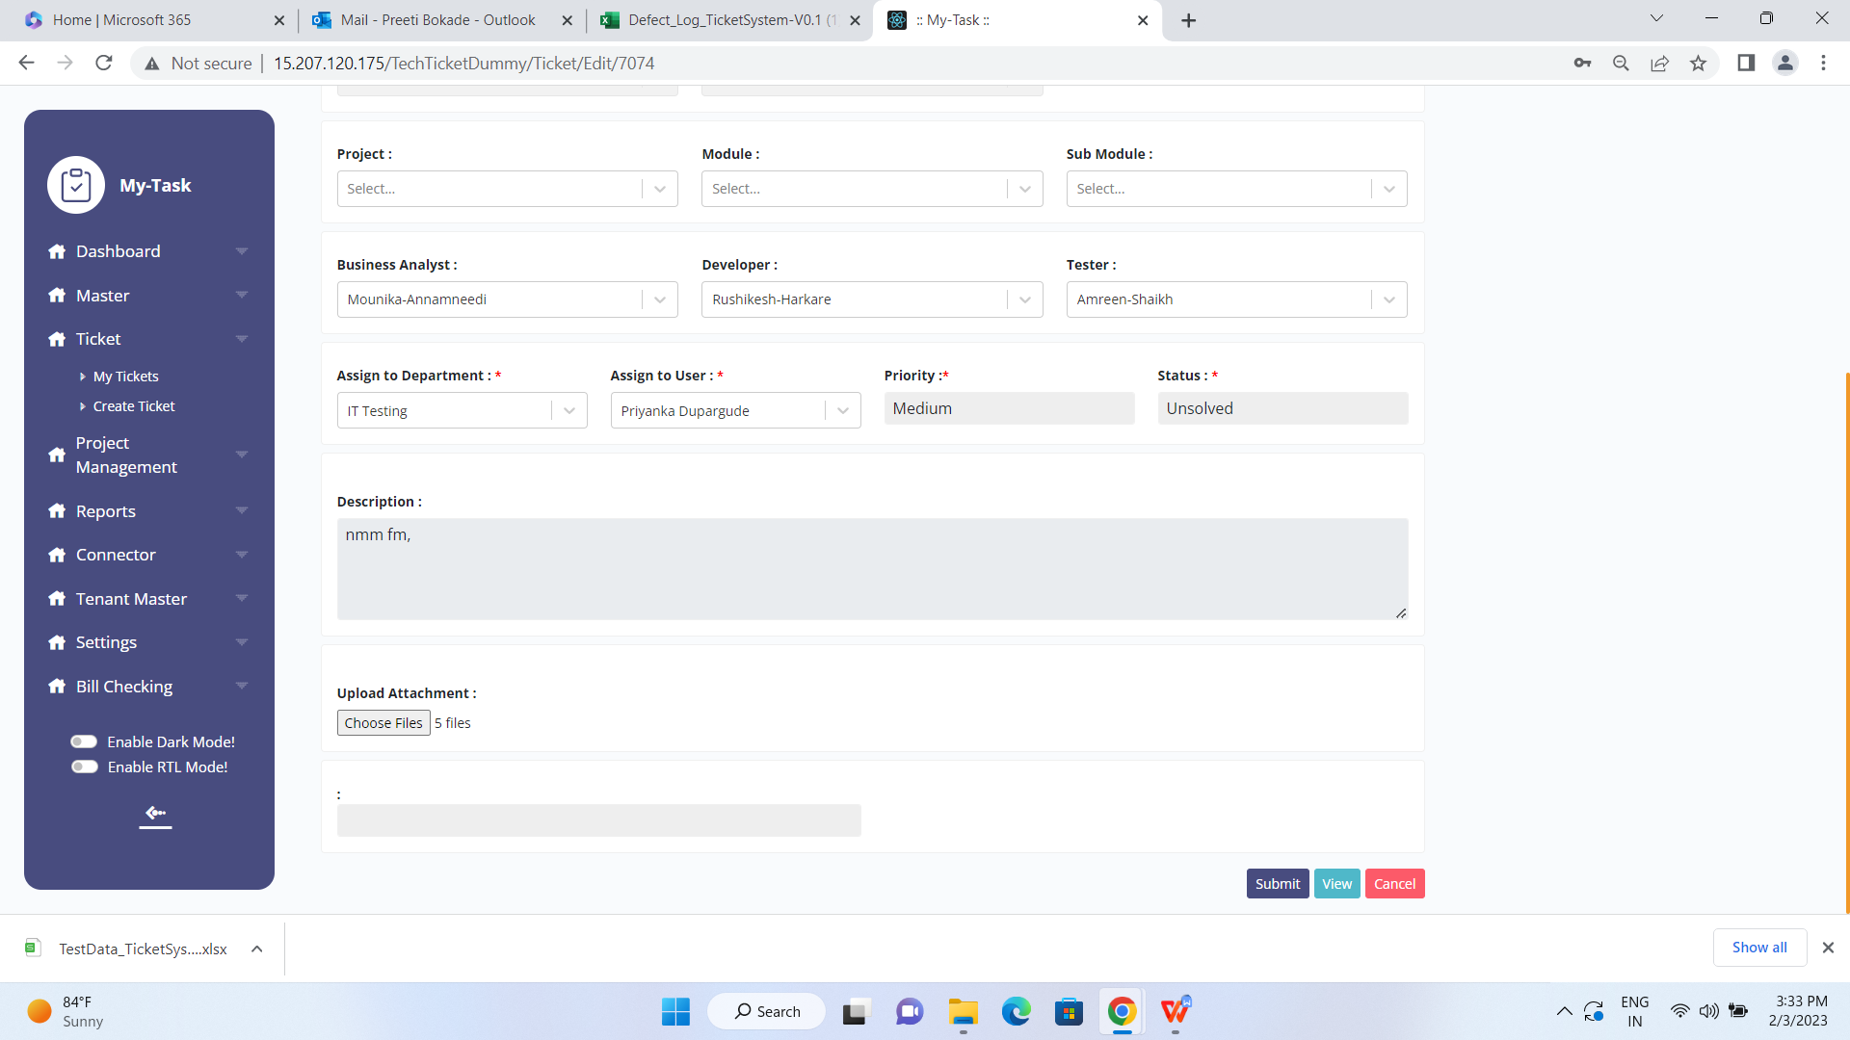

Edit Ticket : Attached multiples files are not visible.

My Tickets--

While Edit Ticket - submit the ticket without expected Solve date , system redirected focus to Expected solve date however user not acknowledged with any error message . If user get any user friendly message. This would be great.

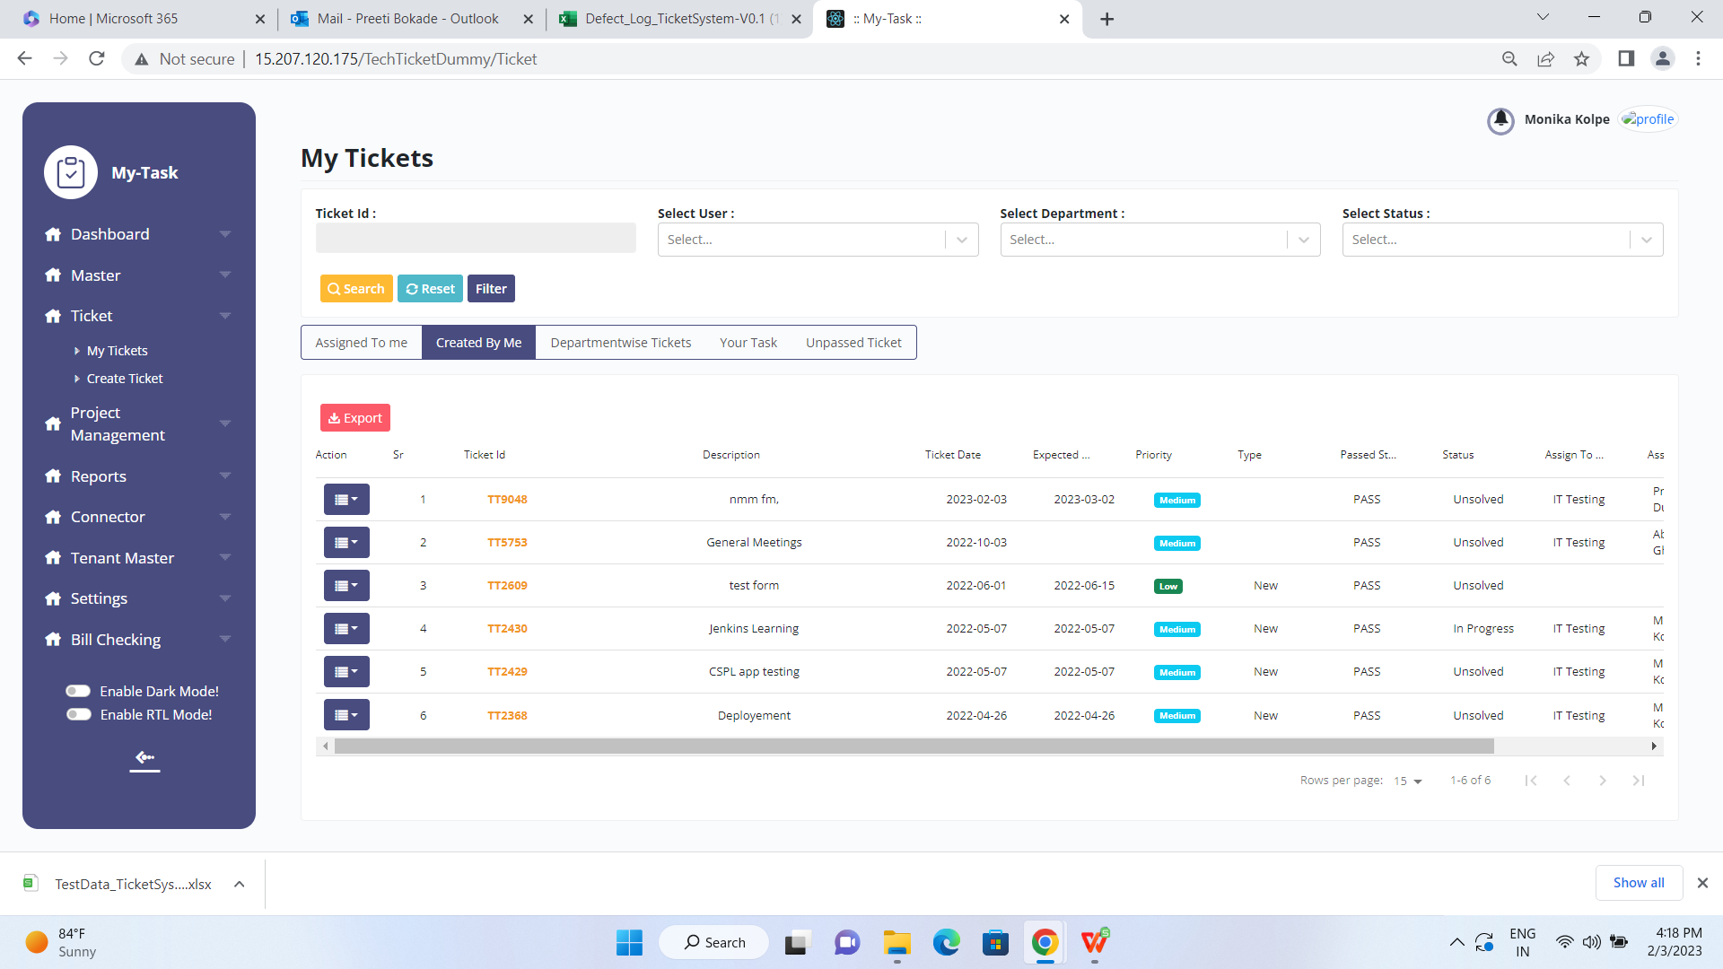

Created by me - Ticket 9048 -

While export it has been observed that On screen total ticket displays as 6 however while exporting
- Total rows count is 20 however on screen it is 6.
- the ticket number displayed on screen /page is different than export.
- The status field value is mis match
- CUID depicted in Export sheet and is not present in Screen

- 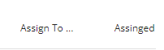 Column heading not visible properly.
- Search Result page coulmn header and Column values are not aligned properly same issue for other tabs as well ( Created by me, Department wise, Your task, Unpassed Ticket)
- Priority values need to be displayed with background colour in same size.

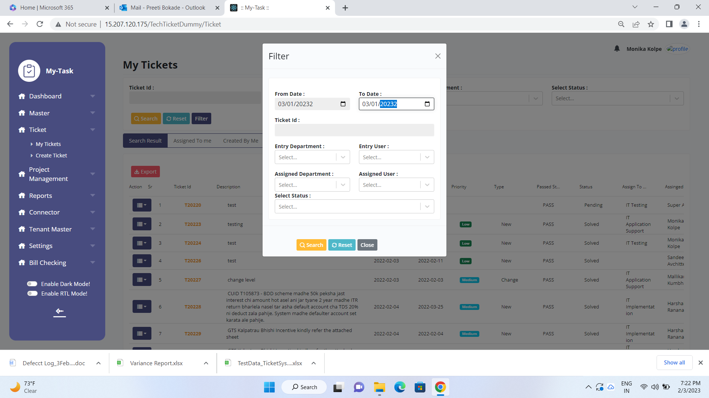
My Tickets - Filter - From date & To date accepting
- future dates
- Year accepting in wrong format
- While click on search button , user is not acknowleged with error nor displayed the data.

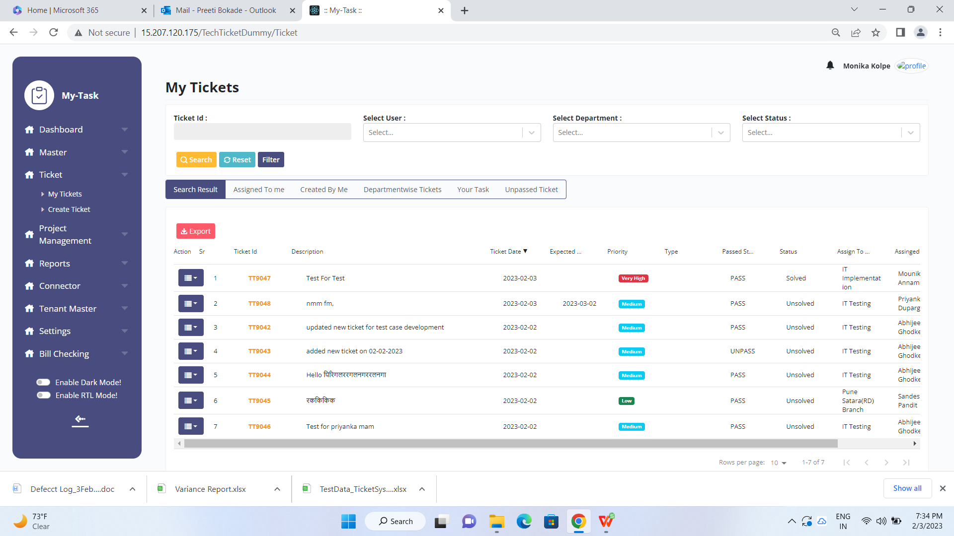

Ticket Date sorting not done properly,
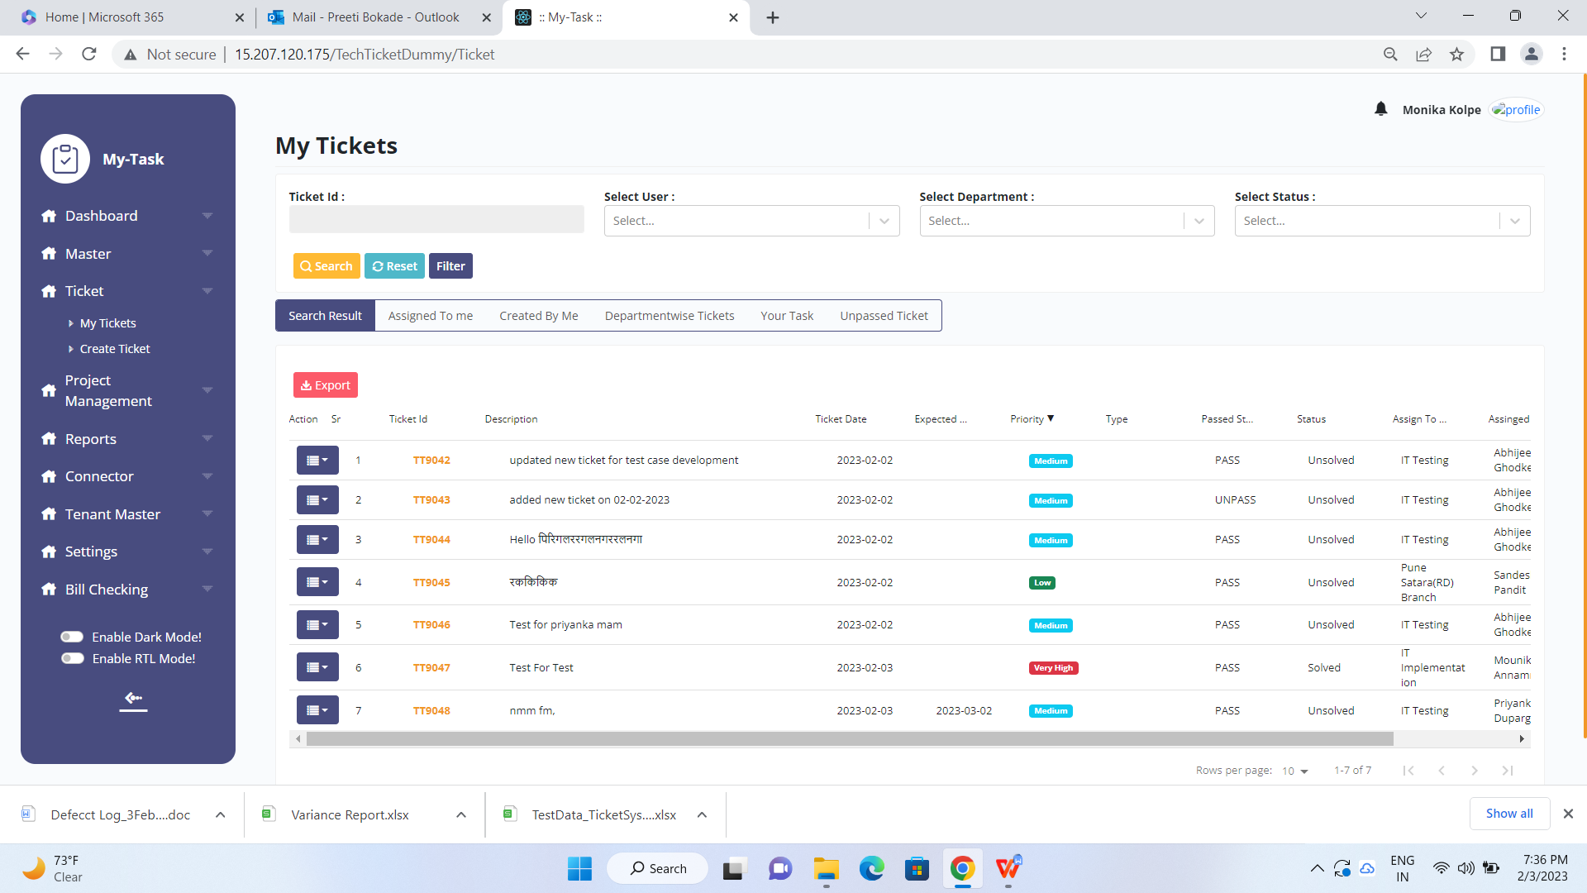

Priority not sorted properly .. it should be in Ascending order (high, medium, low ), Descending order (low, medium , high)

Passed Status, Status, Assign To Dept, Assigned To, Created By are not sorted properly

6th Feb 2023

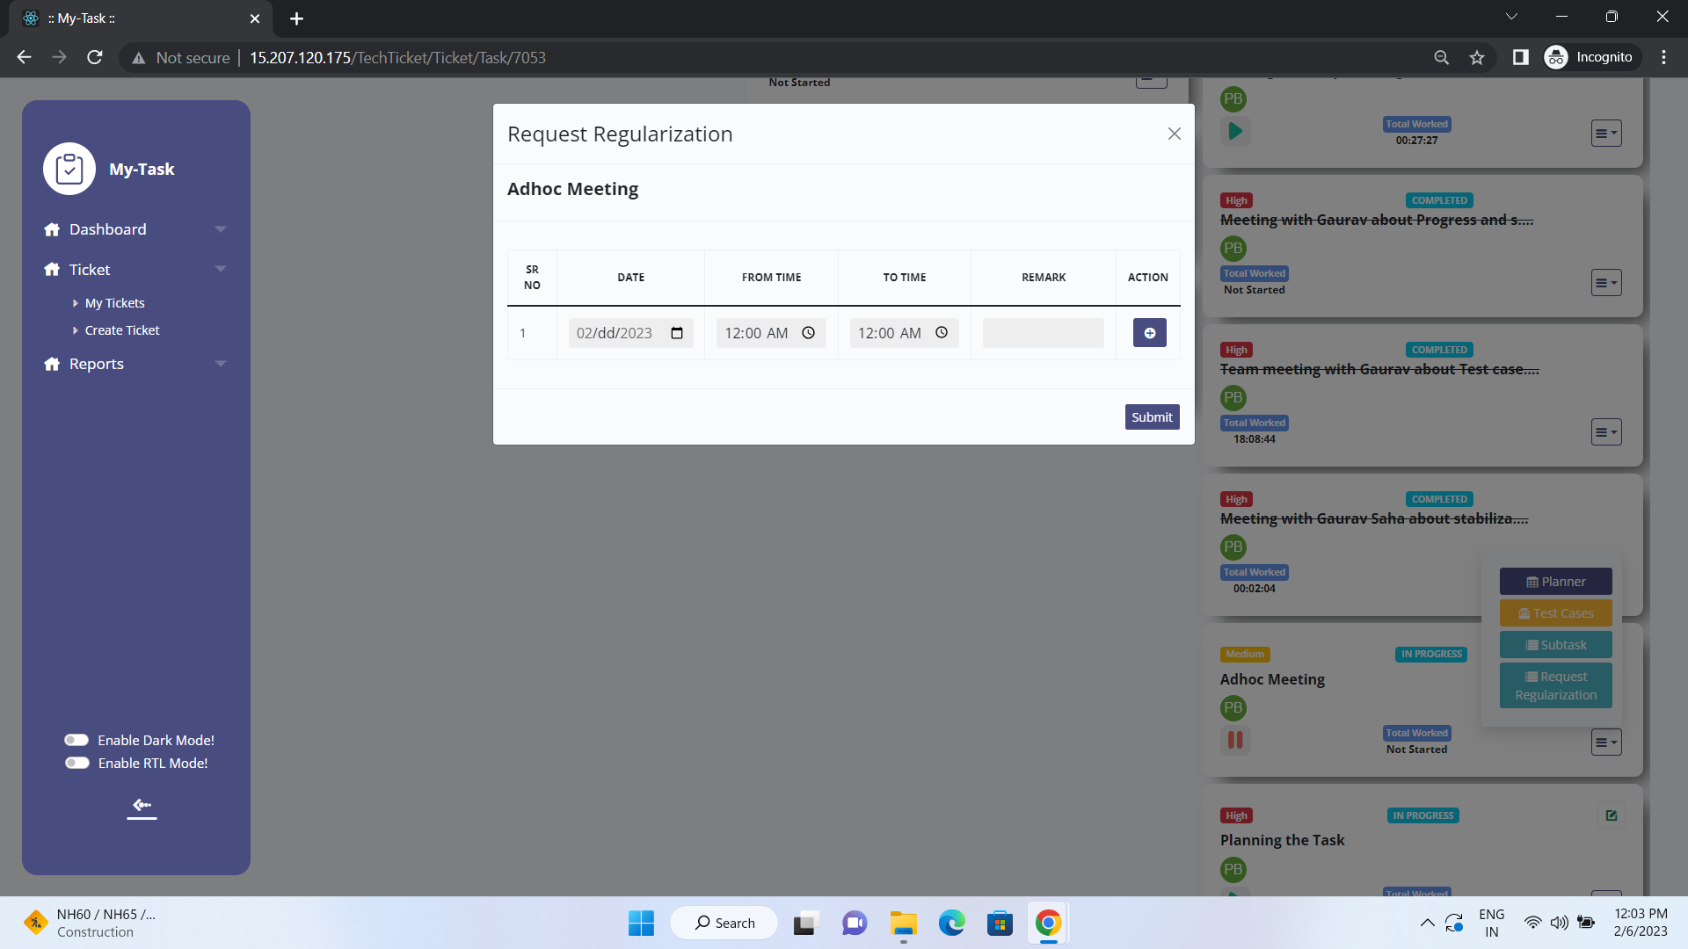

Request Regularization : Date is not displaying the correct value .

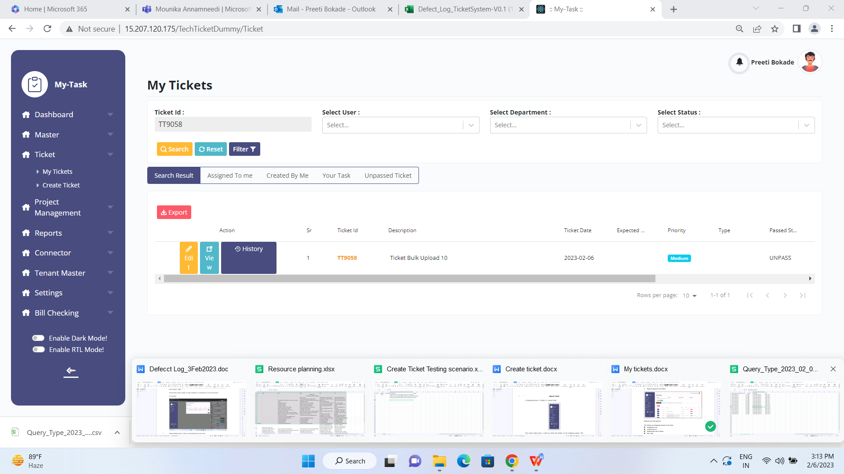

Search Result View for single ticket :

My Tickets - Search by ticket number - Search result for Single ticket - Edit , View and History button is not consistent

11 Feb 2023

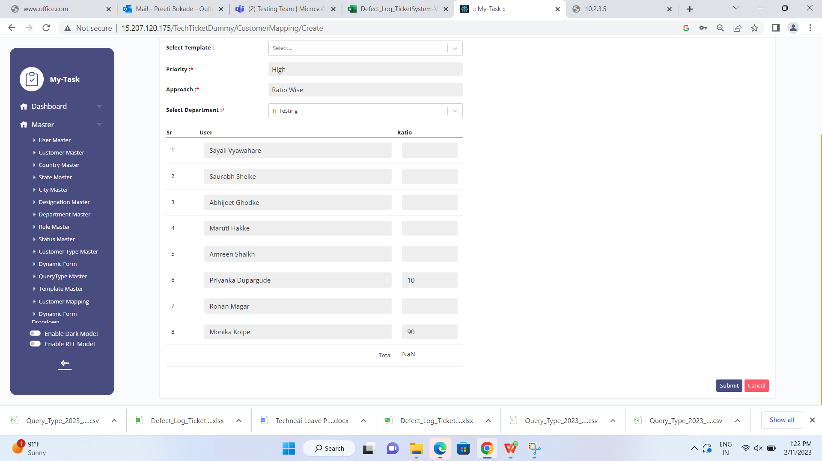

Ratio Wise - Total - displays Nan instead of numerical figure.

