|  |  |
| --- | --- |
| **Ticket ID** | *T153661* |
| **Ticket description** | *User need Reset Sync Process button in CU --> SI Module, So that when user click on reset sync process button then system will function smooth for data synchronization. Also, if data syncing process is already started by someone then user should be able to start over that running process.* |
| **Created by** | *Sandeep Avchitte* |
| **Created on** | *18/11/2021* |
| **Priority** | *High* |
| **Version** | *0* |

**Version**

|  |  |  |  |  |
| --- | --- | --- | --- | --- |
| **Sr. No** | **Version no** | **Version Date** | **User name** | **User department** |
| **1** | **0** | **18/11/2021** | **Nilesh Waghmare** | **IT Application Support** |

**Approvals**

|  |  |  |
| --- | --- | --- |
| **Field** | **Name of the User** | **Approved date by the user** |
| **Actual User Name** | Nilesh Waghmare |  |
| **Actual User Department** | IT Application Support |  |
| **Organization Name** | Techne AI |  |
| **Assigned BA** | Sandeep Avchitte |  |
| **Assigned Developer** | Parth Patel |  |
| **Assigned Tester** | Rohan Magar |  |

**Estimation**

|  |  |  |  |  |
| --- | --- | --- | --- | --- |
| **Department name** | **Estimated Time (In hr)** | **Scheduled Date (Starting date )** | **Estimated date** | **Actual delivery date** |
| **BA** |  |  |  |  |
| **Development** |  |  |  |  |
| **Testing** |  |  |  |  |

**Introduction**

*User need Reset Sync Process button in CU --> SI Module, So that when user click on reset sync process button then system will function smooth for data synchronization. Also, if data syncing process is already started by someone then user should be able to start over that running process.*

**Business requirement**

*User need Reset Sync Process button in CU --> SI Module, So that when user click on reset sync process button then system will function smooth for data synchronization. Also, if data syncing process is already started by someone then user should be able to start over that running process.*

**Abbreviations & terms**

*CU - Connect Us.*

**Existing system**

*Currently no button is available to reset running sync process.*

**Proposed system**

*User need* ***“Reset Sync Process”*** *button in CU --> SI Module, So that when user click on* ***“Reset Sync Process”*** *button all stuck flag 1 should release to flag 0 for smooth functioning of data synchronization process.*

*Also, user should be able to reset running sync process when click on Reset Sync Process button.*

*Currently, When user click on sync button it shows pop up that please try again after 30 Minutes, etc so when click on after 30 Minutes or before if sync process stuck then show pop up message* ***“Process has been stuck please click on reset sync process button to restart the sync process”.*** *After click on reset sync process button the syncing process should start again.*

*When reset sync process successfully done then pop - up message should be populate on the screen that* ***“Reset Sync Process Successfully Done”***

*To recognize the Syncing Process is already running or not for this In present functionality already animation are there for the same.*

***\*\*Please Note that this is create Reset Sync Process authority in special authority and in login special authority mapping user should be able to map this created authority accordingly.***

*Above functionality should be implement in Sync Module as path shown below for the same:*

***CU --> Sales Incentive --> Sales Synchronization --> Sync.***

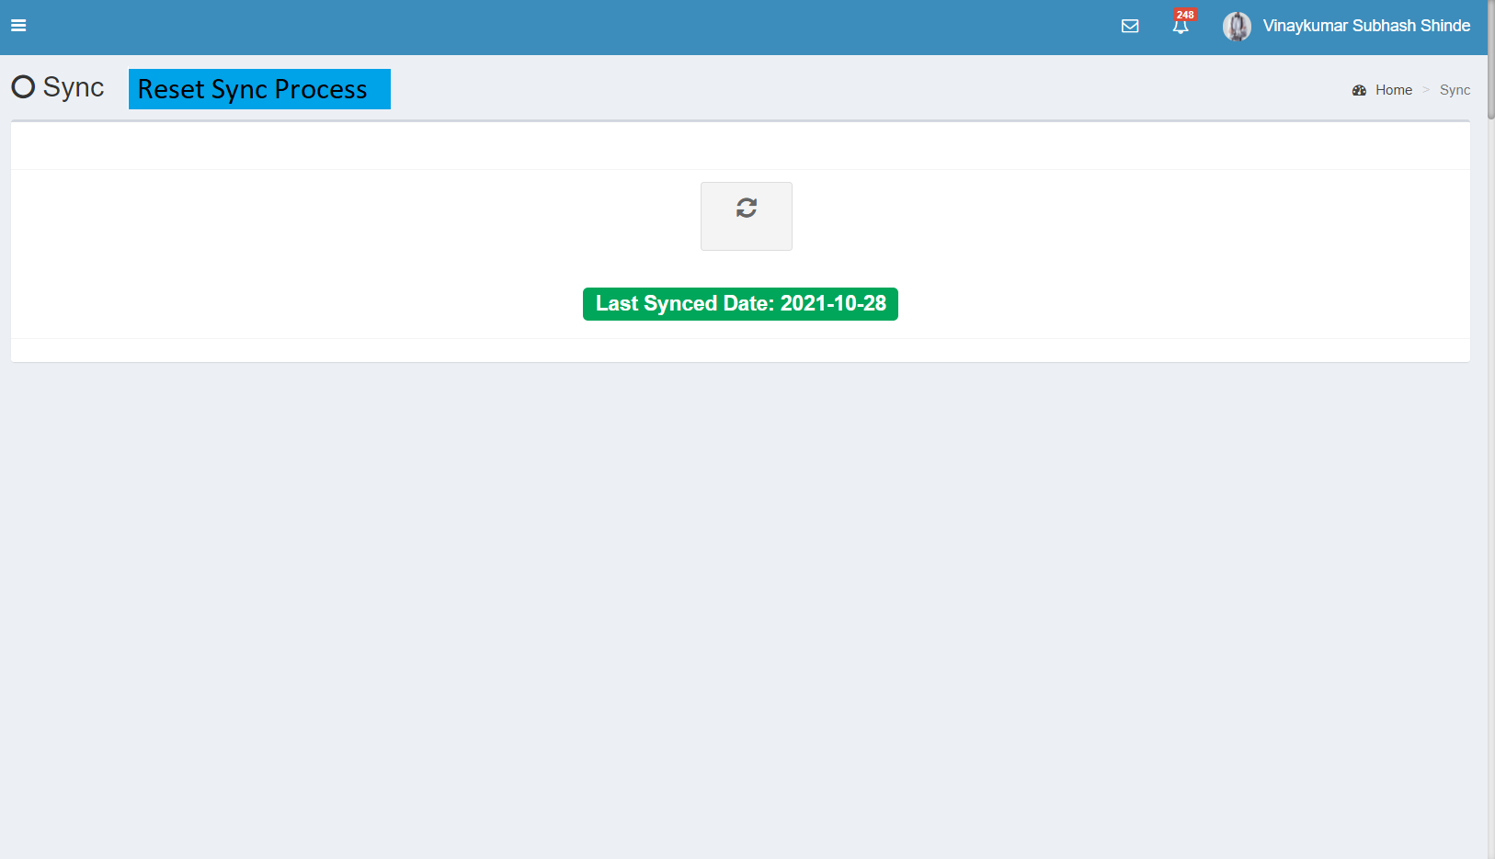

Image 1: Reset Sync Process

**References of the users**

|  |  |  |  |
| --- | --- | --- | --- |
| **User** | **Name** | **Mail** | **Contact number** |
| **Actual user** | Nilesh Waghmare | Nilesh.waghmare@techneai.com | 2999 |
| **Assigned business analyst** | Sandeep Avchitte | Sandeep.avchitte@techneai.com | 2964 |
| **Assigned developer** | Parth Patel | Parth. patel@techneai.com | 2965 |
| **Assigned tester** | Rohan Magar | Rohan.magar@techneai.com | 2979 |