User List

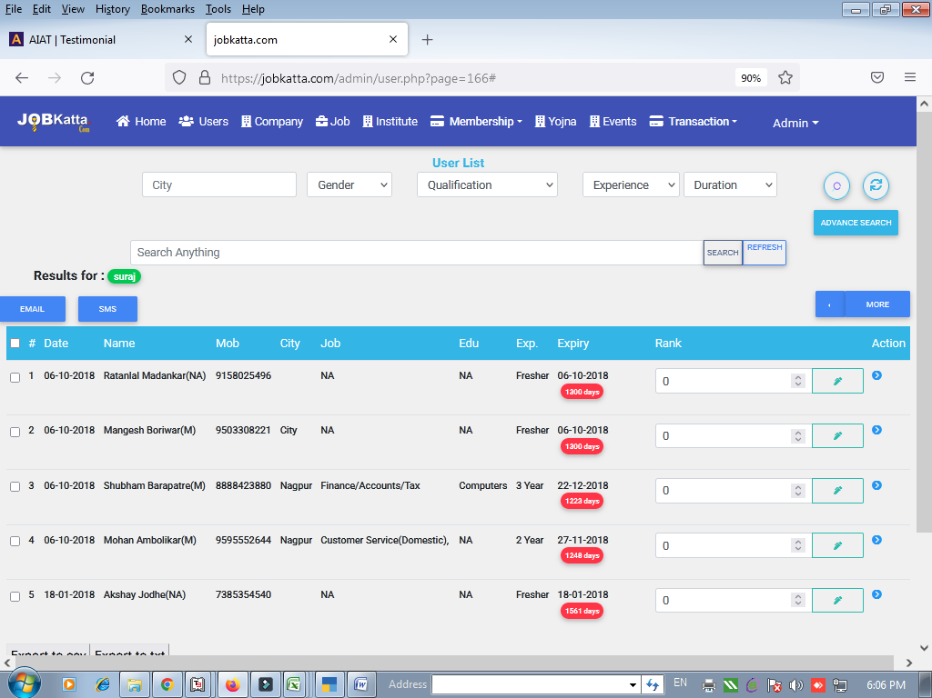

1) Search anything & Other Not working

2) Advanced Search Not working properly

3 ) Expire User List required in More option

4) SMS Templates register option required with DLT and also email

5) Email not sending through this list

6) Whatsapp option required

Company List

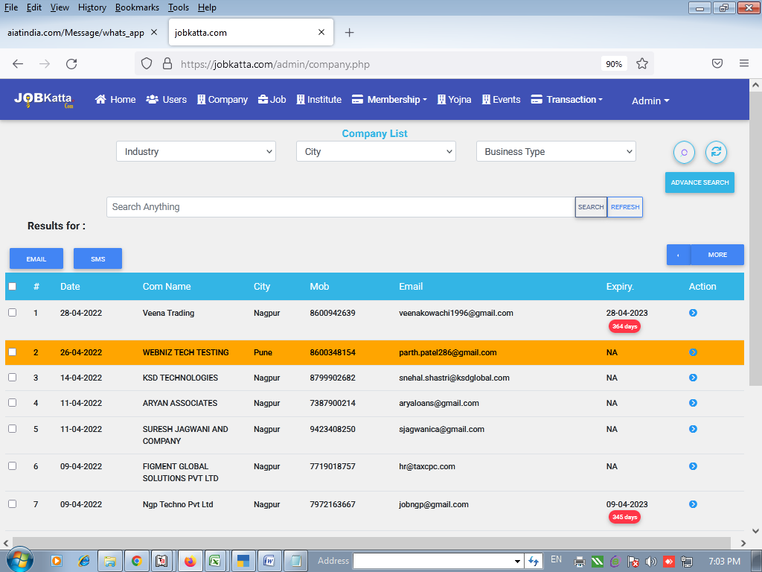

1) Search anything & Other Not working

2) Whatsapp option required in every list

3) Expire Membership List show

4) Email not sending through this list

5) SMS Templates register option required with DLT and also email

<https://jobkatta.com/admin/institute.php>

2) Whatsapp option required in every list

5) SMS Templates register option required with DLT and also email

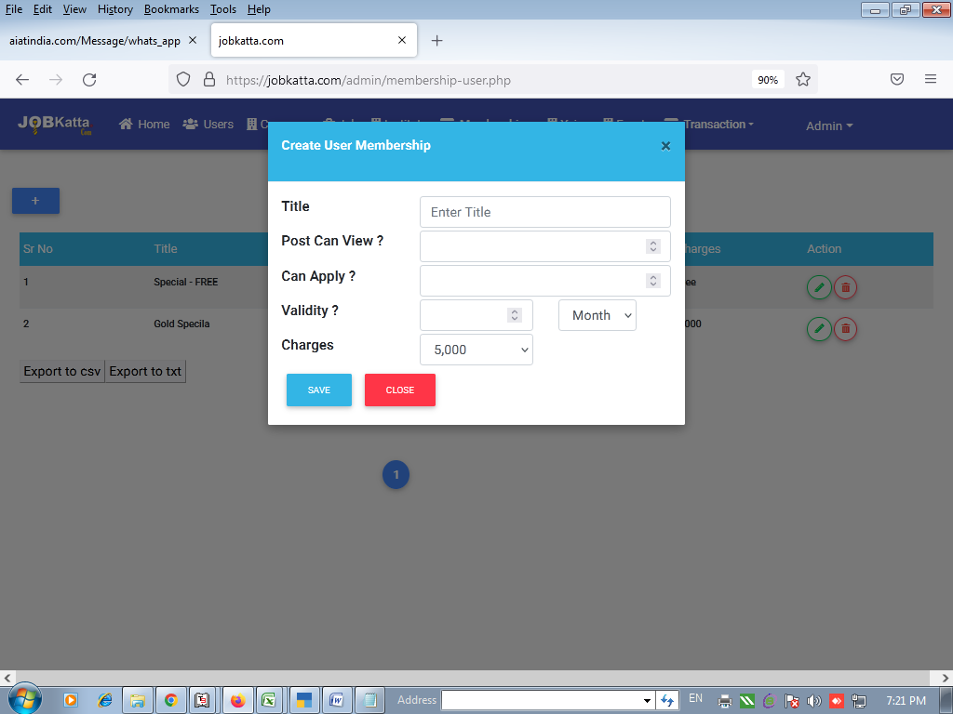

1) Amount Enter in manually in Company & User Part