|  |  |
| --- | --- |
| **Ticket ID** | T200070 |
| **Ticket description** | Kindly provide bulk uploading points & assign to concern branch to Amruta Gaikwad Login. Login Name - gamruta |
| **Created by** | Amruta Vaibhav Gaikwad |
| **Created on** | 16/02/2022 |
| **Priority** | Medium |
| **Version** | 0 |

**Version**

|  |  |  |  |  |
| --- | --- | --- | --- | --- |
| **Sr. No** | **Version no** | **Version Date** | **User name** | **User department** |
| 1 | 0 | 30.05.2022 | Amruta Vaibhav Gaikwad | Branch Operation Control |

**Approvals**

|  |  |  |
| --- | --- | --- |
| **Field** | **Name of the User** | **Approved date by the user** |
| **Actual User Name** | Amruta Vaibhav Gaikwad | 16.02.2022 |
| **Actual User Department** | Branch Operation Control |  |
| **Organization Name** | C S Jewellers |  |
| **Sign-off** |  |  |
| **Assigned BA** | Mounika KrishnaVeni Annamneedi | 30.05.2022 |
| **Assigned Developer** |  |  |
| **Assigned Tester** |  |  |

**Estimation**

|  |  |  |  |  |
| --- | --- | --- | --- | --- |
| **Department name** | **Estimated Time (In hr)** | **Scheduled Date (Starting date )** | **Estimated date** | **Actual delivery date** |
| **BA** | 6 | 30.05.2022 | 30.05.2022 |  |
| **Development** |  |  |  |  |
| **Testing** |  |  |  |  |

**Business requirement**

In connect us -> internal communication -> user requires a new ticket type “Feedback” for raising feedback tickets.

**Existing system**

In the existing system, there is no such kind of system.

**Proposed system**

* Creation of new type “Feedback” in connect us -> internal communication -> add ticket -> type
* Fields of add ticket and edit ticket.
* Bulk upload feedback format and bulk upload feedback buttons in connect us -> internal communication.
* Creation of new menu “Feedback reports” in connect us -> internal communication.

Step 1:

Creation of new type “Feedback” drop down option in connect us -> internal communication -> internal communication -> admin -> add ticket -> type

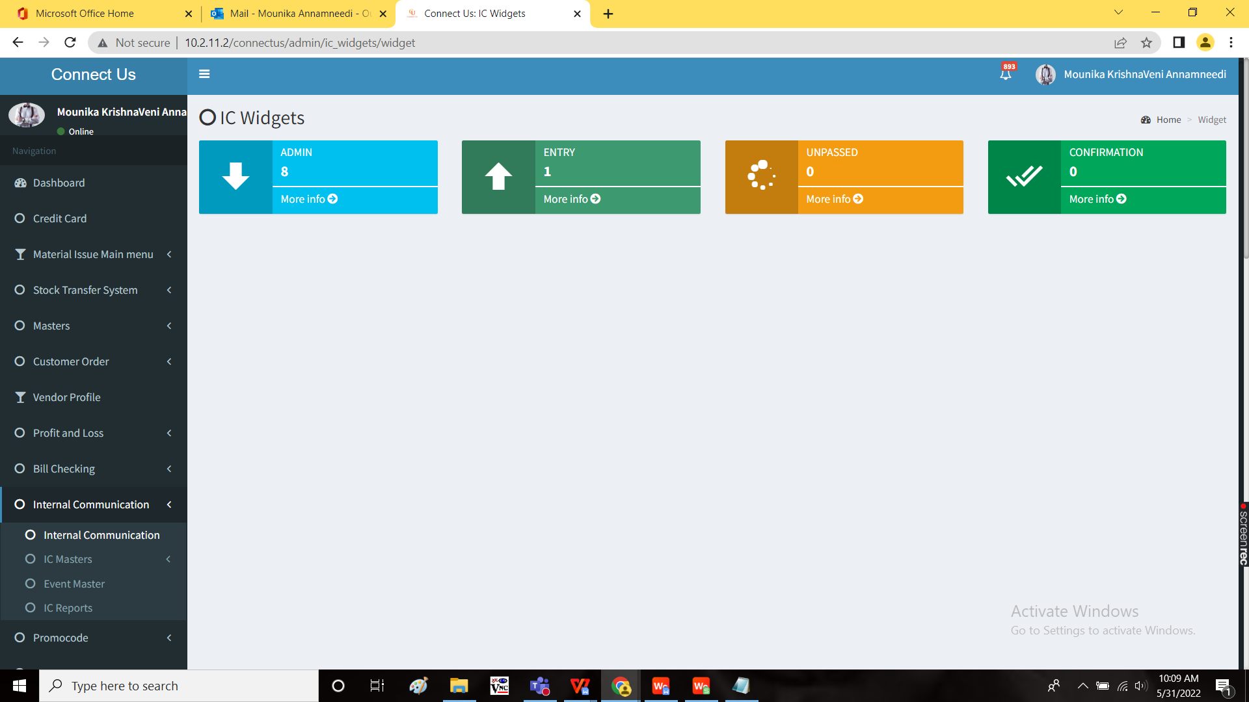

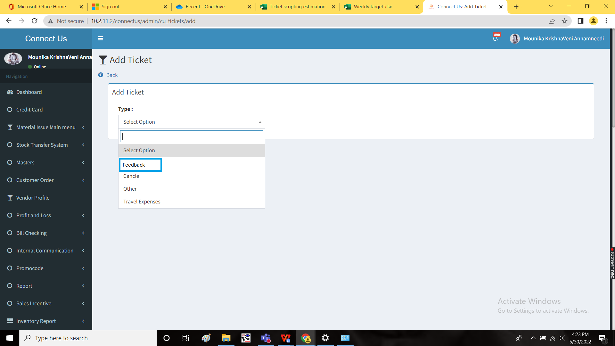

The following are the fields in “Add” page.

|  |
| --- |
| Ticket Id |
| Entry Date |
| Assign To Dept |
| Assign To Person |
| Ticket Status |
| Priority |
| Department |
| Branch |
| Customer Name |
| Visit Date |
| Visit Time |
| Employee Id |
| Employee Name |
| Counter Name |
| Metal |
| Ornament |
| Calling Date |
| First call |
| Call status |
| Reason |
| Next Visit |
| Scheme Informed |
| EMI Informed |
| Service |
| Customer Feedback |
| BM Remark |
| CM Remark |
| HOD Remark |
| BOD Remark |
| Submit |
| Back |

|  |  |  |  |  |
| --- | --- | --- | --- | --- |
| **Field** | **Type** | **Mandatory/ optional** | **Edit/ No** | **Description** |
| Ticket Id | Auto | Optional | No | The ticket ID is automatically generated. |
| Entry Date | Auto | Optional | No | The entry date I.e., the current date at the time of creation of ticket is automatically generated. |
| Assign To Dept | Drop down | Mandatory | Yes | The department to which the ticket is assigned is selected. The drop down options are fetched from department master. |
| Assign To Person | Drop down | Mandatory | Yes | The person to whom the ticket is assigned is selected. The drop down options are fetched from employee master. |
| Ticket Status | Drop down | Optional | Yes | The status of the ticket is selected. The drop down options are fetched from status master. |
| Priority | Drop down | Mandatory | Yes | The priority of the ticket is selected. The drop down options are   * Low * Medium * High * Very high |
| Department | Drop down | Optional | Yes | The department of the entry user is selected. The drop down options are fetched from department master. |
| Branch | Drop down | Optional | Yes | The branch of the entry user is selected. The drop down options are fetched from branch master. |
| Customer Name | Text | Optional | Yes | The name of the customer is entered. |
| Visit Date | Calender | Optional | Yes | The visit date of the customer to the shop is entered. |
| Visit Time | Time | Optional | Yes | The time at which customer visited the shop is entered. |
| Employee Id | Drop down | Optional | Yes | The employee ID of the employee who assisted the customer is selected. The drop down options are fetched from employee master as per employee ID. |
| Employee Name | Drop down | Optional | Yes | The employee who assisted the customer is selected. The drop down options are fetched from employee master as per employee name. |
| Counter Name | Drop down | Optional | Yes | The counter to which the customer arrived is entered. The drop down options of counter name is mentioned below. |
| Metal | Drop down | Optional | Yes | The metal for which the customer visited is selected. The drop down options of metal is mentioned below. |
| Ornament | Drop down | Optional | Yes | The ornament for which the customer visited is selected. The drop down options of ornament is mentioned below. |
| Calling Date | Calender | Optional | Yes | The actual calling date to the customer is selected. |
| First call | Calender | Optional | Yes | The first call on when the employee called the customer is entered. |
| Call status | Drop down | Optional | Yes | The call status is selected from the drop down list. The drop down options of call status are   * Feedback * No feedback |
| Reason | Text | Optional | Yes | The reason if any is mentioned. |
| Next Visit | Drop down | Optional | Yes | The next visit of the customer is selected from the drop down list. The drop down options of counter name is mentioned below. |
| Scheme Informed | Check box | Optional | Yes | Whether the scheme informed to customer is selected from the check box list.  If yes, yes to be selected.  If no, no to be selected. |
| EMI Informed | Check box | Optional | Yes | Whether the EMI informed to customer is selected from the check box list.  If yes, yes to be selected.  If no, no to be selected. |
| Service | Check box | Optional | Yes | Status of the service liked by the customer or not is selected from the check box.  If liked, like is selected.  If no, not like is selected. |
| Customer Feedback | Text | Optional | Yes | The customer feedback if any is selected. |
| BM Remark | Text | Optional | No | BM refers to Branch Manager. The Branch Manager remark if any is selected. |
| CM Remark | Text | Optional | No | CM refers to Cluster Manager. The Cluster Manager remark if any is selected. |
| HOD Remark | Text | Optional | No | HOD refers to Head of department. The head of department remark if any is selected. |
| BOD Remark | Text | Optional | No | BOD refers to the Management. The Management remark if any is selected. |
| Submit | Button | Optional | - | To submit the data |
| Back | Button | Optional | - | To navigate to back page |

The following are the drop down options for counter name:

|  |
| --- |
| Cash Counter |
| Delivery Counter |
| Diamond Counter |
| Tops Counter |
| Vedhnee Counter |
| Chain Counter |
| Angathi Counter |
| Necklace Counter |
| Bangdi Counter |
| Ganthan Counter |
| Silver Counter |
| Forming Counter |
| URD Counter |
| Smith Counter |

The following are the drop down options for metal

|  |
| --- |
| Gold |
| Silver |
| Diamond |
| Stone |
| Mrp |
| Forming |
| Platinium |
| Other |

The following are the drop down options for metal

|  |
| --- |
| Utensils |
| Pooja Items |
| Murti |
| Payal |
| Sakhali |
| Jodvi |
| Challa |
| Mekhala |
| Devache Tak |
| Rakhi |
| Kadali |
| Apata pan |
| Kalas Vel |
| Modak |
| Durva |
| Pratima |
| Satwai |
| Bichave |
| Vale |
| Paan |
| Palna |
| Katree |
| Mukhavata |
| Khulkhula |
| Karadoda |
| Swastik |
| Kamarpatta |
| Supari |
| Devache Paat |
| Saadi Pin |
| Swarovski |
| Black Beeds |
| Oxide Jewellery |
| Tode |
| Janava |
| Other |
| Ganthan |
| Angathi |
| Tops |
| Chamaki |
| Necklace |
| Rani Har |
| Mohanmal |
| Laxmi Har |
| Bangdi |
| Bajuband |
| Bindi |
| Thushi |
| Chain |
| Kada |
| Pendent |
| Nath |
| Vel |
| Kolhapuri Saj |
| Bracelet |
| Pohe Har |
| Coin |
| Vedhanee |
| Dorla |
| Mani |
| Padak |
| Dal Tik |
| Tashiv Mani mal |
| Kap |
| Badam |
| Patli |
| Bor Mal |
| Goth |
| Kanthi Mal |
| Bakuli Har |
| Manchali |
| Watch |
| Putali Har |
| Wedding Set |
| Zumka |
| Bali |
| Dul |
| Bugadi |
| S Phasa |
| Shahi Har |
| Choker |
| Diamond |
| Yellow Sapphire |
| Emerald |
| Ruby |
| Blue Sapphire |
| Quartz |
| Cats Eye |
| Pearl |
| Coral |
| Gomed |
| Zircon |
| Amethyst |
| Alexandrite |
| Sun Stone |
| Hemetite |
| Firoza |
| Topaz |
| Opal |
| Tiger's Eye |
| Moonstone |
| Tourmaline |
| Alexandar |
| Lapis |
| Rudraksha Mala |
| Tanmani |
| Chinchpeti |
| Mala |

The following are the drop down options for next visit.

|  |
| --- |
| Purchase From Another |
| Visit to Our Website |
| Sales Person will Contact them |
| Next Month |
| Next Week |
| Cancelled |
| Visit to our other branch |
| Not Confirm |

The details which mentioned in the table edited using the edit button in the action field.

Step 2:

Bulk upload feedback format and bulk upload feedback buttons in connect us -> internal communication.

In Connect Us -> Internal Communication -> Internal Communication -> Internal Communication -> Admin



Add “Bulk Upload Feedback Format” and “Bulk Upload Feedback” buttons.

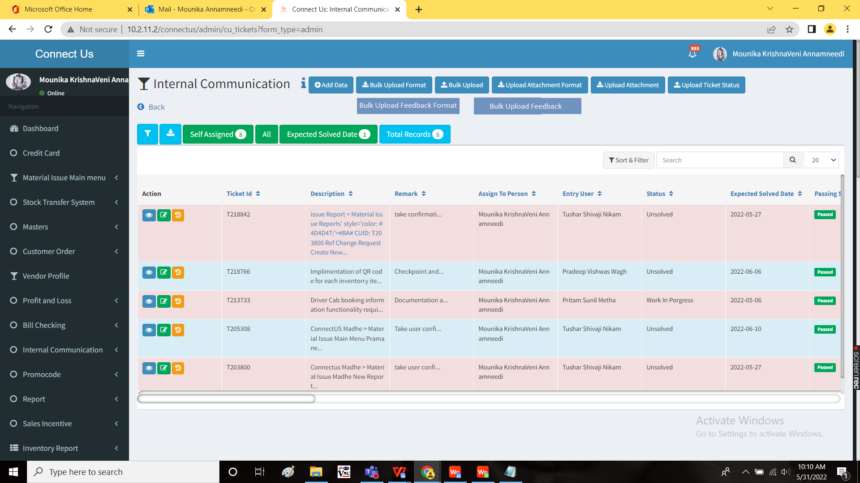

Bulk Upload Feedback Format:

When the user clicks on “Bulk upload feedback format”, the file is downloaded in .csv format.

The bulk upload format consists of following fields.

|  |
| --- |
| Assign To Dept |
| Assign To Person |
| Priority |
| Calling Date |
| Customer visit Date |
| Customer visit Time |
| Employee Id |
| Employee Name |
| Branch |
| First call |
| Status |
| Metal |
| Ornament |
| Counter name |
| Calling Date |
| Reason |
| Customer name |
| Next visit |
| Scheme Informed |
| EMI Informed |
| Service |
| Customer Feedback |
| Department |

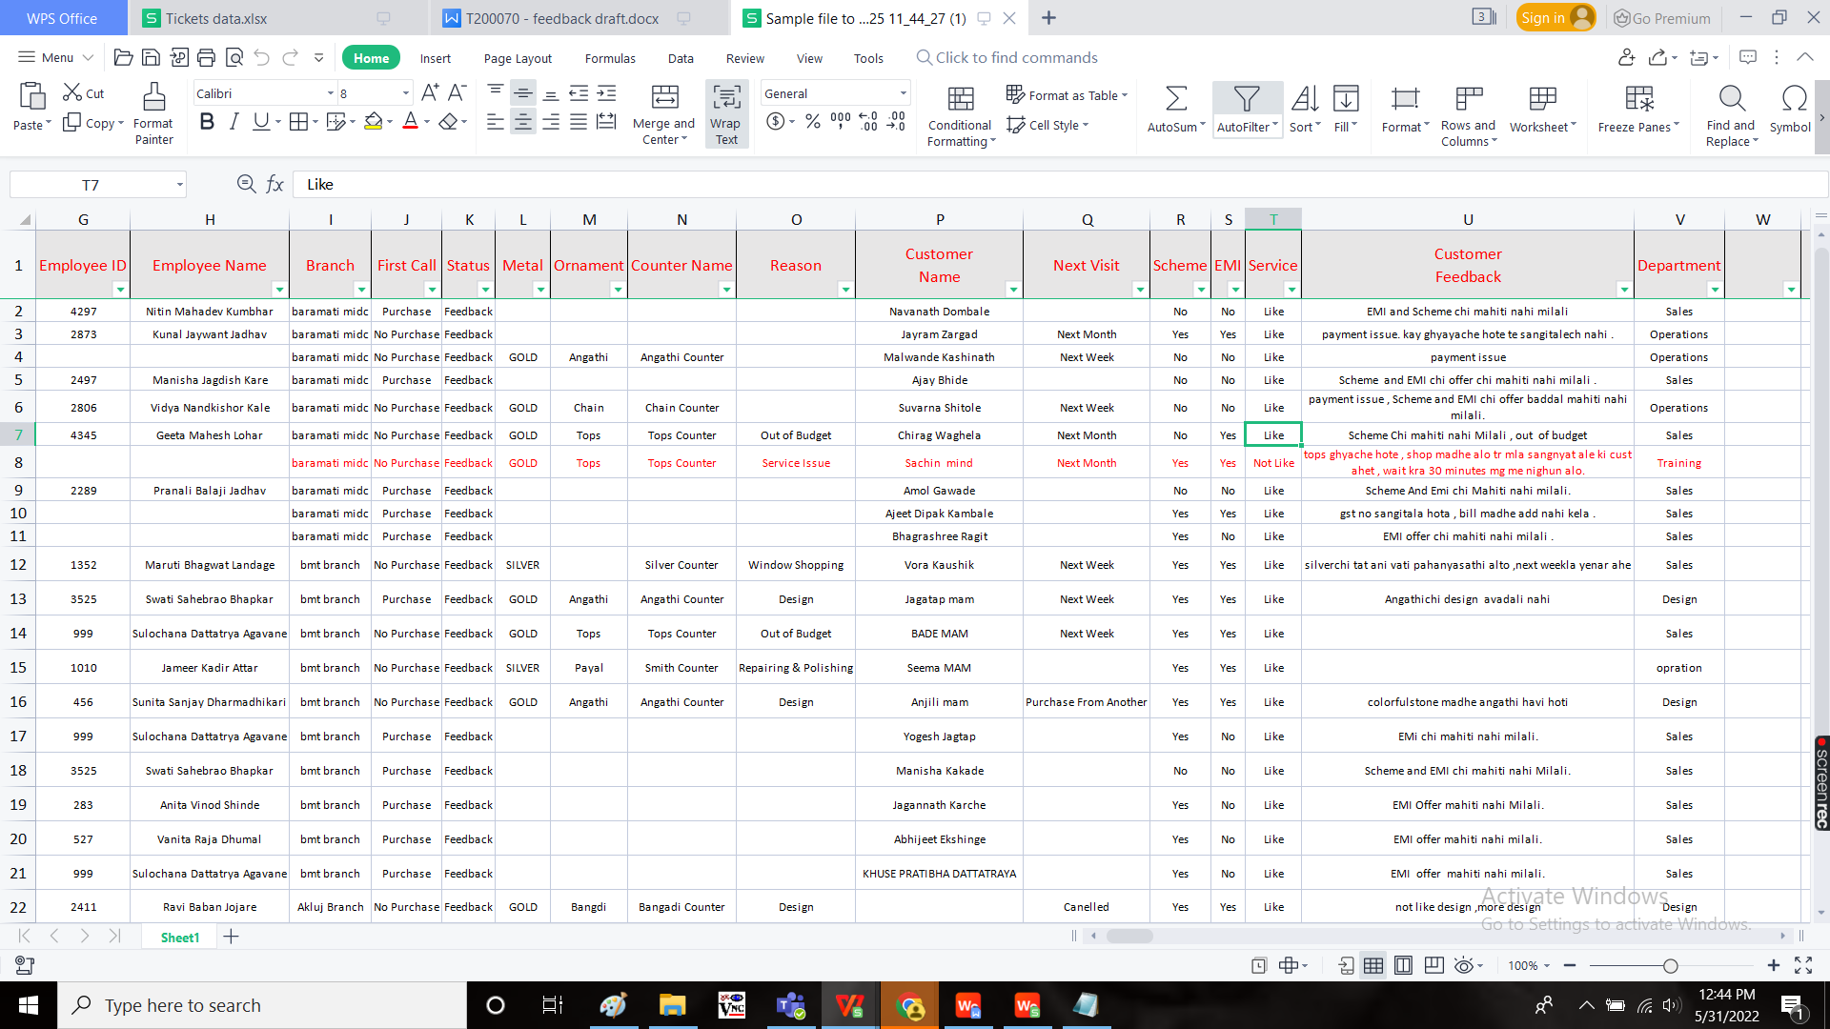

“Assign to department”, “assign to person” and “Priority” are mandatory fields and remaining are optional.

Bulk Upload Feedback:

When the user clicks on “Bulk Upload Feedback”, the following tab opens to upload the file with the following fields.

* Choose file
* Close
* Submit

|  |  |  |  |
| --- | --- | --- | --- |
| **Field** | **Type** | **Mandatory/ optional** | **Description** |
| Choose file | Attachment | Mandatory | To attach the document |
| Close | Button | Optional | To close the tab |
| Submit | Button | Optional | To submit the details |

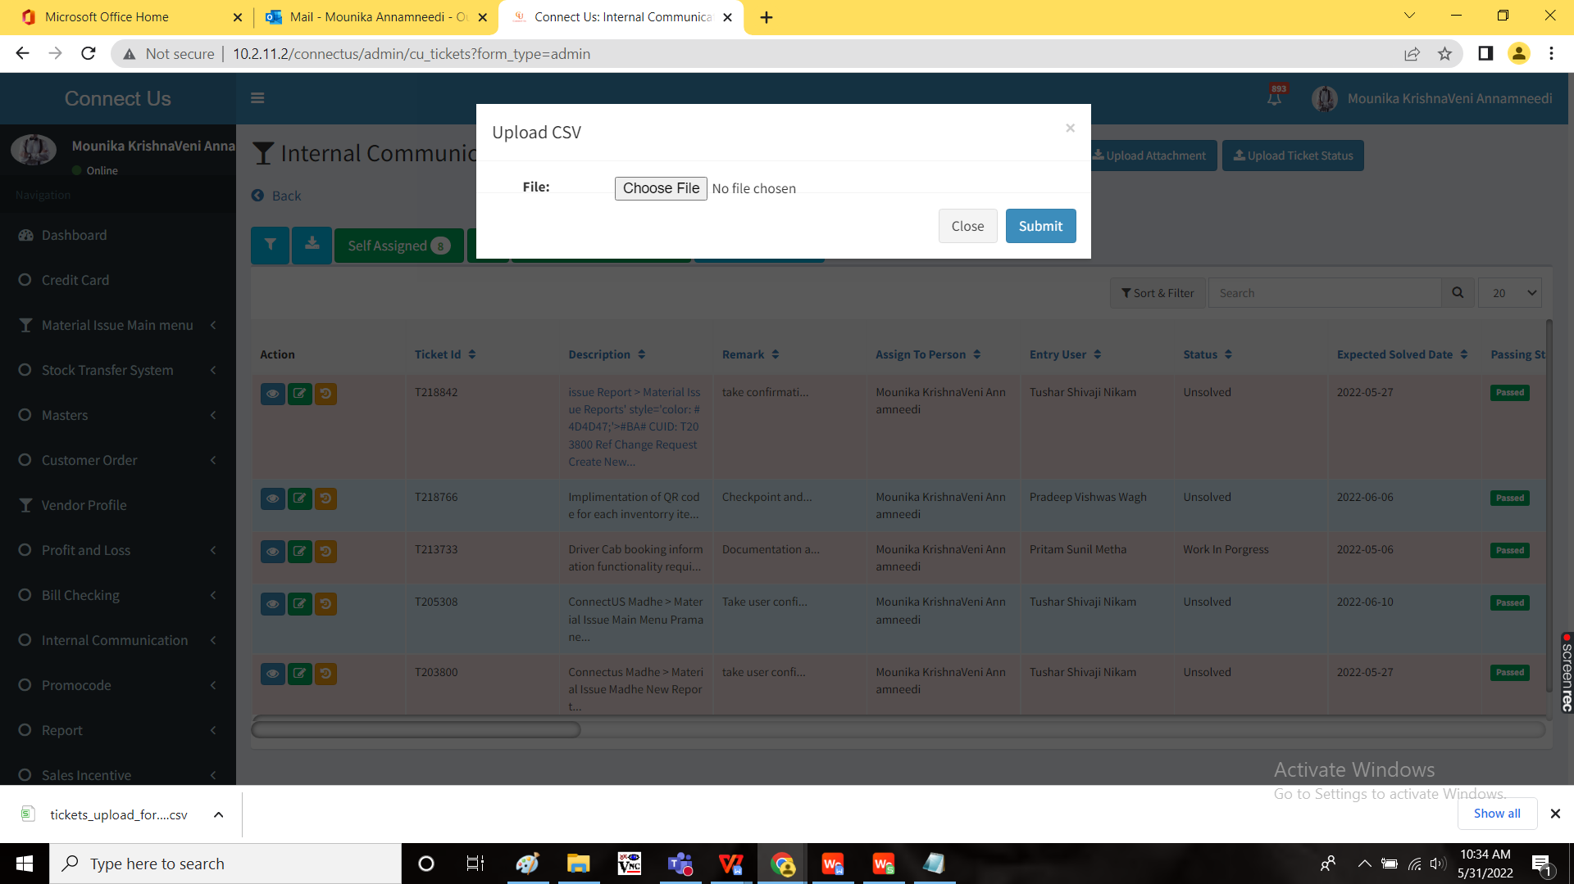

When the user clicks on the “Submit”, the file is uploaded and tickets are created accordingly.

Step 3

Creation of new menu “Feedback reports” in connect us -> internal communication.

In Connect Us -> Internal Communication, add new sub-module “IC Feedback Reports”

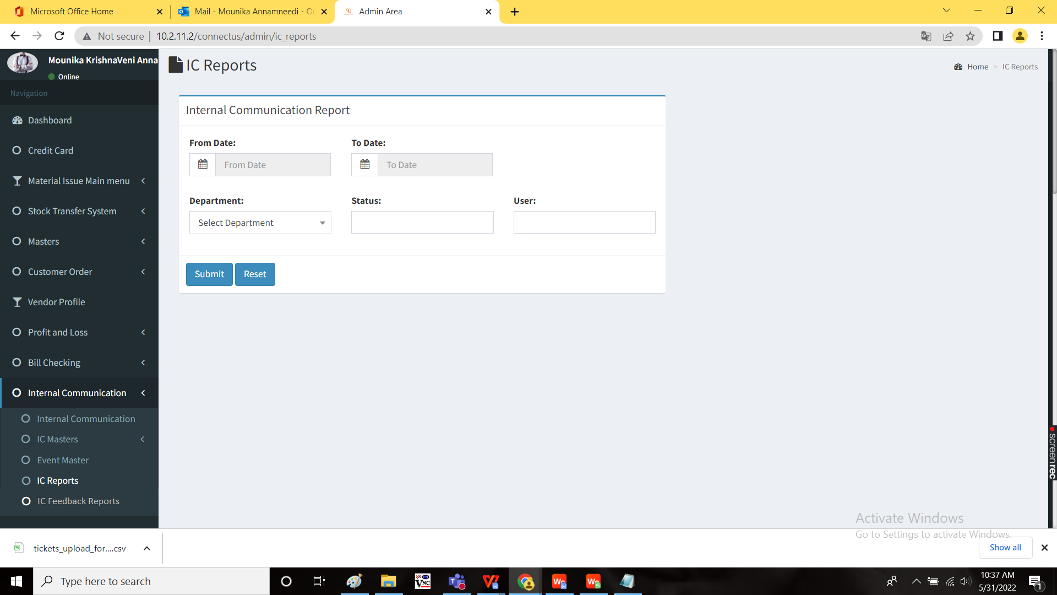

IC Feedback Reports:

The IC Feedback reports consists of all the reports of Feedback tickets.

The following are the filters in IC feedback reports.

* From date
* To date
* Branch
* Submit
* Reset

|  |  |  |  |
| --- | --- | --- | --- |
| **Field** | **Type** | **Mandatory/ optional** | **Description** |
| From date | Calender | Mandatory | The filter from when the data to be fetched. |
| To date | Calender | Mandatory | The filter to when the data to be fetched. |
| Branch | Drop down | Optional | The filter for branches. The drop down options are fetched from branch master. |
| Submit | Button | Optional | To submit the data |
| Reset | Button | Optional | To reset the filters |

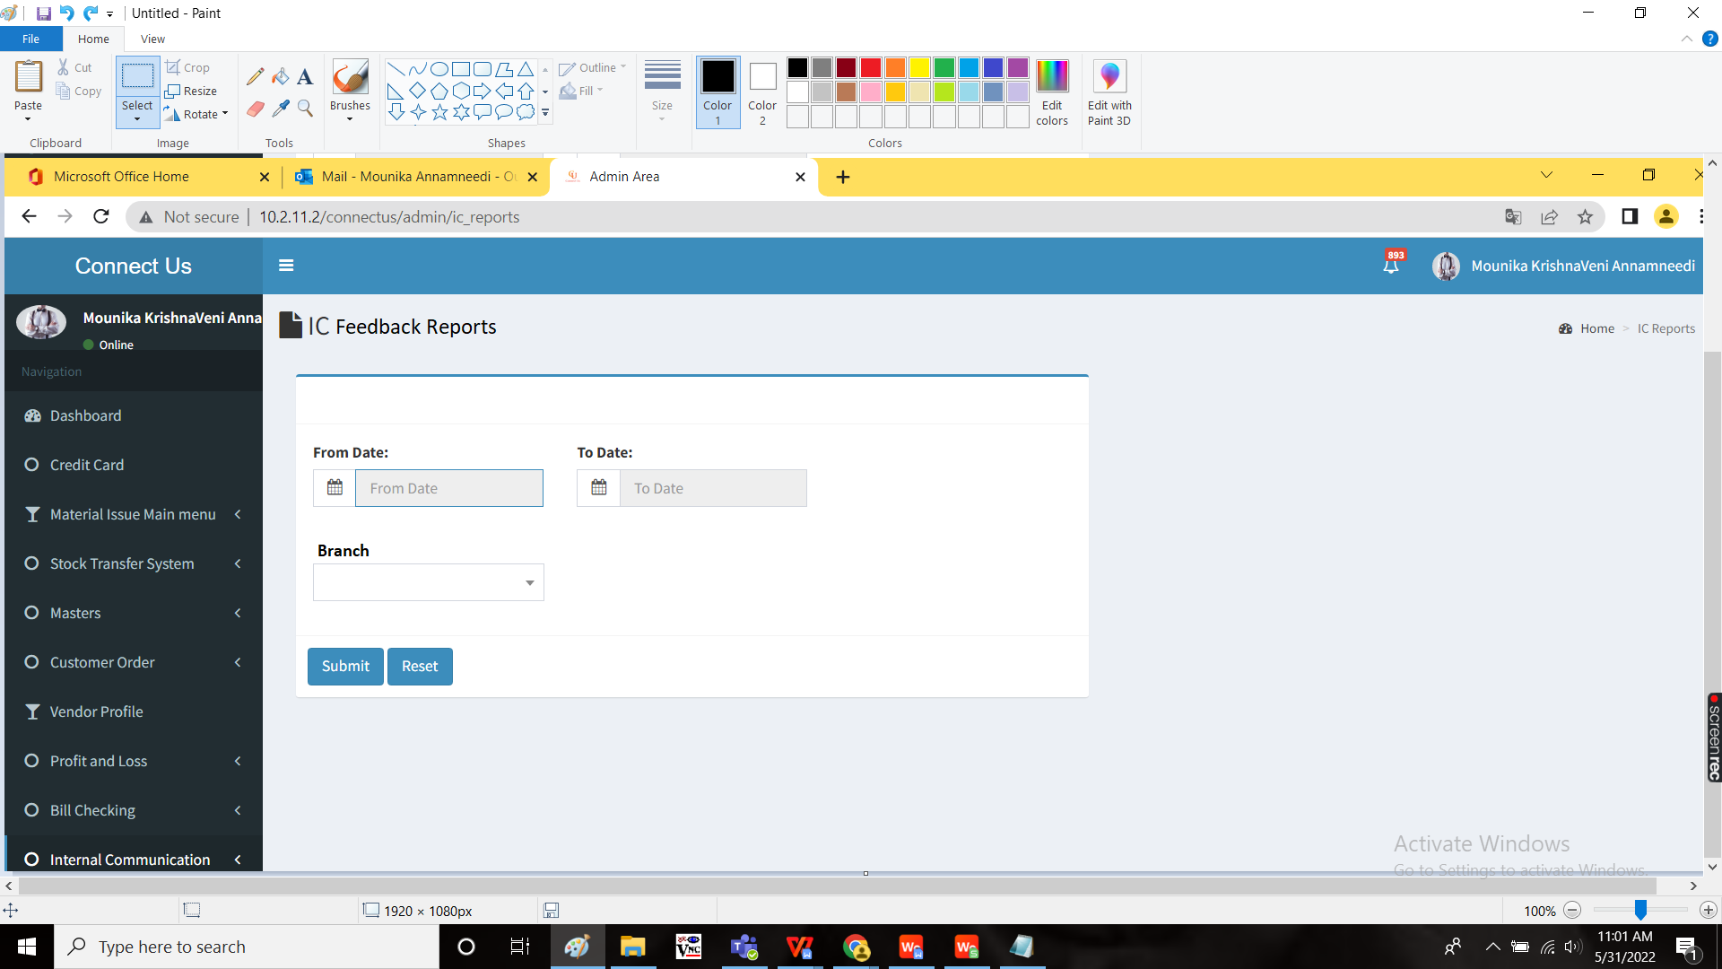

The report is generated with the following fields.

|  |
| --- |
| Ticket Id |
| Entry Date |
| Assign To Dept |
| Assign To Person |
| Ticket Status |
| Priority |
| Department |
| Branch |
| Customer Name |
| Visit Date |
| Visit Time |
| Employee Id |
| Employee Name |
| Counter |
| Metal |
| Ornament |
| Calling Date |
| Reason |
| Next Visit |
| Scheme Informed |
| EMI Informed |
| Service |
| Customer Feedback |
| BM Remark |
| CM Remark |
| HOD Remark |
| BOD Remark |

A export button is displayed to export the data generated.

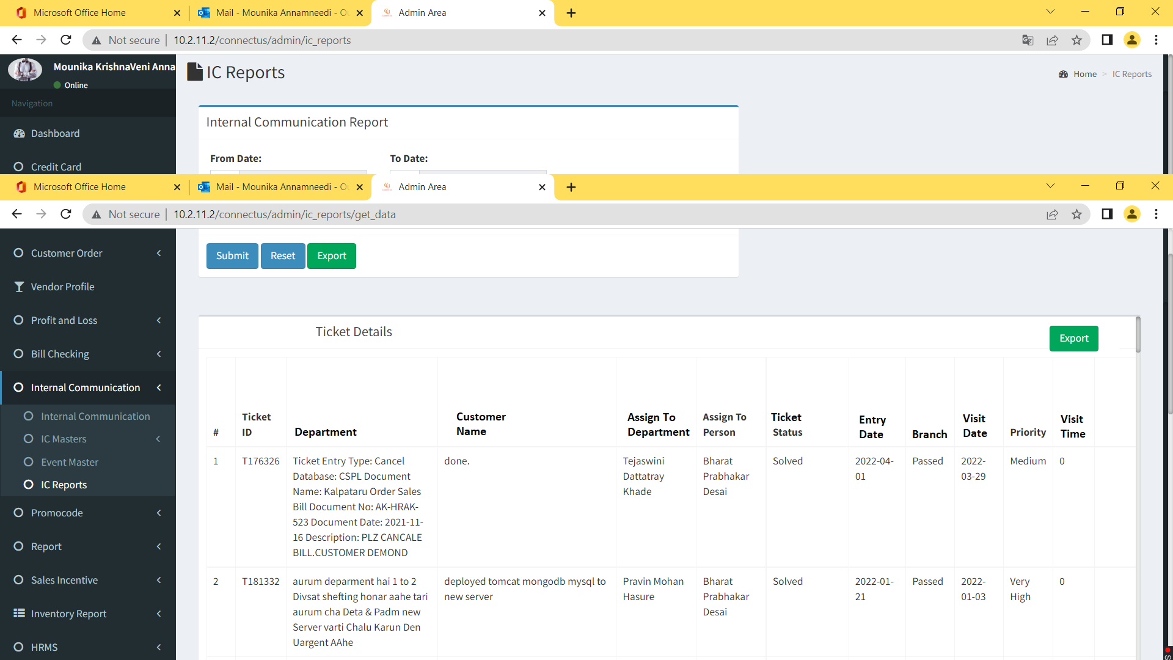

When the user clicks on “export”, the following file is downloaded in .csv format.

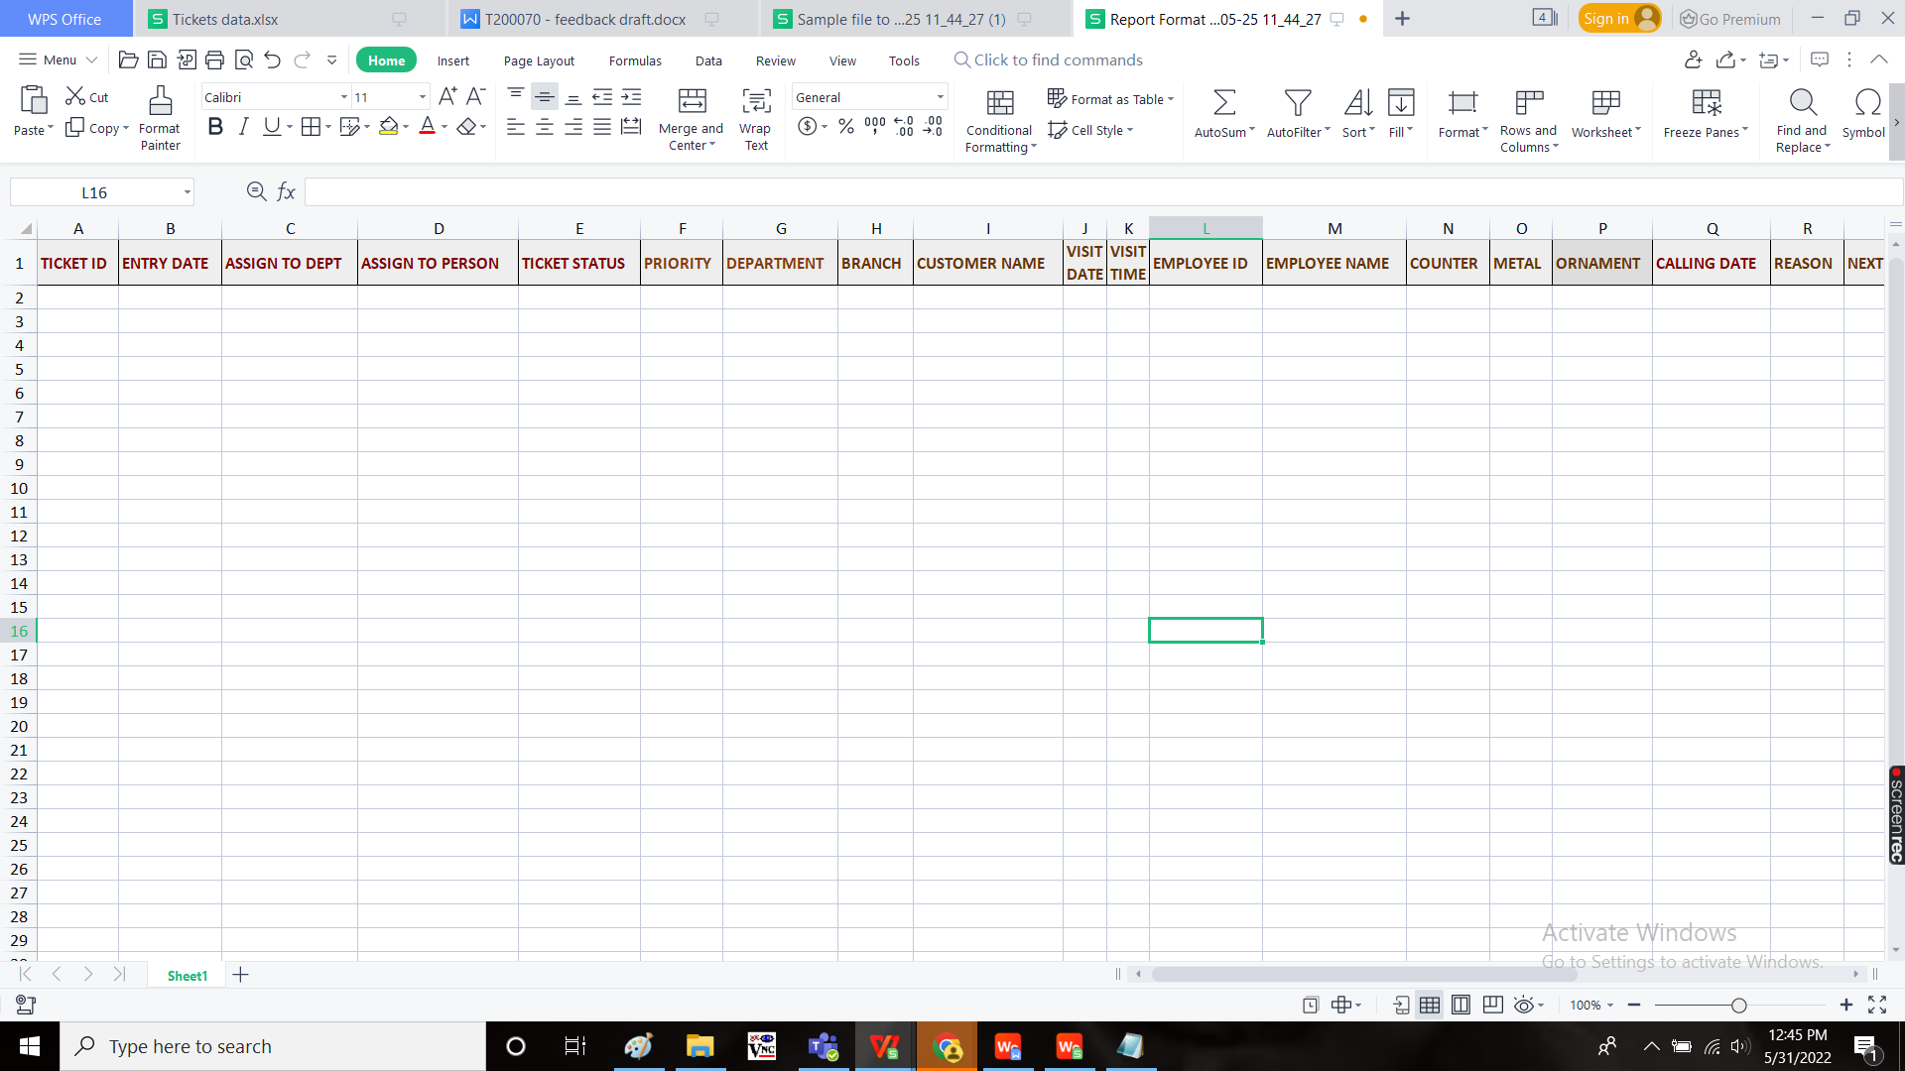

Note:

The remarks of the following is mandatory based on the priority of the ticket for passing the ticket to the assigned person.

|  |  |
| --- | --- |
| Low | Branch manager |
| Medium | Cluster manager |
| High | Department head |
| Very high | BOD Team |

**References of the users**

|  |  |  |  |
| --- | --- | --- | --- |
| **User** | **Name** | **Mail** | **Contact number** |
| **Actual user** | Amruta Vaibhav Gaikwad | aosm@csjewellers.com |  |
| **Assigned business analyst** | Mounika KrishnaVeni Annamneedi | Mounika.annamneedi@techneai.com | 8669917920 |
| **Assigned developer** |  |  |  |
| **Assigned tester** |  |  |  |