**CONFIRMATION**

The ticket confirmed by changing the status to “solved” in ticket edit by the ticket owner.

There are 2 ways in ticket creation.

1. At the time of ticket creation, if the confirmation required is “yes”

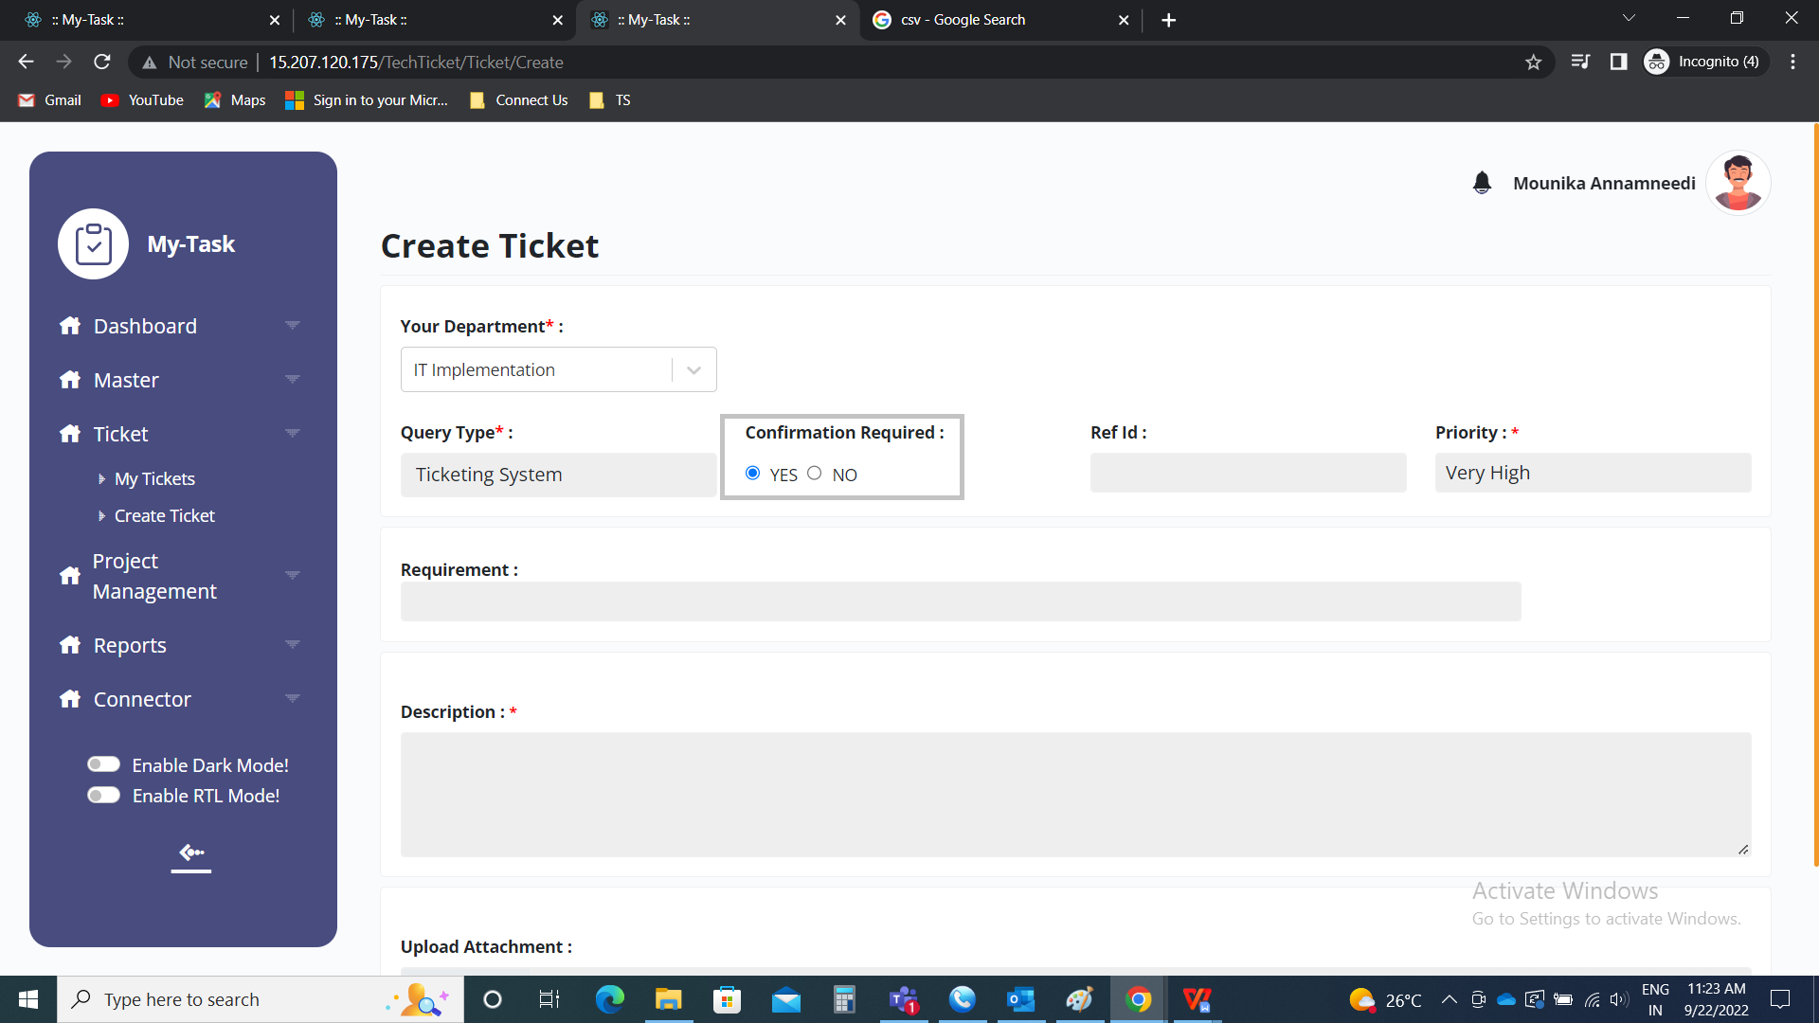

When the ticket is solved, the ticket owner changes the status to solved and submits.

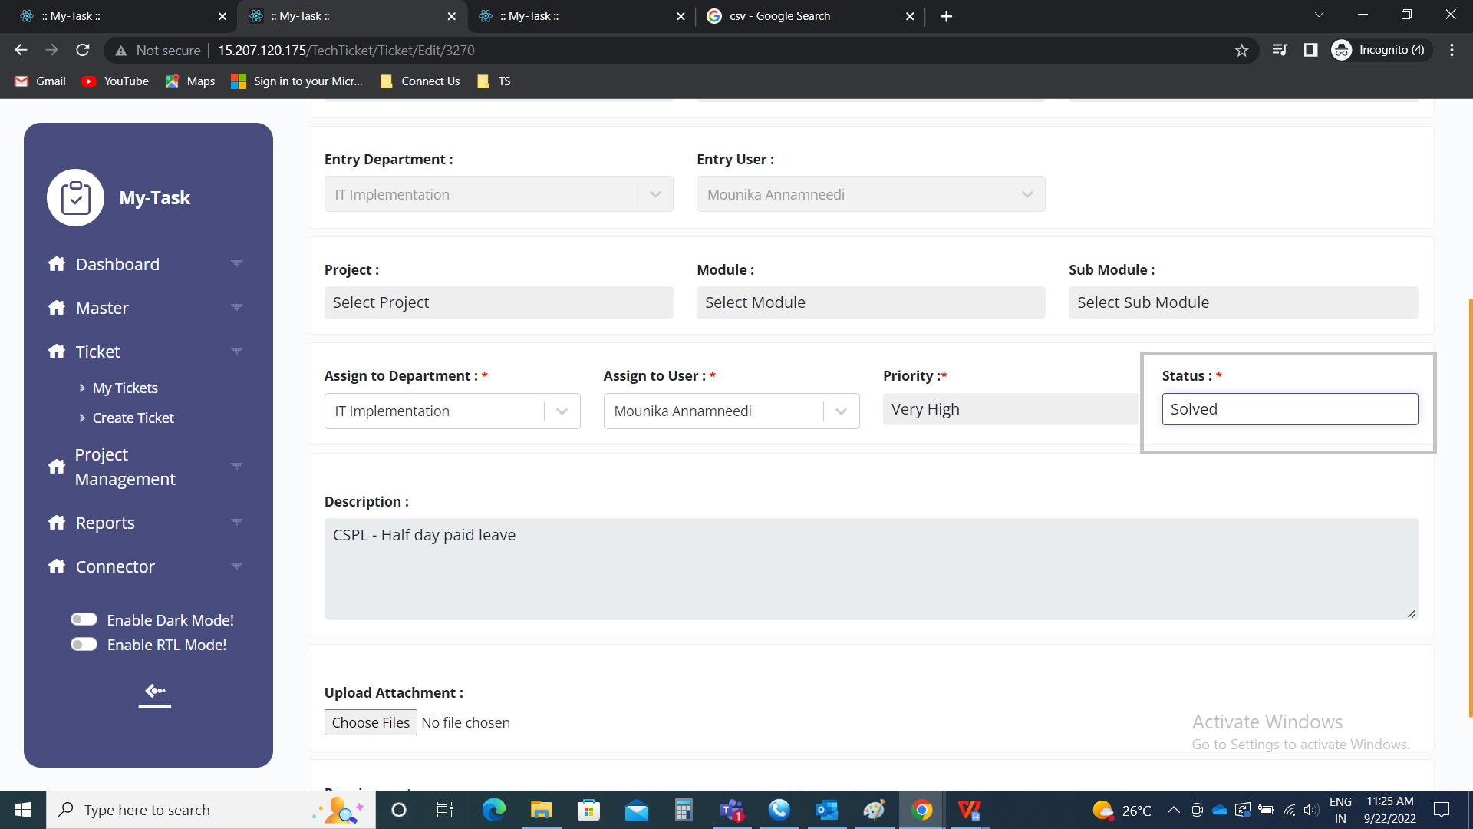

The ticket creator gets the OTP to the preferred communication set in the user profile of the user.

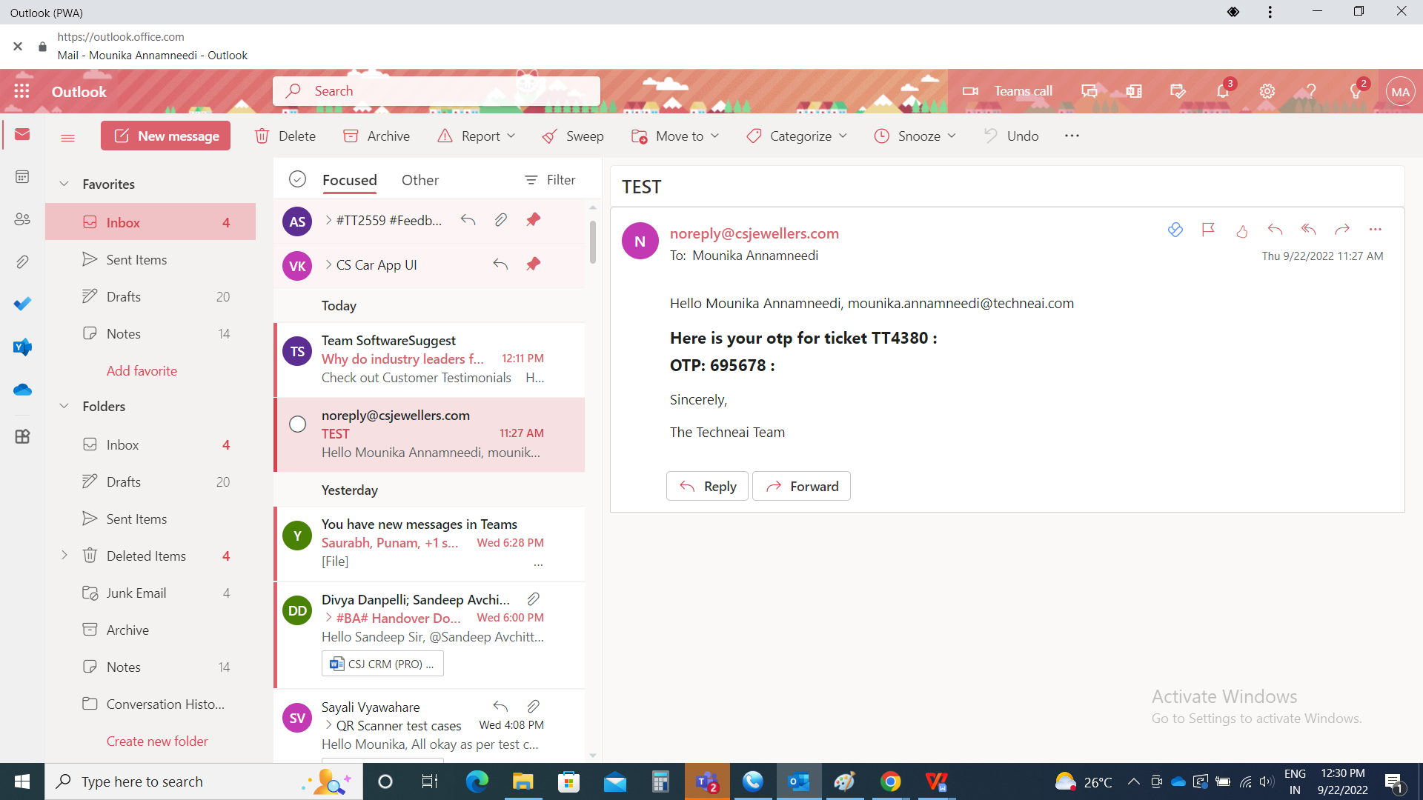

The ticket owner will get a pop up dialog box to send the OTP.

The dialog box consists of the following fields.

* Enter OTP
* Resend OTP
* Submit
* Cancel

|  |  |  |  |
| --- | --- | --- | --- |
| **FIELDS** | **INPUT TYPE** | **MANDATORY/ OPTIONAL** | **DESCRIPTION** |
| Enter OTP | Int | Mandatory | The OTP is sent to the ticket creator is entered here by the ticket owner |
| Resend OTP | Button | Optional | The resend OTP button to resend the OTP to the ticket creator if in case, any issue |
| Submit | Button | Optional | The submit button to submit the data. As soon as the valid OTP entered, the ticket will be solved and record will be removed from the my tickets to the ticket creator, ticket owner, basket owner, task owner and if any task assigned user to that ticket. |
| Cancel | Button | Optional | The cancel button to exit the dialog box |

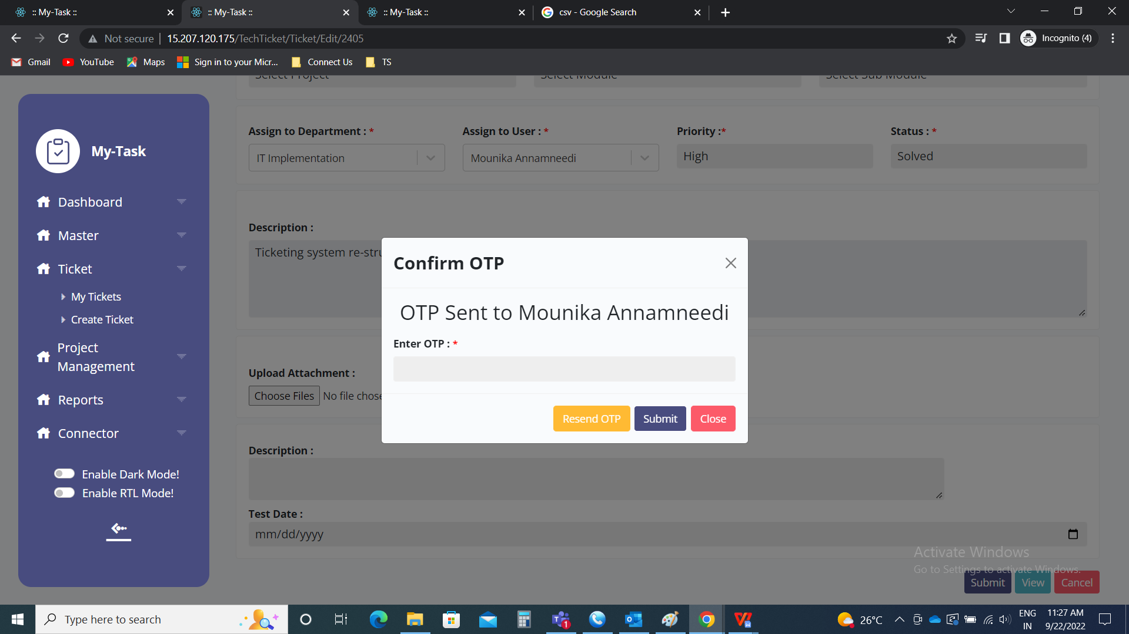

If any invalid OTP is entered by the user, then pop up notification is displayed “OTP is not matched”.

