23.08.2023

BILL CHECKING

Mounika Annamneedi

Mounika.annamneedi@techneai.com

**Functional Requirement Document**

**CONTENTS**

**1. INTRODUCTION** 2

**2. BUSINESS REQUIREMENT** 2

**3. SCOPE** 2

**4. BUSINESS & SYSTEM RULES** 2

**5. PROPOSED SYSTEM** 2

1. **INTRODUCTION**

The bill checking module is the billing process which is helpful in creating bills, payment details, approval process and bill payments.

1. **BUSINESS REQUIREMENT**

Enter details of the ticket requirement.

|  |  |  |  |
| --- | --- | --- | --- |
| **Requirement ID** | **Requirement Name** | **Short Description** | **Priority** |
| BR001 | Bill Checking Transaction | The bill checking transaction module to used to create the bills, view the bills, edit the bills and the to view the payment status etc | High |
| BR002 | Bill checking - filters | The bill checking filters is used to filter the records based on the filters given | High |
| BR003 | Bill checking - export | Bill checking exported in the export module | Medium |
| BR004 | Bill checking - add module | Bill checking add module is used to add the bills into the system | High |
| BR005 | Bill checking - cancel | The cancel button to cancel the bill | High |

1. **SCOPE**

The scope of the point is up to the view the bills assigned, filter the bills, export the bills and to add the bills.

1. **BUSINESS & SYSTEM RULES**

* User should be registered in the system.
* User should be logged in.
* System should display error message for incorrect details if entered.
* System should pop up a message, if any issues in the system is detected.
* All forms should have on field validations. System should display on field errors in case of incorrect inputs.

1. **PROPOSED SYSTEM**

**BR001 - Bill Checking Transaction**

The bill checking transaction is the module where the users can view the bills assigned to the user, filter the bills, export the bills, add the bills, edit the bills etc.

The bill checking transaction consists of the following.

* Add data
* Filter
* Export
* Action
* Sr no
* Bill ID
* Vendor name
* Payment date
* Bill No
* Actual payment date
* Bill amount
* Net amount
* Bill status
* Bill type
* Assign from
* Assign to
* Levels of approval
* Level 1 approvals
* Level 2 approvals
* Approved by
* Pending approval
* Taxable amount
* Debit Advance
* Is original bill
* Internal audit
* External audit
* Bill date
* Received date
* Hold amount
* Paid amount
* Is canceled
* Is TCS applicable
* Created at
* Created by
* Updated at
* Updated by

|  |  |
| --- | --- |
| **FIELDS** | **DESCRIPTION** |
| Add data | The add data button to add the data into the system |
| Filter | The filter button to filter the data entered |
| Export | The export button to export the data in the filters |
| Action | The action field consists of the following buttons.   * Edit * View * History * Payment history * Payment details * Assigned person * Cancel   The edit button to edit the bill. The edit authority is available to the approvers in the hierarchy of approvals from the bill type. After the approvals, the bill is assigned to the assigned user.  The view button to view the bill in detail.  The history button to view the history of the bill.  The payment history button to view the payment history of the bill.  The payment details button to view the payment details of the bill.  The assigned person is the assigned persons of the bill history i.e., the process of assigning of bill from one person to another.  The cancel button to cancel the bill. Only the assigned user can cancel the bill. |
| Sr no | The serial number of the record is displayed |
| Bill ID | The bill ID of the bill generated is displayed |
| Vendor name | The vendor name of the bill is displayed |
| Payment date | The payment date of the bill is displayed. If multiple payment dates are against it, comma separated values are displayed. |
| Bill No | The bill number of the bill is displayed |
| Actual payment date | The actual payment date of the bill is displayed. If multiple actual payment dates are against it, comma separated values are displayed. |
| Bill amount | The bill amount of the bill is displayed |
| Net amount | The net amount of the bill is displayed |
| Bill status | The bill status of the bill is displayed |
| Bill type | The bill type of the bill is displayed |
| Assign from | The assign from person of the bill is displayed |
| Assign to | The assign to person, the current assign to person name is displayed |
| Levels of approval | The number of levels of the approvals is displayed |
| Level 1 approvals | The level 1 approval user’s names is displayed. If there are multiple users, the comma separated values are displayed. |
| Level 2 approvals | The level 2 approval user’s names are displayed if any. If there are multiple users, the comma separated values are displayed. |
| Approved by | The approved by user’s names are displayed. If there are multiple users, the comma separated values are displayed. |
| Pending approval | The pending approval is any displayed. If there are multiple users, the comma separated values are displayed. |
| Taxable amount | The taxable amount of the bill is displayed |
| Debit Advance | The debit advance of the bill is displayed |
| Is original bill | The is original bill check box is selected or not is displayed. If yes, yes is selected. If no, no is selected. |
| Internal audit | the internal audit remark entered is displayed |
| External audit | The external audit remark entered is displayed |
| Bill date | The bill date of the bill is displayed |
| Received date | The received date of the bill is displayed |
| Hold amount | The hold amount total of the bill is displayed |
| Paid amount | The paid amount total of the bill is displayed |
| Is canceled | The is canceled or not is displayed. If yes, yes is selected. If no, no is selected. |
| Is TCS applicable | The TCS applicable or not is displayed. If yes, yes is selected. If no, no is selected. |
| Created at | The created at date and time of the bill is displayed |
| Created by | The created username is displayed |
| Updated at | The updated date and time of the bill is displayed |
| Updated by | The updated by username is displayed |

**BR002 – Bill checking filters**

The bill checking filters consists of the following filters. The user can multiple filters if required.

* BC ID
* Bill No
* Vendor name
* Bill status
* Bill type
* Assign to
* Bill date
* Received date
* Payment date
* Bill amount
* Hold amount
* Is original bill received
* Filter
* Reset

|  |  |  |  |
| --- | --- | --- | --- |
| **FIELDS** | **INPUT TYPE** | **MANDATORY/ OPTIONAL** | **DESCRIPTION** |
| BC ID | Text | Optional | The bill checking ID is entered. In case of multiple bill ID’s, comma separated values are entered.  Validation: Can accept single and multiple bill ID’s. |
| Bill No | Text | Optional | The bill checking number is entered. In case of multiple bill number’s, comma separated values are entered.  Validation: Can accept single and multiple bill numbers. |
| Vendor name | Drop down | Optional | The vendor is selected from the drop down. The drop-down options are fetched from the vendor master (active and de-active).  Validation: Can select all, single and multiple vendors. |
| Bill status | Drop down | Optional | The bill status is selected from the drop down. The drop down consists of the following options.   * Solved * Unsolved * Cancelled   Validation: Can select all, single and multiple statuses. |
| Bill type | Drop down | Optional | The bill type is selected from the drop down. The drop-down options are fetched from the bill type master (active and deactive).  Validation: Can select all, single and multiple bill types. |
| Assign to | Drop down | Optional | The assign to person is selected from the drop down. The drop-down options are fetched from the user master (active and deactive).  Validation: Can select all, single and multiple users. |
| Bill date | Date picker | Optional | The bill date period i.e., the from date and to date is selected, so that the bill in that period is fetched. Validation: To date cannot be smaller than the from date. |
| Received date | Date picker | Optional | The received date period i.e., the from date and to date is selected, so that the bill in that period is fetched. Validation: To date cannot be smaller than the from date. |
| Payment date | Date picker | Optional | The payment date period i.e., the from date and to date is selected, so that the bill in that period is fetched. Validation: To date cannot be smaller than the from date. |
| Bill amount | Text | Optional | The bill amount, the from amount and to amount is entered, so that the bill in that bill amount is fetched. Validation: To bill amount cannot be smaller than the from bill amount. |
| Hold amount | Text | Optional | The hold amount, the from amount and to amount is entered, so that the bill in that hold amount is fetched. Validation: To hold amount cannot be smaller than the from hold amount. |
| Is original bill received | Check box | Optional | The is original bill received bills will be fetched when the is original bill received check box is selected.  Validation: By default, it is unselected. |
| Filter | Button | - | The filter button to filter the data given in the filters. |
| Reset | Button | - | The reset button to reset the data given in the filters. |

**BR003 – Bill checking export**

The export function to export the data shown in the grid view. The following are the fields in the export data.

* Sr no
* Bill ID
* Vendor name
* Payment date
* Bill No
* Actual payment date
* Bill amount
* Net amount
* Bill status
* Bill type
* Assign from
* Assign to
* Levels of approval
* Level 1 approvals
* Level 2 approvals
* Approved by
* Pending approval
* Taxable amount
* Debit Advance
* Is original bill
* Internal audit
* External audit
* Bill date
* Received date
* Hold amount
* Paid amount
* Is canceled
* Is TCS applicable
* Created at
* Created by
* Updated at
* Updated by

**BR004 – Bill checking add data**

The add data button to add the bill into the system. The following are the fields in the bill checking add module.

* Bill type
* Assign to
* Vendor name
* Vendor bill no.
* Bill date
* Received date
* Debit advance
* Taxable amount
* IGST/ GST
* Round off
* TCS amount
* Bill amount
* TDS applicable
* TCS applicable
* Original bill needed
* TDS section
* TDS constitution
* TDS %
* TDS Amount
* Net payment
* Remark
* Remark history
* Audit remark
* Upload attachment
* Submit
* Cancel

|  |  |  |  |
| --- | --- | --- | --- |
| **FIELDS** | **INPUT TYPE** | **MANDATORY/ OPTIONAL** | **DESCRIPTION** |
| Bill type | Drop down | Mandatory | The bill type is selected from the drop-down. The drop-down options are fetched from the bill type master.  Validation: Single selection |
| Assign to | Drop down | Mandatory | The assign to person is selected based on the bill type selected. The assigned person is automatically selected based on the mapping given in the bill type master.  If there are multiple persons assigned for that bill, drop down is shown with the employees. If single person is assigned, the employee is auto assigned. Validation: Single selection |
| Vendor name | Drop down | Mandatory | The vendor’s name is selected from the drop down. The drop-down options are fetched from the vendor master.  Validation: Single selection |
| Vendor bill no. | Text | Mandatory | The vendor bill number is entered. Validation: can accept characters, integers, and special characters up-to 15 digits. |
| Bill date | Date picker | Mandatory | The bill date is selected from the date picker. Validation: Bill date cannot be the future date and can accept the values of the current financial year. |
| Received date | Auto | Mandatory | The received date by default displayed the current date. |
| Debit advance | Text | Mandatory | The debit advance if any is added. Validation: Only positive integers is accepted up to 10 digits. |
| Taxable amount | Text | Mandatory | The taxable amount is entered. Validation: Only positive integers is accepted up to 10 digits. |
| IGST/ GST | Check box & text | Mandatory | If check box is selected, it is treated as the IGST and if not selected treated as the GST. The GST/ IGST amount is entered. Validation: By default, the check box is unselected. Only positive integers is accepted up to 10 digits. |
| Round off | Text | Optional | The round off value if any is entered.  Validation: Both positive and negative integers is accepted up to 10 digits. |
| TCS amount | Text | Mandatory | The TCS amount is entered. Validation: Only positive integers is accepted up to 10 digits. TCS amount will be valid and considered in the bill amount, only when TCS check box is selected |
| Bill amount | Auto | Mandatory | The bill amount is auto calculated.  Bill amount = Taxable amount + IGST/ GST + Round off + TCS (in case, TCS check box is checked). |
| TDS applicable | Check box | Optional | The TDS applicable check box is selected when the TDS is applicable. When TDS check box selected, the following fields are displayed additionally.   * TDS section * TDS constitution * TDS amount * TDS %   Validation: By default, the check box is unselected. |
| TCS applicable | Check box | Optional | The TCS applicable check box is selected, the TCS amount to be included in the bill amount calculation.  Validation: By default, the check box is unselected. |
| Original bill needed | Check box | Optional | If original bill needed is selected when the original bill is needed for the validation so that auditor will cross check.  Validation: By default, the check box is unselected. |
| TDS section | Drop down | Optional | The TDS section field is shown when the TDS applicable is selected. The TDS section is selected from the drop-down. The drop-down consists of the following.   * 194A * 194CB * 194J * I94I * 194H * 194IB   Validation: Single selection |
| TDS constitution | Drop down | Optional | The TDS constitution field is shown when the TDS applicable is selected. The TDS constitution is based on the TDS section selected. The following are the fields displayed automatically and selected when there are multiple options.   * 194A – non-company deductee * 194CB – Company with surcharge and non-company without surcharge * 194J/ 194I – Company with surcharge and non-Company without surcharge * 194H/ 194IB – Blank and disabled   Validation: Single selection |
| TDS % | Auto and drop down | Mandatory | The TDS % field is shown when the TDS applicable is selected. The TDS % is calculated based on the TDS constitution.   * 194A – non-company deductee – 10% * 194CB – Company with surcharge – 2% and non-company without surcharge – 1% * 194J/ 194I – Company with surcharge and non-Company without surcharge – 10% * 194H/ 194IB – Blank and disabled – 0% |
| TDS Amount | Auto | Mandatory | The TDS amount field is shown when the TDS applicable is selected. The TDS amount is auto calculated based on the TDS %. TDS amount = taxable amount * TDS% |
| Net payment | Auto | Mandatory | The net payment is auto calculated and displayed.  Net payment = Bill amount – Debit advance – TDS amount |
| Remark | Text | Optional | The remark is entered. Validation: Can accept characters, special characters, and integers up-to 1000 characters. |
| Remark history | Auto | Optional | The remark history is maintained based on the remark given. |
| Audit remark | Text | Optional | The audit remark is entered by the auditor. Validation: Can accept characters, special characters, and integers up-to 1000 characters. |
| Upload attachment | File upload | Mandatory | The attachment to be uploaded.  Validation: Can accept 10 attachments up-to 5MB. |
| Submit | Button | - | The submit button to add the data in the bill checking module. |
| Cancel | Button | - | The cancel button to cancel the data in the module. |

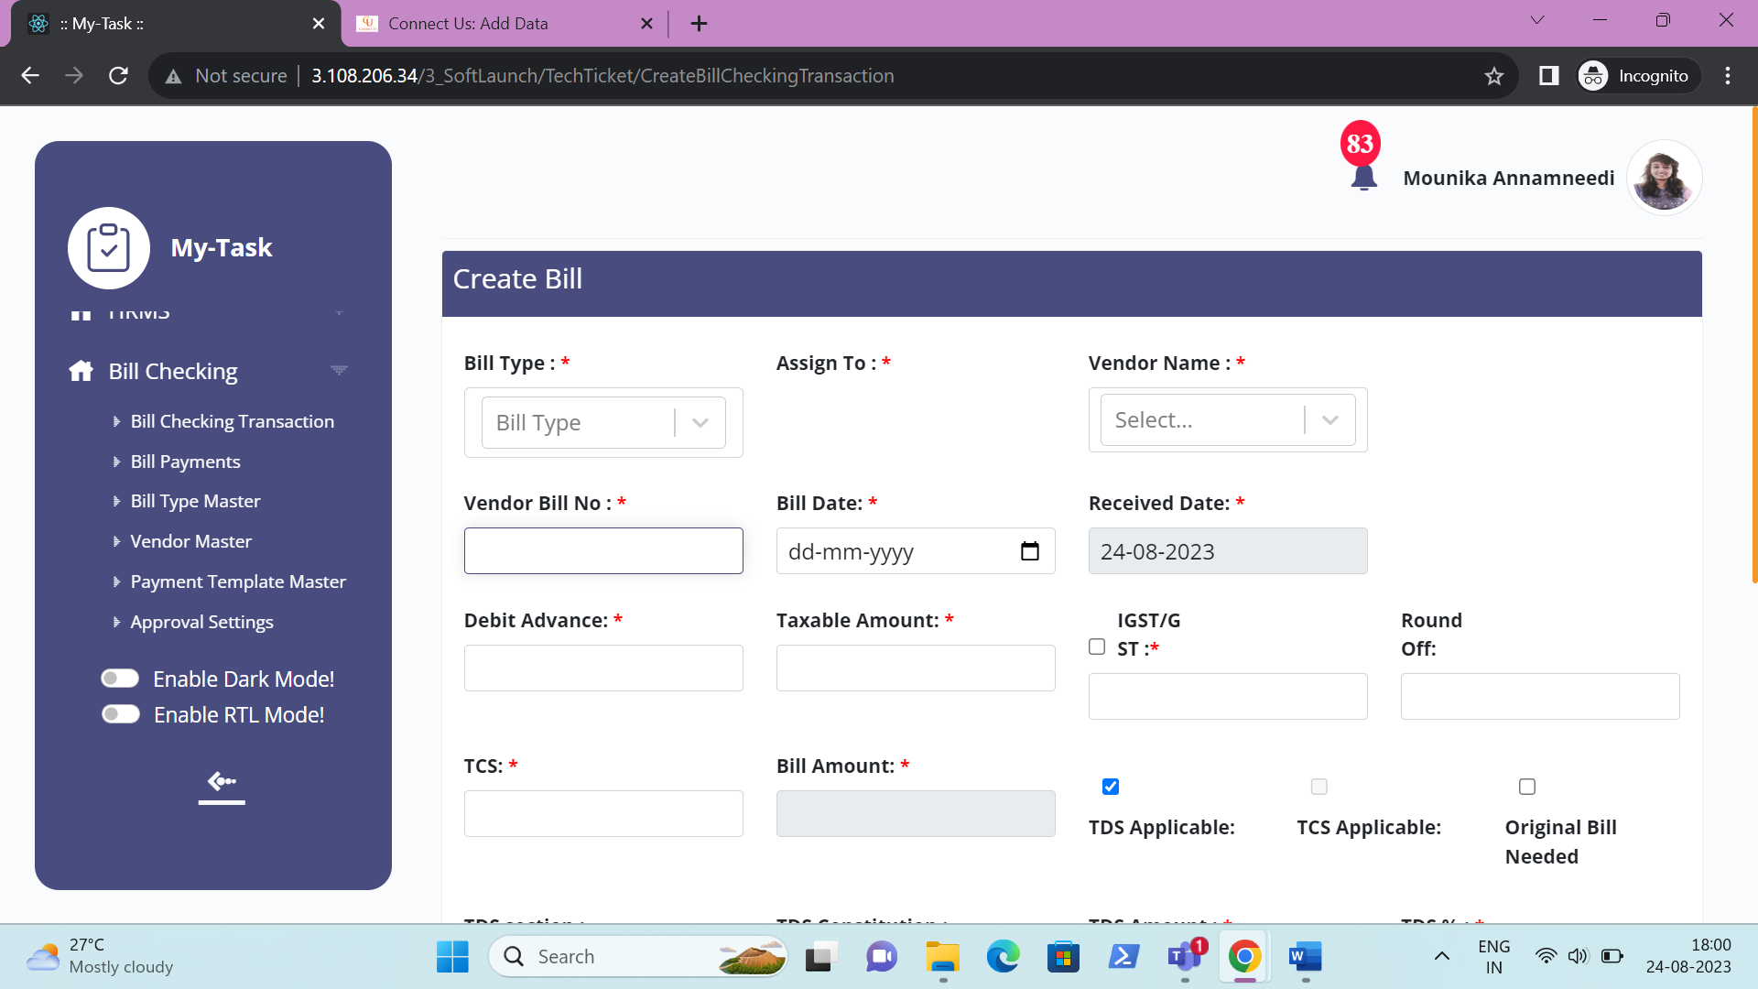

BR005 – Bill checking – cancel bill

The cancel button to cancel the bill. The bill gets canceled with pop up confirmation. When the bill gets canceled, the status changes to canceled and the bill cannot go into the further stages.  
  
But when the bill is rejected, then the bill is assigned to the entry user where the entry user makes the changes and again the bill can be forwarded further.