26.04.2023

[Customer View]

Sanika Dewoolkar

Sanika.dewoolkar@techneai.com

**Functional Requirement Document**

**CONTENTS**

1. TICKET DETAILS 2

2. VERSION CONTROL 2

3. APPROVALS 2

4. ESTIMATION 2

5. INTRODUCTION 3

6. BUSINESS REQUIREMENT 3

7. SCOPE 3

8. BUSINESS & SYSTEM RULES 3

9. ABBREVIATIONS & TERMS 3

10. EXISTING SYSTEM 3

11. GRAPHICAL REPRESENTATION 3

12. PROPOSED SYSTEM 3

13. TEST DATA 4

14. ODUS 4

15. REFERENCES OF THE USERS 5

1. **VERSION CONTROL**

|  |  |  |  |  |  |
| --- | --- | --- | --- | --- | --- |
| **Sr. No** | **Version no** | **Version Date** | **User name** | **User department** | **Updated By** |
|  | **1.0** | **10/12/2023** | **Gaurav Shah** | **IT** | **Sanika Dewoolkar** |
|  | **1.1** | **15/12/2023** | **Gaurav Shah** | **IT** | **Sanika Dewoolkar** |

1. **INTRODUCTION**

This document outlines the business requirement for implementing the customer view settings in ticketing system. In existing system, users of customers are able to view data of other customers and tenant as well. The requirement is to show only authorized menus to the customers, additionally, the users should not be able to view data of other customers and tenant.

1. **BUSINESS REQUIREMENT**

Enter details of the ticket requirement.

|  |  |  |  |
| --- | --- | --- | --- |
| **Requirement ID** | **Requirement Name** | **Short Description** | **Priority** |
| BR001 | Customer View | Users should be able to access only authorized menus.  Users should not be able to access data of other customers and tenant. | Very High |

1. **SCOPE**

In ticketing system, the users of Customers should be able to view only authorized menus, additionally, the users should not be able to view data of other customers and tenant.

1. **BUSINESS & SYSTEM RULES**

* User should be registered in the system.
* User should be logged in.
* System should display error message for incorrect details if entered.
* System should pop up a message, if any issues in the system is detected.
* All forms should have on field validations. System should display on field errors in case of incorrect inputs.

1. **ABBREVIATIONS & TERMS**
2. **EXISTING SYSTEM**

In existing system, users of customers are able to view data of other customers and tenant.

1. **PROPOSED SYSTEM**

User Requirements:

1. **Customer View**

* The customer should be able to view only their user data.
* The customer should not be able to view Tenant and other customer’s data.

1. **Menu Access to Users**

Customers should be able to perform below actions only on their data for different menus in ticketing system as mentioned in the table.

|  |  |  |  |
| --- | --- | --- | --- |
| **MODULE** | **VIEW** | **ADD** | **EDIT** |
| User master | ✔ | x | x |
| Customer master | ✔ | x | x |
| Create ticket | ✔ | ✔ | ✔ |
| My tickets | ✔ | ✔ | ✔ |

1. **User master**

* In user master, when the entry user selects ‘Account for’ as ‘Customer’, while selecting Role, Roles with authorized customer menus only should be displayed.

Example -

( Note : If the authorized menus of customers are Create ticket and My tickets. )

1. A role ‘ Salesperson’ is created. The Salesperson is given access of create ticket, my tickets, City master.
2. A role ‘ HR’ is created and given access of Create ticket and My ticket.

In user master, the entry user selects the Account for ‘ Customer’ then in Role drop down only ‘HR’ should be displayed.

* In user master, if the entry user selects the ‘Account for’ as ‘Self’ , the user should be able to view data of all customers created by them. Additionally, it should not be able to view data of customers of other tenant.

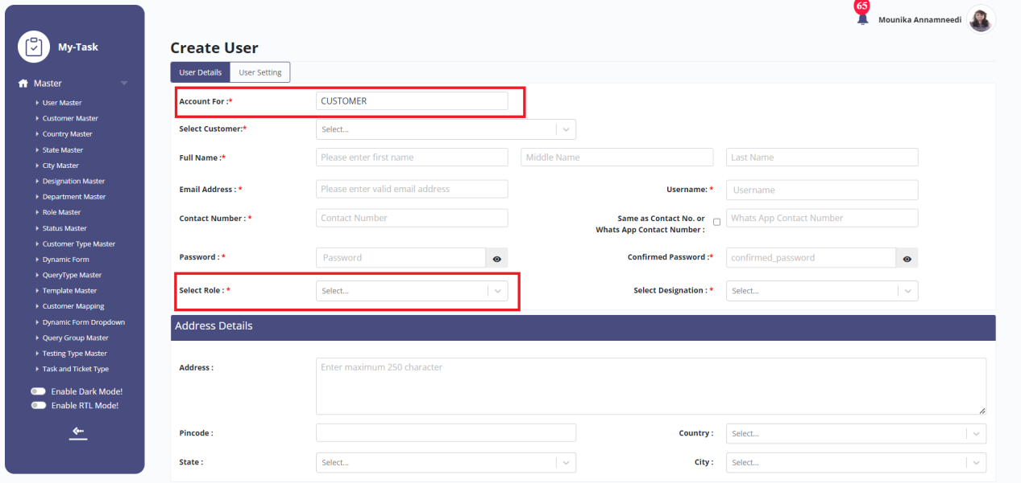

Image : User master

1. **REFERENCES OF THE USERS**

|  |  |  |  |
| --- | --- | --- | --- |
| **User** | **Name** | **Mail** | **Contact number** |
| **Actual user** | Gaurav Shaha | Gaurav.shaha@techneai.com |  |
| **Ticket created by (if any)** | - | - | - |
| **Assigned business analyst** | Sanika Dewoolkar | Sanika.dewoolkar@techneai.com | - |
| **Assigned developer** | 1. Yogita Jagtap 2. Poonam Shinde | [Yogita.jagtap@techneai.com](mailto:Yogita.jagtap@techneai.com)  Punam.shinde@techneai.com | - |
| **Assigned tester** | Priyanka Dupargude | Priyanka.dupargude@techneai.com | - |