14.08.2023

[Purchase System]

Priyanka Suhas Gole

Priyanka.gole@techneai.com

**Functional Requirement Document**

**CONTENTS**

1. TICKET DETAILS 2

2. VERSION CONTROL 2

3. APPROVALS 2

4. ESTIMATION 2

5. INTRODUCTION 3

6. BUSINESS REQUIREMENT 3

7. SCOPE 3

8. BUSINESS & SYSTEM RULES 3

9. ABBREVIATIONS & TERMS 3

10. EXISTING SYSTEM 3

11. GRAPHICAL REPRESENTATION 3

12. PROPOSED SYSTEM 3

13. TEST DATA 4

14. ODUS 4

15. REFERENCES OF THE USERS 5

1. **TICKET DETAILS**

|  |  |
| --- | --- |
| **Ticket ID** | TT15012 |
| **Ticket description** | Purchase System |
| **Created by** | @Priyanka Gole |
| **Created on** | // |
| **Priority** | High |

1. **VERSION CONTROL**

|  |  |  |  |  |
| --- | --- | --- | --- | --- |
| **Sr. No** | **Version no** | **Version Date** | **User name** | **User department** |
| **1** | **1** | **22-08-2023** | **Pratap Mane** | **Purchase Department** |
| **2** | **2** | **12-10-2023** | **Goje Sir** | **Purchase Department** |
| **3** | **3** | **25-122023** | **Goje sir** | **Purchase Department** |

1. **APPROVALS**

|  |  |  |
| --- | --- | --- |
| **Field** | **Name of the User** | **Approved date by the user** |
| **Actual User Name Actual User Department Organization Name** | Pratap Mane  Purchase department  TechneAI |  |
| **Assigned BA** | Priyanka Gole |  |
| **Assigned Developer** |  |  |
| **Assigned Tester** |  |  |
| **Assigned UI/UX Designer** | Prachi |  |

1. **ESTIMATION**

|  |  |  |  |  |
| --- | --- | --- | --- | --- |
| **Department name** | **Estimated Time (In hr)** | **Scheduled Date (Starting date)** | **Estimated date** | **Actual delivery date** |
| **BA** |  |  |  |  |
| **Development** |  |  |  |  |
| **Testing** |  |  |  |  |
|  |  |  |  |  |

1. **INTRODUCTION**

Introduction to the Purchase System: Streamlining Procurement for Efficiency and Collaboration.

In today’s dynamic business environment, effective procurement processes are essential for organizations to stay competitive and ensure the seamless acquisition of goods and services. The purchase system will be implemented is designed to facilitate a well structured and efficient procurement process, with a clear focus on collaboration between key stakeholders: the Client, Sales Person, The Purchase Team and the vendors.

At the heart of Purchase system lies a meticulously planned work flow, where requisitions are raised by client or sales person, leading to the creation of Quotations and purchase Orders. This system will be build to ensure transparency, accountability, and cost-effectiveness at every step, ultimately enhancing the overall procurement experience.

1. **BUSINESS REQUIREMENT**

**Sales Person will take followup with clients/ company for requisition. For that purpose we have to maintain the log for contact with companies.**

|  |  |  |  |
| --- | --- | --- | --- |
| **Requirement ID** | **Requirement Name** | **Short Description** | **Priority** |
| BR001 | Sales Person Activity Log | Create a Interface to maintain log of activity done by Sales Person | High |
| BR002 | Company Master | Create a company master under purchase system masters where it consists of grid view, add (to add the data), edit (to edit the data), view (to view the data), search (to search the data), reset (to reset the search filter) and export (to export the data) | High |
| BR003 | Vendor Master | Create a vendor master under purchase system masters where it consists of grid view, add (to add the data), edit (to edit the data), view (to view the data), search (to search the data), reset (to reset the search filter) and export (to export the data) | High |
| BR004 | UOM Master | Create a master to store unit of measurement | High |
| BR005 | Item type Master | Create a master to store type of the Item like hardware, software, stationary | High |
| BR006 | Item Master | Create a Item master under purchase system masters where it consists of grid view, add (to add the data), edit (to edit the data), view (to view the data), search (to search the data), reset (to reset the search filter) and export (to export the data) | High |
| BR007 | Category Master | Create a Category master under purchase system masters where it consists of grid view, add (to add the data), edit (to edit the data), view (to view the data), search (to search the data), reset (to reset the search filter) and export (to export the data). It is the master to store category of the Item like Lenovo, Dell, thinkpad categories of Laptop item | High |
| BR008 | Purchase Requisition | Sales person or Purchase Agent will raise a requisition for goods and services. creation of requisition form with fields mention below in requirement description. | High |
| BR010 | Requisition to mail vendor | Send the requisition mail for quotation to registered and unregistered vendors. |  |
| BR0011 | Quotation Form | Send requisition details on mail to multiple vendors by purchase team and get quotations from vendor against requisition on mail. Get the Quotation and modify it to send to client. |  |
| BR0012 | Negotiation with vendors Quotation | In this menu, user would be able to do negotiation in existing Quotation by vendor. Including negotiation fields like negotiation date, negotiation rate, negotiation By. |  |
| BR0013 | Modifications in vendor Quotation | In this menu, user would be able to do modifications in existing negotiated Quotation by vendor. Including modification fields like modification date, modification rate, modification By. |  |
| BR0014 | Quotation to client | In this menu, user would be able to send quotations to client based on approved and modified quotation of vendor. Follow the quotation format. |  |
| BR0015 | Purchase Order from client | Once Quotation approved and purchase order raised by client to get the requisition goods and services. |  |
| BR0016 | Purchase order for vendor | Post Purchase order raised by client approve the quotation to vendor and raise the purchase order. |  |
| BR0017 | Bill Invoice to Vendor | Generate invoice for a enquiry, based on material issued. Maintain status of enquiry. |  |
| BR0018 | Proforma Invoice |  |  |
| BR0019 | E-Way Bill | It is the process of generating an e-way bill in India's purchase system involves creating a digital document that provides essential information about the movement of goods.The document helps to ensure transparency , compliance with tax regulations, and the smooth transportation of goods from seller to buyer. |  |
| BR0020 | E-Invoice | E-invoicing simplifies the procurement process by reducing manual work, improving accuracy, and expediting payment cycle. |  |
| BR0021 |  |  |  |

1. **SCOPE**

Scope of this project is to get enquiry for good and services from client. Purchase it from vendors and sell it to client with some modifications in requisition, Quotation and Purchase Order..

Purchase team is responsible for many process in the purchase system. To get Quotation from multiple vendors . Do some negotiations and modifications send it to customer/ client.

Get the purchase order from vendors after approval of quotation.

Send the purchase order to clients and finally get the material from client and provide material to client and close the enquiry.

1. **BUSINESS & SYSTEM RULES**

* Multiple roles are involved in this project. Sales Person, Client, Vendor, Purchase Team and admin. All the should be registered in the system with proper menu allocation.
* Every role has different responsibility, so assign menus accordingly.
* Follow proper format of all processes like Enquiry from client or sales person, Quotations from vendor and Quotation to clients, Purchase order from vendors and purchase order to clients. Bill invoice along with material from vendors and send it to client.
* If the Quotation is rejected from client, close the enquiry with proper remark.
* Payment to vendor as per payment template defined in PO. All of the above processes should have proper validations. System should pop up a message, if any issues in the system is detected.
* All forms should have on field validations. System should display on field errors in case of incorrect inputs.

1. **ABBREVIATIONS & TERMS**

* **Client/Customer :** Client/customer is the individual or firm is the actual user for good or services. For that purpose requisition will be raised by sales person or purchase team in the system.
* **Sales Person** : Sales person is the person who looks for customers/clients to sale IT material/ Non IT Material or software. And gets enquiry from customers.
* **Vendor :** Vendor is the third party entity from where purchase team gets Quotation for enquiry, gets purchase order post approval of quotation
* **Purchase Team :** Purchase team is the team who is totally responsible to work on client enquiry and get quotation from vendor and send it to customer with some modifications. Post quotation approval from client raise a purchase order to vendor and get material from vendor and finally deliver it to client.
* **Quotation :** Quotation is the template used to get tentative amount and tentative delivery date from team who sale the product.
* **Purchase Order** : It is the template used when the quotation is approved from purchase team

1. **EXISTING SYSTEM**

NA

**11. GRAPHICAL REPRESENTATION**

**Data Flow Diagram**

**Sales Person Activity Log**

Login

Go to the menu Sales Person Activity Log

Company Name

Contacted On Date

Contact through (Whats app, Phone Call,text message, email, linked In)

Contact To Person name

Contact No

Email Id

Next Followup Date

Remark

Status of Follow up

Requisition if any

Fill up data for Follow up

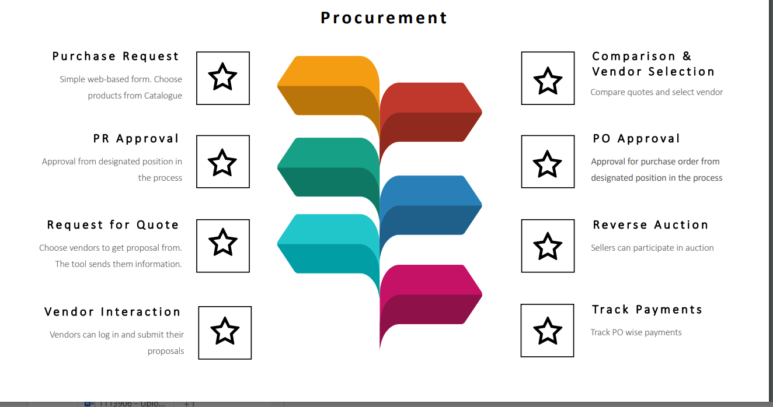

1. **PROPOSED SYSTEM**

Explain the process flow and requirement. Enter the process overview step-by-step in detail. Explain each requirement case in detail.

**BR001: Sales Person Activity Log**

Login

Go to the menu Sales Person Activity Log

Fill up data for Follow up

Company Name

Contacted On Date

Contact through (Whats app, Phone Call,text message, email, linked In)

Contact To Person name

Contact No

Email Id

Next Followup Date

Remark

Status of Follow up

Requisition if any

Sales Person is the person, who is responsible to fill the gap between client and purchase system. We are going to develop a system to maintain the log of activity. Following will be the fields for that.

**Add Data for sales person activity log**

* Name of company,
* contacted On date,
* Contacted by (phone call, whats app, email, text message, linked In),
* contacted to person name, followup Remark,
* Contact No
* Email Id
* Sales Person name (who is taking followup),
* Next Followup Date,
* Status(Open, requisition received, closed, followup in progesss),
* Requisition id raised if any (on click of requisition, it will redirect to requisition page)

|  |  |  |  |
| --- | --- | --- | --- |
| **FIELDS** | **INPUT TYPE** | **MANDATORY/ OPTIONAL** | **DESCRIPTION** |
| Company Name | Text | Mandatory | Name of the Company to take followup for requisition and other activities like quotation, PO.  Validations: allow alphabets of 25 length |
| Contacted On date | Calender | Mandatory | Get the date to make date wise entry  Validations: date picker |
| followup Remark | Text | Optional | Provision to add remark of followup  Validations: allow alphanumeric with 100 limit |
| Next Followup Date | Calender | Optional | This date will be added by sales person to take next followup of company for requisition. Before 1 day notification will get send to sales person. 1 to M relationship will be maintained here  Validations: date picker |
| Next Followup Remark | Text | Optional | Provision to add next followup remark y sales person. 1 to M relationship will be maintained here  Validations: allow alphanumeric with 100 limit |
| Contacted Through | Drop down | Mandatory | Orally/Phone/Whats app/Phone Call/ Text Message/ Linked In |
| contacted to person name | Text | Mandatory | Get the name of person for followup  Validations: allow 50 characters limit |
| followup Remark | Text | Optional | Provision to add remark of followup  Validations: allow 100 characters limit |
| Status | Drop down | Mandatory | Values for Drop down: Open (default), Closed, In progress |
| Requisition Id | Text | Optional | If requisition raised against this followup then Id will be shown here.  Validations: allow 50 alphanumeric data |
| Attachment | Image | Optional | Provision to attach image or pdf of goods or services.  Max size 10Mb |
| Sales Person Name | Drop down | Mandatory | Show list of users having designation salesperson |

**Edit Data for sales man followup**

Following fields will be editable for edit data

* Name of company, ---- Non editable
* contacted On date --- Non editable
* Contacted by (phone, call, whats app), ----Non editable
* contacted to person name, ----Non editable
* followup Remark, ----Non editable
* Next Followup Date, ---Editable
* Next Followup Remark --- Editable
* Status(Open, requisition received, closed, followup in progesss), ----Editable
* Requisition id raised if any --- non editable

Maintain history for followup

**Dashboard**

**Upon login, users should see the today’s company followup**

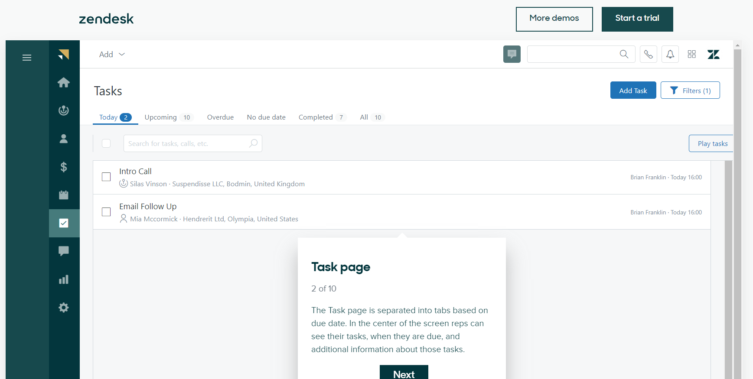

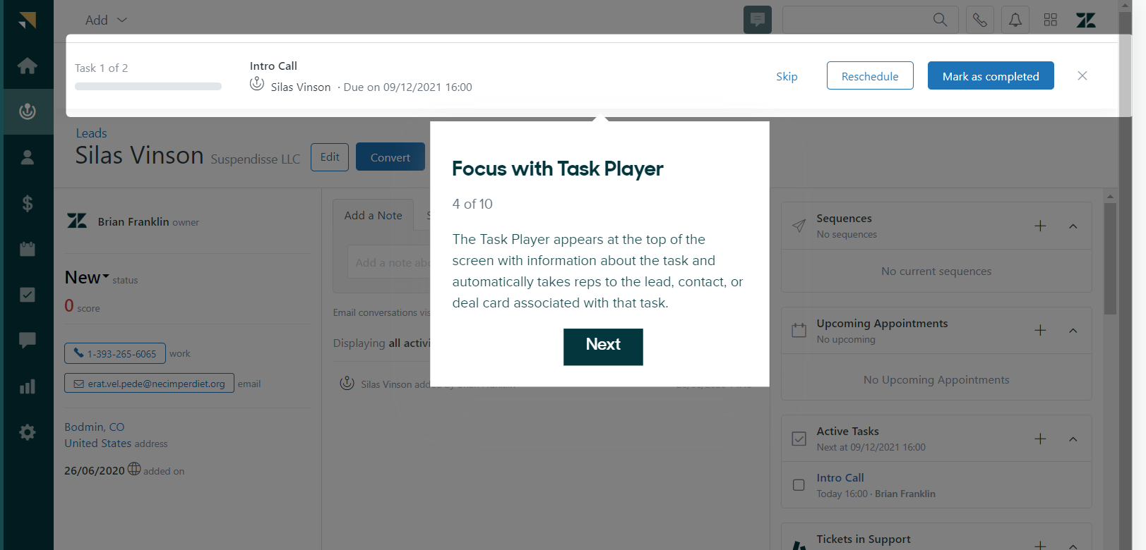

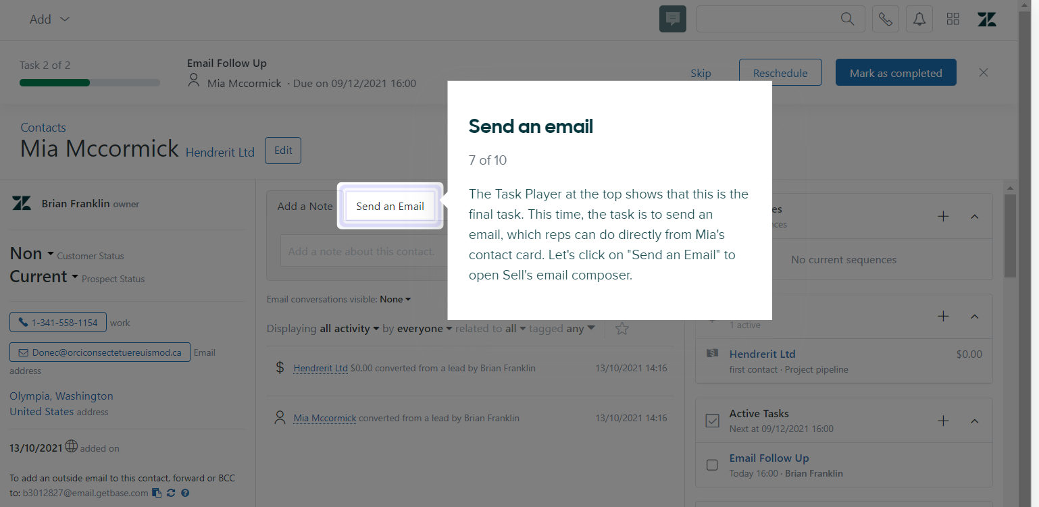

**BR002: Report for Followup**

Make a provision to get today's followup task for sales person by report.

**Filter by data**

* **Name of company**
* **Next Due date --- It will show details of report whose next followup date is Selected date**
* **Sales Person name**
* **Status**

It will contain following details

* Name of company,
* contacted On date,
* Contacted through (phone, call, whats app),
* contacted to person name, followup Remark,
* Sales Person name (who is taking followup),
* Next Followup Date,
* Status(Open, closed, followup in progesss),
* Requisition id raised if any (on click of requisition, it will redirect to requisition page)

**BR003: Creation of Company Master**

In simple terms, a company/client is a person, company, or organization that uses the services or advice of another person, company, or professional. Clients are like customers who seek help or assistance from someone with specific expertise or resources. For example, when you visit a doctor for medical advice, you are the client seeking the doctor's services. In business, clients are often individuals or companies that pay for products or services provided by another business or service provider

|  |  |  |  |
| --- | --- | --- | --- |
| **FIELDS** | **INPUT TYPE** | **MANDATORY/ OPTIONAL** | **DESCRIPTION** |
| Company Name | Text | Mandatory | Name of the Company to take followup for requisition and other activities like quotation, PO. |
| Mobile No* | Text | Mandatory | Get the mobile no of contact person. Follow mobile no validations |
| Email* | Text | Mandatory | Get email of contact person and validations: Allow alphanumeric |
| Address | Text |  | Store address of company |
| Contact Person | Text | Mandatory | Store name of person to contact on be half of company |
| Alternate mobile No | Text | Optional | Alternate mobile no |
| Landline No | Text | Optional | It is the landline no of company |
| Pan No* | Text | Mandatory | Apply proper validations for pan card. |
| Udyog Aadhar Registration No/MSME No | Text | Optional | The Udyog Aadhar Registration Number or MSME (Micro, small and Medium Enterprizes) number is a unique identification number issued by the indian government to small and medium sized company (SMEs) to help them avail of various benefits and support. |
| GST No. | Text | Mandatory | GST stands for Goods and Services Tax, and a GST Number, also known as the GSTIN (Goods and Services Tax Identification Number), is a unique identification number issued to businesses or individuals who are registered under the GST system in India. |
| GST Return (Monthly / Quarterly) | Drop down | Optional | Whether to return GST by monthly or quarterly |
| Created By | auto | Mandatory | Store id of record created user |
| Created at | date time | Mandatory | Store date time of record created user |
| Updated by | auto | Mandatory | Store id of record updated user |
| Updated_at | date time | Mandatory | Store date time of record updated user |
| Is_active | Radio button | Mandatory | Store id 0/1 for yes or no |
| Remark | text | Optional | Remark if any |

**Add Data**

Following are the fields required to add in company master.

* Company Name*
* Mobile No*
* Email*
* Address*
* Contact Person*
* Alternate mobile No.
* Landline No
* Pan No*
* Udyog Aadhar Registration No/MSME No
* GST No.
* GST Return (Monthly / Quarterly)
* Bank Name
* Branch Name
* A/c No
* IFSC
* Account Type

**Edit Data**

**Following are the fields are required for edit**

* Mobile No*
* Email*
* Address*
* Contact Person*
* Alternate mobile No.
* Landline No
* Pan No*
* Udyog Aadhar Registration No/MSME No
* GST No.
* GST Return (Monthly / Quarterly)
* Bank Name
* Branch Name
* A/c No
* IFSC
* Account Type
* Is_active (backend)
* Updated_by (Backend)
* Updated_at (Backend)

**View Data**

* Company Name*
* Mobile No*
* Email*
* Address*
* Contact Person*
* Alternate mobile No.
* Landline No
* Pan No*
* Udyog Aadhar Registration No/MSME No
* GST No.
* GST Return (Monthly / Quarterly)
* Bank Name
* Branch Name
* A/c No
* IFSC
* Accou[[[5nt Type
* Is_Active

**Maintain the history for same**

**BR004: Creation of vendor Master --- Developed under Bill checking Module**

In simple terms, a vendor is a company or person that sells goods or services to another company or individual. Vendors are like the stores where you buy things you need, but in the context of businesses. For example, if a restaurant buys vegetables from a farm, the farm is the vendor for the restaurant. Vendors play a crucial role in the supply chain by providing the products or services that businesses need to operate and serve their customers.

|  |  |  |  |
| --- | --- | --- | --- |
| **FIELDS** | **INPUT TYPE** | **MANDATORY/ OPTIONAL** | **DESCRIPTION** |
| Vendor Name | Text | Mandatory | * Name of the Company to take followup for requisition and other activities like quotation, PO. |
| Contact No* | Text | Mandatory | * Get the mobile no of contact person. Follow mobile no validations |
| Email* | Text | Mandatory | * Get email od contact person and follow validations |
| Address | Text | Optional | * Store address of company |
| Contact Person | Text | Mandatory | * Store name of person to contact on be half of company |
| Alternate mobile No | Text | Optional | * Alternate mobile no |
| Landline No | Text | Optional | * It is the landline no of company |
| Pan No* | Text | Mandatory | * Apply proper validations for pan card. |
| Udyog Aadhar Registration No/MSME No | Text | Optional | * The Udyog Aadhar Registration Number or MSME (Micro, small and Medium Enterprizes) number is a unique identification number issued by the indian government to small and medium sized company (SMEs) to help them avail of various benefits and support. |
| GST No. | Text | Mandatory | * GST stands for Goods and Services Tax, and a GST Number, also known as the GSTIN (Goods and Services Tax Identification Number), is a unique identification number issued to businesses or individuals who are registered under the GST system in India. |
| Bank Name |  |  | * Get bank details of vendor |
| Account No | Text | Optional | * Account No of vendor |
| Branch Name | Text | Optional | * Branch name of vendors bank. |
| IFSC code | Text | Optional | * Set proper validations for IFSC |
| GST Return (Monthly / Quarterly) | Drop down | Optional | * Whether to return GST by monthly or quarterly |
| Created By | id | Mandatory | * Store id of record created user |
| Created at | datetime | Mandatory | * Store datetime of record created user |
| Updated by | id | Mandatory | * Store id of record updated user |
| Updated_at | datetime | Mandatory | * Store datetime of record updated user |
| Is_active | id | Mandatory | * Store id 0/1 for yes or no |
| Remark | text | Optional | * Remark if any |

**View Data for vendor master**

Following are fields to view record

* Vendor Name*
* Contact No.*
* Email*
* Address*
* Contact Person*
* Alternate mobile No.
* Landline No
* Pan No*
* Reffered By
* Udyog Aadhar Registration No/MSME No
* Legal Status (Associate Of Person/ Body Of Individuals/Company/HUF/IndividualLocal / Partership Firm/ Trust)
* GST NO*
* Consider in Payment (Yes/No/Petty Cash)-----> if yes then show payment template
* Payment Template (Set payment template against vendor)
* Bank A/C No
* IFSC code
* Attachment
* Beneficiary Name
* Created By
* Created at
* Updated by
* Updated at
* Remark
* Is_active

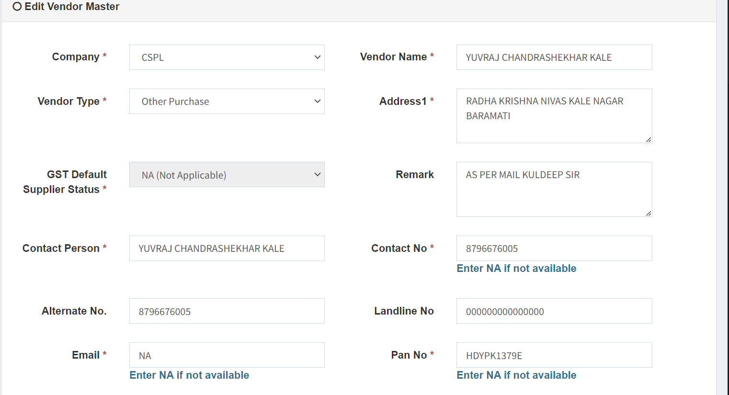

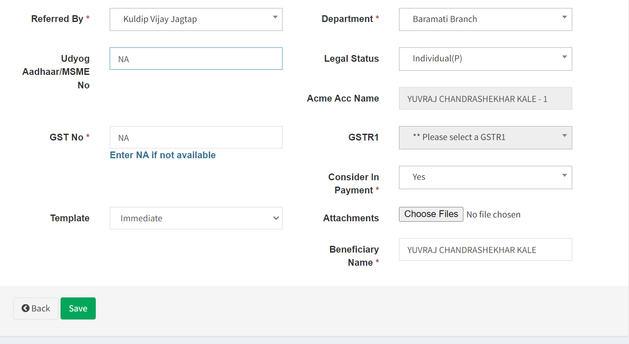

**Add Data for vendor master**

Following are fields to view record

* Vendor Name*
* Contact No.*
* Email*
* Address*
* Contact Person*
* Alternate mobile No.
* Landline No
* Pan No*
* Reffered By
* Udyog Aadhar Registration No/MSME No
* GST No.
* Legal Status (Associate Of Person/ Body Of Individuals/Company/HUF/IndividualLocal / Partership Firm/ Trust)
* GST NO*
* GST Return (Monthly / Quarterly)
* Payment Template (Set payment template against vendor)
* Bank A/C No
* IFSC code

**Edit Data for vendor master**

* Contact No.*
* Email*
* Address*
* Contact Person*
* Alternate mobile No.
* Landline No
* Pan No*
* Udyog Aadhar Registration No/MSME No
* GST No.
* Legal Status (Associate Of Person/ Body Of Individuals/Company/HUF/IndividualLocal / Partership Firm/ Trust)
* GST NO*
* GST Return (Monthly / Quarterly)
* Payment Template (Set payment template against vendor)
* Bank A/C No
* IFSC code
* Updated by --Non editable auto update
* Updated at -Non editable auto update
* Remark
* Is_active
* **BR005: Creation of UOM Master**

UOM master is used to store Unit of measurement for the item while creation of item. Example suppose laptop is the item then UOP for that is nos. Incase of Fiber Optic cable it is in Mtrs

|  |  |  |  |
| --- | --- | --- | --- |
| **FIELDS** | **INPUT TYPE** | **MANDATORY/ OPTIONAL** | **DESCRIPTION** |
| UOM | Text | Mandatory | * It shows UOM here |
| Created By | id | Mandatory | * Store id of record created user |
| Created at | datetime | Mandatory | * Store datetime of record created user |
| Updated by | id | Mandatory | * Store id of record updated user |
| Updated_at | datetime | Mandatory | * Store datetime of record updated user |
| Is_active | id | Mandatory | * Store id 0/1 for yes or no |
| Remark | text | Optional | * Remark if any |

**Add Data for UOM Master**

Following are the fields

* UOM*

make sure it will perform add, update and delete operations with history of each transaction. Also include Export functionality

**BR006: Creation of Item Type Master**

Item Type master is used to store type of the item while creation of item. Example suppose laptop is the item then item type is Hardware. In case of Book, stationary is the item type.

|  |  |  |  |
| --- | --- | --- | --- |
| **FIELDS** | **INPUT TYPE** | **MANDATORY/ OPTIONAL** | **DESCRIPTION** |
| Item Type | Text | Mandatory | * It shows type of item e.g hardware/ stationary |
| SLA | Days | Mandatory | * SLA stands for Service level Agreement, It is the formal agreement between purchase team and client, that defines the response time for item delivery. |

**Add Data for item type master**

Following are the fields

* Item Type*
* SLA *

**Edit Data**

* **SLA**
* **Updated_by ---- backend**
* **Updated_at ------backend**

SLA stands for Service level Agreement, It is the formal agreement between purchase team and client, that defines the response time for item delivery.

make sure it will perform add, update and delete operations with history of each transaction. Also include Export functionality

**BR007: Creation of Item Master**

Item Master will be used for collectively storage of all the items required to raise requisition, Quotation and purchase order.

|  |  |  |  |
| --- | --- | --- | --- |
| **FIELDS** | **INPUT TYPE** | **MANDATORY/ OPTIONAL** | **DESCRIPTION** |
| Item Name | Text | Mandatory | * Name of Item is added over here |
| Item Type | Dropdown | Mandatory | * Select Item Type of Item |
| UOM | Drop Down | Mandatory | * UOM of Item |
| HSN Code | Text | Mandatory | * Unique code of item |

Following are the fields to include in Item Master

**Add data for Item master**

* Item name*
* Item Type*--------->Foreign key of Item Type Master
* UOM* ---------> Foreign key of UOM Master
* HSN Code*
* Created by
* Created at
* Updated by
* Updated at
* remark
* Is active

Edit data for Item Master

* Item Type*--------->Foreign key of Item Type Master
* UOM* ---------> Foreign key of UOM Master
* HSN Code*
* Updated by
* Updated at
* Remark
* Is_active

make sure it will perform add, update and delete operations with history of each transaction. Also include Export functionality

**BR008: Category Master**

Category Master will be used to store categories of item. This master will be useful while creation of requisition, Quotation and Purchase Order.to store of all the items required to raise requisition.

|  |  |  |  |
| --- | --- | --- | --- |
| **FIELDS** | **INPUT TYPE** | **MANDATORY/ OPTIONAL** | **DESCRIPTION** |
| Item Category | Text | Mandatory | * Name of Item is added over here |
| Item Name | Dropdown | Mandatory | * Select Item Type of Item |
| Created_by |  |  |  |
|  |  |  |  |
|  |  |  |  |
|  |  |  |  |
|  |  |  |  |

**Add Data**

Following are the fields to include in Category Master

* Item Name* ------> Foreign key of Item Master
* Category Name*
* Remark
* Is_active

**Edit Data for category master**

Following are the fields for edit of Category Master

* Item Name
* Updated_by
* Updated_at
* Is_Active

make sure it will perform add, update and delete operations with history of each transaction. Also include Export functionality

**BR009: Payment Template Master**

**It is developed under bill checking module**

Payment Template master defines the payment date or day. On that day vendors get paid against a PO.

**You can refer payment template of connect US**

|  |  |  |  |
| --- | --- | --- | --- |
| **FIELDS** | **INPUT TYPE** | **MANDATORY/ OPTIONAL** | **DESCRIPTION** |
| Template Name | Text | Mandatory | * Payment Template |
| Type of payment | Dropdown | Mandatory | * Select the values from dropdown as Weekly/Monthly/Quaterly/Yearly |
| Date consider for payment | Date calender | Mandatory | * Select Date for payment, this may be multiple |
| Min days | No | Mandatory | * Min days should be consider for payment after bill date |
| Payment day | Days | Mandatory | * Multiselect, if weekky selected then payment day will be useful for payment. |
| Payment terms | Text | Mandatory | * Payment terms and conditions mention on Quotation |
| Payment Conditions | Text | Mandatory | * Payment terms and conditions mention on Quotation |

Following are the fields for payment template master

* Name
* Type of Payment (Monthly/Weekly/Quaterly/Yearly)
* Date consider for payment (Multiselect)
* Min_days
* Payment Day (Muliselect)
* Payment Terms
* Payment Conditions
* Remark
* Created By
* Created At
* Updated By
* Updated At
* Is Active

**Example: payment Day Monday, Tuesday**

**Min day : 4**

**Date consider for payment : 1,15,20**

**Vendors payment can be done on date 1 or 15 or 20.considering mindays set against selected payment template.**

**BR0010: Purchase Requisition (PR)**

[Purchase requisitions](https://kissflow.com/procurement/purchase-requisition/purchase-requisition-guide/" \o "Purchase Requisition Guide) are written or electronic documents raised by internal users/customers seeking the procurement team’s help to fulfill an existing need. It comprises key information that is required to procure the right goods, services, or works.

In simple terms, a requisition is like a shopping list or request for something you need. It’s a formal way of asking item or services to be provided.

Imagine you work at a company, and you need new office supplies like pen, paper, laptop, and notebooks. You would create requisition tells a company what you need and helps them to keep track of request and organized and formal way.

In the same way we are developing a system to get requisition from sales person who will take followup from clients for any type of requisition. Purchase team member would be also able to raise requisition behalf of general user.

Initially status of requisition will be “Unprocessed”

One unique id will be created as <requisition id>. This page will be visible to purchase agent.

Purchase manager will approve it or reject it and send back the request to initiator with specific comments as to why the request was rejected. Initially status will be ‘Unprocessed’.

PR can be edited by Purchase Agent until it approved by purchase Manager.

The grid view of the requisition consists of the following.

Add data

Add item

Action

Requisition id

Requisition date

Reference Ticket Id

PO No

Description

Status

Manager approval name

Manager approved remark

|  |  |
| --- | --- |
| **FIELDS** | **DESCRIPTION** |
| Add data | The add data button to add the data into the master |
| Add item | The add item field to add the items, if the requested item is not available in the item master, |
| Action field | The action consists of the view, edit and delete buttons to view, edit and delete the records respectively. |
| Requisition code | The requisition ID generated after raising the requisition is displayed |
| Requisition date | The requisition date when the requisition raised is displayed |
| Reference Ticket Id | The Ticket id (connect us ticket ID) entered at the time of requisition is displayed here |
| Department | The entry department of the user raising the requisition is displayed |
| Assign dept | The assigned department selected is displayed |
| PO No | The purchase order number where the requisition of raised in the purchase order module, the ID generated in the purchase order is displayed automatically after raising the purchase order. |
| Description | The description of PR is mentioned is displayed |
| Status | The status of the requisition is displayed. Like Approved, Rejected, Unprocessed. |
| Manager approval name | The manager who approved the requisition is displayed |
| Manager approved remark | The manager at the time of approval, the remark given is displayed |

Following are the fields for requisition form, show it on grid view

* Requisition ID
* Requisition Date
* Reference Ticket ID
* Sales Person Name
* Status
* Manager Approval name
* Manager Approved remark
* Is non budgeted
* Budget cost
* Delivery Location
* Requisition details (multiple records are added over here)
* Item
* Item Type
* Category
* UOM
* Description/ specification
* Quantity
* Item to be received before (Date)
* Attachment (zip,pdf, jpg, png, pdf file format supported) max size would be 2 MB. Max to max 10 files will be added here.
* Last purchase date
* Last purchase rate
* Last purchase quantity
* Lowest purchase date
* Lowest purchase rate
* Lowest purchase quantity

**Description of Fields in Purchase requisition (PR)**

|  |  |  |  |
| --- | --- | --- | --- |
| **FIELDS** | **INPUT TYPE** | **MANDATORY/ OPTIONAL** | **DESCRIPTION** |
| Requisition ID | Auto | Mandatory | It is auto generated number followed by Req e.g REQ1 |
| Requisition Date | Date | Mandatory | Date of the Requisition Entry |
| Reference Ticket ID | Text | Optional | It is the reference ticket ID, if the req raised by purchase team with reference to ticket id |
| Sales Person Name | Drop down | Optional | If req raised by Sales person then name of sales person, Sales person will raise the requisition.  Value for drop down is user master with designation sales person. |
| Status | Drop down | Mandatory | After each activity, status is updated here. (Unprocessed, approved, Rejected) |
| Item | Drop down | Mandatory | Name of the item for requisition |
| Item Type | Drop Down | Mandatory | Name of the item Type for requisition, Selection from Item Type Master. |
| Category | drop down | Mandatory | Name of the category, selection from category master. |
| UOM | drop down | Mandatory | UOM of item, selection from UOM Master. |
| Specification | text | Optional | Specification of item  Validation: Alpha numeric data with limit 100 char |
| Quantity | Number | Mandatory | Quantity of item  Validation: negative number not allowed. |
| Attachment | File upload | Optional | The attachment if any is attached in the requisition.  Validation: Maximum 10 attachments can be attached. Can accept jpeg, pdf, csv, excel, word, png. |
| Manager approval | Radio button | Mandatory | The users in the user management having the “is manager” authority can only have access for the field. The manager having access selects the options. The following are the options.   * Unprocessed * Approved * Rejected |
| Manager approval remark | Text | Mandatory | The manager having the authority at the time of approval have to provide the remark for the same whatever action taken by the manager.  Validation: Can accept characters, special characters and integers up to 500 characters. |
| Is non budgeted | Radio button | Mandatory | The requisition is non budgeted or budgeted is selected among the options available in radio button options.   * Yes * No |
| Budget cost | Int | Mandatory | The budget cost for purchasing the item is entered in rupees.  Validation: Accept amounts up-to 3 decimals. Maximum amount – 100 crores. |
| Delivery Location | Text box | Optional | It is the address of delivery location where to deliver the request. |
| Reset | Button | Mandatory | The reset button to reset all details in the field. |
| Item to be received Before | date | Mandatory | The items to be received before date is mentioned. The date is enabled from the SLA days selected in the item type master  the date is displayed here auto (current date + SLA days).  Validation: Only future date after the calculation can be selected (current date + SLA days). |
| Last Purchase Date | Auto | Optional | The last purchase date of the item is automatically displayed where the data is fetched from the purchase orders |
| Last Purchase Rate | Auto | Optional | The last purchase rate of the item is automatically displayed where the data is fetched from the purchase orders |
| Last Purchase Quantity | Auto | Optional | The last purchase quantity of the item is automatically displayed where the data is fetched from the purchase orders |
| Lowest Purchase Date | Auto | Optional | The lowest purchase date of the item is automatically displayed where the data is fetched from the purchase orders. |
| Lowest Purchase Rate | Auto | Optional | The lower purchase rate of the item is automatically displayed where the data is fetched from the purchase orders. |
| Lowest Purchase Quantity | Auto | Optional | The lowest purchase quantity of the item is automatically displayed where the data is fetched from the purchase orders. |
| Back | Button | Optional | To navigate to back page |
| Save and add more | Button | Optional | To save the existing data and add more data |
| Save | Button | Optional | To save the existing data |

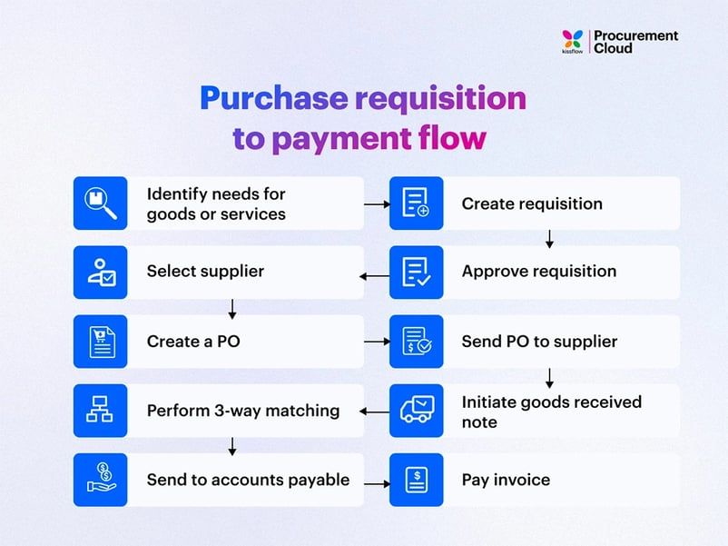

UI of Requisition

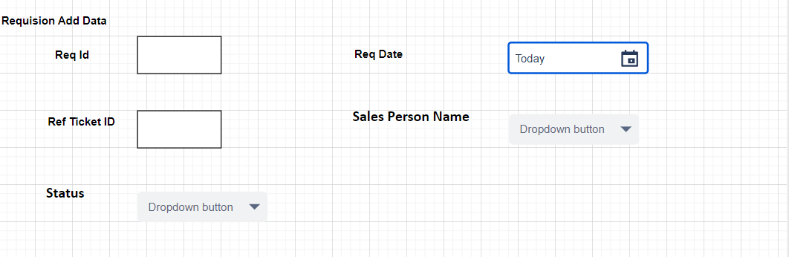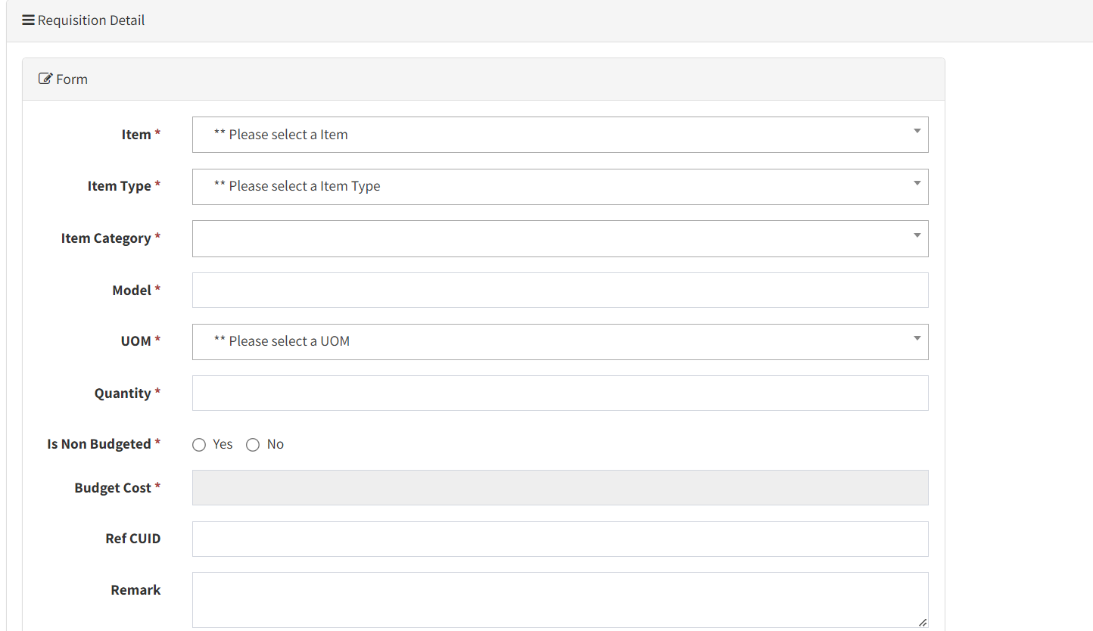

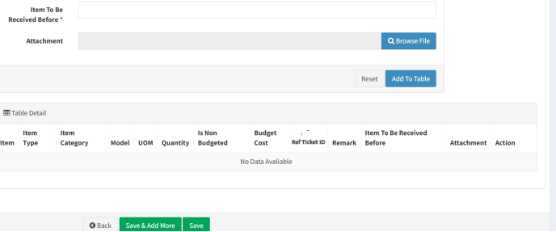

**BR0009: Requisition mail to vendor**

Based on the requisition, sending a requisition mail to vendor for a quotation is a crucial step in the procurement process. It allows you to gather price information and other details from potential suppliers before making a decision on which vendor to choose for your purchase.

Creation of Menu, On the selection requisition, purchase team would be able to select vendor from vendor master.

Sometimes, it may required to send requisition mail to unregistered vendors also.

So, make a provision to directly add mail ids separated by comma.

That involves following process

* Mail To: Select a vendor from vendor master according to requisition. Choose a vendor(supplier or service provider) that purchase team believe can requisition request.
* Mail From : purchase@techneai.com
* Purchase team would also be able to add unregistered vendor, which is not in vendor master.
* Mail Format

Subject Line: Request For Quotation: TechneAI

Update status of requisition as “Requisition mail to vendor”.

|  |  |
| --- | --- |
| **FIELDS** | **DESCRIPTION** |
| Requisition ID | The requisition ID is fetched from the requisition module |
| Requisition date | The requisition date is when the RFQ is raised. |
| Vendor | Vendor is fetched here from vendor master itself. |
| PO No | The Purchase number when the purchase order is against that quotation is updated when the purchase order is raised. |
| Remark | The remark if any entered in the requisition is displayed. |
| Email body | The email body sent to the vendor is displayed. |
| Sent at | The mail sent date and time is displayed. |