31-08-2024

Priyanka Suhas Gole

[Priyanka.gole@techneai.com](mailto:Priyanka.gole@techneai.com)

My CS App - New Scheme Enrollment

**Functional Requirement Document**

**CONTENTS**

1. TICKET DETAILS 2

2. VERSION CONTROL 2

3. APPROVALS 2

4. ESTIMATION 2

5. INTRODUCTION 3

6. BUSINESS REQUIREMENT 3

7. SCOPE 3

8. BUSINESS & SYSTEM RULES 3

9. ABBREVIATIONS & TERMS 3

10. EXISTING SYSTEM 3

11. GRAPHICAL REPRESENTATION 3

12. PROPOSED SYSTEM 3

13. TEST DATA 4

14. ODUS 4

15. REFERENCES OF THE USERS 5

1. **TICKET DETAILS**

|  |  |
| --- | --- |
| **Ticket ID** | TT24961 |
| **Ticket description** | My CS App - New Scheme Enrollment |
| **Created by** | Priyanka Gole |
| **Created on** | 31/08/2024 |
| **Priority** | High |

1. **VERSION CONTROL**

|  |  |  |  |  |
| --- | --- | --- | --- | --- |
| **Sr. No** | **Version no** | **Version Date** | **User name** | **User department** |
| **1** | **1** | **31/08/2024** | **Pritam M** | **BA Head** |
|  |  |  |  |  |
|  |  |  |  |  |

1. **APPROVALS**

|  |  |  |
| --- | --- | --- |
| **Field** | **Name of the User** | **Approved date by the user** |
| **Actual User Name Actual User Department Organization Name** | Pritam Metha  BA  TechneAI |  |
| **Assigned BA** | Priyanka Gole |  |
| **Assigned Developer** |  |  |
| **Assigned Tester** |  |  |

1. **ESTIMATION**

|  |  |  |  |  |
| --- | --- | --- | --- | --- |
| **Department name** | **Estimated Time (In hr)** | **Scheduled Date (Starting date)** | **Estimated date** | **Actual delivery date** |
| **BA** |  |  |  |  |
| **Development** |  |  |  |  |
| **Testing** |  |  |  |  |

1. **INTRODUCTION**

My CS App is the application for the CS. In the My CS APP, we are going to launch new tab called as “New Scheme Enrollment”.

1. **BUSINESS REQUIREMENT**

In the My CS APP, we are going to launch new tab called as “New Scheme Enrollment”. Under this tab user will be able to create new scheme for existing and new customers.

|  |  |  |  |
| --- | --- | --- | --- |
| **Requirement ID** | **Requirement Name** | **Short Description** | **Priority** |
| BR001 | Design a UI | Design a UI for New Scheme Enrollment | High |
| BR002 | New scheme enrollment with mobile No | Under this module, user will be able to enroll new scheme for existing customer by mobile no. | High |
| BR003 | New scheme enrollment with old scheme number. | Under this module, user will be able to pay installments for previously enrolled schemes | High |
| BR004 | Sync enrollment entry on Padm | Auto sync enrollment entry on Padm system | High |
|  |  |  |  |

1. **SCOPE**

Scope of this module is to enroll customer into new scheme. Existing customer can enroll into scheme where as new customer can not be enrolled here.

If the customer had old account then according to old scheme, customer will enroll into new scheme.

1. **BUSINESS & SYSTEM RULES**

* New enrollment scheme is for existing customers only not for new customers.
* App will follow all the scheme details for enrollment and Installment.
* Scheme is defined on Padm system
* Maturity Date calculated based on the duration and extra months
* Installment amount criteria is set on the Scheme master in Padm System.
* Installment amount should not accept less than minimum installment amount.
* Installment amount should accept installment in “installment in multiple of” field.

1. **ABBREVIATIONS & TERMS**

**GDP: Gold Dream Plan**

**KPT: Kalpataru**

1. **EXISTING SYSTEM**

Currently My Cs App do not have provision for enrollment and installment. Currently it is happened in the store only.

1. **GRAPHICAL REPRESENTATION**

Log in to My CS App

Click on the Enroll new Scheme tab.

Create a Scheme on Padm

Customer

Existing Non Existing

Ask for Mobile No/ old bhishi No

STOP

Enter Old Scheme No

Enter Mobile No

Fetch enrolled Schemes

Fetch Customer name and schemes from Padm

Scan QR code and Pay installment

Set Enrollment amount

1. **PROPOSED SYSTEM**

**BR001: Design a module to New Enrollment Scheme**

|  |  |  |  |  |
| --- | --- | --- | --- | --- |
| **FIELDS** | **INPUT TYPE** | **MANDATORY/ OPTIONAL** | **IS EDITABLE** | **DESCRIPTION** |
| New Scheme Enrollment | Tab | - | No | On click of “New Enrollment Scheme” Tab new scheme will be enrolled against customer |
| Location | Text Box | Mandatory | NO | It will fetch location / branch name of the logged in sales person. |
| Employee ID | Text | Mandatory | YES | It will fetch employee id of the logged in user, if require user can change it. |
| Old Scheme Number | Text Box | Optional | YES | If the customer had old scheme no and want to re enroll into same scheme then, sales person will add customers old scheme number. |
| Mobile No | Text Box | Optional | YES | It is the mobile no of the customer to enroll into new scheme, Mobile no will be added by sales person |
| Show | Button | - | - | On click of show button, name of the customer and scheme name will get display. |
| Clear | Button | - | - | It will clear contents of Old scheme number and mobile no. |
| Name Of the Customer | Auto Text Box | Mandatory | NO | It will show name of the customer based on Mobile number from Padm customer master. |
| Scheme Name | Drop Down | Mandatory | YES | If mobile number entered then scheme name drop down will show all active schemes. If the Old scheme number entered then it will show its scheme name initially. |
| Amount Received | Auto Text Box | Mandatory | YES | Based on the scheme name; amount received is auto fetched from padm system.  **Validation** - Padm Document Name: GDP Scheme New Member, Amount Received: It should not be less than min installment set in Padm. And Amount received should be in the multiple of installment on padm scheme master |
| Duration | Auto Text Box | Mandatory | NO | **It is the duration months of selected scheme.** |
| Maturity Date | Auto Date | Mandatory | NO | Maturity date is depend on the duration(months) and additional months before maturity. |
| Passbook Number | Text | Mandatory | YES | It is manually added by sales person.  **Validation:** numeric, negative number will not be acceptable, 1-50 chars allowed. |
| Pay | Button | Mandatory | - | QR code will get display and by scanning it payment will get done as per amount set at amount received field. |

**BR002: New scheme enrollment with mobile No**

If the customer is existing in customer master of padm then after entering mobile number customer name and all active schemes will get fetch from Padm system. Location is by default name of branch of logged in user. And sales person is the name of logged in user.

By selecting one of the scheme, its maturity date will be displayed on the screen.

Maturity date is calculated on duration and additional months before maturity of previously selected scheme name.

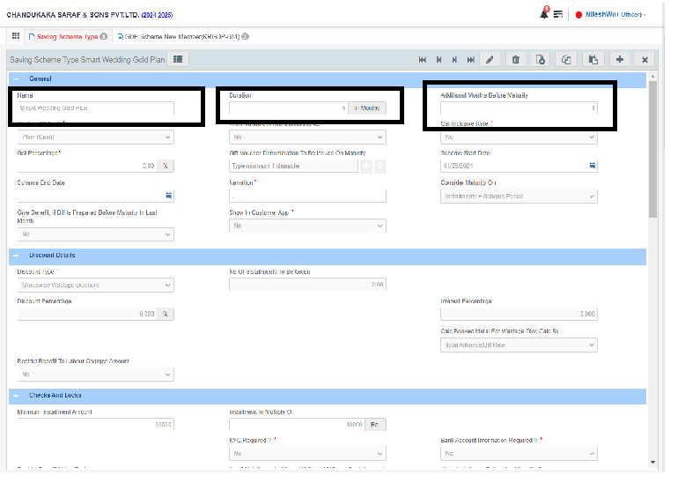

Fig: Duration of the scheme is 5 months and Additional months before maturity is 1

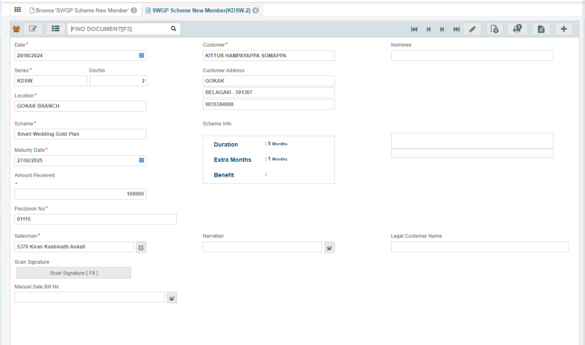

Fig2: Duration of the scheme is 5 months and Additional months before maturity is 1 so, if the opening date is 31-8-2024 then maturity date will be 5+1 = 6 months I.e. 27-2-2025

**BR003: New Scheme Enrollment with old scheme number.**

If the customer has old scheme number then scheme name will show old scheme name with minimum installment amount in the Installment amount field.

Installment amount will not accept more than minimum installment with multiple of “Installment in multiple of” field.

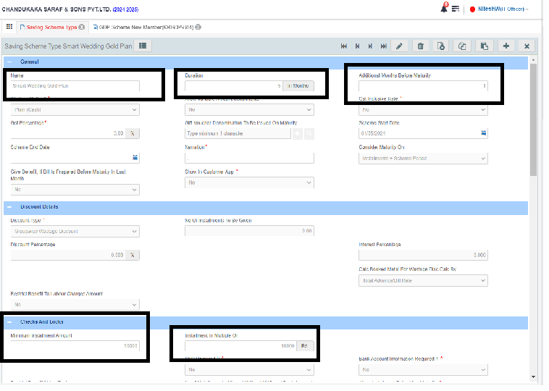

**BR003: Sync enrollment entry on Padm**

**Upon New scheme entry on the My CS App, its entry will be auto generated on the padm with below highlighted fields.**

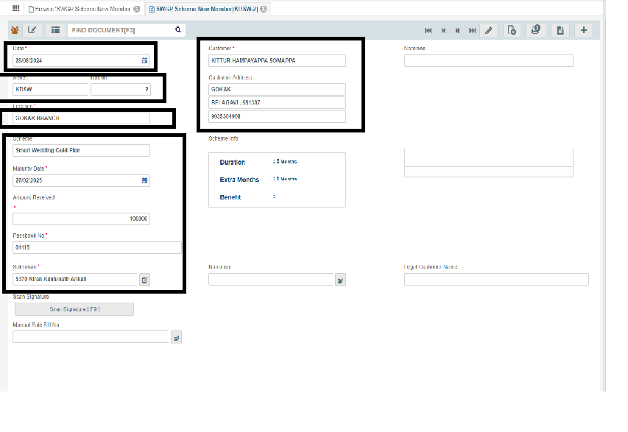

1. **TEST DATA**



1. **ODUS ( Open Discussed Unhanded scenarios )**
2. **REFERENCES OF THE USERS**

|  |  |  |  |
| --- | --- | --- | --- |
| **User** | **Name** | **Mail** | **Contact number** |
| **Actual user** |  |  |  |
| **Ticket created by (if any)** | TT24670 |  |  |
| **Assigned business analyst** | Mallikarjun, Priyanka Gole |  |  |
| **Assigned developer** | Baliram, Swapnali Bhosale |  |  |
| **Assigned tester** | Sayali, Prathmesh K |  |  |