Stock Transfer Changes

Go To Inventory management > Outbound orders > Transfer order

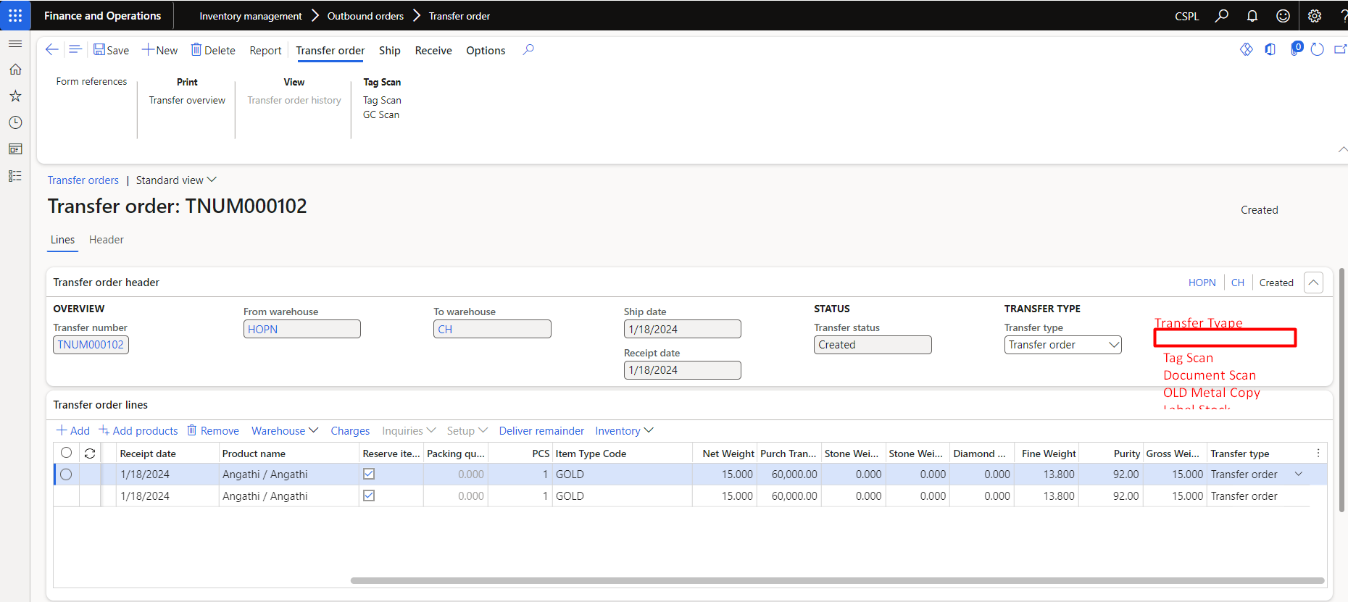

Add One Field Transfer Type Required Dropdown.

Transfer Type Field Required To Mandatory.

Tag Scan, Document Scan, Old Metal Copy, Label Stock.

Add From Location Field & To Location Field.

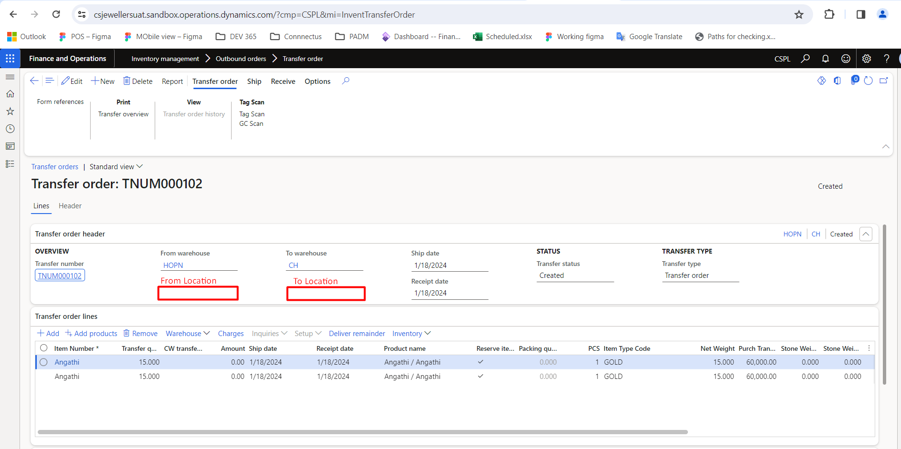

From Warehouse should contain Warehouse assigned to User by default.

In From Warehouse, the list of locations in that warehouse should appear.

You should be able to select the warehouse in the To Warehouse field.

The in transit location of the warehouse selected in the To Warehouse field should appear automatically in the To location field.

After Select Tag Scan in Transfer Type Go to Transfer Order & Click On Tag Scan.

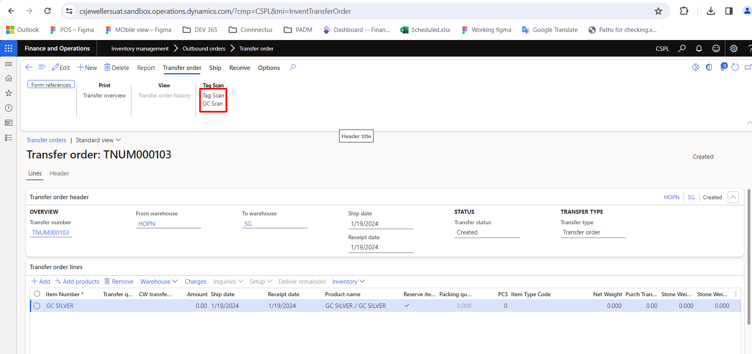

After Select GC Scan Button

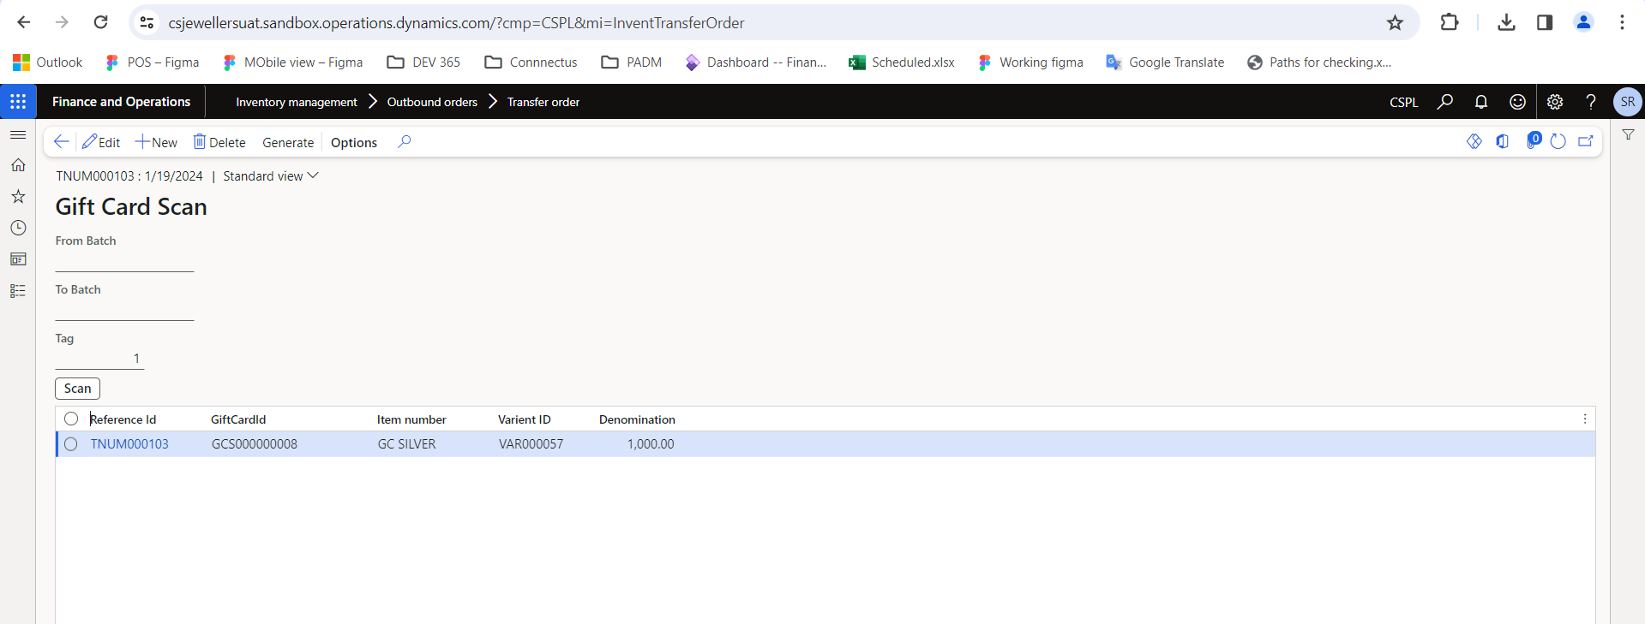

After Click On Generate Button

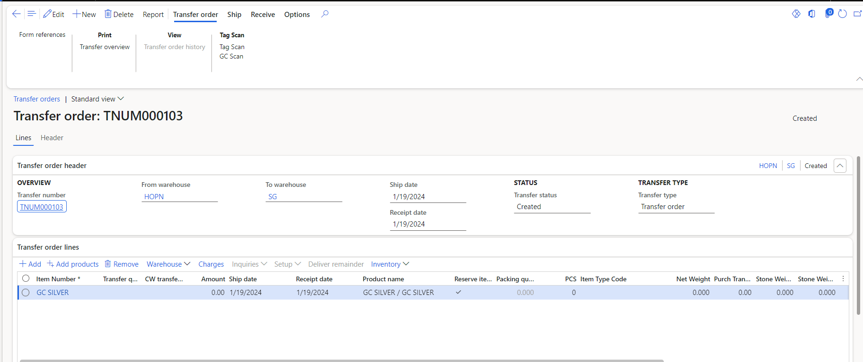

"Trasfer Order lines" add new cloumn gift card id (first).

gc scan denomination field value shoe in the "Trasfer Order lines" "amount" field.

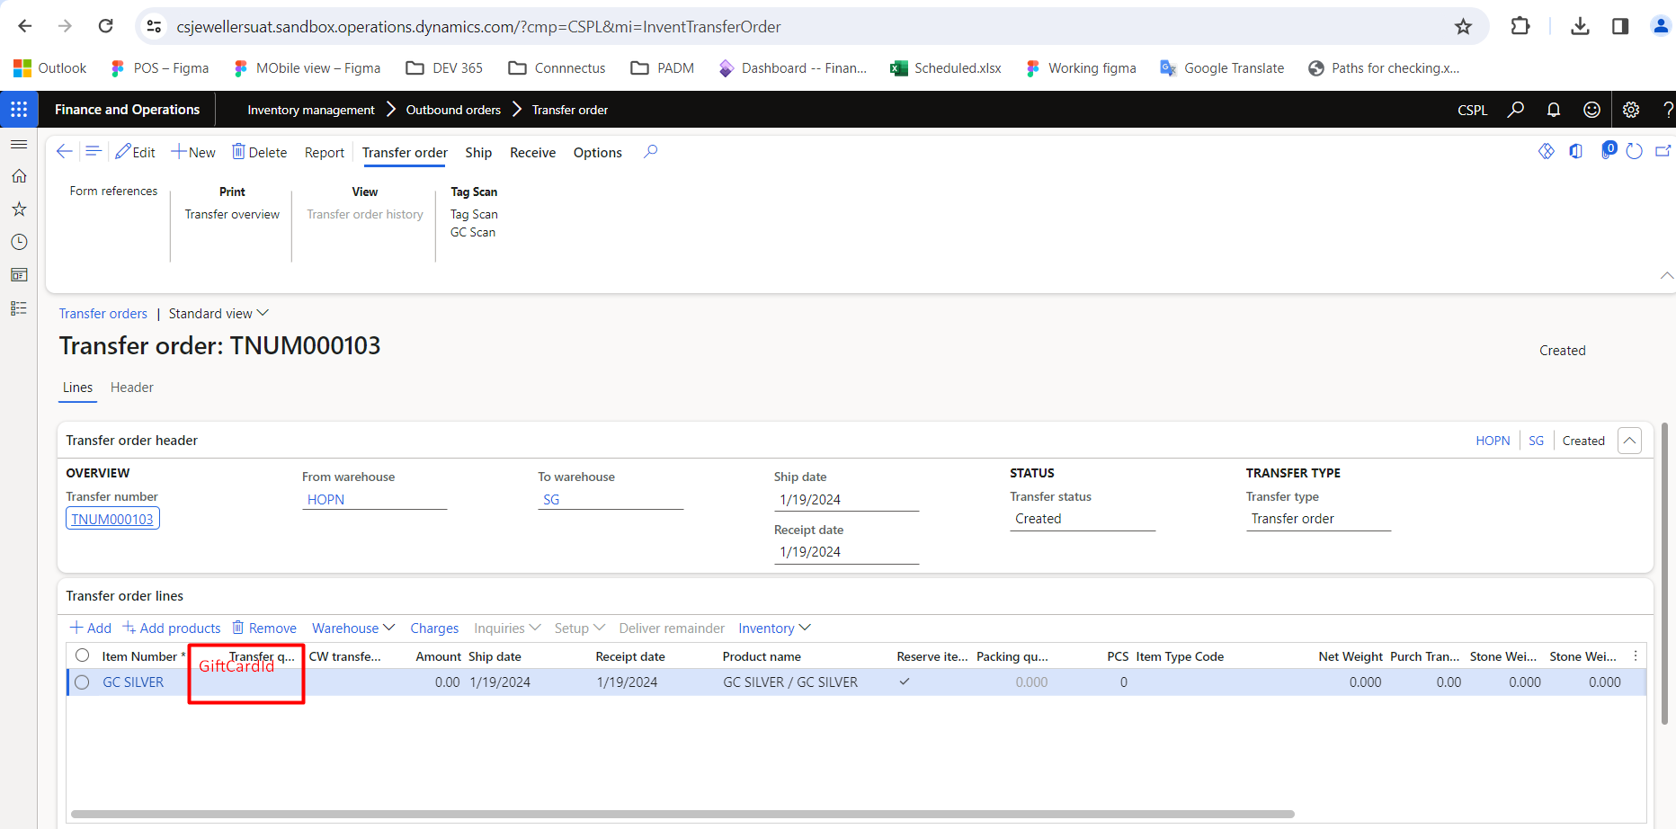

After That click On Ship Button

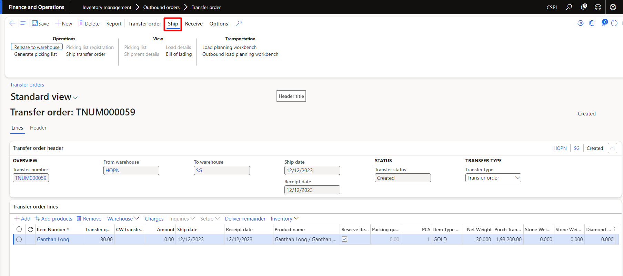

Select Ship Transfer Order

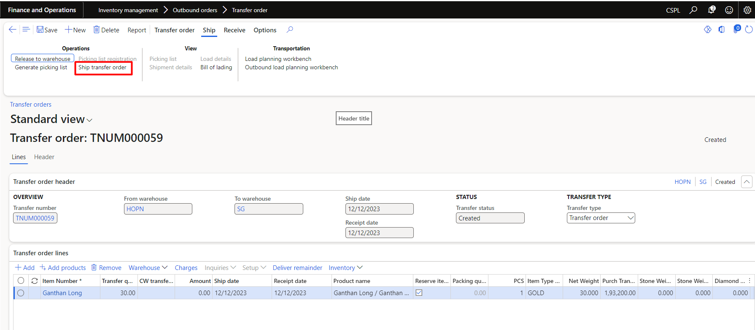

After Click On Ship Transfer Order

After Click On Ok

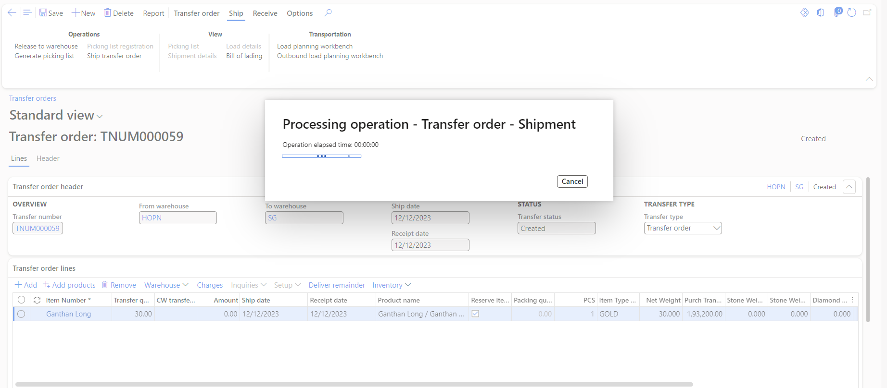

After Complete Operation

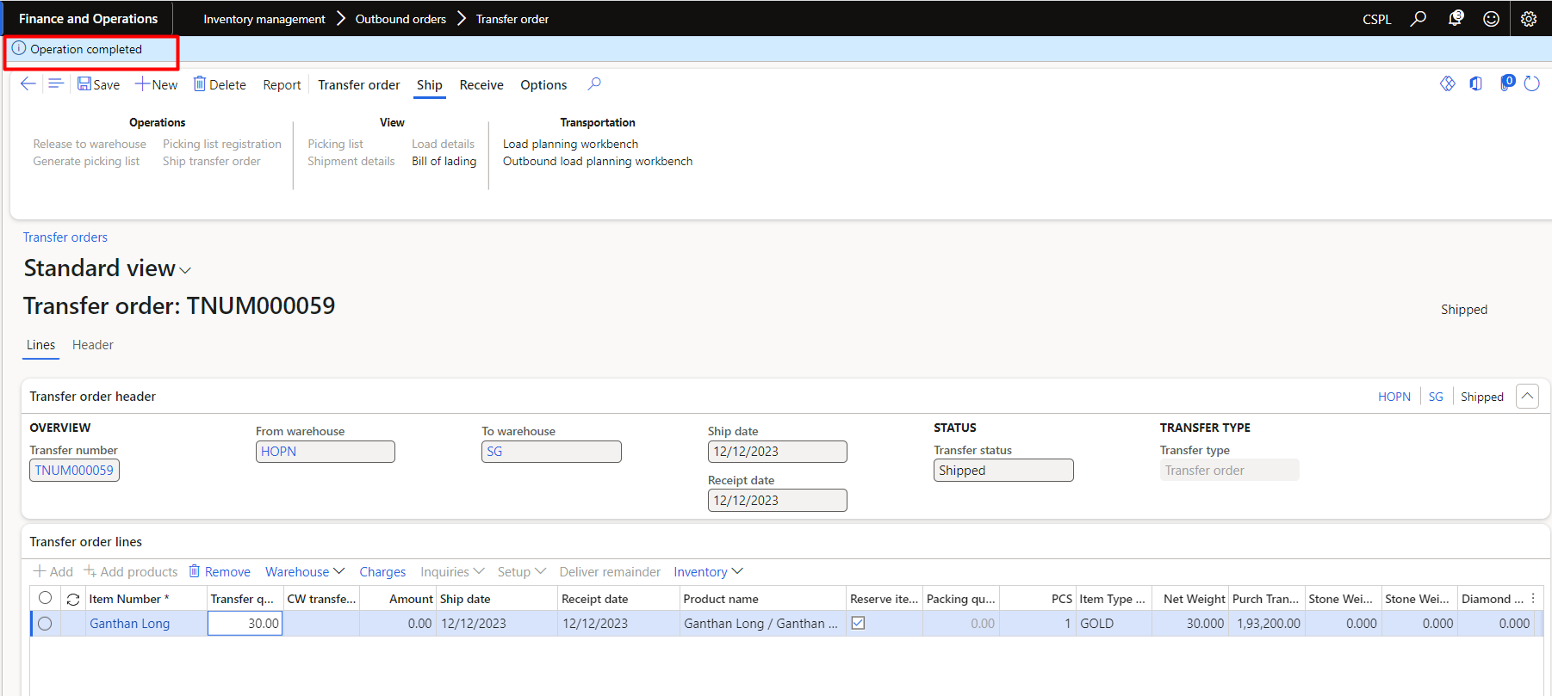

IF gc scan through transfer then the gift card then details will update in this menu Jewellery -> Gift Card Scheme -> Gift Card Details (TA_GiftCardDetails) and Retail and Commerce -> Channels -> Stores -> Gift cards -> All gift cards.

After Click On Tag Scan

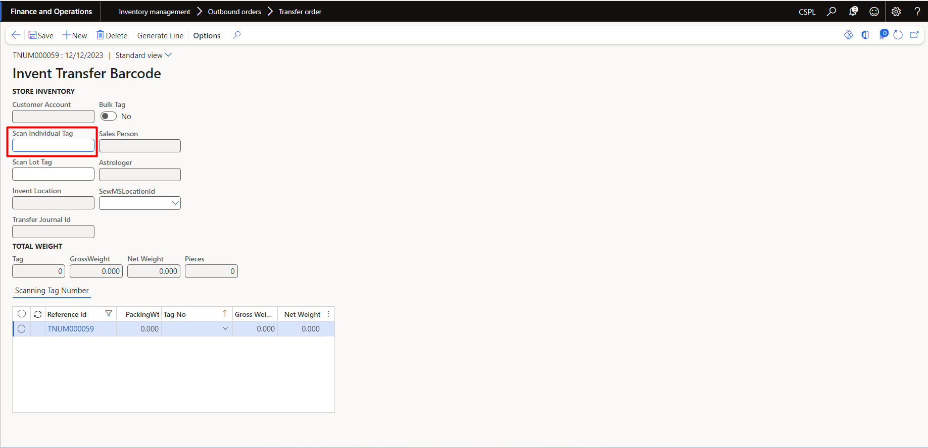

Afetr Tag Scanning

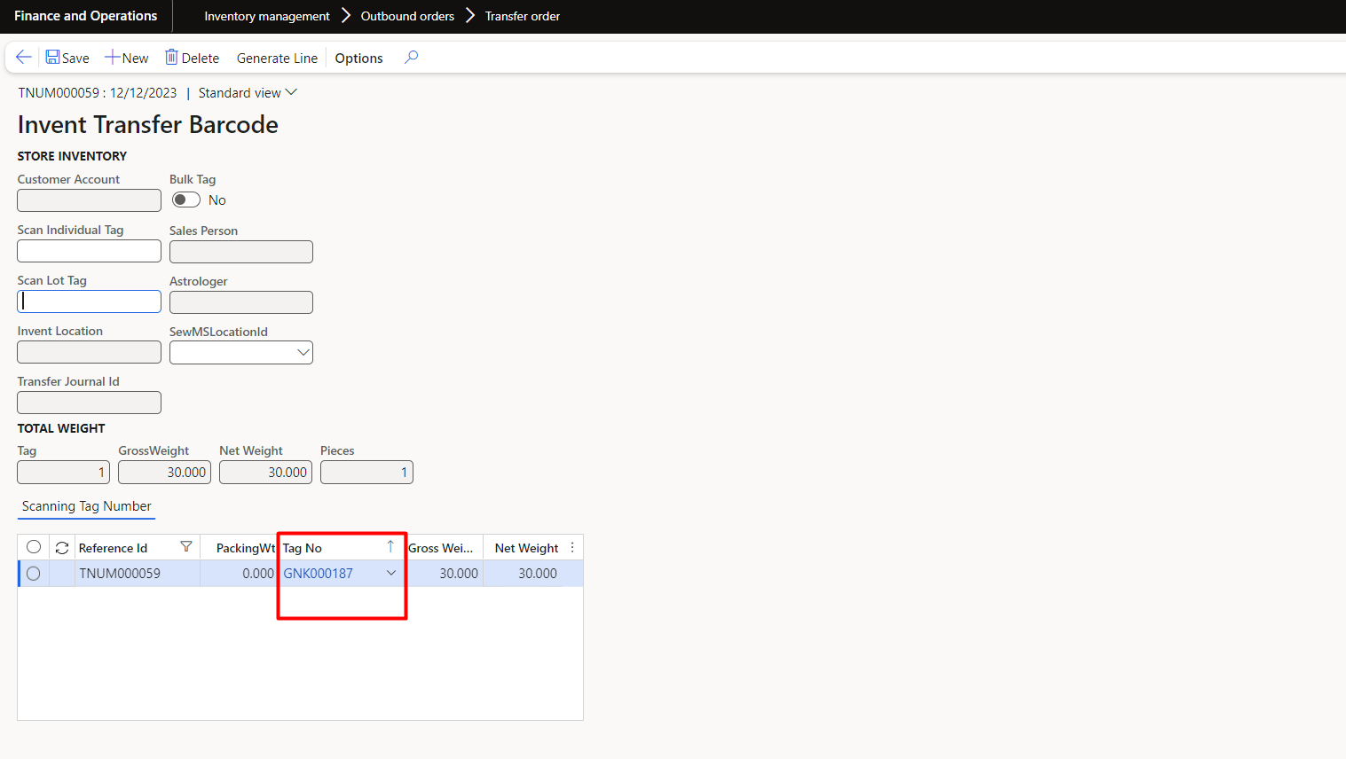

Afetr Scanning Done

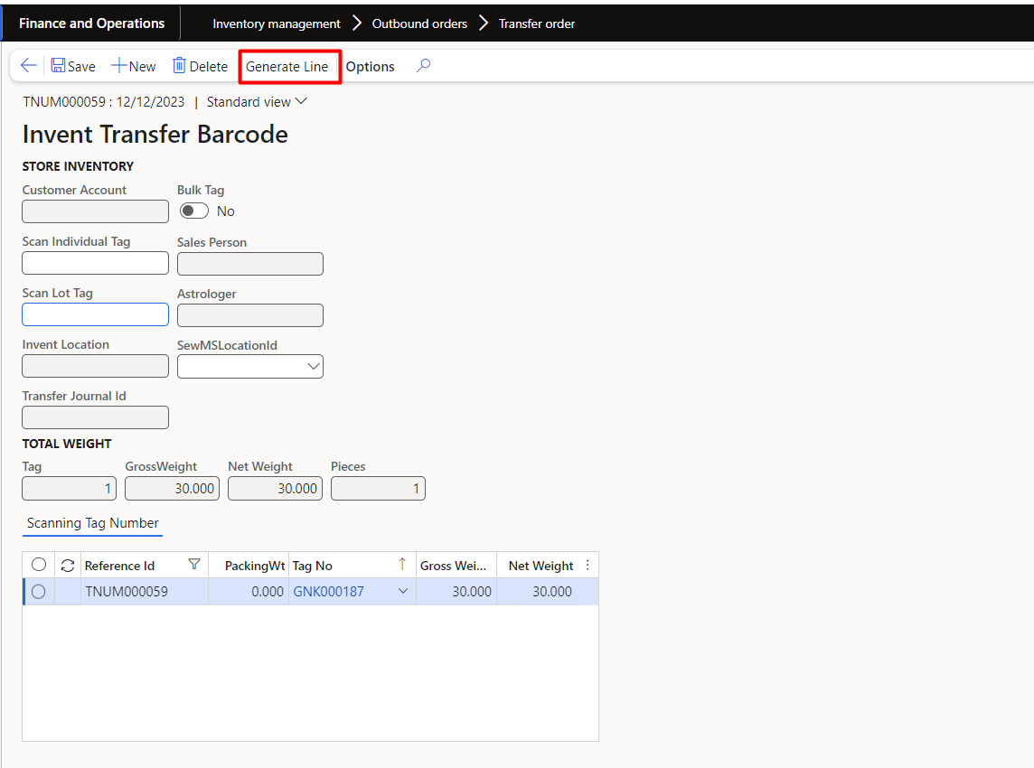

After clicking Generate line, the data is entered in the transfer order line

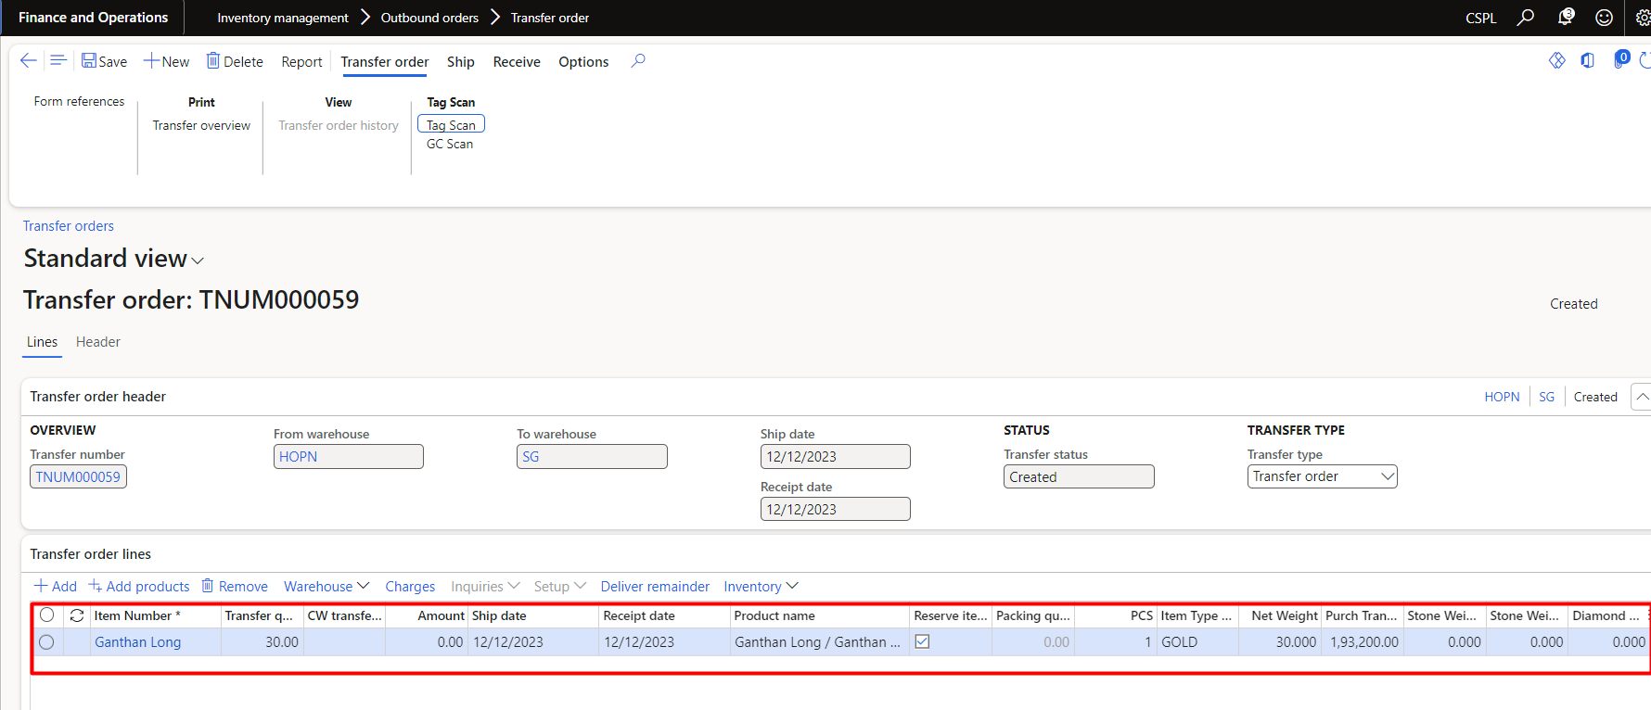

After That click On Ship Button



Select Ship Transfer Order



After Click On Ship Transfer Order

After Click On Ok



After Complete Operation



After Click Shipmate Complete In transit Location Update on All Tag.

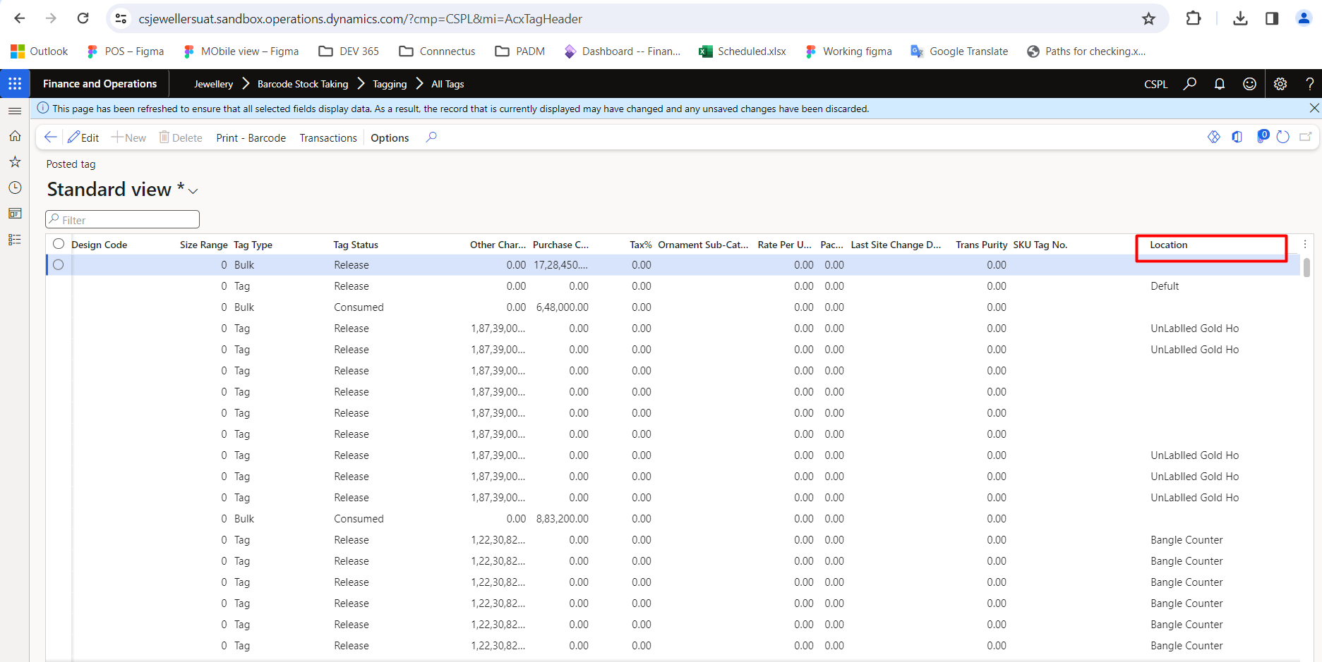

Select Document scan option in Transfer type field, tar next window should open.

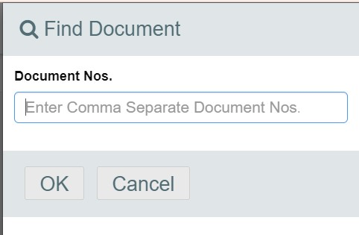

Enter comma separated document number in the Document Nos field so that the tag data in that document should come automatically.

After clicking OK Button, the data is entered in the transfer order line



After That click On Ship Button



Select Ship Transfer Order



After Click On Ship Transfer Order

After Click On Ok



After Complete Operation



After Click Shipmate Complete In transit Location Update on All Tag.



Select OLD Metal Copy option in Transfer type field, tar next window should open.

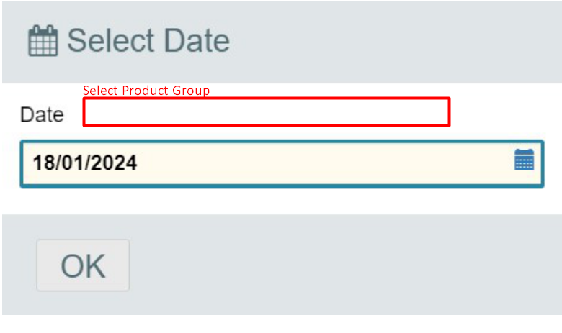

Acxoldtagheader.

After clicking OK Button, the data is entered in the transfer order line



After That click On Ship Button



Select Ship Transfer Order



After Click On Ship Transfer Order

After Click On Ok



After Complete Operation



After Click Shipmate Complete In transit Location Update on All Tag.



**Receive**

By selecting Inventory management > Outbound orders > Transfer order, the user should see the documents from the warehouse assigned to him.

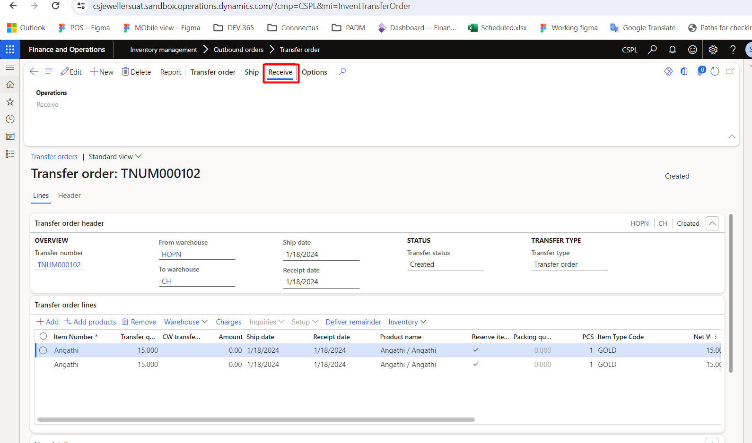

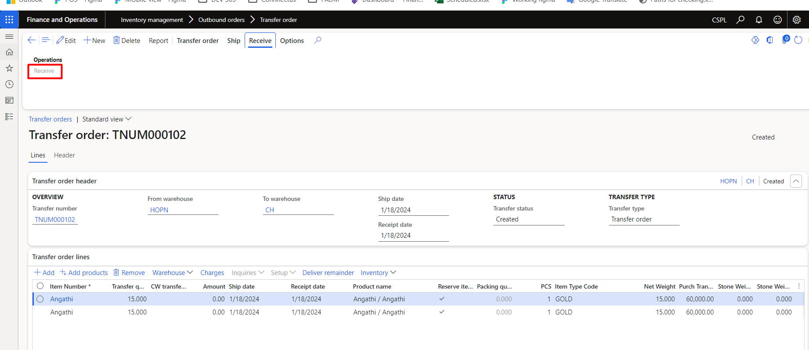

After Receive Process Complete Stock Update on set Location in all tag page.