27.10.2023

**USER MANUAL HANDOVER**

@techneai.com

PICK ITEM DETAILS

Manali ashok bhadirage

Manali.bhadirage@techneai.com

**CONTENTS**

1. VERSION CONTROL 2

2. INTRODUCTION 2

3. SCOPE 2

4. BUSINESS & SYSTEM RULES 2

5. ABBREVIATIONS & TERMS 2

6. GRAPHICAL REPRESENTATION 2

7. DEVELOPED SYSTEM 2

8. TEST DATA AND BUSINESS SCENARIOS 3

1. **VERSION CONTROL**

|  |  |  |  |  |  |  |
| --- | --- | --- | --- | --- | --- | --- |
| **Sr. No** | **Version no** | **Version Date** | **User name** | **User department** | **Updated By** | **Ticket ID** |
| **1** | **1.0** | **27/10/2023** | **Tushar nikam** | **Inventory** | **Manali Bhadirage** | **TT4420** |
|  |  |  |  |  |  |  |
|  |  |  |  |  |  |  |

1. **INTRODUCTION**

The Inventory department comprises both new and experienced team members. New staff members must familiarize themselves with the information pertaining to each item. Through "Pick Item Details" module, users can view details of the the item like product group, category, size image and other specifications. Users can then review details and verify the items based on the information provided while working on it. Through module, users will get to know what are the expected features of the item.

1. **SCOPE**

Authprozed user will add the item details having unique bar-code and these details will be displayed in grid. Further, actual users can search the desired item and view its detailed specifications. Users can download the details of the items. Authorized user can cancel, restore and edit the item details. Authprozed user has provision to add the details of the item individually or through bulk upload.

1. **BUSINESS & SYSTEM RULES**

* User should be registered in the system.
* User should be logged in.
* System should display error message for incorrect details if entered.
* Through Pick Item Details Operations authority, authorized user can add, edit, cancel and restore item details.
* Through Pick Item Details Bulk Upload & download, authorized user can have access to download bulk format and upload it.

1. **ABBREVIATIONS & TERMS**

PCS - pieces (item count)

1. **GRAPHICAL REPRESENTATION**

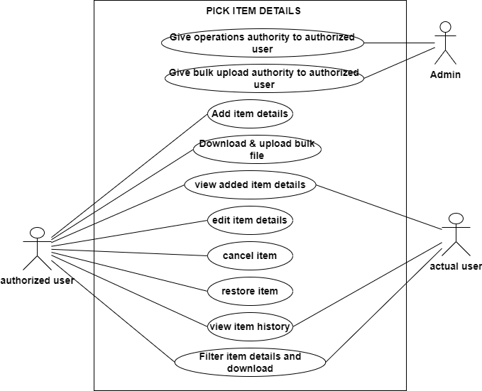

Fig: Use case diagram

1. **DEVELOPED SYSTEM**

Pick item details will have following fields:

* Add Data button
* Bulk upload format button
* Upload file button
* Filter button
* From date
* To date
* Download button
* Reset button
* Edit button
* View button
* Cancel button
* Restore button
* History button
* Operation (add / update / cancel / restore)
* Image 1
* Bar-code
* Product group
* Item name
* Category name
* Sub category name
* Design code
* Pcs
* Consider size
* Enter size
* Consider design code
* Consider hallmark
* Laser mark
* Information
* Attach
* Delete attachment
* Save button
* Back button
* Reset button
* Is cancel
* Created at
* Created by
* Updated at
* Updated by

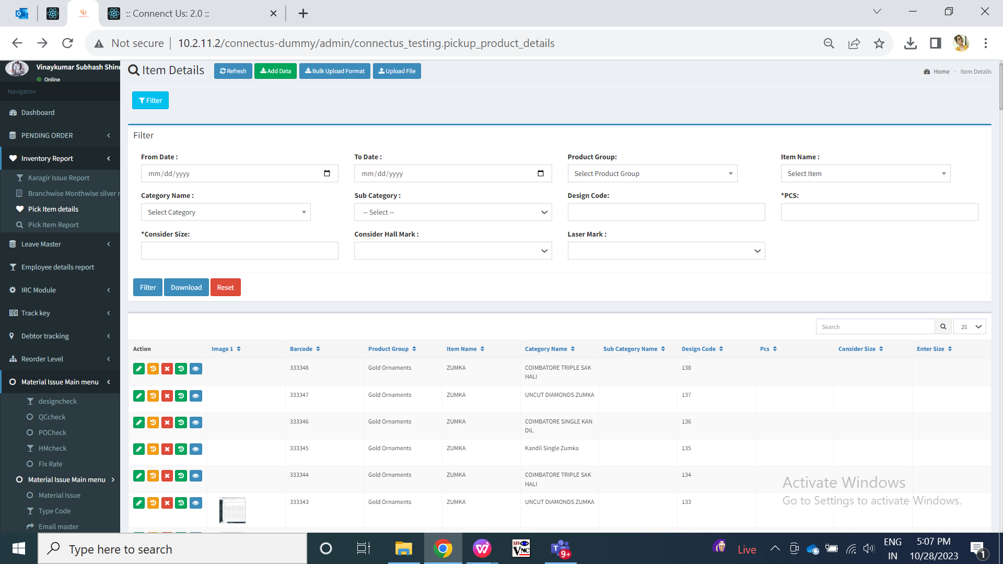

Fig: Pick item details grid

Visibility of fields in functions:

|  |  |  |  |  |  |  |  |
| --- | --- | --- | --- | --- | --- | --- | --- |
| **FIELDS** | **ADD** | **GRID** | **VIEW** | **EDIT** | **HISTORY** | **FILTER** | **BULK UPLOAD FORMAT** |
| Add Data button | **X** | Authority based | **X** | **X** | **X** | **X** | **X** |
| Bulk upload format button | **X** | Authority based | **X** | **X** | **X** | **X** | **X** |
| Upload file button | **X** | Authority based | **X** | **X** | **X** | **X** | **X** |
| Filter button | **X** |  | **X** | **X** | **X** |  | **X** |
| From date | **X** | **X** | **X** | **X** | **X** |  | **X** |
| To date | **X** | **X** | **X** | **X** | **X** |  | **X** |
| Download button | **X** |  | **X** | **X** | **X** |  | **X** |
| Edit button | **X** | Authority based | **X** | **X** | **X** | **X** | **X** |
| View button | **X** |  | **X** | **X** | **X** | **X** | **X** |
| Cancel button | **X** | Authority based | **X** | **X** | **X** | **X** | **X** |
| Restore button | **X** | Authority based | **X** | **X** | **X** | **X** | **X** |
| History button | **X** |  | **X** | **X** | **X** | **X** | **X** |
| Operation | **X** | **X** | **X** | **X** |  | **X** | **X** |
| Image 1 | **X** |  | **X** | **X** | **X** | **X** | **X** |
| Bar-code |  |  |  |  |  | **X** |  |
| Product group |  |  |  |  |  |  |  |
| Item name |  |  |  |  |  |  |  |
| Category name |  |  |  |  |  |  |  |
| Sub category name |  |  |  |  |  |  |  |
| Design code |  |  |  |  |  |  |  |
| Pcs |  |  |  |  |  |  |  |
| Consider size |  |  |  |  |  |  |  |
| Enter size |  |  |  |  |  | **X** |  |
| Consider design code |  |  |  |  |  | **X** |  |
| Consider hallmark |  |  |  |  |  |  |  |
| Laser mark |  |  |  |  |  |  |  |
| Information |  |  |  |  |  | **X** |  |
| Attach |  | **X** | **X** |  | **X** | **X** | **X** |
| Images | **X** | **X** |  | **X** | **X** | **X** | Attachment 1, attachment 2, attachment 3 |
| Delete attachment | **X** | **X** | **X** | **X** | **X** | **X** | **X** |
| Download attachment | **X** | **X** |  | **X** | **X** | **X** | **X** |
| Save button |  | **X** | **X** |  | **X** | **X** | **X** |
| Back button |  | **X** | **X** | **X** | **X** | **X** | **X** |
| Reset button |  | **X** | **X** |  | **X** |  | **X** |
| Is cancel | **X** |  |  | **X** |  | **X** | **X** |
| Created at | **X** |  |  | **X** |  | **X** | **X** |
| Created by | **X** |  |  | **X** |  | **X** | **X** |
| Updated at | **X** |  |  | **X** |  | **X** | **X** |
| Updated by | **X** |  |  | **X** |  | **X** | **X** |

Through ‘Pick Item Details Operations’ from login special auth, authorized user can perform four operations namely add, edit, cancel and restore. Whereas, through ‘Pick Item Details Bulk Upload & download’ user will have access to download bulk format button and upload file button.

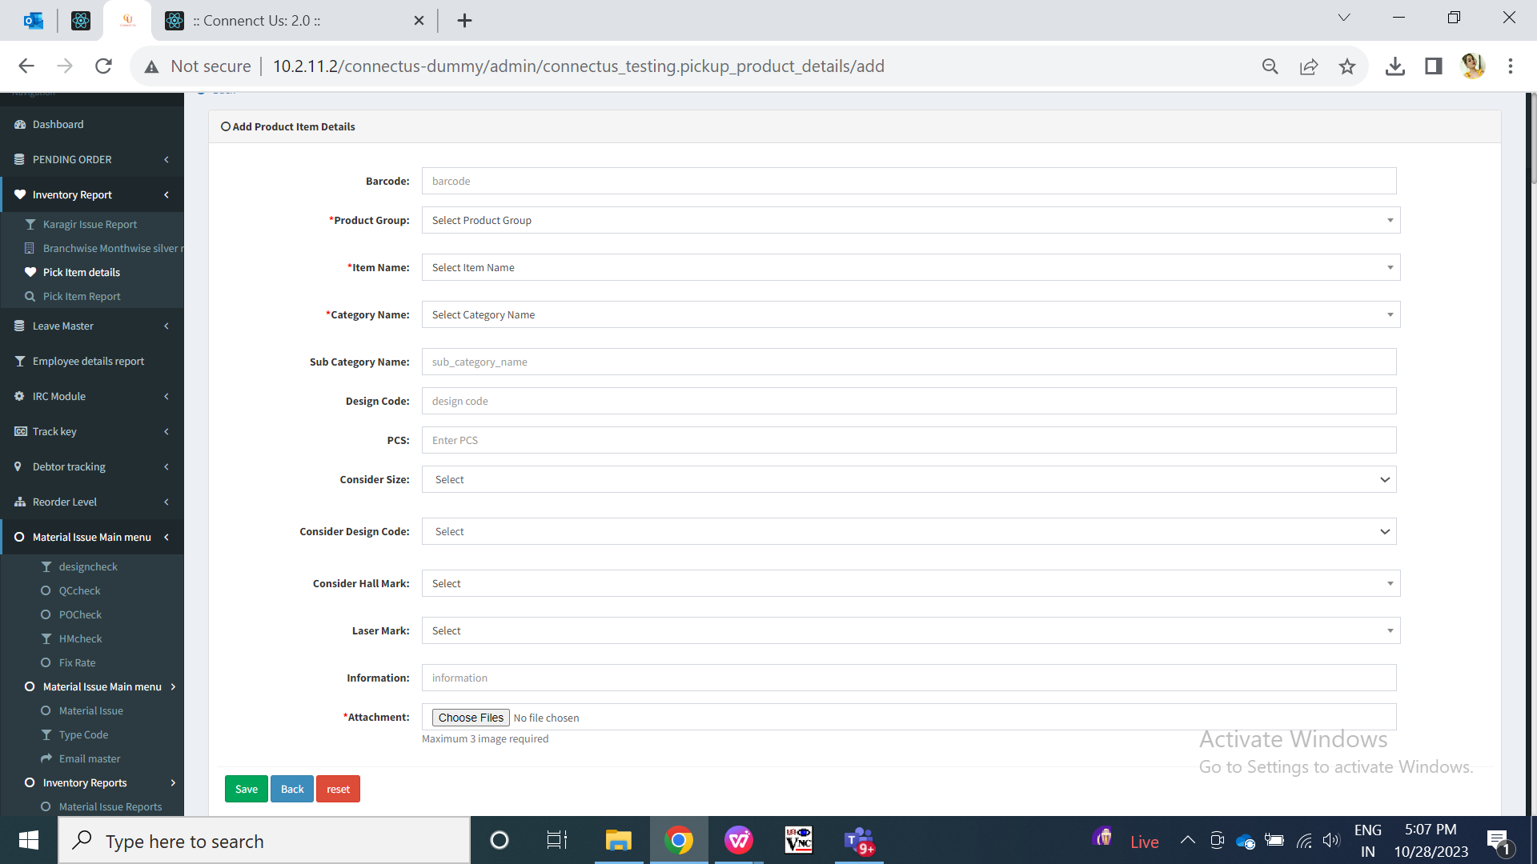

Fig: add action

**Input table**

|  |  |  |  |  |
| --- | --- | --- | --- | --- |
| **FIELDS** | **INPUT TYPE** | **MANDATORY/ OPTIONAL** | **EDITABLE** | **DESCRIPTION** |
| Bar-code | text | Optional | Yes | Each item has bar-code on its package. User will enter the bar-code number of the item.  Validation: It will be alphanumeric field. It will be unique. Same bar-code cannot be added again. Maximum length will be 15 digit. It will have first three letters compulsorily. It is not case sensitive.  Example : NEK123456789012  BNG098765432109 |
| Product group | Drop down | Mandatory | Yes | Display list of product groups as in Padm live -> product groups like Gold bullion, gold ornaments, silver bullion, platinum, sterling silver, mrp items, stone, diamond jewellery, etc.  Validation: it will be single select. |
| Item name | Drop down | Mandatory | yes | List of items will be displayed either from Padm -> master -> item as per selected product group.  Validation: it will be single select. Only active items will be displayed from padm live-> item master. |
| Category name | Drop down | Mandatory | yes | List of items will be displayed either from Padm -> master -> item -> categories as per selected item name.  Validation: it will be single select. |
| Sub-category name | Text | Optional | Yes | User will manually enter sub-category name if any for that item.  Validation: It will accept characters and hyphen. Maximum 25 characters will be accepted. |
| Design code | Text | Optional | Yes | Users require design code only while entering new item from inventory.  Validation: It will accept alphanumeric value. It can be only numbers or only characters or combination of both. It can be repeated but against this design code, bar-code will be different each time while adding data. It will accept maximum 25 digits. |
| Pcs | text | Optional | Yes | User will manually enter the number of pcs of that item - category.  Validation: It has incremental & decrement button into this field for numbers. It will accept only numbers. It will not accept character or any special character. |
| Consider size | Drop down | Optional | Yes | It will display yes, no, optional in the drop-down. This is to inform the actual users that when they will be checking the particular item- category then it’s size should be considered or not while verifying.  If user selects yes or optional, then ‘enter size’ field will be displayed where user will have to mention the size of that item - category.  Validation: It will be single select. |
| Enter size | Text | Optional | yes | If user selects yes or optional, then ‘enter size’ field will be displayed where user will have to mention the size of that item - category.  If user selects yes, then entering size is not mandatory and hence can keep this field blank. Whereas, if user selects optional in consider size field then user will have to compulsorily mention the size.  Validation: It will accept decimals (single value only after decimal point). It will accept maximum “100” number only in this field. It will accept decimal point only once. It will accept only numbers. |
| Consider design code | Drop down | Optional | Yes | It will display yes, no, optional in the list. It specifies to the actual user whether here they should consider the design code of that particular item - category or not while verifying.  Validation: it will be single select. |
| Consider hall mark | Drop down | Optional | yes | It will display yes and no in the list. It specifies to the actual user whether here they should consider the hallmarking of that particular item - category or not while verifying. (means that item should be hall marked or not)  Validation: it will be single select. |
| Laser mark | Drop down | Optional | yes | It will display yes and no in the list. It specifies to the actual user whether that particular item - category should be laser marked or not.  Validation: it will be single select. |
| Information | Text | Optional | yes | User will manually enter information / additional details of the item.  Validation: It will accept English and Devanagari script. It will accept characters, number, space and special characters. It will accept maximum 250 characters. It will accept English and Marathi language. |
| Attachment | Attach / upload | Mandatory | Yes | User will attach the images of that item-category.  As user can attach maximum 3 images, then firstly attached image of particular item will be considered as main image and it will be displayed in grid -> image 1 column.  Once user attaches the images, it will display the count of images attached in that field.  Validation: User can attach maximum 3 photos of item. Image extensions will be .jpg, .jpeg, .heif and .png with maximum size of 5MB per image. |
| Save | Click | - | - | Once user enters mandatory and optional fields and clicks on submit, then successful message will be displayed. Item details will be displayed at top in the grid.  Validation: Once submit button is clicked, then it will be disabled until successful / alert message is displayed. |
| Back | Click | - | - | Once user clicks on back button, user will be directed to grid page and the record will not get added if details are filled any.  Validation: Once back button is clicked, then it will be disabled until user is redirected to grid page. |
| Reset | Click | - | - | Once user clicks on reset button, then page will get reloaded and all pre-filled fields will be cleared.  Validation: Once reset button is clicked, then it will be disabled until all fields are cleared and page is reloaded. |
| Grid: image 1 | Text | - | - | The firstly attached image of particular item in add/ edit -> attachment field, that will be considered as main image and it will be displayed in grid -> image 1 column. |
| Is cancel | Text | - | - | As user can cancel or restore the item, it will display the status as yes / no in ‘is cancel’ field. (means item is active or not) |
| Created at | Text | - | No | It will display the date and time when the item details were added.  Validation: it will be read only. |
| Created by | Text | - | No | It will display the employee name who added the item details.  Validation: it will be read only. |
| Updated at | text | - | - | Once the user edits the item details, then it will display the date and time when the item details were modified.  Validation: it will be read only. |
| Updated by | Text | - | - | Once the user edits the item details, then it will display the employee name who modified the details.  Validation: it will be read only. |

Once user clicks on edit action of the item entry, it will will display all the details which were filled while adding.

|  |  |  |  |  |
| --- | --- | --- | --- | --- |
| **FIELDS** | **INPUT TYPE** | **MANDATORY/ OPTIONAL** | **EDITABLE** | **DESCRIPTION** |
| Attachments | Attach | - | yes | It will display all the images which were attached in add action of that item. In addition to it, all immages will have delete action to it so that user can attach another image. Once user clicks on delete button for any image, it will display dialog bix to confirm deletion of the image. Once you click on yes, then that already attached image will get deleted. |

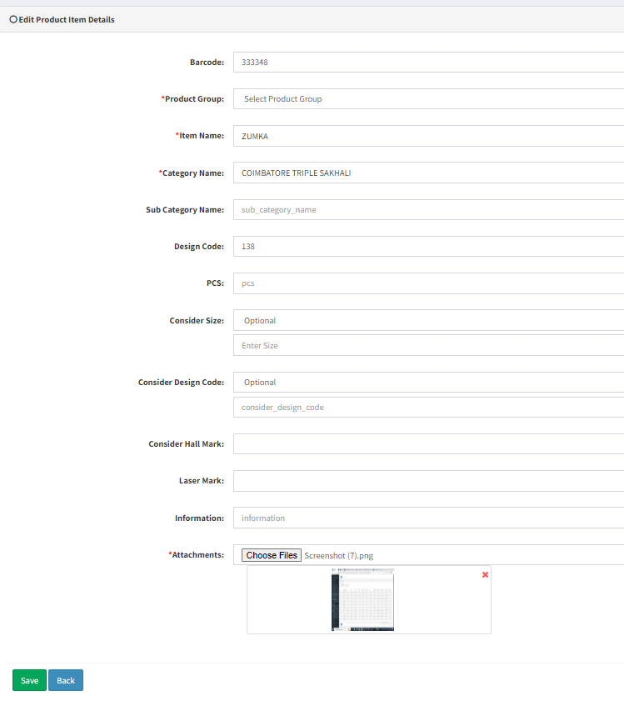

Fig: edit action

Once user clicks on view action of any item details entry, then it will display all the details which were added / edited.

|  |  |  |  |  |
| --- | --- | --- | --- | --- |
| **FIELDS** | **INPUT TYPE** | **MANDATORY/ OPTIONAL** | **EDITABLE** | **DESCRIPTION** |
| Images | Image | - | - | It will display all the images which were attached in add / edit action of that item. Once user clicks on an image, it will zoom in (displayed in maximum size). Also, each image will have download option so that user can download each image individually. |

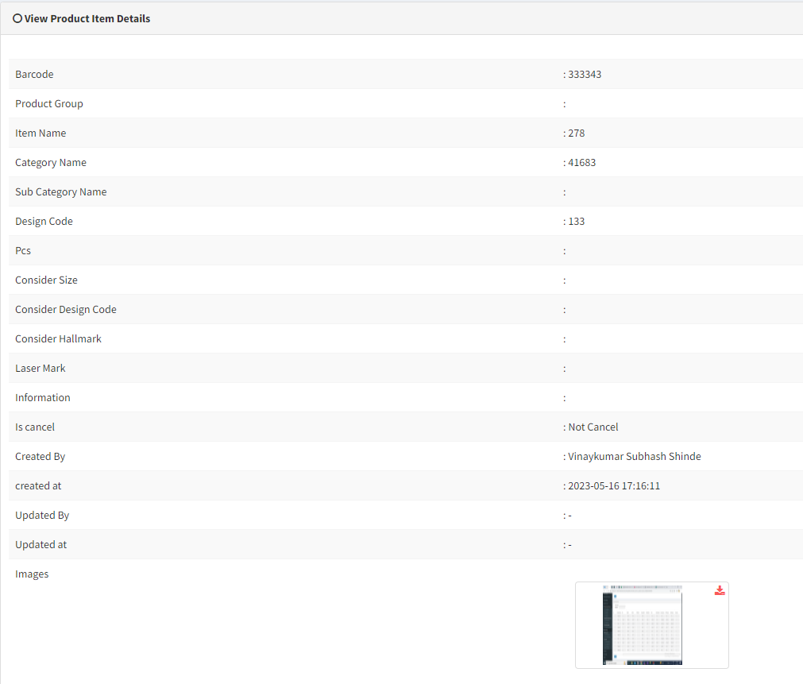

Fig: view action

Once user clicks on cancel action of any item entry, then

1. that item will get canceled which means will be marked as inactive,
2. successful message will be displayed,
3. canceled record will be highlighted,
4. it will be displayed as yes in ‘is cancel’ field of grid,
5. Edit action for canceled item will be removed from grid,
6. If any item is marked as canceled then user can add the same details again by using the same bar-code number.
7. Whereas, if user tried to cancel the already canceled record then it will display alert message as record is already canceled.

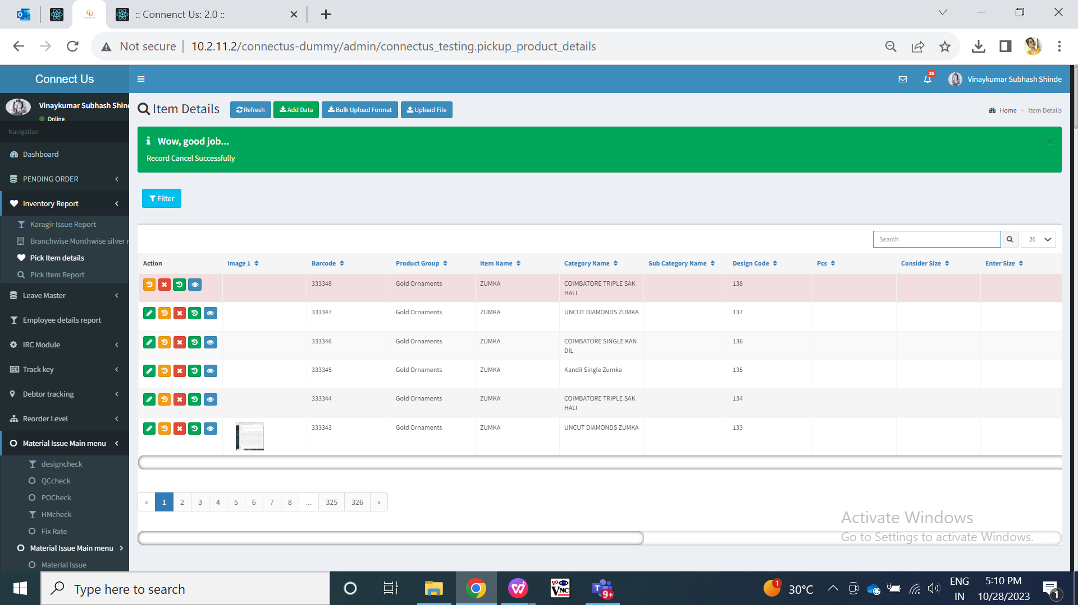

Fig: cancel action

Once user clicks on restore action, then

1. The canceled item will activated,
2. Succesful message will be displayed,
3. Edit action for the restored item will be displayed,
4. Restored items will be displayed as no in grid -> is cancel column.
5. User cannot make another record for the restored item as bar-code should be unique and it already exists in grid as active.
6. In case user clicks on restore action for already active item, then it will display alert message as record already exists.
7. Once item-category is restored, its highlighted colour will be removed.
8. In case user has added one data, then canceled it and added same data - same details for second time. Then the data which was added first time, it will not get restored because second time (same) data is available in grid with same bar-code number.

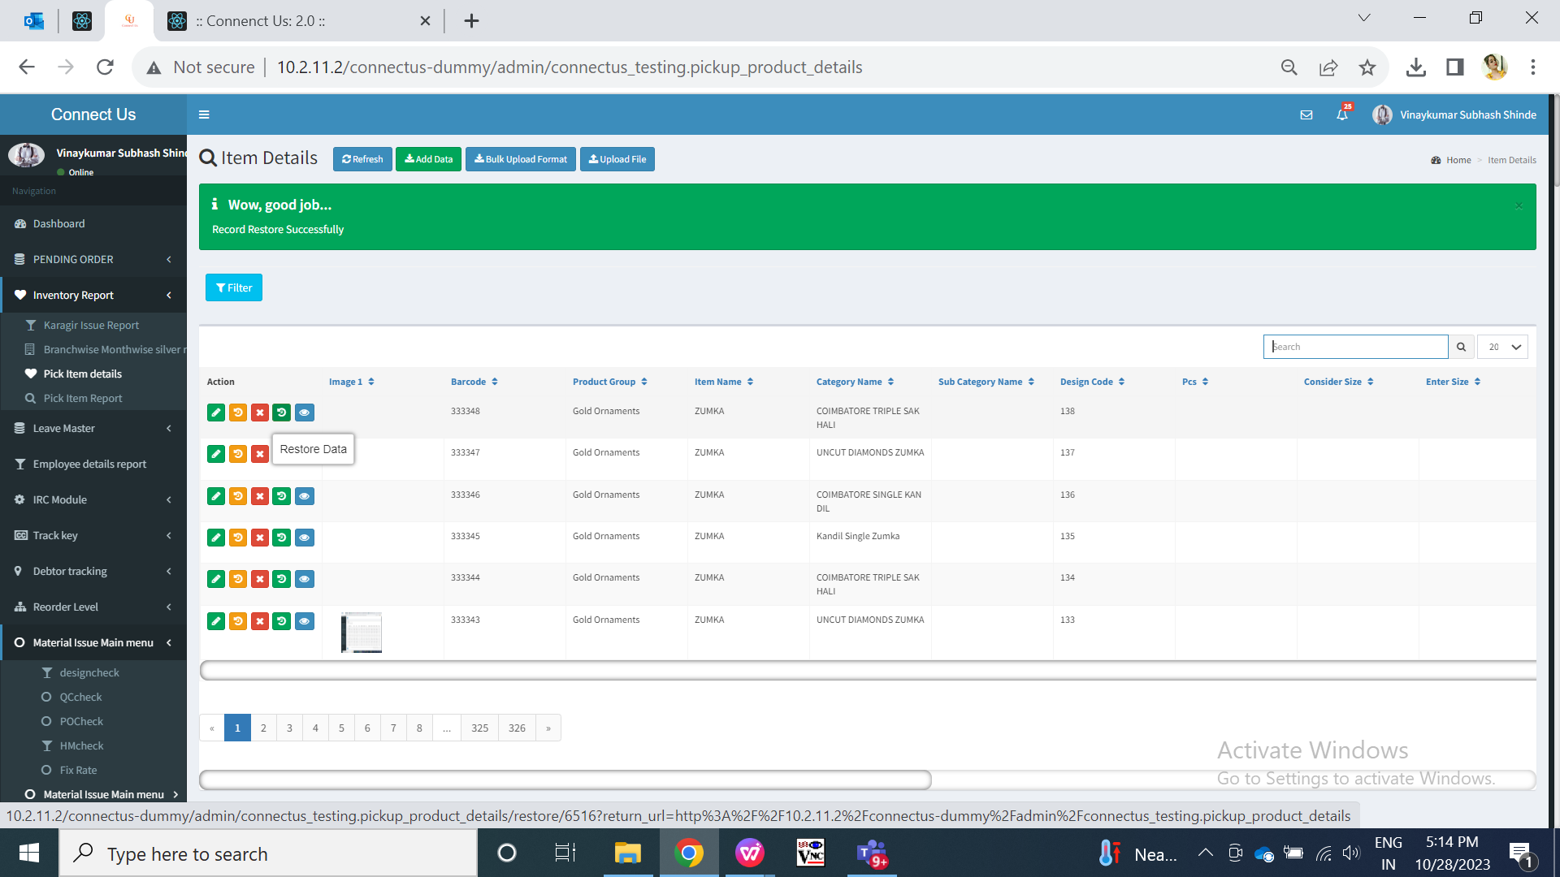

Fig: restore action

Once user clicks on history action, it will display all the details when the item was added and when its fields were edited. Initially when item is added, then it will be displayed as operation-add. Further when details are edited, then its record will be displayed as operation - update and the field which was changed, it will be highlighted. Moreover, if any record is canceled then it will be displayed as operation - cancel whereas as restored record will be displayed as operation- restore.

Note: History of attachments isn’t maintained in history action but updated at & by will be displayed accordingly.

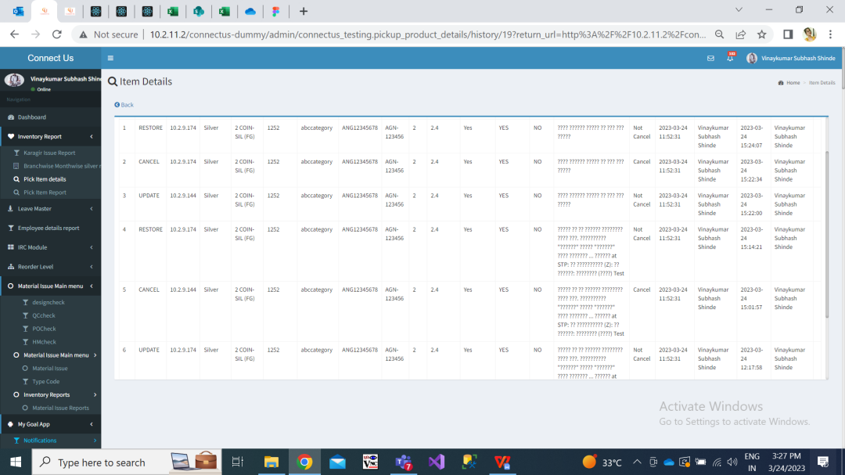

Fig: History action

As user can add single item at a time through add action, authorized users have provision to add multiple items at a time through bulk upload action. Once user clicks on bulk upload format button, csv file will get downloaded. User will have to fill item details in csv file. Once user fills the mandatory details in bulk upload format, user will have to upload it through ‘upload format’ button.

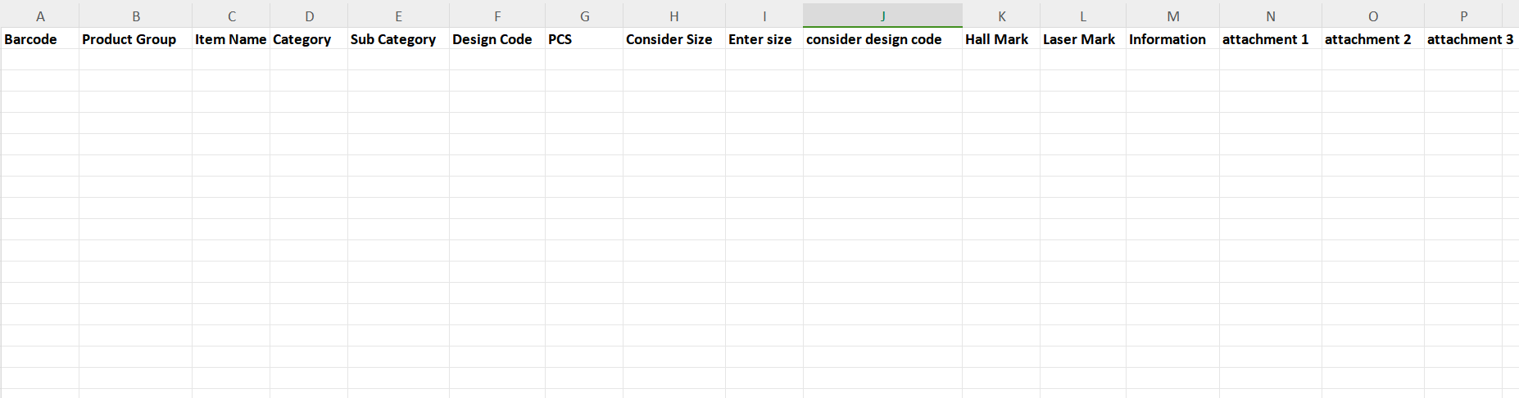

Fig: Bulk upload format

Once user clicks on upload format button, user will have to attach the csv file in file field and images in attachments field.

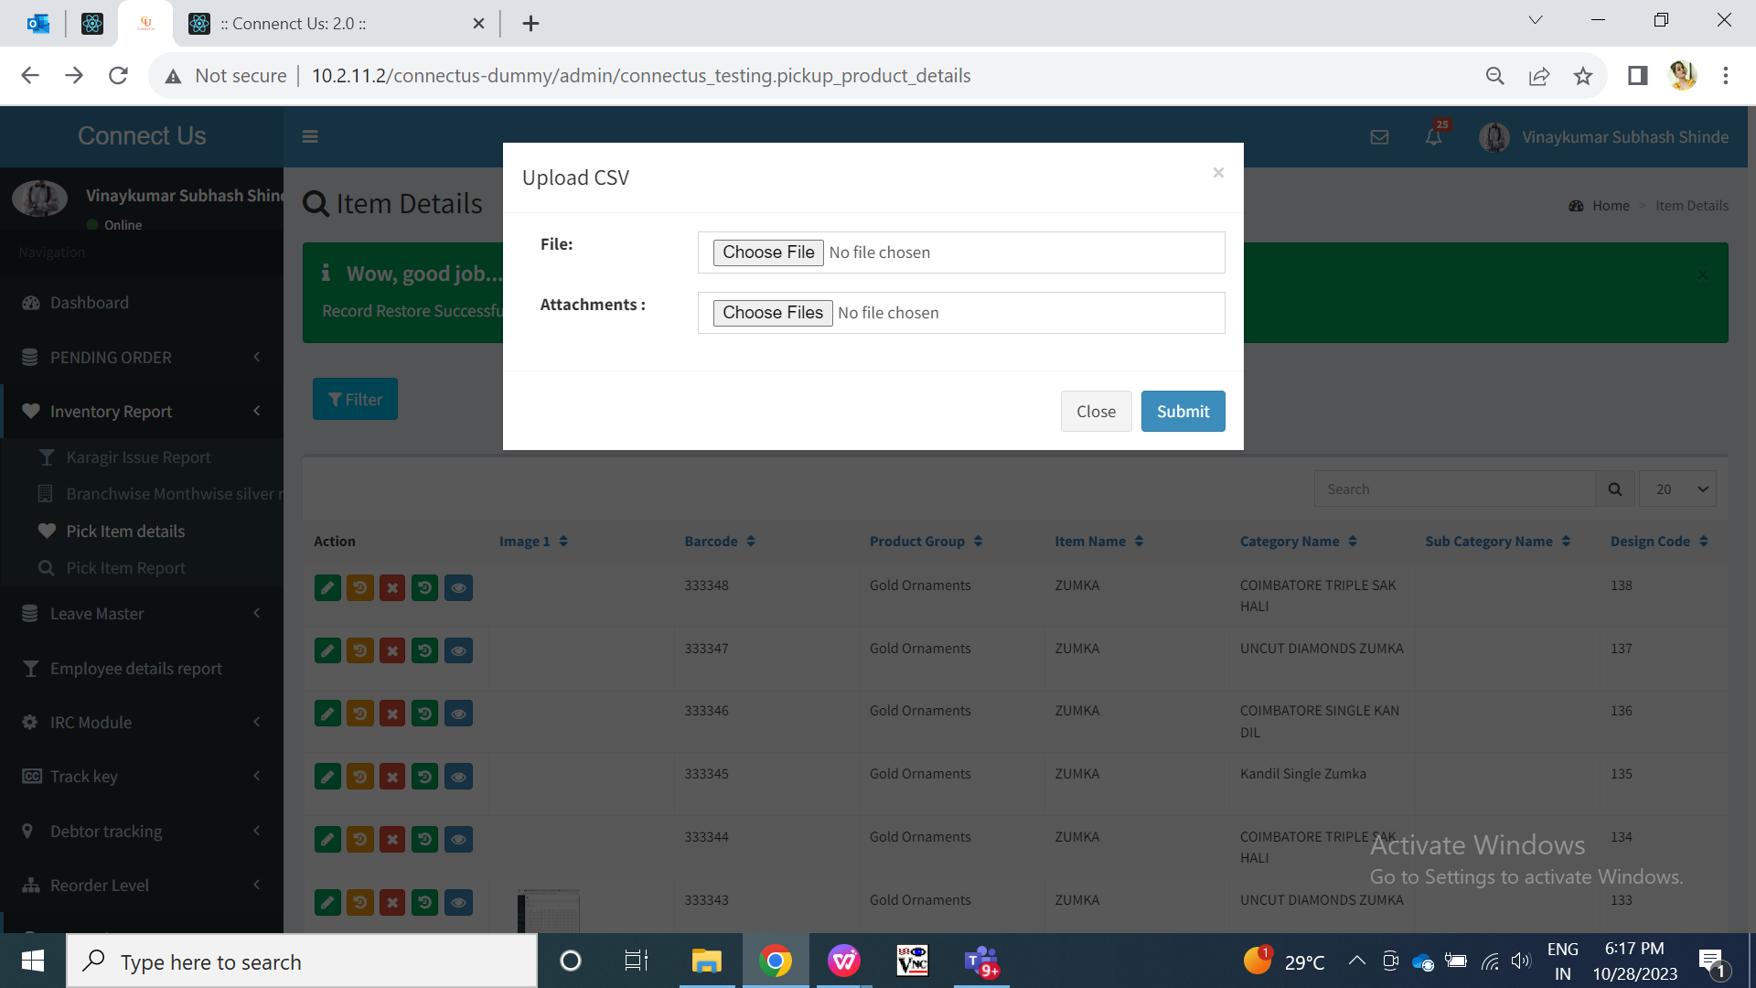

Fig: Upload format button

|  |  |  |  |  |
| --- | --- | --- | --- | --- |
| **FIELDS** | **INPUT TYPE** | **MANDATORY/ OPTIONAL** | **EDITABLE** | **DESCRIPTION** |
| File | Attach | Mandatory | - | User will have to attach / upload the file here in which details of the items are filled.  User will have to fill other details in all fields in the correct format as in add and edit form. For drop-down fields, user will have to manually write the options from the list coirrectly in the same manner as in the list including capital letters and space. Moreover, user will have to mention the name of the image along with its extension in attachment 1, attachment 2 and attachment 3 columns in file because we cannot attach images in csb file. Hence, user will have to write the entire name of the image in csv file. (imagename.extension)  In case anyt field is mentioned wrong and user upoloads that file, then details will not get added and it will display error file. Error file will display the comments mentioning which field is invalid.  Validation: Only single csv file will be attached at a time. |
| Attachments | Attach | Mandatory | - | User will have to attach the same images which are mentioned in the csv file attachment 1 / 2/ 3 columns.  Once file is uploaded, images are attached and user clicks on submit button then it will displayed succesfull message. Item details will get added and displayed in the grid. Whereas, the image which were attached in attachments field and mentioned in csv file, it will get mapped accordingly for that record correctly. |

Furthermore, actual user can search the item and its details through filter action.

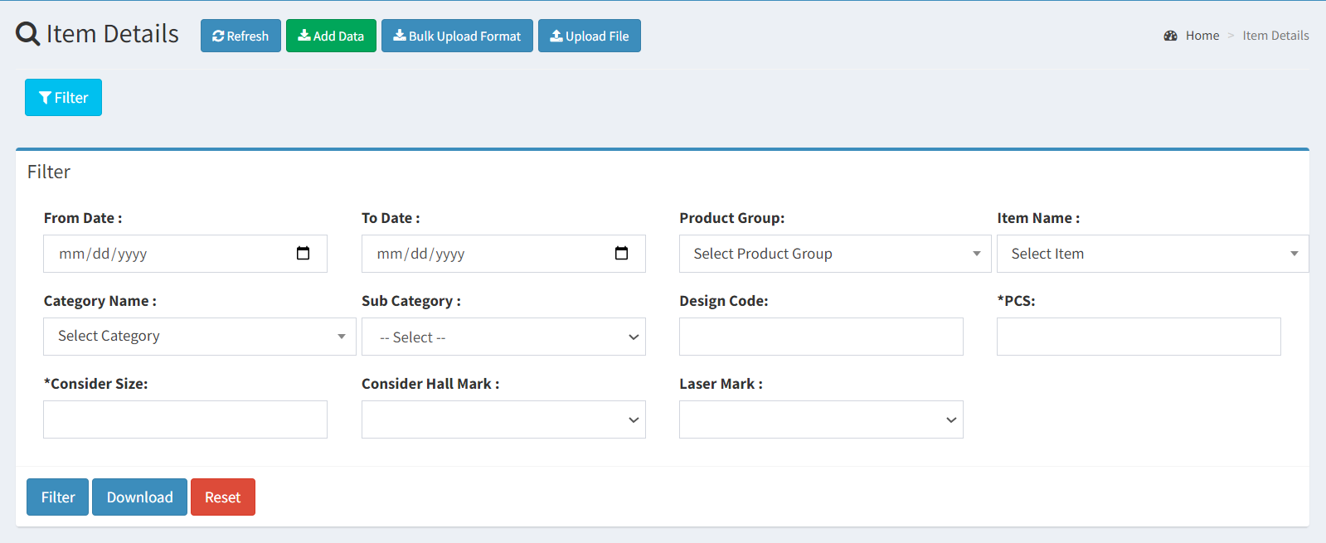

Fig: Filter action

|  |  |  |  |  |
| --- | --- | --- | --- | --- |
| **FIELDS** | **INPUT TYPE** | **MANDATORY/ OPTIONAL** | **EDITABLE** | **DESCRIPTION** |
| From date | Calnder date picker | No | - | User will have to select the date on which the record was added.  Validation: Future dates will be disabled. Only one date can ce selected at a time. |
| Till date | Calnder date picker | No | - | User will select the created sdate till which user have to view the records.  Validation: Future dates will be disabled. Only one date can ce selected at a time. Dates before ‘from date’ will be disabled. |
| Product group | Drop down | No | - | It will display only those product groups against which data is added and is in grid.  Validation: it will be single select. |
| Item name | Drop down | No | - | It will display only those item names against which data is added and is in grid including canceled records.  Validation: it will be single select. |
| Category name | Drop down | No | - | It will display only those category names against which data is added and is in grid including canceled records.  Validation: it will be single select. |
| Sub category | Drop down | No | - | It will display only those sub category names against which data is added and is in grid including canceled records.  Validation: it will be single select. |
| Design code | Text | No | - | User will enter the desired bar-code.  Validation: It will accept alphanumeric value. It can be only numbers or only characters or combination of both. It will accept maximum 25 digits. |
| Pcs | Text | No | - | User will enter the pcs which user wants to search against the items.  Validation: It will accept only numbers. |
| Consider size | Text | No | - | User will have to enter the desired size of the items.  Validation: It will accept only numbers and one decimal point. It won’y accept any chacarters, special characters, space. |
| Consider hall mark | Drop down | No | - | User can search the items which are hall marked or not.  Validation: it will be single select. |
| Laser mark | Drop down | No | - | User can search the items which are laser marked or not.  Validation: it will be single select. |
| Filter | Click | - | - | Once user selects the filter fields and clicks on filter button, then all the data as per selected dates and other filters will be displayed in grid.  If there are no data as per selected filter fields, then it will display ‘no record found’ in grid.  Validation: It will be disabled once filter buton is clicked and until data is displayed in the grid. |
| Download | Click | - | - | Once user clicks on download button, then all the searched data as in grid will be downloaded and displayed in excel file.  In case, there is not data in the grid, then blank excel file will ge downloaded.  Validation: Once download button is clicked, It will be disabled until excel file gets downloaded. |

1. **TEST DATA AND BUSINESS SCENARIOS**