26.10.2023

**USER MANUAL HANDOVER**

VMS MASTER DOCUMENT

Sanika Dewoolkar

Sanika.dewoolkar@techneai.com

CASH PAYMENT VERIFICATION

Manali ashok bhadirage

Manali.bhadirage@techneai.com

**CONTENTS**

1. VERSION CONTROL 2

2. INTRODUCTION 2

3. SCOPE 2

4. BUSINESS & SYSTEM RULES 2

5. ABBREVIATIONS & TERMS 3

6. GRAPHICAL REPRESENTATION 3

7. DEVELOPED SYSTEM 5

8. TEST DATA AND BUSINESS SCENARIOS 11

1. **VERSION CONTROL**

|  |  |  |  |  |  |  |
| --- | --- | --- | --- | --- | --- | --- |
| **Sr. No** | **Version no** | **Version Date** | **User name** | **User department** | **Updated By** | **Ticket ID** |
| **1** | **1.0** | **26/10/2023** | **Pritam metha** |  | **Manali bhadirage** | **TT7641** |
|  |  |  |  |  |  |  |
|  |  |  |  |  |  |  |

1. **INTRODUCTION**

Cash Payment Verification module is a security measure used during URD transactions that involve giving cash to customers. This module is designed to enhance the security and accuracy of such transactions. It ensures the authenticity of these transactions by sending an OTP to the customer's mobile device, which will be confirmed by the user with customer for verification purposes. This process enhances security and provides a clear audit trail for tracking and reporting purposes.

1. **SCOPE**

IN SCOPE:- User will enter the name of the customer correctly as in Padm -> user master. Alternatively, user will enter the document number number from Padm. Each document will have customer name and mobile number against it. Then, user will enter the transaction amount, select one of the message mode as SMS / Whats-app and click on submit. Four digit OTP will get sent to the customer’s registered mobile number and successful message will be displayed. Further, user wise report will be displayed with the customer details and OTP.

OUT SCOPE:- If the user selects whats-app medium for sending OTP message and in case that mobile number is not registered on whats-app then OTP will get sent to the customer but he won’t receive it via SMS as only whats-app medium was selected for message. Thus, we won’t be detected whether the registered mobile number is available on whats-app or not. Also, the project description does not specify how users will be further utilizing OTP while billing.

1. **BUSINESS & SYSTEM RULES**

* User should be registered in the system.
* User should be logged in.
* System should display error message for incorrect details if entered.
* In case there is not mobile number or customer name registered against the entered document number then it will display error message as customer / user not found.

1. **ABBREVIATIONS & TERMS**

SMS - short message service

OTP - one time password

1. **GRAPHICAL REPRESENTATION**

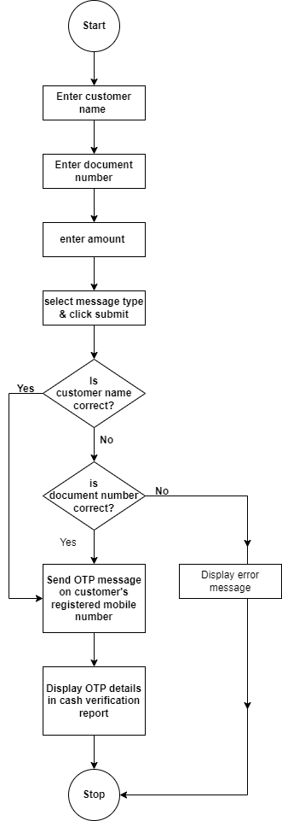

Fig: Flowchart Diagram

1. **DEVELOPED SYSTEM**

In Connect US, we have cash payment verification menu which has Generate OTP and cash payment report in it.

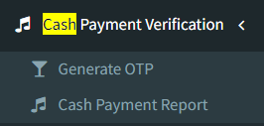

It has following fields:

* Customer Name
* Doc No.
* Amount
* Message Type
* Submit button
* Reset button
* From date
* Till date
* User
* Export report button
* Sr. No.
* Otp
* Generated by
* Generated on

Visibility of fields in menus:

|  |  |  |
| --- | --- | --- |
| **FIELDS** | **GENERATE OTP** | **CASH PAYMENT REPORT** |
| Customer name |  |  |
| Doc no. |  |  |
| Amount |  |  |
| Message type |  | * As OTP mode |
| Submit button |  |  |
| Reset button |  |  |
| From date | X |  |
| Till date | X |  |
| User | X |  |
| Export button | X |  |
| Sr. No. | X |  |
| OTP | X |  |
| Generated on | X |  |
| Generated by | X |  |

Through generate OTP menu, user have to enter either customer’s exact name or the document number from Padm so that OTP will get sent to the customer's registered mobile number.

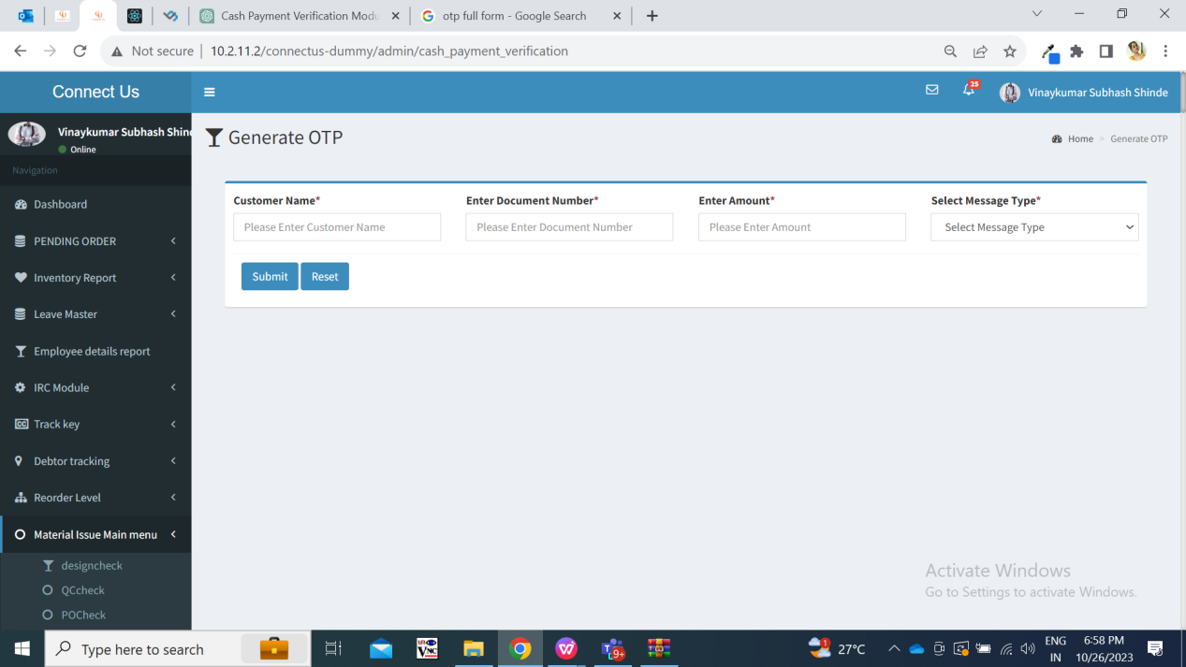

Fig: Generate OTP

**Input table**

|  |  |  |  |  |
| --- | --- | --- | --- | --- |
| **FIELDS** | **INPUT TYPE** | **MANDATORY/ OPTIONAL** | **EDITABLE** | **DESCRIPTION** |
| Customer name | Text | Mandatory | - | User will enter the customer name from padm -> documents -> name as per any bill.  Either customer name or document number, one of the field is mandatory.  If customer name doesn’t match with the name as in padm, then it will display message as “Please enter valid customer’s name.”  Validations: It will accept only characters and space. It will accept maximum length of 100 values. It will not be case sensitive. User will have to enter the exact name of the customer as in Padm system; including space. (Note:- Each customer’s name has mobile number registered to it.) |
| Document number | Text | Mandatory | - | User will enter the doc no. from Padm -> documents. (Note:- Each doc number will be having customer’s name and mobile number registered to it.)  Either customer name or document number, one of the field is mandatory.  If entered name doesn’t match with the customer’s name in padm, then it will sent the OTP on the number as per correct document number.  If entered Doc No. doesn’t match with the doc no. in padm, then display message as “Please enter valid Doc No.”  Validation: It will accept characters, numbers and hyphen. It will accept maximum length of 100 values. |
| Amount | Text | Mandatory | - | User will manually enter the amount as per cash payment that is being done by customer.  Validation: It will accept decimal values too. It accept only single decimal point . as special character.  It will not accept space or other special characters. |
| Message type | Drop down | Mandatory | - | It will be drop-down displaying SMS and Whats-App in the list.  If user selects SMS, then message will be sent via SMS to the customer on his registered mobile number (registered number as per entered customer’s name or as per entered Doc number). If user selects Whats-app as message type, then OTP will be sent via Whats-app to the customer on his registered mobile number.  If user has entered correct customer name but wrong doc number, then message will be sent to the registered number as per customer name.  If user has entered incorrect customer name (name which doesn’t exist in Padm) but correct doc number, then message will get sent to registered number as per document number.  If user has selected whats-app but if that number is not registered o whats-app then OTP will get sent in this case but customer won’t receive it.  If customer name and document number both are incorrect, then it will display error message.  Validation: It will be single select only. Initially it will display ‘select’ in the drop-down as default value. |
| Submit button | Click | - | - | Once user enters mandatory fields and clicks on submit , 5 digit numeric OTP will get sent on the registered customer’s number. Its template will be:  Dear {customer name}, Your OTP is {otp} for the amount Rs.## . Thank You Chandukaka Saraf & Sons Pvt Ltd.  If Whats-app number is mentioned in customer’s details, then customer will receive OTP via Whats-app.  (If registered number isn’t available for Whats-app and if still user has selected message type as Whats-app, then customer won’t receive OTP but it will get sent from the system.  Once OTP is sent then it will display message at top as “OTP sent successfully on registered number.”  The sent OTP will get reflected in report.  Validation: Once button is clicked, it will be disabled until successful / alert message is displayed. |
| Reset | click | - | - | Once yuser clicks on reset button, then page will reload and all pre-filled fields will get cleared so that user can re-enter the values in fields again.  Validation: it will be disabled until page gets reloaded. |

Further, once OTP is sent then it will be displayed in cash payment report. We can view report by dates and users who have generated the OTP for the customers.

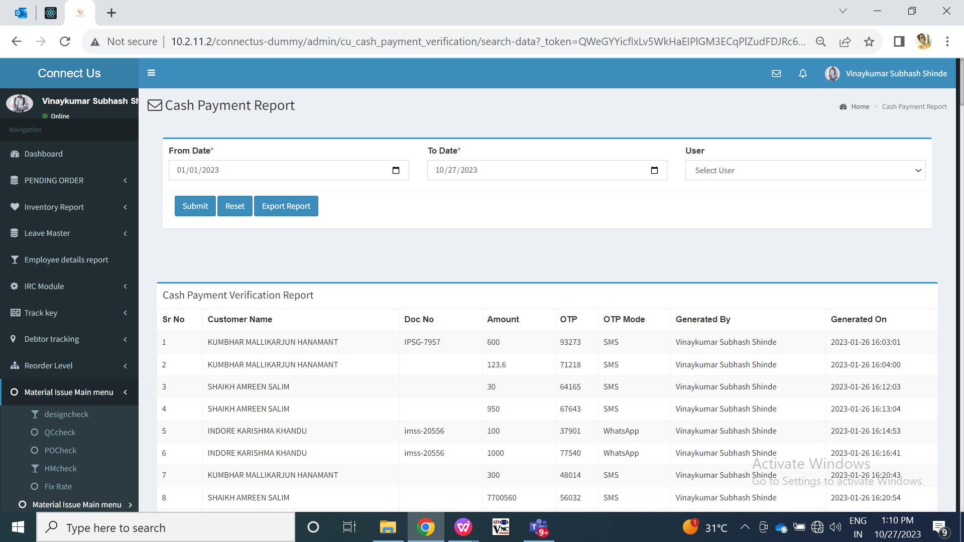

Fig: Cash payment report

|  |  |  |  |  |
| --- | --- | --- | --- | --- |
| **FIELDS** | **INPUT TYPE** | **MANDATORY/ OPTIONAL** | **EDITABLE** | **DESCRIPTION** |
| From date | Calender date picker | Mandatory | - | User will select the date from which OTP was generated by the users.  Validations: It will be single select. Future dates will be disabled. |
| Till date | Calender date picker | Mandatory | - | User will select the date till which OTP was generated by the users.  Validations: It will be single select. Future dates will be disabled. It will disabled dates h=which are prior to ‘from date’ as selected. |
| User | Drop down | Optional | - | User can get report by selecting the user / employee who generated the OTP.  Validation: Drop-down list displays active employees from employee master. It will be single select. |
| Submit | Click | - | - | Once user selects mandatory fields and clicks on submit, then it will display a report at below. Report will have following fields:   * Sr. No. * Customer Name * Doc No. * Amount * OTP * OTP mode * Generated By * Generated On   Report will be displayed between the selected dates and users if selected any. Also, export button will be displayed next to reset button after clicking on submit button. |
| OTP | Text | - | - | It will display the 5 digit OTP code which was generated against that document no. or customer name. |
| OTP mode | Text | - | - | It will display the message type I.e either SMS or whats-app to which the OTP was sent. |
| Generated by | Text | - | - | It will display the name of the employee / user who generated the OTP for that customer. |
| Generated on | Text | - | - | It will display the date and time when OTP was sent to the customer. |
| Export report | Click | - | - | Once user clicks on export button, then csv file will get downloaded displaying the same data as in grid. Downloaded file will have following fields:  Report will have following fields:   * Sr. No. * Customer Name * Doc No. * Amount * OTP * OTP mode * Generated By * Generated On |

1. **TEST DATA AND BUSINESS SCENARIOS**