17.10.2023

**USER MANUAL HANDOVER**

VMS MASTER DOCUMENT

Sanika Dewoolkar

Sanika.dewoolkar@techneai.com

MY GOAL - AUTHENTICATION CODE

MANALI ASHOK BHADIRAGE

Manali.bhadirage@techneai.com

**CONTENTS**

1. VERSION CONTROL 2

2. INTRODUCTION 2

3. SCOPE 2

4. BUSINESS & SYSTEM RULES 2

5. ABBREVIATIONS & TERMS 2

6. GRAPHICAL REPRESENTATION 3

7. DEVELOPED SYSTEM 3

8. TEST DATA AND BUSINESS SCENARIOS 19

1. **VERSION CONTROL**

|  |  |  |  |  |  |  |
| --- | --- | --- | --- | --- | --- | --- |
| **Sr. No.** | **Version no** | **Version Date** | **User name** | **User department** | **Updated By** | **Ticket ID** |
| **1** | **1.0** | **17/10/2023** |  |  | **Manali bhadirage** | **TT8086** |
|  |  |  |  |  |  |  |
|  |  |  |  |  |  |  |

1. **INTRODUCTION**

Users offer discount on bills to customers. This discount is enabled through promo code (connect us -> my goal -> promo code -> category master) . On My CS app, we have created option where employee will click on Category (Types) and get the generated promo code. Further this authorization code will be used by employees for billing purpose in Padm. They will enter this code in ‘Token Code” field of sales bill. Also, we have created reports in back-end about promo code and its details.

1. **SCOPE**

IN SCOPE: User will first create the category for one or more designations and then set limit for each designation against the created category. Further, users of that designation can view the categories in MY CS mobile app and generate unique promo code for it. Employees can generate promo-code up-to the limit that has been assigned to them by authorized user. Further, report of the generated promo-code will be generated.

OUT SCOPE: As users will be mentioning the generated in sales bill, the further usage of this promo-code will not be considered as part of our scope.

1. **BUSINESS & SYSTEM RULES**

* User should be registered in the system.
* User should be logged in.
* System should pop up a message, if any issues in the system is detected.
* If user has already generated promo-code then that can be revoked and will still be considered as one of the count for generation of that employee.

1. **ABBREVIATIONS & TERMS**

Token code - Authentication Code / Auth code / Discount code / Promo code

1. **GRAPHICAL REPRESENTATION**

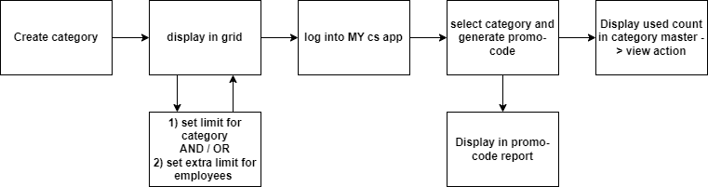

Fig: General context Diagram

1. **DEVELOPED SYSTEM**

**Step 1. Category Master**

User will have to first create the category. Category defines the type of discount that users wish to offer to customers. User will create the category and assign it to one or more designations. Also, user will set the maximum limit for each designation to create the auth code. Further, when employees log into mobile application, they will view the list of categories that have been assigned to them (as per logged in persons designation).

Category Master have following fields:

* Add Data (Button)
* Set limit
* Edit button
* View button
* Category Name
* Assigned to Designation
* Monthly limit
* Set extra limit
* Employee data
* Remark
* Is Active
* Save button
* Save & add more button
* Add button
* Back button
* Created at
* Created by
* Updated at
* Updated by

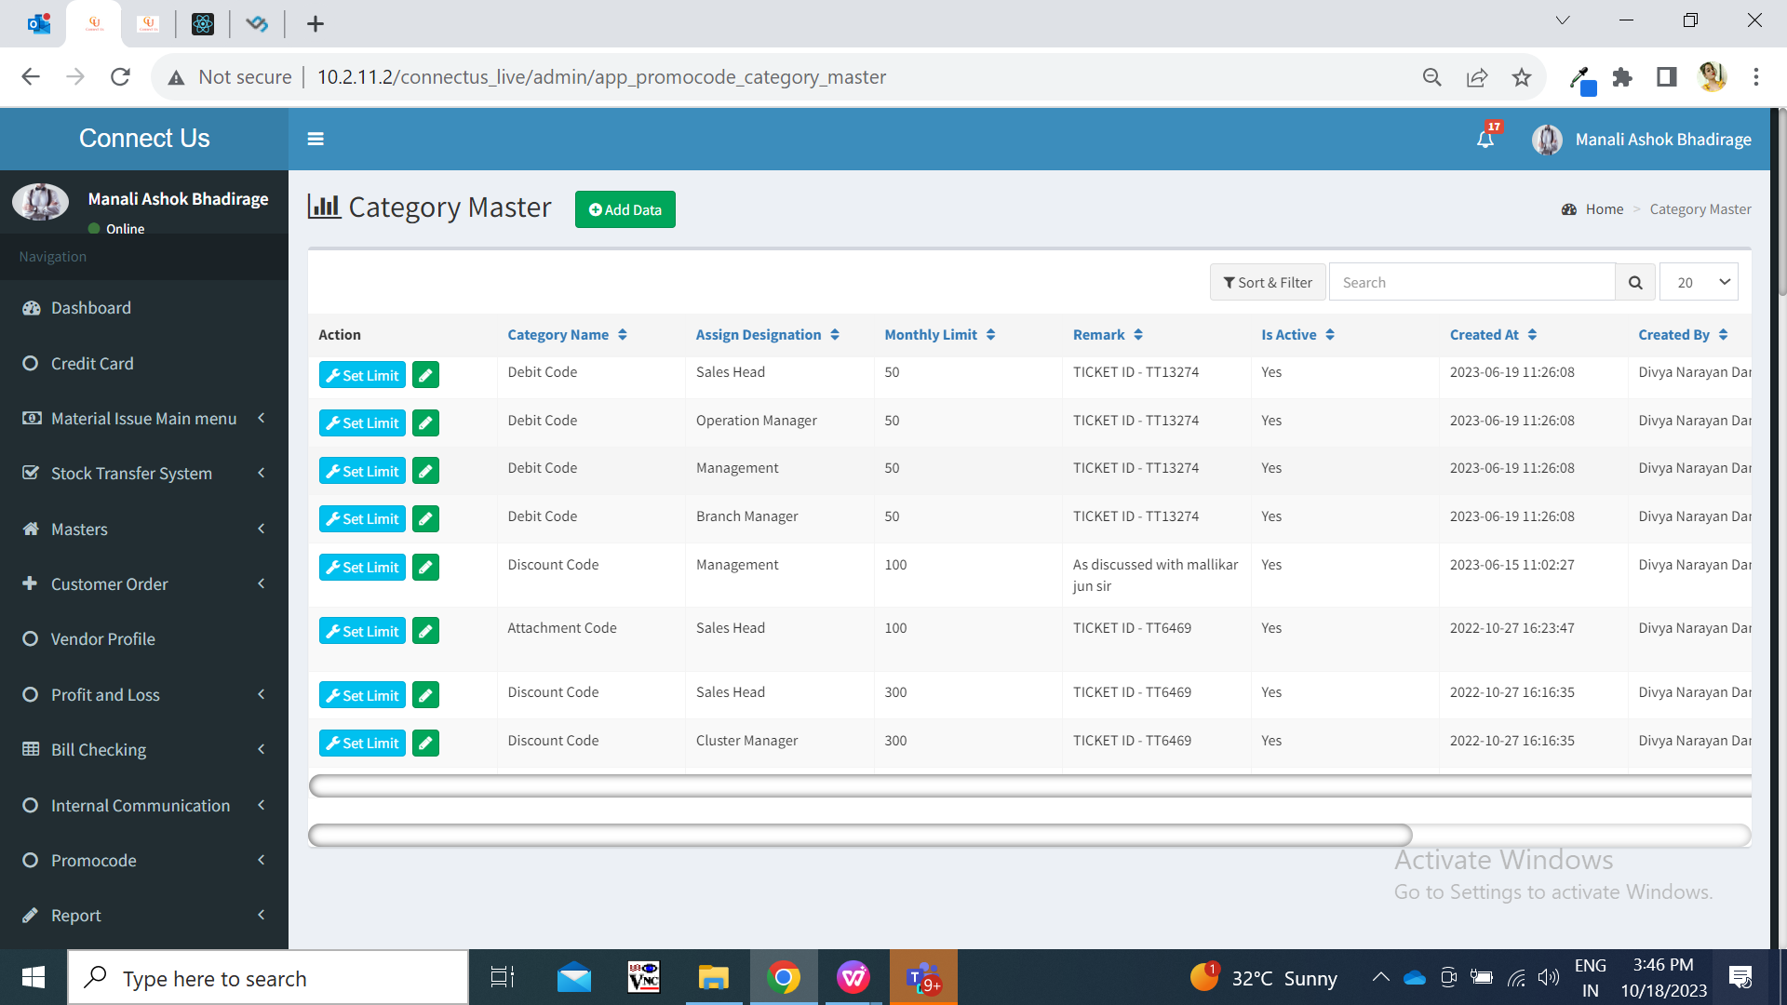

Fig: Category master grid

Visibility of fields in pages:

|  |  |  |  |  |  |
| --- | --- | --- | --- | --- | --- |
| **FIELDS** | **ADD** | **GRID** | **EDIT** | **VIEW** | **SET LIMIT** |
| Add button | **X** | **✓** | **X** | **X** | **✓** |
| Set limit button | **X** | **✓** | **X** | **X** | **X** |
| Edit button | **X** | **✓** | **X** | **X** | **X** |
| View button | **X** | **✓** | **X** | **X** | **X** |
| Category name | **✓** | **✓** | **✓** | **✓** | **✓** |
| Assign to designation | **✓** | **✓** | **✓** | **✓** | **✓** |
| Set monthly limit | **✓** | **✓** | **✓** | **✓** | **✓** |
| Set extra limit | **✓** | **X** | **X** | **X** | **✓** |
| Employee data | **X** | **X** | **X** | **✓** | **✓** |
| Is active | **✓** | **✓** | **✓** | **✓** | **X** |
| Remark | **✓** | **✓** | **✓** | **✓** | **X** |
| Save button | **✓** | **X** | **✓** | **X** | **✓** |
| Save & add more button | **✓** | **X** | **X** | **X** | **X** |
| Back button | **✓** | **X** | **✓** | **X** | **✓** |
| Created at | **X** | **✓** | **X** | **X** | **X** |
| Created by | **X** | **✓** | **X** | **X** | **X** |
| Updated at | **X** | **✓** | **X** | **X** | **X** |
| Updated by | **X** | **✓** | **X** | **X** | **X** |

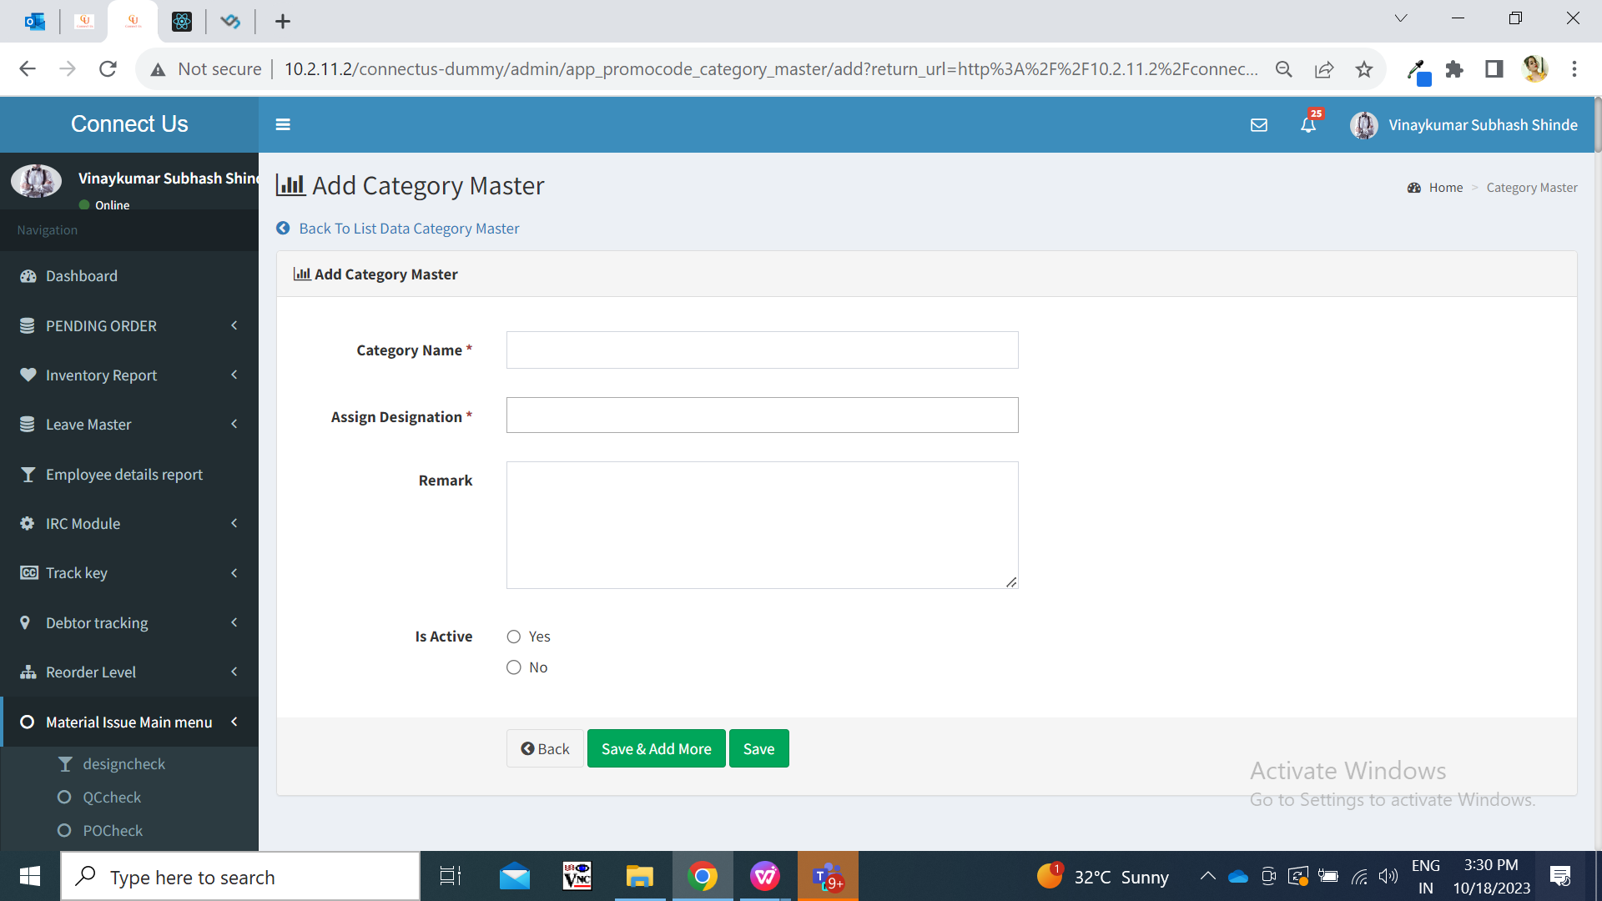

Fig: Add page

|  |  |  |  |  |
| --- | --- | --- | --- | --- |
| **FIELDS** | **INPUT TYPE** | **MANDATORY/ OPTIONAL** | **EDITABLE** | **DESCRIPTION** |
| Category name | Text | Mandatory | Yes | User will enter the name of the category.  This field will be editable in edit action however will be read only in set limit action.  Created category will be reflected in mobile application to the employees as per specified designations.  Validation: It will accept capital and small characters, numbers and space. Maximum 50 characters will be accepted. It will accept english / marathi both the languages. Category name will be unique. |
| Assign designation |  |  |  | This field specifies which designation should have provision to the created category.  Example: If user enters Debit code category name and selects two designations as branch manager and sales head. Then in grid, it will display two rows. One row of Debit code category for branch manager designation. One row of debit code category for sales head designation.  This field will be editable in edit action however will be read only in set limit action.  Validation: It will be multi select. It will display active designations from designation master. |
| Remark | Text | optional | yes | Remark field consists of input box which enables user to enter additional comments if any.  Validation: It accepts both capital and small characters, space and all special characters. Max 100 characters will be accepted. |
| Is active | Radio button | Mandatory | yes | Is Active field consists of two icons namely ‘Yes’ and ‘No’. If user clicks ‘Yes’, then this particular category will be displayed as active and this category will be displayed to employee in my cs App-> auth code for code generation. If user selects ‘No’, then this category won’t be displayed to employees on my cs App and subsequently will not be able to generate code under this category.  Validation: It will be single select. |
| Save button | Click | - | - | Once user fills the above details and clicks on save button, category will get added. Successful message will be displayed and user will be directed to grid page.  Once category is added, category will be displayed in top row of the grid and name of the creator and date & time will be displayed.  Validation: Once clicked, save button will be disabled until category gets created successfully or error message is displayed in case of incorrect inputs in fields. |
| Save & add more | Click | - | - | Once user fills the above details and clicks on save button, category will get added. Successful message will be displayed and user will remain on same page where all fields will be displayed again so that user can enter another details.  Once category is added, category will be displayed in top row of the grid and name of the creator and date & time will be displayed.  Validation: Once clicked, save & add more button will be disabled until category gets created successfully or error message is displayed in case of incorrect inputs in fields. |
| Back | Click | - | - | Once back button is clicked, all fields which might have been field will get cleared and category will not get added. Also user will be directed to the grid page.  Validation: Once back button is clicked, it will be disabled and user will be directed to the grid page. |
| Created at | Text | - | - | It will display the date and time when category was created by the user. |
| Created by | Text | - | - | It will display the employee name who created the category. |
| Updated at | Text | - | - | It will display the date and time when category was modified by the user either through edit action or set limit action. |
| Updated by | Text | - | - | It will display the employee name who updated the category. |

**Step 2. Set limit**

Once category is added, user will have to set limit to each designation. Employee should click on “Set limit” action against designation entry from grid.

User will set general limit for the designation by mentioning in set monthly limit field. Also, user can give extra limit to specific users of that designation.

Example: Once we set limit against designation of Operation Manager as “4” for Attachment code category. If operation manager designation has four employees as Mounika, Manali, Priyanka and Sanika. Then employees with operation manager designation will be able to generate code for 4 times for this particular Attachment code category. However, user can set extra limit for Manali and Mounika.

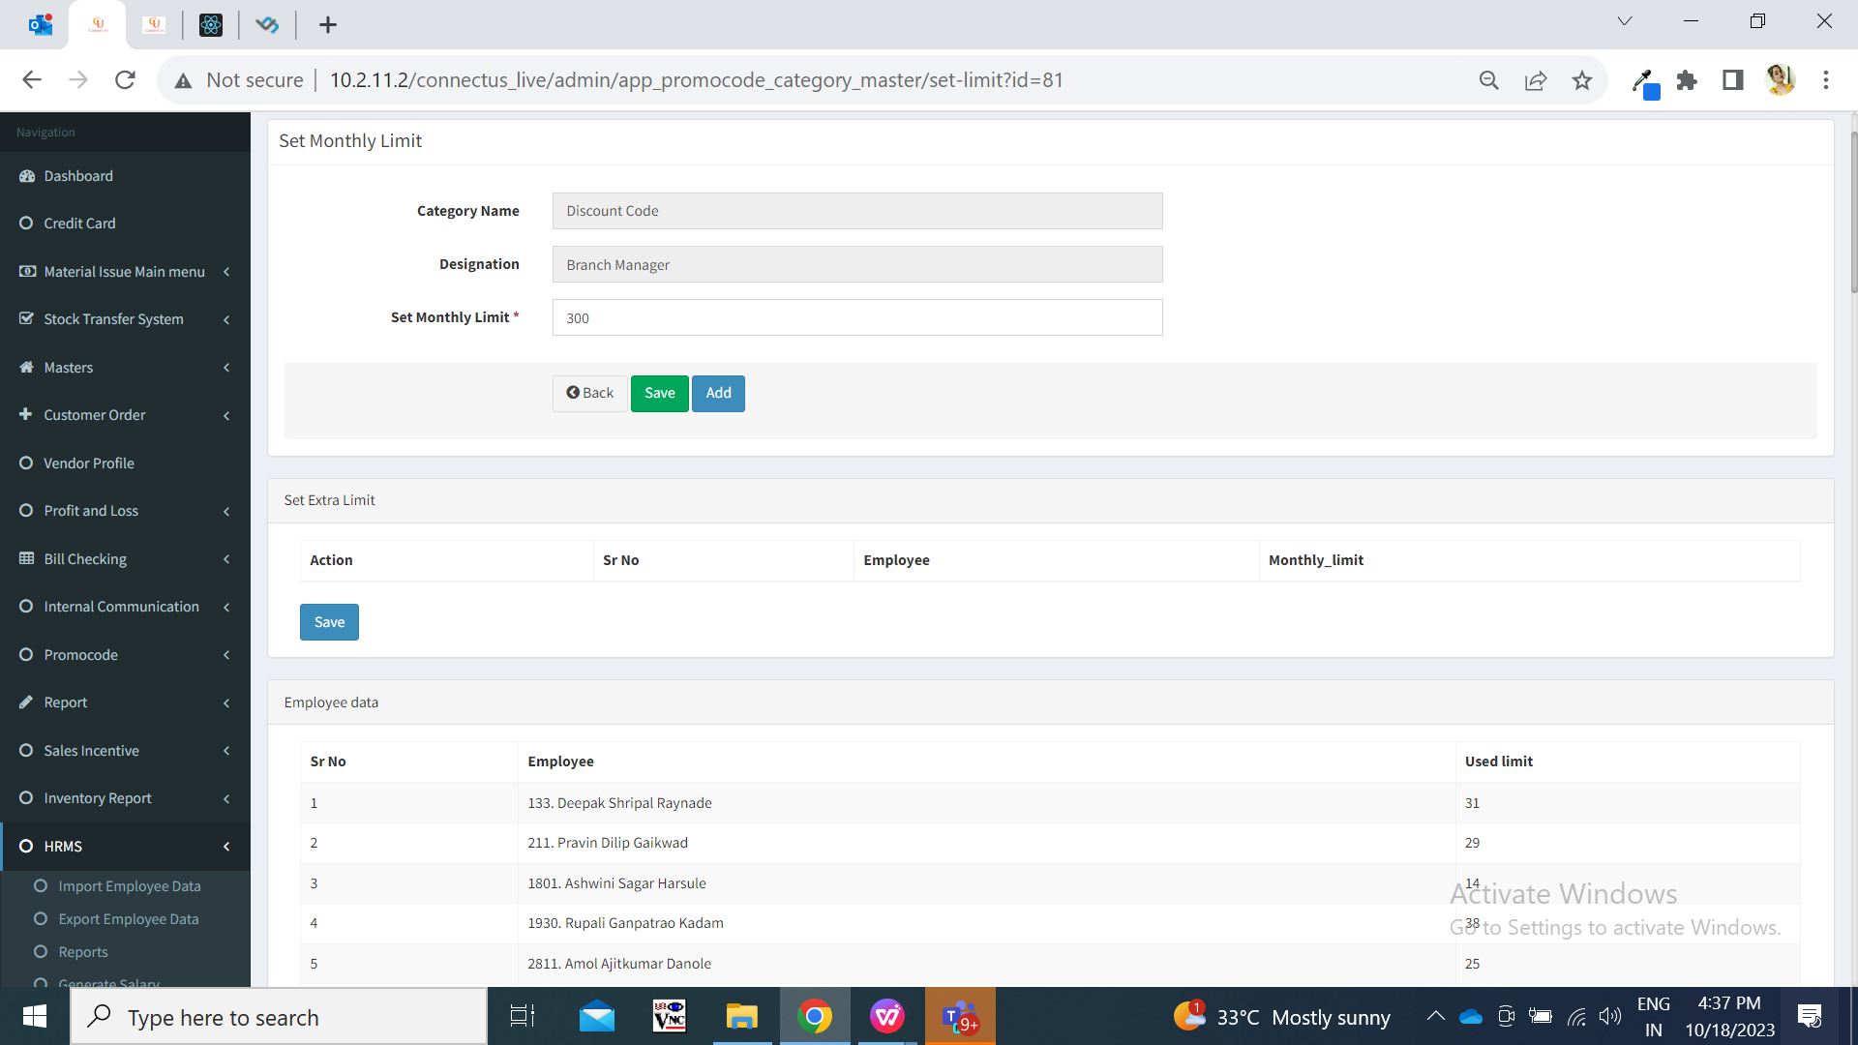

Fig: Set limit page

|  |  |  |  |  |
| --- | --- | --- | --- | --- |
| **FIELDS** | **INPUT TYPE** | **MANDATORY/ OPTIONAL** | **EDITABLE** | **DESCRIPTION** |
| Category name | Text | Mandatory | No | It will display the category name as it was added or edited.  Validation: This field will be editable in edit action however will be read only in set limit action. |
| Assign designation | Text | Mandatory | No | This field specifies which designation has provision to the created category.  Validation: This field will be editable in edit action however will be read only in set limit action. |
| Set monthly limit | Text | Mandatory | Yes | This will represent monthly limit for users in that selected designation for that particular category  User will enter the monthly limit for this category - designation.  Once the limit is set, then users of that designation will be able to generate promo code for that category with maximum times as set in this field.  Validation: It allows max 300th number only.  It won’t accept negative value, special characters, space, decimal value, characters. |
| Save | Click | - | - | Once user enters limit, user will have to click on ‘save button’ so that this limit will be saved & provided to employees of the mentioned designation. |
| Add | Click | Optional | - | If user wants to give some extra limit to specific employees of that designation then user will have to click on add button so that ‘set extra limit’ table will be displayed. Then following fields will be displayed below in ‘set extra limit’ table:   * Action * Sr. No. * Employee name * Monthly limit |
| Set extra limit : Employee | Drop down | Mandatory | Yes | User can set extra limit for each employee here. User will select the name of the employee to whom user wants to give extra limit.  This field will be editable in set limit action only.  Validation: it will be multi select. It will display active employees only out of that designation which is mentioned in assigned designation. One employee can be selected only once for the same specific category - designation. (If employee is already selected and available in the employee data table, then that employee will be disabled from the drop-down list here) |
| Set extra limit : monthly limit | Text | Mandatory | Yes | As per selected employee(s), user will set the extra limit for them.  This field will be editable in set limit action only.  When we set monthly extra limit for any particular employee, then they will have general limit which is set above as well the have extra limit in addition to it as set in monthly limit field.  Example: For designation php laravel developer, general limit is 2 and for Baliram extra limit is 4. That means, Baliram will be able to generated code for total 6 (2 + 4) times.  Validation: Allow limit up to max 300th number only. It won’t accept negative value, special characters, space, decimal value, characters.  Note: Limit for specific user wise will be as entered in “extra limit” field, however limit for the rest of the general users of that designation will be as per the limit entered in “Set monthly limit” field above the table. |
| Set extra limit: save button | Click | - | - | If any details are mentioned in set extra limit table and user clicks on save button, then it will be displayed in employee data as well as those employees will have extra limit for generating promo code. |
| Employee data | Text | - | - | It will display the count of promo codes generated I.e used limit by each employee for that category.  This table will be displayed in view action as well. |

**Step 3. Generate promo code**

Once employee logs into MY CS mobile app, categories assigned to his designations will be displayed in authentication code tab.

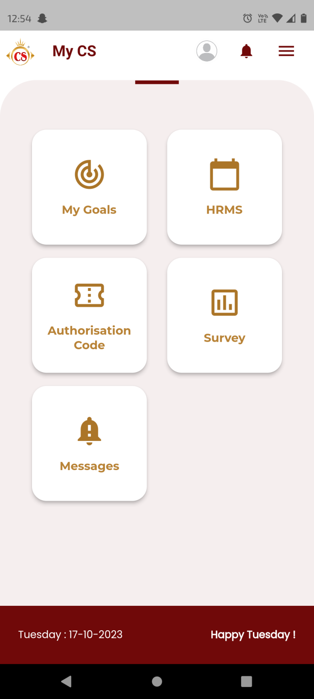

Fig: MY CS App - home screen page

Once user clicks on authentication code tab, it will display following fields:

* Category
* Generate code

|  |  |  |  |  |
| --- | --- | --- | --- | --- |
| **FIELDS** | **INPUT TYPE** | **MANDATORY/ OPTIONAL** | **EDITABLE** | **DESCRIPTION** |
| Category | Drop-down | Mandatory | No | It will display the list of categories that are been assigned to logged in person’s designation through category master.  Validation: It will be single select. Only active categories from category master will be displayed here. |
| Generate code | Click | - | - | Once employee taps on generate button pop-up message will appear asking employee to confirm for generation of code.  Once employee clicks yes, Auth code will be generated and category name will be displayed.  Auth code format is kept such that it has 7 digits. Each time unique auth code will be generated. First digit refers to the category number and later 6 digits will be unique each time.  This generated code will be entered by employees in Padm bills in the field named as “Token Code”. This generated promo-code will also get displayed in promo-code report.  Please note that, if employee has used all his limit for generating code for that particular category, then once again if he clicks to generate code it will display message “Your monthly limit has exceeded”.  Likewise user can generate promo code for each category which are in the drop-down list of the logged in person. Please note that, each user may have different limit to generate promo-code.  Validation: Once promo code can be generated only once. It will be displayed in pop-up message. User cannot review the already generated promo code. |

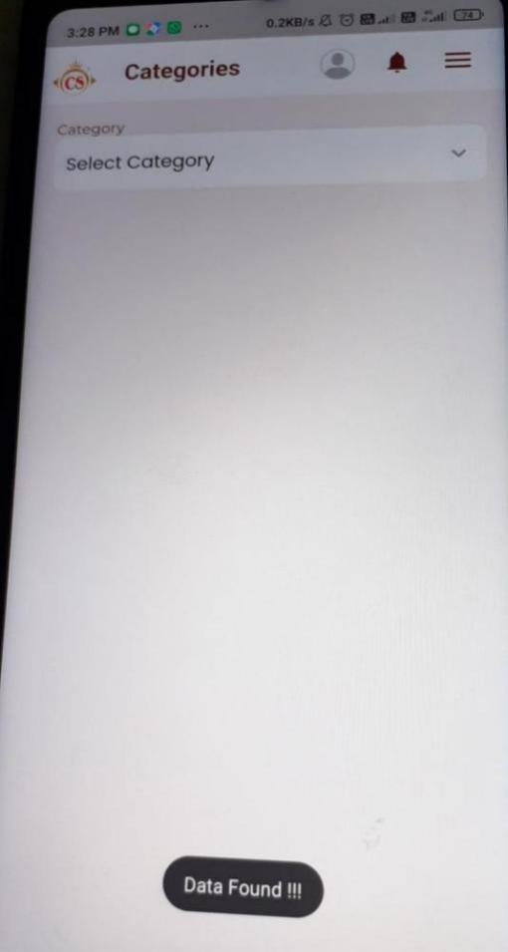

Fig: list of categories

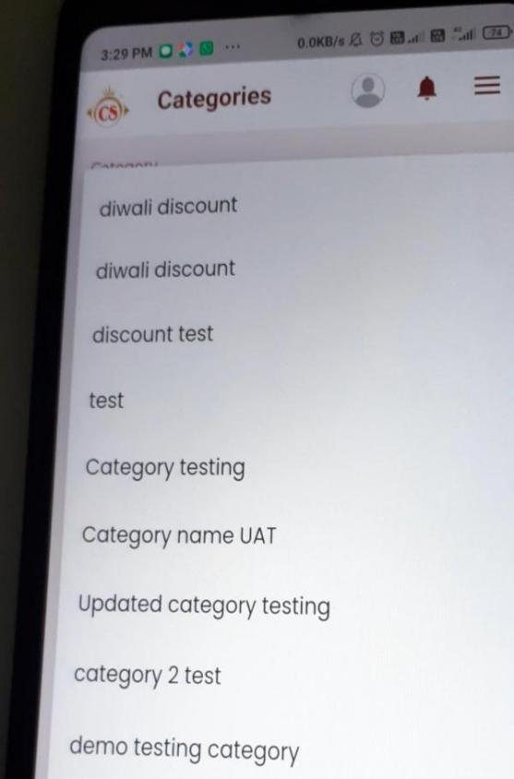

**Step 4. Promo-code Report**

Once promo-codes are generated by the employees, it will be displayed in promo-code report. It will have following fields:

* From date
* To date
* Designation
* Employee
* Reset button
* Submit button
* Export button
* Sr no.
* Date
* Time
* Promo-code
* Category
* Designation
* Employee

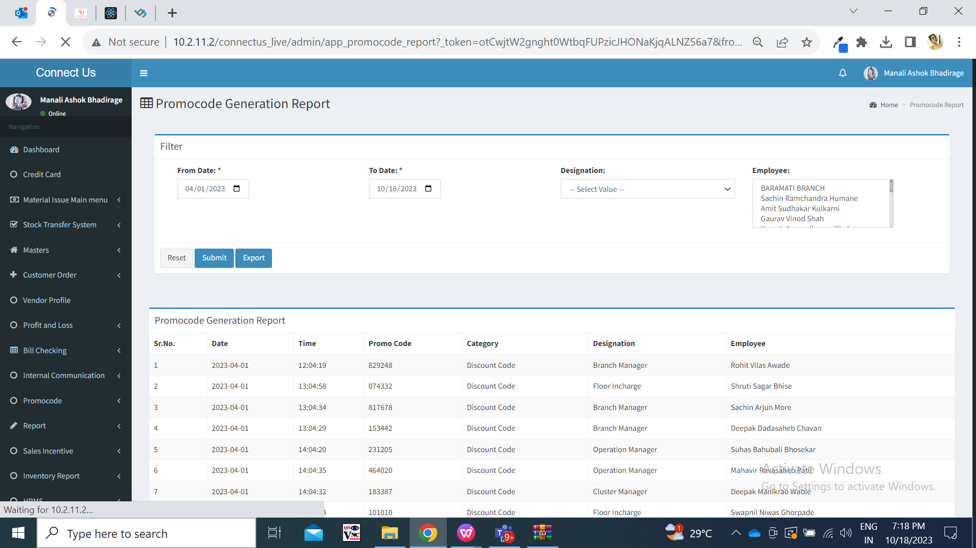

Fig: Promo-code report

|  |  |  |  |  |
| --- | --- | --- | --- | --- |
| **FIELDS** | **INPUT TYPE** | **MANDATORY/ OPTIONAL** | **EDITABLE** | **DESCRIPTION** |
| From Date | Calender date picker | Mandatory | - | User will select the date from which code was generated.  Validation: Future dates will be disabled. Only one date can be selected at a time. |
| To Date | Calender date picker | Mandatory | - | User will select the date till which code was generated by the employees.  Validation: Future dates will be disabled. Only one date can be selected at a time. |
| Designation | Drop down | Optional | - | User will select the designations who have created the promo-code.  Validation: it will be single select. It will display active designations from designation master. If designation is not selected, then report will display the list of employees of all designations who have generated the promo-code. |
| Employee | Drop down | Optional | - | User will select the list of employees who have generated the promo code and thus have to view report of them.  Validation: it will be multi select. It will display active employees from employee master. If employee is not selected, then report will display the list of employees who have generated the promo-code. |
| Reset button | Click | - | - | Once user clicks on reset button, then page will get reloaded and all pre-filled fields in filter will get reset if any. |
| Submit | Click | - | - | Once user selects dates and other filters and clicks on submit, then export button will be displayed next to submit button and promo-code report will be displayed below. It will have following columns:   * Sr no. * Date * Time * Promo-code * Category * Designation * Employee |
| Export | Click | - | - | Once user clicks on export button, then it will export grid data in excel which will have following columns:   * Sr no. * Date * Time * Promo-code * Category * Designation * Employee |

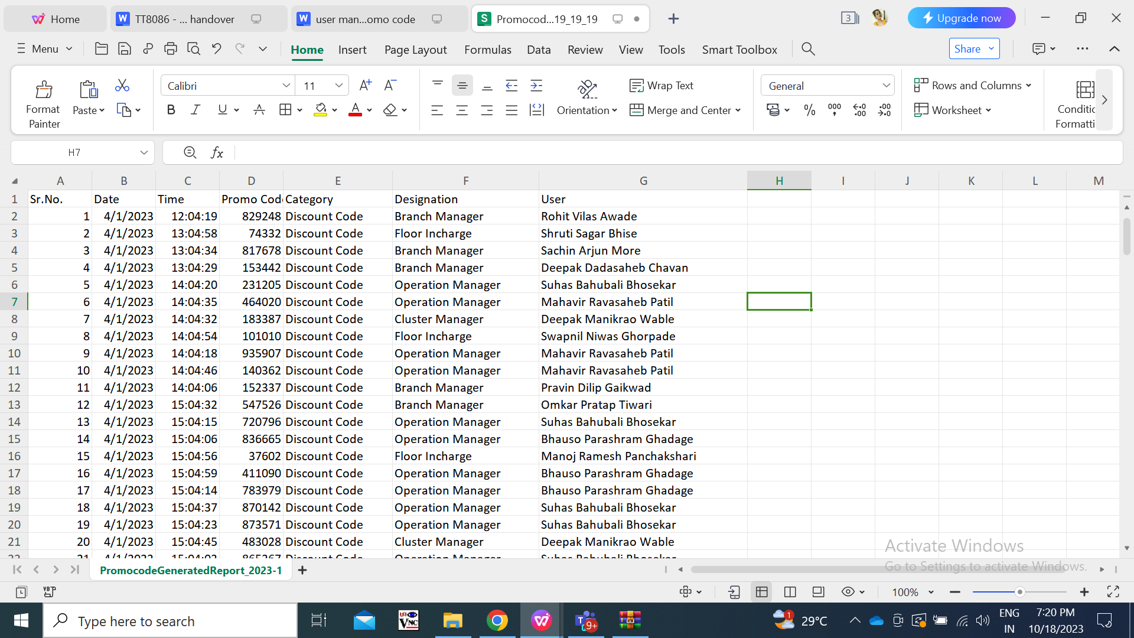

Fig: Export promo-code report

1. **TEST DATA AND BUSINESS SCENARIOS**