01.11.2023

**USER MANUAL HANDOVER**

VMS MASTER DOCUMENT

Sanika Dewoolkar

Sanika.dewoolkar@techneai.com

DIVINE DONOR

Manali ashok bhadirage

Manali.bhadirage@techneai.com

**CONTENTS**

[1. VERSION CONTROL 2](#_Toc16128)

[2. INTRODUCTION 2](#_Toc9277)

[3. SCOPE 2](#_Toc12293)

[4. BUSINESS & SYSTEM RULES 3](#_Toc32418)

[5. ABBREVIATIONS & TERMS 3](#_Toc3998)

[6. GRAPHICAL REPRESENTATION 3](#_Toc11812)

[7. DEVELOPED SYSTEM 4](#_Toc17997)

[8. TEST DATA AND BUSINESS SCENARIOS 80](#_Toc10769)

1. **VERSION CONTROL**

|  |  |  |  |  |  |  |
| --- | --- | --- | --- | --- | --- | --- |
| **Sr. No** | **Version no** | **Version Date** | **User name** | **User department** | **Updated By** | **Ticket ID** |
| **1** | **1.0** | **01/11/2023** | **Gaurav Shah** | **Project Head** | **Manali Bhadirage** | **TT13090** |
|  |  |  |  |  |  |  |
|  |  |  |  |  |  |  |

1. **INTRODUCTION**

'Divine Donor' is a digital donation application to uncomplicate the donation process, help charities expand their support networks and make the app “the most thoughtful place on your mobile.” Through our donation app, user can safely and simply make donations under different organizations and tenants, share meaningful thoughts with the people they care and match words with good deeds by supporting each other’s favorite charities. It has provision to add multiple users & its organizations, to process donations and get reports of each donation type by just one click.

Through web application, super admin will add tenant first and then through mobile application, each tenant will be able to login & add their own users and organizations. Added organizations and users will be reflected in masters of web app as well as in report of mobile app. User will be mapped against organization and then user will able to fill donation details in the form. Added / processed donations will be reflected in mobile app report as well as web app report to that tenant.

1. **SCOPE**

IN SCOPE: Initially, super-admin will add the tenant in web then tenant will be able to log into web and mobile app using the credentials provided by super-admin. Tenant can change the profile details through mobile app and web app after logging in. Now, tenant admin will have to add donation types and payment methods through web so that they will be reflected to users while making donations. Tenant admin will log into mobile app and add organization and then add users. While adding user, tenant will map the user with one or more organization considering that one user can work in multiple organizations of their trust. Further, once organization and user is added, it will be displayed in web as well as reports to tenant admin and super-admin. Tenant can edit the details of the organization and user from reports. Furthermore, once user is added, user can log into mobile app and add donation details of the donor. Donation details will be displayed in reports once done successfully. Also, the receipt will be sent to the donor on whats-app about donation.

User can also export donation details and set reminders for donors I.e. message will be sent to donors 3 days prior to their date of birth. Data of each tenant varies and hence tenants shouldn’t be able to view any details of each other. Also, one donor can be added by multiple tenants. Moreover, in future days, application will be scale-able enough to have additional forms as per tenant’s requirements.

OUT SCOPE: As users will be only filling the donation form, the payment gateway is not part of this project. Through mobile app, user can only add donation details after donation is done by donor by cash or cheque or online.

1. **BUSINESS & SYSTEM RULES**

* System will pop up a message, if any issues in the system is detected.
* All forms will have on field validations. System will display on field errors in case of incorrect inputs.
* Divine donor app doesn’t have any integration with another app / software or payment gateway.
* User use donations forms after the payment is done by the donor. Donation form is not used to initiate payment online, however it used to maintain the record of already made donations by the donor. Once donor pays donation by cash / cheque / upi online, then user adds that donation in donation form that means marks record of the made donation.

1. **ABBREVIATIONS & TERMS**

DOB - Date of birth

UPI - Unified Payment Interface

1. **GRAPHICAL REPRESENTATION**

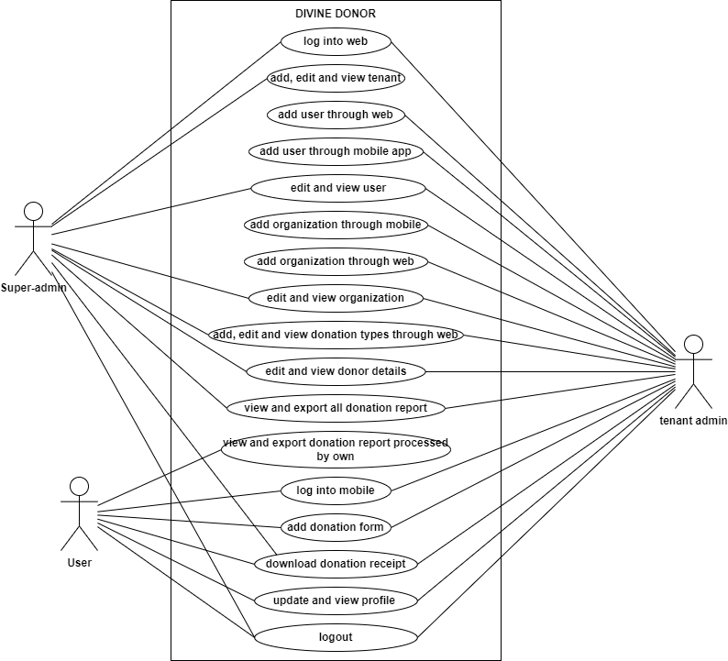

Fig: Use case diagram

1. **DEVELOPED SYSTEM**

Step 1. Once super-admin logs into web app, it will display following fields in tenant master:

* Add button
* Export button
* View button
* Edit button
* Tenant name
* Email
* Password
* Contact number
* Remark
* Profile image
* Is Active
* Back button
* Save & add more button
* Save button
* Created at
* Created by
* Updated at
* Updated by

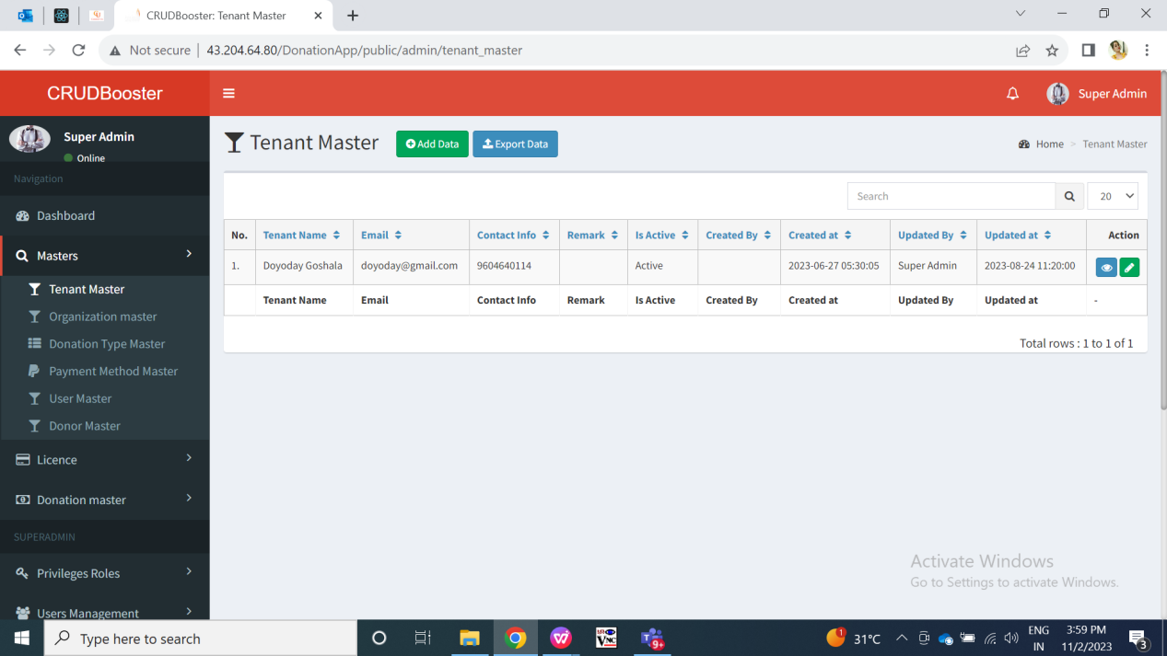

Fig: Tenant Master -> grid

Visibility of fields in functions:

|  |  |  |  |  |  |
| --- | --- | --- | --- | --- | --- |
| **FIELDS** | **ADD** | **GRID** | **VIEW** | **EDIT** | **EXPORT DATA** |
| Add button | **X** |  | **X** | **X** | **X** |
| Export button | **X** |  | **X** | **X** | **X** |
| View button | **X** |  | **X** | **X** | **X** |
| Edit button | **X** |  | **X** | **X** | **X** |
| Tenant name |  |  |  |  |  |
| Email |  |  |  |  |  |
| Password |  |  |  |  |  |
| Contact number |  |  |  |  |  |
| Remark |  |  |  |  |  |
| Profile image |  | X |  |  |  |
| Delete button | X | X | X |  | X |
| Is Active |  |  |  |  |  |
| Back button |  | X | X |  | X |
| Save & add more button |  | X | X | X | X |
| Save button |  | X | X |  | X |
| Created at | **X** |  |  | **X** |  |
| Created by | **X** |  |  | **X** |  |
| Updated at | **X** |  |  | **X** |  |
| Updated by | **X** |  |  | **X** |  |

**Input table**

|  |  |  |  |  |
| --- | --- | --- | --- | --- |
| **FIELDS** | **INPUT TYPE** | **MANDATORY/ OPTIONAL** | **EDITABLE** | **DESCRIPTION** |
| Tenant name | Text | Mandatory | Yes | Super-admin will mention the name of the tenant which is to be added.  Once super-admin enters tenant name, other fields and submits the form then the tenant will get added. And, added details and its tenant name will be displayed in top row of grid view of tenant master page. Also, this will be displayed in view action of the added tenant. This tenant name will be visible to tenant admin in mobile app and web app once he/she logs in.  Validation:- It will be unique name. It will accept maximum 50 characters. It will accept characters, numbers and space. It shouldn’t accept double space after one word. |
| Email address | Text | Mandatory | Yes | Super-admin will mention the email address of the tenant.  Once super admin / admin enters email, other fields and submits the form then the tenant will get added. And, added details and its email will be displayed in top row of grid view of tenant master page. Also, this will be displayed in view action of the added tenant. This email address will be visible to tenant admin in mobile app and web app once he/she logs in.  Further, once tenant is added then tenant can log into web app and mobile app using this email address as username.  Validation:- It will be unique. It will accept maximum 50 characters. It will accept characters, number. It will not accept space. It will accept @ . \_ and - special characters only. |
| Password | Text | Mandatory | Yes | Super-admin will enter the password of the tenant initially whereas tenant admin himself can update this password through their profile.  Password field will be blank in edit action to maintain privacy.  Once super-admin enters tenant password, other fields and submits the form then the tenant will get added. And, added details will be displayed in top row of grid view of tenant master page. Also, details will be displayed in view action of the added tenant where password field will be kept blank.  Added tenant will be able to log into mobile app and will be app using the password set here.  Validation:- Minimum length will be 6 digits. It will accept characters, numbers, special characters. It shouldn’t accept space. |
| Contact Number | Text | Mandatory | Yes | Super-admin will mention the contact number of the tenant.  Once super-admin enters contact number, other fields and submits the form then the tenant will get added. And, added details and its email will be displayed in top row of grid view of tenant master page. Also, this will be displayed in view action of the added tenant.  Validation:- It will be unique. It will accept maximum 10 characters. It will accept only numbers. It shouldn’t accept space / special characters / characters. It shouldn’t accept ten consecutive zeros or ten consecutive one. It will accept only 9 or 8 or 7 or 6 at the beginning. |
| Remark | Text | Optional | Yes | Super-admin will mention the additional details of the tenant if any.  Once super admin enters remark, other fields and submits the form then the tenant will get added. And, added details and its remark will be displayed in view action of the added tenant.  Validation:- It will accept maximum 250 characters. It will accept English and Marathi language. It will accept characters, numbers, special characters and space. It shouldn’t accept double space after one word. |
| Profile image | Attach / upload | Mandatory | Yes | Super-admin will be attaching the photo of the tenant logo or other. This profile image will be displayed to the tenant admin in his profile once he logs into mobile app and web app.  Tenant can change his profile image from mobile app and web app through profile menu. This profile image will also be displayed to the users login on add donation page.  Initially this field will be blank and will display as no file chosen. Further when super-admin attached one image, then it will display the file name in this field.  Once super-admin uploads image from the system, other fields and submits the form then the name of the attached image will be displayed in this field. Once user submits the form, then tenant will get added and this image will be displayed in edit action, view action as well.  Validation:- It will accept single image. It will accept jpg, jpeg, png, pdf, heic and webp extension image files only. |
| Profile image : delete action | Click | Optional | - | In edit action, super admin will have delete action below the profile image if any image is already added here.  Through delete button, super-admin can delete the already attached profile image of the tenant and then can upload another image.  Validation: Delete button will not be displayed if there is no attachment in profile image field. |
| Is active | Radio button | Mandatory | Yes | By default, it will select “Yes” option.  Once super-admin submits the tenant form, then tenant will get added and its status as active yes / no will be displayed in grid as well as in view action of tenant. Whereas, only active tenant and its users will be able to log into mobile app and web app.  Validation:- Both radio buttons shouldn’t get clicked at a time. |
| Save | Click | - | - | Once super-admin fills all mandatory fields in form, clicks on ‘save’ button then the successful message will be displayed, tenant will get added and will be displayed in grid view. And, super-admin will be directed on grid page where recently added tenant will be displayed on top. Further, active tenant will be able to log into mobile app and web app and perform provided action on available menus.  Validation:- Button will get disabled once clicked until the successful pop-up message gets displayed. |
| Save & add more | Click | - | - | Once super-admin fills all mandatory fields in form, clicks on ‘save’ button then the successful message will be displayed, tenant will get added and will be displayed in grid view. And, super-admin will remain on the same page of add form to add another tenant. Further, active tenant will be able to log into mobile app and web app and perform provided action on available menus.  Validation:- Button will get disabled once clicked until the successful pop-up message gets displayed. |
| Back | Click | - | No | Through back button, super-admin will go to grid page and tenant will not got added.  Validation: Back button will be disabled until all pre-filled field will get clear and super-admin is redirected to grid page. |
| Created at | Text | - | No | It will display the name of the user who created the tenant I.e. it will super-admin here.  Validation: it will be read only. |
| Created by | Text | - | - | It will display the date and time when super-admin created the tenant.  Validation: it will be read only. |
| Updated at | Text | - | - | It will display the name of the user who modified the tenant details I.e. it will super-admin here.  Validation: it will be read only. |
| Updated by | Text | - | - | It will display the date and time when super-admin edited the tenant details.  Validation: it will be read only. |

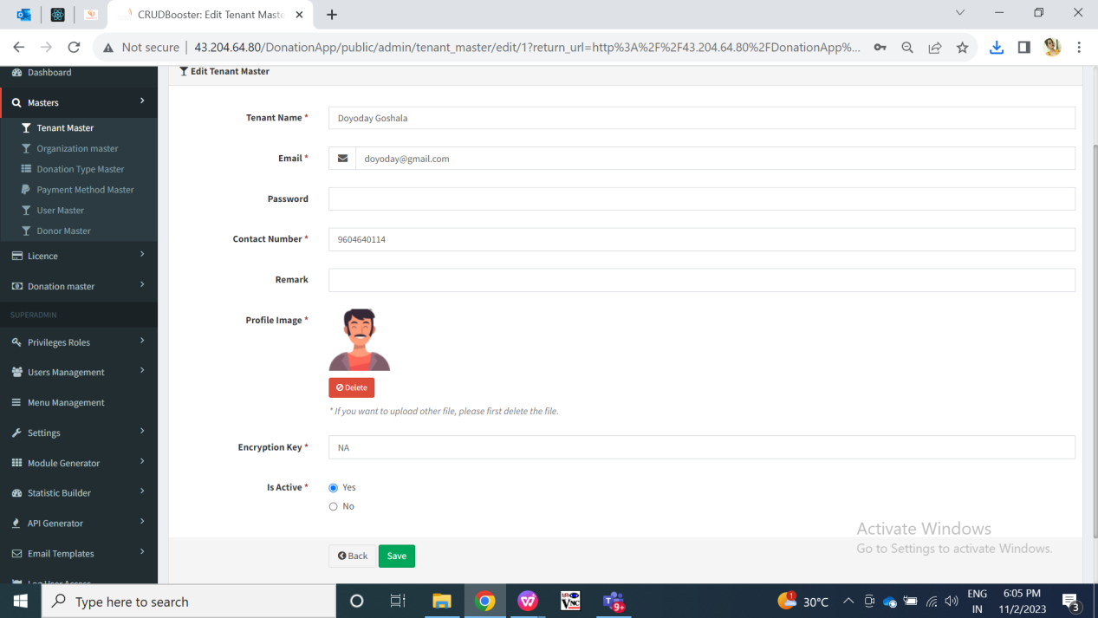

Fig: Edit tenant

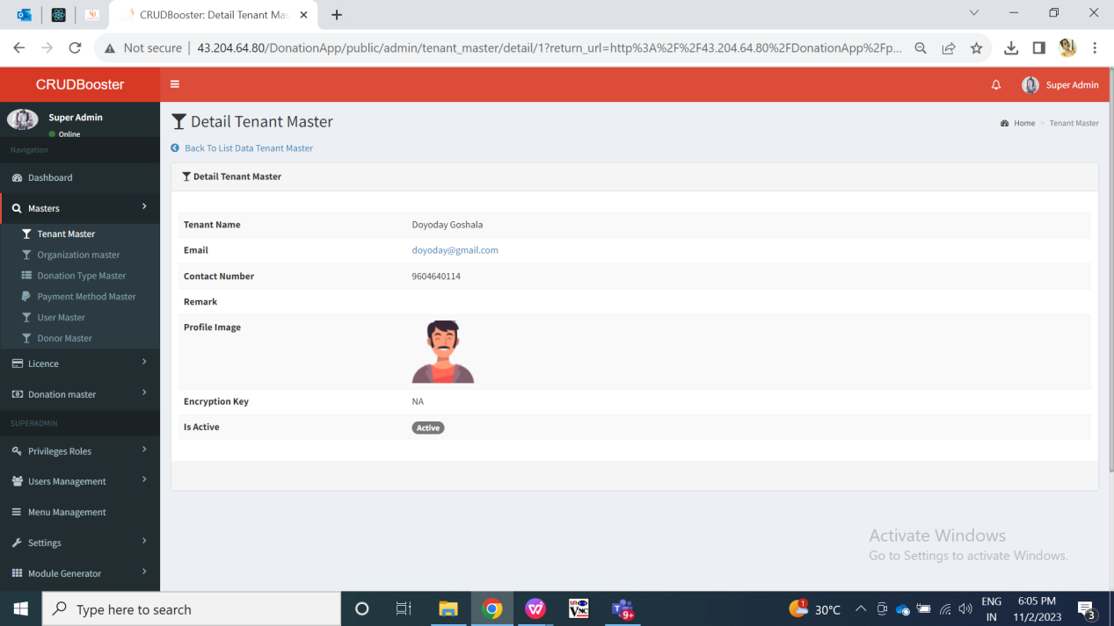

Fig: view tenant

Through export data button, super-admin can all data downloaded in pdf, csv and excel file as in grid with all details of each tenant. File for reference is attached below:



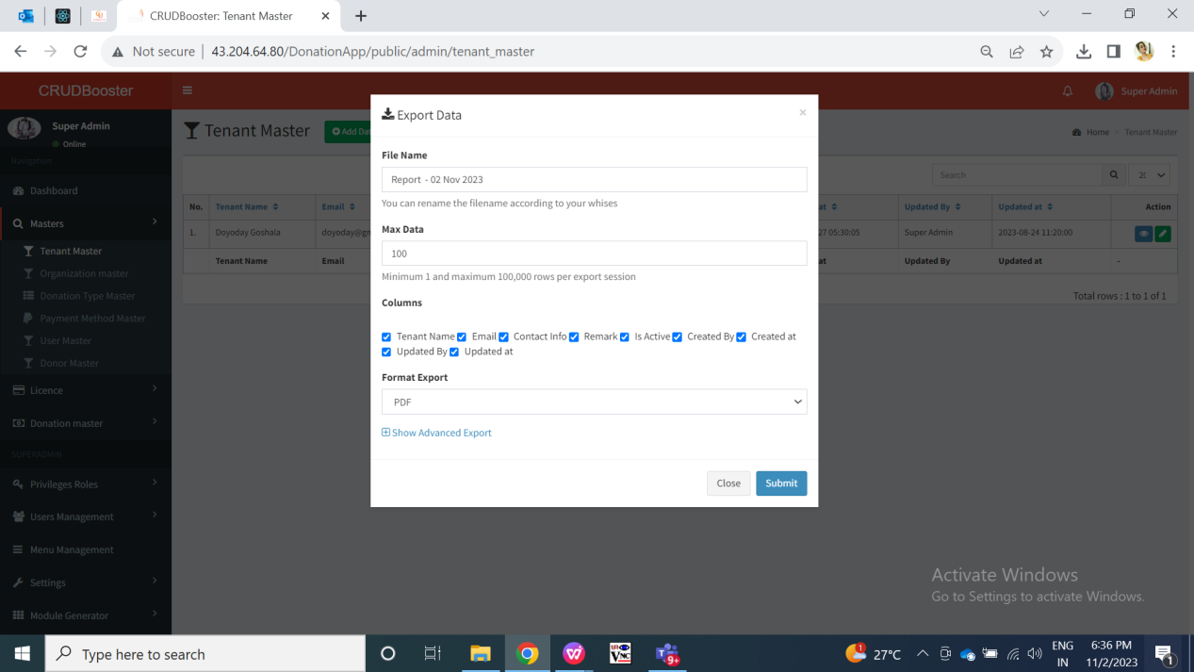

Fig: export tenant master

Once tenant is added, then tenant will be able to log into web application using his credentials. Tenant will have access only to his own data. Following menus will be displayed to tenant in web app:

* Dashboard
* Organization master
* User master
* Donation type master
* Donor master
* Donation master -donation report

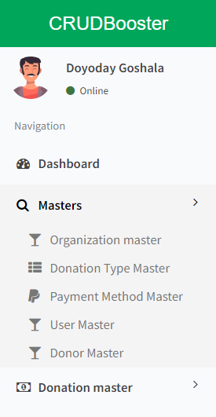

Fig: Menu for tenant in web

Step 2. Once Tenant logs into the mobile application or web application using his email and password, he can add organization through organization master in web and Add -> add organization menu in mobile app.

Tenant can edit and view organization details through reports -> organizations in mobile app. Whereas tenant can edit and view organization details by edit and view action in organization master in web app. Once tenant adds and/or edits details of the organization through web app, it will be displayed in mobile app as well and vice versa.

Organization master in web will have following fields:

* Add data button
* Export data button
* Edit button
* View button
* Tenant name
* Organization name
* Organization Address 1
* Organization address 2
* Whats-app no.
* PAN no.
* GST no.
* 80G no.
* Is active
* Remark
* Save button
* Save & add more button
* Back button
* Created at
* Created by
* Updated at
* Updated by

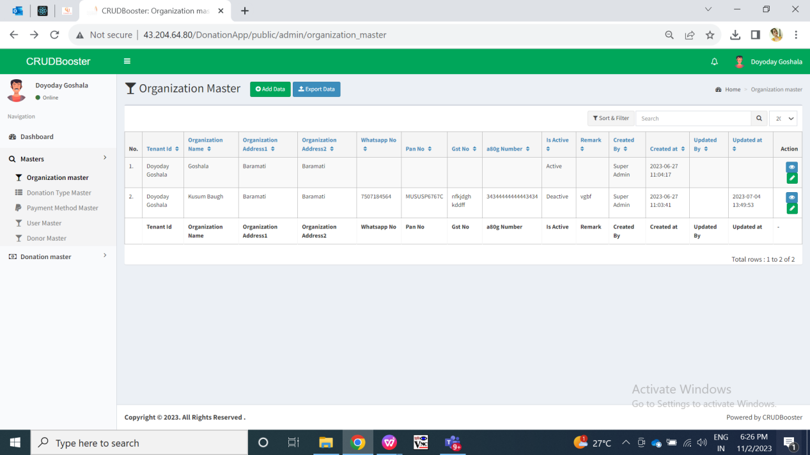

Fig: Organization master - grid

Visibility of fields in function point pages through web for organization:

|  |  |  |  |  |  |
| --- | --- | --- | --- | --- | --- |
| **FIELDS** | **ADD** | **GRID** | **VIEW** | **EDIT** | **EXPORT DATA** |
| Add data button | **X** |  | **X** | **X** | **X** |
| Export data button | **X** |  | **X** | **X** | **X** |
| Edit button | **X** |  | **X** | **X** | **X** |
| View button | **X** |  | **X** | **X** | **X** |
| Tenant name | X |  |  | X |  |
| Organization name |  |  |  |  |  |
| Organization Address 1 |  |  |  |  |  |
| Organization address 2 |  | X |  |  |  |
| Whats-app no. |  |  |  |  |  |
| PAN no. |  |  |  |  |  |
| GST no. |  |  |  |  |  |
| 80G no. |  |  |  |  |  |
| Is active |  |  |  |  |  |
| Remark |  | X | X |  | X |
| Save button |  | X | X |  | X |
| Save & add more button |  | X | X | X | X |
| Back button |  | X | X |  | X |
| Created at | **X** |  |  | **X** |  |
| Created by | **X** |  |  | **X** |  |
| Updated at | **X** |  |  | **X** |  |
| Updated by | **X** |  |  | **X** |  |

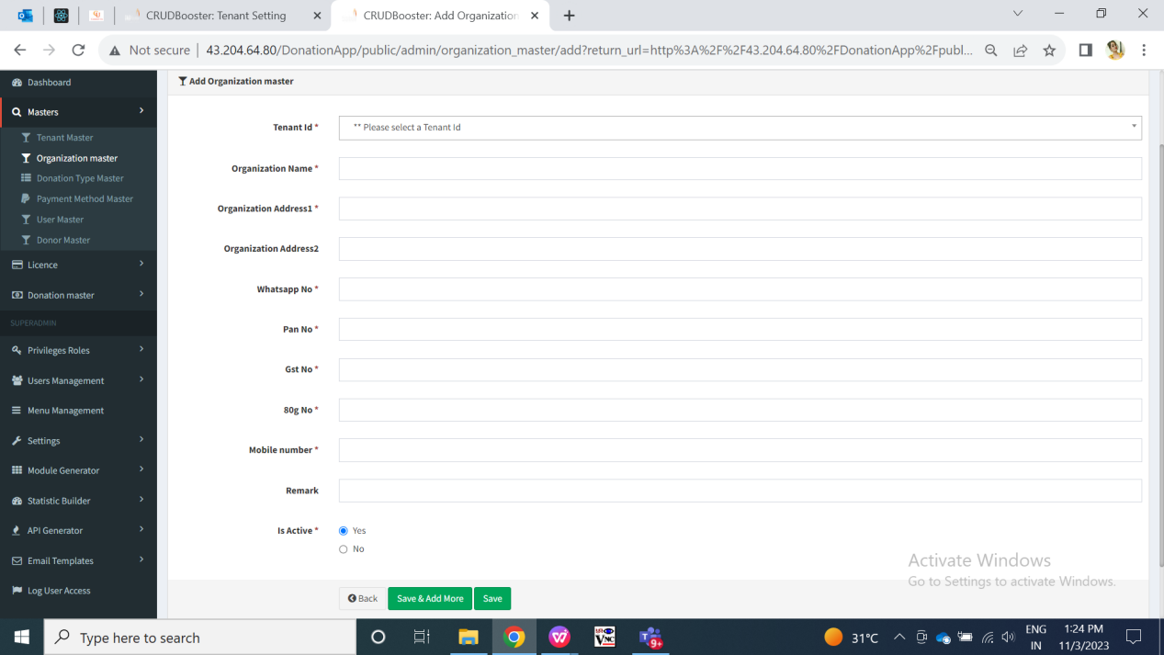

Fig: Add organization in web

Visibility of fields in functions point pages through mobile for organization:

|  |  |  |  |  |
| --- | --- | --- | --- | --- |
| **FIELDS** | **ADD** | **REPORT : GRID** | **REPORT : VIEW** | **REPORT : EDIT** |
| Organization name |  |  |  |  |
| Pan no. |  |  |  |  |
| Address 1 |  | X |  |  |
| Address 2 |  | X |  |  |
| Contact no. |  | X |  |  |
| Whats-app no. |  | X |  |  |
| GST no. |  | X |  |  |
| 80G no. |  | X |  |  |
| Active |  |  |  |  |
| Cancel button |  | X | **X** |  |
| Save button |  | X | **X** |  |
| View button | **X** |  | **X** | **X** |
| Edit button | **X** |  | **X** | **X** |
| ID / Sr. No. | **X** |  |  | **X** |
| Created at | **X** |  |  | **X** |
| Created by | **X** |  |  | **X** |
| Updated at | **X** |  |  | **X** |
| Updated by | **X** |  |  | **X** |

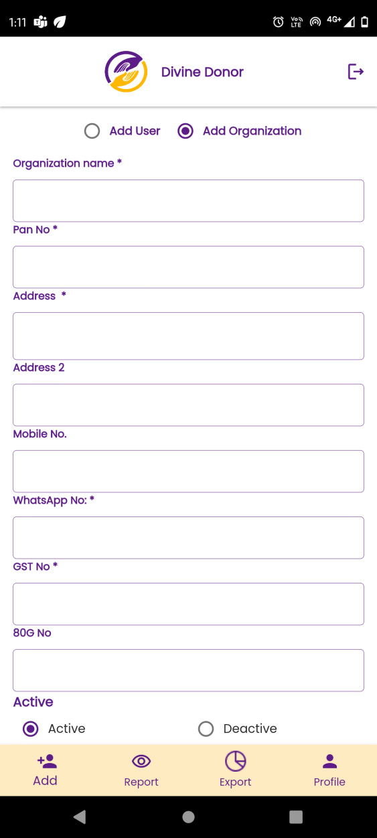

Fig: Add Organization (mobile)

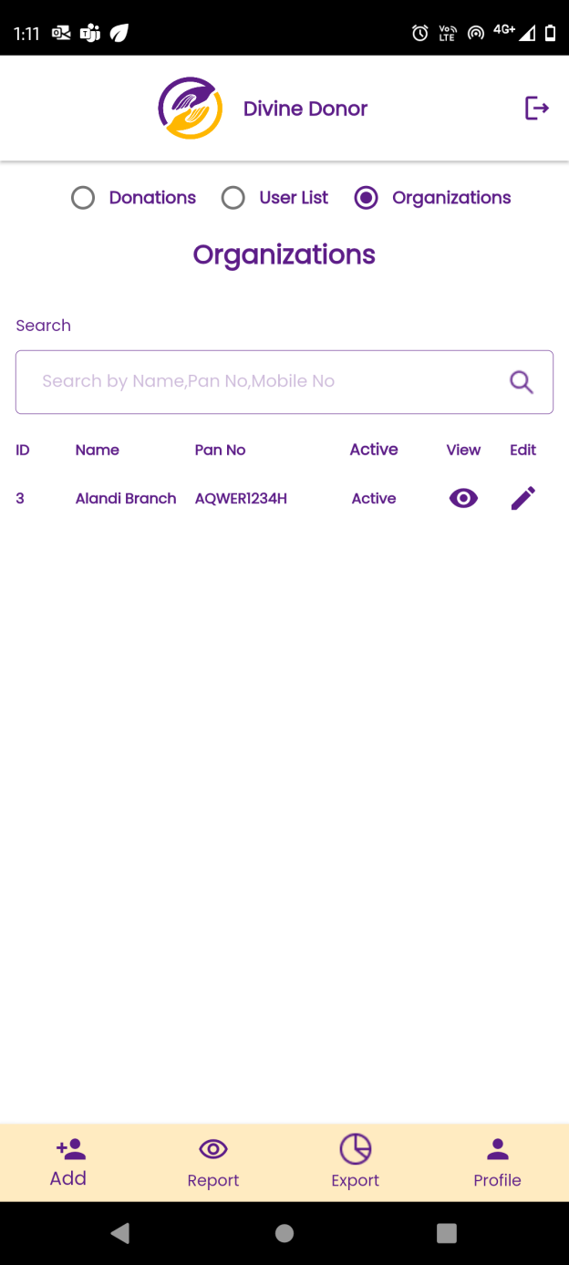

Fig: organization grid in mobile

|  |  |  |  |  |
| --- | --- | --- | --- | --- |
| **FIELDS** | **INPUT TYPE** | **MANDATORY/ OPTIONAL** | **EDITABLE** | **DESCRIPTION** |
| Tenant Name | Text | Mandatory | - | This field will not be displayed to tenant admin in add and edit action. It will be displayed only in grid to that tenant admin because it will consider the organization of that logged in tenant. Whereas in super-admin login, it will display the tenant name who has added that organization.  Validation: It will be read only to tenant. It will be editable to super-admin only. |
| Organization name | Text | Mandatory | Yes | Tenant will mention the name of the organization under them. Tenant may have one or more organizations under them I.e. their firms / institutes.  Once tenant enters organization name, other fields and submits the form then the organization will get added against that tenant only. And, added details and its organization name will be displayed in top row of report -> organization list. Also, this will be displayed in view action of the added organization through report -> organization list -> view action.  Validation:- It should accept maximum 50 characters. It should accept characters, numbers and space. It shouldn’t accept double space after one word. |
| PAN no. | Text | Mandatory | Yes | Tenant will mention the PAN no. for the organization.  Once tenant enters pan number, other fields and submits the form then the organization will get added against that tenant only. And, added details and its pan number will be displayed in top row of report -> organization list. Also, this will be displayed in view action of the added organization through report -> organization list -> view action.  Validation:- It should accept 10 characters. It includes first five letters, followed by 4 numbers and last character. |
| Address 1 | Text | Manadtory | Yes | Tenant admin will mention the address of the organization.  Once tenant enters address, other fields and submits the form then the organization will get added against that tenant only. And, added details and its address 1 will be displayed in organization’s -> view action.  Validation:- It should accept maximum 100 characters. It should accept characters, numbers, special characters . - / only. It should not accept double space after each word. |
| Address 2 | Text | Optional | Yes | Tenant admin will mention the secondary address of the organization.  Once tenant enters address, other fields and submits the form then the organization will get added against that tenant only. And, added details and its address 1 will be displayed in organization’s-> view action.  Validation:- It should accept maximum 100 characters. It should accept characters, numbers, special characters . - / only. It should not accept double space after each word. |
| Contact number | Text | Mandatory | Yes | Tenant admin will mention the contact number of the organization.  Once tenant enters contact info, other fields and submits the form then the organization will get added against that tenant only. And, added details and its contact info will be displayed in report -> organization list -> view action.  Validation:- It will be unique tenant wise (means organizations of same tenant can user this common number but this number cannot be used for organization of another tenant). It should accept maximum 10 characters. It should accept only numbers. It shouldn’t accept space / special characters / characters. It shouldn’t accept ten consecutive zeros or ten consecutive one. It should accept only 9 or 8 or 7 or 6 at the beginning. |
| Whats-App no. | Text | Mandatory | Yes | Tenant admin will mention the contact number of the organization. It can be same as contact number mentioned in above field.  Once tenant enters contact info, other fields and submits the form then the organization will get added against that tenant only. And, added details and its contact info will be displayed in report -> organization list -> view action.  Validation:- It will be unique tenant wise (means organizations of same tenant can user this common number but this number cannot be used for organization of another tenant). It should accept maximum 10 characters. It should accept only numbers. It shouldn’t accept space / special characters / characters. It shouldn’t accept ten consecutive zeros or ten consecutive one. It should accept only 9 or 8 or 7 or 6 at the beginning. |
| GST No. | Text | Mandatory | yes | Tenant admin will mention the GST number of that tenant or organization.  Once tenant enters gst no, other fields and submits the form then the organization will get added against that tenant only. And, added details and its gst no info will be displayed in report -> organization list -> view action.  Validation:- It will be unique for each tenant. It will be 15 digit value. The first 2 digits of the 15 digit GSTIN represents the state code. The next 10 digits are the [PAN](https://groww.in/p/pan-card) of the person or the business entity. The thirteenth digit is based on the number of registrations done by the firm within a state under the same PAN. The fourteenth digit will be the alphabet "Z" by default. The last digit is called the check code to detect errors and can be denoted by either a number of an alphabet. |
| 80G | Text | Mandatory | Yes | Tenant admin will mention the 80G number of that organization or tenant.  Once tenant enters 80G no, other fields and submits the form then the organization will get added against that tenant only. And, added details and its 80g no info will be displayed in report -> organization list -> view action.  Validation:- It will be unique for each tenant. It should accept alphabets, numbers, space and special characters ( ) , - / only. |
| Remark | Text | optional | Yes | Super-admin / tenant admin will mention the additional details of the organization if any.  Once super-admin / admin enters remark, other fields and submits the form then the organization will get added. And, added details and its remark will be displayed in view action of the added organization.  Validation:- It will accept maximum 250 characters. It will accept English and Marathi language. It will accept characters, numbers, special characters and space. It shouldn’t accept double space after one word. |
| Is active | Radio button | Mandatory | Yes | Precondition:- By default, it should select “Yes” option.  Post Condition:- Once tenant submits the organization form, then tenant will get added and its status as active yes / no will be displayed in grid as well as in view action of tenant. Also, inactive organizations will not be displayed in organization drop-down of add user form.  Validation:- Both radio buttons shouldn’t get clicked at a time. |
| Back / cancel | Click | - | - | Once tenant clicks on cancel button then all the fields filled in the form will get blank and organization shouldn’t get added. And, tenant admin will be directed to grid page on web. (If tenant is adding organization from mobile then user will remain on the same page if he clicks on cancel button.)  Validation:- Button will get disabled once clicked until all fields in the form gets blank. |
| Save | Click | - | - | Precondition:- All mandatory fields will be filled in the form.  Post condition:- Once tenant fills all mandatory fields in form, clicks on ‘save’ button then the organization will get added successfully and it will be displayed in report -> organization list view . And, tenant will be directed on grid page in web. (If tenant is adding organization from mobile then tenant will remain on the same page of add organization.)  Validation:- Button will get disabled once clicked until the successful pop-up message gets displayed. |
| Save and add more | Click | - | - | Precondition:- All mandatory fields will be filled in the form.  Post condition:- Once tenant fills all mandatory fields in form, clicks on ‘save & add more’ button then the organization will get added successfully and it will be displayed in grid of web and report-> organization list of mobile. And, tenant will remain on same page to add organization.  Validation:- Button will get disabled once clicked until the successful pop-up message gets displayed. |
| ID | Text | - | No | Once organization gets added then in mobile app, it displays the ID to that newly added organization in report -> organization list.  Validation: It will be read only. It will be incremental when organizations are added. |
| Created at | Text | - | No | Once irganization is added, it will display the date and time when the tenant admin / super-admin has added this organization. It will be displayed in view action of the organization.  Validation: It will be read only and displayed automatically once organization gets added. |
| Created by | Text | - | No | It will display either super-admin or the tenant name whoever has added that organization. It will be displayed in view action of the organization.  Validation: It will be read only and displayed automatically once organization gets added. |
| Updated at | Text | - | - | It will display the date and time when the tenant admin or super-admin has modified the organization details either through mobile or web. It will be displayed in view action of that organization.  Validation: It will be read only and displayed automatically once organization gets edited. |
| Updated by | Text | - | - | It will display either super-admin or the tenant name whoever has updated that organization. It will be displayed in view action of the organization.  Validation: It will be read only and displayed automatically once organization details are edited. |
| Web : export data | Click | - | - | Through export data button in web, tenant admin and super-admin can download the pdf, csv and excel file which will have details of the organization.    Fig: export data in organization master of web |

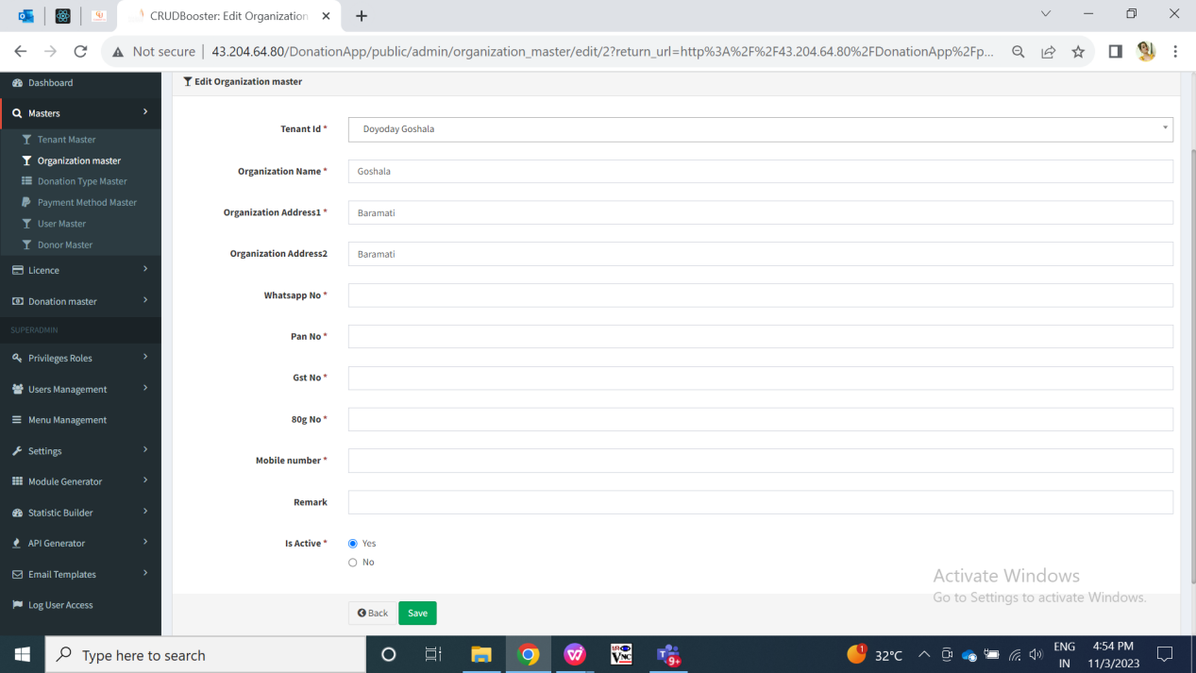

Fig: edit organization in web

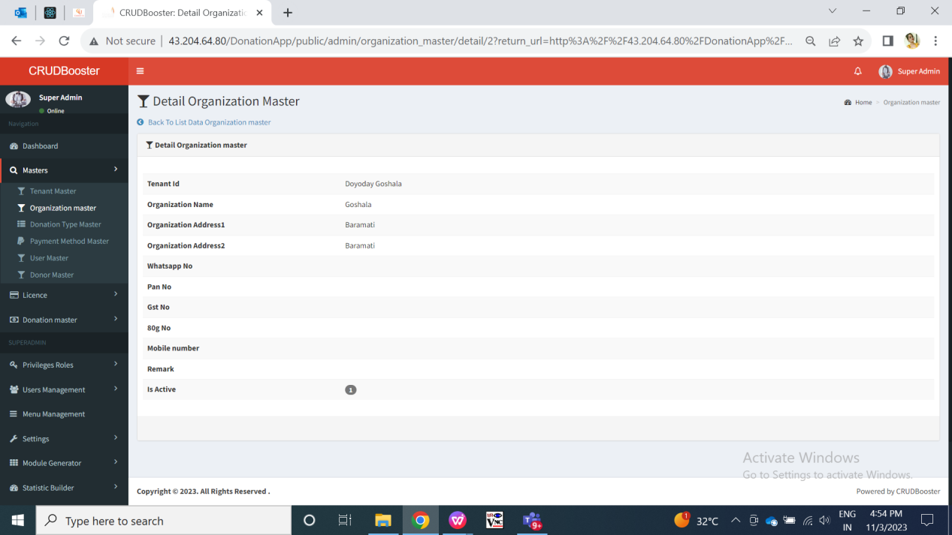

Fig: view organization in web

Step 3. Once tenant admin adds organization, he will add donation types in donation type master through web. These active donations types will be displayed to the user while filling the donation form.

Example; Sandeep Avchitte is tenant name. Organization A, Organization B and organization C are three organizations created & mapped under tenant - Sandeep Avchitte. Manali is the user mapped for organization A under tenant Sandeep Avchitte. Nivedita is the user mapped for organization A and organization B under tenant Sandeep Avchitte. Manisha is the user mapped for organization B and organization C under tenant Sandeep Avchitte.

Further, at organization A we have two donation types available Food donation and clothes donation mapped under it. Organization B has education and food donation type mapped under it. Organization C has food, clothes, education and land donation types mapped under it.

This means, when user Manali will log into mobile application and fill donation form then in donation type drop-down, manali will be able to see Food donation and clothes donation in the list.

Also, when user Nivedita will log into mobile application and fill donation form then for organization A, Nivedita will be able to see Food donation and clothes donation in the donation type list. Alternatively, when Nivedita selects organization B then Nivedita will be able to see education and food donation in the donation type drop-down.

Moreover, when user manisha will log into mobile application and fill donation form then for organization B, then manisha will be able to see education and food donation in the donation type list. Also, when manisha selects organization C then manisha will be able to see food, clothes, education and land donation types in the donation type drop-down.

Once tenant admin clicks on donation type master menu, it will have following fields:

* Add button
* Export data button
* Tenant name
* Organization name
* Donation type name
* Remark
* Is active
* Created at
* Created by
* Updated at
* Updated by
* back button
* Save & add more button
* Save button
* View button
* Edit button

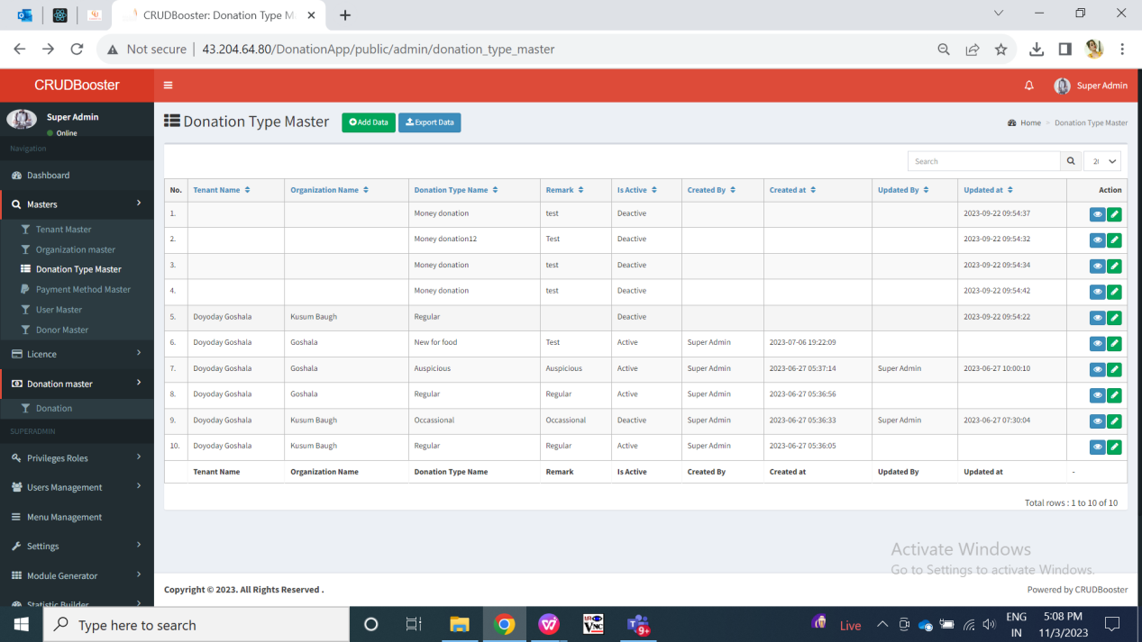

Fig: Donation Type Master - grid

Visibility of fields in function points:

|  |  |  |  |  |  |
| --- | --- | --- | --- | --- | --- |
| **FIELDS** | **ADD** | **GRID** | **VIEW** | **EDIT** | **EXPORT DATA** |
| Add data button | **X** |  | **X** | **X** | **X** |
| Export data button | **X** |  | **X** | **X** | **X** |
| Tenant name | * to super-admin |  |  | * to super-admin |  |
| Organization name |  |  |  |  |  |
| Donation type name |  |  |  |  |  |
| Remark |  |  |  |  |  |
| Is active |  |  |  |  |  |
| Created by | X |  | X | X |  |
| Created at | **X** |  |  | **X** |  |
| Updated by | **X** |  |  | **X** |  |
| Updated at | **X** |  |  | **X** |  |
| Edit button | **X** |  |  | **X** | **X** |
| View button | **X** |  |  | **X** | **X** |
| Back button |  | X | X |  | **X** |
| Save button |  | X | X |  | **X** |
| Save & add more button |  | X | X |  | **X** |

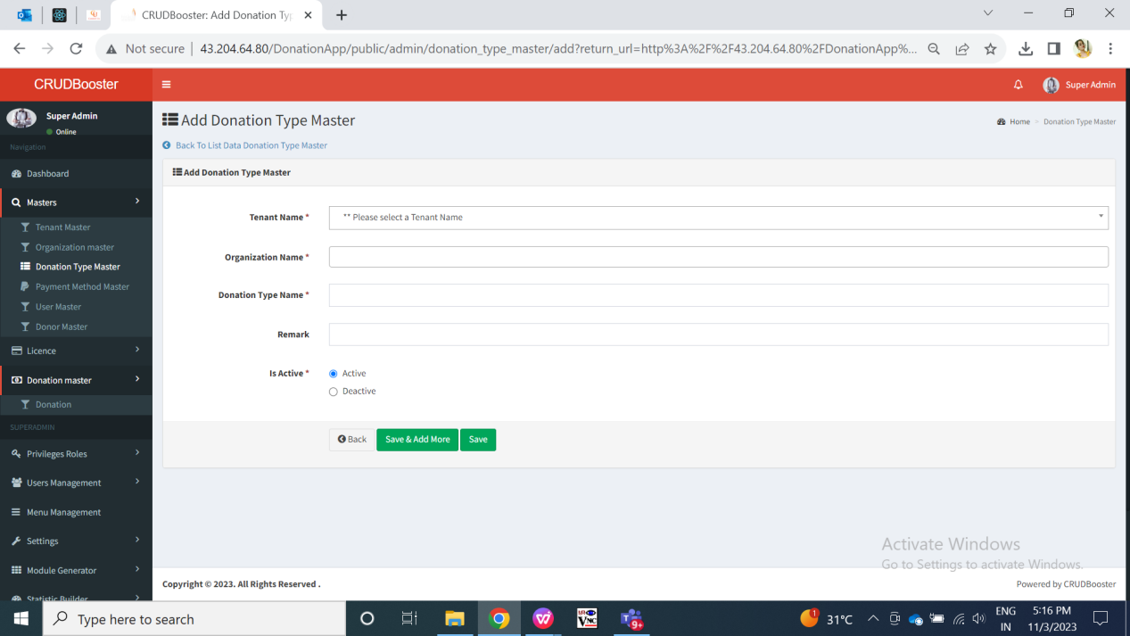

Fig: Add in Donation Type Master

|  |  |  |  |  |
| --- | --- | --- | --- | --- |
| **FIELDS** | **INPUT TYPE** | **MANDATORY/ OPTIONAL** | **EDITABLE** | **DESCRIPTION** |
| Tenant Name | Text | Mandatory | - | This field will not be displayed to tenant admin in add and edit action. It will be displayed only in grid to that tenant admin. Whereas, in super-admin login, it will display the drop-down for tenant name while adding that donation type.  Validation: It will be read only to tenant. It will be editable to super-admin only. |
| Organization name | Drop down | Mandatpry | Yes | Tenant admin will select the organization name under which donation type is to be created.  Validation: it will be single select. Active organizations of this tenant only will be displayed in drop-down. |
| Donation type name | Text | Mandatory | Yes | Tenant admin will mention the donation type name here.  Once admin enters donation type name, other fields and submits the form then the donation type will get added and mapped under the organization of the tenant. And, added details and its organization name will be displayed in top row of grid of donation type master as well as in view action. Pop-up message of data added successfully will be displayed. The created active donation types will be displayed to the user in add donation form.  Validation:- It will be unique for each tenant wise organization. It should accept maximum 25 characters. It should accept characters, space, special characters and numbers. |
| Remark | Text | Optional | Yes | Tenant admin will mention the additional comments of the donation type.  ark, other fields and submits the form then the donation type will get added and mapped under the organization of the tenant. And, added details and its remark will be displayed in top row of grid of donation type master as well as in view action. Pop-up message of data added successfully will be displayed. The created active donation types will be displayed to the user in add donation form.  Validation:- It should accept maximum 100 characters. It should accept characters, numbers and space. It shouldn’t accept double space after one word. It should accept English and Marathi language. |
| Is active | Radio button | Mandatory | Yes | Precondition:- By default, it should select “Yes” option.  Post Condition:- Once tenant admin submits the donation type form, then donation type will get added and its status as active yes / no will be displayed in grid as well as in view action. Also, inactive donation types will not be displayed in donation types drop-down of add donation form.  Validation:- Both radio buttons shouldn’t get clicked at a time. |
| Back | Click | - | - | Once user clicks on back button, donation type will not get added and tenant admin will be directed to grid page of donation type master.  Validation: back button will be disabled until page gets reloaded and tenant admin is directed to grid page of donation type master. |
| Save | Click | - | - | Once user fills all mandatory fields and clicks on save button, donation type will get added. Successful message will be displayed and tenant admin will be directed to grid page of donation type master where newly added donation type will be displayed on top row.  Validation: Save button will be disabled until successful message is displayed and tenant admin will be directed to grid page. |
| Save & add more | Click | - | - | Once user fills all mandatory fields and clicks on save button, donation type will get added. Successful message will be displayed and newly added donation type will be displayed on top row of grid. Whereas, tenant admin will remain on same page of add donation type form.  Validation: Save and ‘save & add more’ button will be disabled until successful message is displayed and page gets reloaded. |
| Created at | Text | - | No | It will display the date and time when super-admin/ tenant admin created this donation type master. It will be displayed in grid and view action.  Validation: it will be read only. |
| Created by | Text | - | No | It will display the either super-admin or tenant admin whoever has created this donation type master. It will be displayed in grid and view action.  Validation: it will be read only. |
| Updated at | Text | - | No | It will display the date and time when super-admin/ tenant admin updated this donation type master. It will be displayed in grid and view action.  Validation: it will be read only. |
| Updated by | Text | - | No | It will display either super-admin/ tenant admin whoever has edited and modified this donation type master. It will be displayed in grid and view action.  Validation: it will be read only. |
| Export data | Click | - | - | Through export data button, tenant admin and super-admin can download the pdf, csv, excel file which will have details of donation types as in grid.    Fig: export data in donation type master |

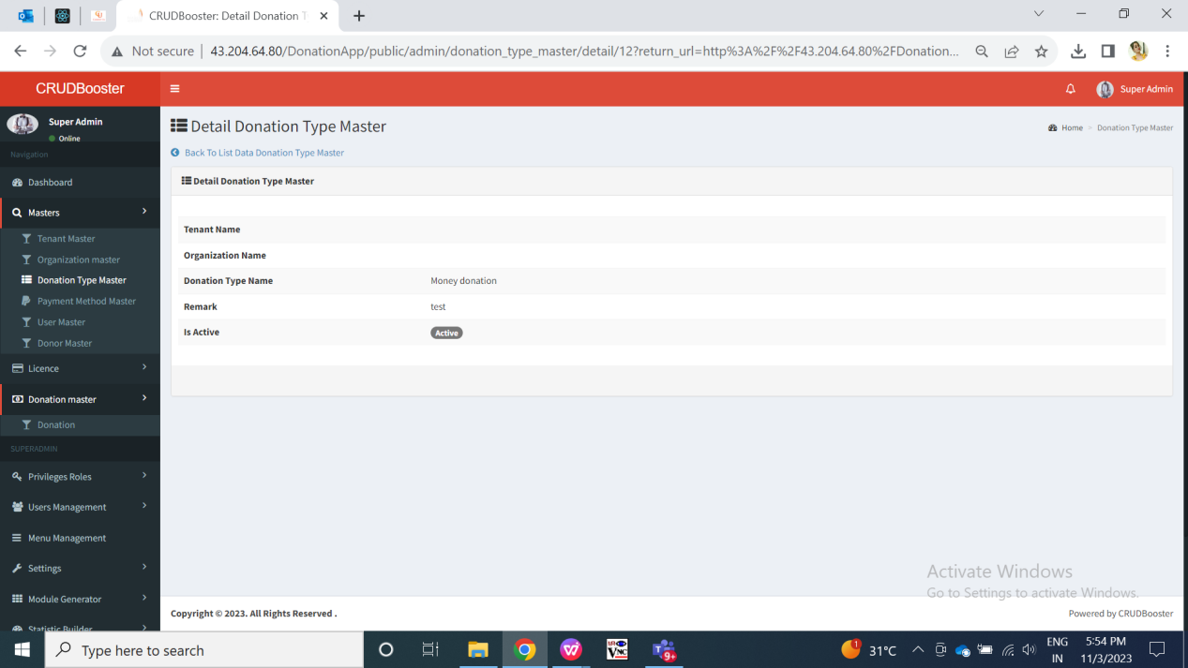

Fig: view donation type master

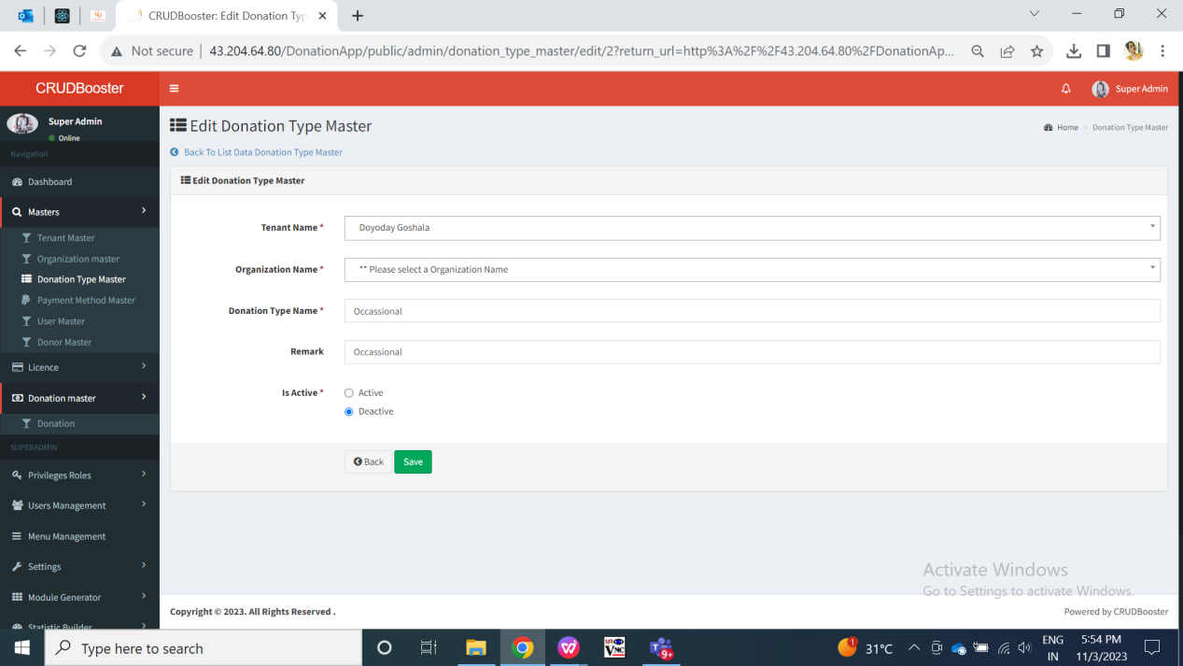

Fig: Edit in donation type master

Step 4. Once tenant admin adds organizations and donation types, tenant admin can add user through mobile app and web app. While adding user, tenant admin will map user with one or more organizations. Once tenant admin clicks on user master menu, it will have following fields:

* Add button
* Export data button
* Tenant name
* Organization name
* Delete button
* name of user
* Password
* Profile image
* Mobile no.
* Whats-app no.
* Email
* Is active
* Created at
* Created by
* Updated at
* Updated by
* Save button
* Back button
* Save and add more button
* Edit button
* View button

Super-admin cannot add user through web and can on;y edit and view users as added by tenant admin. Whereas, tenant admin can add user from web and mobile as well as can view and edit them in user master (for web) and report -> list users (for mobile).

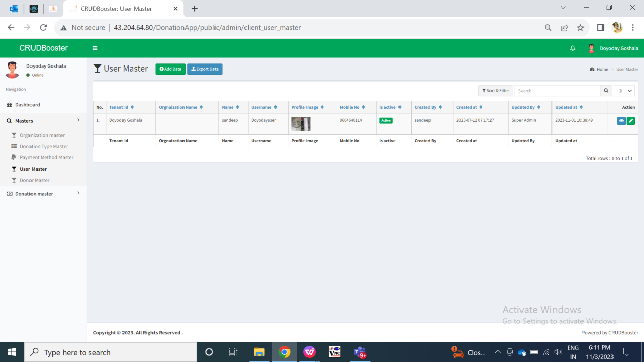

Fig: User master grid in web

Visibility of fields in function point pages through web for user master:

|  |  |  |  |  |  |
| --- | --- | --- | --- | --- | --- |
| **FIELDS** | **ADD** | **GRID** | **VIEW** | **EDIT** | **EXPORT DATA** |
| Add data button | **X** |  | **X** | **X** | **X** |
| Export data button | **X** |  | **X** | **X** | **X** |
| Edit button | **X** |  | **X** | **X** | **X** |
| View button | **X** |  | **X** | **X** | **X** |
| Tenant name | * **to super-admin in edit** |  |  |  |  |
| Organization name |  |  |  |  |  |
| Name of user |  |  |  |  |  |
| Password |  |  |  |  |  |
| Profile image |  |  |  |  |  |
| Email |  |  |  |  |  |
| Contact no. |  |  |  |  |  |
| Whats-app no. |  |  |  |  |  |
| Is active |  |  |  |  |  |
| Created at | X |  |  | X |  |
| Created by | X |  |  | X |  |
| Updated at | X |  |  | X |  |
| Updated by | X |  |  | X |  |
| Save button | **X** | X | X | X | X |
| Save & add more button | X | X | X | X | X |
| Back button | X | X | X | X | X |

**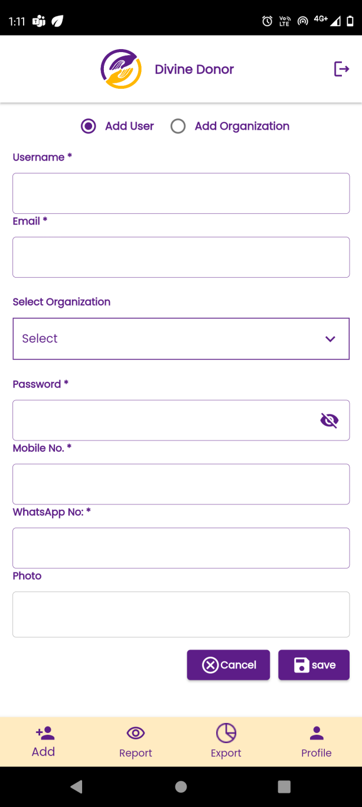**

Fig: Add User in mobile app

Visibility of user fields in function point pages through mobile app:

|  |  |  |  |  |
| --- | --- | --- | --- | --- |
| **FIELDS** | **ADD USER** | **REPORT GRID** | **REPORT : VIEW** | **REPORT : EDIT** |
| Name of the user |  |  |  |  |
| Email |  |  |  |  |
| Select organization |  | **X** |  |  |
| password |  | **X** |  |  |
| Contact no. |  | **X** |  |  |
| Whats-app no. |  | **X** |  |  |
| Save button |  | **X** | **X** |  |
| Cancel button |  | **X** | **X** |  |
| Is active |  |  |  |  |
| View button | **X** |  | **X** | **X** |
| Edit button | **X** |  | **X** | **X** |
| ID | **X** |  |  | **X** |
| Created at | **X** | **X** |  |  |
| Created by | **X** | **X** |  |  |
| Updated at | **X** | **X** |  |  |
| Updated by | **X** | **X** |  |  |

Input table

|  |  |  |  |  |
| --- | --- | --- | --- | --- |
| **FIELDS** | **INPUT TYPE** | **MANDATORY/ OPTIONAL** | **EDITABLE** | **DESCRIPTION** |
| Tenant Name | Text | Mandatory | - | Once tenant admin adds user, then tenant name for that user will be displayed in user master - grid as per the login who has added user. |
| Name of user | Text | Mandatory | - | Tenant admin will mention the full name of the user for whom the tenant admin is creating credentials.  Once tenant enters user name, other fields and submits the form then the user will get added against that tenant under selected organization only. And, added details and name of user will be displayed in top row of report -> user list. Also, this will be displayed in view action of the added user through report -> user list -> view action. Whereas, name of the user will be displayed in profile to the user once he logs into mobile and web app.  Note: This name cannot be used by the user while login. User will lo into map using email address.  Validation:- It should accept maximum 25 characters. It should accept characters and numbers only. It shouldn’t accept space or special characters. |
| Email | Text | Mandatory | Yes | Tenant admin will mention the email address of the user which will be used by the user during login.  Once tenant admin enters email, other fields and submits the form then the user will get added against that tenant under selected organization only. And, added details and its user name will be displayed in top row of report -> user list. Also, this will be displayed in view action of the added user through report -> user list -> view action.  Validation:- It will be unique for each user. It should accept maximum 50 characters. It should accept characters, number. It should not accept space. It should accept @ . \_ and - special characters only. |
| Organization name | Drop down | Mandatory | Yes | Tenant admin can select multiple organizations names that means one user can be mapped with multiple organizations of that tenant.  Once tenant admin selects organization names from the drop-down user name will be displayed in top row of report -> user list. Also, this will be displayed in view action of the added user through report -> user list -> view action.  Validation:- Atleast one organization should be selected. It will display active organization names of that tenant only in this drop-down list. |
| Password | Text | Mandatory | Yes | Tenant admin will mention the password for the user initially, whereas user can further change the password from his end after login into web app and/or mobile app.  Once tenant admin enters password, other fields and submits the form then the tenant will get added. And, added details will be displayed in top row of grid view of tenant master page. Also, details will be displayed in view action of the added tenant where password field will be kept blank.  Validation:- Minimum length will be 6 digits. It should accept characters, numbers, special characters. It shouldn’t accept space. |
| Contact no. | Text | Mandatory | Yes | Tenant admin will mention the mobile number of the user.  Once tenant enters contact info, other fields and submits the form then the organization will get added against that tenant only. And, added details and its contact info will be displayed in report -> organization list -> view action.  Validation:- It will be unique for each user. It should accept maximum 10 characters. It should accept only numbers. It shouldn’t accept space / special characters / characters. It shouldn’t accept ten consecutive zeros or ten consecutive one. It should accept only 9 or 8 or 7 or 6 at the beginning. |
| Whats-app no. | Text | Mandatory | Yes | Tenant admin will mention the whats-app number of user.  Once tenant enters contact number, other fields and submits the form then the tenant will get added. And, added details and its email will be displayed in top row of grid view of tenant master page. Also, this will be displayed in view action of the added tenant.  Validation:- It will be unique for each user but can be same as the contact number mentioned in above field. It should accept maximum 10 characters. It should accept only numbers. It shouldn’t accept space / special characters / characters. It shouldn’t accept ten consecutive zeros or ten consecutive one. It should accept only 9 or 8 or 7 or 6 at the beginning. |
| Profile image | Attach / upload | Mandatory | Yes | Tenant admin will attach the photo of the user. Further, user can change the photo through profile by logging into app.  Once tenant uploads image from the system, other fields and submits the form then the name of the attached image will be displayed in this field. Once tenant submits the form, then user will get added and will be displayed in the grid view. Once tenant clicks on view action of added user, then profile image will be displayed and tenant will be able to zoom it.  Also, when user logs into the mobile application, the photo will be displayed in the profile of the user.  Validation:- It should accept single image. It should accept jpg, jpeg, png, heic and webp extension image files only. |
| Is active | Radio button | Mandatory | Yes | User can make user active or inactive. Inactive users cannot log into mobile app.  Bydefault, it will be clicked on ‘yes’ initially while adding the user. Furtjer user can change the active status as yes or no through edit action from web app -> user master or from mobile app -> report -> user list.  Validation: only one radio button can be selected at a time. |
| Cancel | Click | - | - | Once tenant admin clicks on cancel button then all pre-filled fields will get blank and user shouldn’t get added. Also, tenant admin should remain on the same add user form.  Validation:- Button will get disabled once clicked until all fields in the form gets blank. |
| Save | Click | - | - | Once tenant admin fills all mandatory fields in form, clicks on ‘save’ button then the user will get added successfully and it will be displayed in report -> user list view . And, tenant admin will remain on same page to fill the form for next user.  Validation:- Button will get disabled once clicked until the successful pop-up message isn’t displayed. |
| ID | Text | - | No | Once user is added, it will be displayed on top in web -> user master and in mobile -> report -> user list. ID I.e. serial number will be displayed for the user.  Validation: it will be read only. It will be incremented for each added user for this tenant.  Screenshot_20230807-131131  Fig: report -> User list (mobile) |
| Created at | Text | - | No | It will display the date and time when the user was created.  Validation: It will be displayed automatically once user gets added. It will be read only and displayed in grid of user master and view action of that user on mobile as well as web. |
| Created by | Text | - | No | It will display the name of the person I.e. either super admin or tenant name who has created the user.  Validation: It will be displayed automatically once user gets added. It will be read only and displayed in grid of user master and view action of that user on mobile as well as web. |
| Updated at | Text | - | - | It will display the date and time when super-admin or tenant name has edited the user details from web or mobile.  Validation: It will be displayed automatically once user gets updated. It will be read only and displayed in grid of user master and view action of that user on mobile as well as web. |
| Updated by | Text | - | - | It will display the name of the person I.e. either super admin or tenant name who has modified the details of the user.  Validation: It will be displayed automatically once user details are updated and saved. It will be read only and displayed in grid of user master and view action of that user on mobile as well as web. |

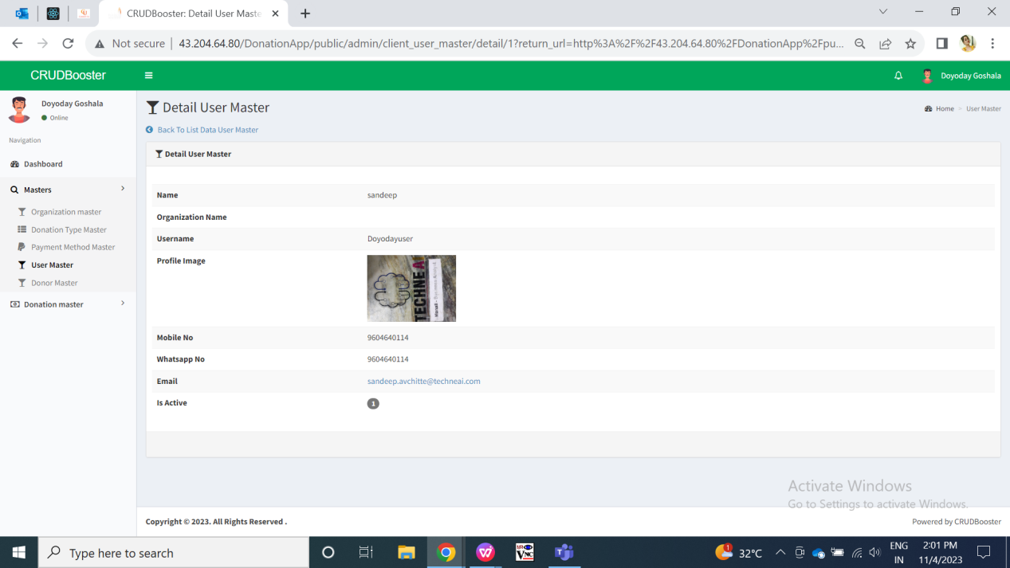

Fig: user master - view

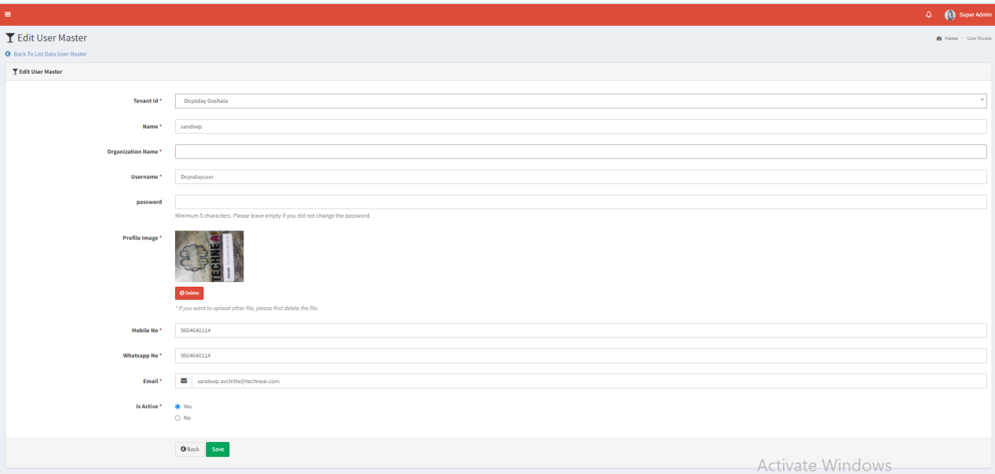

Fig: user master - edit

Step 5. Once user is added by tenant admin, then user can log into mobile app and fill donation forms. Donation form can only be filled by user and only through mobile app.

Through donation form, user will fill the details of the donor and receipt will get sent on the donor’s whats-app number. Also, the donation form once submitted, it will be displayed in the donation report of mobile app as well as in donation master -> donations of web app in super admin login.

Also, once donation is done by user, it will be displayed in mobile -> report -> donations in users login as well as tenant login and also in web -> donation master -> donation to tenant.

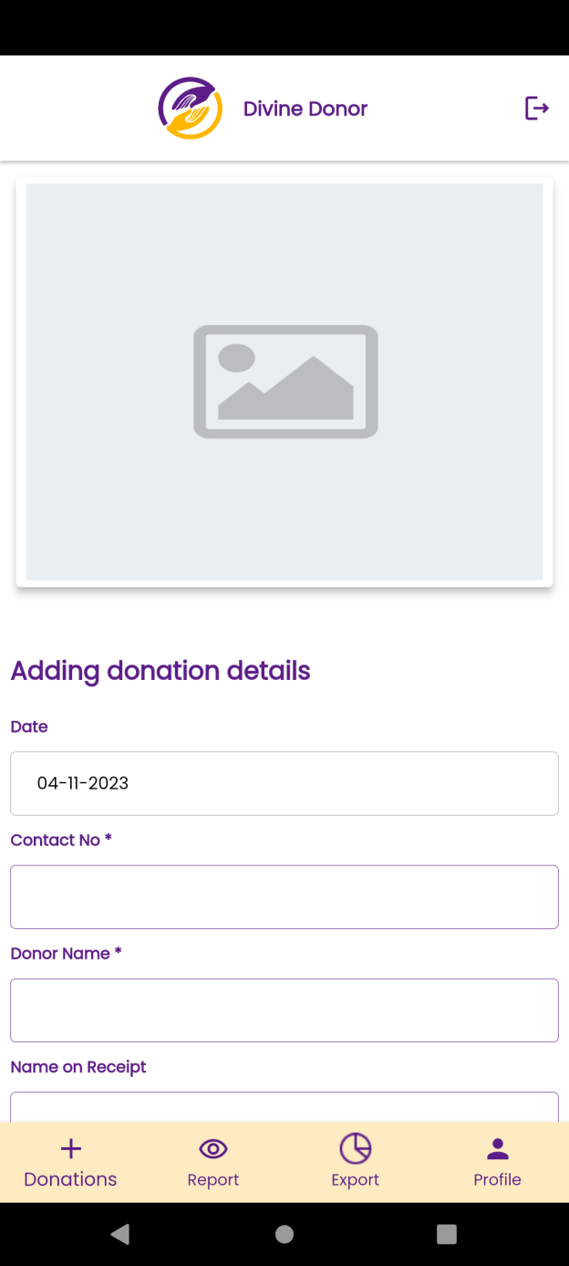 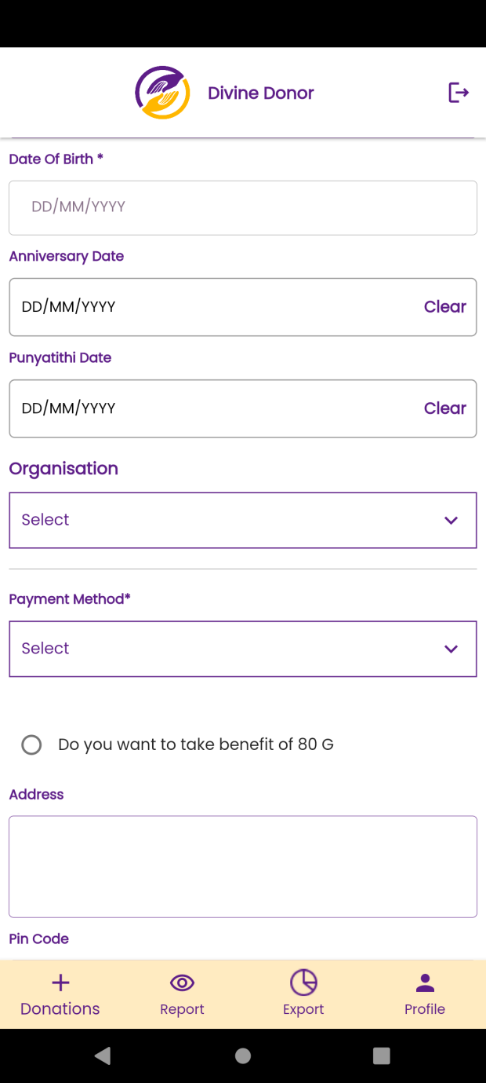

Fig: Add donation details form in mobile

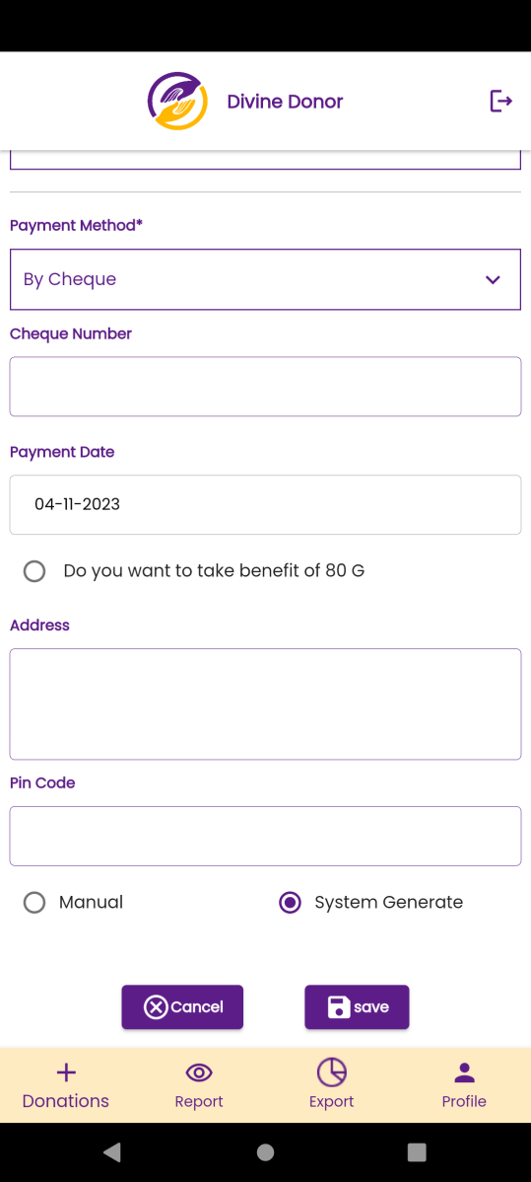

Fig: Add donation details form in mobile

Once user enters donor mobile number, name and other details and other fields in donation form, the donor details will be saved in web-> donor master under this tenant. Further, when user will enter the mobile number of the existing donor, then all other details of the donor will get pre-filled in add donation form. Tenant admin can update the details of the donor through web -> donor master.

Add donation will have following fields:

* Tenant logo
* Date
* Contact no.
* Donor name
* Name on receipt
* Address
* Pin code
* Date of birth
* Anniversary date
* Punyatithi Date of relative
* Organization
* Donation type
* Amount
* Amount in words
* Add more button
* Payment method
* Cheque number
* Payment reference number / UTR number
* Payment date
* Do you want 80g benefit
* Pan no
* Receipt type (manual / system)
* Save button
* Cancel button
* Receipt no.
* Download receipt

Visibility of fields in function point pages:

|  |  |  |  |  |
| --- | --- | --- | --- | --- |
| **FIELDS** | **ADD DONATION** | **REPORT : GRID** | **REPORT : VIEW** | **DOWNLOADED RECEIPT** |
| Tenant logo |  | **X** | **X** |  |
| Date |  |  |  |  |
| Contact no. |  | **X** |  |  |
| Donor name |  |  |  | **X** |
| Name on receipt |  | **X** |  |  |
| Address |  | **X** |  |  |
| Pin code |  | **X** |  |  |
| Date of birth |  | **X** |  | **X** |
| Anniversary date |  | **X** |  | **X** |
| Punyatithi Date of relative |  | **X** |  | **X** |
| Organization |  | **X** |  | **X** |
| Donation type |  | **X** |  | **X** |
| Amount |  |  |  |  |
| Add more button |  | **X** |  | **X** |
| Payment method |  | **X** |  |  |
| Cheque number |  | **X** |  |  |
| Payment reference number / UTR number |  | **X** |  |  |
| Payment date |  | **X** |  |  |
| Do you want 80g benefit |  | **X** |  | **X** |
| Pan no |  |  |  |  |
| Receipt type (manual / system) |  | **X** |  | **X** |
| Save button |  | **X** |  | **X** |
| Cancel button |  | **X** |  | **X** |
| Receipt no. | **X** | **X** |  |  |
| Download receipt | **X** | **X** |  | **X** |

|  |  |  |  |  |
| --- | --- | --- | --- | --- |
| **FIELDS** | **INPUT TYPE** | **MANDATORY/ OPTIONAL** | **EDITABLE** | **DESCRIPTION** |
| Tenant Logo | Text | Mandatory | - | It will display the profile image of user’s tenant as logo.  Once tenant admin or super-admin changes the profile image then updated profile image will be displayed here as well as in downloaded receipt.  Validation: It will display only one image. It will be view only. |
| Date | Calender da picker | Mandatory | No | It is the date on which user is adding the donation form.  Post condition:- Once user fill donation form details and clicks on submit, then donation form will be displayed in report of mobile app and web app where date will be displayed as while submitting form. Moreover, this date will be displayed in the whats-app receipt which is sent to donor after submitting donation form.  Validation:- It will be read only field. It will display today’s date by default. |
| Contact number | Text | Mandatory | No | User will enter the mobile number of the donor. If the donor is giving donation for the first time, then user will have to manually fill all the fields of the donation form. If donor isn’t new, then as donor’s details are being saved in donor master, then second or another time when user will enter the donor’s number then details like donor name, name on receipt, DOB, anniversary date will get auto-filled as per data in donor master.  Once user enters mobile number of the donor and if the number is already present in donor master against that tenant, then the other details like donor name, name on receipt, DOB, anniversary date will get auto-filled as per data in donor master. The fields which got auto-filled will be editable too. If number is new means not registered in donor master against that tenant, then user will have to manually fill all the details in the form. Once number is entered, all fields in form are filled and form is submitted then donation form will be displayed in report of mobile app and web app where number will be displayed in view action of donation detail.  Validation:- One mobile number of donor can be used by another tenant as donor may do donations at multiple tenants. It should accept only numbers and maximum 10 digits. It should accept space. It should accept 9 or 8 or 7 or 6 only at the beginning. |
| Donor name | Text | Mandatory | Yes (only through web -> donor master) | User will enter the mobile number of the donor. If the donor is giving donation for the first time through registered contact number, then user will have to manually fill donor name and other all the fields of the donation form. If donor isn’t new, then donor name will get auto-filled after entering mobile number as per data in donor master.  Initially this field will be blank if contact number is new. Or else this field will get auto-filled if registered number already exist in our donor master under the specified tenant.  Once user enters mobile number of the donor and if the number is already present in donor master against that tenant, then donor name will get auto-filled as per data in donor master. The donor name which got auto-filled will be editable too. If number is new means not registered in donor master against that tenant, then user will have to manually fill all the details in the form including donor name. Once number is entered, all fields in form are filled and form is submitted then donation form along with donor name will be displayed in report of mobile app and web app will be displayed in view action of donation detail.  Validation:- Donor name field should accept maximum 50 characters. It should accept single space. It shouldn’t accept double space after one word. It shouldn’t accept numbers or special characters. |
| Name on receipt | Text | Mandatory | Yes | Name on receipt could be different from the donor name because there are cases where donor makes donation in the name of his relatives / family members / loved ones. When donation details form is submitted by user, then PDF receipt gets sent on donor’s whats-app number. The receipt will contain name which is mentioned in ‘name on receipt’ field of donation form.  Initially this field will be blank if contact number is new. Or else this field will get auto-filled as per donor name.  Once user enters mobile number of the donor and if the number is already present in donor master against that tenant, then donor name will get auto-filled and the same will get auto-filled in ‘name on receipt’ field as per data in donor master. The name on receipt which got auto-filled will be editable too. If contact number is new means not registered in donor master against that tenant, then user will manually fill all the details in the form including donor name. As per name entered in donor master, it will be displayed in ‘name on receipt’ field. Once number is entered, all fields in form are filled and form is submitted then donation form along with donor name will be displayed in report of mobile app and web app will be displayed in view action of donation detail. Moreover, ‘name on receipt’ will be displayed in the whats-app receipt which is sent to donor after submitting donation form.  Validation:- This field should accept maximum 50 characters. It should accept single space. It shouldn’t accept double space after one word. It shouldn’t accept numbers or special characters. |
| Address | Text | Mandatory | Yes | Address of the donor will be mentioned here.  Initially this field will be blank if contact number is new. Or else this field will get auto-filled as per donor contact number.  Once user enters mobile number of the donor and if the number is already present in donor master against that tenant, then address will get auto-filled as per data in donor master. Address will be editable too. If contact number is new means not registered in donor master against that tenant, then user will manually fill all the details in the form including address. Once number is entered, all fields in form are filled and form is submitted then donation form along with address will be displayed in report of mobile app and web app will be displayed in view action of donation detail.  Validation:- This field should accept maximum 100 characters. It shouldn’t accept double space after one word. It should accept characters, numbers special characters - / , only. |
| Date of birth | Calender date picker | Mandatory | Yes | Date of birth of the donor will be mentioned here.  Initially this field will be blank if the entered contact number is new.  Once user enters mobile number of the donor and if the number is already present in donor master against that tenant, then DOB will get auto-filled as per data in donor master. It will be editable too. If number is new means not registered in donor master against that tenant, then user will have to manually fill all the details in the form including DOB. Once number is entered, all fields in form are filled and form is submitted then donation form will be displayed in report of mobile app and web app and also new donor / updated details of DOB will be displayed in grid & view action of donor master in web app.  Validation:- It will display dates only till today’s / current date. Only one date will get selected and displayed in DD/MM/YYYY format. |
| Donor’s anniversary date | Calender date picker | Optional | Yes | Date of anniversary of the donor will be mentioned here.  Initially this field will be blank if the entered contact number is new.  Once user enters mobile number of the donor and if the number is already present in donor master against that tenant, then anniversary date will get auto-filled as per data in donor master. It will be editable too. If number is new means not registered in donor master against that tenant, then user will have to manually fill all the details in the form including date of anniversary. Once number is entered, all fields in form are filled and form is submitted then donation form will be displayed in report of mobile app and web app and also new donor / updated details of anniversary date will be displayed in grid & view action of donor master in web app.  Validation:- It will display dates only till today’s / current date. Only one date will get selected and displayed in DD/MM/YYYY format. Anniversary date shouldn’t be as same as DOB. |
| Relative’s punyatithi date | Calender date picker | Optional | Yes | Date of death of relative on whose behalf / occasion the donor is making donation, it will be mentioned here.  Once user enters mobile number of the donor and if the number is already present in donor master against that tenant, then anniversary date will get auto-filled as per data in donor master. It will be editable too. If number is new means not registered in donor master against that tenant, then user will have to manually fill all the details in the form including date of anniversary. Once number is entered, all fields in form are filled and form is submitted then donation form will be displayed in report of mobile app and web app and also new donor / updated details of anniversary date will be displayed in grid & view action of donor master in web app.  Validation:- It will display dates only till today’s / current date. Only one date will get selected and displayed in DD/MM/YYYY format. Anniversary date shouldn’t be as same as DOB. |
| Select organization | Drop down | Mandatory | No | User will select for which organization the donation has to be taken from the donor.  Once user select the organization name from drop-down, user will have to enter the donation type details and submit the form. Once the donation form is submitted, it will be displayed in web app and mobile app -> donation report. Also, in view action of donation master from web app, it will display the organization type selected.  Validation:- It will display organizations only mapped to the user while adding user. It can be viewed from user master’s organization column. It will display only active organizations of organization master for particular tenant. It will be single select. |
| Donation type | Drop down | Mandatory | No | User will select for the donation type which has to be taken from the donor.  Once user select the donation type name from drop-down, user will have to enter the amount details and submit the form. Once the donation form is submitted, it will be displayed in web app and mobile app -> donation report. Also, in view action of donation master from web app, it will display the donation type selected.  Validation:- It will display donation types only mapped under the selected organization from donation type master of web app. It will display only active donation type for particular tenant from donation type master of web app. It will be single select. |
| Amount | Text | Mandatory | No | User will enter the amount that donor is giving for particular donation type under selected organization.  Once user enters the amount, then amount in words will be displayed below and user will submit the form. Once the donation form is submitted, it will be displayed in web app and mobile app -> donation report which will include donation amount. Also, in view action of donation master from web app, it will display the amount. Moreover, amount will be displayed in the whats-app receipt which is sent to donor after submitting donation form.  Validation:- It should accept only numbers. It shouldn’t accept space or characters or special characters. It should accept maximum ten digit amount. It shouldn’t accept 0 in the beginning. |
| Add more | Click | Optional | No | If donor wants to do donation of more than one donation type, then user will click on add more button and fill details of another donation type. Donor can pay one of the amount for one donation type, another amount for another donation type, whereas receipt for the total amount will be displayed after successfully submitting donation form.  Once user clicks on add more button, it will display donation type, amount and amount in words fields which will be blank initially. Also, this new row which got added will have delete button to it.  Validation:- Button once clicked will be disabled until three fields aren’t displayed below.  Add more button will get clicked only the number of donation types are available in the list as per organization of that tenant. Example: organization C has four types of donations available in it. Hence add more button will get clicked only 3 times because one donation type box entry is going to be displayed by default. Hence, 1 + 3 other donation type boxes = 4. |
| Payment method | Drop down | Mandatory | No | Payment method of donation given by donor will be by cash, by cheque, and UPI / Online.  If user select by cheque as payment method, then payment date and cheque no text field will be displayed below where user will enter the cheque number which donor has given. Else, if user selects UPI/online as payment method, then payment date and payment reference no. / UTR no. text field will be displayed below where user will enter the number which donor has given while making transaction.  Validation:- it will be active payment method from payment method master of web application in super admin login. It will be single select. |
| Cheque no / UTR no / payment reference no | text | mandatory | No | If donor has given donation by cheque, then user will have to note down cheque number.  If donor has given donation by UPI / online then user will have to note down payment reference number / UTR number.  If user select by cheque as payment method, then payment date and cheque no text field will be displayed below where user will enter the cheque number which donor has given. Else, if user selects UPI/online as payment method, then payment date and payment reference no. / UTR no. text field will be displayed below where user will enter the number which donor has given while making transaction.  Validation:- Cheque number field should accept only numbers and will be of maximum 15 digits.  UTR number should accept maximum 16 digits and should accept characters and numbers only.  Payment reference number should accept maximum 16 digits and should accept characters and numbers only. |
| Payment date | Calender date picker | Mandatory | Optional | User will have to mention the date on which the payment was made by the donor by cheque / upi / online method. It could be different from today’s date and hence this field is needed.  Once user enters the payment date, other fields and submits the form then the donation form is submitted, it will be displayed in web app and mobile app -> donation report which will include donation amount. Also, in view action of donation master from web app, it will display the amount. Moreover, amount will be displayed in the whats-app receipt which is sent to donor after submitting donation form.  Validation:- It will display dates only till today / current date. |
| Do you want 80g benefit? | Radio button | optional | No | If donor wants to have exemption in tax, then donor will apply for 80G benefit.  Once user clicks on 80G radio button, then pan number text field will be displayed.  Validation:- Once clicked it will display pan number field. If user clicked on radio button again, then pan number field should disappear. |
| PAN no. | Text | Mandatory | No | Once user clicks on 80G radio button, then pan number text field will be displayed.  Initially this field will be blank. Or else, if donor has already done previous donation and we have donor’s pan number in donor master, then that pan number will be displayed here as per registered number.  Once user enters pan number and submits the form then added details and its pan number will be displayed in donor master. Also, this donation will be displayed in report of mobile app and web app.  Validation:- It should accept 10 characters for each tenant. It includes first five letters, followed by 4 numbers and last character. |
| Receipt type | Radio button | Mandatory | No | It will display manual or system generated receipt.  Precondition:- Initially system generated radio button will be clicked.  Post condition:- If user clicks on manual receipt, then field to attach image will be displayed where user will upload image of invoice copy which is available in his mobile. If user select system generated receipt option then there is no need to attach image. Once user clicks on submit, Also, this donation will be displayed in report of mobile app and web app.  Validation:- Attach image will accept jpg, jpeg, png, heic, webp and pdf extensions only when user selects manual receipt type. Whereas, only PDF receipt will be generated when user selects system generate option. |
| Save | Click | - | - | Once donation form is submitted, successful pop-up message will be displayed on application and all fields in the form will get blank. At the same time, thank you note and receipt will be sent to the donor via whats-app. Also, the donation will be reflected in report of mobile of that user as well as in donation master of web app in super admin login and tenant’s login.  Once donation form is submitted, then thank you note and receipt will be sent to the donor via whats-app. Also, the donation will be reflected in report -> donations of mobile of that user as well as in donation master of web app.  Note: User will be able to view only donations added by the user himself. Whereas, tenant admin will be able to view donation details of the users under him which has processed donations.  Validation:- save button will be disabled until successful pop-up message gets displayed. |
| Cancel | Click | - | - | Once user clicks on cancel button, then all data filled in the fields will get blank and donation form shouldn’t get submitted. Whereas, user should remain on the same page of adding donation.  Validation:- Cancel button will be disabled until all fields doesn’t get blank. |

Once donation is done by user, it will be displayed in mobile -> report -> donations in users login as well as tenant login and also in web -> donation master -> donation to tenant. Each user can view donation details only added by themselves, tenant can view donation details of all users. Moreover, the donor details will get added in web -> donor master to tenant.

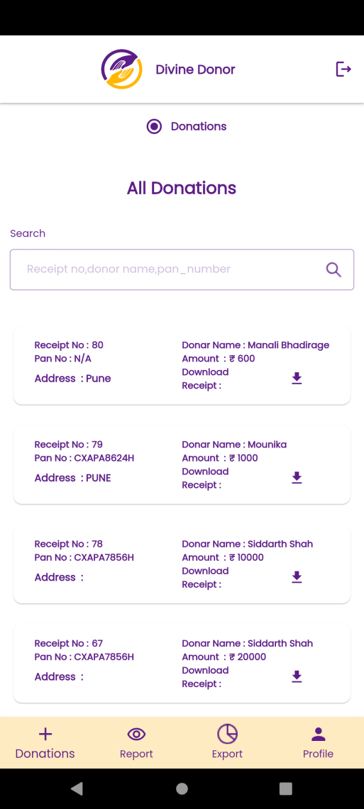

Fig: web -> Donation report

User / tenant can view details of the donation form in mobile by clicking on it.

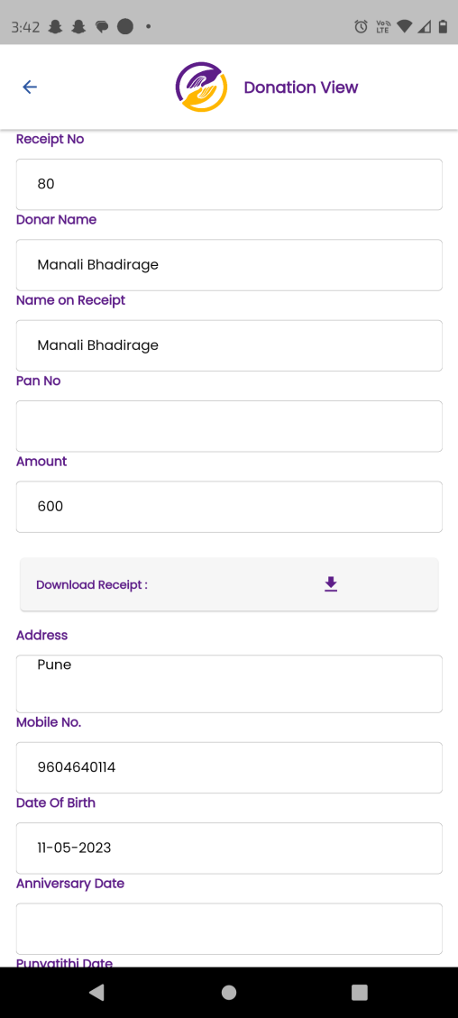

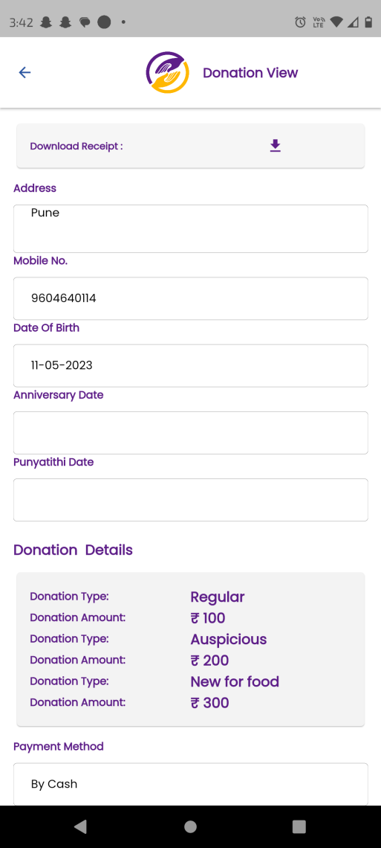

Fig: mobile -> Donation report -> view

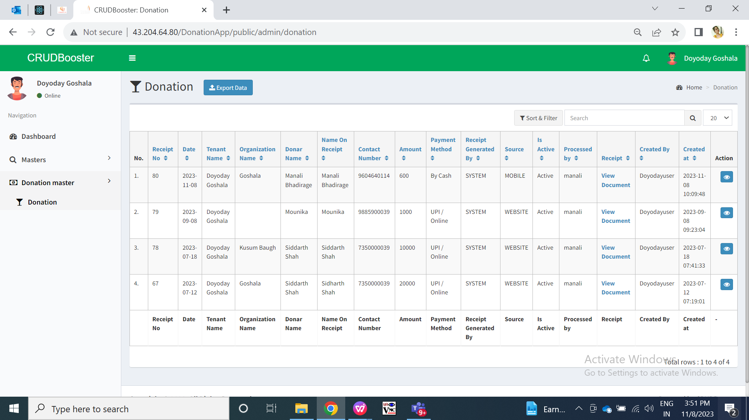

Fig: tenant login in web -> Donation master -> grid

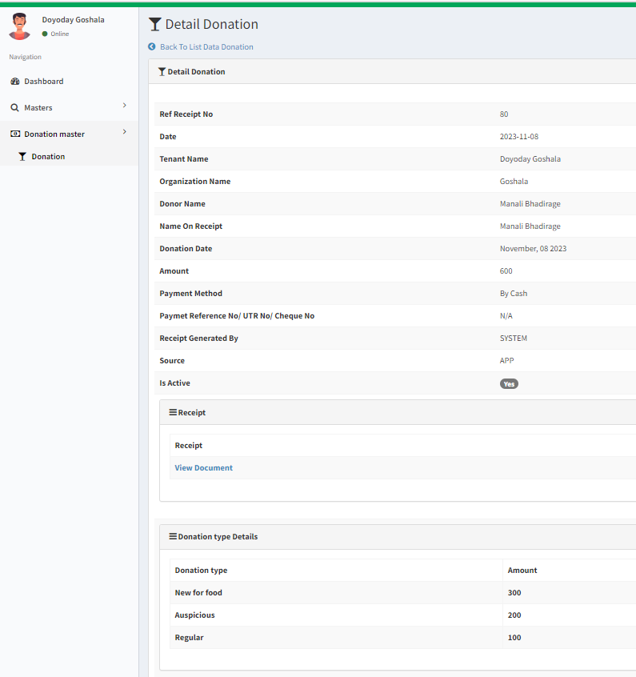

Fig: tenant login in web -> donation master -> view

Step 6. Once new donor details are added, it will be displayed in web -> donor master to tenant admin/. Tenant admin can view and edit donor details. Once donor details are edited through web, then updated donor details will be displayed when user fills donation form of the donor while making donation.

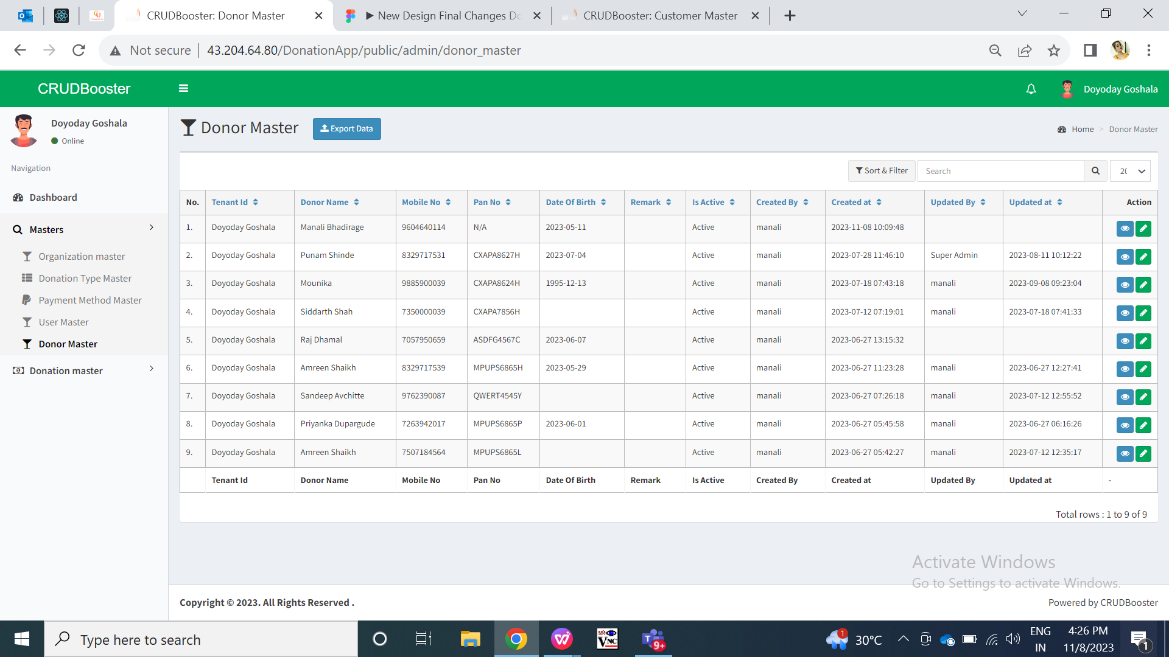

Fig: Donor master in web

Donor master will have following fields:

* Export data button
* Tenant name
* Donor name
* Mobile no.
* PAN no.
* Address
* Pin code
* DOB
* DOA
* Remark
* Is active
* Save button
* Back button
* Created at
* Created by
* Updated at
* Updated by
* View button
* Edit button

Visibility of fields in function point pages:

|  |  |  |  |  |
| --- | --- | --- | --- | --- |
| **FIELDS** | **GRID** | **VIEW** | **EDIT** | **EXPORT** |
| Export data button |  | **X** | **X** | **X** |
| Tenant name |  |  |  |  |
| Donor name |  |  |  |  |
| Mobile no. |  |  |  |  |
| PAN no. |  |  |  |  |
| Address | **X** |  |  |  |
| Pin code |  |  |  |  |
| DOB | **X** |  |  |  |
| DOA | **X** |  |  |  |
| Remark | **X** |  |  |  |
| Is active |  |  |  |  |
| Save button | **X** | **X** |  | **X** |
| Back button | **X** | **X** |  | **X** |
| Created at |  |  | **X** |  |
| Created by |  |  | **X** |  |
| Updated at |  |  | **X** |  |
| Updated by |  |  | **X** |  |
| View button |  | **X** | **X** | **X** |
| Edit button |  | **X** | **X** | **X** |

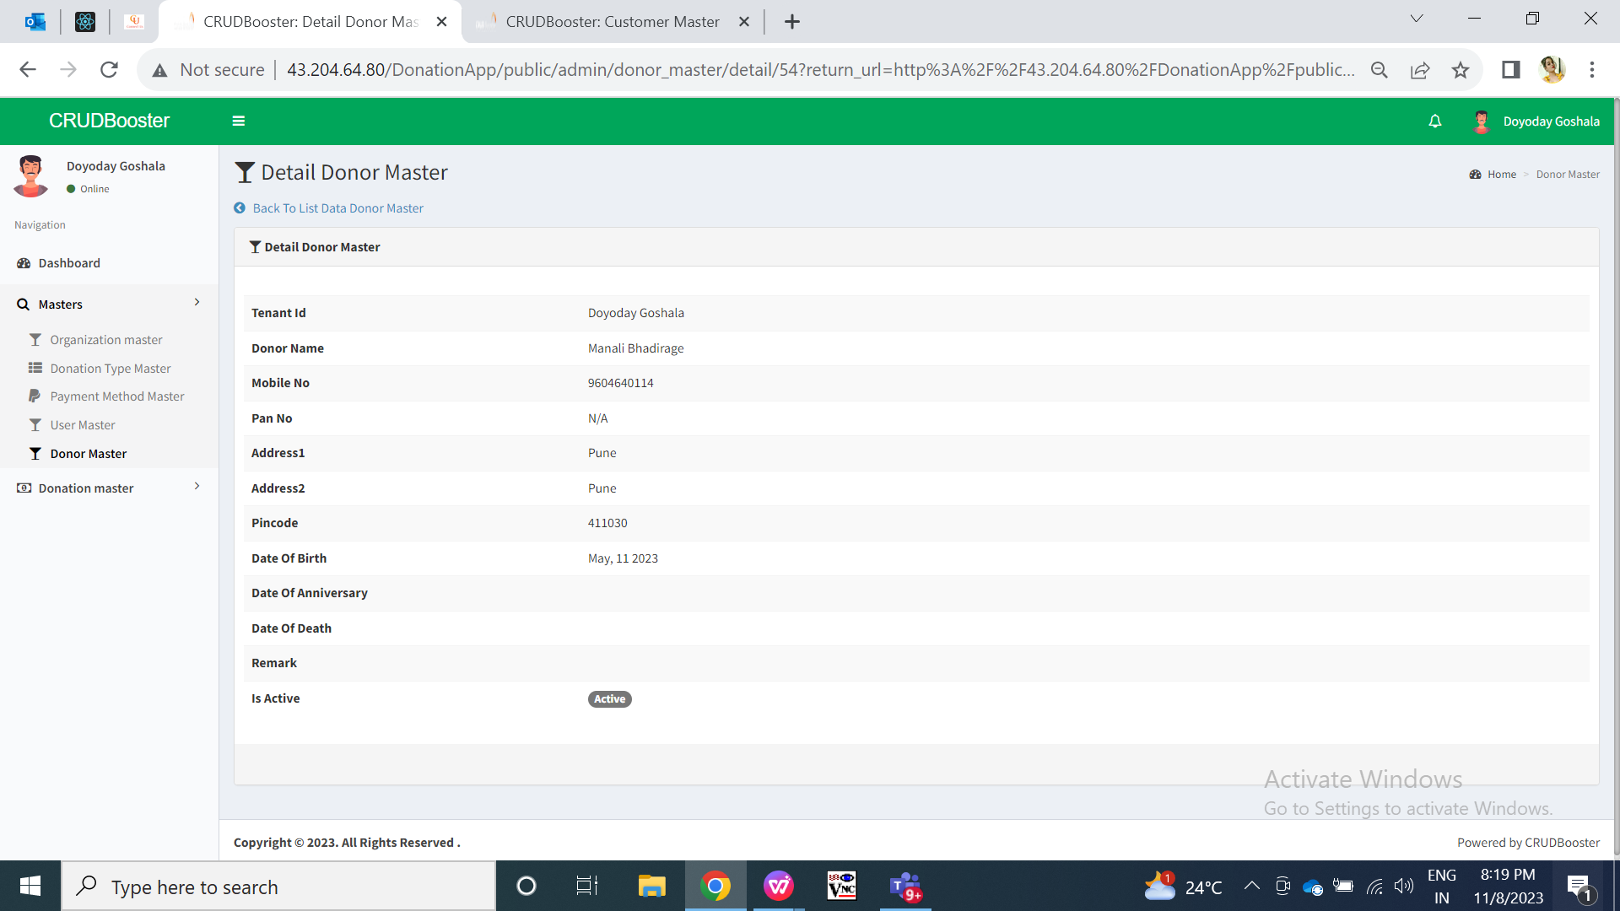

Fig: web donor master -> view

|  |  |  |  |  |
| --- | --- | --- | --- | --- |
| **FIELDS** | **INPUT TYPE** | **MANDATORY/ OPTIONAL** | **EDITABLE** | **DESCRIPTION** |
| Tenant name | Drop down | Mandatory | - | It will display the name of the tenant under whom the donor details are added.  It will be editable only to super admin.  Validation: It will be read only to tenant admin. |
| Donor name | Text | Mandatoy | yes | It will display the name of donor which was mentioned while filling the donation form with mobile number.  Tenant admin can edit donor name. Once donor name is edited and saved, updated donor name will be displayed to respective users when they will enter that donor’s mobile number.  Validation: it will accept maximum 50 characters. It shouldn’t accept special characters or numbers. |
| Mobile no. | Text | Mandatory | Yes | It will display the mobile number as entered by the user while filling donation form for the first time. Further, tenant admin can edit the mobile number.  Validation:-It should be unique for this tenant. One mobile number of donor can be used by another tenant as donor may do donations at multiple tenants. It should accept only numbers and maximum 10 digits. It should accept space. It should accept 9 or 8 or 7 or 6 only at the beginning. |
| Pan no. | Text | Mandatory | Yes | It will display the pan number of the donor as entered by user while adding donation for that mobile number. User can change pan number through donor master whereas updated pan number will be displayed on mobile app -> add donation form once related mobile number is entered by user.  Validation:- It should accept 10 characters for each tenant. It includes first five letters, followed by 4 numbers and last character. |
| Address | Text | Mandatory | Yes | It will display the address of the donor as entered by user while adding donation for that mobile number. User can change address through donor master whereas updated address will be displayed on mobile app -> add donation form once related mobile number is entered by user.  Validation:- It should accept 250 characters. It should accept 1 . , / - special characters only. |
| Pin code | Text | Mandatory | Yes | It will display the pin code of the donor as entered by user while adding donation for that mobile number. User can change pin-code through donor master whereas updated pin code will be displayed on mobile app -> add donation form once related mobile number is entered by user.  Validation:- It should accept only numbers. It should accept maximum 10 digits. |
| DOB | Calender date picker | Mandatory | Yes | Date of birth of the donor will be mentioned here.  It will display the DOB of the donor as entered by user while adding donation for that mobile number. User can change DOB through donor master whereas updated DOB will be displayed on mobile app -> add donation form once related mobile number is entered by user.  Validation:- It will display dates only till today’s / current date. Only one date will get selected and displayed in DD/MM/YYYY format. |
| Date of anniversary | Calender date picker | Optional | Yes | Date of anniversary of the donor will be mentioned here.  It will display the DOA of the donor as entered by user while adding donation for that mobile number. User can change DOA through donor master whereas updated DOA will be displayed on mobile app -> add donation form once related mobile number is entered by user. If user has not mentioned any date of anniversary while filling donation form, then it will be displayed blank in donor master.  Validation:- It will display dates only till today’s / current date. Only one date will get selected and displayed in DD/MM/YYYY format. |
| Remark | Text | Optional | Yes | Tenant admin can mention the comments for the donor through web -> donor master.  Validation: it should accept maximum 250 characters. It should accept space, numbers and special characters. |
| Is active | Radio button | Mandatory | Yes | Tenant admin can deactivate any donor. When tenant deactivates any donor, then user can add new donor and its details by using same mobile number. (Note: only one mobile number details should be active at a time as mobile number of donors has to be unique)  Validation: It will be displayed as yes when donor gets added. Only one radio button can be selected at a time. |
| Created at | Text | Mandatory | No | Once donor details are added in donation, its details will be displayed in donor master along with the date and time when donor was created in system for that tenant.  It will be displayed in grid and view action of donor master.  Validation: It will be read only. It will be displayed in DD/MM/YYYY and HH:MM:SS format. |
| Created by | Text | Mandatory | No | Once donor details are added in donation, its details will be displayed in donor master along with the name of user when donor was created in system for that tenant by that user  It will be displayed in grid and view action of donor master.  Validation: It will be read only. |
| Updated at | Text | Mandatory | - | Once donor details are edited in donor master through edit action, its details will be displayed in donor master along with the date and time when donor details were modified in system for that tenant.  It will be displayed in grid and view action of donor master.  Validation: It will be read only. It will be displayed in DD/MM/YYYY and HH:MM:SS format. |
| Updated by | Text | Mandatory | - | Once donor details are updated in donation, its details will be displayed in donor master along with the name of user when donor was updated in system for that tenant by that user  It will be displayed in grid and view action of donor master.  Validation: It will be read only. |

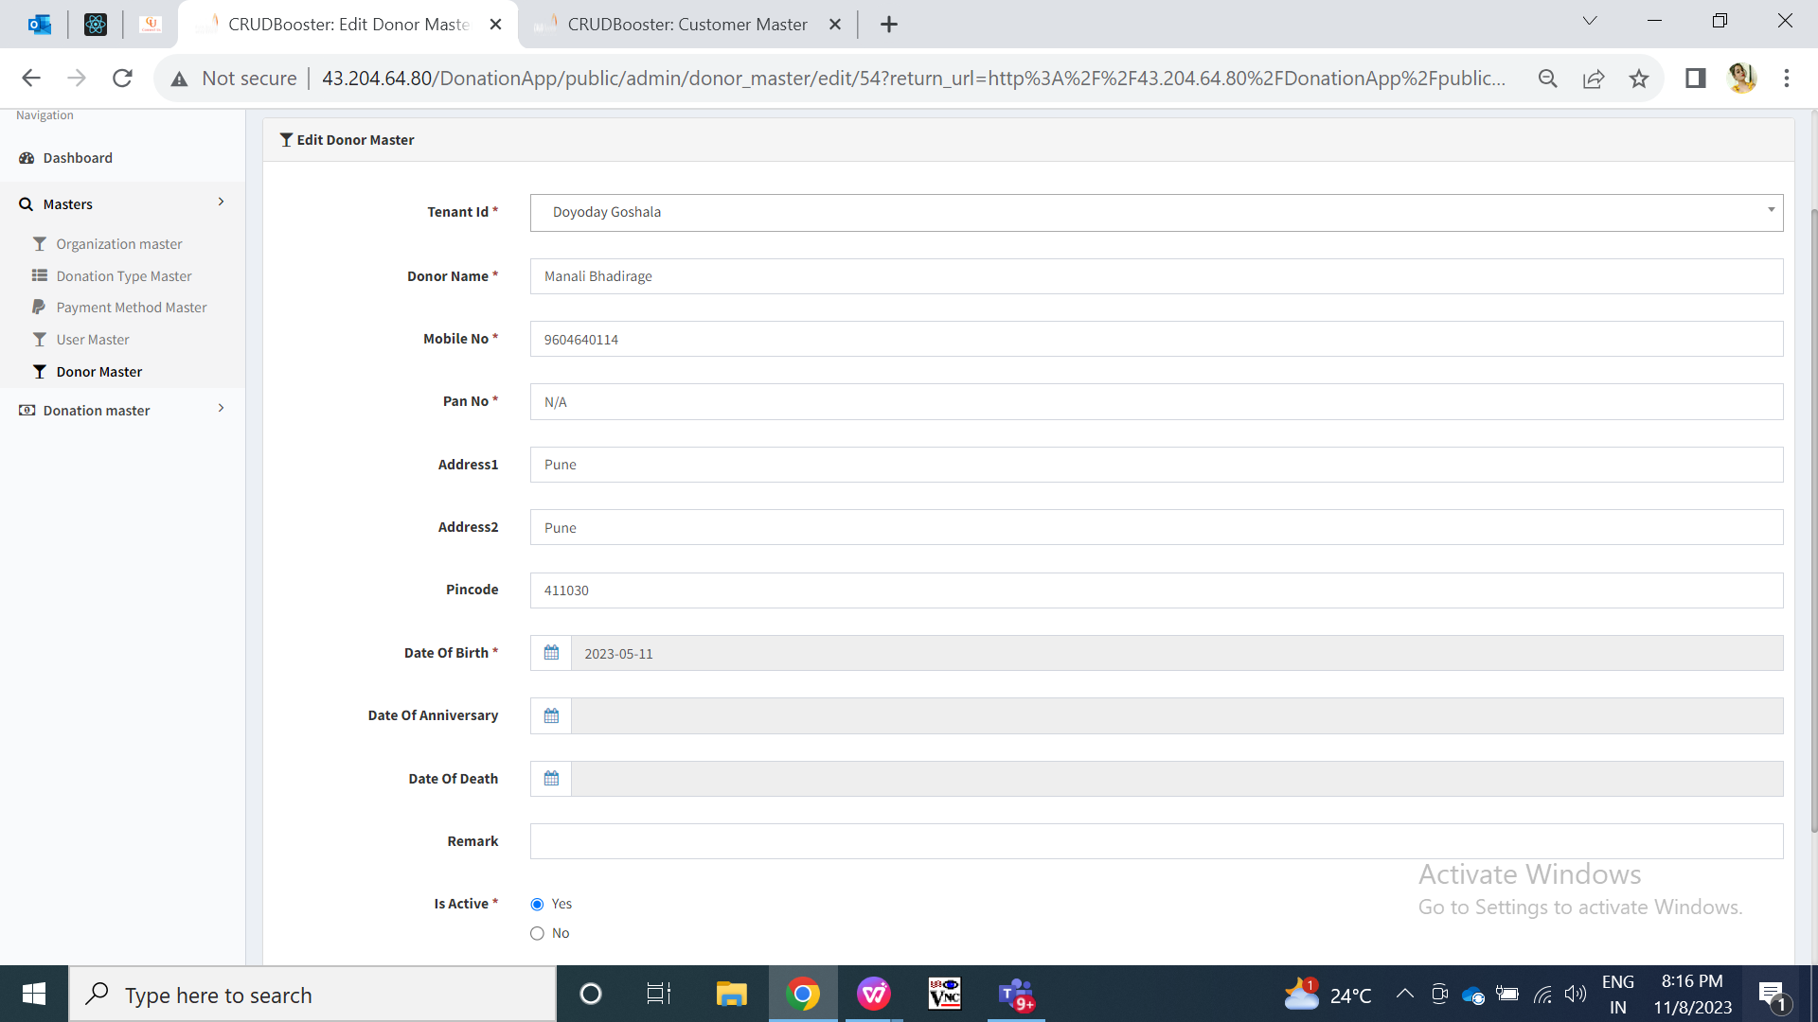

Fig: Web donor master -> edit

Step 7. Tenant can change profile details through mobile app and/or web app. Whereas, user can change login details through mobile app. It will have following fields:

* Profile image
* Delete button
* Name of user
* Email
* Mapped organization
* Mobile no.
* Whats-app no.
* New password
* Old password
* SMS before days
* Apply changes

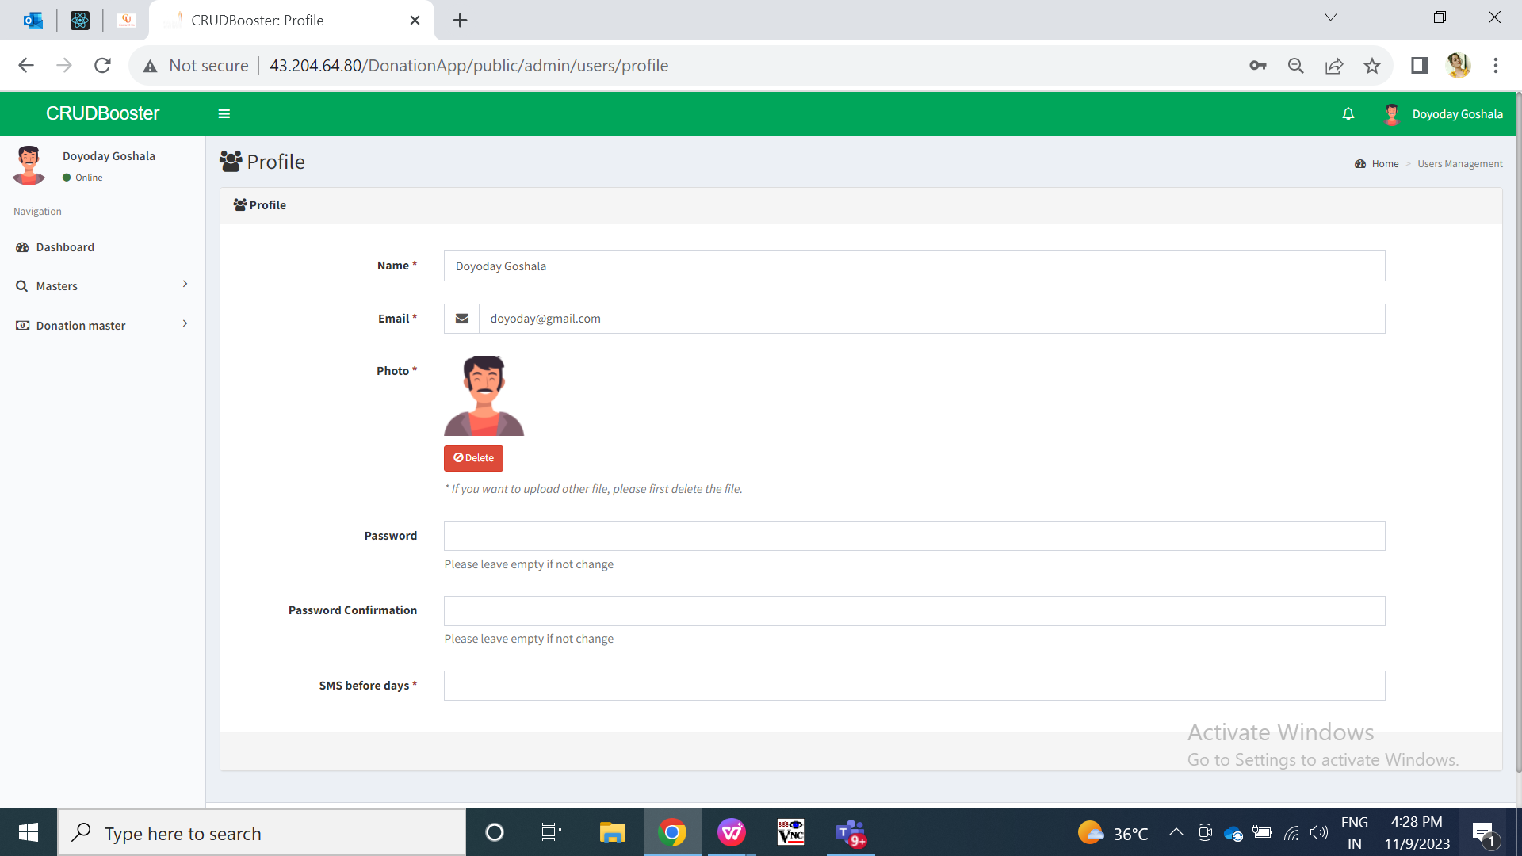

Fig: Tenant web profile

Visibility of fields in function point pages:

|  |  |  |  |
| --- | --- | --- | --- |
| **FIELDS** | **WEB: TENANT PROFILE** | **MOBILE: TENANT PROFILE** | **MOBILE & WEB : USER PROFILE** |
| Profile image |  |  |  |
| Delete button |  | **X** | **X** |
| Name |  |  |  |
| Email |  |  |  |
| Mapped organization | **X** | **X** |  |
| Mobile no. |  |  |  |
| Whats-app no. |  |  |  |
| New password |  |  |  |
| Old password |  |  |  |
| SMS before days |  | **X** | **X** |
| Apply changes | **X** |  |  |

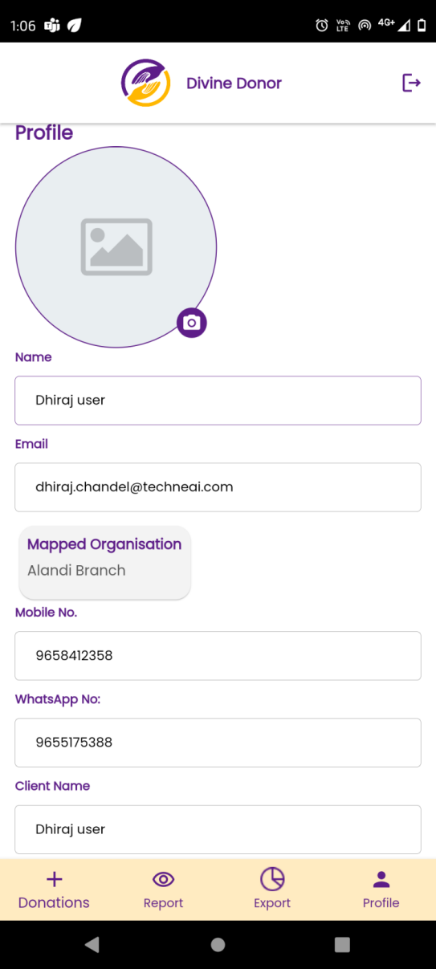

Fig: User profile in mobile app

|  |  |  |  |  |
| --- | --- | --- | --- | --- |
| **FIELDS** | **INPUT TYPE** | **MANDATORY/ OPTIONAL** | **EDITABLE** | **DESCRIPTION** |
| Profile image | Attach | Mandatory | Yes | Initially it will display the image that was attached by super admin for tenant and (by tenant admin for user’s login) while creating them.  Once tenant admin changes the image and clicks on apply changes, then updated image will be displayed in tenant’s profile i) on mobile app, ii) in grid and view action of tenant master at web app, iii) logo of mobile app in tenant master login and iv) logo of mobile app to users mapped under that tenant.  In mobile app, when tenant admin or user clicks on camera button for this field, they get option to attach the profile image either by selecting existing image from device gallery or by clicking through camera.  Validation:- It should accept png, jpg, JPEG, heic, PDF and webp extensions only. |
| Delete | click | - | - | UIt will be displayed only in web -> profile when image is already attached. Tenant admin or user can delete the already attached image and can re-upload the new one.  Validation: it will be displayed only when profile image is already attached. |
| Name | Text | Mandatory | Yes | Initially it will display the name of the tenant admin or user as entered by super admin or tenant admin while creating them respectively.  If tenant admin edits and changes the name, then the updated tenant name will be displayed in the web app and next time when tenant visits his profile page.  Validation:- It will be unique name. It should accept maximum 50 characters. It should accept characters, numbers and space. It shouldn’t accept double space after one word. |
| Email | Text | Mandatory | Yes | Initially it will display the email as entered by super admin while creating the tenant or email of the user entered by tenant admin while adding the user. This email address will be used during login.  If tenant edits and changes the email, then the updated email will be displayed in the web app and next time when tenant visits his profile page.  Validation:- It will be unique. It should accept maximum 50 characters. It should accept characters, number. It should not accept space. It should accept @ . \_ and - special characters only. |
| Mobile no. | Text | Mandatory | Yes | Initially it will display the contact no. as entered by super admin while creating the tenant or mobile number of the user as entered by tenant admin adding the user.  If tenant edits and changes the contact number, then the updated contact number will be displayed in the web app and next time when tenant admin or user visits their own profile page.  Validation:- It will be unique. It should accept maximum 10 digits. It should accept only numbers. It shouldn’t accept space / special characters / characters. It should accept only 9 or 8 or 7 or 6 at the beginning. |
| Whats-app no. | Text | Mandatory | Yes | Initially it will display the whats-app no. as entered by super admin while creating the tenant or mobile number of the user as entered by tenant admin adding the user.  If tenant edits and changes the contact number, then the updated whats-app number will be displayed in the web app and next time when tenant admin or user visits their own profile page.  Validation:- It will be unique. It should accept maximum 10 digits. It should accept only numbers. It shouldn’t accept space / special characters / characters. It should accept only 9 or 8 or 7 or 6 at the beginning. |
| Mapped organization | Text | Mandatory | Yes (by tenant admin only) | It will display the list of organizations that are mapped with the logged in user.  Tenant admin can change mapped organizations through user master -> edit action in web. Once mapped organizations are edited for the user, it will be reflected in user’s profile.  Validation: It will be read only to user. |
| New password | Text | Optional | - | If logged person want to change the password, then they have to enter the new password in this field. Once logged in person tenant enters his new password in this field and clicks on apply changes, Password will get updated successfully. Next time when user or tenant admin has logged off from the application and tries to log in, they will have to enter his recently updated means new password.  Validation:- Minimum length will be 6 digits. It should accept characters, numbers, special characters. It shouldn’t accept space. |
| Old password | Text | Optional | - | To update new password, logged in person will have to enter his old password as well. Once old password is entered correctly and tenant clicks on apply changes button, then password will get updated successfully. Next time when tenant has logged off from the mobile application and tries to log into the mobile application, tenant will have to enter his recently updated means new password.  Validation:- It has to match to the password which was set earlier. |
| SMS before days | Text | Optional | Yes | It will be displayed to tenant admin in web profile only.  Once tenant admin sets the days count here, then reminder message will be sent to their donor’s about donation prior to their date of birth. If tenant admin has set days count as 5 then message will be sent o the donors 5 days prior to their DOB.  Validation: It should accept only numbers. It should not accept any characters, space or special characters. |
| Apply changes | Click | - | - | Once logged in person has made any changes and clicks on apply changes button, then updated changes of logged in person will be reflected in profile page on web as wenn as on mobile. It will display successful pop-up messages once changes are done and saved. Also, changes will be displayed in user master or tenant master on web.  Validation:- It should disable once clicked until changes aren’t updated about profile. |

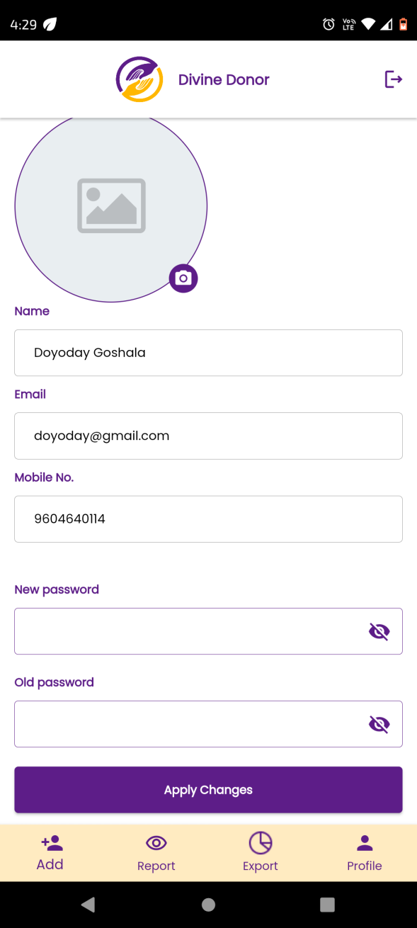

Fig: Tenant mobile profile

1. **TEST DATA AND BUSINESS SCENARIOS**