28.01.2024

EGOLD

Manali Ashok Bhadirage

Manali.bhadirage@techneai.com

**Functional Requirement Document**

**CONTENTS**

1. TICKET DETAILS 2

2. VERSION CONTROL 2

3. APPROVALS 2

4. ESTIMATION 2

5. INTRODUCTION 3

6. BUSINESS REQUIREMENT 3

7. SCOPE 3

8. BUSINESS & SYSTEM RULES 3

9. ABBREVIATIONS & TERMS 3

10. EXISTING SYSTEM 3

11. GRAPHICAL REPRESENTATION 3

12. PROPOSED SYSTEM 3

13. TEST DATA 4

14. ODUS 4

15. REFERENCES OF THE USERS 5

1. **TICKET DETAILS**

|  |  |
| --- | --- |
| **Ticket ID** | TT13173 |
| **Ticket description** | Kindly check attached eGold Requirements for Aadhar card authentication document. |
| **Created by** | Sayali Kasture |
| **Created on** | 14/06/2023 |
| **Priority** | Very high |

1. **VERSION CONTROL**

|  |  |  |  |  |
| --- | --- | --- | --- | --- |
| **Sr. No** | **Version no** | **Version Date** | **User name** | **User department** |
| **1** | **1.0** | **28/01/2023** | **Yogesh Shah** |  |
|  |  |  |  |  |

1. **APPROVALS**

|  |  |  |
| --- | --- | --- |
| **Field** | **Name of the User** | **Approved date by the user** |
| **Actual User Name Actual User Department Organization Name** | Yogesh Shah  CSJ |  |
| **Assigned BA** | Manali bhadirage |  |
| **Assigned Developer** | Jaydeep Patil |  |
| **Assigned Tester** | Uttareshwar Bhusari |  |

1. **ESTIMATION**

|  |  |  |  |  |
| --- | --- | --- | --- | --- |
| **Department name** | **Estimated Time (In hr)** | **Scheduled Date (Starting date)** | **Estimated date** | **Actual delivery date** |
| **BA** |  |  |  |  |
| **Development** |  |  |  |  |
| **Testing** |  |  |  |  |

1. **INTRODUCTION**

We have introduced the E-gold mobile application. This innovative platform enables customers to seamlessly register, engage in online buying and selling of precious metals such as gold and silver, and stay informed about live market rates. Additionally, customers have the convenience of choosing to have their purchased metals delivered to their doorstep. Our application guarantees reliable quality, providing a 100% assurance and ensuring the utmost security on all transactions. In addition to this, customers can buy gold & silver by setting monthly EMIs and also can send e-gifts to their closed ones.

1. **BUSINESS REQUIREMENT**

|  |  |  |  |
| --- | --- | --- | --- |
| **Requirement ID** | **Requirement Name** | **Short Description** | **Priority** |
| BR001 | Registration & KYC |  |  |
| BR002 | Login |  |  |
| BR003 | Dashboard |  |  |
| BR004 | Live rates |  |  |
| BR005 | Buy |  |  |
| BR006 | Sell |  |  |
| BR007 | Delivery |  |  |
| BR008 | SIP |  |  |
| BR009 | Bank settings |  |  |
| BR010 | Preference settings |  |  |
| BR011 | Nominee settings |  |  |
| BR012 | Tenant settings |  |  |
| BR013 | Help Desk |  |  |
| BR014 | Profile |  |  |
| BR015 | Transaction report |  |  |
| BR016 | Customer master |  |  |
| BR017 | Tenant master |  |  |
| BR018 | Customer liability report |  |  |
| BR019 | Customer ledger report |  |  |

1. **SCOPE**

Customer will be able to register himself using the aadhar number and linked mobile number. Customer will further be able to log into app using mobile number after successful registration. Further, customer will be able to view sell rate of gold and silver on dashboard along with banners, features and functionality buttons of bug, sell, rate trigger as per tenant’s settings. Custromer will view details in profile as per aadhar number. Further, customer will be able to buy or sell metal. Weight balance will be displayed in your trades. Customer can set the rate at which they want to receive the message through rate alert option. Customer ha sprovision to add bank and nominee through settings. Moreover, customer can contact tenant via email or call through help desk option.

Tenant has customizable settings through web which will be reflected on mobile app to customers. Tenant can view customer details through customer master and have access to transaction reports, liability report and customer ledger report.

1. **BUSINESS & SYSTEM RULES**

* User should be registered in the system.
* User should be logged in.
* System should display error message for incorrect details if entered.
* Customer can register for multiple tenants using same mobile and aadhar number.

1. **ABBREVIATIONS & TERMS**

Cx - Customer

OTP - One time password

KT - Karat

Wt - Weight

Gm - Grams

SIP - Systematic investment plan

KYC - Know Your Customer

PAN - Permanent Account Number

1. **EXISTING SYSTEM**

Enter all the data related to the existed system and attach all the necessary attachments provided by the user.

1. **GRAPHICAL REPRESENTATION**

Draw the necessary the user interface design using figma, paint, etc. (UI Design / Flowchart / Use case diagram / activity diagram, etc. any one)

1. **PROPOSED SYSTEM**
2. **Register**

User will have to first register himself using mobile no. and aadhar no.to further log into mobie app. It will have following fields:

* Aadhar number
* Mobile number
* Continue button

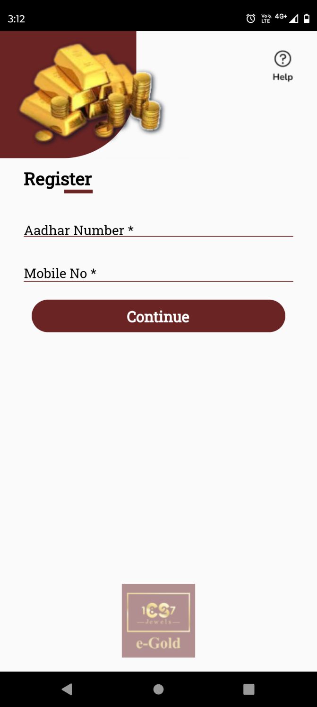

Fig: Register

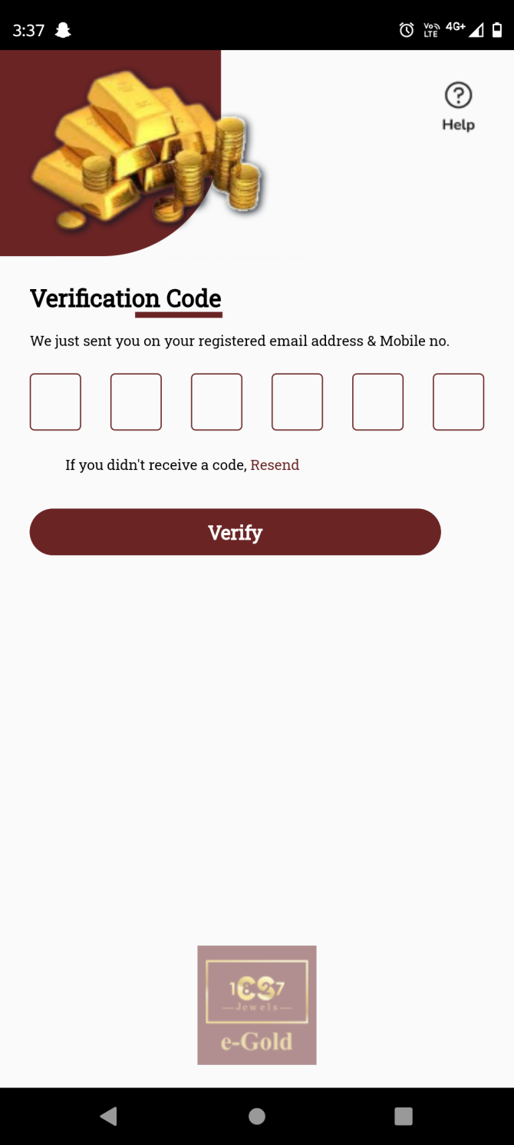

Fig: Verify OTP

**Input table**

|  |  |  |  |  |
| --- | --- | --- | --- | --- |
| **FIELDS** | **INPUT TYPE** | **MANDATORY/ OPTIONAL** | **EDITABLE** | **DESCRIPTION** |
| Aadhar number | Text | Manadatory | Yes | Customer will eneter the regsitered aadhar number against which account is to be created.  Once customer enters aadhar number and clicks on submit, it will display on field error message if the entered aadhar number doesn’t exist or if user has not entered all digits.  Validation: It will accept only numbers. It will accept compulsorily 12 digits. |
| Mobile number | Text | Manadatory | Yes | Customer will enter the mobile number which is registered against the entered aadhar number.  If customer enetrs aadhar number and enters another mobile number which is not linked, then it will display alert message as ‘mobile number not linked with this aadhar number’.  Validation: It will accept numbers only. It will accept max & min 10 digits. |
| Submit | Click | - | - | Once customer enters valid aadhar number and mobile number and clicks on submit button, OTP will get sent to entered mobile number via SMS and user will be directed to verification code page.  If customer enters incorrect aadhar / mobile number and clicks on submit, it will display on field validation error message.  Validation: Once customer clicks on submit button, it should be disabled until user is directed to further page or until error message is displayed in case of invalid details. |
| Verification code | Text | Mandatory | - | Customer will enter the OTP code here which is sent on the registered number via SMS.  If customer enters incorrect OTP and clicks on verify button, then it will display on field error message as incorrect OTP.  Validation: It will accept numbers only. Man & min length = 6 digits. |
| Verify | Click | - | - | Once user eneters valid OTP and clicks on verify button, succesful message will be displayed and customer will get registered under the tenant. Customer’s details will be displayed in customer master of web for that tenant as well as will be displayed in profile once customer logs in. As per successful registration, user can log in by using the registered mobile number.  If customer enters incorrect OTP and clicks on verify button, then it will display on field error message as incorrect OTP. |

As customer registers using aadhar card number, it is considered as KYC done and thus his KYC status is being displayed as accepted in customer master of that tenant.

1. **Sign in**

User can sign in using registered mobile number on which an OTP will be sent. Sign in page has following fields:

* Mobile no.
* Send OTP button
* Register button
* Help icon

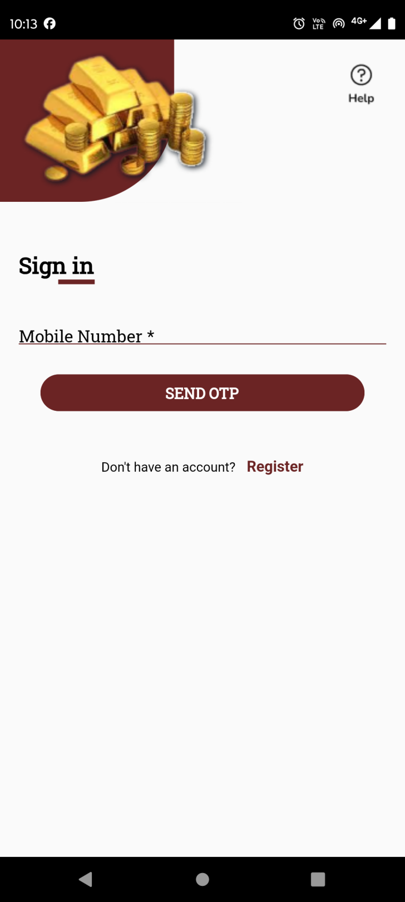

Fig: Sign In

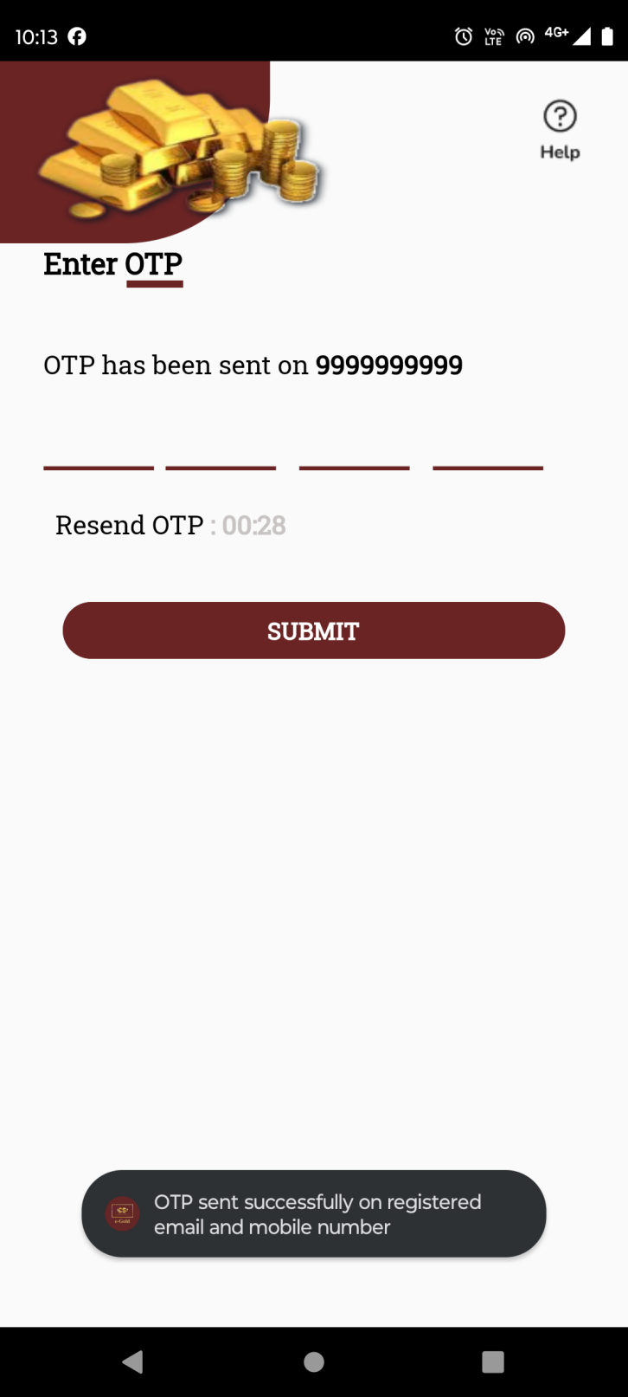

Fig: Enter OTP

|  |  |  |  |  |
| --- | --- | --- | --- | --- |
| **FIELDS** | **INPUT TYPE** | **MANDATORY/ OPTIONAL** | **EDITABLE** | **DESCRIPTION** |
| Mobile number | Text | Manadatory | Yes | Customer will enter the mobile number by which he has registered.  Once customer enters valid registered number and clicks on send button, OTP will be sent on that number via SMS and user will be directed to the page to enter the sent OTP.  If customer enters mobile number by which any ciustomer is not registered yet and clicks on send OTP button, then it will display pop up error message as ‘mobile number not resgistered’. If customer enters less than 10 digits and clicks on send buttton, it will display on field validation error message.  Validation: It will accept numbers only. It will accept max & min 10 digits. |
| Send OTP button | Click | - | - | Once customer enters valid registered number and clicks on send button, OTP will be sent on that number via SMS and user will be directed to the page to enter the sent OTP. |
| Enter OTP | Text | Mandatory | No | Once cx eneters valid registered mobile number and clicks on send button, OTP will get sent to the customer’s mobile number and cx will be directed to enter OTP page. Customer will have to enter 4 digit correct OTP within 30 seconds and click on submit button to log into the app.  If cx enters invalid OTP and clicks on submit button, it will display pop up error message as invalid OTP. |
| Resent OTP button | Click | - | - | Once cx eneters valid registered mobile number and clicks on send button, OTP will get sent to the customer’s mobile number and cx will be directed to enter OTP page where timer of 30 seconds will run in descending order.  Timer will be reset to 00:00 if cx doesn’t enter valid OTP and click on submit button. To crete new OTP, cx will have to click on resend OTP button. Once cx clicks on resend OTP button, new OTP will be sent to cx via SMS and timer will restart again in decremetal order from 30.  Validation: Resend OTP button will be enabled only when time is 00:00. |
| Submit button | click | - | - | Once user enters valid OTP number and clicks on submit button, succesful message will be displayed and cx will be directed to dashboard of the application.  Validation: Submit button will be disabled until user is directed to dashboard or until error message is displayed in case of incorrect OTP number. |
| Help icon | Click | Optional | - | Cx can contact the help desk / support team of the tenant via email or call through this option. |

1. **Dashboard**

Once cx logs into the app, he will be directed to the dashboard page. It will consist of following menus:

* Live rate of gold and/or silver
* Banners
* Buy and/or Sell and/ or SIP button
* Rate alert button
* Features
* Tenant logo

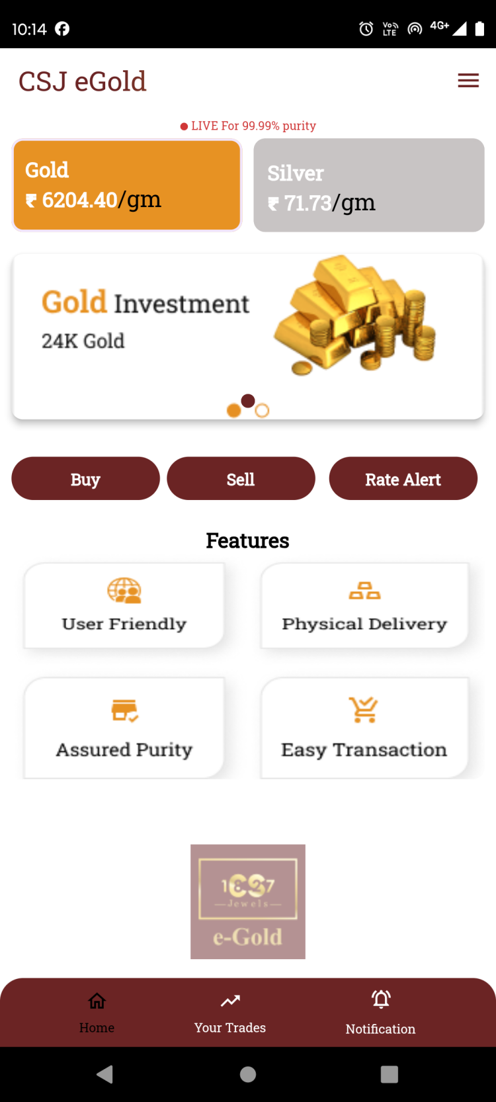

Fig: Dashboard

|  |  |  |  |  |
| --- | --- | --- | --- | --- |
| **FIELDS** | **INPUT TYPE** | **MANDATORY/ OPTIONAL** | **EDITABLE** | **DESCRIPTION** |
| Live rate of gold and/or silver | Text | - | By tenant through customer type setting | It will display live purchase rates of gold and silver per gram with 99.99% purity.  Gold and/ or silver cards will be displayed as per tenant’s commodity settings. If tenant only sets Gold as active commodity, then only card for Gold live rate will be displayed on dashboard to all customers of that tenant.  Rates displayed will be different for each tenant as per settings done by tenant in back-end web app through tenant’s customer type setting. |
| Banners / sliders | Image | Mandatory (min 1 image) | By tenant through banner setting | Sliders will be different for each tenant where tenant will display images related to their offers / new features / etc.  It will be changed from tenant’s web -> settings -> dashboard -> banner.  Validation: It will be view only. Min = 1 image  Max = 4 images. |
| Buy button | Click | - | - | Customer can purchase metal during the timing set by the tenant just by entering either amount or metal weight and book gold or silver in his account after completing transaction.  The button will be displayed as set active by the tenant in functionalty setting. |
| Sell button | Click | - | - | Customer can sell the metal out of the purchased metal just by entering either amount or metal weight. Whereas, amount will be credited during set business days in cx account as selected during transaction.  The button will be displayed as set active by the tenant in functionalty setting. |
| SIP button | Click | - | - | Once customer clicks on SIP button, customer can select date, tenure and amount for auto purchasing the metal each month.  The button will be displayed as set active by the tenant in functionalty setting. |
| Rate alert | Click | - | No | Customer can set the rate triggers for which wants to receive as notification so that it will be useful for customer to analyze uy and sell.  Customer can set multiple alerts for silver and gold individually each. Once the rate matches as per set trigger, then notification will be sent to customer only one time and then the set trigger will get disabled and also will be saved in rate trigger history. |
| Features | Image | - | By tenant through feature setting | Tenant will add the images displaying the features of the application which are read only.  It will be changed by tenant through feature settings. |

1. **Profile**

Cx can view and update its details through profile. The updated details of the customer will be reflected in tenant’s customer master once saved. Profile page has following fields:

* Profile image
* Cx name
* Aadhar number
* Pan number
* KYC status
* Address
* Pin code
* Country
* State
* City
* Mobile no.
* Whatsapp no.
* DOB
* DOA
* Gender
* PAN no.
* Email
* Occupation
* Save button

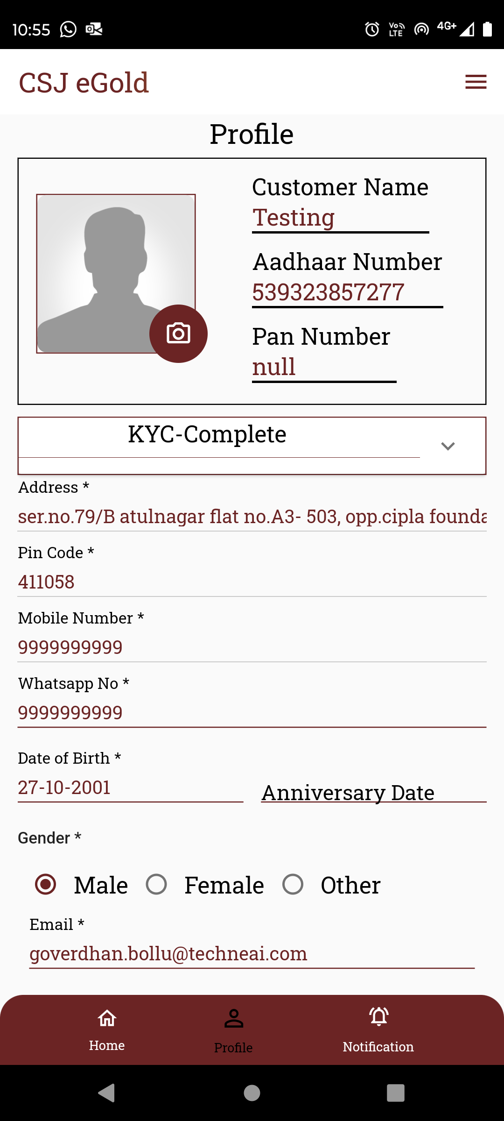

Fig: Profile

|  |  |  |  |  |
| --- | --- | --- | --- | --- |
| **FIELDS** | **INPUT TYPE** | **MANDATORY/ OPTIONAL** | **EDITABLE** | **DESCRIPTION** |
| Profile image | Upload | Optional | Yes | Cx will attach his profile image through here.  Initially when cx registers himself, the profile image field is displayed blank bydefault when cx gets created.  Once cx clicks on camera icon on profile image, it will display options to either attach image from camera or through gallery. Once user selects image or clicks image and clicks on ok, it will be displayed on profile page.  Validation: Only one image can be set at a time. It will accept only jpg, png, heic, heif, webp and jpeg extensions only. |
| Cx name | Text | Mandatory | No | It will display the cx name as per aaadhar number entered while registering.  Validation: It will be read only to customer and can be edited only by the tenant admin through customer master in web. |
| Aadhar number |  |  |  | It will display the aaadhar number entered by cx while registering.  Validation: It will be read only to customer and can be edited only by the tenant admin through customer master in web. |
| Pan number |  |  |  | PAN number will be entered by the cx in the profile. It will be null initially. Whereas, once user enters valid PAN number in the form ans saves it, it will be displayed here. Once PAN number is saved, it will also be displayed in tenant’s customer master against that cx details.  Validation: It will be read only above whereas can be editted through field in the form. |
| KYC status | Text | Mandatory | No | It will display that status whether the cx verification is done using documents or not. As cx registers using aadhar number and further details are being displayed in profile as per aadhar number, KYC status is being displayed as completed. |
| Address | Text | Mandatory | No | It will display the address as per aadhar number. |
| Pin code | Text | Mandatory | No | It will display the pin code number as registered on the aadhar. |
| Country | Text | Mandatory | No | It will display the country name from pin code as mentioned in the aadhar number. |
| State | Text | Mandatory | No | It will display the state name from pin code as mentioned in the aadhar number. |
| City | Text | Mandatory | No | It will display the city name from pin code as mentioned in the aadhar number. |
| Mobile no. | Text | Mandatory | No | It will display the mobile number entered while registration. |
| Whatsapp no. | Text | Mandatory | Yes | Initially it will be blank whereas cx will enter the Whatsapp no. here.  It will display on field validation error message in case user doesn’t enter this number before saving or in case user has not 10 digits.  Validation: It will accept only numbers. It should only accept 7 / 8/ 9 as first digit.  Min & Max length = 10 |
| DOB | Date calender picker | Mandatory | No | It will display customer’s date of birth as per aadhar number. |
| DOA | Date calender picker | Optional | Yes | Cx can enter the Doate of anniversary if applicable. Its format will be DD/MM/YYYY.  Validation: One one date can be selected. It will enable dates till today and future dates will be disabled. |
| Gender | Radio button | Mandatory | No | It will display geneder as male / female / other from aadhar number. |
| PAN no. | Text | Mandatory | Yes | Cx will enter PAN number as it is needed for verifying transactions above 2 lakhs.  In case of invalid pan card number format, it should display error message as “Invalid pan number”. If user enters same pan number which is already added in another cx account, then it should display on field error message as PAN number already exists.  Validation: Customer will enter 10 digit alphanumeric PAN No. of nominee. PAN number should be unqiue in cx master. It includes first five letters, followed by 4 numbers and last character. |
| Email | Text | Optional | Yes | Cx will enter valid email address so as to receive notifications on it.  Validation: It should be unique in cx master. This field should accept “ @ - . “ only as special characters. In case of invalid format, it should display on field error message as “Invalid email address”. It shouldn’t accept space anywhere. It should be unique. Maximum length of input field should be 50 characters. |
| Occupation | Drop down | Optional | Yes | Cx will mention his oocupation for the tenant’s reference.  Validation: It will display active occupations from occupation master. It will be single select. |
| Save button | Click | - | - | Once cx enters valid mandatory details and clicks on save button, succesful message will be displayed and updated details will be displayed in profile as well as in cx master.  Validation: Save button will be disabled until succesful message is disaplyed or error message is displayed in case of invalid details if entered. |

1. **Help Desk**
2. **About Us**
3. **Settings - Nominee settings**
4. **Settings - Bank account settings**
5. **Settings - Preference settings**
6. **Buy**
7. **Sell**
8. **SIP**
9. **Delivery**
10. **Your trades**
11. **TEST DATA & SCENARIOS**

Multiple examples can be mentioned in sheet. Provide multiple scenarios for each field in the module. Input value and expected output value should be specified. Live examples in existing or alternative system should be provided if possible.



1. **ODUS (Open Discussion Unhandled scenarios)**

ODUS sheet will contain questions raised by team which needs to be confirmed from user, points to be discussed with user, confirmation of points which isn’t given from user yet.

|  |  |  |  |  |
| --- | --- | --- | --- | --- |
| **Sr. No.** | **Topic** | **Priority**  **(High / medium / low)** | **Remark** | **Status**  **(Open/**  **Closed)** |
| 1 | Date : Query and its description |  | Write solution which is decided by user or head or us. | Open for queries which are recently asked and which are pending. |
| 2 |  |  |  |  |
| 3 |  |  |  |  |

1. **REFERENCES OF THE USERS**

|  |  |  |  |
| --- | --- | --- | --- |
| **User** | **Name** | **Mail** | **Contact number** |
| **Actual user** |  |  |  |
| **Ticket created by (if any)** |  |  |  |
| **Assigned business analyst** |  |  |  |
| **Assigned developer** |  |  |  |
| **Assigned tester** |  |  |  |