05.02.2024

Anup Deotale

anup.deotale@techneai.com

Door to Door Activity

**Functional Requirement Document**

**CONTENTS**

1. TICKET DETAILS 2

2. VERSION CONTROL 2

3. APPROVALS 2

4. ESTIMATION 2

5. INTRODUCTION 3

6. BUSINESS REQUIREMENT 3

7. SCOPE 3

8. BUSINESS & SYSTEM RULES 3

9. ABBREVIATIONS & TERMS 3

10. EXISTING SYSTEM 3

11. GRAPHICAL REPRESENTATION 3

12. PROPOSED SYSTEM 3

13. TEST DATA 4

14. ODUS 4

15. REFERENCES OF THE USERS 5

1. **TICKET DETAILS**

|  |  |
| --- | --- |
| **Ticket ID** | [TT19167](http://3.108.206.34/TechTicket/Ticket/View/17230) |
| **Ticket description** | Need to redefine D2D app Fields as per attach format 1. If User select "Locate Me" Option then all fields are require like ( Address , city , pin code ) 2. If "Locate Me" is not assess-able for user due to Network Issue then Only Pin Code Option is assess-able for data entry filling. 3. In D2D App please create login credential for the user and link with Emp id and branch if we do this in d2d app then at the time of data filling emp id and branch will come automatically. |
| **Created by** | Anup Deotale |
| **Created on** | 05/02/2024 |
| **Priority** | Very high |

1. **VERSION CONTROL**

|  |  |  |  |  |
| --- | --- | --- | --- | --- |
| **Sr. No** | **Version no** | **Version Date** | **User name** | **User department** |
|  | **1.0** | **05/02/2023** |  |  |
|  |  |  |  |  |
|  |  |  |  |  |

1. **APPROVALS**

|  |  |  |
| --- | --- | --- |
| **Field** | **Name of the User** | **Approved date by the user** |
| **Actual User Name Actual User Department Organization Name** | Dinesh Sonawane  Data Analyst  CSJ |  |
| **Assigned BA** | Anup Deotale |  |
| **Assigned Developer** | Mustafa Sayyam | - |
| **Assigned Tester** | - |  |

1. **ESTIMATION**

|  |  |  |  |  |
| --- | --- | --- | --- | --- |
| **Department name** | **Estimated Time (In hr)** | **Scheduled Date (Starting date)** | **Estimated date** | **Actual delivery date** |
| **BA** |  |  |  |  |
| **Development** |  |  |  |  |
| **Testing** |  |  |  |  |
|  |  |  |  |  |

1. **INTRODUCTION**

D2D mobile app is generally used by CSJ sales team for collecting the customers data during an event. Salesperson fill up the customers data in form, submits it and gets displayed is Connect us -> D2D report. Further, this data is used for marketing purpose by marketing and sales team. The user should have the capability to log in to the system using the employee name and password retrieved from the user management connect us 1.0. Upon successful login, the user can input data, and for the location, they should be able to click the "locate me" button to fetch the current location. In case of network issues, the user can manually select the location, and the pin-code will be entered manually.

1. **BUSINESS REQUIREMENT**

* Employees should be able to login into D2D mobile app using their username and password as in Connect US 1.0.
* The D2D app must provide a "locate me" feature allowing users to automatically fetch their current location.
* When users manually select a location from drop-down, and will manually enter the pin code.

|  |  |  |  |
| --- | --- | --- | --- |
| **Requirement ID** | **Requirement Name** | **Short Description** | **Priority** |
| BR001 | Location Master | A list of location names will be added. | High |
| BR002 | Login | The user must be able to login into the d2d application by using their username and password. | High |
| BR003 | Locate me | The user must be able to click the Locate Me button, which will retrieve the user’s current location. | High |
| BR005 | Report | All fields should be displayed in report. |  |

1. **SCOPE**

The goal of the project is to make a user-friendly system. It will have features like a safe login using employee details, options for location services (both automatic and manual), a way to input data, automatic pin code retrieval, strong error handling for network problems, secure authentication, an easy-to-use interface, recording user actions, and connecting with the user management connect us 1.0.

1. **BUSINESS & SYSTEM RULES**

* User should be registered in the system.
* User should be logged in.
* System should display error message for incorrect details if entered.
* All forms should have on field validations. System should display on field errors in case of incorrect inputs.
* In case of network issue, correct alert message should be displayed in application.

1. **ABBREVIATIONS & TERMS**

D2D - Door to Door

1. **EXISTING SYSTEM**

Currently, there is not login credentials for users and hence we are unable to analyze the exact employee who has added the record of the customer into the system. Hence, to be precise and for security purpose, user login is needed in D2D app. Moreover, users are unable to specify the customer’s address when there is network issue. Thus, there falls a need to provide manual field where user should be able to mention the location of the customer and his pin code.

1. **GRAPHICAL REPRESENTATION**

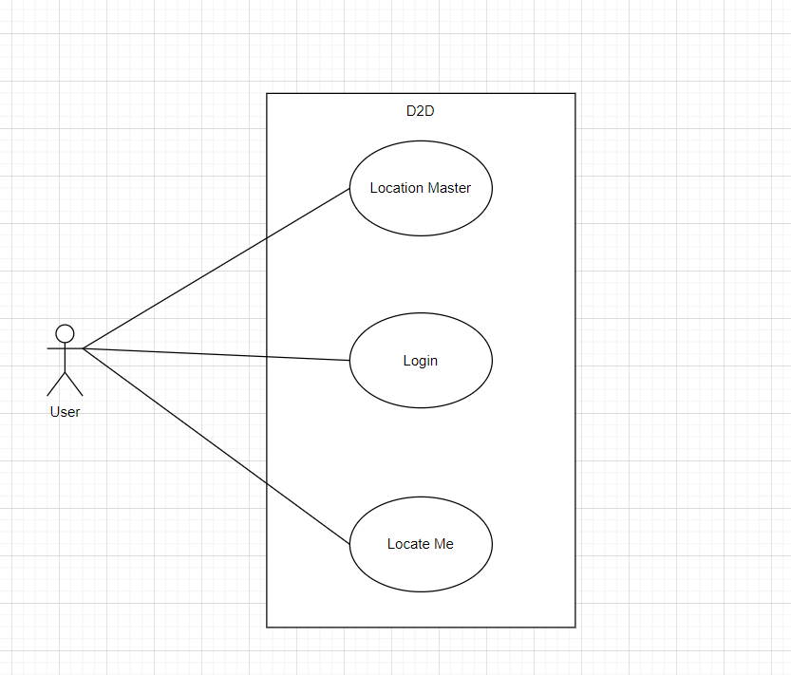

Fig - Graphical Representation

1. **PROPOSED SYSTEM**

**BR001 - Location Master -**

We need to create location master in connect us 1.0 so that these locations will be displayed in D2D form while adding customer’s data. The location master is a list of locations with the following fields:

* Export
* Add data
* View
* Edit
* Location name
* Status
* Remark
* Created by
* Created at
* Updated at
* Updated by

**Input Data -**

|  |  |  |  |  |
| --- | --- | --- | --- | --- |
| **FIELDS** | **INPUT TYPE** | **MANDATORY/ OPTIONAL** | **EDITABLE** | **DESCRIPTION** |

|  |  |  |  |  |
| --- | --- | --- | --- | --- |
| Add Data | Button | - | - | The user will add the Location by clicking on “add data” button. |
| Export | Button | - | - | The export button export the data available in the grid view |
| Sr No | Auto | - | - | The serial number is made up of the numbers who will count the number of location details. |
| Location | Text | Mandatory | Yes | The user will enter the location name into the system.  Validation-  Accepts only alphabets and space up-to 50. It should be unique. |
| Remark | Text | Optional | Yes | If the user want to add a specific remarks they will do so.  Validation:  It must contain alpha-numeric data with special characters up-to 250 characters. It should accept Marathi and English script. |
| Is Active | Radio button | Mandatory | Yes | The user will select "Is Active" status that provides options for both active and inactive status, determining the current status of the location.  If the user selects active as status then it will display in drop down menu of d2d -> add customer data form -> location field.  If the user selects inactive as status then it will not display in drop down of location field.  Validation -  By default, the status will be active. It will be single select. |
| Created at | Auto | - | - | The date and time when the location is created by the user is displayed.  Validation:  The format will be displayed in DD-MM-YYYY HH:MM:SS format. |
| Created by | Auto | - | - | The username who created the location is displayed. |
| Updated at | Auto | - | - | The date and time when the location is updated last is displayed.  Validation:  Format - YYYY-MM-DD HH:MM:SS |
| Updated by | Auto | - | - | The username who last updated the location is displayed. |
| Action  - View | Button | - | - | Once the user clicks on “View” Button then the user will be able to view the location details. Once user clicks on view action, it will display following fields:  Location name  Remark  Status  Created at  Created by  Updated at  Updated by |
| Action  Edit | Button | - | - | Once the user clicks on “edit button” Button then the user will be able to edit the location details where it will display the already entered data in fields. It will display following fields:  Location  Remark  Status  Save button  Back button |
| Save | Button | - | - | The user must be able to click on the "Save" button.  When the user clicks the Save button, the data gets saved to the system and displayed at the top of the grid view along with succesful message. |
| Save & More | Button | - | - | The user must be able to click the "Save & More" button.  When the user clicks the save & more button, the data is saved into the system, and the user can add more details to it along with successful message. |
| Back | Button | - | - | The user must be able to click the "Back" button.  Once the user clicks the back button, the data will not be saved and user will be redirected to the grid page. |

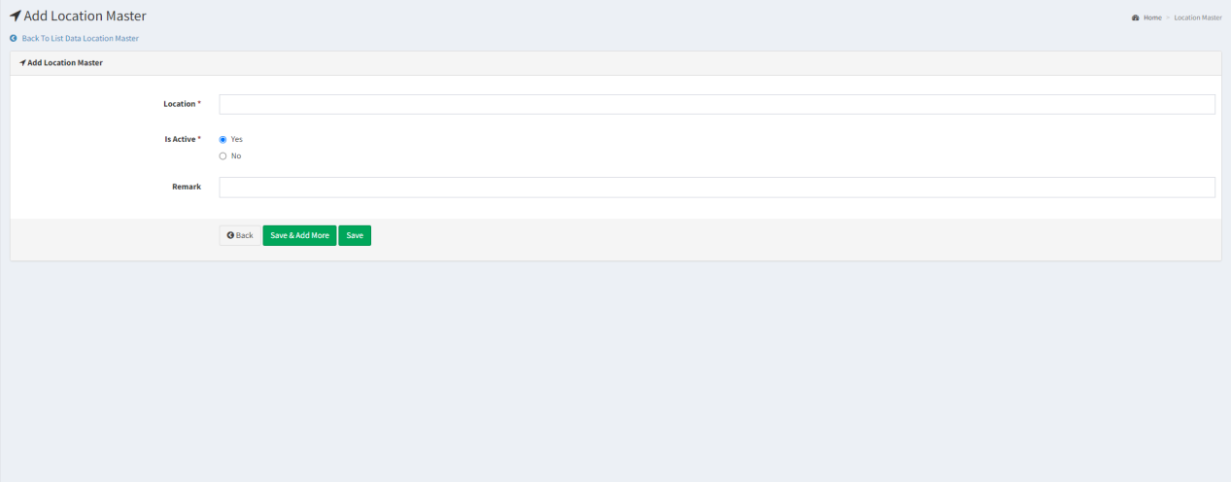

Fig - Location Master

**BR002 - Login -**

The active users must login into the D2D Application using the username and password, which will be fetched from the user management connect us 1.0.

The login page consists of the following fields.

* Username
* Password
* Sign in button

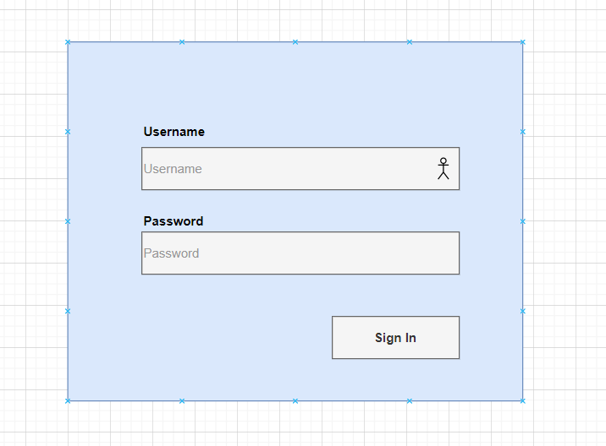

Fig - D2D app -> login Page

|  |  |  |  |  |
| --- | --- | --- | --- | --- |
| **Fields** | **Input type** | **Mandatory/ Optional** | **Editable/ No** | **Description** |
| Username | Text | Mandatory | - | The user must be able to enter a user name that has already been added to the user management.  Validation:  It must contain alpha-numeric with special characters.  A system error must occur whenever a user enters the incorrect username.  “Please enter a correct username.” |
| Password | Text | Mandatory | - | The user must be able to enter a password that has already been added to the user management.  Validation:  Accepts alpha-numeric data and special characters minimum of 8 characters.  A system error must occur whenever a user enters the incorrect password.  “Please enter a correct password.” |
| Sign in | Button | - | - | Once the user enter valid username and password the user must be able to click on “ Sign in” button.  In case user enters incorrect username and password and clicks on sign in button, it should display on field error message and user should not get logged in. |

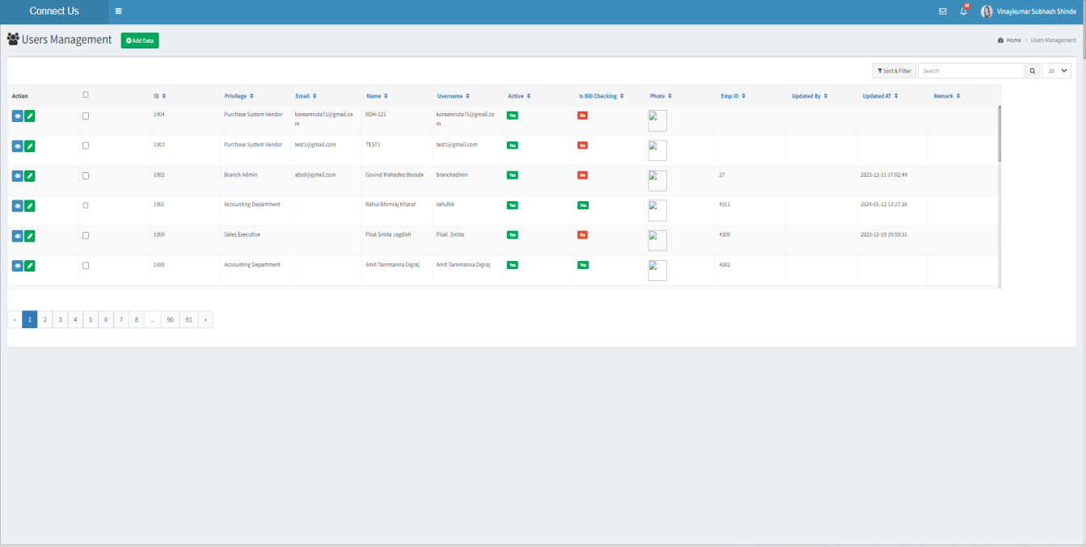

Fig: Connect Us 1.0 -> Users management

Once the user clicks on sign in button after entering credentials, the user will be directed to D2D add customer’s data form. It will have following fields-

* Mobile
* First Name
* Middle Name
* Last Name
* Occupation
* Gender
* Date of Birth
* Date of Anniversary
* Address Line 1
* Address Line 2
* Locate me button
* City
* Location
* Pincode
* State
* Employee Name
* Employee ID
* Event
* Branch
* Submit button

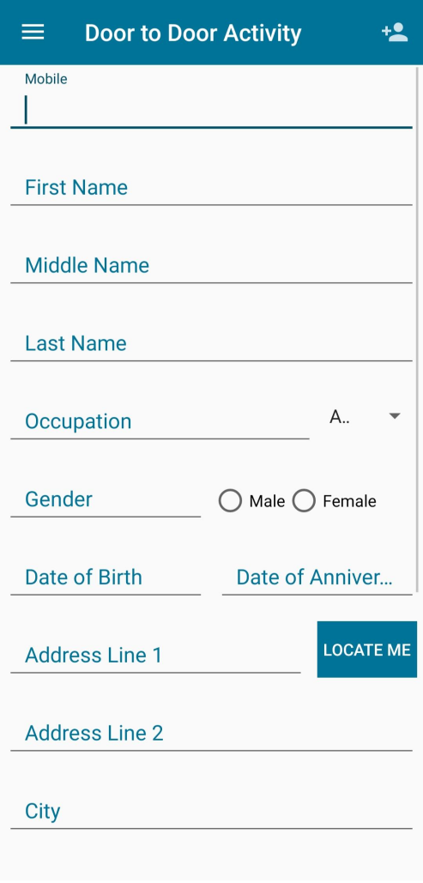 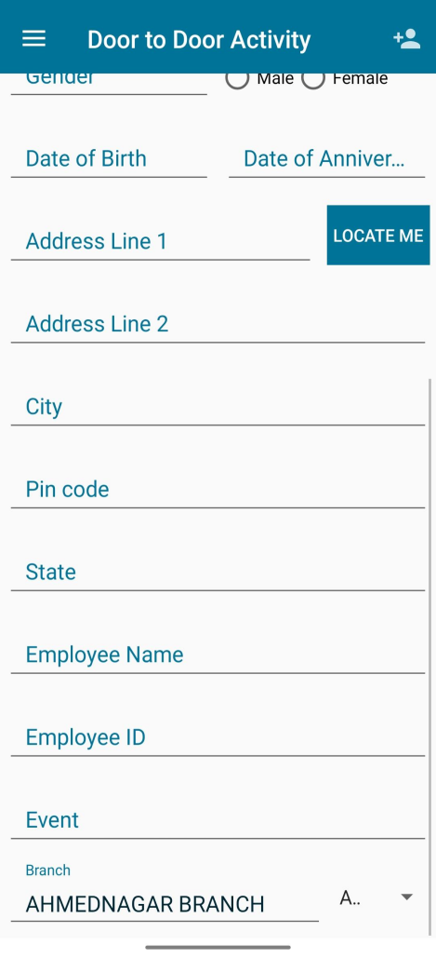

Fig: D2D add customer form

|  |  |  |  |
| --- | --- | --- | --- |
| **FIELDS** | **INPUT TYPE** | **MANDATORY/ OPTIONAL** | **DESCRIPTION** |
| Mobile | Number | Mandatory | The user must be able to enter a valid phone number.  Validation -  Only integer can be entered.  It must contain only 10 digits.  If the user entered less than 10 digits number then the system must throw an error. |
| First Name | Text | Mandatory | The user must be able to enter the first name.  Validation -  It must contain Alpha-numeric with special character and spaces.  Maximum 50 characters must be accepted. |
| Middle Name | Text | Optional | The user must be able to enter the middle name.  Validation -  It must contain Alpha-numeric with special character and spaces.  Maximum 50 characters must be accepted. |
| Last Name | Text | Mandatory | The user must be able to enter the last name.  Validation -  It must contain Alpha-numeric with special character and spaces.  Maximum 50 characters must be accepted. |
| Occupation | Text | Optional | The user must be able to enter the occupation.  Validation -  It must contain Alpha-numeric with special character and spaces.  Maximum 50 characters must be accepted. |
| Gender | Radio Button | Mandatory | The user must be able to to select the gender from the available options.  There are two options:   * Male * Female * Other   Validation- It will be single select. |
| Date of Birth | Date  Picker | Optional | The users must be able to select the date of birth.  Validation -  The date format must be in  “DD-MM-YYYY’. Future date should be disabled. |
| Date of Anniversary | Date  Picker | Optional | The user must be able to select the anniversary date using the date picker.  Validation-  The date format must be in  “DD-MM-YYYY’. Future dates should be disabled. |
| Locate Me | Button | - | Once a user clicks on the "Locate Me" button, their current location must be fetched from the network provider. |
| Address Line 1 | Auto | Optional | Once the user clicks the "Locate Me" button, the user's current address must be fetched.  Validation -  It must contain characters and numbers. |
| Address line 2 | Auto | Optional | Once the user clicks the "Locate Me" button, the user's current address must be fetched.  Validation -  It must contain characters and numbers. |
| City | Auto | Optional | Once the user clicks the "Locate Me" button, the user's current city name must be fetched.  Validation -  It must contain only characters,  Maximum 20 characters must be accepted. |
| Location | Drop Down | Mandatory | If the location cannot be fetched due to network issues after clicking on locate me button, the user will select the location manually.  Validation-  It will be a single select. It will display active locations from connect us -> location master. |
| Pin code | Text | Mandatory | Once the user clicks on “ Locate Me” button the pin code will automatically get fetched into the d2d application.  If the location cannot be fetched due to network issues, then user will manually enter the pin code.  Validation -  It must contain only integers.  It must contain only 6 digits. |
| State | Text | Mandatory | Once the user clicks the "Locate Me" button, the state will automatically fetched. |
| Employee Name | Text | Mandatory | The employee name will be automatically fetched from the username entered at the time of login.  Validation-  It will be read only. |
| Employee Id | Text | Mandatory | The employee id will be automatically fetched from the username entered at the time of login.  Validation-  It is non-editable. |
| Event | Text | Mandatory | The user must be able to enter the name of the event for which the data of customer is being collected.  Validation -  It must be contain alpha-numeric with special characters and spaces.  Min length = 1  Max length = 50 |
| Branch | Drop Down | Mandatory | The user must be able to select a branch from which user belongs.  It will contain list of active branches from branch master.  Validation-  It will be a single select. |
| Submit | Click | - | Once users enters mandatory fields in the form and clicks on submit button, successful message will be displayed and form will get reset. Moreover, data of the customer will be saved and displayed in connect us -> D2D report and in mobile app -> view report after syncing data. |

**D2D Report-**

When a user enters mandatory fields in the form and click the submit button , a successful message is displayed and the forms will get reset.

Moreover, data of the customer will be saved and displayed in connect us -> D2D report.

Once the user clicks on D2D report the system must display the following fields-

* First Name
* Middle Name
* Last Name
* Customer Mobile No
* Occupation
* Gender
* DOB
* DOA
* Address Line 1
* Address Line 2
* City
* Location
* Pincode
* State
* Employee Name
* Employee Id
* Event
* Branch
* Date Time

The location and Religion fields must be added into the reports.

