14.02.2024

Anup Deotale

anup.deotale@techneai.com

Notification

**Functional Requirement Document**

**CONTENTS**

1. TICKET DETAILS 2

2. VERSION CONTROL 2

3. APPROVALS 2

4. ESTIMATION 2

5. INTRODUCTION 3

6. BUSINESS REQUIREMENT 3

7. SCOPE 3

8. BUSINESS & SYSTEM RULES 3

9. ABBREVIATIONS & TERMS 3

10. EXISTING SYSTEM 3

11. GRAPHICAL REPRESENTATION 3

12. PROPOSED SYSTEM 3

13. TEST DATA 4

14. ODUS 4

15. REFERENCES OF THE USERS 5

1. **TICKET DETAILS**

|  |  |
| --- | --- |
| **Ticket ID** | [TT19367](http://3.108.206.34/TechTicket/Ticket/View/17430) |
| **Ticket description** | Dear Team,  We will provide you Microsoft Form Link. This link should be show on in MYCSAPP. on daily basis to respective managers Designation wise. |
| **Created by** | Anup Deotale |
| **Created on** | 12/02/2024 |
| **Priority** | Very high |

1. **VERSION CONTROL**

|  |  |  |  |  |
| --- | --- | --- | --- | --- |
| **Sr. No** | **Version no** | **Version Date** | **User name** | **User department** |
|  | **1.0** | **12/02/2023** |  |  |
|  |  |  |  |  |
|  |  |  |  |  |

1. **APPROVALS**

|  |  |  |
| --- | --- | --- |
| **Field** | **Name of the User** | **Approved date by the user** |
| **Actual User Name Actual User Department Organization Name** | Dinesh Sonawane  Data Analyst  CSJ |  |
| **Assigned BA** | Anup Deotale |  |
| **Assigned Developer** | Mustafa SIyam  Goverdhan Bollu | - |
| **Assigned Tester** | Krushna Patare |  |
| **Backend Developers** | Jaydeep Patil |  |

1. **ESTIMATION**

|  |  |  |  |  |
| --- | --- | --- | --- | --- |
| **Department name** | **Estimated Time (In hr)** | **Scheduled Date (Starting date)** | **Estimated date** | **Actual delivery date** |
| **BA** |  |  |  |  |
| **Development** |  |  |  |  |
| **Testing** |  |  |  |  |
|  |  |  |  |  |

1. **INTRODUCTION**

The Notification sub-module allows users to deliver notifications, alerts, reminders, links, and messages to individuals or groups of employees. Bulk messaging allows you to send a unique message to each employee. The sent messages will be presented to the corresponding employee in the MY CS mobile app -> message tab. The user will receive the message that has been sent to him and I will also reflect in notification report.

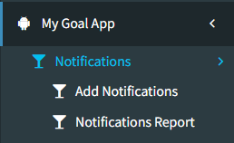

1. **BUSINESS REQUIREMENT**

* The user must be able to select the designation field from the drop down menu, and the names will be fetched from the designation master.
* The user must be able to select employee names from the employee master and fetched them based on the selected designation & selected branch.
* The user can select the assign from and assign to dates to send notifications to employees based on the selected dates.
* After downloading the "Bulk Upload Format," users must be able to view the following information: emp_id, employee name, branch, notification name, assign from, assign to, and description. A link must be included in the description.
* Once user uploads the file, message will get sent to the employees which will be displayed in my cs mobile app -> messages menu.
* To upload a file, click the "upload" button after selecting it from the "choose file" button. The file will then be displayed in the notification report. Furthermore, we can know who received each notification and when they opened the link.

|  |  |  |  |
| --- | --- | --- | --- |
| **Requirement ID** | **Requirement Name** | **Short Description** | **Priority** |
| BR001 | Designation | The user must be able to select the designation. | High |
| BR002 | Employee Name | The user must be able to select the employee based on the selected designation & branch. | High |
| BR003 | Assign From | The user must be allowed to select Assign from dates; after that date, notification will display in the message menu. | High |
| BR004 | Assign To | The user must be allowed to select the Assign to dates; until that date, the user will get notifications in the message menu. | High |
| BR005 | Downloading Bulk Upload Format | Users must be able to download the bulk upload format. The download file must have the following fields: emp_id, employee name, branch, notification name, assign from, assign to, and description.  A link should be mentioned in the description. | High |
| BR006 | Message Menu | The user will receive daily notifications based on the dates selected. | High |
| BR007 | Notification Report | To upload a file, click "upload" after selecting it with the "choose file" button. The file will appear in the notification report, showing who received it and when they opened the link. | High |

1. **SCOPE**

In the Add Notification menu, the user will create a new notification name or select an existing notification name, select designations, employee names, assign from and assign to fields, then click on the download bulk upload format.

Once the file is downloaded, the user must enter a description, which will be in link format.

After entering the URL into the downloaded file, the user uploads the file, and notification alerts and link are reflected in My CS Application “ Message menu”and “notification report”.

When the link is opened by an employee, the employee's name and the time the link was opened are reflected in the notification report.

1. **BUSINESS & SYSTEM RULES**

* User should be registered in the system and User should be logged in.
* System should display error message for incorrect details if entered.
* System should pop up a message, if any issues in the system is detected.
* Messages cannot be sent to the employees who are not active in employee master.

1. **ABBREVIATIONS & TERMS**

NA

1. **EXISTING SYSTEM**

We currently cannot send feedback link notifications to certain designation employees on a daily basis. There is also no opportunity to select the designation and then select a specific employee to get the message after setting up the dates. We need a way to select the designation title and then the employee to whom we want to send the notification on the specified dates.

1. **GRAPHICAL REPRESENTATION**

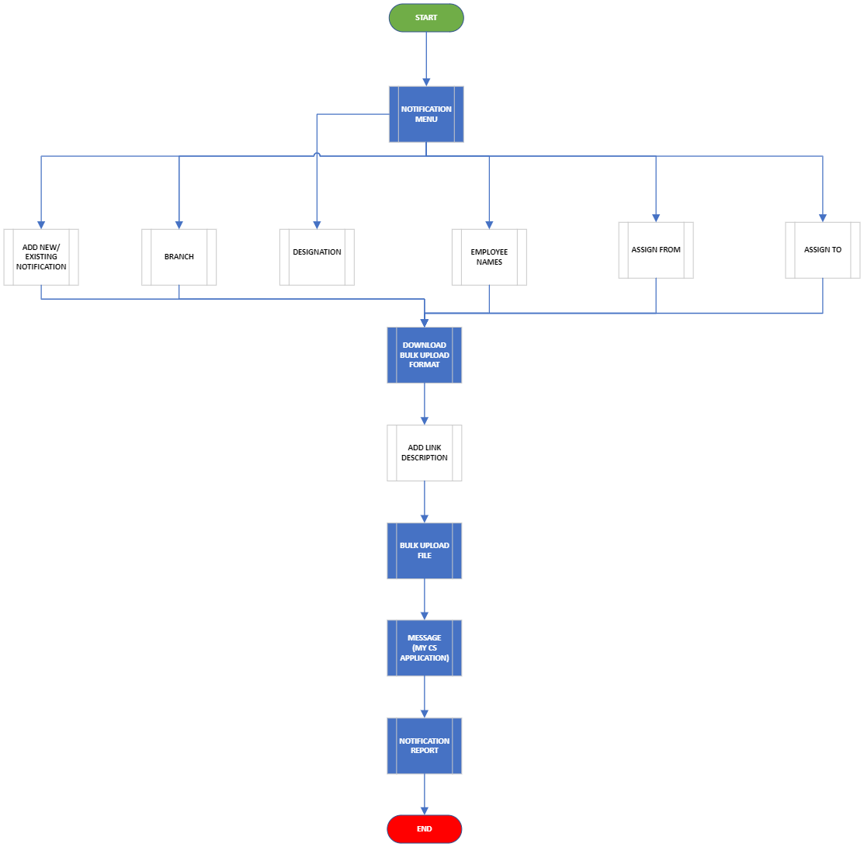

Fig - Graphical Representation

1. **PROPOSED SYSTEM**

**BR001 - Add Notification**

The user must be able to click on add notification menu.

Once the user clicks on “Add Notification” menu the user must be able to display the following fields-

* New Notification Name
* Existing Notification Name
* Branch
* Designation
* Employee Names
* Assign From
* Assign To
* Download Bulk Upload Format (Link Description)
* Bulk Upload File
* Reset

**Input Data -**

|  |  |  |  |  |
| --- | --- | --- | --- | --- |
| **FIELDS** | **INPUT TYPE** | **MANDATORY/ OPTIONAL** | **EDITABLE** | **DESCRIPTION** |

|  |  |  |  |  |
| --- | --- | --- | --- | --- |
| New Notification Name | Text | Mandatory | No | The user must be able to enter the notification name.  To download the bulk format, the user must be able to enter a new notification name or select an existing notification name.  This notification name will display in the notification name column of the downloaded bulk format file.  Validation: It will accept characters, special characters, space and numbers with maximum 50 inputs.  It will accept English and Marathi characters. |
| Existing Notification Name | Drop Down | Optional | No | The user must be able to click on drop down menu.  Once the user clicks on drop down menu the list of active notification names must be display.  User can make existing notification name active or inactive from notification reports menu.  If user selects existing notification name from the drop-down then new notification name field will be disabled.  This name will be reflected in notification name column of downloaded bulk format.  Validation: it will be single select. |
| Branch | Drop  Down | Optional | No | If the user wants all employee names in the downloaded bulk format, they need to keep the branch column blank.  Employees will be reflected in the downloaded bulk format for the selected branch.  Validation:  It will show active branches from the branch master. It will be multi-select.  In addition, it will display All branches and All HO as options. When the user selects "All branch", the bulk upload file will display all employees from all branches.  When the user selects "All HO", the bulk upload file will display all employees from both HOs (Pune HO and Bmt HO). |
| Designation | Drop  Down | Optional | No | The user must be able to click on drop down menu.  Once the user clicks on drop down menu the list of designation name must be fetched from the designation master.  This designation will be reflected in designation name column of downloaded bulk format.  Validation-  It will be a single select. |
| Employee | Drop Down | Optional | Yes | The user must be able to click on drop down menu.  Once the user clicks on drop down menu the list of employee names must be fetched from the employee master.  This employees will be reflected in employee name column of downloaded bulk format.  Validation-  It will be multiple select. |
| Assign From | Date Calender | Optional | Yes | The user must be able select the date from which the notification should be active.  Validation-  Only current & future dates must be display.  The date format must be in DD:MM:YYYY. |
| Assign to | Date Calender | Optional | Yes | The user must be able select the date until which the notification should be active.  Validation-  Only future dates must be display.  The date format must be in DD:MM:YYYY. |
| Download Bulk Upload Format | Button | - | - | Once the user selects an existing notification name or enter a new notification name, designation, employee names, assign from and assign to fields and clicks the download bulk format button, an excel file will be downloaded.  It will include the following fields:   * Employee ID * Employee Name * Branch Name * Designation * Notification Name * Assign From & Assign To * Description   The downloaded excel file will include pre-filled fields for the branch name, designation, employee ID, notification name,Assign from, Assign To and employee name.  The user will download the template and enter the description into it.  The description might include text message and/ or links in it.  Validation:  The link must starts with "http://" or "https://" or www.  The mentioned link must be in blue colour format. Link should not consider space I.e. it should consider it as link from protocol till text before space.  The description field in an excel file must accepts characters, special characters, spaces, and integers. Maximum character limit for the link must be 1000 approx.  The downloaded file will include all active designations and employee names from the  designation & employee masters. |
| Upload bulk file | Button | - | - | The user will save the downloaded file in which the description has entered(link).  The user will attach that file via the 'bulk upload file' button.  When the user clicks on the upload bulk file button, a pop-up box appears in which the user must attach the format with the description data specified. |
| Upload | Button | - | - | When the user attaches the file and clicks the upload button, a successful message will appear if all of the details in the file were entered accurately.  This successful upload will also be reflected in the notification report, which will have the notification name as the heading and the employee details in the view action section.  You will also receive notifications in the message menu in MY CS Application and at the top of the display.  Validation:  it will be disabled until file uploads successfully or error message is displayed. |
| Download Error File | Click |  |  | If the details in the uploaded file are incorrect, it will display the download error file button.  When the user clicks on download error file, an error file is downloaded that specifies which fields were incorrectly filled out. |
| Submit |  |  |  | Once the user has uploaded the file and clicked the submit button, a confirmation dialog box will appear reading "Are you sure you want to send? "Yes or no."  Once the user chooses yes, alerts will be delivered to all of the selected employees via the MY CS mobile app -> messages menu.  And Once the user clicks on the link, they are redirected to the form page.  Validation: Once sent, the notification cannot be edited or removed. |
| Reset |  |  |  | When a user clicks the reset button in the add notifications menu, all of the details entered into the notification name, branch designation , employee are disabled, allowing the user to refill it. The user will remain on the same page.  Validation -  The reset button will be disabled until the page is reloaded and the pre-filled fields are reset. |

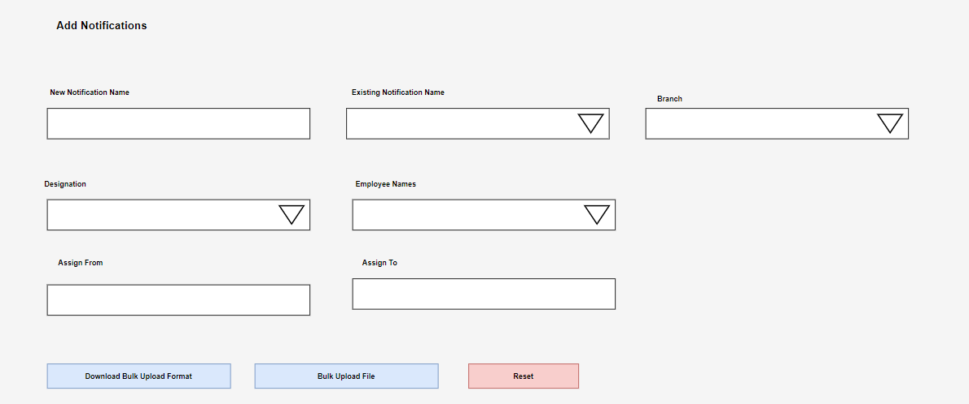

Fig - Add Notification

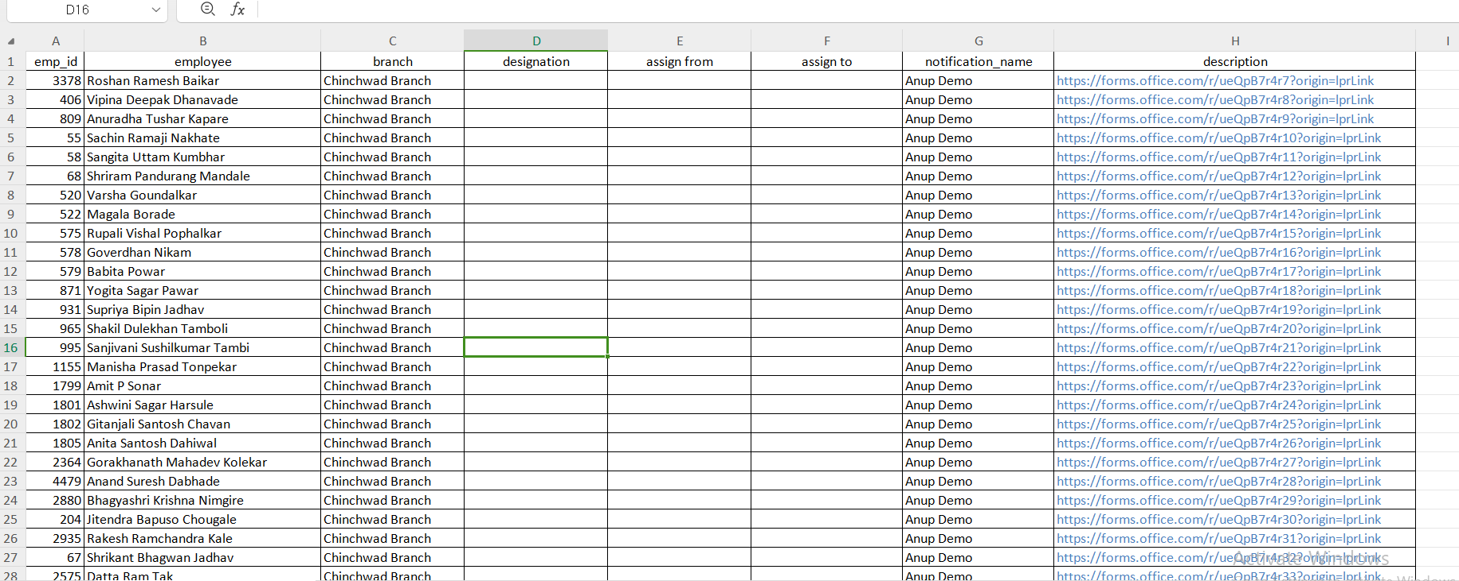

Fig: Downloaded Bulk upload format

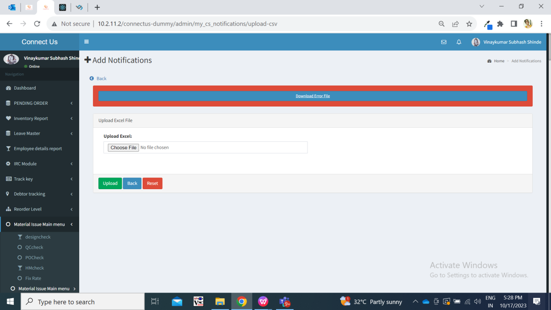

Fig: Error while Uploading bulk file

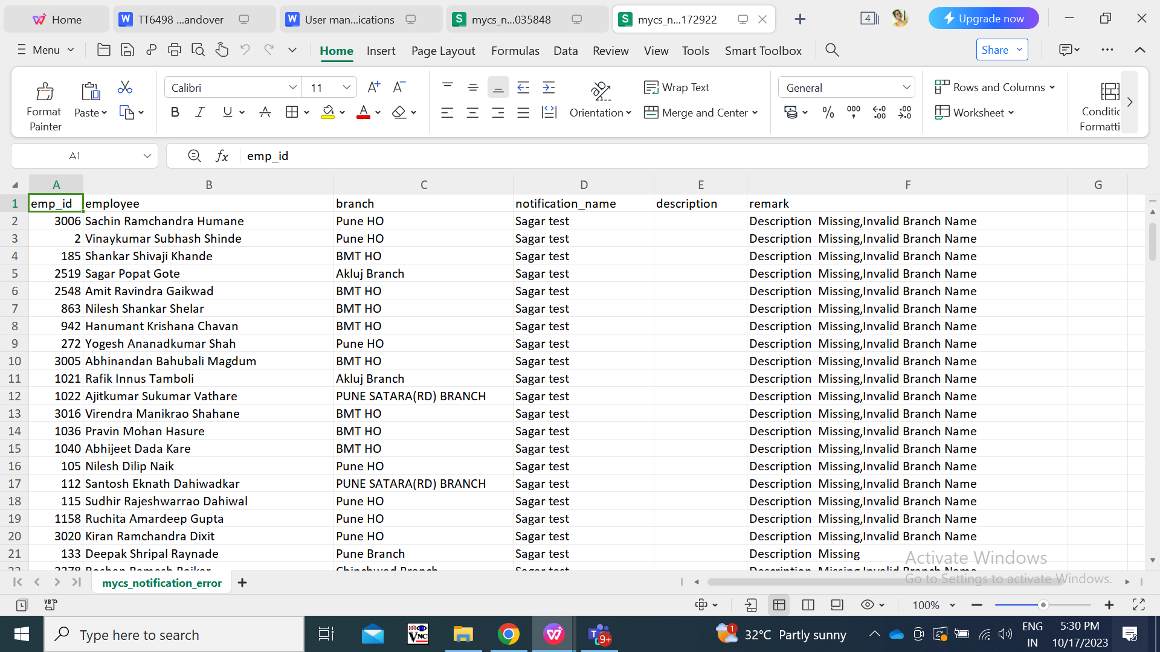

Fig - Error File

**Step 2 :** **View the notification in MY CS mobile app -> "Messages" tab.**

Once the user sends a notification to an employee, the employee will receive a fire-base notification on their mobile app. In addition, the number of notifications will be displayed in the home screen's messages tab.

Once user clicks on messages tab, it will display list of notification with following fields:

* Notification name
* Description
* Date & time
* Status

**Input Data -**

|  |  |  |  |  |
| --- | --- | --- | --- | --- |
| **FIELDS** | **INPUT TYPE** | **MANDATORY/ OPTIONAL** | **EDITABLE** | **DESCRIPTION** |

|  |  |  |  |  |
| --- | --- | --- | --- | --- |
| Notification Name | Text | Mandatory | No | It will display the notification's name as the title that was sent via bulk upload file.  Validation: It will accept characters, special characters, space and numbers with maximum 50 inputs.  It will accept English and Marathi characters. |
| Description | URL | Mandatory | No | It will display link descriptions based on the bulk uploaded files. |
| Date & time | Date & Time Calender | Mandatory | No | The notification will be delivered to the employees and will display according to the date set in the add notification menu. |
| Status |  |  |  | Once the message has been read by the employee, the notification count will be reduced and displayed in the right corner of the 'messages' tab.  Read messages will not be colorized or highlighted.  When an employee clicks on a specific link, it takes them to the next page with a form, and the notification is marked as read.  Messages that are not noticed or read will be shown in red.  Also, once the user reads the message (by clicking on it), the read icon is removed, and the date and time when the message was seen are reflected in the notification report. |

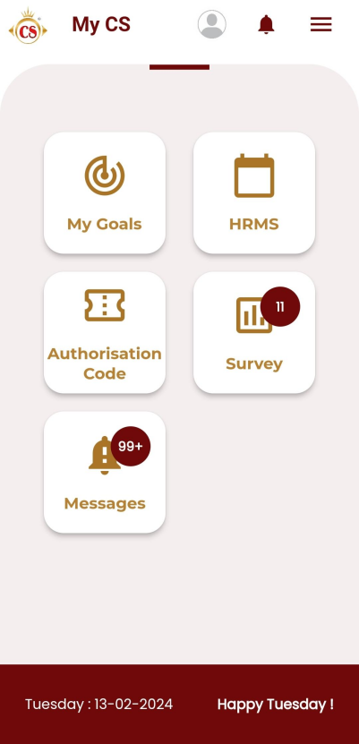

Fig: MY CS mobile app -> message tab on home screen

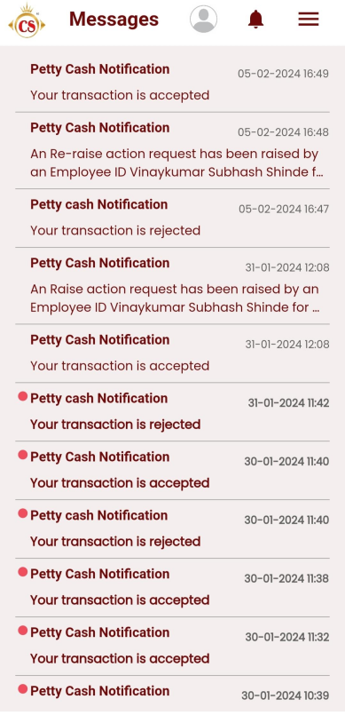

Fig: List of notifications page

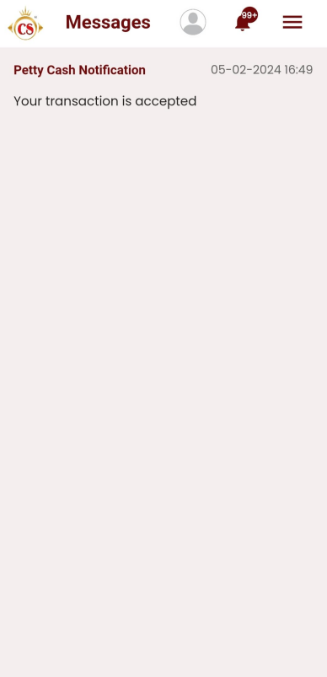

Fig: View message

**Step 3: Notification report.**

Once a notification has been sent in bulk upload format, it will get displayed in the notification report. Furthermore, for each notification name, we can view who received it and when that employee read it. The notification report menu will include the following fields:

* Notification name search
* Search button
* Download button
* Reset button
* View report action
* Change status action
* Notification name
* Branch
* Designation
* Is active
* Created at
* Created by
* Download button
* Sr no.
* Employee id
* Employee name
* Branch
* Designation
* Notification name
* Description (Link)
* Is read
* Read at

**Input Data -**

|  |  |  |  |  |
| --- | --- | --- | --- | --- |
| **FIELDS** | **INPUT TYPE** | **MANDATORY/ OPTIONAL** | **EDITABLE** | **DESCRIPTION** |

|  |  |  |  |  |
| --- | --- | --- | --- | --- |
| Search notification name | Drop-down | Mandatory | No | It will give a list of the notification names that are in the grid.  The user can search for notification names in the grid. However, we are displaying all of the notification names in the grid.  Validation: it will display both active and inactive notification names. |
| Search | Click | - | - | Once the user selects the notification name into the search field and clicks on the search button, the search notification will be displayed in the grid with the following fields-   * Action * Notification Name * Branch Id * Designation * Is Active * Created At * Created By   If the user clicks on the search button without first picking a notification name in the search field, the grid will be displayed as blank. |
| Download  (Grid) | Click | - | - | When the user clicks the download button, the data from the grid is downloaded to an Excel file. It will contain the following columns:   * Sr. No. * Notification name * Branch * Designation * Status * Created at * Created by   When the user selects the download button, the following file will be downloaded for your reference: |
| Reset | Click | - | - | The user must be able to click on “Reset “ button.  Once the user clicks on reset button the grid page reloads and the fields are reset. |
| View | Click | - | - | The user must be able to click on “View” action.  Once the user clicks on view action button against any notification name the user must be able to view the following fields-   * Sr no * Sent at (date and time on which notification got sent to employee in my cs app) * Employee ID * Employee Name * Branch * Designation * Assign From * Assign To * Notification Name * Description * Is Read * Read At   Here, it should display the same employee name in the list number of times the notification is set to send to that employee I.e. assign from and to date. Further, it should display the read date and time once notification is read by the employee on each date. |
| Change status | Click | - | - | User can make notification as active or inactive by using this toggle button. Once user deactivates notification name, then it will not be displayed in add notification -> existing notification name field. However, user can view report of inactive notification names.  Once user clicks on change status button ,the status will be displayed in ‘is active’ field of grid. |
| Notification Name | Text | - | - | When new notification is created, then it will displayed on top row in grid.  The user must be able to view the notification name that they selected in the add notification menu. |
| Branch | Text | - | - | The user must be able to view the branch name that they selected in the add notification menu. |
| Designation | Text | - | - | The user must be able to view the designation name that they selected in the add notification menu. |
| Is Active | Text | - | - | It will display whether the notification is active or inactive. If notification is inactive then it will not be displayed in add notification -> existing notification name drop-down. |
| Created at | Text | - | - | It will display the date and time when notification was created. |
| Created by | Text | - | - | It will display the employee name who created that notification. |
| Sr No | Number | - | - | The serial number is made up of the numbers who will count the number of employee details. |
| Employee ID | Text | - | - | Once the user clicks the view button.  The user must be able to view the employee id depending on the employee names selected. |
| Employee Name | Text | - | - | Once the user clicks the view button.  The user must be able to view the name of the employee they have selected in the add notification menu. |
| Description | Text | - | - | Once the user clicks the view button.  The user must be able to view the description they have entered in the add notification menu. |
| Is Read | Text | - | - | If the assigned employee has not opened the link yet, it will be marked as unread in the report. |
| Read At | Text | - | - | Once employee opened the link from my cs app, then it will be displayed as ‘read’ in report and the date and time when that notification was read that will be displayed in this field. |
| Download  (View) | Click | - | - | The user must be able to click the "Download" button.  When the user selects the download button, the grid data will be downloaded in Excel format. |

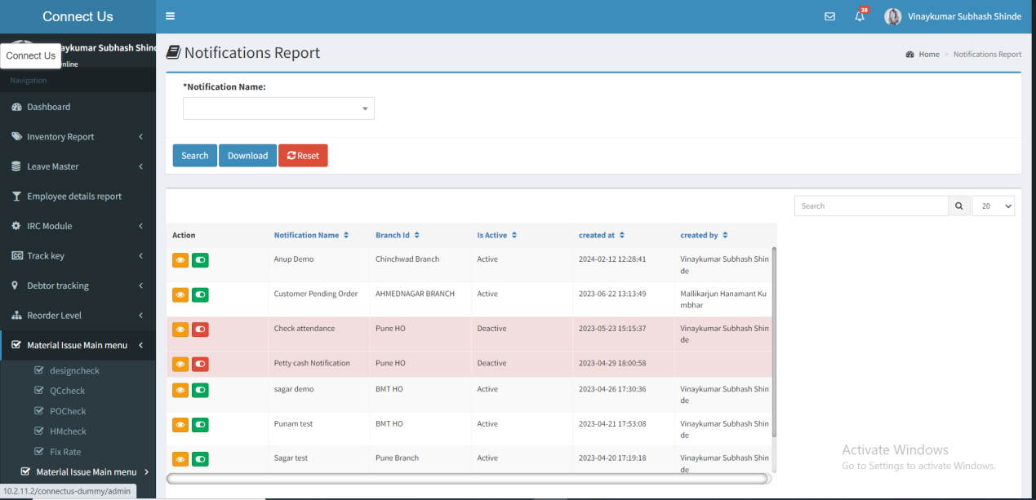

Fig- Notification Report (Grid)

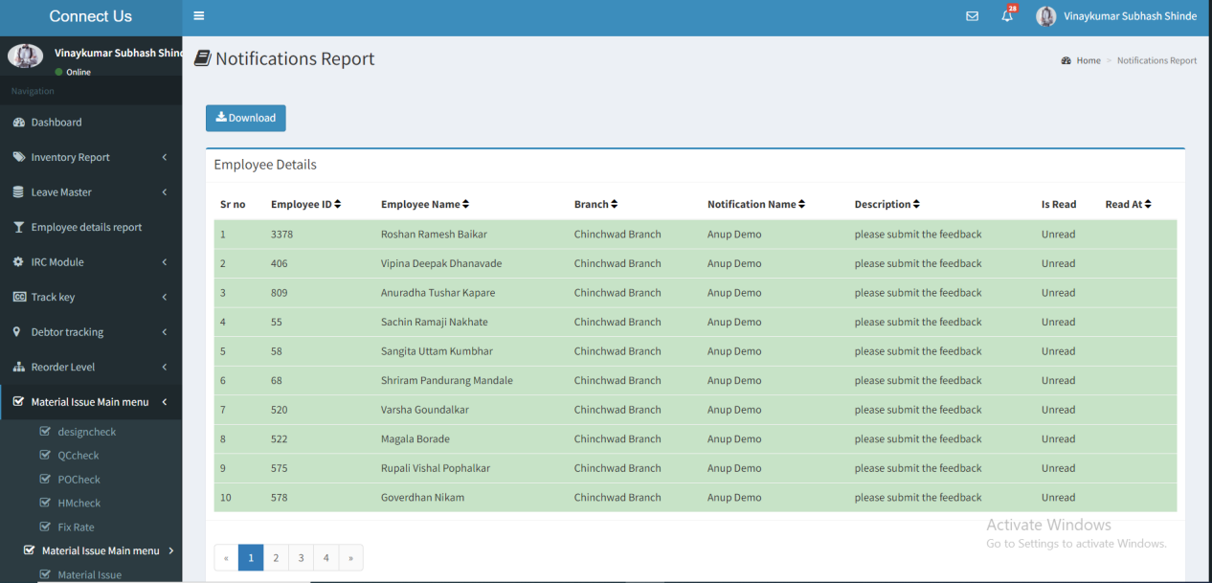

Fig - Notification Report (View)

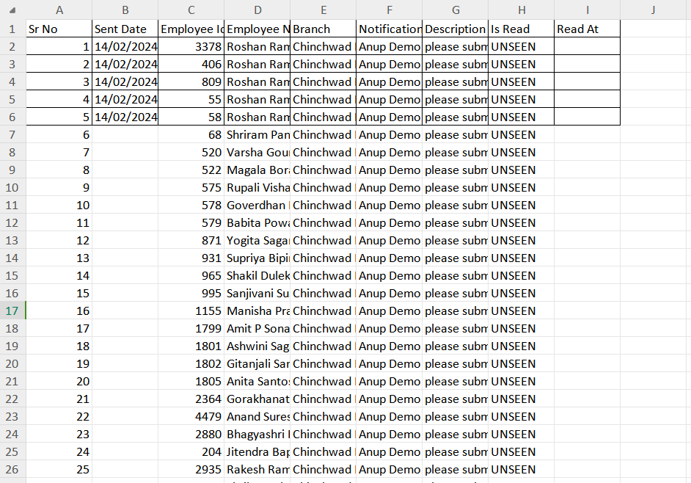

Fig - Download (View)

The sending date (Date & time) must be displayed in the excel report with the employee's name.