17.01.2024

UNFIX / FIX RATE - PHASE 2

Manali Ashok Bhadirage

Manali.bhadirage@techneai.com

**FUNCTIONAL REQUIREMENT DOCUMENT**

**CONTENTS**

1. TICKET DETAILS 2

2. VERSION CONTROL 2

3. APPROVALS 2

4. ESTIMATION 3

5. INTRODUCTION 3

6. BUSINESS REQUIREMENT 3

7. SCOPE 4

8. BUSINESS & SYSTEM RULES 5

9. ABBREVIATIONS & TERMS 5

10. EXISTING SYSTEM 5

11. GRAPHICAL REPRESENTATION 5

12. PROPOSED SYSTEM 7

13. TEST DATA & SCENARIOS 33

15. REFERENCES OF THE USERS 33

1. **TICKET DETAILS**

|  |  |
| --- | --- |
| **Ticket ID** | TT11135 |
| **Ticket description** | Unfix / Fix rate phase 2: We have to provide bill no. field in fix rate menu where the total of DR amount will be displayed in bill checking. Requirement to be taken in detail from Pritam sir. |
| **Created by** | Manali Ashok Bhadirage |
| **Created on** | 11/01/2024 |
| **Priority** | Very high |

1. **VERSION CONTROL**

|  |  |  |  |  |
| --- | --- | --- | --- | --- |
| **Sr. No.** | **Version no.** | **Version Date** | **User name** | **User department** |
| **1** | **1.0** | **25/01/2024** | **Sachin Humne /  Rakesh Thikane** |  |
| **2** | **1.1** | **02/02/2024** | **Rakesh Thikane** |  |
| **3** | **1.2** | **14/02/2024** | **Rakesh Thikane** |  |
| **4** | **1.3** | **15/02/2024** | **Rakesh Thikane**  **Prashant Pise** |  |

1. **APPROVALS**

|  |  |  |
| --- | --- | --- |
| **Field** | **Name of the User** | **Approved date by the user** |
| **Actual User Name Actual User Department Organization Name** | Rakesh Thikane / Sachin Humane / Prashant Pise  CSJ |  |
| **Assigned BA** | Manali Ashok Bhadirage |  |
| **Assigned Developer** | Yogita Jagtap / Prathmesh Shinde |  |
| **Assigned Tester** | Priyanka Dupargude |  |

1. **ESTIMATION**

|  |  |  |  |  |
| --- | --- | --- | --- | --- |
| **Department name** | **Estimated Time (In hr)** | **Scheduled Date (Starting date)** | **Estimated date** | **Actual delivery date** |
| **BA** |  |  |  |  |
| **Development** |  |  |  |  |
| **Testing** |  |  |  |  |

1. **INTRODUCTION**

Generally, following the material issue inspection by the HM, users assess the daily rates in accordance with the vendor. This evaluation is will be done through the fix rate menu, containing documents related to RD purchases with an unfixed rate type. Subsequently, credit or debit notes will be created depending on whether the fixed rate is greater or unfixed rate is greater.

1. **BUSINESS REQUIREMENT**

|  |  |  |  |
| --- | --- | --- | --- |
| **Requirement ID** | **Requirement Name** | **Short Description** | **Priority** |
| BR001 | Fix rate menu -> edit action | Once user scans documents and clicks on submit button, it shouldn’t get submitted if the total data doesn’t match with the accepted and rejected details as per we get until HM check.  It should display alert message as data doesn’t match but shouldn’t submit the document. | Medium |
| BR002 | Fix rate menu -> edit action | Once user scans the document, it should check if the vendor name of scanned is same as the one of material issue doc. No. If vendor is different, then it should not get submitted. | Medium |
| BR003 | Material issue -> Unfix rate type | Display the documents in fix rate menu whose rate type id fix however do not display fix rate action to it. Display only view and edit action to it for scanning documents from Padm. | Medium |
| BR004 | Fix rate -> view action | Once user clicks on submit button of net payable amount, then user should be directed to add form of bill checking where few details in form will get pre-filled as per fix rate document details. | High |
| BR005 | Material issue -> add and edit -> fine rate | Fine rate should get auto calculated and displayed in add and edit action of material issue which will be read only.  Fine rate = unfix rate * 99.50% | High |
| BR006 | Fix rate menu -> fix rate action -> unfix fine rate | We have to display unfix fine rate as well above vendor name field. | High |
| BR007 | Fix rate menu -> fix rate action -> fix fine rate | We have to add fix fine rate field in rowof breaking rate next to fix rate text field.  Fix fine rate = fix rate * 99.50% | High |
| BR008 | Fix rate menu -> fix rate action -> table | Add unfix fine rate and fix fine rate columns in table. | High |
| BR009 | Fix rate menu -> fix rate action -> table -> cr and dr note | If **fix fine rate > unfix fine rate**, then **debit note** should be generated.  If **fix fine rate < unfix fine rate**, then **credit note** should be generated.  If **fix fine rate = unfix fine rate**, then it will display as no note or blank. | High |

1. **SCOPE**

Fix rate automates the process of breaking rate and creating the purchase bill for vendor in bill checking. Once user enters the Challan and item details in material issue and submits it, document no. will be generated and it will be displayed in first row of material issue -> grid. Once authorized user marks its as received, that document will be displayed in Design check process. User will accept / reject few pcs, gross wt and net wt and submit it. Then, accepted pcs of document will be displayed to QC check process. Then, accepted pcs of QC check will be displayed to PO check process and then accepted pcs of POcheck will be displayed in HM check. Once user saves the document, email will be sent to the vendor displaying all the details of rejected and accepted pcs in each checking stage.

Now, only the accepted pcs of document which are saved from HM check process and document which is marked as RD purchase yes, that document will be displayed in Fix rate menu. Initially, each record will have edit action based on authority. Through edit action, user will enter the document number from Padm about RD purchase and Purchase return. Once user submits it, then edit action will be removed and that record will have view action and fix rate action. Fix rate action will be displayed only tot the document which are marked as unfix in material issue -> add / edit -> rate type field. Through fix rate action, user will enter the fix rate and the quantity. Based on greater rate type, credit or debit note message will be displayed for that record in the table along with gross amount. Also, user can enter the debit note or credit note number. Moreover, all the details of scanned documents and the break rate will be displayed in view action. Furthermore, it will have calculate action besides fix rate action once all fine rate is break. Through calculate action, user will calculate the net payable amount and create bill. The created BC ID will be displayed in view action of that document and calculate act ion will be removed.

1. **BUSINESS & SYSTEM RULES**

* User should be registered in the system.
* User should be logged in.
* System should display error message for incorrect details if entered.
* Only purchase return documents will be scanned in purchase return od edit action. And, only accepted details document will be entered in RD purchase.
* One document can be scanned only once in the entire menu.
* Calculate action should be removed once bill is created and all the details will be displayed in view action accordingly.
* Fix rate action will be removed once all fine wt is break and all credit and debit note numbers are entered. Whereas, these details will be displayed in the view action.

1. **ABBREVIATIONS & TERMS**

Wt - weight

Pcs - pieces

RD - registered dealer

1. **EXISTING SYSTEM**

Currently, users are able to submit the document even when accepted and rejected data doesn’t match with the document as per HM check. Moreover, users are able to scan the documents from Padm which does not match with the vendor name in fix rate documents. This results in inaccurate data creation and impact on business accounts. Moreover, only the unfix rate type documents were being displayed in fix rate menu after clearing HM check process. We need to display documents in fix rate menu whose rate type is fix as well. Further, as users do create the bill in bill checking of the purchased metal. Thus to reduce the manual efforts of the user, we need to pre-fill the bill checking form using data from fix rate menu itself.

1. **GRAPHICAL REPRESENTATION**

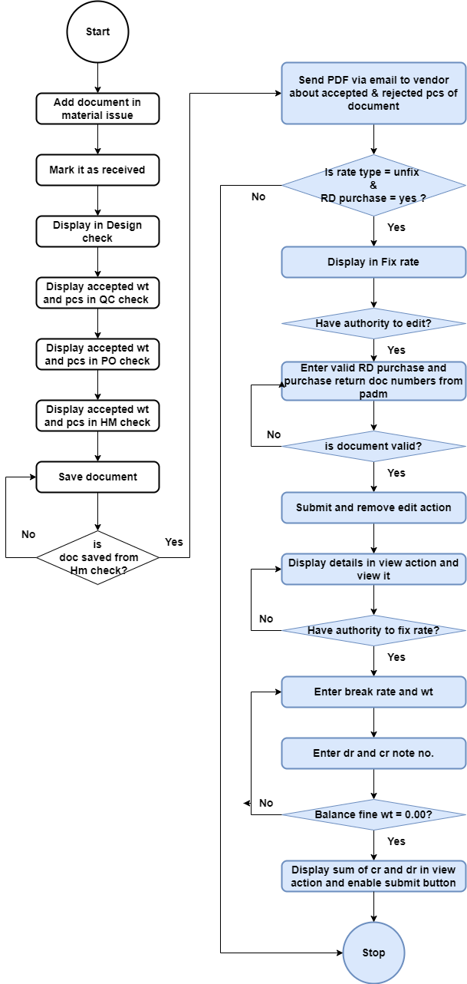

Fig: Process flow diagram

1. **PROPOSED SYSTEM**

Previously, there was no system to break the rate as it was done manually through excel by the user.

Step 1. In Connect us -> material issue main menu -> material issue, once user clicks on add data, it will display following fields:

* Issued Date
* Challan No.
* Location
* Issued Type
* Vendor
* Sub supplier
* Narration
* Remark
* **Is RD purchase?**
* **Type of Rate**
* **Unfix Rate**
* **Unfix fine rate**
* **Bill Date**
* **Attachment**
* Item Detail table
* Save button
* Back button
* Save and add more button

The additional fields will be displayed in add, edit and view action of each record in material issue.

|  |  |  |  |  |
| --- | --- | --- | --- | --- |
| **FIELDS** | **INPUT TYPE** | **MANDATORY/ OPTIONAL** | **EDITABLE** | **DESCRIPTION** |
| Is RD purchase? | Radio button | Mandatory | Yes | It will display yes or no in the list. Only rd purchase - yes documents will be displayed in the fix rate menu.  Validation: It will be single select. Initially, none of the option will be selected. |
| Type of rate | Radio button | Mandatory | Yes | It will display Fix or Unfix. While adding the data in material issue, the user will specify whether the rate for the particular vendor is fixed or not. Only unfix rate type documents will be displayed in fix rate menu.  Validation: It will be single select. Initially, none of the type will be selected. |
| Unfix Rate | Text | Mandatory | yes | Rate which is decided by the vendor for the day during purchase, it will be mentioned here. User will mention the rate of per gram of 99.50% purity.  This field will be disabled once this document has completed HM check process. This field will be editable only till the document hasn’t reached fix rate menu.  Below this text field, we have to display line as ‘per gram rate of 99.50%’.  Validations: In add and both edit actions, it should accept only 4 digits before decimal point and after decimal point. It will accept numbers only. It will accept only one decimal point as a special character.  Min length = 1  Max length = 9 |
| Unfix fine rate | Text | Mandatory | No | It will be rate of 100% purity. It will get auto calculated and displayed once user enters unfix rate in above field.  Unfix fine rate = Unfix rate / 99.50%  Validation: It will be read only. It will round upto 3 decimals after decimal point when fourth didgit will be greater than equal to 5. |
| Bill date | Calender picker | Mandatory | Yes | User will enter the date of the bill received from the vendor.  Validation: Only one date can be selected. Only current financial dates should be displayed. |
| Attachments | Upload | Mandatory | Yes | User will attach the bill of the total items received from vendor. The attached documents should be displayed in view and edit action of material issue.  Validation: It will be multi-select. It will accept jpeg / jpg / png / pdf extensions only. |

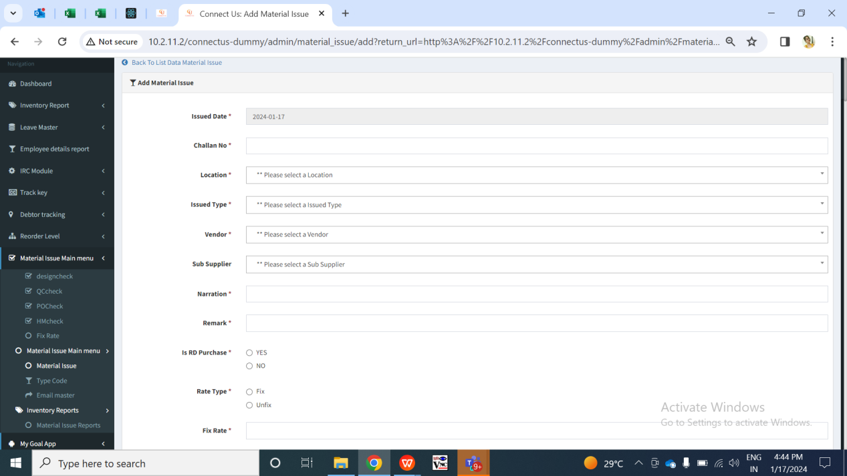

Fig: Material issue -> Add data

Once user enters items details, adds to table and clicks on submit, the doc. no. will be generated to it. It will be displayed in material issue grid.

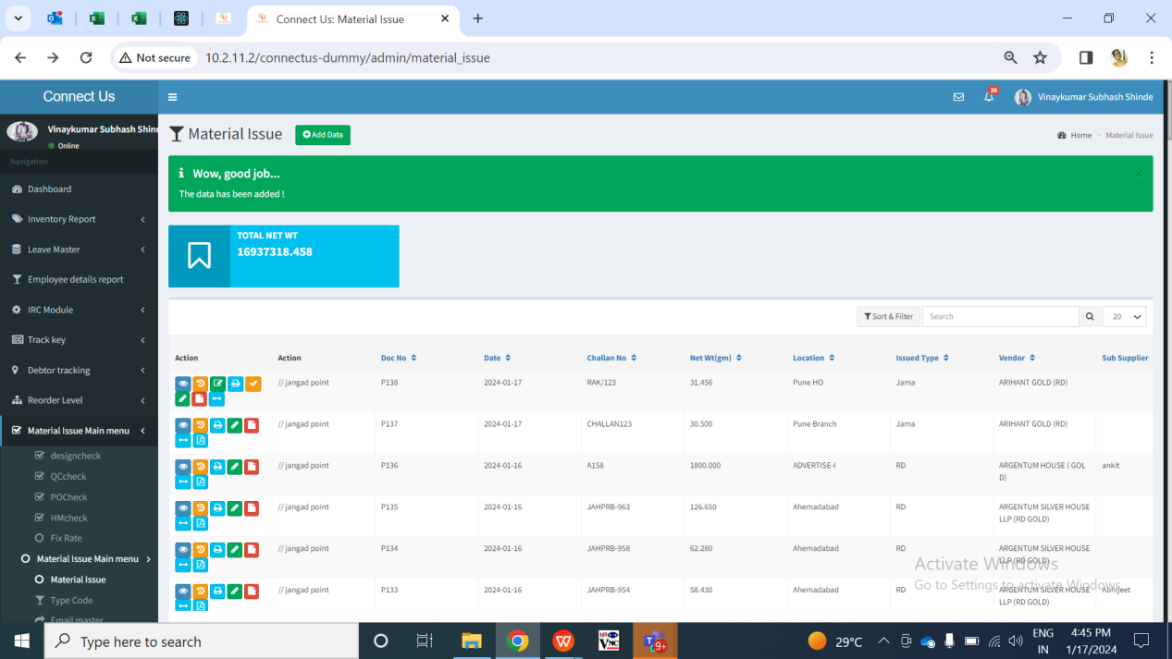

Fig: Material issue -> grid

Step 2. Once the data is marked as received by authority from material issue, it will be displayed in design check module.

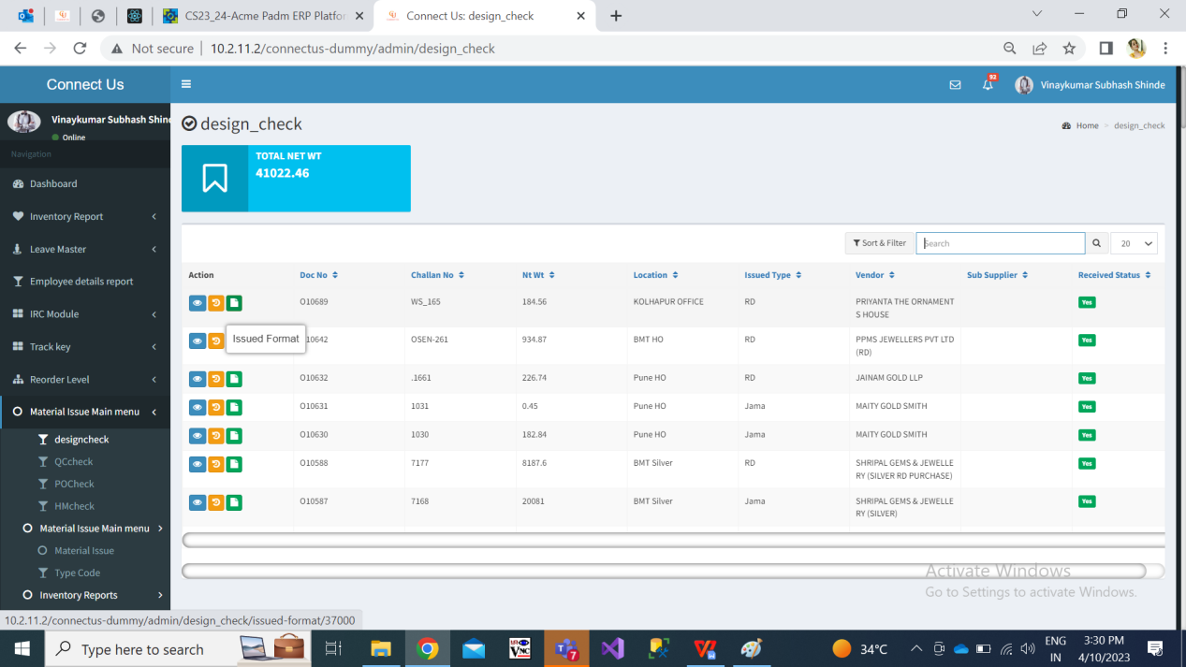

Fig: design check -> grid

Once user checks the items and enters details of rejected gross wt, rejected net wt and rejected pcs , then the remaining accepted gross wt, accepted net wt, accepted pcs will be auto calculated and displayed. Only the accepted details of the items will be forwarded to quality check process.

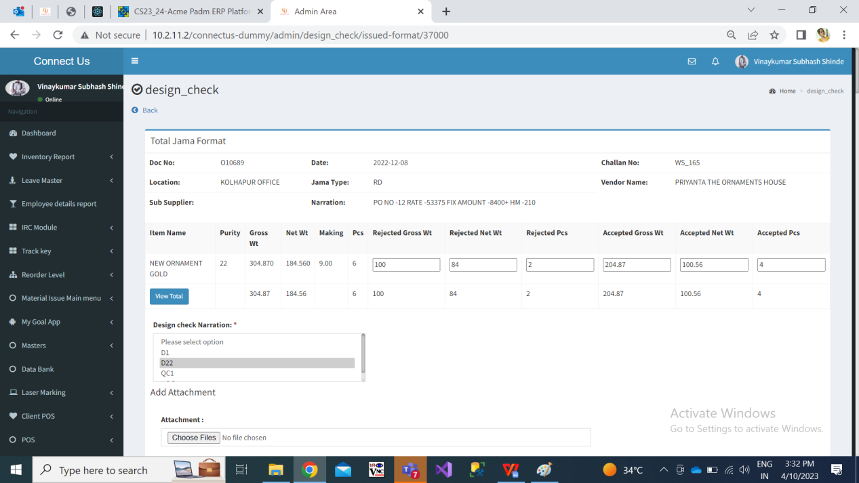

Step 3. Only the accepted gross wt, accepted net wt and accepted pcs from design check will be forwarded to quality check.

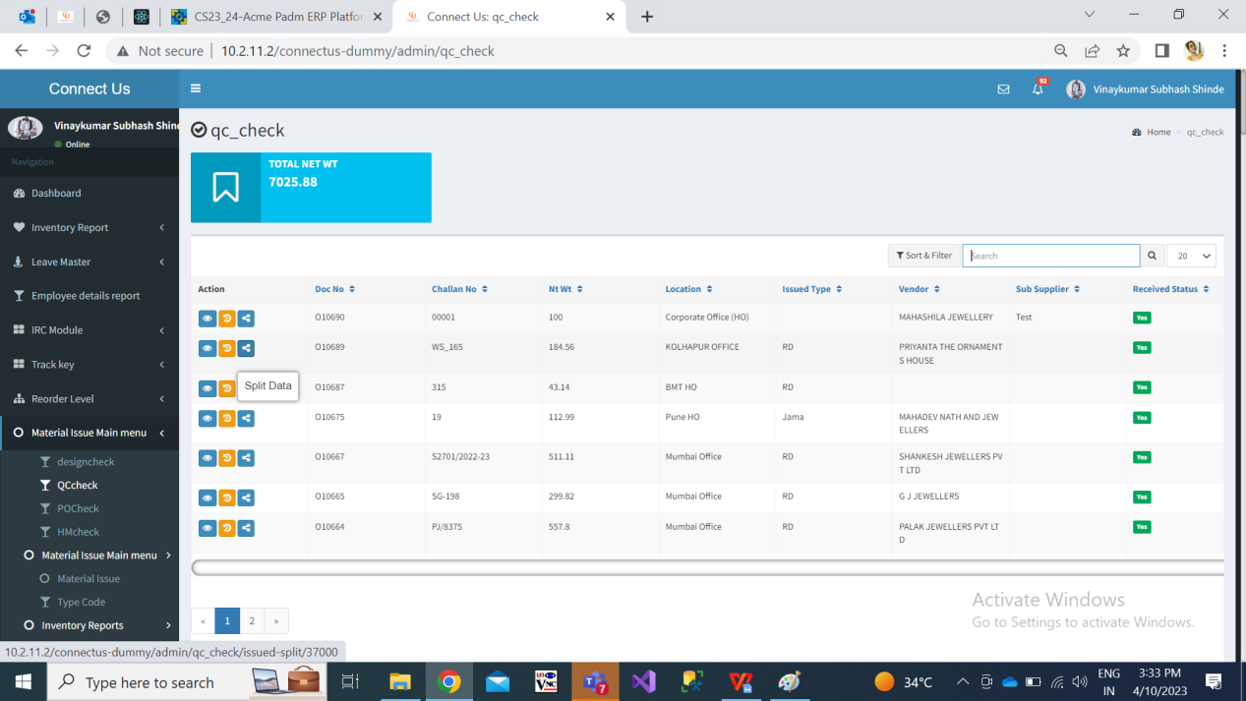

Fig: quality check -> grid

Qc incharge will split the accepted pcs into employees. The split data / pcs will be displayed to the employees and will be able to perform quality checking of the items.

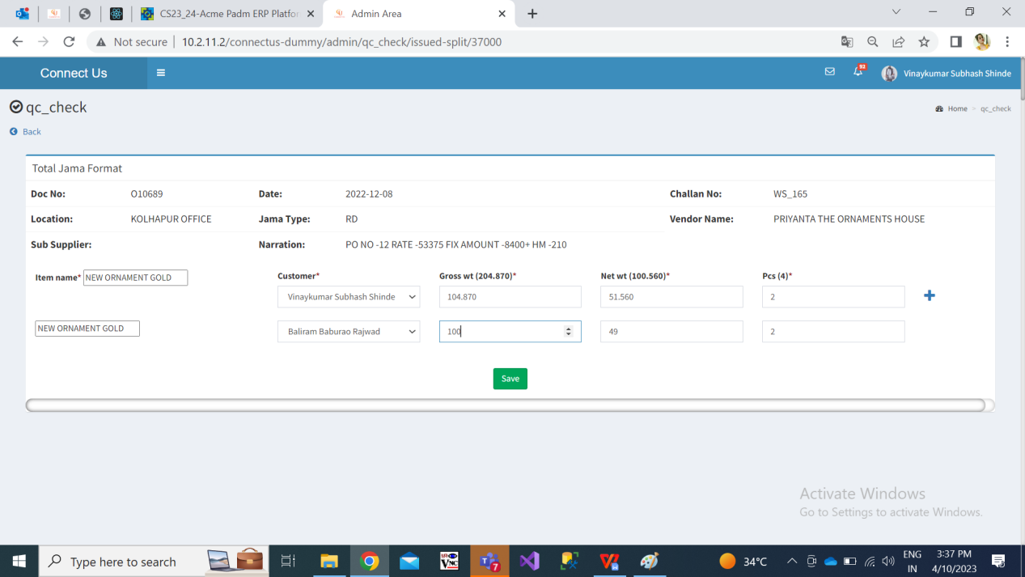

Fig: QC check -> split

Once QC employees checks the items and enters details of rejected gross wt, rejected net wt and rejected pcs , then the remaining accepted gross wt, accepted net wt, accepted pcs will be auto calculated and displayed.

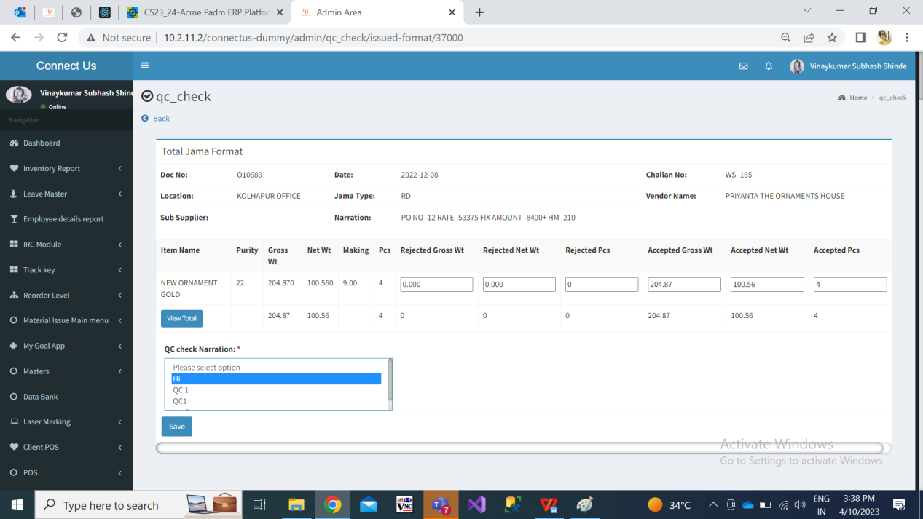

Step 4. Only the accepted details of the items from qc check document will be computed together and will be forwarded to POcheck process.

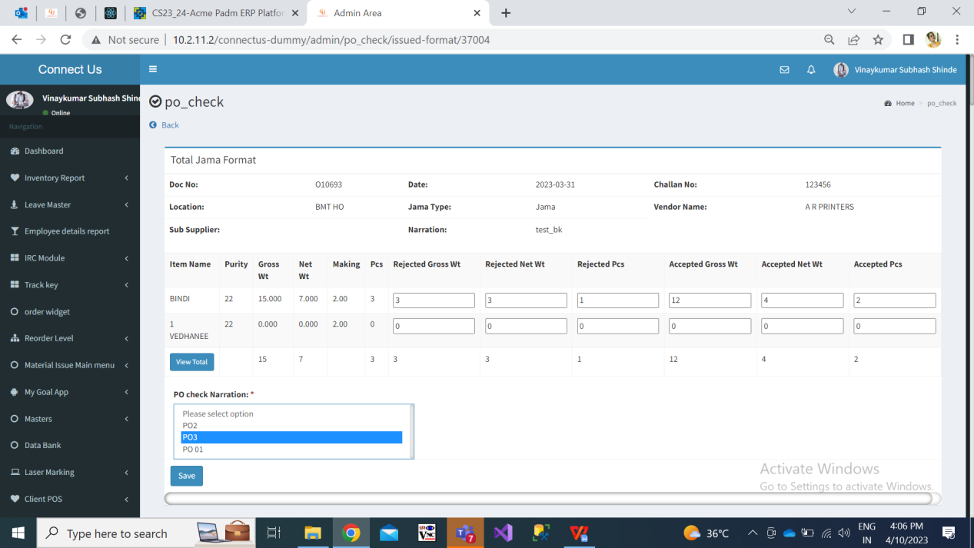

Step 5. Only the accepted details of the items in from PO check document will be computed together and will be forwarded to HMcheck process.

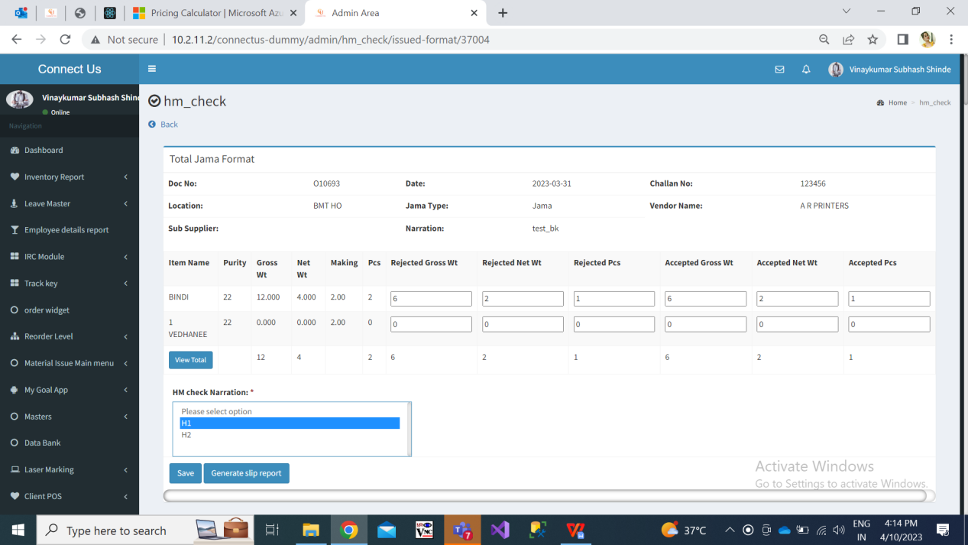

Once user enters of rejected gross wt, net wt and pcs, it will displayed accepted gross wt, net wt and pcs. Once user clicks on view total button, it will display all the collated details of accepted & rejected gross wt, net wt and pcs in each process.

Step 6. All the collated details of accepted & rejected gross wt, net wt and pcs in each process should be sent to the vendor via Email after it is saved in HM check process.

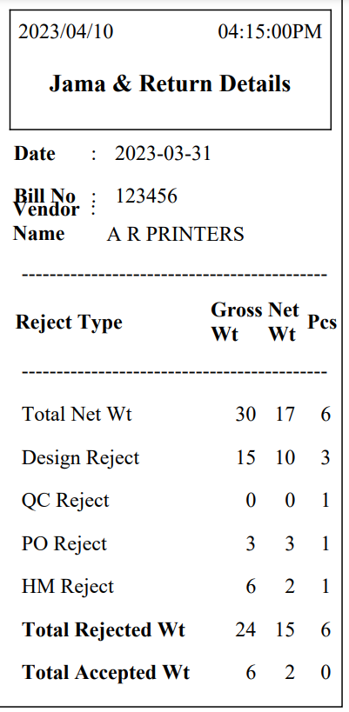

Fig: HM check -> generated slip

Step 7. FIx Rate

User will break the rate for the documents -> wt of the vendor through fix rate menu. All the documents which were marked as ‘yes’ for “Is RD purchase” field in material issue menu and have cleared HMcheck process will be displayed in fix rate menu. It has following fields in grid:

* Action - view, edit, fix rate, calculate
* Doc no.
* Challan no.
* Vendor name
* Rate type - Fix / Unfix
* Rate

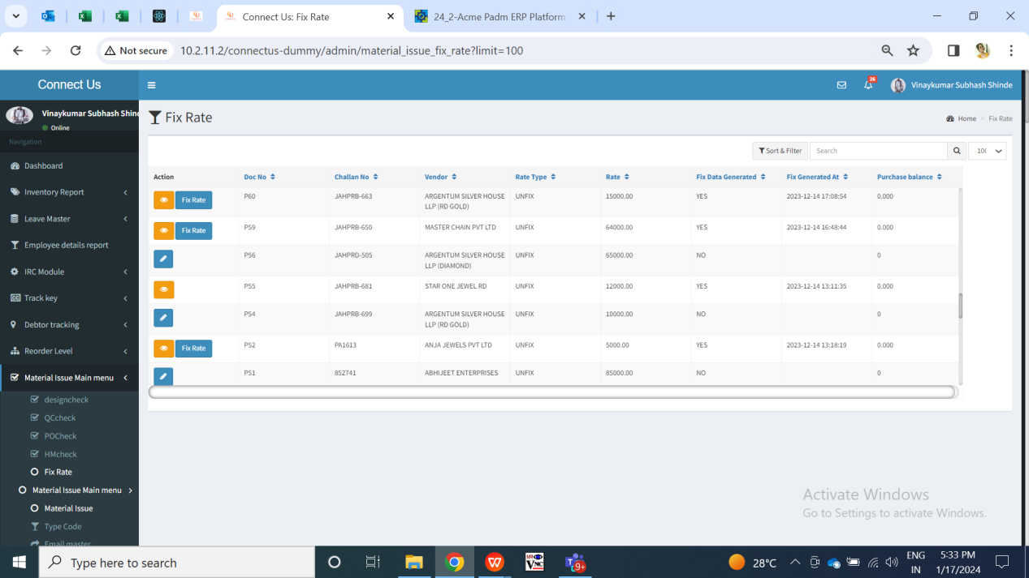

Fig: Fix rate -> grid

**Edit Action:**

Initially, each action will have edit action where user will enter the RD purchase and purchase returns documents from Padm for that record document. As per scanned documents, values will be matched with the doc. no. From material issue -> accepted and rejected till HM check process. Edit button will be displayed based on authority. (Authority from masters -> general master -> login special authority -> edit_action_in_fix_rate_module).

Once user clicks on edit action it will display following fields in form:

* Doc no.
* Challan no.
* Vendor name
* Total accepted - gross wt, net wt, pcs
* Total rejected - gross wt, net wt, pcs
* RD purchase doc no. - search and check button
* Doc no.
* Doc date
* Gross wt
* Net wt
* Pcs
* Stone amount
* HM charges
* Other charges
* TDS
* GST
* Gross amount
* Net amount
* Fine wt
* Purchase return doc no. - search and check button
* Doc no.
* Doc date
* Gross wt
* Net wt
* Pcs
* Stone amount
* HM charges
* Other charges
* TDS
* GST
* Gross amount
* Net amount
* Fine wt
* Save (button)
* Cancel (button)

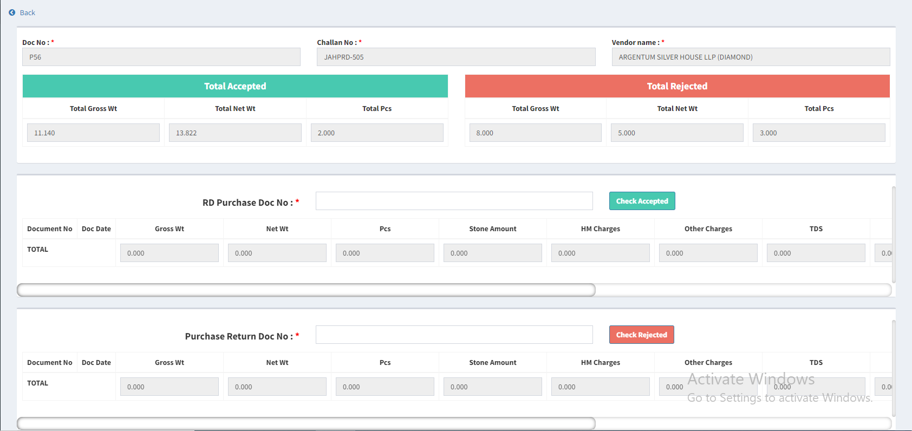

Fig: Fix rate -> edit action

|  |  |  |  |  |
| --- | --- | --- | --- | --- |
| **FIELDS** | **INPUT TYPE** | **MANDATORY/ OPTIONAL** | **EDITABLE** | **DESCRIPTION** |
| Doc no. | Text | Mandatory | No | It will display the doc no. From the material issue which got generated when doc. was created. |
| Challan no. | Text | Mandatory | No | It will display the challan no. which was mentioned for this document in add / edit action of material issue. |
| Vendor name | Text | Mandatory | No | It will display the vendor name. which was mentioned for this document in add / edit action of material issue. |
| Total accepted | Text | Mandatory | No | It will display the total accepted gross wt, total accepted net wt and total accepted pcs which was displayed till saving this document in HM check. |
| Total rejected | Text | Mandatory | No | It will display the total rejected gross wt, total rejected net wt and total rejected pcs which was displayed till saving this document in HM check. |
| Rd purchase doc no. | Text | Mandatory | yes | User will enter the rd puchase doc number from Padm -> documents -> rd purchase.  Entered document no. will be unique from entire system.  User can scan multiple document no. from Padm.  This field will not accept purchase return document numbers.  Validation: It will accept alphanumeric value. It should accept one hyphen as special character before numbers. It should not accept space.  Min length = 5  Max length = 15 |
| Check accepted button | Click | - | - | Once user enters doc no and clicks on check accepted button, it will display following details of that document from Padm:   * Gross wt * Net wt * Pcs * Stone amount * HM charges * Other charges * TDS * GST * Gross amount * Net amount * Fine wt   Once details of scanned documents are displayed, it will be displayed in row and have cancel action against it so that user can remove the scanned document from the table.  If the entered document already exists in the system and user clicks on this button, it will display alert message as document already scanned.  The vendor name of the entered Padm rd purchase document no. should be as same as the vendor name of the document from material issue. Once user enters document number, clicks on check button and if the vendor name doesn’t match, then document should not get added in the row displaying alert message as ‘Vendor doesn’t match’.  Validation: Once user clicks on this button, it will be disabled until all details against that document are displayed in the table row. Also, once valid record of the scanned document gets displayed in the table row, then button will get enabled again so that user will enter another doc number. |
| Total | Text | Mandatory | No | It will display the sum of values of all scanned documents in rd purchase. The total fine wt from this will be displayed in fix rate -> balance fine wt field.  The total of net amount from here will be displayed in view action -> bill amount field of net payable amount table. |
| Purchase return doc no. | Text | Optional | yes | User will enter the rd purchase doc number from Padm -> documents -> purchase return.  Entered document no. will be unique from entire system.  User can scan multiple document no. from Padm. This field will not accept rd purchase document numbers.  Validation: It will accept alphanumeric value. It should accept one hyphen as special character before numbers. It should not accept space.  Min length = 5  Max length = 15 |
| Check rejected button | Click | - | - | Once user enters doc no and clicks on check rejected button, it will display following details of that document from Padm:   * Gross wt * Net wt * Pcs * Stone amount * HM charges * Other charges * TDS * GST * Gross amount * Net amount * Fine wt   Once details of scanned documents are displayed, it will be displayed in row and have cancel action against it so that user can remove the scanned document from the table.  If the entered document already exists in the system and user clicks on this button, it will display alert message as document already scanned.  The vendor name of the entered Padm purchase return document no. should be as same as the vendor name of the document from material issue. Once user enters document number, clicks on check button and if the vendor name doesn’t match, then document should not get added in the row displaying alert message as ‘Vendor doesn’t match’.  Validation: Once user clicks on this button, it will be disabled until all details against that document are displayed in the table row. Also, once valid record of the scanned document gets displayed in the table row, then button will get enabled again so that user will enter another doc number. |
| Total | Text | Mandatory | No | It will display the sum of values of all scanned documents in purchase return.  The total of net amount from here will be displayed in view action -> purchase return field of net payable amount table. |
| Submit button | Click | - | - | Once user enters documents and clicks on submit, it will display alert message as record doesn’t match if the accepted & rejected values of the Padm documents doesn’t match with the accepted and rejected values from HM check. Submit button should be disabled until total of accepted and rejected of RD purchase and purchase return documents doesn’t match with accepted and rejected from HM check. Document should get submitted only when the data gets matched while submitting.  Once the user clicks on submit, then edit action will be removed for that record in the grid and fix rate (only for unfix rate type) & view action (for both rate type) will be displayed for that record. Moreover, documents that were scanned in edit action those will be displayed in view action for that record. |
| Cancel button | Click | - | - | If user clicks on cancel button, details will rmain unaffacted and user will be directed to grid page of fix rate menu.  Validation: cancel button will be disabled until user is directed to grid page. |

**Fix rate action:**

Once documents are scanned in edit action and submitted, edit action against that document will be removed and fix rate action will be displayed against it if document is of unfix rate type from material issue. If document is of fix rate type in material issue then directly calculate action will be displayed against it after edit action (fix rate action will not be displayed for material issue -> fix rate type documents).

Fix rate action will be displayed only for the documents whose rate type is unfix as per material issue -> add / edit / view. Fix rate action will not be displayed against documents whose rate type is fix as per material issue -> add, edit, view. Through fix rate action, user will enter the breaking rate that has been finalized for that day for the vendor. It will be displayed based on special authority (Fixing_rate_action_in_fix_rate_module). This button will be removed from grid against that record once balance fine wt is 0.00 as well as once debit / credit note number in all records is mentioned. It will have following fields:

* Doc no.
* Balance fine wt
* Unfix rate
* Unfix fine rate
* Vendor name
* Fix rate
* Quantity
* Add button
* Break rate table
* Sr. No.
* Balance fine w
* Unfix rate
* Unfix fine rate
* Fix Rate
* Fix fine rate
* Difference amount
* Quantity
* Gross amount
* GST Amount
* Net amount
* Remark
* Created by & at
* Note no.
* Update button

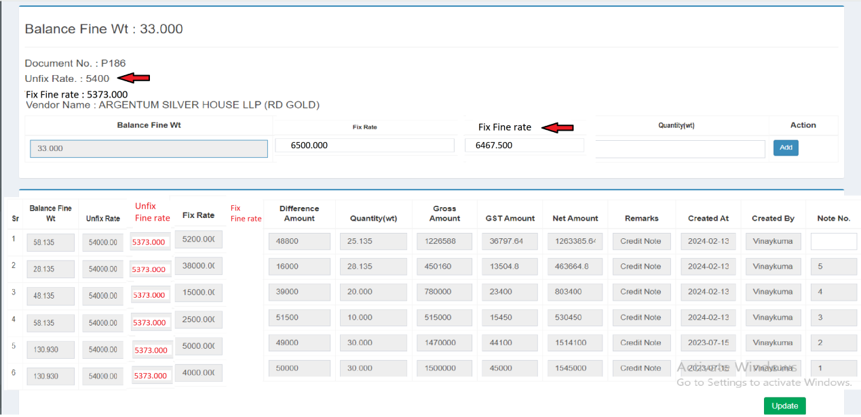

Fig: Fix rate -> fix rate action

|  |  |  |  |  |
| --- | --- | --- | --- | --- |
| **FIELDS** | **INPUT TYPE** | **MANDATORY/ OPTIONAL** | **EDITABLE** | **DESCRIPTION** |
| Doc no. | Text | Mandatory | No | It will display the doc no. From the material issue which got generated when doc. was created. |
| Balance fine wt | Text | Mandatory | No | It will display the balance fine wt for which the rate is not fixed yet. Initially, it will display the total fine wt which is displayed from -> total fine wt of rd purchase documents minus total fine wt of purchase return documents. |
| Vendor name | Text | Mandatory | No | It will display the vendor name. which was mentioned for this document in add / edit action of material issue. |
| Unfix rate | Text | Mandatory | No | It will display the rate which was entered in material issue -> fix rate text field of add / edit action for that document. It will be for per gram. |
| Unfix fine rate | Text | Mandatory | No | It will display the unfix fine rate from material issue -> add / edit / view action of that document.  Unfix fine rate = Unfix rate / 99.50%. |
| Breaking fix rate | Text | Mandatory | No | User will enter the rate of per gram which has to be break for the vendor for that day. User will enter the rate for 99.50% purity.  Validation: It will accept only numbers. It will accept single decimal point as special character. It should accept 3 digits only after decimal point.  Min length = 3  Max length = 15 |
| Breaking fix fine rate | Text | Mandatory | No | It will auto-calculate and display the fix fine rate once user enters the value in breaking fix rate text field. It represents the fix rate for 100% purity.  fix fine rate = breaking fix rate / 99.50%.  Validation: It will be read only. It will round upto 3 decimals after decimal point when fourth didgit will be greater than equal to 5. |
| Breaking quantity wt | Text | Mandatory | No | User will enter the wt for which the rate is finalized.  Validation: It should less than or equal to balance fine wt. It will accept only numbers. It will accept single decimal point as special character. It should accept 3 digits only after decimal point.  Min length = 1  Max length = 15 |
| Add button | Click | - | - | Once user enters valid quantity, fix rate and user clicks on add button then it will display that record in the table below as well as it will be displayed in view action. Moreover, each time when record is added, email will be sent to the vendor of that table.  In case user fills incorrect values in fix rate and quantity field and clicks on add button, then on field error message will be displayed.  Validation: Add button will be disabled until record of break rate gets displayed in the table below. |
| Break rate table - balance fine wt | Text | Mandatory | No | It will display the balance fine wt which was available while breaking rate for that particular record.  Previous balance fine wt - quantity of that record will be displayed here. Initially, it will display total balance fine wt of that document for the fist record in the table. |
| Break rate table - Unfix rate | Text | Mandatory | No | It will display the rate which was entered in material issue -> fix rate text field of add / edit action for that document. It will be for per gram. It will be same for all the records. |
| Unfix fine rate | Text | Mandatory | No | It will display the unfix fine rate from material issue -> add / edit / view action of that document. It will be same in all record of the table as this unfix fine rate is calculated only once in material issue. |
| Break rate table - fix rate | Text | Mandatory | No | It will display the rate which was entered by the user while breaking the rate I.e. rate mentioned in fix rate column of add button table. |
| Breaking fix fine rate | Text | Mandatory | No | It will display the fix fine rate for that record which got calculated when user entered the value in breaking fix rate text field.  Validation: It will be read only. |
| Break rate table - Difference amount | Text | Mandatory | No | Difference amount will display the difference between unfix rate and fix rate of each entry in the table.  Difference amount = Unfix fine rate - Fix fine rate of the table. |
| Break rate table - Gross amount | Text | Mandatory | No | Gross amount = Difference amount * Qty |
| Break rate table - GST amount | Text | Mandatory | No | It will display 3 % of gross amount in each row of the table. |
| Break rate table - net amount | Text | Mandatory | No | Net amount = gross amount + gst amount |
| Break rate table - remark | Text | Mandatory | No | It will display here whether credit note will be generated or debit note will be generated for that breaking rate record each time when it is added.  As per greater rate amount it will display whether credit note or debit will be generated.  If **fix fine rate > unfix fine rate**, then **debit note** should be generated.  If **fix fine rate < unfix fine rate**, then **credit note** should be generated.  If **fix fine rate = unfix fine rate**, then it will display as no note or blank. |
| Break rate table - created at | Text | Mandatory | No | It will display the date and time when that row got added in the table I.e. when break rate along with quantity was entered. |
| Break rate table - created by | Text | Mandatory | No | It will display the name of the employee name who added the record of break rate in that table. |
| Break rate table - note no. | Text | Optional | No | User will enter the credit or debit note no. here from Padm.  Initially, it will be blank whereas once user enters the note no. Clicks on update button, then this field will be read only displaying entered note no. in it.  Once all note no. in all rows of break rate table are entered and all fine wt is break, then update button will be disabled.  Validation: It will accept alphanumeric value. It should accept space and - . / only as special character.  Min length = 1  Max length = 15 |
| Update button | Click | - | - | Once user enters note number and clicks on update button, note number will be saved for that row whereas it will be read only further. Moreover, user will be directed to grid page of fix rate.  Validation: It will be disabled until note number gets saved and user gets directed to update button. |

All the details are mentioned / added in the fix rate will also be displayed in view action page.

**View action:**

Once users submits the document from edit action, then edit action will be removed and view action will be displayed against that record. Through view action, user will all the details of the documents scanned and the break rate table. In addition to this, user will be able to submit the net payable amount here. It has following fields:

* Doc no.
* Challan No.
* Vendor Name:
* Rate type:
* Unfix Rate
* Net payable amount
* Bill amount
* Purchase return amount
* Debit note
* Credit note
* Advance
* Submit button
* Net payable amount
* BC ID
* Bill created on
* RD purchase documents:
* Total gross wt
* Total net wt
* Total pcs
* Total Stone amount
* Total HM charges
* Total Other charges
* Total TDS
* Total GST
* Total Gross amount
* Total Net amount
* Total Fine wt
* Purchase return documents:
* Total gross wt
* Total net wt
* Total pcs
* Total Stone amount
* Total HM charges
* Total Other charges
* Total TDS
* Total GST
* Total Gross amount
* Total Net amount
* Total Fine wt
* Break rate table

1. Balance fine wt
2. Unfix rate
3. Unfix fine rate
4. Fix Rate
5. Fix fine rate
6. Quantity (I.e wt)
7. Net
8. Created at & by
9. Remark
10. Note no.

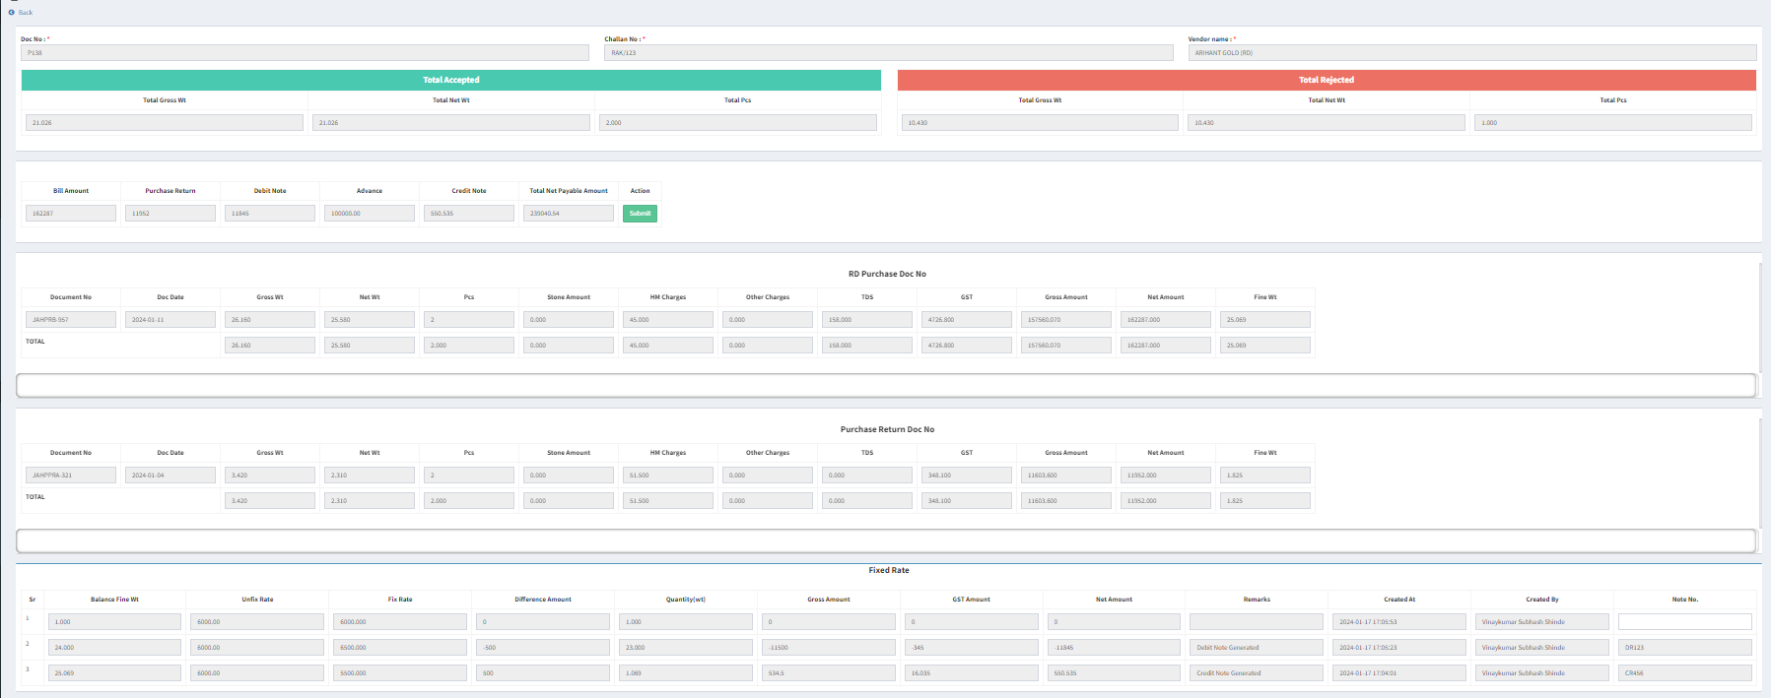

Fig: Fix rate -> view action

**Calculate action:**

Through calculate button, user can calculate net payable amount and create the bill for that document in bill checking. This button will be displayed once balance fine wt is 0.00 means rate for entire wt in document is break. This button will be provided based on authority. It will have following fields:

* Document number
* Vendor name
* Bill amount
* Purchase return amount
* Debit note
* Credit note
* Advance
* Submit button
* Net payable amount
* Create bill button
* Bill created on

|  |  |  |  |  |
| --- | --- | --- | --- | --- |
| **FIELDS** | **INPUT TYPE** | **MANDATORY/ OPTIONAL** | **EDITABLE** | **DESCRIPTION** |
| Bill amount | Text | Mandatory | No | It will display the total net amount of accepted documents I.e. RD purchase documents as submitted from edit action. |
| Purchase return | Text | Mandatory | No | It will display the total net amount of rejected documents I.e. purchase return documents as submitted from edit action. |
| Debit note | Text | Mandatory | No | For unfix rate type documents, It will display the sum of gross amounts of the debit notes rows in fix rate -> break rate table. Do not consider its negative sign.  It will display 0 for fix rate type documents by default. |
| Credit note | Text | Mandatory | No | For unfix rate type documents, It will display the sum of gross amounts of the credit notes rows in fix rate -> break rate table. Do not consider its negative sign.  It will display 0 for fix rate type documents by default. |
| Advance | Text | Mandatory | No | User will manually enter the advance amount given to the vendor here.  Validation: It will accept numbers only. It will accept single decimal point as special character. It will accept three digits only after decimal point.  Min length = 1  Max length = 25 |
| Net payable amount | Text | Mandatory | No | Net payable = Rd purchase net Bill amt - Purchase return net amount - sum of DR note gross amount - Advance + sum of CR note gross amount |
| Submit button | Click | - | - | This button will be disabled until balance fine wt in that document is 0.00 I.e. until rate is break for entire fine wt for unfix rate type. Whereas for fix rate type, this button will be enabled as soon as documents are submitted through edit action and once view action gets displayed.  Once user enters advance amount and clicks on submit button, net payable amount will get calculated and displayed and successful message will be displayed as ‘Net payable amount is calculated.’. Further, submit button will be removed and create bill button will be displayed against it. Also, advance amount field will be disabled and display entered value once submitted. |
| Create bill button | click | - | - | Once net payable amount gets calculated & displayed, create bill button will be displayed next to it. Through create bill button, user can create the bill for that document. Once bill gets submitted and BC ID gets generated and displayed to it, then create bill button will be removed. |
| BC ID | Text | - | No | Once user creates the bill against this document no. And clicks on submit button, BC ID will be displayed here which gets generated for that document in bill checking. |
| Bill created on | Text | - | No | It will display the date on which bill was created for that document and BC ID was displayed. |

All the details will also be displayed in view action of that record in fix rate menu.

**Create bill:**

Further, once user clicks on create bill button, it will direct user to the add form of bill checking displaying pre-filled fields as per document submitted through fix rate -> view -> create bill action.

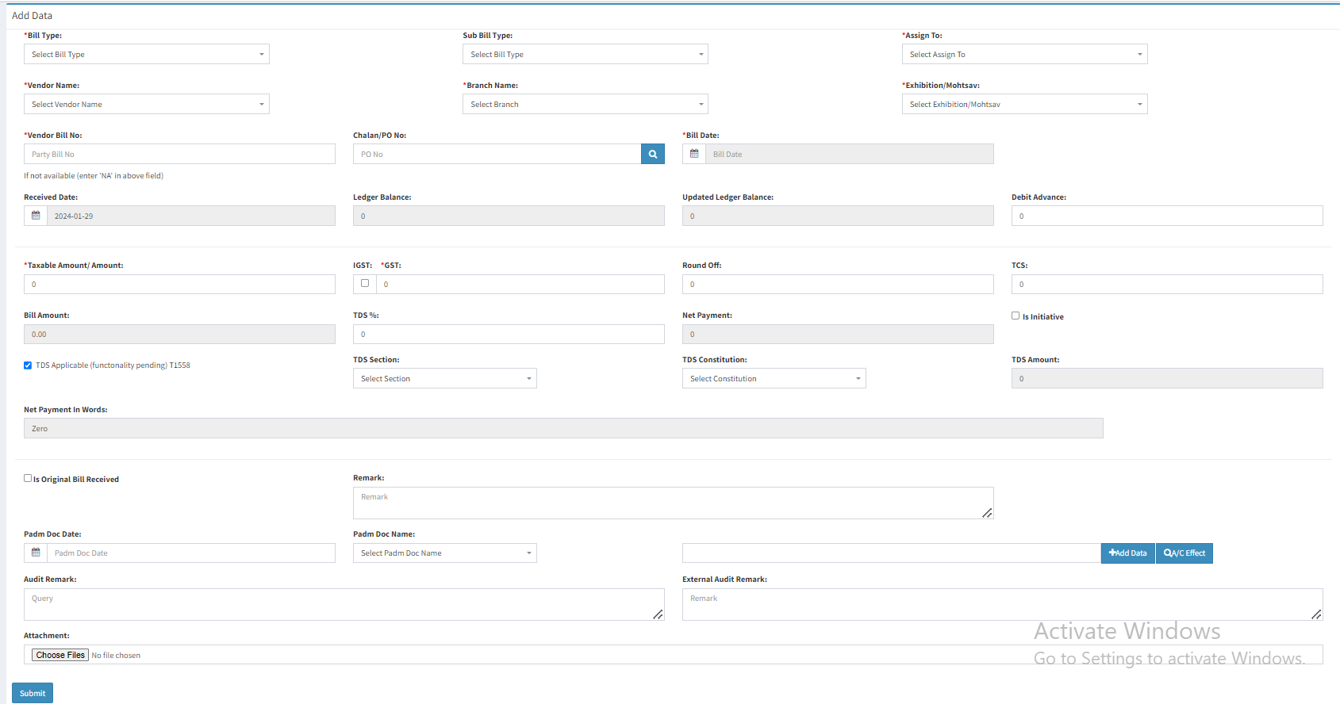

Fig: Bill checking -> add form

|  |  |  |  |  |
| --- | --- | --- | --- | --- |
| **FIELDS** | **INPUT TYPE** | **MANDATORY/ OPTIONAL** | **EDITABLE** | **DESCRIPTION** |
| Bill type | Text | Yes | No | It will display Gold ornament as default bill type for this. |
| Vendor name | Text | Yes | No | It will display the vendor name which is against that document. |
| Branch name | Drop down | Yes | No | It will display the branch which was selected while adding the document in material issue. |
| Exhibition / Mahotsav | Drop down | Yes | No | As this field is not related to fix rate process, it should be disabled while submitting this form or should display NA in it. |
| Vendor bill no. | Text | Yes | No | User will enter the vendor bill no. which is mentioned on the attachment received. |
| **Material issue Doc no.** | **Text** | **No** | **No** | **It will display the material issue doc no. of the document.** |
| Challan / PO no. |  |  | No | It will display the details from the challan no. Field of the view action. |
| Bill date | Text | Yes | No | It will be displayed from material issue -> add / edit -> bill date field.  Validation: It should not accept bill date of last financial year. It should display error message when user clicks on submit bill button. |
| Debit advance | Text | Yes | No | Debit advance = (purchase return + debit note + advance) - credit note as displayed from view action. |
| Taxable amount | Text | Yes | No | It should display total gross amount of rd purchase. |
| GST amount | Text | Yes | No | It will display the total GST amount of the RD purchase documents. |
| Bill amount | Text | Yes | No | Bill Amount = Taxable Amount + GST + Round Off + TCS  Here, round off and TCS will be 0. |
| Net payment | Text | Yes | No | Net Payment = Bill Amount - Debit Advance - TDS Amount |
| TDS amount | Text | Yes | No | It will display TDS amount from total TDS amount of RD purchase.  (It also means 0.10% of total gross amount of RD purchase) |
| Padm doc date | Text | No | No | It will display the date which is displayed against the RD Purchase scanned document. |
| Padm doc name | Text | No | No | It will display the document series number which is displayed against the RD Purchase scanned document row. |
| Attachment | Attach | No | No | It will display the attachments which were added under this document in material issue -> add / edit. |
| Submit button | click | - | - | Once user clicks on submit button, bill will get submitted and displayed in top row of bill checking transaction grid with BC ID generated for it. This generated BC ID will be displayed in the view action of fix rate document along with created date. |

1. **TEST DATA & SCENARIOS**



1. **ODUS (Open Discussion Unhanded Scenarios)**

|  |  |  |  |  |
| --- | --- | --- | --- | --- |
| **Sr. No.** | **Topic** | **Priority** | **Remark** | **Status** |
| 1 | Rakesh : rate field should accept only 4 digits before decimal point. | Medium |  | Closed |
| 2 | Rakesh : TT19564 - Total fine wt in fix rate action should display initial value of (rd purchase total fine wt minus purchase return total fine wt). | High |  | Closed |
| 3 | Rakesh : Fine rate of of 99.50% as well as 100% should be displayed in material issue and fix rate action. | High |  | Closed |

1. **REFERENCES OF THE USERS**

|  |  |  |  |
| --- | --- | --- | --- |
| **User** | **Name** | **Mail** | **Contact No.** |
| **Actual user** | Prashan Pise  Sachin Humne  Rakesh Thikane | isa@csjewellers.com |  |
| **Ticket created by (if any)** | Manali Bhadirage | Manali.bhadirage@techneai.com |  |
| **Assigned business analyst** | Manali Bhadirage | Manali.bhadirage@techneai.com |  |
| **Assigned developer** | Prathmesh shinde  Yogita Jagtap | [Prathmesh.shinde@techneai.com](mailto:Parthmesh.shinde@techneai.com)  Yogita.jagtap@techneai.com |  |
| **Assigned tester** | Priyanka D | Priyanka.dupargude@techneai.com |  |