Manali Ashok Bhadirage

Manali.bhadirage@techneai.com

19.02.2024

Customer Order Details - Unprocessed status Back-end employee name

**Handover Document**

**CONTENTS**

[1. TICKET DETAILS 2](#_Toc25124)

[2. INTRODUCTION 2](#_Toc19751)

[3. BUSINESS REQUIREMENT 2](#_Toc28746)

[4. SCOPE 3](#_Toc14027)

[5. BUSINESS & SYSTEM RULES 4](#_Toc32311)

[6. GRAPHICAL REPRESENTATION 4](#_Toc5910)

[7. DEVELOPED SYSTEM 6](#_Toc32579)

[8. REFERENCES OF THE USERS 20](#_Toc28111)

1. **TICKET DETAILS**

|  |  |
| --- | --- |
| **Ticket ID** | TT19290 |
| **Ticket description** | connect us madhye Customer Order La Status Filter>Unprocessed employee master add karun dene max-10 user (as per Call Discuss) |
| **Created by** | Jotiram Pawar |
| **Created on** | 26/01/2024 |
| **Priority** | Very high |

1. **INTRODUCTION**

In the Padm system, order numbers are generated for customer orders, GTS scheme orders, and Kalptaru scheme orders. These orders are then imported to the "Customer Order -> Order Detail" menu in Connect Us by branch officials. Subsequently, the Head Office (HO) assigns these orders to Karagirs / Sub-Karagirs. Once the order is ready, HO changes the status so that order could be dispatched to branch. When the orders are ready for pickup, branches update their status from "CU Customer Order -> Order Detail" to indicate readiness.

Once customers arrive at the branch to collect their orders, a sales bill is generated in Padm using the already assigned order number. Generating the sales bill marks the order as completed within the Padm system. Simultaneously, branches are expected to update the order's status to "complete" in the "CU Customer Order -> Order Detail" section.

1. **BUSINESS REQUIREMENT**

Once order is imported in the order details menu, its status gets displayed as unprocessed. However, Back-end employee name will be added in edit action against edit action initially and it will be read only further.

|  |  |  |  |
| --- | --- | --- | --- |
| **Requirement ID** | **Requirement Name** | **Short Description** | **Priority** |
| BR001 | Order detail -> edit | Initially, when order status is unprocessed, we have to add Back-end employee name as mandatory field where user will select the Back-end employee name who worked on it. | High |
| BR002 | Order detail -> edit | Back-end employee name field will be read only once Back-end employee name is selected for the first time. | High |
| BR003 | Special authority | We have to create special authority to edit Back-end employee name field further on once Back-end employee name is submitted. | High |
| BR004 | Login special authority | Application support team only should have authority to edit Back-end employee name field once it is submitted. Others will be able to only view Back-end employee name . | High |
| BR005 | Order detail -> view | Add Back-end employee name field in view action near status field. It will be blank until Back-end employee name is selected and submitted. | Medium |
| BR006 | Order detail -> grid | Add Back-end employee name column in grid action near status field. It will be blank until Back-end employee name is selected and submitted. | Medium |
| BR007 | Order detail -> export data & custom export | Back-end employee name column will be displayed in downloaded file. It will display blank value until Back-end employee name is selected against that order number. | Medium |
| BR008 | Order detail -> history | Back-end employee name column will be added in history action. Once Back-end employee name is submitted, it should e displayed. Once Back-end employee name is edited, its history will be displayed and highlighted. | Medium |

Note: It will display employee name field for all unprocessed orders. Whereas, for other status orders on live, employee name field will not be mandatory and will not be editable as those are already processed orders.

1. **SCOPE**

Once order note is created in Padm, it will be displayed in order status menu as well. User will be able to import order number in connect us -> customer order - order detail. Once order is imported, it will be displayed in the grid with default initial status as ‘Unprocessed’. For the first time, when user edits the order, Back-end employee name drop down will be displayed which will be mandatory. User will select the Back-end employee name from the drop down who worked on it. Once submitted, Back-end employee name will be displayed in edit, view, export and grid. Back-end employee name field will be editable based on authority whereas it will be read only to others displaying the name of the employee which was selected and submitted initially.

1. **BUSINESS & SYSTEM RULES**

* User will be registered in the system.
* User will be logged in.
* System should display error message for incorrect details if entered.
* Back-end employee name field will be editable only once whereas it will be read only once submitted. However, it will be editable based on authority and that too only to application support team currently.

1. **GRAPHICAL REPRESENTATION**

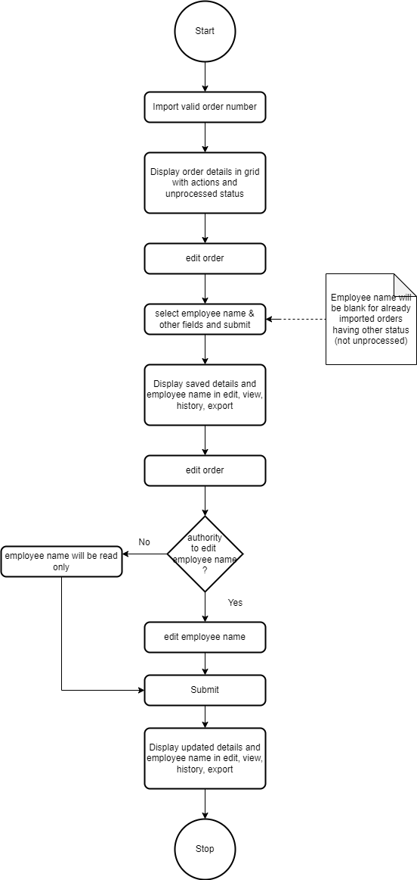

Fig: Process flow diagram

1. **DEVELOPED SYSTEM**

Presently, users log in using generic credentials such as Gold and Silver. Consequently, it becomes challenging to identify the specific user who processed orders, causing leaders to effectively analyze individual user performance for Key Result Area (KRA) evaluations.

Initially, order note is generated for any order at the branches through Padm -> customer order and order number gets displayed for it. Further, these orders are also imported in connect us -> customer order -> order detail.

Once user clicks on import data button, it will display following fields:

* Filter
* Date
* Order number
* Submit button

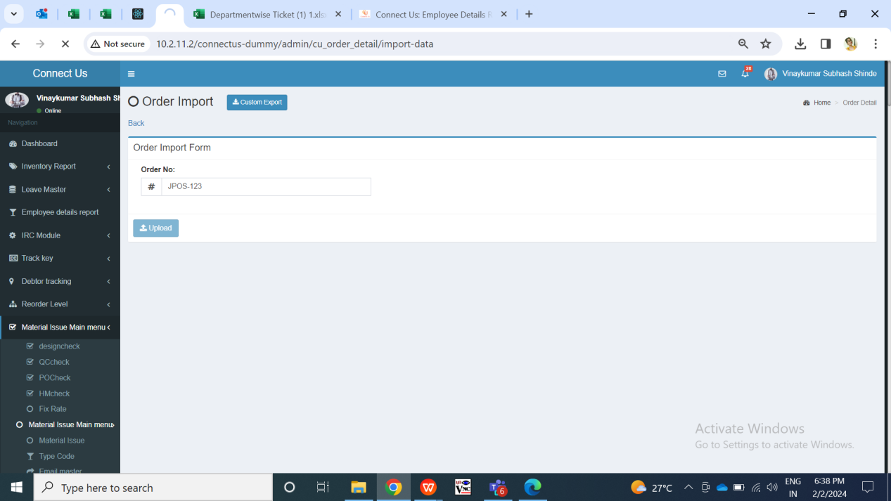

Fig: Import order no.

|  |  |  |  |  |
| --- | --- | --- | --- | --- |
| **FIELDS** | **INPUT TYPE** | **MANDATORY/ OPTIONAL** | **EDITABLE** | **DESCRIPTION** |
| Order no. | Text | Mandatory | - | User will enter the order number from Padm -> documents -> customer order which is to be entered here. Further once order is added, then it will be forwarded further and its status will be changed accordingly.  Validation: It will accept alphanumeric value. It will accept hyphen only as special character.  Min length = 4 Max length = 15 |
| Submit button | Click | - | - | Once user enters valid order no. and clicks on submit button, successful message gets displayed and order gets added in order details menu. The recently added order gets displayed on top of the grid with its initial status as ‘unprocessed’. |

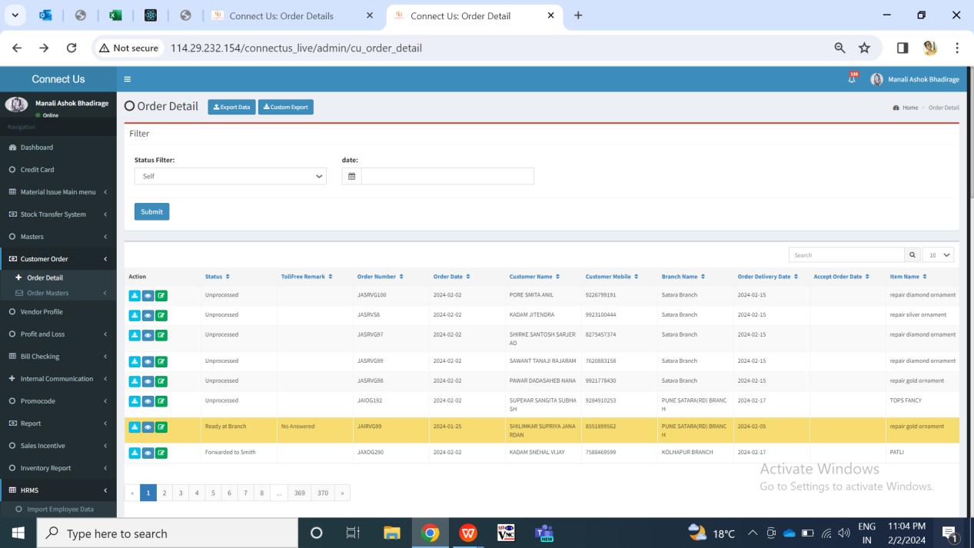

Fig: Order detail -> grid

Once order no. Gets imported, it gets displayed in top row of **grid** along order details from Padm. It will display following columns:

* Action - view, edit, history, export
* Status
* Order no.
* Order date
* Customer name
* Branch name
* Est pickup date
* Order delivery date
* Accept order date
* Item name
* Product group
* Inserted at
* Back-end employee name

When user clicks on **edit action** of unprocessed orders for the first time, it will display following details of the order:

* Order number
* Order date
* Delivery date
* Accept order date
* Estimate pick up date
* Order pick up date
* Customer mobile no.
* Customer name
* Branch name
* Item name
* Category
* Wastage type
* Changed wastage
* Net wt
* Purity
* Salesman name
* Status
* Back-end employee name
* Product group
* Toll-free remark
* Purchased from
* Sales bill no.
* Sales bill date
* Use
* Item details
* Catalog / stone / polish details
* Remark / assign / receipt details
* Other details
* Submit button

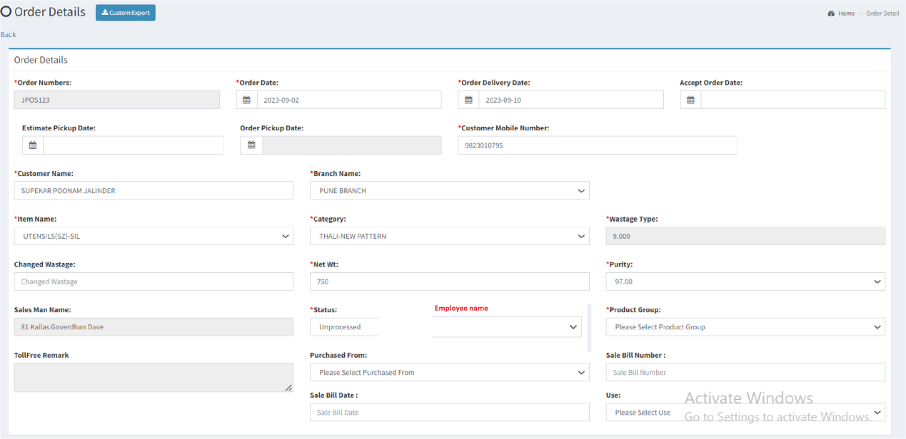

Fig: Order details -> Edit

|  |  |  |  |  |
| --- | --- | --- | --- | --- |
| **FIELDS** | **INPUT TYPE** | **MANDATORY/ OPTIONAL** | **EDITABLE** | **DESCRIPTION** |
| Order no. | Text | Mandatory | No | It will display the order no. Which was imported from Padm. |
| Order date | Calender date picker | Mandatory | Yes | It will display the date on which the order note was generated in the Padm. It will be editable.  Validation: It will be single select. |
| Order delivery date | Calender date picker | Mandatory | Yes | It will display the delivery as per order number from Padm. It will be editable.  Validation: It will be single select. |
| Accept order date | Calender date picker | Optional | Yes | User will select the date on which the order was accepted at the branch.  Validation: It will be single select. Initially, it will be blank. |
| Estimate pick up date | Calender date picker | Optional | Yes | It will display the estimated date on which customer will collect the order from branch.  Validation: It will be single select. Initially, it will be blank. |
| Order pick up date | Calender date picker | Mandatory | No | It will display the date on which the final sales bill was done and customer picked up the order.  It will be displayed from Padm. |
| Customer mobile no. | Text | Mandatory | No | It will display the customer’s contact number from Padm -> order number while creating the order note. |
| Customer name | Text | Mandatory | No | It will display the customer’s name from entered Padm -> order number while creating the order note. |
| Branch name | Drop down | Mandatory | Yes | It will display the branch name from entered Padm -> order number at which the order note was generated. It will be editable to user so that order can be fulfilled by another branch for the customer.  Validation: It will be single select. |
| Item | Drop down | Mandatory | Yes | It will display the item name from the entered order name of Padm. It will be editable so that item name can be changed if required.  Validation: It will display active items from Padm -> item master. It will be single select. |
| Category | Drop down | Mandatory | Yes | It will display the item name from the entered order name of Padm. It will be editable so that category name can be changed if required.  Validation: It will display active categories mapped against items from order masters -> category master. |
| Wastage type | Text | Mandatory | No | It will display the wastage type or % as per selected item & mapped category. It will displayed from wastage details against item -> category in Padm -> item master.  Validation: Only single wastage type will be displayed as set against item - category in Padm. |
| Changes wastage | Text | Optional | Yes | If the wastage type was set another earlier and was changed later due to change in item - category or due to change in wastage type in Padm itself, then user will mention the changed wastage here for employee and customer reference.  Validation: It will accept alphanumeric value.  Min length = 1  Max length = 10 |
| Net wt | Text | Mandatory | Yes | It will display the net wt of the order from entered order number. It will be editable as net wt can be changed if required.  Validation: It should accept only numbers. It should accept only one decimal point as special character.  Min length = 1  Max length = 25 |
| Purity % | Drop down | Mandatory | Yes | It will display the purity of the item - category from order number. It will be editable for user to changed if required.  Validation: it will be single select. It will display active purity from order master -> purity master. |
| Salesman name | Text | Mandatory | No | It will display the employee ID and salesperson name from entered order number who created the order number in Padm. |
| Status | Drop down | Mandatory | Yes | It will display the working status of the order. It will display unprocessed initially when order is imported. Further, user can change the status of the order based on its working stage.  Validation: It will be single select. It will display unprocessed, received to HO, forwarded to smith, forwarded to sub smith, ready at HO, order ready, ready at branch, completed, rejected, rejected to HO1, forwarded to toll-free, change and revert and other order pending in the list. |
| Back-end employee name | Drop down | Optional | Editable based on authority (support team) | User will select the Back-end employee name who has worked on this order. It should display ID and Back-end employee name .  Initially , if user submits the form without selecting the Back-end employee name when status was unprocessed, then it should display on field error message here to fill this field.  Initially, when the status is unprocessed and when user edits the form, this field will be displayed blank. User will select the Back-end employee name and submit. The submitted Back-end employee name will be displayed in edit, view, grid, history, export data and custom export. Further, once submitted, this field will be read only to others displaying the ID and the Back-end employee name which was submitted initially. It will be editable to users having special authority after Back-end employee name is submitted. (Special authority from masters -> general -> login special auth -> edit\_employeename\_Customer\_order\_details where this authority will be give to support team only currently.)  Validation: It will be single select. It should display only three names in the list namely Akshay pawar, Mangesh bhosale, sudhir dahiwal as in employee master as informed by the user. However, we have to display the list of the employees in the list from employee IDs mentioned in the value of global settings.    Fig: global settings  Dummy link is as below:  [http://10.2.11.2/connectus-dummy/admin/global\_setting](http://10.2.11.2/connectus-dummy/admin/global_setting" \o "http://10.2.11.2/connectus-dummy/admin/global_setting" \t "_blank) |
| Product group | Drop down | mandatory | yes | Initially, it will display the product group of the order as mentioned in the order number. It will be editable to user.  Validation: It will be single select. It will display active product group from order master -> product group master. |
| Toll free remark | Text | optional | Editable only for toll free privilege | Toll free user will mention the comment here if they have contacted customer related to order.  Validation: It will accept alphanumeric value.  Min length = 0  Max length = 250 |
| Purchased from | Drop down | Optional | Yes | User will mention whether the item is purchased from CSPL or from others (especially in case of repair).  It will display us and others in the list.  Validation: it will be single select. |
| Sale bill no. | Text | Optional | Yes | User will mention the sale bill number done for this order number in case partial payment is already done. And / or user will mention the sale bill no. when the order is completed and sale bill is done. |
| Sale bill date | Calender date picker | Optional | Yes | User will specify the date on which sale bill is generated for this order. |
| Use | Drop down | Optional | Yes | User will specify whether the item is of daily use or during the functions.  It will display as daily and functional in the list.  Validation: it will be single select. |
| Submit | Click | - | - | Once user enters valid details in mandatory and/or optional fields and clicks on submit button, all the updated details of that order number will be displayed in edit, view, history, grid and export.  Once the order is added, it will be displayed in grid of superadmin as welll as it will be displayed in the grid of the correct location user as per location / branch of the order dicument in padm. Example: If branch / location of order note is baramati then it will be displayed in the grid of baramati user login only and superadmin.  If user clicks on submit button without entering details in mandatory fields, then it will display on field validation error message. |

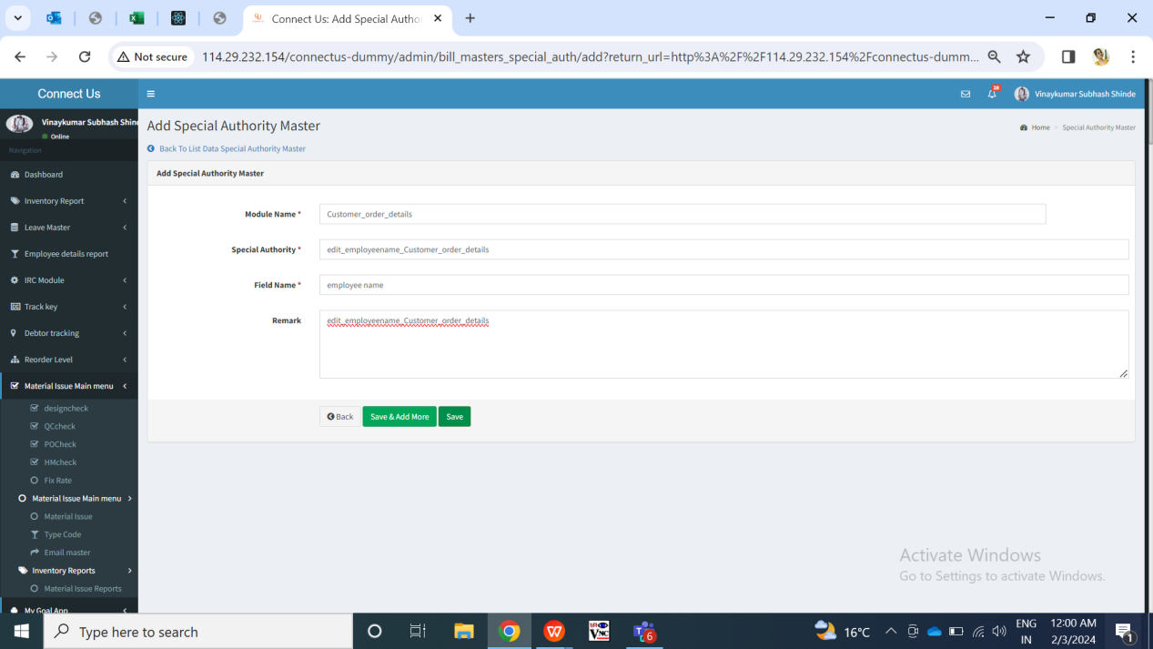

Fig: Special authority master -> edit\_employeename\_Customer\_order\_details

Once user clicks on **view** action of any particular order, it will display following fields:

* Order number
* Order date
* Delivery date
* Accept order date
* Estimate pick up date
* Order pick up date
* Customer mobile no.
* Customer name
* Branch name
* Item name
* Category
* Wastage type
* Changed wastage
* Net wt
* Purity
* Salesman name
* Status
* Back-end employee name
* Product group
* Toll-free remark
* Purchased from
* Sales bill no.
* Sales bill date
* Use
* Item details
* Catalog / stone / polish details
* Remark / assign / receipt details
* Other details

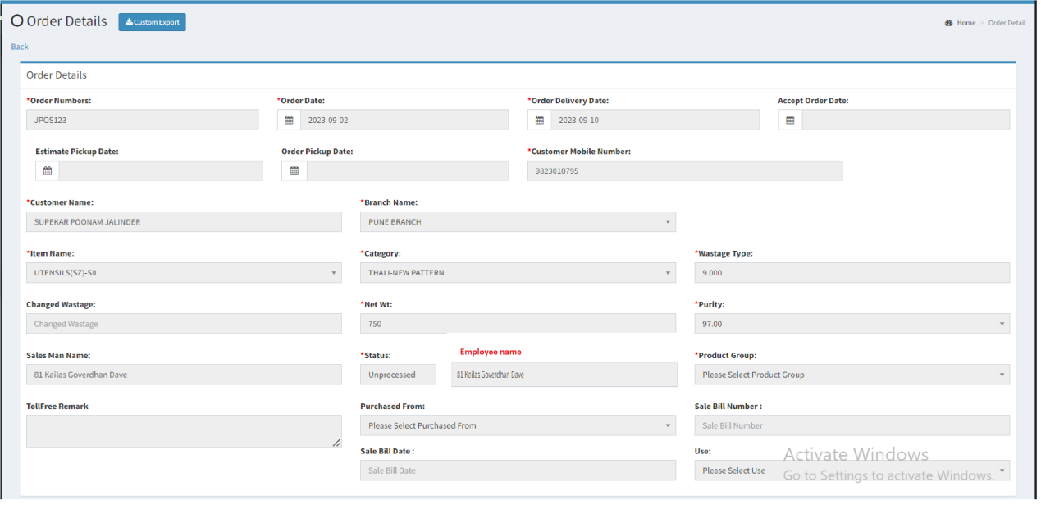

Fig: Order details -> view action

Once user clicks on **export** data button, csv file will get downloaded displaying following columns in it with data as in grid:

* Order no.
* Order date
* Customer name
* Branch name
* Est pickup date
* Order delivery date
* Accept order date
* Item name
* Product group
* Status
* Toll free remark
* Inserted at
* Back-end employee name (ID and Back-end employee name )

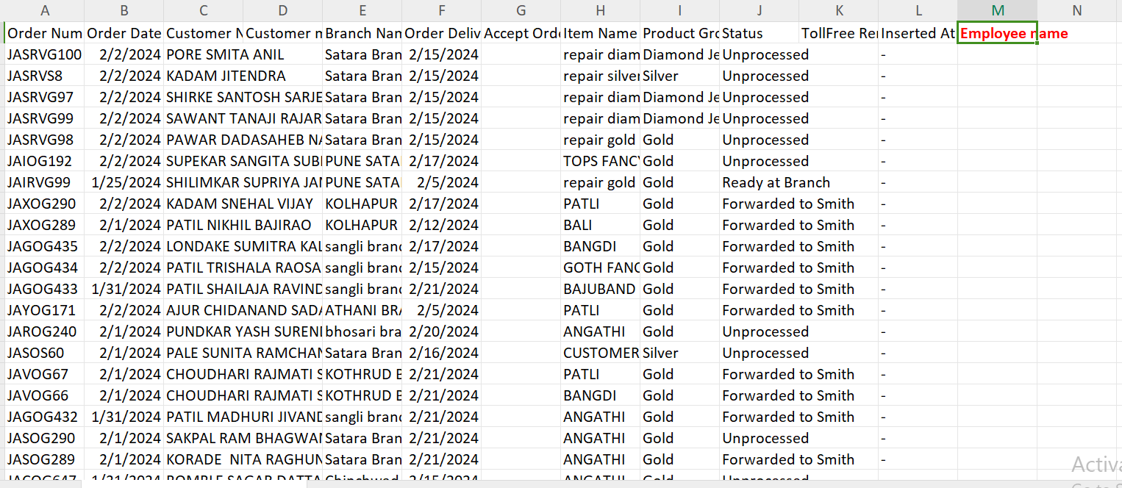

Fig: Export data (grid data)

Each time when order is added, its record will be displayed in **history** action as insert. Whereas each time when any details are edited and submitted, its record will be displayed in history action where the done changes will be highlighted. Once user clicks on history action, it will display following columns:

* Action - insert / update
* Status
* Id
* Order number
* Order date
* Customer name
* Customer mobile
* Branch name
* Est pick up date
* Order delivery date
* Accept order date
* Item name
* Category name
* Net wt
* Wastage type
* Purity
* Product group
* Back-end employee name
* Inserted at
* Inserted by
* Updated at
* Updated by
* Ip address
* Pcs
* item size
* Item width
* Reference bar-code
* Catalog
* Cx detail receipt
* Stone receipt
* Stone amt
* Salesman name
* Cs remark
* Smith remark
* Passing remark
* Assign to
* Smith assign date
* Smith name
* Change wt
* Change wastage
* Receipt date
* New bar-code no.
* Receipt wt
* Assign to sub smith
* Assign to sub smith date
* Polish type
* Import remark
* Is active
* Attachment id
* Sale bill no.
* Sale bill date
* Purchase from
* Use

User can download the specific required data which is required in CSV file through **custom export** action. User selects the columns which are to be displayed in exported file. It will have following options:

* File name
* Max data
* Type
* Select all
* ID
* Order no.
* Order date
* Order delivery date
* Estimate pickup date
* Order pickup date
* Customer mobile no.
* Customer name
* Branch name
* Item
* Category
* Wastage type
* Changes wastage
* Purity
* Net wt
* Salesman name
* Status
* Back-end employee name
* Product group
* Purchased from
* Sale bill no.
* Sale bill date
* Use
* Reference bar-code
* New bar-code
* Item size
* Item width
* Item pcs
* Stone name
* Stone colour
* Measurement mm
* Length
* Height
* Width
* Inclusions
* Stone wt
* Stone cut
* Catalog name
* Catalog details
* Customer detail receipt
* Stone detail
* Stone amt
* Polish name
* Cs remark
* Smith remark
* Passing remark
* Ho remark
* Assign to
* Assign to smith date
* Assign to sub smith
* Assign to sub smith date
* Change wt
* Receipt wt
* Receipt date
* Expected receipt date
* Estimate smith delivery date
* Inserted at
* Export button

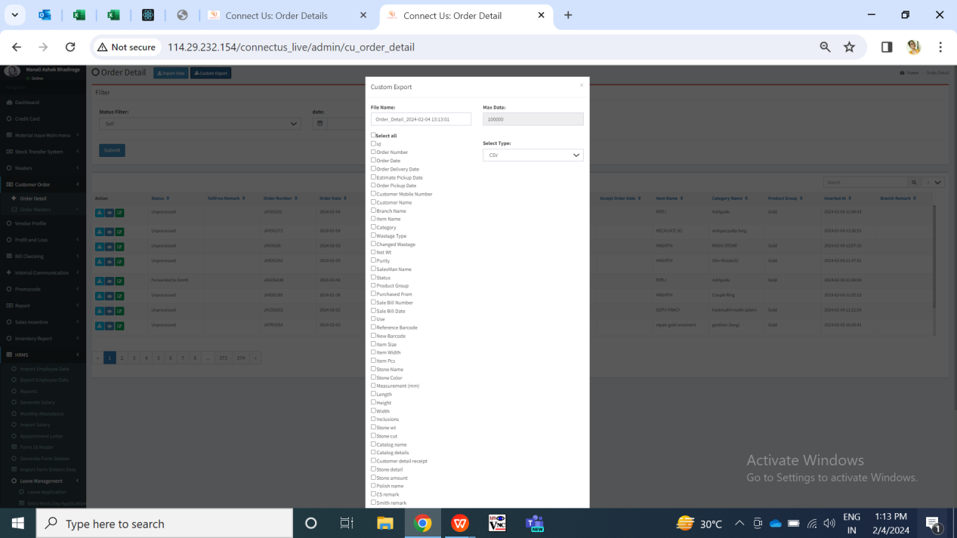

Fig: Custom export

Exported file will display the columns as selected in custom export and data accordingly.

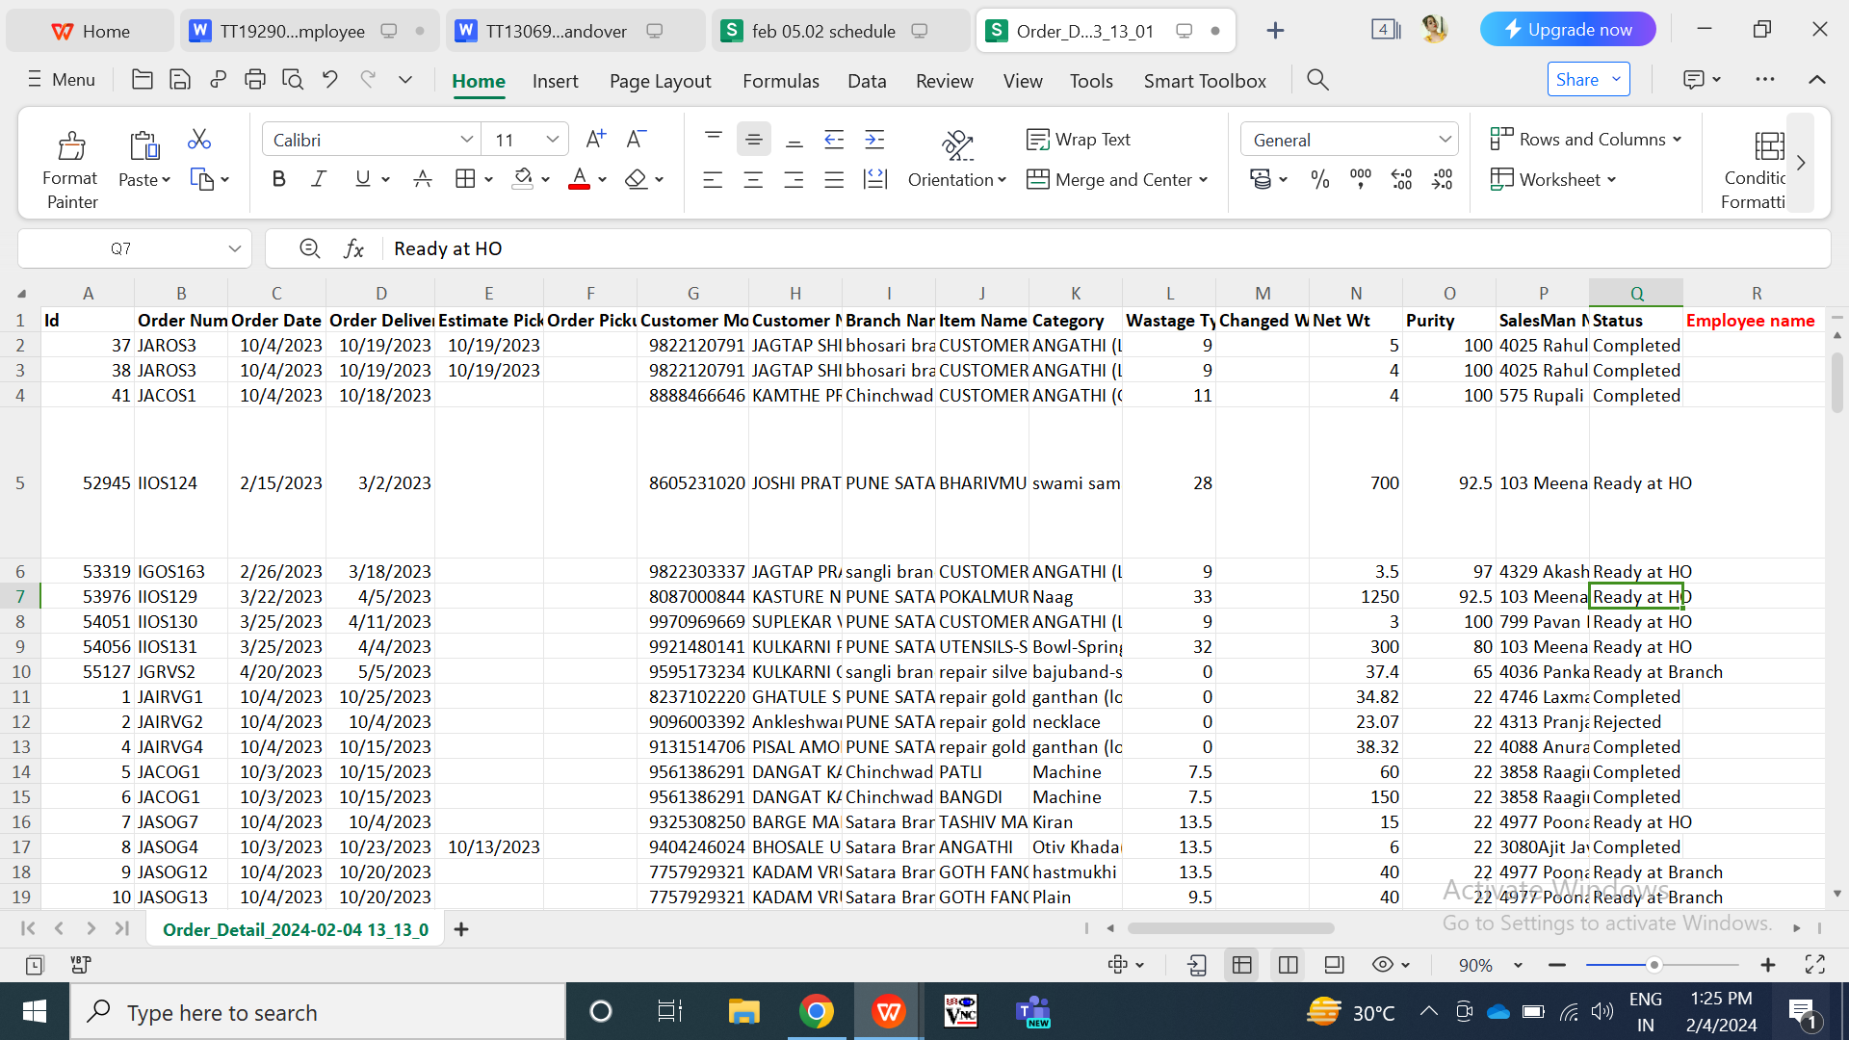

Fig: Custom export -> csv file

1. **REFERENCES OF THE USERS**

|  |  |  |  |
| --- | --- | --- | --- |
| **User** | **Name** | **Mail** | **Contact number** |
| **Actual user** | Jotiram Pawar | isa@csjewellers.com |  |
| **Ticket created by (if any)** | Jotiram Pawar | isa@csjewellers.com |  |
| **Assigned business analyst** | Manali Bhadirage | Manali.bhadirage@techneai.com |  |
| **Assigned developer** | Punam Shinde | Punam.shinde@techneai.com |  |
| **Assigned tester** | Vaishnavi Khandwe | Vaishnavi.khandwe@techneai.com |  |