20.02.2023

Pending Order

Manali Ashok Bhadirage

Manali.bhadirage@techneai.com

**Handover Document**

**CONTENTS**

1. TICKET DETAILS 2

2. VERSION CONTROL 2

3. APPROVALS 2

4. ESTIMATION 3

5. INTRODUCTION 3

6. BUSINESS REQUIREMENT 3

7. SCOPE 5

8. BUSINESS & SYSTEM RULES 5

9. ABBREVIATIONS & TERMS 5

10. EXISTING SYSTEM 5

11. GRAPHICAL REPRESENTATION 6

12. PROPOSED SYSTEM 6

13. TEST DATA 25

15. REFERENCES OF THE USERS 26

1. **TICKET DETAILS**

|  |  |
| --- | --- |
| **Ticket ID** | TT4393 & TT19541 |
| **Ticket description** | Inventory Silver Department Sathi ConnectUS Madhe New Report Create Karne Report Name :- Pending Order Check Ref By :- Vinaykumar Shinde Sir (Attachment Send In Mail)  PO phase 2 CR |
| **Created by** | Tushar Nikam  Manali Bhadirage |
| **Created on** | 22/08/2023  06/02/2024ss |
| **Priority** | Medium |

1. **INTRODUCTION**

Pending order process is an continuity to reorder level process. Through reorder level report, user gets to know the count of pcs / order that is to be given to Karagir for particular SCM (item - category - weight range - size). Through Pending Order checking report, user can understand the count of pcs which are given for labeling and which are pending from the Karagir. The order of one particular SCM is divided and given to one or more karagirs. So, order number is generated for each Karagir. This is called as purchase order. Further, labeling of each piece is done at inventory once orders are received from karagir. User uploads the labeling file which then displays the completed orders, pending orders and total orders in PO report. User can even accept extra pcs against one order through adjust report menu.

Example: Angathi- Fancy - 2.760-3.759 - 0 has total requirement of 40 pcs. Then this order of 40 pcs is divided and given to multiple karagirs. Like, 12 pcs order is given to Karagir A (PO1), 18 pcs order is given to Karagir B (PO2) and 10 pcs order is given to Karagir C (PO3).

1. **BUSINESS REQUIREMENT**

|  |  |  |  |
| --- | --- | --- | --- |
| **Requirement ID** | **Requirement Name** | **Short Description** | **Priority** |
| BR001 | Upload bulk file of new order | User will upload an excel file with details as delivery date, order date, Karagir, item, category, size range, weight range, new order, Karagir weight range and knockoff weight range. | High |
| BR002 | Bulk upload - Grid | Once excel file is uploaded with valid details, record will be displayed in grid with PO no. To it. | Medium |
| BR003 | Bulk upload - view | It will display the details which were inserted displaying the total order details which were inserted in file, count of pcs got mapped after uploading labeling file and count of canceled items. | High |
| BR004 | Bulk upload - cancel action | User will be able to cancel the items of that order by specifying reason from the drop-down list through remark master. | High |
| BR005 | Authority based actions | Uploading excel bulk file will be based on authority.  Canceling order pcs action will be based on authority.  Authority to upload labeling file. | High |
| BR006 | Upload labeling file from Padm | User will upload Padm -> labeling file. Once valid labeling file is uploaded, it will display the count of accepted pcs for that SCM and vendor in bulk upload -> view action as well as in PO report. | High |
| BR007 | Upload labeling - grid | Once valid labeling file is uploaded, it will display the record in grid as per actual jama date, invert jama date and Karagir name. | Medium |
| BR008 | PO report | As per uploaded excel file and labeling report, it will display all the orders which were given to vendor (by uploading bulk file) and the count which we have received at inventory (by uploading labeling file) and the remaining pcs count. | High |
| BR009 | Labeling report | Through labeling report, user can view list of accepted, rejected, knockoff and extra pcs. | Medium |
| BR010 | Padm vendor mapping | We have multiple vendors created with different names in vendor master as per ornament. However, it is only one vendor in Padm. Thus through vendor mapping, user will select vendor name from drop-down and mention all its possible names. This file will be when user will upload the labeling file. | High |

1. **SCOPE**

User will download the bulk file of new order. Enter the jewellery details as per SCM code, vendor name from the vendor master and order details in it. Once user uploads the bulk file, order number will get generated. Further, user will map the vendor name with its possible Padm vendor names through ‘Padm vendor mapping’ menu. Once user uploads the labeling file, it will map the orders as per labeling file, vendor and the given order. It will display the no. of accepted pcs. In addition to it, user can even cancel few pcs from order by specifying reason. Eventually, all the order details will be displayed in PO report. PO report will give wide representation of each order right from total order pcs, completed pcs and pending pcs. Furthermore, user can view knockoff pcs, extra pcs, accepted pcs and returned to vendor pcs through PO adjust report. User can accept or return to vendor the extra received pcs.

1. **BUSINESS & SYSTEM RULES**

* User will be registered in the system.
* User will be logged in.
* System will pop up a message, if any issues in the system is detected.
* Each time when user logs onto the menu and if data is updated then it will display messages as “Data updated as per change in Padm. Please refresh”.

1. **ABBREVIATIONS & TERMS**

PO - Pending Order

SCM code- item, category, weight range, size range, purity range

Wt - weight

1. **GRAPHICAL REPRESENTATION**

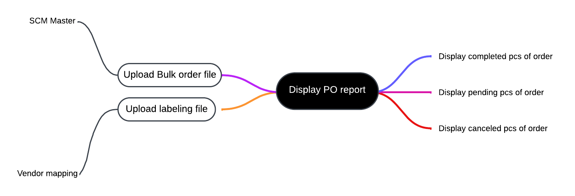

Fig: Mind map

1. **DEVELOPED SYSTEM**

Previously, all work of labeling pcs and new order is done on excel manually and using Vlookup formulas they get the count of pending pcs.

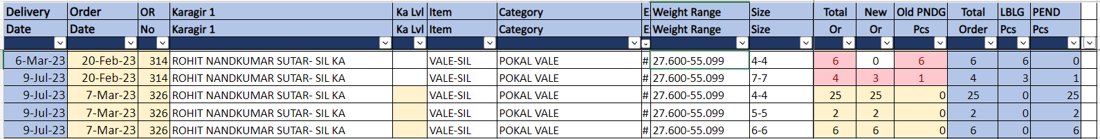

Fig: PO report (manual excel)

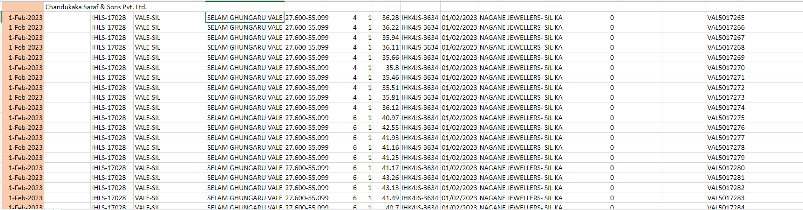

Fig: labeling pcs sheet

In Connect us, we have to create pending order as main menu which will have bulk upload, labeling file upload, PO report, labeling report and vendor PO sub-modules in it.

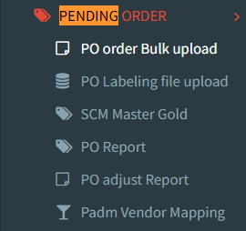

**Step 1. PO BULK FILE UPLOAD**

Through pending order user will upload the excel file which contains the details of orders that is given for Karagirs as per SCM code. It will have following fields:

* Download bulk format
* Upload bulk file
* View action
* History action
* PO date
* PO no.
* Karagir
* Created at
* Created by
* Updated at
* Updated by

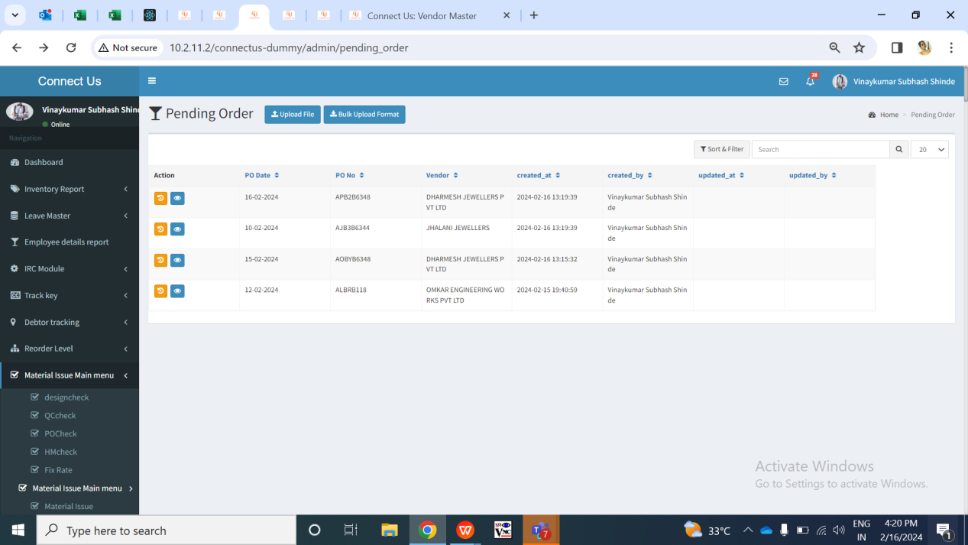

Fig: PO Bulk upload menu -> grid

All the values in each column of grid will be displayed once file is uploaded through ‘upload file’ button.

User will have to first download the bulk format file. Once user clicks on bulk upload format, excel file will get downloaded which will have following columns:

* Delivery date
* Order date
* Karagir
* Item
* Category
* Size range
* Weight range
* Exact wt
* Purity range
* New order
* Karagir weight range
* Knockoff weight range

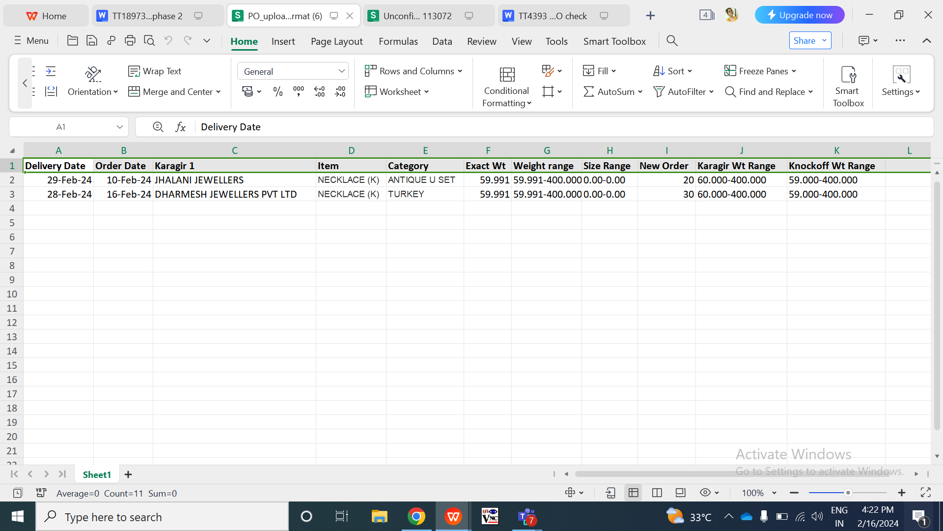

Fig: PO Bulk upload menu -> bulk format

|  |  |  |  |  |
| --- | --- | --- | --- | --- |
| **FIELDS** | **INPUT TYPE** | **MANDATORY/ OPTIONAL** | **EDITABLE** | **DESCRIPTION** |
| Delivery Date | Text | Yes | No | User will enter the delivery date on which the order is expected to be delivered by the vendor at inventory.  Validation: Delivery date will and order date can be same. Its format in excel file will be MM/DD/YYYY or DD-first three letters of month-YY. |
| Order date | Text | Mandatory | No | User will enter the date on which the order is given to the vendor for that SCM code.  Validations: Delivery date will and order date can be same. Its format in excel file will be MM/DD/YYYY or DD-first three letters of month-YY. |
| Karagir | Text | Mandatory | No | User will enter the name of the vendor to whom this order is given.  Validation: It will accept exact name from connect us -> bill checking -> vendor master which are active only. |
| Item | Text | Mandatory | No | User will mention item name from the SCM master gold. |
| Category | Text | Mandatory | No | User will mention category name from the SCM master gold for that item. |
| Exact wt | Text | Mandatory | No | User will mention the exact wt of the item - category which will be between mentioned weight range only. |
| Weight range | Text | Mandatory | No | User will mention weight range from the SCM master gold for that item -category. |
| Size range | Text | Mandatory | No | User will mention size range from the SCM master gold for that item -category. |
| Purity range | Text | Mandatory | No | User will mention purity range from the SCM master gold for that item - category. As SCM code is combination of item-category-weight range - size range - purity range, if user enters any of these values and there is not SCM code then it will display error for that record. |
| New order | Text | Mandatory | No | User will mention the pcs count for which are to be ordered from the vendor for that SCM code. |
| Karagir wt range | Text | Mandatory | No | User will enter the Karagir wt range that that means weight range as per karagir’s record.  Validation: Karagir wt range can be different from weight range column but Karagir wt range has to be between or equal to mentioned weight range only. |
| Knockoff wt range | Text | Mandatory | No | User will mention the weight range against which we have to map the pcs with net wt field of labeling file once uploaded.  Validation: Knockoff wt range can be different from weight range column but knock off wt range has to be between or equal to mentioned weight range only. |

In case any of the data in uploaded bulk file is incorrect, error will be displayed. User can download the error file in which error message will be displayed against each incorrect record. None of the data will get uploaded if any single data is invalid in bulk file. Bulk will upload data only if it has all correct details in it.

Once file is uploaded, then the collated data will be displayed as per Order date, order no and Karagir name. It will have following columns on grid:

* PO date
* Order number
* Vendor name
* Created at
* Created by
* Updated at
* Updated by

|  |  |  |  |  |
| --- | --- | --- | --- | --- |
| **FIELDS** | **INPUT TYPE** | **MANDATORY/ OPTIONAL** | **EDITABLE** | **DESCRIPTION** |
| PO Date | Text | Mandatory | No | It will display the order date from the bulk file.  Validation: It will be displayed in MM/DD/YYYY format. |
| Order number | text | mandatory | no | Once bulk file is uploaded, order no. will be generated by the system.   * First letter for financial year code (A for 2023-24 and there onwards) * Second character stands for order date (A to Z for dates 1 to 26 and then numbers 1 to 5 for dates from 27 to 31) * Third character stands for order date -> month ( A to L means from jan to dec) * Fourth character stands for delivery date (A to Z for dates 1 to 26 and then numbers 1 to 5 for dates from 27 to 31) * Fifth character stands for delivery date -> month ( A to L means from jan to dec) * Sixth onwards will be vendor code from database |
| Vendor name | Text | Mandatory | No | It will display the Karagir name which was mentioned in the uploaded bulk file for that record. |
| Created by | Text | Mandatory | No | It will display the name of the employee who created this record by uploading the bulk file. |
| Created at | Text | Mandatory | No | It will display the date and time on which the record was created in the grid by uploading bulk file. |

For each new order, if scm code and Karagir name is same, then the new order pcs will get added in the same existing order if delivery date is not different.

Through **view action** of each PO, details of that order will be displayed as below:

* PO date
* PO no.
* Vendor name
* Received extra
* delivery date
* total pcs ordered
* accepted pcs count
* Canceled pcs count
* Cancel action
* Table of canceled details

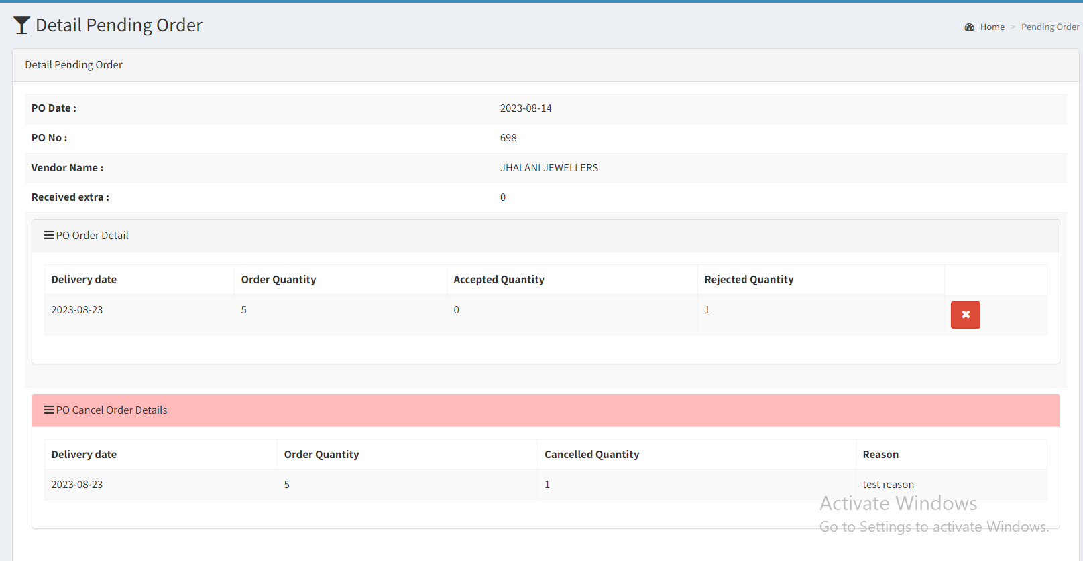

Fig: PO Bulk upload file menu -> view action

|  |  |  |  |  |
| --- | --- | --- | --- | --- |
| **FIELD** | **INPUT TYPE** | **MANDATORY** | **EDITABLE** | **DESCRIPTION** |
| Delivery Date | Text | Yes | No | Delivery date of scm code and Karagir order will be displayed as per excel file which was uploaded. |
| Count of total pcs ordered | Text | Yes | No | It will display the count of total pcs of order that has been given to Karagir. It will be displayed as per uploaded excel file |
| Accepted pcs | Text | Yes | No | Once pcs are being received from the Karagir and labeling is done, then will be considered as accepted. As and when the labeling file is uploaded (step 2) for SCM category and Karagir, the accepted pcs count will get updated here. |
| Canceled pcs | Text | Yes | No | It will display the total pcs of order that have been canceled by the authorized user. |
| Cancel action button | Click | - | - | This button will be provided based on authority.  Through cancel action, authorized user can cancel the entire order or few pcs from the order that has already been given to Karagir. Once authorized user clicks on cancel button, it will display below fields:   * Cancel count * Cancel reason * Confirm button     Reasons on drop-down list of ‘cancellation reason’ will be specified from daily stock remark master.    Cancel count will be text field where user will mention the number of pcs that has to be canceled. If total order count = total accepted count, that means all pcs have been received and labeled. Then in such case, “cancel action button” will be disabled. Also, user will be able to cancel pcs out of total pcs ordered only.  Cancel reason - Once user mentions the cancel pcs count, then user will have to compulsorily mention the reason for cancellation in this text field.  Once user clicks on submit button, dialogue box will be displayed as “Are you sure you want to cancel?” Once user clicks yes, then the count of canceled pcs will be displayed in ‘canceled pcs’ field.  Canceled pcs count will get deducted from the total pcs orders and accordingly pending pcs count will be displayed in report. User can cancel the item pcs out of total order pcs only. However, if user has canceled any pcs and still those are being received and uploaded in PO labeling I.e user definable report then those canceled pcs will be considered as extra and will be displayed in labeling report. |
| Table of canceled details | Text | - | No | It will display details of canceled pcs in table having following columns:   * Delivery date * Order quantity * Canceled quantity * Reason * Canceled by * Canceled date and time |

**Step 2. Padm Vendor Mapping**

As there are multiple vendor names in vendor master for the same vendor name. We need to map the different vendor names with Padm vendor name. When user will upload the labeling file, it will check the supplier name of the labeling file with vendor name in this master and then updated the pcs accordingly in PO report and PO bulk file menu -> view against against that order.

Padm Vendor mapping will have following fields:

* Add button
* View button
* Edit button
* Vendor name
* Padm vendor name
* Is active
* Remark
* Created at
* Created by
* Updated at
* Updated by

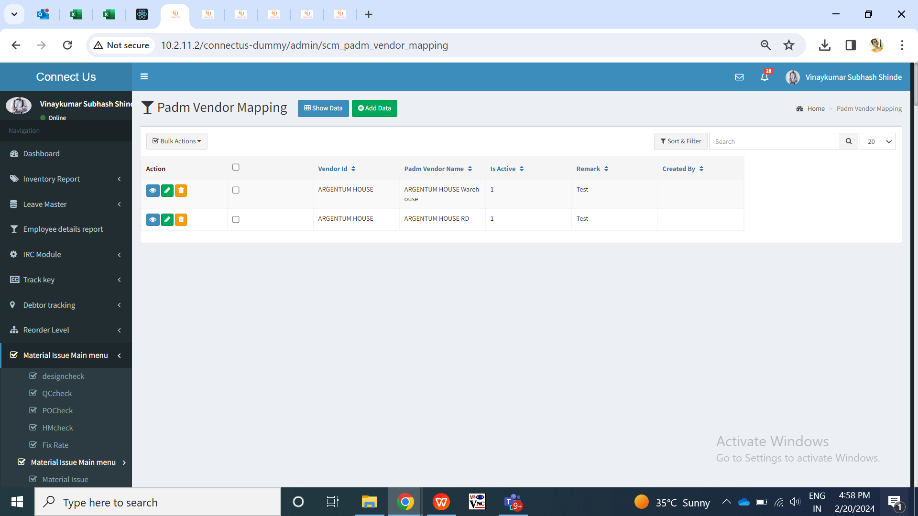

Fig: Padm vendor mapping -> grid

|  |  |  |  |  |
| --- | --- | --- | --- | --- |
| **FIELD** | **INPUT TYPE** | **MANDATORY** | **EDITABLE** | **DESCRIPTION** |
| Vendor name | Drop down | Yes | Yes | User will select the vendor against which the Padm name is to e mentioned which will get checked when labeling file is uploaded. It will display the list of vendors from bill checking -> vendor master.  Validation: It will be single select. |
| Padm vendor name | Text | Yes | Yes | User will mention the Padm names for that vendor here.  Validation: It has to be unique for same vendor else it will display error message as ‘record already exists’.  Min length = 5  Max length = 50 |
| Is active | Radio button | Yes | Yes | If the user selects it as active, then it will consider and map the order correctly with the Padm vendor name mentioned. If this is inactive, then labeling file will display error when user will upload the data of inactive Padm vendor name.  Validation: it will be single select. Default value will be yes. |
| Remark | Text | Optional | Yes | User will mention the additional comments here if required.  Validation: It will accept characters, numbers, space and special characters.  Min length = 0  Max length = 250 |
| Save | Click | - | - | Once user enters data in mandatory fields and clicks on save button, Padm vendor name will get saved for that vendor. |

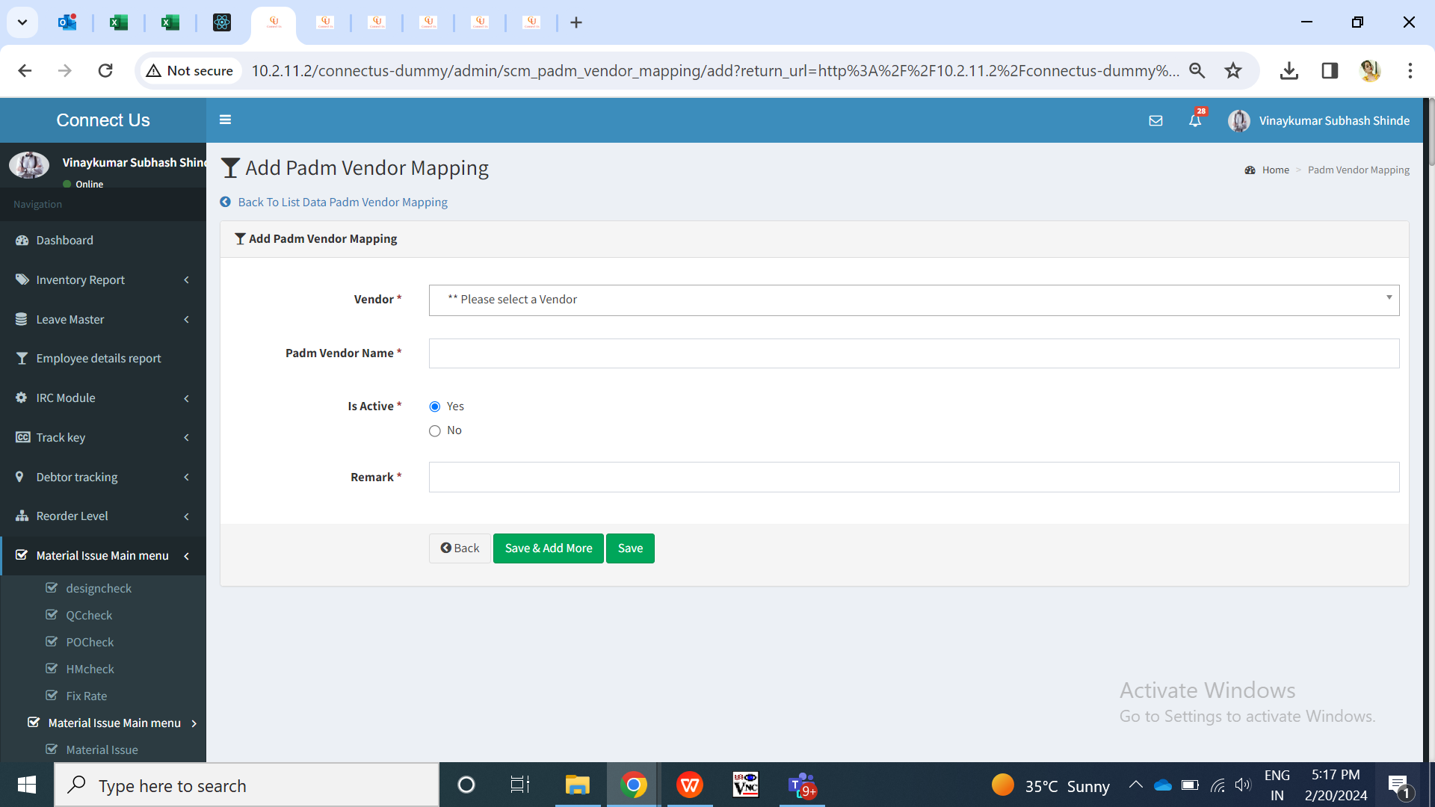

Fig: Padm vendor name menu -> add

View action of Padm vendor mapping menu will have following fields:

* Vendor name
* Padm vendor name
* Is active
* Remark
* Created at
* Created by
* Updated at
* Updated by

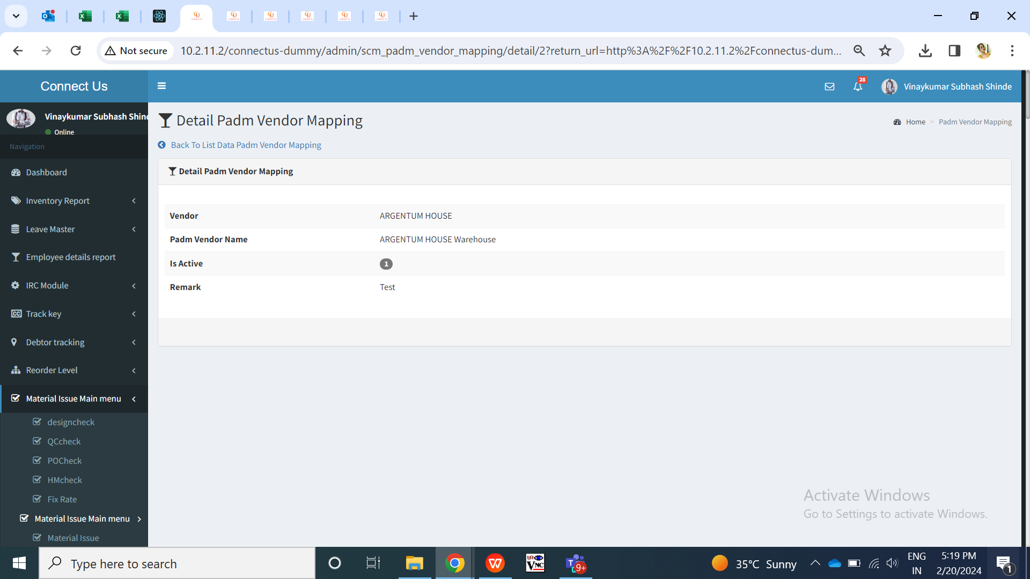

Fig: Padm vendor mapping -> view action

**Step 3. PO LABELING FILE UPLOAD**

User will upload the labeling file from Padm which means the stock which has been received from vendor and has been labeled at our inventory.

PO labeling menu will have following fields:

* Upload file button
* View action
* ID
* Actual jama date
* Invert jama date
* Invert doc no.
* Vendor id
* Sub Karagir id
* Created at & by
* Updated at & by

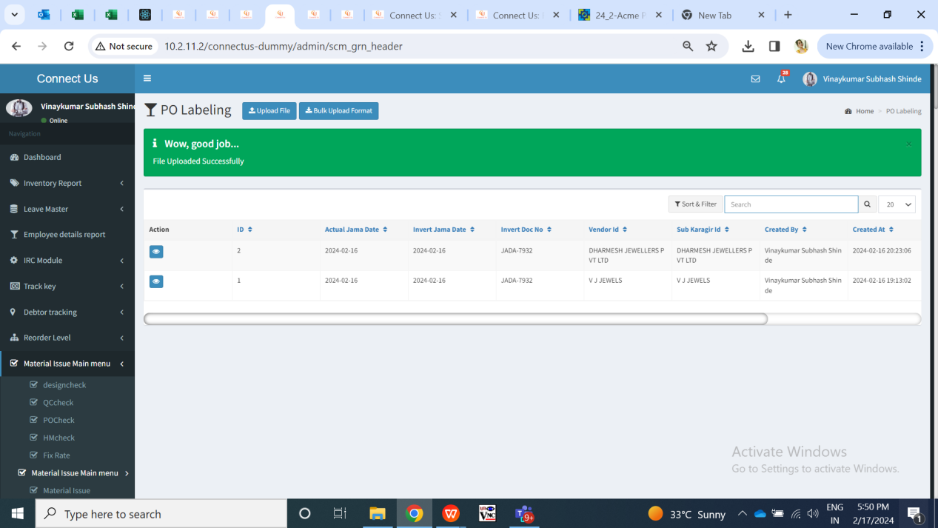

Fig: PO labeling menu -> grid

User will initially download the bulk format of labeling and will enter the labeling records in it and upload that file.

In upload button, user will enter data from Padm -> user definable reports (register). It contains data of each SCM category for which labeling is done at inventory which means that order which was given to Karagir, is available in inventory. User definable file has following columns:

* Order no
* Labeling no
* Item
* Category
* Weight range
* Size
* Pcs
* Net wt
* Lot no
* Labeling date
* Barcode no

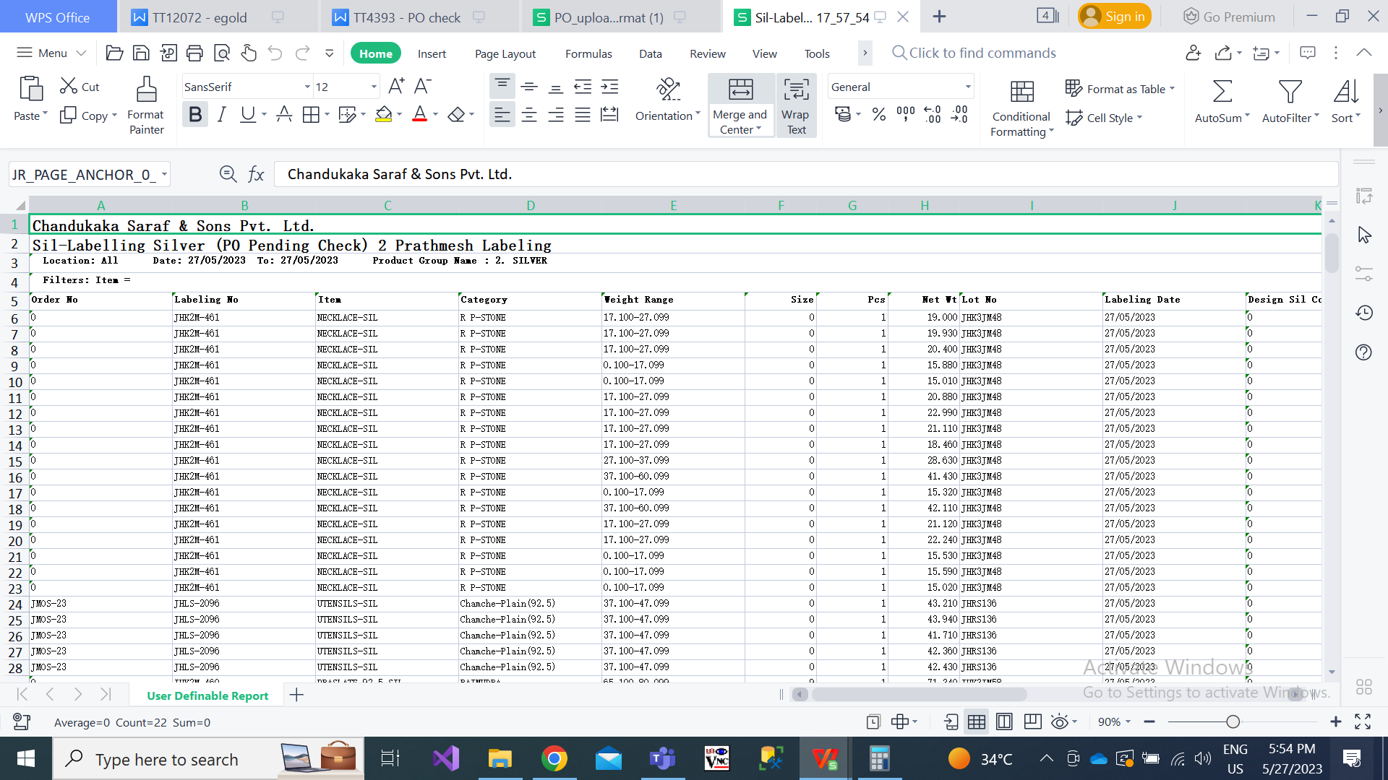

Fig: PO labeling file

Here, it displays each SCM with 1 pcs count generally. Example, if order of 5 pcs is given to Karagir 1 for 001 SCM code. Then, in labeling file it displays five rows of 001 SCM code with pcs count as 1 in each row. In some items, pcs count can be more than 2 like for example bangdi item.

In view action of this grid, it will display the details of each barcode that means each item which was in this order.

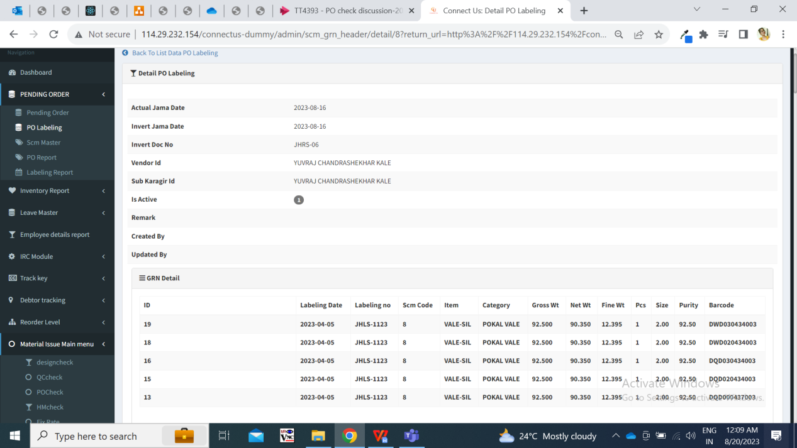

Fig: PO labeling menu -> view action

If labeling file is not uploading, then the same old labeling pcs count will be considered until labeling file isn’t uploaded.

Once file is uploaded, it will map the pcs by considering net wt with knockoff wt range of that SCM code and vendor in PO bulk uploaded file.

Once file is uploaded, accepted pcs of that order will be updated in PO bulk file -> view action. Whereas, there are scenarios where extra pcs can be uploaded in labeling file for that vendor & SCM and these extra pcs will be displayed in ‘labeling report’ as well as view action of that order in Bulk file menu.

**Step 4. PO REPORT**

In PO report, it will display following fields:

* From date
* To date
* Filter button
* Reset button
* Export button

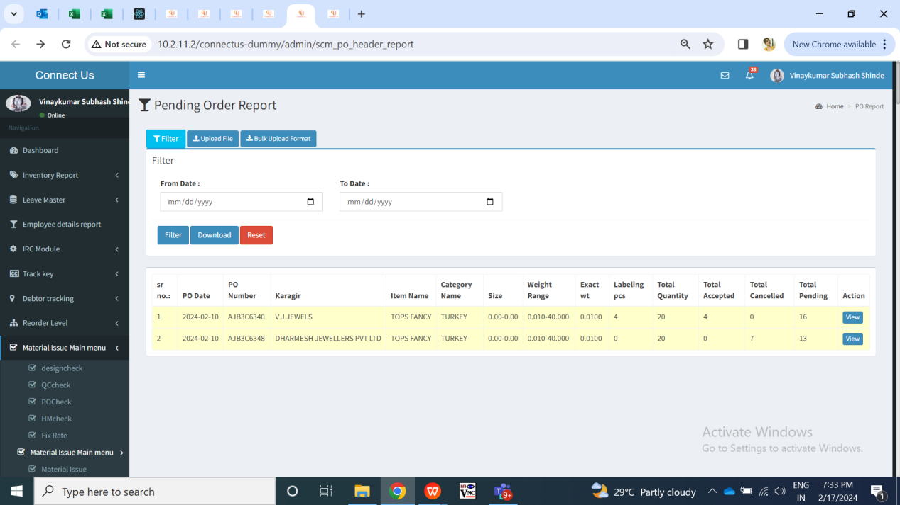

Fig: PO report menu

|  |  |  |  |
| --- | --- | --- | --- |
| **FIELDS** | **INPUT TYPE** | **MANDATORY/ OPTIONAL** | **DESCRIPTION** |
| From Date | Calender picker | Mandatory | User will select the order date from which the report is to be extracted.  Validation: It will be single select. It will accept back dates as well as future dates. |
| To Date | Calender picker | Mandatory | User will select the order date till which the report is to be extracted.  Validation: It will be single select. It will accept back dates as well as future dates. |
| Filter | Click | - | Once user clicks on filter button, the report will be displayed in grid and export button will be displayed.  Report will have following fields:   * Sr no. * Order no. * Order date * Karagir * Item * Category * Wt range * Size range * Purity range * Total order * Canceled pcs * Accepted pcs * Pending pcs * View action   Through view action, user will be directed to view page of bulk file upload menu of that order. |
| Export | Click |  | Export button will be display after user clicks on filter and data will be displayed.  Once user clicks on export button, excel file will be downloaded displaying data in following columns:   * Sr no. * Order no. * Order date * Karagir * Item * Category * Wt range * Size range * Purity range * Total order * Canceled pcs * Accepted pcs * Pending pcs   Downloaded excel file name will be PO report followed by date. |

Each time when labeling file is uploaded, the PO report will display updated data. It will display all the list of orders which are given to vendors with SCM code, total pcs count of order, total accepted means received pcs count, total pending pcs count means which are not received to labeling yet.

|  |  |
| --- | --- |
| **FIELDS** | **DESCRIPTION** |
| Order no. | It will display the order as mentioned in excel file. |
| Order date | It will display the order no. From PO bulk upload menu when bulk file of order was uploaded. |
| Karagir | It will be displayed as mentioned in uploaded excel file for order. |
| Item - category - wt range - size range - purity range | It will be displayed as mentioned in uploaded excel file for order of that order no. |
| Total order | It will display the total order for that order no. Which was uploaded through bulk file. It will also be displayed same in view action of bulk file menu of that order no. |
| Labeling pcs / accepted pcs | It will display labeling pcs count as per labeling file uploaded in PO labeling menu. |
| Canceled pcs | As and when pcs are canceled by the user through cancel action on bulk upload file menu, it will display cancel pcs count here for that order. |
| **Pending pcs** | **Total order - labeling order - canceled pcs = pending pcs**  **From these pending pcs, the inventory team and authorized person can analyse pending order of scm code with its karagir and can further assign new orders to another karagir, take follow ups of pending pcs from karagir, etc.** |

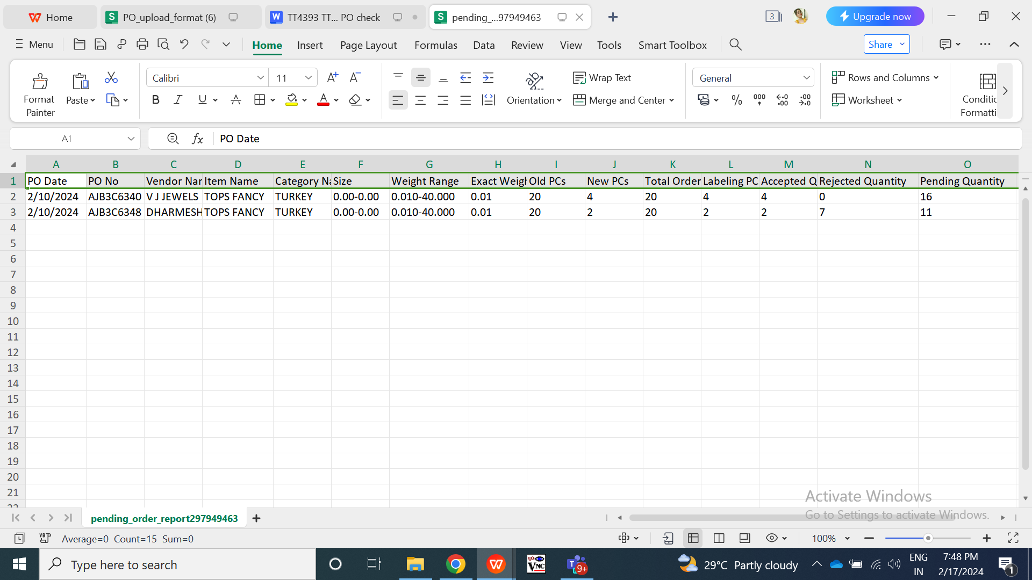

Fig: PO report -> download

**Step 5. PO ADJUST REPORT**

Labeling report will display the count of pcs that are extra, that are Knocked off means mapped with order by uploading labeling file, pcs that are accepted and pcs that are returned to vendor in case of extra. It will display following fields:

* From date
* To date
* Type - Extra / knocked off / accepted / returned to vendor
* Filter button
* Download button
* Reset button.

Here, user will select the duration (dates) from which user wants to view the details of the orders. Once user selects the type and clicks on filter button, then following fields will be displayed:

* View action
* Edit action
* Accept action
* Return to vendor action
* Labeling date
* Labeling no.
* Item
* Category
* Gross wt
* Net wt
* Fine wt
* Purity
* Size
* Knockoff PO no.
* Pcs
* Barcode no.
* Remark
* Created at
* Created by

Knockoff orders will be displayed in green as they have got mapped with order by uploading labeling file. It will display only view and edit action to the knockoff orders.

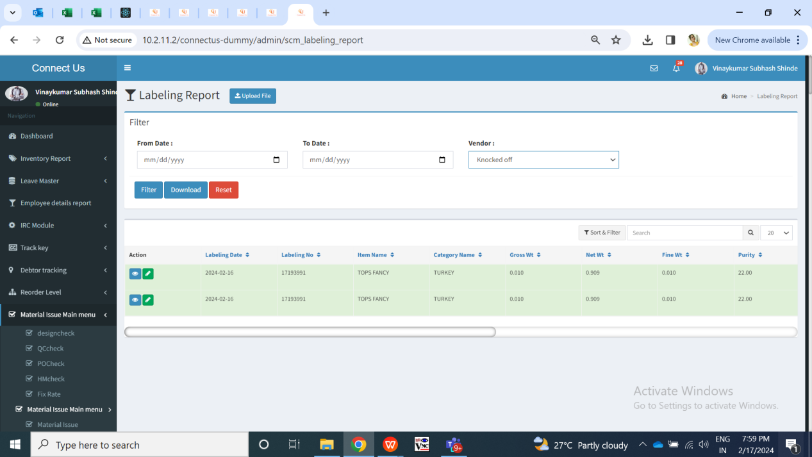

Fig: PO adjust report -> Knockoff orders

For extra orders, it will display accept and return to vendor action as well. User can accpt the extra order or may mark it as return to vendor. Extra orders will be displayed in red as they have not got mapped with any order no but have been uploaded through labeling file. Once pcs are accepted / returned to vendor then edit and view actions only will be displayed against that record. Once the pcs are accepted, then it will be knocked off with the order as per order number - item - category - weight range - size range - karagir - purity range.

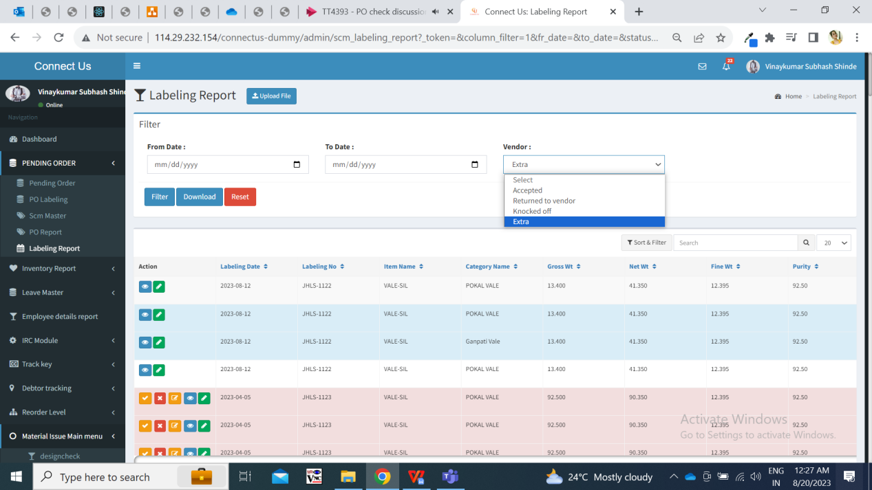

Fig: PO Adjust Report menu

Through edit action, user can only change the category number. This is done when inventory has received item from different category and we are still adjusting and accepting it. Once the category is changed then it will get knocked off against that order number - item - category - weight range - size range - karagir - purity and will be displayed in po labeling -> view action.

1. **REFERENCES OF THE USERS**

|  |  |  |  |
| --- | --- | --- | --- |
| **User** | **Name** | **Mail** | **Contact number** |
| **Actual user** | Rohit Shete  Sunil khuspe | ginventorypn1@csjewellers.com |  |
| **Ticket created by (if any)** | Tushar nikam | itinv@csjewellers.com |  |
| **Assigned business analyst** | Manali bhadirage | [Manali.bhadirage@techneai.com](mailto:Manali.bhadirage@techneai.com) |  |
| **Assigned developer** | Prathmesh shinde | Prathmesh.shinde@techneai.com |  |
| **Assigned tester** |  |  |  |