15.03.2024

EGOLD

Manali Ashok Bhadirage

Manali.bhadirage@techneai.com

**Handover Document**

**CONTENTS**

1. TICKET DETAILS 2

2. VERSION CONTROL 2

3. APPROVALS 2

4. ESTIMATION 2

5. INTRODUCTION 3

6. BUSINESS REQUIREMENT 3

7. SCOPE 3

8. BUSINESS & SYSTEM RULES 3

9. ABBREVIATIONS & TERMS 3

10. EXISTING SYSTEM 3

11. GRAPHICAL REPRESENTATION 3

12. PROPOSED SYSTEM 3

13. TEST DATA 4

14. ODUS 4

15. REFERENCES OF THE USERS 5

1. **TICKET DETAILS**

|  |  |
| --- | --- |
| **Ticket ID** | TT13173 |
| **Ticket description** | Kindly check attached eGold Requirements for Aadhar card authentication document. |
| **Created by** | Sayali Kasture |
| **Created on** | 14/06/2023 |
| **Priority** | Very high |

1. **INTRODUCTION**

We have introduced the E-gold mobile application. This innovative platform enables customers to seamlessly register, engage in online buying and selling of precious metals such as gold and silver, and stay informed about live market rates. Additionally, customers have the convenience of choosing to have their purchased metals delivered to their doorstep. Our application guarantees reliable quality, providing a 100% assurance and ensuring the utmost security on all transactions. In addition to this, customers can buy gold & silver by setting monthly EMIs and also can send e-gifts to their closed ones.

1. **BUSINESS REQUIREMENT**

|  |  |  |  |
| --- | --- | --- | --- |
| **Requirement ID** | **Requirement Name** | **Short Description** | **Priority** |
| BR001 | Registration & KYC | Cx will be able to register via aadhar number and linked mobile number. Further, OTP verification will be done for mobile number. | High |
| BR002 | Login | User will be able to login using registered mobile number once registered. | High |
| BR003 | Dashboard | Cx will have features, banners, functionalities as set by tenant on dashboard. | High |
| BR004 | Live rates | Cx will be able to view live rates of per gram metal of 99.99% purity. The live rate should get refreshed by time set by the tenant. | High |
| BR005 | Buy | Cx will be able to buy metal by entering grams or amount and thus will be able to proceed with transaction. Whereas, purchased metal will be displayed in your trades. | High |
| BR006 | Sell | Cx will be able to sell the metal out of purchased metal. Cx should proceed to transaction and balance will be credited in cx bank account. Weight balance will be updated on each successful trade. | High |
| BR007 | Delivery | Cx will be able to get purchased metal delivered at address and proceed with transaction of delivery charges. Weight balance will be updated on each successful trade. | Medium |
| BR008 | SIP | Cx will be able to start investment of specific amount of metal in each month. SIP transaction will be deducted from cx account and purchased metal will be displayed in weight balance. Cx will be able to cancel the SIP at any time. | Medium |
| BR009 | Bank settings | Cx will be able to add max 3 bank accounts which cx will select while sell transaction in which amount will be credited. | Medium |
| BR010 | Preference settings | Cx will set his communication preferences for the help desk beneficial of tenant. | Medium |
| BR011 | Nominee settings | Cx will add the nominee for the account for legal purpose. | Medium |
| BR012 | Tenant settings | Tenant will edit customization settings from web which will be displayed to all their cx on application. | High |
| BR013 | Help Desk | Cx can contact support team of tenant via call or email in case of any issues. | Medium |
| BR014 | Profile | Cx will e able to view and edit his profile. | Medium |
| BR015 | Notifications | Cx will be able to receive and view notifications of each transaction, changes done in account and rate triggers if set any. |  |
| BR016 | Transaction report | Tenant will be able to view transaction report of all and / or individual cx for buy, sell, sip, delivery and their updated weight balance. | High |
| BR017 | Customer master | Each time when cx registers themselves , they will be added and displayed in cx master to tenant. Also, when profile changes are done by cx, updated details will be displayed in cx master. | High |
| BR018 | Tenant master | Super-admin will add the tenant from tenant master where further cx will get registered under the added tenant. | High |
| BR019 | Customer liability report | Through liability report, tenant admin can view the summary of opening and closing weight of gold and silver on each date of each customer. | Medium |
| BR020 | Customer ledger report | Through customer ledger report, tenant admin will view all the detailed transactions done by the specific customer in selected dates. | Medium |
| BR021 | Rate alert | Customer will get notifications on chosen medium when rate of the metal matches the set amount. | Medium |

1. **SCOPE**

Customer will be able to register himself using the aadhar number and linked mobile number. Customer will further be able to log into app using mobile number after successful registration. Further, customer will be able to view sell rate of gold and silver on dashboard along with banners, features and functionality buttons of bug, sell, rate trigger as per tenant’s settings. Custromer will view details in profile as per aadhar number. Further, customer will be able to buy or sell metal. Weight balance will be displayed in your trades. Customer can set the rate at which they want to receive the message through rate alert option. Customer has provision to add bank and nominee through settings. Moreover, customer can contact tenant via email or call through help desk option.

Tenant has customization settings through web which will be reflected on mobile app to customers. Tenant can view customer details through customer master and have access to transaction reports, liability report and customer ledger report.

1. **BUSINESS & SYSTEM RULES**

* User will be registered in the system.
* User will be logged in.
* System should display error message for incorrect details if entered.
* Customer can register for multiple tenants using same mobile and aadhar number.

1. **ABBREVIATIONS & TERMS**

Cx - Customer

OTP - One time password

KT - Karat

Wt - Weight

Gm - Grams

SIP - Systematic investment plan

KYC - Know Your Customer

PAN - Permanent Account Number

1. **GRAPHICAL REPRESENTATION**

Refer below figma link for reference:

<https://www.figma.com/proto/zoLllak3WHQ6OTncJm5Ac5/Egold-App?type=design&node-id=957-12077&scaling=contain&page-id=927%3A8353&starting-point-node-id=1358%3A17119&show-proto-sidebar=1>

1. **DEVELOPED SYSTEM**
2. **Register**

User will have to first register himself using mobile no. and aadhar no.to further log into mobile app. It will have following fields:

* Aadhar number
* Mobile number
* Continue button

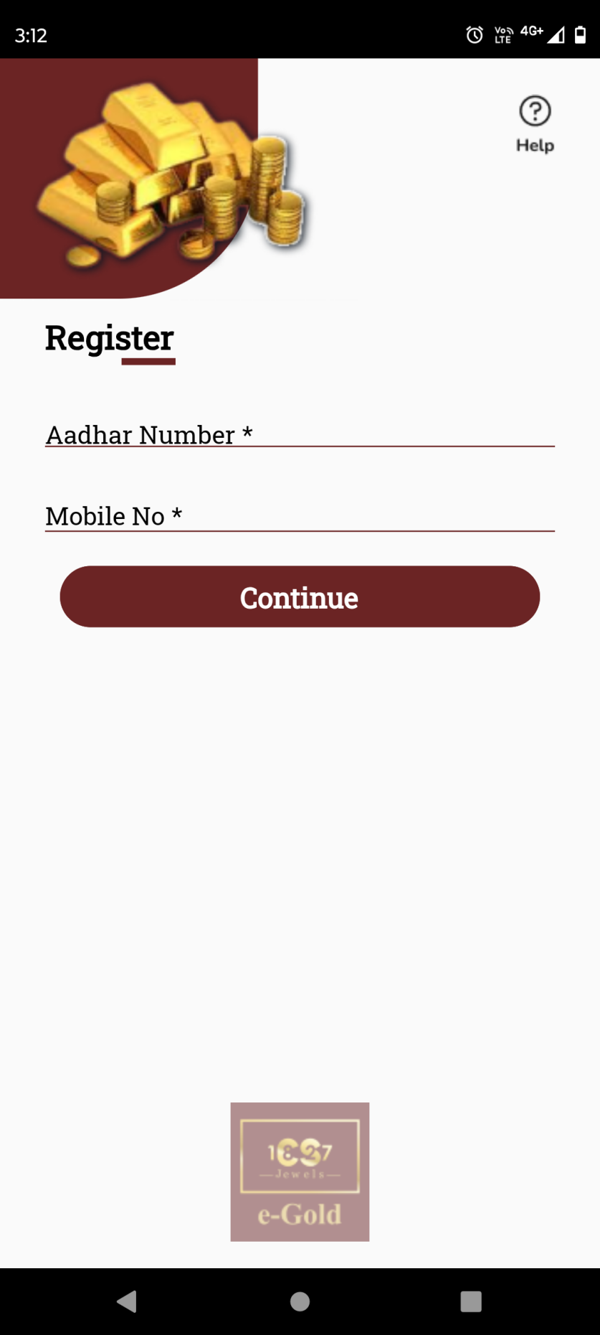

Fig: Register

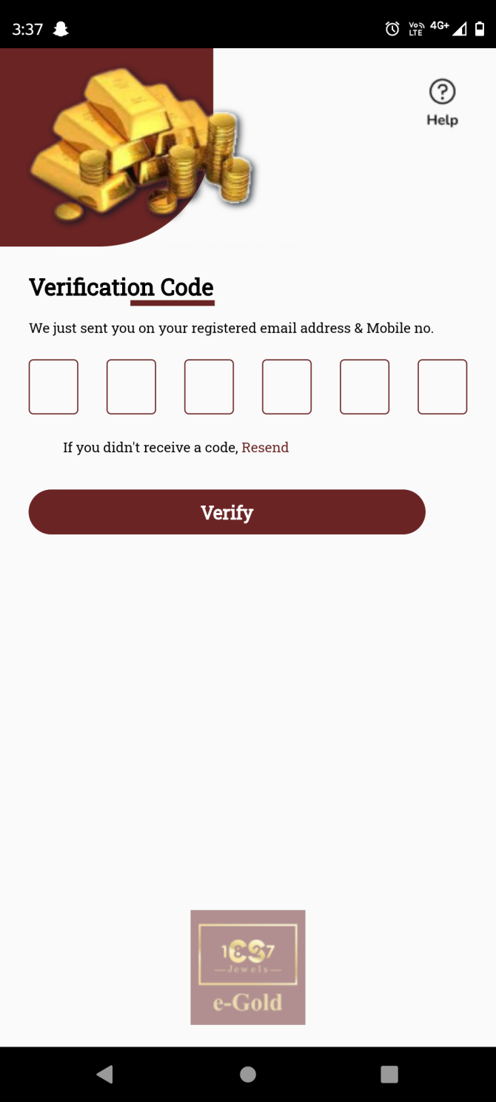

Fig: Verify OTP

**Input table**

|  |  |  |  |  |
| --- | --- | --- | --- | --- |
| **FIELDS** | **INPUT TYPE** | **MANDATORY/ OPTIONAL** | **EDITABLE** | **DESCRIPTION** |
| Aadhar number | Text | Manadatory | Yes | Customer will eneter the regsitered aadhar number against which account is to be created.  Once customer enters aadhar number and clicks on submit, it will display on field error message if the entered aadhar number doesn’t exist or if user has not entered all digits.  Validation: It will accept only numbers. It will accept compulsorily 12 digits. |
| Mobile number | Text | Mandatory | Yes | Customer will enter the mobile number which is registered against the entered aadhar number.  If customer enters aadhar number and enters another mobile number which is not linked, then it will display alert message as ‘mobile number not linked with this aadhar number’.  Validation: It will accept numbers only. It should not accept all zeros. It should only accept 7/8/9 at the beginning.  Min & max length = 10. |
| Submit | Click | - | - | Once customer enters valid aadhar number and mobile number and clicks on submit button, OTP will get sent to entered mobile number via SMS and user will be directed to verification code page.  If customer enters incorrect aadhar / mobile number and clicks on submit, it will display on field validation error message.  Validation: Once customer clicks on submit button, it will be disabled until user is directed to further page or until error message is displayed in case of invalid details. |
| Verification code | Text | Mandatory | - | Customer will enter the OTP code here which is sent on the registered number via SMS.  If customer enters incorrect OTP and clicks on verify button, then it will display on field error message as incorrect OTP.  Validation: It will accept numbers only. Max & min length = 6 digits. |
| Verify | Click | - | - | Once user enters valid OTP and clicks on verify button, successful message will be displayed and customer will get registered under the tenant. Customer’s details will be displayed in customer master of web for that tenant as well as will be displayed in profile once customer logs in. As per successful registration, user can log in by using the registered mobile number.  If customer enters incorrect OTP and clicks on verify button, then it will display on field error message as incorrect OTP. |

As customer registers using aadhar card number, it is considered as KYC done and thus his KYC status is being displayed as accepted in customer master of that tenant.

1. **Sign in**

User can sign in using registered mobile number on which an OTP will be sent. Sign in page has following fields:

* Mobile no.
* Send OTP button
* Register button
* Help icon

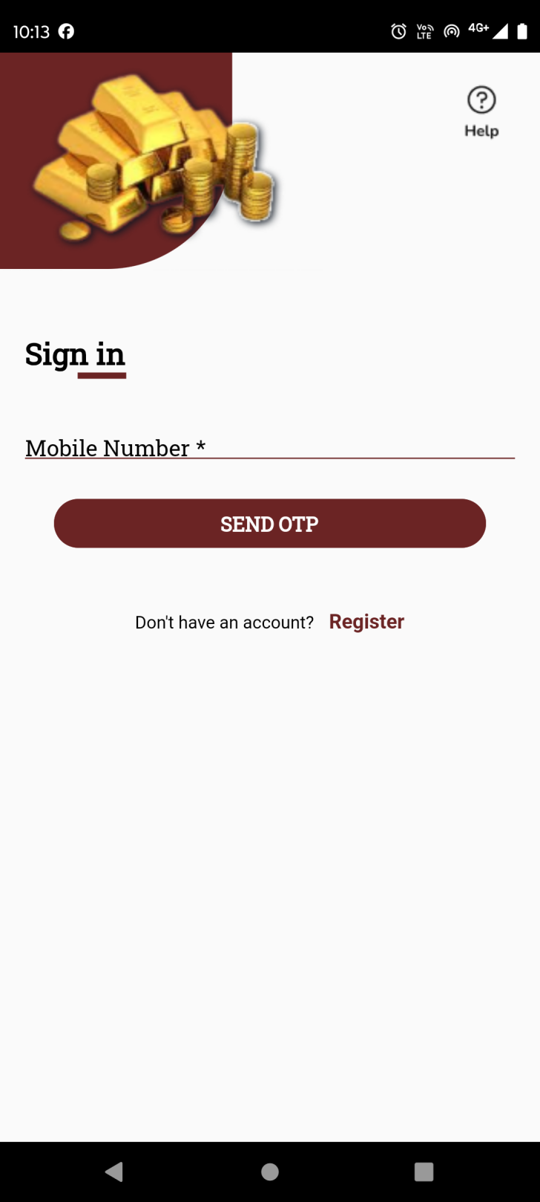

Fig: Sign In

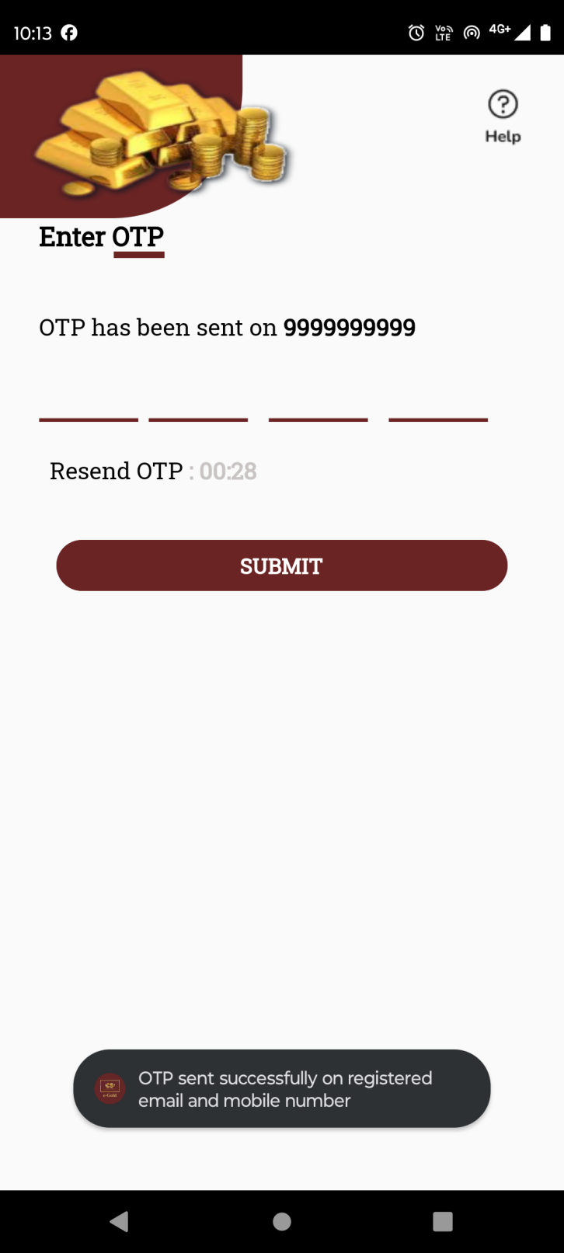

Fig: Enter OTP

|  |  |  |  |  |
| --- | --- | --- | --- | --- |
| **FIELDS** | **INPUT TYPE** | **MANDATORY/ OPTIONAL** | **EDITABLE** | **DESCRIPTION** |
| Mobile number | Text | Mandatory | Yes | Customer will enter the mobile number by which he has registered.  Once customer enters valid registered number and clicks on send button, OTP will be sent on that number via SMS and user will be directed to the page to enter the sent OTP.  If customer enters mobile number by which any customer is not registered yet and clicks on send OTP button, then it will display pop up error message as ‘mobile number not registered. If customer enters less than 10 digits and clicks on send button, it will display on field validation error message.  Validation: It will accept numbers only. It should not accept all zeros. It should only accept 7/8/9 at the beginning.  Min & max length = 10. |
| Send OTP button | Click | - | - | Once customer enters valid registered number and clicks on send button, OTP will be sent on that number via SMS and user will be directed to the page to enter the sent OTP. |
| Enter OTP | Text | Mandatory | No | Once cx enters valid registered mobile number and clicks on send button, OTP will get sent to the customer’s mobile number and cx will be directed to enter OTP page. Customer will have to enter 4 digit correct OTP within 30 seconds and click on submit button to log into the app.  If cx enters invalid OTP and clicks on submit button, it will display pop up error message as invalid OTP. |
| Resent OTP button | Click | - | - | Once cx eneters valid registered mobile number and clicks on send button, OTP will get sent to the customer’s mobile number and cx will be directed to enter OTP page where timer of 30 seconds will run in descending order.  Timer will be reset to 00:00 if cx doesn’t enter valid OTP and click on submit button. To create new OTP, cx will have to click on resend OTP button. Once cx clicks on resend OTP button, new OTP will be sent to cx via SMS and timer will restart again in decrement order from 30.  Validation: Resend OTP button will be enabled only when time is 00:00. |
| Submit button | click | - | - | Once user enters valid OTP number and clicks on submit button, successful message will be displayed and cx will be directed to dashboard of the application.  Validation: Submit button will be disabled until user is directed to dashboard or until error message is displayed in case of incorrect OTP number. |
| Help icon | Click | Optional | - | Cx can contact the help desk / support team of the tenant via email or call through this option.  Once user clicks on help button, it will display following fields:   * Email Address * Mobile Number * Query type * Query text field * Submit button |

1. **Help Desk**

Once user clicks on help button, it will display following fields:

* Email Address
* Mobile Number
* Query type
* Query text field
* Submit button

|  |  |  |  |  |
| --- | --- | --- | --- | --- |
| **FIELDS** | **INPUT TYPE** | **MANDATORY/ OPTIONAL** | **EDITABLE** | **DESCRIPTION** |
| Mobile number | Text | Mandatory | Yes | Customer will enter the mobile number.  If customer is not logged in yet, then this field will be blank. If user has logged in into the app and clicks on help desk button, then mobile number will get pre-filled as per mobile number in the profile and it will be editable here.  Validation: It will accept numbers only. It should not accept all zeros. It should only accept 7/8/9 at the beginning.  Min & max length = 10. |
| Email address | Text | Optional | yes | Customer will enter his own email address.  If cx is not logged in yet, then it will be blank. If user has logged in into the app and clicks on help desk button, then email address will get pre-filled as per email address in the profile and it will be editable here.  Validation: This field should accept “ @ - . “ only as special characters. In case of invalid format, it should display on field error message as “Invalid email address”. It shouldn’t accept space. Maximum length of input field will be 100 characters. |
| Query type | Drop-down | mandatory | yes | Cx will select the type of help they need related to. It will display Concern, transaction issue, application issue, feedback and others in the list.  Validation: it will be single select. |
| Query | Text | Mandatory | Yes | Customer will write his concerns / feedback in the text field.  Validation: It should accept characters, numbers, special characters and space.  Min length = 1  Max length = 250 |
| Submit | Click | - | - | Once customer clicks on submit, it will display message as “Your response has been sent to support team. You will receive an update within 24-48 hours”. And, email will get sent to application support team of tenant. Email will have details of cx mobile no, cx email address, query type, query description, cx preference timing, cx communication language and cx communication mode. Here, email will have preference timing, cx communication language and cx communication mode only if cx has set it.  If user doesn’t enter mandatory fields and clicks on submit button, it will display on field error message.  Validation: Button will be disabled until successful message or error message is displayed. |

1. **Dashboard**

Once cx logs into the app, he will be directed to the dashboard page. It will consist of following menus:

* Live rate of gold and/or silver
* Banners
* Buy and/or Sell and/ or SIP button
* Rate alert button
* Features
* Tenant logo

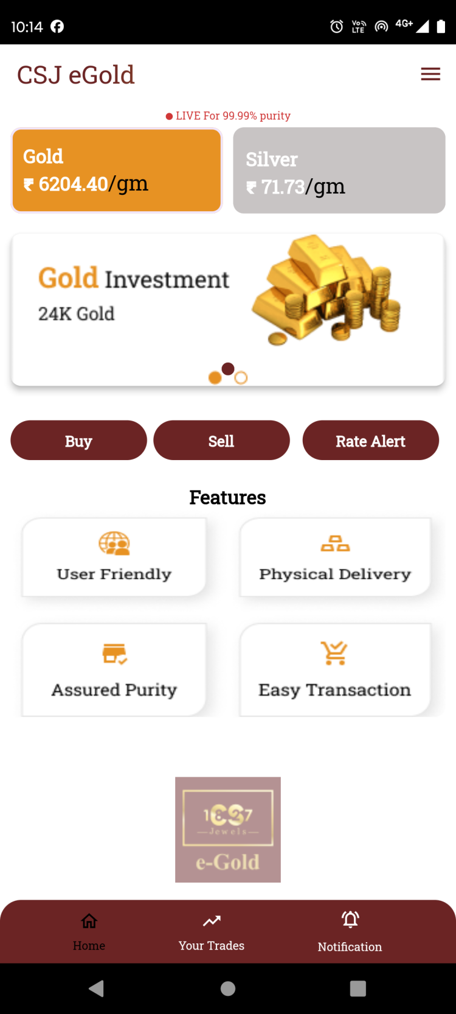

Fig: Dashboard

|  |  |  |  |  |
| --- | --- | --- | --- | --- |
| **FIELDS** | **INPUT TYPE** | **MANDATORY/ OPTIONAL** | **EDITABLE** | **DESCRIPTION** |
| Live rate of gold and/or silver | Text | - | By tenant through customer type setting | It will display live purchase rates of gold and silver per gram with 99.99% purity.  Gold and/ or silver cards will be displayed as per tenant’s commodity settings. If tenant only sets Gold as active commodity, then only card for Gold live rate will be displayed on dashboard to all customers of that tenant.  Rates displayed will be different for each tenant as per settings done by tenant in back-end web app through tenant’s customer type setting. |
| Banners / sliders | Image | Mandatory (min 1 image) | By tenant through banner setting | Sliders will be different for each tenant where tenant will display images related to their offers / new features / etc.  It will be changed from tenant’s web -> settings -> dashboard -> banner.  Validation: It will be view only. Min = 1 image  Max = 4 images. |
| Buy button | Click | - | - | Customer can purchase metal during the timing set by the tenant just by entering either amount or metal weight and book gold or silver in his account after completing transaction.  The button will be displayed as set active by the tenant in functionality setting. |
| Sell button | Click | - | - | Customer can sell the metal out of the purchased metal just by entering either amount or metal weight. Whereas, amount will be credited during set business days in cx account as selected during transaction.  The button will be displayed as set active by the tenant in functionality setting. |
| SIP button | Click | - | - | Once customer clicks on SIP button, customer can select date, tenure and amount for auto purchasing the metal each month.  The button will be displayed as set active by the tenant in functionality setting. |
| Rate alert | Click | - | No | Customer can set the rate triggers for which wants to receive as notification so that it will be useful for customer to analyze uy and sell.  Customer can set multiple alerts for silver and gold individually each. Once the rate matches as per set trigger, then notification will be sent to customer only one time and then the set trigger will get disabled and also will be saved in rate trigger history. |
| Features | Image | - | By tenant through feature setting | Tenant will add the images displaying the features of the application which are read only.  It will be changed by tenant through feature settings. |

1. **Profile**

Cx can view and update its details through profile. The updated details of the customer will be reflected in tenant’s customer master once saved. Profile page has following fields:

* Profile image
* Cx name
* Aadhar number
* Pan number
* KYC status
* Address
* Pin code
* Country
* State
* City
* Mobile no.
* Whatsapp no.
* DOB
* DOA
* Gender
* PAN no.
* Email
* Occupation
* Save button

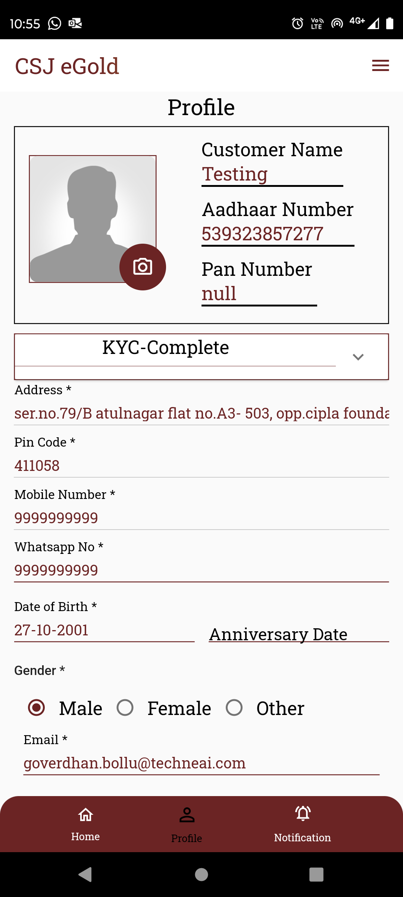

Fig: Profile

|  |  |  |  |  |
| --- | --- | --- | --- | --- |
| **FIELDS** | **INPUT TYPE** | **MANDATORY/ OPTIONAL** | **EDITABLE** | **DESCRIPTION** |
| Profile image | Upload | Optional | Yes | Cx will attach his profile image through here.  Initially when cx registers himself, the profile image field is displayed blank by default when cx gets created.  Once cx clicks on camera icon on profile image, it will display options to either attach image from camera or through gallery. Once user selects image or clicks image and clicks on OK, it will be displayed on profile page. The added image in profile image will also be saved as user image in cx master for that customer.  Validation: Only one image can be set at a time. It will accept only jpg, png, heic, heif, webp and jpeg extensions only. |
| Cx name | Text | Mandatory | No | It will display the cx name as per aadhar number entered while registering.  Validation: It will be read only to customer as well as tenant. |
| Aadhar number |  |  |  | It will display the aadhar number entered by cx while registering.  Validation: It will be read only to customer as well as tenant. |
| Pan number |  |  |  | PAN number will be entered by the cx in the profile. It will be null initially. Whereas, once user enters valid PAN number in the form ans saves it, it will be displayed here. Once PAN number is saved, it will also be displayed in tenant’s customer master against that cx details.  Validation: It will be read only in header table above whereas it can be edited through field in the profile form below. |
| KYC status | Text | Mandatory | No | It will display that status whether the cx verification is done using documents or not. As cx registers using aadhar number and further details are being displayed in profile as per aadhar number, KYC status is being displayed as completed.  Validation: It will be read only. |
| Address | Text | Mandatory | No | It will display the address as per aadhar number.  Validation: It will be read only. |
| Pin code | Text | Mandatory | No | It will display the pin code number as registered on the aadhar.  Validation: It will be read only. |
| Country | Text | Mandatory | No | It will display the country name from pin code as mentioned in the aadhar number.  Validation: It will be read only. |
| State | Text | Mandatory | No | It will display the state name from pin code as mentioned in the aadhar number.  Validation: It will be read only. |
| City | Text | Mandatory | No | It will display the city name from pin code as mentioned in the aadhar number.  Validation: It will be read only. |
| Mobile no. | Text | Mandatory | No | It will display the mobile number entered in mobile number field while registration.  Validation: It will be unique. It will accept only numbers. It should only accept 7 / 8/ 9 as first digit.  Min & Max length = 10 |
| Whats-app no. | Text | Mandatory | Yes | Initially it will be blank whereas cx will enter the Whats-app no. here.  It will display on field validation error message in case user doesn’t enter this number before saving or in case user has not 10 digits.  Validation: It can be same. It will accept only numbers. It should only accept 7 / 8/ 9 as first digit.  Min & Max length = 10 |
| DOB | Date calender picker | Mandatory | No | It will display customer’s date of birth as per aadhar number.  Validation: Its format will be DD/MM/YYYY. It will be read only. |
| DOA | Date calender picker | Optional | Yes | Cx can enter the Date of anniversary if applicable. Its format will be DD/MM/YYYY.  Validation: Only one date can be selected. Future dates will be disabled. Dates before DOB will be disabled. |
| Gender | Radio button | Mandatory | No | It will display gender as male / female / other from aadhar number.  Validation: It will be read only. It will be single select. |
| PAN no. | Text | Mandatory | Yes | Cx will enter PAN number as it is needed for verifying transactions above 2 lakh.  In case of invalid pan card number format, it should display error message as “Invalid pan number”. If user enters same pan number which is already added in another cx account, then it should display on field error message as PAN number already exists.  Validation: Customer will enter 10 digit alphanumeric PAN No. of nominee. PAN number will be unique in cx master. It includes first five letters, followed by 4 numbers and last character. |
| Email | Text | Optional | Yes | Cx will enter valid email address so as to receive notifications on it.  The entered email address will also be displayed in help desk -> email field after login.  Validation: It will be unique in cx master. This field should accept “ @ - . “ only as special characters. In case of invalid format, it should display on field error message as “Invalid email address”. It shouldn’t accept space anywhere. It will be unique. Maximum length of input field will be 50 characters. |
| Occupation | Drop down | Optional | Yes | Cx will mention his occupation for the tenant’s reference.  Validation: It will display active occupations from occupation master. It will be single select. |
| Save button | Click | - | - | Once cx enters valid mandatory details and clicks on save button, successful message will be displayed and updated details will be displayed in profile as well as in cx master.  Validation: Save button will be disabled until successful message is displayed or error message is displayed in case of invalid details if entered. |

1. **About Us**

It will display information about the application, tenant, description of features, terms and conditions and will include sliders, images & videos. It will have social media links at the bottom, contact details and application share button.

The details / information in about us will be displayed as per tenant’s settings from web.It will have following contents:

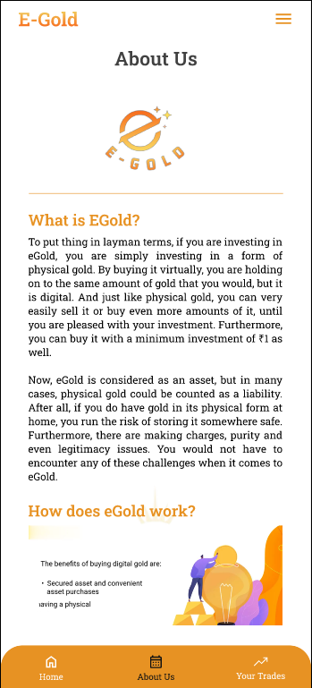

Fig: About us

1. **Settings - Nominee settings**

Customer can add only one nominee under his account. Initially, none of the nominee will be added. Once customer clicks on add button, it will display following fields:

* Nominee name
* Full address
* Date of Birth
* Relation with nominee
* Aadhar number of nominee
* PAN number of nominee
* Mobile number
* Email ID
* Add button
* Cancel button

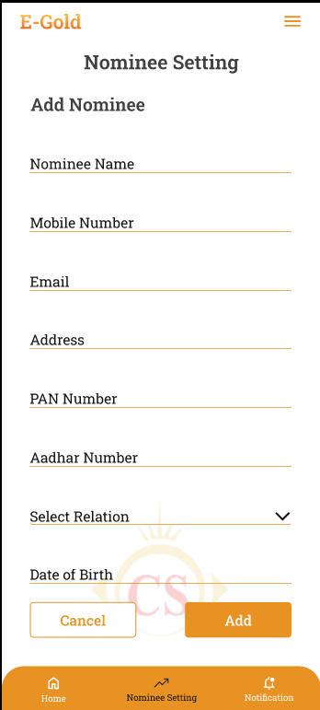

Fig: Nominee settings

|  |  |  |  |
| --- | --- | --- | --- |
| **FIELDS** | **INPUT TYPE** | **MANDATORY / OPTIONAL** | **DESCRIPTION** |
| Nominee name | Text | Mandatory | Customer will enter the name of the nominee he wants to add.  Validations: It should accept characters and space only. It should not accept space initially.  Min length = 2  Max length = 100 |
| Full Address | text | mandatory | Customer will enter the full address of the nominee.  It will accept maximum 250 characters / numbers. It should accept single space only after each word. It should accept . / - , special characters only. |
| Date of Birth | Calendar picker | Mandatory | customer will enter the date of birth of the nominee.  Validation: Future dates will be disabled. It should display dates from 01-01-1924 to current date. |
| Relation with nominee | Text | Mandatory | Customer will choose his relation with the nominee from the drop-down as mother / father / sister / brother / daughter / wife / husband / son/ other.  Validation: It will be single select. |
| PAN number | text | Optional | Customer will enter 10 digit alphanumeric PAN No. of nominee.  Validation: One nominee’s pan number can same as nominee of another person. It includes first five letters, followed by 4 numbers and last character. In case of invalid pan card number format, it should display error message as “Invalid pan number”. |
| Aadhar card number of nominee | Text | Mandatory | customer will enter 12 digit Aadhar number of the nominee.  One Aadhar no. will be entered only once. customer will have to enter unique Aadhar no. Customer cannot mention same already entered aadhar number for another nominee. Also, it cannot be as same as registered user’s aadhar number.  In case of invalid aadhar card number format, it should display error message as “Invalid aadhar number”. |
| Nominee mobile no. | text | mandatory | Customer will enter nominee’s mobile number. It can be same as customer’s number from profile.   Validation: It can be same. It should accept 7/8/9 only at the beginning. It should not accept space or characters or special characters. Min & Max length = 10 |
| Nominee’s Email ID | text | Optional | Customer will enter nominee’s email ID. It can be same as customer’s number from profile.  Validation: Min length = 11  Max length = 100 |
| Save | Click | Mandatory | Once customer enters one or more nominee details and clicks on save, it will save data and display the added details on ‘Nominee settings’ page. |

Once customer adds nominee, added nominee details will be displayed whereas user can edit it.

1. **Settings - Bank account settings**

Customer will add the list of bank accounts into the application. The added bank accounts will be displayed while making payments. Cx will select the added bank in which he want amount credited while performing sell transaction. It will display list of bank accounts if added any and add more button. Maximum 3 banks accounts can be added for one customer. Once customer clicks on add more button, it will display following fields:

* Credit / Debit card number
* Card holder name
* Bank name
* IFSC code
* Save button

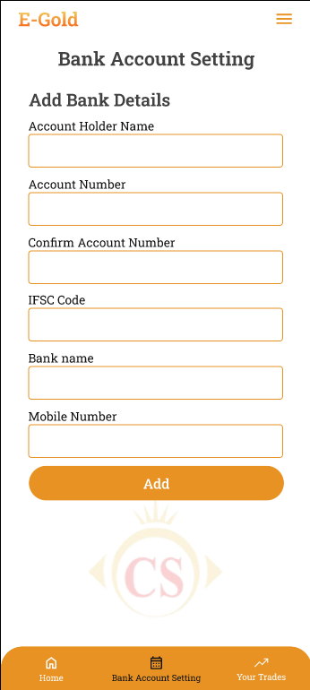

Fig: Bank account settings

|  |  |  |  |
| --- | --- | --- | --- |
| **FIELDS** | **INPUT TYPE** | **MANDATORY / OPTIONAL** | **DESCRIPTION** |
| Card number / account number | Text | Mandatory | Customer will enter the alphanumeric or only numeric bank account number.  Validation: It shouldn’t accept space. It should accept 19 digits. |
| Card holder name | Text | Mandatory | customer will enter the account holder name as on bank passbook or on card.  Validation: It should accept characters and space only. Maximum length of input field will be 50 characters. |
| Bank Name | Drop-down | Mandatory | customer will select the bank name for the list.  Validation: It will be single select. |
| IFSC number | Text | Mandatory | customer will enter 11 digit alphanumeric IFSC number. As per selected bank name and IFSC number, it should validate whether the IFSC number is correct or not and display error message in case it is incorrect.  Validation: Min & max length = 11 |
| Save | click | mandatory | Once customer enters one or more bank details and clicks on save, it will save data and display the added details on ‘Bank account settings’ page. |

1. **Settings - Preference settings**

Customer will set communication preferences. The set preferences will be heloful for the tenant’s support team. It will display following fields:

* Communication mode
* Call timings
* Communication language
* Notification permissions
* App unlock recognition

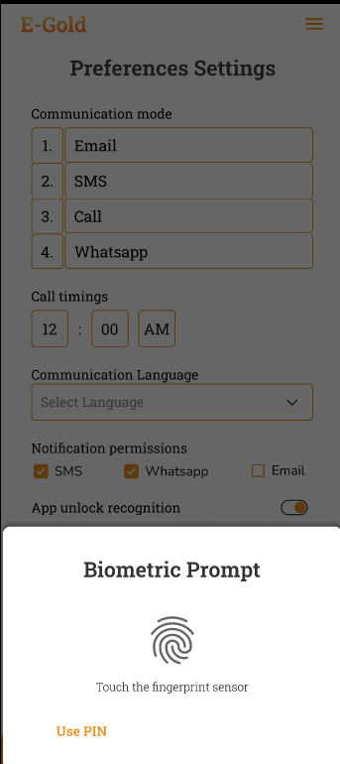

Fig: Preference settings

|  |  |  |  |
| --- | --- | --- | --- |
| **FIELDS** | **INPUT TYPE** | **MANDATORY / OPTIONAL** | **DESCRIPTION** |
| Communication mode | Drag & drop | Optional | customer will drag and drop his preferred communication mode in sequence. It will display following options email, SMS, call, Whats-app. |
| Call timings | Time | Optional | Customer will mention his available ‘from and to’ timing so that tenant’s support team can contact customer as per his preferred time.  Validation: It should accept numbers only. It will display 24 hours clock. By default it will display it as 00:00. |
| Communication language | Drop-down | Optional | customer will select the language that he prefers to get call and messages.  Validation: It will be single select. |
| Notification permissions | Permissions | Optional | customer will enable / disable communication preference by toggle. It will have options as SMS, email and whats-app.  If customer disables any mode, then notification should get sent to customer on that medium and should get sent by the enabled medium only.  However, within application notification will be sent to all by default. Whereas rate trigger notifications will get sent on selected primary medium and its second medium will be the one selected from here.  Validation: it will be multi-select. |
| App unlock recognition | Radio button | Optional | Customer will select the option which he prefers while visiting the app each time and unlocking it.  After setting unlock code, once customer clicks on save button, then later when customer visits / opens app each time, customer will have to enter the pass-code and unlock the app.  Validation: Min & Max length = 4 |
| Save | click | - | Once user sets the preferences and clicks on save button, it will be displayed in web -> preference settings against that |

1. **Buy**
2. **Sell**
3. **SIP**
4. **Delivery**
5. **Your trades**

On app, it will display the list of all successful trades i.e. transactions done by the customer till the date about buy, sell and delivery. It has following fields:

* Gold Weight Balance
* Silver weight balance
* Filter
* Export
* List of trades

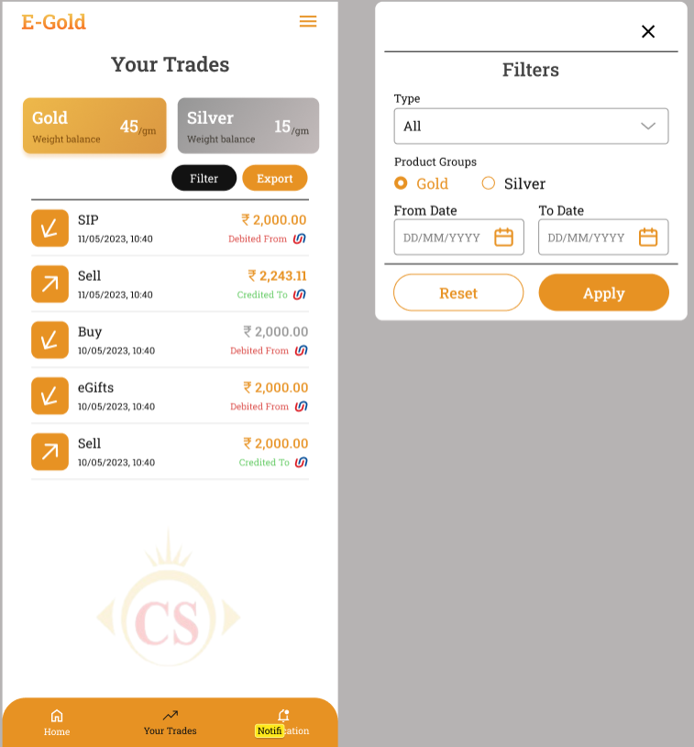

|  |  |  |  |
| --- | --- | --- | --- |
| **FIELDS** | **INPUT TYPE** | **MANDATORY / OPTIONAL** | **DESCRIPTION** |
| Weight Balance | Text | - | It will be read only field.  It will display the total weight in grams for gold and silver that customer has available in his account after making buy / sell / delivery / SIP transactions. |
| Filter | Drop-down | Optional | Customer can filter specific transactions any time.  Once user clicks on filter button, it will display following fields:   * Transaction type * Product Group * From date * To date * Apply button * Reset button   As per selected filter options, once customer clicks on apply button then it should display list of trades accordingly. If customer has selected. Initially all successful transactions will be displayed in the list until users applies filter.  Further, cx will have to click reset button to view all transactions in the list again.  Validation: Once clicked it will be disabled until pop-up to select filter option appears. |
| Filter -> transaction type | Drop down | Mandatory | Customer can view by the type of transactions. It will be display below list:   * All * Buy * SIP * Sell * Delivery * Sent Egifts * Received Egifts   It will display the transactions of selected type only once user selects it and clicks on apply button.  Validations : It will be single select. ‘All’ option will be selected by default. |
| Filter -> product group | Radio button |  | Customer can search transactions by product group - gold / silver.  It will display the transactions of selected metal only once user selects it and clicks on apply button.  Validation: It will be single select. |
| Filter -> from date | Calender date picker |  | It should display calender picker from which customer will select the date from which customer wants to view the trades. In ‘from date’ it will display the date from which customer registered into the application.  Validation: Future dates will be disabled. |
| Filter -> to date | Calender date picker | Mandatory | It should display calender picker from which customer will select the date till which customer wants to view the trades.  Validation: Future dates will be disabled. Dates before selected ‘from date’ will be disabled. |
| Apply button | Click | - | As per selected filter options, once customer clicks on apply button then it should display list of trades accordingly. If customer has selected. Initially all successful transactions will be displayed in the list until users applies filter.  Validation: It will be disabled until list of transactions appears as per applied filter. |
| Export | click | Optional | Once customer clicks on export button, it will download the excel file. If customer directly clicks on export, then it will display data of all transactions till the date. If customer applies filter and then clicks on export button, then in excel sheet, it will display data of transactions as per applied filter.  It will display data in following columns in downloaded file:   * Sr No. * Receipt no. * Transaction no. * Transaction date * Transaction time * Transaction type * Product group * Amount * Grams / metal weight in account * Payment mode * Payment ref no / UTR no. * Bank name * Credited / Debited |
| List of trades | View | Mandatory | It will display the list of successful transactions done by the cx through this account.  If there are not transactions, then list will be blank.  For each trade, it should display following details on first view:   * Trade Id I.e receipt ID * Date & time * Trade type (Buy /sell / SIP) * Amount of trade * Credited / debited * Bank name / symbol   Post condition:- Once customer clicks on each trade, it should display the detailed billing information of the trade done.   * Trade ID * Date & time * Trade type * Amount * Grams (grams purchased or grams sold in that trade) * Bank name * Payment reference number * Customer name * Customer ID * Download button * Share button |
| Download button |  |  | Through download button, customer will be able to download bill in pdf format.  Once user clicks on download button, pdf file will get downloaded for that transaction. Cx can download the same transaction receipt multiple times.  Validation: It will be disabled until file gets downloaded. |
| Share button |  |  | Through share button, customer will be able to share bill in pdf format via any share mode available in mobile.  Once user clicks on share button, list of apps through which cx can share the pdf will appear. Cx will select the app through which he/she wants to share the pdf and then cx will be directed to that application.  Cx can share the same transaction receipt multiple times via any sharing app. |
| Email invoice click |  |  | Customer can get the receipt of that transaction sent over email which is registered in his profile.  Once user clicks on email invoice button, pdf will get emailed to the email address mentioned in profile and successful message will be displayed as ‘Invoice sent via email sent successfully’.  Cx can get pdf emailed multiple times. |

1. **Customer master**

Once customer registers through their mobile against particular tenant, it will be displayed in customer master as well with generated customer ID. It will display following fields:

* Export button
* View action
* Edit action
* Preferences action
* Nominee action
* Customer ID
* Tenant name
* Customer name
* Mobile number
* Email
* KYC
* Status
* Account Balance
* Created at
* Updated at & by

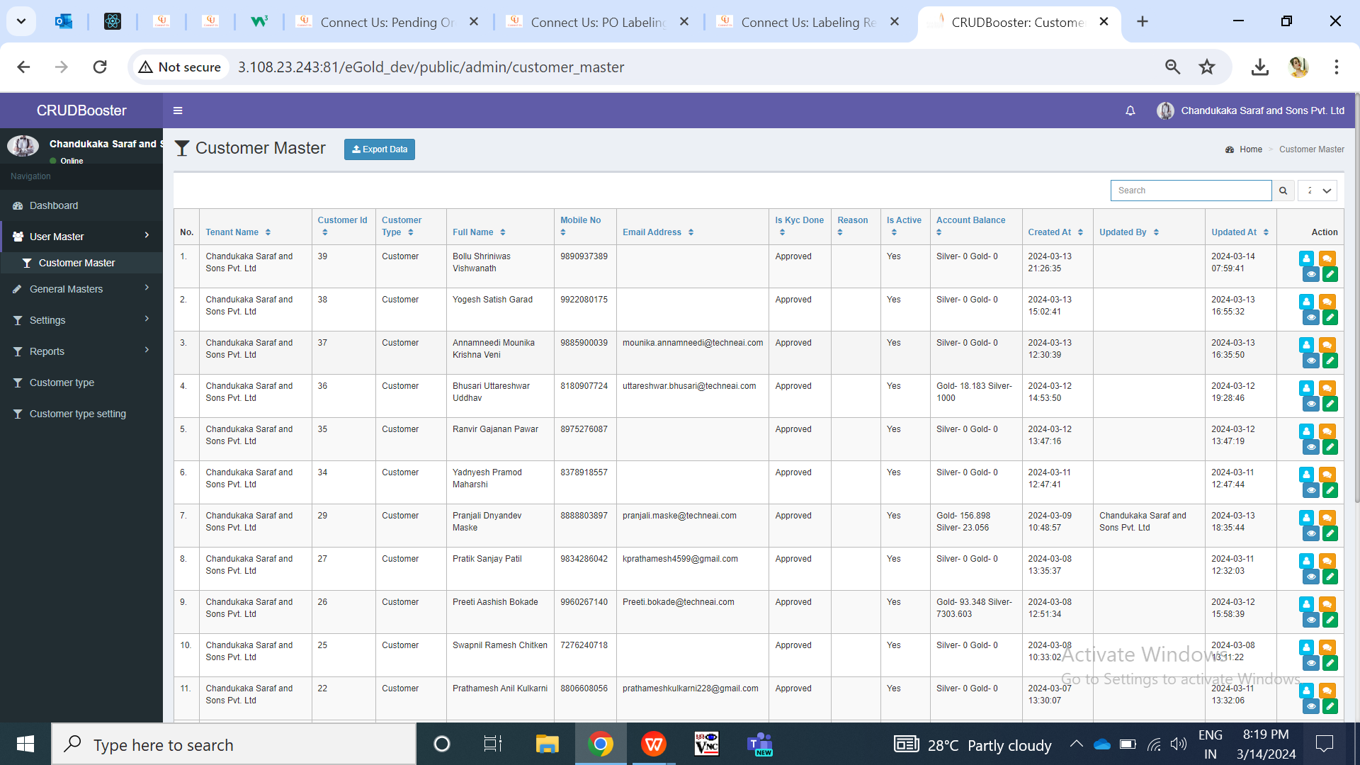

Fig: Customer master

|  |  |  |  |
| --- | --- | --- | --- |
| **FIELDS** | **INPUT TYPE** | **MANDATORY / OPTIONAL** | **DESCRIPTION** |
| Export button | Click | Optional | Tenant admin can download the customer data as in grid.  Once user clicks on export button, user can select the columns needed in exported file and click on submit button so that file will get downloaded. Downloaded file will have the customers details in it as in grid I.e. when cx registered himself.  It will have following columns:   * Customer ID * Tenant name * Customer name * Mobile number * Email * KYC * Status * Account Balance * Created at & by * Updated & by   Validation: Once user clicks on export button, dialogue box will appear to select columns in downloaded file. Once user clicks on export button again, the opened dialogue box will get closed. Submit button will be disabled until file gets downloaded.    Fig: Customer master -> export |
| View action | Click | - | Tenant admin can view the details of each added customer individually through view action. It will display following details:   * Customer ID * Tenant Name * Customer Name * Address * Pin code * Country * State * City * Mobile number * Date of birth * Gender * Email * Occupation * Date of anniversary * Referral Code * Aadhar card number * Pan card number * Password * KYC status * Profile photo * Status * Created at & by * Updated at & by   Validation: All field in view page will be read only.    Fig: Customer master -> view action |
| Edit action | Click | - | Tenant admin can edit the details of the already created customer through edit action here. It will have following fields:    Fig: Customer master -> edit action  Validation: Once tenant admin clicks on edit action, he will be directed to edit page where all fields will be displayed from profile of customer and few fields will be editable. |
| Preferences action | Click | - | Through preferences action, tenant admin can make changes related to communication mode as per customers wish.  Initially, when customer registers himself, then preferences will be blank in web here as well as on app until customer or tenant admin sets his preferences. |
| Nominee action | Click | - | Through nominee action, tenant admin can make changes related to nominee details.  Initially, when customer registers himself, then nominee will be blank in web here as well as on app until customer or tenant admin adds it. |
| Tenant name | Text | Mandatory | It will display the tenant name here against which that customer is registered.  Validation: It will be read only. |
| Customer name | Text | Mandatory | It will display the full name of the customer as per aadhar card when customer registered himself for that tenet.  Validation: It will be read only. |
| Customer ID | Text | Mandatory | It will display the Customer ID when customer registered himself for that tenet.  Validation: It will be read only. It will unique for all. |
| Mobile no. | Text | Mandatory | It will display the mobile number customer entered while registering.  Validation: It will be read only in grid. |
| Email | Text | - | If customer has added email address through profile, then it will be displayed here. Else, if tenant admin has added email address through customer master -> edit -> email, it will be mentioned here.  Validation: It will be read only in grid. |
| Kyc | Text | Mandatory | It will display KYC status as completed as cx are registering themselves using aadhar number.  Validation: It will be read only. |
| Status | Text | Mandatory | It will display whether cx is active or inactive under this tenant. Tenant can edit it from cx master -> edit -> status.  Validation: it will be read only in grid. |
| Created at | Text | Mandatory | It will display the date and time when customer registered himself I.e. when cx data got added and displayed in cx master.  Validation: It will be read only. |
| Updated at | Text | - | It will display the date and time when the tenant admin updated the customer details through cx master -> edit.  Validation: It will be read only. |
| Updated by | Text | - | It will display the name of the user who edited the cx details.  Validation: It will be read only. |

**Customer master -> Edit action**

Through edit action, tenant admin can update the details of the customer. It will have following fields:

* Customer ID
* Tenant Name
* Customer Name
* Address
* Pin code
* Country
* State
* City
* Mobile number
* Date of birth
* Gender
* Email
* Occupation
* Date of anniversary
* Referral Code
* Aadhar card number
* Pan card number
* Profile photo
* Status
* Remark
* Save button
* Back button

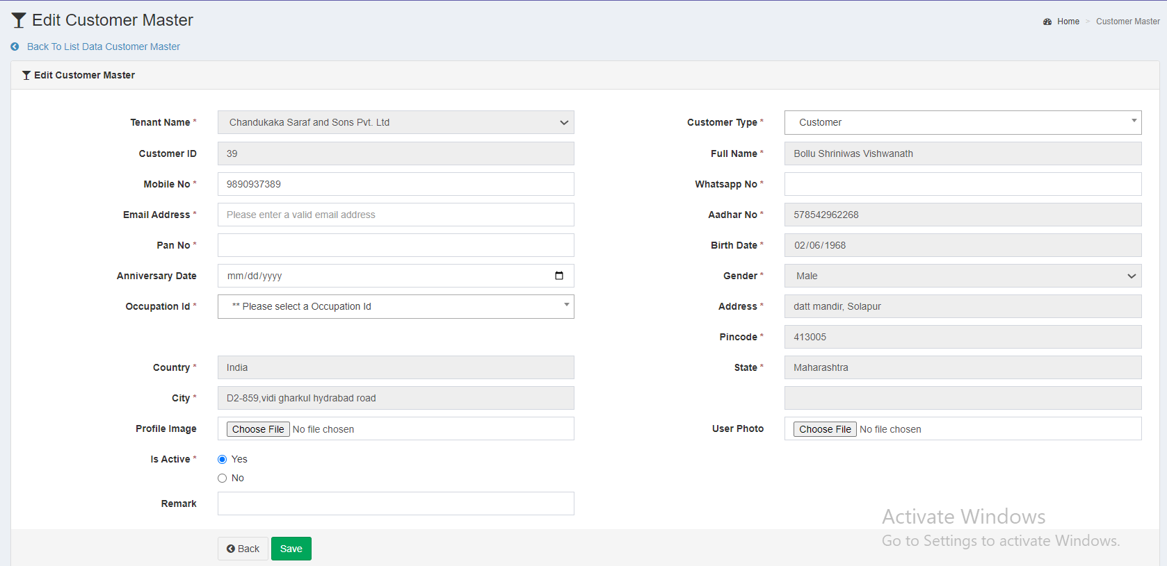

Fig: Customer master -> edit action

|  |  |  |  |
| --- | --- | --- | --- |
| **FIELDS** | **INPUT TYPE** | **MANDATORY / OPTIONAL** | **DESCRIPTION** |
| Cx Id | Text | Mandatory | Once cx is registered, Cx ID gets generated to it by the system and it will be displayed here.  Validation: It will be read only. |
| Tenant name | Text | Mandatory | Once cx registers itself, the tenant name under which cx is registered, it will be displayed here.  Validation: It will be read only. |
| Address | Text | Mandatory | It will display the address of the cx from aadhar number mentioned while registration.  Validation: It will be read only. |
| Pin code | Text | Mandatory | It will display the pin code of the cx from aadhar number mentioned while registration.  Validation: It will be read only. |
| Country | Text | Mandatory | It will display the pin code of the cx from aadhar number mentioned while registration.  Validation: It will be read only. |
| State | Text | Mandatory | It will display the state of the cx from aadhar number mentioned while registration.  Validation: It will be read only. |
| City | Text | Mandatory | It will display the city I.e. vtc or loc of the cx from aadhar number mentioned while registration.  Validation: It will be read only. |
| Mobile number | Text | Mandatory | It will display the mobile number which cx entered while registration. It will be editable from mobile app -> profile as well as from web -> cx master -> edit -> mobile no.  Validation: It will accept numbers only. It should not accept all zeros. It should only accept 7/8/9 at the beginning.  Min & max length = 10. |
| DOB | Calender date picker | Mandatory | It will display the date of birth of the cx as per aadhar number.  Validation: It will be read only. Its format will be DD/MM/YYYY. |
| Gender | Text | Mandatory | It will display the gender of the cx as per aadhar number.  Validation: It will be read only. |
| Email | Text | Mandatory | It will display the email address mentioned by the cx in mobile app -> profile. It will be blank if cx has not added any email address yet. It will be editable in cx master -> edit and through mobile app.  Notifications via email will be sent to the cx on this registered email address.  Validation: This field should accept “ @ - . “ only as special characters. In case of invalid format, it should display on field error message as “Invalid email address”. It shouldn’t accept space.  Min = 6  maximum length = 150. |
| Occupation | Drop down | Mandatory | Tenant admin will mention his occupation. It will be blank if cx has not added any occupation yet. It will be editable in cx master -> edit and through mobile app.  It will display occupations in list from occupation master.  Validation: It will be single select. It will display active occupation names only in the list. |
| DOA | Calender date picker | Optional | Tenant admin will select the date of anniversary if required. It will be blank if cx has not selected any DOA yet. It will be editable in cx master -> edit and through mobile app.  Validation: Only one date can be selected. Future dates will be disabled. Dates before DOB will be disabled. |
| Aadhar card number | Text | Mandatory | It will display the aadhar number mentioned by the cx while registering.  Validation: It is read only. Max length = 12 |
| PAN number | Text | Mandatory | It will be the PAN card number of the cx. It will be blank if cx has not mentioned any PAN number yet. It will be editable in cx master -> edit and through mobile app.  In case of invalid pan card number format, it should display error message as “Invalid pan number”. If user enters same pan number which is already added in another cx account, then it should display on field error message as PAN number already exists.  Validation: Customer will enter 10 digit alphanumeric PAN No. of nominee. PAN number will be unique in cx master. It includes first five letters, followed by 4 numbers and last character. |
| Profile photo | Attach / upload | Optional | It will display the profile image attached by Cx in mobile app -> profile.  Initially when cx registers himself, the profile image field is displayed blank in mobile app and web. Further tenant admin can add image from cx master -> edit or cx can add from profile.  If cx has added profile image, then hyperlink pf profile image will be displayed here through which can view and download it.  Validation: Only one image can be set at a time. It will accept only jpg, png, heic, heif, webp and jpeg extensions only.  Max image size = 2MB |
| Status | Radio button | mandatory | It will display whether cx is active or inactive under this tenant. Only tenant admin can change the status of the cx.  Inactive cx won’t be able to log into the mobile app. It will display alert message to cx as ‘account deactivated’. |
| Remark | Text | Optional | Tenant admin can mention the additional comments here if required. |
| Save | Click | - | Once tenant admin enters valid details and clicks on save button, cx details will be saved and displayed in mobile app -> profile, cx master -> edit, grid and view page.  If invalid details are entered in any single field and tenant admin clicks on save button, on field error message will be displayed where data is incorrect. |
| Back | Click | - | Once user clicks on back, tenant admin will be redirected to cx master -> grid without saving any data. |

**Customer master -> Nominee action**

Tenant admin can view and update the nominee details of the customer through nominee action here. It will have following fields:

* Nominee name
* Nominee email
* Nominee mobile no.
* Nominee DOB
* Nominee relation
* Nominee aadhar
* Nominee PAN number
* Nominee address
* Save button

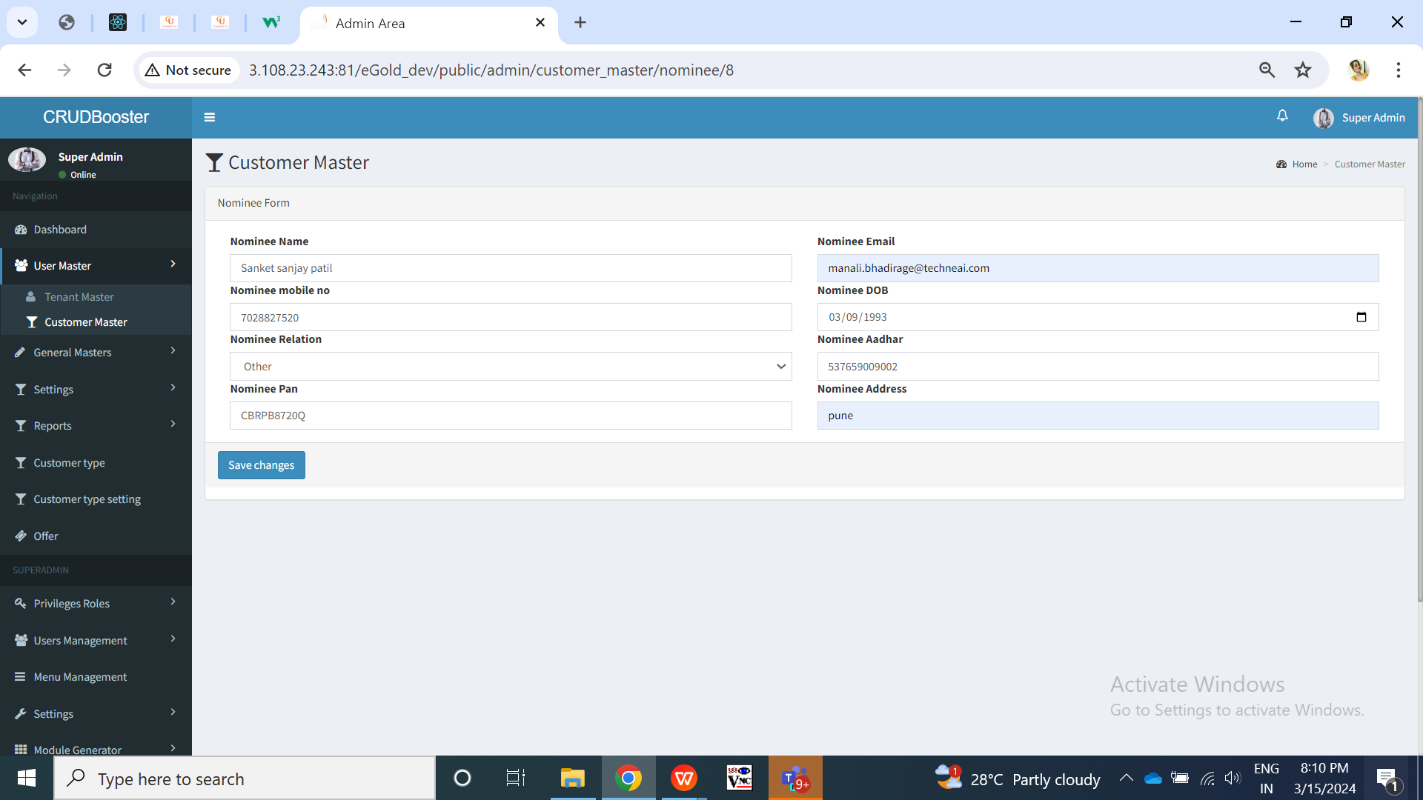

Fig: Customer master -> nominee action

|  |  |  |  |
| --- | --- | --- | --- |
| **FIELDS** | **INPUT TYPE** | **MANDATORY / OPTIONAL** | **DESCRIPTION** |
| Nominee name | Text | Mandatory | Customer will enter the name of the nominee he wants to add through mobile app or else tenant admin can enter nominee name through cx master -> nominee. It will be blank if cx has not mentioned any nominee name through mobile app. It will be editable in cx master -> nominee and through mobile app.  Validations: It should accept characters and space only. It should not accept space initially.  Min length = 2  Max length = 100 |
| Full Address | text | mandatory | Customer will enter the address of the nominee he wants to add through mobile app or else tenant admin can enter nominee name through cx master -> nominee. It will be blank if cx has not mentioned any nominee address through mobile app. It will be editable in cx master -> nominee and through mobile app.  Validation: It will accept maximum 250 characters / numbers. It should accept single space only after each word. It should accept . / - , special characters only. |
| Date of Birth | Calendar picker | Mandatory | Customer will enter the DOB of the nominee he wants to add through mobile app or else tenant admin can enter nominee DOB through cx master -> nominee. It will be blank if cx has not mentioned any nominee name through mobile app. It will be editable in cx master -> nominee and through mobile app.    Validation: Future dates will be disabled. It should display dates from 01-01-1924 to current date. |
| Relation with nominee | Text | Mandatory | Customer will choose his relation with the nominee from the drop-down as mother / father / sister / brother / daughter / spouse / son/ other. Customer will enter the relation of the nominee he wants to add through mobile app or else tenant admin can enter nominee DOB through cx master -> nominee. It will be blank if cx has not mentioned any nominee relation through mobile app. It will be editable in cx master -> nominee and through mobile app.  Validation: It will be single select. |
| PAN number | text | Optional | Customer will enter the pan number of the nominee he wants to add through mobile app or else tenant admin can enter nominee pan number through cx master -> nominee. It will be blank if cx has not mentioned any nominee name through mobile app. It will be editable in cx master -> nominee and through mobile app.  Validation: One nominee’s pan number can same as nominee of another person. It includes first five letters, followed by 4 numbers and last character. In case of invalid pan card number format, it should display error message as “Invalid pan number”. |
| Aadhar card number of nominee | Text | Mandatory | Customer will enter the aadhar number of the nominee he wants to add through mobile app or else tenant admin can enter nominee aadhar number through cx master -> nominee. It will be blank if cx has not mentioned any nominee name through mobile app. It will be editable in cx master -> nominee and through mobile app.  One Aadhar no. will be entered only once. customer will have to enter unique Aadhar no. Customer cannot mention same already entered aadhar number for another nominee. Also, it cannot be as same as registered user’s aadhar number.  In case of invalid aadhar card number format, it should display error message as “Invalid aadhar number”. |
| Nominee mobile no. | text | mandatory | Customer will enter nominee’s mobile number through mobile app or tenant admin can enter it through web -> cx master -> nominee settings. It can be same as customer’s number from profile.   Validation: It can be same. It should accept 7/8/9 only at the beginning. It should not accept space or characters or special characters. Min & Max length = 10 |
| Nominee’s Email ID | text | Optional | Customer will enter nominee’s email ID or tenant admin will enter through cx master -> nominee settings. It can be same as customer’s number from profile.  Validation: It can be same. It should not accept space. It should accept special characters -_@. only. Min length = 11  Max length = 100 |
| Save | Click | - | Once tenant admin clicks on save, nominee settings will get saved / updated and displayed in mobile app -> nominee settings to the cx and on web -> cx master -> nominee.  Validation: Tenant admin will get directed to save grid page once user clicks on save button and successful message is displayed. It will display on field error message if invalid details are entered. Save button will be disabled until details are saved or error message is displayed. |

**Customer master -> Preferences action**

Customer can add preference settings through mobile app from his own end or tenant admin can add / update it through web cx master -> preference settings.

1. **Default settings**

Default settings will be accessible to super-admin only. Super admin will add default settings. Once tenant is created, tenant settings for that tenant gets created whereas it will display value for all the settings from default settings initially. Tenant will either keep value for settings from default or else can edit it from their own end. If tenant removes any tenant setting value, then it will display default value settings to their customers if tenant admin has selected option to take value from default value.

Default settings will have following fields:

* Module name
* Sub module name
* Setting name
* Setting data type
* Default value
* Possible values
* Sort order
* User can change
* Use encryption
* Remark
* Is active
* Save & add more button
* Save button

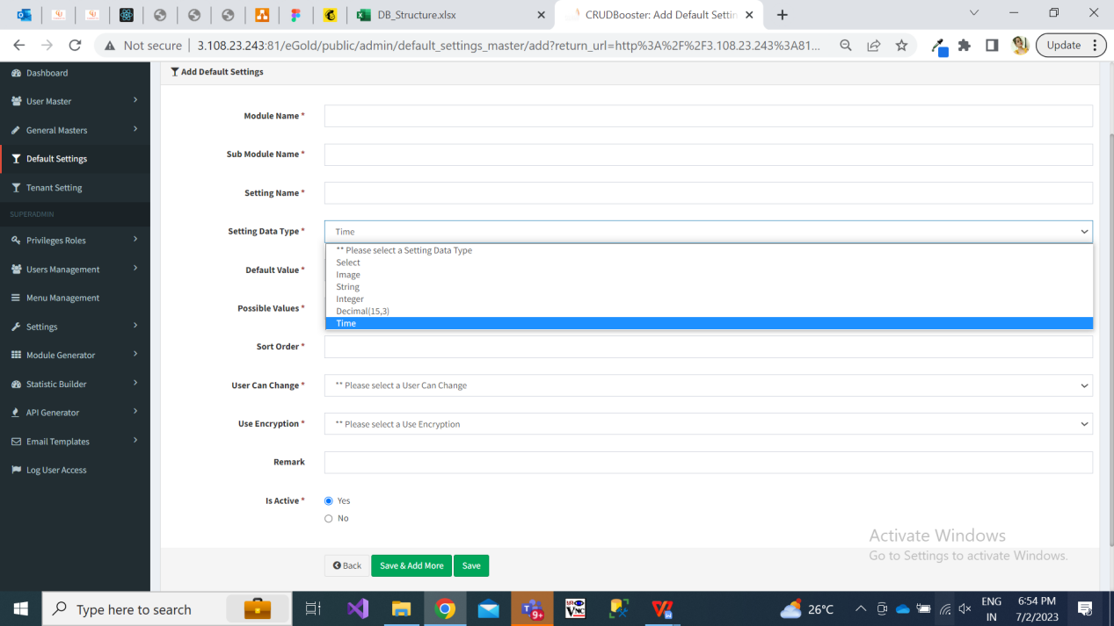

Fig: Add default settings

|  |  |  |  |
| --- | --- | --- | --- |
| **FIELDS** | **INPUT TYPE** | **MANDATORY / OPTIONAL** | **DESCRIPTION** |
| Module name | text | Mandatory | Super admin will enter the module name referring to which the setting is about.  Validation:  Min length = 5  Max length = 50 |
| Sub module name | text | Mandatory | Super admin will enter the sub-module name referring to which the setting is about. |
| Setting name | text | Mandatory | Super admin will enter the setting name referring to which the setting is about.  Validation: It will be unique.  Min length = 5  Max length = 50 |
| Setting data type | Drop-down | mandatory | It will be the data type of setting we are reffing to.   * Image * Select * String * Int * Decimal * Time   Example: If setting is about image like displaying logo, then super admin will select data type as image.  If setting is about text field, then super admin will select string.  If setting is about timing, then super admin will select time. Example: If tenant wants to set start time and end time during which customers can make transactions, then tenant will select data type as time for such setting.  Validation: It will be single select. |
| Default value | text | Mandatory | Super admin will enter the default value as per data type.  Means, by default which image / text will be displayed in the selected setting.  Validation:  Min length = 1  Max length = 50 |
| Possible values | text |  | This field will be displayed only if super admin selects data type as ‘select’. |
| User can change | Drop down | Mandatory | It will display yes / no. Means, whether tenant can change it or not through tenant settings -> edit action. |
| Use encryption | Drop down | Mandatory | It will display yes / no to display encrypted data for selected field on customer’s page. |
| remark | text | Optional | Super admin will mention additional comments in this text field.  Validation: It should accept alphanumeric value, space and special characters.  Max length =250 |
| Is active | Radio button | mandatory | By default it will display as active.  Once the particular default setting is deactivated then this field won’t be editable to tenant.  Further, if any default setting is deactivated by super admin, then that setting will be disabled in tenant setting as well. Whereas, that deactivated setting will be reflected as blank to new customers as well as already existing customers.  Validation: It will be single select. |
| Save button | click |  | Once super admin clicks on save button, then as per settings & development in database, the default setting will get added and the same will get reflected against each active tenant in tenant settings.   Also, default settings will be displayed to customers until their tenant hasn’t changed the particular setting from tenant settings.  Validation: save button will be disabled once clicked until record gets added or error message is displayed. |

1. **Tenant settings**

Initially, tenant will get all default settings further which tenant can edit them. If any changes are not made in settings by tenant, then respective customers of that tenant will get view on application as per default settings.

Once tenant log into web application by their credentials, tenant admin will have access to tenant settings menu. It will have following fields in grid for each available setting:

* Tenant id
* Setting name
* Setting value
* Remark
* Is active
* Created at & by
* Updated at & by
* Edit action
* View action

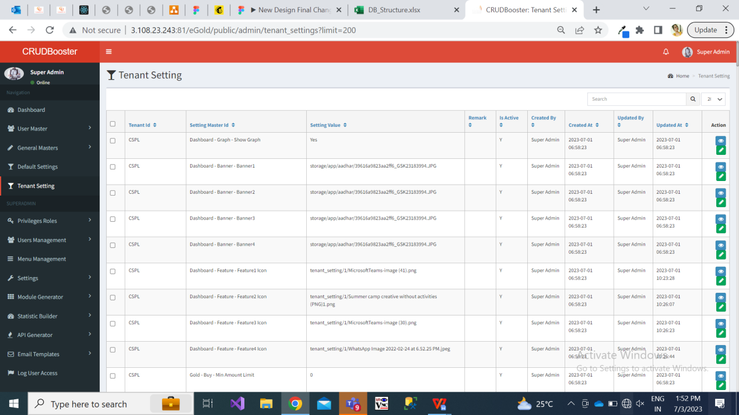

Fig: Tenant setting

Once user clicks on edit action of tenant setting, it will display following pre-filled fields:

* Setting name
* Setting value
* Remark
* Is active

|  |  |  |  |
| --- | --- | --- | --- |
| **FIELDS** | **INPUT TYPE** | **MANDATORY / OPTIONAL** | **DESCRIPTION** |
| Setting name | Text | Mandatory | It will display the setting name as mentioned by the super admin.  Validation: It will be read only. |
| Setting value | Text / Attach | Mandatory | Initially it will display the default setting value for that selected setting name as set by the super admin. Whereas, tenant admin can edit it.  If the setting is attachment, then user will upload the image. The attached image will be displayed to the customers of that tenant.  If the setting name is text, then it will display the limits and amount as here.  If user removes the value from here then if the check-box for that  Validation: It should accept numbers only in case of limits, age, time settings. It should accept single image only in case of attachment settings with extensions png, jpeg, jpg, heic, webp formats only. |
| Remark | Text | Optional | Tenant admin will mention the additional comments here if required.  Validation: It should accept characters, space, numbers and special characters.  Min length = 0  Max length = 250 |
| Save | Click | - | Once user clicks on save button, then it will display the set value to the customers on application. |

1. **Buy report**

As and when customers perform buy transaction it will be displayed to tenant in web -> reports. It will have following fields in grid:

* Sr no.
* View action
* Tenant ID
* Customer ID
* Customer name
* Transaction type as Buy
* Product Group
* Receipt no. / Transaction ID
* Transaction status
* Grams purchased
* Total bill Amount
* Transaction date
* Account Weight balance

Once tenant / super admin clicks on view action, it will display following read only fields:

* Tenant ID
* Customer ID
* Customer name
* Transaction type as Buy
* Product group
* Transaction ID / receipt no.
* Grams purchased
* Current rate - It will display the current rate of buy during which the purchase is done by customer.
* Metal amount
* GST amount
* Offer
* Total bill Amount
* Transaction date
* Transaction Time
* Bank name
* Account Weight balance - It will display the updated weight balance after this particular buy transaction was done by customer.
* Digital receipt - It should display hyperlink of the receipt which as in your trades against this particular transaction and will be downloadable.
* Unique device number - number of device from which the transaction was done by customer

1. **Sell report**

As and when customers undergo sell transaction it will be displayed to tenant in web -> reports. It will have following fields in grid:

* Sr no.
* View action
* Tenant ID
* Customer ID
* Customer name
* Transaction type as Sell
* Product Group
* Receipt no. / Transaction ID
* Grams sold
* Total bill Amount
* Transaction date
* Account Weight balance

Once tenant / super admin clicks on view action, it will display following read only fields:

* Tenant ID
* Customer ID
* Customer name
* Transaction type as Sell
* Product group
* Transaction ID / receipt no.
* Grams sold
* Current rate It will display the current rate of sell during which the sell transaction is done by customer.
* Total bill Amount
* Transaction date - The date on which customer sold the particular grams.
* Transaction Time
* Account Weight balance - It will display the updated weight balance after this particular sell transaction was done by customer.
* Digital receipt - It should display hyperlink of the receipt which as in your trades against this particular transaction and will be downloadable.
* Unique device number - number of device from which the transaction was done by customer
* Refunded to bank - It will display bank name to which refund was done.

Refund date & time - Once amount is refunded to customer’s bank account, the refunded date & time will be displayed.

1. **Delivery report**

As and when customers undergo sell transaction it will be displayed to tenant in web -> reports. It will have following fields in grid:

* Sr no.
* View action
* Edit action
* Tenant ID
* Customer ID
* Customer name
* Transaction type as Delivery
* Product Group
* Receipt no. / Transaction ID
* Grams Delivery
* Delivery charges
* Transaction date
* Delivery Date
* Account Weight balance

Once user clicks edit action, it will display following read only fields:

* Tenant ID
* Customer ID
* Customer name
* Transaction type as Delivery
* Product Group
* Receipt no. / Transaction ID
* Grams Delivery
* Delivery charges
* Transaction date
* Account Weight balance
* Mobile number
* Alternate mobile number
* Address
* Landmark
* Pin code
* State
* City
* ID proof
* Type of address
* Delivery Status - Delivered / not delivered radio button will be provided and will be editable. Tenant will manually mark it as delivered once physical delivery of ordered product is handed over to the customer. Once delivery is marked as delivered, then ‘**delivery date**’ field will be displayed below. Tenant will mention the delivery date and click on save button
* Save button - If status and delivery date has been updated by tenant and once tenant clicks on save button, then notification of delivery should get sent to the customer within app and via medium as per preference.

Once user clicks on view action of delivery report, it will display following read only fields:

* Tenant ID
* Customer ID
* Customer name
* Transaction type as Delivery
* Product Group
* Receipt no. / Transaction ID
* Grams Delivery
* Delivery charges
* Transaction date
* Account Weight balance
* Mobile number
* Alternate mobile number
* Address
* Landmark
* Pin code
* State
* City
* ID proof
* Type of address
* Status
* Updated at date & time

1. **Customer ledger report**

Through customer ledger report, tenant admin will view all the detailed transactions done by the specific customer in selected dates. It will help tenant admin to analyze the transactions customer wise.

It will have following fields:

* From Date
* To Date
* Customer name
* Filter button
* Reset button
* Export button
* Sr. No.
* Transaction Date
* Metal type
* Transaction type
* Transaction amount (means total bill amount)
* Metal weight
* Weight balance

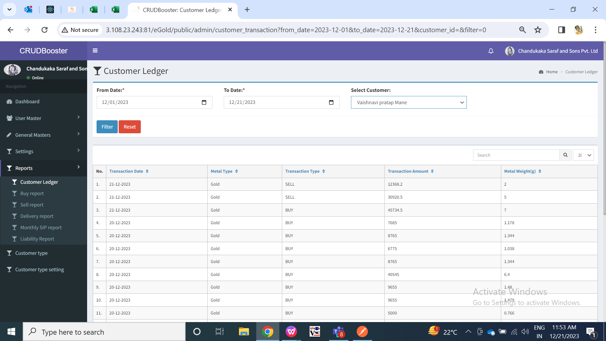

Fig: Customer ledger report

|  |  |  |  |
| --- | --- | --- | --- |
| **FIELDS** | **INPUT TYPE** | **MANDATORY / OPTIONAL** | **DESCRIPTION** |
| From Date | Calender date picker | Optional | Tenant admin will select the date from which they wants to view report from.  Validation: Future dates will be disabled. It will be single select. |
| To date | Calender date picker | Optional | Tenant admin will select the date till which they wants to view report.  Validation: Future dates will be disabled. It will be single select. |
| Customer name | Drop down | Optional | It will display the ID and customer name from customer master of that tenant admin only.  Tenant admin will select the customer for which he wants to view the report.  Validation: It will be single select. It will display the list of customers registered under that tenant. |
| Filter button | Click | - | Once user clicks on filter button, all the details of the transactions done by the selected user will be displayed below in grid.   * Sr. No. * Customer ID * Customer Name * Transaction Date * Metal type * Transaction type * Transaction amount * Metal weight * Weight balance   Validation: If user clicks on filter button then it will display transactions of each customer in the grid. |
| Reset button | Click | - | Once user clicks on reset button, page will get reloaded and all the data in grid will be cleared so that user can select fields.  Validation: It will be disable until page gets reloaded and all prefilled fields gets cleared. |
| Export button | Click | - | Once user applies filter and data appears in grid, export button will be displayed.  User can export the csv file displaying the customer’s all transactions report as in grid. It will have following columns:   * Sr. No. * Customer ID * Customer Name * Transaction Date * Metal type * Transaction type * Transaction amount * Metal weight * Weight balance |
| Transaction Date | Text | - | The date on which the transaction was successfully, it will be displayed in the report. |
| Metal type | Text | - | It will display the metal type I.e gold or silver for which the transaction was made. |
| Transaction type | Text | - | It will display the type of transaction I.e buy, sell, sip, delivery when successful. |
| Transaction amount | Text | - | It will display the total invoice amount of that successful transaction done by customer. (total bill amount) |
| Metal weight | Text | - | It will display the metal weight I.e. grams of the metal that has been either purchased / sold / proceeded for delivery while making the transaction. |
| Weight balance | Text | - | It will display the weight balance of metal that has got updated & displayed in customer’s account after making that particular transaction. Means it will display the total weight balance in customer’s account after making that particular transaction. |

1. **Customer liability report**

Through liability report, tenant admin can view the summary of opening and closing weight of gold and silver on selected dates of each customer. Also, tenant admin can view the details of each customer. It will have following fields:

* From Date
* To date
* Customer
* Metal type
* Summary report checkbox
* Filter button
* Reset button
* Export button

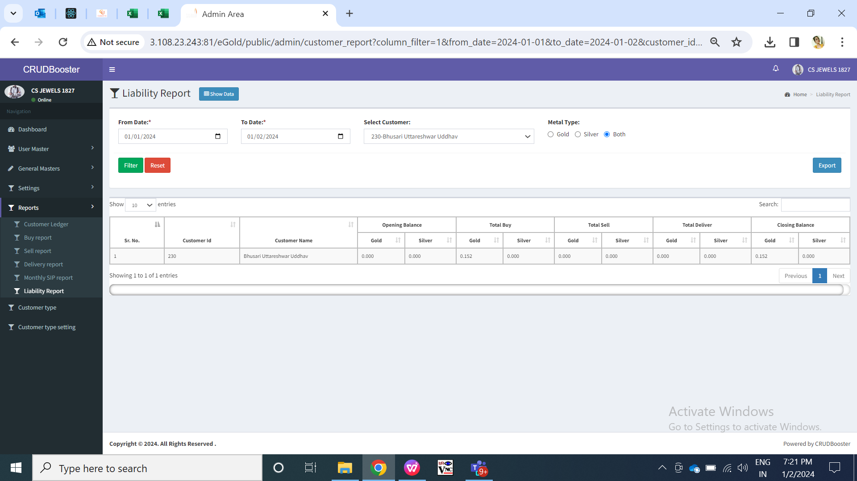

Fig: Liability Report

|  |  |  |  |
| --- | --- | --- | --- |
| **FIELDS** | **INPUT TYPE** | **MANDATORY / OPTIONAL** | **DESCRIPTION** |
| From Date | Calender date picker | optional | Tenant admin will select the date from which they wants to view report from.  Validation: Future dates will be disabled. It will be single select. |
| To date | Calender date picker | optional | Tenant admin will select the date till which they wants to view report.  Validation: Future dates will be disabled. It will be single select. |
| Customer name | Drop down | Optional | It will display the ID and customer name from customer master of that tenant admin only.  Tenant admin will select the customer for which he wants to view the report.  Validation: It will be single select. If user keeps it blank then report for all customers will be displayed once admin clicks on filter button. |
| Metal Type | Drop-down | Mandatory | Admin will select the metal type for which they wants to view the report against customer.  By default, it will be clicked both. Whereas once user selects either gold or silver, then it will display opening balance, closing balance and total for the selected metal type only for customer. |
| Filter button | Click | - | Once user clicks on filter button, all the details of the transactions done by the user will be displayed below in grid. It will display the opening and closing balance of the customer as per selected from and to date whereas it will display the gold / silver accumulated by total buy, sell and delivery.  Validation: Once user selects mandatory fields and clicks on filter button, it will be disabled until data gets displayed below in grid. |
| Summary report | Check box | Optional | Through summary report, tenant can view the opening balance of metal on the selected start date and closing balance of metal on the selected end date. It will display the overall balance means of all the customers together. It will display following columns metal wise:   * Opening balance * Total buy * Total sell * Total delivery * Closing balance   Validation: By default it will be unchecked. |
| Reset button | Click | - | Once user clicks on reset button, page will get reloaded and all the data in grid will be cleared so that user can select fields.  Validation: It will be disable until page gets reloaded and all pre-filled fields gets cleared. |
| Export button | Click | - | Once user clicks on filter button, data will be displayed in grid and export button will be displayed to download csv report.  If user clicks on summary report then exported file should display summarized report in csv file as in grid. Else, it should display customer wise record in grid as in grid.  User can export the csv file displaying the customer’s all transactions report as in grid. It will have following columns:   * Sr. No. * Customer ID * Customer name * Opening balance * Total buy * Total sell * Total delivery * Closing balance |
| Customer ID | Text | Mandatory | It will display the customer id from customer master for that customer. |
| Customer Name | Text | - | It will display the name of the customers in the list along with their trading details who has any opening or closing balance in selected dates.  If customer has 0.00 weight and has not done any trading then it will not be displayed in the list. |
| Opening Balance | Text | - | It will display the weight balance in customer’s account available at beginning of selected from date for gold and silver specifically.  Opening balance of ‘from date’ |
| Closing balance | Text | - | It will display the weight balance of in customer’s account available till end of selected from date.  Closing balance = Opening + Buy - sell - delivery |
| Total Buy | Text | - | It will display the total gram of gold and silver purchased during the selected period (from date and to date). |
| Total sell | Text | - | It will display the total gram of gold and silver sold during the selected period (from date and to date). |
| Total delivery | Text | - | It will display the total gram of gold and silver delivery transactions done during the selected period (from date and to date). |
| Closing balance | Text | - | It will display the weight balance in customer’s account available at end of selected till date for gold and silver specifically. |

1. **REFERENCES OF THE USERS**

|  |  |  |  |
| --- | --- | --- | --- |
| **User** | **Name** | **Mail** | **Contact number** |
| **Actual user** |  |  |  |
| **Ticket created by (if any)** | Manali Bhadirage |  |  |
| **Assigned business analyst** | Manali Bhadirage |  |  |
| **Assigned developer** | Goverdhan Bollu  Pranjali Maske  Jaydeep Patil |  |  |
| **Assigned tester** | Preeti Bokade  Vaishnavi Khandwe  Amreen Shaikh  Uttareshwar Bhusari |  |  |