Manali Ashok Bhadirage

Manali.bhadirage@techneai.com

25.03.2024

MATERIAL ISSUE - ADDITIONAL REMARK IN CHECKING STAGES

**Handover Document**

**CONTENTS**

1. TICKET DETAILS 2

2. INTRODUCTION 2

3. BUSINESS REQUIREMENT 2

4. SCOPE 3

5. BUSINESS & SYSTEM RULES 3

6. ABBREVIATIONS & TERMS 3

7. GRAPHICAL REPRESENTATION 3

8. PROPOSED SYSTEM 4

9. REFERENCES OF THE USERS 26

1. **TICKET DETAILS**

|  |  |
| --- | --- |
| **Ticket ID** | TT19953 |
| **Ticket description** | Connect Us Madhe Material Issue Madhe Document Pass Kartana Remark Narration Takata Ale Pahije . |
| **Created by** | Rakesh Thikane |
| **Created on** | 28/02/2024 |
| **Priority** | Medium |

1. **INTRODUCTION**

When lot is added in material issue, it was marked as received by the authority. Further, the lot is sent for checking in four stages. Here, based on parameters, the items are accepted and rejected. The rejected items are returned to the vendor whereas the purchase document is created in Padm for accepted items. Users use the material issue reports to recheck the documents and its details after completing four checking stages. Through material issue reports, analysis of documents is verified again finally the inventory and audit team. Each document is crossed checked and thus gives better understanding of inventory materials, accuracy and completeness. Reports give understanding on the time required for each process while passing the document along with accepted and rejected details in it.

1. **BUSINESS REQUIREMENT**

We need additional remark text field in all four checking stages and remark history field in issued action of QC check, PO check and HM check. The added remarks will be displayed in material issued reports accordingly.

|  |  |  |  |
| --- | --- | --- | --- |
| **Requirement ID** | **Requirement Name** | **Short Description** | **Priority** |
| BR001 | Additional remark in checking stages | We have to add ‘Additional remark’ column in issued action of all four material issue stages (Design check, QC check, PO check and HM check). | Medium |
| BR002 | Remark History | Once document is saved from one stage, its remark will be displayed in remark history field which will be read only. | Medium |
| BR003 | Additional remark column on material issue reports -> grid | The remark of each stage will be displayed in material issue reports -> grid. | Medium |
| BR004 | Additional remark column on material issue reports -> exported file | The remark of each stage will be displayed in material issue reports -> exported file. | Medium |

1. **SCOPE**

Once user adds document in material issue and marks it as received, that document will get displayed in Design check process. User will accept and/ or reject the pcs from that document by clicking on issued action. Once user clicks on issued action, all the item wise accepted details of that document will be displayed. User will be able to mention the additional remark if required. Further, document will be displayed in another QC check process when document is saved. Once user clicks on issued action of QC check document, it should display additional remark text field along remark history. Remark history should display previous remark which was mentioned by the user in design check process if any and it will be read only. Further, once document will be displayed in PO check once saved in QC check. User can enter accepted and/or rejected details in PO check along with additional remark and view previously added remarks if any. Further, once document is saved, it will be displayed in HM check process along with previous additional remarks and user will be able to enter HM check additional remark as well. Additionally, all the entered additional remarks of each stage will be displayed in material issue reports as well.

1. **BUSINESS & SYSTEM RULES**

* User will be registered in the system.
* User will be logged in.
* System should display error message for incorrect details if entered.
* Material issue reports should display columns in grid and exported file as per selected report type.

1. **ABBREVIATIONS & TERMS**

RD - Registered Dealer

WT - weight

1. **GRAPHICAL REPRESENTATION**

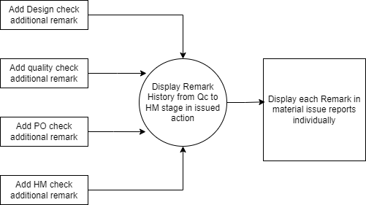

Fig: Context Diagram

1. **PROPOSED SYSTEM**

Earlier, there was no text field in four checking stages to enter additional comments if user wants to add any.

Step 1. In Connect us -> material issue main menu -> material issue, once user clicks on add data, it will display following fields:

* Issued Date
* Challan No.
* Location
* Issued Type
* Vendor
* Sub supplier
* Narration
* Remark
* Is RD purchase?
* Type of Rate
* Rate (per gram for 99.50%)
* Unfix fine rate
* Attachment
* Item Detail table
* Save button
* Back button
* Save and add more button

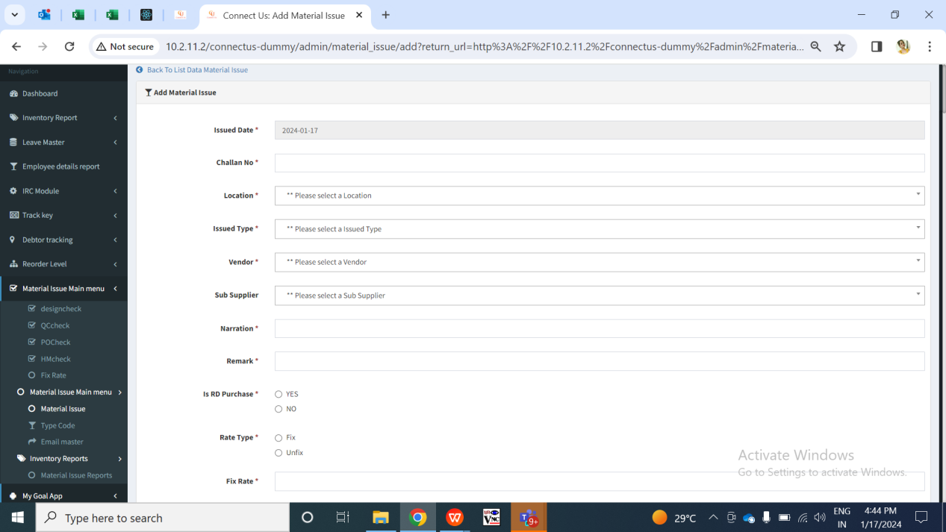

Fig: Material issue -> Add data

Once user enters items details, adds to table and clicks on submit, the doc. no. will be generated to it. It will be displayed in material issue grid.

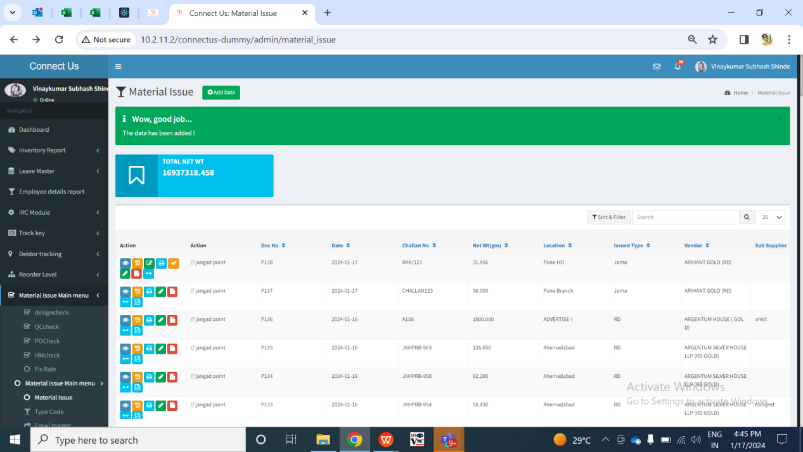

Fig: Material issue -> grid

Step 2. Once the data is marked as received by authority from material issue, it will be displayed in **design check module**.

Once user refer to Design check menu, it will display following fields on grid:

* View action
* History action
* Issued action
* Doc no.
* Challan no.
* Net wt
* Location
* Vendor
* Sub supplier
* Received status

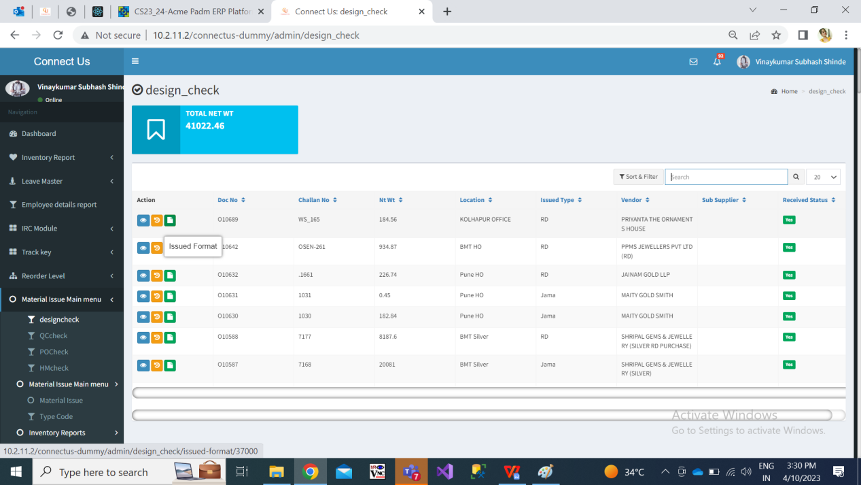

Fig: design check -> grid

Once user clicks on issued action, it will display following fields:

* Doc no.
* Date
* Challan no.
* Location
* Jama type
* Vendor name
* Sub supplier
* Narration
* Item name
* Purity
* Gross wt
* Net wt
* Making
* Pcs
* Rejected gross wt
* Rejected net wt
* Rejected pcs
* Accepted gross wt
* Accepted net wt
* Accepted pcs
* View total
* Narration
* Design Check Additional Remark
* Attachment
* Save button
* Skip button

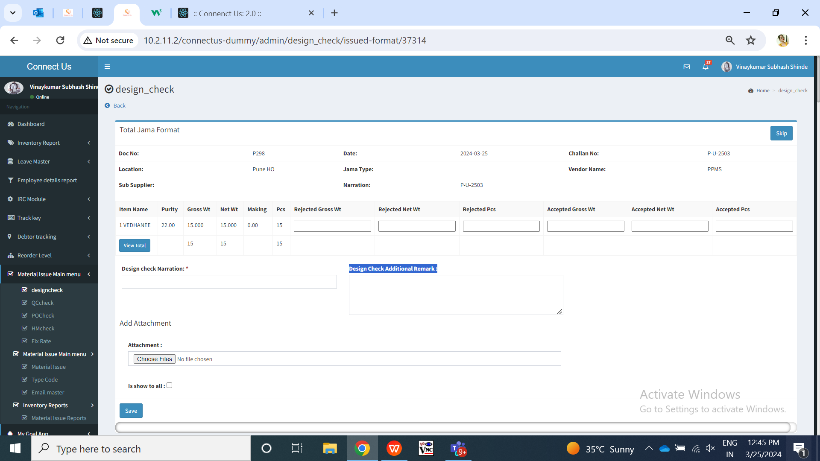

Fig: Design check -> issued action

|  |  |  |  |
| --- | --- | --- | --- |
| **FIELDS** | **INPUT TYPE** | **MANDATORY/ OPTIONAL** | **DESCRIPTION** |
| Doc no. | Text | Mandatory | It will display the doc no. from the material issue which got generated when doc. was created.  Validation: It will be read only. |
| Date | Text | Mandatory | It will display the date on which that document was created in material issue.  Validation: It will be read only. Its format will be yyyy/mm/dd. |
| Challan no. | Text | Mandatory | It will display the challan no. which was mentioned for this document in add / edit action of material issue.  Validation: It will be read only here and will display updated challan no. if it was updated in material issue -> edit against that doc number. |
| Vendor name | Text | Mandatory | It will display the vendor name. which was mentioned for this document in add / edit action of material issue.  Validation: It will be read only here and will display updated challan no. if it was updated in material issue -> edit against that doc number. |
| Sub supplier | Text | Optional | It will display the sub-vendor name here which is updated through material issue -> edit against that doc no.  Validation: It will be read only here and will display updated challan no. if it was updated in material issue -> edit against that doc number. It will be blank if none of the sub supplier is updated through edit action. |
| Narration | Text | Mandatory | It will display the narration which is entered by the user in material issue -> add / edit.  Validation: It will be read only here and it will displayed updated narration once edited by the user through material issue -> edit. |
| Item name | Text | Mandatory | It will display the list of items added by the user in material issue.  Validation: It will be read only. |
| Purity | Text | Mandatory | It will display the list of items with its respective purity added by the user in material issue.  Validation: It will be read only. |
| Gross wt | Text | Mandatory | It will display the list of items with its respective gross wt added by the user in material issue.  Validation: It will be read only. |
| Net wt | Text | Mandatory | It will display the list of items with its respective net wt added by the user in material issue.  Validation: It will be read only. |
| Making | Text | Mandatory | It will display the list of items with its respective making added by the user in material issue.  Validation: It will be read only. |
| Pcs | Text | Mandatory | It will display the list of items with its total pcs as added by the user in material issue. In Design check it will display all the pcs count as it was first checking stage.  Validation: It will be read only. |
| Skip button | Click | Optional | If user wants tp accept all the pcs, gross wt and net wt of all the items in the list then user can click on skip button so that rejected details will be 0 and accepted details will display all gross wt, net, wt and pcs. |
| Rejected gross wt | Text | Optional | If user wants to reject any of the gross wt of the item then user will enter the rejected gross wt here.  Validation: It should not be more than actual / accepted total gross wt of that item. |
| Rejected net wt | Text | - | If user wants to reject any of the net wt of the item then user will enter the rejected net wt here. If user has entered rejected gross wt, then user will have mentioned rejected net wt and pcs as well.  Validation: It should not be more than actual / accepted total net wt of that item. |
| Rejected pcs | Text | - | If user wants to reject any of the pcs of the item then user will enter the rejected pcs here. If user has entered rejected gross wt, then user will have mentioned rejected net wt and rejected pcs as well.  Validation: It should not be more than actual / accepted total pcs of that item. |
| Accepted gross wt | Text | Mandatory | Once user enters the rejected gross wt, then accepted gross wt will be calculated and displayed accordingly where accepted gross wt = total gross wt - rejected gross wt.  Validation: It will be read only and get auto-calculated. |
| Accepted net wt | Text | Mandatory | Once user enters the rejected net wt, then accepted net wt will be calculated and displayed accordingly where accepted net wt = total net wt - rejected net wt.  Validation: It will be read only and get auto-calculated. |
| Accepted pcs | Text | Mandatory | Once user enters the rejected pcs of that item, then accepted pcs will be calculated and displayed accordingly where accepted pcs= total pcs - rejected pcs.  Validation: It will be read only and get auto-calculated. |
| View total | Click | mandatory | Once the user enters rejected gross wt, net wt and pcs, user needs to click on view total button to calculate the total accepted and rejected gross wt, net wt and pcs respectively. These total accepted and rejected details will be displayed further to next stage I.e. QC check stage. |
| Narration | Drop down | Mandatory | User will select the narration from the drop-down for rejecting the pcs if any. |
| Design Check Additional remark | Text | Optional | User will be able to mention additional remark here.  The added additional remark of design check will be displayed in remark history field when document is saved here and gets displayed to further stages. Also, this added additional remark will be displayed in material issue reports -> Design check Additional remark of design check report, all reports.  Validation: It should accepted characters, numbers, special characters and space.  Min length = 0  Max length = 250 |
| Attachment | Upload | Optional | User will upload the attachment of the item if any.  Validation: It should accept maximum 25 attachments. It should accept pdf, png, jpeg, jpg extension files. |
| Save button | Click | - | Once all mandatory fields are entered and user clicks on submit, successful message will be displayed. Document will be removed from design check grid and will be displayed in QC check grid. Also, Design check additional remark which was entered will be displayed in remark history field of QC check -> issued action page of that document. |

Once user checks the items and enters details of rejected gross wt, rejected net wt and rejected pcs , then the remaining accepted gross wt, accepted net wt, accepted pcs will be auto calculated and displayed. Only the accepted details of the items will be forwarded to quality check process.

Step 3. Only the accepted gross wt, accepted net wt and accepted pcs from design check will be forwarded to **quality check**.

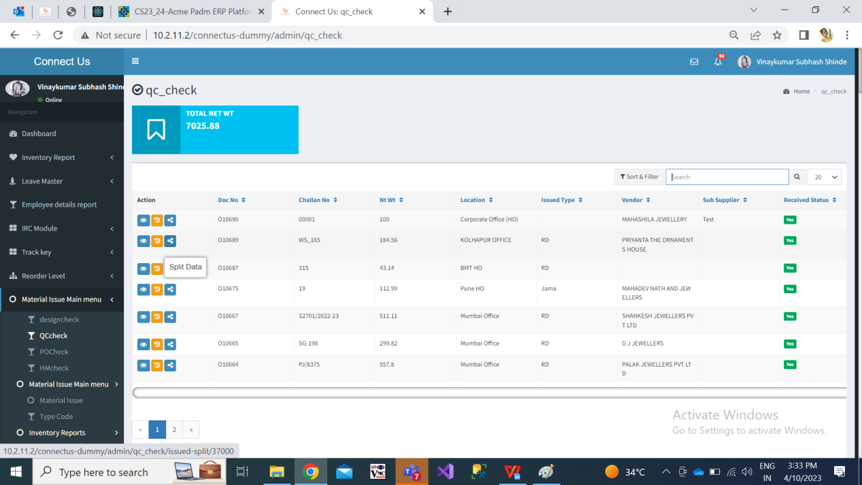

Fig: quality check -> grid

Qc incharge will split the accepted pcs into employees or can directly issue it. The split data / pcs will be displayed to the employees and will be able to perform quality checking of the items.

Once user clicks on issued action, it will display following fields:

* Doc no.
* Date
* Challan no.
* Location
* Jama type
* Vendor name
* Sub supplier
* Narration
* Item name
* Purity
* Gross wt
* Net wt
* Making
* Pcs
* Rejected gross wt
* Rejected net wt
* Rejected pcs
* Accepted gross wt
* Accepted net wt
* Accepted pcs
* View total
* Narration
* QC Additional Remark
* Additional Remarks History
* Attachment
* Save button
* Skip button

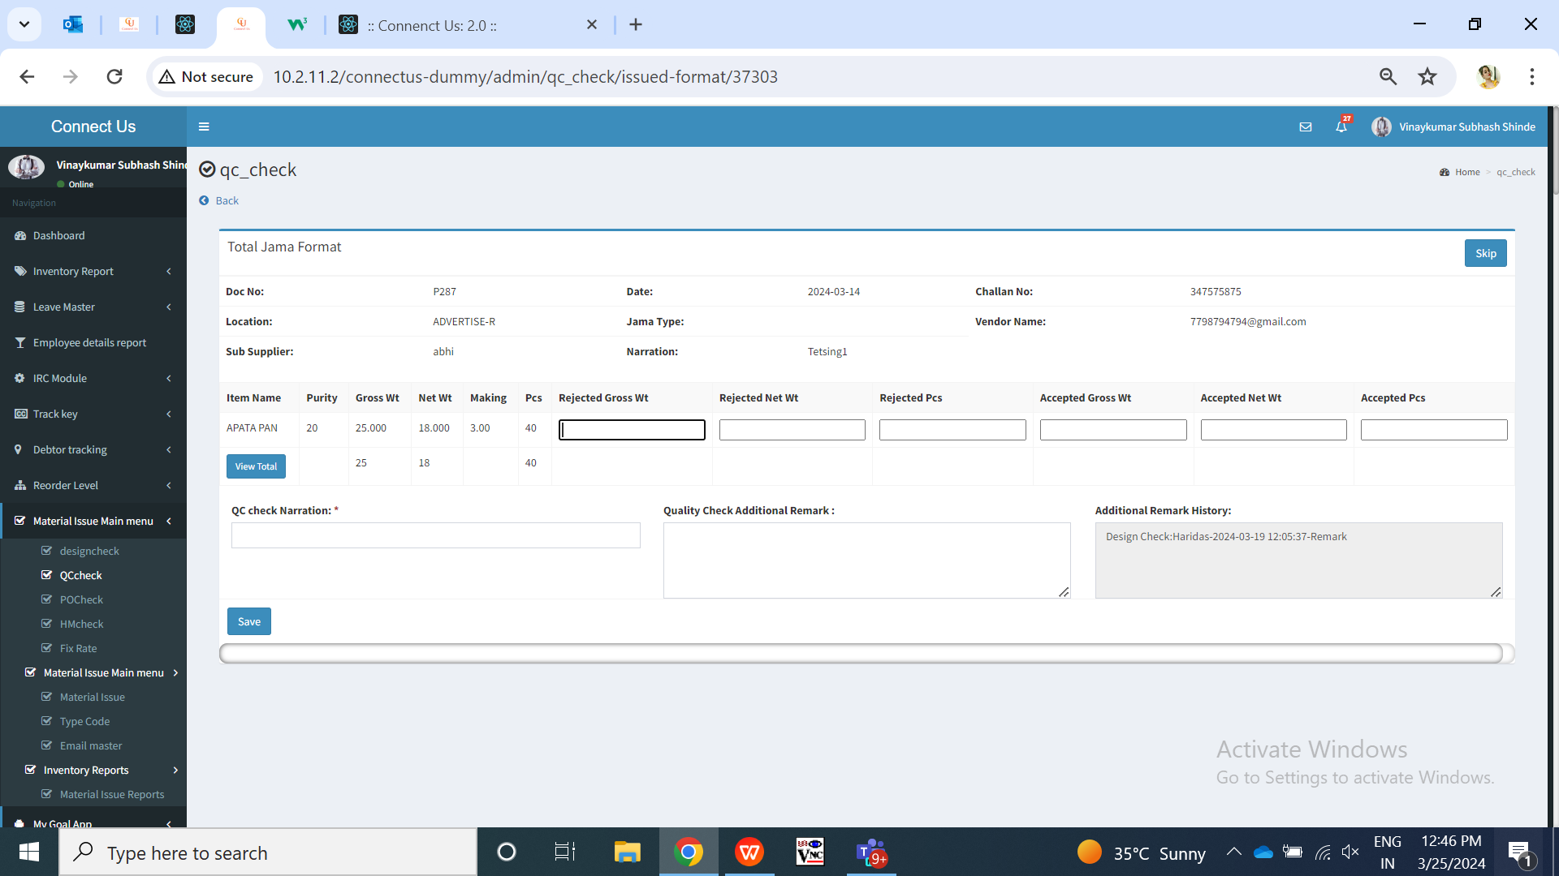

Fig: Qc check -> issued

|  |  |  |  |
| --- | --- | --- | --- |
| **FIELDS** | **INPUT TYPE** | **MANDATORY/ OPTIONAL** | **DESCRIPTION** |
| QC additional remark | Text | Optional | User will be able to mention additional remark here.  The added additional remark of quality check will be displayed in remark history field when document is saved here and gets displayed to further stages. Also, this added additional remark will be displayed in material issue reports -> quality check Additional remark of quality check report and all reports.  Validation: It should accepted characters, numbers, special characters and space.  Min length = 0  Max length = 250 |
| Additional Remarks History | Text | - | All the additional remarks which are entered in design check, quality check, PO check and hm check will be displayed here.  It should display Design check additional remark - username - date and time - mentioned additional remark.  If there is no additional remark in design check then, it will display NA in history for that stage.  Validation: It will be read only. |

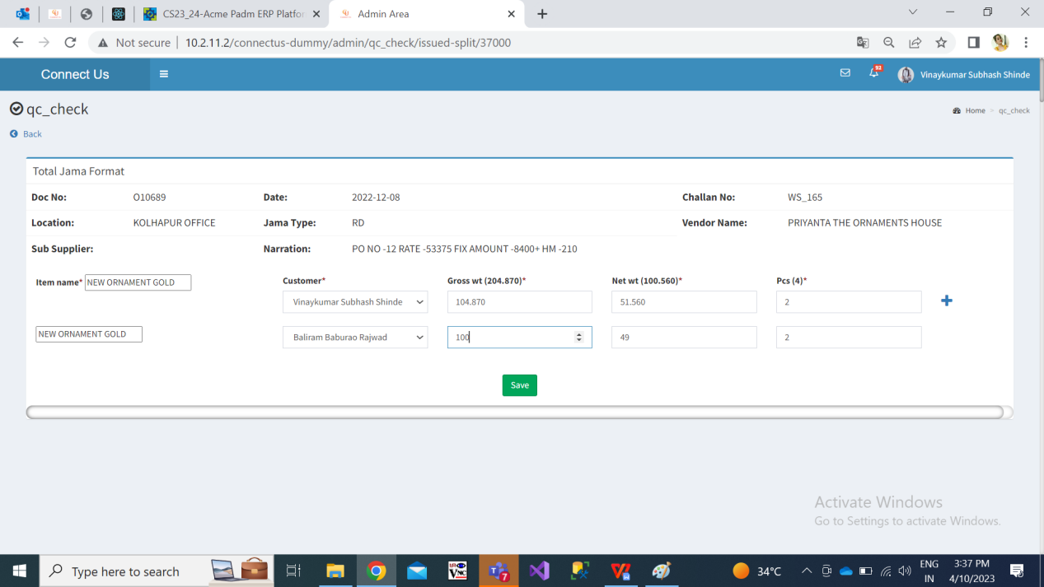

Fig: QC check -> split

Once QC employees checks the items and enters details of rejected gross wt, rejected net wt and rejected pcs , then the remaining accepted gross wt, accepted net wt, accepted pcs will be auto calculated and displayed.

Step 4. Only the accepted details of the items from qc check document will be computed together and will be forwarded to **POcheck process**.

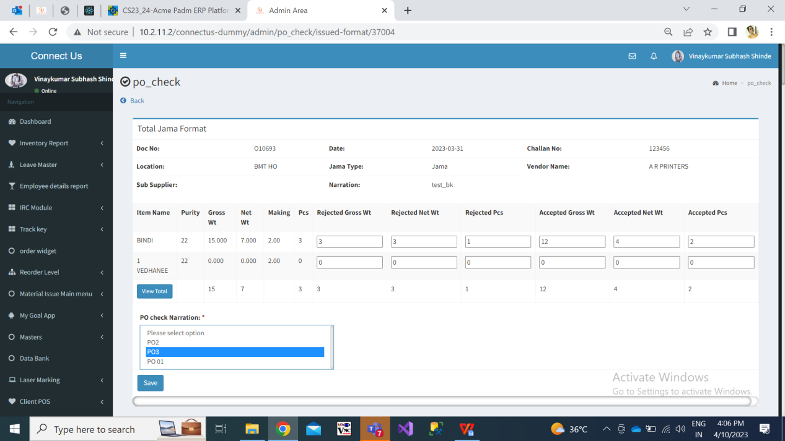

Fig: PO check -> grid

Once user clicks on issued action, it will display following fields:

* Doc no.
* Date
* Challan no.
* Location
* Jama type
* Vendor name
* Sub supplier
* Narration
* Item name
* Purity
* Gross wt
* Net wt
* Making
* Pcs
* Rejected gross wt
* Rejected net wt
* Rejected pcs
* Accepted gross wt
* Accepted net wt
* Accepted pcs
* View total
* Narration
* PO Additional Remark
* Additional Remarks History
* Attachment
* Save button
* Skip button

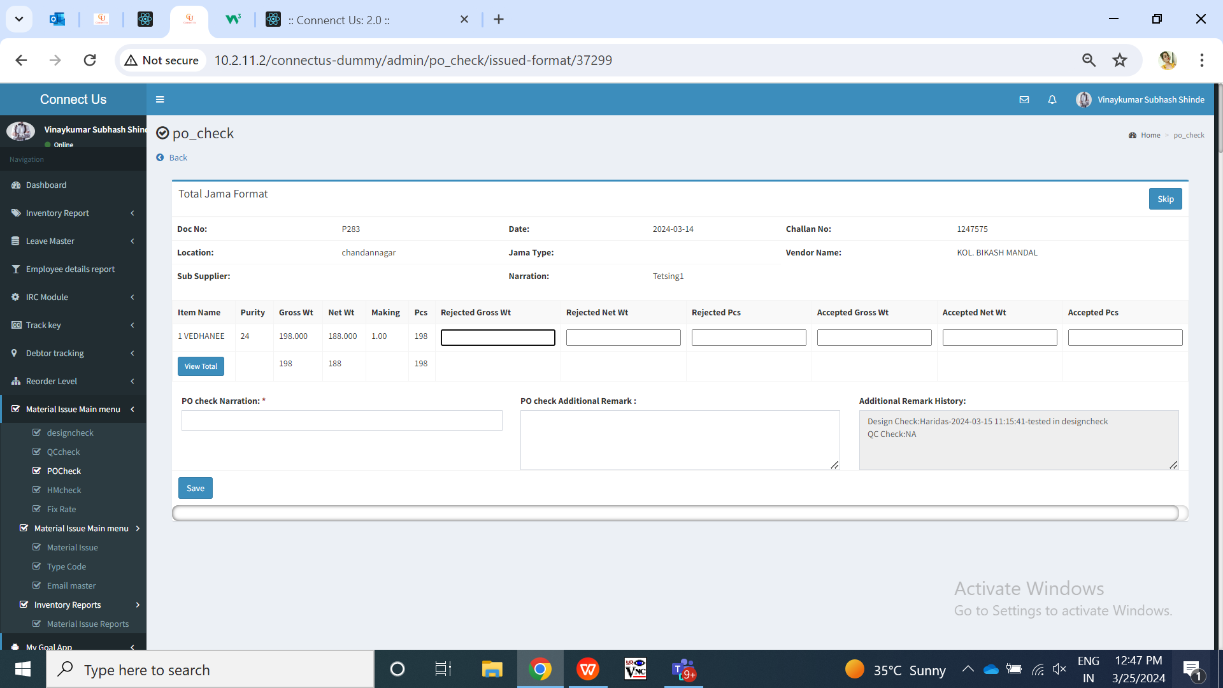

Fig: Po check -> issued

|  |  |  |  |
| --- | --- | --- | --- |
| **FIELDS** | **INPUT TYPE** | **MANDATORY/ OPTIONAL** | **DESCRIPTION** |
| PO additional remark | Text | Optional | User will be able to mention additional remark here.  The added additional remark of PO check will be displayed in remark history field when document is saved here and gets displayed to further stages. Also, this added additional remark will be displayed in material issue reports -> PO check Additional remark of PO check report and all reports.  Validation: It should accepted characters, numbers, special characters and space.  Min length = 0  Max length = 250 |
| Additional Remarks History | Text | - | All the additional remarks which are entered in design check, quality check, PO check and hm check will be displayed here.  It should display Design check additional remark - username - date and time - mentioned additional remark. Below that it will display QC additional remark - - username - date and time - mentioned additional remark.  If there is no additional remark previous two stage then it will display NA against it.  Validation: It will be read only. |

Step 5. Only the accepted details of the items in from PO check document will be computed together and will be forwarded to **HMcheck** process.

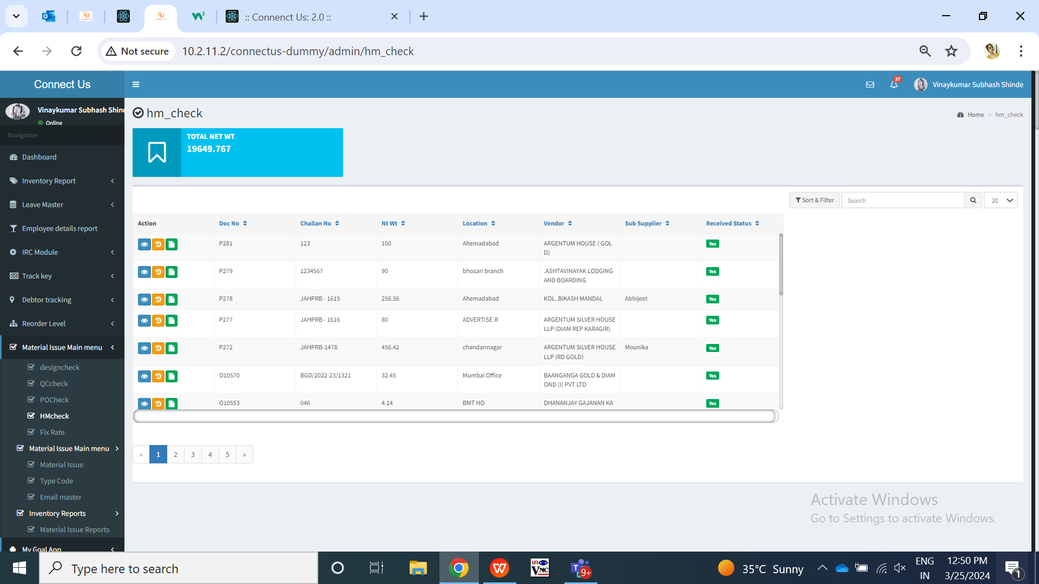

Fig: HM check -> grid

Once user clicks on issued action, it will display following fields:

* Doc no.
* Date
* Challan no.
* Location
* Jama type
* Vendor name
* Sub supplier
* Narration
* Item name
* Purity
* Gross wt
* Net wt
* Making
* Pcs
* Rejected gross wt
* Rejected net wt
* Rejected pcs
* Accepted gross wt
* Accepted net wt
* Accepted pcs
* View total
* Narration
* QC Additional Remark
* Additional Remarks History
* Attachment
* Save button
* Skip button

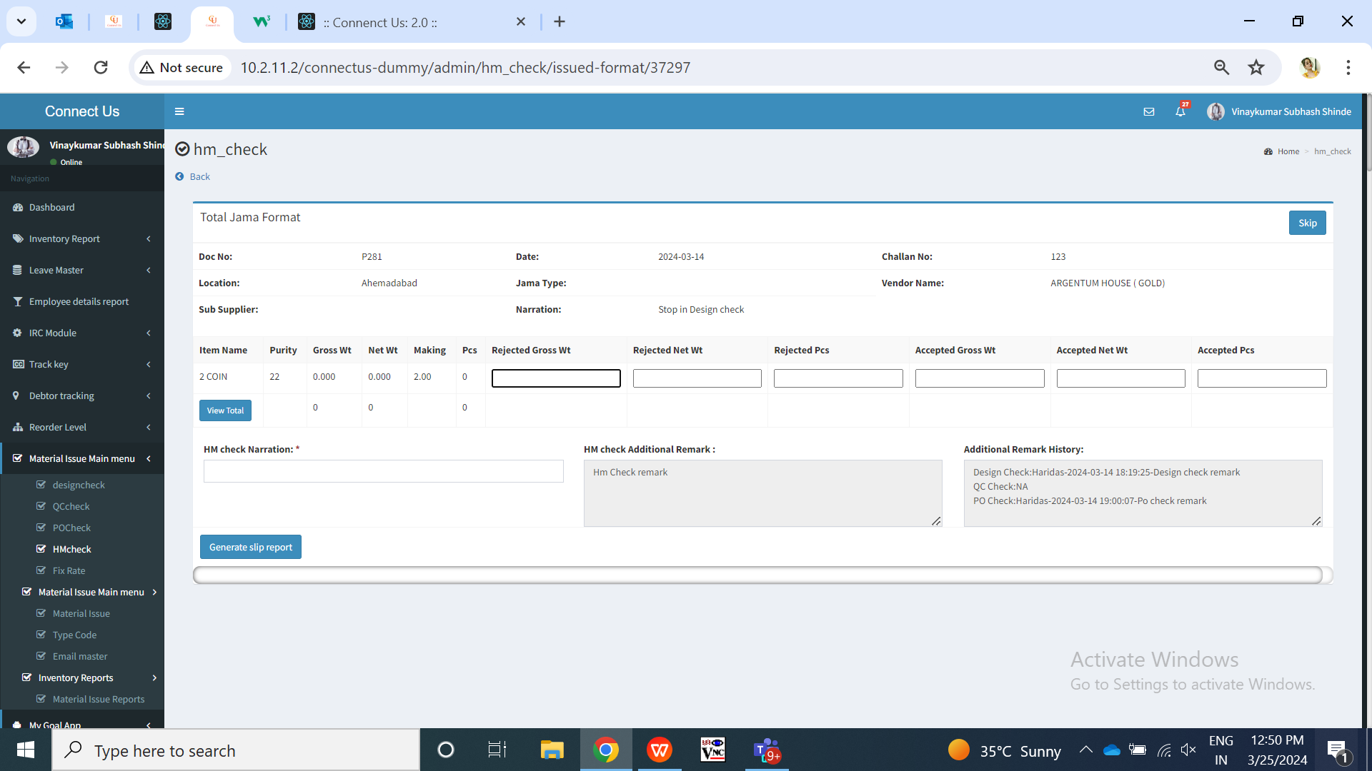

Fig: HM check -> issued

|  |  |  |  |
| --- | --- | --- | --- |
| **FIELDS** | **INPUT TYPE** | **MANDATORY/ OPTIONAL** | **DESCRIPTION** |
| HM additional remark | Text | Optional | User will be able to mention additional remark here.  The added additional remark of HM check will be displayed in remark history field when document is saved here and gets displayed to further stages. Also, this added additional remark will be displayed in material issue reports -> HM check Additional remark of HM check report and all reports.  Validation: It should accepted characters, numbers, special characters and space.  Min length = 0  Max length = 250 |
| Additional Remarks History | Text | - | All the additional remarks which are entered in design check, quality check, PO check and hm check will be displayed here.  It should display username - date and time - mentioned additional remark.  If there is no additional remark previous three stage then it will display NA against it.  Validation: It will be read only. |

Once user enters of rejected gross wt, net wt and pcs, it will displayed accepted gross wt, net wt and pcs. Once user clicks on view total button, it will display all the collated details of accepted & rejected gross wt, net wt and pcs in each process.

Step 6. All the collated details of accepted & rejected gross wt, net wt and pcs in each process will be sent to the vendor via Email after it was saved in HM check process.

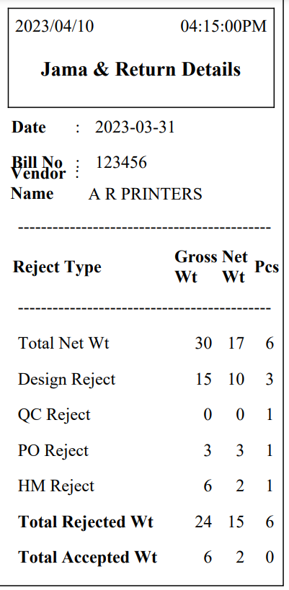

Fig: HM check -> generated slip

Step 9. Once user clicks on **Material issue reports**, it displays following fields:

* From Date
* To date
* Type wise reports
* User wise reports
* Type wise and user wise reports
* All reports
* Submit button
* Reset button

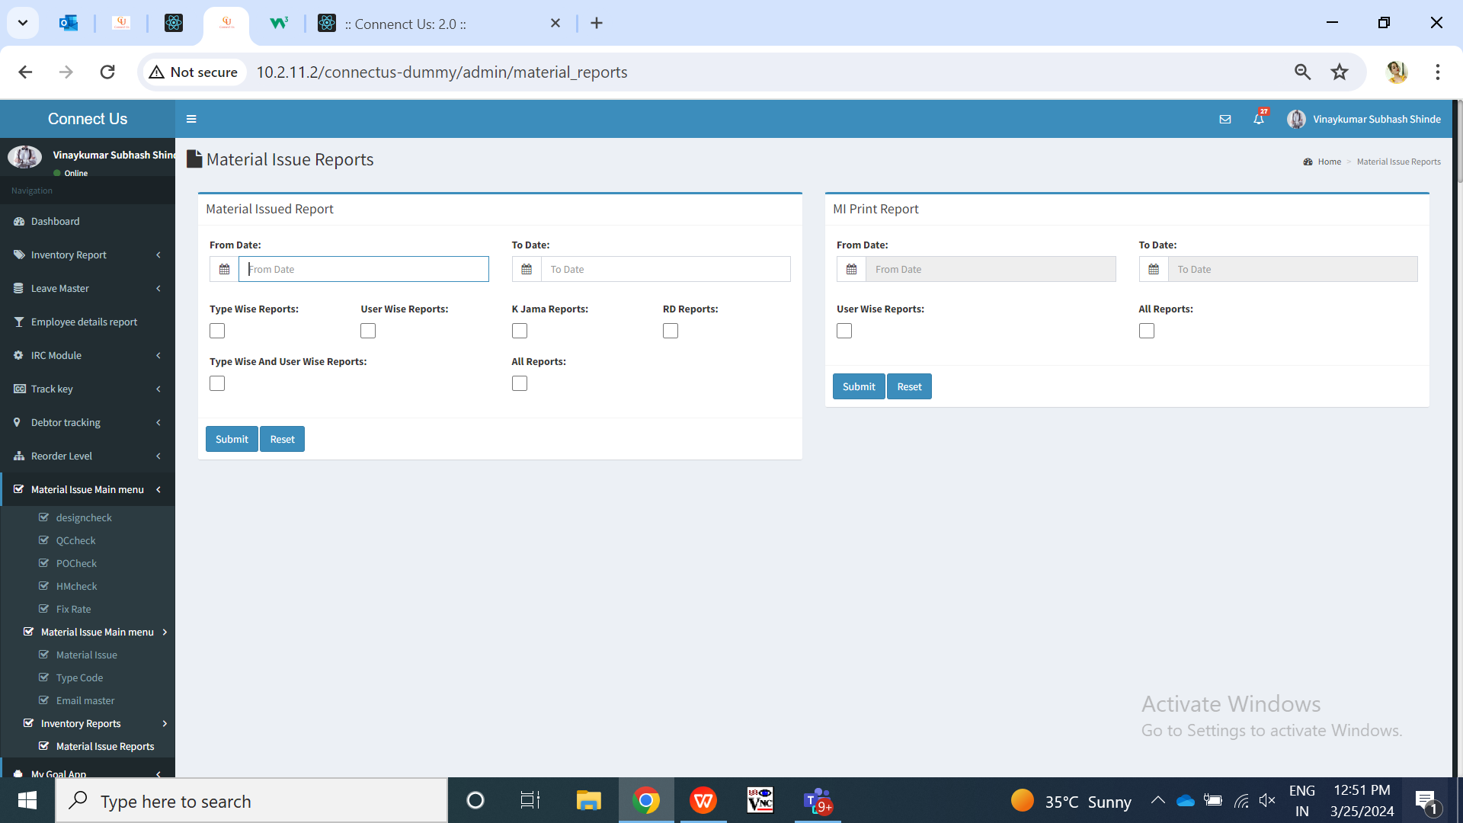

Fig: material issue reports

|  |  |  |  |  |
| --- | --- | --- | --- | --- |
| **FIELDS** | **INPUT TYPE** | **MANDATORY/ OPTIONAL** | **EDITABLE** | **DESCRIPTION** |
| From Date | Calender date picker | Mandatory | Yes | User will select the date from which the document was added in the material issue. (I.e. from issued date)  Validation: It will be single select and future dates are disabled. |
| To date | Calender date picker | Mandatory | Yes | User will select the date till which the document was added in the material issue. (I.e. till issued date)  Validation: It will be single select and future dates are disabled. |
| Type wise reports | Check box | Mandatory to select one report type | - | User can view the report by the checking type (Design check / qc check / po check / hm check). The report will display the fields of the selected type only.  Once user clicks on type wise report check-box, then report type drop-down will be displayed below which will be mandatory. It will be single select.  If user selects type wise report and any one type (design check / qc check / hm check / po check) and clicks on submit button, it will display the documents which are issued I.e. added between the selected filters dates and the details of that document related to design process. Report will display following fields in the grid and export:   * Sr. No. * Issued date * User name * Doc no. * Karagir name * Sub supplier name * Is RD purchase? * Location * Narration * Received status * Current status * Issued date and time * Received date and timing * Time difference * Item * Category * Purity * Making * Pcs * Gross wt * Net wt * Gross wt Rejected * Net wt rejected * Pcs rejected * Gross wt accepted * Net wt accepted * Pcs accepted * Total pcs * Total gross wt * Total net wt * Design check additional remark if user has selected design check report / QC additional remark if user has selected QC report / PO additional remark if user has selected PO report / HM additional remark if user has selected HM report. * Add to received status   It will display the accepted and rejected details here based on the type selected.  If there is no additional remark in any of the stage then it will display NA against it. |
| User wise reports | Check box | Mandatory to select one report type | - | User can view the documents in the report of specific vendor only by clicking here to know which user has done checking in which stage.  Once user click on ‘user wise report’ then users drop-down will be displayed where user will select the vendor for which the data is to be displayed. It will be single select.  As per selected vendor name, it will display the documents in the grid of the selected vendor only.  If user checks user wise report check-box and selects one of the vendor name in the users field, it will display following columns in the report:   * Sr. No. * Issued date * User name * Doc no. * Karagir name * Sub supplier name * Is RD purchase? * Location * Narration * Received status * Current status * Issued date and time * Received date and timing * Time difference * Item * Category * Purity * Making * Pcs * Gross wt * Net wt * Design user * QC user * PO user * HM user * Add to received status * Received status to design check update * Design check update to QC check update * QC check update to PO check update * PO check update to print * Print to HM check update * Time difference start to end process |
| Type wise User wise report | Check box | Mandatory to select one report type | - | User can view documents by specific checking type and vendor.  Once user clicks on type wise user report then report type and user drop-down will be displayed. Both will be single select each. It will display following columns in grid:   * Sr. No. * Issued date * User name * Doc no. * Karagir name * Sub supplier name * Is RD purchase? * Location * Narration * Received status * Current status * Issued date and time * Received date and timing * Time difference * Item * Category * Purity * Making * Pcs * Gross wt * Net wt * Gross wt Rejected * Net wt rejected * Pcs rejected * Gross wt accepted * Net wt accepted * Pcs accepted * Narration * Design check additional remark if user has selected design check report / QC additional remark if user has selected QC report / PO additional remark if user has selected PO report / HM additional remark if user has selected HM report. * Add to received status * Received status to design check , etc. - Here it will display the columns based on the checking type selected.   If there is no additional remark in any of the stage then it will display NA against it. |
| All reports | Check box | Mandatory to select one report type | - | Once user selects all reports, all details of each document will be displayed which were issued within selected dates in filter.  It will display following columns in the grid:   * Sr. No. * Date * Doc no. * Material created by * Material accepted by * Karagir name * Sub supplier name * Is rd purchase * Location * Narration * Received status * Current status * Issued date and time * Received date and timing * Time difference * Item * Category * Purity * Making * Pcs * Gross wt * Net wt * Design Gross wt Rejected * Design Net wt rejected * Design Pcs rejected * Design Gross wt accepted * Design Net wt accepted * Design Pcs accepted * Design narration * Design Additional Remarks * QC Gross wt Rejected * QC Net wt rejected * QC Pcs rejected * QC Gross wt accepted * QC Net wt accepted * QC Pcs accepted * Qc narration * QC additional remark * PO Gross wt Rejected * PO Net wt rejected * PO Pcs rejected * PO Gross wt accepted * PO Net wt accepted * PO Pcs accepted * PO narration * PO Additional remark * HM Gross wt Rejected * HM Net wt rejected * HM Pcs rejected * HM Gross wt accepted * HM Net wt accepted * HM Pcs accepted * HM narration * HM additional remark * Black bits * Stone wt * Stone amt * Other charges * Extra stone wt * Hallmark tunch * Hallmark pcs * Add to received status * Received status to design check update * Design check update to QC check update * QC check update to PO check update * PO check update to print * Print to HM check update * Time difference start to end process   If there is no additional remark in any of the stage then it will display NA against it. |
| Submit | Click | - | - | Once user selects dates, report type and clicks on submit button, expected report will be displayed in the gird.  In case, user doesn’t select mandatory fields in filter and clicks on submit button, then error message will be displayed. |

Once user clicks on export button, csv file will get downloaded displaying all the columns in it as in grid with the documents.

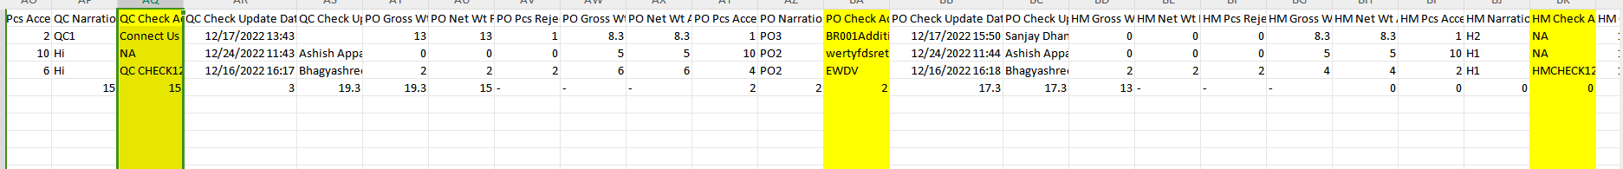

Fig: Material issue all reports -> export

1. **REFERENCES OF THE USERS**

|  |  |  |  |
| --- | --- | --- | --- |
| **User** | **Name** | **Mail** | **Contact number** |
| **Actual user** | Rakesh Thikane | isa@csjewellers.com |  |
| **Ticket created by (if any)** | Rakesh thikane | isa@csjewellers.com |  |
| **Assigned business analyst** | Manali Bhadirage | Manali.bhadirage@techneai.com |  |
| **Assigned developer** | Punam Shinde | Punam.shinde@techneai.com |  |
| **Assigned tester** | Amruta Kore | intern@techneai.com |  |