

**Functional Design Document – Withholding Tax TDS/TCS**

STATUS: Version 1.0

Project

**D365 Implementation**

Prepared by

**Harsh Vaid**

Contributors

TDS/TCS Configuration

Table of Contents

2 Setup TDS/TCS Parameter 2

3 End-to-End process transaction flow 3

4 Configuration 4

4.1 Step-1: Create Withholding authority 4

4.2 Step-2: Create a Withholding settlement period 4

4.3 Step-3: Create Withholding component group and component code (TDS/TCS) 5

4.4 Step-4: Withholding tax Threshold definition 6

4.5 Step-5: Create Withholding tax code and “Rate” 7

4.6 Step-6: Create Withholding tax group and Map to designer 9

4.7 Step-7: Map TAN number for all the addresses which will be used in Transaction posting **Error! Bookmark not defined.**

4.8 Step-8: TDS group, PAN, and TAN information set up for vendors and customers 12

5 Withholding Tax Transactions 14

6 Withholding Tax Reports 15

6.1 Posted withholding tax report 16

6.2 TDS/TCS Enquiry report 16

6.3 Withholding tax transactions report 17

# Revision History

|  |  |  |  |
| --- | --- | --- | --- |
| **Date** | **Editor** | **Section** | **Revision Notes** |
|  |  |  |  |

# Gap List

|  |  |  |  |
| --- | --- | --- | --- |
| **Reference Number** | **Description** | **MoSCoW** | **Gap/Fit** |
|  |  |  |  |

# Setup TDS/TCS Parameter

1. Go to **General ledger > Ledger setup > General ledger parameters**.
2. On the **Direct taxes** tab, in the **Tax Deducted at Source** section, set the **Activate TDS** option to **Yes** to activate the TDS functionality and the pages and fields that are used for it.
3. Set the **Invoice** option to **Yes** to activate the fields that are used to calculate and deduct TDS at the invoice level.
4. Set the **Payment** option to **Yes** to activate the fields that are used to calculate and deduct TDS at the payment level.

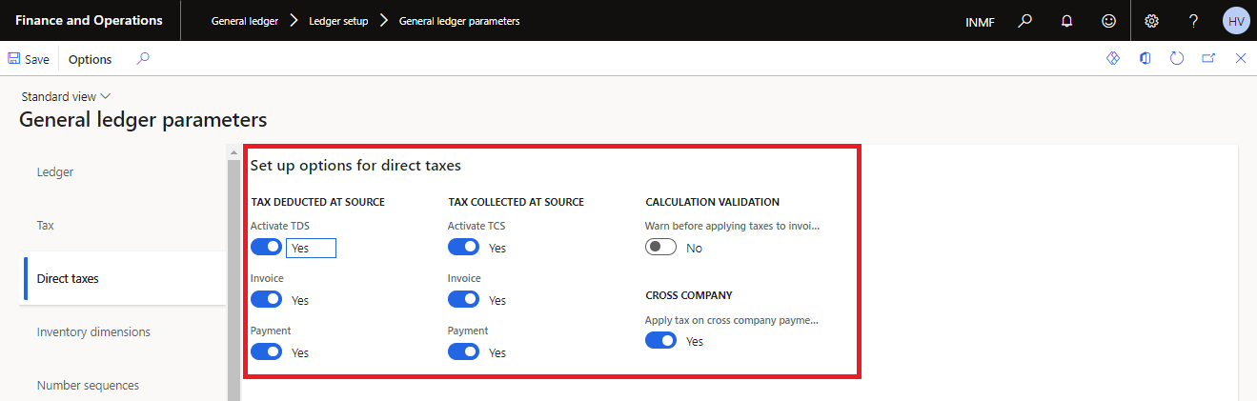

1. On the **Number sequences** tab, find the row where the **Reference** field is set to **Withholding tax payment**. In the **Number sequence code** field for the row, select the number sequence code. The number sequence code is used to generate voucher numbers for the periodic TDS settlement process.  
   **Note: -** To run the periodic TDS settlement process, go to **Tax > Declarations > Withholding tax > Withholding tax payment**.

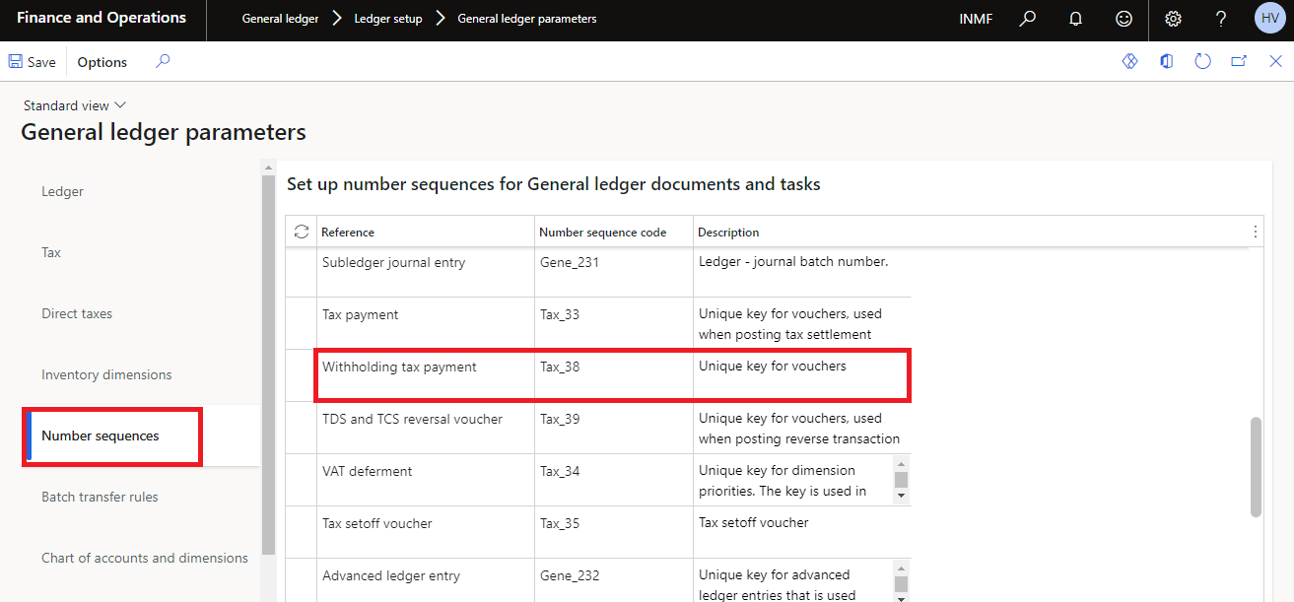

# End-to-End process transaction flow

1. **All TDS payable transactions in the system with the following expected entry**  
   Vendor Debit  
   To TDS Payable Credit
2. **Once process withholding payments process/settlements**  
   TDS Payable Debit  
   To Vendor (Withholding authority) Credit
3. **Payment Process with challan details**  
   Vendor (Withholding authority) Debit  
   To Bank Credit

# Configuration

## Create Withholding Tax Authority

1. Go to **Tax > Indirect taxes > Withholding tax authorities**.
2. In the **Tax type** field, select **TDS or TCS** to set up withholding tax authorities for the TDS tax type.
3. On the Action Pane, select **New** to create a line.
4. In the **Withholding tax authority** field, enter a name for the TDS authority.
5. In the **Description** field, enter a description.
6. On the **General** FastTab, in the **Vendor account** field, select the vendor account for the TDS authority.

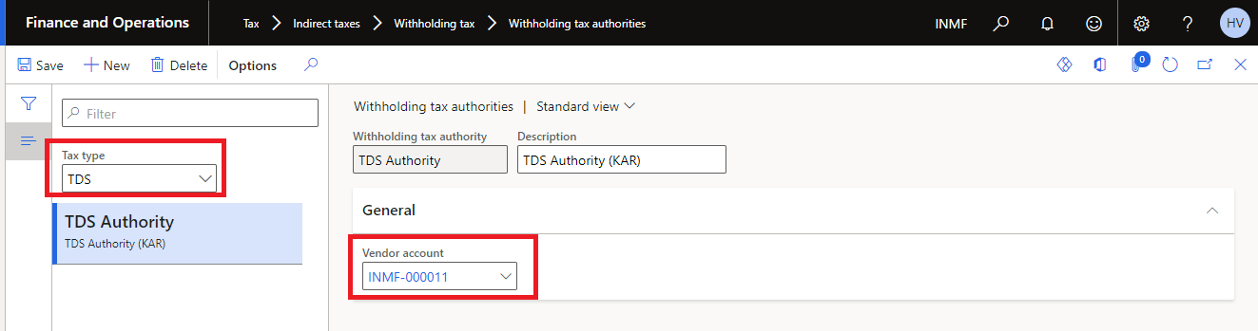

**Note: -** You must define the name of the bank where funds that are owed to the TDS authority vendor will be deposited. The bank's name is defined on the **Bank accounts** page (**Accounts payable > All vendors > Vendor > Set up > Bank accounts**).

1. Close the page.

## Create a Withholding Settlement Period

1. Go to **Tax > Indirect taxes > Withholding tax > Withholding tax settlement periods**.
2. In the **Tax type** field, select **TDS or TCS** to set up withholding tax settlement periods for the TDS tax type.

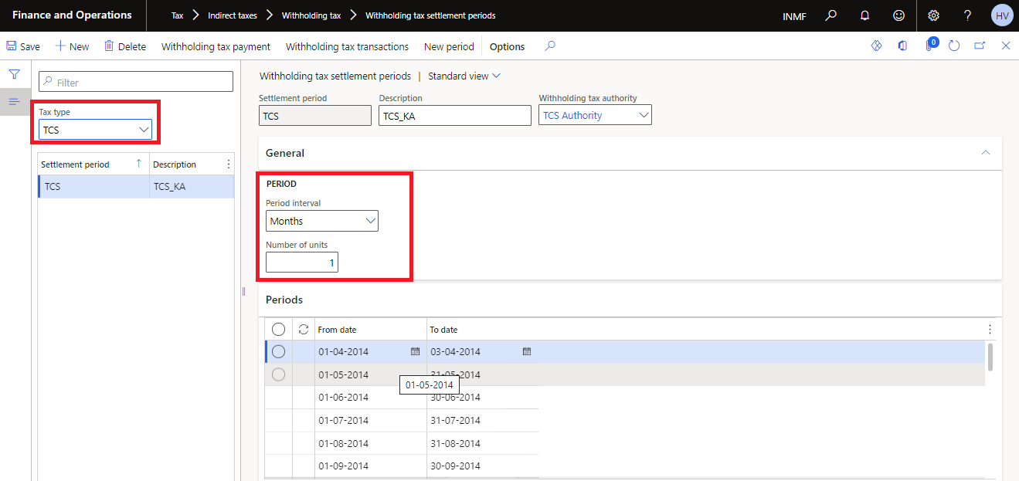

1. Select **New** to create a line.
2. In the **Settlement period** field, enter a name for the TDS settlement period.
3. In the **Description** field, enter a description.
4. In the **Withholding tax authority** field, select the TDS authority that you're defining the TDS settlement period for.
5. On the **General** FastTab, in the **Period interval** field, select the type of period interval for the TDS settlement period.
6. In the **Number of units** field, specify the number of units for the period interval type.
7. On the **Periods** FastTab, in the **from date** field, select the start date for the TDS settlement period. In the **To date** field, select the end date.
8. To create a subsequent TDS settlement period for an existing period, based on the period interval and period units, select **new period**.
9. To view the details of the periodic TDS settlement that is run for a specific settlement period, select **Withholding tax payments** to open the **Withholding tax payment** page.

Note To run the periodic TDS settlement process, go to **General ledger > Periodic > Withholding tax > Withholding tax payment**.

1. Close the page.

## Create Withholding Tax Component Group and Component Code (TDS/TCS)

1. Go to **Tax > Setup > Withholding tax > Withholding tax components**.
2. In the **Tax type** field, select **TDS** to set up withholding tax components for the TDS tax type.
3. On the Action Pane, select **New** to create a line.

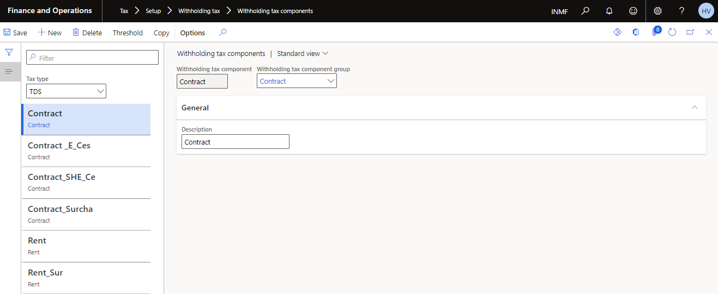

1. In the **Withholding tax component** field, enter a name for the TDS component.
2. In the **Withholding tax component group** field, select the TDS withholding tax component group to attach the TDS component to.
3. On the **General** FastTab, in the **Description** field, enter a description of the TDS component.
4. Close the page.

## Withholding Tax Threshold Definition

1. Go to **Tax > Setup > Withholding tax > Threshold definitions**.
2. On the Action Pane, select **New** to create a line.

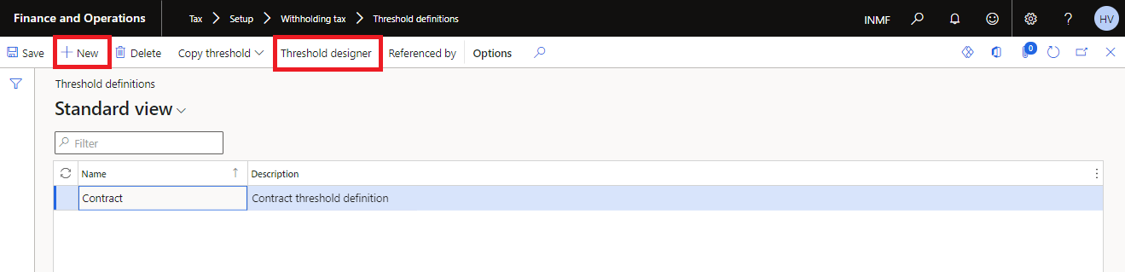

1. In the **Name** field, enter a name for the TDS Section.
2. In the **Description** field, enter a description.
3. On the **Action** Pane, select **Threshold designer**. to open the **Threshold** page, so that you can define the threshold that is used to calculate TDS for the TDS component.

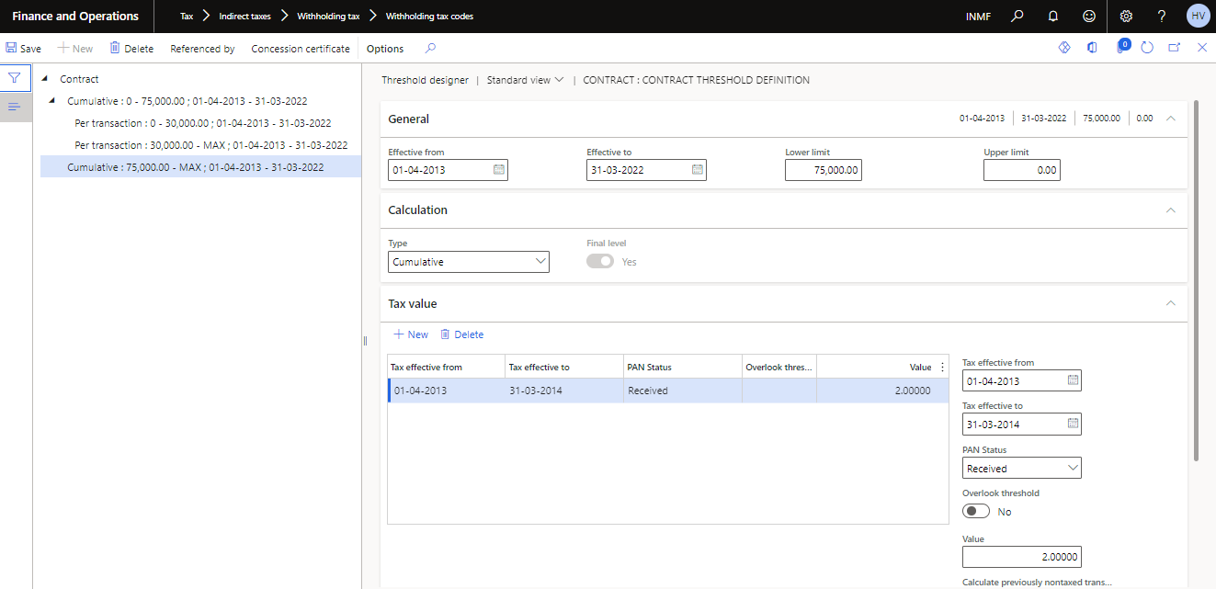

1. Use the **From date** and **To date** fields to define the period that the threshold is applicable to.
2. On the **General** FastTab, in the **Threshold** field, enter the threshold amount that is used to calculate TDS for the TDS component. The tax will be deducted at the source only when the cumulative invoice amount crosses the threshold.

For example, if the threshold amount is 10,000, TDS is calculated after the cumulative invoice amount exceeds 10,000 (in other words, when it's 10,001 or more).

1. In the **Exception threshold** field, enter the exception threshold amount that is used to calculate TDS for the TDS component. The tax on an invoice line will be deducted at the source only when the amount crosses the exception threshold.

For example, if the exception threshold amount is 5,000, TDS is calculated on a specific invoice line if the invoice line amount exceeds 5,000 (in other words, if it's 5,001 or more).

## Create Withholding Tax Code and “Rate”

1. Go to **Tax > Indirect taxes > Withholding tax > Withholding tax codes**.
2. On the Action Pane, select **New** to create a withholding tax code for TDS, and enter the required details.
3. On the **General** FastTab, in the **Tax type** field, select **TDS** to categorize the tax code as a TDS tax code.
4. In the **Settlement period** field, select the TDS settlement period for the TDS tax code.
5. In the **Main account** field, select the ledger account that the TDS amount should be posted to.
6. In the **Receivable account** field, select the receivable account that the TDS amount that is deducted in sales transactions should be posted to.

The **Origin** field is automatically set to **Percentage of the gross amount**, and the value can't be changed.

**Note: -** You can't set the origin to **Percentage of net amount** for tax codes of the TDS tax type.

1. In the **Withholding tax component** field, select the TDS tax component for the TDS tax code.
2. On the Action Pane, select **Values** to open the **Withholding tax values** page.
3. In the **From date** field, enter the start date for the TDS value. In the **To date** field, enter the end date.

**Note: -** The **Minimum limit**, **Upper limit**, and **Exclude %** fields aren't available for tax codes of the TDS tax type.

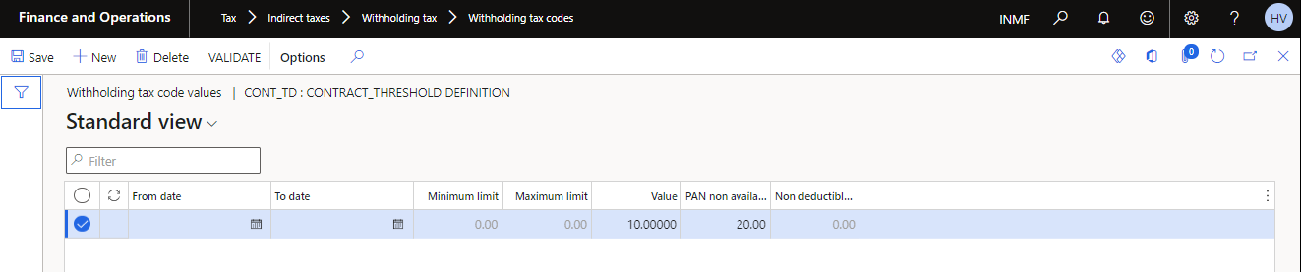

1. In the **Value** field, enter the percentage of TDS for the TDS tax code.
2. Close the **Withholding tax values** page to return to the **Withholding tax codes** page.

**Note: -** The **Limits** button on the **Withholding tax codes** page isn't available for tax codes of the TDS tax type.

1. On the Action Pane, select **Threshold reference** to open the **threshold definition and designer** page.

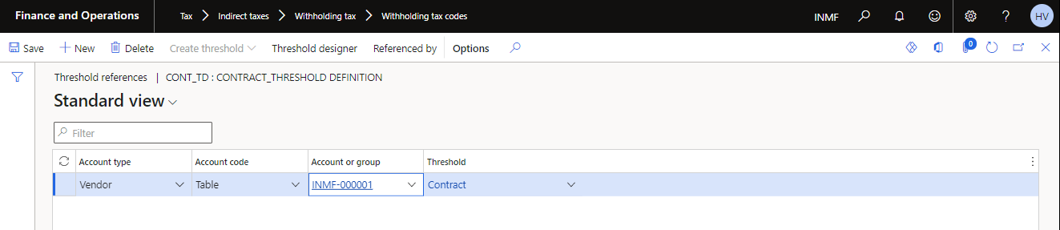

1. Define the matrix of customer/vendor/All for which the threshold is applicable
2. Select Threshold designer to review or modify the threshold designer.

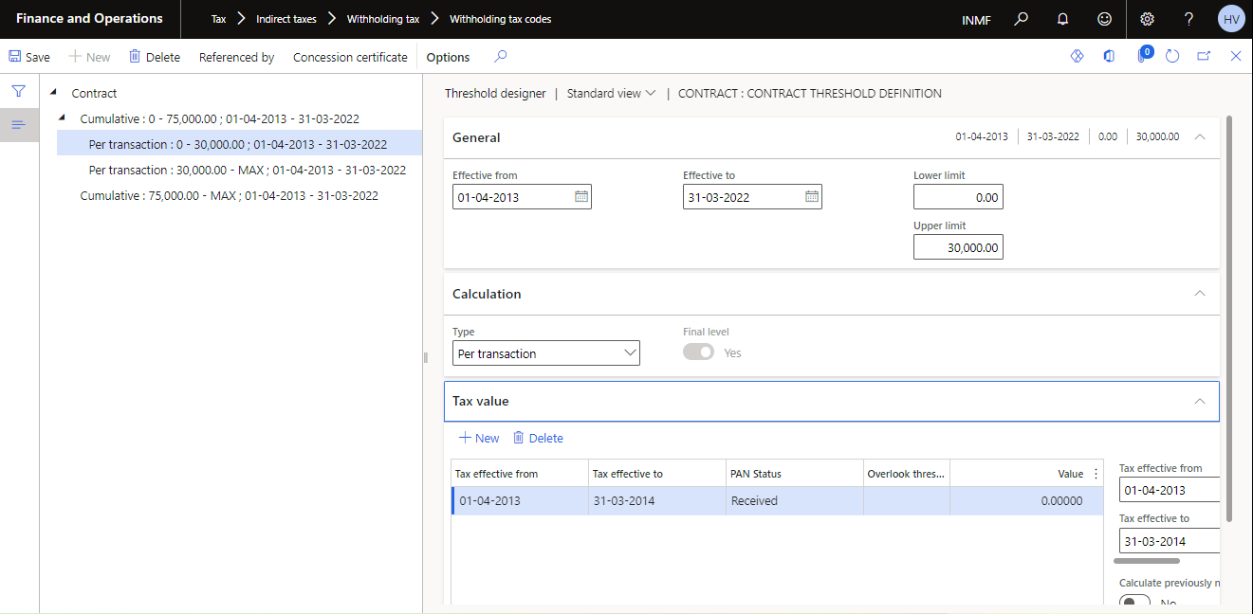

1. Close the page.

## Create Withholding Tax Group and Map to Designer

1. Go to **Tax > Indirect taxes > Withholding tax > Withholding tax groups**.
2. On the Action Pane, select **New** to create a withholding tax group for TDS, and enter the required details.

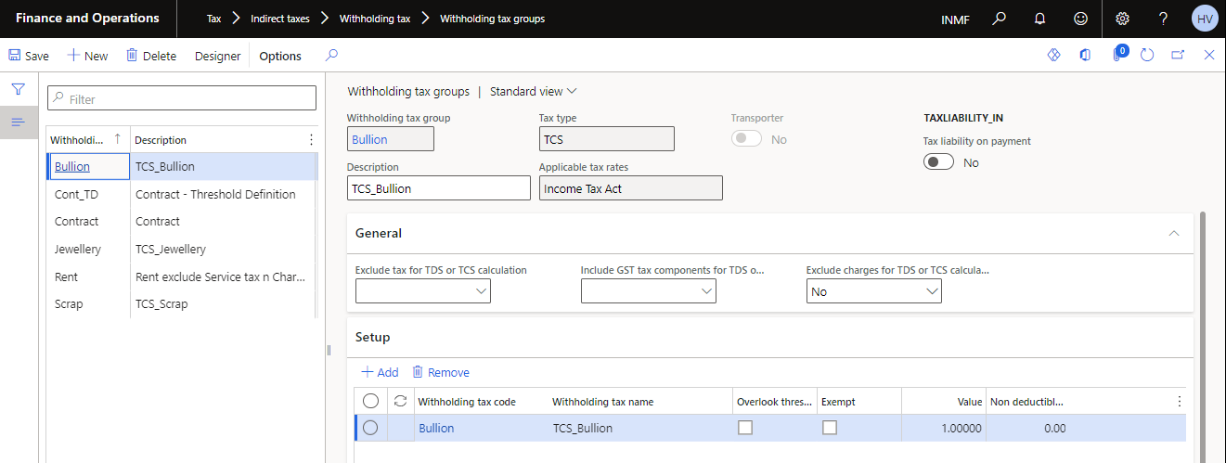

1. In the **Tax type** field, select **TDS**.
2. On the **Setup** FastTab, select **Add** to create a line.
3. In the **Withholding tax code** field, select the TDS tax code for the TDS tax group. The **Withholding tax name** field shows the name of the TDS tax code, and the **Value** field shows the value.
4. To ignore the threshold limit and exception threshold limit that are defined for the TDS tax component that is attached to the TDS tax code in TDS transactions, select the **Overlook threshold** check box.
5. To prevent the tax group from being calculated in transactions, select the **Exempt** check box.
6. On the Action Pane, select **Designer** to open the formula designer, so that you can define the formula for calculating TDS for the TDS tax group. On the **Designer** page, the **Taxes** tab shows the TDS tax codes that have been selected for the TDS tax group.

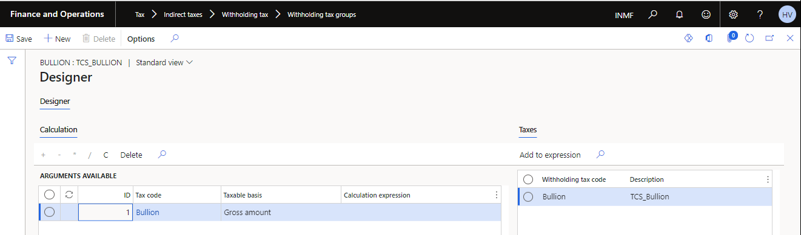

1. On the **Calculation** tab, select **Alt+N** to create a line. The **ID** field shows the automatically generated priority ID for TDS calculation.
2. In the **Tax code** field, select the TDS tax code to define the formula. All the TDS tax codes that have been selected for the TDS tax group are available for selection in this field.
3. In the **Taxable basis** field, select the basis for calculating TDS:
   * **Gross amount** – Calculate TDS based on the gross transaction amount (that is, the invoice amount) by using the calculation expression that is defined for the tax code.
   * **Excl Gross amount** – Calculate TDS based on the calculation expression that is defined for the tax code.  
     **Note: -** The **Taxable basis** field can't be set to **Excl Gross amount** for the TDS tax code that has a priority ID of **1**.
4. The TDS calculation is based on the formula that is defined in the **Calculation expression** field for each tax code that is attached to the TDS tax group. Select the plus sign (+), minus sign (-), multiplication sign (*), or division sign (/) button to enter the calculation expression for the selected TDS tax code in the **Calculation expression** field.

**Note: -** No calculation expression can be defined for the TDS tax code that has a priority ID of **1**.

1. To define the calculation expression for the TDS tax code in the **Calculation expression** field, add TDS tax codes that are available on the **Taxes** tab. To add TDS tax codes in the **Calculation expression** field, you can use any of the following methods:
   * Drag the required tax code from the **Taxes** tab to the **Calculation expression** field.
   * Double tap (or double-click) the required tax code on the **Taxes** tab.
   * Select and hold (or right-click) the required tax code on the **Taxes** tab, and then select **Add tax code**.

**Note: -** Insert a calculation expression before each TDS tax code. The TDS tax codes that have been added to the calculation expression appear in brackets ([...]).

1. To clear the calculation expression that is defined for a tax code in the **Calculation expression** field, select the **C** button.
2. To delete a record on the **Calculation** tab, select **Delete**.
3. Close the page.

## TAN NUMBER MAPPING on Legal Entity and Site Address

This must be done in legal entity addresses and site/warehouse address > Tax information

1. Navigate to **Organization administration** > **Organisations** > **Legal Entities.**
2. Under the **Address** tab, select **More options** > **Advanced.**

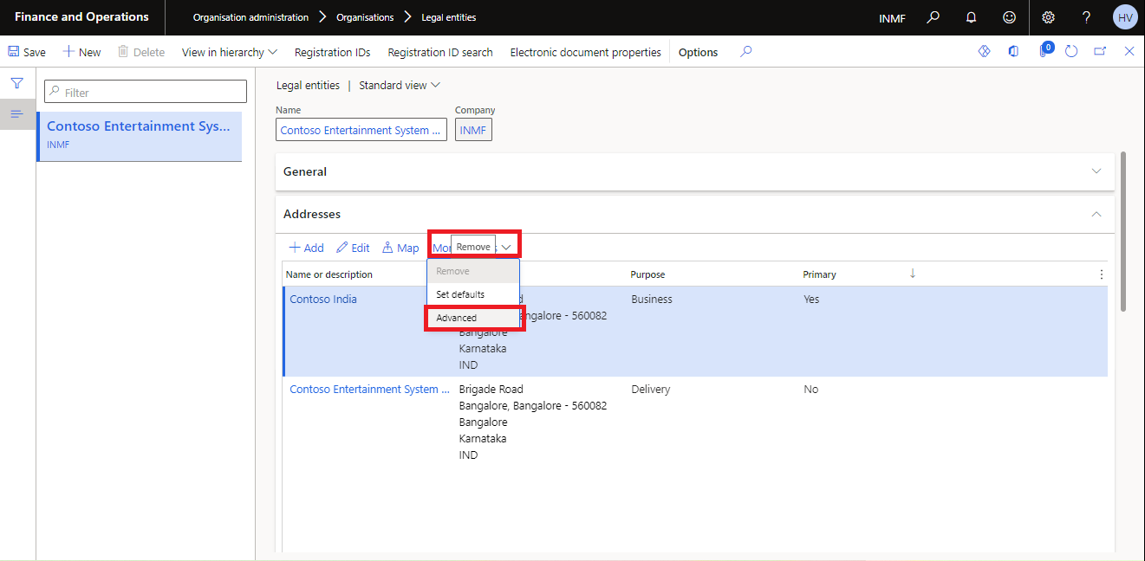

1. Under **Tax Information** tab > Select **New** or **Edit**

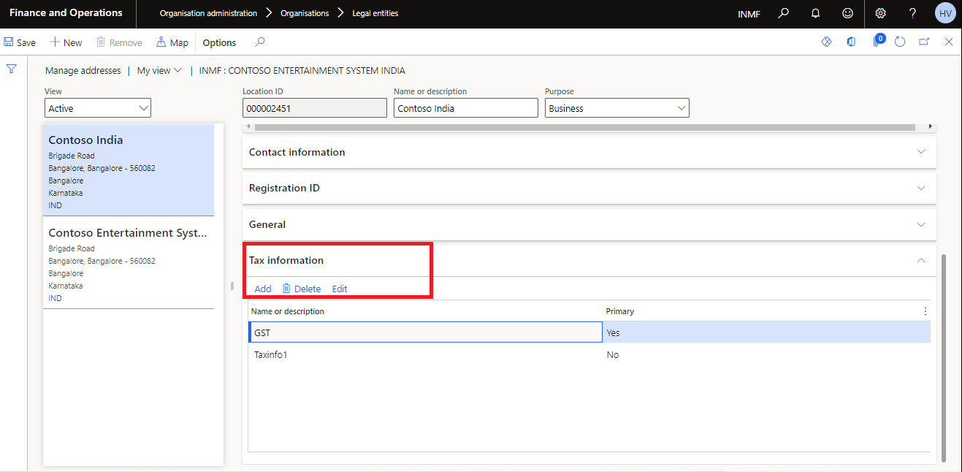

1. Ensure GSTIN and TAN number is defined for all the legal entity addresses.

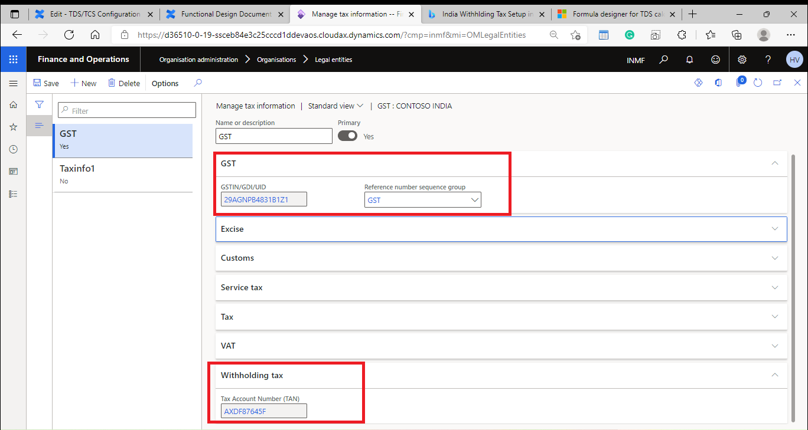

## TDS Group, PAN, and TAN Information Set Up on Vendors and Customers

1. Go to **Accounts payable > Vendors > All vendors** or **Accounts receivable > Customers > All customers**.
2. On the Action Pane, select **New** to create a vendor or customer, and enter the required details. Alternatively, select an existing vendor or customer.
3. On the **Invoice and delivery** FastTab, in the **Withholding tax** section, set the **Calculate withholding tax** option to **Yes** to calculate withholding tax, TDS, or Tax Collected at Source (TCS) for the vendor or customer.
4. TDS for a purchase invoice is calculated based on the default TDS group that is defined for the vendor or customer. In the **TDS group** field, select the default TDS group.

**Note: -** When you select a TDS group in the **TDS group** field, the **Withholding tax group** and **TCS group** fields become unavailable.

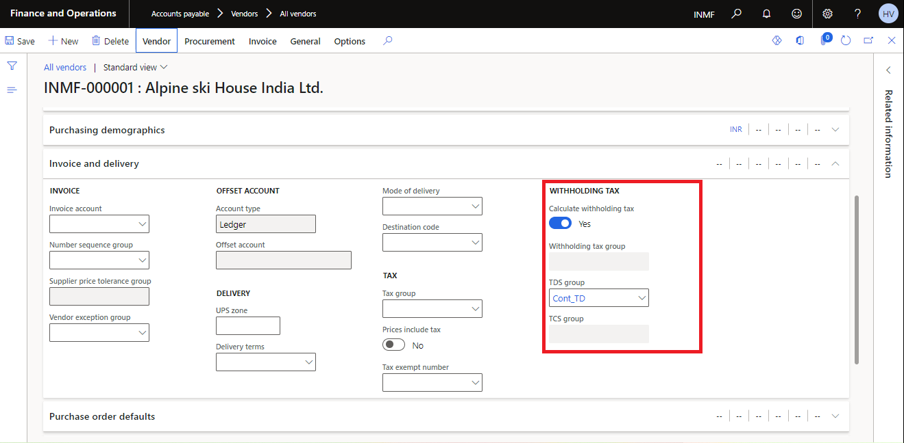

1. On the **Tax information** FastTab, in the **PAN information** section, in the **Status** field, select the status of the permanent account number for the vendor or customer:
   * **Not available** – The vendor or customer doesn't have a PAN.

**Received** – The vendor or customer has a PAN.

**Applied** – The vendor or customer has applied for a PAN.

**Invalid** – The vendor or customer has a PAN, but it isn't valid.

1. If you selected **Received** in the **Status** field to indicate that the vendor or customer has a PAN, enter the PAN in the **Number** field. The PAN must consist of five alphabetic characters, then four numeric characters, and then one alphabetic character. Here is an example: **ABCDE1260A**.
2. If you selected **Applied** in the **Status** field to indicate that the vendor or customer has applied for PAN, enter the reference number in the **Reference number** field.
3. In the **Nature of assessee** field, select the nature of the assessee category that the vendor or customer belongs to:
   * Company
   * HUF
   * Firm
   * Individual
   * AOP
   * BOI
   * Local authority
   * Others
4. On the Action Pane, on the **Vendor** tab, in the **Registration** group, select **Registration IDs** to open the **Manage addresses** page.
5. On the **Manage addresses** page, on the **Tax information** FastTab, select **Add** or **Edit** to open the **Manage tax information** page, where you can maintain the tax registration entry.
6. On the **Manage tax information** page, on the **Withholding tax** FastTab, in the **Tax Account Number (TAN)** field, enter the TAN. The TAN must consist of four alphabetic characters, then five numeric characters, and then one alphabetic character. Here is an example: **AFGH54821T**.

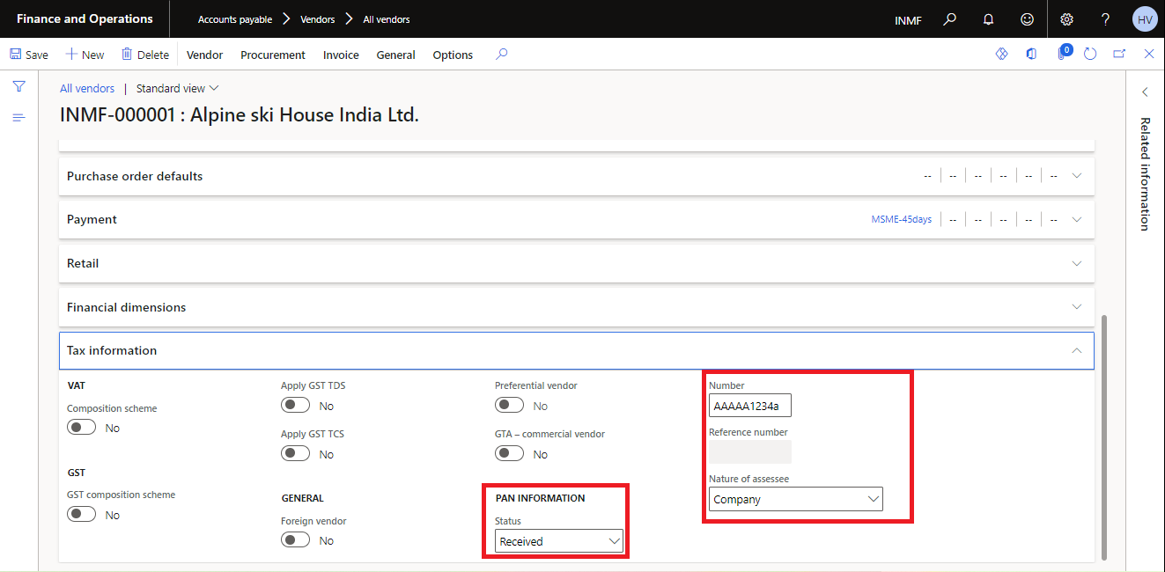

1. Close the page.

***Note:*** This is a mandatory step. If calculate withholding tax Boolean is not marked, the system will not deduct any TDS/TCS on any transaction even if the user selects TDS/TCS code on the invoice/payment transaction.

# Withholding Tax Transactions

**Invoice Journal** - Create the Invoice Journal Entry; select the vendor code, amount in credit, Invoice number, invoice date, TDS group and debit expense GL.

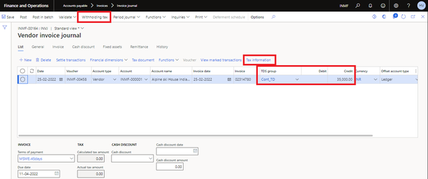

**Vendor Invoice Journal Tax Information** - Click on Tax Information on the Vendor Invoice Journal Line.

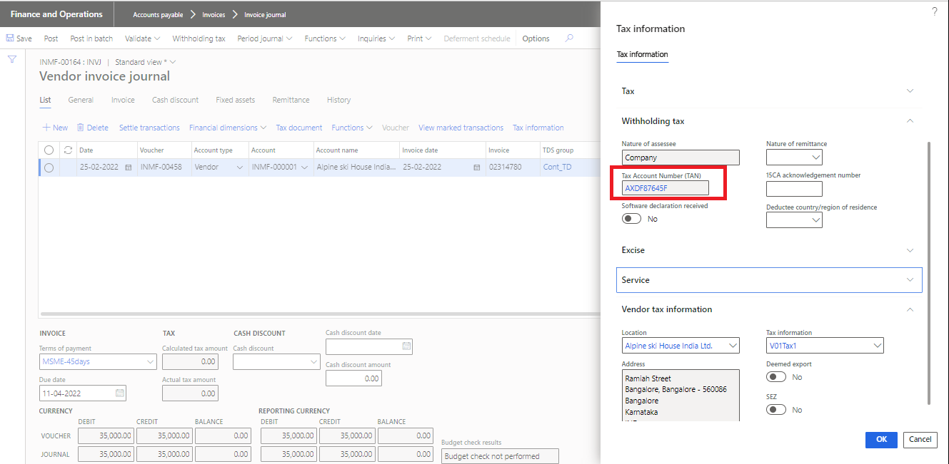

**Withholding Tax Inquiry**- **Click on Withholding tax button on the Action pane.**

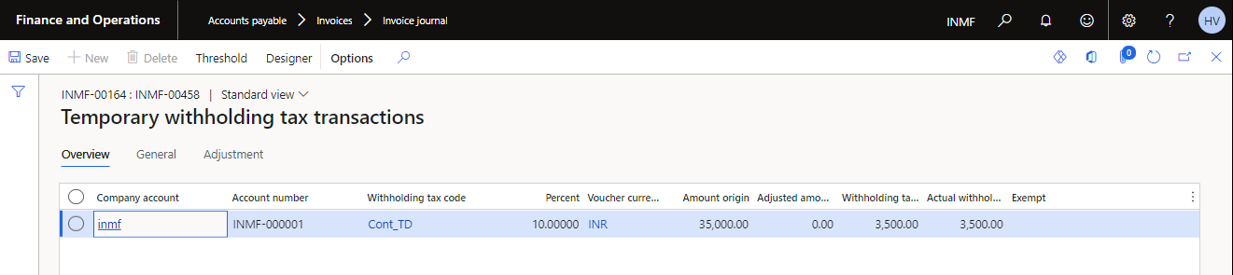

**Posted Accounting Voucher**

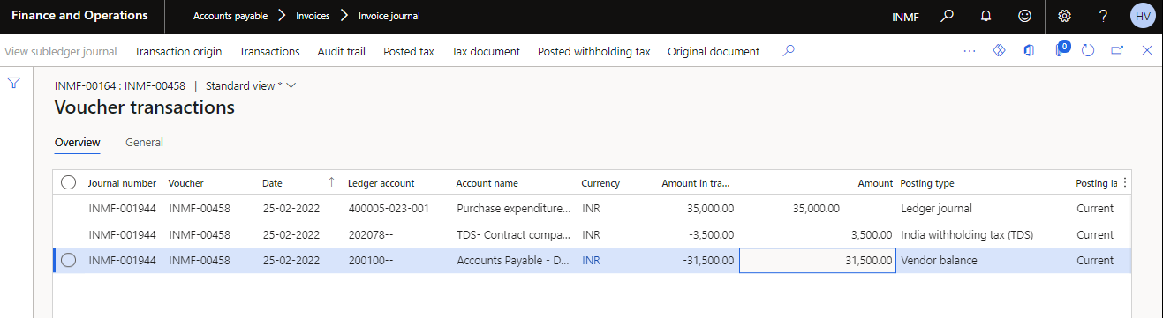

# Withholding Tax Settlement

## Process Withholding Tax Payment Process

This step is to process in month end based on settlement frequency defined in Withholding tax period set up. This must be run for each TAN number.

1. Navigate, Tax module > Declarations > Withholding Tax > Withholding Tax Payment  
   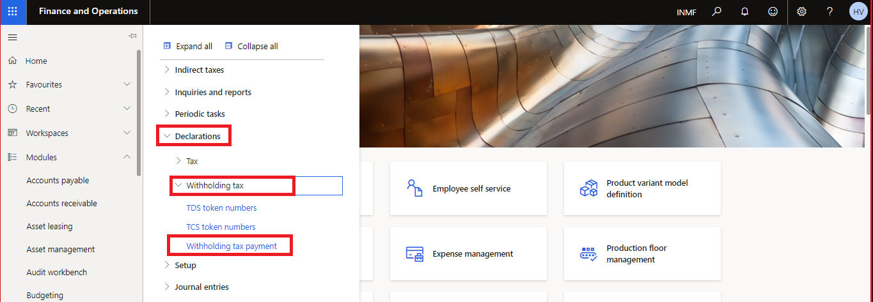
2. Select required parameters to process the payment to authority based on TDS transactions for the month, this will create the liability for the vendor account which has been selected in TDS authority master setup.   
   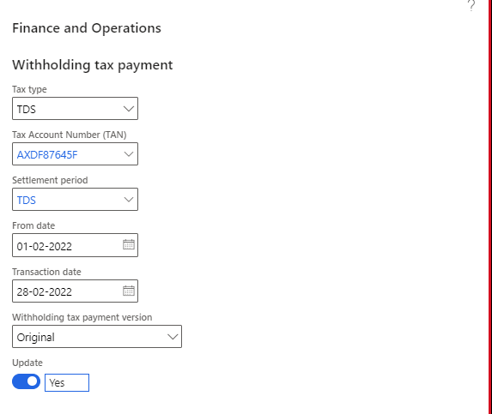
3. In the **Withholding tax payment version** field, select one of the following options:
   1. **Original** – Settle withholding tax payments for the first time for the selected settlement period.
   2. **Latest corrections** – Settle withholding tax payments that were included on journal lines and that were posted in the settlement period since you last settled withholding tax payments for the selected period.

## View Open transactions in Tax Authority Vendor

* Navigate, Vendor > Open > Transactions Or  
  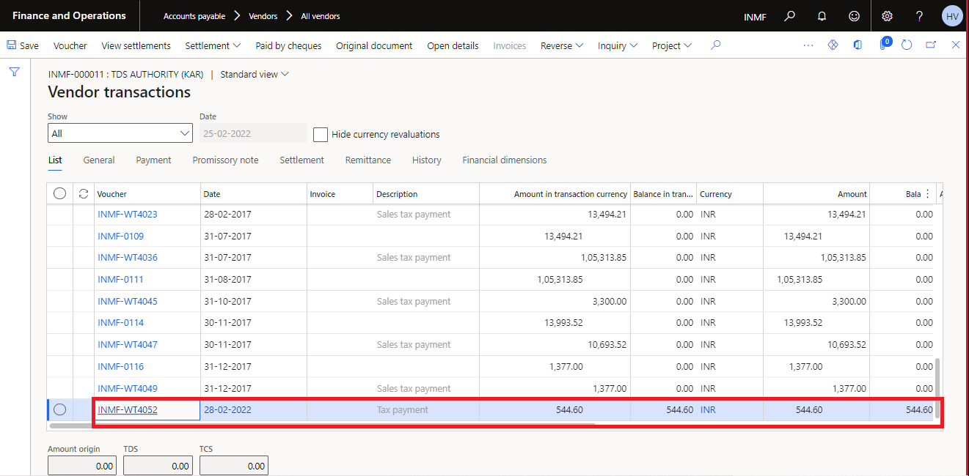
* Navigate Tax module > Indirect taxes > Withholding tax > Withholding tax settlement periods
* Select Withholding tax payment button on the Action pane.  
  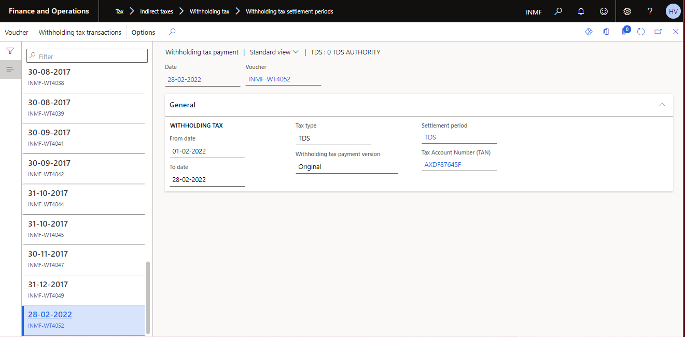

## Create Withholding Tax Payment Journal

* Navigate, Accounts Payable > Payments > Vendor payment journal.  
  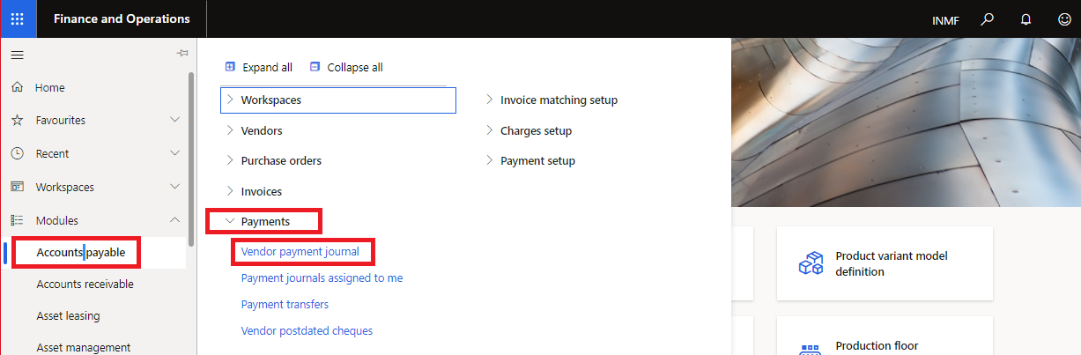

**Note: -** Ensure that payment journal selected for withholding tax liability payment doesn’t have Number allocation at posting boolean marked as True.  
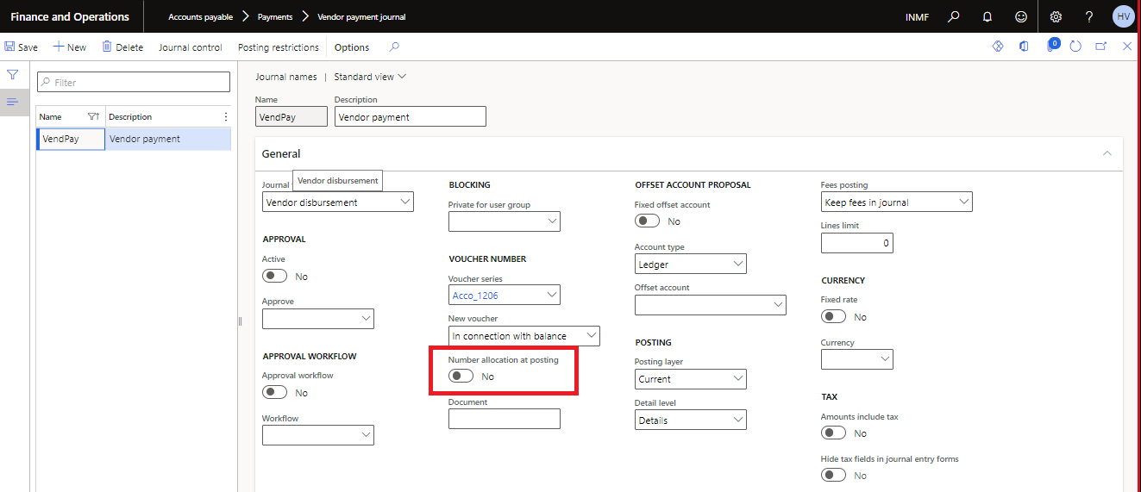

* On Action Pane, click New, select the payment journal and click on Lines button.  
  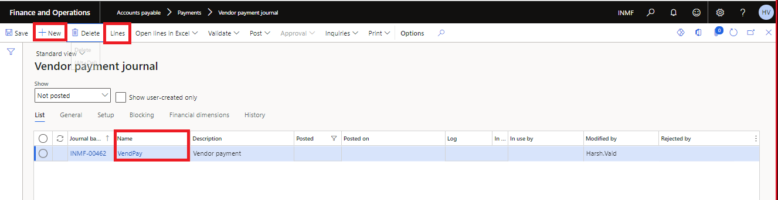
* Create a new line. Select TDS authority vendor & bank account. Click on **Settlement** button.  
  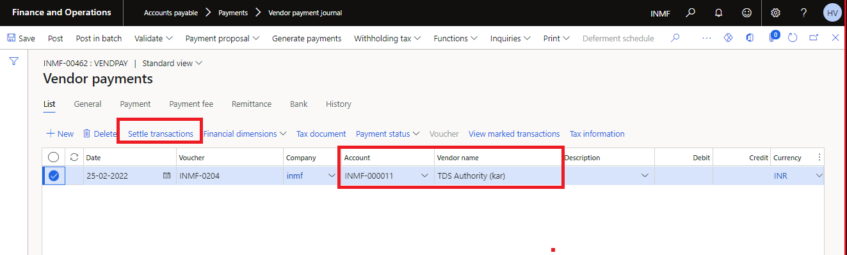
* Mark the transactions, click on OK button Amount will get populated on Journal line.  
  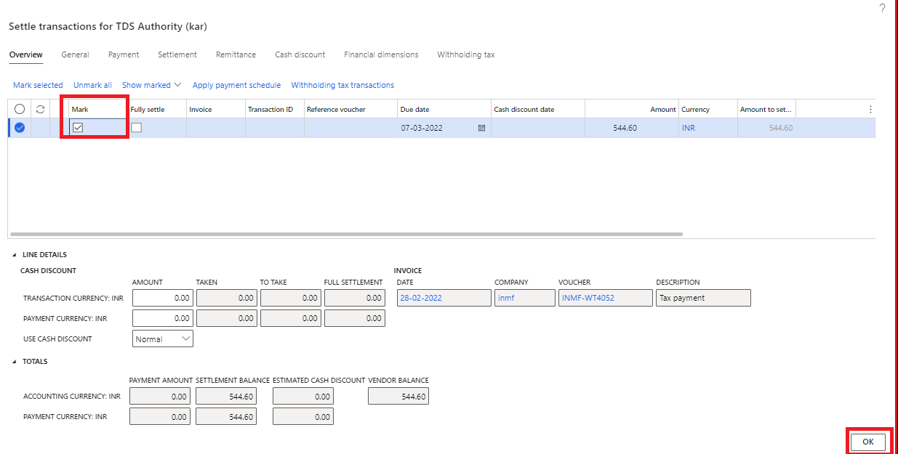  
  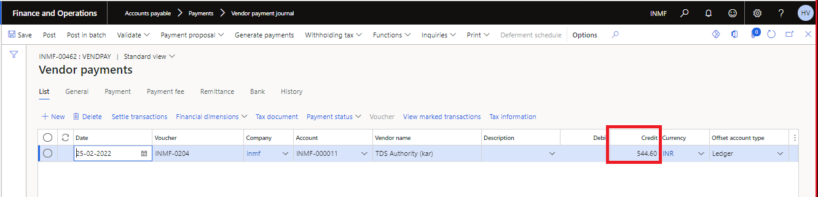

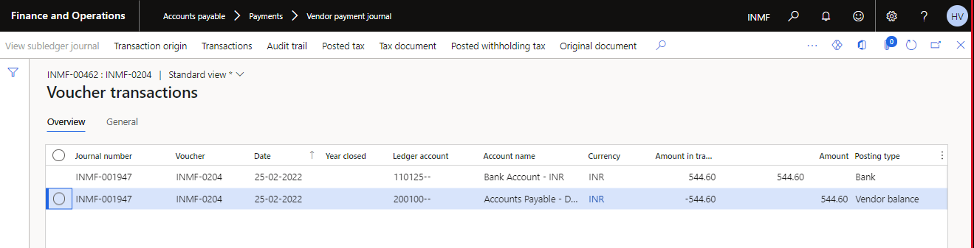

# Withholding Tax Reports

## Posted withholding tax report

Navigate to Tax module > Inquiries and reports > Withholding tax inquiries > Posted withholding tax

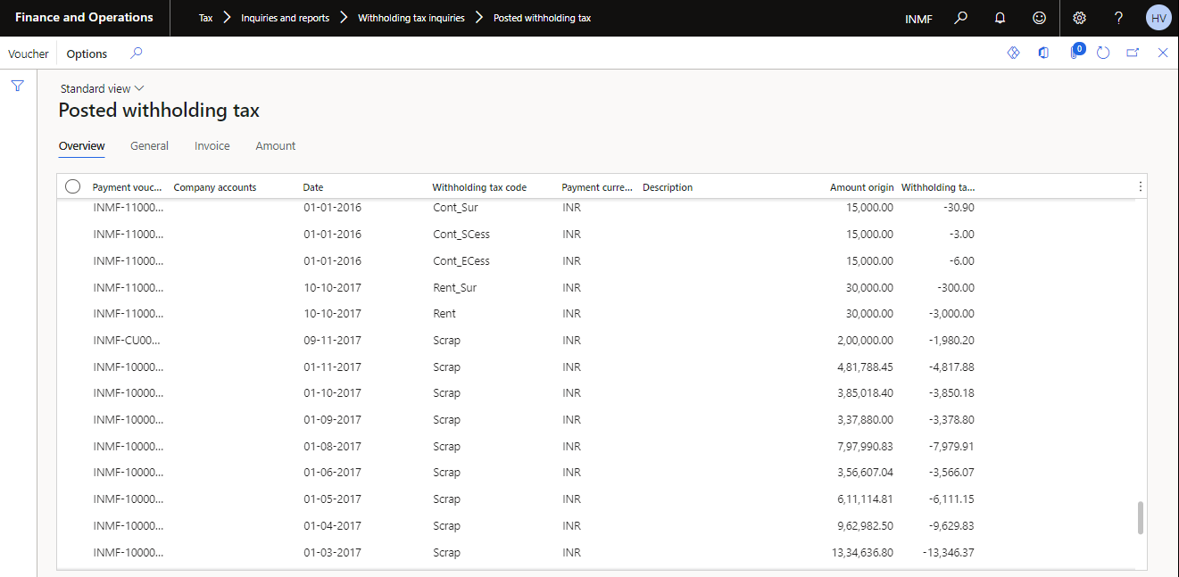

## TDS/TCS Enquiry report

Navigate to Tax module > Inquiries and reports > Withholding tax inquiries > TDS/TCS Enquiry

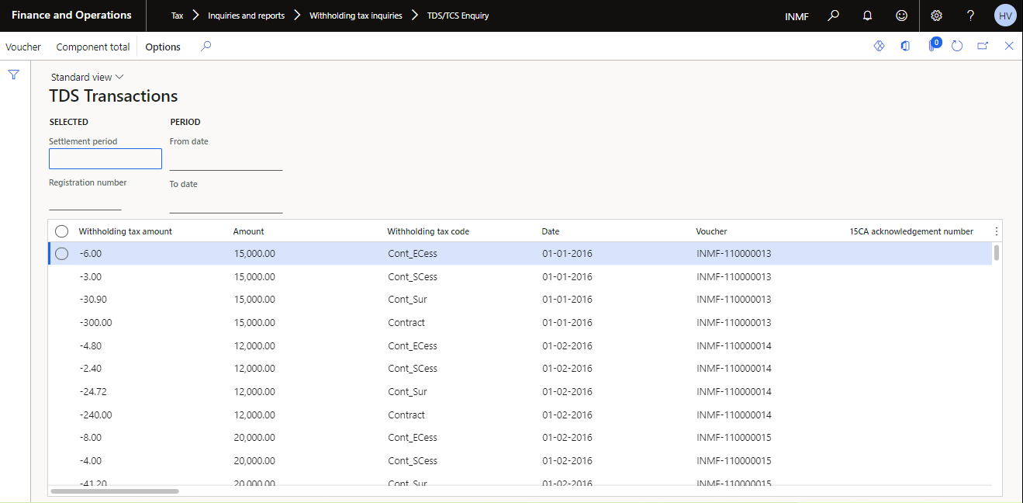

## Withholding tax transactions report

Navigate to Tax module > Inquiries and reports > Withholding tax inquiries > Withholding tax reports > Withholding tax transactions

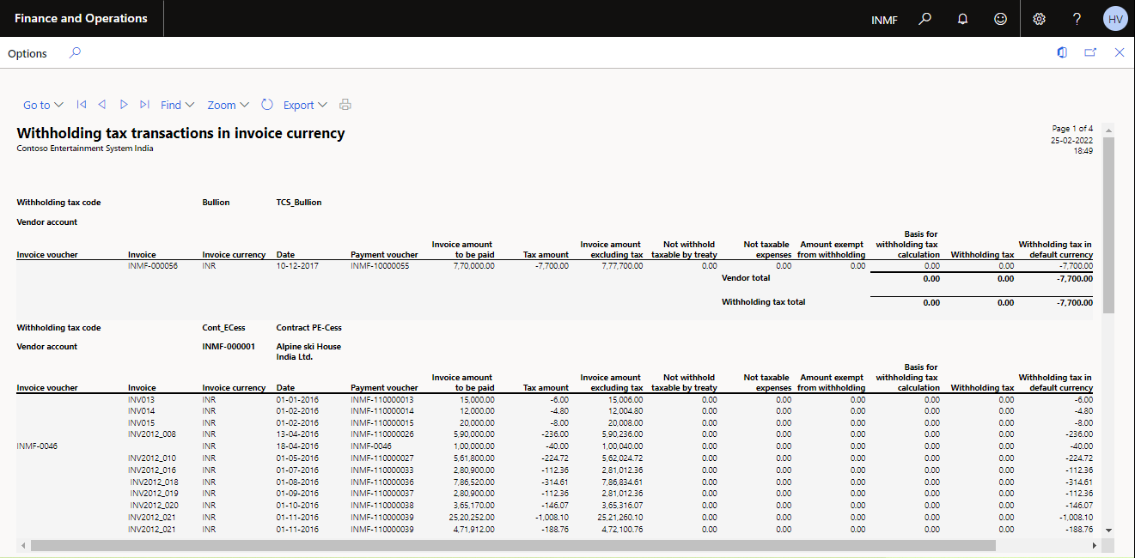

# Withholding Tax Journal Overview

This document will explain how we can post withholding tax adjustments using the withholding tax journals in D365. So, let’s understand in which scenario we need to use withholding tax journal, here are a few:

1. A user forgot to deduct withholding tax on the vendor invoice
2. User forgot to deduct withholding tax on payments
3. Wrongly deducted withholding tax on invoices or payments
4. The wrong amount deducted on invoice or payment

All these adjustments can be made using withholding tax journal which will also have an impact or create a transaction in posted withholding tax report in the Tax module, if we will post simple journal entry then it will not reflect in Tax transactions (Subledger transaction will not be created).

Withhold Tax Journal Process

The user posted an Invoice and forgot to deduct TDS on the invoice, now user wants to post withholding tax against that invoice, so the expected entry for the user is:

**Vendor Debit**

**To Withholding Tax Credit**

## Create General Journal

1. Navigate to, General Ledger > Journal Entries > General Journal.

1. Click on New > Select the Journal Name > Lines

## Create Withholding tax Journal and select Withholding Tax type, Group and Direction

1. On the Action Pane, select Functions > Create withholding tax Journal

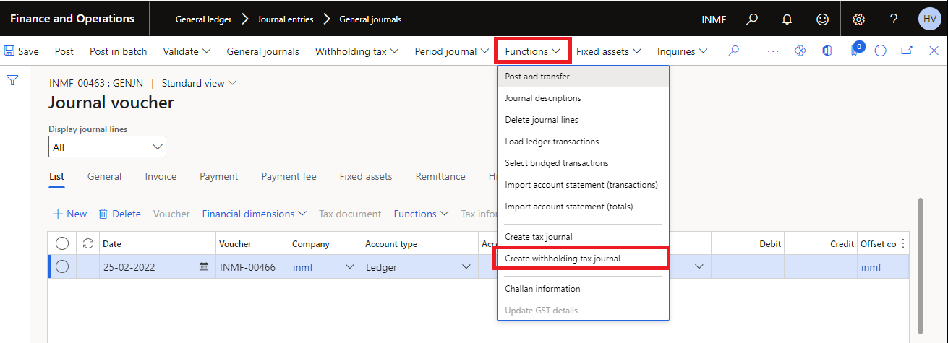

## Select transaction and link with Tax journal

## Select the original transaction

Mark the original transaction > Reference to tax journal.

Click on Calculate button.

## Post the journal, Voucher Transaction

# TDS Initial Threshold.

As the go live date is in the middle of the year the threshold limits of TDS which have been exhausted by vendor is to be checked during GO Live by SUGAR.

To define the initial TDS threshold value for transactions that occur between April 1 and June 30, 2021, you must enable the initial TDS threshold option in Feature management.

1. Go to **Workspaces** > **Feature management**.
2. In the list, find and select the feature that is named **(India) Enable initial TDS threshold under section 194Q**.
3. Select **Enable now**.

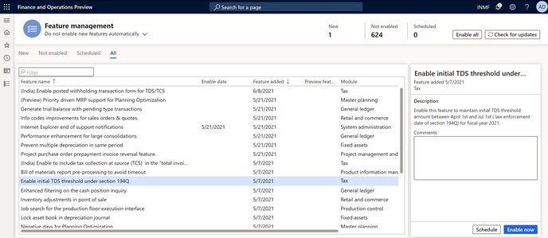

1. You receive a message that prompts you to refresh your browser window after the feature is enabled. Refresh your browser window to verify that you can open the new page.

After the feature is enabled, TDS is automatically reversed at the time of settlement if TDS is deducted on the invoice and the payment. However, you can disable the related feature, **(India) Reversal of vendor TDS at the time of settlement when deducted on both Invoice and payment** at any time in Feature management.

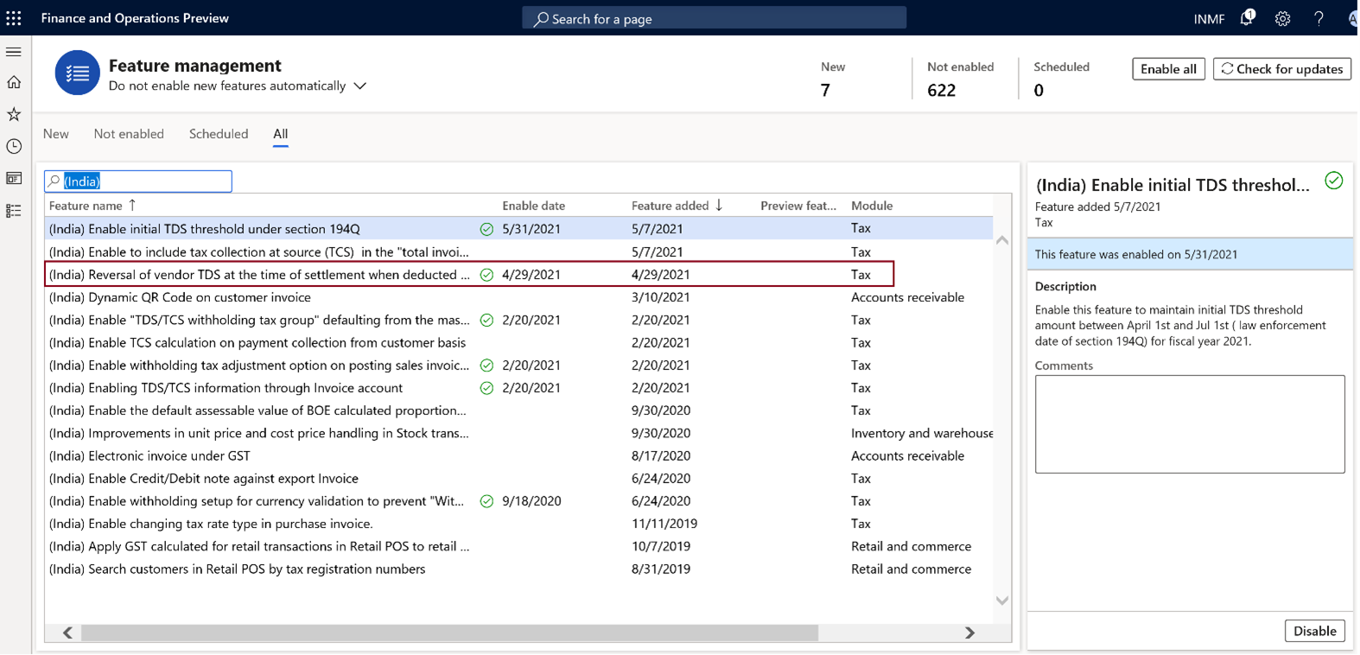

## Define the initial TDS threshold value for each vendor

1. Go to **Tax** > **Setup** > **Withholding tax** > **Initial threshold achieved values**.
2. On the **Vendor initial threshold achieved turnover** tab, select **Add line**.
3. Select a vendor account, and then select a withholding tax code.
4. In the **Initial threshold turnover amount** field, enter the invoice value of transactions that occurred between April 1 and June 30, 2021.

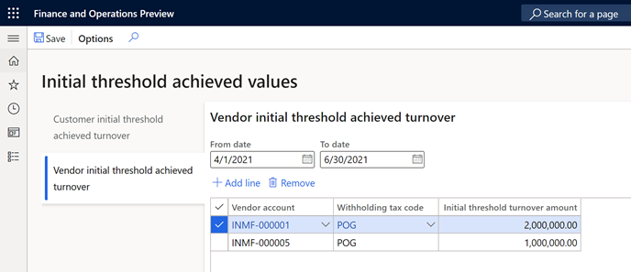

## Create a withholding tax component group

1. Go to **Tax** > **Setup** > **Withholding tax** > **Withholding component group**.
2. Create a withholding component group that is named, **POG**.
3. In the **Description** field, enter **Purchase of Goods**.
4. In the **Status** field, select **Resident**.
5. In the **Section** field, select **194Q**.

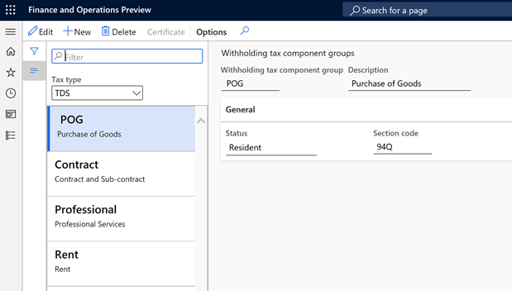

## Create a withholding tax component

1. Go to **Tax** > **Setup** > **Withholding tax** > **Withholding component**.
2. Create a withholding component that is named **POG**.
3. In the **Description** field, enter **Purchase of Goods**.
4. In the **Withholding tax component group** field, select **POG**.
5. In the **Section** field, select **194Q**.

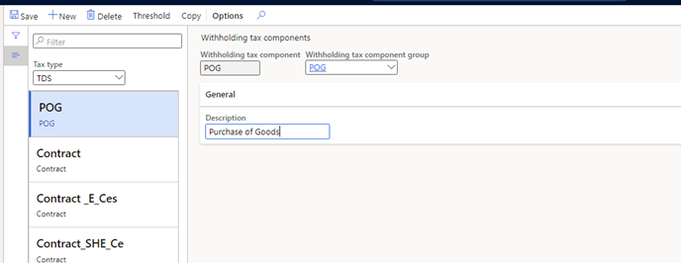

## Set up threshold definitions

1. Go to **Tax** > **Setup** > **Withholding tax** > **Threshold definitions**.
2. Create a record.
3. In the **Name** field, enter **POG**. In the **Description** field, enter **POG threshold definition**.
4. Select **Threshold designer**, and then select **New**.
5. On the **General** FastTab, in the **Effective from** field, select **4/1/2021** (April 1, 2021). In the **Effective to** field, select **3/31/2022** (March 31, 2022).
6. In the **Lower limit** field, enter **0** (zero). In the **Upper limit** field, enter **5,000,000**.
7. In the **Type** field, select **Cumulative**.
8. In the left pane, select **Cumulative: 0 – 50,00,000; 4/1/2021 - 3/31/2022**, and then select **POG**.
9. Select **New**.
10. On the **General** FastTab, in the **Effective from** field, select **4/1/2021**. In the **Effective to** field, select **3/31/2022**.
11. In the **Lower limit** field, enter **5,000,000**. In the **Upper limit** field, enter **0**.
12. Set the **Final level** option to **Yes**, and then close the page.

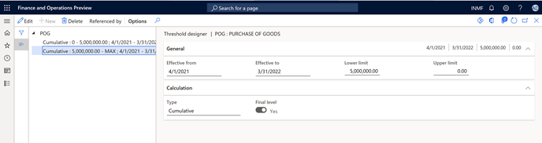

## Set up a withholding tax code

1. Go to **Tax** > **Withholding tax** > **Withholding tax code**.
2. Create a record, and set the following values:
   * **Withholding tax code**: POG
   * **Withholding tax name**: Purchase of Goods Threshold Definition
   * **Tax type**: TDS
   * **Enable threshold hierarchy**: Yes
   * **PAN based accumulation**: Yes
   * **Withholding tax component**: POG
   * **Main account**: 202122
   * **Settlement period**: TDS
   * **Receivable account**: 1322611
3. Select **Values**, and then set the following values:
   * **Value**: 0.1
   * **PAN non-availability %**: 5
4. Close the **Withholding tax values** page.

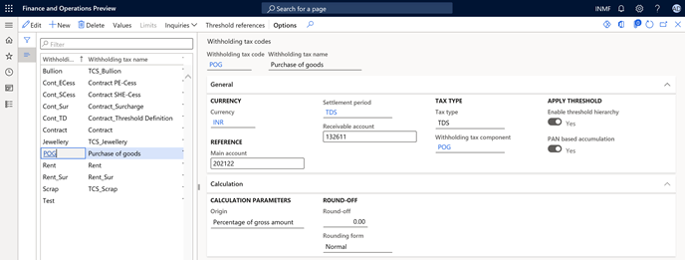

1. On the **Withholding tax codes** page, in the left pane, select **POG**.
2. Mark **Apply threshold**.
3. Select **Threshold references**.
4. Create a record, and set the following values:
   * **Account type**: Vendor
   * **Account code**: All
   * **Account or Group**: Blank
   * **Threshold**: POG
5. Select **Threshold designer**, and then select **POG**.
6. Select **New cumulative; 0 – 50,00,000; 4/1/2021 - 3/31/2022**, and then select **New**.
7. In the **PAN status** field, select **Received**.
8. On the **General** FastTab, set the following values:
   * **Value**: 0
   * **Reason code**: Y
   * **Calculate tax**: No
   * **Include in turnover base**: Yes
9. Unmark **Calculate previously nontaxed transactions**.
10. In the left pane, select **POG: 50,00,000 - MAX; 4/1/2021 - 3/31/2022**.
11. Select **New**, and set the following values:
    * **PAN status**: Received
    * **Value**: 0.1
12. On the **General** FastTab, set the following values:
    * **Calculate tax**: Yes
    * **Include in turnover base**: Yes
13. Unmark **Calculate previously nontaxed transactions**, and then close the page.

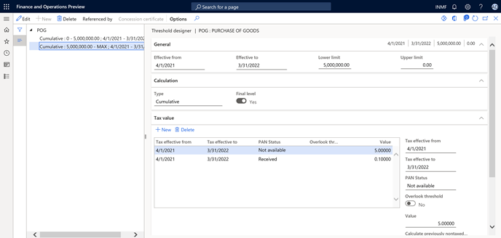

## Create a withholding tax group

1. Go to **Tax** > **Withholding tax** > **Withholding tax group**.
2. Create a record, and set the following values:
   * **Withholding tax group**: POG
   * **Description**: POG - Threshold Definition
   * **Tax type**: TDS
   * **Include GST tax component for TDS calculation**: IGST, CGST, SGST
3. On the **Setup** FastTab, select **Add**.
4. In the **Withholding tax code** field, select **POG**.
5. Select **Designer**, and then create a record.
6. In the **Tax code** field, select **POG**.
7. In the **Taxable basis** field, select **Gross amount**.
8. Close the page.

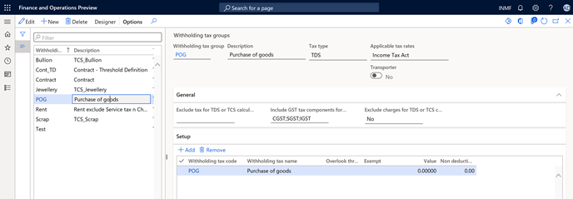

## Attach a withholding tax group to a vendor account

1. Go to **Accounts payable** > **Vendors**.
2. Select vendor **INMF-000001**.
3. On the **Invoice and delivery** FastTab, set **Calculate withholding tax** to **Yes**.
4. In the **TDS group** field, select **POG**.

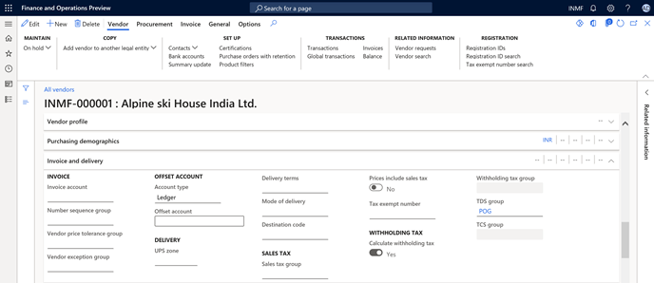

## Create and post the invoice journal

1. Go to **Accounts payable** > **Invoices** > **Vendor invoice journal**.
2. Select **New**, and set the following values:
   * **Account type**: Vendor
   * **Account**: INMF-000001
   * **Invoice**: IN-9
   * **Credit**: 1,500,000.00)
   * **Offset account type**: Ledger
   * **Offset account**: 600120
   * **Already posted transaction**: 2,000,000
   * **Initial threshold value**: 2,000,000

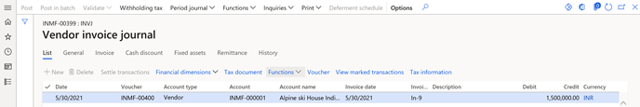

1. Select **Withholding tax**.

Notice that withholding tax is calculated as expected, based on the percentage that you previously set up for this vendor (0.1). The total cumulative transaction value, including the initial threshold, exceeded 50,00,000, as shown here:

* + **Initial threshold achieved value**: 20,00,000
  + **First transaction**: 20,00,000
  + **Second transaction**: 15,00,000
  + **TDS**: Total cumulative value (55,00,000) – 50,00,000 = 5,00,000
  + **Threshold value**: 5,00,000 at a rate of 0.1 percent = 500

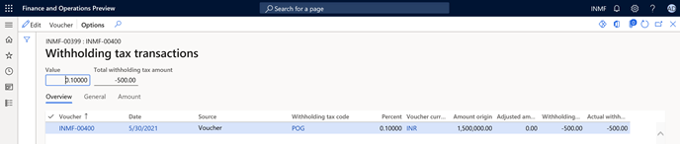

# Lower rate certificate

## Setup the Threshold for the vendor

### Click Tax > Indirect tax > Withholding tax > Withholding tax code

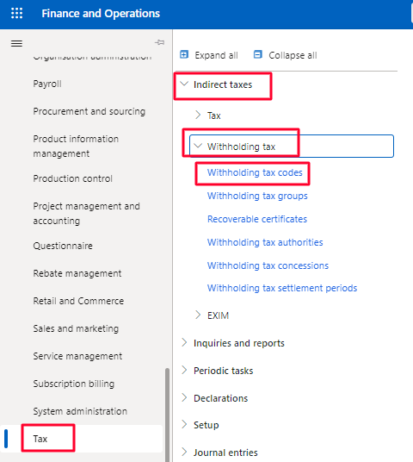

### Select the TDS code on which the vendor has a lower-level certificate.

### Click on Threshold reference

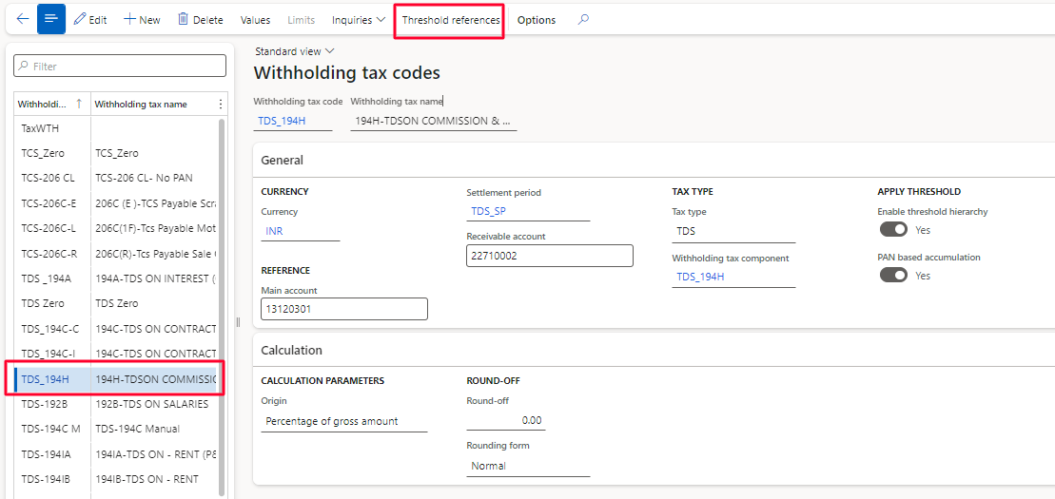

### Click New.

### Select Vendor in account type.

### Select table in account code.

### Select vendor in the account or group.

### Select the threshold

### Click Threshold designer.

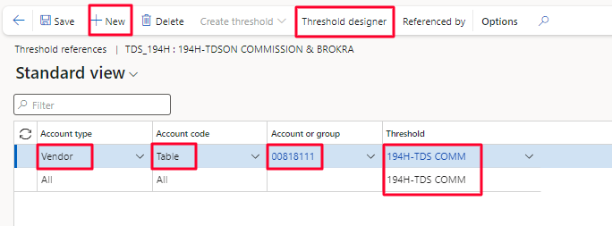

### Select the threshold line in which TDS to be calculated.

### Click New under the tax values.

### Select Not available in PAN status.

### In the field Values enter the percentage by which TDS should be calculated if vendor did not have PAN.

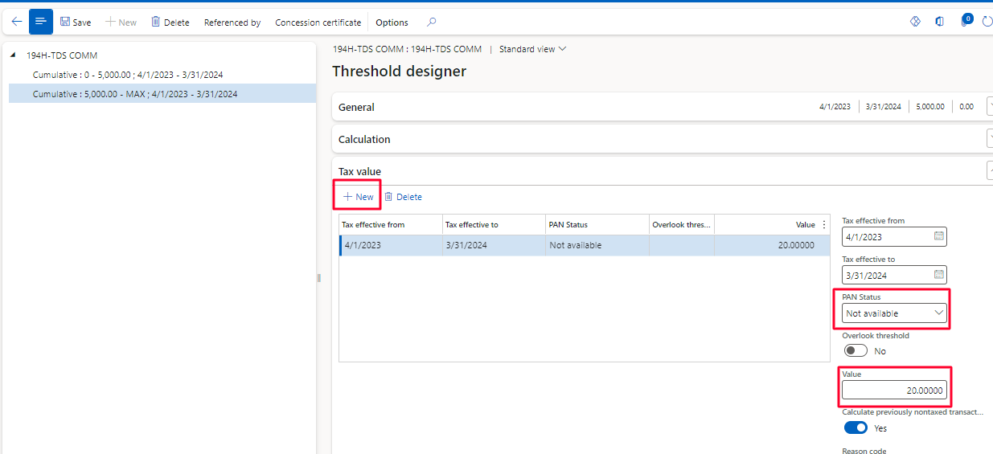

### Click New under the tax values.

### Select Received in PAN status.

### In the field Values enter the percentage by which TDS should be calculated if vendor have the PAN.

### Click on concession certificate to attached the lower rate certificate.

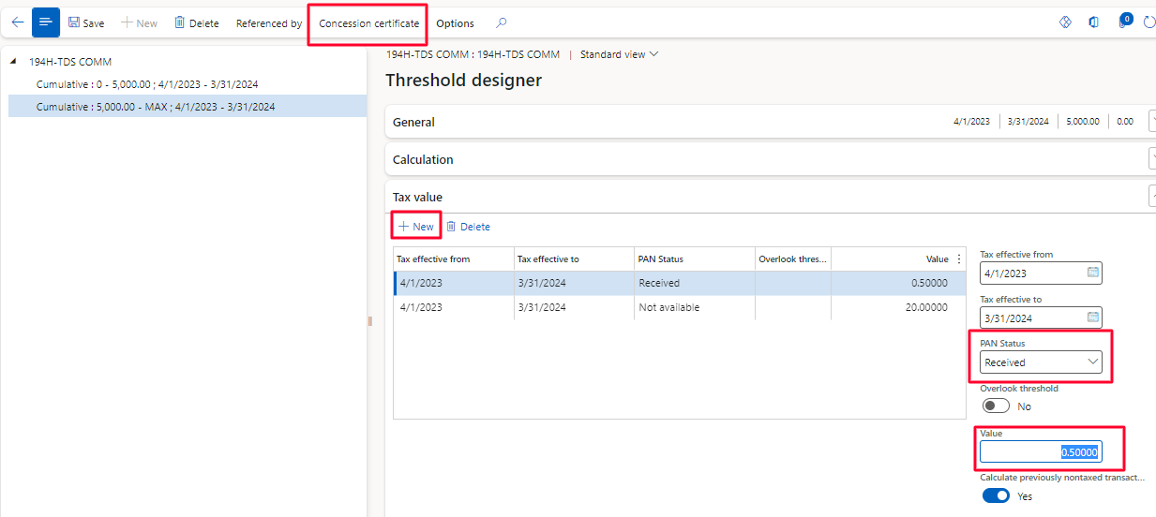

### Fill the certificate number

### Select the period of certificate validity by selecting from and to date.

### Click OK to attached the certificate in the threshold.

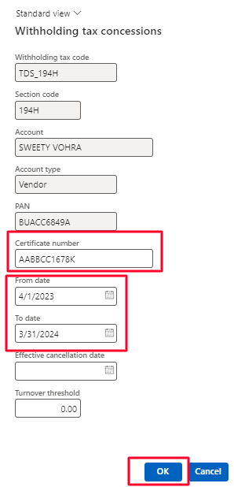

## Verifying the applicability : Posting Invoice.

### Click Accounts payable > Invoices > Invoice Journal.

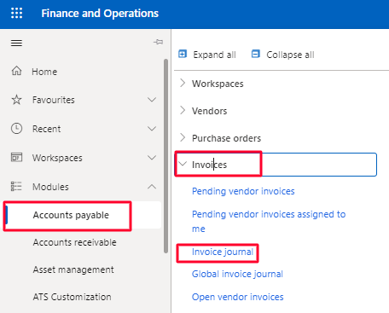

### Click New to create a new invoice journal.

### Click on Lines to open the invoice journal batch.

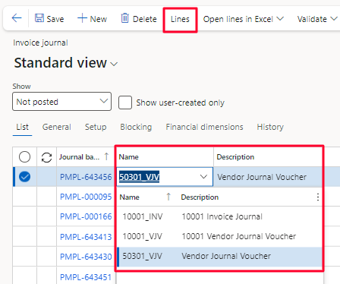

### Create the line in the invoice journal by selecting the vendor and offset account details & the credit amount.

### Select the TDS group on which the new threshold is defined and concession certificate TDS Group can be review or changed from General Tab.

### To check the TDS click withholding tax.

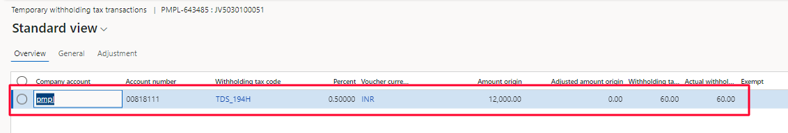

### Click Post to post the invoice journal.

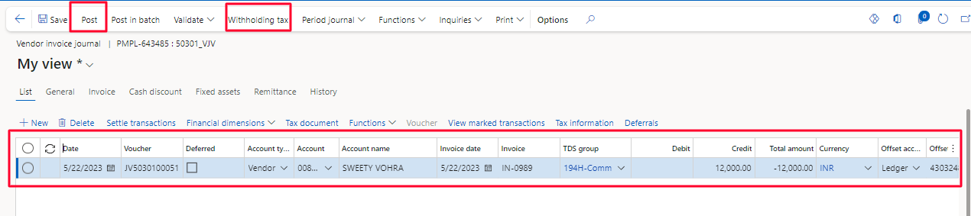

Voucher for the same is attached for the reference.

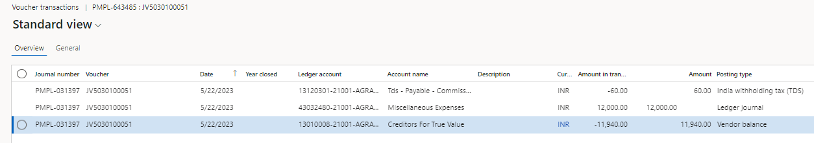

## Verifying the applicability : TDS Enquiry

### Click Tax > Inquiries and reports > withholding tax inquiries > TDS/TCS Enquiry

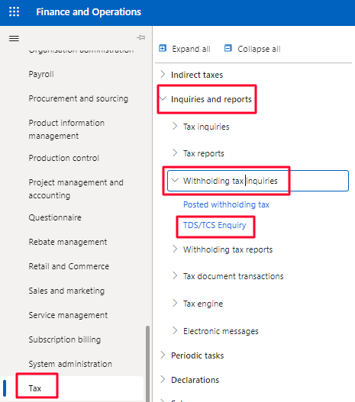

### Select the TDS Inquiry

### Click Add for a new for a new TDS Inquiry.

### Fill Name

### Select the TAN number

### Select the period for the inquiry by selecting the from date and to date.

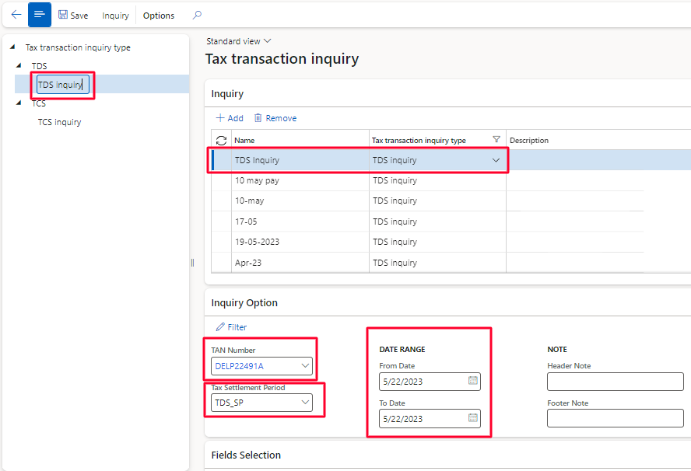

### Under the field selection select the fields which the user wants to include in the TDS inquiry > click transfer sign.

### Click Save to save the inquiry.

### Click Inquiry to open the inquiry.

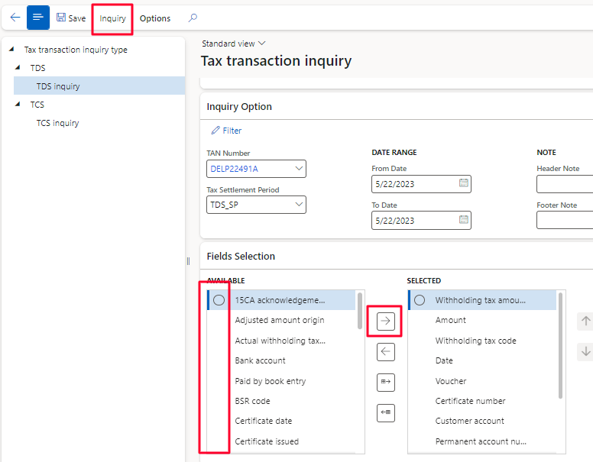

For the reference screenshot of the TDS Inquiry is attached below.

