|  |  |
| --- | --- |
| **Ticket ID** | TT3894 |
| **Ticket description** | Inventory Team require Catalogue App |
| **Created by** | Manali Bhadirage |
| **Created on** | 01/08/2022 |
| **Priority** | Very high |
| **Version** | 01 |

**Version**

|  |  |  |  |  |
| --- | --- | --- | --- | --- |
| **Sr. No** | **Version no** | **Version Date** | **User name** | **User department** |
| **01** | **1.0** | **02/08/2022** | **Tushar Nikam** | **Inventory Team** |
| **02** | **1.1** | **05/08/2022** | **Tushar Nikam** | **Inventory Team** |
|  |  |  |  |  |

**Approvals**

|  |  |  |
| --- | --- | --- |
| **Field** | **Name of the User** | **Approved date by the user** |
| **Actual User Name** | Tushar Nikam |  |
| **Actual User Department** | Inventory Team |  |
| **Organization Name** | CSJewellers |  |
| **Assigned BA** | Manali Bhadirage |  |
| **Assigned Developer** |  |  |
| **Assigned Tester** |  |  |

**CONTENTS**

**Introduction**

**Introduction**

Through Catalogue app / web, vendor will first register themselves. It will be approved / rejected by Super admin. Once approved / rejected, notification will be sent to vendor about their activation. On successful registration, vendor will be able to sign in through app and can upload catalogue. Those catalogue will be displayed to the admin of tenant which have selected this particular vendor. Admin will approve / reject the vendor’s catalogue and will display the approved ones to their multiple branches. Branches will view catalogue and place order. Orders placed by the branches will be displayed to their respective admin / tenant. Admin will review the order, approve / reject / edit the order and forward the confirmed order to the vendor. Vendor will receive this order and can confirm it. Notification / status of confirmed order will be displayed to admin and branch.

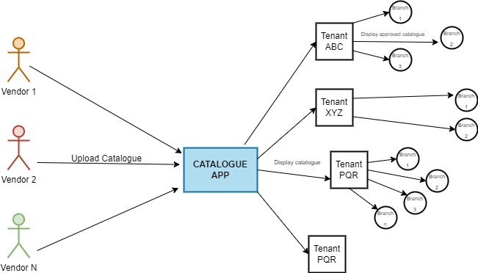

Fig: Catalogue Upload flow

Following are the contents to be displayed on each login on web / app:

**VENDOR MOBILE APP**

* Register
* Sign in
* Notification
* Home page ( Dashboard)
* Search button
* Filter
* Profile
* Single Upload
* Orders Received
* Orders History / Confirmed
* Sign out

**VENDOR WEB**

* Register
* Sign in
* Dashboard ( count of catalogue approved / rejected, count of items received, count of orders confirmed)
* Items uploaded master
* Profile
* Single Upload
* Bulk Upload
* Orders Received
* Orders History / Confirmed
* Notification
* Sign out

**BRANCH MOBILE APP**

* Sign in
* Profile
* Notifications
* Home (catalogue lists)
* Profile
* Place order
* Orders confirmed / status

**TENANT WEB**

* Sign in
* Profile
* Notifications
* Add Branch
* List of vendors
* Vendor Recommendation and send request
* Validate Orders (approve/reject / edit orders placed by their branch)
* Orders confirmed / status
* Reports (Branch wise orders placed, Branch wise orders confirmed)

**MOBILE APP SIGN IN**

Following users will be signing in to the mobile application:

* Vendors
* Tenants

Sign in page will have following fields:

* Username
* Password
* Submit
* Remember me
* Forgot Password
* Language change
* Help
* New registration

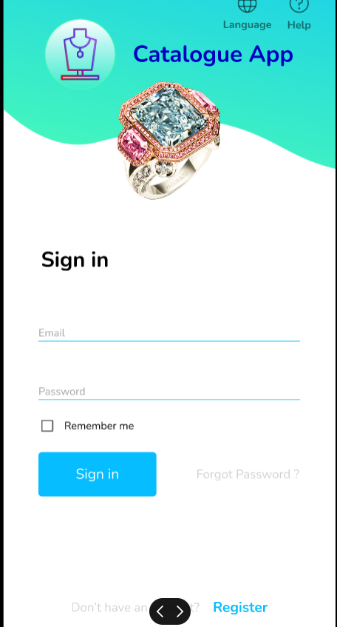l

Fig: Sign in page

|  |  |  |
| --- | --- | --- |
| **FIELDS** | **MANDATORY/ OPTIONAL** | **DESCRIPTION** |
| User email | Mandatory | It will be text field. User will enter registered email address. All special characters should be accepted.  Username shouldn’t be case sensitive.  Provide maximum size of 50 letters in this field.  In case of incorrect username, display notification above as “Please enter registered email address”. |
| Password | Mandatory | It will be text field.  It should also accept alphanumeric value and all special characters.  Password should be case sensitive.  Minimum length of password should be 6 characters and maximum length should be 10.  Password must have at least one capital letter, at least one special character and at least one number.  In case of incorrect password, display notification above as “incorrect password”. |
| Remember Me | Optional | It will be checkbox.  Remember me is to save credentials. If user has clicked Remember me, whenever user wish to sign into the application later on, credentials should get auto-filled. |
| Submit |  | Submit button should be disabled once clicked.  After entering correct credentials and clicking on submit button, user should be able to successfully sign-in to account. |
| Forgot Password |  | Once user clicks on forgot password button, it should direct user to OTP page.  It will have notification as “OTP sent on registered email & SMS”.  Once user enters correct OTP, it will direct user to next page for new password setting. It will have following fields:   * New password * Confirm new password * Submit (button)     Fig: Forgot password - OTP page    Fig: Forgot password - New password page |
| New Registration | Optional | New user can register himself through “New Registration” as vendor or as a tenant. |
| Language Change |  | Once user clicks on this button, it will display two radio buttons:   * English * Hindi   As per selected language, the strings of the application should change. |
| Help |  | Once user clicks on help button, a dialogue box will open up. It should display text field where user will manually enter their suggestions / concern / queries.  It should accept characters, numbers, special characters and space. Maximum length of input field should be 250 characters. It should accept English and devanagiri (marathi / hindi) script.  In case user has kept text field blank and directly clicks on submit button, then it should display on field message as “Please enter your query.”  Once user enters details in text field and clicks on submit, it should display message as “Thank you for writing to us. We will get back to you soon.”  The written query should be sent to super-admin web app. It should be displayed in list of notifications to super-admin.    Fig: Help button |

Once user clicks on “**New registration**” on app, it will display two icons namely Vendor and Tenant.

Once user clicks on **Vendor**, it will display following fields for registration:

1. Profile Details

* Vendor Name
* Email Address (optional)
* Contact Number
* WhatsApp no.
* Authority / Contact Person Name
* Authority contact number
* Website (optional)
* Address
* City - State - Country
* Vendor Logo / Image

1. Vendor Business Details

* Vendor Type
* GST no
* Pan No
* Gst Attachment
* Pan Attachment
* Product group
* Vendor Description (optional)
* Password
* Confirm Password
* Enter OTP
* Timer
* Resend OTP
* Submit (button)
* Back (button)

|  |  |
| --- | --- |
| **FIELDS** | **DESCRIPTION** |
| Vendor Name | 1. It will be text field. 2. It should accept characters and space. 3. Maximum length of input field should be 50 characters. 4. This field shouldn’t be case sensitive. |
| Vendor email address | 1. It will be text field. 2. This field should accept “ @ - . “ only as special characters. 3. In case of invalid format, it should display on field error message as “Invalid email address”. 4. It shouldn’t accept space anywhere. 5. It should be unique. 6. Maximum length of input field should be 50 characters. |
| Contact Number | 1. It will be text field. 2. Only numbers should be accepted. 3. Maximum 10 digits should be accepted. 4. It should be unique. 5. Consecutive ten zeros or consecutive ten ones shouldn’t be accepted as a number. |
| WhatsApp number | 1. Provide checkbox for same as above. (means WhatsApp number will be same as contact number provided above) 2. Also, provide text field to enter WhatsApp number if it is different from provided contact number. 3. Only numbers should be accepted. 4. Maximum 10 digits should be accepted. 5. It should be unique. 6. Consecutive ten zeros or consecutive ten ones shouldn’t be accepted as a number. |
| Authority / Contact Person Name | 1. It will be text field. 2. Name of the person who will be point of contact from vendor side will be mentioned here. 3. Maximum length of input field should be 50 characters. |
| Authority Contact Number | 1. It will be text field. 2. Only numbers should be accepted. 3. Maximum 10 digits should be accepted. 4. It should be unique. 5. Consecutive ten zeros or consecutive ten ones shouldn’t be accepted as a number. |
| Website | 1. It will be text field. 2. Vendor can enter website link if they have any. 3. It should only accept https or http or www at the beginning. 4. In case of invalid format, it should display on field error message as “Invalid website address”. 5. It is optional field. |
| Address | 1. It will be text field. 2. Location of the vendor company. It should accept capital letters, numbers, special characters and space. 3. Maximum length of input field should be 50 characters. |
| Pin Code | 1. It will be text field. 2. It should accept numbers only. It shouldn’t accept characters, space, special characters. |
| Country | 1. As of now, it should display “India” only. 2. It is read only as of now. |
| State | 1. Provide drop-down which will contain list of states in India. 2. It will be single select. 3. User should also be able to search in this field and then select through displayed options in drop-down. |
| City | 1. Provide list of cities as per selected state. 2. It will be single select. 3. User should also be able to search in this field and then select through displayed options in drop-down. |
| Profile Image / Logo | 1. User will attach only one image in this field. 2. It should accept png, jpeg and jpg extensions only. |
| Vendor Type | 1. It should have drop-down consisting Manufacturer / distributor / provider. 2. It will be single select. |
| GST no. | 1. User will enter 15 digit GST No. of vendor. 2. The first 2 digits of the 15 digit GSTIN represents the state code. The next 10 digits are the [PAN](https://groww.in/p/pan-card) of the person or the business entity. 3. The thirteenth digit is based on the number of registrations done by the firm within a state under the same PAN. 4. The fourteenth digit will be the alphabet "Z" by default. 5. The last digit is called the check code to detect errors and can be denoted by either a number of an alphabet. 6. Each vendor will have unique GST no. |
| GST attachment | 1. It should accept only one attachment. 2. It should accept only pdf, jpeg, jpg and png extensions of attached files. |
| PAN no. | 1. User will enter 10 digit alphanumeric PAN No. of vendor. 2. One PAN no. should be used for registration only once. (each vendor will have unique pan no.) 3. It includes first five letters, followed by 4 numbers and last character. 4. In case of invalid pan card number format, it should display error message as “Invalid pan number”. |
| PAN attachment | 1. It should accept only one attachment. 2. It should accept only pdf, jpeg, jpg and png extensions of attached files. |
| Product Group | 1. Vendor will specify catalogue they have for list of product groups. 2. It will display gold, silver, diamond, forming, MRP in the list. 3. It will be multi select. |
| Vendor Description | 1. Vendor can enter their additional remark if they wish to specify anything. 2. This input field should accept characters, special characters capital letters, numbers. Maximum length accepted should be 50 characters. 3. It is optional field. |
| Password | 1. It will be text field. 2. It should accept all special characters. 3. Password should be case sensitive. 4. Minimum length of password should be 6 letters and maximum length should be 10. 5. Password must have at least one capital letter, at least one small letter, at least one special character and at least one number. 6. In case of incorrect password format, display on field error message as “incorrect password format”. |
| Confirm password | 1. It will be text field. 2. This field should match with the inputs in Password field. 3. If inputs doesn’t match, it doesn’t display on field error message below as “Password doesn’t match”. |
| OTP | 1. After password, on next page it should display Enter OTP field. 2. At the same time, 4 digit OTP should be sent to vendor on provided contact number. OTP should be sent via email and sms. 3. It should accept only numbers. 4. On entering correct OTP, submit button should be enabled. 5. On entering incorrect OTP, display message as “Please enter correct OTP” or highlight the input boxes with red colour. 6. Also, 60 seconds timer should be displayed. |
| Resend OTP | Resend OTP button should be activated after 1 minute timer has ended. |
| Verify (button) | 1. Once clicked, submit button should be disabled. 2. On successful registration, display pop-up message for as “Your registration request is sent successfully. You will receive an update within 24-48 hours.” Then user will be directed to sign in page after few seconds.   Once vendor registers themselves, unique vendor ID should get generated. |

Vendor should be able to explore app only after their registration is confirmed by admin.

Once admin verifies and confirms the registration of vendor, SMS and WhatsApp message will be sent to vendor stating “Congratulations, XXXXXX vendor name! Your verification is done successfully. Log into your app using your credentials to proceed for item uploads and orders. Thank you.”

Each vendor while registering should have unique GST number, PAN number, contact number and email address. If already registered vendor, registers again with same details then it will display on field error message to vendor as “Existing Number”.

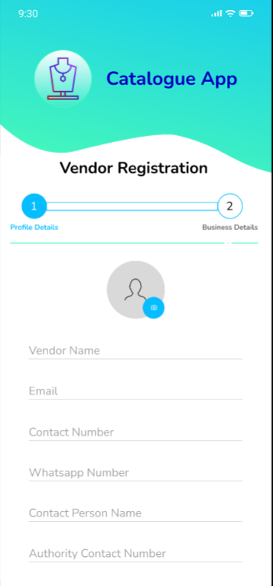

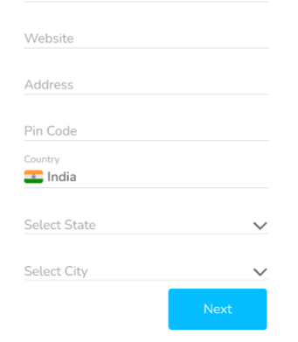

Fig: Vendor registration - Profile details

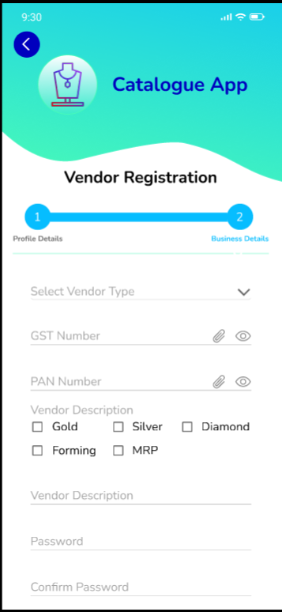

Fig: Vendor details - Business details

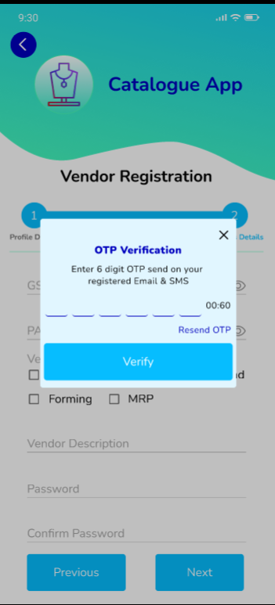

Fig : Vendor Registration - OTP verification

Following are the fields in New Registration as a **Tenant**:

* Tenant Name
* Address
* Country - State - city
* Email address
* Contact No.
* WhatsApp no.
* Type of Ownership : Private ltd / Proprietorship / Partnership / PSU
* Authority Details
* Authority Name
* Authority Designation
* Authority Contact Number
* GST No.
* PAN No.
* Attachments (GST and PAN)
* Certified Product Groups: Gold, Silver, Forming, MRP, Diamond
* Certificate number of registration issued by registrar (while establishment)
* Any other BIS certificate (if any)
* Number of branches
* Choose Vendors : List of vendors in drop-down.
* Password
* Confirm Password
* Enter OTP
* Resend OTP
* Submit (button)
* Back (button)

|  |  |
| --- | --- |
| **FIELDS** | **DESCRIPTION** |
| Tenant Name | 1. It will be text field. 2. It should accept characters and space. 3. Maximum length of input field should be 50 characters. 4. This field shouldn’t be case sensitive. |
| Address | 1. It will be text field. 2. Location of the tenant main office. 3. It should accept capital letters, numbers, special characters and space. |
| Email address | 1. It will be text field. 2. This field should accept “ @ - . “ only as special characters. 3. In case of invalid format, it should display on field error message as “Invalid email address”. 4. It shouldn’t accept space anywhere. 5. It should be unique. |
| Country | 1. Provide drop-down consisting list of countries. 2. As of now, it should display “India” only. |
| State | 1. Provide drop-down which will contain list of states in India. 2. It will be single select. 3. User should also be able to search in this field and then select through displayed options in drop-down. |
| City | 1. Provide list of cities as per selected state. 2. It will be single select. 3. User should also be able to search in this field and then select through displayed options in drop-down. |
| Contact Number | 1. It will be text field. 2. Only numbers should be accepted. 3. Maximum 10 digits should be accepted. 4. It should be unique. 5. Consecutive ten zeros or consecutive ten ones shouldn’t be accepted as a number. |
| WhatsApp number | 1. Provide checkbox for same as above. (means WhatsApp number will be same as contact number provided above) 2. Also, provide text field to enter WhatsApp number if it is different from provided contact number. 3. Only numbers should be accepted. 4. Maximum 10 digits should be accepted. 5. It should be unique. 6. Consecutive ten zeros or consecutive ten ones shouldn’t be accepted as a number. |
| Type of ownership | 1. It will be drop-down field displaying Private ltd / Proprietorship / Partnership / PSU in the list. 2. It will be single select. |
| Authority Details | * Authority Name - It will be text field. Name of the person who will be point of contact from tenant side will be mentioned here. * Authority Designation - It will be text field. User will manually enter the designation of the authority. Maximum length of 25 characters will be accepted. * Authority Contact Number - It will be text field. Name of the person who will be point of contact from tenant side will be mentioned here. Consecutive ten zeros or consecutive ten ones shouldn’t be accepted as a number. |
| GST no. | 1. User will enter 15 digit GST No. of vendor. 2. The first 2 digits of the 15 digit GSTIN represents the state code. The next 10 digits are the [PAN](https://groww.in/p/pan-card) of the person or the business entity. 3. The thirteenth digit is based on the number of registrations done by the firm within a state under the same PAN. 4. The fourteenth digit will be the alphabet "Z" by default. 5. The last digit is called the check code to detect errors and can be denoted by either a number of an alphabet. 6. Each vendor will have unique GST no. |
| GST attachment | 1. It should accept only one attachment. 2. It should accept only pdf, jpeg, jpg and png extensions of attached files. |
| PAN no. | 1. User will enter 10 digit alphanumeric PAN No. of vendor. 2. One PAN no. should be used for registration only once. (each vendor will have unique pan no.) 3. It includes first five letters, followed by 4 numbers and last character. 4. In case of invalid pan card number format, it should display error message as “Invalid pan number”. |
| PAN attachment | 1. It should accept only one attachment. 2. It should accept only pdf, jpeg, jpg and png extensions of attached files. |
| Certified product groups | It will have check boxes for Gold, Silver, Diamond, MRP and forming.  It will be multi select. |
| Certificate number of registration issued by registrar (while establishment) | 1. It could be any government registration number. 2. It will be text field. 3. It will be alphanumeric field. 4. It should accept / - . only. 5. It should accept maximum 25 characters. |
| Any other BIS certificate if any | It is optional field.  It will be alphanumeric field.  It should accept / - . only.  It should accept maximum 25 characters. |
| Number of branches | It will be text field which will accept only numbers.  It should not accept decimal value, characters or special characters. |
| Choose Vendors | It will be drop-down field.  It will have list of confirmed vendors.  It will be multi select. |

**VENDOR MOBILE APP**

On successful registration of vendor, once vendor signs into app, it will display following pages:

* Home page ( Dashboard)
* Single Upload
* Orders Received
* Orders History / Confirmed
* Profile
* Notification
* Upload (single)

Vendor can upload one catalogue at a time from mobile application through Upload page. Once user click on Upload page, it will direct display form of following fields:

1. Product Group
2. Item Name
3. Category Name
4. Catalogue Name
5. Net wt
6. Stone wt
7. Gross wt
8. Size
9. purity
10. Wastage Charges (in %)
11. (For Diamond Product Group) Diamond Name, Diamond wt, Diamond Rate, Diamond Amount
12. Price Range (for MRP and Forming product group)
13. Item Description
14. Images
15. Submit button
16. Back button

|  |  |
| --- | --- |
| **FIELDS** | **DESCRIPTION** |
| Product Group | It will be drop-down.  It will display Gold, Silver, Diamond, MRP and Forming in the list as in Super-admin web -> Product Group Master (active only).  It will be single select. |
| Item Name | It will be drop-down.  It will display active item name list as in vendor web -> Item Master.  It will be single select. |
| Category Name | It will be drop-down.  It will display active category name list as in vendor web -> Category Master.  It will be single select.  It is optional field. |
| Catalogue Name | It will be drop-down.  It will display active catalogue name list as in vendor web -> catalogue Master.  It will be single select. |
| Net wt | Net wt is the weight of the metal only in ornament. It excludes weight of the stone, weight of beads, weight of thread, etc.  Net wt will be entered in grams.  User will manually enter number in this text field.  It should accept only numbers. It should accept decimal value.  It shouldn’t accept space or characters. |
| Stone wt | Stone wt is the weight of the stones and beads in that item.  Stone wt will be entered in grams.  This field should be displayed only when Gold or Silver Product group is selected.  User will manually enter number in this text field.  It should accept only numbers. It should accept decimal value.  It shouldn’t accept space or characters. |
| Gross wt | Gross wt is the total weight of the item which includes weight of the metal, weight of the stones, weight of beads if any, etc.  Gross wt will be entered in grams.  Gross wt = net wt + stone wt  User will auto calculated and read only field.  It should accept only numbers. It should accept decimal value.  It shouldn’t accept space or characters. |
| Size | User will manually enter the size of item in this text field.  It should accept only numbers. It should accept decimal value.  It shouldn’t accept space or characters. |
| Purity (K) | It will be text field.  It should accept only numbers and single decimal value.  It shouldn’t accept space or characters. |
| Diamond Name | If user has selected Diamond product group in the beginning, then it will display Diamond name field in the form.  It will be drop-down which will display list of active diamond names from vendor web app -> diamond name master.  It will be single select. |
| Diamond wt | If user has selected Diamond product group in the beginning, then it will also display Diamond wt field in the form.  User will manually enter number.  It should accept only numbers. It should accept decimal value.  It shouldn’t accept space or characters. |
| Diamond Rate (₹) | If user has selected Diamond product group in the beginning, then it will also display Diamond rate field in the form.  User will manually enter number.  It should accept only numbers. It should accept decimal value.  It shouldn’t accept space or characters. |
| Diamond Amount (₹) | It will be read only field.  Diamond amount = diamond wt * diamond rate  It should auto calculate and display amount. |
| Price (₹) | This field will be displayed only when user will select MRP or Forming product group.  It will be text field.  User will manually enter the price of the item.  It should accept only numbers. It should accept decimal value.  It shouldn’t accept space or characters. |
| Wastage Charges (in %) | Vendor can apply different wastage charges for different groups.  Example: Vendor can make group of tenants purchasing 1 kg from them , group of vendors purchasing 2 kg from them, etc.  OR  Vendor can upload the item for only one tenant and apply wastage charge for that tenant.  It will have two radio button:   * Single Tenant * Tenants Group   If user clicks on ‘Single Tenant’ option then it will display following fields:   * Tenant name * Wastage Charge   Here, tenant name field will consist of list of tenants in drop-down which are linked with this vendor. (vendor web app -> Tenant master)  Wastage Charge - It will be text field. User will manually enter the wastage charge of item for the selected tenant. It should accept only numbers. It should accept decimal value. It shouldn’t accept space or characters.  If user clicks on ‘Tenant Group’ option then it will display following fields:   * Tenants Group Name * Wastage Charge in % * Add more + icon   (Vendor will firstly create group of tenants in web app.)  Tenants Group Name - It will be list of tenant groups made as in vendor web app -> Tenant group master. It will be single select.  Wastage Charge - It will be text field. User will manually enter the wastage charge of item for the selected tenant. It should accept only numbers. It should accept decimal value. It shouldn’t accept space or characters.  Through add more button, user can select one more group and enter wastage charge for them.  (Vendor will have to ensure that same tenant isn’t added in different groups.) |
| Item Description | It will be text field.  Vendor will mention the additional item information in this field.  It is optional field.  It should accept characters, numbers, special characters and space.  Maximum length of input field should be 100 characters. |
| Images | User will attach single or multiple images of item from gallery / camera.  It should accept jpg, .jpeg and png extensions only.  Once image is attached, hyperlinks of image should be displayed in upload form at bottom. |
| Submit (button) | It will be enabled only when user has filled valid details in all mandatory fields.  Once user clicks on submit button, it should be disabled, message should be displayed as “Item uploaded successfully” and user should be directed to dashboard page.  Once item is uploaded, unique design code should be generated for that item and displayed on dashboard.  Newly uploaded item should be displayed at top on dashboard. |

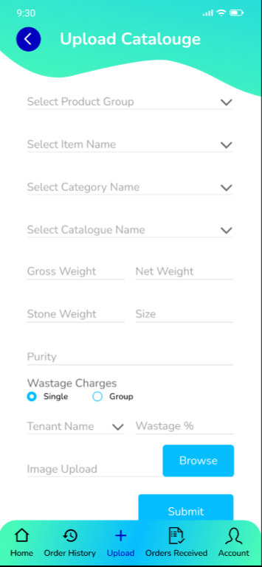

Fig: Single Upload

Also, once vendor has uploaded the item, then it will be sent to the tenants who has chosen to view catalogue from this vendor.

Further, tenant admin will approve / reject catalogue. If the catalogue is approved by tenant admin, then it will be displayed to all their respective branches.

* Vendor Dashboard page - Vendor Home / Dashboard page will have following fields:
* Search menu
* Bookmarked
* Filter
* Product Group wise search tabs
* Item Name wise search tabs
* Uploaded items

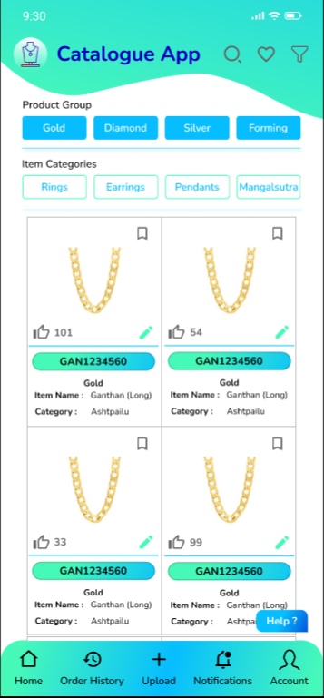

Fig: Vendor Dashboard (Home page)

|  |  |
| --- | --- |
| **FIELDS** | **DESCRIPTION** |
| Search menu | It will be text field.  User will enter the details of the item and the search result should display the search result as per entered details in text field.  Search result should fetch and display the only the vendor’s own items and as present on dashboard page.  Even if the user has entered the entire name of any item and if that item doesn’t exist in the dashboard, then it should display the relevant items in search result. In such case, items should be displayed by product group and item name. |
| Bookmarked | It will display the list of items that vendor has bookmarked.  First view of bookmarked items will be list of items displaying one Image, product group, item name, category name, catalogue name and design code of each item.  Once user clicks on one of the bookmarked item, it will direct user to second view page. Second view of bookmarked items will display all details of item as follows:   * Images * Design Code * Product Group * Item Name * Category Name * Catalogue Name * Stone wt * Net wt * Gross wt * Size * Purity * Wastage Charges (in %) * Diamond Name, Diamond wt, Diamond Rate, Diamond Amount * Price   All details will be read only on first view page of bookmarked item.  Second view of catalogue will have edit action at the corner. Through edit action, vendor can edit details of uploaded items. In edit action; design code and product group will not be editable.  Once user swipes left then the item should be removed / vanished from bookmark list. |
| Filter | It will have following fields:   * Product Group * Item Name * Category Name * Catalogue Name * Net wt * Stone wt * Gross wt * Size * Purity * Wastage Charges (in %) * Diamond Name * Diamond wt * Diamond amount * Price * Apply filter button   For gross wt, net wt, stone wt, size, wastage charges, diamond wt, amount, price we have to provide slider representing the range.  User can apply one, multiple or all filters as per product group.  Stone wt should displayed only if user has selected gold or silver product group. Else stone wt field shouldn’t be displayed.  Diamond name, diamond wt and value range should displayed only if user has selected diamond product group. Else these diamond related fields shouldn’t be displayed.  Price range should displayed only if user has selected MRP or Forming product group. Else this field shouldn’t be displayed.  Search result should fetch and display the only the vendor’s own items and as present on dashboard page. |
| Product Group wise search tabs | It should display Gold, silver, Diamond, MRP and forming tabs.  Once user click on each tab, it should display all the items on dashboard of that selected product group. |
| Item wise search tabs | It should display earrings, necklace, ring, bracelet, bangle, pendant, chain, nose ring, anklet, toe ring, mangalsutra, kamarpatta, bajuband, mekhala, bindi tabs.  Once user click on each tab, it should display all the items on dashboard of that selected item. |
| Uploaded Items | List of items uploaded by the vendor should be displayed on dashboard. For each item, following details should be displayed on dashboard:   * Image * Design Code * Product Group * Item name * Category name * Catalogue Name * Edit action * Bookmark action * Like Count   Once vendor taps on the item, it should direct vendor to item details page which will display following read only fields of each item:   * Images * Design code * Product Group * Item name * Category name * Catalogue name * Net wt * Stone wt * Gross wt * Size * Purity * Wastage Charges (in %) * Diamond Name * Diamond wt * Diamond amount * Price * Like count * Edit action * Bookmark button   Count of tenants who has approved the item and forwarded to their respective branches will be displayed in Like count field.  Through edit action, vendor can edit details of uploaded item. In edit action; design code and product group will not be editable. Once vendor edits the item details, the same should be reflected on dashboard item and to the vendors. The made changes will be applicable to the upcoming orders i.e. edited changes will not be applicable for the orders which are already placed. In edit action, we have to add additional field namely ‘Item Status’. It will be single select drop-down consisting out of stock and out-of-date.  Vendor can bookmark the item and it will be displayed in list of bookmarked items. |

* Orders Received

Orders confirmed by tenants will be submitted to vendor. It will be displayed to vendor on orders received page. First view of orders received page will display the list of orders received from multiple tenants. It will have following fields:

* Order No.
* Date of order
* Image (one)
* Pcs Ordered
* Tenant Name / ID

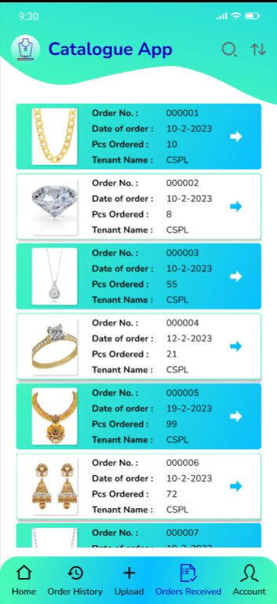

Newest received orders should be displayed at the top. Once vendor clicks on one of the order, it will direct vendor to second view where all details of order will be displayed. It will have following fields:

* Order No.
* Date of order
* Images
* Product Group
* Item Name
* Category Name
* Catalogue Name
* Stone wt (if gold or silver PG)
* Net wt
* Gross wt
* Size
* Purity
* Diamond name, Diamond wt, Diamond rate, Diamond amount (if Diamond PG)
* Price (if MRP or forming PG)
* Pcs Ordered
* Tenant Remark
* Expected Delivery Date
* Vendor Remark
* Confirm Order button
* Cancel Order button

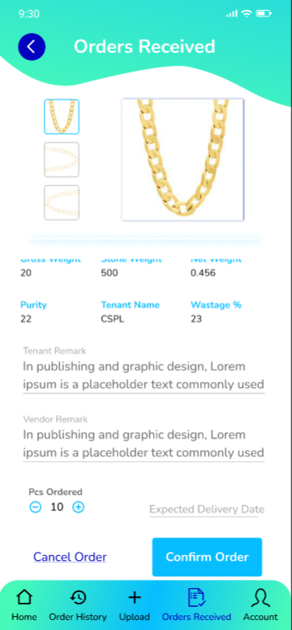

In second page; Pcs ordered, expected delivery date and Vendor remark fields will be editable.

|  |  |
| --- | --- |
| **FIELDS** | **DESCRIPTION** |
| Pcs ordered | It will display the count of pcs confirmed by tenant.  Vendor can edit the count of pcs. In case tenant has ordered some count specific count for particular item but those many pcs aren’t available at vendor, then vendor can edit and confirm the less count of pcs which are available for delivery.  It will have decrement button next to it which will enable vendor to reduce the pcs count.  Vendor may or may not edit the pcs count. |
| Expected Delivery Date | It will be mandatory field.  It will be calender picker.  From order received date, back dates should be disabled. |
| Vendor Remark | It will be optional field if vendor hasn’t reduced the count of pcs as ordered by tenant.  It will be mandatory field if vendor has reduced the count of pcs as in order received from tenant.  It will be text field.  It should accept characters, numbers, special characters and space.  Maximum length of input field should be 100 characters. |
| Confirm order (button) | Confirm order button should be enabled only when vendor has filled mandatory field. Else it should be disabled.  Once user has filled mandatory fields and clicks on confirm order button, pop-up message should be displayed as “Order no. ##### confirmed successfully. Update sent to tenant.” and user should be directed back to first page of orders received.  Once order is confirmed by vendor, notification about confirmation of order should be sent to tenant. Also, the details of the order should get updated on tenant web -> orders confirmed and branch -> order status page.  Order once confirmed by vendor should be removed from first page of orders received and should be displayed on first page of Orders History. |
| Cancel Order button | Vendor can cancel the order if the items in order isn’t available for delivery.  Once user clicks on cancel button, a pop-up message should be displayed as ‘Are you sure you want to cancel this order? Yes / No’.  If vendor confirms as order to be cancelled, then it should be removed from orders received page and should be displayed in orders history page.  Also, notification of cancelled order should be sent to tenant via WhatsApp and SMS.  Additionally, status of cancelled order should be changed and reflected on tenant and branch orders page. |

* Order History

Orders once confirmed by vendor on orders received page, it should be displayed on order History page. Recently confirmed orders should be displayed at top. It will have search menu, sort by option and list of orders.

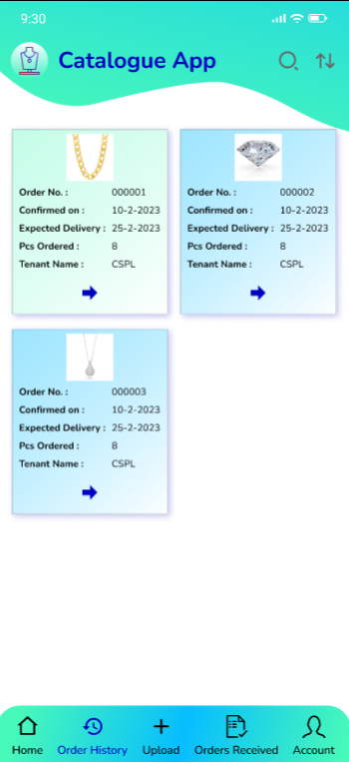

|  |  |
| --- | --- |
| **FIELDS** | **DESCRIPTION** |
| Search menu | Vendor should be able to search order by tenant name / ID. |
| Sort By | Vendor should be able to search orders by date in ascending / descending manner. |
| List of orders | For each order, it should display following read only fields in first page list:   * Order No. * Image (one) * Pcs Confirmed * Tenant Name * Confirmed on |

Once user clicks on one of the order, it should direct user to second page where it will display all the details of the particular order. It will have following fields:

Images

* Order no.
* Product group
* Item name
* Category name
* Catalogue name
* Stone wt (if gold or silver PG)
* Net wt
* Gross wt
* Size
* Purity
* Diamond name, Diamond wt, Diamond rate, Diamond amount (if Diamond PG)
* Price (if MRP or forming PG)
* Tenant Remark
* Vendor remark
* Pcs confirmed
* Expected delivery date
* Confirmed On
* Status
* Send message button

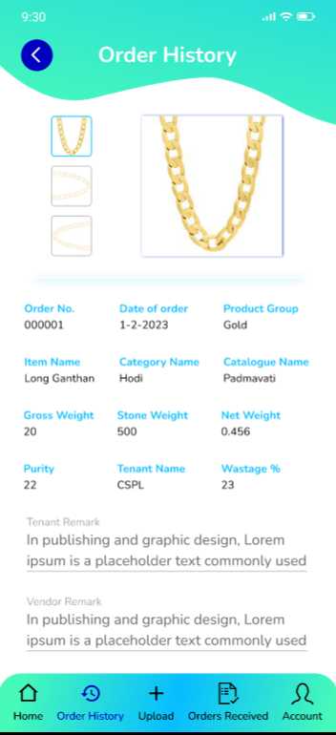 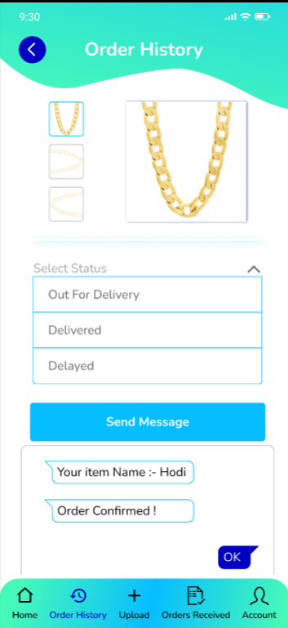

|  |  |
| --- | --- |
| **FIELDS** | **DESCRIPTION** |
| Confirmed On | It will display the date on which the vendor confirmed this order from orders received page. |
| Status | It will be editable field. It will be single select drop-down consisting in process, out for delivery, delayed, canceled and completed in the list.  Initially when user confirms the order, its status should be displayed as in process by default.    Each time when vendor changes the status, its notification should be sent to tenant and status should be changed accordingly on tenant and branch order history page. |
| Send Message Button | Once user clicks on send message button, it should display the previous sent messages (chat done by tenant and vendor). Also, it should have text field at the bottom and send button next to provided text field.  All notifications sent to this vendor related to the particularly selected order should be displayed here.  Each time when vendor will send new message to tenant, it should be reflected to tenant web app -> notification page.  In send message, only the tenant name / Id will be displayed against each message. |

* Profile

It will have following sections:

* Profile details
* Bookmark
* Notification menu
* Language
* Help
* Sign out

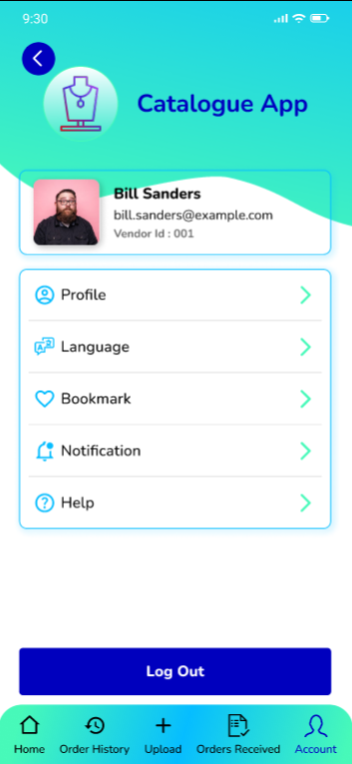

* Once vendor clicks on ‘Profile details’ it will display following details:
* Image / logo
* Vendor ID/ Code
* Vendor Name
* Email address
* Contact Number
* Address
* Authority Name
* Vendor Type
* PAN no.
* GST no.
* Password (button)

|  |  |
| --- | --- |
| **FIELDS** | **DESCRIPTION** |
| Image / logo | It will be image which was added by vendor while registering.  It will be editable field. It should accept png, jpeg and jpg files. |
| Vendor ID / code | Once vendor registration is done and confirmation is given successfully, vendor ID will be created. It will be displayed here.  (Not editable) |
| Vendor Name | Vendor name as entered by vendor while registration, it should be displayed here. |
| Email address | Email address as entered by vendor while registration, it should be displayed here.  (Not editable) |
| Contact number | Contact number as entered by vendor while registration, it should be displayed here. It will be editable field.  It will be text field.  Only numbers should be accepted.  Maximum 10 digits should be accepted.  It should be unique.  Consecutive ten zeros or consecutive ten ones shouldn’t be accepted as a number. |
| Address | Email address as entered by vendor while registration, it should be displayed here.  It will be editable field.  Maximum length of input field should be 50 characters. |
| Authority name | Email address as entered by vendor while registration, it should be displayed here.  It will be editable field.  Maximum length of input field should be 50 characters. |
| PAN no. | PAN number as entered by vendor while registration, it should be displayed here.  (Not editable) |
| GST no. | GST number as entered by vendor while registration, it should be displayed here.  (Not editable) |
| Vendor type | Vendor type as entered by vendor while registration, it should be displayed here.  It will editable field.  It should have drop-down consisting Manufacturer / distributor / provider. |
| Change password button | Once vendor clicks on password button, it should display following fields on next page:   * Old password * New password * Confirm password * Submit (button)   Old password and New password will be text field. It should also accept alphanumeric value and all special characters. Password should be case sensitive. Minimum length of password should be 6 characters and maximum length should be 10. Password must have at least one capital letter, at least one special character and at least one number.  In case of incorrect old password, display error message as “Incorrect old password”.  In case user has entered new password exactly same as old password, then display error message as “Old password & new password cannot be same”.  Once vendor enters valid password and clicks on update button, it will display message as “Password changed successfully.”. |
| Update (button) | Once user has made any changes to editable fields and clicks on update button, It should display message as “Profile details updated successfully.”. |

* Notification

Once user clicks on notifications, it should direct user to list of notifications which will be displayed tenant wise. Here, it will display following details:

* Tenant name / ID
* Date of recently received message
* Unread message count

Once user clicks on tenant name, it will display list of all the notifications / messages sent by vendor to this tenant as well as notifications / messages received from this tenant. For each notification, it will display the order number, notification content, date and time ans send message button next to it.

Once user clicks on send message button, it should direct the vendor to chat of that order in order status page.

* Language

It will display two radio buttons:

* English
* Hindi

As per selected language, the strings of the application should change.

* Help

Once user clicks on help button, a dialogue box will open up. It should display text field where user will manually enter their suggestions / concern / queries.

It should accept characters, numbers, special characters and space. Maximum length of input field should be 250 characters. It should accept English and Devanagiri (marathi / hindi) script.

In case user has kept text field blank and directly clicks on submit button, then it should display on field message as “Please enter your query.”

Once user enters details in text field and clicks on submit, it should display message as “Thank you for writing to us. We will get back to you soon.”

The written query should be sent to super-admin web app. It should be displayed in list of notifications to super-admin.

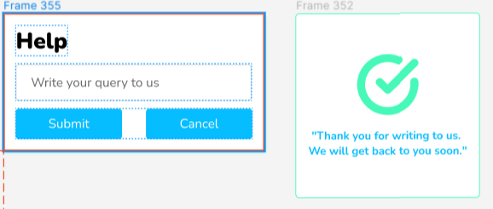

Fig: Help

* Sign out

Once vendor clicks on sign out button, it should display pop-up message as “Are you sure you want to log out? Yes / No”.

Once vendor clicks on yes, it should display message as “Logged out” and direct vendor on sign-in page.

If user clicks on No, it should keep vendor on the existing page.

**BRANCH MOBILE APP**

Once tenant has successfully added their branch and created credentials for their branch, branch can log into mobile app. Branch will have following pages in mobile application:

* Sign in
* Home (catalogue lists)
* Your orders
* Profile
* Sign out
* Home (catalogue lists)

It will display following fields:

* Search menu
* Filter button
* Bookmark button
* Product group wise tabs
* Item wise tabs
* List of items (approved by their respective tenant)

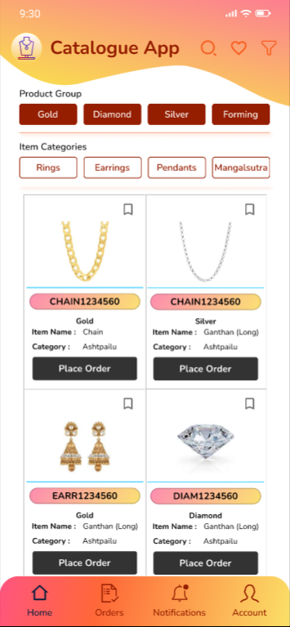

|  |  |
| --- | --- |
| **FIELDS** | **DESCRIPTION** |
| Search menu | It will be text field.  Branch will enter the details of the item and the search result should display the search result as per entered details in text field.  Search result should fetch and display the items as present on dashboard page.  Even if the branch has entered the entire name of any item and if that item doesn’t exist in the dashboard, then it should display the relevant items in search result. In such case, items should be displayed by product group and item name. |
| Bookmarked | It will display the list of items that branch has bookmarked.  First view of bookmarked items will be list of items displaying one Image, product group, item name, category name, catalogue name and design code of each item.  Once user clicks on one of the bookmarked item, it will direct user to second view page. Second view of bookmarked items will display all details of item as follows:   * Images * Design Code * Product Group * Item Name * Category Name * Catalogue Name * Stone wt * Net wt * Gross wt * Size * Purity * Wastage Charges (in %) * Diamond Name, Diamond wt, Diamond Rate, Diamond Amount * Price * Pcs (+ and -) * Branch Remark * Place order button   Branch can enter pcs they want to order. Initially, pcs count should display zero as default value.  Branch remark : It will be mandatory text field.  It should accept characters, numbers, special characters and space.  Maximum length of input field should be 100 characters.  Once user clicks on place order button, it should display pop-up message as “Do you want to confirm this order request? Yes / No”. Once branch clicks on yes, then it should display message as your order is forwarded successfully to your tenant.  If branch hasn’t entered pcs count and directly clicks on place order then it should display error message near pcs field. |
| Filter | It will have following fields:   * Product Group * Item Name * Category Name * Catalogue Name * Net wt * Stone wt * Gross wt * Size * Purity * Wastage Charges (in %) * Diamond Name * Diamond wt * Diamond amount * Price * Apply filter button   For gross wt, net wt, stone wt, size, wastage charges, diamond wt, amount, price we have to provide slider representing the range.  User can apply one, multiple or all filters as per product group.  Stone wt should displayed only if user has selected gold or silver product group. Else stone wt field shouldn’t be displayed.  Diamond name, diamond wt and value range should displayed only if user has selected diamond product group. Else these diamond related fields shouldn’t be displayed.  Price range should displayed only if user has selected MRP or Forming product group. Else this field shouldn’t be displayed. |
| Product Group wise search tabs | It should display Gold, silver, Diamond, MRP and forming tabs.  Once user click on each tab, it should display all the items on dashboard of that selected product group. |
| Item wise search tabs | It should display earrings, necklace, ring, bracelet, bangle, pendant, chain, nose ring, anklet, toe ring, mangalsutra, kamarpatta, bajuband, mekhala, bindi tabs.  Once user click on each tab, it should display all the items on dashboard of that selected item. |
| List of Items | List of items approved by their tenant should be displayed on dashboard. For each item, following details should be displayed on dashboard:   * Image * Design Code * Product Group * Item name * Category name * Catalogue Name * Bookmark action * place order button   Once branch taps on the item, it should direct vendor to item details page which will display following read only fields of each item:   * Images * Design code * Product Group * Item name * Category name * Catalogue name * Net wt * Stone wt * Gross wt * Size * Purity * Wastage Charges (in %) * Diamond Name * Diamond wt * Diamond amount * Price * Bookmark button * Pcs * Branch remark * Place order button   Branch can bookmark the item and it will be displayed in list of bookmarked items.  Branch can enter pcs they want to order. Initially, pcs count should display zero as default value.  Branch remark : It will be mandatory text field.  It should accept characters, numbers, special characters and space.  Maximum length of input field should be 100 characters.  Once user clicks on place order button, it should display pop-up message as “Do you want to confirm this order request? Yes / No”. Once branch clicks on yes, then it should display message as your order is forwarded successfully to your tenant.  If branch hasn’t entered pcs count and directly clicks on place order then it should display error message near pcs field. |

* Branch Profile

It will have following fields:

* Profile details
* Wish list
* Notification menu
* Language
* Help
* Sign out

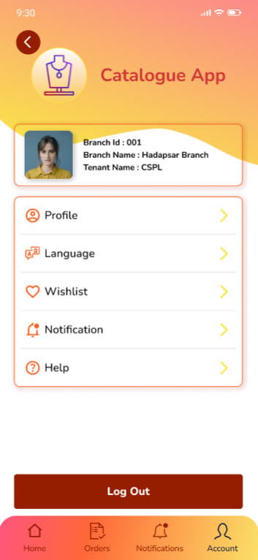

* Once branch clicks on ‘Profile details’ it will display following details:
* Image / logo
* Branch ID/ Code
* Branch Name
* Tenant Name & ID
* Contact Number
* Address
* Branch manager Name
* Password (button)

|  |  |
| --- | --- |
| **FIELDS** | **DESCRIPTION** |
| Image / logo | It will be image which was added by their respective while adding branch in web app.  It will be editable field. It should accept single file with png / jpeg / jpg extension. |
| Branch ID / code | Once tenant has added their branch in web app, branch ID / code will be generated by the system. It will be displayed here.  (Not editable) |
| Branch Name | Once tenant has added their branch name in web app while adding, it will be displayed here.  (Not editable) |
| Tenant name and ID | It will display the name and ID of their tenant. (not editable) |
| Contact number | Contact number as entered by tenant while adding branch, it should be displayed here. It will be editable field.  It will be text field.  Only numbers should be accepted.  Maximum 10 digits should be accepted.  It should be unique.  Consecutive ten zeros or consecutive ten ones shouldn’t be accepted as a number.  Once branch has updated the contact number from their end through mobile application, the same should be updated in branch master (web app). |
| Branch Address | Address as entered by tenant while adding the branch, it should be displayed here.  It will be editable field.  Maximum length of input field should be 50 characters.  Once branch has updated the address from their end through mobile application, the same should be updated in branch master (web app). |
| Branch manager Name | Branch manager name as entered by tenant while adding the branch, it should be displayed here.  It will be editable field.  Maximum length of input field should be 50 characters.  Once branch has updated the branch manager name from their end through mobile application, the same should be updated in branch master (web app). |
| Change password button | Once vendor clicks on password button, it should display following fields on next page:   * Old password * New password * Confirm password * Submit (button)   Old password and New password will be text field. It should also accept alphanumeric value and all special characters. Password should be case sensitive. Minimum length of password should be 6 characters and maximum length should be 10. Password must have at least one capital letter, at least one special character and at least one number.  In case of incorrect old password, display error message as “Incorrect old password”.  In case user has entered new password exactly same as old password, then display error message as “Old password & new password cannot be same”.  Once branch enters valid password and clicks on update button, it will display message as “Password changed successfully.”.  Once branch has changed password, the details should be updated in branch master. |

* Notification

Branch will receive the notification when order was confirmed by their tenant and each time when status of the order gets changed.

Once user clicks on notifications, it should direct user to order wise list of notifications. It will display following details:

* Order number
* Date of recently received message
* Unread message count

Once user clicks on notification of any one of the order, it will display the all the notifications related to that order, content of notification, date and time when notification was received.

* Language

It will display two radio buttons:

* English
* Hindi

As per selected language, the strings of the application should change.

* Help

Once user clicks on help button, a dialogue box will open up. It should display text field where user will manually enter their suggestions / concern / queries.

It should accept characters, numbers, special characters and space. Maximum length of input field should be 250 characters. It should accept English and Devanagiri (marathi / hindi) script.

In case user has kept text field blank and directly clicks on submit button, then it should display on field message as “Please enter your query.”

Once user enters details in text field and clicks on submit, it should display message as “Thank you for writing to us. We will get back to you soon.”

The written query should be sent to super-admin web app. It should be displayed in list of notifications to super-admin.



Fig: Help

* Sign out

Once branch clicks on sign out button, it should display pop-up message as “Are you sure you want to log out? Yes / No”.

Once branch clicks on yes, it should display message as “Logged out” and direct vendor on sign-in page. If branch clicks on No, it should keep vendor on the existing page.

* Your orders

Here it will display the list of orders placed by the branch and its status.

On first view, it will display list of orders with following details of each order:

Image

Order No.

Product group

Item name

Category name

Pcs

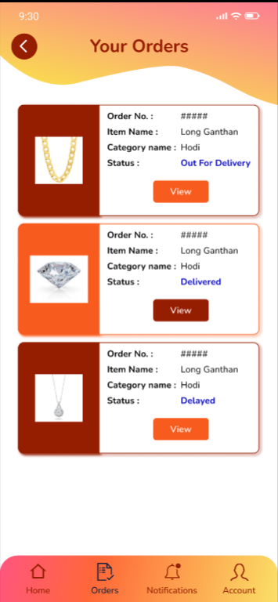

Once branch clicks on one of the order, it will display following read only fields on second page:

* Images
* Order no.
* Product group
* Item name
* Category name
* Catalogue name
* Stone wt (if gold or silver PG)
* Net wt
* Gross wt
* Size
* Purity
* Diamond name, Diamond wt, Diamond rate, Diamond amount (if Diamond PG)
* Price (if MRP or forming PG)
* Branch Remark
* Tenant remark
* Pcs ordered
* Pcs approved by tenant admin
* Pcs confirmed by vendor
* Expected delivery date
* Status
* Order placed on (date)
* Send message button - Once branch enters message here, it will be sent to their respective tenant in orders notification page.

**TENANT WEB APP**

Once tenant admin logs into web application, it have provision to following menus:

* Sign in
* Profile
* Notifications
* Add Branch
* List of vendors
* Vendor Recommendation and send request
* Validate Orders (approve/reject / edit orders placed by their branch)
* Orders confirmed / status
* Reports (Branch wise orders placed, Branch wise orders confirmed)
* Profile

It will display following fields as entered by tenant while registration:

* Image / logo
* Tenant ID/ Code
* Tenant Name
* Contact Number
* WhatsApp no.
* Address
* Country - State - city
* Email address
* Type of Ownership
* Authority Details
* Authority Name
* Authority Designation
* Authority Contact Number
* GST No.
* PAN No.
* Certified Product Groups: Gold, Silver, Forming, MRP, Diamond
* Certificate number of registration issued by registrar (while establishment)
* Any other BIS certificate
* Password
* Save (button)

Here, tenant name, GST no, PAN no, registration no, BIS certificate will be non editable fields.

Password field will display encrypted password. It will have view button and change password button next to it. Through view button, it will display password in decrypt-ed format. Through change password, tenant admin can change password by entering updated password in ‘new password’ and ‘confirm password’ text fields.

Once tenant admin edits remaining editable fields, it will display message as ‘profile edited successfully’.

* Add branch

It will display following fields:

* Add branch (button)
* Grid:
* Sr No.
* Action - edit, view
* Branch ID
* Branch name
* Branch address
* Branch contact no.
* Email
* Branch manager name

Once user clicks on add branch button, it will display following fields of form:

* Branch name
* Branch address
* Branch contact no.
* Email
* Branch manager name
* Password
* Image / logo
* Remark
* Is active
* Submit (button)

|  |  |
| --- | --- |
| **FIELDS** | **DESCRIPTION** |
| Branch name | It will be mandatory text field.  Tenant will enter branch name.  It should accept characters and space.  Maximum length of input field should be 50 characters.  This field shouldn’t be case sensitive. |
| Branch address | It will be mandatory text field.  Tenant will enter branch address.  It should accept characters and space.  Maximum length of input field should be 50 characters.  This field shouldn’t be case sensitive. |
| Branch contact no. | It will be mandatory text field.  Only numbers should be accepted.  Maximum 10 digits should be accepted.  It should be unique.  Consecutive ten zeros or consecutive ten ones shouldn’t be accepted as a number. |
| Email | This field should accept “ @ - . “ only as special characters.  In case of invalid format, it should display on field error message as “Invalid email address”.  It shouldn’t accept space anywhere.  It should be unique.  Maximum length of input field should be 50 characters. |
| Branch manager name | It will be mandatory text field.  Tenant will enter branch manager name.  It should accept characters and space.  Maximum length of input field should be 50 characters.  This field shouldn’t be case sensitive. |
| Image / logo | Tenant will attach only one image in this field.  It should accept png, jpeg and jpg extensions only. |
| Password & confirm password | Tenant admin will enter ans set password for the branch. |
| Remark | Optional text field.  Maximum length of input field should be 50 characters. |
| Is active | Yes / No radio buttons will be displayed.  By default radio button will be displayed on yes.  If tenant admin deactivates the particular branch then the branch shouldn’t be able to login on mobile application. It should display message to branch on sign in page “Branch deactivated. Please contact your admin”. |
| Submit | Once tenant admin clicks on submit, then branch should be added and displayed on grid. Branch ID should be generated for the added branch and displayed on grid.  Also, the notification of the credentials should be sent to branch via sms and email on mentioned email address and number.  Also, once branch is added then it should get added in super admin -> list users. |

* Notifications

It will display list of notifications received from vendor and branch against each order. On first view, it will display following fields of each order:

Image

Order no.

Date and time of notification

Content

Notification from - (vendor name or branch name will be displayed here)

Once tenant admin clicks on particular notification, it should direct tenant admin to chat box where it will display list of all messages received from both vendor and branch. (Display messages by tenant admin, branch and vendor with different colour for each.)

Whereas, tenant admin will select send to (either branch or either vendor) while sending reply or message. As per selected to person (either send to branch or send to vendor), the messages should be displayed to them in their application in the selected order number.

**References of the users**

|  |  |  |  |
| --- | --- | --- | --- |
| **User** | **Name** | **Mail** | **Contact number** |
| **Actual user** | Tushar Nikam | itinv@csjewellers.com | 2607 |
| **Ticket created by (if any)** | Tushar Nikam | itinv@csjewellers.com |  |
| **Assigned business analyst** | Manali Bhadirage | Manali.bhadirage@techneai.com | 2964 |
| **Assigned developer** | Pranjali Maske | [Pranjali.maske@techneai.com](mailto:Pranjali.maske@techneai.com) |  |
| **Assigned tester** | Poonam deshmukh | Poonam.deshmukh@techneai.com | 2964 |