Manali Ashok Bhadirage

Manali.bhadirage@techneai.com

06.09.2023

CU BILL CHECKING - EXPORT CUSTOM

**Handover Document**

**CONTENTS**

1. TICKET DETAILS 2

2. INTRODUCTION 2

3. BUSINESS REQUIREMENT 2

4. SCOPE 3

5. BUSINESS & SYSTEM RULES 3

6. ABBREVIATIONS & TERMS 4

7. GRAPHICAL REPRESENTATION 4

8. DEVELOPED SYSTEM 4

9. REFERENCES OF THE USERS 6

1. **TICKET DETAILS**

|  |  |
| --- | --- |
| **Ticket ID** | TT12398 |
| **Ticket description** | In Connect us Bill checking Point Custom Export add two new Coolum Debit Advance And UTR Number |
| **Created by** | Amar Landge |
| **Created on** | 19/05/2023 |
| **Priority** | Very high |

1. **INTRODUCTION**

Introducing "Bill Connect US": a seamless system that simplifies bill management for users. With this innovative platform, users can effortlessly submit vendor bills and facilitate swift payment processing. All payment records are meticulously maintained and audited to ensure transparency.

Integrating with Padm, "Bill Connect US" offers an added advantage by displaying the current balance of each vendor. This feature empowers entry users to make informed decisions when submitting bills, as they can analyze the available funds in the Padm account for each vendor. By having visibility into the vendor's balance, users can strategies their bill submissions, avoiding unnecessary work and streamlining the process.

In summary, "Bill Connect US" streamlines bill submissions and payment processing, providing valuable insights into vendor balances through integration with Padm. This empowers entry users to optimize their bill submissions and foster a more efficient workflow.

1. **BUSINESS REQUIREMENT**

In CU -> Bill checking -> Bill checking transaction, we have export custom button through which user selects the fields that he wants from the bills displayed in his grid and can download the report in csv or pdf format.

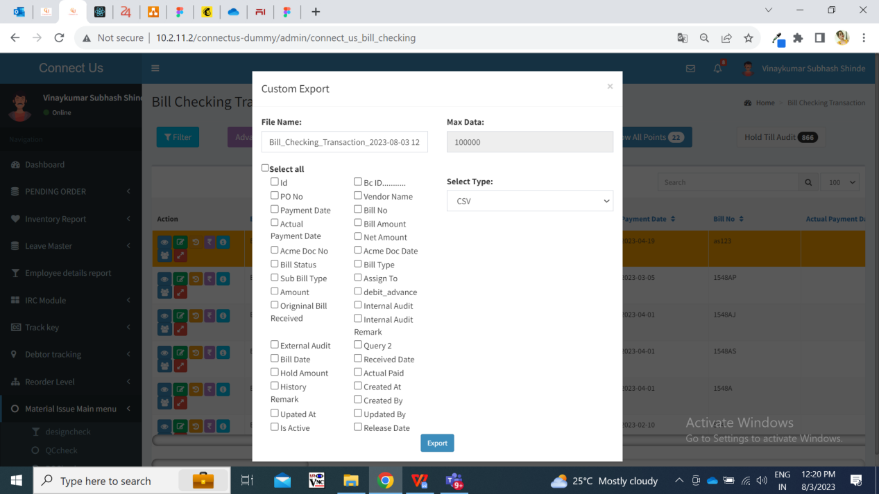

|  |  |  |  |
| --- | --- | --- | --- |
| **Requirement ID** | **Requirement Name** | **Short Description** | **Priority** |
| BR001 | Debit advance check-box in custom export fields | We have added the debit advance field in custom export options. It will display the correct data in this field once file is downloaded. | Medium |
| BR002 | UTR no. Check-box in custom export | We have added UTR no. Field in custom export and it will display the correct data in this field once file is downloaded. | medium |
| BR003 | Downloaded file | Once user selects the fields / columns needed in his report and clicks on download, then the report will display the selected columns and the right data in it as per bills. | Medium |

1. **SCOPE**

Once user selects debit advance field, UTR no. field, other fields and clicks on export button, then pdf / csv file will get downloaded as selected and it will display all correct data with the columns as chosen in custom export. It should display data from the bills that are available in the logged in person’s grid only.

The functionality and validation issues in add bill, edit bill, view bill, payment history, payment details, assigned person, history are not part of this scope.

1. **BUSINESS & SYSTEM RULES**

* User will be registered in the system.
* User will be logged in.
* In case there are no bills in grid of the person’s login, then it will display .message as ‘No data to export’ when user tries to download data through custom export button.

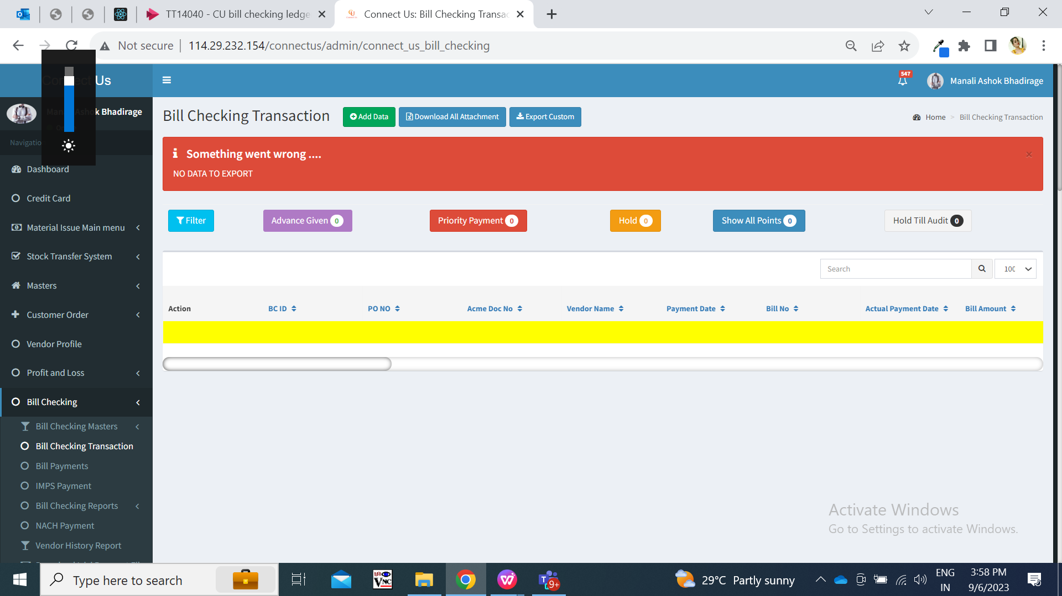

1. **ABBREVIATIONS & TERMS**

CU - Connect Us

UTR number - Unique Transaction Reference

1. **GRAPHICAL REPRESENTATION**

**Download file & display selected columns with data**

**Select file type and click on export button**

**Select fields from custom export button**

**Add UTR number or Debit Advance in custom export**

Fig: General Context Diagram

1. **DEVELOPED SYSTEM**

In Cu -> Bill checking transaction -> export custom button, we have added ‘UTR Number’ and ‘Debit advance’ fields.

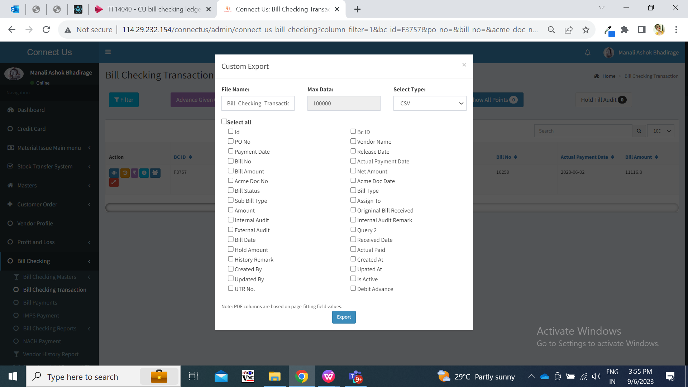

**Input table**

|  |  |  |  |
| --- | --- | --- | --- |
| **FIELDS** | **INPUT TYPE** | **MANDATORY/ OPTIONAL** | **DESCRIPTION** |
| UTR Number | text | Optional | Once user clicks on UTR number check-box and clicks on export button, then it will download the file and downloaded file will have UTR number column in it.  Further, it will display the UTR number for each bill from payment details action of that bill.  In case, the amount from one bill is split into more than one rows then it will display UTR number in downloaded file separated by comma. If UTR number is not available for that bill in payment details, then it will be displayed blank in downloaded file. |
| Debit Advance | text | Optional | Once user clicks on Debit advance check-box in custom export and clicks on export button, then it will download the file and downloaded file will have Debit advance column in it.  Further, it will display the debit advance for each bill from bill transaction -> debit advance field. If there is no value in debit advance field in bill, then in exported file will display blank in this column for that bill. |

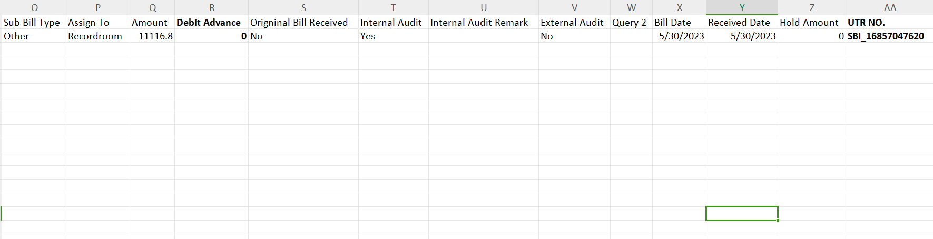

1. **REFERENCES OF THE USERS**

|  |  |  |  |
| --- | --- | --- | --- |
| **User** | **Name** | **Mail** | **Contact number** |
| **Actual user** | Amar landge  Pritam metha | [isa@csjewellers.com](mailto:isa@csjewellers.com)  ia@csjewellers.com |  |
| **Ticket created by (if any)** | Amar landge | is@csjewellers.com |  |
| **Assigned business analyst** | Manali bhadirage | Manali.bhadirage@techneai.com |  |
| **Assigned developer** | Yogita jagtap | Yogita.jagtap@techneai.com |  |
| **Assigned tester** | Vaishnavi khandwe | Vaishnavi.khandwe@techneai.com |  |