Manali ashok bhadirage

Manali.bhadirage@techneai.com

29.09.2023

IMPS PAYMENT - IFSC CODE & ACCOUNT NUMBER VALIDATION

**Handover Document**

**CONTENTS**

1. TICKET DETAILS 2

2. INTRODUCTION 2

3. BUSINESS REQUIREMENT 3

4. SCOPE 3

5. BUSINESS & SYSTEM RULES 3

6. ABBREVIATIONS & TERMS 3

7. GRAPHICAL REPRESENTATION 3

8. PROPOSED SYSTEM 4

9. REFERENCES OF THE USERS 11

1. **TICKET DETAILS**

|  |  |
| --- | --- |
| **Ticket ID** | TT14060 |
| **Ticket description** | दिलेल्या फोटो प्रमाणे connect -us मध्ये कॅशियर लॉगिनला अकाउंट नंबर Hide करणे तसेच IFSC CODE ११ अंकी पाहिजे. |
| **Created by** | Firoj Shaikh |
| **Created on** | 12/07/2023 |
| **Priority** | Medium |

1. **INTRODUCTION**

IMPS payment, a sub-module in Connect US -> Bill Checking, is used during 12 URD purchase transactions done in Padm. The payments of URD purchases are processed through IMPS payment module i.e. we have to pay the mentioned payment amount to the customer. The user enters the document series number from Padm and the data as per document number gets displayed. Further these bills are assigned to another user. The authorized person verifies the bill and then changes the status hold / hold till audit / release / paid. Once payments status is changed to release then that bill gets displayed in list of download payment. Moreover, once user enters the bank file then the successful payments get displayed as paid in imps payment module.

1. **BUSINESS REQUIREMENT**

Currently, users (cashiers) are entering the account number and copy-pasting the same in confirm account number field without confirming it. Also, IFSC code doesn’t have any validations.

|  |  |  |  |
| --- | --- | --- | --- |
| **Requirement ID** | **Requirement Name** | **Short Description** | **Priority** |
| BR001 | Decrypt account number field | Through add action, once user enters the values in ‘account number’ field, we have to decrypt it (display asterisk when entered).  User should not be able to copy it.  However, account number will be visible in edit action. | High |
| BR002 | IFSC code validation | In add and edit action, IFSC code field should accept only 11 digits valid format and display error message in case of incorrect format. | High |

1. **SCOPE**

While adding the bill, when user enters account number, then it will be displayed in asterisk. User should not be able to copy encrypted / asterisk value. IFSC code field should accept maximum 11 digits compulsorily. In case, user enters less than 11 digits, then it should display on field error message. Once bill is added by the entry user then it will be displayed in grid of the user to whom the bill is assigned to. Once bill is added then it should display all correct details in view action, grid and history action. Further, when assigned person clicks on edit action then all the details will be displayed correctly as it was entered by entry user while adding the bill.

1. **BUSINESS & SYSTEM RULES**

* User will be registered in the system.
* User will be logged in.
* User should not be able to copy value from account number field.
* IFSC code field should display on field error message in case of incorrect values.

1. **ABBREVIATIONS & TERMS**

IMPS - Immediate Payment Service

IFSC code - Indian financial system code

RTGS - Real time gross settlement

NEFT - national electronic fund transfer

1. **GRAPHICAL REPRESENTATION**

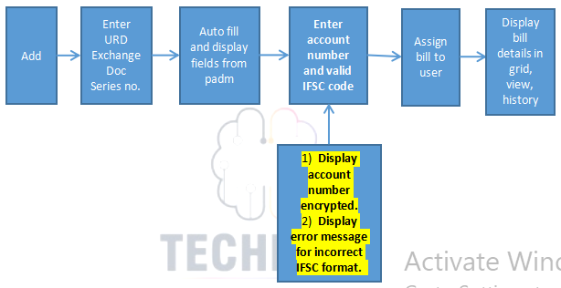

Fig: General context Diagram

1. **PROPOSED SYSTEM**

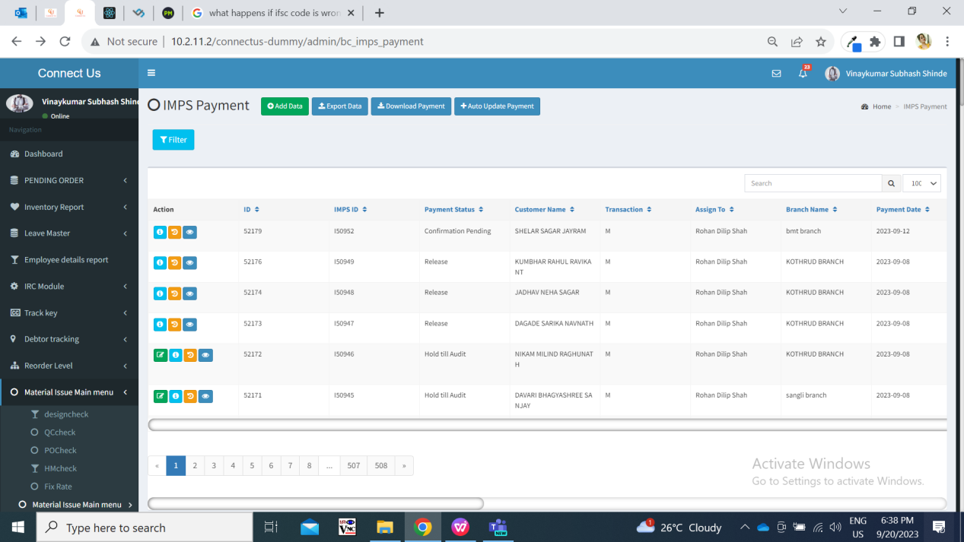

Fig: IMPS Payment menu

Once entry user clicks on **add button** to enterthe bill, it displays following fields:

* Series no. And search button
* Branch name
* Customer name
* Mobile no.
* Address
* Adjust amount
* Padm credit balance
* Payment amount
* Assign to
* Type
* Bank name
* Bank branch
* Ifsc code
* Account number
* Confirm account number
* Attachments
* Remark
* submit button

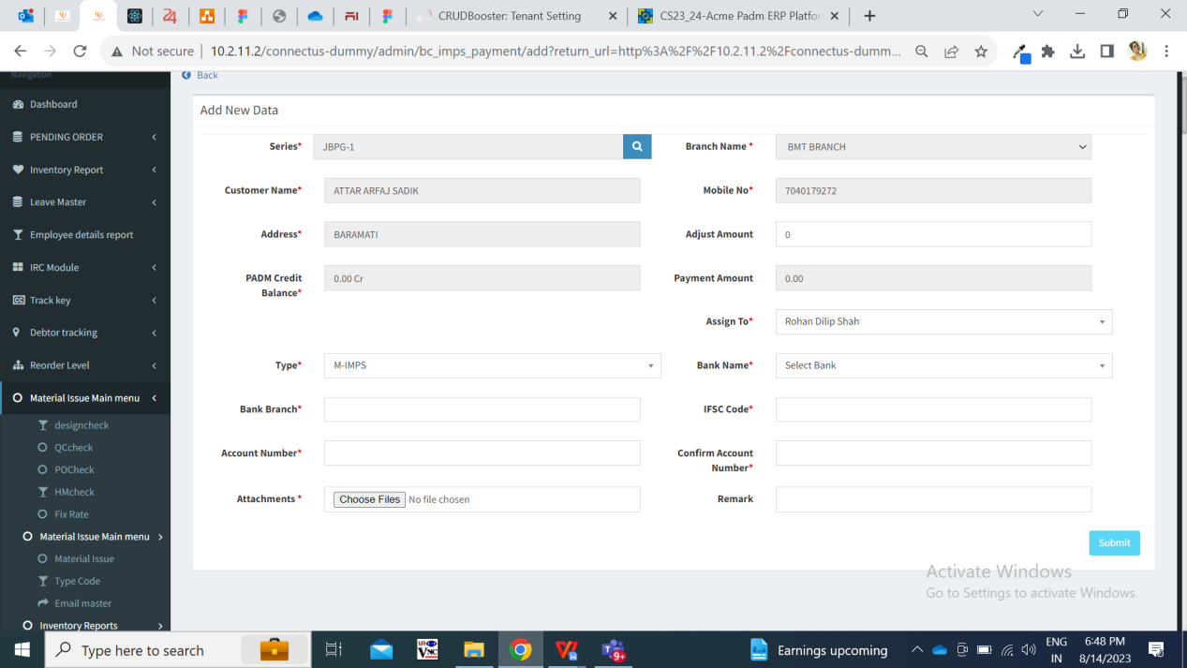

Fig: IMPS Payment -> add action

|  |  |  |  |
| --- | --- | --- | --- |
| **FIELDS** | **INPUT TYPE** | **MANDATORY/ OPTIONAL** | **DESCRIPTION** |
| Series number | text | Mandatory | User enters the document number from Padm -> document -> 12 Gold URD purchase. |
| Branch name | text | Mandatory | It displays the branch name of the logged in person who is adding bill. It displays the branch of logged in person as mentioned in employee master against that logged in person.  It will be read only. |
| Customer name | Text | Mandatory | Once user enters the document number, then it will pre-fill and display the customer name from number against entered series number from padm. |
| Mobile number | Text | Mandatory | Once user enters the document number, then it displays the mobile number of the customer from number against entered series number from padm. |
| Address | Text | Mandatory | Once user enters the document number, then it will pre-fill and display the address of the customer from number against entered series number from padm. |
| Adjust amount | Text | Optional | User manually enters the amount that is to be rounded off I.e. not to be considered for payment out of net payment. |
| Padm credit balance | Text | Mandatory | It will be read only.  iIt displays the net payment value as per entered series number. |
| Payment amount | Text | Mandatory | It will be read only.  Once document number is entered, it displays the value in net payment amount in this field.  Further, if any value is entered in adjust amount field, then it will calculate and display amount which is to be paid to the customer. Payment amount = padm credit balance - adjust amount |
| Assign to | Drop-down | Mandatory | It displays the name of the user to whom the bill is to be assigned. (currently we have only added Rohan shah name in the list as only this user is handling URD bills) |
| Type | Drop-dwon | Mandatory | By default it displays M- Imps from the list whereas user can change it from the drop-down.  It has RTGS, NEFT and M IMPS in the list. |
| Bank name | text | Mandatory | User will enter the customer’s bank name.  Validation: Maximum 30 digits / characters will be accepted. It shouldn’t accept space. |
| Bank branch | text | Mandatory | User will enter the customer’s bank branch name.  Validation: Maximum 25 digits / characters will be accepted. |
| IFSC code | text | Mandatory | User will enter the bank IFSC code.  Validation: Maximum 11 digits will be accepted. User shouldn’t be able to enter more than 11 digits. In case user enters less than 11 digits and submits bill, then it will display on field validation error message. It will not accept space. |
| Account number | text | Mandatory | User will enter the customer’s bank account number.  As and when user enters the account number, each input will be displayed with asterisk. User will not be able to copy it.  Validation: Maximum 25 digits will be accepted. It will not accept space. |
| Confirm account number | text | Mandatory | User will enter the customer’s bank account number as same as entered in above account number field.  Validation: Maximum 25 digits will be accepted. It will not accept space. It should display on field error message if account number is not as same as account number field. |
| Attachments | Attach | Mandatory | User will attach the images of customer’s account document like passbook, cheque, purchase bill invoice, etc.  Validation: It should accept maximum 25 attachments. It should accept png, jpg, jpeg, pdf, doc, heic, webp file extensions only. |
| Remark | text | Optional | User will mention the additional comments in this section.  Validation: Maximum 250 characters / digits. |
| Submit | Click |  | Once bill is submitted, ID for bill will be created and bill will be displayed in the imps payment grid of the assigned person.  Also, it will be displayed in the logged in person’s grid as per branch assigned to him. |

Once bill is submitted, it gets display in the grid of the assigned user and in the grid of the users of their branch. Once bill is displayed in **grid**, it displays following columns in grid:

* View action
* Edit action
* History action
* Payment detail action
* ID
* IMPS ID
* Payment status
* Customer name
* Transaction
* Assigned to
* Branch name
* Payment date
* Customer account
* Series
* Payment amount
* Adjust amount
* IFSC code
* Bank name
* Entry user name
* Active
* Remark
* Entry time

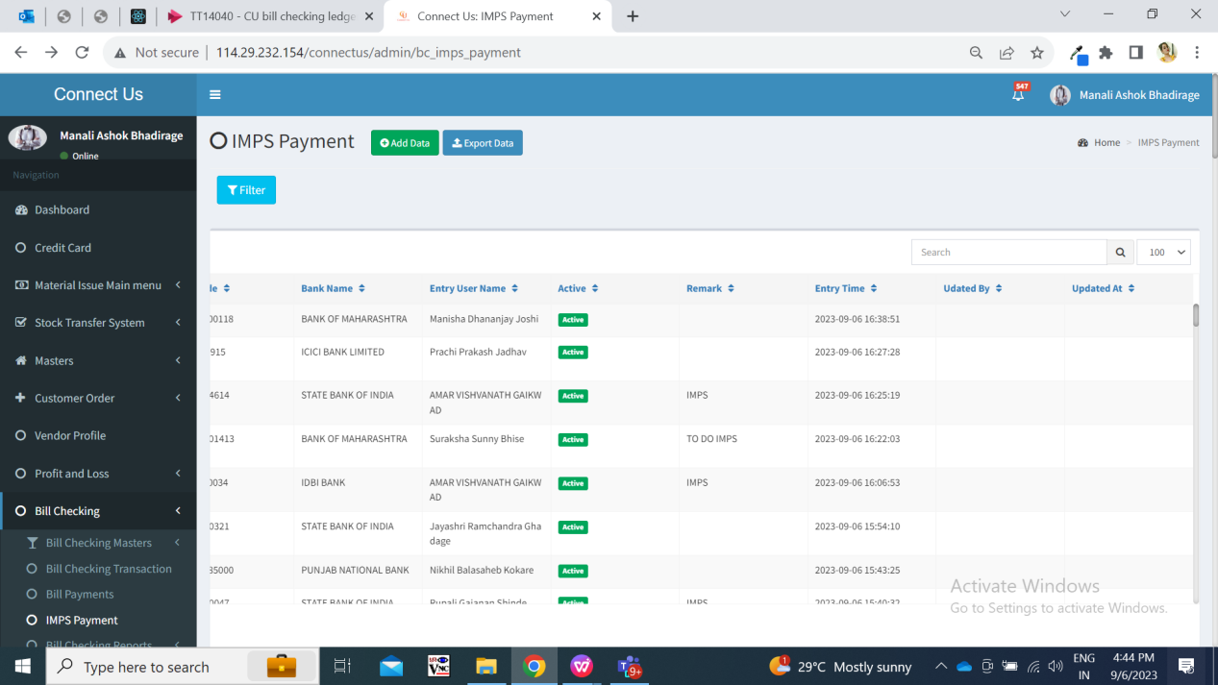

Fig: IMPS payment -> grid

Once data is added / edited, then updated data will be displayed in grid and view action of that bill. Once users click on **view** action, it displays following fields:

* IMPS ID
* Series
* Branch name
* Customer name
* Mobile no.
* Entry user
* Address
* Adjust amount
* Padm balance
* Payment amount
* Assign to
* Type
* Payment status
* Bank name
* Bank branch
* Ifsc code
* Account number
* Attachments
* Remark
* Is active
* Entry time
* Updated at & by

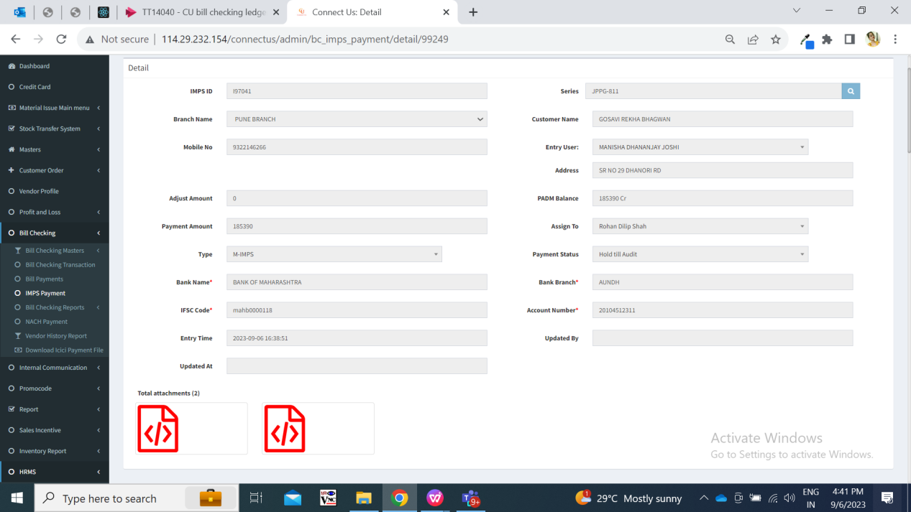

Fig: IMPS payment -> View bill

All the details will be displayed correctly as entered while adding the bill or when bill is edited and submitted.

Once assigned user clicks on **edit** action of the bill, it displays following pre-filled fields:

* IMPS ID
* Series
* Branch name
* Customer name
* Mobile no.
* Entry user
* Address
* Adjust amount
* Padm balance
* Payment amount
* Assign to
* Type
* Payment status
* Bank name
* Bank branch
* Ifsc code
* Account number
* Attachments (to attach)
* Delete / download already added attachments
* Remark
* Is active
* Submit button

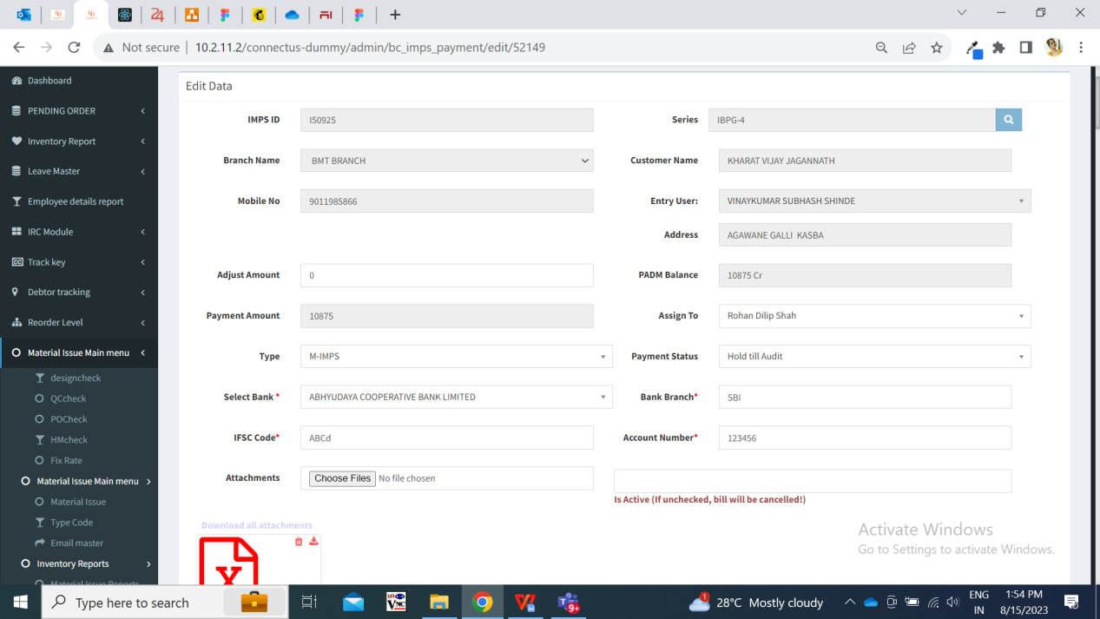

Fig: IMPS payment -> edit action

|  |  |  |  |
| --- | --- | --- | --- |
| IFSC code | text | Mandatory | User will enter the bank IFSC code.  Validation: Maximum 11 digits will be accepted. User shouldn’t be able to enter more than 11 digits. In case, user enters less than 11 digits and submits bill, then it should display on field validation error message. It will not accept space. |
| Account number | text | Mandatory | User will enter the customer’s bank account number.  In edit action, account number will be displayed correctly as it is. (It will not display in encrypted format)  Validation: Maximum 25 digits will be accepted. It should not accept space. |

1. **REFERENCES OF THE USERS**

|  |  |  |  |
| --- | --- | --- | --- |
| **User** | **Name** | **Mail** | **Contact number** |
| **Actual user** | Firoj shaikh | brpayment@csjewellers.com | 2569 |
| **Ticket created by (if any)** | Firoj shaikh | brpayment@csjewellers.com | 2569 |
| **Assigned business analyst** | Manali bhadirage | Manali.bhadirage@techneai.com |  |
| **Assigned developer** | Yogita jagtap | Yogita.jagtap@techneai.com |  |
| **Assigned tester** | Vaishnavi khandwe | Vaishnavi.khandwe@techneai.com |  |