### Vastu jama

### POS

* Vastu jama is use for debit bill. On POS invoice will be created this invoice number will be scan here.
* All invoice number accept here.
* Created by name record as per login.
* POS Table Name - EXT.TAVastuJamaTable

|  |  |  |  |  |  |  |
| --- | --- | --- | --- | --- | --- | --- |
| **Sr. No** | **Section** | **Label name** | **Field Name** | **Data type** | **Data type (POS view)** | **Description** |
|  | Header | Date | Date | Date | Date | Today's date will display auto. This is disable field |
|  | Header | Store | StoreId | Str | Text | This will be show as per login. This is disable field |
|  | Header | Document Number | DocumentNumber | Str | Text | As per branch document number will be generated. This is disable field |
|  | Header | Sales Person name | SalesPersonName | Str | Drop-down | This is mandatory field. Data fetch from “Jewellery -> Master -> agent master” where agent type = Salse person. This data only show. |
|  | Header | Approval Name | ApprovalName | Str | Drop-down | This is mandatory field. Data fetch from “Jewellery -> Master -> agent master” where agent type = Reference person. This data only show. |
|  | Header | Invoice No | InvoiceNo | Str | Text | * Accept alphanumeric field. * If invalid invoice number enter then show popup “Enter valid invoice Number”. * Same customer Multiple invoice number can we enter. * As per invoice number tag list will be show in the line item details. * Customer name must be same on POS and invoice number. If not same then show error. |
|  | Header | Customer Name | CustomerName | Str | Text | Customer name auto fetch from the POS screen. |
|  | Header | Customer Mobile Number | CustomerMobileNumber | Real |  | Customer mobile number auto fetch from the POS screen. |
|  | Header | Customer Address | CustomerAddress | Str |  | Customer address auto fetch from the POS screen. |
|  | Header | Status | Status | Enum |  | When add data then this status is open.  Enum value -  0 - open  1 - partially close  2 - close |
|  | Line | Action |  |  | Button | “x” click on this button then remove the selected line. |
|  | Line | Invoice No | InvoiceNo |  |  | Header “Invoice Number” will be show here. |
|  | Line | Tag No | TagNo | str |  | As per the invoice Tag no show.This is disable field. |
|  | Line | Item name | ItemName | str |  | As per tag item name will be display. This is disable field. |
|  | Line | category | Category | str |  | As per tag category will be display. This is disable field. |
|  | Line | Net wt | NetWt | real |  | As per tag net wt will be display. This is disable field. |
|  | Line | Gross wt | GrossWt | real |  | As per tag gross wt will be display. This is disable field. |
|  | Line | Pcs | Pcs | real |  | As per tag pcs will be display. This is disable field. |
|  | Line | Item amount | ItemAmount | real |  | As per tag item amount will be display. This is disable field. |
|  | Header | Pending Invoice Amount | PendingInvoiceAmount | real |  | Pending invoice amount will be show.  Payment mode  Credit - then amount show.  Cheque - pending amount show 0.  All clear then amount show 0. |
|  | Header | Cheque Amount | ChequeAmount | Real |  | This value fetch from invoice payment mode. |
|  |  | Save and create invoice |  |  | Button | Click on this then document will save go to the next page. Take customer signature. |
|  |  | Save and print |  |  | Button | Click on this then print will be generate. |

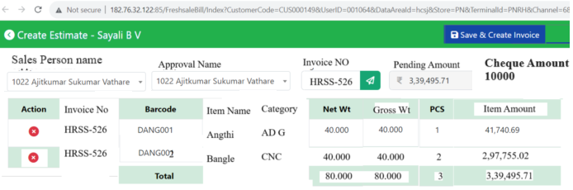

Click On “Save and Create Invoice” then open the below popup.

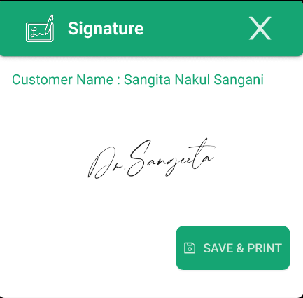

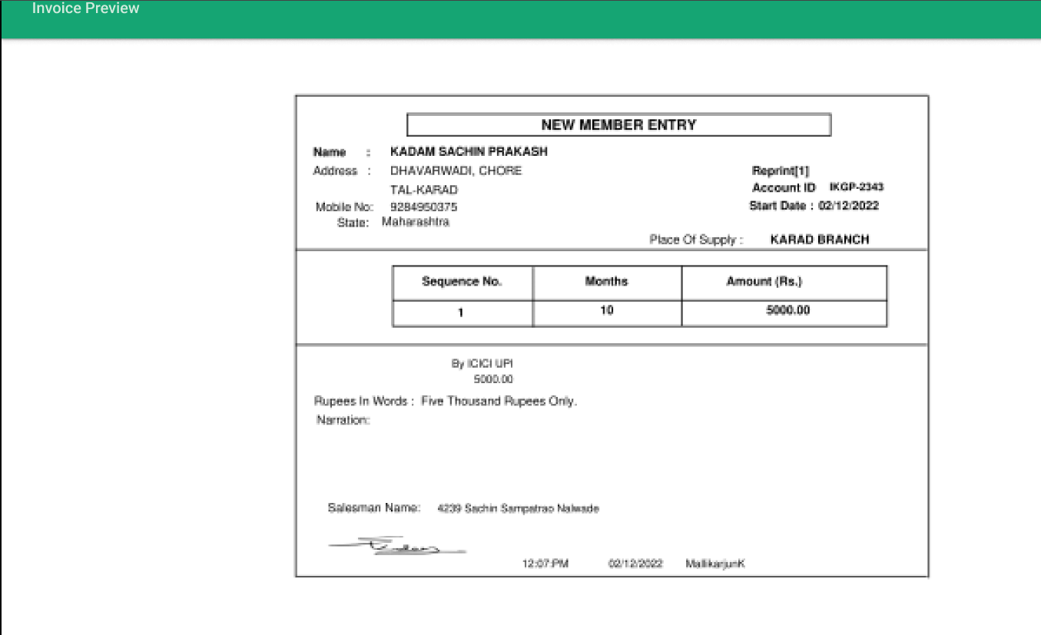

### D365

Create a new menu on “Jewellery -> Vastu Jama -> vastu jama”.

Vastu jama handover document is save in the POS then status , cash receipt no and otp will update on D365.

D365 Table Name - TAVastuJamaTable

|  |  |  |  |  |
| --- | --- | --- | --- | --- |
| **Sr. No** | **Section** | **Label name** | **Field Name** | **Data Type** |
|  | Header | Date | Date | Date |
|  | Header | Store | StoreId | Str |
|  | Header | Document Number | DocumentNumber | Str |
|  | Header | Sales Person Name | SalesPersonName | Str |
|  | Header | Approval Name | ApprovalName | Str |
|  | Header | Invoice No | InvoiceNo | Str |
|  | Header | Customer Name | CustomerName | Str |
|  | Header | Customer Mobile Number | CustomerMobileNumber | Real |
|  | Header | Customer Address | CustomerAddress | Str |
|  | Header | Status | Status | Enum |
|  | Header | Cash Receipt No | CashReceiptNo | Str |
|  | Header | Cash Receipt Amount | CashReceiptAmount | Real |
|  | Header | OTP | Otp | Str |
|  | Line | Tag No | TagNo | Str |
|  | Line | Item name | ItemName | Str |
|  | Line | Category | Category | Str |
|  | Line | Net wt | NetWt | Real |
|  | Line | Gross wt | GrossWt | Real |
|  | Line | Pcs | Pcs | Real |
|  | Line | Item amount | ItemAmount | Real |
|  | Header | Pending Invoice Amount | PendingInvoiceAmount | Real |
|  | Header | Cheque Amount | ChequeAmount | Real |
|  | Header | Cheque Status | ChequeStatus | Str |
|  | Header | Auth Code Person | AuthCodePerson | Str |
|  | Header | Auth Code | AuthCode | Str |



Click On “document number” then below form is open.

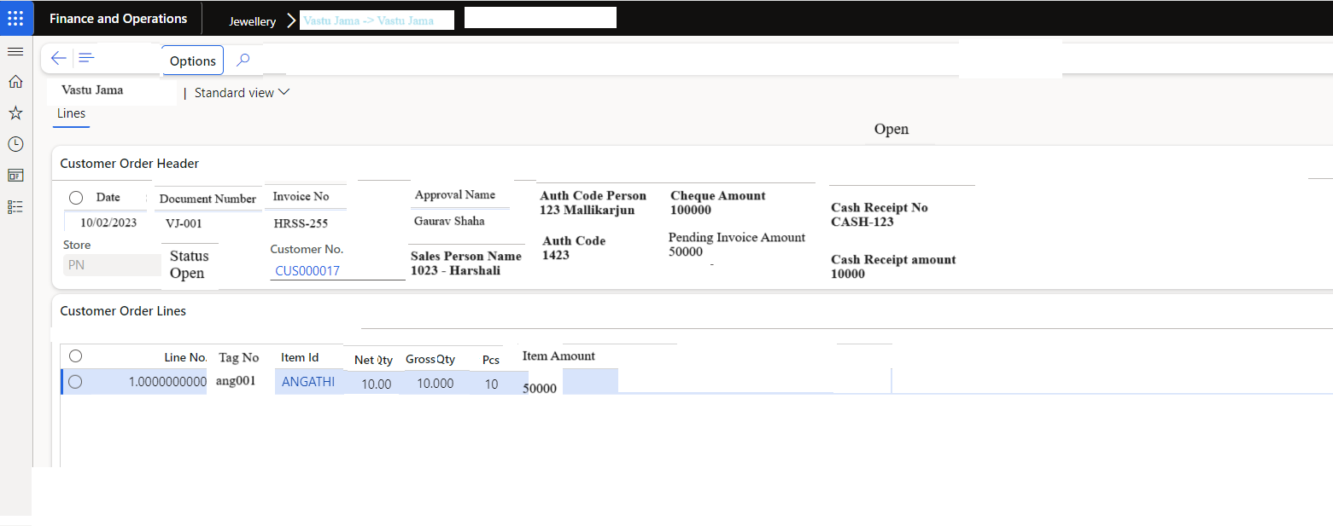

### POS Vastu Handover to customer

* Customer have 2 item in the vastu jama bill then vastu handover time customer can take one item then the vastu jama status is partially close.
* Customer have 2 items in the vastu jama bill and vastu handover document customer can take 2 items then vastu jama status is close.
* If vastu jama status is close then this vastu jama document should not be scan.

|  |  |  |  |  |  |  |
| --- | --- | --- | --- | --- | --- | --- |
| **Sr. No** | **Section** | **Label name** | **Field Name** | **Data type** | **Data type (POS view)** | **Description** |
|  | Header | Date | Date | Date | Date | Today's date will display auto. This is disable field |
|  | Header | Store | StoreId | Str | Text | This will be show as per login. This is disable field |
|  | Header | Document Number | DocumentNumber | Str | Text | * User can enter the vastu jama document no. * If invalid vastu jama number enter then show popup “Enter valid vastu jama Number”. * Multiple invoice number can we enter. * As per invoice number tag list will be show in the line item details. * Customer name must be same on POS and vastu jama number. If not same then show error. |
|  | Header | Customer Name | CustomerName | Str | Text | Customer name auto fetch from the invoice. |
|  | Header | Customer Mobile Number | CustomerMobileNumber | Real |  | Customer mobile number auto fetch from the invoice. |
|  | Header | Customer Address | CustomerAddress | Str |  | Customer address auto fetch from the invoice. |
|  | Header | Document No | DocumentNo | Str |  | Vastu jama doc no can insert then all line should be show. |
|  | Header | Cash Receipt No | CashReceiptNo | Str |  | * User can enter the cash receipt no. * Cash receipt amount and pending invoice amount must be match. * If customer want to partially close the document then check the amount also. |
|  | Header | Cash Receipt Amount | CashReceiptAmount | Real |  | This value will be fetch from cash receipt. This is disable field. |
|  | Line | Action |  |  | Button | “x” click on this button then remove the selected line. |
|  | Line | Invoice No | InvoiceNo |  |  | Header “Invoice Number” will be show here. |
|  | Line | Tag No | TagNo | str |  | As per the invoice Tag no show.This is disable field. |
|  | Line | Item name | ItemName | str |  | As per tag item name will be display. This is disable field. |
|  | Line | category | Category | str |  | As per tag category will be display. This is disable field. |
|  | Line | Net wt | NetWt | real |  | As per tag net wt will be display. This is disable field. |
|  | Line | Gross wt | GrossWt | real |  | As per tag gross wt will be display. This is disable field. |
|  | Line | Pcs | Pcs | real |  | As per tag pcs will be display. This is disable field. |
|  | Line | Item amount | ItemAmount | real |  | As per tag item amount will be display. This is disable field. |
|  | Footer | Pending Invoice Amount | PendingInvoiceAmount | real |  | Pending invoice amount will be show. |
|  | Header | Cheque Amount | ChequeAmount | Real |  | Cheque payment amount will be show. |
|  | Header | Auth Code Person | AuthCodePerson | Str |  | This is mandatory field. Data fetch from “Jewellery -> Master -> agent master” where agent type = Reference person. This data only show. |
|  | Header | Auth Code | AuthCode | Str |  | This is a alphanumeric field. |
|  | Header | Cheque Status | ChequeStatus |  | Button | Click on this button then cheque status will get. If cheque status is “Pass” then we can proceed. Table name - AcxCustSchemePaymentChequeEntry  Field name - InvoicePost |
|  |  | Generate OTP |  |  | Button | Click on this then otp will be send on the customer mobile number. |
|  |  | Save and create invoice |  |  | Button | Click on this then document will save go to the next page. Take customer signature. |
|  |  | Save and print |  |  | Button | Click on this then print will be generate. |

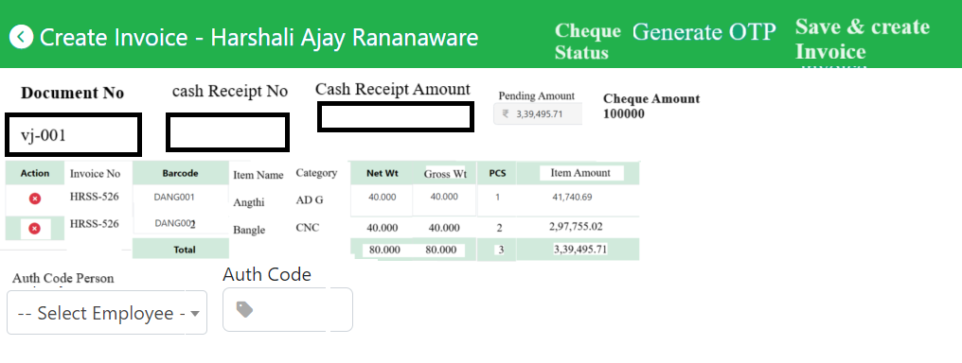

Click On “Cheque Status” below screen will be show.

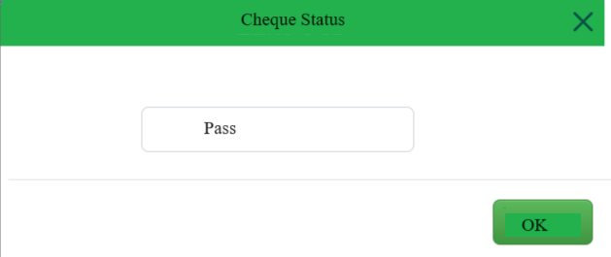

Click On “Generate OTP” below screen will be show.



Click On “Save and Create Invoice” then open the below popup.



Print will generated.



### Jewellery Paramete in D365

Add new section “Vastu Jama”. below fields are add.

|  |  |  |  |  |
| --- | --- | --- | --- | --- |
| Sr. No | Field | Data Type | Value | Description |
| 1 | Without signature Bill Save | Radio button | Yes or no | If yes then without signature we can print the document.  If no then signture required. |
| 2 | Payment Setting | Drop down | Create enum   1. Full Payment 2. Partial Payment | If full payment then customer outstanding balance must be zero.  If Partial Payment then customer outstanding balance is reaming then we can save the invoice. |

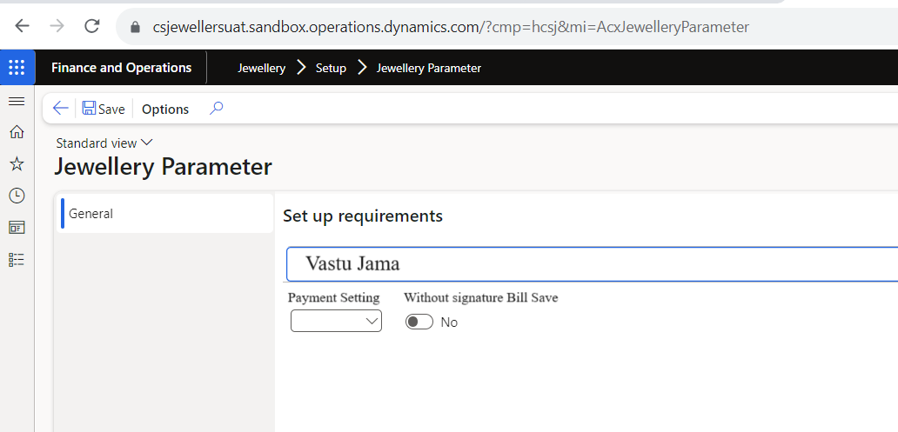

### TBD

Print format of vastu jama

table name of cash receipt - CustTrans 1) for cash receipt - Voucher 2) for balance - AmountMST

Job name for cash receipt -

2 cash payment entry