Manali ashok bhadirage

Manali.bhadirage@techneai.com

22.10.2023

Tech Ticket Mobile App - Phase 1

**User Manual Document**

**CONTENTS**

1. VERSION CONTROL 2

2. INTRODUCTION 2

3. SCOPE 2

4. BUSINESS & SYSTEM RULES 3

5. ABBREVIATIONS & TERMS 3

6. GRAPHICAL REPRESENTATION 3

7. DEVELOPED SYSTEM 3

8. TEST DATA AND BUSINESS SCENARIOS 19

1. **VERSION CONTROL**

|  |  |  |  |  |  |  |
| --- | --- | --- | --- | --- | --- | --- |
| **Sr. No** | **Version no** | **Version Date** | **User name** | **User department** | **Updated By** | **Ticket ID** |
| **1** | **1.0** | **22/10/2023** | **Gaurav Shaha** | **Projecr head** | **Manali Bhadirage** | **TT3711** |
|  |  |  |  |  |  |  |
|  |  |  |  |  |  |  |

1. **INTRODUCTION**

Tech Ticket is tool designed for planning & managing your projects by creating tickets. It is easy to use IT software for scheduling tasks of team under each ticket and thus further increasing productivity of each member.

We have developed user-friendly mobile application for tech ticket management, empowering users to log in and effortlessly access their assigned tasks. With the ability to conveniently pause and resume tasks at any point, users can have greater control over their workflow. Additionally, the application enables instant report extraction for quick and efficient progress tracking.

1. **SCOPE**

User will be able to login to the mobile app as per the credentials added in user master in web. User will be able to reset the password and verification code should get sent to the entered email address. Once user logs into the mobile app, then count of tasks will be displayed correctly on dashboard. All the tasks as added from the web as per date, will be displayed in the task list on dashboard. User will be able to play and pause the tasks from the dashboard. Also, when task is played then it will be displayed in fire-base notification. User will be able to play and pause tasks from notification play list as well as will be able to shuffle list and go to next or previous task

Further, once the task is played from the web, then once you refresh the dashboard page of mobile application it will display which task is being played recently from web and the same will be reflected in notification playlist. Vice versa. The play and pause time will be reflected correctly on variance report on web.

1. **BUSINESS & SYSTEM RULES**

* User will be registered in the system.
* System should display error message for incorrect details if entered.
* Only one task can be played at a time.
* Notification playlist will get cleared if you pause any task and close the mobile application.
* Fire-base Notification will still be displayed even if you have closed the task but task is in played state.
* All tasks as added from web will get reflected in task list on dashboard of mobile application once you refresh the dashboard page or else when you close the app and login.
* Time for which the task was played will get updated and displayed on dashboard after the task is paused.
* Functionality will be same for all android versions (5 to 13) however the UI of fire-base notification may differ.

1. **ABBREVIATIONS & TERMS**

NA

1. **GRAPHICAL REPRESENTATION**

Play task from dashboard

View details of task and task list

Log into mobile app using credentials

Create user in user master from web

Reset password if needed

Display it as played in notification list and dashboard

Display played time in dashboard of mobile app and variance report

Pause task from dashboard / web app / notification list

Fig: Context Diagram (phase 1)

1. **DEVELOPED SYSTEM**

In mobile application, it will have following fields:

* Username
* Password
* Remember me check-box
* Forgot password button
* Login button
* Enter email
* Get otp button
* Insights count
* Pending list
* Today’s list
* Upcoming list
* Task name
* Ticket ID
* Task priority
* Scheduled date
* Scheduled hours
* Played hours
* Play button
* Pause button
* Search bar
* Hamburger menu
* Next button
* Previous button
* Shuffle button

|  |  |  |  |  |
| --- | --- | --- | --- | --- |
| **FIELDS** | **LOGIN** | **FORGOT PASSWORD** | **DASHBOARD** | **NOTIFICATION** |
| Username |  | X | X | X |
| Password |  | X | X | X |
| Remember me check-box |  | X | X | X |
| Forgot password button |  | X | X | X |
| Login button |  | X | X | X |
| Enter email | X |  | X | X |
| Get otp button | X |  | X | X |
| Insights count | X | X |  | X |
| Pending list | X | X |  |  |
| Today’s list | X | X |  |  |
| Upcoming list | X | X |  |  |
| Task name | X | X |  |  |
| Ticket ID | X | X |  |  |
| Task priority | X | X |  |  |
| Scheduled date | X | X |  |  |
| Scheduled hours | X | X |  |  |
| Played hours | X | X |  |  |
| Play button | X | X |  |  |
| Pause button | X | X |  |  |
| Search bar | X | X |  | X |
| Hamburger menu | X | X |  | X |
| Next button | X | X | X |  |
| Previous button | X | X | X |  |
| Shuffle button | X | X | X |  |
| Play button | X | X | X |  |
| Pause button | X | X | X |  |

In hamburger menu, it will display name and email address of the logged in person as in user master. Below, it will display dashboard and sign out menus.

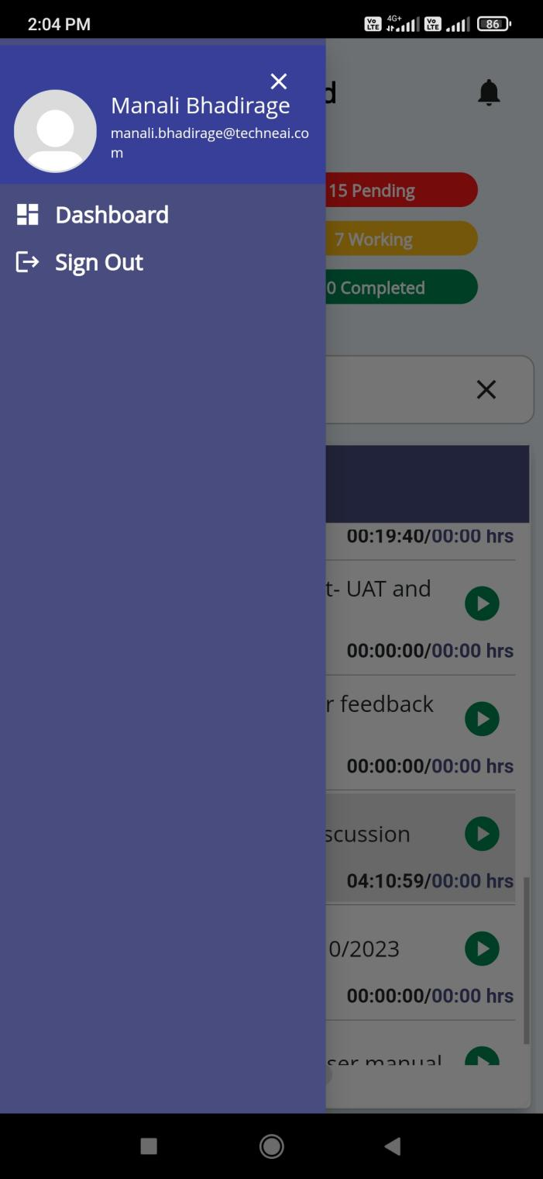

Fig: Hamburger menu

* 1. **Login**

Registered user from web will be able to log into the mobile application.

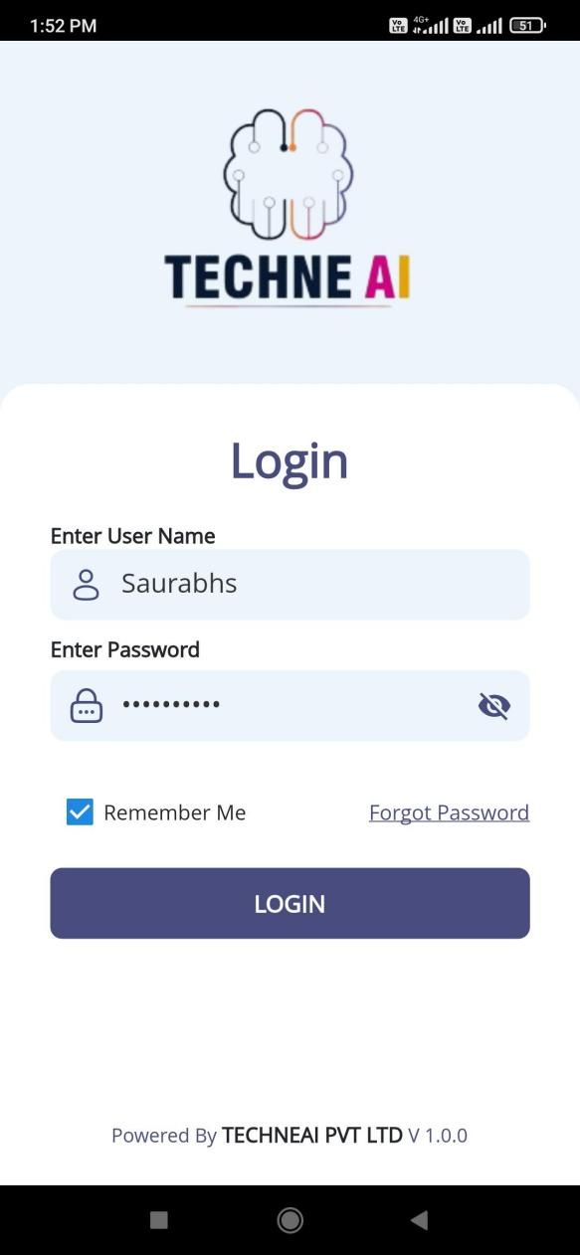

Fig: Login page

|  |  |  |  |  |
| --- | --- | --- | --- | --- |
| **FIELDS** | **INPUT TYPE** | **MANDATORY/ OPTIONAL** | **EDITABLE** | **DESCRIPTION** |
| User name | text | Mandatory | No | User have to enter the user name as mentioned in the user master by the admin.  Validation:- Max limit will be 25 characters. It shouldn’t accept space. It will be unique. |
| Password | Text | Mandatory | No | User will enter the password as set in the user master.  It will have hide / expose button to view password or display it as encrypted.  Validation:- Maximum limit would be 25 characters. It shouldn’t accept space. |
| Login | Click | - | - | Precondition:- User will be registered.  Post condition:- Once user enters valid username and password, it will display successful message and direct user on dashboard page of mobile application. In case of invalid user name and password, user won’t be able to log into the system and it will display error message.  Validation: login button will be disabled until user gets directed to dashboard page. |
| Remember me | Check box | Optional | - | This is to save the user name and password in the application, so that next time when user logs out and visits login page then it will pre-fill the recently saved username and password.  User will have to check this box to save the entered credentials.  Validation: It will display only the recently saved username and password. (Only one credentials are getting saved saved at a time.) |
| Forgot password | Click | Optional | - | Through forgot password button, code will get sent to the entered email address and then user can reset his password. The password of the account will get reset for which the email address is entered.  Once user clicks on forgot password button, it will direct user to next page where user will enter email address on which code will be sent to the user.  Once user enters email and clicks on submit, code will be sent to the user’s email address. Timer will be displayed once code is sent to user’s email address. Then, user will mention the correct code and will be able to further set new password.    Post condition: After setting new password, user whose email address was entered for code, his account’s password will get updated. Thus, later user can log into the application using new password.  Validation: Email address field will accept maximum 50 characters. It will accept . _ @ only as special characters. Special chacaracter should be followed by letter only.  Timer in code page will be of maximum 30 seconds. If user doesn’t enter code within 30 seconds then timer will be removed and resend code button will be enabled. |

* 1. **Dashboard**

Once user logs into the application successfully, it will display insights and task list on the dashboard. Insights will display the count of pending tasks (till the date), completed tasks, upcoming tasks and completed tasks of the week. Whereas, task list will display the tasks in today’s list, pending list and upcoming list.

All the details will be displayed as per task added by the user or any task that has been assigned to user by another person.

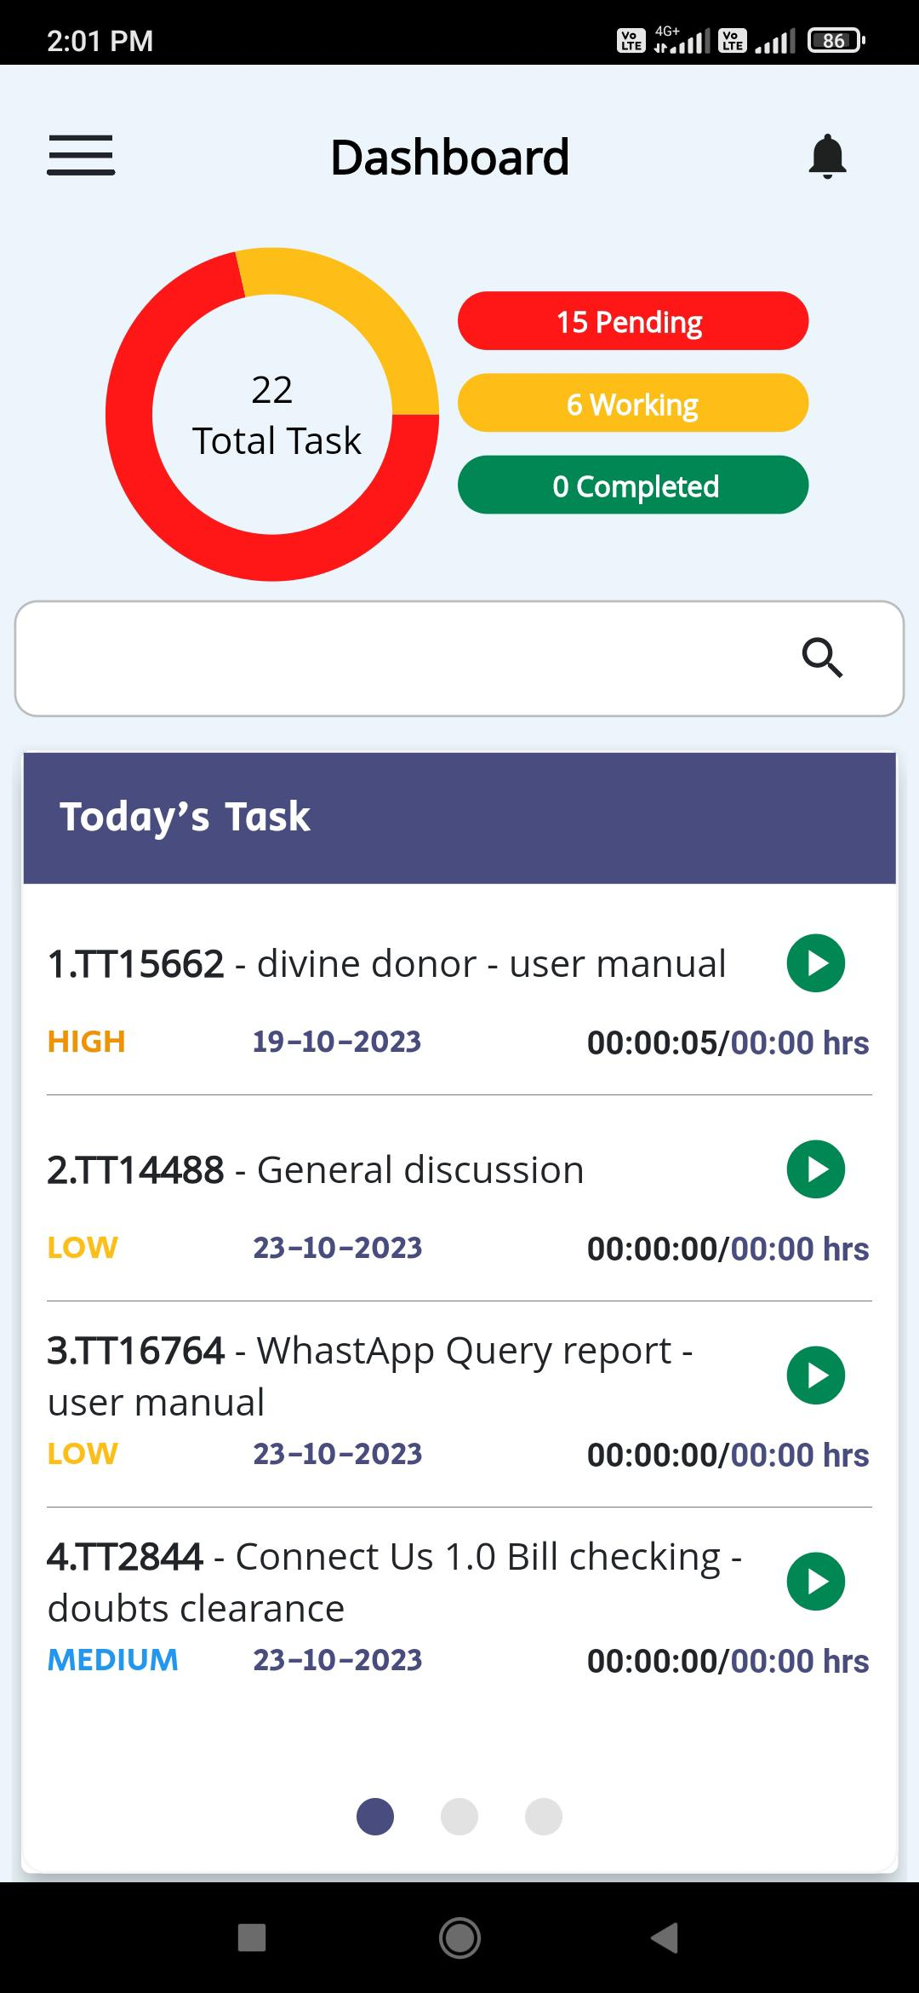

Fig: Dashboard -> today’s task list

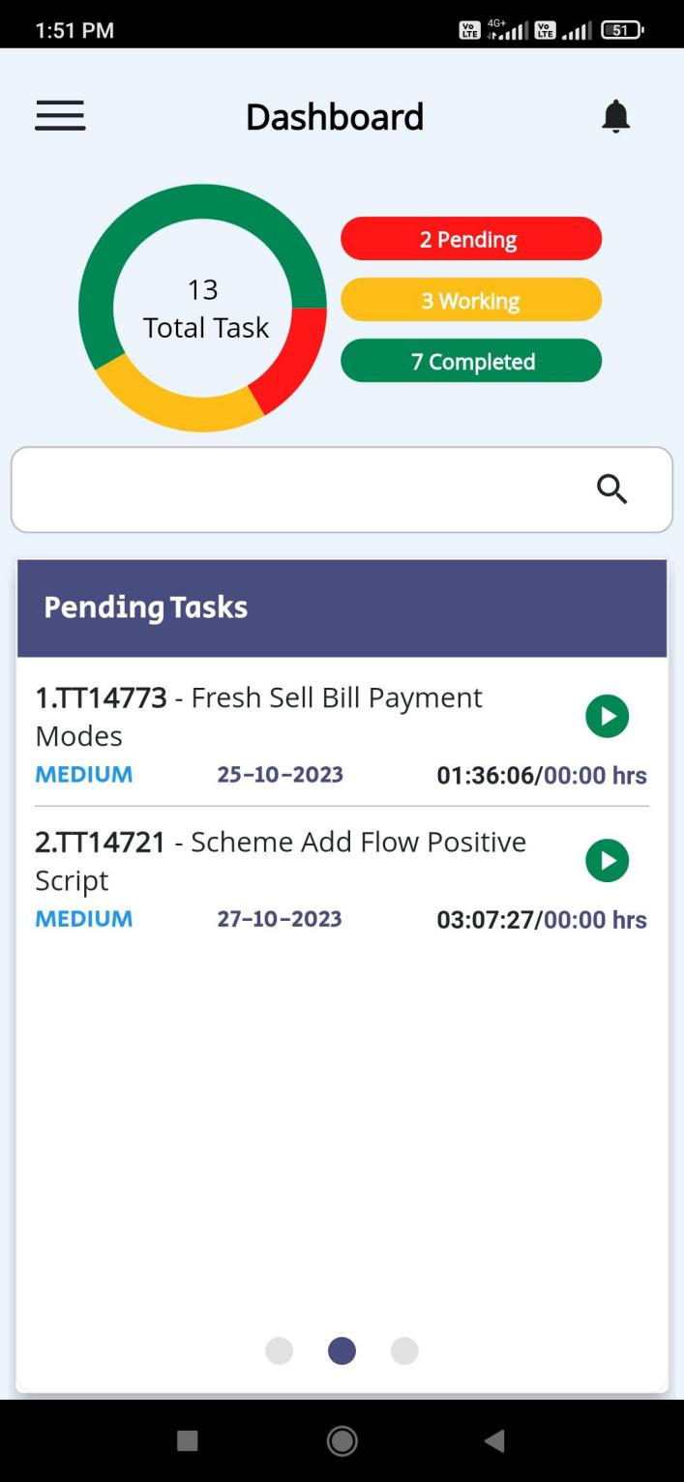

Fig: Dashboard -> pending task list

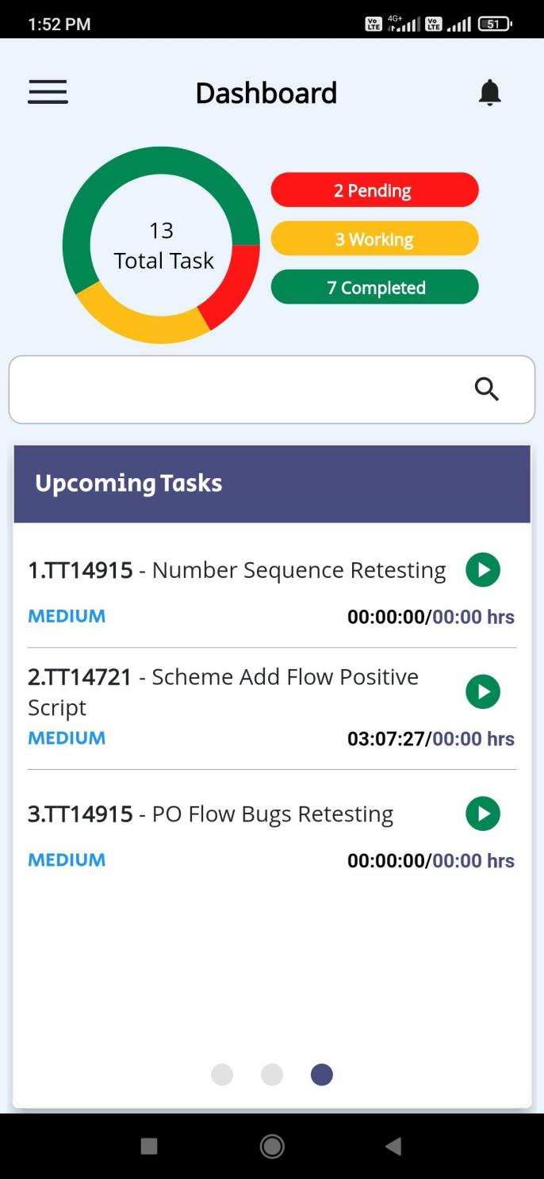

Fig: Dashboard -> upcoming task list

|  |  |  |  |  |
| --- | --- | --- | --- | --- |
| **FIELDS** | **INPUT TYPE** | **MANDATORY/ OPTIONAL** | **EDITABLE** | **DESCRIPTION** |
| Insights | Doughnut chart | Mandatory | No | It will display weekly analysis of tasks. It will display count of pending tasks of current week, pending tasks till now, upcoming tasks, completed tasks of current week and total tasks.  Total tasks = Pending + upcoming + in progress tasks + completed….. [provided none of the task is common]  These count will be updated and displayed as and when the tasks are added from my tickets -> task -> add task through tech ticket web.  If any task is being displayed in pending, today’s and current list then it will be counted as one tasks only and will be displayed as one in insights.  Tasks which are not played yet and has passed scheduled date, it will be displayed in pending list. Tasks which are in today’s list or upcoming list and are played even once, then it will be displayed in ‘in progress / working’ count. Tasks which are in upcoming list and not played even once, then it will be displayed in upcoming count. |
| Today’s task list | Slider list |  | no | It will display all the tasks whose start date is scheduled for the today’s date / current date.  If there are no tasks in the list then it will be displayed blank. |
| Pending tasks list | Slider list |  | no | If any task is scheduled for the dates till yesterday and are not being completed, then it will be displayed in pending task list. |
| Upcoming tasks list | Slider list |  | No | If any task is scheduled for the dates from tomorrow, then it will be displayed in upcoming task list. |
| Task Name | Text | Mandatory | Editable from web only through manage tasks page | It will display serial number, ticket ID and the task name when user adds the task from tech ticket web -> my tickets -> task -> add task.  Whenever task name is edited by the user from my tickets -> edit task, then it will be reflected on dashboard task list of web as well as mobile app.  In addition to this, whenever future tasks are added and being displayed in upcoming list, then it will be displayed in today’s task list when the current date arrives as per task schedule and it will not be displayed in upcoming task list.  If any task is not completed by today, then this task will be displayed in pending list from next day. |
| Priority | text | Mandatory | Editable from web only through manage tasks page | It will display high / medium / low priority as mentioned while adding the task. As and when task is edited and its priority is changed then its updated priority will be displayed on dashboard. |
| Date | Text | Mandatory | Editable from web only through manage tasks page | In date field, it will display the date for which that task was scheduled.  For today’s task list, it will display today’s date as task is planned for today. If there is any tasks scheduled for 3 days which is present in today’s, pending and upcoming list. Then in today’s list it will display today’s date whereas in upcoming and pending list it will display the end date for that task.  Whenever task date is edited by the user from my tickets -> edit task, then it will be reflected on dashboard task list as well. |
| Task played time | Timer | Mandatory | No | It will be display the actual time that user has worked on the particular task in HH:MM:SS format.  Initially it will display 00:00:00 when task is added and not played. Further when user clicks on play button, then timer will be displayed. Once user clicks on pause button, then updated time will be displayed. This time will also be displayed in variance report for that task and user. |
| Scheduled hours | Time | Mandatory | Editable from web only through manage tasks page | It will display the total time that has been scheduled by user while adding the task in HH:MM:SS format.  Whenever scheduled hours is edited by the user from my tickets -> edit task, then it will be reflected on dashboard task list as well. |
| Play and pause | Click | Mandatory | No | Through this user will play the task when user is actually on working it.  Once play button is clicked, then timer will be displayed for that task. Once task is played from the dashboard / notification / manage task -> task of web, then it will display as paused in dashboard task list (web and mobile) as well as in manage task -> task of web.  Once user plays the task, then it will be displayed at top of that list.  In addition to this, notification of task list will be displayed and the task will be played. Once task is paused from the notification, then it will display as paused in dashboard task list as well as in manage task -> task of web.  Once task is marked as completed from web, then it will be removed from the tasks list.  Validation: If user clicks on play button then task gets played and pause button will be displayed for user to pause that task and vice versa when task is paused the play button will be displayed against that task.  If start date and end date of task is such that task lies in pending, today’s and upcoming task list, then when user plays that task from any of the list then that task will get played from all three lists. |
| Search bar | Text | Optional | Yes | Through search user can search the task from any of the three lists and can get directed to that list.  Once user enters task name or ticket id and if any task is available in any of the list - pending / today’s / upcoming, then it will display the relevant search results in the drop down. Further, once user clicks on the desired task from the search result, then user will be directed to that task list and that selected task will get highlighted.  MicrosoftTeams-image (47)  Fig: search bar  Validation: If user User will have to clear the inputs in search bar search bar by |

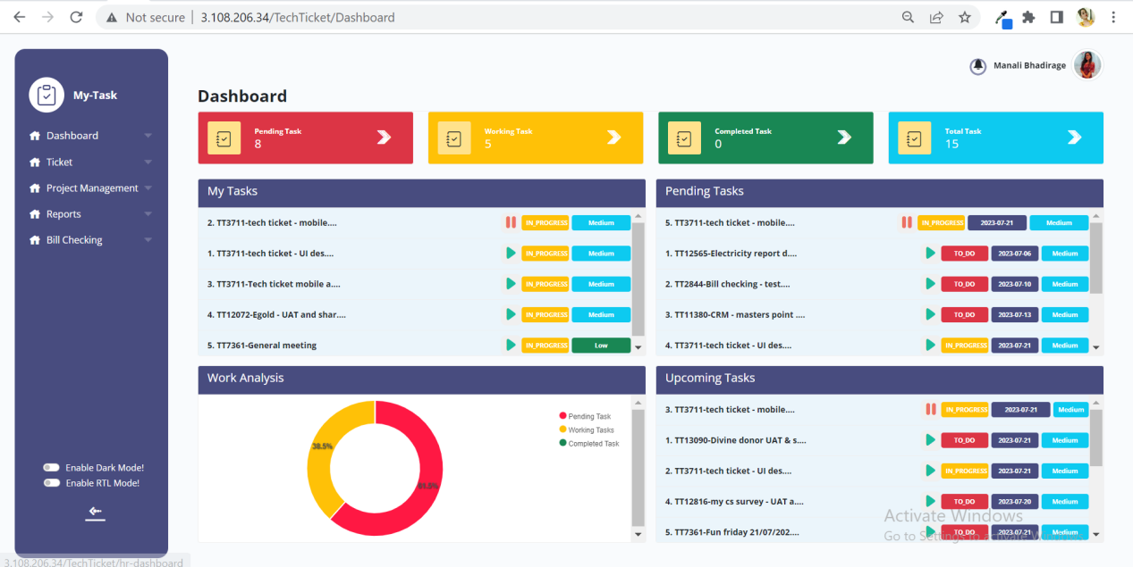

Fig: Web dashboard

* 1. **Notification task play list**

Once user plays any particular task from manage task or from dashboard then task play list will be displayed in notification. Once the task is played from dashboard, then notification gets display regarding task played. However, the notification won’t get cleared until the played task is paused.

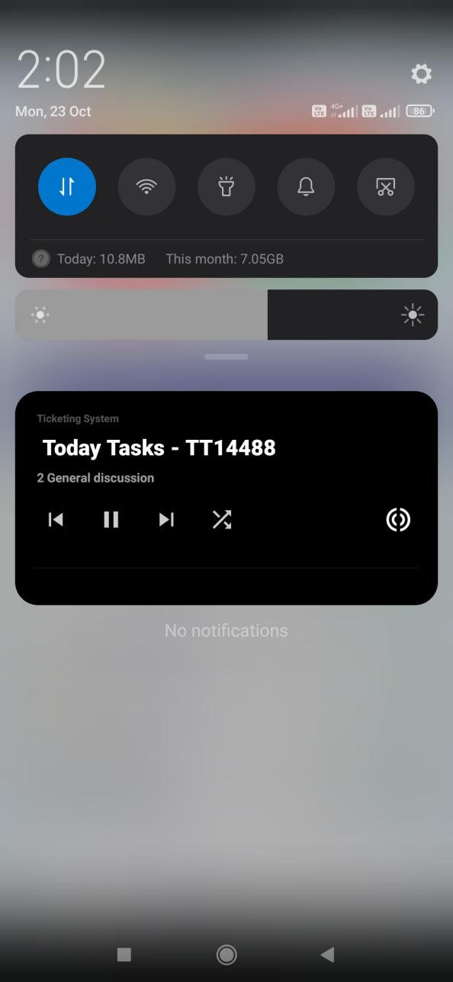

Fig: notification playlist

|  |  |  |  |  |
| --- | --- | --- | --- | --- |
| **FIELDS** | **INPUT TYPE** | **MANDATORY/ OPTIONAL** | **EDITABLE** | **DESCRIPTION** |
| Task list name | Text | Mandatory | No | It will display today’s task / pending task / upcoming task as per the task which is being played.  Validation: Initially it will display list of the task which is being played. |
| Ticket ID - task name | Text | Mandatory | No | It will display the ticket ID and the task name that is being played.  Validation: Initially, it will display the task name which is being played. It will display updated task name when it is edited from web -> manage task page. |
| Play | Click | - | No | User will be able to play the task. Whereas if any task is being played from the dashboard or manage task -> task, then it will display the played tasks as played in the notification as well as in web.  Validation: Initially, it will display the task which is played. Further it will display play button to the other tasks when user clicks next or shuffle. |
| Pause | Click | - | No | User will be able to pause the played task. It will display pause button to the task which is played. Once task is paused, then updated timer will be displayed in dashboard as well as in variance report for that task.  Validation: Initially, it will display the task which is played and will have pause button to it. |
| Next | Click | - | No | When user clicks on next, then the next task of that task list will be displayed.  Further, suppose there are 10 tasks on today’s list and user has played first one. Then each time when user clicks on next button, then next task of today’s list will be displayed. Further, once user has reached to tenth task and clicks on next button, then it will go to first task again of today’s task list.  Validation: it will display next task of that list in sequential manner. |
| Shuffle | Click | - | No | User can shuffle entire task list from today’s task to pending task and to upcoming task.  User will be able to shuffle the list even when task from one of the list is played, however that played tasks should remain played I.e. shouldn’t get affected.  User can further also play and pause the task after shuffling the task list.  Validation: If user is in today’s task list and Once user clicks on shuffle button, then it will display tasks of pending task list. If user is in pending task list and once user clicks on shuffle button, then it will display tasks of upcoming task list. |

* 1. **Sign out**

User will be able to sign out from the application. Once user signs out, it will direct user to login page.

1. **TEST DATA AND BUSINESS SCENARIOS**