16.10.2023

**USER MANUAL HANDOVER**

VMS MASTER DOCUMENT

Sanika Dewoolkar

Sanika.dewoolkar@techneai.com

MY GOAL - SURVEY

Manali Ashok Bhadirage

Manali.bhadirage@techneai.com

**CONTENTS**

1. VERSION CONTROL 2

2. INTRODUCTION 2

3. SCOPE 3

4. BUSINESS & SYSTEM RULES 3

5. ABBREVIATIONS & TERMS 3

6. GRAPHICAL REPRESENTATION 3

7. DEVELOPED SYSTEM 4

8. TEST DATA AND BUSINESS SCENARIOS 30

1. **VERSION CONTROL**

|  |  |  |  |  |  |  |
| --- | --- | --- | --- | --- | --- | --- |
| **Sr. No** | **Version no** | **Version Date** | **User name** | **User department** | **Updated By** | **Ticket ID** |
| **1** | **1.0** | **12/10/2023** | **Pritam metha** | **Audit** | **Manali Bhadirage** | **TT12887** |
|  |  |  |  |  |  |  |
|  |  |  |  |  |  |  |

1. **INTRODUCTION**

We have successfully implemented a survey module within our Connect Us platform, as well as a corresponding survey menu in our MY CS application. This module allows authorities to effortlessly assign surveys to their employee which will be related to topics such as process knowledge test, feedback, opinions, judgments, etc. The assigned employees can then respond to the surveys through MY CS mobile app that have been assigned to them. Furthermore, the module offers the ability to export comprehensive reports regarding answers given by the employees.

Through question master, user will be able to add question and set its data type. Further user can view or edit the already added question.

Through template master, user will be able to create the survey template and map the active questions in it.

Through assign survey mobile, user will be able to assign the survey to all the employees or selective employees from employee master and then set the validity date for submitting the survey.

Furthermore, employees will receive fire-base notification on mobile app once survey is assigned to them. Employees will then submit the answers of questions in survey. Submitted surveys can be displayed in mobile app as well to the employee.

Moreover, authorized user can then further view the report of the surveys submitted by employees. Through survey report, authorized user will get clear insights through pie chart. It will display the count of employees who have submitted survey within time, count of employees who have submitted survey after validity date. Count of employees who still haven’t submitted survey and then total count of employees to whom the survey is assigned to.

In addition to this, user can export data from grid as in question master, template master and survey report.

1. **SCOPE**

IN SCOPE:- Survey creation, assigning survey, receiving response on survey from employees, survey management and reporting & analysis lies within scope of this project. In addition to this, designing the survey module to handle a large number of surveys, respondents, and data points while maintaining optimal performance will be considered as scope of the project. Further, integrating the survey module seamlessly into the existing Connect Us platform and MY CS application, ensuring a cohesive user experience are part of our scope.

OUT SCOPE:- Any extensive redesign or revamp of the overall user interface of Connect Us or MY CS application beyond the survey module's specific requirements would be considered out of scope. In addition to this, when survey gets assigned to the employee, notification gets sent to the employee and can be displayed in my cs mobile app -> messages menu from dashboard. However, testing of messages tab is not part of our scope as it is considered as part of Notification sub-module.

1. **BUSINESS & SYSTEM RULES**

* User should be registered in the system and should be logged in.
* System should display error message for incorrect details if entered.
* User can assign survey only to active employees as in employee master.
* Survey once submitted cannot be edited or revoked.
* As system is new to the users yet, hence restricting employees from submitting survey after expiration of validity date is not preferred currently.
* If employee has logged out from the MY CS mobile app, then employee won’t receive fire-base notification.

1. **ABBREVIATIONS & TERMS**

**✓**- Yes

X - No

HO - Head Office

MCQ - multiple choice question

1. **GRAPHICAL REPRESENTATION**

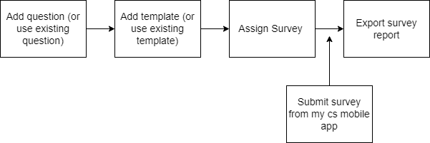

Fig: System Communication Diagram

1. **DEVELOPED SYSTEM**

Survey sub-module includes following menus:

* Question Master
* Template Master
* Assign Survey
* Survey report

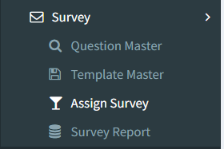

**Step 1. Question Master**

User (authority) will create Questions from Connect-us -> My Goal App -> Survey -> Question Master. It will have following fields:

* Export button
* Add question button
* Edit button
* Question
* Answer Type
* Is Active
* Remark
* Save button
* Save & add more button
* Back button
* Created at
* Created by
* Updated at
* Updated by

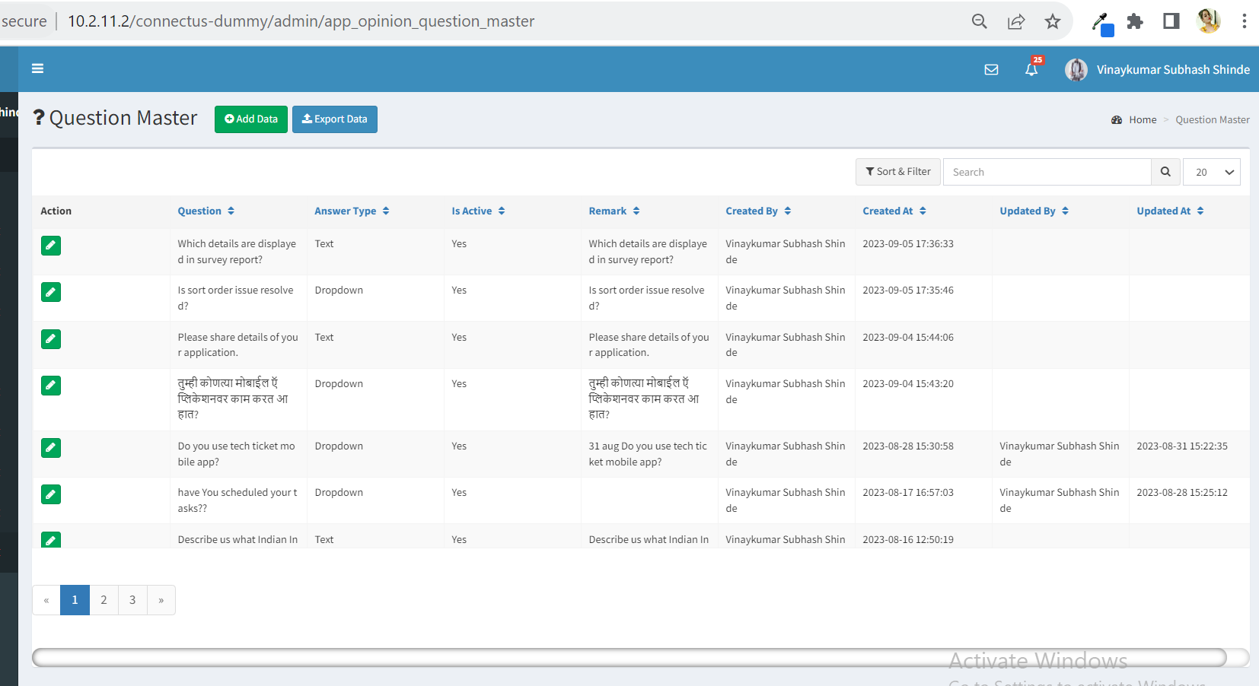

Fig: Question Master grid

Visibility of fields in pages:

|  |  |  |  |  |
| --- | --- | --- | --- | --- |
| **FIELDS** | **ADD** | **GRID** | **EDIT** | **EXPORT** |
| Export button | **X** | **✓** | **X** | **X** |
| Add button | **X** | **✓** | **X** | **X** |
| Edit button | **X** | **✓** | **X** | **X** |
| Question | **✓** | **✓** | **✓** | **✓** |
| Answer type | **✓** | **✓** | **✓** | **✓** |
| Is active | **✓** | **✓** | **✓** | **✓** |
| Remark | **✓** | **✓** | **✓** | **✓** |
| Save button | **✓** | **X** | **✓** | **X** |
| Save & add more button | **✓** | **X** | **X** | **X** |
| Back button | **✓** | **X** | **✓** | **X** |
| Created at | **X** | **✓** | **X** | **✓** |
| Created by | **X** | **✓** | **X** | **✓** |
| Updated at | **X** | **✓** | **X** | **✓** |
| Updated by | **X** | **✓** | **X** | **✓** |

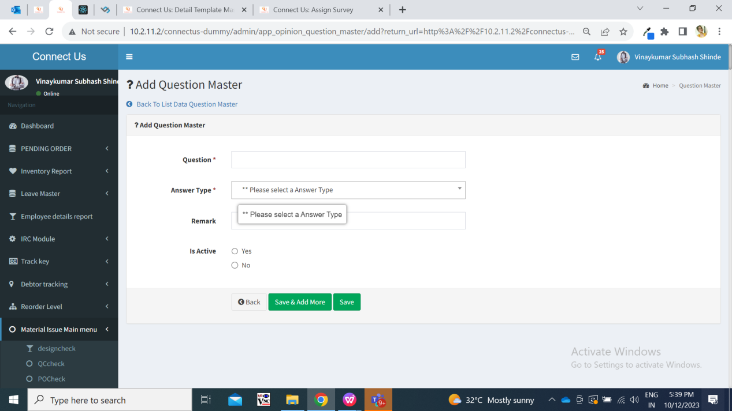

Fig: question master -> Add action

|  |  |  |  |  |
| --- | --- | --- | --- | --- |
| **FIELDS** | **INPUT TYPE** | **MANDATORY/ OPTIONAL** | **EDITABLE** | **DESCRIPTION** |
| Question | text | Mandatory | Yes | User will mention the question here.  Validation :- Question field accepts text, digits, space and special characters. It will accept English and Marathi language. |
| Answer Type | Drop-down | Mandatory | Yes | Answer type field includes either text or drop-down. If answer type is selected as text, then in application it will reflect text input box where employees will write their answer. Wheres, if answer type is selected as drop-down, then in application that question will display options out of which employees will select any one of the provided options.  Validation:- It will be single select. |
| Is Active | Radio button | Mandatory | Yes | Is active fields consist of yes or no button through which question can be kept active or inactive.  Validation:- It will be single select. By default, it will select yes option initially. |
| Remark | Text | Optional | Yes | Remark field is input box where user may enter additional notes while adding question.  Validations: It will accept text, digits, space and special characters. It will accept English and Marathi language. |
| Save button | Click |  |  | Once save button is clicked after filling mandatory fields, the question will be added successfully and displayed on top of the grid. Successful message will be displayed.  Validation: Once save button is clicked, it will be disabled and user will be directed to the grid page. |
| Save & add more button | Click |  |  | Once save button is clicked after filling mandatory fields, the question will be added successfully and displayed on top of the grid. Successful message will be displayed.  Validation: Once save & add more button is clicked, it will be disabled and user will remain on the same add page to add another question. |
| Back button | Click |  |  | Once back button is clicked, all fields which might have been field will get cleared and question will not get added. Also user will be directed to the grid page.  Validation: Once back button is clicked, it will be disabled and user will be directed to the grid page. |
| Created at | Text |  |  | It will display the date and time when question was created by the user. |
| Created by | Text |  |  | It will display the name of the employee who created the question. |
| Updated at | Text |  |  | It will display the date and time when question was modified by the user.  Validation: It will be displayed blank of the already added data is not edited. |
| Updated by | Text |  |  | It will display the name of the employee who modified the question.  Validation: It will be displayed blank of the already added data is not edited. |

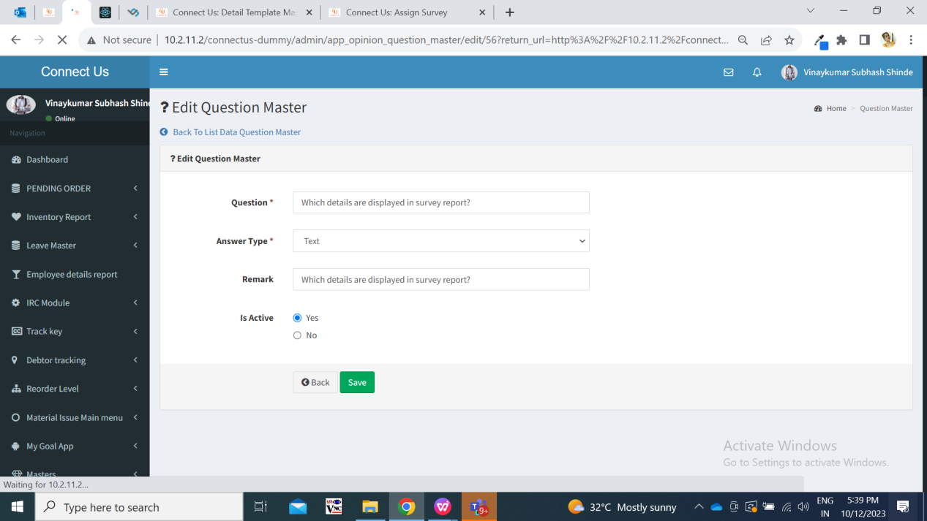

Fig: question master -> Edit action

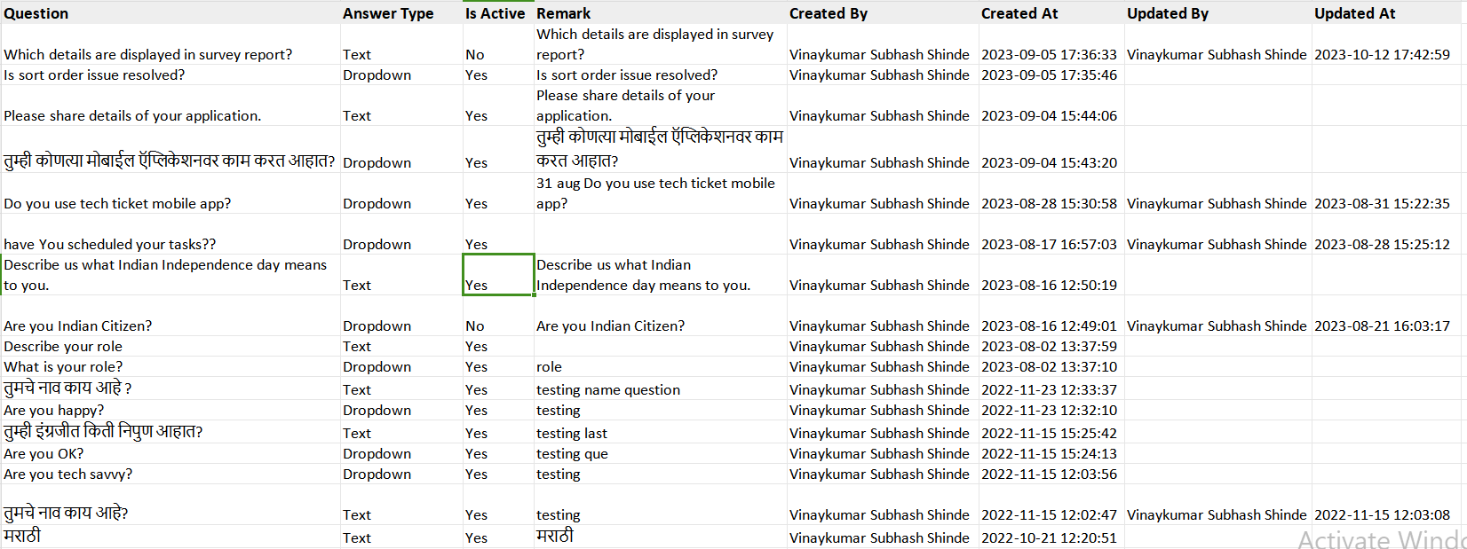

Fig: question master -> Export file

**Step 2. Template Master**

Once questions are added, user need to map these questions in template. Hence template needs to be created from Connect-us -> My Goal App -> Survey -> Template master. Template can be referred as Survey. It will display following fields:

* Export button
* Add button
* View Action
* Edit action
* Template name
* Description
* Is Active
* Map Questions
* Question
* Answer
* Is required
* Question order
* Add to table button
* Reset button
* Save changes button
* Table details
* ID
* Question
* Answer
* Is required
* Question order
* Edit button
* Delete button
* Save and add more button
* Save button
* Back button
* Created at
* Created by
* Updated at
* Updated by

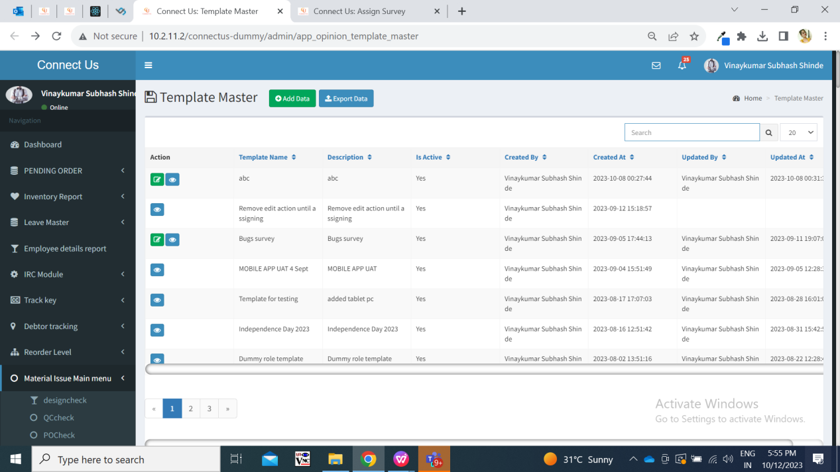

Fig: Template Master Grid

Visibility of fields in pages:

|  |  |  |  |  |  |
| --- | --- | --- | --- | --- | --- |
| **FIELDS** | **ADD** | **GRID** | **VIEW** | **EDIT** | **EXPORT** |
| Export button | **X** | **✓** | **X** | **X** | **✓** |
| Add button | **X** | **✓** | **X** | **X** | **✓** |
| Edit button | **X** | **✓** | **X** | **X** | **✓** |
| View button | **X** | **✓** | **X** | **X** | **✓** |
| Template name | **✓** | **✓** | **✓** | **✓** | **✓** |
| Description | **✓** | **✓** | **✓** | **✓** | **✓** |
| Is active | **✓** | **✓** | **✓** | **✓** | **✓** |
| Map questions | **✓** | **X** | **✓** | **✓** | **X** |
| Table details | **✓** | **X** | **✓** | **✓** | **X** |
| Save button | **✓** | **X** | **X** | **✓** | **X** |
| Save and add more button | **✓** | **X** | **X** | **✓** | **X** |
| Back button | **✓** | **X** | **X** | **✓** | **X** |
| Created at | **X** | **✓** | **✓** | **X** | **✓** |
| Created by | **X** | **✓** | **✓** | **X** | **✓** |
| Updated at | **X** | **✓** | **✓** | **X** | **✓** |
| Updated by | **X** | **✓** | **✓** | **X** | **✓** |

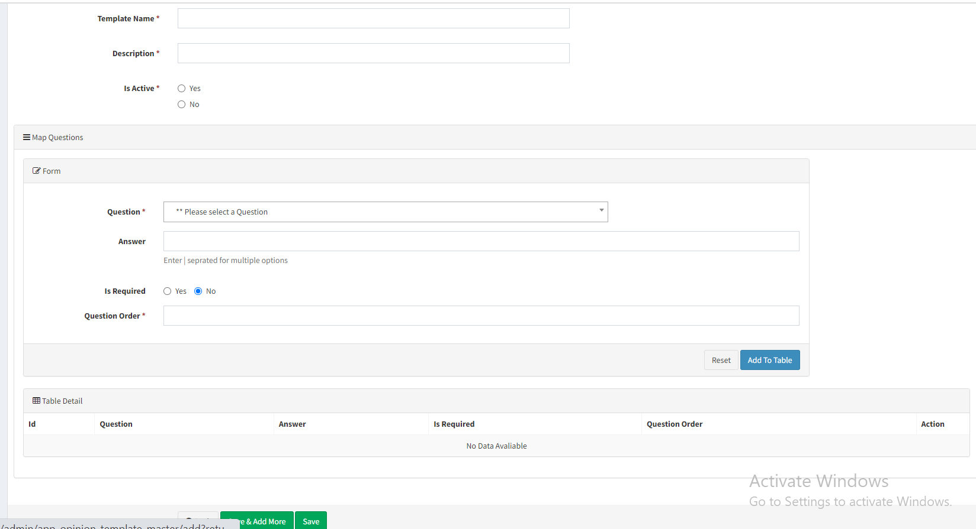

Fig: Template master -> Add action

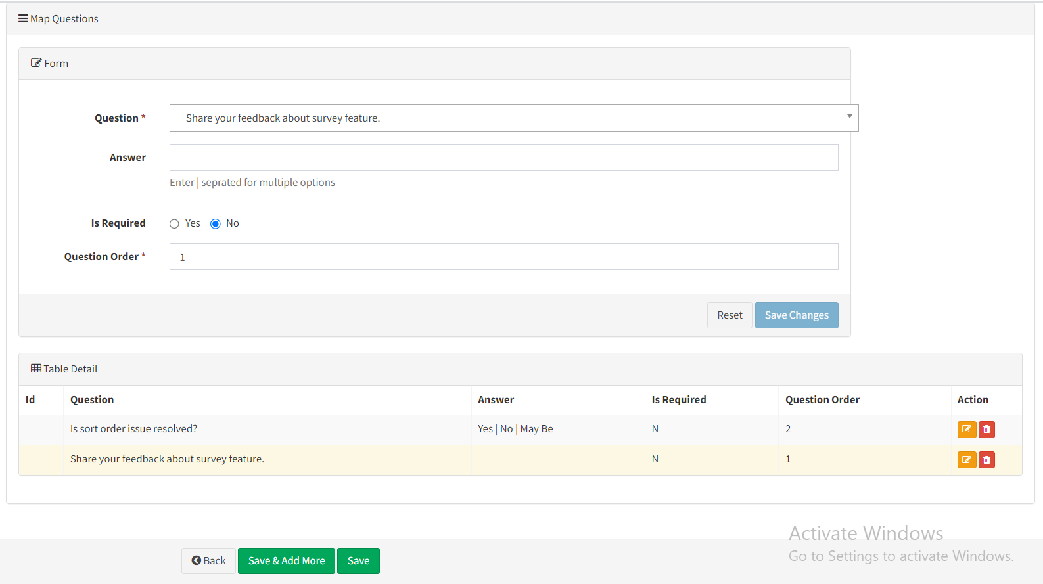

Fig: Map questions and table detail

|  |  |  |  |  |
| --- | --- | --- | --- | --- |
| **FIELDS** | **INPUT TYPE** | **MANDATORY/ OPTIONAL** | **EDITABLE** | **DESCRIPTION** |
| Template name | text | Mandatory | Yes | Template name consists of input box where user can mention the name of the template which means survey name.  Validation: It accepts text, digits and space. Maximum 250 characters should be accepted. It will accept Marathi and English language. |
| Description | Text | Mandatory | Yes | Description specifies the details of the template.  Validation: It accepts text, digits and space. Maximum 250 characters should be accepted. It will accept Marathi and English language. |
| Is active | Radio button | Mandatory | Yes | User can keep created template active or make it inactive.  If template is inactive , then it won’t be displayed in the drop-down while assigning the template.  Validation: It will be clicked on yes button by default initially. Only one radio button can be clicked at a time. |
| Map questions: Question | Drop down | Mandatory | Yes | User will map the questions to template by selecting questions from the drop-down of this field.  User will select the question from the drop-down, mention its options in answer field if answer type of the selected question is drop-down, set the question order number and then click on add to table button. Then, this question will be displayed in table below. Likewise, user can add multiple questions in this template bu just selecting it from drop-down and adding it to table.  Validation: It will be single select. Inactive questions from question master will not be displayed here. |
| Map questions : Answer | Text | Optional | Yes | If the answer type for the selected question is drop-down then user will have to mention the options here by mentioning | after each option. If the answer type for the selected question is text then user will keep this field blank.  Validation: User has to give space after the mentioned option and then mention | so that options will be displayed as MCQs radio button in mobile application. User can mention multiple options. |
| Map questions : is required | Radio button | Optional | Yes | This specifies whether this question is mandatory or not in the survey so that the employees will have to compulsorily answer this question while submitting survey.  Validation: It will be clicked on yes button by default initially. Only one radio button can be clicked at a time. |
| Map questions: question order | Text | Mandatory | Yes | It specifies the sequence of the question in the survey.  Validation: 0 will not be accepted. If user has already given one of the number to already added question, then user cannot use same question order number to another question while adding. It will not accept negative value. It will not accept characters, special characters or space. |
| Map questions: Add to table | Click |  |  | Once user selects question, answer options, gives question order number and once user adds on ‘add to table’ button then the question will be displayed in table below.  (However this doesn’t mean that template has got created. Template will get created with questions only after user clicks on final save button)  Validation: It will be disabled if user has mention incorrect or already existing question order number. It will be disabled if user has just selected question and not mentioned options in answer field even when that answer type for that question was drop-down. It will be disabled until questions gets successfully added in table. It will remain disabled until all correct and mandatory fields are filled. |
| Map questions : reset button | Click |  |  | It will reset fields in map questions -> form.  Validation: It will be disabled until question and other fields are reset. |
| Table Detail | Text |  |  | It will display the questions as and when added in table. It will display ID, question, answer, is required, question order, action (edit and delete). |
| Table detail - edit action | Click | Optional |  | If user has to edit any already added question from the table, then user will click on edit action.  Once user clicks on edit action against any particular question then that question will be displayed in ‘map questions form’ where question, answer, question order field will be editable.  Once user clicks on edit action for any question, then it will be highlighted in the table detail. |
| Map questions: save changes button | Click |  |  | Once user clicks on edit action for the question, it will be displayed in map questions form. Whereas, it will have save changes button to it so that user will make necessary changes in the question and save it.  Once user clicks on save changes button, the edited question and its details will be added to the table.  Once user clicks on save changes button, that question will get added to table and the map questions: form will be displayed with blank fields.  Validation: Save changes button will be disabled until edited question gets added to the table. |
| Table detail - delete action | Click | Optional |  | User can delete the question from the table.  Once user clicks on delete action, it will display pop -up message as ‘are you sure?’. Once user clicks on yes, the question will get deleted from the table.  (Note: report of deleted questions will not be displayed.)  Validation: It will be disabled until question gets deleted successfully from the table. |
| Save | Click |  |  | Once user enters mandatory fields, adds question to the table and clicks on save button then template will get added successfully and will be displayed on top row of the grid. User will be directed to the grid page once template is added.  Validation: it will be disabled until mandatory fields and correct values are not filled. It will be disabled until minimum one question id added to the table. It will be disabled if entered question order number is incorrect. It will be disabled until template gets added successfully. |
| Save & add more | Click |  |  | Once user enters mandatory fields, adds question to the table and clicks on save button then template will get added successfully and user will remain on the same add page so that user can add another template in th system.  Validation: it will be disabled until mandatory fields and correct values are not filled. It will be disabled until minimum one question id added to the table. It will be disabled if entered question order number is incorrect. It will be disabled until template gets added successfully. |
| Back | Click |  |  | Once user clicks on back button then all fields will get reset and template won’t get added. User will be directed to grid page.  Validation: It will be disabled until user gets directed to the grid page. |
| Grid : edit action | Click |  |  | Once template is added, then it will be displayed on top row of the grid with view action and edit action to it.  User will be able to edit any template only if that template is not assigned to any of the user yet. Edit action will be displayed against the template only if that template / survey is not assigned to at least one or more employees yet.  Note: If any template is created, is already assigned to employees and if employees have already answered the question. So, further if any changes are made in template then that updated changes will be displayed in survey to the employees who haven’t submitted the survey yet and t the new employees to whom the survey will be assigned to. |
| Grid view action: | Click |  |  | Once template is added, then it will be displayed on top row of the grid with view action and edit action to it. |
| Created at | Text |  |  | It will display the date and time when template was created by the user. |
| Created by | Text |  |  | It will display the name of the employee who created the template. |
| Updated at | Text |  |  | It will display the date and time when template was modified by the user.  Validation: It will be displayed blank of the already added data is not edited. |
| Updated by | Text |  |  | It will display the name of the employee who modified the template.  Validation: It will be displayed blank of the already added data is not edited. |
| Export data | Click |  |  | User can export the date as from the grid. It will have following columns:   * Template name * Description * Is active * Created at * created by * Updated at * Updated by |

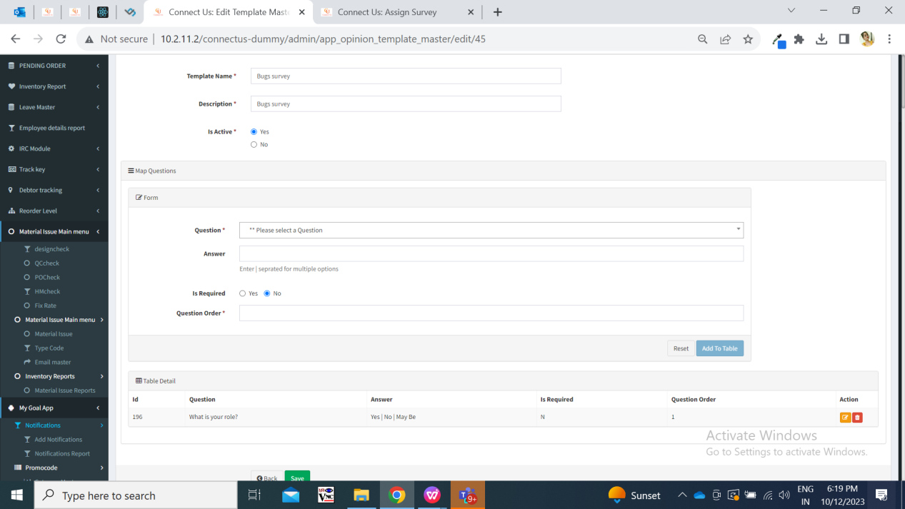

Fig: Template master -> edit action

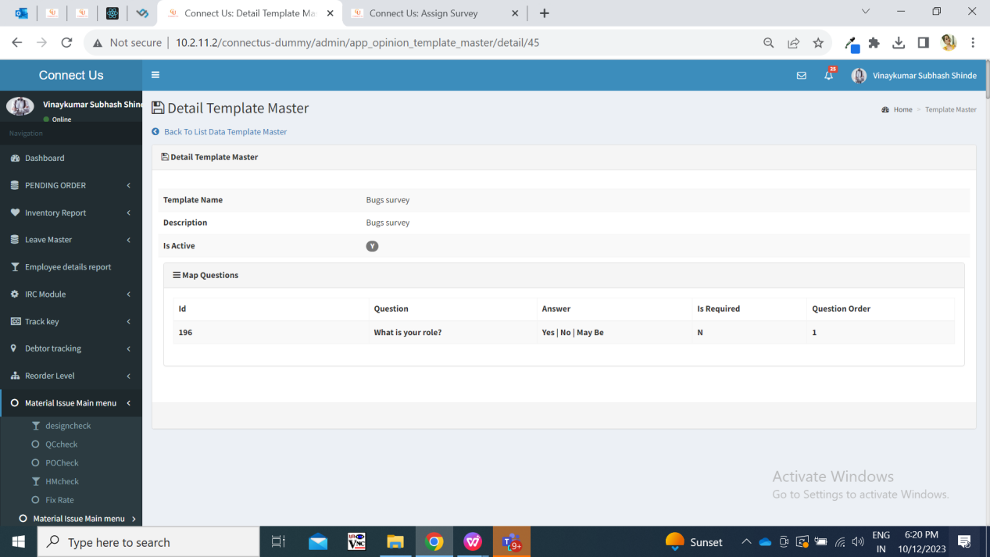

Fig: Template master -> view action

**Step 3. Assign Survey**

Once template is created, user can assign survey to employees through Connect-us -> My Goal App -> Survey -> Assign Survey. It has following fields:

* Branch
* Department
* Designation
* Gender
* Reset button
* Submit button
* Template
* Valid till
* Assign button
* Check box
* Sr. No.
* List of employees - ID and name

Once user clicks on submit button, it will display list of employees, template drop-down, validity date and assign button.

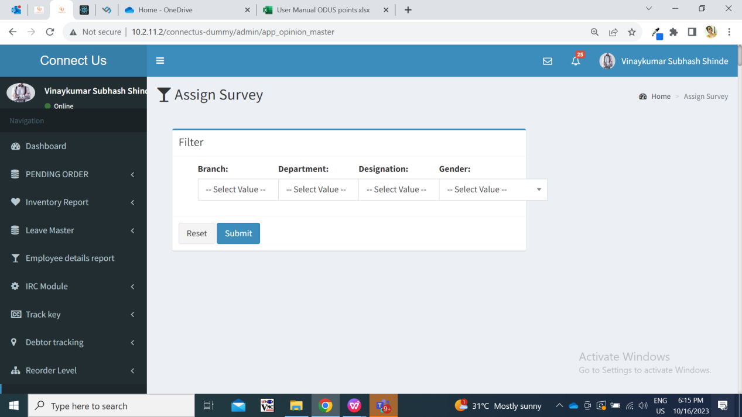

Fig: Assign survey

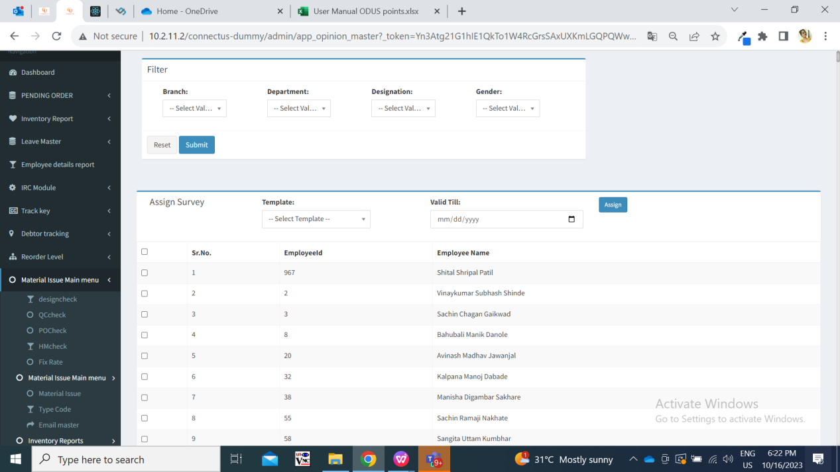

Fig: Assign survey -> assign button

|  |  |  |  |  |
| --- | --- | --- | --- | --- |
| **FIELDS** | **INPUT TYPE** | **MANDATORY/ OPTIONAL** | **EDITABLE** | **DESCRIPTION** |
| Branch | Drop  down | Optional | - | User will select the branch. So that survey can be assigned to the employees of that selected branch.  User will keep it un-selected if user wants get list of all employees of all branches and both HOs.  Validation: it will be single select. It will display active branches from the branch master. |
| Department | Drop  down | Optional | - | User will select the department. So that survey can be assigned to the employees of that selected department.  User will keep it un-selected if user wants to get the list of employees of all departments.  Validation: it will be single select. It will display active departments from the department master. |
| Designation | Drop  down | Optional | - | User will select the designation. So that survey can be assigned to the employees of that selected designation.  User will keep it un-selected if user wants to get list of employees of all designations.  Validation: it will be single select. It will display active designations from the designation master. |
| Gender | Drop-down | Optional | - | It will display male and female.  It will display list of employees from employee master as per selected gender.  Validation: it will be single select. |
| Submit | Click |  | - | Once user clicks on submit button, it will display list of employees as per selected filters or all employees if filter wasn’t selected. |
| Reset | Click |  | - | Once user clicks on reset button, it will reset the selected fields from filter if any. |
| Template | Drop  down | Mandatory | - | User will select the template from this drop-down which is to be assigned to the employees.  Validation: Active templates from the template master will be displayed in the list here. It will be single select. One template can be assigned to the employees at a time. (I.e. if user wants to assign two templates / surveys to the employee then user will have to assign survey 1 to the employees first and assign another survey to the employees.) |
| Valid till | Calender date picker | Mandatory | - | User will select the validity date for the survey means the date till which employee can submit the survey.  Validation: It will disable back dated dates. Only one date can be selected. |
| Check box | Check box | - | - | User will select the employees from the filtered list to whom the user wants to assign the survey to. User can select all employees or few employees by clicking on the check-box.  Validation: User will have to select at least one employee to assign the survey. |
| Employee ID and employee name | Text | - | - | It will display the list of employees as per selected filter. It will display the employee ID and employee name from employee master.  Validation: It will display active employees from the employee master. |
| Assign | Click | - | - | Once user selects template name, validity date, employees and clicks on assign button, then survey will get assigned to the employees. Successful message will be displayed. Fire-base notification will be sent to the employee on mobile to whom the survey is assigned to. Survey will be displayed to the assigned employees on my cs mobile app.  Survey once assigned cannot be revoked.  Validation: It will be disabled once user clicks on it and survey gets successfully assigned. Same survey cannot be assigned to the same employee until that employee submits the already assigned survey from mobile. If user selects all employees out of which the survey was already assigned to few of them, then survey will get assigned to the new employees and it will display message as survey was already assigned to few of them by mentioning their employee ID in alert message. |

**Step 4.** **Submit Survey from MY CS mobile app**

Employees will be able to submit survey through “Survey” tab in MY CS application after logging in. Once survey is assigned to employee, fire-base notification will be sent to him. Along with that, notification will be displayed in my cs mobile app -> messages tab and the count of the survey will be displayed on survey tab.

Once clicked on survey tab, it will display two radio buttons namely Pending & Completed. It will display following details:

* Count of survey
* Pending list
* Completed list
* Name of survey
* Status
* Validity date
* Completed date
* Submit button
* Save button

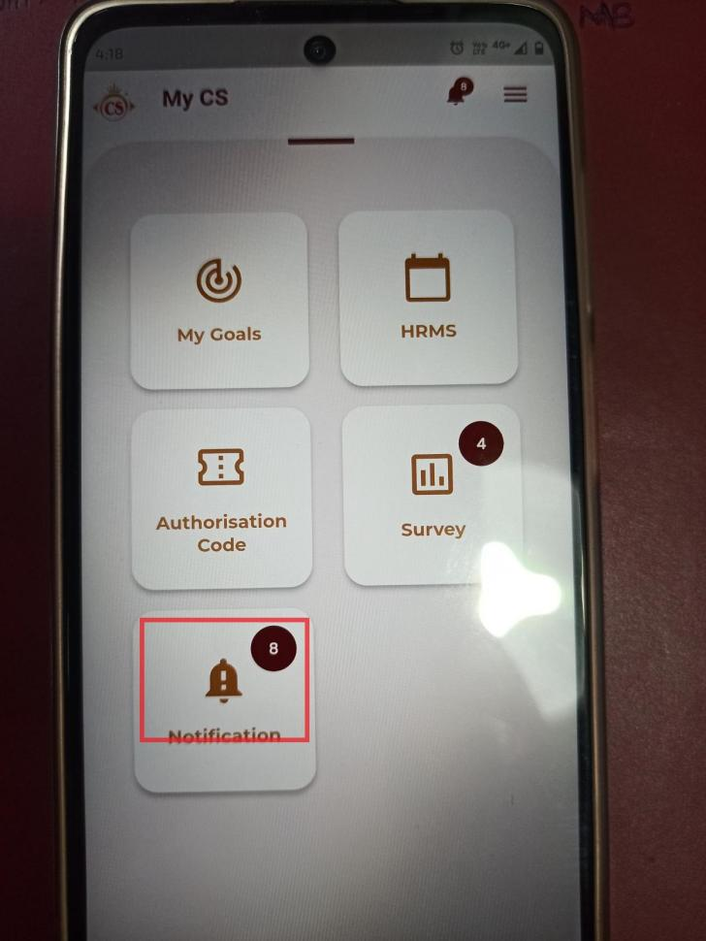

Fig: MY CS mobile app -> home-screen page

Visibility of fields in pages:

|  |  |  |  |
| --- | --- | --- | --- |
| **FIELDS** | **HOME-SCREEN MENU** | **PENDING LIST** | **COMPLETED LIST** |
| Count of survey | **✓** | **X** | **X** |
| Name of survey | **X** | **✓** | **✓** |
| Status | **X** | **✓** | **✓** |
| Validity date | **X** | **✓** | **X** |
| Completed date | **X** | **X** | **✓** |
| Submit button | **X** | **✓** | **X** |

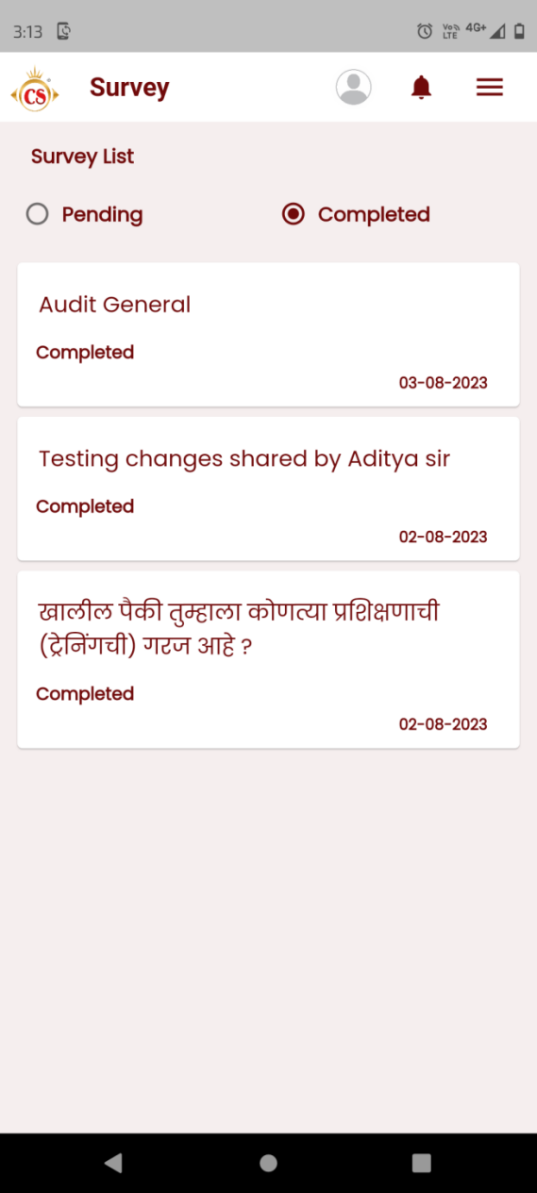

Fig: MY CS Mobile app -> survey -> completed list

|  |  |  |  |  |
| --- | --- | --- | --- | --- |
| **FIELDS** | **INPUT TYPE** | **MANDATORY/ OPTIONAL** | **EDITABLE** | **DESCRIPTION** |
| Pending list | Radio button | - | - | Surveys which aren’t submitted by employee yet will be displayed in pending menu.  Once survey is assigned, then the count of the survey will be increased and updated count will displayed on home-screen of my cs app for survey menu.  Once survey is submitted then it will be removed from pending list and will be displayed in completed list.  It will display survey in ascending order of validity date. |
| Completed list | Radio button | - | - | Surveys which are submitted will be displayed in Completed list.  Once survey is submitted, then the count of the survey will be reduced and updated count will displayed on home-screen of my cs app for survey menu.  Recently submitted surveys will be displayed on top. |
| Name of survey | text | - | - | It will display the name of the template / survey which is assigned to logged in person.  Once user clicks on the survey, it will display the questions which are mapped in it. Also, it will display the answers that were submitted by the logged in person.  If user clicks on survey from the pending list, it will display the list of questions along with the MCQ options and text field to answer the question. |
| Status | Text | - | - | It will display status as pending if survey is in pending list.  It will display status as completed in completed list. |
| Submit | Click | - | - | Once user specifies mandatory questions and clicks on submit, survey will get submitted. Pop-up message will be displayed. And the submitted answers will be displayed in completed list and survey report.  Validation: Submitted survey cannot be edited. Once user clicks on submit button, it will be disabled until survey gets submitted successfully. |
| Cancel | Click | - | - | Once user clicks on cancel button, the survey will not submitted and user will be directed to pending list page. |

**Step 5. Survey Report**

Once survey is assigned to the employees, user can view report to whom the survey is assigned to, employees who have submitted the survey and the details of survey submitted. It will display following fields:

* From Date
* To Date
* Survey
* Reset button
* Submit button
* Export button
* Survey analysis
* Response analysis
* Survey Report
* Sr no.
* Survey Submitted Date
* Emp Id
* Employee name
* Branch
* List of Questions in selected template / survey.
* App verison

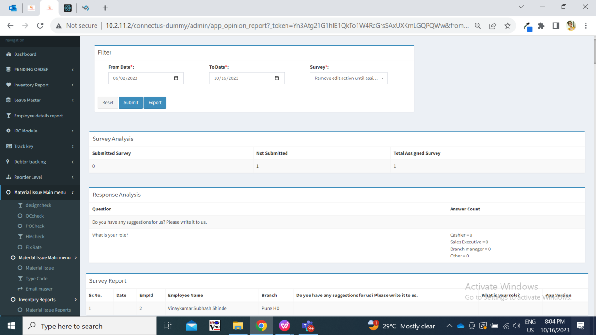

Fig: Survey report

|  |  |  |  |  |
| --- | --- | --- | --- | --- |
| **FIELDS** | **INPUT TYPE** | **MANDATORY/ OPTIONAL** | **EDITABLE** | **DESCRIPTION** |
| From Date | Calender date picker | Mandatory | - | User will select the date from which survey was assigned to employees and get report accordingly.  Validation: Future dates will be disabled. Only one date can be selected at a time. |
| To Date | Calender date picker | Mandatory | - | User will select the date till which employees have submitted the survey.  Validation: Future dates will be disabled. Only one date can be selected at a time. |
| Survey | Drop down | Mandatory | - | User will select the survey / template for which report is to be displayed.  Validation: It will display all surveys from the template master. It will be single select. |
| Reset | Click | Optional | - | All the selected fields from the filter will be reset by clicking on reset button.  Validation: it will be disabled until page gets reset and all pre-filled fields gets blank. |
| Submit | Click | - | - | Once user clicks on submit button, it will display survey analysis, question analysis and survey report in detail as per selected date and survey in filter options.  Validation: it will be disabled until report is displayed. |
| Export | Click |  |  | User can export survey report in excel file.  It will have following columns:   * Sr no. * Survey Submitted Date * Emp Id * Employee name * Branch * List of Questions in selected template / survey * App verison   Validation: Export button will be displayed after user clicks on submit button and report gets displayed in grid below. |
| Survey analysis |  |  |  | As per selected survey, it will display following details in table:   * count of employees who have submitted that survey, * count of employees who haven’t submitted that survey, * total count of employees to whom that survey is assigned to. |
| Question analysis |  |  |  | In response analysis table, question wise response sent by the employees for drop-down questions is displayed. For each question, we have displayed the count of employees who chose which of the options. |
| Survey report |  |  |  | All the employees to whom the survey is assigned to will be displayed in report. It will display following columns:   * Sr no. * Survey Submitted Date * Emp Id * Employee name * Branch * List of Questions in selected template / survey. (in columns) * App verison   However, if the employee hasn’t submitted the survey yet (survey is still pending in MY CS app), then date and answers of questions will be kept blank. If employee has submitted survey, answers submitted by employee and the date on which employee submitted the survey, it will be displayed in report. |

1. **TEST DATA AND BUSINESS SCENARIOS**

