17.10.2023

**USER MANUAL HANDOVER**

VMS MASTER DOCUMENT

Sanika Dewoolkar

Sanika.dewoolkar@techneai.com

MY GOAL - NOTIFICATIONS

Manali Ashok Bhadirage   
manali.bhadirage@techneai.com

**CONTENTS**

1. VERSION CONTROL 2

2. INTRODUCTION 2

3. SCOPE 2

4. BUSINESS & SYSTEM RULES 3

5. ABBREVIATIONS & TERMS 3

6. GRAPHICAL REPRESENTATION 3

7. DEVELOPED SYSTEM 3

8. TEST DATA AND BUSINESS SCENARIOS 18

1. **VERSION CONTROL**

|  |  |  |  |  |  |  |
| --- | --- | --- | --- | --- | --- | --- |
| **Sr. No.** | **Version no** | **Version Date** | **User name** | **User department** | **Updated By** | **Ticket ID** |
| **1** | **1.0** | **17/10/2023** | **Sagar Dahane** | **Data Analyst** | **Manali Bhadirage** | **TT6498** |
|  |  |  |  |  |  |  |
|  |  |  |  |  |  |  |

1. **INTRODUCTION**

Notification sub-module enables users to send notifications, alerts, reminders, and messages to individual employee or groups of employees. Unique message can be sent to each employee through bulk. The sent messages will displayed to the respective employee in MY CS mobile app -> message tab. User will read the message sent to him. Further, report of messages will be retrieved and exported through CU-> Notifications -> Notifications report.

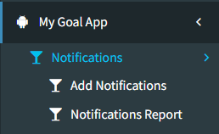

1. **SCOPE**

IN SCOPE: Through Add Notifications menu, user can give notification name, select branch so that employee names will be mentioned in downloaded bulk format as per selected branch. And, user will mention the message against each employee to whom he wants to send message. Once user uploads the file, message will get sent to the employees which will be displayed in my cs mobile app -> messages menu. Further, report of notifications can be exported through notifications report menu by notification name. Also, user can make notification inactive so that messages for same notification name cannot be same again.

1. **BUSINESS & SYSTEM RULES**

* User should be registered in the system and User should be logged in.
* System should display error message for incorrect details if entered.
* System should pop up a message, if any issues in the system is detected.
* Messages cannot be sent to the employees who are not active in employee master.

1. **ABBREVIATIONS & TERMS**

HO - Head Office

1. **GRAPHICAL REPRESENTATION**

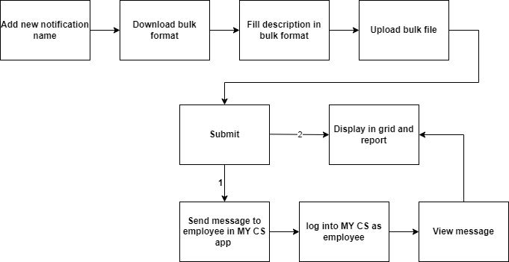

Fig: System Communication Diagram

1. **DEVELOPED SYSTEM**

**Step 1. Create Notification**

Through Add Notification menu, user can create new notification or use already created notification. It will have following fields:

* New Notification name
* Existing notification name
* Branch
* Download bulk format
* Upload bulk file
* Upload button
* Reset button
* Upload file
* Upload button

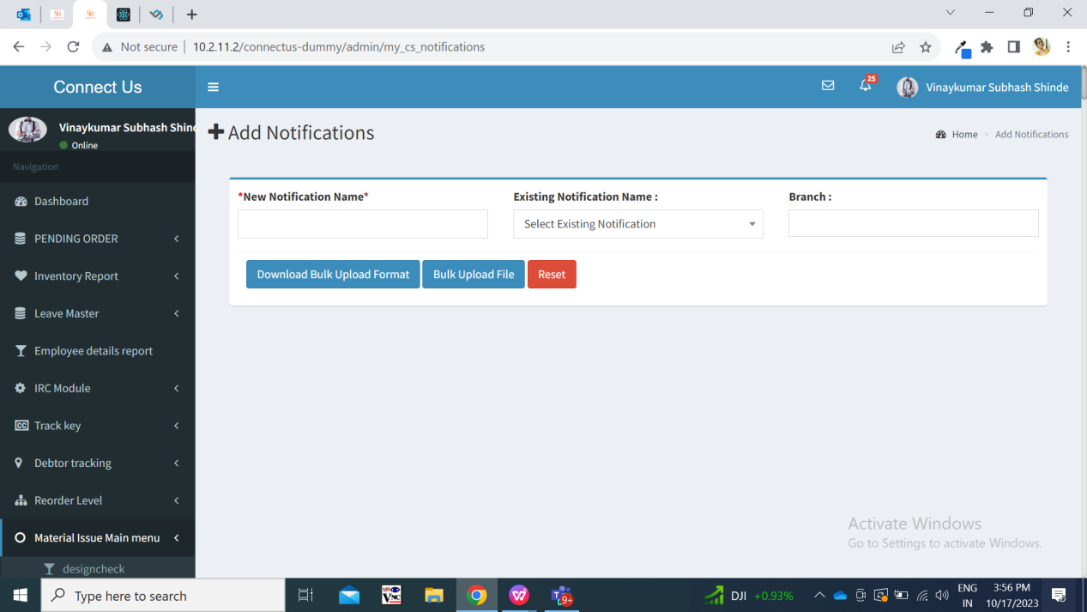

Fig: Add Notification

|  |  |  |  |  |
| --- | --- | --- | --- | --- |
| **FIELDS** | **INPUT TYPE** | **MANDATORY/ OPTIONAL** | **EDITABLE** | **DESCRIPTION** |
| New Notification Name | text | Optional | No | User will enter the subject of the notification in this field.  User can either mention the new notification name or select existing notification name to download the bulk format. Hence, either new notification name or existing notification name is mandatory.  This notification name will be reflected in notification name column of downloaded bulk format file.  Validation: It will accept characters, special characters, space and numbers with maximum 50 inputs. It will accept English and Marathi characters. |
| Existing notification name | Drop down |  | No | It will be drop-down displaying list of all active notification names. User can make existing notification name active or inactive from notification reports menu.  If user selects existing notification name from the drop-down then new notification name field will be disabled.  This name will be reflected in notification name column of downloaded bulk format.  Validation: it will be single select. |
| Branch | Drop down | Optional | - | If user wants to have all employee names in the downloaded bulk format then user will have to keep branch field blank.  The employees will be reflected in downloaded bulk format as per selected branch.  Validation: It will display active branches from branch master. It will be multi select.  Also, it will display All branches and All HO as option. Once user selected “All branch”, then in bulk upload file, it will display all the employees from all branches. Once user selected “All HO”, then in bulk upload file, it will display all the employees from both HO (Pune HO and Bmt HO). |
| Download bulk format | Click |  |  | Once user selects either existing notification name or enters new notification name, and clicks on download bulk format button then excel file will get downloaded. It will have following fields:   * Sr. No. * Branch Name * Employee ID * Employee Name * Notification Name * Description   Downloaded excel file will have branch name, employee ID, notification name and employee name columns pre-filled in it.  User will download the template and enter the description in it.  Validation: It will include all active employees from employee master in the downloaded file.  Description field in excel file will accept characters, special characters, space and numbers. It will accept english and marathi characters. It has no word limit. |
| Upload bulk file | Click |  |  | User will save the downloaded file in which user has written the description. User will attach that file through ‘bulk upload file’ button.  Once user clicks on upload bulk file, pop up box will be displayed where user will have to attach the format filled with description data mentioned in it.  Validation: It will be single select. It will accept excel or .csv file only. |
| Upload | Click |  |  | Once user attaches the filled file and clicks on upload button, the successful message will be displayed if all the details in the file were entered correctly. Also this successfully upload details will be reflected in notification report with notification name as header and employee details in its view action.  Validation: it will be disabled until file uploads successfully or error message is displayed. |
| Download error file | Click |  |  | In case the details in the uploaded file wre incorrect, then it will display download erro file button. Once user clicks on download error file, error file will get downloaded which will specify which fields were filled incorrectly. |
| Submit | Click |  |  | Once user uploads the file and clicks on submit button, it will display a confirmation dialog box stating “Are you sure you want to send? Yes /no”  Once user clicks on yes, notifications will be sent to all the desired employees in MY CS mobile app -> messages menu.  Validation: Once submitted, sent notification cannot be edited or revoked. |
| Reset | Click |  |  | Once user clicks on reset button from add notifications menu age, then all the details which were filled in the notification name or branch will be disabled so that user can refill it. User will remain in the same page.  Validation: it will be disabled until page gets reloaded and prefilled fields gets reset. |

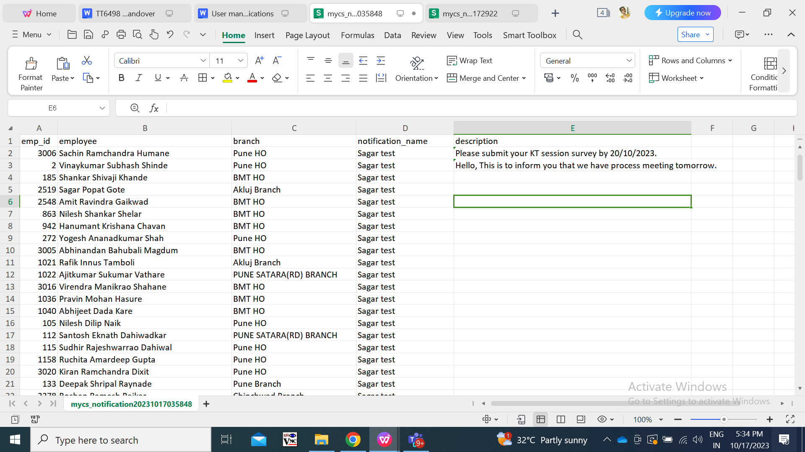

Fig: Downloaded Bulk upload format

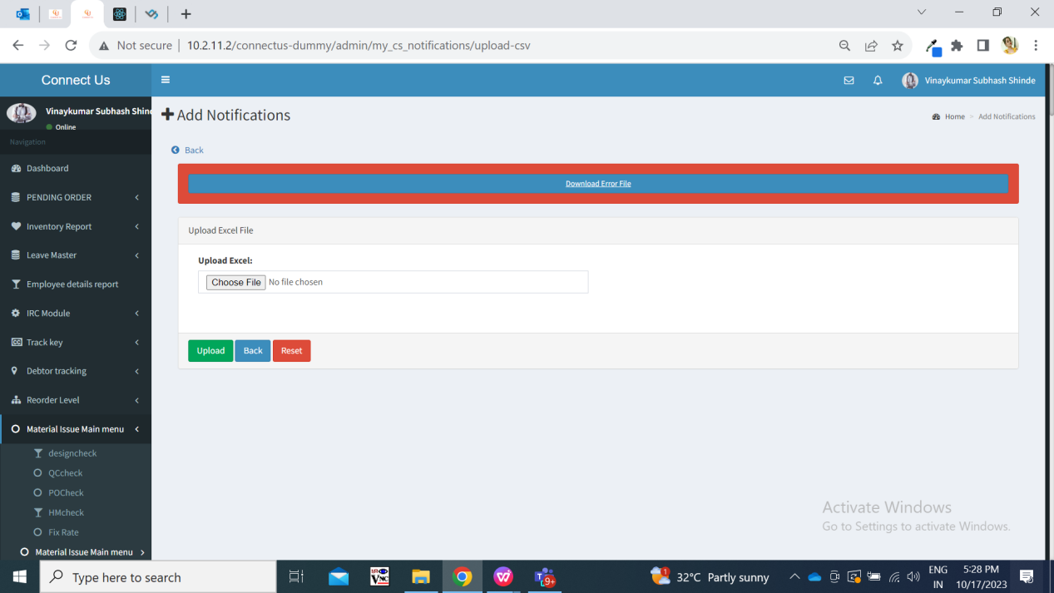

Fig: Upload bulk file

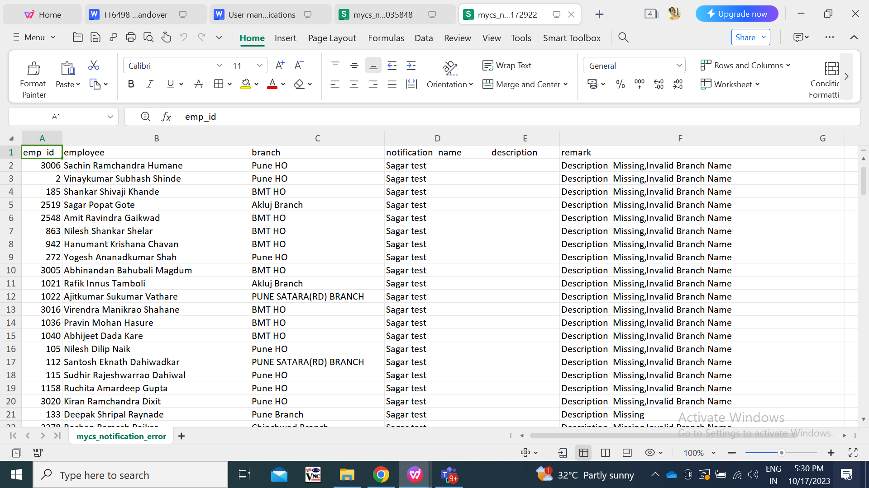

Fig: Error file

**Step 2. View notification in MY CS mobile app -> “Messages” tab**

Once notification is sent by the user to the employee, those employees will receive fire-base notification on mobile app. Also, the count of the notification will be displayed in the messages tab of home-screen.

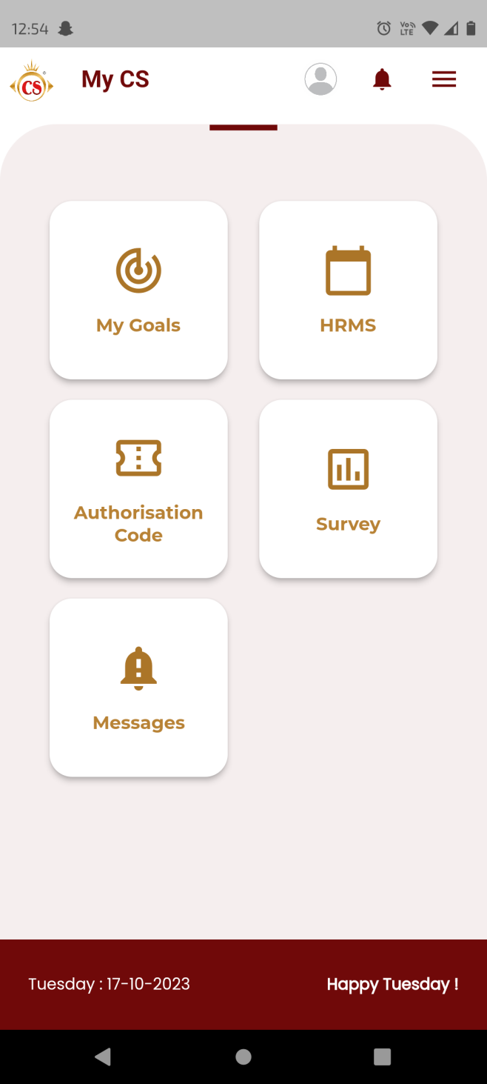

Fig: MY CS mobile app -> message tab on home screen

Once user clicks on messages tab, it will display list of notification with following fields:

* Notification name
* Description
* Date & time
* Status

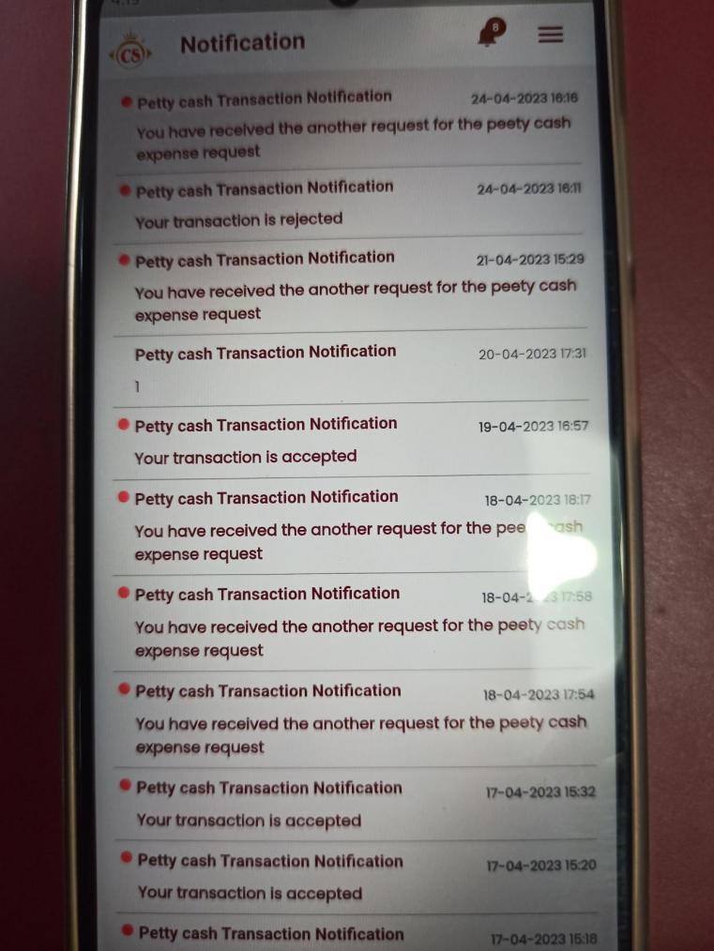

Fig: List of notifications page

|  |  |  |  |  |
| --- | --- | --- | --- | --- |
| **FIELDS** | **INPUT TYPE** | **MANDATORY/ OPTIONAL** | **EDITABLE** | **DESCRIPTION** |
| Notification Name | text | - | No | It will display the notification name as title which was sent through bulk upload file. |
| Description | Text | - | No | It will display short description as per the bulk uploaded file. |
| Date & time | Text | - | No | Date & Time on which the notification was sent to the employee will be displayed. |
| Status |  | - | No | Once message is read by employee, then the count of the notification will be reduced and will be displayed on right corner of the ‘messages’ menu.  Read messages will not have colour / will not be highlighted.  Once employee clicks on particular notification, notification will be viewed on next page with all content in it and that notification will be considered as read.  Whereas, messages which are not seen / read will be displayed with red colour.  Also, once user reads the message that means clicks on it, then read icon will be removed and the date and time when message was seen will be reflected in notification report. |

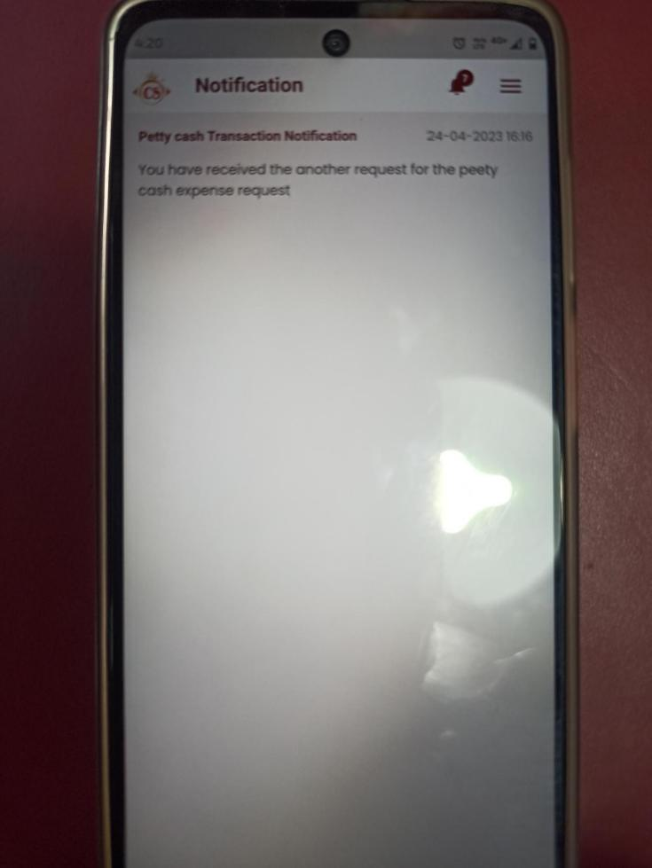

Fig: View message

**Step 3. Notification report**

Once notification is sent through bulk upload format then it will be displayed in notification report. Further for each notification name, we can view to whom it was sent and when that employee has read the notification. Notification report menu will have following fields:

* Notification name search
* Search button
* Download button
* Reset button
* View report action
* Change status action
* Notification name
* Branch id
* Is active
* Created at
* Created by
* Download button
* Sr no.
* Employee id
* Employee name
* Branch
* Notification name
* Description
* Is read
* Read at

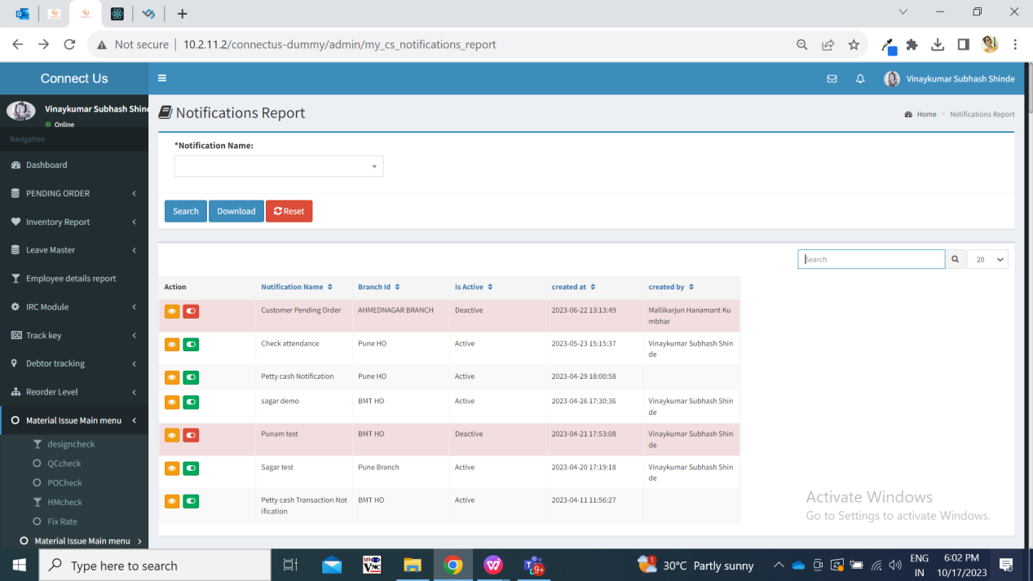

Fig: Notification report grid page

Visibility of fields in pages:

|  |  |  |  |  |
| --- | --- | --- | --- | --- |
| **FIELDS** | **GRID** | **VIEW REPORT** | **GRID DOWNLOAD** | **REPORT DOWNLOAD** |
| Notification name search | **✓** | **X** | **X** | **X** |
| Search button | **✓** | **X** | **X** | **X** |
| Download button | **✓** | **✓** | **X** | **X** |
| Reset button | **✓** | **X** | **X** | **X** |
| View report button | **✓** | **X** | **X** | **X** |
| Change status button | **✓** | **X** | **X** | **X** |
| Notification name | **✓** | **✓** | **✓** | **✓** |
| Branch id | **✓** | **✓** | **✓** | **✓** |
| Is active | **✓** | **X** | **✓** | **X** |
| Created at | **✓** | **X** | **✓** | **X** |
| Created by | **✓** | **X** | **✓** | **X** |
| Sr. No. | **X** | **✓** | **X** | **✓** |
| Employee id | **X** | **✓** | **X** | **✓** |
| Employee name | **X** | **✓** | **X** | **✓** |
| Description | **X** | **✓** | **X** | **✓** |
| Is read | **X** | **✓** | **X** | **✓** |
| Read at | **X** | **✓** | **X** | **✓** |

|  |  |  |  |  |
| --- | --- | --- | --- | --- |
| **FIELDS** | **INPUT TYPE** | **MANDATORY/ OPTIONAL** | **EDITABLE** | **DESCRIPTION** |
| Search notification name | Drop-down | Mandatory | - | It will display the list of notifications name which are in the grid.  User can search notification name from the grid. However, we are displaying all the notification names in the grid.  Validation: it will display both active and inactive notification names. |
| Search | Click | - | - | Once user enters notification name in search field and clicks on submit, it will display the search notification in the grid.  If user directly clicks on submit button without selecting notification name in the search field, then it will display grid as blank. |
| Grid: Download | Click | - | - | Once user clicks on download button then the data from the grid will get downloaded in excel file. It will have following columns:   * Notification name * Branch id * Is active * Created at * Created by   Once user clicks on download button, following file will be downloaded for your reference: |
| Reset | Click | - | - | Once user clicks on reset button, then grid page will get reloaded and fields will be reset. |
| Grid: Notification name | Text | - | - | When new notification is created, then it will displayed on top row in grid. |
| Is active | Text |  |  | It will display whether the notification is active or inactive. If notification is inactive then it will not be displayed in add notification -> existing notification name drop-down. |
| Created at | Text |  |  | It will display the date and time when notification was created. |
| Created by | Text |  |  | It will display the employee name who created that notification. |
| View report | Click |  | - | Once user clicks on view action against any particular notification name, it will display list of employees to whom that notification was sent and when they have read it. It will display of following columns:   * Sr no. * Employee id * Employee name * Branch * Notification name * Description * Is read * Read at |
| Change status | Click |  |  | User can make notification as active or inactive by using this toggle button. Once user deactivates notification name, then it will not be displayed in add notification -> existing notification name field. However, user can view report of inactive notification names.  Once user clicks on change status button ,the status will be displayed in ‘is active’ field of grid. |
| View report : download button | Click | - | - | Once user clicks on download button, it will download excel file displaying report of employees to whom that notification was sent and when they have read it. It will have following columns:   * Sr no. * Employee id * Employee name * Branch * Notification name * Description * Is read * Read at |
| Is read | Text | - | - | If assigned employee has not read the notification yet, then it will be displayed as unread in the report. |
| Read at | Text | - | - | Once employee reads the message from my cs app, then it will be displayed as ‘read’ in report and the date and time when that notification was read that will be displayed in this field. |

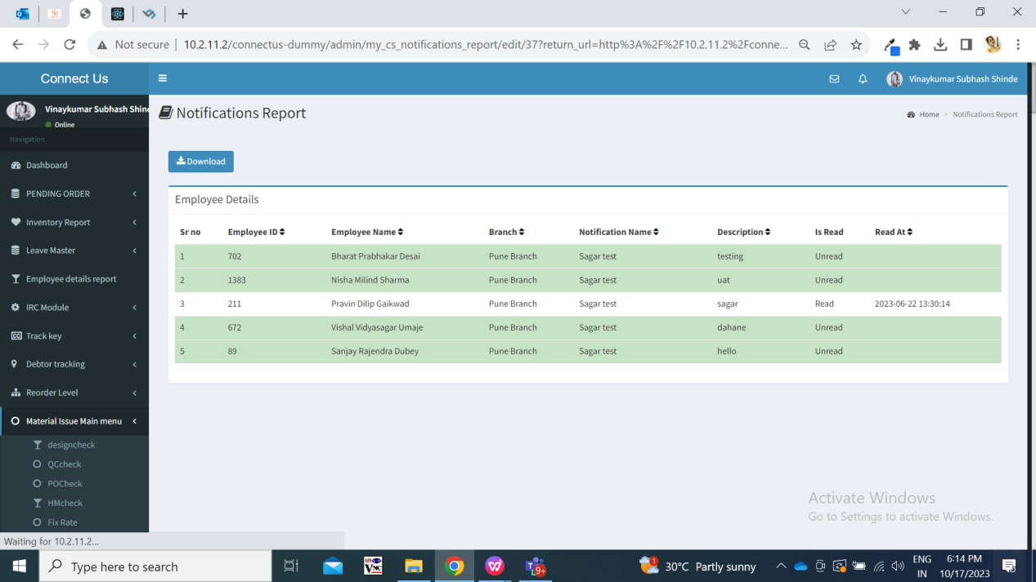

Fig: View report button page

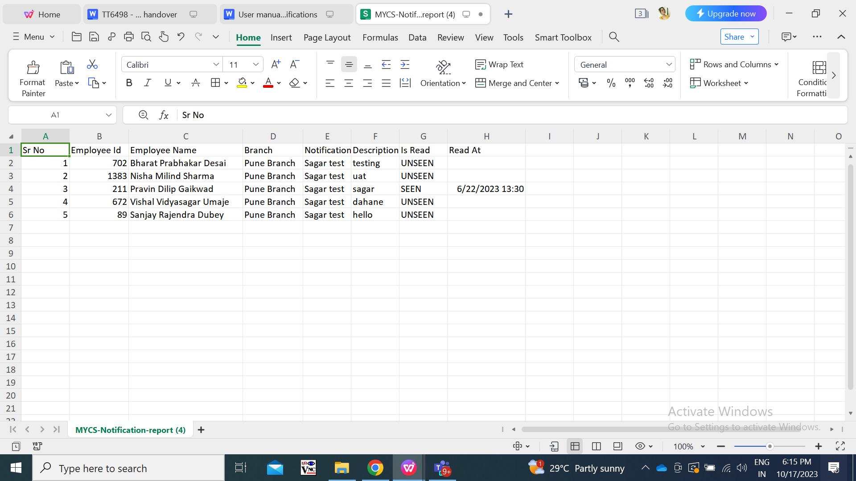

Fig: Report download file

1. **TEST DATA AND BUSINESS SCENARIOS**

